Report on
“Merchandising Business in Ready Made Garments”- A case study on Shelltex International”.

Submitted by
WWW.ASSIGNMENTPOINT.COM

The garments industry of Bangladesh has been the key export division and a main source of foreign exchange for the last 35 years. At present, the country generates about $6 billion worth of products each year by exporting garment. The industry provides employment to about 3 million workers of whom 90% are women. Two non-market elements have performed a vital function in confirming the garment industry's continual success; these elements are (a) quotas under Multi- Fibred Arrangement1 (MFA) in the North American market and (b) special market entry to European markets. The whole procedure is strongly related with the trend of relocation of production. It has been reveals that the tendency of low labor charges is the key reason for the transfer of garment manufacturing in Bangladesh. Bangladesh Garment Sector and Global Chain The cause of this transfer can be clarified by the salary structure in the garment industry, all over the world. Apparel labor charge per hour (wages and fringe benefits, US$) in USA is 10.12 but it is only 0.30 in Bangladesh. This difference accelerated the world apparel exports from $3 billion in 1965, with developing nations making up just 14 percent of the total, to $119 billion in 2001, with developing nations contributing 59 percent. In 1991 the number of workers in the ready-made garment industry of Bangladesh was 582,000 and it grew up to 1,404,000 in 1998. In USA, however, 1991-figure showed 1,106.0 thousand workers in the apparel sector and in 2008 it turned down to 765.8 thousand.

1.2 Objective of the Study
The objective of the case study is to develop the concept about the various aspects of the organizational structure, success & marketing process of the garments industry. This case study will help me to analyze the various concept of marketing, formal hierarchy, standardized export policies & rules, organizational network, various types of approaches to make profit, decision making in stable & unstable situation, how to improve the quality of products & the production process which will enrich my experience for my future career.

1.3 Scope of the Study
During my internee period I have got chances to visit many buying house, factory, supervise much production process, & completed many sample program. And Inshallah, I will get a job in LE as asst. merchandiser & as an assistant merchandiser; I will try to elaborate the merchandising profession and the production and marketing process of a garments factory.

1.4 Methodology

Data instrument
As the raw data is being collected by personal interview with various employee & buyer of different company and buying house, it was analyzed by the Microsoft office. This program was also used for the table a graphical presentation.
Beside those, the universal report writing software MS WORD was used to process all necessary research writing, charts graphs and tables.
To formulate the research problem I have constitute the following steps:

Data collection procedure
The source of data or information we divided into two parts that are primary and secondary source.

Source of Data

PRIMARY DATA
SECONDARY DATA

Figure: Sources of data
Both primary and secondary data sources were used to generate this report.

Primary data
In the primary source data are collected directly from Shelltex International
Secondary data
Secondary data are collected through different website journal and textbook and other data also collect by going various buying house.

The Primary sources are follows:
Primary data are measurements observed and recorded as part of an original study. When the data required for a particular study can be found neither in the internal records of the enterprise, nor in published sources, may it become necessary to collect original data. For the completion of this report, the primary sources of data are-
* Face-to-face conversation with the respective officers and staffs
* Informal conversation with the clients.
* Practical work exposures from the different desks of the departments .
* Study of the relevant files as instructed as instructed by the officers concerned
* Experts’ opinion and comments,

The Secondary sources and data are follows:
The data which has already been collected by others, such data are called Secondary data. For this internship report, the secondary data are collected from the below sources-
* Training materials available at the garments,
* Various books articles, compilations etc. regarding marketing of financial products are informed below:
* Published of different products,
* Office circular and other published papers,

Methodology used
There are various methodology that I have used to analyze performance are
Ratio Analysis
BCG Matrix
SWOT Analysis
.
1.5 Limitations of the Study
- It’s very hard to find necessary information because there are no fixed place such as library where data is kept.
- Foreign buyers English are not that much clear.
- The answer of certain questions I had go through people's opinion. While doing the survey lots of people did not want to respond to many questions. Sometimes they even did not fill out the questionnaire properly for the busy schedule.
- Time was one of the major constraints. As our internship program is only three-month long, it was difficult to cover and collect all the necessary materials for completion of such a large report within this time boundary.
- The people of Merchandising Incorporation are under tremendous workload. Although, they wanted to cooperate with me in writing my report, their busy schedules sometimes did not allow them to do so. On the other hand, due to secrecy of official information, sometimes they showed unwillingness to provide me information.
- There are many code names in garments industry that is very important for production process, and I have memorized those codes.
- In garments factory most of the employee doesn’t have any educational background they do their job only with experiences.
- Political unrest of our country such as strike or hartal was major problem in this regard as it is difficult to go out and work during that time and to maintain the work schedule.

An overview of Merchandising in Ready Made Garments Sector in Bangladesh
Chapter 2

2.1 The concept of merchandising in general terms:
Merchandising is the methods, practices, and operations used to promote and sustain certain categories of commercial activity
There are:
1) Promotional merchandising
2) Trading industry
3) Retail supply chain
4 Licensing
a) Children
b) Adults

2.1.1 Promotional merchandising:
In retail commerce, visual display merchandising means maximizing merchandise sales using product design, selection, packaging, pricing, and display that stimulate consumers to spend more. This includes disciplines in pricing and discounting, physical presentation of products and displays, and the decisions about which products should be presented to which customers at what time.

This annual cycle of merchandising differs between countries and even within them, particularly relating to cultural customs like holidays, and seasonal issues like climate and local sporting and recreation.

In the United States for example, the basic retail cycle begins in early January with merchandise for Valentine's Day, which is not until mid-February. Following this, Easter is the major holiday, while springtime clothing and garden-related merchandise is already arriving at stores, often as early as mid-winter. Mothers Day and Fathers Day are next, with graduation gifts (typically small consumer electronics like digital cameras) often being marketed as "dads and grads" in June (though most semesters end in May). Summer merchandise is next, including patriotic-themed products with the American flag, out by Memorial Day in preparation for Independence Day (with Flag Day in between).

By July, back-to-school is on the shelves and autumn merchandise is already arriving, and at some arts and crafts stores, Christmas decorations. By September, the summer merchandise is on final closeout and overstock of school supplies is marked-down some as well, and Halloween (and often even more of the Christmas) merchandise is appearing. As the Halloween decorations and costumes dwindle in October, Christmas is already being pushed on consumers, and by the day afterward retailers are going full-force with advertising, although the "official" season does not start until the day after Thanksgiving. Christmas clearance sales now begin even before Christmas at most retailers, and continue on to as little as New Year's Day or as long as February.

Merchandising also varies within retail chains, where stores in places like Denver, Minneapolis, or Buffalo might carry snow blowers, while stores in Florida and southern California might instead carry beach clothing and barbecue grills all year. Coastal-area stores might carry water skiing equipment, while ones near mountain ranges would likely have snow skiing and snowboarding gear if there are ski areas nearby.

2.1.2 Trading industry:
In Eastern Europe, particularly in Russia, the term “merchandising” is commonly used within the trading industry and denotes all marketing and sales stimulation activities around PoS (point of sale): design, creation, promotion, care and training of the sales staff. Basically a merchandiser is someone who is continuously involved in business promotion by buying and selling of goods.

2.1.3 Retail supply chain:
In the supply chain, merchandising is the practice of making products in retail outlets available to consumers, primarily by stocking shelves and displays. While this used to be done exclusively by the stores' employees, many retailers have found substantial savings in requiring it to be done by the manufacturer, vendor, or wholesaler that provides the products to the retail store. In the United Kingdom there are a number of organizations that supply merchandising services to support retail outlets with general stock replenishment and merchandising support in new stores. By doing this, retail stores have been able to substantially reduce the number of employees needed to run the store.

While stocking shelves and building displays is often done when the product is delivered, it is increasingly a separate activity from delivering the product. In grocery stores, for example, almost all products delivered directly to the store from a manufacturer or wholesaler will be stocked by the manufacturer's/wholesaler's employee who is a full time merchandiser. Product categories where this is common are Beverage (all types, alcoholic and non-alcoholic), packaged baked goods (bread and pastries), magazines and books, and health and beauty products. For major food manufacturers in the beverage and baked goods industries, their merchandisers are often the single largest employee group within the company. For nationwide branded goods manufacturers such as The Coca-Cola Company and PepsiCo, their respective merchandiser work forces number in the thousands.

2.1.4 Licensing:
In marketing, one of the definitions of merchandising is the practice in which the brand or image from one product or service is used to sell another. Trademarked brand names, logos, or character images are licensed to manufacturers of products such as toys or clothing, which then make items in or emblazoned with the image of the license, hoping they'll sell better than the same item with no such image. For the owners of the intellectual property in question, merchandising is a very popular source of revenue, due to the low cost of letting a third party manufacture the merchandise, while the IP owners simply sit back and collect the merchandising fees.

Children:
Merchandising for children is most prominently seen in connection with films and games, usually those in current release and with television shows oriented towards children.

Merchandising, especially in connection with child-oriented films and TV shows, often consists of toys made in the likeness of the show's characters (action figures) or items which they use. However, sometimes it can be the other way around, with the show written to include the toys, as advertising for the merchandise. The first major example of this was the TV show "He-man and the Masters of the Universe," in the early 1980s, but this practice has been common in children's broadcasting ever since.

Sometimes merchandising from a television show can grow far beyond the original show, even lasting decades after the show has largely disappeared from popularity. In other cases, large amounts of merchandise can be generated from a pitifully small amount of source material (Mashimaro).

Adults:
Example of professional sports merchandising - A Boston Celtics cap manufactured by Adidas
The most common adult-oriented merchandising is that related to professional sports teams (and their players).

A smaller niche in merchandising is the marketing of more adult-oriented products in connection with similarly adult-oriented films and TV shows. This is common especially with the science fiction and horror genres. (Examples: Star Trek, McFarlane Toys) Occasionally shows which were intended more for children find a following among adults, and you can see a bit of a crossover, with products from that show oriented towards both adults and children. (Gundam model kits)

Sometimes a brand of non-media products can achieve enough recognition and respect that simply putting its name or images on a completely unrelated item can sell that item. (An example would be Harley-Davidson branded clothing.)

2.1.5 A Glimpse of The Growth & Status of Ready-Made Garment Export of Bangladesh:
Year | Export of RMG (in Million US$) | Total export of Bangladesh (in Million US$) | % of RMGS to total Export
1987-88 | 31.57 | 811.00 | 3.89
1988-89 | 116.20 | 934.43 | 12.44
1989-90 | 131.48 | 819.21 | 16.06
1990-91 | 298.67 | 1076.61 | 27.74
1991-92 | 433.92 | 1231.20 | 35.24
1992-93 | 471.09 | 1291.56 | 36.47
1993-94 | 642.16 | 1523.70 | 40.96
1994-95 | 866.82 | 1717.55 | 50.47
1995-96 | 1182.57 | 1993.92 | 59.31
1996-97 | 1245.01 | 2382.89 | 60.64
1998-99 | 1555.79 | 2533.90 | 61.40
1999-2002 | 2547.13 | 382.00 | 65.61
2002-2004 | 3001.25 | 4418.28 | 67.93
2004-2006 | 3781.94 | 5161.20 | 73.28
2006-2008 | 4019.98 | 5212.86 | 75.67
2.1.6 Apparel-The Highest Export Earning Sector:
1991-92 | RMG EXPORT VALUE (MILLION US $)
1991-92 | 1182.57
1998-99 | 1445.22
1999-98 | 1555.79
1998-99 | 2232.09
1999-2000 | 2547.13
2000-2001 | 3001.25
2001-2002 | 3781.94
2002-2003 | 4019.98

2.1.7 Share of RMG In Country's 1998-99 Total Export:
Commodity | Export Share (%)
RMG | 75.67
JUTE GOODs | 5.72
RAW JUTE | 5.16
TEA | 1.35
LEATHER | 3.17
CHEM. PRODUCTS | 0.72
FROZEN GOODS | 1.49
OTHERS | 12.91

2.2 History
The ready-made garment (RMG) industry of Bangladesh started in the late 1970s and became a prominent player in the economy within a short period of time. The industry has contributed to export earnings, foreign exchange earnings, employment creation, poverty alleviation and the empowerment of women. The export-quota system and the availability of cheap labour are the two main reasons behind the success of the industry. In the 1980s, the RMG industry of Bangladesh was concentrated mainly in manufacturing and exporting woven products. Since the early 1990s, the knit section of the industry has started to expand. Shirts, T-shirts, trousers, sweaters and jackets are the main products manufactured and exported by the industry. Bangladesh exports its RMG products mainly to the United States of America and the European Union. These two destinations account for more than a 90 per cent share of the country’s total earnings from garment exports. The country has achieved some product diversification in both the United States and the European Union. Recently, the country has achieved some level of product upgrading in the European Union, but not to a significant extent in the United States. Bangladesh is less competitive compared with China or India in the United States and it is somewhat competitive in the European Union.
The phase-out of the export-quota system from the beginning of 2005 has raised the competitiveness issue of the Bangladesh RMG industry as a top priority topic. The most important task for the industry is to reduce the lead time of garment manufacturing. The improvement of deep-level competitiveness through a reduction in total “production and distribution” time will improve surface-level competitiveness by reducing lead time. Such a strategy is important for long-term stable development of the industry, but its implementation will take time. In contrast, the establishment of a central or common bonded warehouse will improve surface-level competitiveness by reducing lead time, but deep-level competitiveness will not be improved and long-term industry development will be delayed. Therefore, granting permission to establish in the private sector such warehouses with special incentives, such as the duty-free import of raw materials usable in the export-oriented garment industry for reducing the lead time in garment manufacturing is a critical issue for Bangladesh. Second, Bangladesh needs to improve the factory working environment and various social issues related to the RMG industry. International buyers are very particular about compliance with codes of conduct. Third, issues related to product and market diversification as well as upgrading products needs to be addressed with special care. Moreover, the Government of Bangladesh needs to strengthen its support. The development of the port and other physical infrastructure, the smooth supply of utilities, a corruption-free business environment and political stability are some priority concerns for the Government to consider in its efforts to attract international buyers and investors.
The RMG industry of Bangladesh has expanded dramatically over the last three decades. Traditionally, the jute industry dominated the industrial sector of the country until the 1970s. Since the early 1980s, the RMG industry has emerged as an important player in the economy of the country and has gradually replaced the jute industry. The “export-quotasystem”1 in trading garment products played a significant role in the success of the industry. However, that quota system came to an end in 2004. Therefore, the competitiveness issue needs to be addressed, with special attention given to the long-term sustainability of the industry. The term “competitiveness” itself is a broad concept. Its meaning, implications, adaptation and achievement vary from firm to firm, industry to industry, or country to country. Michael E. Porter is a pioneer of the “competitiveness theory” (Porter, 1990)at the national or macro level (Cho and Moon, 2000). Firm/industry-level (micro level) competitiveness depends on various parameters. However, the literature provides no universal agreement on the definition of competitiveness. For example, some researchers consider the labor cost, unit cost, exchange rate, interest rate, prices of material inputs other price- or cost-related quantitative factors for measuring the competitiveness of a manufacturing firm/industry (Edwards and Golub , 2004; Fukunishi, 2004; Cockburn another’s, 1998; and Edwards and Schoer, 2002). Some other researchers consider product quality, innovativeness, design, distribution networks, after-sales service, transaction costs, institutional factors relating to the bureaucracy of export procedures and other non-price factors for measuring the competitiveness of a manufacturing firm/industry (Abdel-Latif,1993; Chen and others, 1999; and Sachwald, 1994). The influences of both price and on-price factors on the competitiveness of a firm/industry are reflected by market share and profit ( 2006). This study attempts to incorporate price, non-price and result(for example, market share) factors in order to address the international competitiveness of the Bangladesh RMG industry. The majority of the competitiveness-related research studies focus on the “competitive performance” or on the “factors influencing competitive performance”. The studies consider product price, market share and other indicators to measure competitive performance, while considering wages, costs, productivity and other issues as factors influencing competitive performance. However, Fujimoto (2001) puts special emphasis on the “capability” factor that influences the competitive performance of a firm. According to him, improvement in the “capability” of a firm enhances its “competitive performance”. This improvement takes time, but it ensures the long-term sustainability of a firm. In contrast, improving only “competitive performance” and not “capability” may not be sufficient to ensure the long-term development of the firm.
This study addresses the competitiveness issue from two broader dimensions: surface-level and deep-level competitiveness.3 Surface-level competitiveness reflects the “competitive performance” of a firm or industry that is directly observable to consumers. Deep-level competitiveness reflects the “capability” of a firm or industry that is not directly observable to consumers. An improvement in the deep-level performance enhances the performance at the surface level. The severe competition under the quota-free trading environment pressures the RMG industry of Bangladesh to enhance its surface-level competitiveness at the earliest convenient time. However, the long-term sustainability of the industry demands enhancement of deep-level competitiveness. Therefore, the future development of the industry will depend on how much importance will be given to which factors/dimensions, and how the individual firms will respond and how government policies will influence the industry. Hence, the discussion of the competitiveness of the Bangladesh RMG industry requires simultaneous consideration of both the surface and deep dimensions. In particular, this study uses (a) export value, product price, market share and lead time as surface-level indicators, and (b) linkage expansion, factory environment, product/market composition, and “production and distribution” time as deep-level indicators for measuring the international competitiveness of the Bangladesh RMG industry. The paper is structured as follows.
2.3 AN OVERVIEW OF THE BANGLADESH READYMADE GARMENT INDUSTRY:
The RMG industry is the only multi-billion-dollar manufacturing and export industry in Bangladesh. Whereas the industry contributed only 0.001 per cent to the country’s total export earnings in 1976, its share increased to about 75 per cent of those earnings in 2005. Bangladesh exported garments worth the equivalent of $6.9 billion in2005, which was about 2.5 per cent of the global total value ($276 billion) of garment exports. The country’s RMG industry grew by more than 15 per cent per annum on average during the last 15 years. The foreign exchange earnings and employment generation of the RMG sector have been increasing at double-digit rates from year to year. Some important issues related to the RMG industry of Bangladesh are noted in table
Table 2. Important issues related to the ready-made garment industry

Year(s) Issue
1977-1980 Early period of growth
1982-1985 Boom days
1985 Imposition of quota restrictions
1990s Knitwear sector developed significantly
1993-1995 Child labor issue and its solution
2003 Withdrawal of Canadian quota restriction
2005 Phase-out of export-quota system
Currently, there are more than 4,000 RMG firms in Bangladesh. More than 95 percent of those firms are locally owned with the exception of a few foreign firms located inexpert processing zones (Gonzales, 2002). The RMG firms are located mainly in three main cities: the capital city Dhaka, the port city Chittagong and the industrial city Narayangonj. Bangladesh RMG firms vary in size. Based on Bangladesh Garment Manufacturers and Exporters Association (BGMEA) data, (2000) found that in1997 more than 75 per cent of the firms employed a maximum of 400 employees each. Garment companies in Bangladesh form formal or informal groups. The grouping helps to share manufacturing activities, to diversify risks; horizontal as well as vertical coordination can be easily found in such group activities. Ready-made garments manufactured in Bangladesh are divided mainly into two broad categories: woven and knit products. Shirts, T-shirts and trousers are the main woven products and undergarments, socks, stockings, T-shirts, sweaters and other casual and soft garments are the main knit products. Woven garment products still dominate the garment export earnings of the country. The share of knit garment products has been increasing since the early 1990s; such products currently account for more than 40 per cent of the country’s total RMG export earnings (BGMEA website). Although various types of garments are manufactured in the country, only a few categories, such as shirts, T-shirts, trousers, jackets and sweaters, constitute the major production-share (BGMEA website). Economies of scale for large-scale production and export-quota holdings in the corresponding categories are the principal reasons for such a narrow product concentration.

2.4 COMPETITIVENESS OF THE BANGLADESH READY-MADEGARMENT INDUSTRY:
The United States was the main export destination for Bangladeshi RMG products in the early 1990s followed by the European Union, but the European Union has surpassed the United States over time. These two destinations generate more than 90 per cent of the total RMG export earnings of Bangladesh (BGMEA and the Export Promotion Bureau websites; and Quddus and Rashid, 2000). The shares of other importers, such as Australia, Canada, China, Japan and the Russian Federation as well as countries in the Middle East, in the total RMG export earnings of Bangladesh are minimal. This section of the paper focuses on surface-level competitive performance of the Bangladesh RMG industry in the United States and the European Union markets only. In addition, the performance of China and India along with Bangladesh as RMG suppliers to international markets is also considered for comparative analysis. (a) Export competitiveness in the United States market5 Bangladesh has experienced some product diversification in its export of garments to the United States market in recent years compared with the early 1990s.6 However, the country’s performance in upgrading its products is not significant with regard to the United States market (Haider, 2006). The country experienced a sharp increase in the export of garment products to the United States market in the 1990s, but faced declines in export earnings from that country in 2002 and 2003, followed by slow increases since 2004. The exports of India also increased rapidly in the 1990s, although that country experienced comparatively slow progress in the last few years. However, the RMG exports of China to the United States have increased at a startling rate over the years. For example, the textile and garment export earnings of China, India and Bangladesh from the United States were $3.6 billion, $0.8 billion and $0.4 billion respectively in 1990, and increased to$22.4 billion, $4.6 billion and $2.5 billion respectively in 2005. Such rapid expansion in the exports of China represents a major challenge to other exporters.
Cotton non-knit shirts, man and boy was the highest contributor to the export earnings of Bangladesh from the United States, amounting to $332 million in2005. The export earnings of only eight categories8 crossed the $100 million export benchmark in the same year for the country. A total of 16 categories of exports crossed the$50 million benchmark and 31 categories crossed the $10 million export benchmark.
2.4.1 Export competitiveness in the European Union market:
Bangladesh has experienced both quantitative and qualitative changes in exporting garment products to the European Union market during the period 1996-2005. The textile and garment export earnings of Bangladesh from the European Union increased from1.2 billion Euros in 1996 to 3.7 billion Euros in 2005. For India and China, the corresponding earnings increased from 3 billion and 5.3 billion Euros in 1996 to 5.3 billion and 21.1 billion Euros in 2005 respectively. Garment products generate the major share of Bangladesh’s export earnings from the European Union. However, both textile and garment products in China and India contribute to the export earnings from the European Union. For example, garment products on average generated more than a 95 per cent share of the total textile and garment exports to the European Union from Bangladesh during the period1996-2005. The corresponding shares for India and China stand at below 75 per cent and80-90 per cent respectively. The top five product groups contributed 76 per cent of the total garment export earnings of Bangladesh from the European Union in 1996, and that share increased to82 per cent in 2005. The corresponding changes for India and China were from shares of62 per cent and 34 per cent in 1996 to 54 per cent and 45 per cent in 2005 respectively. This trend demonstrates that product diversification in Bangladesh is lower than that of India and China in exporting garments products to the European Union market. Knit garments from Bangladesh have gained remarkable access to the European Union market during the period 1996-2005 (see table 2).Duty- and quota-free access of garment products manufactured under “two-stage local transformation” (yarn to fabrics, and fabrics to garment) have accelerated the exports of knit garment products from Bangladesh to the European Union. As the knit textile subsector is relatively less capital intensive and requires relatively simple technologies, it managed to undergo rapid expansion, benefiting from the European Union Generalized System of Preferences. The woven part of the category has failed to utilize that facility owing to a lack of sufficient backward linkages. In contrast to the European Union, both knit and non-knit products have entered the United States market simultaneously, as no special tariff or tax reduction incentive was available there for the import of garment products from Bangladesh. The product-mix of garment products exported from Bangladesh to the European Union has changed significantly during the period 1996-2005. The share of shirts in total garment exports from Bangladesh to the European Union has decreased, whereas the shares for overcoats, jackets, sweaters, suits and some other garment products have increased indecent years. These changes demonstrate that Bangladesh is achieving some level of product diversification in exporting garment products to the European Union. In addition, a gender analysis indicates that Bangladesh has achieved some upgrading of its products recently in terms of exporting garment products to the European Union. Garments for females are treated as upgraded products compared with garments for males, since they add more value on average. The earnings of Bangladesh from the export of garments for females to the European Union has increased during the period 1996-200.

Table- 3 Exports of knit, non-knit and made-up products to the European Union
(Millions of Euros and percentage)

Exporter to  the European  Union | Year | Knit garments  Total % | Non-Knit garments  Total % | Made- up products  Total % | Total  Total %
Bangladesh  India  China | 1996  2005  1996  2005  1996  2005 | 506 44  2195 60  510 28  1508 38  1538 34  6639 36 | 624 54  1334 36  1012 55  1720 44  2488 56  10178 55 | 29 2  132 4  320 17  714 18  432 10  1748 9 | 1159 100  3661 100  1842 100  3942 100  4458 100  18565 100

2.4.2 Price competitiveness:
China and some other competitors of Bangladesh have implemented sharp price-cutting policies in exporting garment products over the last few years, but Bangladesh has failed to respond effectively to such policies. China was able to drop the export price of29 garment categories10 by 46 per cent11 on average in the United States within a year, from $6.23 per sq meter in December 2001 to $3.37 per sq meter in December 2002.However, all other suppliers were able to drop the price by only 2 per cent, from $3.50 per sq meter to $3.41 per sq meter during the same period. By the end of 2002, China had underpriced all other exporters to the United States in 22 out of 29 garment categories and it had underpriced others in 26 out of 29 categories by March 2003 (American Textile Manufacturers Institute, 2003). Moreover, China rapidly managed to be price competitive in the European Union and other major international markets. For example, the average unit export price of garment products integrated in the third stage of the Multi fiber Arrangement phase-out decreased from 11,600 Euros per ton in 2001 to 9,500 Euros in 2002 for Bangladesh in the European Union, whereas the corresponding decrease for China in that market was from 13,500 Euros to 8,800 Euros per ton (European Commission, 2003). Bangladesh needs to respond to such price-cutting policies of its rivals in order to remain competitive in the quota-free global market. (d) Lead time Lead time refers to the time required for supplying the ordered garment products after the export order has been received. In the 1980s, the usual lead time in the garment industry was 120-150 days for the main garment supplier countries of the world; it has been reduced to 30-40 days in the current decade.12 However, in this regard the Bangladesh RMG industry has improved little; for example, the average lead time is 90-120 days for woven garment firms and 60-80 days for knit garment firms. In China, the average lead time is 40-60 days and 50-60 days for woven and knit products respectively; in India, it is 50-70 days and 60-70 days for the same products respectively.13Shortening the lead time is the most urgent priority task for Bangladesh. The best way is to develop domestic backward linkages with the aim of reducing “production and distribution” time.14 Such a strategy would contribute to enhancing the deep-level performance of the industry and would have a positive impact on surface-level performance. An alternative solution would be to establish a central or common bonded warehouse in the private sector for storing raw materials usable in the export-oriented garment industry, with special incentives such as duty-free import. While such a solution is the fastest way to improve surface-level competitiveness by reducing lead time, it carries the risk of delaying deep-level competitive performance-enhancing initiatives and the long-term development of the industry.

Literature review
Chapter 3

3.1 Letter of Credit (LC):

- Letter of credit (LC) is a financial instrument opened by importer.
- LC can be opened in favor of exporter. It gives assurance that the importer is solvent.
- Most of the LC is irrevocable. An irrevocable LC means that once the exporter has accepted the credit, the buyer cannot alter it without any permission of exporter.

Transaction of letter of credit (LC)

7. Authorization of payment

2. LC
Exporter Bank
Importer Bank

3. Document 1. Request
5. Of To open LC 8. Debited
6. LC

Exporter
Importer

- shipment
4. SHIPMENT
Of good

- Buyer requests the bank for open a letter of credit.
- Issuing bank open an irrevocable LC and send it to exporter bank.
- Advising bank prepare letter of conformation of LC and send it to exporter
- Exporter review the LC. IF acceptable, exporter arranges with freight forwarder to delivery the goods.
- Exporter present delivery documents to advising bank for payment.
- Advising bank forward the entire document to issuing bank to authorize payment.
- At the same time, advising bank pays necessary payment to exporter.
- 8 buyers account in the issuing bank is debited

3.2 Terms of LC:
C.I.F (Cost, Insurance and freight):
- Charge by the exporter- the goods, transportation, insurance, miscellaneous etc.
- Must mention a delivery point up to where the exporter will bear the cost of freight.
C.F (Cost and Freight)
- The exporter quotes a price including the cost of goods and transportation.
- The insurance cost by importer.
- Importer knows such insurance company who offer lower insurance price.
F.O.B (Free on Board)
- F.O.B means exporter will take the responsibility up to the goods are loaded on the ship
- Importer has own transportation
- Ship company is well known to importer
Commercial invoice:
Commercial invoice is the final bill that allows the importer about how to pay to exporter. Commercial invoice is needed customs to impose tax.
Bill of lading:
A bill of lading is a documents issued by the ship-owner or by the master or captain of the ship or other agent in exchange of mate’s Receipt after the goods have been placed on the board the ship for being carried to a specific destination. It is used when the goods shipped from only a part of the cargo of a ‘general ship’
A bills of lading must be stamped and signed by the ship-owner or his agent, the master or captain of the ship
Backward Integration:
Customers are another potential source of competition. For reducing the production cost manufacturer make linkage or own the source of raw materials. Those linkages are called backward linkage or backward integration.
Labor-Capital relationship:
In countries where there is little capital available for investment and where the amount of investment per worker is low, manager might expect to find cheap labor rate and export competitiveness in product that require large amount of labor relative to capital.

Overview of the company
Chapter 4

4.1 Organizational Profile:


Company Profile
Legal Identity: Private Limited Company.
Established: 2000
Production Unit: 30 (Includes Knitting, Dyeing, Printed label, label. Hang tag).
Production Item: Printed label, label. Hang tag etc.
Yearly Turnover: US $ 1 Million.
Total Employee: 52 Persons
Bank: NCC bank.
Comments: Our buyers are steady and satisfied and we are also doing business in European Union.

4.2 Organogram of Shelltex International:
Managing
Director
Merchandiser  Md. Reza | Sampling Manager  (Md. Bakul) | Accessory Manager  (Md. Huzzad Ullah) | Commercial  Manager  (M.A. Khlaque) | QC Manager  (Md. Jahingir) | Shipping Manager  (Md. Mahafuz) | Accounts  Manager  (Md. Zakir Hossain)

General Manager
(Khabir Uddin)
Merchandising Dept. | Sampling Dept. | Accessory Supply Dept. | Commercial Dept. | Production Dept. | Shipping Dept. | Accounting  Dept.

Asst. Merchandiser | Assistant | Supervisor | Assistant | QC Inspector | Supervisor | Asst.  Manager

4.3 Professional service:

Our policies and services have been built to fulfill customer satisfaction with finest quality products and services as well as ethical responsibilities based on strong time management, teamwork and modern communication.

Global sourcing solution for our customer: We source for supply chains for major brands and retailers worldwide. Our sourcing network 13 plus countries and territories across North America, Europe and Asia. In addition to the wide range and variety of consumer products available through its sourcing network, JAK also provides its strength in custom product design and development to provide complete global sourcing solutions for its customers.

Quality Service: Quality leads flavor in our business existence as quality control is the first preference of job conduct. Our QC teams who are highly trained and experienced follow up following issues:
- On site production monitoring
- Multiple Midterm inspection
- Spot check
During production pick the product and match with buyer recent production comments.
Maintain standard quality in every step of manufacturing from the selection of right and best materials to the packaging and shipping.

Communication & Coordination: Communication & Coordination are the important role in our service. We always communicate with our buyer and coordinate with production department, sourcing department time to time we inform to our overseas customer updated status for all of issue. We always follow our buyer comments

Development and Sampling: This is an important sector in our service. Our professional team always review buyers development package and communicate with buyer to meet their requirements by providing Fit sample, PP sample, Salesman sample etc.

Effective and Strong Management: On time delivery is very important to us. We manage our entire professional as follows:
- Merchandising work instruction
- Production Plan
- Sourcing for all of accessories and Fabrics
- Shipping work instruction
- Compliance
- Quality maintain
- Sampling

All team members, top management to bottom are aware of shipment date. Also, an off-line database is used to track all the process of the production, so buyers can be updated.

4.4 Mission and Vision of Shelltex International
Since the establishment, Shelltex International has always been dedicated to its customer service. The success of the company is based on its management’s devotee and innovative attitude and firm commitment to its ultimate goal.

Our Vision:
Our vision is to provide services which directly belong to international trade in commodities and services, by safeguarding its customers’ interests, protecting their integrity and to make business by capturing major shares in the market through quality products and services which would be most trusted anywhere in the world.

Our Mission:
Our Mission is realization of Vision through maximum delivery of quality product and services strictly on ethical and moral standards at competitive costs ensuring optimum benefits to the clients and ……….

1. To ensure the best and ultimate solution to the customers in meeting their ongoing needs with the best quality of products and services.
2. Within the stipulated period of time.
3. To be the market leader of the trade.
4. To handle the requirement of the customers both profitably to them and to ourselves.
5. Factory visiting service is available when necessary.
6. A perfect solution will be efficiently presented by the Shelltex International trained staffs when technical problems occur or on customer’s request. Orders are continuously monitored by the Shelltex International’s most efficient staffs and improved thereof till shipment.
7. Value-added service ensures its customers’ high profits and advantage in a fierce competitive climate.
8. To manufacture world-class standard products for our valued customers with on time delivery.

4.5 Organizational Goals of Shelltex International
- To employ resources as incendiary for the growth of RMG sector.
- To provide service for the parties involved and invention of the necessary new service dimension.
- To search for new buyers for investment and help to develop products to suit such needs.

4.6 Principal Objectives
- Profit maximization
- To provide standard services.

4.7 Strategic View of Shelltex International
- A truly international outlook for exporting
- A long-term commitment for exporting
- A strategic approach to the development of new export market
- Credibility and close and long-term relationship in export market
- An international reputation for quality
- Resources available for export support

Operating Procedure of Propel Sourcing
Chapter 5

5.1 Functional Departments of Shelltex International
All the functions of Merchandising Inc. are operated under four major departments:
1. Merchandising department.
2. Sampling department.
3. Commercial department.
4. Accessory supply department.
5. Production department.
6. Distribution department.

5.1.1 Merchandising Department:
This department of merchandising department is responsible for the following activities:
Searching buyers: The task of this department started with the searches of buyers, who want to import garment products from our country, to get the order of the garment product manufacturing.
Introduce letter: After finding suitable buyers this department issues an introducing letter to the respective buyers which describes merchandising department's total years of experience, its parameter of total activities, efficiency and effectiveness and relationship with existing buyers.
Cost of Making: CM is another important activity that stands for Cost of Making. Here the merchandiser of this dept. determines what are the things are required to make a unit or dozen of an order. Then he makes calculation' of per unit cost on the basis of accessories consumption, fabric consumption, labor cost and other relevant costs.

Price negotiation: When this department has the clear idea about the cost involved in the desired transaction they start price negotiation to determine a final price that the buyer agrees to pay.
Select supplier: Merchandising department recognizes the effectiveness, of their commitment to buyers and thereby it shoulders the responsibility of finding out efficient buyers. The bases of efficiency include supplier's adequate administrative setup to prepare all necessary documents for exports, supplier's financial status and adequate capacities etc.

5.1.2 Sampling Department:
It starts its activities after receiving the original sample or sketch sample from the buyer with an, intention to testify the capability of sampling department to meet the desired standard of the products. Two people contribute toward the efficiency of sampling dept. They are sampling man and pattern master of M. Inc.

5.1.3 Commercial Department:
The commercial department of Shelltex International prepares pro-forma invoice for the respective buyer. The invoice includes the quantity of the buyer's order, its unit price and total price. The commercial department also transfers master L/C on the name of selected supplier. This department also maintains all clerical activities such as maintaining the accounts of daily transaction, maintaining payroll, keeping the accounts of daily expenditures etc.

5.1.4 Accessory supply department:
For a smooth manufacturing, the assurance of on time delivery of fabric and accessories is must. The responsibility of supplying accessories to the suppliers landed on the ground of this department. To assure this supply Merchandising Inc. utilizes two sources. One is its sister concern FM. Printing and Packaging Company. Another is the outsourcing from its suppliers of long term relationship. As a result the manufacturer doesn't need to be worried about the availability of accessories.

5.1.5 Production Department:
Although named as production department, this service department rather follows up production dividing its activities into following sections of Responsibilities: Quality monitor and control: This dept. supervises the manufacturing process to maintain the quality and scheduled progress of the manufacturing in behalf of merchandising Incorporation.
Final Inspection: For its reputation, buyers usually delegate the responsibility of final inspection on the shoulder of quality. Inspector of Merchandising Incorporation. The efficient inspection is the responsibility of the quality inspector of Merchandising Inc.

5.1.6 Shipping Department:
As the name mentions the task of shipping department of M. Inc starts from -receipt of final goods from the supplier factory after the final inspection and ends- with loading of the goods bound for supplier. This department also prepares the supporting documents for export such as bill of exchange, bill of lading, commercial invoice, certificate of origin, packing list etc.

5.2 List of Machineries
Our mission is to provide not only the highest possible product quality but also a total service.

SL. NO | DESCRIPTION
01 | Plain Machine
02 | Over Lock
03 | Flat Lock
07 | PMD
13 | Button Hole
14 | Button Attach
15 | Rib Cutter
8 | Kansai

Other logistic Machineries
1 | Cutting
2 | Auto Boiler
3 | P.P Belt Machine
4 | Vacuum Table
5 | Steam Iron
6 | Embroidery Machine (20 head)
7 | Sewing Thread Machine (72 cone)

We have created world-class facilities to ensure better quality control and faster deliveries, the way the market is demanding today
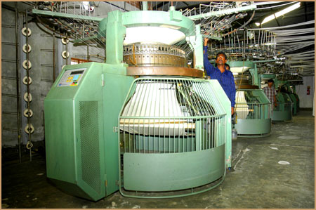

Rib & Interlock

Interlock

Interlock


Washing-Garments-Dyeing-Machine



laser_ engraving _cutting _machine _high _precision


High-Frequency-Rotary-PVC-Welding-Machine-GL-8GR-Y3Z-
Our mission is to provide not only the highest possible product quality but also a total service to match.
Machine Specification:
SI | NAME OF MACHINE | DIA/GG & FEEDER.
1 | MACA BRAND HIGH SPEED SINGLE JERSY MACHINE | 20"X24GGX60 FEEDER
2 | MACA BRAND HIGH SPEED SINGLE JERSY MACHINE | 21"X24GGX63 FEEDER
3 | MACA BRAND HIGH SPEED SINGLE JERSY MACHINE | 22"X24GGX66 FEEDER
4 | MACA BRAND HIGH SPEED SINGLE JERSY MACHINE | 23"X24GGX69 FEEDER
5 | MACA BRAND HIGH SPEED SINGLE JERSY MACHINE | 24"X24GGX72 FEEDER
6 | MACA BRAND HIGH SPEED SINGLE JERSY MACHINE | 26"X24GGX78 FEEDER
7 | MACA BRAND HIGH SPEED SINGLE JERSY MACHINE | 25"X24GGX75 FEEDER
8 | MASA BRAND HIGH SPEED SINGLE RIB/INTER LOCK MACHINE | 30"X24 GGX60 FEEDER
9 | MASA BRAND HIGH SPEED SINGLE RIB/INTER LOCK MACHINE | 34"X24GGX63 FEEDER
10 | MASA BRAND HIGH SPEED SINGLE RIB/INTER LOCK MACHINE | 36"X24GGX66 FEEDER
11 | MASA BRAND HIGH SPEED SINGLE RIB/INTER LOCK MACHINE | 40"X24GGX69 FEEDER

Special Effect: - Enzyme finishes, silicon finish, antistatic system

List of Dyeing Machine

MACHINE NAME
Brand new tensionless relax dryer
Ballooning squishier with compacting device
Atmospheric normal temperature & normal pressure dyeing machine
Fire tube boiler
Folding compactor machine
Over flow high temperature rapid dyeing machine & laboratory equipment.
Spec to photo meter
Gas generator

5.3 Working Environment
Next to its security measures, the factory is will equipped and furnished with enough fire-fighting equipment, fire alarms systems and trained personnel for facilitating emergency evacuation. All of which contribute to minimizing the fire- risks. The factory environment, with excellent lighting and ventilation, is one of the very best of its kind in Bangladesh.

5.4 Products of Shelltex International
- Fabrics in 100% cotton, blends and 100% polyester
- Dyeing and finishing fabric of 100% cotton, blends and 100% polyester.
- We coordinate with the manufacturers and exporters of readymade garments like T-shirts, polo shirts, sportswear, underwear, and sweatshirts, casual wear, night wears, lingerie & polar fleece jacket etc.
- Different type of printing like Pigment, Rubber, Flock, Foil, Sugar, Discos, Deactive, Embross, Plastic sole, Glitter, Hidensi , Transper, Gel, Stone print.
- All type of Label and Tags.
Besides, we have very strong marketing division for all kinds’ of ready-made garments to expand market to Europe, U.S.A, Canada and all over the world.

5.5 Customers of Shelltex International
Customer | Angel, SPANE
Customer | Wal-Mart stores inc, U.S.A
Customer | Lefties , U.S.A
Customer | NKD,Germany
Customer | Prime Canada,CANADA
Customer | Teronva,ITALY.

Payment procedure:
We specially deal all financial matter with our buyer by our advising bank. Off course it is a matter that influence by the relationship with our buyer. Most common way is-
- Receive L/C
- At sight

5.6 Production Process of Shelltex International

5.6.1 Buying house
Buying house is the middleman between the buyer and RMG factory. It is quite difficult to arrange buyer for RMG factory because most of the buyer come from foreign. And RMG factories website is not that much effective that’s why a class of broker grow in this gap between buyer and the manufacturer. As they always maintain correspondence with the buyer they have better understanding of buyer’s requirement. They act as a helping hand for us.

5.6.2Buyers Order
At first buyer request sample from the garments factory with all the necessary information regarding to their product and then we match our capability with the buyer’s requirement. If capability matched then we submitted a fare costing of that product to the buyer. Here I present a copy of buyers order.
Date – 26th Sept 2007
Subject – WARREN

Hi babu,
Pls find below a file of man t-shirt to make as follow at 2.40€:

WARREN
- 95% cotton 5% lycra
- enzyme wash
- neck width 19cm, neck drop 1.5cm, neck depth 17cm
- with our badge on back collar
- DTL-1: thick embroidery in silver lurex yarn on the right shoulder at 3cm from the seam
- DTL-2: thick embroidery in silver lurex yarn 6x2cm
- DTL-3: cross with 5 plies in silver lurex yarn on front left armhole at 4cm from the shoulder
- DTL-5: make exactly same seam on all the body in grey color reverse seam on sides body + sleeves sewed with a ton to ton chain seam
Rgds,
Noémie

5.6.3 Costing
For costing of garments we have consider so many things such as fabric consumption, accessories, fabric GSM, colour, Print, embroidery, sewing charge, and other additional expenses that is required in the production process here I present some copy of costing of sample program
ART NO |  | ISTITUZIONAL 08 | FABRICATION | GSM | CONSUMPTION | FAB PRICE | TOTL FAB COST
FABRICS+RIB | FABRICS |  | 100% COTTON S/JERSEY | 400 | 5.28 | $ 5.50 | $ 29.04
FABRICS+RIB | NECK RIB |  | 1X1 LYCRA RIB | 250 | 0.4 | $ 7.00 | $ 2.80
 | MAIN LABEL AT BACK NECK |  |  |  |  |  | $ 4.00
 | SZ LABEL BESIDE MAIN LABEL |  |  |  |  |  | $ 0.20
 | TWILL TAPE AT BACK NECK |  |  |  |  |  | $ 0.60
 | 3 PRINTED CARE LABEL AT LEFT SIDE SEAM |  |  |  |  |  | $ 0.45
 | HEM LABEL |  |  |  |  |  | $ 0.96
 | PATCH(YELL) ON R SLEEVE G/MELANGE |  |  |  |  |  | $ 1.20
 | PATCH ON RIGHT SLEEVE |  |  |  |  |  | $ 1.20
 | PATCH ON BACK BOTTOM |  |  |  |  |  | $ 1.20
 | PRICE TAG |  |  |  |  |  | $ 0.20
 | BARCODE |  |  |  |  |  | $ 0.20
 | POLY |  |  |  |  |  | $ 1.20
 | CARTON |  |  |  |  |  | $ 1.20
 | GUMTAPE |  |  |  |  |  | $ 0.20
 | OTHERS |  |  |  |  |  | $ 0.20
 | S/THREAD |  |  |  |  |  | $ 0.61
 | EMBRO
 | PRINT |  |  |  |  |  | $ 6.00
CM |  |  |  |  |  |  | $ 12.00
TOTAL/DZN |  |  |  |  |  |  | $ 63.46
COMMERCIAL COST |  |  |  | 5% |  |  | $ 3.17
COST/DZ WITH COMMERCIAL COST |  |  |  |  |  |  | $ 66.64
COST/PC WITH COMMERCIAL COST |  |  |  |  |  |  | $ 5.55

ART NO |  |  | ISTYCAP 08 |  | FABRICATION |  | GSM |  | CONSUMPTION |  | FAB PRICE |  | TOTL FAB COST
FABRICS+RIB | FABRICS |  |  |  | 100% COTTON FRENCH TERRY |  | 400 |  | 10.2 |  | $ 5.50 |  | $ 56.10
FABRICS+RIB | INSIDE HOOD LINING |  |  |  | 100% COTTON JERSEY |  | 200 |  | 0.7 |  | $ 5.00 |  | $ 3.50
FABRICS+RIB | EMBROIDERY FAB |  |  |  | TWILL |  |  |  | 1 |  | $ 2.00 |  | $ 2.00
FABRICS+RIB | COLLAR CUFF |  |  |  | Y/DYED 1X1 FLAT KNIT WAIST BAND+CUFF |  |  |  | 1DZN SET |  | $ 17.75 |  | $ 17.75
TRIMS | LACE FOR HOOD |  |  |  |  |  |  |  |  |  |  |  | $ 1.06
TRIMS | LACE LABEL |  |  |  |  |  |  |  |  |  |  |  | $ 0.15
TRIMS | MAIN LABEL AT BACK NECK |  |  |  |  |  |  |  |  |  |  |  | $ 3.40
TRIMS | SZ LABEL BESIDE MAIN LABEL |  |  |  |  |  |  |  |  |  |  |  | $ 0.25
TRIMS | PRINTED TWILL TAPE AS BACK NECK TAPE |  |  |  |  |  |  |  |  |  |  |  | $ 1.06
TRIMS | PRINTED TWILL TAPE LABEL AT CUFF |  |  |  |  |  |  |  |  |  |  |  | $ 1.20
TRIMS | 3 PRINTED CARE LABEL AT LEFT SIDE SEAM |  |  |  |  |  |  |  |  |  |  |  | $ 0.45
TRIMS | POCKET LABEL |  |  |  |  |  |  |  |  |  |  |  | $ 0.15
TRIMS | RUBBER PATCH AT ZIP PULL |  |  |  |  |  |  |  |  |  |  |  | $ 3.50
TRIMS | EMBRO PATCH ON HOOD |  |  |  |  |  |  |  |  |  |  |  | $ 1.20
TRIMS | RUBBER PATCH AT SLEEVE |  |  |  |  |  |  |  |  |  |  |  | $ 3.60
TRIMS | PRICE TAG |  |  |  |  |  |  |  |  |  |  |  | $ 0.20
TRIMS | BARCODE |  |  |  |  |  |  |  |  |  |  |  | $ 0.20
TRIMS | POLY |  |  |  |  |  |  |  |  |  |  |  | $ 1.20
TRIMS | CARTON |  |  |  |  |  |  |  |  |  |  |  | $ 1.20
TRIMS | GUMTAPE |  |  |  |  |  |  |  |  |  |  |  | $ 0.20
TRIMS | OTHERS |  |  |  |  |  |  |  |  |  |  |  | $ 0.20
TRIMS | S/THREAD |  |  |  |  |  |  |  |  |  |  |  | $ 0.61
 | FRONT ZIP, NYLON # 5 OPEN END AUTO LOCK |  |  |  |  |  |  |  |  |  |  |  | $ 3.00
 | POCKET ZIP, NO 5 NYLON ZIP CLOSE END AUTO LOCK |  |  |  |  |  |  |  |  |  |  |  | $ 1.80
 | EMBRO |  |  |  |  |  | STITCH/BODY |  |  |  | 120,000 |  | $ 42.00
CM |  |  |  |  |  |  |  |  |  |  |  |  | $ 25.00
TOTAL/DZN |  |  |  |  |  |  |  |  |  |  |  |  | $ 170.98
COMMERCIAL COST |  |  |  |  |  |  | 5% |  |  |  |  |  | $ 8.55
COST/DZ WITH COMMERCIAL COST |  |  |  |  |  |  |  |  |  |  |  |  | $ 179.53
COST/PC WITH COMMERCIAL COST |  |  |  |  |  |  |  |  |  |  |  |  | $ 14.96
ART NO |  |  |  | HEART 09 |  | FABRICATION |  | GSM |  | CONSUMPTION |  | FAB PRICE |  | TOTL FAB COST
FABRICS+RIB |  | FABRICS |  |  |  | 100% COTTON FRENCH TERRY ALL OVER PRINT |  | 400 |  | 9.3 |  | $ 5.50 |  | $ 51.15
 |  | COLLAR |  |  |  | Y/DYED 1X1 FLAT KNIT WAIST BAND+CUFF |  |  |  | 1 DZN |  | $ 3.00 |  | $ 3.00
TRIMS |  | MAIN LABEL AT BACK NECK |  |  |  |  |  |  |  |  |  |  |  | $ 3.40
 |  | SZ LABEL BESIDE MAIN LABEL |  |  |  |  |  |  |  |  |  |  |  | $ 0.25
 |  | SOLID TWILL TAPE |  |  |  |  |  |  |  |  |  |  |  | $ 0.86
 |  | VELVET TAPE AT BACK NECK |  |  |  |  |  |  |  |  |  |  |  | $ 1.20
 |  | 3 PRINTED CARE LABEL AT LEFT SIDE SEAM |  |  |  |  |  |  |  |  |  |  |  | $ 0.45
 |  | REVET AT BOTTOM |  |  |  |  |  |  |  |  |  |  |  | $ 0.60
 |  | REVET PATCH LABEL |  |  |  |  |  |  |  |  |  |  |  | $ 1.50
 |  | BUTTON |  |  |  |  |  |  |  |  |  |  |  | $ 0.60
 |  | PRICE TAG |  |  |  |  |  |  |  |  |  |  |  | $ 0.20
 |  | BARCODE |  |  |  |  |  |  |  |  |  |  |  | $ 0.20
 |  | POLY |  |  |  |  |  |  |  |  |  |  |  | $ 1.20
 |  | CARTON |  |  |  |  |  |  |  |  |  |  |  | $ 1.20
 |  | GUMTAPE |  |  |  |  |  |  |  |  |  |  |  | $ 0.20
 |  | OTHERS |  |  |  |  |  |  |  |  |  |  |  | $ 0.20
 |  | S/THREAD |  |  |  |  |  |  |  |  |  |  |  | $ 0.61
 |  | FELT FOR EMBRO PATCH |  |  |  |  |  |  |  |  |  |  |  | $ 3.00
 |  | EMBRO |  |  |  |  |  | STITCH/BODY |  |  |  | 60,000 |  | $ 21.00
 |  | WASH |  |  |  |  |  |  |  |  |  |  |  | $ 3.00
CM |  |  |  |  |  |  |  |  |  |  |  |  |  | $ 12.00
TOTAL/DZN |  |  |  |  |  |  |  |  |  |  |  |  |  | $ 105.82
COMMERCIAL COST |  |  |  |  |  |  |  | 5% |  |  |  |  |  | $ 5.29
COST/DZ WITH COMMERCIAL COST |  |  |  |  |  |  |  |  |  |  |  |  |  | $ 111.11
COST/PC WITH COMMERCIAL COST |  |  |  |  |  |  |  |  |  |  |  |  |  | $ 9.26
PRICE ON 100% COTTON FRENCH TERRY SOLID |  |  |  |  |  |  |  | 400 GSM |  |  |  |  |  | $ 9.25
PRICE ON 100% COTTON FRENCH TERRY AOP |  |  |  |  |  |  |  | 400 GSM |  |  |  |  |  | $ 10.90
PRICE ON 100% COTTON S/JERSEY printed |  |  |  |  |  |  |  | 240 GSM |  |  |  |  |  | $ 7.06

ART NO |  | ARVID | FABRICATION | GSM | CONSUMPTION | FAB PRICE | TOTL FAB COST
FABRICS+RIB | FABRICS |  | 100% COTTON FRENCH TERRY | 400 | 10.76 | $ 5.50 | $ 59.18
FABRICS+RIB | INSIDE HOOD LINING |  | 100% COTTON JERSEY | 200 | 0.7 | $ 5.00 | $ 3.50
FABRICS+RIB | COLLAR CUFF |  | Y/DYED 1X1 FLAT KNIT WAIST BAND+CUFF | 300 | 1.8 | $ 8.00 | $ 14.40
TRIMS | LACE FOR HOOD |  |  |  |  |  | $ 1.06
TRIMS | LACE LABEL2 LABEL IN 2 SIDE. |  |  |  |  |  | $ 0.30
TRIMS | MAIN LABEL AT BACK NECK |  |  |  |  |  | $ 3.40
TRIMS | SZ LABEL BESIDE MAIN LABEL |  |  |  |  |  | $ 0.25
TRIMS | HERRINGBONE SOLID COLOR (TPX 18-1658) TWILL TAPE AT BACK NECK |  |  |  |  |  | $ 0.60
TRIMS | 3 PRINTED CARE LABEL AT LEFT SIDE SEAM |  |  |  |  |  | $ 0.45
TRIMS | CUFF LABEL |  |  |  |  |  | $ 0.30
TRIMS | EMBOSED METAL PATCH |  |  |  |  |  | $ 6.00
TRIMS | RIF 6 WOVEN LABEL (AT BACK NECK) |  |  |  |  |  | $ 3.00
TRIMS | PRICE TAG |  |  |  |  |  | $ 0.20
TRIMS | BARCODE |  |  |  |  |  | $ 0.20
TRIMS | POLY |  |  |  |  |  | $ 1.20
TRIMS | CARTON |  |  |  |  |  | $ 1.20
TRIMS | GUMTAPE |  |  |  |  |  | $ 0.20
TRIMS | OTHERS |  |  |  |  |  | $ 0.20
TRIMS | S/THREAD |  |  |  |  |  | $ 0.61
 | EMBRO |  |  | STITCH/BODY |  | 6,000 | $ 2.10
 | PRINT |  |  |  |  |  | $ 3.00
CM |  |  |  |  |  |  | $ 16.00
TOTAL/DZN |  |  |  |  |  |  | $ 117.35
COMMERCIAL COST |  |  |  | 5% |  |  | $ 5.87
COST/DZ WITH COMMERCIAL COST |  |  |  |  |  |  | $ 123.22
COST/PC WITH COMMERCIAL COST |  |  |  |  |  |  | $ 10.27

ART NO |  | PARADISE 09 | FABRICATION | GSM | CONSUMPTION | FAB PRICE | TOTL FAB COST
FABRICS+RIB | FABRICS |  | 100% COTTON S/JERSEY | 240 | 9.3 | $ 5.50 | $ 51.15
FABRICS+RIB | NECK RIB |  | 1X1 LYCRA RIB | 250 | 1.8 | $ 7.00 | $ 12.60
 | MAIN LABEL AT BACK NECK |  |  |  |  |  | $ 4.00
 | SZ LABEL BESIDE MAIN LABEL |  |  |  |  |  | $ 0.20
 | TWILL TAPE AT BACK NECK |  |  |  |  |  | $ 0.60
 | 3 PRINTED CARE LABEL AT LEFT SIDE SEAM |  |  |  |  |  | $ 0.45
 | REVET LABEL |  |  |  |  |  | $ 0.96
 | RIVET |  |  |  |  |  | $ 0.50
 | VELVET TAPE AT BACK NECK |  |  |  |  |  | $ 3.00
 | PRICE TAG |  |  |  |  |  | $ 0.20
 | BARCODE |  |  |  |  |  | $ 0.20
 | POLY |  |  |  |  |  | $ 1.20
 | CARTON |  |  |  |  |  | $ 1.20
 | GUMTAPE |  |  |  |  |  | $ 0.20
 | OTHERS |  |  |  |  |  | $ 0.20
 | S/THREAD |  |  |  |  |  | $ 0.61
 | EMBRO |  |  |  |  |  | $ 20.00
 | PRINT |  |  |  |  |  | $ 8.00
CM |  |  |  |  |  |  | $ 12.00
TOTAL/DZN |  |  |  |  |  |  | $ 117.27
COMMERCIAL COST |  |  |  | 5% |  |  | $ 5.86
COST/DZ WITH COMMERCIAL COST |  |  |  |  |  |  | $ 123.14
COST/PC WITH COMMERCIAL COST |  |  |  |  |  |  | $ 10.26
FABRIC | S/JERSEY | 240 GSM | S/S TSHIRT |  |  |  | 6.45
 | FRENCH TERRY |  | L/S –T |  |  |  | 10.46

ART NO |  | IRON | FABRICATION | GSM | CONSUMPTION | FAB PRICE | TOTL FAB COST
FABRICS+RIB | FABRICS |  | 100% COTTON S/JERSEY | 240 | 3.8 | $ 5.00 | $ 19.00
FABRICS+RIB | NECK RIB |  | 1X1 LYCRA RIB | 250 | 0.2 | $ 6.00 | $ 1.20
 | MAIN LABEL AT BACK NECK |  |  |  |  |  | $ 3.40
 | SZ LABEL BESIDE MAIN LABEL |  |  |  |  |  | $ 0.25
 | TWILL TAPE AT BACK NECK |  |  |  |  |  | $ 0.60
 | 3 PRINTED CARE LABEL AT LEFT SIDE SEAM |  |  |  |  |  | $ 0.45
 | FLAG LABEL |  |  |  |  |  | $ 0.60
 | RIF 3 EMBROIDERY PATCH |  |  |  |  |  | $ 3.00
 | RIF 6 WOVEN LABEL (AT BACK NECK) |  |  |  |  |  | $ 3.00
 | PRICE TAG |  |  |  |  |  | $ 0.20
 | BARCODE |  |  |  |  |  | $ 0.20
 | POLY |  |  |  |  |  | $ 1.20
 | CARTON |  |  |  |  |  | $ 1.20
 | GUMTAPE |  |  |  |  |  | $ 0.20
 | OTHERS |  |  |  |  |  | $ 0.20
 | S/THREAD |  |  |  |  |  | $ 0.61
 | EMBRO |  |  | STITCH/BODY |  | 110,000 | $ 27.50
 | PRINT |  |  |  |  |  | $ 8.00
CM |  |  |  |  |  |  | $ 12.00
TOTAL/DZN |  |  |  |  |  |  | $ 82.81
COMMERCIAL COST |  |  |  | 5% |  |  | $ 4.14
COST/DZ WITH COMMERCIAL COST |  |  |  |  |  |  | $ 86.95
COST/PC WITH COMMERCIAL COST |  |  |  |  |  |  | $ 7.25

ART NO |  | ISTITUZIONAL 08 | FABRICATION | GSM | CONSUMPTION | FAB PRICE | TOTL FAB COST
FABRICS+RIB | FABRICS |  | 100% COTTON S/JERSEY | 400 | 5.28 | $ 5.50 | $ 29.04
FABRICS+RIB | NECK RIB |  | 1X1 LYCRA RIB | 250 | 0.4 | $ 7.00 | $ 2.80
 | MAIN LABEL AT BACK NECK |  |  |  |  |  | $ 4.00
 | SZ LABEL BESIDE MAIN LABEL |  |  |  |  |  | $ 0.20
 | TWILL TAPE AT BACK NECK |  |  |  |  |  | $ 0.60
 | 3 PRINTED CARE LABEL AT LEFT SIDE SEAM |  |  |  |  |  | $ 0.45
 | HEM LABEL |  |  |  |  |  | $ 0.96
 | PATCH(YELL) ON R SLEEVE G/MELANGE |  |  |  |  |  | $ 1.20
 | PATCH ON RIGHT SLEEVE |  |  |  |  |  | $ 1.20
 | PATCH ON BACK BOTTOM |  |  |  |  |  | $ 1.20
 | PRICE TAG |  |  |  |  |  | $ 0.20
 | BARCODE |  |  |  |  |  | $ 0.20
 | POLY |  |  |  |  |  | $ 1.20
 | CARTON |  |  |  |  |  | $ 1.20
 | GUMTAPE |  |  |  |  |  | $ 0.20
 | OTHERS |  |  |  |  |  | $ 0.20
 | S/THREAD |  |  |  |  |  | $ 0.61
 | EMBRO
 | PRINT |  |  |  |  |  | $ 6.00
CM |  |  |  |  |  |  | $ 12.00
TOTAL/DZN |  |  |  |  |  |  | $ 63.46
COMMERCIAL COST |  |  |  | 5% |  |  | $ 3.17
COST/DZ WITH COMMERCIAL COST |  |  |  |  |  |  | $ 66.64
COST/PC WITH COMMERCIAL COST |  |  |  |  |  |  | $ 5.55
FABRIC 100% COTTON FRENCH TERRY |  |  |  | 400 GSM |  |  | $ 7.25
FABRICS 100% COTTON S/JERSEY |  |  |  | 240 GSM |  |  | $ 5.55

ART NO |  | SIMPLEX 08 | FABRICATION | GSM | CONSUMPTION | FAB PRICE | TOTL FAB COST
FABRICS+RIB | FABRICS |  | 100% COTTON S/JERSEY | 400 | 5.58 | $ 5.50 | $ 30.69
FABRICS+RIB | NECK RIB |  | 1X1 LYCRA RIB | 250 | 0.4 | $ 7.00 | $ 2.80
 | MAIN LABEL AT BACK NECK |  |  |  |  |  | $ 4.00
 | SZ LABEL BESIDE MAIN LABEL |  |  |  |  |  | $ 0.20
 | VELVET TAPE AT BACK NECK |  |  |  |  |  | $ 0.96
 | 3 PRINTED CARE LABEL AT LEFT SIDE SEAM |  |  |  |  |  | $ 0.45
 | HEM LABEL |  |  |  |  |  | $ 1.20
 | PVC PATCH AT RIGHT BACK BOTTOM |  |  |  |  |  | $ 4.80
 | FLOCK PRINTED LOOP AT RIGHT SLEEVE CUFF |  |  |  |  |  | $ 4.00
 | PRICE TAG |  |  |  |  |  | $ 0.20
 | BARCODE |  |  |  |  |  | $ 0.20
 | POLY |  |  |  |  |  | $ 1.20
 | CARTON |  |  |  |  |  | $ 1.20
 | GUMTAPE |  |  |  |  |  | $ 0.20
 | OTHERS |  |  |  |  |  | $ 0.20
 | S/THREAD |  |  |  |  |  | $ 0.61
 | EMBRO |  |  |  | 10,000 |  | $ 3.50
 | PRINT |  |  |  |  |  | $ 2.00
CM |  |  |  |  |  |  | $ 12.00
TOTAL/DZN |  |  |  |  |  |  | $ 70.41
COMMERCIAL COST |  |  |  | 5% |  |  | $ 3.52
COST/DZ WITH COMMERCIAL COST |  |  |  |  |  |  | $ 73.93
COST/PC WITH COMMERCIAL COST |  |  |  |  |  |  | $ 6.16
FABRIC 100% COTTON FRENCH TERRY L/S |  |  |  | 400 GSM |  |  | $ 7.95
FABRICS 100% COTTON S/JERSEY L/S T |  |  |  | 240 GSM |  |  | $ 6.20

ART NO |  | DRY 09 | FABRICATION | GSM | CONSUMPTION | FAB PRICE | TOTL FAB COST
FABRICS+RIB | FABRICS |  | 100% COTTON S/JERSEY | 400 | 3.8 | $ 5.50 | $ 20.90
FABRICS+RIB | NECK RIB |  | 1X1 LYCRA RIB | 250 | 0.2 | $ 7.00 | $ 1.40
 | MAIN LABEL AT BACK NECK |  |  |  |  |  | $ 3.40
 | SZ LABEL BESIDE MAIN LABEL |  |  |  |  |  | $ 0.20
 | HERRINGBONE TWILL TAPE AT BACK NECK |  |  |  |  |  | $ 0.60
 | 3 PRINTED CARE LABEL AT LEFT SIDE SEAM |  |  |  |  |  | $ 0.45
 | HEM LABEL |  |  |  |  |  | $ 1.20
 | METAL PATCH ON PVC AT BACK NECK |  |  |  |  |  | $ 6.00
 | PRICE TAG |  |  |  |  |  | $ 0.20
 | BARCODE |  |  |  |  |  | $ 0.20
 | POLY |  |  |  |  |  | $ 1.20
 | CARTON |  |  |  |  |  | $ 1.20
 | GUMTAPE |  |  |  |  |  | $ 0.20
 | OTHERS |  |  |  |  |  | $ 0.20
 | S/THREAD |  |  |  |  |  | $ 0.61
 | EMBRO |  |  |  | 10,000 |  | $ 6.00
 | PRINT |  |  |  |  |  | $ 2.00
CM |  |  |  |  |  |  | $ 12.00
TOTAL/DZN |  |  |  |  |  |  | $ 57.96
COMMERCIAL COST |  |  |  | 5% |  |  | $ 2.90
COST/DZ WITH COMMERCIAL COST |  |  |  |  |  |  | $ 60.86
COST/PC WITH COMMERCIAL COST |  |  |  |  |  |  | $ 5.07
FABRIC 100% COTTON FRENCH TERRY L/S |  |  |  | 400 GSM |  |  | $ 7.75
FABRICS 100% COTTON S/JERSEY S/S T |  |  |  | 240 GSM |  |  | $ 5.25

5.6.4 Order:
If costing is in satisfactory level than the buyer will send the order sheet to the factory and will request to send sample of the ordered garments for approval. Here I present some copy of order sheet

Supplier: Shelltex International.
Mode of Delivery: Boat
Time of Delivery: End December

Style: JACOBSON
Composition: 95% cotton 5% elastane
Wash: Enzyme
Weight: 180/200 gsm
Shrinkage: 4% maximum
Label: HOPE ‘N LIFE
Price: 3.00 USD/PC CIF

Assortment: S M L XL

BODY / CONTRAST + BUTTONS + THICK PRINT / PRINT + CHAIN SEAM
WHITE / GREY MELANGE / LILAC 2 2 2 2
PINK / WHITE / CHOCO 2 2 2 2
BLACK / WHITE / PINK 1 1 1 1
TURQUOISE / WHITE / ANTHRACITE 1 1 1 1

Pieces/box: 24 pieces
Total pieces: 1008 pieces
Total box: 42 boxes
We won’t accept not assorted boxes.

MEASUREMENT IN CM
SIZES | S | M | L | XL
LENGTH | 66 | 68 | 70 | 73 | CM
½ CHEST WIDTH | 46 | 48 | 50 | 54 | CM
½ BOTTOM WIDTH | 47 | 49 | 51 | 55 | CM
SHOULDER TO SHOULDER | 39 | 41 | 43 | 47 | CM
½ ARM HOLE WIDTH | 22 | 23 | 24 | 26 | CM
SLEEVE LENGTH | 15 | 16 | 17 | 19 | CM
½ OPENING ARM WIDTH | 15 | 16 | 17 | 19 | CM
NECK WIDTH | 20 | 21 | 22 | 23 | CM
NECK LENGTH | 8 | 8 | 8 | 8 | CM
NECK DEPTH | 4 | 4 | 4 | 4 | CM
HEIGHT OPENING COLLAR | 14 | 14 | 14 | 14 | CM
WIDTH OPENING COLLAR | 2 | 2 | 2 | 2 | CM

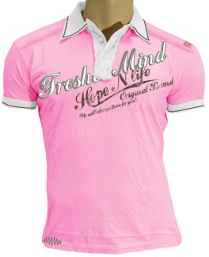
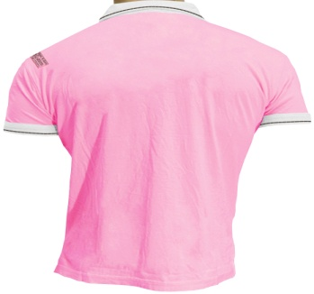

Comments:

- Make exactly as your sample except for following details to rectify:
- Don’t iron the collar in order not crush it?
- Make normal sew on armhole not raw edge.
- Be careful to buttons on the opening collar, they are not straight on the middle tape.
- Cancel the front print & the back bottom print.
- Add this badge, put it on front & back shoulder at 2cm from the left shoulder seam & 1cm from the armhole, and don’t forget the silver nails 1cm diameter on this badge.

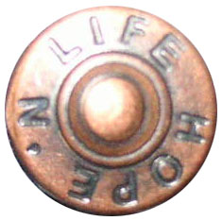


- Put the back print on front. Measures I gave you wasn’t respected so make it as
foresee 37x15.5cm


- Make a thicker print 37x6.4cm as you didn’t make a patch.



- The print quality you have used is not good, I need a lighter print & with exact lettering details, it’s not enough used.



- Make same used print 24x8cm than this picture

- Make same used print 15.3x3cm than this picture.


- Make same used print 16x1.8cm than this picture.


- This chain seam from the style DEMPSEY or the bottom seam from the sample JACOBSON are good, use it for the seam around the collar & the cuff.
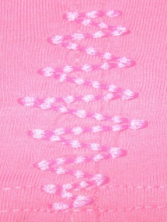

Shades colours:
BODY
WHITE optic
PINK as the sample style LYLE
BLACK reactive
TURQUOISE as the sample style ARCHIBALD

CONTRAST + BUTTONS + PATCH
GREY MELANGE as your swatch n° O
WHITE optic
WHITE optic
WHITE optic

PRINT + CHAIN SEAM
LILAC as your swatch n° B
CHOCO 18-1222 TP
PINK as the sample style LYLE
ANTHRACITE 18-0601 TP

Printed main label colours:
- Make a half moon inside the back t-shirt & put the main label print on it.
BODY / PRINTED MAIN LABEL
WHITE / LILAC
PINK / CHOCO
BLACK / PINK
TURQUOISE / ANTHRACITE

Supplier: SUNDRY TEX BANGLADESHLTD.
Mode of Delivery: Boat
Time of Delivery: End December

Style: ARCHIBALD
Composition: 95% cotton 5% elastane
Wash: Enzyme
Weight: 180/200 gsm
Shrinkage: 4% maximum
Label: HOPE ‘N LIFE
Price: 3.00 USD/PC CIF

Assortment: S M L XL

BODY / PRINT / PRINT + SEAM / SNAP BUTTONS
WHITE / LIGHT GREY / LIGHT PINK / SILVER 2 2 2 2
PINK / WHITE / TURQUOISE / SILVER 2 2 2 2
BLACK / TURQUOISE / ANIS / SILVER 1 1 1 1
GREY MELANGE / BLACK / PURPLE / SILVER 1 1 1 1
Pieces/box: 24 pieces
Total pieces: 1008 pieces
Total box: 42 boxes
We won’t accept not assorted boxes.

MEASUREMENT IN CM
SIZES | S | M | L | XL
LENGTH | 66 | 68 | 70 | 73 | CM
½ CHEST WIDTH | 46 | 48 | 50 | 54 | CM
½ BOTTOM WIDTH | 47 | 49 | 51 | 55 | CM
SHOULDER TO SHOULDER | 39 | 41 | 43 | 47 | CM
½ ARM HOLE WIDTH | 22 | 23 | 24 | 26 | CM
SLEEVE LENGTH | 15 | 16 | 17 | 19 | CM
½ OPENING ARM WIDTH | 15 | 16 | 17 | 19 | CM
NECK WIDTH | 20 | 21 | 22 | 23 | CM
NECK LENGTH | 8 | 8 | 8 | 8 | CM
NECK DEPTH | 4 | 4 | 4 | 4 | CM
HEIGHT OPENING COLLAR | 18.5 | 18.5 | 18.5 | 18.5 | CM
WIDTH OPENING COLLAR | 2.7 | 2.7 | 2.7 | 2.7 | CM

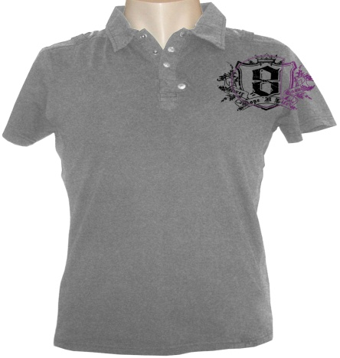
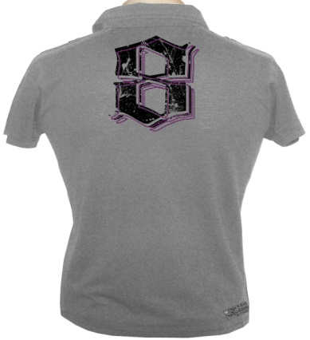

Comments:

- Make exactly as your sample except for following details to rectify:
- Don’t iron the collar in order not crush it.
- Use silver snap buttons for the collar & the shoulders.
- It misses the silver nails 1cm diameter on this badge.


- I made a typing mistake for the collar tape, it’s 2.2cm height instead of 4cm height. And be careful to the opening collar height & width + snap buttons position, the sample is not in accordance with the below picture. So please rectify further to these below measures.

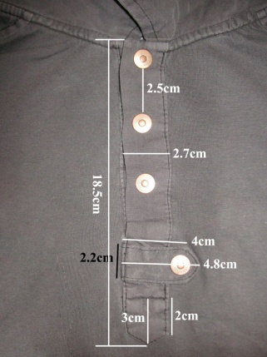
  - Be careful to the print, on the sample the print dribble & the crown on top has disappeared.



- The print 8 is upside-down on the sample; keep the same way than this picture.

- This is chain embroidery, what you do is not.



Shades colours:
BODY
WHITE optic
PINK as the sample style LYLE
BLACK reactive
GREY MELANGE as your swatch n° O

PRINT / PRINT + SEAM
LIGHT GREY 13-4105 TP
WHITE optic
TURQUOISE as the sample style ARCHIBALD
BLACK reactive

PRINT / PRINT + SEAM
LIGHT PINK 12-2903 TP
TURQUOISE as the sample style ARCHIBALD
ANIS 12-0524 TP
PURPLE 18-3520 TP

Printed main label colours:
- Make a half moon inside the back t-shirt & put the main label print on it.

BODY / PRINTED MAIN LABEL
WHITE / LIGHT GREY
PINK / WHITE
BLACK / TURQUOISE
GREY MELANGE / BLACK

Supplier: SUNDRY TEX BANGLADESHLTD.
Mode of Delivery: Boat
Time of Delivery: End December

Style: DEMPSEY
Composition: 95% cotton 5% elastane
Wash: Enzyme
Weight: 180/200 gsm
Shrinkage: 4% maximum
Label: HOPE ‘N LIFE
Price: 3.00 USD/PC CIF

Assortment: S M L XL

BODY + BOTTOM CHAIN SEAM / CONTRAST + BUTTONS + CHEST CHAIN SEAM + SLEEVE BADGE / PRINT / FOIL PRINT
WHITE / GREY MELANGE / TURQUOISE / SILVER 2 2 2 2
PINK / WHITE / ANTHRACITE / SILVER 2 2 2 2
BLACK / LILAC / PLUM / SILVER 1 1 1 1
GREY MELANGE / TURQUOISE / BLACK / SILVER 1 1 1 1

Pieces/box: 24 pieces
Total pieces: 1008 pieces
Total box: 42 boxes
We won’t accept not assorted boxes.

MEASUREMENT IN CM
SIZES | S | M | L | XL
LENGTH | 66 | 68 | 70 | 73 | CM
½ CHEST WIDTH | 46 | 48 | 50 | 54 | CM
½ BOTTOM WIDTH | 47 | 49 | 51 | 55 | CM
SHOULDER TO SHOULDER | 39 | 41 | 43 | 47 | CM
½ ARM HOLE WIDTH | 22 | 23 | 24 | 26 | CM
SLEEVE LENGTH | 15 | 16 | 17 | 19 | CM
½ OPENING ARM WIDTH | 15 | 16 | 17 | 19 | CM
NECK WIDTH | 20 | 21 | 22 | 23 | CM
NECK LENGTH | 8 | 8 | 8 | 8 | CM
NECK DEPTH | 4 | 4 | 4 | 4 | CM
HEIGHT OPENING COLLAR | 18 | 18 | 18 | 18 | CM
WIDTH OPENING COLLAR | 2 | 2 | 2 | 2 | CM

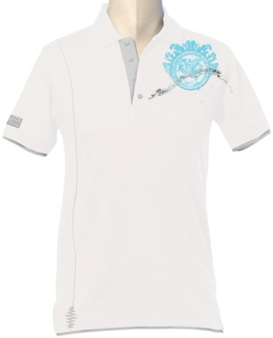
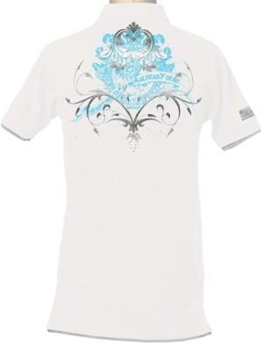

- Be careful to the print, on the sample the print dribble & you cut it because it misses a part of this print.

Comments:
- Make exactly as your sample except for following details to rectify:
- Don’t iron the collar in order not crush it.
- Make a collar in jersey doubled not in rib like the style CURTIS.
- The buttons have to be in the same colour than the contrast.
- Use silver snap buttons for the collar & the shoulders.
- It misses the silver nails 1cm diameter on this badge. The background has to be in the same colour than the contrast



- The print on back dribble on the t-shirt so make it lighter & we have to see it better, it’s not enough used.
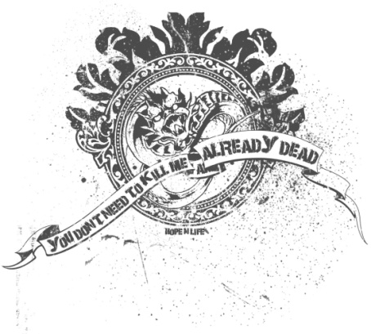
Shades colours:
BODY + BOTTOM CHAIN SEAM
WHITE optic
PINK as the sample style LYLE
BLACK reactive
GREY MELANGE as your swatch n° O

CONTRAST + BUTTONS + CHEST CHAIN SEAM + SLEEVE BADGE
GREY MELANGE as your swatch n° O
WHITE optic
LILAC as your swatch n° B
TURQUOISE as the sample style ARCHIBALD

PRINT
TURQUOISE as the sample style ARCHIBALD
ANTHRACITE 18-0601 TP
PLUM as your swatch n° F
BLACK reactive

Printed main label colours:
- Make a half moon inside the back t-shirt & put the main label print on it.

BODY / PRINTED MAIN LABEL
WHITE / TURQUOISE
PINK / ANTHRACITE
BLACK / PLUM
GREY MELANGE / BLACK

Supplier: SUNDRY TEX BANGLADESHLTD.
Mode of Delivery: Boat
Time of Delivery: End December

Style: JOHANN
Composition: 95% cotton 5% elastane
Wash: Enzyme
Weight: 180/200 gsm
Shrinkage: 4% maximum
Label: HOPE ‘N LIFE
Price: 3.00 USD/PC CIF

Assortment: S M L XL XXL

BODY / CONTRAST + BUTTONS + EMBROIDERY + PRINT + BADGES / FOIL PRINT
WHITE / PINK / SILVER 1 2 2 1 1
PINK / TURQUOISE / SILVER 1 2 2 1 1
BLACK / GREY MELANGE + GREY / SILVER 1 1 1 1 1
LILAC / WHITE / SILVER 1 1 1 1 1
Pieces/box: 24 pieces
Total pieces: 1008 pieces
Total box: 42 boxes
We won’t accept not assorted boxes.

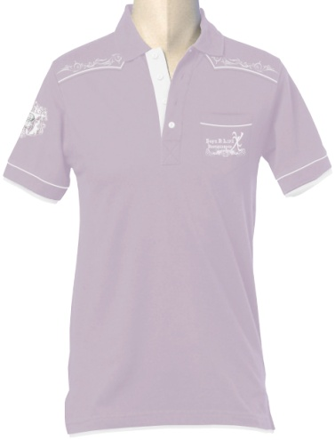
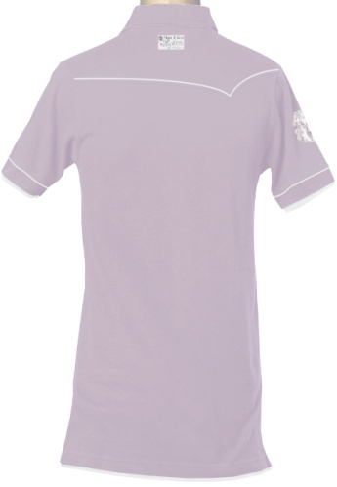

Comments:
- Make exactly as your sample except for following details to rectify:
- Don’t iron the collar in order not crush it.
- Make a collar in jersey doubled not in rib like the style CURTIS.
- Be careful to buttons on the opening collar, they are not straight on the middle tape.
- Piping only 0.2cm width.
- It misses the silver nails 1cm diameter on this badge. Lettering print in silver foil.

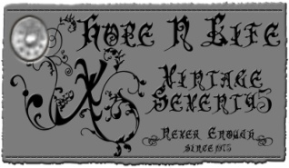

- It misses the pocket on chest



- The badge is good, make the letter B in silver foil.


Shades colours:
BODY
WHITE optic
PINK as the sample style LYLE
BLACK reactive
LILAC as your swatch n° B

CONTRAST + BUTTONS + EMBROIDERY + PRINT + BADGES
PINK as the sample style LYLE
TURQUOISE as the sample style ARCHIBALD

Comments:
- Make exactly as your sample except for following details to rectify:
- Same t-shirt base than the style LYLE.
- Don’t iron the collar in order not crush it.
- Make a collar in jersey doubled not in rib like the style CURTIS.
- Be careful to buttons on the opening collar, they are not straight on the middle tape.
- It misses this badge, put it on the back at 4cm from the bottom & 3cm from the right side body, and don’t forget the silver nails 1cm diameter on this badge.

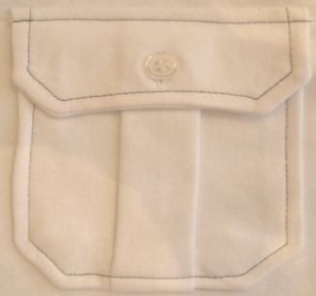
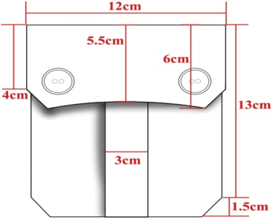

- The pocket measures are not good, I need these measures not more. Cancel the contrast chain seam & the logo printed. Make as the 2nd below picture with one button on the middle & same folded piece on the middle pocket but with ton to ton thin seam.

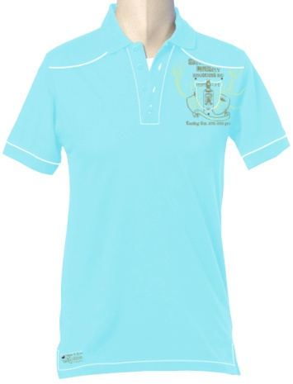
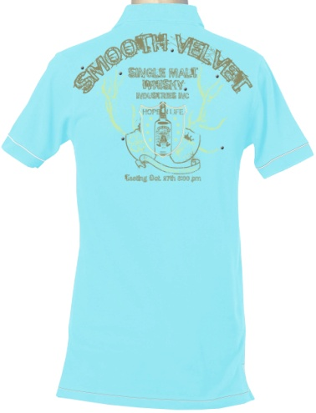

Comments:
- Make exactly as your sample except for following details to rectify:
- Don’t iron the collar in order not crush it?
- You forgot all the silver nails on front & back prints.
- It misses the silver nails 1cm diameter on this badge.

- We would like to add a piece fabric in contrast colour sewed on the opening collar tape as below pictures.
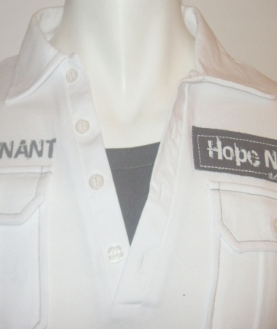
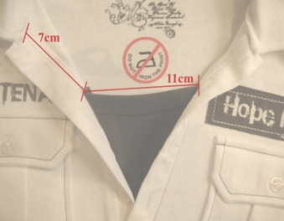
- Use the chain seam from the style DEMPSEY for this badge.

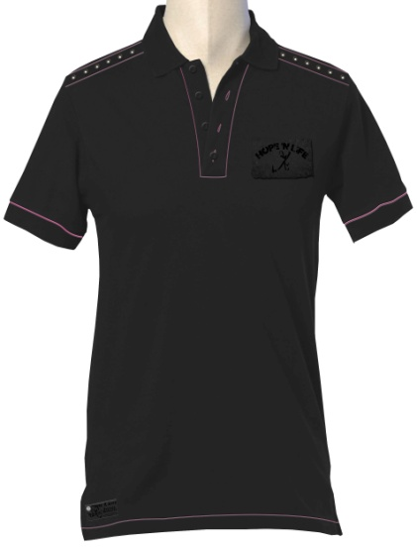
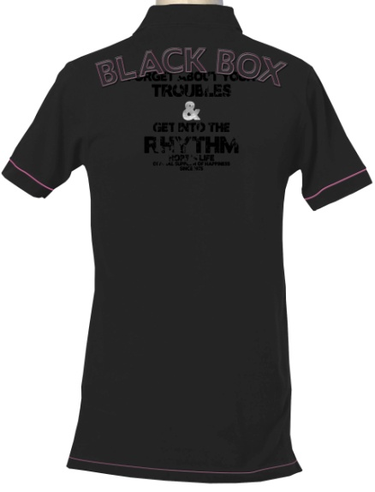


Comments:
- Make exactly as your sample except for following details to rectify:
- Don’t iron the collar in order not crush it.
- Make a collar in jersey doubled not in rib like the style CURTIS.
- Be careful to buttons on the opening collar, they are not straight on the middle tape.
- It misses the silver nails 1cm diameter on this badge. Lettering print in silver foil.

- This is the front badge you made
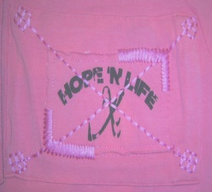
- This is the front badge I want now:
Cancel the big badge below
Cancel the embroidery on sides of the small badge
Keep only chain seam in cross without the ends in square shape
Bright print ton to ton 3 shades darker than the body

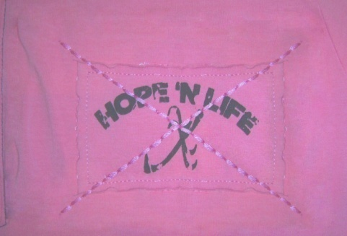

- You forgot the nails 1cm diameter on shoulders between the chain seams. Make same chain seam than the style DEMPSEY.


- Back print: patch same colour than the body
Seam patch in contrast colour
Bright print 3 shades darker than the body
Letter & silver foil print



Shades colours:
BODY
WHITE optic
PINK as the sample style LYLE
BLACK reactive
LILAC as your swatch n° B

PRINT (3 SHADES DARKER)
WHITE 3 shades darker than the body
PINK 3 shades darker than the body
BLACK 3 shades darker than the body
LILAC 3 shades darker than the body

SEAM
PLUM as your swatch n° F
KHAKI as your swatch n° M
PINK as the sample style LYLE
ANTHRACITE 18-0601 TP

Printed main label colours:
- Make a half moon inside the back t-shirt & put the main label print on it.

BODY / PRINTED MAIN LABEL
WHITE / SILVER
PINK / SILVER
BLACK / SILVER
LILAC / SILVER

Supplier: SUNDRY TEX BANGLADESHLTD.
Mode of Delivery: Boat
Time of Delivery: End December
Style: RANDAL
Composition: 95% cotton 5% elastane
Wash: Enzyme
Weight: 180/200 gsm
Shrinkage: 4% maximum
Label: HOPE ‘N LIFE
Price: 3.00 USD/PC CIF

Assortment: S M L XL XXL
BODY + POCKET / CONTRAST + BUTTONS + BADGES / SEAM + PRINT
WHITE / LILAC / CHOCO 1 2 2 1 1
PINK / TURQUOISE / WHITE 1 2 2 1 1
BLACK / TURQUOISE / GREY 1 1 1 1 1
GREY MELANGE / PINK / ANTHRACITE 1 1 1 1 1
Pieces/box: 24 pieces
Total pieces: 1008 pieces
Total box: 42 boxes
We won’t accept not assorted boxes.

MEASUREMENT IN CM
SIZES | S | M | L | XL | XXL
LENGTH | 66 | 68 | 70 | 73 | 75 | CM
½ CHEST WIDTH | 46 | 48 | 50 | 54 | 56 | CM
½ BOTTOM WIDTH | 47 | 49 | 51 | 55 | 57 | CM
SHOULDER TO SHOULDER | 39 | 41 | 43 | 47 | 49 | CM
½ ARM HOLE WIDTH | 22 | 23 | 24 | 26 | 27 | CM
SLEEVE LENGTH | 15 | 16 | 17 | 19 | 20 | CM
½ OPENING ARM WIDTH | 15 | 16 | 17 | 19 | 20 | CM
NECK WIDTH | 20 | 21 | 22 | 23 | 24 | CM
NECK LENGTH | 8 | 8 | 8 | 8 | 8 | CM
NECK DEPTH | 4 | 4 | 4 | 4 | 4 | CM
HEIGHT OPENING COLLAR | 17 | 17 | 17 | 17 | 17 | CM
WIDTH OPENING COLLAR | 2 | 2 | 2 | 2 | 2 | CM
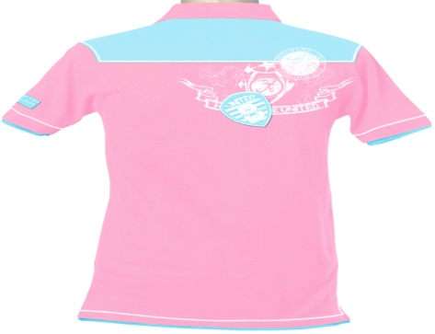
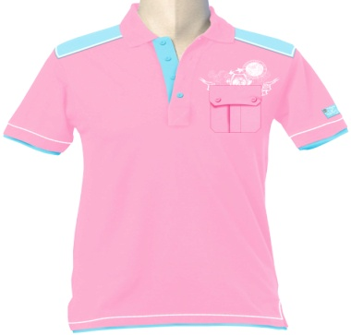

Comments:
- Make exactly as your sample except for following details to rectify:
- Don’t iron the collar in order not crush it.
- Make a collar in jersey doubled not in rib like the style CURTIS.
- It misses the silver nails 1cm diameter on this badge.

5.6.5 Dyeing program:
After receiving the order of program merchandiser at first prepare the color and size ratio of the program and after that they prepare the knitting and ratio program. There some law for fabric consumption that is important to identify the required quantity of fabrics.
LAW:
BODY LENGTH+SLEEVE LENGTH X CHEST X 2PART X .GSM % 1000= FABRIC FOR 1 PCS+ 15% FABRIC
Here I present a copy of dyeing program

 | FABRIC TYPE : 100% COTTON FRANC TERRY 400 GSM WITH OUT BRUSH
 | & SINGLE JERSEY 240 GSM
S/L
1 | STYLE | FABRIC TYPE | Colour | GSM | DIA/CM | QTY/KG | 1X1LYCRA
2 | Iron Cap | 100%cotton terry fleece | White 11-0601tpx | 400 | 58 | 30 kg | With Flat knit
3 | Iron | 100% cotton S/Jersey | White 11-0601tpx | 240 | 58 | 15 kg | 02 kg
4 | Istycap 08 | 100% cotton terry fleece | Black 19-0303 tpx | 400 | 58 | 30 kg | with tipping
5 | Dry 08 | 100% coton S/Jersey | Black 19-0303 tpx | 240 | 58 | 15 kg | 02 kg
6 | Istituzionale 08 | 100% cotton S/Jersey | Black 19-0303 tpx | 240 | 58 | 15 kg | 03 kg
7 | Arvid | 100% cotton terry fleece | Black 19-0303 tpx | 400 | 58 | 25 kg | 04 kg
8 | Simplex 08 | 100% cotton S/Jersey | Black 19-0303 tpx | 240 | 58 | 15 kg | 04 kg
 |  |  |  |  | Merchandiser
 |  |  |  |  | G.M knitting Ltd
After knitting program we send 1x1m fabric to the buyer for the approval of color and shade of the fabric. If the fabric matched with the requirement than we use the fabric for production purpose.

5.6.6 Cutting:
After the fabric arrive in the factory then we send the fabric along with the measurement sheet to the cutting section. In cutting section cutting master cut the fabric according the measurement & sends it to printing section or embroidery section if necessary.
5.6.7 Printing:
In printing section print master at first develop the design of the print and make frame according the print. Before printing print master send a printing sample to the merchandiser. Merchandiser mach the print with the requirement and color Pantone if matched than he give permission to print the fabric. Here I present a copy of printing requirement.

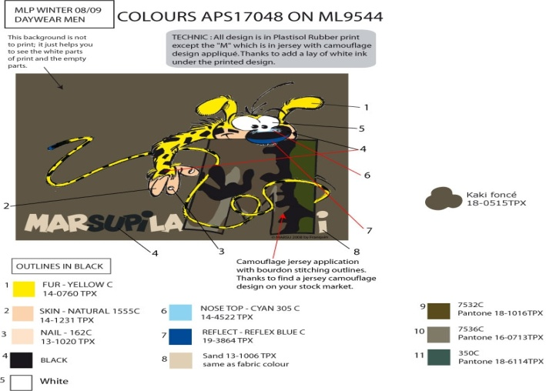
5.6.8 Embroidery:
When printing finished then print master send the fabric to th embroidery section if necessary. In embroidery section embroidery designer make the design of embroidery and set stitches for that design here I present some copy of embroidery design.
Embroidery patch

Embroidery design
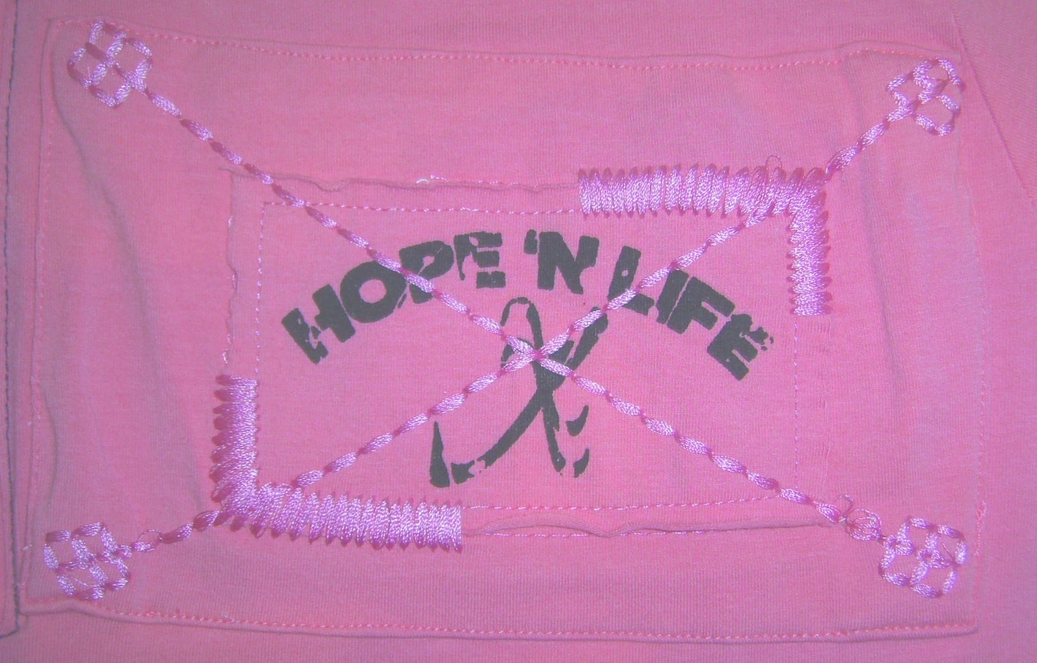
5.6.9 Sewing Thread:
Thread may be contrast or in same color it must be matched with requirement. Store manages the sewing thread and the merchandiser approves the color and quality.
5.6.10 Sewing:
After embroidery of fabric in charge of the section send the Fabric to the sewing section in sewing section we send some of the accessories which need to be attached with the garment. Sewing section in charge and production manager observes the sewing process and keep them update with comments from the measurement. (Here by comments I mean the correction of order sheet and approval from buyers
5.6.11 Finishing:
After sewing the RMG goes to finishing sector for attachment of other accessories, folding, packing, here we aid them with folding and packing approval from buyers. Here I present some list of accessories

5.7 PRODUCTION ACCESSORIES
- Hang tag: 6x10cm
Paper thickness 500gsm
Background white colour
Attached with orchid satin lace & a silver pin

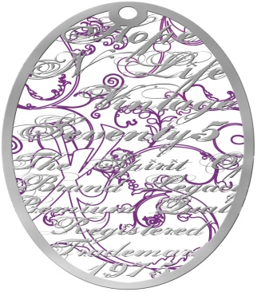

FRONT SIDE

Background draw orchid 17-3628 TP

Outline + lettering in bright silver foil

After attachment of all accessories and packing the finishing section pack the garments in required carton in proper ratio and put the level of buyer address and the factory address on the carton. After Buying Quality Controller come in inspection to if the product meet their requirement. Then they send theses carton in our store house before shipment date

5.7.1 Cargo booking:
Cargo booking is another impotent responsibility of merchandiser there is a law of cargo booking.
After booking of cargo we send RMG to port and there Buyer runs an inspection where the product is ok or not if products ok then the commercial merchandiser take the shipment document after customer clearance and submit the document to exporter bank and receive the LC money

Assessment of Internship

Chapter 6

6.1 Learning through my tasks (Job Responsibility):

As Business Promotional Officer I face the following responsibility:

- Communicate with new and existing buyers to expand the business even farther in national and in international areana.
- From an inquiry, all information is gathered (measurement, Which fabric, color, what type of print, quantity, packaging, FOB or CIF etc) to provide a good price.
- If price is o.k.; Then making & sending of sample to buyer for approval of style, print (if any), GSM, fabric, measurement & if there is any rectification to be made, I must done it accordingly.
- After approval + fixing a delivery date, order is placed to the nominated factory. Fabric conjunction information
- Forwarding master sample + accessories + PO to factory.
- With the help of QC, whole production status is being send to buyer through mail + phone.
-Daily production discussion with QC + keeping in touch with factory production in charge.
-Prepare weekly reports, monthly reports, master summary; incoming accessories inventory report to be sent to buyer for a better follow up of production in here + for a good understanding & correspondence system.
-Always being a source of information for a prompt reply for buyer queries through phone or by mail. During buyer visit in Bangladesh, all discussion, claims (if any) queries concerning production inspection or any production problem should be solved here itself.
- Maintain liaison with the shipping Lines & forwarder.
-For delivery, vessel is booked from the nominated shipping line.
-Preparing I/C based on inspected garments for shipment. Scrutinizing Export & Import documents. After delivery, buyer is provided the original documents through courier.

6.2Comparison between textual work in school and in internship:

The text books that I have learn trough out my education life had helped me a lot in the practical work life of internship. This has created a base for me, depending on which I have worked and learned various job related problems and managed to find solutions for those problems.

- When I worked in accounting department the accounting related knowledge that I have learn in various courses has helped me such as Financial Accounting, Accounting Theory, Advanced Accounting, Auditing etc.
- When I worked in production department and worked on production of various products the knowledge I gained from Cost Accounting, Strategic Management Accounting helped me.
- When I worked as Business promotional officer my main job responsibility was to communicate with new and existing buyers from both inside and outside national boundaries.
- To understand the nature and complication of government regulations on the business and the law by which it is controlled the course Business Law helped me a lot.

Finding & Analysis
Chapter 7

Findings

7.1.1 Readymade garments market of Bangladesh
Bangladesh now exports garments to about 25 countries around the world, the USA is the single largest importer of its RMG products, amounting to 43 percent of total garment exports. Bangladesh is the sixth-largest supplier of apparel in the US market. Considering the European Union as a single market, the USA then becomes the second largest. Over the past few years, Bangladesh’s RMG exports to the EU have expanded rapidly, with the EU currently importing about 52 percent of Bangladesh’s total garment products. The inter-temporal evidence of the narrow market base of Bangladesh RMG exports in the 1990s is provided by the concentration of exports to the US and EU market. While the export share to the USA has witnessed an annual average rate of decline of 1.5 percentage points, however, the corresponding share to the EU has experienced an annual growth rate of 1.6 percentage points. Thus, the increment in the EU share has simply replaced the declining share in the USA market, which suggests that, instead of diversification, Bangladesh’s export market has remained concentrated over the past decade. The combined market share of the USA and the EU has thus increased from 95.5 percent to 95.6 percent between 1991-92 and 1998-99. Bangladesh so far has been unable to gain access to ASEAN or Indian markets, although it imports a huge quantity of fabrics and yarn from these countries. Similarly, although it imports about 95 percent of its total garment machinery from Japan, its market share of apparel export to Japan is a mere 0.1 percent.16 Bangladesh’s inability to gain access to these large markets in turn suggests that the country has yet to establish its claims, as advocated by the WTO, to the principles of reciprocity and market access. The North American quota system and GSP facilities afforded by the EU have contributed to the undiversified RMG export market in Bangladesh; in that entrepreneurs have focused on taking advantage of these special opportunities. Thus, the entire national clothing export business will be endangered by the year 2008, when the MFA is eliminated and GSP schemes may cease to operate. The country must thus make immediate and vigorous attempts to diversify its export markets.

7.1.2Why buyers come here:
The principal static comparative advantage that Bangladesh enjoys over potential competitors is
its cheap labour force. The wage level in the RMG industry is low both for males and females,
compared with workers in a similar category in other sectors. For instance, a comparison on the
basis of wage data provided by Bangladesh Bureau of Statistics8 shows that the average monthly
wage of skilled RMG factory workers is 1.4 to 2 times lower than that of similar factory workers
in the textile and other sectors.

Table : Labor costs in selected countries (in US $/hour)
Countries 1991 1993
Bangladesh NA 0.16
India 0.25 0.27
Pakistan 0.24 0.27
Sri Lanka 0.39 0.35
China 0.24 0.25
Indonesia 0.18 0.28
Thailand 0.59 0.71
Italy 13.5 NA
UK 7.99 NA
US 6.77 NA

Sources: Moore 1997, Table 2; Ramaswamy and Gereffi 1998, 123 as quoted in M. Vijayabaskar,
“Productivity, Competitiveness and Job Quality in Garment Industry in India,” a discussion
paper prepared for the Sub-regional Meeting on Productivity, Competitiveness and Job Quality
in Garment Industry in South Asia, Kathmandu 25-26 September 2001.

Table : Unit price realization of selected garment exports (in US $/piece)

SITC Product Bangladesh India Pakistan Sri Lanka China Thailand
description

Men’s woven wear
8414 Trousers 4.21 3.91 3.67 6.44 5.74 6.35
84151 Cotton shirts 4.82 5.59 3.74 6.15 4.02 7.51
84159 Shirts (others) 4.17 6.16 2.89 5.72 5.28 4.85
Men’s knit wear
84324 Trousers 3.17 2.80 3.21 3.90 2.04 3.29
84371 Cotton shirts 2.97 4.53 4.06 7.44 5.49 7.48
84379 Shirts (others) 3.45 4.62 3.81 6.08 8.14 3.34
Women’s woven wear
8425 Trousers, breeches
3.47 4.77 4.04 5.39 7.53 6.05
8426 Blouses, shirt-blouse
4.55 4.22 3.67 5.87 5.85 7.13
8427 Skirts 3.28 3.94 3.14 5.69 6.77 7.04
Women’s knit wear
8425 Skirts 0.00 2.92 5.68 4.85 3.13 4.41
8426 Trousers, breeches
2.59 3.74 2.90 4.82 6.78 4.54

Source: “Globalization and the Apparel Industry of Pakistan,” a discussion paper prepared by Asir Manjur for SMEDA
(Small and Medium enterprise Development Authority) for the Sub-regional Meeting on Productivity, Competitiveness and
Job Quality in Garment Industry in South Asia, Katmandu 25-26 September 2001.

7.1.3 Merchandising in garments factory in Bangladesh
There is two type of merchandising in Garment Company:
- Commercial
- Official

Commercial
They manage the export related document and ensure that the buyer LC is accurate. After production they also manage the document of shipment.

Official
They manage the production process and see whether the product is produced regarding the requirement of the buyer and delivery the produced good within the shipment date. I am an official business promotional officer of Shelltex International.

7.1.4 Problems and Barriers of RMG merchandising - supplier Industry of Bangladesh:
The problems and barriers that are hindering the growth of export oriented Buying House industry are classified under the following major functional areas:
- Human resource development
- Infrastructure.
- Marketing

Human Resource Problems of Buying House:
Unskilled Employee:
Most of the employees are not enough skilled to perform their job. In the there are some post such as quality controller, design maker, merchandiser that require technical skill to be performed but as the employees do not have any institutional training they lack such technical skill. On1y way they can learn is through on the job training. Convincing foreign buyers and establishing long term relationship with them is one of the most important tasks. To perform this job employees need proper language and communication skill. 13ut in our country as the education medium is Bengali and there is less opportunity to learn other foreign languages therefore employees lack communication skill to convince and establish long-term relationship with foreign Buyer.

No training Institution:
There are no such courses designed in any of the public or private educational institutions of our country which can give employees training specifically to perform their job. As a result people usually coming to this field are from different background. They are usually unskilled and inexperienced. Fleeting tendency of Employees has a very high tendency to switch their jobs. This may be because of their poor salary structure and no service benefit. As a result whenever they find any better offer they try to switch they exist one.

Lack of career development:
Employees involved with this industry have fewer chances for career development because of small structure of the industry. As a result less people are interested to come to this field.

Dictatorship of employer:
Employers are usually autocratic with their subordinate employees as a result of which employees are often demotivated to work. They feline they are always under pressure.

No Trade Union:
As the employees of this industry do not have any union to support their claims, the employers always neglect their demands.

Infrastructural problem:
No vision:
RMG industry is in its growth industry but this growth is a result of so caned blessing of quota system but not the achievement of their efficiency. Even the constituents of this industry buying houses have never been shown any vision of prospect, both in their attitude and actions. This is the warming of undesired maturity for this industry. Even though they are aware about the guillotine of year 2008, but it seems that they are ready to dye out.

Insufficient and Poor Backward linkage:
Threat, button, cartoon, backboard these are treated as accessory of garments product. Industries of these products are treated as backward linkage industry of garment exports. Most of the times supply these accessories to garment manufacturers. But due to insufficient number of factories, they face diff1culties to supply these accessories on time. The quality of these accessory most of the time do not matches, as it demanded due to their inefficiency and ineffectiveness in production. Majority people involved in this sector are illiterate. As a result of which they are not concerned of the consequence of the late delivery as well as poor quality.

Rules and Regulations:
There are also no written rules and regulation for operating this industry. As a result, people involved in this industry operating their business according to their willingness.

Marketing problem of Buying House Industry:
Short Shipment:
This means delivering goods with inappropriate quantity. This is a very common problem for all working in this sector. Garment manufacturers of our country are the victim of many natural contingences including strike, hartal or political instability: So a result they often fail to finish their on time which result short shipment. Due to this short shipment respective buyer become dissatisfied with the Buying House and as a result all parties involved suffer loss.

Poor product quality of supplier:
Another important problem is the poor quality of its supplier (garment manufacturer). Desired quality is the first condition of the foreign. Garment manufacturers due to their unskilled worker cannot produce the product with expected quality. As a result buyers reject the product.

Improper document:
At the time of releasing goods from the port, a buyer needs to show
Some documents such as to prove his authentication. These documents are sending to buyer from buying house or the respective supplier. However, sometimes due to lack of experience or knowledge they sometimes fail to send appropriate documents for which the buyer cannot discharge his goods from the port. As a result the buyer becomes dissatisfied.

Document Delay:
Besides improper document, sometimes the supplier or buying house fails to send documents on time. Without proper document the foreign buyer cannot discharge goods from the ship. This problem is very irritating to buyer as the product has arrived at the port but due to unavailability of proper document he is unable to discharge goods from the port. For this reason sometimes the suppliers has to break relationship with its buyers.

Commission Recover Problem:
This problem mainly occurs due to unethical practices of few people. Normally, the amount of the commission is specifically written at the back of letter of credit. So, nobody can deny paying the house. However sometimes due to ill intention of the people of bank of the merchandiser faces difficulties to receive its commission.

Analysis

7.2.1.1 Ratio Analysis

Profitability ratio (2009)

- ROA=return on assets= NI /ATA

= net income/ average total assets

=tk.629,767.50/ tk.6,604557.19

=0.9535%

- PM=profit margin=NI /OI

= net income/ operating income

=tk. 629,767.50/ tk.53,869,537.50

= 0.01169%

Efficiency ratios

3. OEA=operating expense to assets=OE/ATA

=operating expenses/ average total assets

=tk.5,253,925/tk. 6,604,557.19

= 0.7954%
4. OER=operating expenses to revenue

=OE/OI=operating expenses/ operating income (revenue)

=tk. 5,253925/tk. 53,869,537.50

=0.0975%

Liquidity ratio = Current Assets / current Liabilities

=tk.6,144,724.19/tk. 4,450289

=1.38%

Profitability ratios (2008)

- ROA=return on assets= NI /ATA

= net income/ average total assets

=tk.524,500.69/ tk. 2,905200.69

= 0.1808%

- PM=profit margin=NI /OI

= net income/ operating income

=tk. 524,500.69/ tk.33,869,537.50

=0.0154%
Efficiency ratio
3. OEA=operating expense to assets=OE/ATA

=operating expenses/ average total assets

=tk.3,380,820 /tk. 2,905200.69

=1.1637 %
4. OER=operating expenses to revenue
=OE/OI=operating expenses/ operating income (revenue)
=tk. 3,380,820 /tk. 33,869,537.50
=0.0998%
Liquidity ratio = Current Assets / current Liabilities
=tk.2,454,300.69/tk. 1,130,700
=2.17%

Comparison (2008 -2009)

Ratios | year  2008 | Year  2009
ROA(Return  on assets) | 0.9535% | 0.1808%
PM (Profit  Margin) | 0.01169% | 0.0154%
OEA(operating expense to assets) | 0.7954% | 1.1637 %
OER(operating expenses to revenue ) | 0.0975% | 0.0998%
L,R (Liquidity ratio) | 1.38% | 2.17%

Graphical Representation of Ratios (2008 -2009)

Here,

ROA=Return on assets
PM= Profit Margin
OEA=operating expense to assets
OER=operating expenses to revenue
L.R=Liquidity ratio
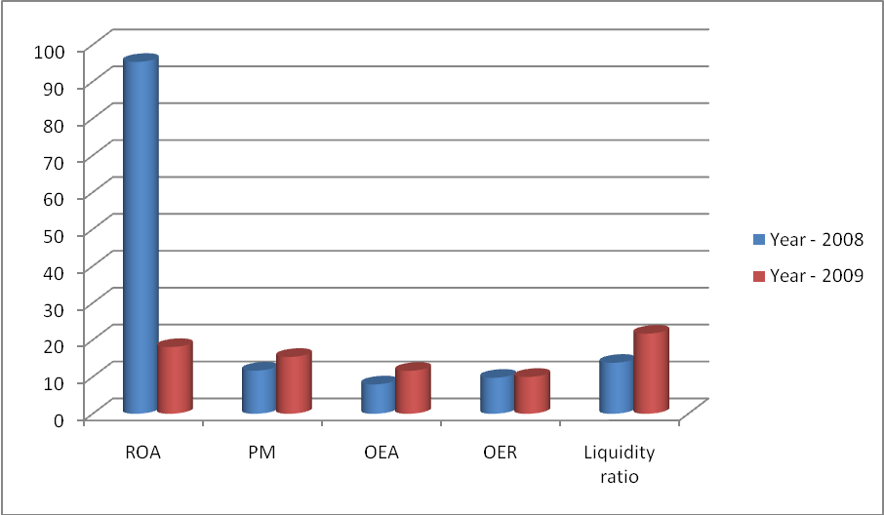

Production Department

Although Shelltex International is a merchandising concern but it also have its own production about few of its products, such as Label, Printed label, Hangtag, Care label. The Sales department handles the products that other manufacturers produce on behalf of us according to our customer specification.

Below I have analyzed data of last five years of production department.

Units produced

Products | Year-2005 | Year-2006 | Year-2007 | Year-2008 | Year-2009
Label | 100,000 | 150,000 | 200,000 | 230,000 | 300,000
Printed label | 110,000 | 150,000 | 200,000 | 250,000 | 280,000
Hangtag | 90,000 | 120,000 | 150,000 | 200,000 | 300,000
Care label | 100,000 | 150,000 | 180,000 | 220,000 | 310,000

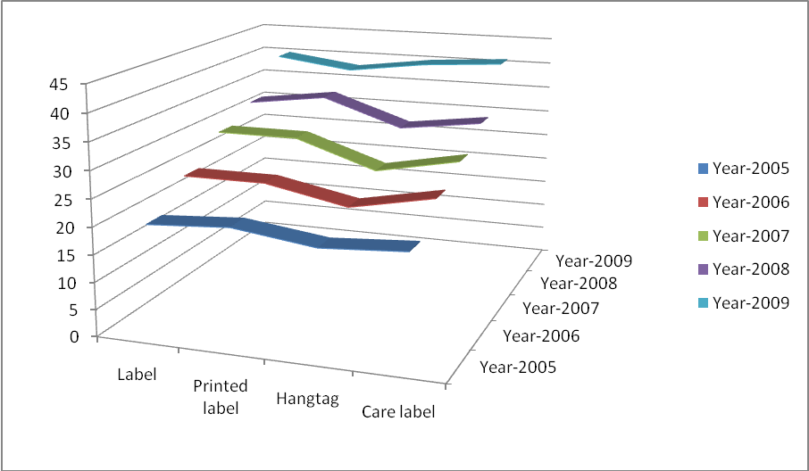

Expenses

Products | Year-2005 | Year-2006 | Year-2007 | Year-2008 | Year-2009
Label | Tk. 50,000 | Tk. 80,000 | Tk. 100,000 | Tk. 110,000 | Tk. 180,000
Printed label | Tk. 70,000 | Tk. 80,000 | Tk. 98,000 | Tk. 100,000 | Tk. 120,000
Hangtag | Tk. 30,000 | Tk. 50,000 | Tk. 100,000 | Tk. 120,000 | Tk. 200,000
Care label | Tk. 30,000 | Tk. 95,000 | Tk. 100,000 | Tk. 130,000 | Tk. 210,000

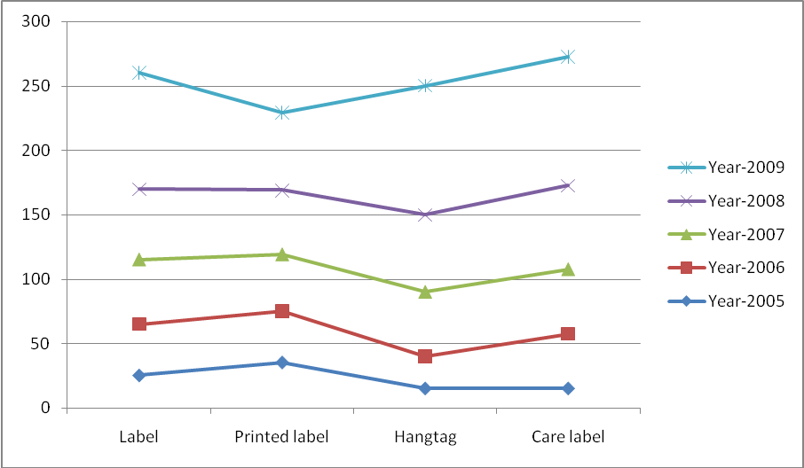

Revenue

Products | Year-2005 | Year-2006 | Year-2007 | Year-2008 | Year-2009
Label | Tk. 200,000 | Tk. 250,000 | Tk. 300,000 | Tk. 430,000 | Tk. 600,000
Printed label | Tk. 210,000 | Tk. 250,000 | Tk. 400,000 | Tk. 450,000 | Tk. 480,000
Hangtag | Tk. 150,000 | Tk. 220,000 | Tk. 250,000 | Tk. 400,000 | Tk. 600,000
Care label | Tk. 200,000 | Tk. 250,000 | Tk. 280,000 | Tk. 420,000 | Tk. 610,000

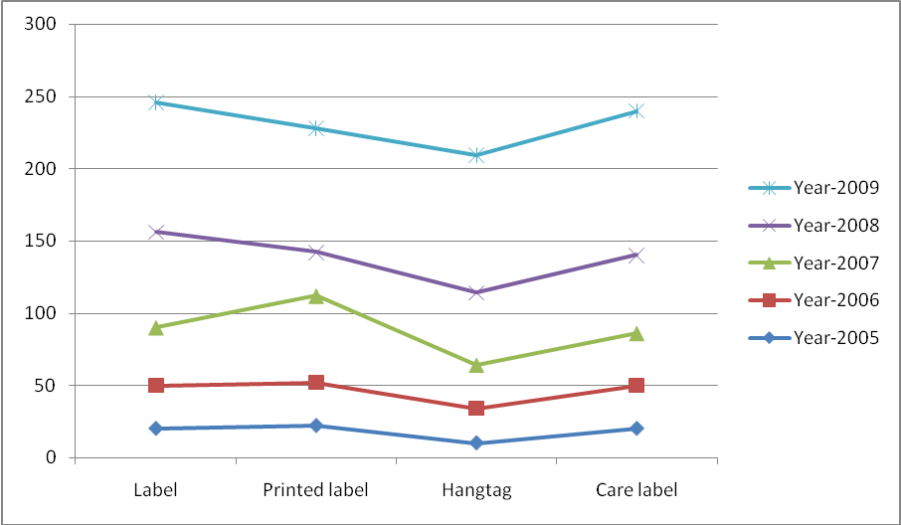
7.2.2 The BCG matrix

The BCG matrix (Boston Consulting Group analysis) is a chart that had been created by Bruce Henderson for the Boston Consulting Group in 1968 to help corporations with analyzing their business units or product lines. This helps the company allocate resources and is used as an analytical tool in brand marketing, product management, strategic management, and portfolio analysis.

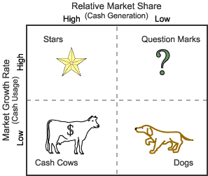

The BCG matrix is used to rank the business units (or products) on the basis of their relative market shares and growth rates.

Cash cows
Cash cows are units with high market share in a slow-growing industry. These units typically generate cash in excess of the amount of cash needed to maintain the business. They are regarded as staid and boring, in a "mature" market, and every corporation would be thrilled to own as many as possible. They are to be "milked" continuously with as little investment as possible, since such investment would be wasted in an industry with low growth.

Dogs
Dogs, or more charitably called pets, are units with low market share in a mature, slow-growing industry. These units typically "break even", generating barely enough cash to maintain the business's market share. Though owning a break-even unit provides the social benefit of providing jobs and possible synergies that assist other business units, from an accounting point of view such a unit is worthless, not generating cash for the company. They depress a profitable company's return on assets ratio, used by many investors to judge how well a company is being managed. Dogs, it is thought, should be sold off.
Question marks
Question marks (also known as problem child) are growing rapidly and thus consume large amounts of cash, but because they have low market shares they do not generate much cash. The result is a large net cash consumption. A question mark has the potential to gain market share and become a star, and eventually a cash cow when the market growth slows. If the question mark does not succeed in becoming the market leader, then after perhaps years of cash consumption it will degenerate into a dog when the market growth declines. Question marks must be analyzed carefully in order to determine whether they are worth the investment required to grow market share.

Stars
Stars are units with a high market share in a fast-growing industry. The hope is that stars become the next cash cows. Sustaining the business unit's market leadership may require extra cash, but this is worthwhile if that's what it takes for the unit to remain a leader. When growth slows, stars become cash cows if they have been able to maintain their category leadership, or they move from brief stardom to dogdom.

Merchandising business in our country is in stars category compare to most of the countries of the world and it has huge possibility to be the cash cow. The company I have worked in Shelltex International will also fall in stars compare to other merchandising companies of our country.

7.2.3 SWOT Analysis

SWOT Analysis of Merchandising Business

SWOT Analysis is a strategic planning method used to evaluate the Strengths, Weaknesses, Opportunities, and Threats involved in a project or in a business venture. It involves specifying the objective of the business venture or project and identifying the internal and external factors that are favorable and unfavorable.

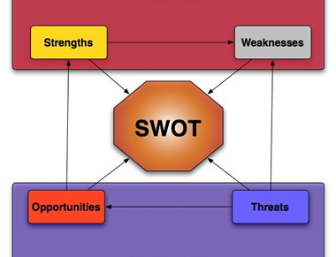

Strengths: attributes of the person or company that are helpful to achieving the objective.
Weaknesses: attributes of the person or company that are harmful to achieving the objective.
Opportunities: external conditions that are helpful to achieving the objective.
Threats: external conditions which could do damage to the objective.

The Strengths, Weaknesses, Opportunities and Threats (SWOT) analysis described in the following tables:-

Table: SWOT Analysis Merchendising Business in Bnagladesh

S  T  R  E  N  G  T  H  S | - Sound profitability and growth with good capital generation.  - Large client base.  - Experienced and efficient management team and human resource.  - Quaity products and services.  - Energy at low price .  - Rreputation and goodwill of bangladeshi business personal.  - Easily accessible infrastructure like sea road, railroad, river and air communication.  - FDI is legally permitted.  - Moderately open Economy, particularly in the Export Promotion Zones.  - Bangladesh is a member of Multilateral Investment Guarantee Agency (MIGA) under which protection and safety measures are available.  - Investment assured under Foreign Private Investment (Promotion and Protection) Act, 1980 which secures all foreign investments in Bangladesh  - Excellent Tele-communications network of E-mail, Internet, Fax, ISD, NWD & Cellular services  - Weakness of currency against dollar and the condition will persist to help exporters.  - Convenience of duty free custom bonded w/house.  - Readiness of new units to enhance systems and create infrastructure accordant with product growth and fast reactions to circumstances.
W  E  A  K  N  E  S  S  E  S | - Market share is not at satisfactory level.  - Lack of marketing tactics  - The country is deficient in creativity  - Absence of easily on-hand middle management  - A small number of manufacturing methods  - Low acquiescence: there is an international pressure group to compel the local producers and the government to implement social acquiescence.  - The machinery required to assess add on a garment or increase competence are missing in most industries.  - Lack of training organizations for workers, supervisors and managers.  - Autocratic approach of nearly all the investors.  - Fewer process units for textiles and garments.  - Incompetent ports, entry/exit complicated and loading/unloading takes much time.  - Speed money culture.  - Time-consuming custom clearance.  - Unreliable dependability regarding Delivery/Product knowledge.  - Communication gap created by incomplete knowledge of English.  - Subject to natural calamities.  - Political usability in Bangladesh.  - Frequent hortals and blockades.
O  P  P  O  R  T  U  N  I  T  I  E  S | - There are a ever expanding market worldwide.  - EU is willing to establish industry in a big way as an option to china.  - Bangladesh is included in the Least Developed Countries with which US is committed to enhance export trade.  - Skilled technicians are available thanks to various training institutes.  - Government’s policy of encouraging heavy inflow of foreign investment.  - Regulatory environment favoring private sector development.  - Increasing trend in international business.
T  H  R  E  A  T  S | - Increased competition for market share in the industry.  - The exporters have to prepare themselves to harvest the advantages offered by the opportunities.  - We have to compete with the competitors of first world countries who have access to advanced technologies.  - Market pressure for lowering product rate.  - National and global political unrest.

Table: SWOT Analysis Shelltex International
S  T  R  E  N  G  T  H  S | - Highly experienced employees.  - Good number of existing local and foreign buyers.  - Dedicated employee base.  - Have good reputation among buyers for the quality of their product.  - Have good reputation among buyers for on time delivery.  - Business friendly government.  - Strong communication to communicate with buyers.
W  E  A  K  N  E  S  S  E  S | - Small size of the company.  - Cpital of the company is not big enough compare to to the lage competitors in the market.  - No treaning facility of its own to train its employees.
O  P  P  O  R  T  U  N  I  T  I  E  S | - Highly adoptable compare to business rivals.  - Number of potential buyers are increasing specially the overseas buyers.  - BESIC and EPZ are creating new business opportunity almost in weekly basis.  - Easy bank lone opportunity.
T  H  R  E  A  T  S | - Number of new copetitors are increasing.  - Increased competition for market share.

Table: SWOT Analysis of Production Department
S  T  R  E  N  G  T  H  S | - Well trained machine operators and helpers.  - New machines.  - Good management of resources by the management team involve in production.  - Production units are located at prime location so that products are distributed in least amount of time.  - Compare to other departments the production department are most experienced.
W  E  A  K  N  E  S  S  E  S | - Limited resources.  - Machines are not uptodate.  - Not sufficent number of employees.  - All of the employeees are not well trained.
O  P  P  O  R  T  U  N  I  T  I  E  S | - This department has the have the opportunity to be the backbone of the company.  - Have the opportunity to expand as there are plans for acquiring new machine for this department.  - There will be also a small training facility for the employees of production department soon.
T  H  R  E  A  T  S | - Frequent power shortages interrupts the production.  - Using alternate power source such as generators are costly.  - All employees are not dedicated enough.  - Turnover rate in production is comparatively high then other departments.

Recommendation &
Conclusion

Chapter 8

8.0 Recommendation
- Due to low labor productivity Bangladesh is competitive, with low value and thus low-priced items, at the lower end of the RMG market. RMG production is concentrated in a relatively limited range of products such as shirts, T-shirts, trousers, and shorts. To be internationally competitive, Bangladesh needs to expand its product range and should begin producing fashion-wear and higher value-added items. Product diversification is essential to meet the challenges of the world.
- Establishment of backward linkages, especially the domestic production of yarn, can reduce the cost of production. The current gap in demand and domestic production, met through imports, is estimated to be 480 million kg for yarn, and 2,300 million meter for fabrics. The country could thus save considerable foreign exchange by increasing domestic production of yarn and fabric. Production costs would also be reduced, since the RMG manufacturers would not have to buy fabrics at international prices that are not necessarily competitive.
- RMG industry in Bangladesh is the slow rate of increase in productivity, and the gap that exists between this country and other competitors in this regard. There is also scope for capacity building in different types of skills and processes
- A considerable gap also exists in knowledge about trade and investment flows. This is understandable, given that most entrepreneur interactions are with buyers who merely specify their product needs, provide the designs, etc. The emerging global environment, however, calls for more strategic action with regard to major competitors.
- Introduction of functional English courses for managerial and supervisory staff and greater attention to on-the-job training, with appropriate incentives such as tax rebates.
- Encouragement for relocation of factories outside main urban areas, with serviced plots being made available and adequate supervision to ensure that factories are functionally designed.
- After recruitment of employee, they should provided with three to six month training to learn the technical work to perform the technical job.
- The company should provide money to its employee to develop' communication skill in particular language in order to communicate with foreign buyers.
- Instead of full autocracy or democracy, the employers of buying house should show lenient view in all aspects so that they get motivated to work.
- Employee pay structure should be consistent with the employee . work pressure, in order to stop their tendency to switch job.
- Company should introduce service bonus or service benefit in order to encourage and motivate their employee.
- Having no visions of prospects the garments industry in our country is bound to suffer from the worst deterioration with their withdrawal of quota system. So the only remedy to develop this scenario is to strengthen their infrastructure through combined effort of both government and non-government for proper support and facilities.
- Encourage people to develop industry such as threat, button, interlining and other packing materials treated as backward linkage industry of garment export by make short term or long term contract of taking goods so that buying house do not have to import those at higher price or the local supply can the fulfill the required demand of the industry.
- Government of our country should also provide incentives to develop backward linkage industry of RMG export, for the smooth supply of accessories by buying house to garment factories.
- Company owned accessory supplier can also the developed to maintain quality or on time delivery.
- Maintaining product quality is very important. To maintain appropriate quality, buying house should take necessary steps such as training course for their quality controller or inspector etc.
- For improper document or document delay buyers cannot receive his product from the ship in his country for which relationship between he and buying house may break up. So buying house should be always careful in preparing right documents. They also should send documents at right time.
- The total industry should keep in mind that they need a truly international outlook for exporting to attract buyers as well as long-term commitment with both of their buyers and suppliers.
- The total industry must achieve an international reputation for quality to challenge the quota free environment.
- Company should ensure that they have all the resources.
- Company should start marketing through trade fair.
- Company should start marketing through internet.
- Requirement of obtaining approval from Bangladesh Bank for creating Forced/Demand loan by the lien banks should be withdrawn.
- The liability of any L/C should also not be considered as default loans.
- Bangladesh/bank should provide the lien banks with adequate funds for necessary payment of cash incentives to our exporters without delay.
- Negotiation Bank should be authorized to take into consideration for deciding upon discount unto 20%.
- Condition for obtaining approval for discount from the Bangladesh Bank should be relaxed.
- From the date of document negotiation, forty-five days should be allowed for fund remittance. Overdue interest should not be charged in the event if remittance is delayed.
- All private sector commercial banks should immediately cease charging L/C Acceptance charges like the nationalized Banks of the country.
- submitting statement by the commercial banks to the NBR should be waived.
- To strengthen the security in cargo shade of Airport forming and to take necessary steps to exporting through air.
- To waive the high royalty rates at specific times of the tear so that the emergency import of raw material and export of readymade garment could remain steady.
- To reduce Communication gap created by incomplete knowledge of English.
- Need to right time make decision.
- Workers should have awareness about the quality of product.

8.2 Conclusion
Garment industry is controlled by the transfer of production. The globalization of garment production started earlier and has expanded more than that of any other factory. The global economy is now controlled by the transfer of production where firms of developed countries swing their attention to developing countries. The garment industry of Bangladesh has been the key export division and a main source of foreign exchange for the last 35 years. Many people have earned their livelihood through this industry. Their may be gender discrimination, low wage level exist in the garments industry, but still, they supply employment for all of theses people who come here to live. The Ready Made Garment industry in Bangladesh is made up of 3,486 manufacturers and accounts for 76% of total foreign exchange earnings. It employs about 180,000 managers and 1.5 Million workers, of whom 1.2 Million are women. In Bangladesh, the RMG industry has emerged as a major economic sector and has had its impact on the financial services sector, communications, transportation, and on other related industries. The RMG industry has had a major social impact. It has empowered 1.2 million women with employment and economic independence, which in turn has earned for Bangladesh recognition as a modern and enlightened society. The surface-level competitive performance of the Bangladesh RMG industry is rather good, as indicated by quantitative expansions of its exports to major international markets over the time period. Moreover, the industry has already initiated the process of enhancing its deep-level competitive performance. For example, the Bangladesh RMG industry has achieved some product diversification in both the United States and the European Union as a garment supplier. Recently, the industry has achieved some upgrading of its products in the European Union, but this has not occurred to a significant extent in the United States. Some important areas which require more attention to sustain and enhance deep-level competitiveness of the industry are reduction in “production and distribution “time, expansion of linkages, compliance with code of conduct of buyers and changes in product/market composition. The Government of Bangladesh should also provide more active policy support. Figure 5 illustrates a simple competitiveness enhancement model for the Bangladesh RMG industry. The most urgent and important task for the Bangladesh RMG industry is shortening the lead time; otherwise, international buyers may divert their attention towards other suppliers for the importation of garment products in the current quota-free business environment. The best option for Bangladesh is to improve its deep-level competitiveness by reducing total “production and distribution” time, which will improve surface-level competitiveness by reducing lead time. An important precondition for implementing that strategy is the existence of a strong domestic textile industry. Bangladesh faces significant constraints in this regard and hence it is not possible to establish strong backward linkages overnight. Therefore, to retain competitiveness in the global market, Bangladesh has to think of other alternatives. The establishment of common bonded warehouses in the private sector for storing raw materials for use in export-oriented garment factories under some special incentives, such as duty-free imports, could play a significant role in reducing lead time. Such a policy runs the risk of delaying the initiatives that are necessary in order to strengthen deep-level competitiveness. However, globalization is putting pressure on the country to accept that risk. The establishment of common bonded warehouses and the expansion of backward linkages are two options for the Bangladesh RMG industry. While the establishment of common bonded warehouses will improve only surface-level competitiveness, the latter will improve both surface and deep-level competitiveness. A good balance between these options will sustain and enhance Bangladesh’s position in the world market, and at the same time upgrade the country’s current status of being only an assembler so that it could become a full-package supplier of garment products. Second, Bangladesh needs to concentrate on improving the working environment in factories and address other social issues related to the garment industry. The RMG firms in Bangladesh have been facing immense pressures from international buyers for compliance with their codes of conduct. In contrast, the big buyers are interested in continuing and expanding their business with Bangladesh if shorter lead time and compliance standards can be met. Therefore, Bangladesh should address these two issues very carefully and immediately, which are the least conditions necessary to survive the competition.

