Internship Report
on
Diamond Valley Homes Ltd.

Submitted by
WWW.ASSIGNMENTPOINT.COM

There are five basic needs in human life. Housing is one of those and is very essential for every people. Real Estate Industries are working to provide residences for those people who would like to buy apartment to live in a luxurious and peaceful condition. Besides, this industry also has created a large number of jobs in the job market. Thousands of backward linkage industries such as: Brick, Sand, Ceramic, Sanitary wears industry etc. have set up on the base of real estate industries. So, it is playing a great role in our national economy as it has a huge impact on the country’s revenue collection. There are about five hundred real estate Companies in our country. All the companies are not well recognized by the people. Many of the companies do not fulfill their commitment. Unfortunately many people have lost their faith on few developers, and to satisfy those people, Diamond Valley Homes Ltd. (DVHL) has taken the challenge and trying to do the best. Diamond Valley Homes Ltd. is one of the fast growing Real estate Company. It is very new in the Real Estate market but I found peoples behind it are very experienced and professional. In this internship report I tried to go through a total look at the overall Real Estate business in Bangladesh and then I started work at Diamond Valley Homes Ltd. to make the report better informative and meaningful so that the readers will be able to get a simple idea about the sector’s history, nature and style of business, services etc. including a live example of a well known company that is DVHL.
1.2 Origin of the Report
Internship report is one of the very important and vital requirement, for business graduates. For this it is very important to gain practical knowledge on this subject that, why our honorable Teacher Dr. Shaista Shaheen assigned us to prepare a report on internship working period. For the fulfillment of his requirement I have chosen DVHL for my Internship.

1.3 Objectives
Study or working on any subject must have objective. It may be only one objective or a combination of some objectives. My study also have objective. Before submitting the report I need to discuss briefly my Broad Objective and related Specific Objectives.

1.3.1 Main Objective
The main objective is to prepare an internship repot and some realistic recommendation to increase the selling of Diamond Valley Homes Ltd.

1.3.2 Specific Objectives
- To find out whether the sales growth rate of DVHL is going upward.
- To find out the pricing of DVHL comparing with other Real Estate companies.
- To find out the influence of Real Estate in our national economy.

1.4 Scope of the Report
The scope of the report is to make a critical study regarding the project management of that above mentions corporate company in Bangladesh. We had to make heavy preoccupation in internship report. The results of this internship period are presented in this report.

1.5 Sources of Information
To prepare this I have generally used both the primary and secondary sources.

1.5.1 Primary Sources
I have collected my data during the working period in the company, company’s magazine, annual report, newspaper, REHAB directory and also from the website of the company.

1.5.2 Secondary Sources
I have collected information from their corporate office by discussing with the employees.
1.6 Methodology
Sources of Data: The followings are the sources and methods of data collection for the purpose to prepare the report:
Primary sources: The primary data have been collected mainly though working experience gathered by working through internship period and survey. The survey includes the following:
- Observation
- Interview
    - Personal Interview
    - Telephone Interview
    - Personal interview through questionnaire
    - Besides these Oral & informal interview with officers and employees of the Marketing Division of DVHL and also Face to face meeting with the Company personnel and Face to face meeting with the different sales people.

Observation Method applied to some specific area of interest of different Real Estate companies during survey. To observe the areas I have visited various projects physically. It was very useful to collect the primary data. After making the observation it was needed to talk with the companies to know their price, features, amenities etc. about their projects in that specific area. In that case the Interview Method was applied.
Secondary sources: The secondary data have been collected from different publications of different Real Estate companies in Bangladesh, publications of Real Estate Housing Association of Bangladesh (REHAB), publications of DVHL and related Magazines and. Websites.
1.7 Limitations

When I developed this report, then I had to face some problems, which disrupted the fulfillment of this report. There were several constrains while preparing this report. Only twelve weeks were not sufficient to visit all the desks of the division. Some desks were remained unvisited moreover some officers in desk were found non-cooperative. In course of my internship I faced a number of problems, which may be termed as the limitations of the study. These are as follows:

- I could not spend sufficient time required to make an in-depth study on such an important subject because of office time constraint.
- Sometimes it was very difficult to get sufficient help from the employees of DVHL due to their limited executive hours.
- There is no sufficient informative Web site of DVHL
- They did not give us exact information for maintaining their secrecy.
- It was very difficult to get the actual information. In many cases, the questionnaire had to be explained elaborately to the respondents.
- Sufficient records, publications were not available. The constraints narrowed the scope of real analysis.
- Sufficient information was not attainable because officers were very busy with their day-to-day work; they could hardly provide enough time.
- Last but not least lack of time has also limited the scope for the research work.

Chapter - 2

2.1 Real Estate
Real estate is a legal term (in some jurisdictions, notably in the USA, United Kingdom, Canada, and Australia) that encompasses land along with anything permanently affixed to the land, such as buildings, specifically property that is stationary, or fixed in location. Real estate law is the body of regulations and legal codes which pertain to such matters under a particular jurisdiction. Real estate is often considered synonymous with real property (also sometimes called realty), in contrast with personal property (also sometimes called chattel or personality under chattel law or personal property law).
However, in some situations the term "real estate" refers to the land and fixtures together, as distinguished from "real property," referring to ownership rights of the land itself.
The terms real estate and real property are used primarily in common law, while civil law jurisdictions refer instead to immovable property.

2.2 Real Estate in Business Sector

With the development of private property ownership, real estate has become a major area of business. Purchasing real estate requires a significant investment, and each parcel of land has unique characteristics, so the real estate industry has evolved into several distinct fields. Specialists are often called on to valuate real estate and facilitate transactions. Some kinds of real estate businesses include:
- Appraisal: Professional valuation services
- Brokerages: A fee charged by the mediator who facilitates a real estate transaction between the two parties.
- Development: Improving land for use by adding or replacing buildings
- Property management: Managing a property for its owner(s)
- Real estate marketing: Managing the sales side of the property business
- Real estate investing: Managing the investment of real estate
- Relocation services: Relocating people or business to a different country
- Corporate Real Estate: Managing the real estate held by a corporation to support its core business—unlike managing the real estate held by an investor to generate income

Within each field, a business may specialize in a particular type of real estate, such as residential, commercial, or industrial property. In addition, almost all construction business effectively has a connection to real estate.

2.3 Residential Real Estate

The legal arrangement for the right to occupy a dwelling is known as the housing tenure. Types of housing tenure include owner occupancy, Tenancy, housing cooperative, condominiums (individually parceled properties in a single building), public housing, squatting, and cohousing.
Residences can be classified by if and how they are connected to neighboring residences and land. Different types of housing tenure can be used for the same physical type. For example, connected residents might be owned by a single entity and leased out, or owned separately with an agreement covering the relationship between units and common areas and concerns.
Major physical categories in North America and Europe include:
- Attached / multi-unit dwellings
- Apartment ("flat" outside North America) - An individual unit in a multi-unit building. The boundaries of the apartment are generally defined by a perimeter of locked or lockable doors. Often seen in multi-story apartment buildings.
- Multi-family house - Often seen in multi-story detached buildings, where each floor is a separate apartment or unit.
- Terraced house (a.k.a. townhouse or rowhouse) - A number of single or multi-unit buildings in a continuous row with shared walls and no intervening space.
- Condominium - Building or complex, similar to apartments, owned by individuals. Common grounds are owned and shared jointly. There are townhouse or rowhouse style condominiums as well.
- Semi-detached dwellings
- Duplex - Two units with one shared wall.
- Single-family detached home
- Portable dwellings
- Mobile homes - Potentially a full-time residence which can be (might not in practice be) movable on wheels.
- Houseboats - A floating home
- Tents - Usually very temporary, with roof and walls consisting only of fabric-like material.
The size of an apartment or house can be described in square feet or meters. In the United States this includes the area of "living space", excluding the garage and other non-living spaces. The "square meters" figure of a house in Europe reports the area of the walls enclosing the home, and thus includes any attached garage and non-living spaces.
It can also be described more roughly by the number of rooms. A studio apartment has a single bedroom with no living room (possibly a separate kitchen). A one-bedroom apartment has a living or dining room, separate from the bedroom. Two bedroom, three bedroom, and larger units are also common. (A bedroom is defined as a room with a closet for clothes storage.)
See List of house types for a complete listing of housing types and layouts, real estate trends for shifts in the market and house or home for more general information.

2.4 Real Estate Development
Real estate development is the process by which an entity makes improvements to real property, thereby increasing its value. In legal form the developer may be an individual, but is more often a partnership, limited liability company or corporation. However anyone involved as a principal in such transactions is a property developer by occupation. A real estate developer may choose to develop a business model usually by specific building typology (residential, commercial office, industrial, retail) or by geographic preference. Structured education for real estate development has not truly existed until the last decade as many developers have historically came from career paths as architecture, finance, city planning, engineering or construction. Many development companies are also family owned and operated.

2.5 Categories of Real Estate Development Activity
There are two major categories of real estate development activity: land development and building development.

2.5.1 Land Developers
Land developers typically acquire natural or "unimproved" land (often referred to as englobo land, raw land, real property with no improvements or infrastructure) and "improve" or alter it with utility connections, roads, earth grading, covenants, and entitlements. Infrastructure improvement provides a base for further development of built improvements. Covenants define the context in which future development of built improvements may take place (often in the form of deed restrictions on particular parcels: a sort of "private zoning code" limited only to those properties). Entitlements are secured legal permissions from regulatory bodies (typically in the form of permits, but sometimes in the form of re-zoning or planned unit developments). Once these improvements have been made to the raw land, it is typically subdivided and sold piecemeal at a profit to individuals or building developers.

2.5.2 Building Developers
Building developers acquire raw land, improved land, and/or redevelopable property in order to construct building projects. The buildings are then sold entirely or in part to others, or retained as assets to produce cash flow via rents and other means. Some building developers have their own internal departments for designing and constructing buildings (more common among larger developers), while others subcontract these parts of the work to third parties (typical of small developers).
2.6 Economics
Real estate development is first and foremost a cash flow business.
Real estate is, by its nature, an expensive non-liquid asset. This means that it costs a lot of money to own it, and it can be difficult to sell. In development activity, there are also the added costs of improvements themselves (typically called "hard costs") and the fees of various and sundry consultants necessary to get the work done properly (typically called "soft costs"). Because expense is high, sale is difficult, and return on investment is delayed, real estate investment is inherently risky. A large part of the work of developers is the management of risk.
Since there are significant initial investment requirements, a majority of real estate development projects are financed with a large amount of debt leverage. While more leverage increases potential profit, it also magnifies risks and builds in a periodic negative cash flow (regular payments on the debt). Projects will generally be profitable if the upfront commitment of cash is kept to a minimum and the project can quickly start generating a positive cash flow sufficient to cover debt service.
There are almost as many ways to finance a real estate development project as there are development projects. However, most financing arrangements fall into a few broad categories:
- Private investors (pension funds, insurance funds, wealthy individuals, joint ventures, etc.)
- Public investors (REITs, share offerings, public-private partnerships, etc.)
- Private debt (individual loans, bank mortgages, construction loans, etc.)
- Public debt (redevelopment loans, etc.)
- Private grants (non-profit target grants, etc.)
- Public grants (anti-blight subsidies, affordable housing credits, tax incentives, historic preservation grants, etc.)
- Equity financing (use of cash flows from other projects owned by the developer)
- Subordination
Successful real estate developers can become enormously wealthy due to the large sums of money being transacted and the value of the assets they control. However, because of the non-liquidity of their assets, they also are very often cash poor. Inability to remain cash solvent is the primary cause of business failure for real estate developers.
2.7 The Process of Real Estate Development
Although the process for development of real estate varies from project to project, the various phases can be categorized roughly as follows (in approximate chronological order):
Market research
Site selection / feasibility analysis
Due diligence / preliminary pro forma
Property acquisition, perhaps using option to buy
Project design / refined pro forma
Obtain entitlements
Financing / final pro forma
Construction
Lease-up / sales
Operation (in cases where the project is retained as an asset)
2.8 Trend of Population Growth in Bangladesh

Year | Population (in million) | Growth Rate
1974 | 76.4 | 2.26%
1987 | 89.91 | 2.48%
1997 | 111.4 | 2.35%
2007 | 123.1 | 1.48%

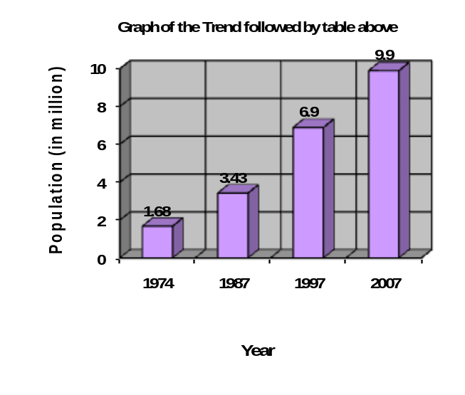

2.9 Trend of Population Growth in Dhaka City

Year | Population (in million) | Growth Rate
1974 | 1.68 | -
1987 | 3.43 | 14.88%
1997 | 6.9 | 10.11%
2007 | 9.9 | 4.34%

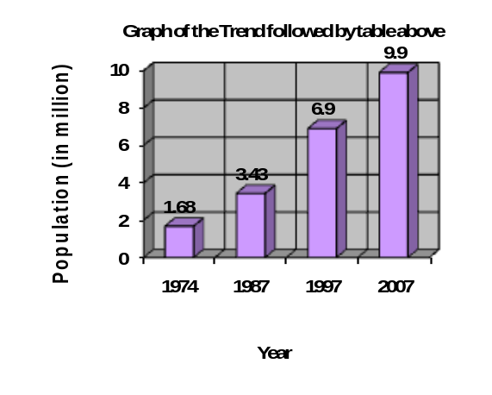

APARTMENT UNITS DELIVERED IN THE LAST 15 YEARS
Year | No. of Apartment | Growth Rate
1990 | 1540 | 21
1991 | 2140 | 39
1992 | 1530 | 28
1993 | 1850 | 20
1994 | 2298 | 24
1995 | 2320 | 01
1996 | 2430 | 05
1997 | 2684 | 10
1998 | 2840 | 06
1999 | 3298 | 16
2000 | 3620 | 10
2001 | 3930 | 09
2002 | 4172 | 06
2003 | 4465 | 07
2004 | 5074 | 14
2005 | 5480 | 10
Total | 53,193 | -

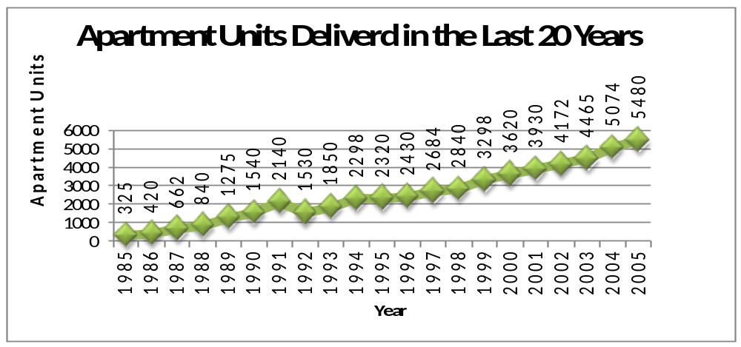

Note: Current Average Growth Rate is 10% (approximately)

Chapter - 3

3.1 About DVHL

Success lies in the ability to adapt with changing times. That is something Diamond Valley Homes Ltd use as their strategy to anticipate that change and mould their services to meet the needs of their valuable clients.
Diamond Valley Homes Limited (DVHL) is a family run Independent company with experience in the Property & Land business, and has excellent connections with many of the most successful architects, planning specialists and other property and Land professionals.
The basic demand of a civil citizen is food, shelter, clothes and medicine. But considering the present scenario shelter is the main problem to all of us. Dhaka is now one of the fast growing and densely populated metro-city in the world. It has been an unplanned city with disorganized facilities for residents. But there should be a change; it is the demand of time. And the change maker is none other than them - Diamond Valley Homes Limited.
They are committed to providing their customers with quality, affordable Lands. They visit all of their Lands to ensure accuracy in the descriptions they provide.
They are delighted to offer to people the lands they currently have available. They strive after 100% customer satisfaction. They achieve this by personal and individual customer treatment. They will assist their customers with thinkable help during the whole buying process.
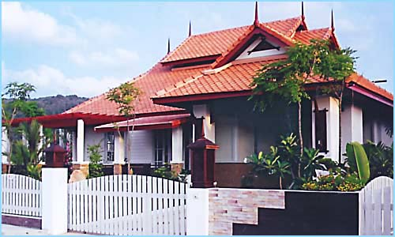
Their business has been around for 1 year. However, their team is young and ambitious. They continuously grow, innovate, and reinvent themselves. They take pride in what they do and it is always a pleasure for them to serve their customers.

3.2 Mission Statement
“To be the leading provider of land development solutions today and tomorrow by building on our strong foundation of integrity and on our commitment to associates, clients, and communities. Our commitment is to preserve the natural beauty of the environment and generate economic growth for the area.”
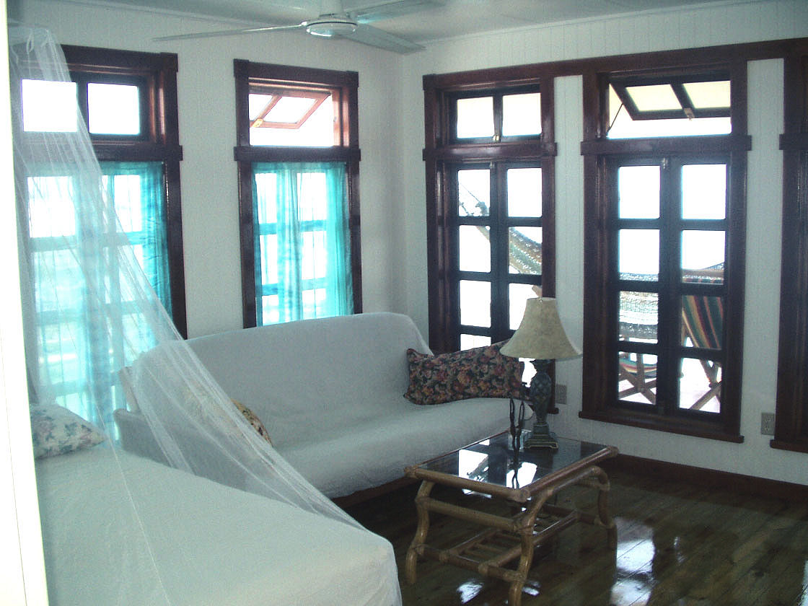

3.3 Company Perspectives
The DVHL's business strategy is to: build on its leading position in the small and medium sized residential units development segment; increase recurring income from growing rental property portfolio; maintain strategic investments to strengthen income and asset base; generate significant future cash flow from diversifying businesses.

3.4 Vision Statement
”With ethics and integrity, DVHL strives for excellence in all facets of Land Development services in order to enhance our position as an industry leader. Our team transforms forward thinking ideas into cutting edge applications, to achieve maximum results for our clients, company and community.”

3.5 Corporate Values
“Support and demonstrate our corporate values of growth, passion, integrity, flexibility, benevolence and collaboration.’’
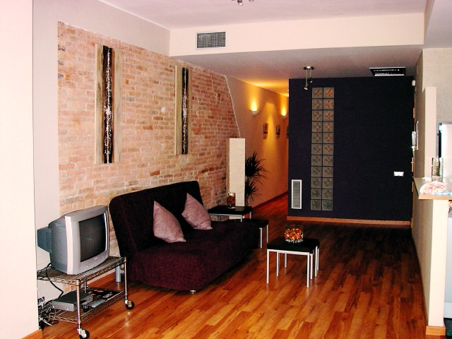

INTEGRITY- Over the past 1 years, DVHL built a reputation on performance and integrity. Many people know and select DVHL for their land development needs.
VISION - Seeing opportunities others miss
ADAPTIVE - Anticipating and preparing for change
VIBRANT - Infusing energy to vitalize communities
TRUST - Confirming your confidence, exceeding expectations
COMMITMENT - Our greatest asset is YOU”

3.6 Why Invest in Land?
Land is real
Unlike shares, land for sale is tangible, - it can be visited, seen, and walked on.
Land is a finite resource
Bangladesh is a small country with the majority of the population wanting to live in the Capital City, Dhaka.
Land is a solid and easy to understand investment
Land is not open to accounting scandals and it is clear when property prices are going up (or down) and the reason for this movement. For example, everyone in Bangladesh is presently aware of the housing crisis in the country. Other traditionally 'solid' investments such as precious metals are not as simple as they appear.
Land increases in value
This is due to demand outstripping supply and also from land gaining planning permission to have houses built on it.
Investment land has a wide range of uses
Investment land can be used for grazing animals, starting a business or building a home on, or it can simply be left as it is - whatever is done with it, the price is likely to rise considerably, even with the slowdown in house price inflation
Land investment - The alternative investment opportunity
"The population is growing, the economy is growing, the demand for new workers is growing, and household formation is changing with an aging society and family break up. The demand for housing is increasing."
The result is a massive pent-up demand for new housing. What shape and form that housing takes is irrelevant to land owners. Whether executive houses, or affordable flats for key workers, land is needed for new homes.
Decision process
One should decide where to buy land by applying in exactly the same two key criteria as for any other investment, reward and risk. What is the potential reward? How great is the potential risk.
- How great is the potential return?
Get it right and the rewards can be exceptional. Typically, when land is redesigned for development purposes its value dramatically increases. The exact percentage increase varies between plots and locations, but it should be reasonable to expect a substantial return on investment if your land is rezoned for development purposes.
- And what's the risk factor?
The risk is that one’s land will not be re-zoned for development purposes, in which case, he still owns the land, and it should still have its initial value. After all, land never goes out of business!

The Diamond Valley Homes Limited’s efforts seek to:
- Create affordable housing (developed land & homes) for people
- Foster better living environments and pleasant surroundings
- Ensure environmental balance and sustainability
- Treat industrial effluents
- Develop a meaningful partnership with others for development
- Provide better working conditions for its staff members
The DVHL works in close partnership with the City Corporations, the Government of Bangladesh, other private sector companies, multilateral institutions, the environment department, and myriad financial institutions.
DVHL has its head office in Dhaka, Bangladesh.

3.7 Addresses

Diamond Valley Homes Ltd.

Head Office: House # B/169, Road# 23,
New DOHS, Mohakhali,
Dhaka – 1206
Bangladesh

Corporate Office: House # B/338 (2nd Floor), Road# 23,
New DOHS, Mohakhali,
Dhaka – 1206
Bangladesh

The common features in all the projects of DVHL are:
- Wide roads for easy access
- Open spaces
- Pollution free environment
- Detailed landscaping
Over the years, DVHL’s approach to Land development has evolved from A to Z to bring sophisticated, yet easy-to-use solutions which guarantee success. They deliver the best quality and increased resource efficiency following a few simple steps:
- Their superior project management is based on deep customization of user-oriented solutions. They carefully assess customers’ project requirements to eliminate all possible risks and eventually find an optimum choice for them.
- Their team works out for their customer a project scheme, including its estimate and timeline, and, as soon as they give us their approval of it, the actual development process begins. All team members have excellent credentials in their particular field of Land development, so customers may rest assured of their profound understanding and excellent implementation of IT.
- They provide a streamlined continuous control over the entire project. This helps them reduce the amount of testing procedures as well as stay within the time and budget frames.

Gulshan Destiny Valley will be the most planned modern city where one can get all the facilities for a better and comfortable lifestyle for him and as well as his future generation. DVHL will design this model city with all best standard facilities for the peace lovers. Being the member of the metro-city, they offer a futuristic living plots within the most suitable location in Dhaka City that gives people natural fresh environment, broad roads and lanes, power, water, IT communication, club, college, corner shop, hospitals, katcha bazaar, lake, mosque, school, park, and round the clock security facility to make their life peaceful and happy.
The project is located at Shatarkul, on the west side of the Gulshan-1 and Gulshan-2 with a huge attractive area.

3.8 Features and Facilities

What facilities people will enjoy in the Gulshan Destiny Valley:

            - Very easy and convenient communication with offices, educational institutions, hospitals, mosque, lake and commercial areas.
            - Gulshan Destiny Valley is a RAJUK registered project.
            - Bus stops, train station and airport are within 500 to 700 meters.
            - Project planners are highly experienced and reputed town planners have been working for its development.
            - Inside the project roads and lanes are minimum 30feet and maximum 80 feet broad.
            - Flood free area.
            - International standard schools, colleges, universities, children parks, hospitals, shopping malls, bazaars, restaurants, clubs, community centers, banks, mosques, post offices all these facilities will be available inside the project.
            - 40% of the project area has been allotted for the above facility.
            - 16 Security service by police, ansar and company security forces.
            - Easy and interest free payment system in 12/24/36/48/60 installments.
            - Plot sizes are 3, 3.5, 4, 5, 6, 10, 11, and 12 kathas.
            - The project is outside of the flood flow zone of RAJUK.

3.9 Price Chart

Sl. No. | Payments Term | Special Discount | Per Katha | Installment Per Month
01 | Cash Payments* within 10 days | 55% | 4,50,000.00 | ____
02 | 03 Months* | 50% | 5,00,000.00 | 1,50,000.00
03 | 06 Months | 40% | 6,00,000.00 | 1,00,000.00
04 | 12 Months | 30% | 7,00,000.00 | 50,000.00
05 | 24 Months | 20% | 8,00,000.00 | 30,000.00
06 | 36 Months | 10% | 9,00,000.00 | 25,000.00
07 | 48 Months | 0% | 10,00,000.00 | 20,000.00

* This price will be applicable for first 500 plots.

3.10 DVHL Ensures the Followings

- DVHL Ltd. is very sensitive to fulfill their commitment.
- They use high quality construction equipments.
- They always try to satisfy their customers.
- All of the directors, Managers, Executives and other employees of DVHL Ltd. are very experienced and professional.
- DVHL Ltd. ensures their customers that they are tension free about the quality of their apartments.
- They provide maximum benefit to their customers.

3.11 DVHL’s Residential Projects

3.11.1 Amenities and Technical Specifications

Common Amenities
o Heavy secured gateway with decorative lamps and signs on logo of the Complex.
o Spacious entrance & (well decorative) driveway with security arrangement for control of incoming & outgoing persons, vehicles, goods, etc.
o Main lobby & Reception (Granite finished Top) area in secured premises with an impressive Concierge Desk complete with personal Mail boxes, Register docks, etc.
o Car parking in covered and protected Ground floor for residents with comfortable driveways.
o Stair case with easy to climb steps & adequate lighting.
o Fire protection features conforming to International Fire Code.
o Separate manual fire alarm and a Fire Extinguisher in each floor.
o Provision of Fly proof net in all the windows.
o Elaborate Intercom system to connect each apartment to the Concierge Desk.
o One standby Emergency Generator in case of power failure of (Capacity 30 KVA to 50 KVA):
Ø the lift
Ø the water pumps
Ø lighting in common spaces and stairs
Ø two light and two fan points in each apartment
o One superior quality high speed lift for the building from reputed European/Korean/equivalent manufacturer to be with:
Ø capacity of lifting 6 persons
Ø adequate lighting
Ø well furnished and attractive doors & cabins
Ø emergency alarm and escape provision.
o Tastefully furnished visitors' waiting area.
o Drivers’ waiting area with toilet
o Management Office at roof top.

Roof Facilities:
- Linen clothes drying arrangement.
- RCC water tank to serve all the Apartments.
- Protective parapet wall.
- Heat & damp protection measure to be taken on top roof of the building.

General Engineering:
- Materials like brick chips from machine made Sub-soil investigation and analysis.
- High quality structural building high quality picket Jhama, 60 grade Deformed/Tor steel bar, Sylhet sand etc. to meet design requirements.
- Testing of construction materials and concrete works shall be carried out at all important stages of construction and also whenever felt necessary (in the field & in the laboratory).
- Ensure close supervision at every stage of construction by Developer's experienced and qualified Engineers and Architects.

Design Criteria:
- Structure designed to withstand Earthquakes at 7.5 of intensity in Richter scale.
- Structural design parameters to be based on ACI, ASTM and BNBC code.
- For all service connections and disposals (sewerage, solid waste, silage) British / American / BNBC building codes will be followed.
- Considered maximum wind load.
- Level of ground floor will be above 1988/1998 flood level and considering surrounding buildings & road level.
- For concrete works to give crushing strengths of 3000 psi to 3500 psi (Cyl. test) at 28 days depending on concrete ratio & design.
- Non-load bearing (partition walls) walls with 1st class bricks for exterior & interior walls.
- Floor to bottom of roof (ceiling) will be min 9 feet 6 inch high except toilets false ceiling (7 feet).
- Ceiling edge will be in living and dining area.
- Provide damp proof course.
- All electrical wiring, plumbing and sanitary piping will be concealed and tested for leaks.
- Reinforced cement concrete floor slab.

3.11.2 Specifications
Kitchen :
o Concrete shelf at 2.5 feet height from floor level with Glazed Tiles work top (RAK/equivalent).
o Provision for double burner Gas outlet.
o Concealed Hot and Cold water lines.
o A 2.5 feet Band of wall Tiles running on wall along the sink and Gas Cooker (RAK/equivalent).
o Suitably located Exhaust fan.
o One high polished stainless Counter Top Steel Sink with Mixer (Malaysian).

Bathrooms :
o Bath Tub in Master Bathroom.
o Cabinet Basin with marble Top in Master Bathroom.
o Provision of Shower Area in the Second Bathroom.
o Glazed Tiles in Bathrooms up to 7 feet height except maid’s (RAK/equivalent).
o Floor Tiles in all Bathrooms except maid’s (RAK/equivalent).
o Company Standard Sanitary fittings.
o Water proof imported Door.
o Mirrors in all Bathrooms with Overhead Lamps.
o Enamel Paint on the ceiling and walls to prevent dirt and dampness arising from moisture.
o Soap cases.
o Towel Rails.
o Concealed Hot and Cold water lines in M & Child Bathrooms.
o Essentially correct uniform floor sloped toward the water outlet.
o Tiles in maid’s room and in walls of maid’s bathroom up to 5 ft. with long pan (RAK) & shower.
o Nicely arranged Bathroom fittings & fixtures.

Floors :
o RAK Homogeneous tiles on all floors (16” X 16”).
o Essentially correct uniform floor sloped toward water outlet.
o RAK Homogeneous tiles on Stairs & Lobby.

Electrical:
o Independent Electric Meter for each apartment.
o Good quality local Electrical Switches & fittings, Circuit Breakers and Plug points (MK type/equivalent).
o Electrical distribution box with Main Switch.
o Concealed Electrical wiring.
o Washing machine provision in each apartment.
o All power outlets with Earthling connection.
o Concealed Fan Hook.
o Provision for Air Conditioner in Master Bedroom, Second Bedroom and Living room.
o Light and Fan points in Veranda.
o Two emergency light and two fan points in each apartment.
o Emergency electricity connection in Lift, Pumps, Lobby, Intercom service, Common spaces like Car parking, Reception area, Guard room and Main gate.
o Concealed Intercom and Telephone lines (02), TV/Satellite Dish connection (02) in each apartment.

Doors & Windows:
o 36 mm Solid, well seasoned, decorative main Entrance Door Frame & Shutter (Malaysian/Equivalent): -
- Shutter thickness 36mm
- Doorframe 6.25” X 3”
- Door Chain
Ø Check Viewer
Ø Solid Brass Door Knocker
Ø Apartment No.
Ø Door handle with Lock (imported).
o Internal Doors are of strong and durable Veneer Flush door Shutters with French polish (Chamb Veneer).
o All Doors with good quality Mortise Locks and fittings.
o All internal Door frames are made of Malaysian solid wood.
o Sliding windows with Color Glass complete with mohair lining and Rainwater Barrier in Aluminum Section.
o Safety Grills in all windows, color as matched with Aluminium Section in Enamel paint.

Painting & Polishing:
o French polished Door frames & Shutters.
o Weather coat on outside walls (Berger/Elite).
o Smooth finished and soft colored plastic paint on all internal walls & ceilings (Berger/Elite).
o Veranda railing as per the design of perspective.
o Enamel paint on the ceilings and walls of Bathrooms color as matched with Tiles (Berger/Elite).

Utility Lines (Water & Gas):
o Concealed water lines.
o Hot & cold water lines in Bathrooms & Kitchen.
o Sewerage & stream water connected to WASA.
o Water reservoir designed to hold sufficient water supply.
o Two best quality water pumps (one standby emergency).
o Titas Gas approved plumbing design.
o Concealed Gas lines.
o Individual Gas Riser.
o Gas pipe lines connection from Titas Gas Distribution System as per total calculated consumption with adequate safety measures.
o Approved quality Titas Gas materials for internal wiring of Gas line.

3.11.3
Salient Features
Building Entrance: An impressive entrance gate with lamp post and the Project Logo on modern sign welcomes one to this contemporary apartment complex. The heavy secured gateway leads to a spacious covered parking floor.

Reception Lobby: An elegantly designed main Reception lobby decorated with tiles/synthetic marble. Personalized Mail Boxes and a stylish Register Dock for visitors' check-in. An elegant guest waiting area highlights the Reception lobby.

Lift, Lobbies & Staircase: A major element of convenience & comfort is the lift that has been selected to exacting European styles. This comes in impressive doors & cabin providing fast & reliable services to residents on all floors. Best level of safety has been maintained in the specifications.
The staircase is well located and easily accessible with easy to climb stairs. This leads to lobbies on each floor. The top of the stair railing will be of S. S.

Apartment Layouts: The total layout has been thoughtfully arranged to maximize advantages especially in relation to day light and cross ventilation throughout. Privacy has been emphasized by spreading the layout from end to end. The master and the second bedrooms have been located away from the living room.

Optional Features: Various interior designing and additional fittings & fixtures as per choice of allottee may be arranged at cost basis upon approval of the company.

3.12 Terms and Conditions for the Buyer

Application: Interested buyer shall submit application on the prescribed form duly signed by him/her/them along with earnest money. DVHL serves the right to accept or reject any application without assigning any reason.

Allotment: Allotment will be made on first come first served basis. On acceptance of application & earnest money, DVHL will issue an allotment letter to the applicant on receipt of which he/she shall start making payments as per the schedule of payments in the brochure. Buyers willing to make a one time payment will be entertained with substantial discount. Until the full payment of installments, buyer shall have no right to transfer the allotment to the third party.

Payment: All payments shall be made by A/C Payee Cheque or Bank Draft or Pay-order in favor of "DVHL.". Bangladeshis residing abroad may remit payments by TT or DD. Buyer must strictly follow the payment schedule. DVHL may issue reminders to the buyer for delay in payment beyond due date. The buyer is liable to pay a delay charge @ 0.1% per day on the amount of payment delayed. If the payment is delayed beyond 30 days DVHL shall have the right to cancel the allotment. In such an event the amount paid by buyer shall be refunded after deducting 5% of the total price after resale of the Apartment.

Company's Right: The Company may take minor changes in the design both Architectural & Structural of the project should these become necessary. Limited changes in the specification and facilities may be made by DVHL for overall interest of the project.

Hand Over: The possession of the apartment will be handed over within 24 months from the date of commencement of construction work except for reasons beyond control of DVHL such as force majeure, natural calamities, political disturbances, strikes, Acts of God or economic conditions, etc. This hand over will only be made after the full payment of installments.
Utility Connection: Connection fee, security deposit for water, Gas & Electricity and incidental costs relating to these are not included in the price of apartment. Buyer will make these payments directly to the authorities concerned. Should expenditure on these accounts be incurred by DVHL buyer will reimburse the same to the company proportionate to his/ her share.

Refund: For any reason beyond the control of DVHL LTD like force majeur, natural calamities, political disturbances, strikes, Acts of God or economic conditions, etc., the company may be bound to abandon the Project. In such an event the buyer will be entitled to refund of all installments along with the earnest money already paid by him/ her.

Transfer of Ownership: Proportionate share of undivided & undemarcated land will be registered in favor of each allocate as per the current rules & regulations of Ministry of Works.

Transfer Cost: All costs relating to transfer of ownership of the proportionate share of land will be borne by the allot tee on actual basis.

Management: The buyer must undertake to become a member of the Owners’ Cooperative Society that will be formed by the owners of the apartments for the management of common services such as lift, pumps, security, compound, etc. Each allocate must initially deposit Tk. 25000.00 (twenty five thousand) only in the Reserve Fund of the Association or Company for maintaining management expenses of the complex.

Chapter - 4

4.1 Findings from Queries
During the period of my internship I had some findings that are described here on the basis of Frequently Asked Questions (FAQs). I asked the Project Manager some questions. My queries, his answers, and my comments on the answers are given below:
- Please name one of your Completed/Running Project.
Ans. Gulshan Destiny Valley (Running project)
Comments: This the first and running project of the company
- Does it satisfy the characteristics of project such as objective, fund, time etc?
Yes, the GDV project satisfies the characteristics of project which are
- Purpose
- Temporary
- Unique
- Resources
- Cost Time Constraints
- Interdependencies
- Life Cycle - Tasks
- Conflict
- Risk
Comments: It is an ongoing project and till now it satisfies objective, fund, time etc. But the project manager should be careful of monitoring the project himself as it is the first project and many uncertainties are all around the project.
- What is the objective of this project?
The project objective consists of the business benefits that an organization expects to achieve as a result of spending time and exerting effort to complete a project. A project objective is often referred to as the goal. The project objective serves as the marching orders or charge for the project leader and team. It provides information as to what, where, and when, as well as information about how much improvement or change needs to occur. At the completion of the project, any person should be able to refer back to the project objective and determine whether the project was successful. Project goals keep the focus on what is most important. However, on some teams these primary goals are lost in their meeting's activities. Even if the progress is only inches rather than by huge leaps, the team must be pushing the project forward as quickly, safely, and reasonably as possible.
Objectives or Goals of GDV Project

Finish the project within the scheduled timetable.

The objective of GDV project is be to finish the project within the timeframe agreed upon. This means the project manger must do everything possible to drive the project to the end and stay on time. He should remember to avoid guessing and incompetence in the planning of the scope so as to have a reasonable time schedule with which to work.

Finish the project within the scheduled budget.

Budgets are set by GDV project teams while others inherit them. Whether they set the budget or inherit it, they need to make sure they are doing their best to track their expenditures and know where the money is going. When they will finish the project within the scheduled budget, they will demonstrate their ability in running the project responsibly.

Finish the project with the same level of quality.

Unfortunately, when projects lag behind, quality is often sacrificed in order to catch up. Project leaders sometimes feel that in order to pick up speed, pieces of the project will need to be downsized or cut completely. True, the project plan will have to be revised when problems arise, but the revision should never compromise quality. While it is important to keep deadlines, it is equally important to keep the project's quality high throughout the project.

Finish the project within the specified guidelines.

GDV project makes sure they are meeting the customer's needs. They must "wow" the customer! This can be done simply by finishing the project with the specifics the customer really wanted. The best way to solidify this is to verify their accomplishment by customer handoff and close down.

Do the best you can with what you have been given.

There is no such thing as a perfect project. Some projects run up against major odds and hurdles. For example, many recent projects in our country have endured major setbacks because of terror attacks, severe weather causing power outages, or a nation at war. Even against these catastrophes, projects were remarkably turned around and back on track because of great project team leaders and teams. Project goals were met because they did their best with what came their way.

- In your project management, do you follow the four phases of project management?
Four Phases of Project Management
According to the project management there is four phases exist. DVHL is going through with all the phases.
- First they define the project in which they set up their goals according to the desire of their clients. Like this Gulshan Destiny Valley project, the top management defined it. This stage called D1.
- After that at D2 stage they make the detail proposal for the project. They ensure the answer of these questions, like-
  - How to conduct the project?
  - Who will conduct the project activities?
  - When will they have to deliver the project to the clients?
- In project right now is in D3 stage that means the project manager is implementing the project according to design criteria of the project.
- The Gulshan Destiny Valley project is the first project of the company and till now it is being implemented. So, the D4 stage will be completed.
Comments: It is clear that they are following the four phases of project and has already completing three of four phases and the last phase is still left. Every phase of this project is important for the company as it is the first project.

- Projects have become complex- how do you respond?

Project Complexity is the extent to which a project, or one of its components, involves a large number of parts, and/or a large number of people, to be coordinated and/or interfaced.
Successful land development requires the developer to go through a complex process of many interrelated parts. While land development is both an art and a science, the most important aspect of the process is its holistic nature. Each separate part influences the others and a viable solution must take into account market demands, budget constraints, and site conditions.
The process usually begins with an idea for the creation of a new development that will serve the needs of the local market. This new development should take its place as a good neighbor within the local community by acknowledging its relationship to adjacent land uses. It should also become economically viable for both its inhabitants and the developer. Therefore, the project manager said that to produce a successful idea for his project, he begins with a thorough understanding of what his potential buyer needs and wants in a new development.
Comments: As the projects have become complex for the reasons described above, there is another extra reason for the company and that is, the company is going to complete a project for the first time.

- Do you follow any time planning like Gantt chart, Activity on arrow or anything else?
Ans. The Company follows only Gantt chart but no other A-O-A or A-O-N Diagram.
Comments: We think that the company is not willing to reveal their secrecy and that is why they are hiding their strategies.

- Do you follow the Critical Path Analysis to complete the project in time?
Ans. As there is no A-O-A or A-O-N Diagram, there is no critical path to be needed.

- What kind of cost plan is used: Bottom up, Top down or anything else?
Ans. The Top-down cost planning is used here as it is a real estate project and prices of lands are set before the project is completed.

Comments: It is a good decision to use top-down method as the price is fixed for the land and the project manager does not have the scope to increases cost and must use as needed. Cost is the main concern here, not the quality.

- How do you estimate the cost of project- Experience, Forecasting etc?

Estimating is the process of forecasting a future result in terms of cost, based upon information available at the time. Many techniques, books and software packages exist to help with estimating project costs. Cost estimating is one of the most important steps in project management. A cost estimate establishes the base line of the project cost at different stages of development of the project. A cost estimate at a given stage of project development represents a prediction provided by the cost engineer or estimator on the basis of available data.

The costs of a GDV land development facility to the owner include both the initial capital cost and the subsequent operation and maintenance costs. Each of these major cost categories consists of a number of cost components.
The capital cost for a GDV land development project includes the expenses related to the initial establishment of the facility:
- Land acquisition, including assembly, holding and improvement
- Planning and feasibility studies
- Architectural and engineering design
- Construction, including materials, equipment and labor
- Field supervision of construction
- Construction financing
- Insurance and taxes during construction
- Owner's general office overhead
- Equipment and furnishings not included in construction
- Inspection and testing
The operation and maintenance cost in subsequent years over the project life cycle includes the following expenses:
- Land rent, if applicable
- Operating staff
- Labor and material for maintenance and repairs
- Periodic renovations
- Insurance and taxes
- Financing costs
- Utilities
- Owner's other expenses
The magnitude of each of these cost components depends on the nature, size and location of the project as well as the management organization, among many considerations.
The project manger of GDV project follows the following rules will to ensure that an accurate and realistic estimate is produced.
- He assumes that resources will only be productive for 80 percent of his time.
- Resources working on multiple projects take longer to complete tasks because of time lost switching between them.
- People are generally optimistic and often underestimate how long tasks will take.
- Make use of other people's experiences and his own.
- Obtain an expert view.
- Include management time in any estimate.
- Always build in contingency for problem solving, meetings and other unexpected events.
- Cost each task in the Work Breakdown Structure to arrive at a total, rather than trying to cost the project as a whole.
- Agree a tolerance with his customer for additional work that is not yet defined.
- Communicate any assumptions, exclusions or constraints he have to his customer.
- Provide regular budget statements to his customer, copying his team, so that they are always aware of the current position.
Comments: There is no previous experience of the company as a whole, so they must be careful of estimating cash inflows and cash outflows and uncertainty involving these.
- What kind of cost plan analysis you follow- payback method, discounted cash flow, IRR?
Ans. Discounted Cash Flow method is being used to plan analysis here as it gives almost correct estimation and considers time value of money.
- How do you identify the risk of project? What are the probable risks of this project? What is your preparation?

Several techniques are available that Project manager can employ to identify risks to his projects. He relies on regular team meetings, brainstorming sessions, reviews with stakeholders or experience from similar projects to identify risk of the project. Risks may result from high-level support, funding, resources, skills, hidden agendas and planning related issues.

What are the probable risks of this project?
Once he has identified the risks, he takes the following steps to overcome the situation:
Risk Evaluation
Once he has identified his risks, he writes them down in a risk log. The log is used to monitor and track his risks. He makes his risk log visible to the project stakeholders so they are able to see risks that concern them being addressed. They may flag new risks he hasn’t identified.
The risk log should evolve over time with potential risks removed and new ones added as the project progresses.
Once he has filled out his risk log, then he evaluates his risks. He grades the risks on two levels, likelihood and severity. Assign a value to both the likelihood and severity of high, medium or low. It follows that he should concentrate his efforts on the high / high and high / medium risks. He looks at the financial implication of each risk as an additional factor.

Corrective Actions
Once he understands where his risks are coming from and which he should addresses first, then he takes corrective actions. He thinks of two actions for each risk. He documents the actions (in his risk log) he intends to take to minimize the impact from each risk.

Risk Control
Finally, he monitors and controls his risks. Risk control involves keeping a risk management plan, a record of risks handled, a description of his proposed corrective actions, costs involved and a risk escalation plan for when problems occur. He includes information about the risks in his progress reports. This keeps them visible and prevents any nasty shocks during the project.

Nobody likes to think about what may go wrong in a project, especially early on, but to overlook risk management means that we chance an unnecessary project failure.
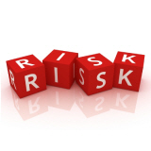
Comments: Risk and uncertainty are all around this project as it is the first project of the company. A simple mistake can be very dangerous for the success of the project. So, steps should be taken carefully.

- Do you prefer team work in project management? What do you do?
The project manager of GDV project prefers team work in project management. He believes that Human Resource Management is needed everywhere, at home, at the office, and especially when working on a project with a group of people. Using human resources during a project requires getting the most effective use of the people involved with the project. This includes everyone associated with the project: sponsors, customers, partners, and individual contributors.
According to him, there are three major aspects of project human resource management: organizational planning, staff acquisition, and team development.
Organizational Planning
Organizational planning identifies, documents, and assigns project roles, responsibilities, and reporting relationships. Before the project begins, all role and responsibilities should be designated. This will cut down on any confusion after the project starts. Each team member will know what is expected of him or her and will be able to follow through on the assigned tasks. Having a staff development plan and an organizational chart will also decrease uncertainty and conflict. A staff development plan describes how and when human resources will be brought onto and taken off the project team. An organizational chart is a graphical way to breakdown the project reporting relationship. It diagrams who is to report to whom. There will not be any question as to the chain of command with a detailed organizational chart. Good organizational planning also includes any supporting documents needed to outline each job title and description or any training needs.
Staff Acquisition
Staff acquisition is the process of getting the human resources needed assigned to and working on the project. Choosing the correct people for a project is almost as important as the project itself. Without a knowledgeable team, the project will be much more difficult. Some things to consider when picking your team are previous experience, personal interests, personal characteristics, availability, and competencies and proficiency. Your resources for finding team members are endless. They may come from negotiations with managers and other project teams, pre-assignment from another project, or even from outside the organization. He also needs to determine whether each team member will be working on the project full or part time. Thinking ahead of the ideal team members will save your valuable time later.

Team Development
Team development includes developing individual and group competencies to enhance project performance. By coming together as a true team, the project will be more successful. The project manager follows the following ways to achieve team Development:
- Team building activities
- General management skills
- Reward and recognition systems
- Collocation or frequent face-to-face meetings
- Training
Significant improvements in team morale will cause an increase in team mentality. Other improvements that will be seen include performance improvements, improvements in individual skills, improvements in team behaviours, and improvements in either individual or team competencies.
Comments: It may become very tough to maintain team work because, team work is the result of working together for a specific time. As time passed and the team work will be more effective for this project.

- What is the organizational structure of this project management?

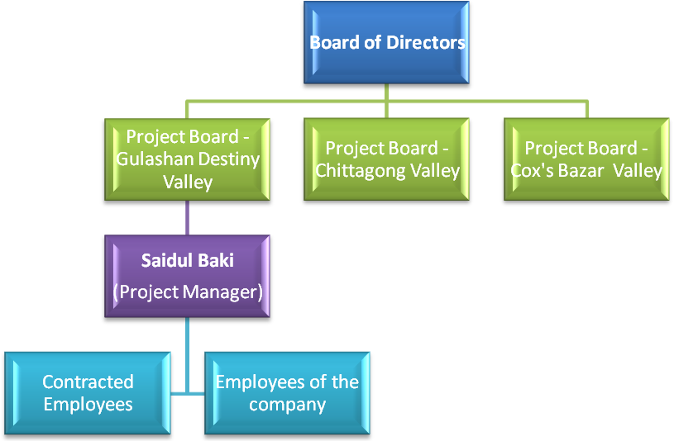
- How do you maintain the control system of the project?
A project control system is a tool that enables managers to recognize problems before they become unsolvable. In essence, it monitors and controls the actual work to be done along with the cost of doing the work and the time needed to do it. How elaborate a system is depends on the size and scope of the task to be managed, as well as the size and distribution of the team working on it.
Comments: There is no written technique to be followed to control the project.
- According to the project classification in which category this specific project belongs to?

There are three types of project, such as-
- X category: Productive of self sustaining & earn revenue. Example: power plant.
- Y category: Productive but does not earn revenue. Example: Irrigation.
- Z category: Service providing project non-visible product. Example: education, health etc.
According to the project classification, the GDV project belongs to “X category” because it is not only productive but also earns revenue.
Comments: It is a private owned company and for-profit project
- What are the key factors of your project?
Project managers stay current with ever-changing development regulations and are responsible, either directly or indirectly, for key factors in land development project.

The key factors of FDV land development projects are:
Interface with public agencies
The project manager of Gulshan Destiny Valley works with city and county planning departments, flood control and state agencies (for zoning, subdivision platting, street layouts, street dedications and other urban planning items), with public works departments (for water, sanitary sewer, storm sewer, streets and flood control issues), with state agencies (for utility environmental quality) and in some cases with the utility district authority.
Environmental conditions
Environmental issues must be dealt with before lenders will commit to financing, and typically prior to breaking ground. Every project should begin with an environmental report. Wetlands, live/inactive water bodies, burial sites, illegal dumping, pollution — natural or manmade — to name a few, are all environmental issues that have a major factor in the ultimate use of the property. Water bodies, flood-prone areas and areas that warrant special use can be protected to add an amenity and appeal to a project.

Contracts with consultants and contractors
Appropriate contracts for all subcontractors and consultants are critical to the legal and financial aspects of the project.
Land planning, landscape architecture, amenity planning.
A project manager must be versed in various land-planning strategies to maximize use of the land and project appeal. Appropriate and pleasing landscape architecture and amenity design can determine the tone and impact that a developer is hoping to achieve. Designing amenities for the ultimate users — such as water features that act as storm water detention and amenities — improves the marketability and sales velocity of a project.
Development costs
The project manager is generally responsible for providing a cost analysis for all aspects and each phase of a development project.
Civil engineering
It is the project manager's responsibility to choose the project's civil/design engineer, who is ultimately responsible for the design and operation of all utility and infrastructure functions of the project. Water, sanitary sewer and storm sewer capacity must be determined from the appropriate utility provider, and governmental approvals must be obtained for every engineering and design-related construction item.
Infrastructure construction
The project manager works with the project engineer to coordinate the bidding for infrastructure construction, whether it is by publicly advertised bidding or selective bidding. In addition, the project manager and project engineer supervise the construction and progress payments throughout development of the project. Additionally, the project manager coordinates the extension and installation of electric service and street light installation (an increasingly difficult task since electricity deregulation), natural gas, telephone, cable television, telephone and, if available, bundled digital services.
Subdivision restrictions
The project manager supervises the creation and initial operation of the homeowners association, typically by hiring a professional firm that specializes in this. The project manager also supervises preparation of deed restrictions and serves on architectural control committees, if necessary.
Amenities
The project manager coordinates the design, financing, construction, maintenance and operations of amenities, which may include the subdivision entrance, parks, recreation areas, open space, landscaping and water features, plus active recreation features, such as golf courses.
Market Analysis
One of the first tasks of the project manager is to coordinate and direct a market analysis, which helps determine the demand for, absorption and price of the product.
Financing district development
The project manager should be versed in the various development-oriented financing districts, including municipal utility districts, tax increment reinvestment zones, public improvement districts, municipal management districts and road improvement districts.
Development regulations
Project managers must be versed in all aspects of development regulations, including zoning, subdivision platting, environmental regulations (including wetlands), utility and infrastructure regulations and development financing regulations.
Professional groups and politics
Through activity in land development and real estate oriented professional groups, project managers stay current in development trends and changing regulations and take advantage of networking opportunities. Project managers also often are politically active so they can work to retain or improve property rights regulations that provide positive land development activity.

- What are the key elements of your project?
Key Elements in Gulshan Valley (DVHL) Project
The key elements of the land development process Gulshan Valley (DVHL) Project are market research, site selection and analysis, project design, site engineering, project costs, and financial feasibility. Each element has a unique role to play.
Market research involves determining which type of buyers to capture; understanding their buying power, lifestyle characteristics, and product demands; and matching housing types and master plan concepts with those characteristics.
This part of the process can extend through to the marketing and selling of the project.
Site selection and analysis involve developing a list of desirable site characteristics; analyzing site conditions; and evaluating all the physical, legal and political, and off-site characteristics of a particular site for their contribution to the project's success. Project design matches marketing information on buyer preferences with site characteristics to produce a master plan and housing types that best satisfy these requirements. Site engineering deals with the physical handling of the topography and installing the infrastructure to support the master plan.
Managing project costs involves determining both soft costs (fees, marketing, and testing and investigating site conditions) and hard costs (labor and materials) for the project together with the schedule for completing each task. From this information, one can then produce an accurate project cash flow.
Financial feasibility refers to determining the profitability of the project from sales forecasting and project costs.

- What your role and responsibility as a project manager?

Roles and Responsibilities of GDV project manager
A project manager is the person who has the overall responsibility for the successful planning and execution of a project. The GDV project manager possesses a combination of skills including an ability to ask penetrating questions, detect unstated assumptions and resolve interpersonal conflicts as well as more systematic management skills.
Key amongst his duties is the recognition that risk directly impacts the likelihood of success and that this risk must be both formally and informally measured throughout the lifetime of the project.
Risk arises primarily from uncertainty and the successful project manager is the one who focuses upon this as the main concern. Most of the issues that impact a project arise in one way or another from risk. A good project manager can reduce risk significantly, often by adhering to a policy of open communication, ensuring that every significant participant has an opportunity to express opinions and concerns.
It follows from the above that a project manager is one who is responsible for making decisions both large and small, in such a way that risk is controlled and uncertainty minimized. Every decision taken by the project manager should be taken in such a way that it directly benefits the project.
Project managers use project management software, such as Microsoft Project, to organize their tasks and workforce. These software packages allow project managers to produce reports and charts in a few minutes, compared to the several hours it can take if they do not use a software package
The role of the GDV project manager encompasses many activities including:
- Planning and Defining Scope
- Activity Planning and Sequencing
- Resource Planning
- Developing Schedules
- Time Estimating
- Cost Estimating
- Developing a Budget
- Controlling Quality
- Managing Risks and Issues
- Creating Charts and Schedules
- Risk Analysis
- Benefits Realization
- Scalability, Interoperability and Portability Analysis
- Documentation
- Team Leadership
- Strategic Influencing
- Customer Liaison
Comments: These rules and responsibilities are defined by the top management.

Chapter - 5

5.1 Conclusion

After getting the findings from the internship I have conducted, I have found that most of the organization members from top to bottom are individually experienced of doing this kind of projects earlier. But the company as a whole does not have any previous experience and trying to make the running project successful by creating outstanding workforce. They need to be more careful of taking every necessary step and must be aware of competitors in this market as they have very strong and experienced competitors with a huge amount of cash in hand. At this stage they need to follow the other similar companies or should make a try to snatch the experienced, effective, and efficient employees from the competitors.

5.2 Recommendation for the Company

Get Your Home Ready
Have your real estate agent take a close look at your home and let you know what needs to be done to get it ready to sell. Properly preparing your home before putting it in the multiple listing will help get you a higher price and a quicker sale. In general, you want your home to look as clean and as new as possible.

Carpeting and Painting
Painting walls and replacing carpet are the most frequent cost effective recommendations. Because of recent mold concerns, make sure that anyone installing new carpet agrees to replace all existing tack strips. This is especially important in the basement and anywhere the carpet may have gotten wet. Some companies leave many of the old tack strips in place and reuse them.

Sell or Donate Your Extra Stuff
Relocation is seldom fun, but there are ways to make it easier. Don’t pass up the opportunity to sell or give away all of that stuff you have stored, but haven’t used for a year or more. Getting rid of things may be hard to do, but it will also make your move to a new home easier. If you are relocating across country, it may even be cheaper to buy new furniture and appliances than to move them. Yard sales and donations to local charities are both great ways to reduce clutter and make your home more attractive to buyers.

Beware Referral Companies
Beware of internet companies offering to refer you to a good or experienced Realtor or agent. The primary requirement for an agent to be listed with these companies is simply to be willing to pay them a fee for referrals. Education and experience requirements are minimal if they exist at all. Many newer agents use these companies, because the agents lack the experience and referral client base to obtain enough leads on their own to stay in business. Discount real estate companies, and their agents who have to rely on volume, may not be able to provide the level of attention and service that you expect and deserve.

