Report
On
Bangladesh Economy & Vision 2050

Submitted by

WWW.ASSIGNMENTPOINT.COM


Preface
Objectives of the Study
Scope of the report
Source of information
Methodology
Limitations of the Study

Part - 1 | Introduction

Preface

Bangladesh has achieved remarkable progress in the areas of primary schooling, girls’ education, immunization, micro-credit, female economic participation, birth control, physical mobility and safety nets. The most remarkable achievement is in the field of primary education with the country well on its way to meet the development goal of universal primary education by 2015. The challenge here is ensuring adequate finances to keep up the momentum and ensuring quality education for all.
Although all relevant indicators of development goals have moved towards Bangladesh 2015 targets, its performances have been uneven. To understand this variation, it is important to analyze the reasons of the slowing down of the child mortality rate, the apparent plateauing of total fertility rate, the rise in youth unemployment rate, and most important of all what factors work in accelerating the pace of poverty reduction.

It is important because the main underlying factor for the slow pace of development goal achievement is poverty. Poverty permeates all sectors and holds back growth in every sense. To address this issue, Bangladesh is in the process of completing its first PRSP, which has taken into account the development goals. The PRSP is addressing the issues of pro-poor growth and human development, and when implemented, will accelerate the achievement of the goal. For this to happen successfully there is need for strong partnership at the global and at the national level. For countries like Bangladesh to meet the MDG commitments made at the 2000 Millennium Summit, industrialized countries must honor their commitments to finance development in developing countries. Trade barriers must be lifted and both the rich and the poor must be allowed to benefit from globalization so that we can all move towards a more equal world.

Objectives of the Study

The broader objective is to review the governance system of the economy sector and to identify the economic situation and set a vision likely to be present in the different divisions of the economy.
Specific Objectives of the study
- To identify the existing problems and governance failure have caused to severe problem in economy.
- To identify the vulnerable areas of problems and risks as at policy level, procurement, generation, transmission, distribution of resources of economy.
- To identify the factors responsible for poor HRM, accountability and transparency of resource distribution.
- To identify the reasons for non-technical loss and estimate economic loss.
- To provide policy guidelines finally
- Detailed study of each of the strategies and show how it is useful for the economic growth for Bangladesh.
Scope of the report
This is about the Bangladesh economic situation and its problem. Here information shows the obstacles that hampering the growth of Bangladesh economy. In this report, there are also some prediction that at 2050 where we want see Bangladesh economically and other sector of development. GDP of current year, previous years and also a prediction of 2050 are also including here. So there are opportunities to know about Bangladesh economic condition and vision for 2050.
Source of information
The general source is classified with the different aspect which is related as on their main view of information & related field.most of the information are collected by ibternet from different sites. Some sites are:

- National Accounts Statistics published by Bangladesh Bureau of Statistics
- Bangladesh Economic Review published by the Financial Advisor Wing, Ministry of Finance
- Economic Trends
- www.Earthtrends.com (For the Data of India, Pakistan and Srilanka)
- DCCI Website
- Bangladesh 2050.com
- Web site of finance ministry

Methodology

Data Analysis
Structuring the Vision

Data Collection

Literature Review

Limitations of the Study

- Gathering of information related to our topic is a major problem in this regard.
- The Study did not capture all the wings of the economical sector due to limited time and information.
- Due to poor data management, the real picture of governance failure could not be included.
- As vision 2050 is relatively a new addition in the government’s strategy, there lacks sufficient studies and literatures
Major part of the report is based upon the secondary sources of data, which consists of the views and opinions of the financial analysts. In that case, the reliability and
authenticity of the information provided by them is not absolutely above the question.

Bangladesh at a glance
Geography
Overview of Economy
Sector wise situation of Bangladesh economy
SWOT Analysis of Bangladesh economy

|
Part - 2 | Bangladesh overview

Bangladesh at a glance

Official Name: | The People's Republic of Bangladesh
Political system: | Parliamentary democracy
Capital name: | Dhaka
Time zone: | GMT + 6 hours
Major cities: | Dhaka, Chittagong, Khulna, Rajshahi, Sylhet, Barisal, Rangpur
Principal rivers: | Padma, Meghna, Jamuna, Brahmaputra, Teesta, Surma and Karnaphuli.(total 310 rivers including tributaries).
Principal industries: | Ready made garments, pharmaceuticals, cements, garment accessories, chemicals, fertilizers, newsprint, leather and leather goods, paper, sugar, jute, ship building.
Principal exports: | Readymade garments, frozen foods (shrimps), leather, leather products, jute, jute products, tea, ceramic, textile fabrics, home textile, chemical product, light engineering products including bi-cycle.

Geography

Location: | Between 20⁰ 34' and 26⁰ 38' north latitude and between 88⁰ 01'  and 92⁰ 41' east longitude.
Boundary: | North: India  West: India  South: Bay of Bengal  East: India and Myanmar
Area: | 56,977 sq. miles or 147,570 sq. km.
Territorial | 12 nautical miles
Main seasons: | Summer (March-May), rainy season (June-September) and winter (December-February)
Climate variations: | Season | Temperature |  | Rainfall | Relative humidity
 |  | maximum | minimum
 | Pre monsoon | 32.6⁰C | 22.4⁰C | 453 mm | 74%
 | Monsoon | 31.5⁰C | 25.5⁰C | 1,733 mm | 86%
 | Post monsoon | 30.5⁰C | 21.4⁰C | 210 mm | 80%
 | Winter | 26.5⁰C | 13.9⁰C | 44 mm | 73%
 | Annual | 30.4⁰C | 21.2⁰C | 203 mm | 78%
Principal seasonal crops and fruits: | Paddy, jute, wheat, tobacco, pulses, oil seeds, spices, vegetables, jack-fruit, banana, mango, coconut, pineapple etc.
Natural resources: | Natural gas, coal, lime, white clay, granite, glass sand.
Urban demographics
Administrative unit | Number
Division | 7
District | 64
City corporation | 6
Municipalities | 309
Upazila | 483
Thana | 599
Union | 4,498

Population by religion (%)

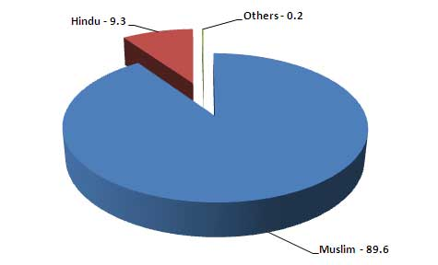
Overview of Economy
GDP total: | $100.00 bn (at current prices 2010-11)
GDP per capita: | $750 (at current prices 2011-12)
GDP growth rate (%): | 7.0 (at constant prices 2011-12)
Total exports: | $16.20 bn (2009-10)
Total imports: | $23.74 bn (2009-10)
Total FDI: | $0.913 bn (2010)
Forex reserves: | $10.700 bn (Nov 2010)
Currency: | BDT (1 BDT=$0.01438) (avg 2009-10)

Sector wise situation of Bangladesh economy

The economy of Bangladesh is primarily dependent on agriculture. About 84% of the total population lives in rural areas and are directly or indirectly engaged in a wide range of agricultural activities. Agriculture contributes about 20.29% to the country’s GDP- 23%. About 43.6% of the labor force is employed in agriculture with about 57% being employed in the crop sector.
The abundance of natural resources available in Bangladesh supports a range of highly profitable investment opportunities in agribusiness. Over 90 varieties of vegetable are grown in Bangladesh, yet in this fertile land there is under utilisation of the country’s agricultural capacity. This presents many opportunities for investors seeking to export agricultural products, or to meet the rapidly growing local demand.
Agro industry

Sector Highlights
Thriving in this sector are canned juices, fruits, vegetables, dairy and poultry. The country offers:
- Huge supply of raw materials exists for the agribusiness industry.
- A tropical climate for all year growing, a lot of fresh water, indeed a land interspersed with numerous rivers, available land with fertile soil.
- Government and NGOs conduct regular training programs to develop skilled manpower in the industry.
- Wide range of biodiversity exists for different crops.
- Agricultural commodities have a comparatively higher value added than non-agricultural commodities.

Investment Opportunities
There is a wide variety of investment opportunities including:
- Cold storage facilities serving the supply chain, especially fresh produce for export.
- Fresh produce production for local and export markets.
- Production of fertilizers and cultivation of seeds.
- Eco-friendly jute production, supported by jute technology development institutes.
- Shrimp farming.
- Halal foods.
- Milk and dairy products.
- High value-added foods for export, including herbs, spices, nuts and pulses.

Industry Outlook
Bangladesh has the essential attributes for successful agri-based industries namely rich alluvial soil, a year-round frost-free environment, available water and an abundance of cheap labor. Increased cultivation of vegetables, spices and tropical fruits now grown in Bangladesh could supply raw materials to local agribusiness industries for both domestic and export markets.
Progressive agricultural practices, improved marketing techniques and modern processing facilities have raised the quality of agribusiness and expanded production levels significantly.

Industry Incentives
The government encourages development of the agricultural sector through measures to increase crop sector productivity and production of non-crop agriculture. To achieve this it provides increased credit, and facilitates greater access to inputs and modern technology. Investments in agribusiness industries in Bangladesh are encouraged with the following support measures:
- The Equity Entrepreneurship Fund for development of agribusiness industry.
- Special loan facilities available to set up an agribusiness.
- Agribusiness industry enjoys tax holidays.
- Any investment in this sector will enjoy similar tax amnesty as available in other sectors.
- Imposition of supplementary duty on mango, orange, grape, apples, dates and others to utilize the high quality and cheaper local resources.
Cash incentives to the exporters ranges from 15% to 20% in various sub sectors.
Ceramics
The global ceramics industry is worth in excess of $10bn. Bangladesh is perfectly positioned to expand rapidly in this sector with its high quality: cost ratios and creative human resource base.

Sector Highlights
Thriving in this sector are tableware, sanitary ware and insulators. The country key advantages are these:
- Technical expertise and skilled manpower in tableware and other ceramics.
- Clean gas reserves in certain locations to fire kilns for competitive cost advantage.
- Bangladesh ceramic tableware has a good reputation in the international markets like North America and EU countries.
- Sanitaryware and insulators have a strong domestic demand as well as international market demand.

Industry Outlook
The global ceramic tableware industry is currently going through a phase of acquisition and consolidation as smaller firms in the developed countries are becoming uncompetitive and bankrupt. As a result, the big names like Noritake, Wedgewood, Lenox, Villeroy & Boch and Royal Doulton are all individually becoming billion-dollar operations.
Traditionally, the tableware industry is labor-intensive and companies in developed countries experience difficulties in remaining competitive. Bangladesh, being a gas-rich and low-labor-cost economy, is perfectly positioned to be a strategic partner in production and supply of ceramic products. Investment interests in this sector are strongly welcome.

Industry Status
A few ceramic tableware manufacturers dominate the industry producing high quality products for the international brands. A pool of skilled manpower has been developed. The latest technological advancements in ceramics are also being utilised. Bangladesh produces high quality bone china, transferring the technology from Japan.
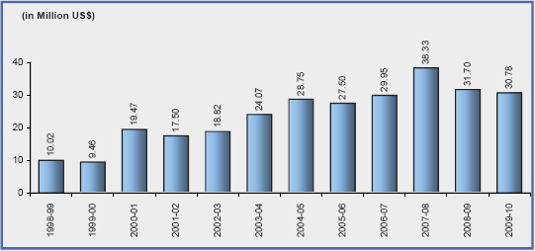
Electronics
The high skill, low cost labor resource of the electronics sector in Bangladesh offers companies great returns on investment. Whilst the global market for semiconductors is worth in excess of $200bn and is dominated by the Asian economies, Bangladesh has significant financial and economic factors in its favor that make it the best choice for many companies.
Sector Highlights
- Manufacturing of semiconductors could be established as a standalone industry.
- Bangladesh is going to be one of the largest cell-phone markets in South Asia.
- The home appliance market in Bangladesh is growing rapidly.
- The labor-intensive nature of the electronic industry matches the ability of Bangladesh to provide a high skilled labor source.

Industry Background
The electronics industry in Bangladesh mostly produces consumer items. Home appliances includes televisions, radios, DVDs and CD players, refrigerators, air conditioners, ovens, electronic fans, blenders etc. are being assembled to a large extent. To ensure the performance reliability, the key challenges in this sector are technical assistance and proper technology orientation of the industry. Developing the significant capacity and skill in assembly and manufacture of a wide range of electronic components and parts is crucial.
As yet, Bangladesh does not have any telecommunication equipment industry in the private sector. However, an urgent need for diversification and modernization is felt among the existing entrepreneurs, government and professionals. The government is keen to provide and ensure enabling assistance to the development of this sector.
Frozen food
Frozen foods is the second largest export sector of the economy. The massive natural resources available in Bangladesh make this sector particularly promising for investors looking to supply in international as well as in domestic markets.
The Public sector corporation and the private organizations have setup about 148 numbers of shore based export oriented fish processing plants at Dhaka, Chittagong, Khulna, Jessore, Satkhira, Bagerhat, Cox's Bazar, Chandpur, Kishoregonj, Syihet and Patuakhali. These plants produces Fresh Water shell On (FWSO), Ser Water shell On (SWSO), Peeled and Deveined (P&D), Peeled and Undevined (PUD), shrimp products under the most hygienic and sanitary condition under the supervision, control and guidance of foreign trained handling & processing experts. At all levels, USFDA registrations and directives of the European Communities concerning the production and exportation of frozen foods are strictly followed.

Sector Highlights
Thriving in this sector are shrimp farming and fish production.
- The government is promoting semi-intensive shrimp farming.
- Shrimp processing and export industry is largely dominated by the small business sector.
- Government has developed initiatives of quality assurance for frozen foods in co-operation with exporters.
- 15% cash incentive offered to shrimp export amount.

Exportable Products
The private organization and the public sector corporation offer the following products for export:
- Frozen shrimp & prawn
- Frozen fish
- Fresh & chilled fish
- Frozen fillets & steaks of fish, sharks shells skates & rays
- Shark fins & fish maws
- Salted & dehydrated fish
- Dry fish
- Live crabs & tortoises
- Fish meals & crushed
- Value added shrimp & fish products

Growth in Export of Processed Fish
Shrimp is the second largest source of export from Bangladesh which earned as much as 437.40 million US dollar in the year 2009-10. Commercial culture of shrimp increased rapidly in the coastal belt of Bangladesh and it went through several stages of transformation. During the last ten years, Bangladesh has earned international credibility by responding to the food-safety and quality requirements of its destinations, mostly, the United States and the European Union countries. Continuous investment has enabled the sector to progress in the teeth of competition from other countries.
Year | Product item |  | Quantity (m lbs) | US$ (m)
2006-07 | Shrimp and fish | 112.15 |  | 515.22
2007-08 | Shrimp and fish | 111.35 |  | 534.07
2008-09 | Shrimp and fish | 117.31 |  | 454.53
2009-10 | Shrimp and fish | 129.81 |  | 437.40

Frozen Food Export from Bangladesh
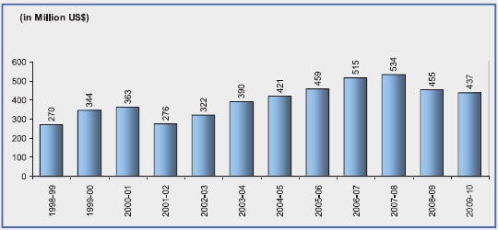
Garments and textiles
From spinning to weaving, from knitwear to leisurewear and high street fashions, the textiles and clothing industry is Bangladesh’s biggest export earner with value of over $ 16 bn of exports in 2009-10. Our factories design and produce for the world’s leading brands and retailers. This rapidly growing sector of the Bangladeshi economy offers a unique competitive edge that supports profitable expansion into new strategic markets.
RMG EXPORTS AND IT'S SHARE IN TOTAL EXPORT OF BANGLADESH
YEAR | EXPORT OF RMG  (IN MILLION US$) | TOTAL EXPORT OF BANGLADESH  (IN MILLION US$) | % OF RMG'S TO  TOTAL EXPORT
2004-05 | 6417.67 | 8654.52 | 74.15
2005-06 | 7900.80 | 10526.16 | 75.06
2006-07 | 9211.23 | 12177.86 | 75.64
2007-08 | 10699.80 | 14110.80 | 75.83
2008-09 | 12347.77 | 15565.19 | 79.33
2009-10 | 12496.72 | 16204.65 | 77.12
2010-11 (July-Sep) | 3971.52 | 5029.05 | 78.97

Employment in RMG Sector
Year | No. of garment factories | Employment (in million workers)
2005-06 | 4,220 | 2.2
2006-07 | 4,490 | 2.4
2007-08 | 4,743 | 2.8
2008-09 | 4,925 | 3.5
2009-10 | 5,063 | 3.6
2010-11 | 5,150 | 3.6

Main Apparel Items Exported From Bangladesh (m US$)
Year | Shirt | Trouser | Jacket | T-shirt | Sweater
2005-06 | 1,056.69 | 2,165.25 | 389.52 | 1,781.51 | 1,044.01
2006-07 | 943.44 | 2,201.32 | 1,005.06 | 2,208.90 | 1,248.09
2007-08 | 915.6 | 2,512.74 | 1,181.52 | 2,765.56 | 1,474.09
2008-09 | 1000.16 | 3,007.29 | 1,299.74 | 3,065.86 | 1,858.62
2009-10 | 993.41 | 3035.35 | 1350.43 | 3145.52 | 1795.39

Sector Highlights
- Cost and quality of products that are produced on time, reliably and very competitively with a highly skilled labor force.
- A unique regional location for expansion into key Eastern and other markets.
- Favored trading status with the EU and the USA.
- Clusters of companies providing a local supplier base with real depth in skilled labor, training and technical development facilities.

Favored Trading Status
Bilateral agreements with 28 countries and Generalised System of Preferences (GSP) of the EU are key reasons for Bangladesh RMG products having access to global markets. The current cycle of GSP applied from 1 January 2009 to 31 December 2011. Bangladesh is now a significant RMG supplier to North America and Europe. Bangladesh has also taken a better position in the USA market through competition. Bangladesh is expected to maintain its tariff-free access to EU under the European GSP, since the GSP is not covered by the Uruguay Round Agreement. Recently Canada has also provided tariff-free access for all the items from Bangladesh. Meantime, the Bangladesh RMG industry has become very competitive as a global standard RMG source. Marketing investments have been made in trading partner economies; end users can often differentiate products with confidence.

Investment Opportunities and Government Support
Enormous investment opportunities exist in this sector. In the RMG industry demand for fabric significantly exceeds local supply and so is currently being met by imports. Backward linkage is a significant trading opportunity and is supported by a government backed incentive: 15% cash subsidy of the fabric cost to exporters sourcing fabrics locally.
Additionally the government has created a highly favorable policy framework for investment in these sectors offering investors the following choices:
- Establishment of new textile/RMG mill in the private sector
- Joint ventures with the existing textile/RMG mill
- Acquisition of public sector textile mills that are being privatised
- Indirect investment through financial services and/or leasing
The most beneficial public policy of introducing back to back LC* and bonded warehouse facilities provide a tremendous impetus to the export scenario in Bangladesh.
ICT and Business Services
ICT and business services in Bangladesh are a vibrant sector supported by an enthusiastic culture and a government committed to providing a pro-business climate for all investors. Over 400 IT companies are now thriving in the country supplying to local and international markets worldwide.

Sector Highlights
- Industry ranges from inbound call centers to the latest in Web 2.0 software development.
- Widespread use of English makes Bangladesh a fast, emerging option for the global business services industry.
- Vibrant cluster of international companies exporting worldwide.
- Highly skilled, cost effective workforce with a strong work ethic.
- Ideal geographical location to meet needs of key markets.
Investing in Bangladesh is of compelling interest to high quality companies that are committed to business growth, reducing manufacturing or research and development costs, and promoting exports. Opportunities include:
- Direct investment in proprietary ICT and business/financial services.
- Outsourcing of ICT and business services to existing established Bangladesh businesses.
- Development of telecoms infrastructure and services.

Key Factors
Opportunities exist for companies that invest their futures with Bangladesh based on a number of key factors.
- ICT cluster: over 400 well established companies, 150+ exporting worldwide of which two thirds export to North America.
- Managerial skills: high graduate output with excellent IT and linguistic skills, over 90% fluent in English at managerial level.
- Workforce: highly skilled, cost-effective, strong work ethic. 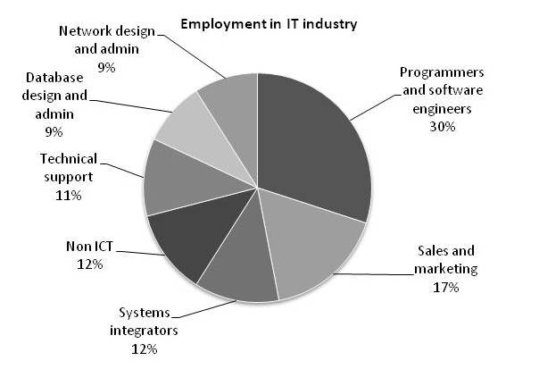
- Infrastructure: connected to the high speed international submarine cable network, established IT and e-commerce service. sector - ensuring reduced set-up time and costs, excellent transport links to key markets and suppliers.
- Supportive fiscal and non-fiscal environment; incentives to ease start-up costs, competitive tax regime, low utility and energy costs.
- Liberal FDI regime: no prior approval requirements or limits on equity participation or on the repatriation of profits and income.
- Geographical location: excellent market access and location between the key markets of India and China, and ASEAN* countries.
- BOI Business support: maximum fast-track help and co-operation from all relevant authorities through BOI-experienced professional advisers to welcome and support incoming businesses.

Skilled and Cost Effective Workforce
With tens of thousands of young IT skilled workforce conversant in English, Bangladesh is one of Asia’s most attractive IT outsourcing destinations in South Asia, particularly for clients in the USA and other Anglophone countries.
- Bangladesh offers significant cost advantages for IT outsourcing , both in terms of labor and infrastructure costs.
- Salary of programmers in Bangladesh is 40% of that in India, 50% of Philippines and 70% of Vietnam.
- Charges for Internet bandwidth in Bangladesh are currently the lowest in South Asia (50% of that in India).
- Rent for office space in Dhaka (capital) is below 20% of that in Delhi and 40% of Manila.
- Over 15,000 IT engineers are working in more than 400 software and IT service companies. Around 150 of these companies are specialized in servicing overseas clients.
Leather and Leather Goods
Bangladesh has a long established tanning industry which produces around 2-3% of the world’s leather from a ready supply of raw materials. The country is therefore an established and attractive location to source and outsource the manufacture of finished leather products. The leather industry is ideally suited to Bangladesh with its abundance of labor and natural resources at internationally competitive rates.

Sector Highlights
Flourishing in this sector are finished leather and leather goods.
- Abundant, low cost labor – ideal for labor intensive industry.
- Good quality domestic supply of raw materials, as by-products of large livestock industry.
- Government support in the form of tax holidays, duty free imports of raw materials and machinery for export-oriented leather market, export incentives.
- Tariff and quota free access to major markets such as the EU.

Trend of Leather Export from Bangladesh
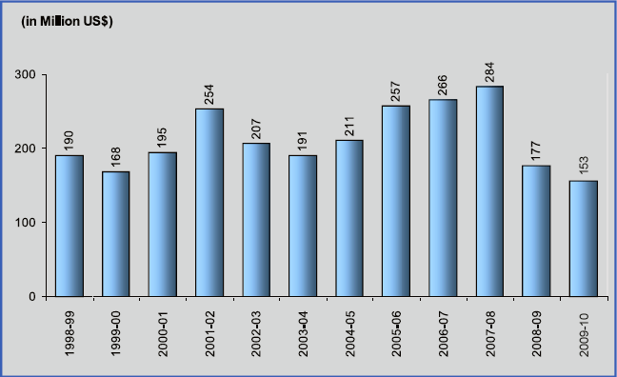
Life Sciences
The pharmaceutical sector in Bangladesh has developed fast. Originally set up to cater for local needs as a manufacturer of patent medicines, the industry now exports drugs to highly regulated markets. Expansive international companies have established operations in the country as they seek to grow, promote exports, drive down manufacturing costs, and undertake research and development into reverse engineering of patented medicines.

Sector Highlights
Flourishing opportunities in this sector are pharmaceuticals, patented medicines manufacture, active pharmaceutical ingredients production, and generic pharmaceuticals. The main advantages for investing in Bangladesh are:
- Highly skilled work force and internationally competitive cost base, with high quality management resources fluent in English.
- Ideal regulatory and tariff environment.
- Excellent geographical location close to emergent economic giants of China and India.
- Significant potential for research and development, contract research outsourcing and clinical trials development
- Quality tertiary education producing a plentiful supply of top flight scientific talent.

Light Engineering
The burgeoning domestic market and the prospect of significant cost reductions for companies sourcing components and finished goods for international markets makes Bangladesh a compelling choice for investors.

Sector Highlights
Thriving in this sector are machinery parts and consumer items.
- Increasingly affluent middle class creating demand for consumer durables.
- About 40,000 small scale light engineering enterprises existing over the country.
- Export-oriented production has experienced strong growth in past few years.
- Currently about 10,000 types of different items are manufactured for the local industry.
- As demand grows for engineering and electronic goods, so does demand for light engineering products.
- Government provides cash incentive facilities to exporters of value-added light engineering products.

Industry Situation
The light engineering industry in Bangladesh continues to grow each year. This labor-intensive sector produces a diverse range of items, including import substitute machinery spares, plant machineries, small tools, toys, consumer items and paper products for the domestic market. Most of these enterprises are located in and around Dhaka metropolis. Entrepreneurs from China, Japan and Korea have taken advantage of Bangladesh's cheap and easily trainable labor and its infrastructure facilities to manufacture products for the export market.
Light Engineering
The burgeoning domestic market and the prospect of significant cost reductions for companies sourcing components and finished goods for international markets makes Bangladesh a compelling choice for investors.

Sector Highlights
Thriving in this sector are machinery parts and consumer items.
- Increasingly affluent middle class creating demand for consumer durables.
- About 40,000 small scale light engineering enterprises existing over the country.
- Export-oriented production has experienced strong growth in past few years.
- Currently about 10,000 types of different items are manufactured for the local industry.
- As demand grows for engineering and electronic goods, so does demand for light engineering products.
- Government provides cash incentive facilities to exporters of value-added light engineering products.

Industry Situation
The light engineering industry in Bangladesh continues to grow each year. This labor-intensive sector produces a diverse range of items, including import substitute machinery spares, plant machineries, small tools, toys, consumer items and paper products for the domestic market. Most of these enterprises are located in and around Dhaka metropolis. Entrepreneurs from China, Japan and Korea have taken advantage of Bangladesh's cheap and easily trainable labor and its infrastructure facilities to manufacture products for the export market.
SWOT Analysis of Bangladesh economy

OVER the last few decades, Bangladesh has been following a development path that was blazed by the fast growing Asian economies with export led growth fuelling higher living standards and falling poverty. Despite this, it is not too difficult to posit that Bangladesh today has more in common with the laggards in Asia. Slow growth, rising inequality, and a deprived countryside deny the vast majority of the Bangladeshi people the opportunity to enjoy happier, healthier, and more prosperous lives.
For moving forward, Bangladesh needs to identify the opportunities and the key weaknesses that the country faces and adopt appropriate measures. There are many ways of doing this analysis. One popular method is to list the Strengths, Weaknesses, Opportunities, and Threats (SWOT) facing the economy and society at large. Although the SWOT analysis is more often applied to evaluate the competitive position of a company this can also be applied to a country. In particular, SWOT analysis is forward looking; it is less for the past than for the future. The exercise identifies areas that need attention or might emerge as problem areas in future. There may be success in some areas. But does that mean we should continue to do the same or shift gears and put more emphasis on other issues? The main purpose of conducting a SWOT is to get a sense of the relevant issues of taking strategic decisions-- of priorities, of possibilities, and of dangers. This is important to begin a thoughtful discussion; a serious conversation about the priorities that we should focus on.

Strength
- In terms of strengths, there is no doubt Bangladesh is in a good geographic location. It provides an important link between the economies of South Asia and the dynamic Southeast Asian region. Bangladesh sits on strategic trade lanes and Chittagong can emerge as a major port to service the regional economies.
- Although Bangladesh is a new nation, it represents an old and flexible civilisation. Both its ecology and history point to the people's hidden resilience in the face of adversities, with capacity to produce unexpected social renewals and economic recovery.
- Another source of its strength is the rapid advance made by the non governmental organizations (NGOs) and other grassroots bodies, creating alternative delivery mechanisms and acting as vocal civic institutions especially for the poor. This is an important source of 'social entrepreneurialism' and a channel of vibrant development of many elements in society.
- The ongoing process of mainstreaming women into development is a strategic strength to bring wider and deeper social and economic changes. Gains in increasing political and electoral participation of women, enhancing press freedom, and creating a vibrant civil society are important for strengthening democratic institutions and consolidating human rights.
- The country's vulnerability to natural disasters has significantly declined that used to inhibit greater investment flow and reduce its productivity and return in the past.
- Several important structural changes have taken place, such as agriculture becoming more resilient with the spread of dry season irrigated crop production and rapid expansion of non-crop agriculture; non-agricultural sectors assuming greater importance; infrastructure and market developments contributing to greater spatial integration and lower price effect of exogenous shocks; and higher mitigation capacity in responding to natural disasters.
- Bangladesh has a fairly good and expanding stock of both physical and human capital, and with favorable policies, the upgrading potential of both capital is bright.
- The remittances from overseas workers have already become a great source of strength and this can be increased manifold with right policies.
- Relative stability of the country's economic fundamentals has created a fairly good macroeconomic environment. As one can see, all the above elements represent significant strengths of the Bangladesh economy.
Weakness
- One uncomfortable feature is that Bangladesh is one of the few countries where income poverty is falling slowly even though economic growth has picked up.
- Even after three decades, most of the economic sectors (especially agriculture) are still weak; health and education indicators are low. Infrastructure, while improving, is still poor especially in electricity, having a per capita use which is among the lowest in the world.
- Corruption is certainly high.
- The economic and administrative cost of securing business is high as well.
- A feature of both a weakness and a threat is the rapidly rising inequality in income and wealth, which neither supports economic efficiency nor social equity. This is socially destabilizing as underemployed urban masses and a swelling rural landless people are much more volatile than a well-rooted community of employed non-farm workers and landed farmers.
- The absolute size of the population, despite success in lowering the growth rate, is increasing fast that creates tremendous pressure on resources as well as on provision of essential services.

Opportunities
- If agricultural productivity is low, investments in irrigation, improved agricultural systems, markets, and infrastructure can raise production and productivity.
- If foreign direct investment (FDI) is low, then improvements in governance, infrastructure, and investment climate can attract more investments.
- A higher demand for skilled workers can create an incentive for better training and education.
- Services sector development including export of skilled manpower is a real possibility.
- There is a promising private sector and the dynamism of this sector, especially in information communication technology (ICT), can be an important opportunity.

Threats
- In the past, Bangladesh achieved a slow progress in poverty reduction. In the future, improper management of development may accentuate poverty and inequality leading to social instability.
- The threat is that governance would become worse and economic decisions would further concentrate wealth, fund capital flight, and increase social tensions.
- The efficiency in use of resources, and a political strategy for stability, equity, and growth is of greater priority in the coming years than it is now.
- Several other developments also threaten to undermine the socio-political stability and future economic progress, such as the challenge to ensuring good governance and stable law and order situation, reducing corruption and ensuring political stability, and adverse global developments including terrorism and sharp increase in commodity prices in the global market.
- The loss or reduction in garment exports is one such possibility.
- Building up a real competitive advantage by lowering port and other transport costs and informal charges and bringing in more efficiency in garments production is the best and only response. Similarly, any development that adversely affects the healthy growth of remittances will create a serious threat to economic and social progress.
- The failure to enhance the supply of quality education and good health is likely to create another threat.
- For the majority with poor education, the prospects for earning a decent income to move and stay out of poverty are not good. For them, indeed jobs will remain insecure and low paying.
- To help the growing number of young workers find decent jobs, to increase competitiveness, and to improve poverty situation, finding a way to improve critical services, including quality education and health services, is necessary.

Part - 3 | Analytical Part

- Bangladesh Economy
- Present conditions
- monetary policy
- Outlook for investment and growth
- Bangladesh GDP &PPP
- Nominal GDP per capita in 2050
- GDP growth rate diagram in 2050
- Bangladesh - Economic development
- Four wheels of economic development
- Development model
- Economical Development Challenges
Bangladesh Economy: Present conditions, monetary policy, outlook for investment and growth

The steady, stable growth performance of Bangladesh over years amid repeated episodes of natural calamities and external shocks has provided markets and entrepreneurs a predictable policy environment of low uncertainty. Following a couple of years in global crisis related mild slowdown, economic activities have rebounded in fiscal year (FY) 11 with strong (above 40 per cent) growth in both exports and imports. Provisional Bangladesh Bureau of Statistics (BBS) estimate reports 6.7 per cent real GDP growth for FY 11 (July 10-June11), following 5.7 and 6.1 per cent respectively of FY 09 & FY 10. The severe power supply shortages impeding output activities eased significantly in FY 11, enabling utilization of idle installed capacities. Benign climate and timely support measures yielded good growth in agricultural output. Given the palpable pace in growth momentum, the final estimate for FY 11 real GDP growth may touch 7.0 per cent; and the growth rate is projected to rise to 8.0 per cent per annum (pa) by FY 15. Growth path of per capita gross national income or GNI (estimated at USD 818 for FY 11) is on course to reach the middle income country group threshold (USD 996) by FY 15 or earlier.
Bangladesh has consistently pursued a cautious, prudent stance in monetary and fiscal policies, with fiscal deficits below four per cent of gross domestic product (GDP) in recent years. The government's modest revenue base (in GDP percentage) is widening steadily with ongoing reforms in revenue administration; rising to 12.1 in FY 11 from 11.5 of FY 10.The country's medium term macroeconomic framework targets this to reach 14.6 per cent by FY15.
In the post-crisis surge, exports to new markets in fast growing Asian economies and exports of newer items like marine vessels and information technology (IT) enabled services are gaining momentum. Domestic demand also remains robust, with spiking rural real wages signaling tightness of rural labour markets. Extensive self-employment lending by microfinance institutions and small & medium enterprise (SME) financing flows promoted by financial inclusion campaign of Bangladesh Bank (BB) are visibly transforming economic life in rural regions. Near self-sufficiency in food grain output (domestic rice production meets 96 per cent of local needs) cushions the economy against stresses from global shortages and price spikes.
According to World Bank (WB) and WTO rankings, Bangladesh in 2010 had 21st position in GDP growth rate, 7th position in remittance receipt, 70th and 68th positions respectively in export and import volume. Growth potential of Bangladesh has earned recognition in several global surveys; like 'one of the frontier five markets' (JP Morgan Chase), 'in next 11 emerging markets after Brazil, Russia, India and China or BRICS' (Goldman Sachs), ' 7th among top 10 global online outsourcing destinations' (Christian Science Monitor).

Social and human development indicators of Bangladesh are also improving steadily. The percentage of total population living in poverty (upper poverty line, 2122 kilocalorie or kcal daily food intake) has declined from 57 of late nineteen nineties to 31.5 in 2009; and Bangladesh is on course for attaining most of the Millennium Development Goals (MDGs) by or before 2015. Recently Bangladesh received UN award for impressive progress in reducing infant mortality, and for being among top ten performers in gender equality, already attaining it in primary school enrolment.
Monetary policy and FY 11 Consumer Price Index (CPI) trends: Propped by buoyant global commodity prices and robust domestic demand, CPI inflation has remained above the targeted 7.5 per cent annual average level throughout FY11 (8.7 per cent in May 2011), with its food price component at double digit level from December 10 onward. Point-to-point food CPI inflation came down to 13.2 per cent in May from 14.4 per cent of April with local harvest of new boro rice crop arriving in the market; but the non-food (core) CPI inflation has risen at the same time to 4.8 per cent from 4.0 per cent, due to increases in subsidized user prices of energy. Headline point-to-point (p-to-p) CPI inflation has eased slightly in May 2011 to 10.2 per cent from 10.7 per cent of April, and may just make touchdown to single digit level by end-June
Domestic monetary policies of small economies like Bangladesh have limited leverage on domestic inflation; much depends on trends of prices of imports from global markets, which are influenced by spillover effects of domestic macroeconomic policies of larger economies. Bangladesh Bank (BB) remains proactive in using the monetary policy tools at hand to limit demand pressures in domestic markets from excessive monetary growth. Cash reserve requirement for banks were enhanced in both FY 10 and FY 11, and BB's policy interest rates (repo, reverse repo) were enhanced thrice in FY 11. The rather sudden sharp acceleration in investment and output activities in FY 11 following a spell in relative slowdown placed the domestic financial markets under substantial liquidity strain; and BB had to engage substantially with the markets on a day to day basis; injecting Taka and USD liquidity to meet part of the growing demand while allowing interest rate hike and exchange rate depreciation to curb the remainder.
As the central bank of a developing country, Bangladesh Bank uses its monetary and credit policy tools in an integrated way, seeking to maintain optimal balance in growth-inflation tradeoff. Positive outcome of this approach has shown up in GDP growth gain, with core (non-food) inflation remaining at lower single digits. Domestic prices of food and fuel commodities (which happen to be large components of headline CPI inflation) follow trends of their import prices (Bangladesh government subsidizes user prices of fuels, and some agricultural inputs to cushion shocks from uptrends in global prices; this is already a big fiscal burden). We expect the current round of policy measures in larger economies (viz., monetary tightening in China and India, fiscal austerity in Europe, end of quantitative easing in US) to have some cooling off effect on global commodity prices, helping bring CPI inflation in Bangladesh down to single digit levels by the second half of 2011 [Half One (H1) FY 12]. The FY 12 national budget projects annual average CPI inflation easing down to 7.5 per cent, from the current level above 8.5 per cent.
It would be relevant here to recall some pretty straightforward global disciplines that could keep global commodity price volatility and global inflation in check but are being overlooked or avoided under influence of big vested interests. Firstly, the prevailing volatility in futures prices in global commodity markets have far more to do with speculation by quarters that are neither producers, processors or users than with supposed price discovery by actual producers, users and other bonafide stakeholders in the supply chains. It is a shame to see speculation fuelled price volatility in essential commodities enriching speculators at the expense of impoverishing the consumers or the governments subsidizing their consumption.
Outlook for growth and investment:
Bangladesh's Perspective Plan for period up to FY 20 envisages transition from the low income country group to the middle income group by 2020, in terms of GNI per capita. Beyond this, we are looking forward to crossing the upper middle income country group threshold by 2030, on course to maturity by 2050 as a prosperous advanced economy and one of the leading growth drivers in Asia. A recent Citigroup global report sees Bangladesh sustaining an annual average 7.5 per cent real growth rate through decades up to 2050, enabled inter alia by her favorable demographics. This projection of growth pace is consistent with our own longer term vision for Bangladesh in 2050; and beckons the country as a very promising investment destination for both local and foreign entrepreneurs with global aspirations.

Bangladesh GDP &PPP

GDP (purchasing power parity): $258.6 billion (2010 est.)
$243.9 billion (2009 est.)
$230.6 billion (2008 est.)
note: data are in 2010 US dollars
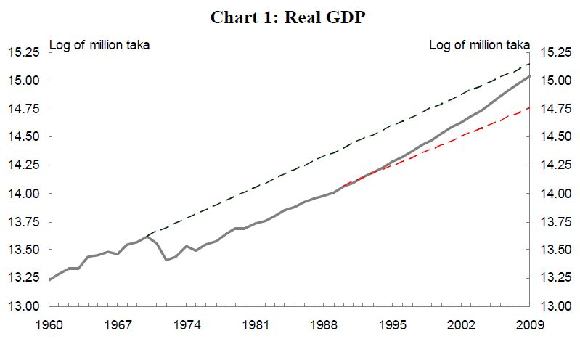
This entry gives the gross domestic product (GDP) or value of all final goods and services produced within a nation in a given year. A nation's GDP at purchasing power parity (PPP) exchange rates is the sum value of all goods and services produced in the country valued at prices prevailing in the United States. This is the measure most economists prefer when looking at per-capita welfare and when comparing living conditions or use of resources across countries. The measure is difficult to compute, as a US dollar value has to be assigned to all goods and services in the country regardless of whether these goods and services have a direct equivalent in the United States (for example, the value of an ox-cart or non-US military equipment); as a result, PPP estimates for some countries are based on a small and sometimes different set of goods and services. In addition, many countries do not formally participate in the World Bank's PPP project that calculates these measures, so the resulting GDP estimates for these countries may lack precision. For many developing countries, PPP-based GDP measures are multiples of the official exchange rate (OER) measure. The difference between the OER- and PPP-denominated GDP values for most of the weathly industrialized countries are generally much smaller.

Nominal GDP per capita in 2050

2005 | $422
2010 | $505
2015 | $611
2020 | $773
2025 | $1,018
2030 | $1,371
2035 | $1,865
2040 | $2,540
2045 | $3,379
2050 | $4,501

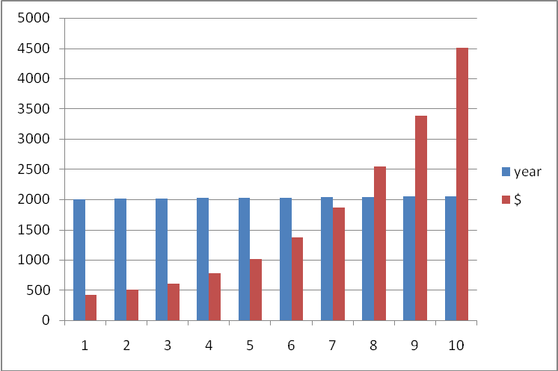
Figure: Nominal GDP per capita in 2050

GDP growth rate diagram in 2050

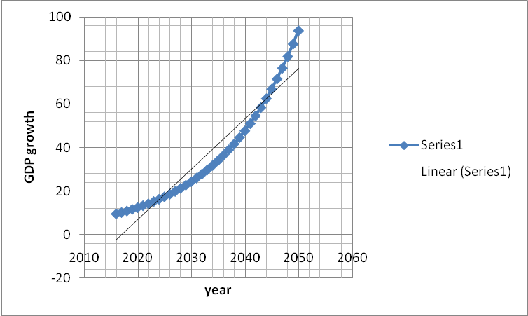
Figure: GDP growth rate in 2050

Bangladesh - Economic development

The major objectives of planned development have been increased national income, rural development, self-sufficiency in food, and increased industrial production. However, progress in achieving development goals has been slow. Political turmoil and untamed natural hazards of cyclone and flooding have combined with external economic shocks to persistently derail economic plans. Bangladesh's first five-year plan (1973–78) aimed to increase economic growth by 5.5% annually, but actual growth averaged only 4% per year. A special two-year plan (1978–80), stressing rural development, also fell short of its projected growth target, as did the second five-year plan (1980–85), which targeted 7.2% annual growth. The third five-year plan (1985–90) had a5.4% annual growth target though only 3.8% was actually achieved.
In 1991, with the reinstitution of elected government, a new economic program was initiated that included financial sector reform and liberalization measures to encourage investment, government revenue improvement efforts (realized largely through implementation of a value-added-tax), and tight monetary policy. Income transfer measures, Food-for-Work, and other programs were also implemented to help protect the poorest segments of the population from the transitional effects of structural reform. Political turmoil from 1994 to 1996 helped reduce the final average annual growth rate under the Fourth Five Year Plan (1990–1995) to 4.15% (short of the 5% target), albeit the best performance so far under an economic plan. The 1996 elections brought renewed economic stability. Exports grew 14% 1996, and GDP growth for 1996/97 rose to 5.5% as the economy rebounded. Floods during 1998 and 1999 caused some economic slowdown but this was balanced by unprecedented growth in gas production and electricity production sectors. Average annual GDP growth under the Fourth Five-Year Plan rose to 5.3%.
Fiscal year 2000 was marked by a sharp increase in monetary expansion due to unprecedented borrowing from the banking sector (though the sale of treasury bills) to cover budget shortfalls due. Domestic borrowing increased primarily due to the reduced availability of external concessional financing. Historically, Bangladesh has received foreign aid disbursements equivalent to about 6% of GDP, have lately declined to amount equaling 3–4% GDP. Moreover, according to the IMF, much of the domestic borrowing was being used to cover recurrent expenses such as wage and salary increases. The revenue to GDP ratio rose in 2001 from 8.5% to 9.4%, but this improvement was more than offset by expenditure to GDP ratios of 14.4% and 14.1%, creating budget deficits amounting to 5.9% and 5%, in 2000 and 2001 respectively. The drain on foreign reserves from domestic borrowing contributed to reducing the foreign exchange cover for imports to imprudent levels of two months in 2000 and one-anda-half months in 2001.
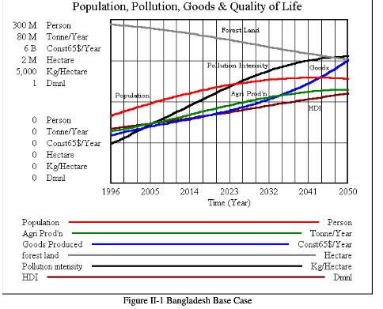

Four wheels of economic development

Human resource
The concern for policy and action planning guideline for human resources development in Bangladesh stems from the recognition that the economic progress of the past several decades, notable as it has been, has not led to the eradication of widespread poverty in the country. This is due, in part, to the limited attention paid to human resources as a crucial means as well as the ultimate end of development.
We can consider the following issues in guiding policies and planning for human resources development: (a) sequential and long-term approach; (b) assessment of the efficacy of formal and non-formal approaches; (c) strengthening of political and administrative infrastructure for promoting and supporting popular participation; and (d) ensuring adequate levels of resources.
Natural resource
The principal resources of Bangladesh are the fertile soils of the delta region, the long growing season, and the heavy rainfall suitably distributed over the year for growing rice and jute. The nation's abundant water supplies are used to produce hydroelectric power and for irrigating farmlands during the dry season. Although minerals have traditionally been economically unimportant, the country has large reserves of natural gas and some petroleum deposits. Natural gas is piped into Dhaka and CHITTAGONG for industrial use. There are also large deposits of low-grade coal, mined at Jamalpur.
I must add that Bangladesh's natural resource is huge in terms of low-cost artisans, sea-farers and empowered women with tailoring skills. Her rieverine and coaster fish and sea food resourcebase is very substantial. All these including the fertile soil is as yet untapped/ underutilized in terms of potential production and more imoportantly productivity growth due to lack of adequate investments, inadequate opening up to foreign investments, land reforms besides political instability, terroism and corruption.
Capital resource
Foreign capital means capital invested in Bangladesh in any industrial undertaking by a citizen of any foreign country or by a company incorporated outside Bangladesh, in the form of foreign exchange, imported machinery and equipment, or in such other form as the Government may approve for the purpose of such investment;
Foreign private Investment means investment of foreign capital by a person who is not a citizen of Bangladesh or by a company incorporated outside Bangladesh, but does not include investment by a foreign Government or an agency of foreign Government;
Industrial undertaking” means an industry, establishment or other undertaking engaged in the production or processing of any goods, or in the development and extraction of such mineral resources or products, or in the providing of such services, as may be specified in this behalf by the Government.
Technological resource
The socio-economic setting necessary for successful implementation of Science and Technology (S&T) policies in a developing country has been discussed and the concept of “technology culture” introduced. It is posited that the absence of technology culture in a given socio-economic setting makes implementation of S&T policies problematic. Technological resource base in Bangladesh and the low S&T achievement indices for the country, as worked out by some international organizations, are also presented. In discussing the status of existing R&D institutions it has been stated that, with the notable exception of agricultural research, there is absence of organized and well-planned research management systems in several areas. It is argued that even though individuals, national organizations and institutions continue to make commitments to development of S&T, the relative strength of such commitments vary significantly.

Development model

Defining development
It is difficult to define the level of development as there is a continuum from more to less developed and so they are relative concepts.
There are 4 main areas for defining development:
- Economic progress
- Technological improvement
- Social, cultural & political freedom
- Justice

Measures of Development
- % of people in each sector of industry
- GNP per person
- Birth rate / death rate / infant mortality rate
- Number of doctors per 1000 people.
- % of urban population
- Life expectancy
- Income
- Manufacturing workforce.
The most common measure of development is the Human Development Index (HDI).
However it is difficult to measure development, particularly cultural & political factors. There are also some problems with the measurements:
- Data from country to country may not be comparable.
- The data is not necessarily reliable
- There may be variations within a country making the average unreliable.
The results are very dependent on what indicators are used & their relative importance.

Gross National Product (GNP)
A measure of the wealth of a country. It is the total amount of money made from products & services by companies from a particular country. However there are some problems:
- Doesn’t include income inequalities.
- Don’t show regional variations.
- Does not take into account the cost of living.
- Fails to pick up the social & environmental impacts of development.

Gross Domestic Product (GDP)
This is instead a measure of the output of goods & services produced in that country which may not necessarily all belong to that country. The difference between GNP & GDP is likely to increase as a result of the rise in foreign owned companies & TNCs.

Purchasing Power Parity (PPP)
Relates the average earnings to the ability to buy goods. PPP therefore raises the GNP for developing countries & lowers it for developed countries. However it still doesn’t take into account regional variations or the social & environmental costs of development.
Rostows Development model

Creator: Walt Whitman Rostow 1916-2003 was an American economist who proposed his five stage model of development in the 1950’s, the ideas of which stemmed from modern free trade and Adam Smith. Rostow’s model does not deny John Maynard Keynes in that it allows for a degree of government control over domestic development not generally accepted by some ardent free trade advocates. Although empirical at times, Rostow is hardly free of normative discourse. As a basic assumption, Rostow believes that countries want to modernize as he describes modernization, and that society will assent to the materialistic norms of economic growth.
Purpose: requires a country to identify its distinctive or unique economic resources. The model puts forth the idea that a country can develop economically by concentrating on resources in short supply to expand beyond local industries to reach the global market and finance the country’s further development.

The Five Stages of Development:
1. Traditional Society- Refers to a country that has yet to begin developing, where a high percentage of people are involved with agriculture and a high percentage of the country’s wealth is invested in activities such as the military and religion, seen as “nonproductive” by Rostow. These are societies which have pre-scientific understandings of gadgets, and believe that gods or spirits facilitate the procurement of goods, rather than man and his own ingenuity.
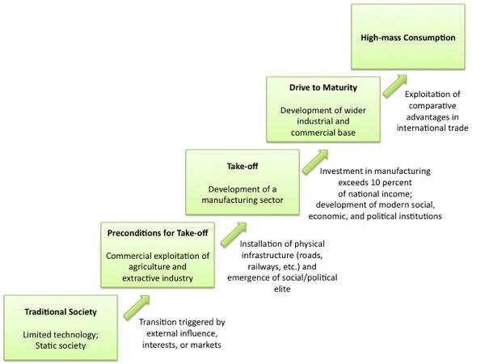
In 1960, the American Economic Historian,WW Rostow suggested that countries passed through five stages of economic development.

2. Transitional Stage- AKA the preconditions for takeoff. Under the model, the process of development begins when an elite group initiates innovations economic activities. Under the influence of these well-educated leaders, the country starts to invest in new technology and infrastructure, such as water supplies and transportation systems. These projects will ultimately stimulate an increase in productivity likely increasing the GDP. There is a limited production function, and therefore a limited output. There are limited economic techniques available and these restrictions create a limit to what can be produced. Increased specialization generates surpluses for trading. There is an emergence of a transport infrastructure to support trade. External trade also occurs concentrating on primary products.
3. Takeoff- Rapid growth is generated in a limited number of economic activities, such as textiles or food products. These few, takeoff industries achieve technical advances and become productive, whereas other sectors of the economy remain dominated by traditional practices. After take-off, a country will take as long as fifty to one hundred years to reach maturity. Globally, this stage occurred during the Industrial Revolution. Industrialization increases, with workers switching from the agricultural sector to the manufacturing sector. The level of investment reaches over 10% of GNP. The growth is self-sustaining as investment leads to increasing incomes in turn generating more savings to finance further investment.
4. Drive to maturity- Modern technology, previously confined to a few takeoff industries, diffuses to a wide variety of industries, which then experience rapid growth comparable to the takeoff industries. Workers become more skilled and specialized. The economy is diversifying into new areas the economy is producing a wide range of goods and services and there is less reliance on imports.
5. High Mass Consumption- AKA age of mass consumption. The economy shifts from production of heavy industry such as steel and energy, to consumer goods, such as motor vehicles and refrigerators. Of particular note is the fact that Rostow's "Age of High Mass Consumption" dovetails with (occurring before) Daniel Bell's hypothesized "Post-Industrial Society." The Bell and Rostovian models collectively suggest that economic maturation inevitably brings on job-growth which can be followed by wage escalation in the secondary economic sector (manufacturing), which is then followed by dramatic growth in the tertiary economic sector (commerce and services).
Main Points & Examples:
Rostow's development model was based on two factors. First, the developed countries of Western Europe and Anglo-America? had been joined by others in Southern and Eastern Europe and Japan. Second, many LDCs contain an abundant supply of raw materials sought by manufacturers and producers in MDCs. In the past, European colonial powers extracted many of these resources without paying compensation to the colonies, as core countries do to periphery. In a global economy, the sale of these raw materials could generate funds for LDCs to promote development.
- According to the model, each country is in one of these five stages of development. With MDC’s in stage 4 or 5, whereas LDCs are in one of the three earlier stages. The model asserts that today's MDC’s passed through the other stages in the past. For example, the U.S. was in stage 1 prior to independence, stage 2 during the 1st half of the 1800’s, stage 3 during the middle of the 1880’s, and stage 4 during the late 1800’s, before entering stage 5 during the early 1900’s. The model assumes that LDCs will achieve development by moving along from an earlier to a later stage.
- A country that concentrates on international trade benefits from exposure to consumers in other countries. To remain competitive, the takeoff industries must constantly evaluate changes in international consumer preferences, marketing strategies, production engineering, and design technologies.
- Examples of countries adopting this method of development include areas in East/Southeast Asia and Arabian Peninsula.
In Southeast Asia, a group of countries, Singapore, Taiwan, South Korea, and the former British colony of Hong Kong came to be known as the “four dragons” after adopting the international trade approach. They were lacking in natural resources so they promoted development by concentrating on producing a handful of manufactured goods, especially clothing and electronics. Low labor costs enabled these countries to sell products inexpensively in MDCs.
The countries of the Arabian Peninsula, which includes Saudi Arabia, Kuwait, Bahrain, Oman, and the United Arab Emirates, went from LDC’s to some of the wealthiest countries almost overnight due to increased petroleum prices during the 1970’s. Arabian Peninsula countries have used petroleum revenues to finance large-scale projects, such as housing, highways, airports, universities, and telecommunications networks.
Weaknesses:
1: Rostow is 'historical in the sense that the end result is known in the outset and is derived from the historical geography of developed society.
2: Rostow is mechanical in the sense the underlying motor of change is not disclosed and therefore the stages become little more than a classificatory system based on data from developed countries.
3: His model is based on American and European history and aspiring to American norm of high mass consumption.
4: His model represents a “non-communist manifesto” or we can say a “capitalist manifesto”.
Rostow's thesis is biased towards a western model of modernization, but at the time of Rostow the world's only mature economies were in the west, and no controlled economies were in the "era of high mass consumption." The model de-emphasizes differences between sectors in capitalistic vs. communistic societies, but seems to innately recognize that modernization can be achieved in different ways in different types of economies.
The most disabling assumption that Rostow is accused of is trying to fit economic progress into a linear system. This charge is correct in that many countries make false starts, reach a degree of transition and then slip back, or as is the case in contemporary Russia, slip back from high mass consumption (or almost) to a country in transition. On the other hand, Rostow’s analysis seems to emphasize success because it is trying to explain success. To Rostow, if a country can be a disciplined, uncorrupt investor in itself, can establish certain norms into its society and polity, and can identify sectors where it has some sort of advantage, it can enter into transition and eventually reach modernity. Rostow would point to a failure in one of these conditions as a cause for non-linearity.
Another problem is that Rostow’s work considers mostly large countries: countries with a large population (Japan), with natural resources available at just the right time in its history (Coal in Northern European countries), or with a large land mass (Argentina). He has little to say about small countries, such as Rwanda, which do not have such advantages. Neo-liberal economic theory to Rostow, and many others, does offer hope to much of the world that economic maturity is coming and the age of high mass consumption is nigh.
Limitations
Many development economists argue that Rostows's model was developed with Western cultures in mind and not applicable to LDCs. It addition its generalized nature makes it somewhat limited. It does not set down the detailed nature of the pre-conditions for growth. In reality, policy makers are unable to clearly identify stages as they merge together. Thus as a predictive model it is not very helpful. Perhaps its main use is to highlight the need for investment. Like many of the other models of economic developments it is essentially a growth model and does not address the issue of development in the wider context.
Rostow's thesis is biased towards a western model of modernization, but at the time of Rostow the world's only mature economies were in the west, and no controlled economies were in the "era of high mass consumption." The model de-emphasizes differences between sectors in capitalistic vs. communistic societies, but seems to innately recognize that modernization can be achieved in different ways in different types of economies.
The most disabling assumption that Rostow is accused of is trying to fit economic progress into a linear system. This charge is correct in that many countries make false starts, reach a degree of transition and then slip back, or as is the case in contemporary Russia, slip back from high mass consumption (or almost) to a country in transition. On the other hand, Rostow’s analysis seems to emphasize success because it is trying to explain success. To Rostow, if a country can be a disciplined, uncorrupt investor in itself, can establish certain norms into its society and polity, and can identify sectors where it has some sort of advantage, it can enter into transition and eventually reach modernity. Rostow would point to a failure in one of these conditions as a cause for non-linearity.
Another problem that Rostow’s work has is that it considers mostly large countries: countries with a large population (Japan), with natural resources available at just the right time in its history (Coal in Northern European countries), or with a large land mass (Argentina). He has little to say and indeed offers little hope for small countries, such as Rwanda, which do not have such advantages. Neo-liberal economic theory to Rostow, and many others, does offer hope to much of the world that economic maturity is coming and the age of high mass consumption is nigh. But that does leave a sort of 'grim meat hook future' for the outliers, which do not have the resources, political will, or external backing to become competitive.
Self-sufficiency
China, India and most African and Eastern European countries adopted this strategy at one time. The idea is to protect local, fledgling businesses from large, international competition. This also helps to make your country independent of the MDCs and not at the whim of TNCs.
Elements of self-sufficiency approach - Import limitation
-Higher taxes on imported goods (tariffs)
-Set quotas on imports
-Import-license requirements
India once did all of these and even made it illegal to exchange their money on currency exchanges.
The government wanted businesses to produce for India only (local businesses that is). If private companies could not make a profit, the government subsidized them.

Okuns Law

What Does Okun's Law Mean?
The relationship between an economy's unemployment rate and its gross national product (GNP). Twentieth-century economist Arthur Okun developed this idea, which states that when unemployment falls by 1%, GNP rises by 3%. However, the law only holds true for the U.S. economy, and only applies when the unemployment rate falls between 3-7.5%. Other version of Okun's Law focus on a relationship between unemployment and GDP, whereby a percentage increase in unemployment causes a 2% fall in GDP.

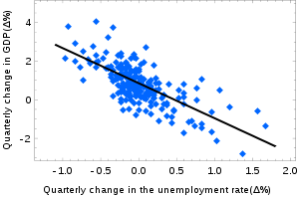
Graph of US quarterly data (not annualized) from 1947 through 2002 estimates a form of the difference version of Okun's law: %Change GNP = .856 - 1.827*(Change Unemployment Rate). R^2 of .504. Differences from other results are partly due to the use of quarterly data.
In economics, Okun's law is an empirically observed relationship relating unemployment to losses in a country's production first quantified by Arthur M. Okun. The "gap version" states that for every 1% increase in the unemployment rate, a country's GDP will be at an additional roughly 2% lower than its potential GDP. The "difference version" ^{[1]} describes the relationship between quarterly changes in unemployment and quarterly changes in real GDP. The accuracy of the law has been disputed. The name refers to economist Arthur Okun who proposed the relationship in 1962.

Imperfect relationship
Okun's law is more accurately called "Okun's rule of thumb" because it is primarily an empirical observation rather than a result derived from theory. Okun's law is approximate because factors other than employment (such as productivity) affect output. In Okun's original statement of his law, a 3% increase in output corresponds to a 1% decline in the rate of unemployment; a .5% increase in labor force participation; a .5% increase in hours worked per employee; and a 1 % increase in output per hours worked (labor productivity).^{[3]}
Okun's law states that a one point increase in the unemployment rate is associated with two percentage points of negative growth in real GDP. The relationship varies depending on the country and time period under consideration.
The relationship has been tested by regressing GDP or GNP growth on change in the unemployment rate. Martin Prachowny estimated about a 3% decrease in output for every 1% increase in the unemployment rate (Prachowny 1993). The magnitude of the decrease seems to be declining over time in the United States. According to Andrew Abel and Ben Bernanke, estimates based on data from more recent years give about a 2% decrease in output for every 1% increase in unemployment (Abel and Bernanke, 2005).
There are several reasons why GDP may increase or decrease more rapidly than unemployment decreases or increases. As unemployment increases,
- a reduction in the multiplier effect created by the circulation of money from employees
- unemployed persons may drop out of the labor force (stop seeking work), after which they are no longer counted in unemployment statistics
- employed workers may work shorter hours
- labor productivity may decrease, perhaps because employers retain more workers than they need
One implication of Okun's law is that an increase in labor productivity or an increase in the size of the labor force can mean that real net output grows without net unemployment rates falling (the phenomenon of "jobless growth").
As a relationship between changes in the unemployment rate and economic growth, Okun’s law predicts that growth slowdowns typically coincide with rising unemployment. The recent experience of 2006 shows, however, that this is not always the case. This article has documented several reasons for this. First among these is that Okun’s law is not a tight relationship. There have been many exceptions to Okun’s law or instances where growth slowdowns have not coincided with rising unemployment. This is true when looking over both long and short time periods. This is a reminder that Okun’s law—contrary to connotations of the word “law”—is only a rule of thumb, not a structural feature of the economy. This article has also documented that Okun’s law has not been a stable relationship over time. Part of this variation is related to the state of the business cycle: The relationship between output and unemployment is different in recessions and expansions, and recent expansions have been longer than average. Additionally, the data suggest that a weakening of the contemporaneous relationship between output and unemployment has coincided with a stronger relationship between past output growth and current unemployment.

The Harrod-Domar Model

Main Prediction: GDP growth is proportional to the share of investment spending in GDP.
Assumptions:
1. Assume unemployed labor, so there is no constraint on the supply of labor.
2. Production is proportional to the stock of machinery.

Growth Rate of GDP

We want to determine the growth rate of GDP, which is defined as:
G(Y) = (change in Y) / Y where Y = GDP
To do this, we estimate the Incremental Capital-Output Ratio (ICOR), which is a measure of capital efficiency.
ICOR = (change in K) / (change in Y) where K = capital stock
A high ICOR implies a high increase in capital stock relative to the increase in GDP. Thus, the higher the ICOR, the lower the productivity of capital.
Since capital is assumed to be the only binding production constraint, investment (I) in the Harrod-Domar model is defined as the growth in capital stock.
I = (change in K)
But investment is also equal to savings (S), which is equal to the average propensity to save (APS) times GDP (Y). Denote APS = s
I = S = APS * Y = s*Y
So,
ICOR = (s Y) / (change in Y)
Rearranging terms,
G(Y) = (change in Y) / Y = s / ICOR

Growth Rate of GDP per Capita

The growth rate of GDP per Capita is defined as

G(Y/P) = G(Y) – G(P) where G(P) = the population growth rate

From (1),
G(Y/P) = s / ICOR - G(P)
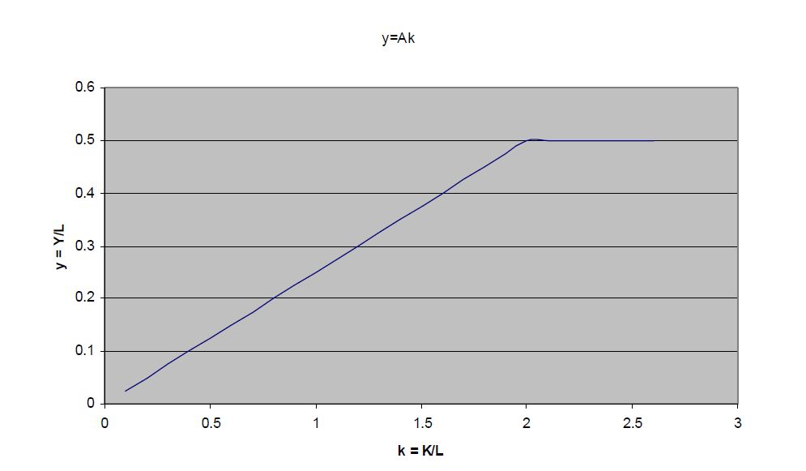

Thus, a 1 percent increase in population growth will cause the growth rate of GDP per capita to decrease by 1 percent. The empirical question is whether policy makers can achieve a constant marginal product of capital when the centralize investment decisions.

Examples

1. Assume that a country has a savings/investment rate of 4 percent of their GDP and an ICOR of 4, they will have a growth rate of 1 percent. But if the population growth rate were also 1 percent, then the country would have zero GDP growth per capita. These assumptions imply that for a country to develop, it needed to have an investment rate of around 12-15 percent of GDP, which would result in a GDP growth rate of 3 percent. The country in our example, however, only invests 4 percent. The difference between the required investment rate (12 percent) and the country’s own investment (4 percent) is what development economists call the financing gap. Foreign aid by Western countries fills this financing gap in order to attain the target growth for the country. However, unless the investment is used productively, there is no guarantee that it will generate the desired change in output.

2. The Harrod-Domar model assumes fixed coefficients:

Y = F(K,L) = min (AK,BL) where
A and B are positive constants. With fixed proportions, if the available capital and labor happen to fit AK=BL, then all workers and equipment are fully employed. However, if AK>BL, then only BLA⎛⎞⋅⎜⎟⎝⎠ of the capital is used and the rest is unemployed. If AK<BL, then only AKB⎛⎞⋅⎜⎟⎝⎠ of the labor is used and the rest is unemployed.
3. Assume that Shanistan producers cigars with a fixed coefficient technology:
Y = min (1/4K, 1/2L)
Currently, Shanistan has 80 units of K and 100 L. What is the feasible output?
Y = 20
What is employment? (1/2) 80 = 40
Divide both sides by L to get per capita output:
y = min (Ak, B)
If k< B/A, then K is fully employed and output y = Ak
For k> B/A, then Y = BL and capital would be unemployed, so y = B.
(In the graph, below, we derive y and k when 0<K<30 and L = 10).

Limitations of the model:
1. Economic growth and economic development are not the same. Economic growth is a necessary but not sufficient condition for development
2. Harrod Domar model was formulated primarily to protect the developed countries from chronic unemployment, and was not meant for developing countries.
3. Practically it is difficult to stimulate the level of domestic savings particularly in the case of LDCs where incomes are low.
4. It fails to address the nature of unemployment exists in different countries. In developed countries, the unemployment is ‘cyclical unemployment’, which is due to insufficient effective demand; whereas in developing countries, there is ‘disguised unemployment’.
5. Borrowing from overseas to fill the gap caused by insufficient savings causes debt repayment problems later.
6. The law of diminishing returns would suggest that as investment increases the productivity of the capital will diminish and the capital to output ratio rise.
The Harrod-Domar model of economic growth cannot be rejected on the ground of above limitations. With slight modifications and reinterpretations, it can be made to furnish suitable guidelines even for the developing economies.
Economical Development Challenges

Bangladesh has approximately 160 million people, making it the seventh-largest population in the world. It is a densely-populated country (> 1,000 people per km2), with a land mass roughly the size of the state of Iowa. Over the past 10 years, Bangladesh has made considerable progress to curb population growth: the average Bangladeshi woman now bears fewer than three children in her lifetime, down from more than six in the 1970s. Nonetheless, projections forecast more than 50% growth in Bangladesh’s population, to approximately 250 million over the next four decades. This poses massive challenges for the government in terms of employment and the delivery of social services. Further, between 20-30% of the country is normally flooded each year and the country suffers from frequent natural disasters. Dhaka City is poised to become fastest growing megacity by 2025. It began with a manageable population of 2.2 million in 1975 which reached 12.3 million in 2000. There is no city in the world that has experienced such a high growth rate in population during this period. Due to the current growth rate of 2.7, Dhaka will be 4th on the list of world’s megacities. This rapid growth of Dhaka City is not commensurate with its industrial development, with about one-third of the city’s population living in slums.
More than 45% of the population lives in abject poverty and 35 million live in extreme poverty. Bangladesh ranks 67th out of 84 countries in the Global Hunger Index 2009 and over 10 million children under the age of 5 suffer from malnutrition, which contributes to two in three child deaths. A weak public health system hampers delivery of care. The maternal mortality rate is one of the highest in the region but recently witnessed a 40% decrease to 194 deaths per 100,000 live births. Forty-nine percent of children under 5 and forty-six percent of women are anemic. Inequalities and challenges for women and girls are not adequately addressed, and improvement in this area is especially important given their role as gatekeepers of the country’s social capital. Further, Tuberculosis is still the major cause of adult mortality as Bangladesh has the fifth highest level of TB cases in the world. Fortunately, HIV/AIDS is well below 1% and our efforts will focus on maintaining that level.

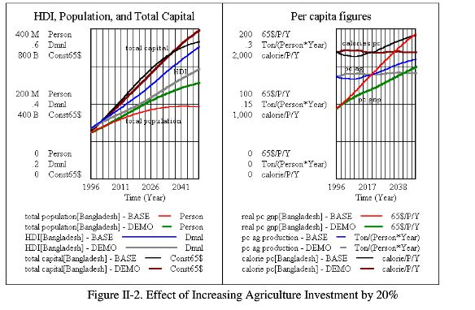

Part - 4 | Vision 2050
- Visionary goals of Bangladesh in 2050
- Bangladesh prospect of 2050
- Key Targets based on Vision 2021
- Millenium development goal of bangladesh
- Power Industry Goal
- Problems & solutions of BD economy
- Challenges and recommendation for economic growth
- Way of sustained growth in BD
- Six step policy for attaining development goal

Vision of Bangladesh 2050
We envision a democratic system where people choose their government freely and get services from it without hassle, enjoy freedom from fear and intolerance, live with dignity; where every citizen is assured of social justice, environmental protection, human rights and equal opportunities; and where the rule of law and good governance flourish. We envision a liberal, progressive and democratic welfare State. Simultaneously we envision a Bangladesh which by 2, will be a middle income country where poverty will be drastically reduced where, our citizens will be able to meet every basic need and where development will be on fast track, with ever-increasing rates of inclusive growth.
Goal 1
To become a participatory democracy
- Strengthened intra-party democracy and financial transparency
- A credible election process
- A transparent campaign financing system
- A civil and enlightened dialogue and debate oriented political culture
- An Effective Parliament and Accountable Members of Parliament
- Mandatory nominations for directly elected female Members of Parliament
- 1Widely implemented Right to Information Act
- An independent, efficient, decentralized and corruption-free judiciary
- Guaranteed protection of human rights and the rule of law
- A non-partisan and professional public administration system
- An elected President with meaningful discretionary power
- A vigilant and active civil society.

Goal 2

To have an efficient, accountable, transparent and decentralized system of governance
- A transparent and accountable policy-making process
- A transparent procurement system
- Wide use of e-governance in all government agencies
- An effective Anti-corruption Commission
- Planning, implementation and monitoring of the budget from a
- poverty alleviation perspective
- An independent Bangladesh Bank
- An efficient, transparent and people-friendly land administration
- A decentralized and devolved local government system
- A trusted, decentralized, and impartial police force
- A permanent Pay and Services Commission
Goal 3

To become a poverty-free middle-income country
- Greater productivity, diversification and commercialization of agriculture
- Accelerated growth in the industry and services sectors
- A competitive investment climate
- Increased global market access by Bangladeshi firms
- A diversified export base and markets
- A sizeable domestic consumer market
- Development of small town growth hubs via rural non-farm industries and services
- Sound financial institutions and greater financial depth
- A skilled workforce
- Higher foreign exchange earnings from the export of semi-skilled and skilled labor.
- Coordinated and complementary roles of the public and private sectors in all areas of the economy
- Poverty, income and employment
- Agriculture
- Land management,
- Diversification of agriculture, agricultural research, extension and communication
- Agricultural input supply, including irrigation
- Issue of subsidy
- Trade liberalisation and agriculture
- Food security and social safety nets
- Rural infrastructure and rural non-farm sector
- Industry
- Domestic industry
- Export oriented production
- Physical infrastructure
- Financial sector, financial infrastructure and capital markets
- Role of multinational corporations, foreign private investment and level playing field
- Revival of the jute industry
- Privatization of state-owned industries
Goal 4

To have a nation of healthy citizens
- A replacement level of fertility rate
- Survival and healthy development of all children
- Improved health and well-being of women
- Universal access to basic healthcare and quality services
- Better nutritional status of mothers and children
- Adoption and maintenance of healthy lifestyles
- Universal access to safe drinking water and sanitation towards improved public health
- Decentralization and community involvement to improve overall health services
- A rigorous medical education system

Goal 5

To develop a skilled and creative human resource
- Universal access to education up to the secondary level
- An integrated/unified education system
- Necessary infrastructure to ensure quality of education at all levels
- Analytical and creative thinking by our youth, supported by a core set of values
- Vocational training for secondary school graduates
- Need-based free tertiary education for the best students
- Increased opportunities for research
- A decentralized education system and effective education governance
- Computer literacy for all
- Gender balance at all levels of education
- A culture of Corporate Social Responsibility for increased investment in education
- Financing public education

Goal 6

To become a globally integrated regional economic and commercial hub
- Develop a clear marketing strategy to attract foreign investment
- Build a mega port along Chittagong coastline
- Build a super highway connecting the mega port with neighboring countries
- Establish an international airport in close proximity to the mega port
- Develop and expand port facilities at Mongla
- Develop cyber parks to boost an ICT driven service sector
- Ensure uninterrupted power supply all over the country
- Integrate into a regional energy market
- Promote the deepening and broadening of capital markets
- Train a suitable workforce
- More effective regional integration of Bangladesh economy

Goal 7

To be environmentally sustainable
- Effective urban planning
- Reduced air pollution
- Reduced water pollution
- Conservation of designated wetlands to maintain ecosystem balance
- Strengthened regional water management
- Retention and improvement of soil fertility
- Environmentally safe waste management and disposal by households, hospitals and industries
- Cost-effective alternate sources of energy
- Protection of designated forest areas
- Effective natural disaster management
- Institutionalization and effective implementation of EIA

Goal 8

To be a more inclusive and equitable society
- Access to productive asset opportunities for the property-less and marginalised groups
- Corporate ownership rights for workers and the deprived
- Safety nets for vulnerable groups
- Ensuring gender equality
- Provide minimum guaranteed employment opportunities for the resourceless
- Targeted programmes for the physically challenged
- Economic and social inclusion of minorities
- Guaranteed access to educational and healthcare opportunities for the resource-poor and minorities
- Promotion of cultural, religious and ethnic diversity as a national heritage
- Reduced regional inequality.

Goal 9:
Sustainable power and energy
Bangladesh will generate around 30,000 MW electricity per year, and explore new possible & probable COAL & Gas reserve to substrate Bangladesh’s energy demand for at least 100years
- Generating electricity
- Generation of electricity from proven gas reserve
- Proven coal reserve 7 nuclear power plant
- The government should encourage the entrepreneurs to invest in the captive power generation by waiving the renewal fee
- Concentrated & coordinated efforts by Govt.

Goal 10
Technology based agriculture
Bangladesh will have enhanced productivity based on modern technology, diversified types of agricultural outputs, & commercialized agricultural produce. The economy of Bangladesh is primarily dependent on agriculture about 84 percent of the total population live in rural areas and is directly or indirectly engaged in a wide range of agricultural activities.

Opportunities:
- Agriculture sector is the single largest contributor to GDP.
- Crop production system is highly labour intensive and there is an abundance of labour supply in the country.
- Agriculture is the largest source of employment for skilled and unskilled labour.
- Favorable natural environment generally exists throughout the year for crop production.
- Wide range of bio-diversity exists for different crops.

Constraints:
- Agriculture is dependent on the vagaries of nature and is risky.
- Availability of cultivable land is decreasing.
- Lack of proper land use planning.
- Widespread poverty among the population engaged in agriculture.
- Lack of required capital for agricultural activities.
- Agricultural commodities are rapidly perishable and post harvest losses are too high.
- Inadequacy of appropriate technology considering farmers’ socio-economic conditions.
- Decreasing yields of different crops due to slow expansion of modern technology as well as unplanned use of soil and water.
- Uncertainty of fair price of agricultural due to underdeveloped marketing system.
- Very weak backward-forward linkage in agriculture.
Why need?
- Supply seeds & fertilizers
- Innovative technology based productions
- Better land usage
- Increasing domestic milk production
- Increasing the cold storage facility
- Poultry & dairy medical services
- Removing the role of intermediate agent
- Overcoming the shortage of working.

Bangladesh prospect of 2050

1. Democracy and effective parliament
Democracy and strong democratic institutions will be established for holding reliable election at regular intervals, accountability of government and effective Parliament. All necessary steps will be taken for making Parliament effective.

2. Political framework, decentralization of power & people’s participation
Local government will be given due importance with a view to effecting radical change of the political system. The local government institutions will play a critical role in development programmes. Self-reliant local self-government institutions will be established at upazila and zila levels to ensure representative, responsive and functional governance at the grassroots levels.

3. Good governance through establishing rule of law and avoiding political partisanship
Human rights will be established on a strong footing with a view to ensuring the rule of law. Independence of the judiciary will be ensured and the institutions of the state and administration will be freed from partisan influence. The basis of appointments and promotions will be merit, efficiency, seniority, honesty and loyalty to the Republic; political connections will have no relevance.

4. Transformation of political culture
Terrorism, corruption and use of religion for politics will be eliminated. Steps appropriate to the time will be taken to establish democratic principles in the political parties, transparency of political funding, civility and tolerance.
5. A society free from corruption
The institutions of the State will be made more effective along with an independent and strong Anti-corruption Commission for curbing corruption. Social resistance to corruption will be promoted along side legal steps. All possible steps will be taken to stop corruption, such as charter of citizens’ rights, right to information, computerization of official documents, and decentralization of power. Adequate checks at every level of public spending would be built into the financial management system of the government.

6. Empowerment and equal rights for women
The Women’s Policy of 1997 will be revived for ensuring equal right and access for women to the state and social space; laws which discriminate against women will be amended and 100 seats will be reserved for women for direct election.

7. Economic development & initiative
a. Meeting basic needs: With a view to providing food, clothing, shelter, education and health care to the citizens in accordance with Article 15 of the Constitution, gross domestic product will be raised to 8% by 2013 and 18-20% by 2050 which will be sustained thereafter.
b. Population and labour force: Population in 2050 is estimated at 195m, and labour force at 135m. Programmes will be taken up for employment of at least 90% of the work force.
c. Alleviation of poverty: We aim not at reduction of poverty, but removal of poverty, through which we shall try to achieve the Millennium Goals declared by UN by 2015, and by 2017 latest. Beginning in 2050, poverty will be reduced to 5% from 45% now, progressively. Number of poor people will rise from 45 million now to 65m in 2021, and then fall to 25m in 2021. Sustainable safety nets will be established for the extreme poor until poverty is removed.
d. Food & nutrition: Food deficiency will be removed and self-reliance in food production achieved by 2012, which will enable us to meet the nutrition needs of 85% of the population.
e. Health care: By 2050, a minimum daily intake of 2,122 kilo calories of food, elimination of contagious disease, primary health care and sanitation for all will be ensured. Average longevity will be increased to seventy years, and efforts will be made for the reduction of child and maternal mortality.
f. Education: Enrolment at the primary level will be increased to 100% net by 2010. Elimination of illiteracy by 2014, improvement in the quality of education, creation of a generation educated in science and technology, graduation degree level education made free by 2013 and ensuring higher salary for teachers are the other educational goals.
g. Industry: A strong foundation for industrialization will be established by 2050. Contribution of the industrial sector to national GDP will be doubled. Primacy will be given to agro and labour intensive industries and the highest emphasis will be given to the information technology sector. The investment policy will be geared to implementing a strategy for attracting both domestic and foreign investment.
h. Energy security: An energy policy will be adopted tapping all sources of traditional and non-traditional energy to ensure an accelerated rate of economic development and industrialization. A three year crash programme will be taken up to meet the existing crisis. By 2015, electricity production will be increased to 8,000 megawatt. By 2050, demand for electricity is projected to increase to 35,000 megawatt. We will take all possible actions aiming at enhancing our generation capacity. To increase gas production, regular survey of gas resources and work on well development will be undertaken. To meet energy demand, efforts will be undertaken for regional energy security through mutual cooperation in addition to exploring internal sources.
i. Infrastructural development: Road, rail, river and air transport and telecommunication systems will be expanded. Construction of bridges and tunnels for Padma and Karnaphuli rivers, connecting Bangladesh with the Asian highway and Asian railway, improvement of port facilities, building of a deep sea port to open up Bangladesh's ports to countries of Asia will be implemented. In Dhaka, construction of a metro tunnel, elevated rail and circular rail to remove traffic jams and to solve public transport problems will be studied forthwith in order to undertake a feasible project. The project will then be implemented on a priority basis.
j. Housing: By 2015, housing for all will be ensured. In every union and upazila, ‘growth center’ centric village housing and in towns housing with modern amenities will be implemented.
k. Environment: All measures will be taken to protect Bangladesh, including planned migration abroad, from the adverse effects of climate change and global warming. Facing natural calamities, planned reduction of air pollution, prevention of industry and transport related air pollution and disposal of waste in scientific manner will be ensured. Steps will be taken to make Bangladesh an ecologically attractive place through retention of forests and water bodies and prevention of river erosion.
l. Water resources: Bangladesh Awami League will take the initiative to formulate a comprehensive regional water policy along with India, Nepal and Bhutan for regional water security. In addition, in keeping with a comprehensive water policy, articulated earlier by Bangladesh Awami League, measures will be taken for development of our water resources and their rational use.

8. Bangladesh in the global arena
a. Achievements of liberation: Multi-pronged measures will be taken to uphold the glorious history and the fruits of our national independence and liberation, to energize the new generation with the spirit of liberation, struggle, patriotism and love for humanity. Highest priority will be given to the development of an innovative spirit in the younger generations and opportunity will be provided for them to participate in nation building activities.
b. Culture: Measures will be taken to remove obstacles in the development of Bengali culture, literature, art, music and sport and to provide all opportunities by the state to enable the younger generations to attain international standards and to contribute to the nation.
c. Foreign policy: In international affairs Bangladesh will follow the policy of ‘friendship towards all and malice towards none’.
Key Targets based on Vision 2021

- Secure and sustain an annual rate of GDP growth of 8 per cent by 2013, which will increase to 10 per cent from 2017.
- Bring down the proportion of disadvantaged people living below the poverty line to 25 million, i.e. 15 per cent by 2021.
- Ensure a minimum of 2,122 k.cal/person/day of food for all poor people and standard
nutritional food to at least 85 per cent of the population by 2021.
- Ensure 100 per cent net enrolment at primary level as soon as possible after 2010, provide free tuition to degree level as soon as possible after 2013, attain full literacy as soon as possible after 2014, and ensure that Bangladesh is known as a country of educated people with skills in information technology.
- Achieve self sufficiency in food by 2012.
- Ensure living accommodation for the entire population as soon as possible after 2015,
- supply of pure drinking water for the entire population as soon as possible after 2011
and bring each house under hygienic sanitation by 2013.
- Eliminate all contagious diseases and increase life expectancy to 70 years by 2021.
- Reduce maternal mortality to 1.5 per cent, raise the use of birth control methods to 80 per cent, and bring down infant mortality to 15 per thousand live births by 2021.
- Change the sectoral composition of output with the shares of agriculture (primary), industry (secondary), and services (tertiary) standing at 15 per cent, 40 per cent, and 45 per cent respectively in 2021.
- Reduce the unemployment rate to 15 per cent; change the shares of agriculture industry, and services in employment to 30 per cent, 25 per cent, and 45 percent respectively in 2021.
- Generate 8,500 megawatts of electricity by 2013, which will increase to 11,500 megawatts in 2015, and make provisions to meet the expected demand for power of 20,000 megawatts in 2021.

Millenium development goal of bangladesh

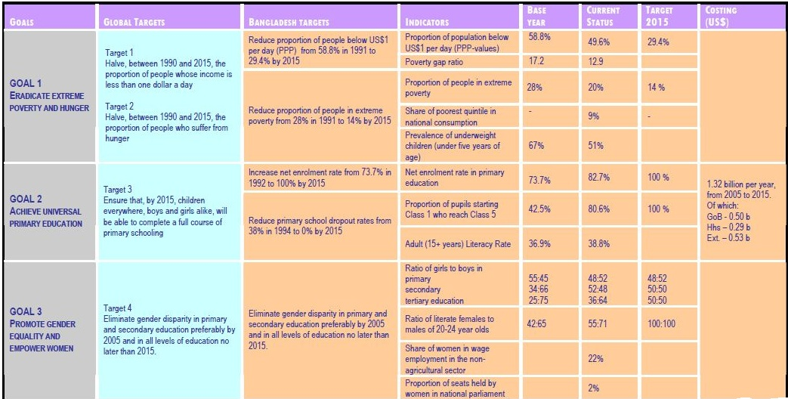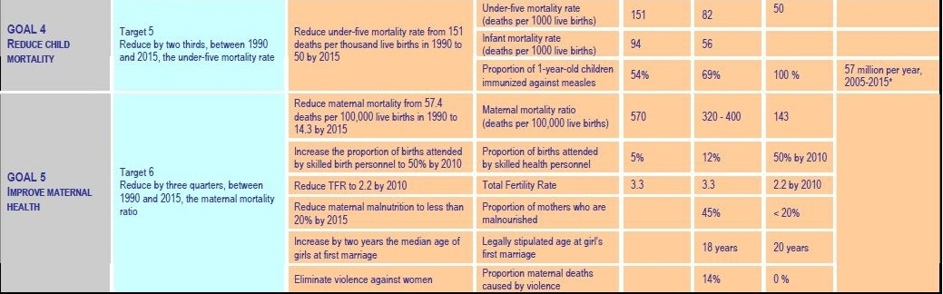

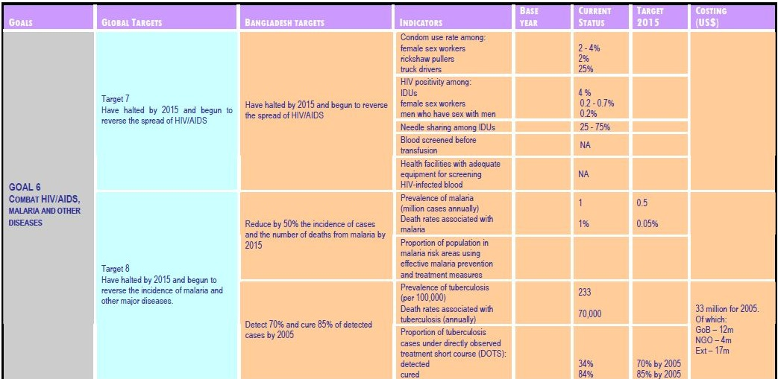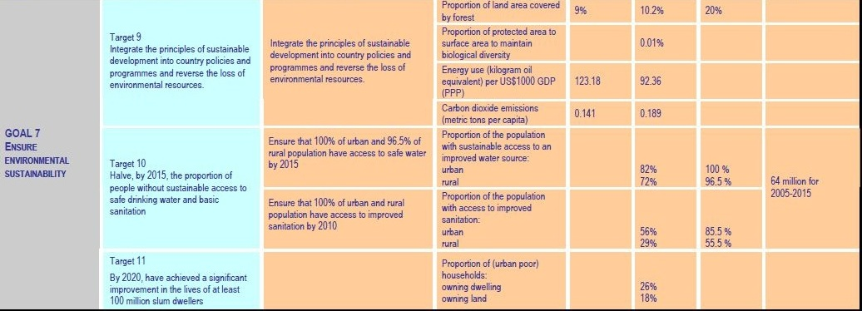

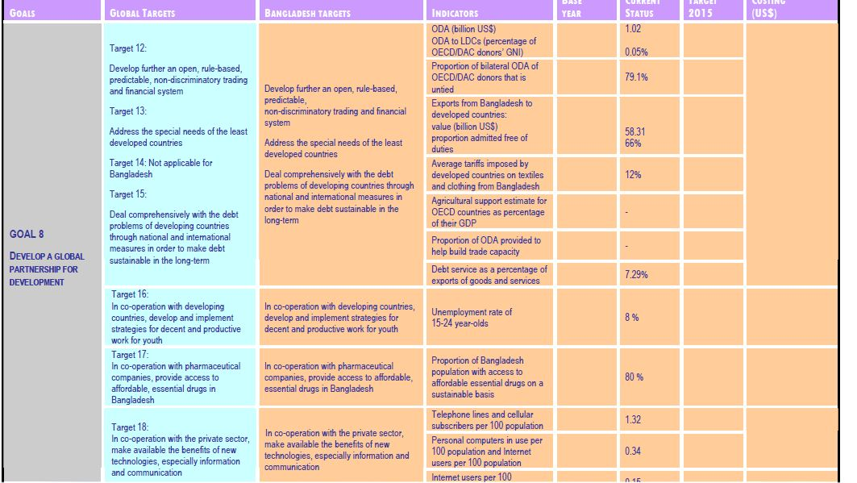

Power Industry Goal

At present, 48.5% of the total population of Bangladesh is enjoying the electric facilities. As of April 2010, the total numbers of transmission and distribution lines are recorded to 8,359 km and 266,460 km respectively. However, 53,281 villages have been electrified so far. In Bangladesh per capita generation is 220 KW hr which is comparatively lower than other developed countries in the world.

Recent Status:
Installed capacity (Feb 2011) | 6,658 MW
Derated generation capacity | 5,480 MW
Generation | 3,900-4,300 MW
Maximum generation (Feb 2011) | 4,699 MW
Peak demand | 5,800 MW
Access to electricity | 47%
Per capita generation | 220 KW hr
Public and private sector produces 63% and 37% of electricity respectively. Public sector produces electricity through Bangladesh Power Development Board (BPDB), Ashuganj Power Station Company LTD (APSCL) and Electricity Generation Company of Bangladesh (EGCB). On the other hand, private sector produces power through small independent power producers and rental that government buys at a constant price. BPDB individually produces 46% of the total production.

Electricity Production (Public), 2010, by %
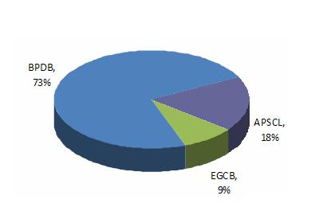
Electricity Production (Private), 2010, by %
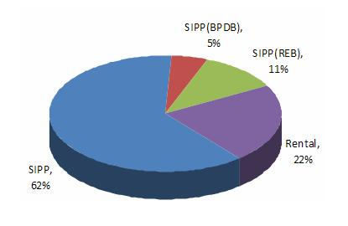
Raw material used to produce electricity, 2010, by %
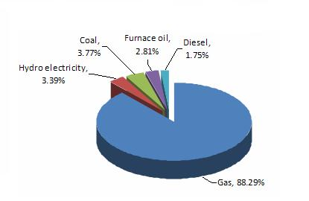
Bangladesh is progressing through a phase of development where automation is the key to its economy and business. As the country continues to industrialise the importance of power generation and electricity supply becomes a key government priority.

Power Industry Development Plan
In order to realize the government’s vision to provide electricity to most of the population at a reasonable price and to achieve overall socio-economic development of the country, the government of Bangladesh has initiated a Power and Energy Sector Development Roadmap (2010-2021) which targeted to produce 8,500 MW by 2013, 11,500 MW by 2015 and 20,000 MW by 2021. However, to ensure overall and balanced development of this sector government has taken various plans in terms of duration. The plans have been developed based on a techno-economic analysis and a least-cost option. These plans include balanced development in generation, transmission and the distribution system to achieve a desired level of reliability of supply. A summary of the development plan is given as follows:
Short Term Plan (2011)
According to the short-term plan, liquid fuel based 12-24 months of implementable power stations will be established. However, government has initiated to implement a power station with a capacity of 920 MW.

Mid Term Plan (2012-2015)
Under this plan, government has taken into account to establish 3 to 5 years of implementable coil based power stations with a capacity of 2,600 MW to the total capacity of 7,714 MW.

Long Term Plan
As of the Power and Energy Development Roadmap (2010-2021), government expects to meet the desire destination (20,000 MW by the year 2021) through the increment of 10% production per year towards reaching the per capita consumption to 600 Kw.

Projected Surplus Electricity Production (Year wise)
Year | Public sector | public sector | Total (MW)
2011 | 920 | - | 920
2012 | 505 | 1,764 | 2,269
2013 | 725 | 950 | 1,675
2014 | 1,170 | - | 1,170
2015 | - | 2,600 | 2,600
Total surplus |  |  | 9,426

Projected Electricity Demand and Supply (Year wise)
Projected data | 2011 | 2012 | 2013 | 2014 | 2015
Projected demand (MW) | 6,298 | 6,832 | 7,709 | 8,699 | 9,812
Capacity retired (MW) | - | - | 448 | 378 | -
Projected supply (MW)  (excluding quick rental) | 5,177 | 7,029 | 8,326 | 9,545 | 11,625
Projected supply (MW)  (including quick rental) | 6,363 | 8,683 | 9,764 | 10,527 | 12,601
Shortage/surplus (MW)  (exlcuding quick rental) | -1,121 | 197 | 617 | 846 | 1,813
Shortage/surplus (MW)  (including quick rental) | 65 | 1,851 | 2,055 | 1,822 | 2,789
Bangladesh is steadily climbing up the development ladder. Energy and power needs to act as a key catalyst in helping Bangladesh in this endeavour. Industries are being automated and the country is gradually moving from a labor-intensive economy to a capital intensive one. Electricity and power are vital to the nation at such a stage. Bangladesh has a vast market as far as power and electricity is concerned and good prospects for constructing power generation plants exist in the country in terms of resources available and government policies.
Problems & solutions of BD economy

Vast Population. Bangladesh being a small country has around 150 million populations. This figure is growing rapidly day-by-day. In order to achieve and maintain a recognized standard of living for them, the basic needs of this vast population have to be met first. Then education and employment has to be ensured for every citizen in order to maintain social law and order. This is a huge task for a developing country like Bangladesh. With required international assistance, Bangladesh needs to turn this vast population into ‘Population Resource’ by following:
- Introducing technical education and skill development training.
- Creating job facilities for all.
- Facilitating vast migration as skilled manpower to Europe and Middle Eastern countries.
- Developing awareness for family planning and ensuring medication for all in order to ensure good standard of national health.
- Ensuring social justice and democracy.
Population Growth. The population growth (1.47% as per Census 2001) has to be kept controlled within the capacity of national economy so that the later can support the development of ‘Human Resource’.
Terrorism. Terrorism is growing as a serious concern in Bangladesh not only for the Govt but also for all levels of citizen. hundreds of killings by several bomb blast has shaken the stability of the society. Even foreign ambassador and the opposition Party Leaders have been made target by anti-state elements. Govt can ensure security of all by adopting following:
- Establish strong intelligence network throughout the country to monitor the terrorists.
- Ensure adequate protection for any diplomat and political gatherings.
- Ensure arrest of leaders of any terror organization.
- Strong vigilance along the border to prevent infiltration and exfiltration of any terror group.
- Ensure recovery of all illegal weapons.
- Effective check of arms smuggling.
- Finding out suspects of all bomb attacks.
- Ensuring exemplary punishment for terrorists and illegal arms holders.
- Seek international support where necessary.
- Raising people’s awareness against terrorism through media propagation.
- Countering terrorism and separatist movement in CHT.
Unemployment. Every year around 12 to 14 lakh students appear at each SSC and HSC Exam. Our traditional school and college education system produce young generation who are not qualified on any trade. An employer cannot expect any skilled performance from these passed out youths. Again there is no employment opportunity created in the country by the govt. Almost all the products available in the market are imported, very few items are produced within own country. Even Ball Pens are also imported. So unemployment causes poverty, drug-addiction, social crime etc which destabilizes the law and order situation throughout the country. To solve this problem, our Govt. can do the following:
- Introduce practical oriented education system which will facilitate employment just after passing out.
- Introduce massive 5 year program to train the unskilled youths in any skillful subject.
- Introduce law for banning import of items which are easily produced within the country, such as gems clip, blade, steel lock, bye- cycle tyre/ tube, ball pen etc.
- Undertake short-term and long-term policies to establish small and large industries for production of common commodities. Agricultural and communication sector’s machines should be produced within the country which will have a large market within the country itself. Reduce import gradually.
- Facilitate training and higher education at home and abroad for students at a large scale.
- Facilitate foreign employment.
- Encourage self-employment business by providing loan with min tax and other support required.
- International organizations can be invited to train our youths by establishing various training institutes.
- Private entrepreneurs can be encouraged for establishing various training institutes and industries.
- .Conduct survey all over Bangladesh to identify feasibility for establishing cottage, small and large industries.
Massive Corruption. Bangladesh has become number 1 corrupted country in the world thrice. This has seriously affected country’s image and foreign investment in the country. Govt. needs to :
- Identify weaknesses and measures to control the corruption at all levels.
- Ensure strict law and punishment for bribe takers, human traffickers, smugglers, illegal stockholders etc.
- Introduce moral education in all institutions.
- Assign responsibility for each sector to control corruption within particular period.
Poverty Reduction. This problem cannot be solved by nights. Our Government can reduce the poverty level by undertaking a long-term and short-term national strategy by following:
- Massive industrialization in small and large scale industries sectors, thus ensuring massive employment.
- Ensuring free education not only for girls but also for poor boys.
- Introducing technical education in both traditional schools and madrasas.
- Arranging foreign employment and facilitating large scale migration for skilled workers.
Political Unrest. Political conflict and lack of tolerance for opposite opinion is a serious problem for national unity and development. Recent introduction of bomb culture has complicated the issue to a greater extent. Following can be done:]
- Steps to be taken for national unity by the ruling alliance and opposition parties.
- Opposition parties’ participation to be included in nation building programs.
- Strike should be band unanimously.
- Law and Order Maintenance Committee should be formed at each Upa-zila level by combining both ruling and opposition party leaders who will identify criminals and ensure action by law and order authority.
- Muscle power and use of excessive money should be restricted in election.
- Terrorists should not be sheltered by any party.
Religious Fundamentalism. Due to frequent occurrence of religious violence in neighboring India, Bangladesh also may suffer from the spillover effect created by any extremist group. Our Govt. needs to do following:
- Remain vigilant and firm to prevent such occurrence.
- Propagate religious tolerance and peaceful coexistence through media.

Illiteracy. As education is the backbone of a nation, our national backbone is weak due to large scale of illiteracy. The definition of literacy needs to be evaluated. Only education of traditional method does not provide any fruit in the practical field. So any person trained and skilled in any particular profession should be recognized as ‘literate’. Nursery, cow fattening, poultry firming etc need no pen and paper education but practical training on those aspects is perfect and effective training for them. In Bangladesh, more than 2500000 middle class families possess house servants who are girls or boys, these poor fellows remain illiterate and learn no technical job other than house cleaning or cooking. Allowing such a large number of young people illiterate, how can a nation overcome poverty? Our Govt. can solve this illiteracy problem by:
- Arranging practical education for respective professionals who are aged such as farmers, fishermen, poultry farmers etc.
- Effecting law for ensuring attendance of children in schools.
- Introducing penalty for not sending house workers to school. Some Child labor-watch-dogs should be employed for checking this.
- Introducing Education Loan from banks for any student who applies.
Child Labour. More than 5000000 child labors work in different houses, small industries and on footpaths. Their working time is never maintained by employers though every year ‘May Day’ is observed in our country. Their salaries also vary from employers to employers. A nation cannot prosper by neglecting such a large number of populations of younger age. Our Govt. can solve these human right violations by:
- Introducing an ‘age-limit’ for employment in any household or outside work.
- Introduce a ‘minimum wage’ rate for any worker in any job.
- Introduce ‘maximum time limit’ for work and ‘over-time’ system for their extra time labour.
Prostitution. Every year thousands of Bangladeshi women and children are trafficked to foreign countries for working in sex industries. Also more than lacs are engaged in such inhuman trade within the country. This creates not only human miseries for those unfortunate women and children but also risking the spread of AIDS, drug addiction and related crimes in the country. Bangladesh Government with the support of neighboring/foreign countries and UNO can solve this tragedy by:
- Ensuring economic emancipation of common mass.
- Ensuring awareness.
- Ensuring severe penalty for traffickers.
- Ensuring border control for illegal trace pass.
- Arranging proper rehabilitation of victims.
- Taking support of neighboring and destination countries.
- Taking assistance of UN body.
Violence Against Women. This a serious social curse that women are subjected to torture, divorce, trafficking, rape, acid attack, killing, burning, abandoning by husband, unequal treatment etc. The Govt. can implement following:
- Pass and implement harder law against for such act of inhumanity.
- Raise social consciousness against such torture.
- Introduce awareness through academic syllabus at school , college and university level.
Cast of Dowry. Every year hundreds of women are to face torture and divorce or even murder for the demand of dowry. Raise of social hatred and punishment can be introduced against such demand.
Gender Inequity. Male and female ratio in our country is 103.8: 100 as per Census 2001. Around half of the population of the nation is women, so by keeping themselves aloof from nation building activities, country cannot prosper. Govt. should ensure following:
- Equal facility for education and employment.
- Equal wage rate and social-treatment should be ensured.
- Raise awareness through media and education system.
Violence in Educational Institutions. Almost all the public universities are badly affected by so-called ‘student politics’. Frequent strikes and terrorist activities in these universities hamper the educational process. This creates session jam and unnecessary sufferings of poor students. As a result, every year thousands of Bangladeshi students get admitted in India. Our Govt can solve this problem by:
- Introducing academic and disciplinary systems so that no student gets chance to get involved in student politics.
- Ensure ousting of outsiders from student campus and halls.
- Ensure strong surveillance to detect illegal arms and take drastic measures against terrorists.
- Establish minimum one university in every district and reduce student numbers in each university.
- Ban professor’s politics
- Ban all types of political gathering and procession within and near university area.
- Facilitate establishment of private universities and develop their standard.
- Facilitate large number of students’ admission in developed countries.
- Introduce ‘last age limit’ for students to continue study in universities so that no student can remain in university more than years required for Honours and Masters Degree at a stretch.
- Introduce strong disciplinary measures for students staying in different halls such as morning and evening roll call, in-out checking, compulsory study and rest period, restriction on guests etc.
Hostility by big Neighbor and Need for Deterrent Defense. Survival of this country as a sovereign political entity is under threat from her big neighbor by which it is geographically surrounded. Neheru’s ‘One India Doctrine’ is still being pursued by the Govt of India which dreams reunification of Pakistan and Bangladesh with India. In order to deter any military misadventure by India’s Forces, Bangladesh needs to:
- Maintain a sizable force compatible to any potential invader.
- Possess modern armament (with effective anti-Tank and anti-aircraft defense system ) and equipment to effectively deter any aggressor.
- Maintain adequate number of troops to counter any internal separatist movement like Chakma Tribal’s insurgency in Chittagong Hill Tracts (CHT).
Lack of Skill Education Policy. Our education policy is not capable of meeting the challenges of practical needs. In order to make the education fruitful to the development of the country, Govt. needs to:
- Introduce practical oriented subjects which will be helpful for the student’s employment.
- Education to be made complementary to the needs of the country. Student should be developed as a skilled force for the development of the country.
Slum Dwelling. Approximately 1 million people live in slums in Dhaka City. They get minimum level of health, hygiene and sanitation and dwelling facilities in those slums which is inhuman. Our Govt. NGOs and international organizations should come forward to reduce miseries of these poor people by:
- Providing dwelling facilities.
- Rehabilitating by creating employment.
- Arrange training for youths on different skills.
- Arrange education for children.
- Establishing cottage, small and large industries in the rural areas to encourage repatriation and stop further migration to cities.
- Arrange distribution of newly raised islands in the south of the country and create administrative, medical and communication facilities to encourage poor people for settling there.
Micro Financing. Present system of micro financing with high rate of interest only enriches the NGOs and making the credit holders poor to poorer. Govt. banks, NGOs and international grant authorities should provide more micro credits to poor people so that they can do some income generating activities and also return the loan easily. Our Govt. should:
- Fix a minimum interest rate for all micro lending by NGOs and save the poor from suppression.
- Banks to provide loans with easer terms.
- Stop middlemen’s interference and illegal profit.
Lack of Adequate Mineral Resources. There are limited quantities of mineral resources available which are not adequate to fulfill the long-term requirement of the gradually increasing vast population. In order to preserve and ensure optimum utilization of country’s meager mineral resources, our Govt. needs to:
- Conduct unbiased survey of all types of mineral resources.
- Develop own exploration organizations and avoid dependence on foreigners.
- Ensure access of all citizens to gas and solar power in order to reduce deforestation.
- All vehicles to be converted to CNG system.
- Preserve the gas and oil resources for future generations.
Lacking Behind in Satellite Communication. Bangladesh needs to have own satellite for communication, media, survey and intelligence requirement. Dependence on foreign satellites may not serve the purpose in time of need. If our nearby orbit is captured by other countries then we will not get orbit to place our satellite. In order to be independent on this aspect, Bangladesh needs to :
- Educate own researchers and scientists at home and abroad on space technology.
- Establish a research center for conducting research and development.
- Undertake plan to possess own satellite.
Hazardous Transportation System. There are lacks of transports ply in the country. Due to lack of wide road, poor traffic system and different types of unfit transports, road accidents and traffic jam causes many deaths and loss of countless working hours every day. In order to streamline our traffic system, Govt. needs to:
- Widen the roads throughout the country.
- Ensure fitness of all transports ply on road. Ban unfit vehicles.
- Authorize scientific designs for body construction of different types of vehicles.
- Convert all motor engines into CNG system.
- Introduce traffic system in educational curriculum.
- Ensure modern driving training and licensing system.
- Facilitate extension of Dhaka City.
- Shift max Govt. offices, from center of cities.
- Construction of new super markets and high raised buildings beside narrow roads to be restricted.
- Establishment of new industry within the city to be restricted.
- Hawker stalls to be removed from roadside.
- Develop modern residential areas and markets at outskirts of the city to encourage shifting of people and reduce pressure on existing unplanned city.
Food Shortage. Every year several million metric tons of food grains are to be imported by spending lots of foreign currencies. Food production may be increased by:
- Providing modern agricultural technologies to our farmers.
- Proving agricultural loans to farmers at easier terms.
- Undertaking flood control measures.
- Ensuring water reservation by digging canals, ponds, excavating rivers, constructing embankments and ensuring due water share from India.
- Ensuring pesticides and fertilizer at affordable prices to farmers.
- Arrange cultivation of huge newly raised islands.
- Arrange agricultural education packages for farmers to raise their production skills.
- Ensuring high productive seeds in time.
- Establishing agricultural institutions in all districts.
- Restricting food stacking and ensure adequate supply.
Impact of Globalization. Due to revolution in communication technology, rise of world level corporate giants, political and economic interests of developed countries, impact of globalization is an unavoidable reality in today’s world. In order to survive as an independent and sovereign nation, Bangladesh needs to achieve independence on economic sector. To sustain negative impact of globalization, Bangladesh needs to:
- Encourage Foreign Direct Investments (FDI) and facilitate establishment of EPZs.
- Increase production and value adding capability to meet internal and export-target requirement.
- Increase diplomatic and trade relation with developed and ASEAN countries.
Trade Deficit. Every year Bangladesh suffers a trade deficit of around 35000 crore Taka with India. Again Indian good of worth 40000 crore Taka are smuggled into Bangladesh. Bangladeshi markets are flooded with Indian goods. Besides these, barriers put by India against our export to that country affecting the very survival of our industries. In order to reduce the trade deficit with India and other countries, Bangladesh needs to:
- Pursue stronger diplomacy.
- Put ban on import of goods which can be produced within own country like food grains, fish, clothes, cycle parts, pens, office stationeries etc.
- Ensure effective border checking for smuggled goods.
- Patronize establishment of various industries within own country and enrich own export basket.
- Raise patriotism by media for use of own products.
- Increase export to ASEAN and Islamic Economic Zones.
Lack of Foreign Direct Investment (FDI). Bangladesh needs to encourage the world nations and international financing organizations to invest more in social, economic and infrastructural development of the country. Political stability, improved law and order situation and managerial efficiency is required for attracting and proper utilization of FDI which needs to be ensured by the Govt.
Dependency on Foreign Technology and Goods. No country can be real independent if it remains dependent on foreign countries for it’s every kind of technology. Bangladesh being a country of 15 crore population, is dependent on foreign countries for it’s agricultural, transportation, industrial, defence and all other types of technologies. Even after 33 years of independence, no research institute has been established for technological research and development. To be independent on technological side, Bangladesh needs to:
- Establish a ‘Research and Development Organization’ for all kinds of technological research and development.
- Establish industries for producing transportation equipments like-Motor Cycle, CNG Taxi, car, Van etc.
- Produce all agricultural machineries like power pump, trailer, tractor etc within own country.
- Be self reliant in producing certain categories of arms and ammunitions within own country as Bangladesh may be cut off from rest of the world in times of any invasion by potential neighbour.
- Emphasis on introducing technology oriented education in all educational institutions.
Poor Water Management. Bangladesh has no water management policy to meet the water demand of her vast 15 crore population. In the cities, villages and hilly areas, people suffer from inadequate supply of water. Lack of water for irrigation causing food shortage in the country. Tista Barrage itself is going ineffective due to siltation in Tista River. To overcome this, our Govt needs to:
- Prepare a water management plan for the country.
- Ensure preservation of water by digging ponds and canals and building embankment around haors/bills of Sylhet and Rajshahi etc.
- Dazing of rivers for maintaining water transportation.
- Encourage forestation by loan.
Insignificant Trade with ASEAN Countries. Bangladesh has become dependent on Indian goods as it she did not develop trade relation with other neighboring countries of Asia from where we can meet our demand easily. Present initiative of the Govt. for

improving relation with ASEAN countries may reduce our dependence on India. Our Govt. needs to:
- Develop and maintain diplomatic relation with ASEAN countries.
- Establish road communication with Myanmar and then with China and Thailand.
- Encourage tourism to and from these countries.
- Study needs of those countries and e encourage our entrepreneurs and exporters to increase trade with those countries.
- Build Karnophuli Bridge over River Karnophuli immediately to facilitate export –import with those countries.
Lack of adequate Patronization for IT Revolution. Though few steps taken by the Govt. for IT development, there needs more initiative to keep the pace with the modern world. IT Revolution does not mean distribution of few computers in few schools. To mean a real revolution, our Govt. needs to:
- Arrange to create required numbers of IT instructors to meet countrywide demand.
- Arrange distribution of required number of computers in every school, college, Madrasa and university.
- Arrange purchase of computer by every student with long-term credit.
- Ensure production of adequate units of current.
- Ensure supply of current and solar power in all rural areas.
- Arrange higher education on specialized subjects of IT.
- Arrange employment of IT specialists at home and abroad.
- Promote development and export of Software.
Negligence in Human Resource Development and Export of Skilled Manpower. Bangladesh may convert her vast population into Population Resource. Skilled people are demanded by European, American, African and Middle Eastern countries. Bangladesh may hold this vast market of skilled manpower. For this, our Govt. needs to:
- Introduce technical education in educational institutions.
- Arrange skillful training for employed and unemployed youths.
- Provide adequate study loan on long-term basis.
- Assist for employment in international job market.
Dependency on Primitive Technology in Agriculture, Transportation and Industrial Sector.
To boost our economy, we need to adopt modern technology. Our Govt. needs to:
- Provide modern equipments for agriculture along with its training.
- Develop roads throughout the country and introduce modern transportation along with training.
- Introduce modern technology in industrial sector to improve production level.
- Arrange training on different technologies to develop skilled manpower to operate modern machines.
Flood and Poor Disaster Management System. Flood has become every year’s tragedy for the people of Bangladesh. This is not a natural but a man-made disaster as India releases huge quantity of upper-stream rain water through Farakka Barrage opening all the gates suddenly. As due to Farakka Barrage all the river’s bed has became filled up with silt. This has reduced water containing capacity of the rivers. Even our maritime transportation system is also becoming ineffective due to raise of several islands in the rivers. To solve this, our Govt. needs to:
- Arrange gradual release of water through Farakka Barrage by India.
- Digging of canals, dredging of river beds to increase river’s water containing capacity.
- Arrange early warning for people.
- Introduce floating seed fields and vegetable fields.
- Arrange adequate measures for protection of fisheries so that fishery projects are not overflowed by flood.
- Preserve adequate amount of medicine and relief materials stacked for distribution with immediate effect.
- A National Disaster Management Policy should be undertaken taking Govt and opposition parties’ representatives.
- International communities to be involved in surveying the effect, estimate the damage and providing assistance for rehabilitation.
Probability of Earth Quake. Bangladesh is located within a dangerous perimeter of earth-quack zone. Around every year, earth quack is traced here. An earth-quack of greater. Any earth quack within the Dhaka or Chittagong City area is likely to cause devastating effect on peoples lives and property. To reduce the damage, our Govt. needs to:
- Undertake a national policy to manage the disaster.
- Ensure abidance of engineering design for construction of buildings.
- Ban present system of gas supply for household use by pipeline as this gas line will cause fire and burning of lives and properties. Govt. should introduce cylinder compulsorily for house-hold purpose.
- The electricity supply line also should be made under surface to avoid people’s death by electrification.
- A reserve of emergency food and medicine should be maintained to manage big level crisis.
The major issues for sustainable development in socio, economic and environmental sectors have been identified and some suggested measures put forward for policy formulation. Our approach to these issues needs to be undertaken based on national interest and NOT political party-biased interest. Though the approach may be different from government to government; but all these issues need to be taken under consideration to find feasible solutions.
Challenges and recommendation for economic growth

- Improve the Image of Bangladesh in the International Community:

Bangladesh should establish a positive image by highlighting its reform and opening up, the growth of the media, cable television, the rapid expansion of the cellular phone network (the subscriber base should cross 50 million by the end of the year), and technological improvements and reforms in the communications and the ICT sectors. Developments in the ship building, pharmaceutical, textile and RMG sectors also need to be projected. It is also important to communicate widely the on-going initiatives to combat corruption, install regulatory reforms and make improvements in the business climate in the country.

- Compete in an increasingly competitive global environment:

Bangladesh must continue the strategy of emphasizing trade over aid; it should also take advantage of the foreign investment funds flowing into its dynamic regional neighbors, India, Vietnam, and China.

- Remittances and Diaspora:

It is important to build bridges with the Non-Resident Bangladeshi (NRB) population. NRBs can contribute most significantly to the national economy of Bangladesh, especially in terms
of investments. Thus Bangladesh should promote investment facilities for the NRBs. These investments can help increase the foreign reserves of the country, as well as promote its gross productivity. It is highly likely that if the policies are convenient to NRBs, they will be keener to invest in Bangladesh. Moreover, the diaspora population could potentially allow access to the global economic and financial chain, as they may have linkages with foreign trade channels.

- Respond to the global economic crisis:

Bangladesh must continue the easy money policy until there are clear signs the economic trends have turned positive. Policy makers must also provide a large fiscal stimulus to modernize the nation’s infrastructure and protect the economy from the global economic slowdown.

- Reduce regional disparities:

To sustain development and gain political support for fundamental reforms, citizens residing in different parts of the country should all experience an improved living standards and quality of life.

- Maintain price stability:

Since food and energy prices have come down substantially in world markets, the overall inflationary pressures should remain in check in the foreseeable future. The public must be apprised of the global price scenario through media releases.

- Improve Bangladesh-India Bilateral Relations:

There are still many unresolved issues in the Bangladesh- India bilateral relations. The proper way to mitigate these problems is to pursue an effective and consistent foreign policy. Apart from the regular diplomatic initiatives such as arranging regular summit level meetings, public diplomacy can also play an important role to solve many of these problems. The government of
Bangladesh should try to promote public diplomacy; that is, to promote interaction among the people of both the countries.

- Strengthen Regional Cooperation in South Asia:

Among the most noteworthy achievements of Bangladeshi diplomacy has been the creation of SAARC. As such, our diplomacy should continue focusing on strengthening SAARC as a platform for peace and prosperity in the region. Regional cooperation in the energy sector has become vital for maintaining security and development in the region. A comprehensive and integrated trade facilitation framework needs to be adopted in our foreign policy incorporating: promoting integrated transport infrastructure including transit and transshipment of goods; facilitating and promoting development and modernization of Chittagong and Mongla sea ports as regional hubs; pursuing economic diplomacy to remove non-tariff barriers in trade between Bangladesh, India, Pakistan, Nepal, Bhutan, and SriLanka; promoting regional customs cooperation; and promoting regional energy cooperation. Bangladesh should also pursue market access in different parts of the world. Through economic diplomacy, Bangladesh. Should develop and maintain close linkages with the OIC, ASEAN, EU, and the Commonwealth.

Way of sustained growth in BD

The secret of achieving sustained high growth really is no secret at all. The fact that it is no secret does not mean, however, that it is easy to achieve.
Growth should be easy for those starting out far behind, and lists out 17 reasons, all of which hold true for Bangladesh:
1. Far below the frontier levels of labour productivity and total factor productivity, and with a low stock of capital per worker.
2. Have a young population, that is, a large population of working age relative to the economically inactive population.
3. Educate the workers and future workers, men and women, to the maximal extent.
4. Let the best and brightest be educated abroad. They will come back if the country provides a reason for them to come back.
5. Create a professional, well-trained career civil service.
6. Strive for institutions that support the orderly succession of supreme political power. Avoid personalised autocracies.
7. Create a market economy and rely to the fullest possible extent on the profit motive for the provision of private (rival and excludable) goods and services.
8. Invite in FDI to the fullest extent. The technology, know-how and expertise it brings in are far more important than the equity funding these are bundled with.
9. Invite foreign businesses, entrepreneurs, managers and workers and open up to the global treasure chest of ideas.
10. Make sure you can achieve economies of scale, either by having a large domestic market or by opening up fully to world trade. Global export markets will allow you to exploit any economies of scale for traded goods and services. Competition from foreign imports and FDI will keep domestic producers in both traded and non-traded sectors on their toes.
11. Focus limited public spending on infrastructure, health, pre-school, primary and secondary education and vocational training and poverty relief.
12. Achieve high domestic investment rates and fund domestic capital formation mainly through domestic saving. Funding domestic capital formation with foreign saving/current account deficits always brings additional risks with it.
13. Liberalise the capital account slowly and deliberately, making sure the domestic banking sector and financial system can cope with the stresses and strains brought by financial openness. the way to minimise corruption is (a) to limit bureaucratic discretion (the source of corruption rents), (b) to maximise transparency and openness in government and (c) to encourage an open society, through diverse and critical media and a thriving civil society (to maximise the risk of exposure). When closer to the frontier, the quality of institutions matters more.
14. Make sure domestic financial market development and international financial integration do not get ahead of your supervisory and regulatory capacities.
15. Try to make sure that domestic savers have choices other than bank deposits and residential real estate. Consider the early liberalisation of portfolio investment abroad for this reason.
16. Encourage competition. Avoid man-made obstacles to entry and exit in labour markets and product markets, wherever possible. Avoid unnatural monopolies.
17. Regulate natural monopolies through transparent, accountable mechanisms.

Six step policy for attaining development goal

Policy-1…..Ensure human rights, establish democratic values and practices, improve governance, and establish rule of law:

In order to achieve a prosperous and progressive society, a clear policy statement must emanate from the government that addresses the most fundamental concerns: (i) human rights (ii) democratic values and practices, (iii) governance and (iv) rule of law. No nation can progress without satisfactorily addressing these fundamentals. The Constitution of Bangladesh stipulates that all power of Bangladesh belong to its people. We recommend its full implementation in letter, spirit and practice and urge the elected public representatives to remain pledge-bound to this sacred trust. It is particularly important for the new government to make a clear statement about Bangladesh’s stance on its secular values. At the very least, it must emphasize
and reiterate its tolerance and respect for “all” faiths and creeds, giving them the assurance that, as citizens, their legitimate rights will have equal protection. The people of Bangladesh have also been historically deprived of democratic values and practices that have been replaced by despotic and dictatorial regimes. Re-establishment of democratic values must become a priority of the present government: from the party, to the community, to the national level.

The contributions of the military, however, need to be recognized. They have demonstrated in the past that they are often better at bringing stability to unstable situations. The recent and successful voter drive by the military is also noteworthy. Political leaders, bureaucrats and the military must work together so that their unique strengths are not frittered away in tensions and conflict. The rule of law has to be established immediately. To plan the transition to a modern economy, policy makers must create a 21st century regulatory framework. Crime and corruption must be brought to an end. Reforms must be undertaken to increase transparency in government policy-making, raise public awareness, establish independence of the anti-corruption bureau, strengthen the independence of the judiciary, and build up the civil society. The party in power and the opposition must each set the tone for bipartisanship and respect for the civil society. Finally, appropriate steps must be taken so that the elections and transition of power occur smoothly every five years.

Policy-2……Generate Employment

Each year approximately two million additional workers enter the labor force looking for jobs. Even if the population growth rate declines dramatically, large annual additions to the labor force will continue for some years given the dynamic effects of demographic transition. The new administration will be responsible for creating roughly 10 million new jobs during its five years in office. The minority communities, including women, must have the same opportunities in the government’s efforts to create jobs. The collapse in crude oil prices and the abrupt end to the real estate bubble in the oil-producing Middle-East may result in the return of many Bangladeshi workers. As the share of the farm sector in the economy continues to decline, the industrial and service sector must be able to create millions of new jobs to absorb the influx of farm labor. In this backdrop, we recommend that the new government take a number of steps to boost employment. The administration should create jobs for Bangladeshis by facilitating increased flow of remittances that work their way into creating jobs in the economy. Second, a sophisticated and sustained effort must be launched to substantially increase foreign direct investment in Bangladesh. There is no reason why Bangladesh cannot compete with its Asian neighbors like Vietnam, which have attracted a large pool of global investment, thereby creating millions of jobs. Bangladesh must be seen as an attractive destination for global investors.
In sum, global investors must be made to feel welcome.
The new government should build on the demonstrated record and potential of micro-finance and other non-traditional strategies popularized by the Grameen Bank, BRAC and other globally recognized NGOs to create small- and medium-scale entrepreneurs, who are self-employed and who can create new jobs in the local economy. A massive investment program strategically implemented to build the national infrastructure for the traditional and the new economy will create millions of new jobs directly, as well as through the multiplier effect.

Policy-3…..Achieve Long-term Food Security

As long as millions of Bangladeshi citizens live on the margin of starvation, any natural disaster or price spike in the international food markets can create a painful food crisis. The recent food crisis (2007–08) was partially caused by disruptive price bubbles in the world rice and grain markets. Self-sufficiency in food production is an important challenge, and a stated goal by the major political parties. We welcome this commitment, particularly in light of the high levels of inflation during 2007–08 that devastated the purchasing power of many ordinary citizens in Bangladesh. The recent reductions in fertilizer and diesel prices reflect the government’s concerns about food security. This will bring welcome relief for farmers producing the next boro crop. The recent collapse in the price of crude oil should help maintain the lower price of fertilizer and diesel, two very important ingredients for farmers. The extent of price reductions must, however, account for cross-border informal transactions (smuggling) that could run counter to the goal of benefiting the farmers from such measures. Food security also has more to do with real incomes (buying power) than the available stock of food. The battle for poverty alleviation is thus the struggle for increasing real incomes for all Bangladeshi citizens. Second, major investments in the agricultural and food market infrastructure — roads, waterways, railways, storage facilities, dredging the rivers and embankments for flood control, etc. — will help the farmers increase production and income, while creating jobs, and help the country reach food self-sufficiency. Bangladeshi farmers must also benefit from the ready availability of credit to invest in modern farm machineries, the availability of flood insurance and futures markets to reduce risks, and from having greater access to market information via the mobile phone and the Internet.

Policy-4…..Increase Investments in Infrastructure and Energy

Infrastructure
We recommend that the new administration take up the challenge of laying the foundations of a 21st century infrastructure as a top priority. Bangladesh’s physical infrastructure is in serious disrepair and has lagged behind compared to its needs. Thus, patients die on their way to hospitals in the rural areas for lack of decent roads and transportation modes. Food supplies do not move readily from one area to another to match demand and supply, causing temporary price spikes. And the clogged streets in the cities that delay deliveries of key shipments (especially garments) increase the uncertainty and cost of doing business and encumber competitiveness. A bold and ambitious strategy of investment to build the country’s infrastructure will achieve multiple outcomes: generate immediate employment and income to reduce poverty, reverse the impact of the ongoing global economic slowdown, support ready-made garment (RMG) and other export industries, and ultimately create conditions for sustained economic progress. In the face of a severe global economic slowdown, the time is right to take up this project. Massive and strategically planned investments in physical and digital infrastructure can help Bangladesh leapfrog other nations, and at the same time work as a stimulus package to create jobs necessary to confront the vagaries of global recession. These mega projects should be undertaken with a firm commitment..

Energy
Energy is a prime mover of the national economy. With vibrant sectors such as ready-made garments, pharmaceuticals, shipbuilding, agro-industries, ceramics, raw hides and leather goods, jute, tea, and related products, as well as the service industries, that earn huge foreign exchange and are reliant on consistent supplies of energy, the government must have a viable energy policy that will address short and long term energy needs for the country’s operation and development. As capacity is gradually increased, how that capacity will be allocated also needs to be projected for a stable and sustainable growth model of the economy. It may also be noted that roughly 30% of the population presently has access to power supplies. With the present output of roughly 5,000 MW of electricity, effective power generation by the PDB is about 3900 MW while private power suppliers produce about 1200 MW. With a burgeoning population and the need to extend power to a larger segment of the population, power generation capacity must be increased substantially. We project that a 100% increase in power generation would be immediately absorbed. Reliance on natural gas to generate power must be weighed against alternate sources. Reliance on imported oil is not a solution for Bangladesh and hard earned remittances and export dollars should not be spent on unplanned energy expenditure as oil prices raise. Relying on domestic energy will also lower the rate of inflation, the current account deficit, and the continued devaluation of the taka. Energy efficient transportation systems, alternative energy development and use for power and industrialization needs will allow the country to continue its low carbon imprint. Local entrepreneurs should be encouraged to invest in small power plants and renewable energy technologies to increase and diversify the production capacity of the national grid.

Policy-5…..Invest in education and develop human resources

The education system of Bangladesh must be designed afresh. Foremost is the need for a comprehensive and fresh education policy that envisages the specific needs of Bangladesh for the present, as well as for the future. The government must envision a ground-up new education system that integrates the various, unrelated and incoherent streams of education that exist today.
The government must be able to clearly state what entities are to be produced by the education system and to what purpose. We reiterate that it is imperative for such system to consider the needs of Bangladesh now and for the next few decades. The new administration must find resources to invest in education at all levels, aligning this part with the needs of building, supporting and sustaining the nation’s infrastructure, industries, and service sectors. The 21st century global economy will increasingly demand knowledge workers. To this end, the government must offer more technical and vocational training opportunities to build people with technical skills — basic machining, operating, repair, computer operations, etc. — with a basic 10th grade education. The government needs to promote and establish programs to train people for retail, transportation, education, and other service sector jobs, since these are the primary areas of employment. By expanding literacy to 100% of the population and ensuring that an increasing number of young people have opportunities for higher education, the nation can succeed in alleviating poverty and achieve other ambitious goals. Another alarming problem is the current capacity of the education system in Bangladesh to accommodate the growing number of willing and capable students. In 2005, out of approximately 73 million students of different age-groups, only 25 million had any education (90% at primary, 44% at secondary, 10% at intermediate college and 1.6% at university levels). During this year, the number of educational institutions was approx: 80,397 (primary), 18,500 (secondary and higher secondary), 3,150 (intermediate, colleges) and 74 (universities). By 2025, the population will grow to a staggering 192.9 million, of which nearly 83 million people, an increase of nearly 10 million additional students, will be of school age. At the current rate of attendance, the nation will have to increase capacity by 15%, will have to build almost 15,318 additional educational institutions. And, if the demand for education goes up (which is expected to happen), even by adding 100% to capacity, the system will be under tremendous pressure for space, especially at the higher education levels.

Policy-6…..Manage the Nation’s Health and Population

Health
Health and human productivity are intertwined. There is a bi-directional relationship between health and economic development. The positive externalities of keeping a nation’s human resources healthy also cannot be emphasized enough. From a policy perspective, the government must be able to envision the desired state of health of the nation reflected in nutrition, water quality, air quality, economic status, mental health, physical health, reduced state of disabilities, etc. What is vitally important is to articulate a pro-poor health strategy where accountability, quality, cost effectiveness, access, and sustainability must be ensured, all focusing on the need for more effective and efficient health programs. The focus on preventive rather than curative health care must be strengthened. The National Health Accounts study (NHA-2, 2003) estimates household expenditures at Tk. 48.35 billion on health related expenses of which pharmaceutical purchases constitute around 70%, while expenditures on qualified medical providers is only 4.1%. This represents a problem in that the ability to purchase drugs freely can be downright harmful. Legislation must address this problem so that drugs are not available without qualified prescriptions. We also advocate periodic certification of healthcare providers (doctors and nurses in particular) to ensure that the people receive a basic standard of services. In addition, we feel many trained doctors end up in administrative work far removed from the direct provision of health services. We advocate the establishment of health administration training so that a different cadre of health administrators is created for those who want to be administrators.

Population
Bangladesh is the 7th largest nation in the world. Estimates are that there are now about 150 million people that is expected to grow to 250 million before it stabilizes. This can be seen as strength if managed properly. Thus, population management (not control) should be given major attention to harness this strength effectively, both for the local economy as well for earning from abroad. It is easy to surmise the tremendous opportunities that await a skilled workforce to fill the population bust, thereby sending remittances back to Bangladesh that could be multiples of the present $6.4 billion. The under-15 population is also roughly 40% of the total population, resulting in the “population momentum” phenomenon driven by the young age-structure of the population. When it comes of age, its needs must be met, not only in education and health, but in employment and various service needs.

Ending summary

Bangladesh started its journey from 1971. But it doesn’t get its targeted development on economy and other social sectors. Bangladesh is a democratic country but it doesn’t enjoying its advantages of democracy. Bangladesh has a great potentiality of development in economy and social sector. Bangladesh is in a sweet geographic from where a country can enjoy the potentiality of development.
Bangladesh is an agrarian country in south eastern area of Asia. Its economy largely depends on agro based sector but now the trends are changing and economy is mainly depending on garments industry. Bangladesh receives a huge amount of export earnings from garments industry. Even though Bangladesh is not prospering due to some disorders on distribution of wealth. There are huge corruptions on economy; population is also a great problem economical development. Bangladesh has a vast population rather than its geographical area. So that Bangladesh economy is not progressing. Even though, Bangladesh can gain sustainable development through some policy and with some attainable goals. Bangladesh govt. has taken some initiative to boost its economy. Bangladesh has to follow international development policy to boom its economy. Population control is one of the major challenges for Bangladesh to attain its economical vision; corruption is another challenge for Bangladesh. Illiteracy is another problem for Bangladesh and has to overcome it as soon as possible. Bangladesh has to look after more on industrial sector for getting sustainable development. Target for Bangladesh should to attain GDP rate in double digit. By following those policy and recommendation Bangladesh can boost its economy.

Part-5 | Appendix

Appendix

Web References
- <ntth://www.dcci.com.bd/>
- <ntth://www.goggle.com./>
- <ntth://www.bangladesh2050.com.bd/>
- <ntth://www.dsebd.com.bd/>
- <ntth://www.bbsas.com.bd/>
- <ntth://www.fbcci.com.bd/>
- <ntth://www.mof.com.bd/>
- <ntth://www. Bing.com/>

Other References
Books:
- Major Performance of Bangladesh.
- Bangladesh 2020
- Digital Bangladesh
- Millennium development goal
Seminars:
- Seminar on Strategy for Growth. Bangladesh 2030
- Seminar on ICT, 1st Driver of Strategy for Growth. Bangladesh 2030
- Seminar on Clean Development Mechanism
- Seminar on Climate Change

***************End**************

