INTERNSHIP REPORT
ON

CUSTOMER SATISFACTION THROUGH CUSTOMER SERVICE POINT OF GP LTD: A CASE STUDY

Submitted by

WWW.ASSIGNMENTPOINT.COM

CHAPTER-1

The Organization


TTT

  - INTRODUCTION OF THE COMPANY

GrameenPhone Ltd. (GP) is the market leader in the mobile telecommunication industry of Bangladesh. The address of its Head Office is: GP HOUSE. Bashundhara, Baridhara Dhaka ‐ 1229, Bangladesh. GP is a joint venture between Bangladesh and Norway. Major shareholders were Telenor and Grameen Telecom. In 2008 it went public. Presently the shareholder status of the company is Telenor (55.8%), Grameen Telecom (34.2%), Institute (5%), and Public (5%). Telenor is the state owned telecommunication company of Norway. It has operations in different countries of the world. On the other hand, Grameen Telecom is the sister concern of Grameen Bank, one of the biggest Non Government Organizations (NGO) of Bangladesh.
Principally GP was established in 1995. But due to government policy, GP did not permission to start their operation. The license agreement was signed on October 31, 1996. They started the hard work of the developing the infrastructure facilities in the country. GP did not take much time to start its operations. The commercial launch was on March 26, 1997. Bangladesh is a developing country. Per capita income here is very low. Very few people have access to telecommunication. In this situation GP started their operation here. GP’s aim was to develop one GSM cellular mobile communications network in Bangladesh in competition with two other GSM operators and one AMPS (Advanced Mobile Phone System) operator. GP aims to provide the best possible technical quality, customer service, and coverage also in the rural areas at the most favorable prices, to as many customers possible in Bangladesh. Grameenphone has so far invested more than BDT 15,900 crore to build the network infrastructure and will reinvest their profit share to GP.

The GrameenPhone network is designed with latest computer assisted design technology. GP has reached its break‐even point in the year 2000, in the fourth year of its operation. The company made its first net profit of $ 3.7 million during the year ending in December 2000.
GrameenPhone is the leading Cellular Net Provider in Bangladesh. GrameenPhone started their business approximately 12 years. Since then GrameenPhone has been operating in the market for a long time. During this time GrameenPhone went for different types of mergers as well as acquisitions.
They gained success from the very beginning of their operation and were capable enough to hold the success year after year. GrameenPhone main competitors are AKTEL, BANGLA LINK, and CITYCELL AIRTEL TELECOM & TELETALK. One of the strongest sides of GrameenPhone is its customer’s service and relationship.
GrameenPhone was awarded license to operate as a mobile telecommunication service provider in Bangladesh on 28th of November 1996. It officially launched its network on 26th of March 1997 and went into commercial operation on 15th of April.

1.2 HISTORY OF GRAMEENPHONE LTD

November 28, 1996:
GrameenPhone was offered a cellular license in Bangladesh by the Ministry of Posts and Telecommunications.

March 26, 1997:
GrameenPhone launched its service on the Independence Day of Bangladesh.

June 1998:
GP started its services in the port city of Chittagong, the second largest city in the country. Cell to cell coverage in the Dhaka‐Chittagong corridor also enabled GP to introduce its service in a number of other districts along the way.

September 1999:
GP started its service in the industrial city of Khulna. Once again, a number of other districts came under coverage of GP because of the cell to cell coverage between Dhaka and Khulna. Earlier in September 1999, it introduced the EASY pre‐paid service in the local market. It also introduced the Voice Mail Service (VMS) and the Short Message Service (SMS) and other Value Added Services (VAS).

June 2000:
GrameenPhone started its services in Sylhet, Barisal and Rajshahi, bringing all six divisional headquarters under the coverage of its network. The service in Barisal region was started after the microwave link between Khulna and Chittagong was completed.

August 2003:
After six years of operation, GrameenPhone has more than one million subscribers.

November 2005:
GrameenPhone continues to being the largest mobile phone operator of Bangladesh with more than 5 million subscribers.
November 16, 2006:
After almost 10 years of operation, GrameenPhone has over 10 million subscribers. GrameenPhone has built one of the most extensive infrastructures of Bangladesh and is a major contributor to the development of the national economy

December 31, 2007:
GrameenPhone is one of the largest private sector investments in the country with an accumulated investment of USD $1.7 billion up to December 2007. GrameenPhone is also one the largest taxpayers in the country, having contributed nearly BDT 5000 Crore in direct and indirect taxes to the Government Exchequer over the years of which is amount, BDT 1670 Crore was paid in 2005 alone.

GP was also the first operator to introduce the pre‐paid service in September 1999. In addition to core voice services, GrameenPhone offers a number of value‐added services, in each case on both a contract and prepaid basis. It established the first 24‐hour Call Center, introduced value‐added services such as VMS, SMS, Fax & Data Transmission Services, International Roaming Service, WAP, SMS ‐ based Push‐Pull Services, EDGE, personal ring back tone and many other products and services.
GrameenPhone nearly doubled its subscriber base during the initial years while the growth was much faster during the later years. It ended the inaugural year with 18,000 customers, 30,000 by the end of 1998, 60,000 in 1999, 193,000 in 2000, 471,000 in 2001, 775,000 in 2002, 1.16 million in 2003, 2.4 million in 2004 and 5.5 million in 2005 customers. Currently the customer base of GrameenPhone is over 20 million.
GrameenPhone offers the widest coverage in Bangladesh. The population coverage has increased from approximately 85% in 2005 to above 90% in 2006. Currently the population coverage is 98% (Including voice call and Edge/GPRS). In addition; GrameenPhone also offers GPRS in most of the country and EDGE in urban areas.
From the very beginning, GrameenPhone placed emphasis on providing good after‐sales services. In recent years, the focus has been to provide after‐sales within a short distance from where the customers live.
There are now more than 600 GP Service Deskr, 82 GPC Franchise, recharge retailers: 1,05,000+, total retailers: 18000+, distributors: 96, Single hotline which operates 24/7; the country covering all 64 districts. In addition, there are 62 GP Customer Centers in all the divisional cities and they remain open from 8am‐7pm every day including all holidays.

GrameenPhone has generated direct and indirect employment for a large number of people over the years. The company presently has more than 5,000 full‐time, part‐time and contractual employees. Another 3,00,000 people are directly dependent on GrameenPhone for their livelihood, working for the GP dealers, retailers, scratch card outlets, suppliers, vendors, contractors and others.
In addition, the Village Phone Program, also started in 1997, provides a good income‐earning opportunity to more than 210,000 mostly women Village Phone operators living in rural areas. The Village Phone Program is a unique initiative to provide universal access to telecommunications service in remote, rural areas. Administered by Grameen Telecom Corporation, it enables rural people who normally cannot afford to own a telephone to avail the service while providing the Village Phone operators an opportunity to earn a living.
The Village Phone initiative was given the “GSM in the Community” award at the Global GSM Congress held in Cannes, France in February 2000. GrameenPhone was also adjudged the Best Joint Venture Enterprise of the Year at the Bangladesh Business Awards in 2002.
GrameenPhone considers its employees to be one of its most important assets. GP has an extensive employee benefit scheme in place including Gratuity, Provident Fund, Group Insurance, Family Health Insurance, Transportation Facility, Day Care Centre, Children’s Education Support, higher Education Support for employees, In‐House Medical Support and other initiatives.

1.3 SHAREHOLDER’S OF GRAMEENPHONE LTD.

The shareholders of GrameenPhone contribute their unique, in‐depth experience in both telecommunications and development. The international shareholder brings technological and business management expertise while the local shareholder provides a presence throughout Bangladesh and a deep understanding of its economy.

1.3.1 TELENOR
Telenor AS is the leading Telecommunications Company of Norway listed in the Oslo and NASDAQ Stock Exchanges. It owns 55.8% shares of GrameenPhone Ltd. Telenor AS have played a pioneering role in development of cellular communications. It has substantial international operations in Mobile Telephony, Satellite Operations and Pay Television Services. In addition to Norway and Bangladesh, Telenor AS owns GSM companies in Denmark, Austria, Hungary, Russia, Ukraine, Montenegro, Thailand, Malaysia and Pakistan.
1.3.2 GRAMEEN TELECOM
Grameen Telecom Corporation, which owns 34.2% of the shares of GrameenPhone Ltd., is a non‐profit company and works in close collaboration with Grameen Bank. The internationally reputed bank for the poor has the most extensive rural banking network and expertise in micro finance. Grameen Telecom, with the help of Grameen Bank, administers the Village Phone Program, through which GrameenPhone provides its services to the fast growing rural customers.
Grameen Telecom’s objectives are to provide easy access to GSM cellular services in rural Bangladesh, creating new opportunities for income generation through self‐ employment by providing villagers with access to modern information and communication based technologies.

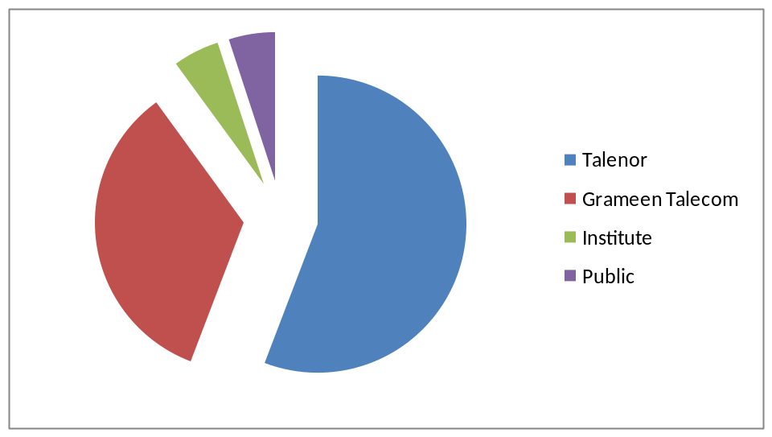

1.3.3-Total Subscriber of GP and others mobile operator in Bangladesh:

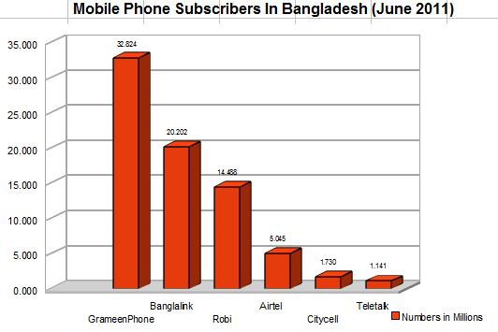
Grameenphone is the Market leader and Grameenphone has the height number of Subscriber and the number is up to June 2011 is 33 million.

1.3.4 Total Market Share of GP and others mobile operator in Bangladesh:

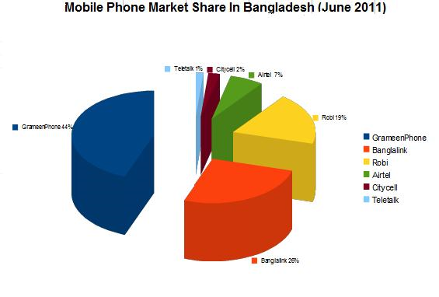
Grameenphone is the Market leader and Grameenphone has the height number of Market Share in Bangladesh and Now the Market Share is 44% up to June 2011.

1.3.5 MANAGEMENT OF GRAMEENPHONE LTD:
The top management of GrameenPhone Ltd carried out their management roles comprehensively over the years. There has been replacement or changes in the positions but all have worked together to increase the overall performance of the organization. Management Team of GrameenPhone comprises of the CEO, Directors and the Divisional Heads of the company.

1.4 COMPANY VISION
We are here to help
The key to achieve this vision is a mindset where every one of us works together. Making it easy to buy and use our services. Delivering on our promises. Being respectful of differences. Inspiring people to find new ways. Get this right and Telenor will be a driving force in modern communications and customer satisfaction.

1.5 MISSION STATEMENT & VALUES
1.5.1 Mission:
• Knowing customer Expectations
• Knowing us
• Organizing us

1.5.2 Values:
Make it Easy
We’re practical. We don't over complicate things. Everything we produce should be easy to understand and use. No waste. No jargon. Because we never forget we're trying to make customers' lives easier.

Keep Promises
Everything we set out to do should work, or if you don't get it, we're here to help. We're about delivery, not over promising ‐ actions not words.

Be Inspiring
We are creative. We strive to bring energy into the things we do. Everything we produce should look good, modern and fresh. We are passionate about our business and customers.

Be Respectful
We acknowledge and respect local cultures. We do not impose one formula worldwide. We want to be a part of local communities wherever we operate. We believe loyalty has to be earned.

THE PEOPLE
The people of GrameenPhone are young, dedicated and energetic. All employees are well educated at home or abroad, with an even distribution of males and females and social groups in Bangladesh. They know in their hearts that Grameenphone is more than phones. This sense of purpose gives them the dedication and the drive, producing the biggest coverage and subscriber‐base in the country. GrameenPhone provides equal employment opportunities and recognizes the talents and energy of its employees.
THE SERVICE
GrameenPhone believes in service that leads to good business development. Telephony helps people work together, raising their productivity. This gain in productivity is development, which in turn enables them to afford a telephone service, generating good business. Thus development and business go together.
CORPORATE GOVERNANCE
In the fast‐paced world of telecommunications, vibrant and dynamic Corporate Governance practices are an essential ingredient to success. GrameenPhone believes in the continued improvement of Corporate Governance. This in turn has led the company to commit considerable resources and implement internationally accepted Corporate Standards in its day‐to‐day operations.

Being a public limited company (PLC), the Board of Directors of GrameenPhone have a pivotal role to play in meeting all stakeholders’ interests. The Board of Directors and the Management Team of GrameenPhone are committed to maintaining effective Corporate Governance through a culture of Accountability, Transparency, Well-Understood Policies and Procedures. The Board of Directors and the Management Team also persevere to maintain compliance of all laws of Bangladesh and all internally documented regulations, policies and procedures. GrameenPhone is a truly transparent company that operates at the highest levels of integrity and accountability on a global standard.

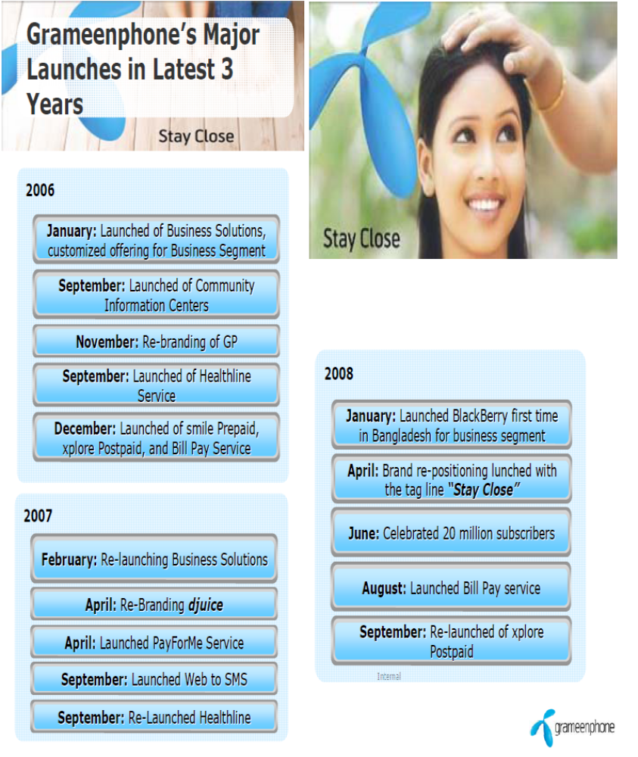

THE TECHNOLOGY
GrameenPhone’s Global System for Mobile or GSM technology is the most widely accepted digital system in the world, currently used by over a billion people in 172 countries. GSM brings the most advanced developments in cellular technology at a reasonable cost by spurring severe competition among manufacturers and driving down the cost of equipment. Thus, consumers get the best for the least. GrameenPhone is now the leading telecommunications service provider in the country with more than 23 million subscribers as of March 2010 and with more than 31 million subscribers as of February 2011.
Over the years, Grameenphone has always been a pioneer in introducing new products and services in the local market. GP was the first company to introduce GSM technology in Bangladesh when it launched its services in March 1997. The technological know‐how and managerial expertise of Telenor AS has been instrumental in setting up such an international standard mobile phone operation in Bangladesh. Being one of the pioneers in developing the GSM service in Europe, Telenor AS has also helped to transfer this knowledge to the local employees over the years.

GrameenPhone-
Largest Network Coverage

13000 based station 7000 location

98% Population
(Voice+EDGE/GPRS)

Indoor and Highway
Coverage

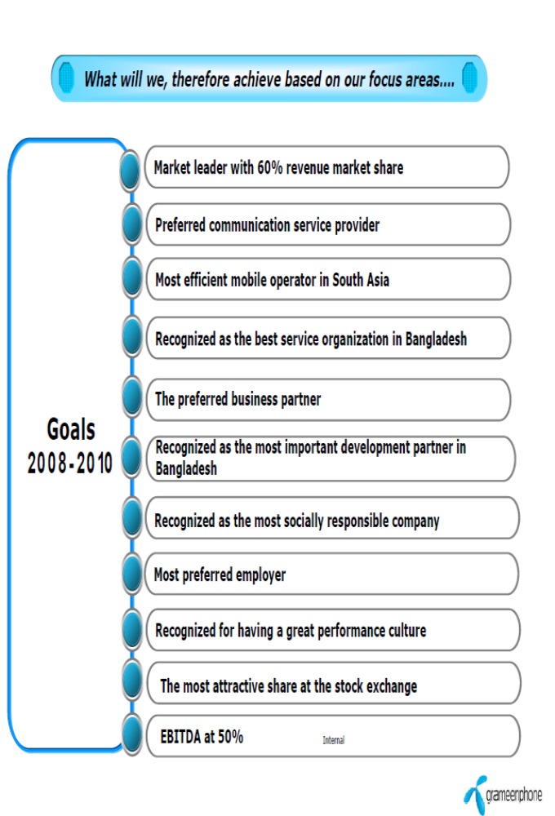

1.6 ECONOMIC CONTRIBUTION & CORPORATE SOCIAL RESPONSIBILITIES
GrameenPhone started its journey 13 years back with the believe that‐ “Good development is Good business”. Since its inception, GrameenPhone has been driven to be inspiring and leading by example, when it comes to being involved in the community. GrameenPhone believe that, sustainable development can only be achieved through long term economic growth. Therefore, as a leading corporate house in Bangladesh GP intend to deliver the best to their customers, business partners, stakeholders, employees and society at large by being a partner in development.
GrameenPhone defines Corporate Social Responsibility as a complimentary combination of ethical and responsible corporate behavior as well as a commitment towards generating greater good in society as a whole by addressing the development needs of the country.
To interact effectively and responsibly with the society and to contribute to the socio‐economic development of Bangladesh, GrameenPhone has adopted a holistic approach to Corporate Social Responsibility, i.e. Strategic & Tactical. Through this approach GP aims to, on the one hand involve itself with the larger section of the society and to address diverse segments of the stakeholder demography and on the other remain focused in its social investment to generate greater impact for the society.
GrameenPhone focuses its Corporate Social Responsibility involvement in three main areas ‐ Health, Education and Empowerment. They aim to combine all their CSR initiatives under these three core areas to enhance the economic and social growth of Bangladesh.
1.6.1 Health
Helping and caring for the community is an essential component of GrameenPhone’s Corporate Social Responsibility; therefore they endeavor to make a positive contribution to the underprivileged community of Bangladesh by helping in improvement of the health perils in the country as much as possible.

Healthcare is still inaccessible for many Bangladeshis. Almost half of the country's population live below the poverty line and cannot even afford basic healthcare. Only 35% of the rural population use adequate sanitation facilities and 72% have access to clean drinking water. Moreover the people of the flood‐prone areas suffer from many waterborne diseases.
The major problem in this sector is the significant gap between healthcare knowledge and practice and availability of the healthcare services. Therefore, all possible sources, be it public or private, should mobilize their efforts to make healthcare services available to the people who need it most, and thus help in achieving the MDG goals. GP’s plan is to engage in programs, especially in the rural areas, that will assist in creating awareness about healthcare and healthcare services and help improve the overall quality of life.
Keeping their vision in mind ‐ We are here to help; GrameenPhone aim to extend their contribution to the development of the healthcare system and work to provide a brighter and healthier future for the people of Bangladesh.
1.6.2 Education:
Education is the key to prosperity and good life. Every human being should have the opportunity to make a better life for him or herself. One of the Millennium Development Goals (MDG) for Bangladesh is to achieve universal primary education; unfortunately too many children in Bangladesh today grow up without this opportunity, because they are denied their basic right to even attend primary school. The country’s low literacy rate of 41% (2004 UNESCO Report), may indicate that we are far away in pursuit of sustainable development, but at the same time the gradual increase in the adult literacy rate gives us the hope that our nation has the potential to improve in this sector.
The marginalized and disadvantaged groups in general ‐ particularly the rural and urban‐poor of Bangladesh ‐ have significantly less access to education than other groups. Though initial enrollment in primary school is high, the completion rate is notably low; approximately 65% (World Bank Report 2004) and a smaller percent of that even complete secondary school.

Bangladesh government has provided lot of incentives, such as, free distribution of textbooks in primary schools, secondary stipend program for 100% of the girls, Food for Education project, to encourage and improve the educational sector of the country, which has helped in improvement in the literacy rate. But still we have a long way to go to make our country illiteracy free, thus GP look forward to support this sector, which will eventually help to build a developed country.

Providing access to education, especially for children from disadvantaged backgrounds who might not otherwise get the opportunity, is the main goal of GrameenPhone’s CSR education initiatives. Many people in Bangladesh still lack the basic technological knowledge and marketable skills, thus GP plan to focus further to develop an educated and skilled workforce through creating opportunity in capacity development; skilled workforce would in turn be able to create and share knowledge and contribute to the economy of Bangladesh.
1.6.3 Empowerment
Lack of empowerment and poverty is a chronic and complex problem for Bangladesh. According to UNDP HDI Report 2006, which measures the average progress of a country in human development, in terms of, life expectancy, adult literacy and enrolment at the primary, secondary and tertiary level, Purchasing Power Parity (PPP), etc., Bangladesh ranks 137th among 177 countries. Moreover, 50% of the total population of Bangladesh lives below the poverty line, defined by less than a dollar a day.
Some of the major factors contributing to this situation are inequality in income distribution, lack of access to resources, lack of access to information and inadequate infrastructure. The rural people of Bangladesh especially are deprived of these facilities, which is a major issue to break out from the shackles of poverty prevailing in the country.
Empowerment is a key constituent towards poverty reduction, and it is a key driver for sustainable economic development. Empowerment is a process of enhancing the capacity of individuals or groups to make choices and to transform those choices into desired actions and outcomes, which in turn helps them to secure a better life.
GP acknowledge that development and poverty reduction depend on holistic economic prosperity; therefore their aim is to increase development opportunities, enhance development outcomes and contribute towards development of the quality of life of the people through their

CSR initiatives and innovative services. They would like to facilitate empowerment opportunities to the vulnerable people of Bangladesh, so that it enables them to better influence the course of their lives and live a life of their own choice.


1.7 Products & Services offered by GrameenPhone
In this section we will get introduced with different products and services and the principal functions of GP products and services. GrameenPhone’s core offering is “air‐time” (talking time). GP provides this air‐time with variations. Their product line is much deeper than its competitors. I would like to briefly focus on different GP products and their features:
These attractive products and services are designed to cater to the needs of the individual subscribers. There are six products currently being offered by GrameenPhone. The products are:
1.7.1 Core Products
Bangladesh Post Office (BPO): This is another special type of product of GP, distributed through Bangladesh Railway.
Prepaid Package:
- Smile: Call charge of smile out going to GP operator is 1.5 taka and to other operator is 2.0 taka. All smile subscribers enjoys T&T and ISD incoming and out going facility. For smile package Special time and my choice is applicable. In special time, 12 pm to 4 pm and 12 am to 8 am a subscriber can talk in a lower rate .49 taka GP to GP. This package is not available in market now.

- Shohoj: The price of the prepaid SIM Smile card is 149 taka. Call charge of Sohoj out going to any number is .79 taka. A call generation charge of .30taka will add in the first minute. All Sohoj subscribers enjoy T&T and ISD incoming and out going facility. For Sohoj package Special time and my choice is not applicable.

- Bondhu: The price of the prepaid SIM Smile card is 149 taka. In this pakage a subscriber can activate 7 fnf numbers and talk only .49taka 24 hour. Call charge of Sohoj out going to other number is .99 taka. A call generation charge of .30 taka will add in the first minute. All Sohoj subscribers enjoy T&T and ISD incoming and out going facility. For Sohoj package Special time and my choice is not applicable.



- Aapon: The price of the prepaid SIM Smile card is 149 taka. Call charge of Apon out going to GP operator is 1.25 taka and to other operator is 1.49 taka. All Apon subscribers enjoys T&T and ISD incoming and out going facility. For Apon package Special time and my choice is applicable. In special time, 12 pm to 4 pm and 12 am to 8 am a subscriber can talk in a lower rate .49 taka GP to GP. In this pakage a subscriber can activate 3 fnf numbers and talk only .49 taka 24 hour. A call generation charge of .09 taka will add in the first minute.


- Djuice: Call charge of Djuice, out going to GP operator is 2.00 taka and to other operator is 2.00 taka. All Djuice subscribers enjoys T&T and ISD incoming and out going facility. For Djuice package Special time and my choice is applicable. In special time, 12 pm to 4 pm and 12 am to 8 am a subscriber can talk in a lower rate .49 taka GP to GP. In this pakage a subscriber can activate 2 fnf numbers and talk only .49 taka 24 hour. Community tariff of djuice is .49 taka/ min. This package is not available in market now.
- Djuice Adjusted: The price of the prepaid SIM Smile card is 149 taka. Call charge of Djuice, out going to GP operator is 1.35 taka and to other operator is 1.49 taka. All Djuice subscribers enjoys T&T and ISD incoming and out going facility. For Djuice package Special time and my choice is applicable. In special time, 12 pm to 4 pm and 12 am to 8 am a subscriber can talk in a lower rate .49 taka GP to GP. In this pakage a subscriber can activate 3 fnf numbers and talk only .49 taka 24 hour. A call generation charge of .09 taka will add in the first minute.

- Business Solution: The price of the prepaid SIM Smile card is 149 taka. Call charge of Business Solution out going to GP operator is 1.00 taka and to other operator is 1.20 taka. All Apon subscribers enjoy T&T and ISD incoming and out going facility. For Business Solution package Special time and my choice is applicable. In special time, 12 pm to 4 pm and 12 am to 8 am a subscriber can talk in a lower rate .49 taka GP to GP. In this package a subscriber can activate 4 fnf numbers and talk only .49 taka 24 hour. Community tariff is .49 taka/ min.



- Ekota: The price of the prepaid SIM Smile card is 149 taka. Call charge of Ekota out going to GP operator is 1.00 taka and to other operator is 1.20 taka. All Ekota subscribers enjoys T&T and ISD incoming and out going facility. For Ekota package Special time and my choice is applicable. In special time, 12 pm to 4 pm and 12 am to 8 am a subscriber can talk in a lower rate .49 taka GP to GP. In this pakage a subscriber can activate 4 fnf numbers and talk only .49 taka 24 hour. Community tariff is .49 taka/ min.
- GP Public Phone: The price of the package is 200 taka. Subscriber gets 1 second pulse for all call from the 1st minute. Call rate .99 taka/min to any number. For ISD out going, ISD charges will be added with .99 taka. They have another option to convert it in to .65 taka per minute plan, but then they have no pulse for talking. Community tariff of Gp Public Phone is .75 taka/ min.
- Village Phone: This is a special type of product of GP, distributed through Grameen Bank. This product is sold only for business purpose and especially to underdeveloped village women. The price of the package is 200 taka. Subscriber gets 1 second pulse for all call from the 1st minute. Call rate .99 taka/min to any number. For ISD out going, ISD charges will be added with .99 taka. They have another option to convert it in to .65 taka per minute plan, but then they have no pulse for talking.
- Internet SIM: The price of the prepaid SIM Smile card is 149 taka. Subscribers can use internet and can send SMS with this SIM.
Postpaid Package:
- Xplore: The price of the prepaid SIM Smile card is 650 taka. Call charge of Xplore out going to GP operator is 1.3 taka and to other operator is 1.30 taka. All Xplore subscribers enjoys T&T and ISD incoming and out going facility. For Apon package Special time and my choice is applicable. In special time, 12 pm to 4 pm a subscriber can talk in a lower rate .49 taka GP to GP. In this pakage a subscriber can activate 4 fnf numbers and talk only .49 taka 24 hour. Subscriber can enjoy 1 second pulse from the 1st minute.

- Business Solution Postpaid: The price of the prepaid SIM Smile card is 650 taka. Call charge of Business Solution Postpaid out going to GP operator is 1.0 taka and to other operator is 1.2 taka in business hour. All Business Solution Postpaid subscribers enjoys T&T and ISD incoming and out going facility. For Business Solution Postpaid package Special time and my choice is applicable. In special time, 12 pm to 4 pm a subscriber can talk in a lower rate .49 taka GP to GP. In this pakage a subscriber can activate 3 fnf numbers and talk only .49 taka 24 hour. Subscriber can enjoy 30 second pulse from the 1st minute.

- Internet SIM Postpaid: The price of the prepaid SIM Smile card is 150 taka. Subscribers can use internet and can send SMS with this SIM.

1.7.2 Value added services
GP is offering the following value added services along with the above mentioned products to its subscribers:
- Short Message Service (SMS) -With this service, GP’s subscribers can send text messages of up to 160 characters from one GP handset to another. The service comes with most of the products, free of monthly charges. Such messages can also be sent to other GSM phones in other networks abroad provided the subscriber has the ISD options with his/her service. The charge of sending SMS is 0.5 taka local and 2.0taka in abroad.
- Voice Mail Service (VMS) – This service works like an answering machine. Anyone calling a GP subscriber who is out of reach at that moment can leave a message, which the subscriber can retrieve later. The service comes with most mobile products, free of monthly charges.
- Fax / Data – Fax and data services are available in post‐paid packages for corporate clients. The service enables users to send/receive fax and data through their handsets by connecting to a PC/Laptop.
- Standard GSM features –Caller Identification, Call Barring, Call Holding, Call Conference, and Call Forwarding in both pre paid and Post‐paid packages. These GSM feature can be activated or deactivated free of cost.
- EDGE service: GrameenPhone is providing Edge services under which a subscriber can use internet, multi media message services and WAP. But for using EDGE, the hand set of the subscriber should be EDGE software supportable. There are seven packages for EDGE. In package1 subscriber have to pay .02 taka for per kilobytes browsing. In package2, subscriber will pay 850 taka per month and against that, s/he cal have unlimited browse. In Package subscriber can enjoy unlimited browsing from 12 am to 8 am at a cost of 300 per month. In package 4 subscribers can use 24 hour browsing at a cost of 60 taka. In package 5 subscribers can use 5GB at a cost of 700taka with a validity of 30 days. In package 6 subscribers can use 1GB at a cost of 300taka with a validity of 30 days. And in package 7 subscribers can use 15 MB at a cost of 29 taka with a validity of 15 days.
- Voice SMS: GP provide voice sms service in which a subscriber can leave a voice message of 60 seconds. Last 10 voice sms is kept in GP server. For hearing voice sms first time, there is no charge. But for next each time one subscriber wants to hear, s/he needs to pay 1 taka.
- Additional features – GP has set up a number of information hotlines, which can be reached by dialing a three digit number from the handset.
- Call conferencing: By this feature, three to nine subscribers can make call conferencing with each other. The charge will be normal out going charge for all of them.

- Welcome tune: Subscriber can set their favorites song as their caller tune at a cost of 30 taka per month; Subscribers can set 99 songs at a time.
- Missed call Alert: Subscriber can activated Missed call Alert service in their SIM at a cost 10 taka per month, so that if the phone is switch off then when it switch on then they get a alert sms who call them during this period.

1.8 ORGANIZATIONAL STRUCTURE

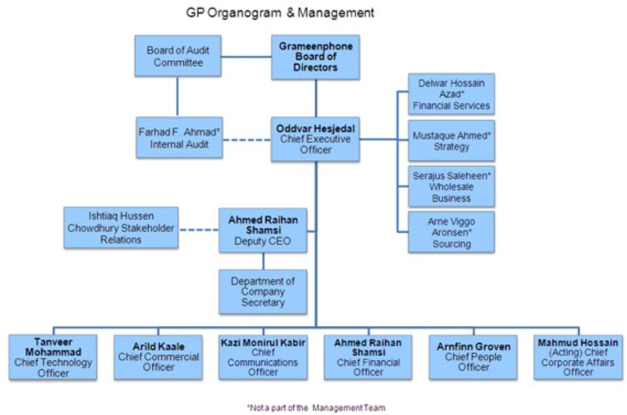

At present, Oddvar Hesjedal is the CEO; Petter Russ- Director CHQ; Emad Ul Ameen- Director Human Resources, Khalid Hasan-Chief Corporate Affairs, Ahmed Raihan Shamsi - Chief Financial Services, Syed Yamin Bakht- Director Public Relations, N K A Mobin-Director Climate

Strategy, Arnfinn Groven- Director Customer Services of GrameenPhone Ltd. They equally contributed to GrameenPhone’s superior leadership, by carrying out their unique roles. They worked well together, respecting each other’s abilities, & arguing openly & without any rancor when they disagreed

1.9 DIVISIONS AT GRAMEENPHONE LTD
GrameenPhone Ltd. has approximately 6000 employees working at different levels of organizational hierarchy. There are 9 functional departments engaged in managing these employees‐ with the aim to meet organizational objectives. GrameenPhone follows a mix of centralized and decentralized decision making process‐where the top management mainly takes all the strategic decisions while the functional managers have flexibility to take decisions by themselves on a day to day basis. At GrameenPhone the Managing Director is assisted by 9 Senior Executives who are heading different departments in the strategic decision making process. The departmental names of GrameenPhone are given below:
- Corporate Affairs Division
- Customer Service Division
- Finance Division
- Human Resource Division
- Information Technology Division
- Internal Audit Division
- Internal Control Office Division
- Marketing Division
- Network Division
- Public Relation Division
- Sales Division

GrameenPhone follows a 3-layer management philosophy in Bangladesh. These are Directors, Managers and Officers. The CEO is the top most authority of all the levels. Directors are the departmental heads that are responsible for the activities of their departments. Managers have the authority next to directors. These two layers represent the management level of GrameenPhone. Officers are the next persons to stand in the hierarchy list. They are the typical mid-level employees of GrameenPhone’s organizational hierarchy. These officers are responsible for managing the operational activities and operating level employees.

1.9.1 CORPORATE AFFAIRS DIVISION
Main Objective:
Within the direction from the CEO of GrameenPhone, the Head of Corporate Affairs shall ensure that the Regulatory & Corporate Affairs function within the company at all times is aligned with and supports the business objectives.

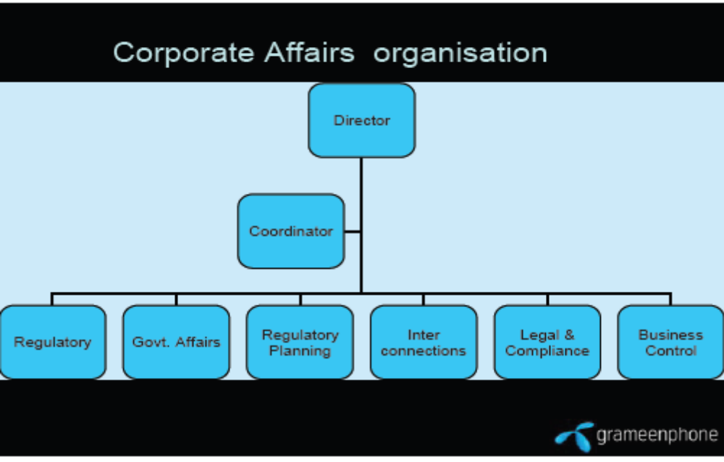

Main Responsibilities:
Develop, maintain and implement company strategies, policies and procedures for the functional area which includes:
- Regulatory & Corporate Affairs
- External Relations

  - Monitor and control Regulatory & Corporate Affairs activities;
  - Provide support and consulting to other functions within scope, in order to ensure coordination, business alignment and adaptation of best practices;
  - Develop and maintain descriptions of departments reporting to the Head of Regulatory & Corporate Affairs, defining their responsibilities and how work is organized between these departments;
  - Ensure awareness of, and ability to comply with, legal requirements applicable for the company and its governance documents, including SOA required internal controls and Codes of Conduct;
  - Ensure necessary capabilities within function to ensure that the organization is able to meet its current and future business objectives;

1.9.2 CUSTOMER SERVICE DIVISION
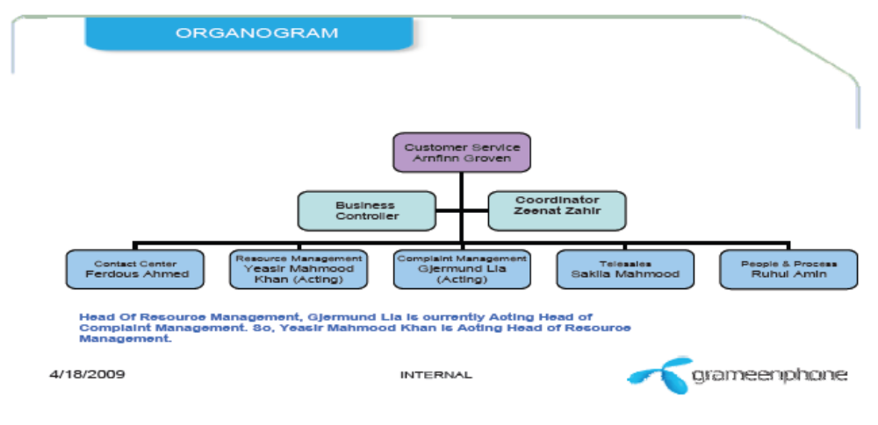

Main Objective:
Within the direction from the CEO of GrameenPhone, the Head of HR shall ensure that the HR function within GrameenPhone at all times is aligned with and supports the realization of GrameenPhone’s business objectives. The Head of HR shall optimize the human resources in GrameenPhone, through individual performance management and organizational development, as well as nurturing a culture supporting the realization of the vision and values. In order to achieve this, leadership excellence is a key focus area for HR.
The units in HR Division include:
- HR Operations;
- Recruitment & Selection
- HR Development;
- Health, safety and environment
- Expatriate and travel support
Main responsibilities:

- Position as the most reliable, friendly and quality service provider in the industry to be perceived as the operator that provides segment based services beyond expectations

- Manage business environment with superior efficiency and operational excellence for profitable growth

- Establish Customer Service to gain sustainable competitive advantage for GrameenPhone

- Foster a competent team in a culture with empowerment and involvement

- Recruit the best, develop every employee and retain the best

- Convert each customer contact to an opportunity for retention and new sales with a focus on competitor’s profitable customers

Build effective alliance with other customer services, within the Telenor group and in Asia.

1.9.3 FINANCE DIVISION

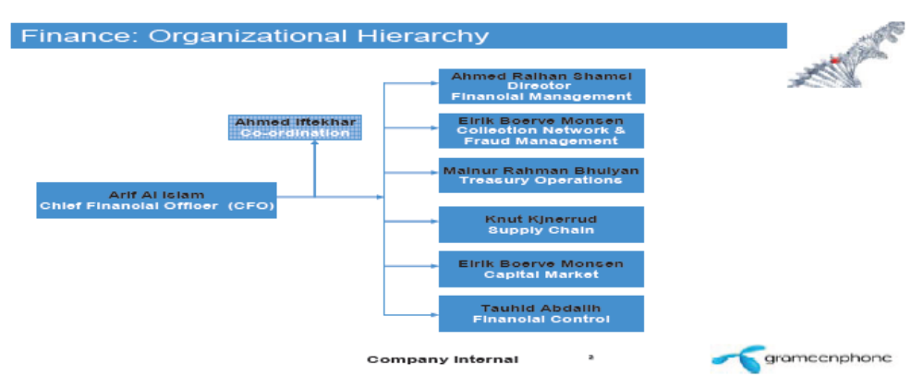

Main Objective:
Within the direction from the CEO of GrameenPhone, the CFO shall ensure that the Finance & Supply Chain Management function within Grameenphone at all times is aligned with and supports the realization of GrameenPhone’s business objectives. The CFO must prepare financial statements with reasonable assurance that statements are not materially misstated at the consolidated group level and for local statutory accounts.
Main Responsibilities:

- Develop, maintain and implement company strategies, policies and procedures for the functional area, which includes:

- Treasury
- Financial Reporting & Controlling
- Tax
- Risk Management Supply Chain Management

- Investor Relations

- Monitor and control company‐wide Finance & Supply Chain Management activities;
- Provide support and consulting within scope, to all other divisions in the company, in order to ensure coordination, business alignment and adaptation of best‐practices;
- Develop and maintain descriptions of departments reporting to the CFO, defining their responsibilities and how work is organized between these departments;
- Ensure awareness of, and ability to comply with, legal requirements applicable for the functional area and its governance documents, including SOA‐required internal controls and Codes of Conduct;

1.9.4 HUMAN RESOURCES DIVISION
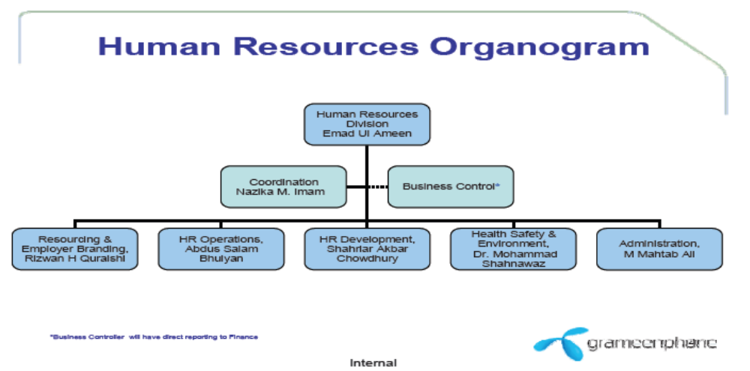

Main Objective:
Within the direction from the CEO of GrameenPhone, the Head of HR shall ensure that the HR function within GrameenPhone at all times is aligned with and supports the realization of GrameenPhone’s business objectives. The Head of HR shall optimize the human resources in GrameenPhone, through individual performance management and organizational development, as well as nurturing a culture supporting the realization of the vision and values. In order to achieve this, leadership excellence is a key focus area for HR.

The units in HR Division include:

- HR Operations;
- Recruitment & Selection
- HR Development;

- Health,safety &environment

- Expatriate and travel support

Main Responsibilities:

Develop, maintain and implement company HR strategies, policies and procedures in order to establish organizational capabilities company-wide to meet current and emerging business needs, which include:

- Leadership
- Employee Capabilities
- Organizational Desiga
- Collaboration
- Recruitment
- Compensation & Benefits
- Employee relations and Health ,Safety and working Environment

- Monitor and control company -wide HR activities.

- Provide support and consulting within scope, to all divisions in the company, in order to ensure coordination, business alignment and adaptation of best-practices.

- Develop and Maintain description of Departments reporting to the head of HR, defining their responsibilities and how worker is organized between these departments,

- Ensure awareness of, and ability to comply with, legal requirements applicable for the function and its governance documents, including SOA-required internal control and codes of conduct;

- Ensure necessary capabilities company wide to ensure that the organization is able to meet its current and future business objectives.

1.9.5. Information Technology Division

Main Objective:

Within the direction from the CEO of GrameenPhone, the Head of IS/IT shall ensure thatthe Information Security/Information technology function within Grameenphone at all time is aligned with and supports the realization the Grameenphone’s business objectives. The head of IS/IT shall ensure the realization of the business objectives through delivering services and information with sufficient quality.

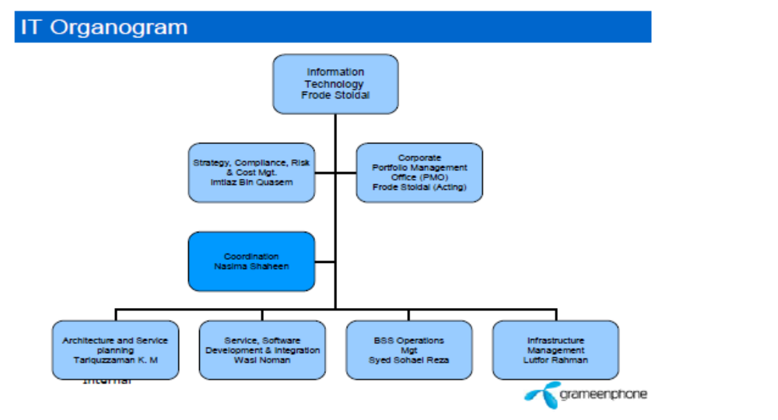

Main Responsibilities :

Develop, maintain and Implement Company Strategies, Policies and Procedure for the functional area, which includes:

- Strategy and Architecture
- IS/IT Governance
- IT Quality and Risk Management
- IT Sourcing (IT Compliance with Company Procurement policy)

1.9.6 INTERNAL AUDIT DIVISION

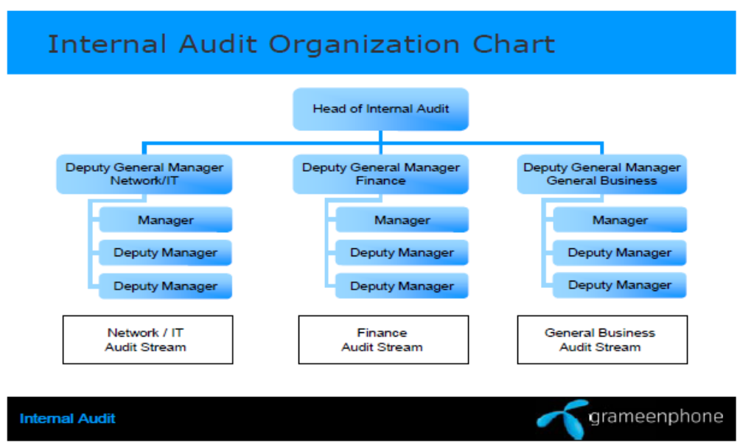

Main objective

“Internal auditing is an independent, objective assurance and consulting activity designed to add value and improve an organization's operations.
It helps an organization accomplish its objectives by bringing a systematic, disciplined approach to evaluate and improve the effectiveness of risk management, control, and governance processes.”
Main Responsibilities:
The Department is responsible for:
- Develop Risk Based Audit Plan
- Coordinate with External Auditors / others to provide optimal audit coverage
- Implement approved audit plan
- Review and revise Audit Plan as required
- Follow up and report on the implementation of audit action plans.
- Report significant deficiencies in internal control.
- Assist in the investigation of suspected fraudulent activities
- Provide consulting and advisory services to management as appropriate

1.9.7 INTERNAL CONTROL OFFICE DIVISION

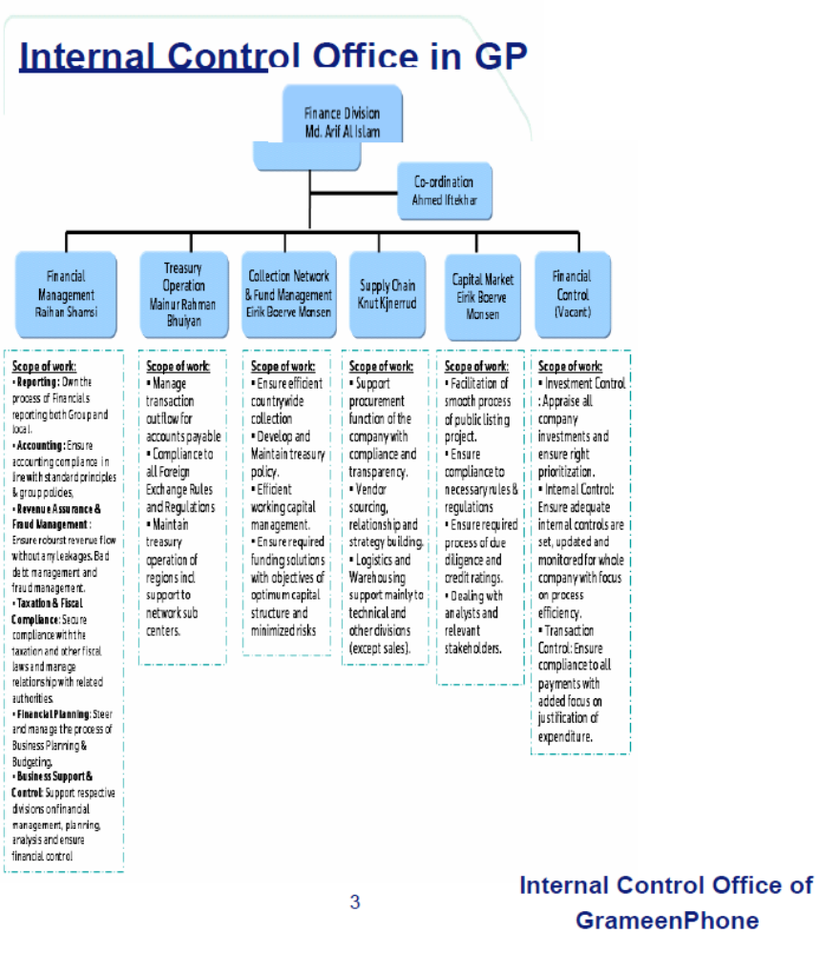

Main Objective:

Under the COSO Framework, a widely‐used framework in the United States,
Internal control is broadly defined as follows:
A process, affected by an entity's board of directors, management, and other personnel, designed to provide reasonable assurance regarding the achievement of objectives in the following categories:

- Effectiveness and efficiency of operations
- Reliability of financial reporting and
- Compliance with laws and regulations.

Main Responsibilities:

The Department is responsible for:

- Control Environment:
Sets the tone for the organization, influencing the control consciousness of it’s people. It is the foundation for all other components of internal control.
- Risk Assessment:
The identification and analysis of relevant risks to the achievement of objectives, forming a basis to find out how the risks can be managed.
- Control Activities:
The policies & procedures that help ensure mgt. directives carried out.

- Information and Communication:
Systems or processes that support the identification, capture, and exchange of information in a form and time frame that enables people to carry out their responsibilities.
- Monitoring:
Processes used to assess the quality of internal control performance over time.

1.9.8 MARKETING DIVISION

Main Objective:
The main objective of marketing department of GrameenPhone is to promote the brand name of the company and increase brand awareness among the customers.

Main Responsibilities:
The Department is responsible for:
- “New non‐core” product portfolio.
- Acts as a portfolio area for strategically important revenue earners (CIC, Health line, cell bazaar etc.) P&L;
- To support the core business for strengthening retention and social efforts in core Telco
- To generate ROI through creation of new asset base and revenue source.
- Development and management of non‐core products roadmap.
- Strategic analysis, development of strategic alternatives, and evaluation & control of feedback
- Division‐wide roadmap for strategic deliverables
- Monitor and manage segment activities in terms of alignment
- Administration of KPIs; IVC
- Program Office for Marketing Division
1.9.9 NETWORK DIVISION
Main Objective:
The main objective of Network department of GrameenPhone is to manage and control the network of GrameenPhone throughout the country.

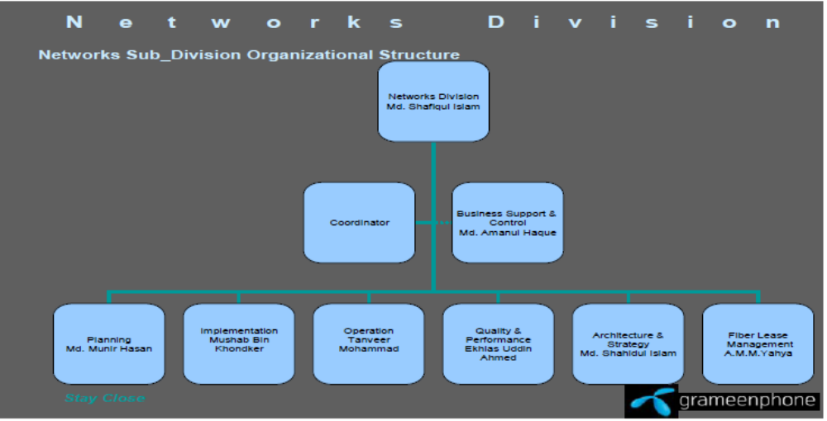

Main Responsibilities
The Department is responsible for:
- Effort to maintain LOW CAPEX and OPEX per sub
- Maintain competitive qualities through whole process of work
- Maintain service KPI for Network quality and availability focusing customers perspective
- Maximum Resource utilization by network optimization & efficient management
- Maintain living values of organization in the activities

1.9.10 PUBLIC RELATIONS DIVISION
Main Objective:
The main objectives of Public Relations department of GrameenPhone are to Promote and protect GrameenPhone reputation as a compliant, transparent and socially responsible company among both internal and external stakeholders.
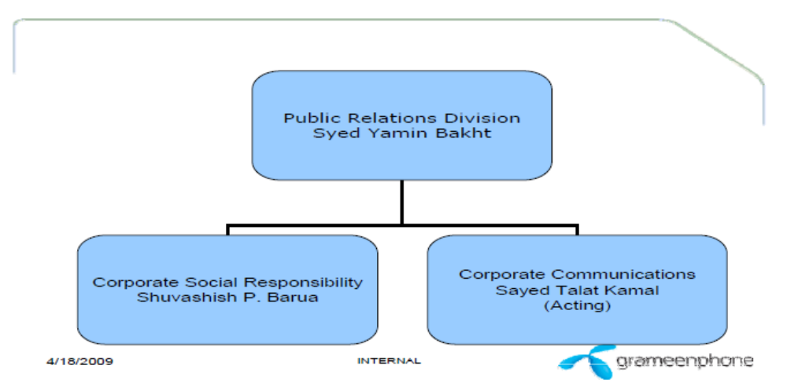

Main Responsibilities:
The Department is responsible for:
- Project GP as a responsible and transparent company to both internal and external stakeholders
- Assist in gaining business results through effective media exposures of company events and initiatives
- Manage a portfolio of social investment initiatives in line with key stakeholders’ expectations of being a socially responsible business

1.9.11 SALES DIVISION
Main Objective:
The main objective of Sales department of GrameenPhone is to Deliver excellent Compliant Sales Channel Management practice (Logistic, Distribution and Retail) to ensure the Best Customer Experience for GP customers at maximum number of POS to support the ‘2 out of 3’ objective.

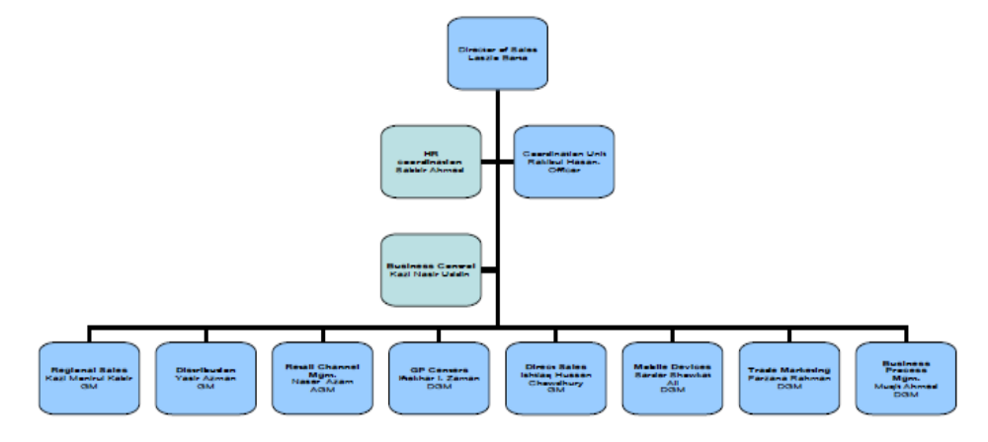

Main Responsibilities:
The Department is responsible for:
- Execute Retail Channel strategy
  - Select best POS candidates for channels

  - Develop them according to strategy

- Support Retail Cannel partners
- Regular visits and consultancy

- ‘Get Close to Stay close’

- Manage product ‘In‐Flow and ‘Out‐Flow’
- POS Portfolio and stock optimization

- Control customer influencing activities
- Best Customer Experience through specific BTL and conscious selling

- Report field information
- Monitor progress of GP

- Observe competitors activities

CHAPTER-2

SWOT Analysis

2. SWOT ANALYSIS
2.1 STRENGTHS
- Good Owner Structure ‐ GrameenPhone has the best owner structure in the telecommunication industry of Bangladesh. Telenor is one of the largest company, which is operating in different countries around the world. Again, in Bangladesh, Grameen Bank is one of the largest NGO, which has the better communication all over the country. Gonofone is also network base telecommunication organization, which has good reputation in USA. Marubini is called one of the Asian tiger organizations for its expansion of Business.

- Market Leader ‐ GrameenPhone is the first organization in Bangladesh, which have reached to the general people. Though City Cell had started their operation beforehand, but they were unable to reach the general people. So, the people are being used to with GrameenPhone. This is a huge advantage of GrameenPhone.

- Network Availability ‐ GrameenPhone has widest network coverage and a large number of BTS station (Tower) all over Bangladesh. That’s why the company can provide better connectivity in most of the area of the country.

- Brand Name of Grameen Image ‐ Grameen Bank is well known all over the country because of its appreciable activities in financial sector for poor people in Bangladesh. So, when the name Grameen has been added with this telephone company, the organization gets a huge exposure due to this Grameen image.

- Financial Soundness ‐ Because of effective planning, GrameenPhone is able to earn a healthy amount of revenue, which gives them financial soundness.
- Skilled Human Resource ‐ All the staff, which are related to GrameenPhone are skilled and effective in their own job responsibility. The reason behind this is the Human Resource department of GrameenPhone follows ethical strategy to recruit new employees.

- Effective Support Organization ‐ GrameenPhone have shared the idea from the employees of Bangladesh Railway and Grameen Bank, who are experienced and was able to provide precious guideline for the operation of GrameenPhone.
- Access to the Widest Rural Network through Grameen Bank ‐ Through the help of Grameen Bank, this was easier to GrameenPhone to reach the rural area of Bangladesh.
- High Ethical Standard ‐ To keep the quality of service, GrameenPhone is strict to follow its ethical standard.

2.2 WEAKNESSES
- Culture Gap: In GrameenPhone management, employees from different country are existed. Suppose, The Managing director is a Norwegian, Director from technical is Indian and many more employees come from different country. That’s why; some times there may be lack of understanding due to cultural gap. Different Ideas create problem: In Grameen Phone, this is highly encouraged to apply new strategy for the better performance. Sometimes it creates problem because employees are used to with the previous strategy.
- Complicated Pricing Structure: GrameenPhone has lots of products. The pricing of these products and their billing policies are different which also difficult for a user to understand.

- Incomplete Messages through Promotional Activities – Most of the time the advertisement of GrameenPhone do no clear the appropriate messages. Not only that, most of them are also so confusing to understand. As a result subscribers get the wrong meaning of what has been said to them.

- Problem Contained Offers – Recently all most all of the new offers of GrameenPhone are having some technical problems. Either they are not working at all or part of the
services of those offers is disabled. Not only that, GrameenPhone is also delaying to solve those problems which is only raising the dissatisfaction level of its subscribers.
- Different Departments are not Working Together ‐ The interconnection of the department is little bit weak. The reason behind this, there is no exchange program for employees to work between departments.

2.3 OPPORTUNITIES
- Economic Growth of Bangladesh ‐ The economic growth of the country will increase the expansion of telecommunication industry. From 1995 to 2006, there is a huge change in telecommunication sector.
- New and Better Interconnect Agreement ‐ GrameenPhone is going to have agreement with T&T to have better connection from land phone. The organization has agreement with other operators like AKTEL, City Cell or Bangla Link to have better internal connectivity.
- Huge Demand for Telecom Services ‐ The market of telecommunication is expanding. So, this is easy for GrameenPhone to achieve the major portion of expanded market because of its leading position.
- Increased Intentional Activities in Bangladesh ‐ As international activities increased in the country, people need the connectivity not only in the country, but also out side of the country. So, the market for outside of the country is also expanding.

- Declining Prices for Handsets – Few years ago the people of low income could not effort mobile phone services due to the high price of handsets. Now the price of handset has decreased and the low income people want to get connected through mobile phone.
- New International Gateway ‐ As BTTB has established new gateway to connect internationally, this is easy for mobile phone companies to provide services of ISD call and international roaming.
- Flexibility of Mobile Phone ‐ Communication through mobile phone is popular because the land phone connection between inter city is costly. Mobile phones are also easier to carry and because of its lower cost and portability, people are getting more dependent on mobile phones than land phones. So there is a chance to achieve more subscribers and more market share.
2.4 THREATS
- More Rigid Government Regulations ‐ Government is becoming restricted for taking away currency from the country. So, Foreign Company are threatened because they may have risk to back their investment to the country. The government also put restriction for the work permit of foreign employee.
- Upgraded Technology Used by Competitors ‐ New mobile phone operator like Bangla Link are establishing their channel with latest technology. Whereas GrameenPhone using the stations which are five years old. So, this is the disadvantages for GrameenPhone.
- Political Instability ‐ Political instability is another threat because, with the change of Government, policies are also changed. So, this is difficult for any multinational organization to cope with new policies.
- Devaluation of Taka ‐ As the investments occurs in foreign currency, that’s why the devaluation of Taka decrease profit from financial point of view.
- Risky Position of Valuable Resource ‐ The organizations have a large number of BTS stations which are spread all over the country. Any one can make damage to these BTS station and this is also difficult to arrange proper security for these stations.

- Non-co-operation of Government for the Revenue of BTTB - Government does not want to provide the better services from BTTB to other operator due to remain competitive.

CHAPTER -3

Description of the job

3.1 Job Description
In my 12 week work experience I go through different responsibilities, training, one to one conversation, team meeting etc.
First two week of my jobs I go through different type of training. As I join the customer service department of gramophone I have to learn lots of thing. In the training session I learn about the corporate culture of GrameenPhone, the dress code of the company. The rules and regulation, the values, and more important thing are how to handle and satisfy the subscriber.
I learn to operate different type of tools and software which is essential to execute the subscriber query and request. So there is computer tainting in between the two week.
Next two week I was assign with one of my senior collegue to learn the job practically.
There are lots of segment in customer service in Grameenphone.
There two main segment is
- Inbound
- Outbound
3.1.1 Inbound:
In an inbound, customers generally place their queries, and complain about product and service. Subscribers also request to activate of deactivate different service in his mobile. The query and the request are instantly solve by the customer manager but complains are solve by backend complain management team because there need to verify complains whether the complain is valid or not. It takes 24 to 72 hours.

3.1.2 Outbound:
Outbound call centers are usually, sales jobs over the phone, as a telecommunication company GrameenPhone has different service to sale like different package of edge, missed call alert, welcome tune, and call block service mobile backup service etc.outbound is use not only for sale but also use to aware subscriber about the new product and service and offer.
In inbound there are different segment in customer service.

Segments:

- Consumer (Smile and Xplore)
- Youth (Djuice)
- Business (Corporate and SME)
- Emerging (GPPP and VP)
- Channel (Retailer)

Another segment of customer service is complain management, where customer managers deals with the complain of the subscribers.
Next eight week I had to work in different segment of customer service. In below I describe my work experience in different segments.
At first I am assign in Channel (retailer) segment. The hotline number is 155. Retailer and distributor of Grameenphone call here for different queries and request. The basic query of Retailer is that, they send money to subscribers mobile and is it received by the subscriber or not. They mention the date and we confirm their query. Distributor house call 155 to deactivate or activate any retailer phone for any lost case. This hotline is free for retailer and distributor. In this segment I work for two week.
Secondly I am assign in consumer and youth segment. The hotline number is 121. All prepaid and post paid subscribers call 121 except business segment. They have lots of query, request and complain. The main query of the subscribers is the product, service and different type of offer. In request part they request to active or deactivate different type of service and offer, like FNF number activation or change, edge service activates or deactivate different kind of other services. In complain part subscribers complain about overcharge, network problem etc. post paid Xplore subscriber’s main query to know their current usages and in request part they request to unbar their line. This hotline charge is 1.15 taka/ min. In this segment I work for three week.

Finally I work for business and outbound segment, the query and request of business segment is almost same as consumer and postpaid subscribers.
The job responsibilities of Outbound segment to sell the different service of Grameenphone by telesales. We call the subscribers randomly and explain the different service of Grameenphone and then sell them if they wish to take the service.
But in present time there are only two segments inbound and outbound. All segment of inbound are marge due to technological improvement, and all the customer manager are trained to handle all kind of call. All the customer manager of customer service are multi skilled.
In the mean time I participate different training, one to one session with my supervisor and team meeting, whenever any new product or service came to the market people and process department organize tainting session to aware about the product and service though we can provide service smoothly. Once in a week or once in month I have one to one session with my supervisor. In this session we discussed about my performance and my key performance index (KPI). My supervisor suggests me how to improve my KPI and my service quality.

3.2 Specific Responsibilities of the job:

- Provide one‐stop quality Customer Service over phone to ensure positive customer experience.
- Proactively aware / inform customers regarding products / service.
- Sale through inbound and outbound contacts.
- Capture customer insights and escalate critical issues / complaints and provide timely feedback.
- Maintain targeted KPI on a regular basis.
- Serve customers with helping attitude and thus play a significant role in customer satisfaction, retention and acquisition. In this way enhance GrameenPhone’s brand image.

3.3 Observations and Recommendations
Grameenphone is the largest telecom service provider in Bangladesh. For all kind of business after sales service is more important than other service to retain customers. As a telecom service provider, customer service is more important for Grameenphone. From customer service and call center GrameenPhone subscriber gets all kind of after sales service. So customer service is very impartment.
In my observation Grameenphone gives more emphasis on customer service. Customer service is not only after sales service but also an income source for Grameenphone. So now a day’s customer service division is important like other division. All the customer manager of customer service is very efficient, energetic and educated. They all are trained well to handle customers. The quality of service is very good. The environment of the office is also very good. The office setup is very modern and technological advance. All the calls from subscribers come in to automated answering machines which call IVR. Subscriber has to wait for a human agent. All the computer and pabx system is up to date, so customer manager can provide service very smoothly. The main problem is Grameenphone has a large number of subscribers and the ratio of subscribers and customers manager is large, so it is very difficult to handle the call pressure for the customer manager. It is very painful for subscribers to wait a long time for getting the service.

In recommendation part I want to recommend something to betterment of customer service.
- Decrease the call pressure to increase customer satisfaction.
- Give more training to the customer manager so that they can increase their skills.
- Create a strong IVR (interactive voice response) so that subscriber get more service from IVR without the help of human agent.
- Free the call charge when subscribers are in queue.
- Effectively make the break plan so that the customer manager can remove stress.
- Increase the number of employee to reduce call pressure.
- Motivate the employee by different motivational factor because it is a monotonous job.
- Provide health checkup specially eye and hearing checkup on a regular basis to the employee.
- Give more benefit to the employee to reduce employee turnover.
- Reduce the time limit of solve complains of the subscribers to increase customer satisfaction.

3.4 Some scope of implementation would be helpful:
- Increase GrameenPhone Service point to serve more people.
- Use the easiest communication method to reach all level of subscribers.
- Recruit skilled customer manager who can serve the subscriber with high quality.
- Provide training to the customer manager so that they can satisfy the customers.
- Recruit local people in local area so that they can understand local subscribers need.
- Use the latest technology to serve the subscribers more efficiently.

CHAPTER-4

PROJECT-PART

4.1 Introduction:
GrameenPhone (GP) today is apparently the largest mobile telecommunication industry in Bangladesh. It operates its function with an aim to accomplish two principal targets. Firstly, as with other commercial organizations, it operates in such a manner that it receives a good economic return on the investment. Nonetheless, secondly, it contributes significantly to the economic development of the country in making telecommunication a popular medium for exchange of information.
GP, in its operation, has to address a large number of customers throughout the country. It is therefore imperative to get to the customers to know their impression on the services of this important communication medium. This encouraged me to choose the topic of this internship as “Customer satisfaction of GrameenPhone”.

The introductory part of subject under investigation contains the following:

- Objectives of the Study
- Significance of the Study
- Sources of the study
- Reason of choosing customer satisfaction of GP
- Methodology of the study
- Limitations of the Study

As an intern-member of GP’s CMD the assigned job of the researcher involve providing different services to the esteemed subscribers over telephone, which is known as helpline service. In other words, the job related to satisfy the customers.

4.2 Objectives of the Study:
This Program was designed to accomplish two objectives. The objectives were identified through a closer interaction and exchange of views with the management of CMD. The objectives are:

- To find out the satisfaction level of Grameenphone subscribers through Customer Service point GP Ltd with Questionnaires.
- To find out the Marketing Problem 4ps.
- To locate specific areas of dissatisfaction of the GP users.

4.3 Significance of the Study:
Organizationally GrameenPhone is the market leader in the mobile telecommunication sector in Bangladesh. Its growth rate is splendid. But in this age of free market economy and hard competition, it is very difficult to keep up the leadership without mitigating the day-to-day problems in the structural and operational segments and making demand-driven improvement. Companies therefore need to come up with new ideas to remain in healthy competition for business development. They need to maintain the optimum level of their customers’ satisfaction. It is very important for GrameenPhone as well to assess whether its customers are satisfied or not. If the customers are not satisfied, GP can then identify and specify the areas of dissatisfaction and take necessary action to remove the dissatisfactions.
4.4 Sources of the study: rationale
Data were gathered from both primary and secondary sources. Collection of data was not that difficult as GrameenPhone Ltd is a leading fast generation private telecommunication Industry in the country. The assignment in such an esteemed industry was a great privilege to collate relevant data to prepare this report.

4.5 Reason of choosing customer satisfaction of GP:
GrameenPhone is a leading market in mobile telecommunication sector with its customers perhaps not fully satisfied with company’s performance and services. If GP does not care of these dissatisfactions for ultimate solutions, other companies might penetrate into the market with similar or better offers. Then, it would be difficult on the part of the GrameenPhone to keep up the current market share.
GrameenPhone is a highly growing company. It tripled its subscriber base in the year 2000. In this high growth situation, it might be very difficult to keep customers satisfied. They are using GP’s service because of it has a large number of customer to contact. So, if a big player from another industry can capture a sizeable number of customers, it may appear as treat to GP.
It is therefore imperative for GP to analyze the customer’s opinion in regard to its services an take care of the dissatisfaction, if any, to keep up the market share. This study is aimed at reviewing the prevailing situation to assist GP so that it can take appropriate measures for its improvement if needed.
4.6 Methodology of the study:
Based on the topic chosen, I was assigned the task in the Customer Management Division (CMD) in GP. This divisions consists of a big team of abut 2000 employees. Its functions relate with the customer service after the sales occur. Prime functions and activities of the GP Customer Management Divisions cater to all after‐sales services starting from activation of subscriptions, all customer contacts (Centralized Call Center, Customer Relations Centers, and centralized Customer Communications), billing, bank communication, bill collection throughout the country, helpline services, etc
This study is based on both secondary and primary data but mainly based on primary data that was collected through direct survey. To accomplish this, a questionnaire was developed that consisted mainly closed‐ended questions.
This study was confined in Dhaka city and Tangail city, the tangail city has been selected because I am working in a position as a Customer Manager in customer service point of GrameenPhone Ltd.

Sampling Size: Small sample <70 respondent are taken both Male and Female.
Some data and other necessary information were collected by interviewing officials of GP. These can also be treated as secondary data.
Data collection was done on a random basis. The results are represented through bar charts. The research findings came out through analyzing those data.

4.7 Limitations of the Study:
GrameenPhone basic strategy is widening its market through its emerging countrywide network. As a result of this strategy, the subscribers are from different segments or from different income levels. Moreover, the subscribers are scattered all over the country.
The time constraint confined the study mostly on the data collected in Tangail and Dhaka zone. Moreover, it was not possible to get all required internal information of the company as these are treated as confidential to the company.
The outcome of the study can thus be regarded exploratory, and may not be treated as absolute for the whole country. In latter case a more comprehensive study is required.
4.7.1 Customer Satisfaction:
The Customers are in the mainstream of sales oriented services. The success of such companies largely depends on the satisfaction of the customers .The buyers are happy if the product and or the services meet their expectations. If their requirements do not meet the expectations the buyers become discontented, they are delighted when the performance fulfils their requirements.
Customers’ past buying experiences, the opinion of friends, associates, marketer, competitor information and promises lead to the expectations. Marketer must be careful to set the right level of expectations. If they set expectations too low, they may satisfy those who buy but fail to attract enough buyers. In contrast, if they raise expectations too high, buyers are likely to be disappointed. Dissatisfaction can arise either from a decrease in product and service quality or from an increase in customer expectations. In either case, it presents an opportunity for companies that can deliver superior customer value and satisfaction.
To‐day most successful companies have taken the strategy of are raising expectations and delivering performance to match. Such companies track their customers’ expectations, perceived company performance, and customer satisfaction. Highly satisfied customers produce several benefits for the company. Satisfied customers are fewer prices sensitive remain customers for a longer period and talk favorably to others about the company and its products and services.
Although the customer centered firm seeks to deliver high customer satisfaction relative to its competitors, it does not attempt to maximize customer satisfaction. A company can always increase customer satisfaction by lowering its price and increasing its services, but it may result in lower profits. Thus, the purpose of marketing is to generate customer value profitably.

Now, we have a very good idea regarding the importance of customer satisfaction. So, it is also important for the company to know about the satisfaction level of the customers. When any problem is identified, it becomes easier to solve the problem.
The next part of this paper has focused on the “Customer Satisfaction Factors of GrameenPhone”. It is done through a research survey to find out the customer satisfaction level of GrameenPhone.
4.7.2 Customer Satisfaction Factors of GP:
GrameenPhone is a fast growing mobile company. In mobile telecommunication industry, there are direct and indirect factors that influence customer satisfaction. Here focus on the most important factors that influence customer satisfaction at GrameenPhone which relates with after sales services.
4.7.3 Airtime:
Air time is the core offering of GrameenPhone, So, quality of communication network availability, etc, are the most important customer satisfaction factors, quality of airtime depends on the ratio of subscribers and transmission base station. It the numbers of subscribers are increased without developing the network, quality of airtime goes down.
After Sales Services:
After sales services is very important in the mobile telecommunication industry. GP has extensive after sales customer care tools. Here focus on these step by step.
4.7.4 Helpline:

GP is the first company that introduced 24 hours helpline in Bangladesh. In this part of my paper I tried to focus on the existing operations of the helpline service of GP which will enable us to understand the importance of the helpline service.
A GP subscriber needs to dial 121 to reach GrameenPhone Helpline. The hotline number has a language option for English, Bangla. It is a computer aided information base to afford immediate access to the information about the subscribers, but the operations are done manually. After dialing 121 subscribers are first welcomed by an automated and standarilized process. Then he needs to wait for few seconds. After that the subscriber reaches the Customer Manager. CM starts the conversation with a greeting. The subscriber explains his/her problems to the CM.
If the inquiry is regarding general information, the customer relations officer does not need to take help of information system. She/he just provides the information and the subscriber keep the phone.
There are some queries that are much more personalized and the CM needs to get into the account of that particular subscriber to provide the service. In some case, the subscriber just keeps the complaint/ request and later action is needed to be taken.
Customer need to pay TK. 1.15 per minute to take the service from helpline.

4.7.5 Service Desk & GrameenPhone center:
Most of the problems of the subscribers are solved by the helpline service. But there are some problems that can not be solved there. Subscriber need to come physically to deal with those problems. Grameenphone has 82 Grameenphone centers and 600 GPSDs which provide services all over the country.
These Customer Relation Centers are situated in the prime divisional head quarters like Dhaka, Chittagong, Sylhet, Rajshahi and Khulna Noakhali and GPSDs situated all most everywhere in Bangladesh. In these information centers the subscribers can come directly with their problems like billing, address change, SIM change, handset problems, etc.
These after sales services are very crucial to keep subscribers satisfied regarding GrameenPhone.

4.7.6 The 4 P’s of Marketing – The Marketing Mix strategies:

The basic major marketing management decisions can be classified in one of the following four categories, namely Product, Price, Place (distribution) and Promotion.
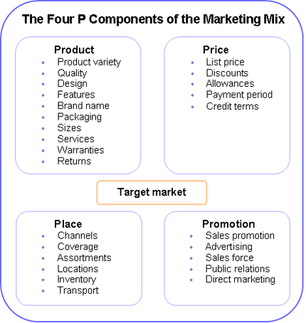

- Product: It is the tangible object or an intangible service that is getting marketed through the program. Tangible products may be items like consumer goods (Toothpaste, Soaps, Shampoos) or consumer durables (Watches, IPods). Intangible products are service based like the tourism industry and information technology based services or codes-based products like cellphone load and credits. Product design which leads to the product attributes is the most important factor. However packaging also needs to be taken into consideration while deciding this factor. Every product is subject to a life-cycle including a growth phase followed by an eventual period of decline as the product approaches market saturation. To retain its competitiveness in the market, continuous product extensions though innovation and thus differentiation is required and is one of the strategies to differentiate a product from its competitors.
- Price: The price is the simply amount a customer pays for the product. If the price outweigh the perceived benefits for an individual, the perceived value of the offering will be low and it will be unlikely to be adopted, but if the benefits are perceived as greater than their costs, chances of trial and adoption of the product is much greater.
- Place: Place represents the location where a product can be purchased. It is often referred to as the distribution channel. This may include any physical store (supermarket, departmental stores) as well as virtual stores (e-markets and e-malls) on the Internet. This is crucial as this provides the place utility to the consumer, which often becomes a deciding factor for the purchase of many products across multiple product categories.
- Promotion: This represents all of the communications that a marketer may use in the marketplace to increase awareness about the product and its benefits to the target segment. Promotion has four distinct elements: advertising, public relations, personal selling and sales promotion. A certain amount of crossover occurs when promotion uses the four principal elements together (e.g in film promotion). Sales staff often play a major role in promotion of a product.
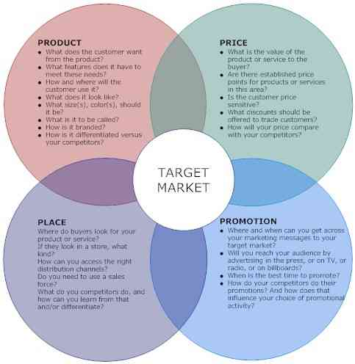

The 7 Ps of services marketing
Services are very different from products. So the marketing concepts need to be revisited while marketing a service. Services can range from financial services provided by the banks, technology services provided by the IT company, food and ambiance as a service provided by restaurants or even a blog where an author provides a service (information presentation, interesting reading etc) to his audience. Services marketing are dominated by the 7 Ps of marketing namely Product, Price, Place, Promotion, People, Process and Physical evidence.
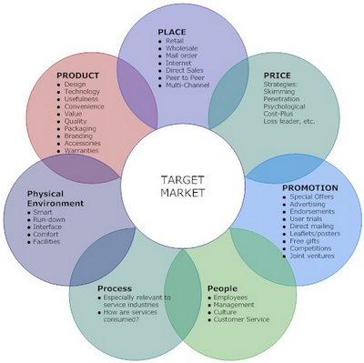

The following form the marketing mix for services marketing, the first 4 P’s being the core and the next 3 P’s being the extended marketing mix.
- Product is our core offering. This is “the thing” that will fulfill the needs of your customer. If your product is faulty, every thing else fails.
- Price has a lot of impact on the service buyer’s satisfaction level. Often, paying a higher price makes a customer more satisfied. Price is often considered a proxy for quality.
- Place often offers a different side of value (utility) to the customer. Who would want to travel 10 miles to have a regular dinner, even if that is priced very competitively and has a super quality? Services are often chosen for their place utility. Closer to the customer means higher probability of purchase.
- Promotion plays a role in the perception the possible target audience may have about your service. There has to be a fit between the promotion and the positioning.
- People are crucial in service delivery. The best food may not seem equally palatable if the waitress is in a sour mood. A smile always helps.
- Processes are important to deliver a quality service. Services being intangible, processes become all the more crucial to ensure standards are met with.
- Physical evidence affects the customer’s satisfaction. Often, services being intangible, customers depend on other cues to judge the offering. This is where physical evidence plays a part.
Services marketing is that elusive concept which stays incomplete without a thorough understanding of 7 Ps. These form the critical success factors for any service as evaluated by a possible customer.

4.8 Survey Findings:
In order to measure the satisfaction of the customers a series of questions were asked to the customers with the help of a questionnaire, the data from these questions are tabulated below. For clear understanding, the overall satisfaction has been divided into satisfaction with the package and satisfaction with the after sales service. As already mentioned, the survey was conducted among fifty GrameenPhone subscribers; it was conducted in three way direct appointment, over telephone and with the help of email.
I asked total twenty two closed end question to fifty subscribers. In the basis of strongly agree to strongly disagree. So the point of strongly agree is 5, and strongly disagree is 1.
From the total point and average point I divided in to three categories of subscribers, satisfied subscribers, moderate subscribers and not satisfied subscribers.
- If the average point is more then 4 then satisfied subscribers.
- If the average point is more then 3 then moderate subscribers.
- If the average point is less then 3 then not satisfied subscribers.

4.8.1 Average Mean & Grand Mean of each questions which I asked to the subscribers:
Questions | Mean | Satisfaction Level of Mean | Grand  Mean | Satisfaction Level of Grand Mean
1. Do you get the service what you need when you go to GrameenPhone customer service point? | 4.30 | Satisfied | 2.80 | Not Satisfied
2. When you buy a new service does it activated quickly? | 3.52 | Moderate | 3.36 | Moderate
3. Do you satisfied with the network coverage of the provider? | 4.66 | Satisfied | 1.92 | Not Satisfied
4. Do your provider fulfil your need with the current product and service? | 3.46 | Moderate | 3.20 | Moderate
5. Is the EDGE service of GP is very good? | 3.42 | Moderate | 2.80 | Not Satisfied
6. Does the customer manager well behave to you? | 4.28 | Satisfied | 2.80 | Not Satisfied
7. Does the customer manager carefully listen /give attention to your problem? | 3.96 | Moderate | 3.73 | Moderate
8. Does the customer manager provide the right information to  You? | 3.74 | Moderate | 3.20 | Moderate
Questions | Mean | Satisfaction Level of Mean | Grand  Mean | Satisfaction Level of Grand Mean
9. Do you get the service quickly? | 3.56 | Moderate | 3.37 | Moderate
10. Is the Price of GrameenPhone’s different package is affordable? | 3.44 | Moderate | 3.20 | Moderate
11. Is the Call rate of GP hotline is reasonable? | 2.2 | Not Satisfied | 2.92 | Not Satisfied
12. When you make a complain do your complain settled quickly? | 2.7 | Not Satisfied | 3.95 | Moderate
13. Is the Call rate of Grameenphone is reasonable? | 2.22 | Not Satisfied | 2.92 | Not Satisfied
14. Does GrameenPhone concentrate on quality services? | 3.14 | Moderate | 2.92 | Not Satisfied
15. Do you get the Customer manager when you feel need ? | 2.12 | Not Satisfied | 3.37 | Moderate
16. Do your think customer service charge reasonable? | 1.7 | Not Satisfied | 3.06 | Moderate
17. Does the customer manager show different attitude between different customer? | 1.7 | Not Satisfied | 2.92 | Not Satisfied
18. If you don’t get the customer manager does the company provide you alternative service? | 1.7 | Not Satisfied | 3.37 | Moderate
19. Does the customer manager show you Greetings? | 2.3 | Not Satisfied | 3.37 | Moderate
20. If another company comes up with the similar offers, would you still be loyal to GP? | 2.78 | Not Satisfied | 3.20 | Moderate
21. Do you think GP Customer Service Point Successful at meeting the Customer need? | 3.5 | Moderate | 3.37 | Moderate
22. According to the service your possibilities switching from GrameenPhone? | 2.9 | Not Satisfied | 3.37 | Moderate

4.8.2 Discussion of the Questionnaires instate of Mean & Grand Mean:
Questions no-1
GrameenPhone Subscribers get the service what they need and whenever they need from Grameenphone customer service Point, the mean of this point is 4.30. So grameenphone achieve customer satisfaction in this area.
Questions no-2&3
Subscribers are Moderate about the activation of new service or product because the mean point is 3.52 and also they are highly satisfied about network coverage of Grameenphone the mean if this point is 4.66. So Grameenphone need to keep this satisfaction level of the customers.
GrameenPhone has some additional advantageous features in comparisons to its competitors. There is easier access to person to person contract. Before GP’s introduction to the market, mobile phones were virtually out of reach to the major part of the current market. Moreover, GrameenPhone subscribers are happy with the country wide network.
Questions no-4
Subscribers are Moderate about the new product and service. Because the GP is aware about the new product and service and they give the follow up about their service. Here the Mean point is 3.46.
Questions no-5
Current product and service cannot fulfill all the need and demand of the subscribers, customer satisfaction of this area is moderate. Edge service is also not so good, So Grameenphone need to improve their product and service to increase the level of customer satisfaction because the Mean Points is 3.42

Questions no-6&7
Subscribers are satisfied about the behavior and attitude of customer managers they behave well and also the Subscribers are Moderate for listen carefully the problem of subscribers and provide the right information to the customers, the mean of this two point are respectively 4.28 and 3.96. So the customer is satisfied. People believe that Grameenphone concentrate on quality services so there are satisfied about their service.
Questions no -8 &9
Subscribers are Moderate about provide the right Information of Customer Manager of GP and Get the service quickly, the Mean point is 3.74 and 3.56 so Customer manager must provide the right information to the Customer and must be quickly.
Questions no-14 &10
Customer satisfaction level is moderate about the speed of the service and price of the different package. So Grameenphone need to give concentrate in this issue to increase customer satisfaction. The mean points are respectively 3.14 and 3.44

Questions no-11&13
From the Questionaire 11&13 we can see Customers are not satisfied about the call rate of Grameenphone and the call rate of hotline because the mean point is only 2.2 and 2.22 which is very low. Call rate of Grameenphone is high and to get the service from call center subscribers need to pay high rate. So to increase the level of satisfaction grameenphone need to reorganize their call rate.
Questions no-12

Subscribers are not satisfied about the communication of GrameenPhone. . They do not get any confirmation whether complain has been fixed or not. It also take long time to fixed the complain. The mean point is only 2.7

Questions no- 15
Subscribers are not satisfied because customer Managers is not available in the GrameenPhone Customer Service Point, because the CMs stay 10 AM to 5 PM in the Customer Service Point.

Questions no-16& 17
The GP STP is an important customer care tool. But it is also in shortage of capacity. Subscribers need to spend significant amount of time to reach the STP and pay money for that. Complains is not solve quickly. Behavior of the helpline CM is also sometimes unmanageable. They are to handle continuous queries. So it may so happen at times the CMs cannot keep up smiling voice and amenable behavior. Here for this two questions Mean points are same 1.7 which is very low and customers are not Satisfied.
Questions no-19
Customer satisfaction level is not satisfied the mean point is 2.3 only.

Questions no-21
Customer satisfaction level is Moderate the mean point is 3.5 only. So Grameenphone need to improve their product and service to increase the level of customer satisfaction.

Questions no-22
According to the Customer Service through Customer Service Point of GrameenPhone Ltd Customer satisfaction Level is not satisfied here the Mean point is 2.9 only.

4.8.3 Satisfaction Level of Mean and Grand Mean:

Total questions for Mean and Grand Mean |  | Satisfied | Moderate | Not Satisfied
Mean-22 |  | 3 | 9 | 10
Grand Mean-22 | 0 |  | 14 | 8
Totel-44 | 3 |  | 23 | 18

From each point of my survey I analyze the result.
By analyzing the findings and result I find out that in some point grameenphone subscribers are really satisfied where Satisfaction point is 3 and 0 total3, some point grameenphone subscribers are not really satisfied where not satisfied point is 10 and 8 total 18 and some points satisfaction level is moderate where moderate point is 9 and 14 and total is 23.

4.9 -Recommendations:

Following those recommendations, GrameenPhone can eliminate the dissatisfactions and thus earn a sustainable distinct competitive advantage to continue their market leadership

- GP should earn flexibility to be able to reduce the bill. Currently it should take into account that others are offering lower price packages.
- Capacity of the helpline should be increased in the peak hours.
- The customers should be made aware of the waiting charges they are to pay to be in queue in getting the services from the call center.
- To improve the load on the network, the existing capacity should be improve to fulfill the need of the customers.
- The customers face difficulties in payment of bill on bank holidays. It would be convent for them to introduce payments card.
- The customers are made happy if they receive greetings message on special occasions.
- Network development should be steady; GP should never sell connections in excess to its capacity.
- Capacity of the GrameenPhone Center (GPC) and service task point (STP) should be increased to reduce the stress of the subscribers.
- Different programs should be taken to educate the subscribers regarding different essential features of mobile phone.

- GrameenPhone should take extensive program to build a positive image among their users. In this process they should try to eliminate the misconceptions of the users regarding GP.
- To improve the load on the network, the existing capacity should be improve to fulfill the need of the customers.

4.9.1 Possible strategies to improve customer satisfaction:
- Analyze the market in a regular basis and find out what customers need and want in the area where subscribers are not satisfied like call rate, package speed, and moderate. Grameenphone have to take necessary action to increase customer satisfaction by lowering their call rate, offer different package, speed up their service etc.

- Communicate with the customer in easiest way like sending bangle SMS bangle voice service, so that subscriber can understands all the product and service, most of the subscribers still watch BTV and listen radio so they have to give advertisement in BTV and ‘Bangladesh Betar’ and in this way Grameenphone can increase customer satisfaction.

- Offer various kind of package in their product so that their subscribers can match with their preference.
- Create strong Brand image by different promotional activities which catch people’s emotion and feelings so that subscribers will be very much loyal.

- Offer various services with their connection so that subscribers can enjoy various services at a single device.

- Fulfill corporate social responsibilities to create a good image in subscribers mind. By organizing different events, donating money, do something for the poor people; help the government to give education to the poor children.

- Capacity of the helpline should be increased in the peak hours because in peak hour pressure of calls is high and customers need to wait long time to get the service which decrease customer satisfaction. So recruit more efficient customer manager to increase customer satisfaction.

- Send greetings message on special occasions to the subscribers which increase customer satisfaction.
4.10 Literature Review

The main purpose of review of literature is to identify the hiatus or knowledge gap in the field of proposed research. With this end in view a researcher should review all the pioneer works already done in the proposed field of research. We should select those literatures for review, which are relevant, reliable, representative (3Rs).

- Customer Satisfaction Mobile Phone Services: An Empirical Study on GrameenPhone (GP) in Bangladesh(International Business Management Year: 2011 | Volume: 5 | Issue: 3 | Page No.: 140-150 DOI: 10.3923/ibm.2011.140.150)
- The influence of Regulatory Environment on Mobile Phone Service Quality FOR ‘ANNUAL ASIAN BUSINESS RESEARCH CONFERENCE 2010

4.11 Conclusion:
GrameenPhone Ltd. (GP) is the market leader in the mobile telecommunication industry of Bangladesh. The majority of the grameenapahone subscribers satisfaction level is moderate.
However, there is Moderate among the GP users with the service of the company. Many important factors are acting as reasons behind this overall Moderate Level. Quality of network is the main reason for Moderate. Different package is match with subscriber’s preference. Most of the time GrameenPhone connections is available to reach. But it so happens that the subscribers used to pay extra money to get the access. This is especially true for prepaid service. It is encouraging that very recently situation has improved to a certain extent bases on the findings in this report.

So GrameenPhone try to improve their product and service continuously to satisfy their subscribers. Because in service related organization Customer satisfaction is very important, and GP provide service to their subscribers and they need to find out where and why subscribers are dissatisfied or moderate and improve the situation to retain the subscribers.

As my discussion shows, GP is doing great in its business. Their market share is significantly high. The mobile telecommunication industry is also growing at a significant pace. But, if we assess the external environment, we find, the path for Grameenphone is not that smooth. The service of GP is extensively dependent on BTTB (Bangladesh Telephone & Telegraph Board). In many cases, GP did not get full support of the government owned department.
So, it has the scope to enhance and strengthen its market position. To do so, they need to put more stress on their policies like efficiency, quality, innovation, and customer responsiveness. If everything goes right, with least risk I can say, GP is headed towards a bright future.

4.12 References:

- Web Site: www.grameenphone.com
- Annual Report 2010, GrameenPhone Ltd.
- http://www.vanillaplus.com/admin/data/userfiles/images/grameenphone_white.gif
- http://www.grameenphone.com/about-us/corporate-information
- http://www.grameenphone.com/about-us/corporate-information/ownership-structure
- http://www.grameenphone.com/about-us/corporate-information/corporate-governance
- http://www.grameenphone.com/about-us/corporate-information/corporate-governance/organization-structure
- http://www.grameenphone.com/about-us/corporate-information/our-brand
- http://www.grameenphone.com/about-us/corporate-information/corporate-responsibility
- http://www.grameenphone.com/about-us/corporate-information/social-initiatives
- http://www.grameenphone.com/products-and-services
- http://www.grameenphone.com/customer-service
- http://cf.juggle-images.com/fit/white/600x600/wg-grameenphone-1.jpg

- 14. Newsletter of GrameenPhone Limited

- Image Guide Book & Intranet of GrameenPhone.

- Divisional Annual report (Customer Management Division)

- http://medwelljournals.com/fulltext/?doi=ibm.2011.140.150

- http://www.scribd.com/doc/7127346/Customer-Satisfaction-Grameen-Phone-Bangladesh

