Internship Report
On
Identify the Key Marketing Deficiencies of STAR

Submitted by
WWW.ASSIGNMENTPOINT.COM

Low segment is the most critical segment for BATB for its volume leadership in the industry. Recent trend indicates the segment is growing faster than any other segment and attracting highest number of new entrants and up-traders. The segment is expected to grow and become the most influencing segment in the industry over mid term.

“STAR” is the drive brand in this segment. In recent years, the brand has grown substantially and became the biggest brand of BATB. However, “NAVY” is also has grown and in some markets grown faster than “STAR”. Right now “NAVY” is slightly ahead of “STAR” in terms of off-take share. To maintain BATB's leadership it is absolutely critical to overtake “NAVY” and establish “STAR” as the leading brand of the low segment. The hidden truth behind this strategy is that BATB wants to establish “STAR” as the leading brand in this low segment because it does not want “NAVY” to get strong base and to endorse Castle in the mid segment where John Player Gold Leaf (JPGL) and Pall Mall are the main profitable brands for BATB.

In light of the above facts, “STAR”'s superiority over “NAVY” needs to be clearly established in each segment of trade “STAR”ting from the retailers to the ultimate consumers. Project Seedbed is a bold step towards that direction. Project Seedbed was first proposed to the Marketing Top-Team Meeting (MTM) and then to the Executive Committee Meeting (ExCoM) in December 2004 as a regional initiative by Khulna Region. This Campaign is expected to clearly establish “STAR”'s product positioning and provide smokers reasons to rationalize “STAR”'s superiority over competition. Just to update, overall product superiority of “STAR” has been confirmed during the last MASQ, where “STAR” was rated over “NAVY” in terms of product performance.

The purpose of the study is to successfully identify the key marketing deficiencies of “STAR” in Khulna and propose some appropriate and market specific strategic solutions to establish “STAR”’s superiority over its competitive brands.
1.2 Origin of the Report
This report is prepared to fulfill the partial requirement of my Project of BBA Program of East West University, supervised by Omar Faruq, Assistant Professor. I have been working for this project since June 2009.

1.3 Objectives
The objectives of the study are as follows:
- Evaluate the form and status of competition in the segment.
- Identify the key marketing deficiencies of “STAR” as a brand in Tk. 1 segment against its largest competitor “NAVY” on the basis of consumer disposition funnel.
- Recommend some appropriate and market specific solutions to minimize the gap.
- Design a detail pilot project for implementation of the recommendations.

1.4 Scope
1.4.1 Brand Scope
There are several Tk. 1 segment brands in the market. BATB has two strong brands in the segment – “STAR” and Scissor. In the same way, DTI holds another strong brand - “NAVY”. As a requirement of the organization, the study limits its focus only on two brands – “STAR” and its largest competitor “NAVY”. Also “STAR” sees an organic growth in few important territories and also its brand image creates its demand.

1.4.2 Demand Factors
While analyzing, factors like volume swapping, external market influences on demand condition, seasonality and several other inevitable incidents are kept aside to rest the focus on the purpose.
1.4.3 Market
As an organizational requirement, the study needed to be focused on Khulna market. Therefore, the data presented here are from the same market and can vary significantly from the rest of Bangladesh due to state of competition, economic condition and many other influencing factors.

The Khulna Region consists of 21 different markets, divided into 4 areas. Therefore, the question naturally comes, what are the reasons behind selecting Khulna for the study and the pilot run? Broadly, what is the significance of this particular market?

To answer the question, we need to look deeper into individual market characteristics. If we summarize the market characteristics in terms of competition, geographical importance, volume and growth potential, Kushtia, Chuadanga, Jessore, Khulna, Faridpur, Madaripur, Barisal, Jhalokati, Potuakhali, Borguna and Gopalgonj are some of the top priority markets for Khulna Region. They provide a business of more than 60 percent of the total market volume of the region and holds great potentiality for future growth. Among these markets, Khulna, Jessore, Kushtia and Barisal are the hearts of the regional business.

From the results of prior a market research, it has been identified that the market characteristics of these four markets are identical with some minor dissimilarity. They hold similar type of geographical dispersion, importance, growth potential and trend. Apart from these huge similarities, only Kushtia holds some extra advantages, like better economic condition of the consumers, strong brand position of “STAR” among Tk. 1 brands. So, if any particular strategy works for one of these markets, we can safely infer that it will have similar or better impact in other markets, if implemented. Additionally we will also have the advantage of having some concrete ideas about the result and impact in the market.

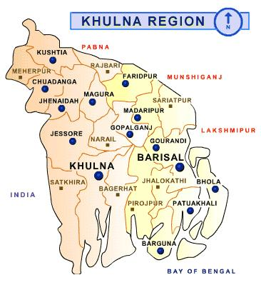
Seed Bed
Green Belt
Time Shop

Illustration 1A: Khulna Region

So, the region decided to these four markets into three categories:
- Seedbed: Jessore and Khulna
- Green Belt: Kushtia
- Time Shop: Barisal

Seedbed
The general modality that will be followed is to design a detail work plan and implement able pilot project and run it into Khulna. As the competition is fierce in Khulna, so any plan which can show moderate results in Khulna can bring significant impact for other markets with less competition. For example, as the competition is not so significant in Kushtia, it is believed to bring significant impact in that market. To ensure optimum use of resources, if needed, some of the activities of the project will be rearranged and cut short to ensure resource optimization.

Green Belt
A project with similar objective, but different modality is being run in Kushtia. It is believed that the results of the project will provide further insights of the market and will strengthened the seedbed for better performance upon implementation.

Time Shop
Scissor is a strong brand in Barisal. So, time will be bought from Barisal and after the successful completion of Project Seedbed in Khulna, activities for Barisal will be decided based upon the findings and results of the pilot run.

1.5 Methodology

1.5.1 Research Method
This research includes a consumer survey module to identify the key deficiencies in case of “STAR”. One thing that needs to be mentioned here is that, the survey module were already designed and the modality were already prepared and accepted by the team. There was not much scope to customize or rearrange the survey methodology. Therefore, the applicability issue does not come under the scope of the study.

Also, secondary data sources such as sales report and other materials were used as necessary. Fragmented retailer interviewing were done in several cases to get a comprehensive view.

Sampling Plan
The survey conducted for the study is done considering the effect of different stages in the market. Major clusters in Khulna were identified based upon differentiating characteristics and then proportional sample size was determined to represent the whole market.

Data Collection
The survey routine was divided into seven areas. The main objective of the survey was to find out the position of the consumer in the disposition funnel for both “STAR” and “NAVY”. The areas of data collection were:
- Introductory Part
- Top of the Mind (TOM) Awareness Level
- Consideration Level
- Trial Level
- Repertoire Level
- Regularity Level
- Loyal Level

A common datasheet form, designed by the BATB survey management team to distinguish consumer loyalty and some other relevant attributes were used for the survey. The form helps the surveyor to find definite clue about the consumer’s level of attachment with “STAR” as well as “NAVY”. After the Introductory Part, each question judges the consumer to find out in which level the consumer is in currently now. It “STAR”ts from Awareness Level and ends in the Loyal Level.

1.5.2 Method of Analysis
The collected data from the survey were extracted from the datasheets and put into a flow-table to analyze the chronicle changes in the disposition funnel. The data taken for “NAVY” was used as the benchmark. From there, it is possible to successfully identify the major deficiency areas and have an outline for recommendations and further decision making.

1.6 Limitations
Despite of the effort to make the study as proximate to perfection, there are several unavoidable reasons, which might contribute for its limitations.
- There were several organization bindings and requirements those I needed to consider while conducting the study.
- There are several data and formats, which are highly classified and contain sensitive information. While, attaching them with this report would definitely provide the reader with a broader view on the rationale of the study and the findings, but it was not possible.
- In many ways, the geographical dispersion of the clusters hindered the study and in certain cases prevented from going for deeper insights.
- Definitely, there might be some judgmental errors occurred due to inexperience and surroundings.

1.7 Contribution to the Study
The study is believed to contribute significantly in minimizing the gap between “NAVY” and “STAR” in terms of consumer perception, brand position and ultimately sales. While gaining leadership over a strong brand such as “NAVY” is a long-term process and cannot be done in one night, but the study will definitely help to identify the major lacking and help to take future decisions.

The recommendations from the findings will definitely help in making future decisions and will also contribute by presenting some real life data from its pilot run.

1.8 Scope for Further Research
Obviously, there are many factors, which are outside of the scope of the study but will definitely have some impact over the market and the competition. Therefore, there is scope to include as many of those factors as possible and consider their effect in the study and observe the result. This will make the findings more comprehensive and will help to minimize uncertainty, which are critical for decision-making. Also there are some factors that can not be anticipated. But many factors also can be overlooked. So factors that have impact will make the research accurate if these are included.

2.1 British American Tobacco Bangladesh Company Ltd.
British American Tobacco Bangladesh is a member of the British American Tobacco Group that is based in UK and one of the leading players in the global tobacco business. With a long established reputation for providing its consumers with consistently high quality brands, British American Tobacco Group was formed at the turn of the 20th century with the objective of establishing a worldwide business. British American Tobacco is World's most global tobacco company. BAT has 85,000 employees selling more than 300 brands in more than 180 markets worldwide. Today, the company produces some 2 billion cigarettes every day. More than a billion people across the globe enjoy smoking tobacco. One in every eight chooses a British American Tobacco brand.

In order to support the company's business goals, the merger of British American Tobacco with Rothmans International had been announced on 11 January 1999. This global merger was completed on 7th June 1999. This brings together the number 2 and 4 players which together will boast a combined volume exceeding 900 billion cigarettes around the world with some 120,000 employees and a world-wide market share of 16 percent (Phillip Morris has a 17 percent share). The merger is a major step forward in British American Tobacco’s vision of becoming the world’s leading International Tobacco Company.

British American Tobacco Bangladesh Company Limited, a market leader in the country, is a subsidiary of British American Tobacco PLC and is one of the 66 countries in which the British American Tobacco Group has manufacturing plants. British American Tobacco Bangladesh has operated in Bangladesh since pre-independence and has it’s headquarter in Dhaka, with a tobacco leaf processing operation in Kushtia. It is one of the oldest, largest and most respected multinational companies operating in Bangladesh.

BATB markets major international cigarette brands like Benson & Hedges, State Express 555, John Player Gold Leaf and Pall Mall, which are complemented by local brands such as Capstan, “STAR” and Scissors. The company also exports processed tobacco leaf in the international market, mainly in the European Countries with its effort to create an international market of its products.

British American Tobacco Bangladesh currently employs more than 1,300 people and provides indirect employment to a further 24,500 farmers, distributors and suppliers.

Currently, British American Tobacco Bangladesh has two factories in Bangladesh. The Cigarette Manufacturing Factory (Dhaka Factory) is located on the same premises as the Head Office in Mohakhali, Dhaka. The Green Leaf Threshing Plant (GLTP) is situated in Kushtia.

In line with the global identity change of British American Tobacco PLC, BTC was renamed as British American Tobacco Bangladesh Company Limited (BATB) in 1998. The Company is listed on both the Dhaka and Chittagong stock exchanges in the country.

2.2 The Vision and Mission of BATB
The vision of the organization is:
To Extend Our Leadership through World-Class Performance

There are certain missions the organization is heading to accomplish. They are:
- Double the net revenue by 2006
- Growing our share of the total tobacco market
- Dominating key identified segments

2.3 Historical Background of BATB
The journey of this company “STAR”ted long back. BATB was established back in 1910 as Imperial Tobacco Company Ltd. with head office in Calcutta. In the very beginning, Imperial Tobacco Company (ITC) launched a branch office at Moulivibazar, Dhaka in 1926. Cigarettes were made in Carreras Ltd., Calcutta. Imperial and Carreras merged into a single company in 1943. After the partition in 1947, cigarettes were coming freely from Calcutta, but introduction of customs barriers in 1948 between India and Pakistan interrupted the smooth flow of cigarettes from Calcutta to East Pakistan.

In March 1, 1949, Pakistan Tobacco Company (PTC) came into existence with head office in Karachi; with the assets and liabilities of ITC Limited held in Pakistan. The then East Pakistan Office was situated in Alico Building, Motijheel. In order to meet the increasing demand, the first factory in the then East Pakistan was established in Chittagong in 1952. From this time, onwards requirements for cigarettes for East Pakistan markets were met from products manufactured in Karachi. In 1954, PTC established its first cigarette factory although high-grade cigarettes still came from West Pakistan. The Dhaka factory of PTC went into production in 1965. After the war between India and Pakistan in 1965; the import of tender leaf from India for the production of Biri was stopped. This gave a big boost to cigarette business. It was at that time the East Pakistani entrepreneurs set up 16 cigarette factories in this region.

After independence, Bangladesh Tobacco Company (Pvt.) Limited was formed on 02 February 1972 under the Companies Act 1913, with the assets and liabilities of PTC. Shareholding position for GOB and BAT was 1:2. BTC (Pvt.) was converted into a public limited company on 03 September 1973. British American Tobacco played a pivotal role in BTC's creation in 1972 and since then has been involved in BTC's development every step of the way. To pronounce the successful relationship with British American Tobacco, BTC has changed its name and identity to British American Tobacco (BAT) Bangladesh Company Limited on March 22, 1998. The company changed its identification to establish commitment to the highest international standards.

Timeline | Incident
March 1949 | Formation of Pakistan Tobacco Company (PTC)
1954 | PTC opened its first factory in Fouzdarhat, Chittagong
1962 | Opened a branch in Moulavibazar, Dhaka
1965 | Building of a factory in Mohakhali, Dhaka
February 1972 | Incorporation of BTC with a paid up capital of Tk. 400 million
March 22, 1998 | Changed its identity from BTC to BATB
Table 2A: History of BATB

2.4 Relationship between BAT & BATB
The parent company of BATB is called BATCO or British American Tobacco Company. They are the major shareholders of BATB. The operations of BATB are regulated according to BATCO regulations and BATCO looks after the management aspects of BATB. BATB management is trained by BATCO and in many occasions. BATCO sends over their own management to work in BATB. BAT industries are widely known as BATCO and has two major divisions:
- Tobacco Division
- Financial Division
The following organ gram shows the relationship between BATCO and BATB very clearly:
BATCO
Tobacco Division
Financial Division
AMESCA
BATB

Illustration 2A: BATCO Organ gram

Currently British American Tobacco Bangladesh is retaining 63% of the cigarette market in Bangladesh. British American Tobacco Bangladesh is a sister concern of British American Tobacco Company (BATCO). The cigarette division is known as British American Tobacco Holdings (BAT Holdings), which operates in more than 78 countries. BAT Holdings is a sister concern of BAT industries - a London based world famous business house. BAT industries operate in financial services, paper manufacturing, and tobacco sector. BATCO divided its cigarette operation in five regions. They are:
- North and Central America
- Europe
- South America
- Asia Pacific
- AMESCA

BATB actually maintains a relationship with BATCO through AMESCA. It is actually a region of BATCO to which BATB reports. AMESCA is made up of: A = Africa, ME = Middle East, S= Subcontinent, CA = Central Asia.

2.5 Structure of BATB
BATB is a public limited company. Management Director is the operational head and appointed by the British American Tobacco. Head of every department carries out their functions with the help of line managers. Different departments have different structure according to their function and responsibility.

The Board of Directors and Executive Committee (ExCo) govern the overall activities of the company. The Board of Directors is composed of 10 members who are called Directors. The Chairman heads the Board of Directors. Chief Executive of British American Tobacco Bangladesh is called the Managing Director, who is normally appointed by BAT Holdings. Managing Director of the company is the chairperson of the Executive Committee. This committee includes the head of all the functional departments.

2.6 Ownership Status of the Company
British American Tobacco Bangladesh is listed in the Dhaka Stock Exchange (DSE). It has an authorized capital of Tk. 400,000,000 of 40,000,000 ordinary shares of Tk. 10 each. British American Tobacco Bangladesh, which encompasses 62% of the shares of the British American Tobacco, London. The Government held 32% of its shares. Subsequently the government has gradually sold its holdings to different organizations of the country. The composition of shareholders on December 31, 1999 was:

Investing Organization | Percentage
Raleigh Investment Co. Ltd. UK | 65.91 %
Investment Corporation of Bangladesh | 26.99 %
Sadharan Bima Corporation | 2.86 %
Investing Organization | Percentage
Bangladesh Silpa Rin Sangstha | 0.84 %
Government of Bangladesh | 0.65 %
Sena Kalyan Sangstha | 0.52 %
Others | 2.23 %
Table 2B: Ownership Status of BATB

2.7 Employee and Trade Union of BATB
The employees of the BATB are dynamic, self-motivated and energetic to perform any assigned job, because they are selected based on excellent academic and experience records. The company employs 1,244 permanent employees and varying number of seasonal and temporary workers as required. Each permanent employee receives remuneration in excess of Tk. 36,000 per annum. Remuneration depends on the nature and conditions of work. The workers are labeled in the following categories:
- Permanent
- Probationer
- Temporary (seasonal)
- Badli
- Casual

Trade union is established in the following company’s working locations:
- Head Office and Dhaka Factory
- Chittagong Factory
- Rangpur Leaf Factory
There is a positive relationship between the company and the trade union based on mutual trust and respect. All the employees of the company belong to the trade union. When a worker becomes a member of the union, according to his request a certain amount of his wage is deducted as the union subscription fees on a check off system. Trade union election is held after every two years and governed by their respective constitutions. The terms and conditions of services of the employee are negotiated and determined through a process of collective bargaining between the company and the union.

2.8 Physical Infrastructure of the Company
The infrastructure of the company has a broader field where the company plays its important role. BATB has six Regional Trade Marketing Offices (RTMOs), 12 Regional Sales Depots, 1 Factory, 1 Green Leaf Threshing Plant, 7 Leaf Depots and a Head office consisting of Corporate Head Office and Production Head Office. The Company’s Head office and Cigarette factory are located in Dhaka. A Green Leaf Threshing (GLT) Plant has been set up in Kushtia and it has “STAR”ted operation from April 1995.

The company’s products are manufactured in the factory at Mohakhali, Dhaka. The Plant Manager who reports to the Production Director at the Head Office heads Dhaka factory. The company’ procures tobacco leaf maintaining the international standard and it imports processed tobacco leaf for its international brands. It procures green tobacco from the registered farmers of the leaf area mainly for its local brands.

The company’s authorized leaf areas are located in Kushtia, Chittagong and Manikgonj. However, bulk of tobacco leafs comes from Kushtia region. The Chittagong area is under development process and it now covers Rangunia and Lama. The company operates seven leaf depots in the leaf area. Four of them are located in Kushtia region, two of them are located in CDA and other one is in Manikgonj, The Company provides all sorts of supports to the registered growers through its depot personnel. This includes technical know how, agricultural inputs and financial assistance.

The company performs its sales and distribution operation all over the country through its six regional sales offices. They are located in Dhaka, Khulna, Chittagong, Sylhet, Bogra and Mymensingh. Each of the regions is again divided into operational areas, each of which in turn is divided into territories. To perform its sales and distribution smoothly, the company operates 10 sales depots in different locations of the country and it has 63 authorized distributors.

2.9 Tobacco Cultivation in Kushtia
Tobacco cultivation in Kushtia Leaf area was first introduced in 1967 with an area of 10 acres. It was expected to expand to 650 acres by 1971. Flue-cured and Air-cured tobacco were cultivated in Kushtia and the Leaf Department achieved self-sufficiency in cigarette tobacco by 1975. Tobacco cultivation though registered growers and procurement of the product tobacco is done through four leaf depots In Kushtia. Those depots are Meherpur, Jhenidah, Chechua and Allardarga Leaf Depot. Kushtia Leaf Factory stands on 4.31 acres of land and is located at about three kilometers away from main town. The Green Leaf Threshing (GLT) plant could complete the entire leaf purchase in 1995. A team of management including the Plant Engineer, Processing Manager, Shift Manager, Quality Control Manager, Leaf Account and the Leaf Personal Manager is managing the GLT plant. The Plant Manager is the team leader of GLT management team.

2.10 Environmental, Health & Safety Policy and Afforestation Program
All the activities in the manufacturing unit and Green Leaf Threshing Plant ensure that work is conducted in a manner to minimize environmental pollution. GLT has won British American Tobacco’s Environment, Health and Safety Merit award for the year 1995 and 1996 for achieving consecutive two years of operation with zero accident. The company also received the prestigious EHS Silver Award for 1999 without any lost time due to accident in any part of the company, which was the second year in a row.

In line with BAT's environmental, health, and safety policy, the company is involved in an afforestation program. The contribution of the company in afforestation program in Bangladesh has earned recognition in the country though winning of the Prime Minister’s Trophy in 1993. In 1998, the company distributed 3.5 million free saplings in Dhaka through the Bonsai Nursery project. This program had caused more than 28.5 million trees planted or distributed till 1998 and is expected to yield around 120,000 metric tons of timber for fuel-wood, furniture making, or construction process in 1998 . The Food and Agricultural Organization (FAO) has awarded British American Tobacco Bangladesh for pioneering the development of vegetable seed industry in Bangladesh. The company had “STAR”ted its vegetable seed multiplication program in 1990 with the technical support of FAO with a view to provide quality vegetable saplings for free distribution amongst farmers in the tobacco growing areas.

It is not enough for BATB only to contribute to the afforestation of the country. The company felt the need to promote the use of alternate wood fuel for tobacco curing by its farmers. Briquette as an alternate was introduced to the farmers to reduce their dependency on trees for wood fuels. Briquettes are made of paddy husk and sugarcane biogases. Briquettes can be used for cooking, in burns for curing tobacco and brick. The company promotes Briquette manufacturing in the tobacco growing areas and tries to make them easily available to the farmers.

A company wide safety awareness program was initiated and completed in 1996. The objective of this program was to brief employees about the techniques to reduce the risk of occurrence of preventable accidents. The company's commitment to the highest level of safety practices are recognized with awards being received from the British American Tobacco Group headquarters in more than one year. Workers and management are provided with regular safety training. Hard hats are required during shift work. All movable machine parts have guards to prevent workers from accidental injury.

2.11 Commitment to Develop the Future
British American Tobacco has over the decades consistently invested in the Bangladesh market through BATB. Thus BATB has always been in the business of manufacturing and marketing brands that meet standards found anywhere in the world.

The company believes in attracting the best talent available by offering a challenging working environment with international career development opportunities. Individuals here are entrusted with significant responsibility and autonomy, and investment in people through regular training and career development has helped them to establish a culture, which encourages people to think creatively, generate new ideas and approach problems from a number of different perspectives. In the quest of becoming a World Class Company by achieving the visions, strategic imperatives and the values, the company has launched a change management program called – Winning in Our World in 1999. The objective is to bring about a cultural change by embedding the WOW Values and removal of barriers. To this effect, the company has organized different workshops, employee care and development activities throughout the year with direct participation of its people.

With state-of-the-art machinery, excellent people, and a portfolio of world-beating brands, British American Tobacco Bangladesh could not be anything but instinctively international.

People's attitudes have changed much over the time. Without this changed attitude of excelling in their performance, it would not have been possible to make so much progress. This spirit of people will help in achieving the company's Vision and Mission and ultimately to be a world class company.

Lotus notes is a highly evolved advanced communication system of BAT through which all the employees of BAT worldwide communicate among themselves. This hi-tech device helps to provide quick and uninterrupted communication and information. Quantum is a marketing information tool with the objective of effective utilization of marketing spends through better targeting and evaluation of BATB’s marketing activities. This strategic investment helps BAT to achieve competitive edge in case of facing any competition. The company has implemented Tetra CS/3, a totally integrated software package that links Manufacturing, Finance, and Distribution providing one set of clearly understood information that can be used throughout the company. Apart from this software, the company uses several other software packages for some specific purposes that are shared throughout the company.

Another important development with regard to accessibility of information is the implementation of the Global Enterprise Network (GEN) standard. GEN provides a standardized IT infrastructure throughout the British American Tobacco group that allows users to access their work areas from any location within the group.

Also the company has developed a system to have better control of its supply chain process. This has made a major impact in terms of automating the entire supply chain process from shipping go-down to retailer, providing on-line information at every stage of the secondary supply chain.

As a company that aspires to be the world class, the company also looks at the interests of its suppliers and trading partners. A team is currently looking at how the company can support them as they strive to improve their performance.

2.12 Functional Areas
BATB has been operating its business under the following major functional areas:
- Production
- Leaf
- Finance
- Human Resource
- Marketing
- Information Technology
- Corporate and Regulatory Affairs
- Business Development

For the relevancy of the study, only the marketing department and its structure have been discussed to provide a comprehensive view.

2.13 Marketing Department
The marketing department has two main wings:
- Brand Marketing
- Trade Marketing and Distribution

While the Brand Marketing wing focuses upon the branding aspects of a product, the Trade Marketing & Distribution (TM&D) Wing focuses upon the trade and distribution aspect. These two wings are joined by the Trade Development Team (TDT).

2.13.1 Brand Marketing

Structure of Brand Marketing Wing
The Brand Marketing department concentrates on satisfying consumers’ needs from within the brand portfolio. Once consumers’ needs are understood and evaluated, brands can be made available, accessible and desirable through strong, consistent communication. The brand marketing elements covers the adopting of products, logistics and brand marketing policies that best meet the needs of particular trade channels and strategic customers. The Brand Managers and Brand Executives are responsible for the allocated brand(s). They are responsible for all type of brand management activities.

Head of Marketing

Senior Brand Manager
Super Premium
Brand Manager
CORA Marketing Manager
Senior Brand Manager
VFM
Group Brand Manager
Premium Brand
Senior Brand Manager
DVFM
Marketing Intelligence Manager
Marketing Finance Manager
Product Development Manager
Assistant Marketing Intelligence Manager
Senior Brand Manager
Pall Mall

Coordinating Officer
Brand Manager, JPGL
Brand Manager, B&H
Brand Manager Pall Mall
Brand ManagerDVFM

Brand Executive, JPGL
Brand Executive, B&H
Brand Executive Pall Mall
Brand Executive
Brand ExecutiveDVFM

Illustration 2B: Brand Marketing Wing Organ gram
Market intelligence includes the in market research teams. The team keeps constant eye on the market situation. Through continuous research, market research teams generate useful market information for the brand managers. Interface is required between brand marketing and research, which is carried out by any project that is divided by three phases:
- Preparation prior to the study
- Collection and analysis of data
- Presentation and utilization of information

Vision and Mission of Brand Marketing
The vision of the Brand Marketing wing is:
Within five years to be the undisputed leader of Bangladesh tobacco market

It also includes:
- Dominate value share
- Dominate volume share base
- Destination brand in key segments.

The mission of the wing is:
- Promise of future profit growth
- Grow quality share: ASU30
- Owning the medium and premium segment (90% share)

Core Strategies of Brand Marketing
Aggressive:
- Expand the premium segment growth.
  - Internationalism, destination status & image differentiator: Youthful
- Expand Mid segment
  - Key differentiators are international standard with affordability & distinctive image: masculinity/adventure
- Dominate volume base
- Build the critical mass
- Protect BAT’s leadership.

Innovative:
- Investigate & build new segments
  - Lights
  - New brands & line extensions
- Product enhancement
  - Packaging, spec. change & higher satisfaction
- Creative communication
  - Focused: HoReCa (Hotels, Restaurants and Cafés), rural penetration
- Consumer insight
  - World-class knowledge base: consumer research & market tracking

2.13.2 Trade Marketing and Distribution

Mission and Objectives of TM&D
TM&D Mission is:
To reach our target consumers in the most efficient and effective way by becoming the benchmark supplier to the trade within strategic channels in every market place where we do business.

TM&D identifies the areas in which best practice must be achieved to enable markets meet the Trade Marketing and Distribution objectives, which are:
- Create an efficient entry barrier against international competition
- Improve our benchmark supplier status to the trade pioneer among all FMCG companies.

Six Critical Factors to Achieve TM&D Mission
- Secondary Supply Chain/ Product Management: Optimize cost and performance while ensuring achievement of brand objectives. The associated sub-activities are:
  - Supply chain strategy/management
  - Order management
  - Order fulfillment
  - Trading terms
  - Inventory management

- POP (Point of Purchase) Management: Create effective competitive entry barrier at point of sales while driving international brands. The associated sub-activities are:
  - Display
  - Promotions
  - In-store communication/advertising
  - Implementation
  - HoReCa (Hotels, Restaurants and Cafes)

- Account Management/ Channel Development: Create an effective entry barrier while driving brand imagery, awareness and trial in HoReCa and superior grocery outlets. The associated sub-activities are:
  - Account planning
  - Account profitability
  - New business development

- Strategy and Planning: Ensure effective implementation of EMF (effective market focus) process to support achievement of company’s objectives. The associated sub-activities are:
  - TM&D planning
  - Cycle planning
  - Coverage planning

- Resource Management: Ensure that TM&D organogram is responsive to the changing trade and company needs. The associated sub-activities are:
  - Financial planning and management
  - Manpower planning
  - Organization development
  - Management information for marketing overview

- Information Management: Drive Quantum business benefits to the fullest. The associated sub-activities are:
  - Market intelligence
  - Internal monitoring
  - Information technology
  - Customer satisfaction

Structure of TM&D Department:
The following illustrations show detail organizational structures of the TM&D wing. The structure is divided into two segments – Head Office and Regions.

Head of Marketing

Coordinating Officer
National Sales Manager

Marketing IT Manager
Trade Development Manager
Marketing Intelligence Manager
Marketing Finance Manager
Demand Manager
Regional Manager

Marketing Skill Development Manager
Quantum System Manager
Cycle Planning Manager
Analyzing and Reporting Manager
Merchandising and Promotions Manager
Area Manager

Territory Officer

Illustration 2C: Trade Marketing Wing Organogram

Some Critical Aspects of Trade Marketing and Distribution

Regional Trade Marketing Office (RTMO): The British American Tobacco Bangladesh has a well-defined mission for the marketing and distribution of products, which is to reach the target consumer in the most efficient manner by becoming the benchmark supplier to the trade within the strategic channels in every market where the company operates. A well-organized trade marketing team is working continuously to make this mission successful. Furthermore, the whole country has been divided into six regions to perform the marketing activities efficiently. Moreover, the regions are further spitted into 11 areas. Right now, there are six regional managers, 20 area managers and 51 territory officers working under the Head of Trade Marketing. At present, there are 63 distributors involved with BATB who are responsible to make the products of the company available throughout the country.

The British American Tobacco Bangladesh considers the distributors as their customers. They have identified the distinction between the customers and consumers in a proper way. Consumers are those who buy cigarette for smoking. The Company sells their product to the distributors. The distributors in turn sell to the retailers and cash & carry as well. Cash & Carry are nothing but wholesalers. Cash & Carry are needed because at times the retailers may not have adequate funds to buy the required quantity. However, the company is trying to discourage the use of these wholesalers to control the price of their product in the market. Generally, the trade marketing and distribution team performs three main activities, which are trade coverage, cycle implementation and training & development.

Trade Coverage: Accumulating primary data from the market is a function of trade coverage. There is a team working to identify retailers who contribute eighty percent (80%) of their total sales volume. The Territory Officers (TO) are responsible for making a route plan by which they can identify which outlets to visit and in what frequency on the basis of those classes. The Territory Officers have to visit at least 12 outlets a day and collect raw data from the retailers on the call card in the Laptop computer. A set of questions regarding the various aspects of the out lets make up the call card. There is a database at the RTMO, which is updated regularly by using those calls. This database serves as a powerful tool to identify and classify different outlets in terms of volume sales, outlet characteristics and consumer profile.

Cycle Implementation: The marketing people of BAT have divided the whole year into 13 cycles and each cycle focuses on a particular brand, Furthermore, the brand marketing group along with trade marketing people develop promotional campaign plans for each brand. They also select the brand for the cycle and develop cycle instructions and send it to RTMOs. After that, the trade marketing team develops some objectives and implements those within their territory, which helps to follow the proposal cycle instructions. The regional manager and the area manager(s) then brief the TO’s about the cycle objectives and in turn, the TO’s brief the distributor and ultimately work with the retailers. In this regard the contract merchandisers generally perform well to accomplish the TO’’s job, at the end of each cycle, the TO’s prepare a cycle evaluation report.

Training & Development: To train the working people is one of the most important jobs of any TO. They generally train the people working for the distributors, for example distribution representative and the contract merchandisers within his territory. They also train the retailers about how to approach consumers, if necessary.

Retail Outlet Classification: The British American Tobacco Bangladesh has classified all the retail outlets into three categories, these are:
- Convenience
- Grocery
- HoReCa.

- Convenience Outlet: All shops where consumers generally go without any purchasing intention fall in this category. The consumers like to buy product on impulse from this sort of outlets. These outlets generally maintain a limited product range and do not offer flexibility in prices.
- Grocery: These are the outlets where consumers visit on a regular basis with a purchasing intention. They generally make a list of items before they will visit these sorts of outlets. These outlets typically offer variety in terms of product range and flexibility in prices.
- HoReCa: Shops like hotels, restaurants, and cafes are considered in this category. The prime characteristic of a HoReCa is that the shops must have a seating arrangement. It is assumed that consumers visit those shops with the intention to spend some time. These outlets range from small roadside cafes with seating arrangements to luxurious restaurants of fast food outlets.

Retail Outlet Classification in Terms of Volume: BAT also classifies all the outlets in terms of the average daily sales volume:

Class | Stick/Day | Sticks/Year
1 | 54,795 + | 20,000,000
2 | 27,397 – 54,794 | 10,000,000 – 19,999,000
3 | 13,699 – 27,396 | 5,000,000- 9,999,000
4 | 5,479 – 13,698 | 2,000,000- 4,999,000
5 | 2,740 – 5,478 | 1,000,000- 1,999,000
6 | 1,370 – 2,739 | 500,000- 999,000
7 | 548 – 1,369 | 200,000- 499,000
8 | 274 - 547 | 100,000- 199,000
9 | Less than 274 | Less than 100,000
Table 2C: Retail Outlet Classification in Terms of Volume

The Marketing Department and the Production Department activities are highly correlated. According to the needs of the Marketing Department, Production Department carries out the cigarette manufacturing. The Marketing Department forecasts the sales volume of the different brand cigarettes for the coming business year and based on this; prepare a marketing plan known as the Sales Operational Plan (SOP). According to the Plan, Marketing Department communicates the brand wise sales target for each month to the Production Department. Based on the SOP, Production Department sets its production schedule. The inventories of cigarettes are also evaluated at this stage to find out the actual output to be produced.

Khulna region contributes the 3rd largest industry volume accounting for 13.6% of the total volume (over 5 billion.) and 14.1% of value. The following figure shows the region wise by segment average off-take per month.

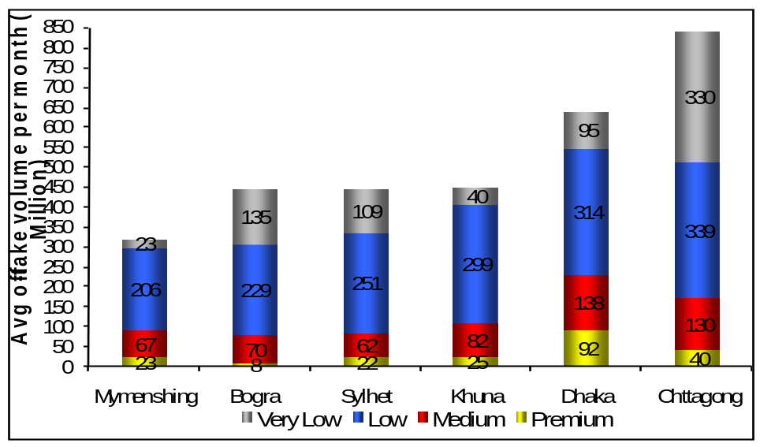

Figure 3A – 1 Segment-wise Industry Volume

Khulna represents 18% of low segment, almost equal to Chittagong and Dhaka region, bigger than Sylhet & Mymensingh. Also contributes 15% of medium segment but the very low segment remains very small.

The industry is on a growing trend at the rate 9% per year,
driven by growth of low segment as shown in the figure below.

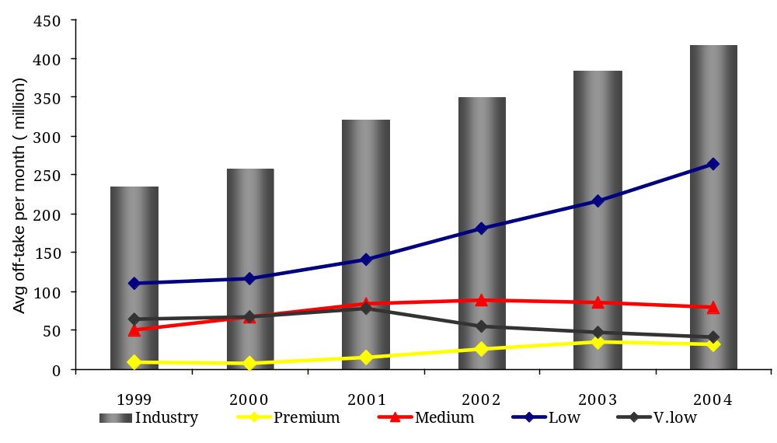
Figure 3A – 2 Growth by Segment

The low segment is growing here at a rate of 22% as opposed to 11% national growth rate. The mid segment is declining by 6% per year and the very low segment is on a declining trend which provides opportunity of low segment to further grow. Thus low segment is the most critical for gaining market share in Khulna.

3.1 Growth of Retail Universe
Khulna experienced the highest numeric growth of the retail universe. The retail universe has grown at the rate of 20% per annum as opposed to national rate of 14.5%.
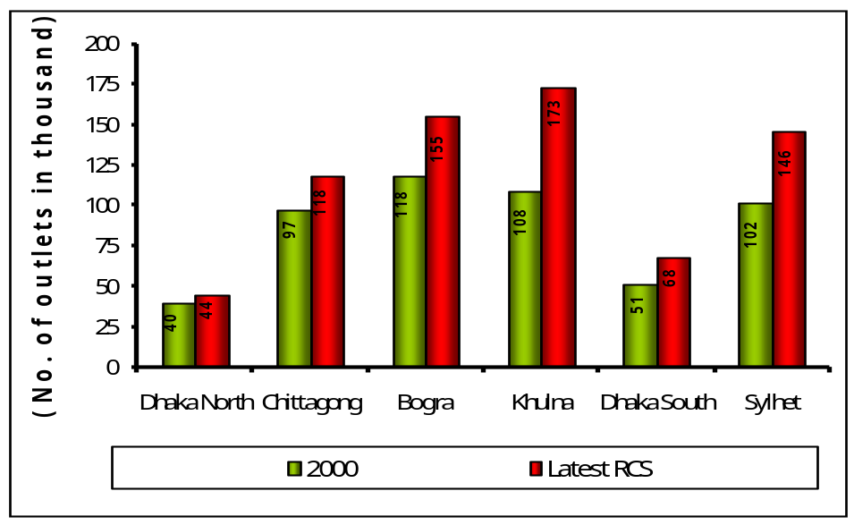

* Latest RCS (DK,CTG,BOG = 2002; KHL=2003;DS,SYL=2004)
Figure 3A –3Growth of Retail Universe

If we convert it to numeric figure it means addition of 22,000 outlets each year or 60 outlets every day. According to RCS 2003 the retail universe of the region is 173,0000.

The growth has taken place mainly in rural areas. If we compare the growth of outlets in rural areas of Khulna region with national scenarios, we find that it is considerably higher. In Khulna, growth of rural outlets is 27% as opposed to 4% in urban areas.
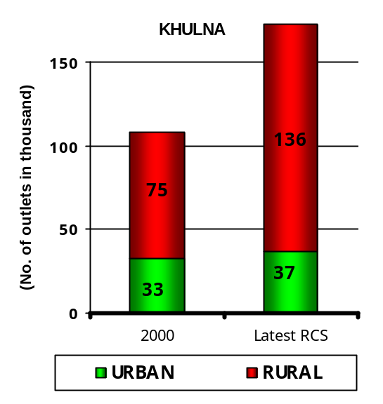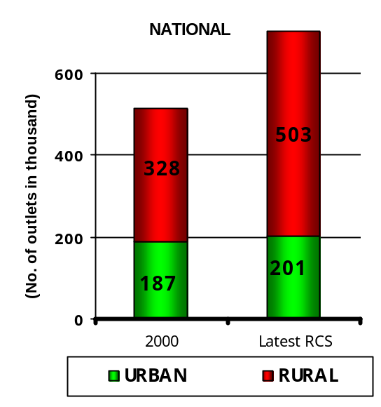
+27.3%
+3.9%
+2.6%
+17.7
Figure 3A – 4 Comparative Growth of Retail Universe
The highest growth in rural markets naturally resulted in growth of very low volume class outlets. Khulna experienced highest growth in low volume class outlets since 1997. As depicted in the following figure, volume class 9 contributes 88% of the retail universe of Khulna region.
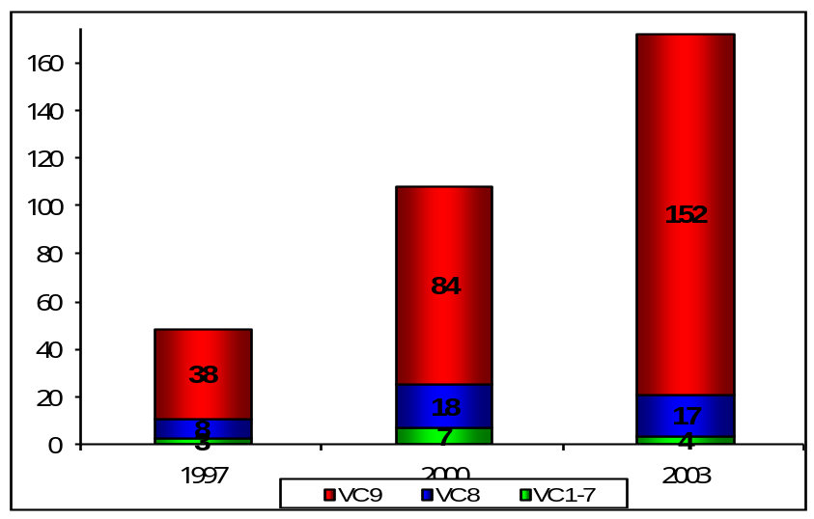
+40.3%
+41.7%
+70.3%
+27%
- 2%
-14.3%

Figure 3A – 5 Growth of Outlets by Volume Class
The figure tells us that the growth of retail universe is mainly driven by volume class 9 outlets – the outlets that sell the least number of cigarettes.

3.2 DTI – The New Market Leader in Khulna
The highest growth in the low segment is fully capitalized by DTI which puts BAT on back foot in Khulna. In the BAT brand portfolio Scissors and “STAR” represent low segment while “NAVY” represents low segment of DTI. The strategy to drive the low segment with Scissors in Khulna did not work properly and DTI took full advantage of deteriorating situation of Scissors. Contraction of the brand penetration of Scissors continued in all the markets of Khulna region as depicted in the figure below.

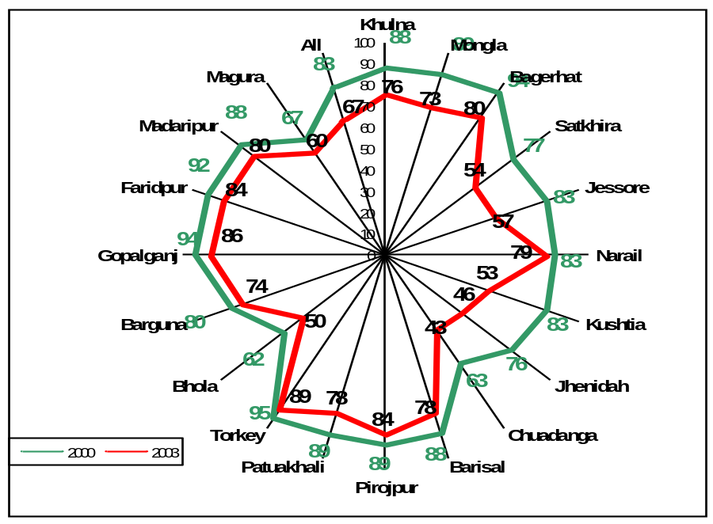

Figure 3A – 6 Brand Penetration of “NAVY”

On the other hand DTI expanded “NAVY” penetration at almost 100% in all markets with very few expectations. The major gains came in Scissors market in 2003.
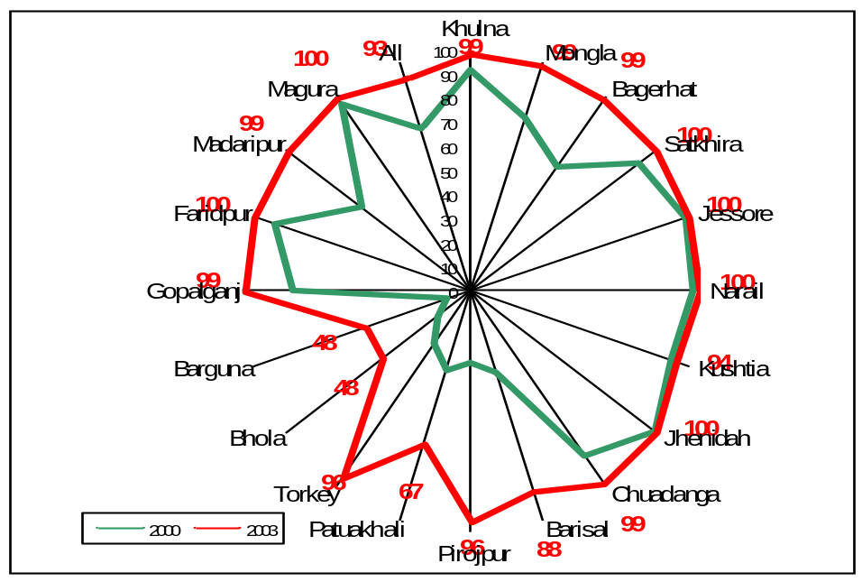

Figure 3A – 7 Brand Penetration of Scissors

To fight back “NAVY”’s aggressive entry into Scissors markets BAT has launched project SHARP in early 2004 with an image campaign, retail & consumer engagement. The key activities of the project are summarized below:
- Image:
  - Improved Product
  - Launched new pack design – 3 month Long Campaign
- Retail Engagement
  - Mega Retail Promotion involving 18,922 outlets
- Consumer Engagement
  - 1,78,216 consumer contact and sampling

However massive consumer and retail activities did not bring any desired effect. By that time DTI has achieved 80% reach in almost all markets and was continuously expanding coverage and ensured a 45% plus smoker share. As an obvious result Scissors has lost its ground both from retail reach and consumer mindscape across the region.
The other brand in low segment of BAT portfolio – “STAR”’s availability has increased over time but on a very low base. We can have an idea about how “STAR” is responding in Khulna region if we closely observe its availability in all markets.

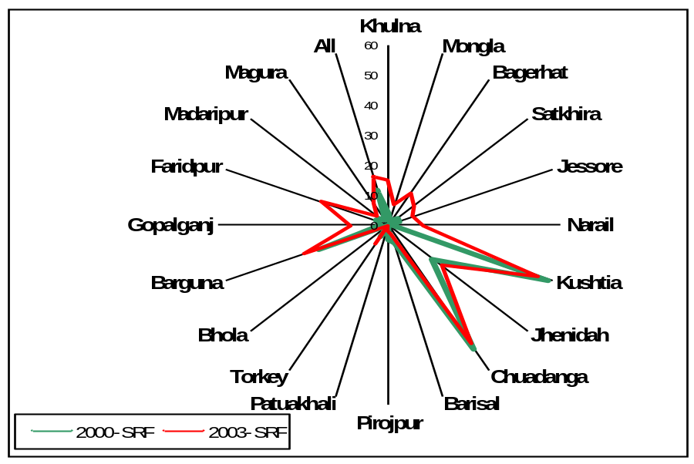

Figure 3A – 8 Brand Penetration of “STAR”
Nationally “STAR” Filter and “NAVY” are moving in the same direction. Excluding Khulna, “STAR” Filter has achieved higher growth than “NAVY”. But the “NAVY”’s growth in Khulna is pulling BAT down. The following figures show the comparison between the growth of “STAR” Filter and “NAVY” nationally and excluding Khulna.

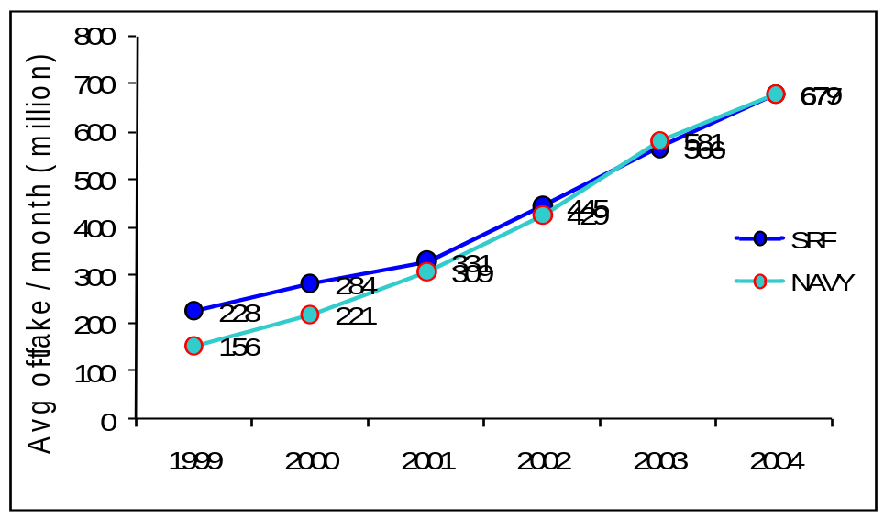

Figure 3A – 9 Trend of “NAVY” and “STAR”

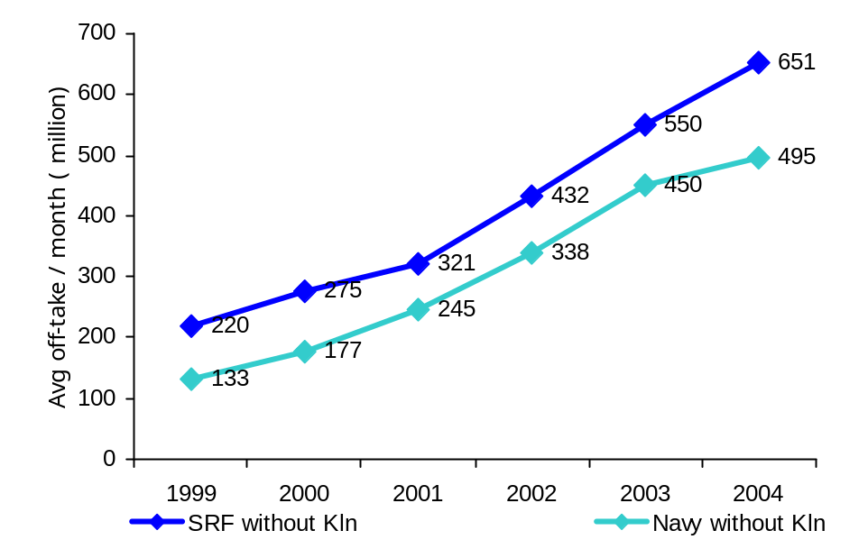
+25%
+16%
+35%
+18%
+27%
+33%
+38%
+38%
+10%
+33%
Figure 3A – 10 Trend of “NAVY” & “STAR” Excluding Khulna

Analyzing the data presented on the figures above we can say that the national scenario of “STAR” Filter would be far better if it could perform better in Khulna at the cost of “NAVY”’s market share. Khulna has become the largest “NAVY” market nationally and BAT lost 17% segment share in low segment since 2002. The market share of “NAVY”, “STAR” and Scissors in the low segment is shown in the figure below:

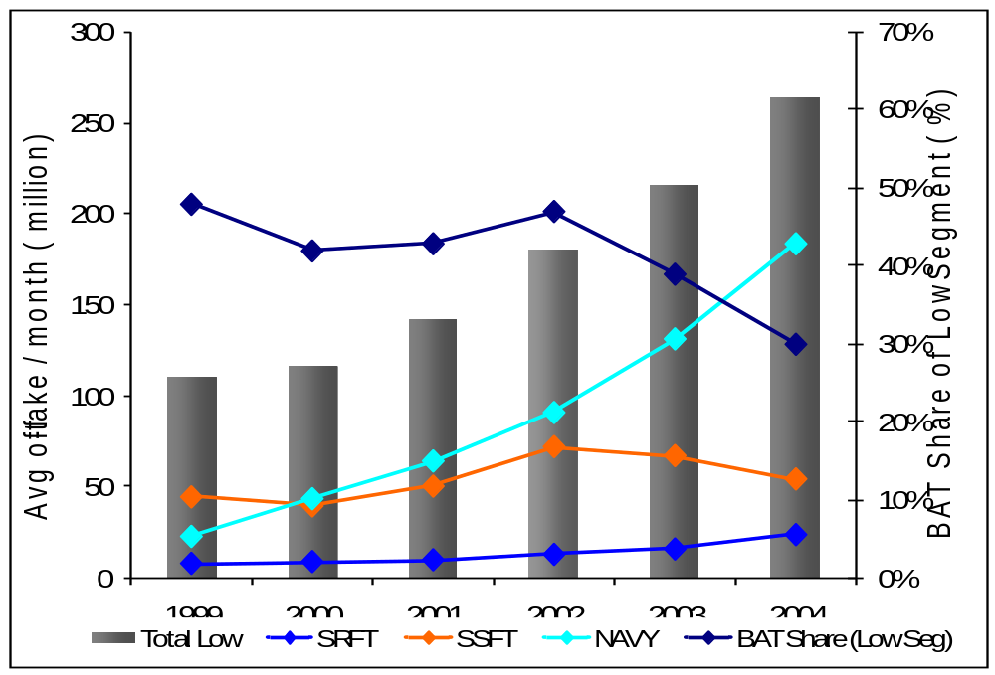

Figure 3A – 11 Brand Market Share in Low Segment
Besides loosing market share of low segment, low coverage has lead to low brand penetration of mid segment. As a result the JPGL has contracted in all the market as shown below.
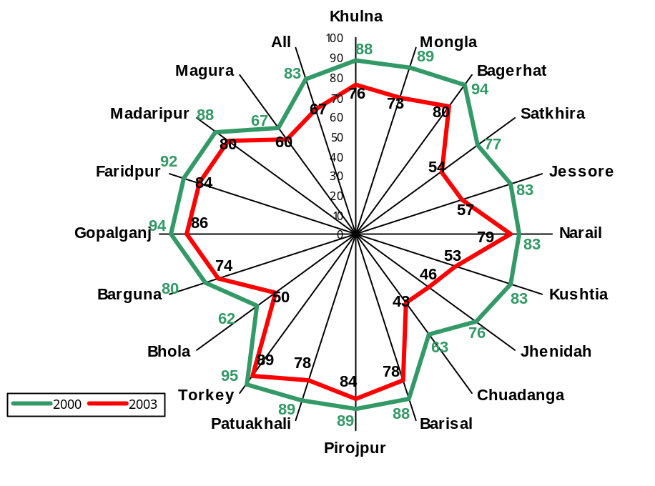

Figure 3A – 12 Brand Penetration of JPGL

Because of overwhelming growth of “NAVY”, and decline of mid segment in Khulna region, the situation aggravated and DTI has taken away market share from BAT.
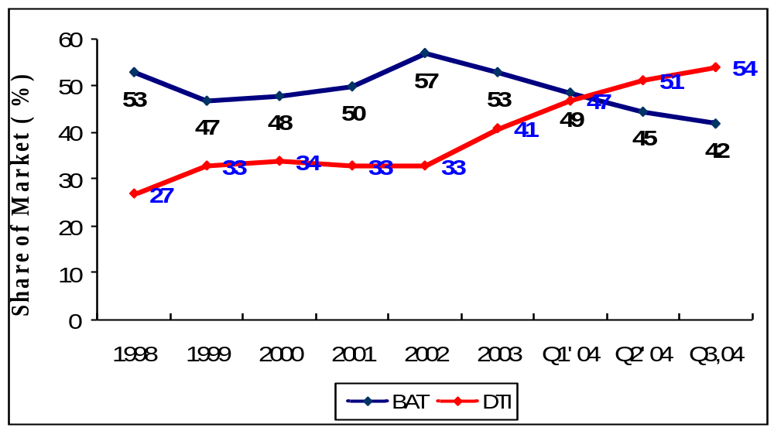

Figure 3A – 13 BAT Vs DTI Market Share in Khulna
BAT has lost 12% market share since 2002 and today DTI is the market leader in Khulna having a share of 54% as opposed to 42% of BAT.

As mentioned earlier, the growth of low segment and retail universe especially low volume contributing outlets are two major factors that changes the industry scenarios in Khulna. To cope up with the expanding outlet universe DTI continued DSD coverage expansion driven by its Biri volume at a faster rate in spite of low volume base of “NAVY”. This has laid foundation for robust growth as shown in the figure below.

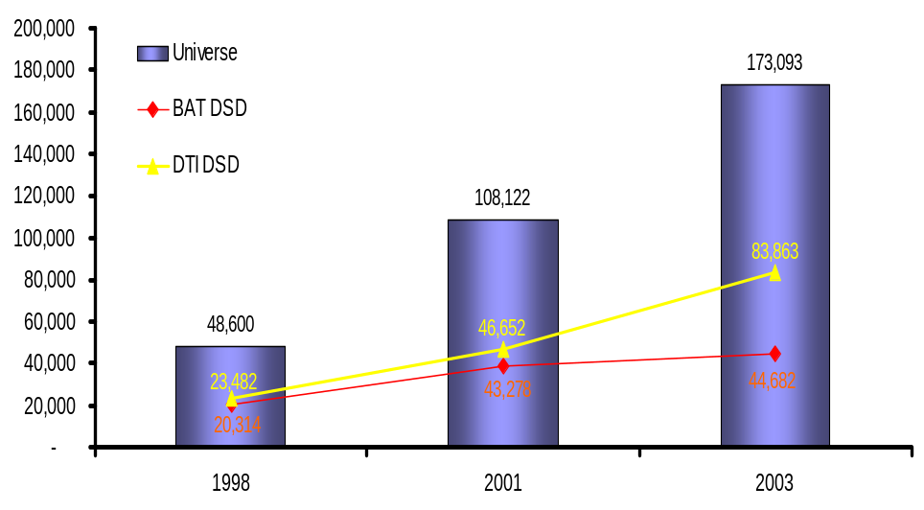
In spite of low volume base of “NAVY” DTI continued expansion of DSD driven by their Biri Volume

Figure 3A – 14 BAT Vs. DTI DSD Coverage

With growth and fragmentation of retail universe distribution cost is surging and eroding distributors’ profitability of BAT. The additional investment of the distributors for manpower and logistics in 2001 could not be sustained due to eroding profitability. The following figure shows the comparison between logistics and people of BAT and DTI in Khulna region.

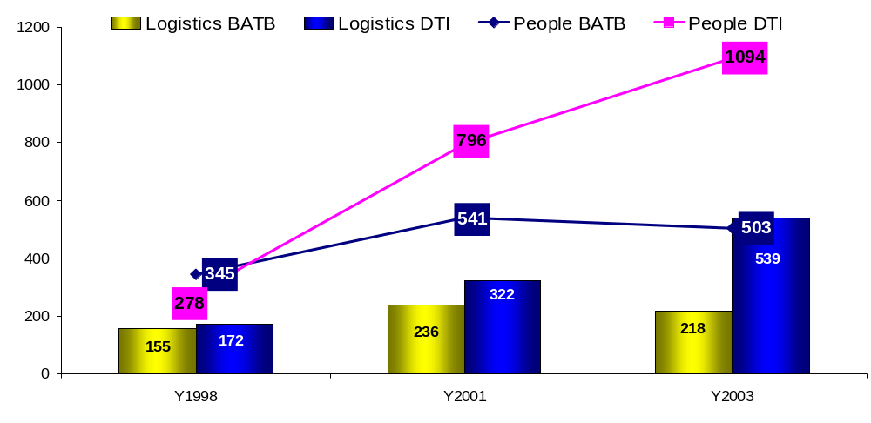

Figure 3A – 15 BAT Vs. DTI Logistics & People

We find an opposing picture between DTI and BAT. While DTI has increased its logistics and people to support expanded coverage aggressively, BAT has reduced both. As a result DTI could exploit the full potential in low segment in unserved markets of BAT.

Besides extending coverage DTI has been aggressively working for brand building of “NAVY”. Activities include focused or targeted consumer sampling, word of mouth campaign and aggressive merchandising expansion. DTI has conducted 150 sampling incidence per field force which translates into approximately 2 million sampling incidences of “NAVY” per year. It has highlighted the achievement of national export trophy as nation’s pride in its campaign. In addition it has placed both in-store and on-store merchandising material in Khulna region at a large scale. The following table shows the regional status of permanent merchandising material (PMM) status for low segment.

PMM | BAT |  |  | DTI
PMM | SRFT | SSFT | Total | “NAVY”
In-store | 1421 | 987 | 2407 | 4592
On-store | 2364 | 1631 | 3995 | 2072
Total | 3785 | 2681 | 6402 | 6664

Table 3A – 1 Growth of Outlets by Volume Class

The bottom line of extensive market coverage and aggressive brand building activities of DTI is loss of market share of BAT. Because of low coverage, the brand building activities do not have much impact on BAT’s low segment portfolio. As a result BAT is continuously loosing market share in low segment and now having only 30% of the pie as shown below along with low segment market share trend for specific markets of Khulna region.

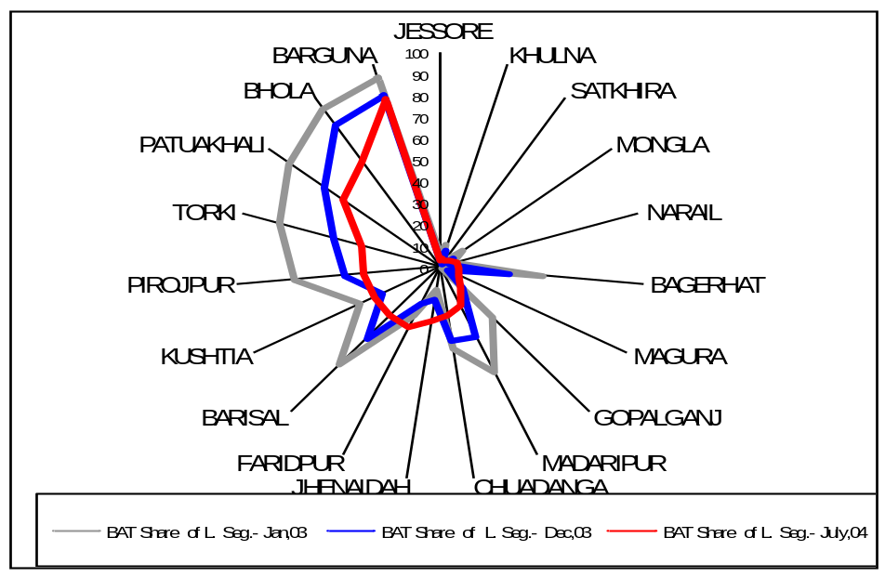

Figure 3A – 16 BAT Share of Low Segment
As shown in the figure in most of the markets, BAT share of low segment is consistently shrinking. As a result there is no more critical mass DVFM volume and share required for ensuring strong DSD operations.

Low volume from the current coverage has put our profitable DSD operations under strain. But doing nothing is not an option. Because business would continue to decline and within 23 months would hit bottom. This would lead us to the danger of losing our distribution as our business is no longer profitable and lucrative to distributors. Because of poor coverage, volume of mid and premium segment would gradually be affected. To turnaround the scenario, Khulna requires both coverage expansion and brand building activities in short and medium term.

3.3 Regaining the Leadership – The Only Target
There is no doubt something has to be done to ensure business sustainability in Khulna. But the big question remains – where to “STAR”t? The industry trend in Khulna region suggests there is no alternative other than expanding distribution and building low segment brand to turnaround the scenario. We have to expand the outlet coverage first to create a launch pad for brand building because brand building activities with current coverage scenario would not have any desired effect.
The question yet remains how we can achieve competitive level of brand availability in order to create ground for executing brand building activities to regain leadership. The answer is through:
- Correcting Fundamentals: A zero based distribution planning and implementation for the whole region
- Revisiting our portfolio focus: Establishing “STAR” as strong low segment brand.

In order to execute the ways defined above, the Project Blueprint has been undertaken as a regional initiative to regain the market leadership in Khulna.

4.1 Khulna - 1 Territory
The Khulna - 1 territory consists of Khulna and Satkhira. In terms of volume and market potential, the territory is considered with utmost importance. It contributes around 22 million sticks of cigarettes per month, which is a significant portion of the total area.

Our distributor distributes in Khulna, Satkhira and Bagerhat. Satkhira and Bagerhat are considered as an OSDO (On Site Distribution Office) of Khulna and controlled from Khulna. In total our distributor covers almost close to 10,722 outlets out of their retail universe of 24,177 outlets in Khulna – 1 territory.

Monthly Average Volume
The monthly average volume of Khulna and other markets in the territory are as follows:

Brands | Khulna | Satkhira | Total
Benson & Hedges | 2.3 | 0.7 | 3
JPGL | 11 | 2.5 | 13.5
Pall Mall | 1.5 | 0.7 | 2.2
“STAR” Filter | 1 | 0.2 | 1.2
All Brands | 16 | 6 | 22
Table 4A: Volume Share (In Million Sticks), March 06

The Satkhira market is in a better position in terms of volume than khulna. Particularly both Khulna & Satkhira is facing fierce competition from “NAVY”, and we are fighting back.

Consumer Off-take Share
If we consider the consumer off-take share in the markets, the scenario is like this:
Brands | Khulna | Satkhira | Total
Benson & Hedges | 6.7 | 3.2 | 5.1
JPGL | 16.5 | 15.0 | 16.2
Pall Mall | 10.5 | 12.6 | 10.7
“STAR” Filter | 1.45 | 4.0 | 2.75
All Brands | 60.0 | 59.0 | 61.0
Table 4B: Consumer Off-take Share (In Percentage), March 06

In terms of consumer share off-take, we see that BATB is in a better position from its competitors and leads the markets with more than 60 percent of total consumer off-take share.

4.2 Khulna Market

Competition and Potential
Khulna is considered the heart of DTI where “NAVY” has a 54 % consumer off-take share, whereas “STAR” has 1.45 % of the Cake. “STAR” was launched in Khulna in June, 03 with the new pack. In one month time, the share has increased from 1.45 % to 12 % in May, 03. The reach of “STAR” has significantly increased to more than 48 % from 12 %. Therefore, roughly it is a responsive market with huge potential and with high percentage of volume growth. At the same time, the market involves risks like volume swapping and lack of long-term sustainability of consumer preference.

Uniqueness of Khulna
One of the first characteristics of Khulna is that it is the home ground of DTI. They are very aggressive in terms of protecting their position in the market. Therefore, hitting Khulna means hitting the heart of DTI and making them vulnerable in their base.

The second unique characteristic of Khulna is its large and strong base for low segment. It promises a high potential market for “STAR” in the future.

Last but certainly not least, the third uniqueness is its responsiveness. It ensures that minimum effort and expenditure at this stage will bring huge effect in the market. For instance, in the last “STAR” Mega Cycle, new pack was launched on 14th June, 2003. The response from the market over exceeded al the expectations. Where in previous months, the reach of the brand was 12 % and average STT was only 100,000 sticks, after the new pack launch, the reach became more than 48 % and the average STT became 450,000 sticks. The volume growth in “STAR” filter came without any significant loss in Scissors Filter volume.

The research findings from the consumer datasheet and retail interview can be categorized into three parts:
- TOM awareness level of the brand
- Consumer disposition funnel
- Retailer’s confidence level

5.1 TOM Awareness Level

Findings
The Top of the Mind Awareness Level is critical for a Tk. 1 brand to establish in the market. In the consumer survey, the following results are being found through the datasheets. The data are presented along with the data taken form a previous survey conducted in 2002. For a depth understanding, the results are further categorized into different market types.

Market Category | Khulna - 1 |  | Main Market |  | Out Station |  | Rural
Year | 2002 | 2006 | 2002 | 2006 | 2002 | 2006 | 2002 | 2006
“NAVY” | 42 % | 54 % | 39 % | 47 % | 52 % | 72 % | 36 % | 42 %
“STAR” | 13 % | 10 % | 17 % | 12 % | 15 % | 16 % | 6 % | 3 %
Table 5A: Top of the Mind Awareness Level

From the above data, it is clear that “NAVY” is enjoying an unexpectedly higher level of awareness among the consumers compared to its closest competitor “STAR”. While, the overall awareness level of “NAVY” is 54 percent, “STAR” has only 10 percent TOM awareness.

Gap Analysis and Interpretation
“NAVY” has a very strong TOM brand awareness significantly among low segment smokers. Improvement is seen across all the centers. This improvement came at the cost of “STAR”, Scissors and JPGL as well. Trends are showing that, the TOM awareness level for “STAR” is decreasing and at the same time, it’s shifting towards “NAVY”, which is alarming.

“STAR” has significantly low awareness among the low segment smokers. A strong awareness drive is required for the brand to push the brand on a growth trend. “STAR” will not be able to surplus “NAVY”’s strong TOM awareness in the mid term. Therefore, there is a need to take some focused approaches with “STAR” Filter to tackle awareness growth of “NAVY”.

5.2 Consumer Disposition Funnel

Findings
Consumer Disposition funnel provides with a systematic state of the consumer’s decision-making and loyalty level. In the consumer survey, the following results are being found through the datasheets. The data are presented along with the data taken form a previous survey conducted in 2001 and 2002.

Levels |  | Awareness |  | Consideration |  | Trial |  | Repertoire |  | Regular |  | Loyal
Year |  | Abs.  % | Conv.  Rate | Abs.  % | Conv.  Rate | Abs.  % | Conv.  Rate | Abs.  % | Conv.  Rate | Abs.  % | Conv.  Rate | Abs.  % | Conv.  Rate
“NAVY” | 2001 | 100 | 100 | 83 | 83 | 68 | 81 | 53 | 78 | 37 | 69 | 18 | 49
“NAVY” | 2002 | 100 | 100 | 85 | 85 | 66 | 78 | 53 | 80 | 44 | 83 | 21 | 49
“NAVY” | 2006 | 100 | 100 | 86 | 86 | 82 | 95 | 61 | 74 | 49 | 81 | 33 | 67
“STAR” | 2001 | 100 | 100 | 42 | 42 | 17 | 41 | 6 | 37 | 2 | 26 | 0 | 28
“STAR” | 2002 | 100 | 100 | 47 | 47 | 22 | 45 | 11 | 49 | 5 | 45 | 1 | 15
“STAR” | 2006 | 98 | 98 | 49 | 50 | 17 | 35 | 10 | 60 | 6 | 60 | 2 | 26
Table 6B: Consumer Disposition Funnel

From the above data, we can easily identify that, in the funnel, “STAR” is clearly facing a bottleneck in the consideration and trial stage. While “NAVY” is going at a steady rate, “STAR” due to its poor performance in the consideration and trial stage is failing to deliver enough loyal consumers.

In addition, it seems that, in the recent years, the rate has further decreased due to increased competition and other related factors.

Gap Analysis and Interpretation
If we take “NAVY” as benchmark, “STAR” is clearly having problem in consideration and trial stage. “NAVY”, having higher TOM brand awareness, distribution and image is smoothly moving through these two stages of the disposition funnel.

To drive awareness there should be focused activity to drive up consideration and trial among for “STAR” Filter. Only awareness drive will not be able to tackle strong growth of “NAVY”

5.3 Retailer’s Confidence Level

Findings
From the retailer interviews, it is clear that the brand has fall into a vicious cycle. The scenario is like that, the retailers does not stock or make it available to the consumers because there is not enough pull from the consumer’s end. At the same time, the consumer’s are switching their brands due to non-availability in the shops.

Gap Analysis and Interpretation
From the findings, it is clear that, there is a gap between the pull and push. Furthermore, if we try to have a look at its impact, we see that, even if we do convert the consumers and make them smoke “STAR” through any consumer-focused program, but eventually they will not last. Because, at that point of time, they will be in the most vulnerable stage and will not sacrifice their convenience to find the brand. On the other hand, if we try to pile up stocks in cigarette selling outlets through trade promotions and DR incentives, but failing to create the same level of pull will eventually disrupt the free flow and will bring noise in the market. This will further hamper natural sale flow and might hinder the STT (sales to trade) of other BATB brands.
If we summarize the findings, followings are the key areas, which need to be improved:
- “STAR” Filter is having a very low level of TOM awareness compared to its competitor.
- In the consumer disposition funnel, it is clear that there is a huge gap in the consideration and trial stage.
- Lastly, there is a huge level of retailers’ lack of confidence in the Brand in terms of pushing it to the consumers, as there is not enough pull from the consumer end.

Analyzing the gaps, followings are some of the recommendations those are believed to have a positive impact on the market.

- “STAR” Filter has to be active to arrest strong TOM brand awareness growth of “NAVY”. A full blast merchandising and awareness enhancing activities will definitely help to prevent the decreasing trend of awareness.
- To drive awareness there should be focused activity to drive up consideration and trial among for “STAR” Filter. Only awareness drive will not be able to tackle strong growth of “NAVY”. Robust consumer interactive activity is required for driving consideration and trial for “STAR” Filter.
- Synchronized and controlled retail promotional activities should be in place to create a free flow of push and pull. Creation of a steady pull will help the retailers to get their confidence back on the brand and trade promotion will further encourage them to push the brand to the consumers and drive up the rate of conversation.

In the next chapter, detail modality and cost of the pilot run of the recommendations is discussed. While, this is comprehensive and believed to provide the optimum result, but there is always scope for further customization to make it more adaptive to the market for a better and focused result.

7.1 Overall Objective
The project will run for accomplishing the following objectives:
- Drive up the TOM Brand Awareness in the cluster and induce consideration and trial among the consumers. The broad objective will be to create a loyal consumer base.
- Build up trade support with confidence in the brand.
- Deliver 62 percent of distribution reach and 1.25 million sticks of monthly sales volume.

7.2 Identifying Key Clusters
To ensure resource optimization, the whole market is divided into three categories:
- High Attractive Zone: Average JPGL ADS of 160+, Average DVFM ADS of 200+ and “STAR” reach of 50 percent.
- Moderate Attractive Zone: Average JPGL ADS of 100+, Average DVFM ADS of 160+ and “STAR” reach of 40 percent.
- Low Attractive Zone: Average JPGL ADS less than 100, Average DVFM ADS less than 160 and “STAR” reach less than 40 percent.

In the first stage, we will be considering only the first two zones. The tables on the next page shows specific cluster classifications for Khulna market based upon above criteria.

Zone Criteria | Cluster Name | Current Monthly “STAR” Volume
High Attractive Zone | Sonadanga Bus Stand | 10,400
High Attractive Zone | Dakbangla | 8,840
High Attractive Zone | Boira | 22,360
High Attractive Zone | Doulatpur | 9,360
High Attractive Zone | Fultola | 11,960
High Attractive Zone | Satkhira Bus Stand | 5,980
High Attractive Zone | Gollamari | 12,740
High Attractive Zone | Shib bari Mor | 4,810
High Attractive Zone | New Market | 4,680
Moderate Attractive Zone | Kaligong | 4,160
Moderate Attractive Zone | Kolaroa | 4,680
Moderate Attractive Zone | Ashashuni | 4,680
Moderate Attractive Zone | Bagachra | 5,200
Table 7A: Zone Classification

7.3 Activities for High Attractive Zones

Consumer Interactive Program

Activities
To encourage off-take in the above-mentioned clusters, we will be conducting consumer interactive program. The program will include consumer contact, games for the consumers, quiz contest etc. All these activities will be conducted from “STAR” Booth decorated with “STAR” POS.
- Consumer Contact from “STAR” Booth decorated with “STAR” POS materials
- Interactive games for Consumers
  - Puzzle Games
  - Pack Making, etc.
- Any Consumer buying any Tk. 1 cigarette from the adjacent outlets will be contacted by the RDT and will be invited to participate in the games
- Winner will choose gifts through a raffle draw
- This activity will run for a whole week

Key Result Area
This will drive the Brand Awareness in the Cluster and induce Consideration and Trial among the Consumers. The trade results are as follows:
- No. of contact per day: 80
- No. of contact per week: 480
- No. of contact for 1 week in the high attractive zone: 4,320
- At 20% switching rate, new “STAR” consumers: 864
- At 5 sticks/day consumption rate, “STAR” off-take/day: 4,320
- In one month, total consumption: 129,600 sticks

Connecting “STAR” People: Consumer & Customer Encouragement Program

Activities
We will be conducting Customer & Consumer Encouragement Program in the clusters where we are running Incremental Target Based Trade Competition. In this program, we will be inviting few key Retailers and the new “STAR” consumers who have switched from the competition brand in a local HoReCa. We will show them “STAR” AV, talk about the brand, provide small refreshment and distribute sapling or clothing. This activity will create news regarding “STAR” resulting in more consideration & trial and in long term will induce brand loyalty.
- In the second and third week we will re-contact the consumers to measure the success in terms of switching/conversion
- We will invite the new/converted smokers and few supportive retailers in a local HoReCa
- We will again talk about “STAR” Filter, show them “STAR” AV
- Provide refreshment
- Sample 1 pack of “STAR” Filter
- Provide Saplings as a token of our appreciation

Key Result Area
This activity will induce Regularity among the Consumers.

“STAR” Privilege Circle

Activities
After we conduct the consumer interactive program in a cluster for one week, we will track down the newly converted “STAR” consumers. With these consumers, we will form a “STAR” Club where the members will get maximum of three packs of “STAR” HL (60 sticks) at a time at a discounted rate from the distribution house. They will also get a “STAR” Coupon with which they can buy goods worth Tk 50 from some selected outlets in his cluster.
- We will form a “STAR” Privilege Circle with the “STAR” Filter consumers
- Members of the “STAR” Privilege Circle will get “STAR” Credit Card. With this card, they can buy maximum of 3 pack “STAR” Filter HL at a time from the Distribution House at Tk 15.00 per pack for 1 Year
- They will also get a coupon worth Tk 50 along with the “STAR” Credit Card, with this coupon they can buy goods worth Tk 50.00 in selected Outlets in his Cluster

Key Result Area
This activity will reinforce regularity and induce loyalty among the consumers.

“STAR” Outlet

Activities
We will select some clusters where we will create three/four “STAR” Outlet through our relationship building activity. These outlets will be the representative of our brand with a sales exclusivity. This will build confidence of the other retailers of that cluster on our brand.
- Sales Exclusivity Outlet for three months
- Provide Identity Card for the retailer
- After successful completion of Exclusivity Program the retailer will get a token gift and also get the privilege to buy “STAR” Filter at a discounted rate for next six months

Key Result Area
This activity will generate more trial through our relationship with the trade. The trade results are as follows:
- Nos. of “STAR” outlet: 30
- Additional ADS of “STAR”/outlet: 100 sticks
- For 30 “STAR” outlets, additional ads of “STAR”: 3,000 sticks
- Additional “STAR” sales through these 30 outlets/ month: 90,000 sticks

Trade Activity

Activities
It is an incremental volume target based trade competition. The competition will run in remote/isolated clusters or hubs for one month.
- After we conduct consumer activity, we will run trade competition in the second week
- It will be a target based trade competition for three weeks
- Outlets will be categorized according to “STAR” Filter sales volume
- There will be weekly target volume of “STAR” Filter for each outlet. Retailers achieving weekly target will be rewarded weekly.
- This competition will be run on cluster basis approach

Key Result Area
This activity will help us in getting trade support with confidence in the brand, as there will be a consumer pull by this time. The trade results are as follows:
- No. of clusters: 9
- No. of outlets: 180
- Total average monthly volume: 91,000 sticks
- Expected 2004 exit monthly volume: 260,000 sticks
- Growth: 186%
- Expected cost for 1 year: Tk. 80,000

“STAR” HoReCa

Activities
We need to establish “STAR” HoReCa to drive the image of the brand. These HoReCas will also be helpful in conducting the above-suggested Consumer Encouragement Program. Besides, these HoReCas will be the key point of our consumer contact.
- Establish “STAR” HoReCa to drive the image and awareness of “STAR” Filter
- Conduct Consumer Interaction

Key Result Area
This activity will help us in getting some extra mileage from our consumer interactivity program and will build up further awareness and trial.

7.4 Activities for Moderate Attractive Zones

Consumer Interactive Program

Activities
To encourage off-take in the above-mentioned clusters, we will be conducting consumer interactive program. The program will include consumer contact, games for the consumers, quiz contest etc. All these activities will be conducted from “STAR” Booth decorated with “STAR” POS.
- Consumer Contact from “STAR” Booth decorated with “STAR” POS materials
- Interactive games for Consumers
  - Puzzle Games
  - Pack Making, etc.
- Consumers will have to buy at least two sticks of “STAR” from the adjacent outlets and collect coupon to participate in the games
- Winner will choose gifts through a raffle draw
- This activity will run for a whole week

Key Result Area
This will drive the brand awareness in the cluster and induce consideration and trial among the consumers. The trade results are as follows:
- No. of contact per day: 80
- No. of contact per week: 480
- No. of contact for 1 week in the moderate attractive zone: 1,920
- At 20% switching rate, new “STAR” consumers: 384
- At 5 sticks/day consumption rate, “STAR” off-take/day: 1,920
- In one month, total consumption: 57,200 sticks

Trade Activity

Activities
It is an incremental volume target based trade competition. The competition will run in remote/isolated clusters or hubs for one month.
- After we conduct consumer activity, we will run trade competition in the second week
- It will be a target based trade competition for three weeks
- Outlets will be categorized according to “STAR” Filter sales volume
- There will be weekly target volume of “STAR” Filter for each outlet. Retailers achieving weekly target will be rewarded weekly.
- This competition will be run on cluster basis approach

Key Result Area
This activity will help us in getting trade support with confidence in the brand, as there will be a consumer pull by this time. The trade results are as follows:
- No. of clusters: 4
- No. of outlets: 95
- Total average monthly volume: 22,000 sticks
- Expected 2004 exit monthly volume: 100,000 sticks
- Growth: 355%
- Expected cost for 1 year: Tk. 20,000

7.5 Project Support
For the implementation of the project, the following financial support is required:

Activity | Issues Addressed | Support Required
RDT | To generate trial | Tk. 0.60 Million
Cluster Based Trade Competition | To support Retailers & to boost their confidence | Tk. 0.10 Million
Consumer Interactive Program | To drive Consumer Awareness | Tk. 0.35 Million
“STAR” Outlet | To generate more trial through relationship with trade | Tk. 0.22 Million
“STAR” HoReCa | To drive awareness | Tk. 0.25 Million
Merchandising Leadership | To build TOM awareness and brand image | Tk. 1.4 Million
Total Budget Requirement
For Trade and Consumer Activities: Tk 1.52 Million
For Merchandizing Activities: Tk 1.4 Million
Total Budget Required: Tk 2.92 Million
Table 7B: Budget Summary and Requirement

Therefore, a total of Tk. 2.92 Million is needed for the pilot project to be implemented. Detail breakdown of the budget is given in the appendix.

7.6 Project Deliverables and Payback
Other than the improved trade condition and strong brand position in the market, the project is expected to contribute 7,925,000 sticks of cumulative sales in addition to the present average monthly volume. By the end of the project period, it is expected that the monthly sales volume will exceed 1.24 million per month. Detail cluster wise sales expectations are attached in the appendix. Below is the quarterly expected sales summary:

Timeline | Q1 | Q2 | Q3 | Q4 | Total
“STAR” Volume | 2,345,000 | 2,825,000 | 3,345,000 | 3,610,000 | 12,125,000
Base Volume | 1,050,000 | 1,050,000 | 1,050,000 | 1,050,000 | 4,200,000
Additional Volume | 1,295,000 | 1,775,000 | 2,295,000 | 2,560,000 | 7,925,000
Gross Margin (Tk.) | 72,779 | 99,755 | 128,979 | 143,872 | 445,385
Table 8C: Expected Sales Summary

In addition to the volume contribution, it is also expected that the product reach will increase from 50 percent to more than 62 percent.

Therefore, calculating the cost of the project and its additional yield, the project payback period is 3 years. Although sustained volume assumption shows a much less payback period (2 years 4 months), but to be in a fail-safe position, we are considering the volume to decrease up to a percentage after the completion of the project and then regain again.

“STAR” Filter is a critical brand for BATB. While, this is only a small part of the total brand portfolio, but in holds greater importance other than its face value. Strength of “STAR” will determine the condition of future competition. If DTI can get a strong grip in Tk. 1 segment with their “NAVY”, they will move forward to attack JPGL – one of the major strengths of BATB. Therefore, keen importance should be placed for establishing “STAR” in every market to keep DTI busy for their sustenance.

From another perspective, Tk. 1 segment is a huge and fastest growing segment in the industry. As a result, naturally it promises greater potentiality for BATB. Therefore, getting the brand establish in this stage will make it easier for BATB to lead the way in the future.

8.1. Conclusion

After complete the research on BATB based on global marketing strategy in Khulna region, I have earned lots of information about BATB. Now I can understand that how they control market and beat their competitor. Actually they takes different types of step in different region to get success. As I have worked on Khulna region so, I knew that Khulna is considered the heart of DTI where “NAVY” has a 54 % consumer off-take share, whereas “STAR” has 1.33 % of the Cake. “STAR” was launched in Khulna in June, 03 with the new pack. In one month time, the share has increased from 1.33 % to 12 % in May, 03. The reach of “STAR” has significantly increased to more than 48 % from 12 %. Therefore, roughly it is a responsive market with huge potential and with high percentage of volume growth. At the same time, the market involves risks like volume swapping and lack of long-term sustainability of consumer preference. I think Tk. 1 segment is a huge and fastest growing segment in the industry. As a result, naturally it promises greater potentiality for BATB. Therefore, getting the brand establish in this stage will make it easier for BATB to lead the way in the future.

Retail Audit, July 05
Retail Audit, July 05

