“Tourism Marketing”
A new prospect for Bangladesh (Last a Has)

Submitted by

WWW.ASSIGNMENTPOINT.COM

Chapter 1

Introduction

10841

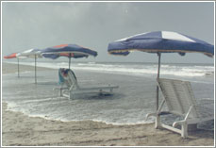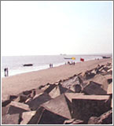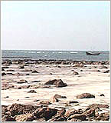

1.1 Introduction

Tourism is one of the fastest growing and single largest industries in the world. The contribution of tourism industry in the global as well as individual perspective is really amazing. Many countries in the world depend upon tourism as a main source of foreign exchange earnings. According to the World Tourist Organization (WTO), while 448.5 million tourists moved throughout the world during the year 1991, about 593 million tourist arrivals were recorded during 1996 registering a 4.6% increase over 1995 and 32.22 percent growth in five years. The World Tourism Organization recorded a total number of 763 million international tourist traffics in 2004 which is 10.58% higher than previous year and earned US$ 623.00 billion which shows an increase of 18.89% over 2003. Tourism continues to surge as a world economic force, contributing nearly $5.5 trillion to the world’s economy in 2004. The increasing trend of tourist arrivals and earnings is continuing. In 2005, the world tourist arrivals rose to 808 million. The World Tourism 2020 Vision forecasted that this figure will be 1,006.4 million in 2010 and the same will reach to 1,561.1 million in 2020. This continued growth in tourism business through out the world is encouraging and nations are becoming more concern to attract more tourists to their own destinations and trying to promoting this sector as a major source for the economic development of the nation.

Bangladesh is of no exception from this. The country is trying from the inception of this industry to attracting more tourists to its destinations and to earn more foreign currency from this sector. The statistics on this sector shows that both the arrivals and earnings from tourism in Bangladesh have increased over the past. Statistically it may reflect an impressive profile but in a true sense the picture is somewhat different. In terms of global increasing trend in both the number of tourist arrivals and the earnings from tourism, the same in Bangladesh is very insignificant. Even in consideration of the positions of the neighbouring countries, Bangladesh is far behind in this respect. In 2004 about 271,270 foreign tourists visited Bangladesh during the year and the country earned about Tk 3967.56 million (US$ 66.82 million) from this sector in the same year. Though tourism industry and its market have grown phenomenally worldwide, the industry and its market have not grown in Bangladesh. Lack of proper/sufficient promotion is one of the major reasons not for developing the industry in Bangladesh up to the mark. Because, potential tourists need to know properly about the attractions, services, facilities, etc. at the destinations and accessibility to there through various forms of promotional measures. Besides, the expansion of tourism business and the increased competition among destination countries throughout the world have necessitated developing appropriate promotional approaches by the tourism firms worldwide.

Marketing promotion includes all means of conveying the message about a product or service to potential customers by using publicity or sales campaign or TV commercial or free gift etc. Promotion is regarded as one sub-category of the marketing mix elements. According to Kotler, promotion consists of those activities which are used to communicate the products or services and its merits to target customers and persuade them to buy. One of the tools of marketing promotion is sales promotion which consists of short-term incentives to encourage sales of a product or service through samples, coupons, rebates, premiums, allowances, price-offs, contests, push money, trade promotion, exhibits, premiums, sales rallies etc. Sales promotion refers to a vast range of novelty items that can carry promotional messages or a visual representation of the products or services. It includes in-store promotions such as two-for-the-price-of-one, 10 percent off, free gifts, redeemable coupons, competitions or money-back for returning so many bottle-tops or labels. Sales promotion can be used to dramatize the offers of BPC. Researcher will specifically look for advertising, sales promotion, public relation and publicity, personal selling and or direct marketing including direct sales for the promotion of this industry.

As Bangladesh tourism appears to have suffered mostly due to inadequate and ineffective promotional activities and promotional activities play an important role in the marketing of the same, it is necessary to study how promotion can play the role in tourism industry in Bangladesh. Bangladesh Parjatan Corporation (BPC), the only public sector tour operator in Bangladesh spent Tk. 7.935 million in 1995-96 which rose to TK. 10.413 in 2004-05 for promotional activity which is only 0.71% and 0.23% of its earning respectively. On the other hand the Virginia Tourism Corporation (VTC) generates a return-on-investment of $4 for every dollar spent promoting Virginia's tourism and for every one dollar spent in advertising returns almost four dollars in taxes to Virginia. According to the latest Longwoods International report Colorado Travel Year 2003, more than 3.8 million people visited Colorado in 2003 as a direct result of the state’s tourism promotion, resulting in a $65.5 million boost in state and local taxes and without aggressive tourism promotion, the additional revenue would not have been realized.

In the face of stiff competition among the destination countries, effective promotional measures are essential for the development of the industry. Bangladesh Parjatan Corporation or Bangladesh tourism could not meet this requirement due to lack of needed fund along with the absence of decision-makers’ foresightedness. As a result, this sector and its market have failed to grow properly not merely because it lacks enough attractions and facilities. But time has not yet past over. Still there are lots of scopes and opportunities if Bangladesh attempts to highlight it as a tourist destination to the potential tourists properly through an effective promotional measure and can take some initiatives to develop some infrastructural facilities, the country would be able to earn many times higher than the present by attracting more tourists with in a short time. Considering the time factor and limitation of other resources, only the promotional aspects has been considered for the present study and it will be attempted to examine the existing promotional approaches of both the public and private sector tour operators, identify the problems and the limitations of their promotional activities, and prescribe necessary policy measures for effective promotional actions for the industry in Bangladesh.

1.2 Importance of the Study

Tourism is the fastest growing and single largest industry in the world. Tourism as a multi-faced industry is playing pivotal role in the global as well as in the individual economic perspective. In the year 1950, the international tourist arrivals were 25.2 which rose to more than 800 million in the year 2005 and in 1950, the world tourism earning was US$ 2.1 billion and the same stood at US$ 623 in 2004. The World Tourism Organization forecasted that in the year of 2010, the total world tourist arrivals will be 1,006.4 million and it will increase to 1,561.1 million in 2020 and the figure of the same for South Asia will be 10.6 million and 18.8 million in the year of 2010 and 2020 respectively and at the same time WTO forecasted that the number of tourist arrivals in Indian Ocean destinations will be 91.544 million and 179.249 in the year 2010 and 2020 respectively and the figure of the same in Bangladesh will be 0.255 million and 0.415 million in the corresponding years. According to WTO forecast the earnings from tourism will rise to US$ 2 trillion a year by 2020.
The tourism industry of Bangladesh is of no exception from this. It can play an important role to contribute in the national economy of the country. In view of several holy shrines in the country there is the prospect of attracting millions of tourists to the country. But full potential of tourism could not be used largely due to inadequate and ineffective promotional activities of the industry. Institutional framework for attracting tourists has been in existence for more than three decades, but various institutions promote Bangladesh tourism with little coordination. This is construed to be one of the major hurdles adversely affecting the promotional activities and the resultant growth rate of the tourism industry in the country. It is of utmost importance to examine the special features of tourism firms' promotional activities and suggest how to improve those activities in order to attract a reasonably good number of foreign tourists to visit the country and take their services. So far the researcher knows no comprehensive study addressing promotional aspects of the industry in Bangladesh has been conducted yet by anyone. Even a very few studies are available related to the issue of tourism marketing in Bangladesh.
As tourism industry in Bangladesh has failed to undertake adequate and effective promotional activities due to policy guidelines, resource constraints, and they lack of marketing orientation, hence, a study on this area is essential to uncover the relevant facts. It is also expected that the findings and analysis of this study will help formulate appropriate promotional measures and thus motivate effectively more potential foreign tourists to visit Bangladesh as well as to contribute the economy of the country. At the same time, this study may be helpful for the policy-makers of the country to devote their attention to the issue of the segments of the tourism market that they wish to attract.

1.3 Research Areas
On the basis of the research problem, the proposed study will mainly attempt to concentrate on the following areas:
- To study the current development trends of the tourism industry in Bangladesh;
- To examine the marketing activities undertaken by the different tour operators and evaluate the role of their activities for the development of this industry;
- To identify the problems and limitations of marketing activities undertaken by the above mentioned tourism firms; and
- To prescribe necessary policies and managerial implications of the tour operating firms in Bangladesh in light of findings and current theory in the field.

1.4 The Research Problems
Tourism marketing is gaining importance all over the world. The marketing of tourism in Third World countries is increasingly common and the fastest growing destinations are in these regions and increasingly the focal points for development and marketing of new, adventurous and exotic tourist destinations. As a result, most of the fastest growing tourism regions are in the Third World countries which continue to grow and, correspondingly, the promotion of these regions is increasingly popular and important. Currently, about 30% of all international tourist arrivals are in the Third World and this proportion has nearly tripled over the past 20 years.
Considerably less has been written on Third World tourism marketing and there are a few notable articles that generally address the issues of marketing Third World destinations as well as several studies that critically examine specific sets of Third World tourism promotion.
Bangladesh as a third world country has the lacking of proper study and attention on tourism promotion. As a result, though the tourism industry of Bangladesh has a bright prospect and could contribute to the economy to a greater extent, but the sector could not flourish up to the mark due to lack of necessary and proper initiative of the concerned firms/institutions. It is emphasized to eliminate this organizational problem and suggested for the coordinated efforts of the concerned authorities, professional efficiency of the management, and pleasant behaviour of the service providers to present the products or services and develop tourism fruitfully in a country like Bangladesh. Pannell Kerr Forster Associates’ Report (1988) blamed that the BPC for not playing its role completely as a national tourism promotion agency and suggested preparing itself for playing its proper role in this regard. These reveal that there remains ample scope for further expansion and growth of the tourism industry if effective promotional activities are taken to cater to the expectations of the tourists and motivate them to visit Bangladesh. It is pointed out that a very few studies have addressed the promotional aspects even the marketing aspects of tourism in Bangladesh.
Only a few articles and a few research reports appear to have attempted to deal with the marketing problems of the tourism industry in Bangladesh in a skin-deep and peripheral manner. It is also pointed out that the promotional activities undertaken by the Bangladesh Parjatan Corporation (BPC) is awfully inadequate to cover the main tourist generating countries and suggested for developing more dynamic promotion tool. The BPC’s present promotion strategy with folders and posters is not satisfactory and would not produce any result. Review of literature on the development of the tourism industry in Bangladesh also reveals that there remains much to do in matching the supply side with what the tourists demand from the host country.
As noted, a remarkable marketing situation characterizes Third World tourism promotion, that is, these destinations are most often promoted by multinational tour operators, travel agencies, and other intermediaries with origins in the First World. The primary targets of these marketing efforts are also located in the First World, as the developed countries are the main generators of tourists. This situation creates a marketing system whereby the majority of the images used to represent Third World tourism destinations are selected by First World promoters in order to cater to the needs of consumers in developed countries which results many of the concerns aired by previous researchers focus on the images and stereo-types of the Third World that are being created from a primarily First World perspective.
In the face of worldwide stiff competition, intangible nature of tourism services and need of pre-purchase information for potential tourists, promotional measures in tourism industry play key role in the performance and development of this industry. As Bangladesh tourism appears to have suffered mostly due to inadequate and ineffective promotional activities, it is necessary to study the strategic promotional approaches of the tour operators in Bangladesh and find out the remedies to overcome the problems or limitations identified

Chapter 2

Research Methodology and Techniques

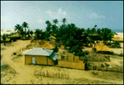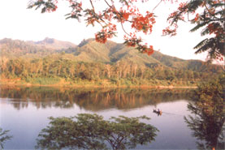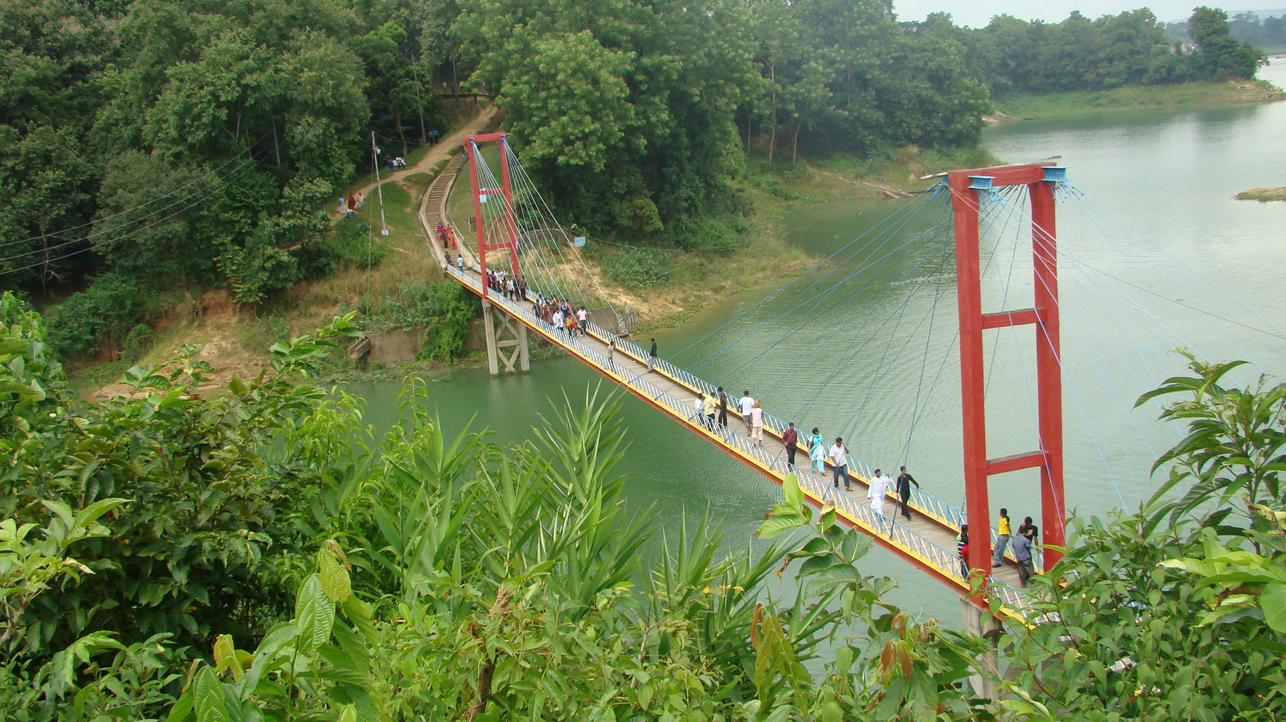

2.1 The Nature of the Study

Marketing activities can play the significant role for the development of tourism industry. Tourism in Bangladesh is of no exception from this. Lack of marketing plans is likely to affects the development of tourism in any country as well as in Bangladesh. But the existing literature on the promotional aspects of Bangladesh tourism is very rare and even on the literature covering the marketing aspects of tourism industry in Bangladesh is very limited. As a result, the study is exploratory in nature.
It was assumed that promotion is a vital force for an effective marketing strategy of tourism products and services. But Bangladesh is far behind from the realization of the fact and due to that Bangladesh could not take advantage of the full potential of the sector and which causes not to develop the industry significantly and expectation which could be and failed to earn sufficient amount of foreign currency. The present study on the use of promotional activities in Bangladesh tourism industry is an attempt to highlight the issues related to promotion and put forward some suggestions to what actual promotional measures are best suited for attracting more tourists to Bangladesh and contribute more positively to the economy of the country. It was also attempted to identify the promotional approaches of the industry in Bangladesh.

2.2 Source of Data and Data Collection Procedure
The research has been conducted based on both primary and secondary data. As it was mentioned earlier that the existing literature on the promotional aspects of Bangladesh tourism and even on the overall marketing aspects is not adequate, the study was done on the primary data collected through questionnaire on the use of promotional activities by Bangladesh tourism industry. Secondary data was also used in this study.

A survey questionnaire was used to collect the primary data from the sample selected for this study. The five relevant top executives from BPC and 15 private tour operators were interviewed for the collection of the data. Again, the private tour operators were selected from the members’ list of Tour Operators’ Association of Bangladesh (TOAB). To collect the primary data, the researcher took the help from one of his friends working as an Associate Professor, Marketing), University of Dhaka, Bangladesh. It is worth mentioning here that most of the tour operators are located in Dhaka and an insignificant number of them are located in other larger cities of the country. Due to the lake of time and fund, all the tour operators for interview were selected only from Dhaka- the capital city of Bangladesh.

Secondary data was also used in this study. To collect the secondary data, annual reports of BPC, related journals, periodicals, newspapers, BPC’s web page etc. were consulted. In addition to that for literature review and for other theoretical analysis different journals, periodicals, textbooks, newspapers, internet and other related materials were consulted and used as references.

2.3 Population and Sample Size of this Study

Bangladesh Parjatan Corporation (BPC) – the only National Tourism Organization or government owned tourism organization in Bangladesh, the private tour operators (only the members of TOAB) were considered as the population for this study. It was mentioned in the previous section that a total number of five top executives from BPC and fifteen owners/top executives from the private tour operators were selected as the respondents for collecting the data on the promotional aspects tourism in Bangladesh.

The responses of the respondents interviewed were analysed to gain insights into both qualitative and quantitative aspects of the promotional activities used by their firms. Both qualitative and quantitative analysis of the collected data from the respondents’ firms has been made. In quantitative analysis of the data, conventional statistical tool like percentage, simple averages etc have been used.

2.4 Organization of the Study

The research was conducted considering the time frame allowed for the study. The whole discussion of the study has been organized in a systematic way and has presented in eleven different chapters.

The first chapter includes an introductory discussion covering the justification of the study, research areas and problems.
The second chapter is a presentation of the research methodology or the procedure of conducting the study.

The third one is on the theoretical discussion on the different terms and issues.
Chapter four discusses the product specification or the tourist attractions in Bangladesh.
Chapter five covers the perception of the international tourists to Bangladesh and the present marketing strategies and activities undertaken in Bangladesh.
Chapter six is the analysis of statistics on tourist arrivals and earnings from this sector.
Chapter seven and eight presents the problems and limitations of the tourism marketing in Bangladesh and the prospects and potentiality of the same sector in Bangladesh.
Chapter nine is the important remarks made after the study and findings.

Chapter ten covers with the recommendations and suggestions to improve the tourism sector in the country.

Last chapter eleven, contains the conclusion based the whole discussion of the study.

Chapter 3

Theoretical and Conceptual Framework

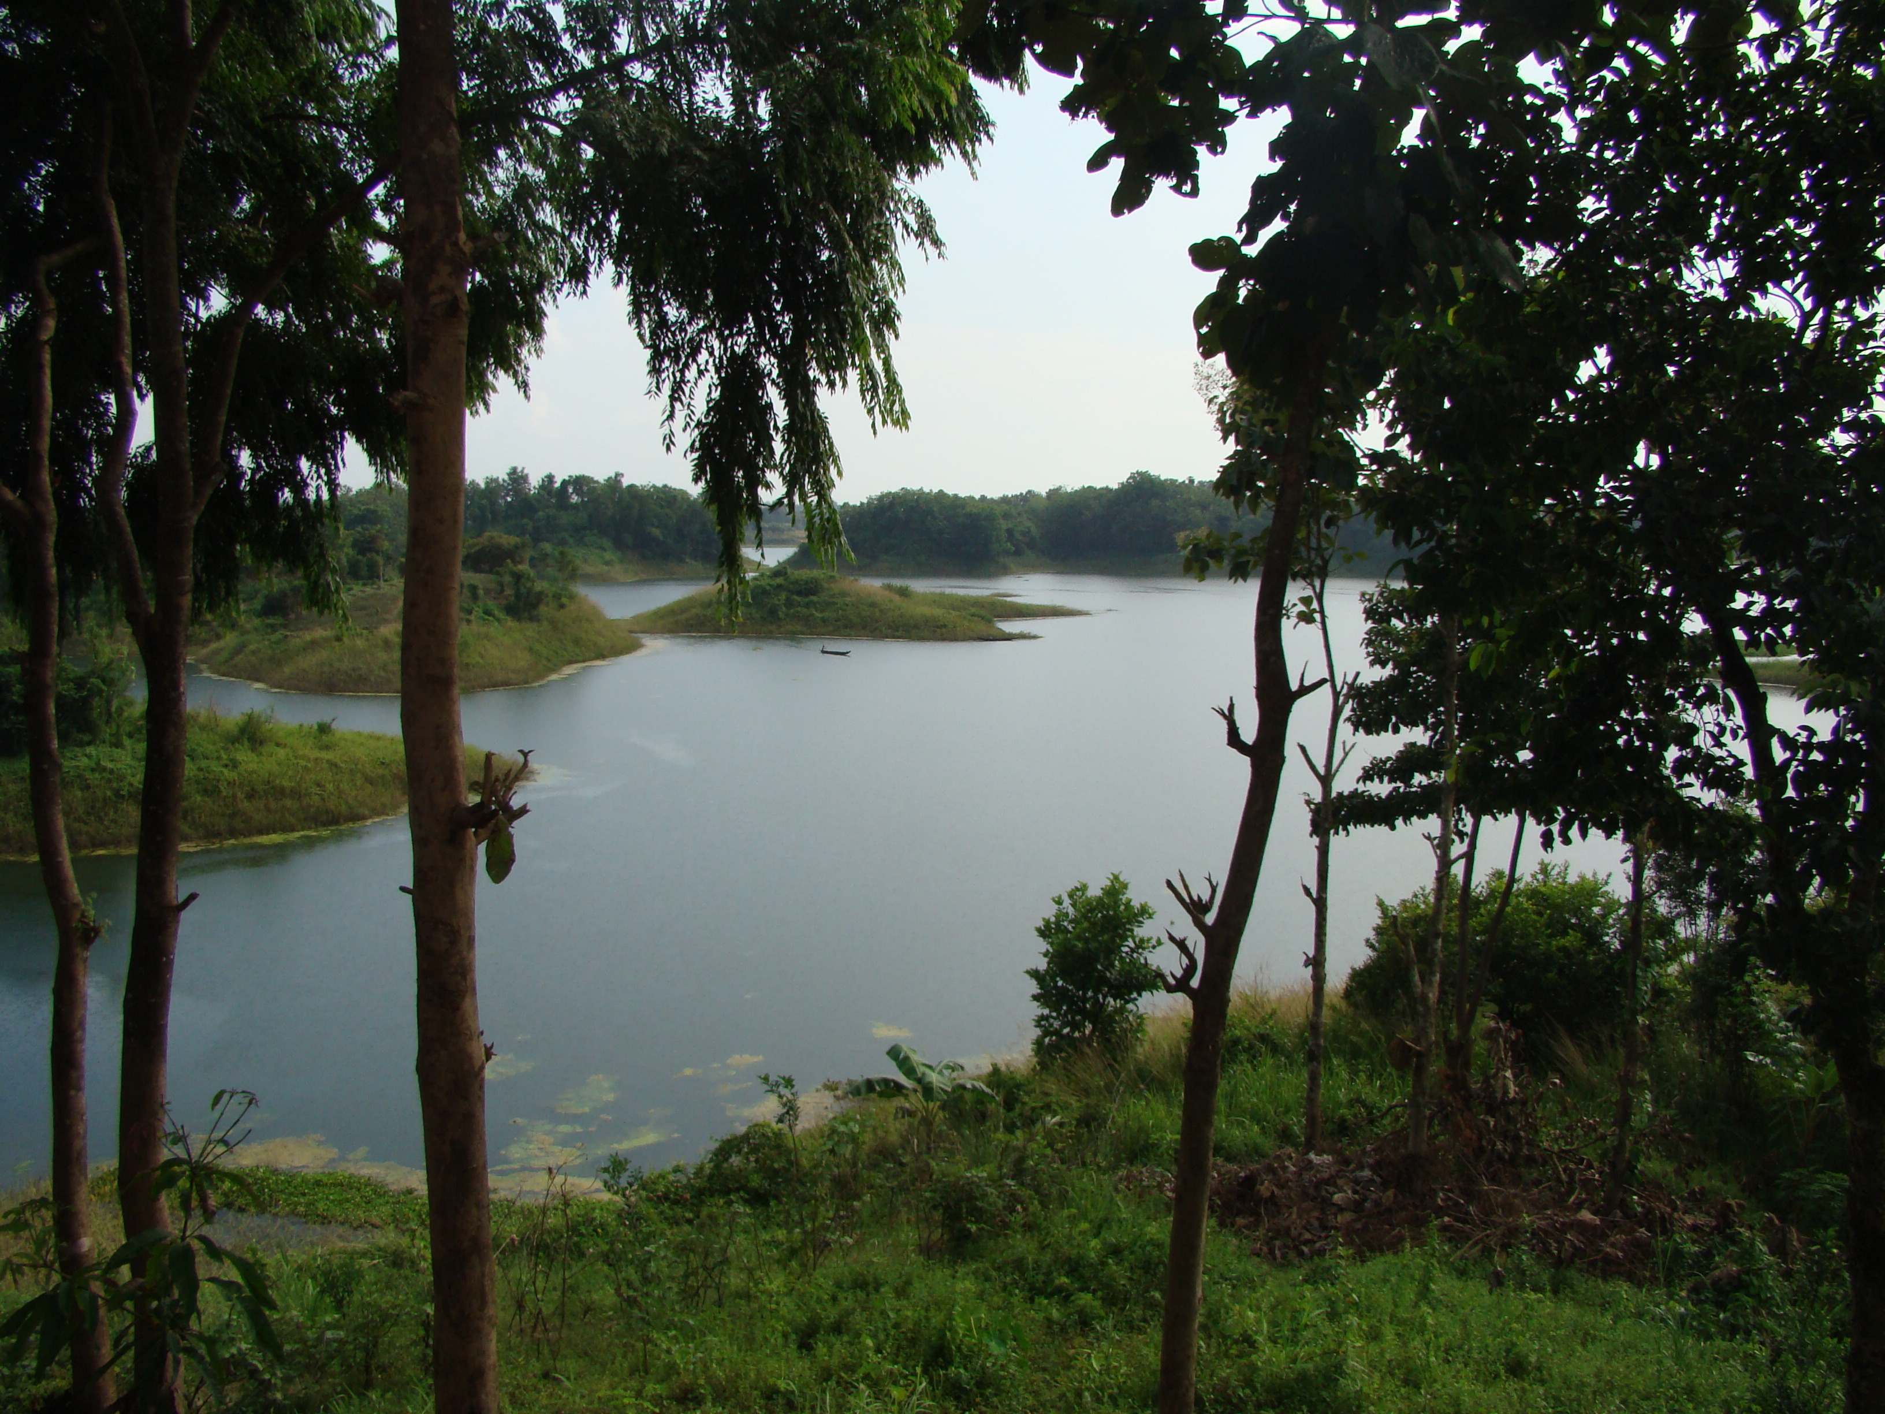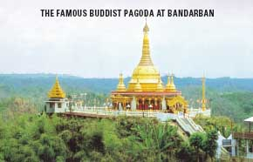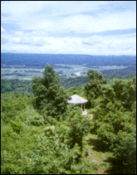

3.1 Defining Tourism and its Related Terms

There are some conceptual terms related to tourism industry which need to be described here for a clear understanding. Among these terms, the most important ones are tourism, tourist, tourist attraction, travelling, service, recreation and leisure which can be stated briefly as:

3.1.1 Tourism – Meanings and Scope
Tourism is an important field of discussion which covers many interrelated areas. As a result, important elements based on which tourism is built required special attention to define tourism itself. It was observed from the World Conference on Travel and Tourism in Rome in 1963 that tourism has both the positive and negative impacts on economy, socio-cultural, political and environmental. For many nations especially for the developing countries, tourism brings economic benefits by generating employment opportunities in tourism related different sub-sectors, earning foreign currency, while United Nations for example consider it as a strong way of contributing to peace and understanding.

The definition of tourism which one was endorsed by the WTO in 1992 and adopted by the United Nations Statistical Commission (UNSC) in 1993 is as:
“Tourism comprises the activities of persons travelling to and staying in places outside their usual environment for not more than one consecutive year of leisure, business and other purpose.”

Wikipedia defined tourism as the act of travel for the purpose of recreation and business, and the provision of services for this act. It also included a more comprehensive definition which would be that tourism is service industry comprising a number of tangible and intangible components. According to this definition, the tangible elements include transport systems- air, rail, road, water and now space; hospitality services- accommodation, foods and beverage, tours, souvenirs; and related services such as banking, insurance and safety and security and the intangible elements in include rest and relaxation, culture, escape, adventure, new and different experiences. Basically, tourism is a whole interrelated and interdependent industry. Sometimes tourism is also used pejoratively which implies a shallow interest in the societies and place that the tourist visits.

3.1.2 Tourist Attractions – Meanings
Defining tourist attraction is not an easy task. Even it is difficult to recognize a definition of the term which is widely accepted. But an attempt can be taken to define tourist attractions as places which draw or attract persons to visit a place, attend an event, or travel to a location for the purposes like recreation, enjoyment, education and information gathering or intellectual hobbies or searches. In a simple word, it can be said that attractions are the reason of travelling people.

Tourist attractions may include:
- Man made attractions are physical structure (Sydney Harbour Bridge) or events (Olympics).
- Natural attractions are physical phenomena deemed unusual and/or beautiful (Bungle Bungles).
- Secondary attractions have tourist appeal, but are not the primary reason for visiting a location.
- A negative attraction is an attribute of an area that tends to make some customer or market choose not to visit as for example pollution or crime.

In conclusion, tourist attractions can be places of interest open to public offering recreation, education or historic interest. It can be any theme parks, historic houses, museums, zoos, art galleries, country parks, leisure complexes etc.

3.1.3 Travelling- Meanings
Travel is the act of going from one place to another. Sometimes tourism and travel are used interchangeably. In this context travel has a similar definition to tourism, but implies a more purposeful journey. Travel is the transport of people on a trip or journey. Reasons for travel include: Tourism-travel for recreation, Visiting: friends and family; Trade; Commuting–going to various routine activities, such as work or meetings; Migration -travel to began life somewhere else; Pilgrimages-travel for religious reasons.

3.2 Different Types of Tourism

Tourism can be classified in a number of ways based on the nature of activity, location type or duration of stay. A brief description on major types of tourism can be presented as:

3.2.1 Adventure Tourism
Adventure Tourism is a type of niche tourism involving exploration or travel to remote areas, where the traveller should expect the unexpected. It is rapidly growing in popularity as tourists seek unusual holidays, different from the typical beach vacation and typically involves travelling into remote, inaccessible and possibly hostile areas. It may include the performance of acts that require significant effort and grit and may also involve some degree of risk.

3.2.2 Agritourism
A style of vacation in which hospitality is offered on firms which may include the opportunity to assist with farming tasks during the visit where the tourists have the opportunity to pick up fruits and vegetables, ride horses, taste honey, learn about wine, shop in gift shops and farms stands for local and regional produce or hand-crafted gifts, and much more. Each farm generally offers a unique and memorable experience suitable for the entire family.

3.2.3 Ecotourism
Ecotourism essentially means ecological tourism; where ecological has both environmental and social connotations. Ecotourism refers to tourism that is based on the natural environment but that seeks to minimise the harmful impacts and better still, seeks to promote conservation. It focuses on local cultures, wilderness adventures, volunteering, personal growth and learning new ways to live on our vulnerable planet.

Responsible ecotourism includes programs that minimize the adverse effects of traditional tourism on the natural environment, and enhance the cultural integrity of local people.

3.2.4 Heritage Tourism
The most hottest or recent trend in today’s tourism industry is heritage tourism or visiting historical sites of an area. Now a day, people want to enrich their lives through travelling not to escape rather than visiting a park or a mountain range. They want to experience unique places, traditions and history and learn about their cultural roots.

Heritage tourism involves visiting historical or industrial sites that may include old canals, railways, battleground etc with the purpose of gaining an appreciation of the past. In addition to that education, fun, marriage, employment, etc can also be the purpose of heritage tourism. It can also be attributed to historical events that have been dramatized to make them more entertaining.

3.2.5 Sex Tourism
A sex tourist is usually defined as an adult who travels in order to have legal consensual sexual relations with another adult often for the exchange of money or presents. Most sex tourists are male, but sex tourists can be of either gender. Sex tourism is legal in many countries in the world where prostitution is legal. Sex tourism is by a majority considered the gloomy side of the global phenomenon of tourism.

3.2.6 Space Tourism
A recent concept in tourism is space tourism where individuals travel for the purpose of personal pleasure and is only affordable to exceptionally wealthy individuals and corporations. Among the primary attractions of space tourism is the uniqueness of the experience, the awesome and thrilling feelings of looking at the earth from the space.

3.2.7 Cultural Tourism
The cultural tourism has been around for a long time and is the “oldest of the ‘new’ tourism phenomena”. Cultural tourism is the subset of tourism concerned with a country or region’s culture, especially its arts and includes tourism in urban areas, particularly historic or large cities and their cultural facilities such as museums and theatres. It can also, less often, include tourism to rural areas; for outdoor festivals, the houses of famous writers and artists, sculpture parks and landscapes made famous in literature and is generally agreed that cultural tourists spend substantially more than standard tourists do.

3.2.8 Alternative Tourism
Alternative tourism is a tourism that gives emphasis to the contact and understanding between the hosts and the tourist, as well as the environment. Also as a tourism that is consistent with the natural, social and community values and that allows a positive relationship among locals and tourists. Alternative tourism includes micro and small companies of local inhabitants' property. The classifications that can be included under the concept of alternative tourism can be Natural, Cultural and Events etc.

3.2.9 Geotourism
Geotourism is defined as tourism that sustains or enhances the geographical character of a place, its environment, culture, aesthetics, heritage, and the well-being of its residents. Geotourism adds to sustainability principles by building on geographical character - "sense of place" - to create a type of tourism that emphasizes the distinctiveness of its locale, and that benefits visitor and resident alike.

3.2.10 Benefit Tourism
The benefit tourism is, the individuals travel from other countries to obtain free medical attention or to take advantage of the country’s welfare system. Benefit tourism is the name given to the perceived threat that after May 1, 2004, huge masses of citizens from the European Union's ten new member countries would move to the previous fifteen member states to benefit from their generous social welfare systems rather than to work.

3.3 Transportation, Accommodation, Food and Drinks

Transportation, accommodation, food and drinks or beverage are the important elements of tourism system. A tourist wants to be ensured about cheap, comfortable, and easy access transportation and accommodation available for the destination place so that he/she can reach and stay safely and can enjoy the attraction of the destination.

In addition, food and beverage are considered as partial tourist products and the tourists want to be satisfied with these products qualitatively, quantitatively, aesthetically, ethnologically and in any other sense. These elements also incur the major costs for a tourist. As a result, before deciding about a destination to travel, it’s a major consideration for a tourist along with the attraction(s) of the destination.

3.3.1 Transportation in Tourism
Passenger transportation is one of the vital components of the tourism system which virtually connects the visitor to their choice and helps to reach the attraction of the destinations.

Transports, making the destination accessible to the tourists, act as the sinews and blood vessels for the tourism industry of the country concerned. Different modes of transport provide varying functions, facilities and operating characteristics.

In travel on land, the travellers can choose any one among private cars, buses or trains while choices for long distance air travels are limited to commercial airlines. Ships or cruises can be considered as another interesting option for transportation because a cruise does not only carry passengers it also provides them the opportunity with vacation atmosphere as soon as they are on board with facilities tailored at holidaymaker market.

Also there should have the coordination among the different types of transportation modes for example air, rail, bus and cruise to facilitate transfer between modes.

3.3.2 Accommodations/ Hotels in Tourism

Accommodation is one of the most significant factors to have contributed to the development of tourism world-wide and the absence of which may put off the tourists from travelling to enjoy the attractions.

The overall competitiveness of a destination is related to many factors, not least being the tourist “product” consisting of three components, usually the access, which is the mode of transport to the destination chosen by the tourist and is determined by the time and the cost to reach the destination; attractions, which underpin the choice of the tourist to visit one destination rather than another; and amenities, which are the facilities available at the destination visited.

In a generic sense, amenities include accommodation which needs to be emphasized that for countries to survive in the international tourism marketplace they must provide internationally acceptable facilities, which also must be marketable and the price charged for accommodation has to be right; needless to say, the quality of the provision should not be compromised. Because the travellers want good services regarding their accommodation so that they can get relief from travel hassle. So, customer satisfaction is an important factor that needs to be considered carefully.

Chapter 4

Tourist Attractions in Bangladesh
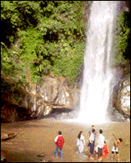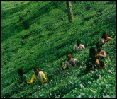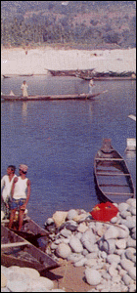

4.1 Geographical Location of Bangladesh

Bangladesh is a developing country in South Asia located between 20°34’ to 26°38’ north latitude and 88°01’ to 92°42’ east longitude, with an area of 147,570 square km and with the boarder on the west, north, and east with India, on the southeast with Myanmar, and the Bay of Bengal is to the south.

The territorial waters of Bangladesh extend 12 nautical miles, and the exclusive economic zone of the country is 200 nautical miles. There is a large marshy jungle coastline on the Bay of Bengal and popularly known as the Sundarbans - one of the largest mangrove forests in the world, the home of Royal Bengal Tiger. Bangladesh located in the Ganges Delta- the largest delta in the world having densely vegetated lands often called the Green Delta. The densely populated delta is formed by the confluence of the Ganges (Padma), Brahmaputra (Jomuna), and Meghna rivers and their tributaries as they flow down from the Himalaya situated near the north-western frontier of the country, creating the largest riverine delta in the world. On the south is a highly irregular deltaic coastline of about 600 km, fissured by many rivers and streams flowing into the Bay of Bengal.

Standard Time in Bangladesh is GMT + 6 hours. Due to the country’s geographical position, the country is remote from the major tourist generating countries of Europe, North America and Japan, but at the heart of some of the world’s major tourism destinations (Pannell Kerr Forster Associates, 1988) of the South East Asia.

4.2 Seasons and Climate
Bangladesh has a subtropical monsoon climate characterized by wide seasonal variations in rainfall, moderately warm temperatures, and high humidity. The warmest month is April and January is the coldest month in the country. Heavy rainfall is characteristic of the climate of Bangladesh with only the exception of the relatively dry western region of Rajshahi, where the annual rainfall is about 160 centimetres and the other regions have at least average rainfall of 200 centimetres.
The best period for foreign tourists to visit Bangladesh is the rainless dry season lasting from November to March, when the temperature ranges between 13.3 and 26.5 ˚C.

4.3 Tourism Attractions of Bangladesh

The world thinks of Bangladesh as poor, flood-ravaged, and more of a disaster zone than a travel destination. In some respects, the world is right but hiding behind these images is a country with a rich history, tradition, and architecture, a strange beauty, and some interesting attractions and it is not, however, a destination for everyone. Incredible greenery, mighty rivers and attractive river cruises, sunny beaches, colourful tribal life and attractive cultural functions offer great tourist attractions.

Bangladesh can offer to the foreign tourists to satisfy their unquenchable needs by the artistic with bounty of tourism resources like natural beauty, sea beaches, forests, lakes, hills, wild lives, archaeological attractions, monuments, handicrafts, sanctuaries, religious festivals, folklore, cultural heritage, way of life, tribal culture etc.

The French traveller Francois Bernie observed and stated “Egypt has been represented in every age as the finest and most fruitful country in the world, and even our modern writers deny that there is any other land of peculiarly favoured by nature; but the knowledge I have acquired of Bengal during two visits paid to that kingdom inclines me to believe that pre-eminence ascribed to Egypt is rather due to Bengal”.

Presently, Bangladesh has got improvement and has overcome some of the limitations regarding the facilities of accommodation, transportation and other benefits required to attract foreign tourists and swelling in numbers. Bangladesh has many tourist attractions including beaches, archaeological sites, historic mosques and monuments, resorts, forest and wildlife. The major tourist attractions of Bangladesh can be presented in following sub sections
4.3.1 Sea Beaches
Cox’s Bazar: Bangladesh has the world longest 120 km unbroken sea beach sloping here down to the blue water of the Bay of Bengal in Cox’s Bazar. Such a longest sea beach covering miles of golden sands, soaring cliffs, surfing waves, rare conch shells, Buddist Temples, Pagodas and enjoyable sea-food all of these make Cox’s Bazar today, the tourist capital of Bangladesh which is almost impossible to be found in any where of the other tourist destination of the world. The warm shark free water is most suited for bathing and swimming along with the opportunities for sun-bathing offered by the sandy beaches. In addition to that the tourists can enjoy the charming beauty of the sun-setting behind the waves of the sea. Its uniqueness also lies in the natural beauty having an uninterrupted smooth-sandy sea shore along with silvery waves and high tides on the one side and a chain of green deep forested hills, artful pagodas, colourful tribal people, etc. running parallel to the beach and making a picturesque background on the back side. All these appeals made Cox’s Bazar as one of the most attractive tourist spots in the world.

Kuakata: Kuakata is the second longest beaches in Bangladesh which is approximately 18 km long and 2 km wide and is situated at a distance of 70 km from the district headquarter of Pautuakhali. The opportunities of observing the scenic beauty of both sunrise and sunset in a calm environment from the sea shore has made it a rare and magnificent sea beach in the world.

Parki beach: Parki beach is another attractive tourist spot in Bangladesh located at Gahira and lies at Karnafuli river channel. This beach is about 15 km long and 300 feet to 35o feet wide with 20km tamarisk forest. The visitors can enjoy to view the Karnafuli river and the Bay of Bengal together and can observe the big ships anchored at the outer dock, fishermen catching fish in sea, sunset, various coloured crabs at the beach, and calm surroundings. In addition to that, there are some other beaches like Inani beach in Ukhia, Cox’s Bazar, St. Martin Island also known as Naikel Jinjira (Coconut Island), Patenga beach which are also attractive to the foreign tourists as well as the local tourists of the country.

4.3.2 Archaeological Sites
Bangladesh is a country which is significantly rich in archaeological wealth from the pre- Muslim as well as during the Muslim rules. The major archaeological sites of Bangladesh include

Mainamati: Mainamati Lalmai ridge- a wide-ranging centre of Buddhist culture which is located about 8 km to the west of Comilla town. The remnants of the enormous Buddhist stupas and monastery disclose the information of previous glorious history Buddhist civilization of the 8th to 12th centuries A.D. of this region. A site museum housed the archaeological finds which include terracotta plaques, bronze statues and casket, coins, jewellery, utensils pottery and votive stupas stamped with Buddhist inscription. All these have made Mainamati renowned and capable to attract the tourists.

Paharpur: The largest Buddhist seat of learning located at Rajshahi. The most important and the largest known monastery, help to recollect the glorious past of the then Bengal under the Pala dynasty of 8th century A.D. and had been declared as a World Heritage Site by UNESCO.

Mahasthangarh: The oldest archaeological site of Bangladesh situated at a distance of 18 km to the North Bogra town and is famous for its size and height of the tower and pavilion. There are several isolated mounds which are locally well-known as Govinda Bhita Temple, Khodai Pathar Mound, Mankalir Kunda, Parsuramer Bedi; Jiyat Kunda etc. surround the fortified city. It is an archaeological site of the 3rd century B.C. and till today held to be of immense holiness by the Hindus. It is also to be mentioned here that the shrine of Shah Sultan Bulkhi Mahisawary and Gokul Medh in the neighbourhood of Mahasthangarh.

Sitakunda: One of the oldest temples in the Indian subcontinent which is famous for Chandranath Hindu Temple and is located about 37 km far away from Chittagong, the 2nd largest city of Bangladesh. In addition to that in Sitakunda, there is also Buddhist Temple with a footprint of Lord Buddha and the places are considered as very scared by the Hindus and Buddhist and attractive for both the local and foreign tourists.

4.3.3 Historical Places and Cultural Heritage
Bangladesh is a country which has an ancient land full of historical events and cultural traditions. Its ancient cultures, age-old customs, wonderful traditions, religious vales, etc spiced and added to by conquerors, adventures and powerful dynasties now represent a great wealth for historical and cultural tourism. During more than five centuries (1202 A.D. to 1757 A.D.) of the Muslim rule in Bengal, many new cities were built and she was adorned with innumerable places, forts, free-standing victory towers, mosques, madrashas, mausoleums, roads and bridges. The Bengal region has a multifaceted folk heritage, enriched by its ancient animist, Buddhist, Hindu, and Muslim roots. Weaving, pottery and terracotta sculpture are some of the earliest forms of artistic expression.

Bangladesh has a rich and diverse culture and her deep rooted heritage is amply reflected in her architecture, literature, dance, drama, music and painting. Bangladeshi culture is influenced by three great religions- Hinduism, Buddhism and Islam in successive order, with Islam having the most pervading and lasting impact. The traditional music, tribal dances, drama and theatre are old traditions and very popular in Bangladesh.

4.3.3.1 Historical Places:
There are some places in Bangladesh which are historically important in the South Asia and many tourists are attracted to these places. Sonargaon is one of them. It is one of the oldest capitals of Bengal. This place is also famous for folk-arts and craft museum, the shrines of Panjpirs and Shah Alia and the tomb of Sultan Giasuddin (1399-1499 A.D.) one of the ancient monuments still intact of that region. Another one is Natore, an old seat of the Maharajah of Dighapatiya, Sagordari, Jessore, and the birth place of poet Michael Modhusudan Dutta - the first modern poet of Bangla Literature. Mujibnagar Memorial, Meherpur - the beautiful memorial dedicated to the first revolutionary government of Bangladesh that was declared here on 14 April, 1971 during the liberation war of Bangladesh. Trishal, Mymensingh - the place where innumerable boyhood memories of our national poet Kazi Nazrul Islam are found around. Gandhi Asram at Jayag in Noakhali was built in the memory of historic visit of the Mahatma Gandhi to that place in 1946-47 and devoted to his ideology and deep respect to the unique memories of the great soul.

4.3.3.2 Monuments
Among the different monuments, the major ones include National Memorial which is located at Savar, Dhaka , dedicated to the sacred memory of millions of unknown martyrs of liberation war of 1971; Central Shahid Minar bears the symbol of Bengali nationalism and is dedicated to the honour of martyrs of the historical language movement of 1952; Lalbagh Fort is the scene of bloody battle during the first war of independence and the fort also includes the Tomb of Pari Bibi (daughter of Nawab Shaista Khan), mosque, Hammam Khana (bathing place) of Nawab Shaista Khan presently housing a museum; Martyred Intellectual Memorial to commemorate the intellectuals killed in 1971; National Poet’s Graveyard in the memory of revolutionary poet Kazi Nazrul Islam; World War II Cemetery, Chittagong where over 700 soldiers burried from Commonwealth countries and Japan, who died during the Second World War; Tomb of Sultan Ghiyasuddin Azam Shah at Sonargaon; Mausoleums of the National Leaders, War Memorial at Mujib Nagar, Meherpur; Mausoleum of Atish Dipankar, Bikrampur; Mausoleum of Shah Ali Bagdadi at Mirpur; Bahadur Shah Park Monuments is dedicated in the memory of the martyrs of 1857 war against the British rule etc are the most famous monuments in Bangladesh.

4.3.3.3 Historical Buildings
There are some prominent buildings which are the symbols of history and have the attractiveness to the tourists. Some of them are: Lalbagh Fort was built in 1678 A.D. by prince Mohammad Azam, son of Mugal Emperor Aurangazeb, The National Parliament building known as Jatiya Sangsad Bhaban designed by the well-known architect Louis I Kahn and is famous as a distinctive architectural features throughout the region, Banga Bhaban is the official residence of the President, Old High Court Building was the residence of the British Governor which carries combined symbol of European and Mughal architectures, Curzon Hall, Chota Katra built in 1663 A.D. by Nawab Shaista Khan, Baro Katra built in 1664 A.D. by Subadar Shah Shuja, Nonakanda river port, Indrapukur river port at Munshiganj, Kazi Nazrul Academy etc. All these bear the epitome of the nation's rich cultural tradition.

4.3.3.4 Museums
Among the different museums in Bangladesh, the major ones include National Museum established in 1913 and which has four main departments, namely: National History, History and Cultural art, Ethnography and Decorative art, and Contemporary art and Civilization. Each department is enriched with rare collections; Ahsan Manzil a monument of immense historical beauty and displaying of traits, furniture and household articles and utensils used by the Nawab; Folk Art Museum established in 1975 to fulfill the dream of the celebrate painter Shilpacharya Zainul Abedin; Science Museum located at Agargaon, Dhaka is a museum of modern learning centre related to the latest scientific discoveries; Shilaidaha Kuthibari Museum, Kustia which carries memories of Nobel Laureate poet Rabindranath Tagore; Ethnological Museum at Chittagong with full of extensive facilities for ethnological research of objects associated with the ethnic tribes of Bangladesh, tribes of Australia, India and Pakistan; Court Building Museum located on the Fairy Hill in Chittagong with the commands of magnificent view of the port city and witness to many activities and during the war of liberation in 1971; Tribal Museum is a tribal cultural museum located at Rangamati and established in 1978 for the preservation of valuable objects and articles of different tribes; Varendra Research Museum at Rajshahi, this museum has a rich collection of objects from Mohenjodaro and also from 16th to 19th centuries with a rich collection of interesting objects of Hindu, Buddhist and Muslim heritage; Mainamati Site Museum, Paharpur Site Museum and Mahasthangarh Site Museum.

4.3.3.5 Dances, Art and Music
Bangladesh is rich with the heritage of classical dances, arts and music covering both traditional Bengali artists and the various hill tribes. The convention of dance in Bangladesh includes classical dance, indigenous and folk dance, ethnic groups dance traditions etc. The Bangladeshis on an average have a profound relationship with nature and the music of Bangladesh is therefore emotional, thrilled and romantic. Some of them are: classical and semi-classical songs and music, palli geeti or folk song, Rabindra sangeet (songs by Nobel Laureate in Literature 1913, Rabindranath Tagore), Nazrul geeti (songs by the Rebel and national poet of Bangladesh), band music or rock music, pop songs, inspirational songs for the masses, Adhunik Gaan or modern Bangla songs etc.

4.3.4 Forest, Gardens and Parks
Forests, gardens and parks can be the suitable sites for the marvellous potentialities of eco-tourism development in the country, as there are numerous sites for the same and can be attracted numerous tourists.

4.3.4.1 Forests
Forest is considered as renewable resource in every country. Bangladesh is no exception from this.
Sundarban is the world’s largest mangrove forests is formed at the delta of the Ganges, Brahmaputra and Meghna rivers on the Bay of Bengal. This mangrove forest is a cluster of islands with an approximate area of 6216 Sq. kms within the Bangladesh territory and further extended to the south-west in the Indian Territory which includes as area of 4800 sq kms. The Sundarbans - the home of world famous Royal Bengal tiger inhabited by varieties of beautiful trees and is criss-crossed by a network of rivers and creeks. It is named as Sundarban due to the Sundari tree is a common species of this forest.

Considering the exceptional natural value of Sundarban mangrove forest, the World Heritage committee of UNESCO acknowledged the Sundarban of Bangladesh in the World Heritage list by their 21st session in 1997 and Bangladesh government declared the Sundarban as World Heritage Site in 1999 that it offers fabulous opportunities for tourism. For foreign visitors and for the expatriate community there are two principal attractions: firstly, the peace and tranquillity of an unspoiled wilderness which is free from noise and commercial exploitation and also which is very often in immediate contrast with the cities they inhabit; and secondly, a relatively unknown and unexplored destination with a reputation for wildlife to be able to indulge in recreational activities such as wildlife watching, jungle walks and exploration. There are three wildlife sanctuaries in Sundarbans’ heritage site like Sundarban East Wildlife Sanctuary, Sundarban South Wildlife Sanctuary and Sundarban West Wildlife Sanctuary.
A complex network of tidal waterways, mud flats and small islands of salt tolerant mangrove forests has interconnected these three sanctuaries. In addition to that, the region also includes the wildlife of cheetahs, spotted deer, crocodiles, monkeys, pythons, wild bears and hyenas. Tourists have the opportunities to observe the tides flowing in two directions in the same creek and often tigers swimming across a river or huge crocodiles basking in the sun. Hiron Point known as Nilkamal, Katka and Tri Kona Island provide the best vantage points for watching tigers, deer, monkeys, crocodiles and birds. Dublachar of Sundarban is a major point of a fishing village and where groups of spotted deer often come to graze there. Sundarbans have much potentials of being the most attractive and resourceful attraction in the world and can be one of the most highly visited tourist-spots for the eco-tourists in the world if suitable accommodation, proper facilities and necessary transport networks are developed. By ensuring these arrangements, the unspoiled wilderness of the mysterious Sundarbans will attract a huge number of local and foreign tourists for seeing sights, watching wild lives and birds, seeing colourful forests, walking in the jungles, enjoying short-day excursions, meeting special interests and doing other activities.
There are some other forests like Sal forest in Mymensingh, Gazipur, Comilla region and lush green forest of Sylhet, Mymensingh and Chittagong Hill-tracts have the capabilities of attracting tourists from all over the world.

4.3.4.2 Gardens and Parks
Gardens and parks are considered the tourists products. The tourists can enjoy the natural beauty of the gardens and parks.
Suhrawardy Uddayan: Formerly known as the Race Course Maiden surrounded by Dhaka University, Mausoleum of National poet Kazi Nazrul Islam, National Museum, Dhaka Shishu Park, The Engineers’ Institution of Bangladesh, High Court and Supreme Court Building, Bangladesh Shishu Academy, Curzon Hall, Bangla Academy etc which are also attractive tourist attractions of the city.

National Park: Bhawal national park, 40 km away to the north of Dhaka is located at Gazipur district with an area of over 16,000 acres of land. There is a 1000 metre long meandering man-made lake having angling and rowing facilities in side the park. The main plants of this recreational forest is Garjan (Assam Sal) and fauna includes small tigers, leopards, small bears, monkeys, porcupine, foxes and pythons, lizards and many local birds. The closeness of the park from the capital city creates the park as a promising one to be developed as eco-destination with developed services and recreation facilities.
Modhupur National Park: Located in Tangail district which was established in 1962 with an area of 8436 hector of land. Once upon a tine the park was very rich in wild fauna like elephant, buffalo, tiger, leopard, peafowl etc. but these are died out now with a rest of 21 species of mammals, 140 species of birds and 29 reptiles. The park seems to be a very suitable destination of future eco-tourist because of its unique biodiversity, cultural heritage of local tribal communities and wilderness of the park.
Kaptai National Park: Established in 1999 with a total area of 5464 hectare of land which is located in Rangamati Hill District. The green hills, vast Kaptai lake, Tribal Cultural Museum, Rajbon Bihar, Hanging Bridge adjacent of Tourism complex, Soubolng, Kaptai Hydro-Electric Project, numerous springs as well as the unique life style of tribal people, wildlife like Deer, Elephant, Jungle cat, Monkey etc. in the park have made it as one of the tourist place of Bangladesh and attracting a huge number of tourists.

Ramna Park: The largest park in Dhaka and popularly known as Ramna Green with trees, flowers, gardens and walking, boating and restaurants facilities for the recreationists. A large number of indigenous and foreign varieties of plants and trees are available in the park.
Himchari National Park: Established in 1980 with an area of 1729 hectare of land in Himchari, Cox’s Bazar. Evergreen and semi-ever-green tropical forests are found in this area with a large number of species. A large waterfall along with a unique place comprising the scenic beauty of green hills and blue waves of huge sea is considered as the heaven of tourists which attracts a huge number of tourists.
Ramsagar National Park: A famous tourist spot with an area of 27.76 hectare of land at Tejpur about 8 km away to the south of Dinajpur and was extended in 2001 over 69.16 acres of land . It is basically the biggest man-made water tank of Bangladesh which bears some exceptional historic events of national heritage. The tank was named after Raja Ram Nath who excavated it on the eve of the battle of Palashi. During winter huge number of migratory birds visits this lake which added some recreational charms of visitors.
Baldha Garden: One of the oldest botanical garden in this part of the Indian subcontinent founded by Zamindar Narendra Narayan Roy Chowdhury in 1909 at Wari, Dhaka. There are about 1500 indigenous and exotic plants which cover of 672 species and 87 families in the garden. Some of these plants are collected from different countries during the last one century. The garden is prominent for its floristic splendour and a huge collection of rare and exotic plant species.
National Botanical Garden: Established in 1961 and is located to the eastern side of National Zoological Garden in Mirpur with a total area of 84 hectare of land. The garden has a collection of about 100 species of local and foreign plants. About 100 varieties of roses, in the bamboo grove 100 varieties of bamboo, varieties of sandal wood are some notable attractions of the garden along with about 60 species of different rare and exotic plants like Anthurium (Anthurium crystallinum), Sambucuas (Sambucus nigra), Dambia (Dombeya spectabilis), African Tulip (Spathodea campanulata), white 'Rangan' (Ixora superba), Amazon Lily (Victoria amazonica), Camphor (Cinamomum camphora), Rabbit Fern (Davallia canariensis), Harhjora' (Vitis quadrangularis), white 'Chandan' (Santalum album), etc.

National Zoological Garden: is also known as Mirpur Zoo which is established on about 230 acres of land. This Zoo is rich with collection of nearly 1500 animals and birds including 128 species like: Lions, Royal Bengal Tiger, panthers, Kangaroo, Tapir, Deer, Monkeys, Chimpanzees, Pythons, and Crocodiles, Elephants, Colourful Birds and other animals. Approximately two million people visit the zoo in a year.
Sitakunda Botanical Garden and Eco-park: a reserved forest block with unique natural beauty established in 1998 at the foothill of historically renowned Chandranath Hill at Sitakunda, Chittagong with a total area of 808 hectare. It is a promising site for developing habitat of wild flora and fauna, blooming eco-tourism and developing research and education for scientists of home and abroad.

Madhabkunda Eco-park: established in 2001 with an area of 265.68 hectare of land and located in Madhabkunda, Moulavibazar. The park has been declared as Eco-park to conserve the Madhabkunda waterfall and surrounding biodiversity which has widen a new facet of developing eco-tourism, biodiversity conservation and development of education and research in the areas.
Dulahazra Safari Park: a promising park for eco-tourism established in 1999 with an area of 600 hectare of land and is located near Chakaria. An amazing park where the visitors can watch animals in natural state moving freely in large areas.
4.3.5 Sanctuaries
In Bangladesh, there are some beautiful and ancient sanctuaries which have special appeal to attract tourists in Bangladesh. Visitors from the Middle East, Pakistan, India, Korea, Thailand and Japan can be attracted to the historically important sanctuaries like mosque, shrines, tombs, temples, churches and Buddhist monasteries.
4.3.5.1 Mosques

In Bangladesh there are so many ancient and beautiful mosques which have the capabilities to attract tourists especially for religious tourism because of their arts, designs and historical importance. Specially, Dhaka has several hundred historic mosques and is known as the city of mosques. Some of the major notable mosques in the country includes Seven Domed Mosque built in 17th century, Baitul Mukarram the national mosque of the country which was built after the pattern of the Kaba Sharif, Star Mosque built in 18th century, Chawkbazar Mosque, Huseni Dalan Mosque, Shait-Gambuj Mosque, Bagerhat built by Ulugh Khan Jahan the earliest torchbearer of Islam in the, Chota Sona Mosque at Chapai Nababgonj is one of the most graceful monuments of the Sultanate period, Small Golden Mosque at Gaur in Rajshahi built in Sultan Alauddin Husain Shah, Bagha Mosque and Kusumba Mosque at Rajshahi, Mosque of Baba Adam in Rampal is a six domed mosque erected by one Malik Kafur during the reign of the last Ilyas Shahi Sultan in 1483 A.D., the Shahi Jama-e-Masjid and Qadam Mubarak Mosque in Chittagong, Begum Bazar Mosque is a five domed mosque built by Nawab Murshid Kuli Khan, Khan Muhammad Mirdha Mosque, Mosque and Tomb of Hazi Khawaja Shahab near High court, mosque of Rasti Khan at Hathazari, Saat Gambuj Mosque a seven domed mosque at Dhaka, etc.

4.3.5.2 Tombs and Shrines and Churches
There are several places of historical interest in Bangladesh. Among these, the most noteworthy ones are the shrine of Hazrat Shah Jajal (R) in Sylhet is the shrine which is visited by innumerable devotees of every caste and faith everyday, the shrine of Hazrat Shah Paran (R) in Sylhet, the shrine of Sultan Bayazid Bostami in Chittagong is the shrine which attracts a large number of visitors and pilgrims, the shrine of Shah Amanat is an another place of religious attraction which attracts hundreds of people daily, Tomb of Chisti Behesti near High Court, Mirpur Mazar is the Tomb of Hazrat Shah Ali Bagdadi, Kadam Rasul Shrine in Nabiganj, Narayangonj, Tomb of Khan Jahan Ali in Bagerhat etc.

4.3.5.3 Temples and Monastery
The Bangladesh region contains relics of the finest specimens of different temples and Buddist monastic architecture. The most important temples include Dhakeshwari Temple (11th century), Ramkrishna Mission, Kantaji Temple of Dinajpur built by Maharaja Pran Nath in 1752 is the most metaphorical among the late medieval Hindu temples of Bangladesh, Sri Chaitanya Temple is a 500 years old famous temple, Wooden Buddhist Temples at Ramu in Cox’s Bazar, Chandranath Temple and the Buddhist Temple at Sitakund with the footprint of Lord Buddha, Khodar Pathar Moud, Maniklir Kunda, Parasuramer Bedi in Bogra, Gokul Medh in Mahastangarh, Kamalapur Buddhist Monastery, International Buddhist Monastery, Dhaka, Pyramidal Cruciform Temple the largest monastery in the South of Himalayas at Paharpur, Vasu- Vihar at Mahastangarh, Salban Bihar at Mainamati etc., Vihara of Deva dynasty at Mainamati are some prominent temples and monastery in Bangladesh and some extraordinary sculptures of ancient Bengal like stone figures of Buddha from Ujani in Faridpur district, Varaha avatara from Bogra of 10th century, the Vishnu Stela from Comilla of 11th century and Chandi image from Dhaka district of 12th century etc. which are considered as outstanding products for religious tourism and can attract the tourists if it can be marketed properly.
There are some famous and ancient churches in Bangladesh which are considered as important attractions to the tourists. These include St. Mary's Cathedral at Ramna – the centre of all Roman Catholic Churches in Bangladesh, Church of Bangladesh or former Holy Rosary Church built in 1677 A.D. at Tejgaon, Bangladesh Baptist Sangha at Sadarghat, Portuguese Church, the American Church built in 1781 A.D. etc.

4.3.6 Fairs and Festivals
Fair and festivals are the part and parcel of Bangalee culture and tradition and have played a significant role in the life of the people in Bangladesh. These are the main ways of joy, entertainment and colour for life. It is important to mention here that most of the festivals have sprung from religious ritual and the fairs have their roots in the very heart of the people of Bangladesh irrespective of religion, caste or creed.

4.3.6.1 Pahela Baishakh
The beginning of Bengali New Year is cheerily observed throughout the country. The first day of Bengali New Year is 14th April and is observed as a govt holiday. The day-long colourful gathering, fairs, cultural shows, tournaments, boat races, discussion etc. are arranged throughout the country.

4.3.6.2 National Mourning Day & International Mother Language Day
21st February of each year is observed as a national mourning day throughout the country stated at the 1st moment (12:01 a.m.) of the day with a silent processions, with the song “amar vaier raktay rangano ekushay February” to pay homage to the martyrs of language Movement, 1952 by placing flora wreaths at the Shahid Minar. The right of ‘Bengali’ was established through the blood shed which is also the inspiration for all movements against the Pakistani including the liberation war of Bangladesh in 1971. In 1999, UNESCO declared the day as ‘International Mother Language Day’ and is observed the day though out the world. The day is also a public holiday in Bangladesh.

4.3.6.3 Independence Day
One of the main state festivals in Bangladesh is ‘Independence Day.’ The day is observed on 26 March in every year. In this day in 1971, Bangabandhu Sheikh Mujibur Rahman declared the independence of Bangladesh. In this day, the country wears a celebratory look especially in capital city and other major cities of the country. People from all corners of the society including government leaders, socio-political organizations and freedom fighters place, cultural organizations, students, intellectuals, journalists, Head of the foreign missions, floral wreaths at the National Martyrs Monument at Savar. For a dazzling look, all public and private buildings and establishments are illuminated. The day is also a public holiday.

4.3.6.4 Victory Day
Another important state-festival is observed on 16 December in every year as the ‘Victory Day’ of the country. Different programs are initiated on this day like the ‘Independence Day’ through out the country. The commander of the Pakistani occupation forces surrendered on 16 December 1971 at Suhrawardy Uddayan formerly known as the Race Course Maiden in Dhaka and Bangladesh became as an independent country.

4.3.6.5 Eid-e-Miladunnabi
Eid-e-Miladunnabi is the birth and death anniversary of the great Prophet Hazrat Muhammad (s) which is very important day to the Muslim community. He was born and died the same day. The Muslim community offers special prayers, milad mahfils, munajats and the discussions are arranged on the Islamic ideals, way of life and teaching of the prophet (s). The day is national a holiday.

4.3.6.6 Edi-ul-Fitre
The largest Muslim festival observed by the Muslims in Bangladesh. This is held on the day following the Ramadan or the month of fasting. In Dhaka big congregations are held at the National Eidgah and many mosques as well as all over the country. It’s a day of Eid prayers in the morning, attiring in the new clothes, having improved diet and meeting friends and relatives on the Eid day.

4.3.6.7 Eid-ul-Azha
The second largest festival of the Muslim community is Eid-ul-Azha and also observed in Bangladesh. It’s a day of sacrifice. After the Eid congregations are held throughout the country in the morning and people sacrifice domestic animals like cows, goats, sheep camels etc. according to their ability in reminiscence of Hazrat Ibrahim's (AM) preparedness for the supreme sacrifice of his beloved son to Allah. It is a public holiday.

4.3.6.8 Muharram
The Day is observed through a ceremonial mournful procession of Muslim community which is observed in 10th Muharram in (Arabic month) in memory of the awful martyrdom of Imam Hussain (RA) on this day at Karbala in Iraq.

4.3.6.9 Bishwa Istima
A three-day long biggest congregation during December-January is held in every year at Tongi, Gazipur near the capital city Dhaka. Millions of Muslim devotees from the different part of the world gather there and hold the discussion on the ideal of Muslim, the way of life directed by the great Prophet Hazrat Muhammad (s), offer a special prayer for the peace of Muslim Ummah as well as for the well-being of the world at the end of the congregation.

4.3.6.10 Rabindra and Nazrul Jayanti
Birth anniversary of the noble laureate Rabindranath Tagore on 25th Baishakh and same of the National Poet Kazi Nazrul Islam on 11th Jaystha are observed throughout the country. Different cultural programs are arranged and discussions are held on those occasions.

4.3.6.11 Durga Puja
The Hindu community observe their biggest religious festival popularly known as Durga Puja through out the country for ten days and the last three days being culmination with the idol immersed in rivers. Another very attractive festival of Hindu community which is known as Langalbandh Mela is observed by them every year near Sonargaon on the last day of Chaittra (last Bengali month).

4.3.6.12 Christmas
The main festival of Christmas community popularly known as "Bara Din (Christmas Day)," is celebrated in 25th December including illumination of churches, decorating Christmas tree and other Christian festivities and it is also a govt holiday.

4.3.6.13 Buddha Purnima
The main and important religious festival of Buddhist community is observed through out the country. They also celebrate Baishakhi Purnima and Maghi Purnima through out the country. In addition to that, various other festivals are habitually observed by Bangalees all the year round.

4.3.7 Hills, Rivers, Lakes and Island
In Bangladesh there are some attractive hilly regions which are considered as the beautiful tourism spots and attract a large number of tourists. These hilly regions keep significant differences from the rest of the country on a number of points because of its indigenous inhabitants belong to different ethnic indigenous minorities who have a distinctive lifestyle from the majority of the population. The most of the hilly regions are located in greater Chittagong district among which Khagrachari (known as the hilltop town), Bandarban (known as the roof of Bangladesh) and Rangamati (also known as the Lake District) are famous ones. There are some other attractive hills in Khasia and Jaintia in Sylhet territory.
Bangladesh is a land of rivers that crisscrossed throughout the mostly flat territories of the country. Rivers are the most important geographical features in Bangladesh. The Padma, Jamuna, Brahmaputra etc, the most important rivers along with other hundreds of rivers have created breath-taking riverine beauty for the tourists.
In addition to that there are also some attractive islands and lake which can draw the attention of the recreationists and are considered as the tourism products for the tourists. Moheshkhali is an island off the coast of Cox's Bazar with an area of 268 square km. Sonadia Island is another small island with an area of only 9 square km near Cox’s Bazar, Kaptai Lake is the largest Man-made lake in the world provides the numerous opportunities for the visitors like: rowing, boat cruising, swimming etc., Rangamati is popularly known as the Lake District. Its scenic beauty, lakeside location, colourful tribes, homespun textile products, ivory and jewellery, speed boat cruising, water skiing, bathing or merely enjoying nature have attracted the eyes of adventurous tourists, Foy’s Lake is surrounded by small hills and green deep forests in the suburbs of Chittagong, an ideal spot for outing and picnics, swimming and boating for hundreds of visitors every day.

Chapter 5

Tourism Marketing in Bangladesh
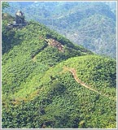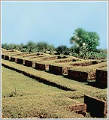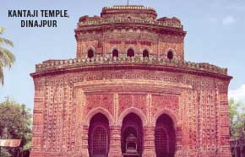

5.1 Tourists’ Impressions
Tourists’ impressions toward the tourism service(s) are important for the marketers. The positive impression obviously will result the repeat visit by the same tourist as well as it will serve the purpose of word of oral advertisement for the destination. Buyers judge whether a product or service is fairly priced by asking themselves whether it represents value for money. It is expected that the tourists will receive more value or at least equal to their perceived value after visiting the destination or tourist spot. Any change in price or quality at a particular point of time will also change consumers’ perception on the value. A study about the reasonableness of prices on some selected components of tourism arrangements in Bangladesh which is presented in the following table:
Table 5.1 Tourist’s Impressions on the Prices of Some Important Tourism Components
Tourism Components | Don’t Know Frequency | Highly Reasonable  (5) | Quite Reasonable  (4) | Fairly Reasonable  (3) | Quite Unreasonable  (2) | Highly Unreasonable  (1) | Mean Score
Food & Drinks | 6  (5.94) | 7  (6.93) | 23  (22.77) | 48  (47.52) | 16  (15.84) | 1  (0.99) | 3.2
Accommodation | 13  (12.87) | 5  (4.95) | 16  (15.84) | 41  (40.59) | 18  (17.82) | 8  (7.92) | 2.91
Transport | 12  (11.88) | 5  (4.95) | 46  (45.54) | 32  (31.68) | 6  (5.94) | 00  (00) | 3.56
Guided Packaged Tours | 62  (61.38) | 4  (3.96) | 7  (6.93) | 13  (12.87) | 12  (11.88) | 3  (2.97) | 2.92
Information materials | 48  (47.52) | 21  (20.79) | 19  (18.81) | 9  (8.91) | 4  (3.96) | 00  (00) | 4.08
Shopping Items | 26  (25.74) | 27  (26.73) | 25  (24.75) | 20  (19.80) | 3  (2.97) | 00  (00) | 4.01
Source: Hossain, Md. Afjal, University of Pune, India (1999)
The table shows that the tourists’ impressions on most of the arrangements of tourism in Bangladesh are below the scale of quite reasonable (mean score is below 4:00). The information materials and shopping items have considered to them as quite reasonable (mean score is above 4.00). It indicates that the tourism authority and the marketer of the same need to devote their attention in such a way so that it can satisfy the visitors in a more positive way.

5.2 Effectiveness of Promotional Measures

It was mentioned earlier that promotional measures play a vital role in tourism marketing like other products or services which needs the marketers to conduct the same in an effective way. Effectiveness is important rather than how much the promoter has spent for this purpose or how many times he has advertised or even which media he has used. The ultimate goal is to reach the advertiser’s message to the potential tourists and to influence them positively to visit the destination of the advertiser. The following table shows the effectiveness of various forms of promotional measures of Bangladesh tourism industry:

Table 5.2 Effectiveness of Various Promotional Measures of Tourism in Bangladesh
Form of Promotion | Don’t Know Frequency  (%) | Highly Effective  (%)  (5) | Quite Effective  (%)  (4) | Fairly Effective  (%)  (3) | Quite Ineffective  (%)  (2) | Highly Ineffective  (%)  (1) | Mean score
Advertisement | 86  (85.14) | 00  (00) | 1  (0.99) | 10  (9.90) | 2  (1.98) | 2  (1.98) | 2.67
Publicity | 81  (80.19) | 00  (00) | 5  (4.95) | 9  (8.91) | 5  (4.95) | 1  (0.99) | 2.90
Information Materials (Brochures, Guides, Souvenirs, Folders, Handbooks.) | 48  (47.52) | 4  (3.96) | 14  (13.86) | 18  (17.82) | 11  (10.89) | 6  (5.94) | 2.98
Posters and View Cards | 74  (73.26) | 2  (1.98) | 5  (4.95) | 8  (7.92) | 10  (9.90) | 2  (1.98) | 2.81
Cable TV Highlights | 86  (85.14) | 2  (1.98) | 2  (1.98) | 4  (3.96) | 4  3.96() | 3  (2.97) | 2.73
Internet | 93  (92.07) | 00  (00) | 2  (1.98) | 5  (4.95) | 1  (0.99) | 00  (00) | 3.13
Word of Mouth (WOM) | 53  (52.47) | 17  (16.83) | 18  (17.82) | 12  (11.88) | 1  (0.99) | 00  (00) | 4.06
Motivation by Foreign Tour Operators | 62  (61.38) | 5  (4.95) | 22  (21.78) | 9  (8-91) | 2  (1.98) | 1  (0.99) | 3.72
Motivation by Foreign Travel Agencies | 81  (80.19) | 00  (00) | 7  (6.93) | 6  (5.94) | 5  (4.95) | 2  (1.98) | 2.90
Biman’s Overseas Offices | 83  (82.17) | 00  (00) | 2  (1.98) | 5  (4.95) | 4  (3.96) | 7  (6.93) | 2.11
Bangladesh Mission Abroad | 65  (64.35) | 2  (1.98) | 5  (4.95) | 11  (10.89) | 11  (10.89) | 7  (6.93) | 2.56
Source: Hossain, Md. Afjal and Firozzaman, Bureau of Business Research, University of Dhaka (2003)

It is found from the above table that only word of mouth is quite effective with a mean score of 4.06. Tourists rely more on personal source of information and, hence, personal selling will be the most effective promotional tool in tourism marketing. The mean score of Internet is 3.13 and motivation by foreign tour operators is 3.72 which indicate that these two forms of promotional measures are fairly effective. Though the national airlines can play an active and vital role for country’s tourism industry, but the image of Biman Bangladesh Airline is not good and the Biman’s overseas offices failed to contribute in this regard. The mean score of Biman’s overseas offices is 2.11 which indicate that as a form of promotion, it is ineffective. The researchers also mentioned that the overall mean score of effectiveness of all the promotional forms accounted to 3.10 with a standard deviation of 0.53 which is slightly higher than the mid-value of the scale. This overall mean effectiveness score 3.10 can be considered that the promotional measures of Bangladesh tourism industry is fairly effective.

5.3 Promotional Activities Used for Tourism Marketing

BPC is the only National Tourism Organization (NTO) in Bangladesh and acts as the public sector tour operator and there are a few number of private tour operators. But most of the private tour operates established newly and lack the sufficient amount of funds. Instead of the lacks of sufficient amount of funds, both BPC and private tour operators are trying to conduct the promotional activities in order to attract more tourists to its destination and thus, develop the tourism industry in Bangladesh. As we know that marketing promotion includes advertising, Personal selling, sales promotion and publicity. All these tools of promotion are used in promoting Bangladesh tourism.

BPC also uses a web site for disseminating the information to the potential tourists. But the fact is that the web site does not contain the complete information of Bangladesh tourism and it related facilities. As a result, it is tough for a potential tourist to have the required information from the said page.

Bangladesh Parjatan Corporation is trying at its utmost level by using the different form and techniques of promotional tools. But BPC’ lacks seriously for sufficient funds and it limits the promotional activities in a very limited scale. The following table shows the year-wise foreign exchange earnings of BPC and promotion expenditure:

Table 5.3 Foreign Exchange Earnings, Promotion Budget & Promotion Expenditure of BPC
Year | Earnings from Tourism (TK. in Million) | Promotion Expenditures (TK. in Million) | % of Promotion Expenditures on Earnings
1991-92 | 391.3 | 2.965 | 0.76%
1992-93 | 448.3 | 5.363 | 1.20%
1993-94 | 607.1 | 8.065 | 1.33%
1994-95 | 823.6 | 7.143 | 0.87%
1995-96 | 1125.4 | 7.935 | 0.71%
1996-97 | 1799.7 | 10.391 | 0.58%
1997-98 | 3086.9 | 9.058 | 0.29%
1998-99 | 2370.1 | 8.096 | 0.34%
1999-00 | 2582.7 | 10.147 | 0.39%
2000-01 | 2638.1 | 10.834 | 0.41%
2001-02 | 3087.1 | 7.399 | 0.24%
2002-03 | 3207.4 | 10.06 | 0.31%
2003-04 | 3782.7 | - | -
2004-05 | 4203.25 | 10.413 | 0.25%
Source: Bangladesh Bank and BPC Web site

It is apparent from the table 5.3 that BPC spend a small percentage of its total income for promotional activities. In 1991-92, BPC spent only TK. 2.965 million which in only 0.76 percent of its total earnings. The spending for the same purpose increased to Tk. 10.413 in 2004-05 but the percentage on total earnings decreased to only 0.25 percent. Tk. 10.413 million is equivalent to about US$ 158,000 only can not meet the demand for the need of expenditure of an effective promotional measure. Because of the diverse location of the potential tourists and the increasing competition among the different competitive destination countries, tourism sector needs undertake vigorous promotional activities at the national and international levels. Again, the promotion for tourism needs to have the international coverage which requires using international media. To use the international media for promoting any product or service needs a hand some amount of money to spend. But it is clear that the amount spend by BPC is not sufficient enough to use international media covering a vast area of the potential tourist attracting regions. As a result, Bangladesh fails to highlight its tourist attractions to the potential tourists as well as to draw the attention and influence them to select Bangladesh as a tourist destination. The insufficiency of the fund for conducting promotional activities, BPC has to depend on the local media, posters, folders, brochures, tourist maps etc.

The private tour operators also use some sorts of sales promotion like off-season price discounts, free distribution of printed materials; organize live music programs for the visitors in destination’s spot, extra service offers, group tour discounts for the packages offered and river cruise programs. Hardly two or three operators are using the web page for the promotion of the tourism in Bangladesh.

5.4 Promotional Activities Undertaken in Bangladesh

All most all the tour operators use all the tools of promotion mix in order to promote the industry. They make the advertisements in local newspapers, magazines and televisions. In addition to that they also use the printed materials like brochures, souvenirs, booklet, guides and posters, folders in disseminating information among the potential tourists in order to draw their attention and grow interest among the potential tourists. But they don’t use any international medium to advertise its products or services.

BPC has the arrangements to train up their employees and contact personnel to ensure the better interactions and maintain good relationships with the prospective tourists and to motivate them in visiting Bangladesh. BPC and some of the larger private tour operators maintain contact with the foreign tour operators to influence them highlight Bangladesh tourism and its facilities to the foreign tourists.

Both the private tour operators and BPC uses the techniques of sales promotion which include quantity discount, children discount, off-season price rebate and improved service packages for it package tours, cruise programs and accommodations to persuade the local tourist as well as the foreign tourists.
In addition to that BPC and some private tour operators participate at the tourism exhibition/fair arranged locally and internationally. Occasionally, BPC arranges different cultural night shows, food festivals, seminars, symposiums, audio-visual presentations etc. at the popular tourism destination of the country. BPC has a web site to provide the information of Bangladesh tourism and its facilities among the prospective tourists though the web site is not well designed.

Chapter 6

Statistics on Tourist Arrivals and Earnings
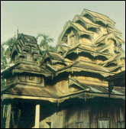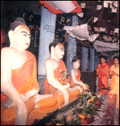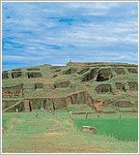

6.1 Total Tourist Arrivals in Bangladesh

Earlier it has been discussed the situation of the tourist arrivals by different regions and sub-regions along with its share as well as the situation prevailing in the South Asian countries. Attempts were also made to highlight details of the same for Bangladesh. The following table shows the tourist arrivals in Bangladesh in different years and the rate of growth of the same:

Table 6.1 Year-Wise Total Tourist Arrivals in Bangladesh
Year | Tourist Arrivals
Year | Number | Growth Rate (%)
1991 | 113242
1992 | 110475 | (-) 2.44
1993 | 126785 | (+) 14.76
1994 | 140122 | (+) 10.52
1995 | 156231 | (+) 11.50
1996 | 165887 | (+) 6.18
1997 | 182420 | (+) 9.97
1998 | 171961 | (-) 5.73
1999 | 172781 | (+) 0.48
2000 | 199211 | (+) 15.30
2001 | 207199 | (+) 4.01
2002 | 207246 | (+) 0.02
2003 | 244509 | (+) 17.98
2004 | 271270 | (+) 10.94
Average Growth Rate |  | +7.79 %
Source: Bangladesh Parjatan Corporation

The table shows that the number of tourist arrivals in Bangladesh has increased to 271,270 in 2004 from 113,242 in 1991 which shows an average annual growth rate of 7.79 percent. The tourist arrivals increased in 2003 by 17.98 percent and 10.94 percent in 2004 over its preceding year. In general, the statistics shows a very good and positive trend. But the fact is that the overall scenario is not good. This rate can be considered very accelerative for those countries that have already matured in the market. But for the initial level of market entry, the above growth rate is not a positive one.

By using the above data (Table 6.1) the projected number of tourist arrivals for the year 2010 and 2020 can be calculated with the help of regression analysis where, the model:
y = mx + b
Here, x is independent variable (year) and y is dependent variable (total number of tourist arrivals)
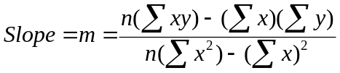


By interpreting and solving this we get the value m = 10873.734 and b = 94828.35 and then the model stands as: y = 10873.734(x) + 94828.35 and the projected tourist arrivals is 312303 and 421040 for the year 2010 and 2020 respectively subject to remaining the present trend unchanged, whereas the BPC forecasted that Bangladesh will receive 0.9 million tourists in 2020 which seems very unrealistic forecast.

6.2 Foreign Exchange Earnings from Tourism

The marketing performance of any tourism organization can be evaluated based on the earnings by the organization. So, it was attempted to focus on the earnings of BPC and the growth rate of the same for the last couple of years to have a clear picture of the sector in terms of financial performance. The following table is shows the earnings and growth rate of the same of BPC, the only government owned tourism organization in Bangladesh:

Table 6.2 Foreign Exchange Earnings from Tourism and Travels in Bangladesh
Year | Earnings from Tourism
Year | Amount (Million Tk*) | Growth Rate (%)
1990-91 | 267.7
1991-92 | 391.3 | (+) 46.17
1992-93 | 448.3 | (+) 14.57
1993-94 | 1607.1 | (+) 35.4
1994-95 | 823.6 | (+) 35.66
1995-96 | 1125.4 | (+) 36.64
1996-97 | 1799.7 | (+) 59.92
1997-98 | 3086.9 | (+) 71.52
1998-99 | 2370.1 | (-) 23.22
1999-00 | 2582.7 | (+) 8.97
2000-01 | 2638.1 | (+) 2.15
2001-02 | 3087.1 | (+) 17.02
2002-03 | 3207.4 | (+)3.90
2003-04 | 3782.7 | (+) 17.94
2004-05 | 4203.25 | (+) 11.12
Average Growth Rate |  | (+) 24.12
Source: Bangladesh Bank and BPC Web page

Though the foreign exchange earnings through mobilizing domestic resources by the host country’s tourism industry can play an important role in the economy, the earning of BPC is very insignificant in terms of the overall earnings of the said industry in the world and even in the Asian region. The earnings from tourism in Bangladesh was Tk. 267.7 million in 1990-91 which increased to Tk. 4,203.25 million in 2004-2005. There is also a very positive sign that every year from 1990-01 to 2004-2005 has a positive growth rate except 1998-99. The year 1998-99 is exceptional and achieved a negative growth rate over its preceding year may be due to devastating flood in all over the country and which lasted about 2 months. The highest growth rate was achieved in 1997-98 which is 71.52 percent over the previous year. From the above table, comment can be made that though Bangladesh does not have a good position in world tourism, but the trend of growth rate in the earnings is encouraging.

6.3 Tourists Arrivals from SAARC Countries

There are seven countries of South Asian Association of Regional Cooperation (SAARC) including Bangladesh. As it was clear from the discussion made in the earlier sections that the position of Bangladesh in world tourist arrivals and even is not amazing through the industry is growing faster than in any other industry. It was also observed that in the South Asian countries, the position of Bangladesh is very insignificant. The picture of the tourist arrival in Bangladesh from the SAARC countries shown in the following table:

Table 6.3 Tourists Arrivals from Member Countries of SAARC (1995-2004)
Country  Year | Bhutan | India | Maldives | Nepal | Pakistan | Sri Lanka | SAARC Total | Total Arrivals | Share of SAARC Countries
1995 | 415  (0,65) | 46015 (72.10) | 94  (0.15) | 2995  (4.69) | 12903  (20.22) | 1395  (2.19) | 63817  (100,00) | 156231 | 40.85
1996 | 568  (0.86) | 53007  (80.45) | 97  (0.15) | 3628  (5.51) | 7070  (10.73) | 1522  (2.31) | 65892  (100,00) | 165887 | 39.72
1997 | 959  (1.18) | 61606  (75.92) | 123  (01.5) | 5296  (6.53) | 11481  (14.15) | 1686  (2.08) | 81151  (100,00) | 182420 | 44.49
1998 | 441  (0.57) | 57937  (75.26) | 63  (0.08) | 4799  (6.23) | 12087  (15.70) | 1563  (2.15) | 76980  (100,00) | 171961 | 44.77
1999 | 730  (0.93) | 62935  (80.50) | 53  (0.07) | 4733  (6.05) | 7894  (10.10) | 1839  (2.35) | 78184  (100,00) | 172781 | 45.25
2000 | 1010  (1.09) | 74268  (79.85) | 189  (0.20) | 4481  (4.82) | 10637  (11.44) | 2427  (2.61) | 93012  (100,00) | 199211 | 46.69
2001 | 1263  (1.35) | 78090  (83.25) | 129  (0.14) | 4280  (4.58) | 7010  (7.47) | 3026  (3.23) | 93798  (100,00) | 207199 | 45.27
2002 | 1241  (1.28) | 80415  (82.74) | 150  (0.15) | 4159  (4.56) | 8703  (8.95) | 2524  (2.60) | 97192  (100,00) | 207246 | 46.90
2003 | 1228  (1.20) | 84704  (82.97) | 182  (0.18) | 3904  (3.82) | 9238  (9.05) | 2831  (2.77) | 102087  (100,00) | 244509 | 41.75
2004 | 874  (0.88) | 80469  (80.95) | 98  (0.10) | 3144  (3.16) | 11997  (12.07) | 2826  (2.84) | 99408  (100.00) | 271270 | 36.65
Source: Special Branch, Bangladesh.
It can be noted that a large number of tourist visited Bangladesh is from SAARC Countries. It is almost half of the total tourist arrivals in Bangladesh. The share of the tourist arrivals from SAARC countries to Bangladesh was more than 40 percent from 1995 to 2003 which was decreased to 36.64 percent in 2004. Another important issue to observe here is that most of the tourists of SAARC countries are from India. The share of Indian tourists travelled Bangladesh constituted 72.10 percent in 1995 which increased to 80.95 percent in 2004. The second highest number comes from Pakistan which was 12.07 percent in 2004 followed by Nepal by 3.16 percent.

6.4 Cost of Hotel/Accommodation in Bangladesh

A tourist destination country needs to provide the secured accommodation facilities to the foreign tourists as well as to the local tourists. It is vital for the success for a tourist region to provide sufficient quantity or right quality accommodations at a competitive price compare to its competitive destinations countries to fulfil the visitors’ needs. The following table shows the accommodation/hotel cost in Bangladesh and its competitive neighbouring countries:

Table 6.4 Average Hotel/ Accommodation Cost (in US$) in South Asian Countries
Name of the country | Hotel Ranking
Name of the country | 5 Star | 4 Star | 3 Star
Bangladesh | 1 Adult: 177  2 Adults:177 | 1 Adult: 114  2 Adults: 138 | 1 Adult: 90  2 Adults: 100
India | 1 Adult: 279  2 Adults:291 | 1 Adult: 109  2 Adults: 117 | 1 Adult: 91  2 Adults: 100
Maldives | 1 Adult: 319  2 Adults:334 | 1 Adult: 184  2 Adults: 223 | 1 Adult: 132  2 Adults: 149
Nepal | 1 Adult: 151  2 Adults:164 | 1 Adult: 87  2 Adults: 100 | 1 Adult: 54  2 Adults: 63
Pakistan | 1 Adult: 225  2 Adults:241 | 1 Adult: 94  2 Adults: 109 | 1 Adult: 62  2 Adults: 75
Sri Lanka | 1 Adult: 134  2 Adults:138 | 1 Adult: 75  2 Adults: 84 | 1 Adult: 73  2 Adults: 82
Source: WTO
In this study only the star hotel ranging from 3 stars to 5 stars are considered to provide a brief overview of the accommodation cost for the tourists in the South Asian region. In addition to the above every country has many other cheap hotels, motels, guest houses etc.

Chapter 7

Problems of Tourism Marketing in Bangladesh
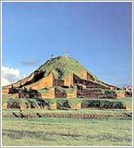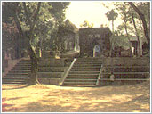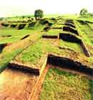

7.1 Problems of Tourism Marketing in Bangladesh

Tourism is now a fastest growing industry in the world. The ever increasing growth of this industry and its market has increased the competition among the tourists importing countries. As a result, the success of any destination country depends on how well it can initiate and adopt the competitive marketing strategy over its competitors. The destination country needs to take the effective marketing measures so that they can gain the positive result through attracting more tourists to its destination.

Bangladesh is trying to attract more tourists to its destination through different measures. But the country lacks far behind to conduct the appropriate and sufficient measures regarding the marketing measures. The position of Bangladesh tourism in world context is very negligible even the country’s position is at the bottom line in the South Asian region. Among the seven countries of SAARC in this region, Bangladesh holds the 6th position just above the position of Bhutan. One of the reasons of not succeeding Bangladesh tourism is ineffective marketing plans undertaken for the sector. So, it is essential for the policy makers of the concern industry to consider the following issues very carefully and on the priority basis for the expected development of the industry.

7.1.1 Negative Impact of Security and Country's Poor Image
Bangladesh, whose image abroad tends to revolve round its being one of the poorest countries in the world and prone to natural calamities like flood and cyclone, is not an obvious tourist destination. The tourism industry has also suffered significantly due to the bomb attacks and terrorist activities in the recent past years.

7.1.2 Underdeveloped accommodation and other facilities
Accommodation is one of the most significant factors to have contributed to the development of tourism world-wide and the absence of which may put off the tourists from travelling to enjoy the attractions. Standard hotel accommodation and transport system in Bangladesh is not adequate for attracting international tourists even the local tourists. Hotels' infrastructure and other services are still underdeveloped in the country.

7.1.3 Lack of Infrastructure and Government Support
The presence of very few international standard hotels, the low frequency of flights and the underdevelopment of tourist attractions has limited the tourism potential. With poor infrastructure, little marketing sense and direction, and a national carrier too busy serving the labour traffic, tourism potentials of Bangladesh this far remained unexploited. Another key aspect of infrastructure is the availability of monetary funds during travel. Even until recently, the ATMs outside Dhaka aren't connected to the international network, and traveller's cheques are very difficult to cash.

7.1.4 Ineffective marketing strategies and poor promotional activities
Promotional activities undertaken by Bangladesh tourism sector is not effective and is limited to traditional activities like distributing brochures, hand book, advertising in national news papers, local TV channels etc. Both the existing literature and the data collected show that the promotional measures taken by Bangladesh tourism are not effective. The existing literature shows that the promotional activities undertaken by this sector is very traditional in form and are limited to folders, posters, accommodation guide etc. and again it is not well distributed and publicized.

7.1.5 Insufficient fund and government support
Most of the private tour operators started their activities recently. As most of the tour operators are new in this area of marketing, they lack the experience and capital to run the business as most of them expressed their sufferings due to lack of fund for conducting the necessary promotional activities for the marketing of tourism services.

7.1.6 Unavailability of updated information
Both the local and potential international tourists face the problem of easy access to information related to Bangladesh tourism and its facilities. Though BPC uses its web page, but it is not capable to highlight the Bangladesh tourism attractions and the necessary related information properly.

Chapter 8

Prospects of Tourism Marketing in Bangladesh
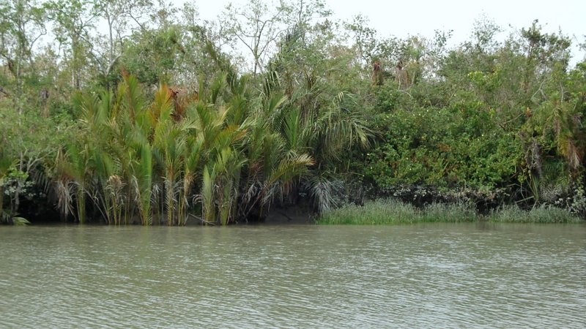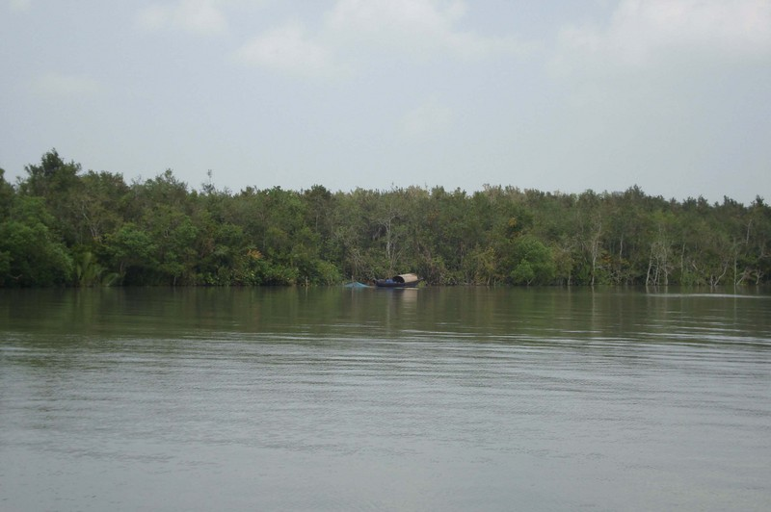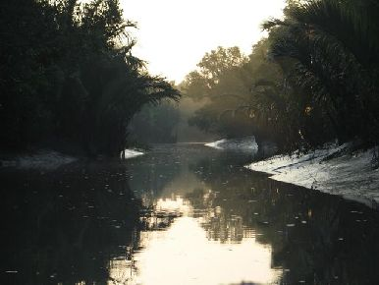

8.1 Prospects of Tourism Marketing in Bangladesh

A report of the World Travel and Tourism Council (WTTC) released recently on its website expected the tourism industry in Bangladesh will contribute 2.96 billion U.S. dollars, or 3.9 percent of GDP.

According to WTTC's estimation, Bangladesh's tourism industry contributed around 1.5 percent to the country's GDP in 2007, or 998.2 million U.S. dollars.

Apart from this, the report said the contribution of Bangladesh’s tourism industry to employment is expected to rise from over 2, 065,000 in 2008, or 3.1 percent of total employment to 2,791,000 jobs, 3.2 percent of total employment by 2018.

Bangladesh has some unique attractions like world’s longest and unbroken sea beach, world’s largest mangrove forest with a variety of wild lives, historical cultural heritage, tribal culture, captivating beauty of the nature etc. Bangladesh has huge potential for attracting foreign tourists as it has a deep cultural heritage, a number of ancient monuments and temples, and a rich natural heritage, including tropical forests, beautiful hills, rivers, and national parks. The country offers bargain-shopping and exotic souvenirs, as well as a wide variety of activities, from eco-friendly to adventure tourism.

The growth of the tourism industry in the Asia and the Pacific region is more accelerating than any other region. Bangladesh has a vast prospect to gain maximum outcome from the tourism industry as the country has some unique attractions.

8.1.1 Tourism potential of Bangladesh
Bangladesh is located conveniently on the east-west air-corridor making it a gateway to the Far East. It is endowed with resources and the potential for a tourism industry. In the south-east the country has a 120 km long beach of soft silvery sand, perhaps the world's longest, in a Riviera-like setting with crescent-shaped low hills overlooking the Bay of Bengal. The range of the hills clad in lush green thickets are treasured locations for eco-tourists and wildlife watchers. At the head of this terrain is Cox's Bazaar which is as romantic as its name is to the outside world. The Hill Districts to the north and north-east of Cox's Bazaar nestle the Kaptai and Rangamatilakes, a 840 sq.km body of crystal clear water lying in sylvan shadows not far from where a dozen hill tribes follow their traditional life-styles. The Tea District of Sylhet in the far north-east of the country has prospects of tourism, as does the Sundarbans, a large mangrove forest in the South which is home of the Bengal tiger; remains of palaces of old principalities and archaeological sites of Buddhist monasteries. Shrines and holy places, mosques and temples, particularly in the northern part of the country, are among the tourist treasures of Bangladesh.

8.1.2 Potential to receive a large number of tourists
Bangladesh has the potential of receiving a large number of tourists and a handsome amount of earnings from this sector. The average growth rate in tourist arrivals in Bangladesh from 1991 to 2004 is 7.19 percent and the same in earnings from 1990-91 to 2004-2005 is 24.12 percent whereas the WTO’s forecast is average annual growth rate is 6.10 percent between 1995 to 2020 for South Asia.

8.1.3 A competent land for tourism
Bangladesh as a vacation land has many facets. The country’s tourist attractions include archaeological sites, historic mosques and monuments, resorts, beaches, picnic spots, forest, colourful tribal life and wildlife. Bangladesh offers opportunities for angling, water-skiing, river cruising, hiking, rowing, surfing, yachting and sea bathing as well as bringing one in close touch with Mother Nature. The country is also rich in wildlife.

8.1.4 Prospective eco-tourism
As a destination for eco-tourism, Bangladesh is truly hard to beat. A country in South Asia with an area of 144,470 square kilometres, Bangladesh definitely offers a lot to see enjoy and do. The main attraction of Bangladesh could be its opportunities for eco-tourism with it’s a variety of animals, birds, forests, hills and hillocks and aquatic life. The country can become popular as an eco-destination in South Asia.

Chapter 9

Findings Based on the Empirical Study

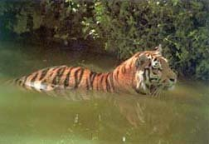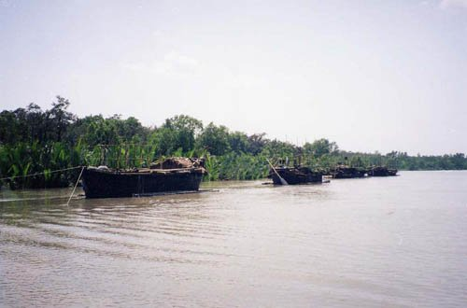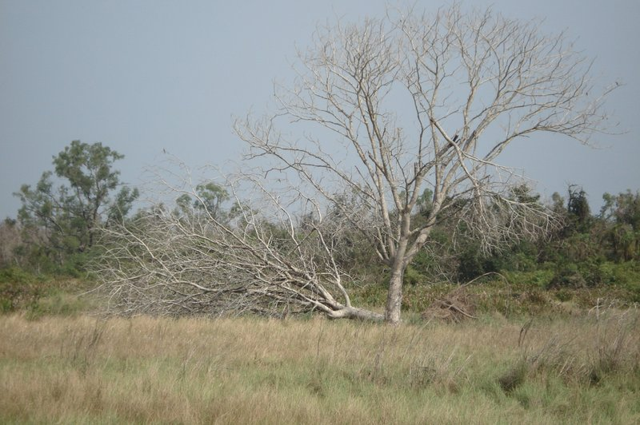

9.1 Findings Based on the Empirical Study

- Bangladesh is suffering with negative image because of the international media most often highlight Bangladesh negatively rather an attractive tourist destination which leads the tourists not to chooses Bangladesh to visit. This indicates that the concern authority needs to undertake proper initiatives from the government level to correct the present image and needs to have the international media coverage in a positive way.

- Data shows that Bangladesh has the potential of receiving a large number of tourists and a handsome amount of earnings from this sector. In 2004, an increase in tourist arrivals of 10.94 percent, to 271,000, an increase of 11.12 percent in receipts to Tk. 4203.25 million in the year 2004-05 marked as a very positive growth for tourism in Bangladesh. The average growth rate in tourist arrivals in Bangladesh from 1991 to 2004 is 7.19 percent and the same in earnings from 1990-91 to 2004-2005 is 24.12 percent whereas the WTO’s forecast is average annual growth rate is 6.10 percent between 1995 to 2020 for South Asia. The effective measures can uphold the present growth rate or even can be useful to accelerate the growth rate and can contribute to earning more from this sector.

- Bangladesh lacks the required infrastructural facilities like sufficient number of standard hotels, motels, transportation, security of the potential tourists, new products and services etc in the destination for developing the tourism sector at an expected way. So, due attention and initiatives are essential for a significant growth of this sector.

- For a real sense, the promotional activities for tourism products or services need to undertake and launch at the national level and also at the international levels. It is a must to attract foreign tourists to earn foreign currency from this sector which needs to conduct the marketing promotion at the international level especially to those countries or destinations from where the host county wants to attract or receive the tourists. To conduct any promotional measure or campaign for any product or service in the international level needs to use the media which has the international coverage like international Newspapers, Internet, Cable TV, participation in the international tourism fairs etc and these media are also expensive. But the total promotion budget of BPC was Tk. 10.413 million in 2004-05 (at present market price this amount is equivalent to US$ 150,000, where US$ = TK. 69.4) which is only 0.25 percent of the total earnings Bangladesh tourism. In consideration of the amount spent for promotion in the year 2004-05 is the highest amount since the inception of BPC. It can easily comment that this amount for promotional activities for a vital sector like tourism is quite insufficient in conducting any promotional campaign at the national and international levels. This leads BPC not to take any vigorous promotional effort for tourism. If Bangladesh tourism wants to undertake any extensive promotional campaign more promotional budget is required to allocate for the same.

- Promotional activities undertaken by Bangladesh tourism sector is not effective and is limited to traditional activities like distributing brochures, hand book, advertising in national news papers, local TV channels etc. Both the existing literature and the data collected show that the promotional measures taken by Bangladesh tourism are not effective. The existing literature shows that the promotional activities undertaken by this sector is very traditional in form and are limited to folders, posters, accommodation guide etc. and again it is not well distributed and publicized. The empirical data shows that the mean score of the effectiveness is 3.75 where the average score for effectiveness is 4.00 (‘average score’ indicates neither effective nor effective). It indicates that the promotional measures undertaken by BPC can affect the potential tourists in a very limited scale which causes not to attract the expected number of tourists and earning from the sector. If Bangladesh wants to attract a large number of tourists for earning more foreign currency by using the full potential of this sector, there is no alternative of taking rigorous promotional activities at least to some major tourists generating destinations or countries.

- The WTO Tourism 2020 Vision forecasts that the average growth rate in tourism industry for South Asia will be 6.1% during 1995-2020. The present trend in tourist arrivals in Bangladesh indicates that the average annual growth rate in tourist arrivals to Bangladesh 7.19% which is above the WTO estimates. Bangladesh Parjatan Corporation forecasted that if the present growth rate continues, Bangladesh will receive 900,000 tourists in 2020 and the earning from this sector will increase accordingly (BPC, 2004) though it is not suggested by the projected valued of the regression model.

- Most of the private tour operators started their activities recently. Out of the 20 respondents, 5 were from Bangladesh Parjatan Corporation (BPC), the only National Tourism Organization in Bangladesh started its operation in 1973 and the remaining 15 were from private tour operators. Among the private tour operators, seven out of fifteen constituting 46.46% started their activities during 2001 to 2005, five operators constituting 33.33% started the same with in the period of 1996 to 2000, one in 1991-1995, one in 1986-1990 and the remaining one has started the same in 1976-1980. As most of the tour operators are new in this area of marketing, they lack the experience and capital to run the business as most of them expressed their sufferings due to lack of fund for conducting the necessary promotional activities for the marketing of tourism services. It also indicates that the government should extend the cooperation to provide some training to enhance the skills of the operators and should provide some extra opportunities to the tour operators to get long-term loan at a minimum interest so that they can meet their financial requirements.

- The international tourist arrivals in South Asian countries was 3,150,000 in 1990 which increased to 7,501,000 in 2004 and the same in Bangladesh increased from 115,000 to 271,000 in the same period. Though the number of arrivals in Bangladesh increased during this period (1990 to 2004), there is a minor decrease from 3.65% to 3.61% in the share of Bangladesh. The foreign exchange earnings from international tourist arrivals in SAARC countries was US$ 2029 million in 1990 which increased to US$ 7332 million in 2004 and the same in Bangladesh increased from US$ 11 million to US$ 67 million in the mentioned period. The share of Bangladesh in foreign currency earnings among SAARC countries increased from 0.54 percent in 1990 to 0.91 percent in 2004. These can be again increased by taking the proper measures and attracting more tourists to the destination of Bangladesh.

- Out of the 20 respondents, 17 constituting 85% respondents realize that promotional activities need to increase but they fail to do that due to lack of funds. But if the tourism destination and it facilities is not properly highlighted to potential tourists, no destination can expect more tourists to visit same. Because the capability of any destination not only depends on the destination’s attractiveness but also how effectively marketers can present it to the prospective tourists and can draw their attention and grow interest to that particular destination.

- Both the local and potential international tourists face the problem of easy access to information related to Bangladesh tourism and its facilities. Though BPC uses its web page, but it is not capable to highlight the Bangladesh tourism attractions and the necessary related information properly. Bangladesh National Tourism Organization needs to develop a well designed sophisticated web page so that the potential tourists can get all the necessary information related to Bangladesh tourism from any corner or part of the world and thus, can make their queries and bookings through online easily.

Chapter 10

Recommendations & Suggestions
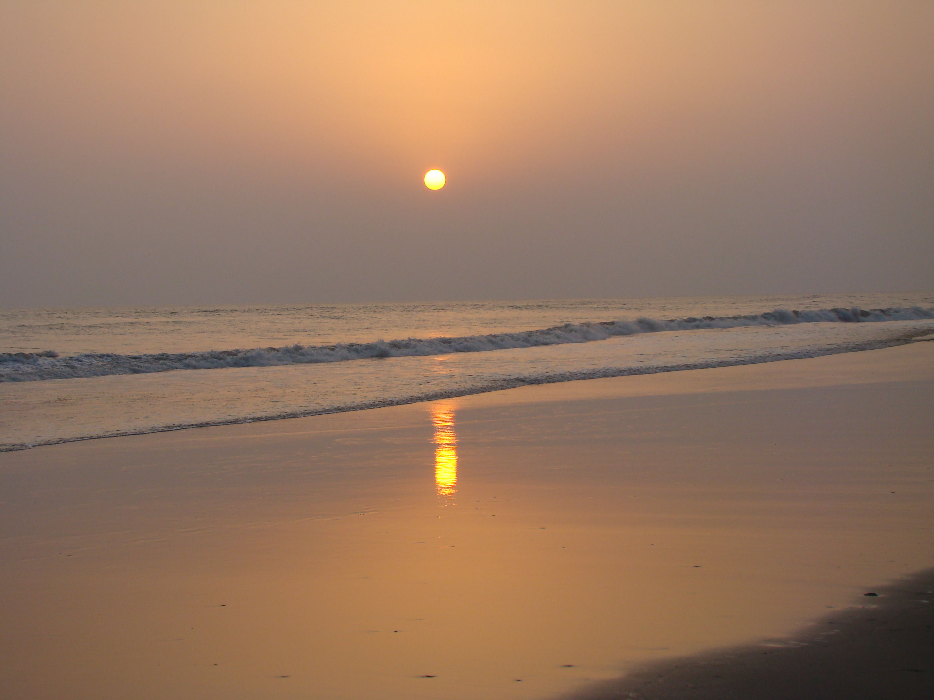

10.1 Suggestions from the Tour Operators
The summary of suggestions of tour operators about the steps those should be undertaken to attract more tourists are presented in the table below:
Table 10.1 Required measures undertaken to attract more tourists
To attract foreign tourists | To attract local tourists
- Participate in international tourism fairs  - Uses Bangladesh mission abroad  - Contracting international tour operators  - Distributing brochures and tourist hand books  - Uses of well-designed website | - Advertises in local Newspapers and Bangladesh Television  - Arranges tourism fairs  - Distributes tourism publications to the potential tourists

The National Tourism Organization (BPC) and the private tour operators in Bangladesh put forward some suggestions for the development of Bangladesh tourism. Their suggestions can be presented in a summarised form in the following table:

Table 10.2 Suggestions from the Tour Operators
Suggestion from BPC | Suggestion from Private Tour Operators
1. Need to develop new attractions/ products or services in the destinations.  2. More promotional activities should be undertaken  3. Should develop and update an attractive web site to provide the required information to the potential tourists.  4. Government should priories this sector for development plan.  5. Security of the tourists should be ensured.  6. BPC should have full autonomy to take necessary decision timely | - Infrastructural development is needed.  - Developing new products or services in the destinations.  - Well designed website is needed  - Foreign mission should be involved in promotional activities.  - Law and order situation should be developed.  - Need coordinated promotion activities by NTO and other parties involved.  - Govt support to the private tour operators is necessary for the development of this sector.  8. Tax holiday for vehicles is necessary for minimizing cost of operation.

10.2 Recommendations to Improve the Tourism Industry

Based on the findings of the study the following suggestions can be put forwarded to improve the promotion of tourism industry in Bangladesh:

I. Correcting the image of the country
The image of the destination plays a vital role to attract tourists to that particular destination. But Bangladesh is suffering from the image problem because of some international media. These media highlight Bangladesh negatively which results to create misconception among the potential tourists. Even some Non Government Organizations (NGOs) do the same thing in order to collect funds by highlighting the country as a dreadfully poor, flood ravaged, pestilence and means there is nothing to be in a country to consider as a tourist destination. As a result, many foreigners do not choose Bangladesh as a tourist destination because of either they don’t have enough idea about the country and its tourism attractions and facilities or what they have is negative. To some extent, it may be partially true but is not the fact as a whole. Once someone visits the country his/her perceived image is changed. So, Bangladesh tourism should emphasize first on its promotional measures to correct this negative image. But it is not only the issue to be solved by Bangladesh tourism authority; it requires the government’s initiative as a whole and the Bangladesh Mission offices abroad have a major role in this regard. As Bangladesh tourism industry has not enough funds to use to international media for correcting this negative image, it should emphasize on the printed materials and to distribute it to the potential tourists through different airlines, foreign tour operators and foreign mission abroad etc.

II. Ensuring the security of the tourists
Security at the destination place is considered as one of the major factors for the foreign tourists. Because of every tourist gives the high priority on security to select a foreign country as a tourist destination. Therefore, the question of adequate security to the tourists during their visit is also very important. The tourists need to be fear free in visiting a place especially when it is outside their home country. The government of Bangladesh should improve the security in the major tourist areas with a view to correct Bangladesh’s tarnished image. Any sort of risk and uncertainty related to the destination will lead the tourists not to select that particular destination. Promotional measures can remove these sorts of fear, risk, harassment or cheating.

III. Use of Information Technology in promotional activity
The recent change and progress in information technology have a revolutionary impact on tourism industry. Because of travel and tourism-related products and services are highly compatible with the Internet and the rapid growth of the Internet is having an impact on the distribution of travel services and has heightened speculation about the potential for disintermediation of the travel agent. Again, the international tourism system is dependant on information technology for its future growth, competitiveness and long-term survival - particularly in terms of tourism marketing and distribution. It is considered that who are able to access more information and make use of it are likely to be the winner in the competitive environment.

In promoting the tourism industry of any country, the Internet can play the leading role to facilitate information exchange internationally. In addition to that World Wide Web (WWW) is the most popular application on the Internet which can be used effectively for the many purpose of tourism marketing including direct sales, advertisement, customer support, etc. Bangladesh tourism authority must consider the effective use of this technology for the promotional activity of this industry. It is worth mentioning here that though BPC has it own web page, it should be well designed containing all the necessary information.

IV. Promoting to some specific regions
As Bangladesh tourism is at the early development stage, the country should target a specific number of countries from where the country can generate more tourists rather than targeting the whole market areas. At least by targeting five more prospective tourist generating countries, the country can undertake more promotional activities to those countries so that a larger number of tourists can be attracted. Even to those countries, Bangladesh can launch heavy promotional activities by using different tools of promotion. If the industry wants to attract more foreign tourists, it needs to publish some creative advertisement in some specific travel guides, magazines, and specialized professional journals that the potential tourists, overseas tour operators, travel agents, and travel writers read. The authors described that tourist customers are more likely to respond to the creative advertising message projected through specialized and appropriate media vehicles. Then they urged that that the extent of success in appealing to a particular market segment or encouraging them to visit the destination(s) depends upon the right choice of advertising media and thus the choice of media is an important decision for the marketers of the tourism industry.

V. Allocation of more promotional funds
Bangladesh don’t have that level of capability to compete with the world’s top tourist generating countries, but it has the capability to compete with the member countries of SAARC or at least some other small countries of SAARC except India. To compete with these countries, needs to conduct more promotional measures. But what the amount is allocating presently for this purpose is not sufficient. Though the country has not enough financial capabilities, but it can easily increase it promotional budget up to 4 or 5 percent of it total earnings from this sector. In addition to that the authority should have a plan for the effective use of the promotional budget. Because of it will again help to increase the earnings by attracting more tourists.

VI. Use of foreign tour operators to promote Bangladesh
Foreign tour operators can play an important role to in motivating the potential tourists to a specific tourist destination. BPC and the private tour operators of Bangladesh can maintain the contact and liaison with the foreign tour operators and to influence them to send more tourists to Bangladesh. Even foreign tour operators can be used to distribute the brochure, souvenirs, and tourists’ maps of Bangladesh tourism. For this purpose they need to have some incentives. Bangladesh can sell package tours through foreign tour operators where they receive a handsome amount of discount.

VII. More discounted offer for a group tour and long stay
Bangladesh can attract more tourists by offering more discounts on group tours and long stay visits. For example, discount on air tickets, hotel rents, discounted price of local transport arranged by the tour operators etc.

National airlines have a major role in this regards. Since the position of the national airlines of Bangladesh is not so good, the country can make the mutual arrangement on some selected international airlines. In addition to that the tourism authority should offer more off-season discounts, students discount, SAARC tour rebate etc to motivate the potential tourists to visit Bangladesh. At the same time, steps should be taken to attract the local tourists to travel more in a number and frequent visit of different tourism spots of the country.
VIII. Cooperation among the neighbouring countries
The SAARC countries can co-operate each other for the development of tourism in this region. Each country can be benefited through building and maintaining a meaningful cooperation among the SAARC countries’ tour operators, travel agencies, tourist organizations etc. This region can undertake the promotional activities jointly to identify and highlight the tourist spot of the SAARC countries. Again the bi-lateral co-operation between any two countries of the same region can help both the participants in developing the sector.
IX. Developing infrastructure facilities and diversified products
The present infrastructural facilities of tourism in Bangladesh are not up to the standard of international level. There need to develop more hotels, motels, restaurants, and internal transport for the easy access to the spots. At the same time, the tourism authority needs to take the necessary steps for diversify the products or services. For example, introducing new river, lake and sea cruising, Bangladesh can have a bonanza in tourism industry. Before going to advertise in the international media, the country needs to develop these facilities.

X. Encouraging more private sector investment
Bangladesh tourism industry needs for heavy investment in order to develop infrastructure facilities and promotional measures. Since the government is not in a position to fulfil the needs of this heavy investment due to resource constraint, the government should consider promoting private sector investment both from domestic and foreign investors in order to develop and promote the tourism industry in Bangladesh. To encourage the private investment, the government should declare some incentives to the private investors.

The incentives like tax holiday for a certain period on their return, tax free import of vehicles for using in tourism, arrangement of loans at a lower rate of interest, providing physical facilities etc. can be considered favourably for this purpose. A revised tax holiday for the hotel industry will provide incentives for the construction of new units and motivate the tourists to stay longer period. Tax holiday for accommodation units is necessary as the room rent in Bangladesh is very high. In addition to this, the professional tourism institution of learning should be expanded if possible and the private sector should be encouraged to operate with concessions from the government of Bangladesh.

XI. Coordination among the different related sectors
Bangladesh tourism industry needs the coordinated efforts and promotional activities among the parties involved in this industry. Both the government sector and private sector tour operators should take the joint programs in developing the industry. As tourism is a multifaceted industry, there should have some coordination among the tour operators, hoteliers, airlines, local transport authorities and other service provider so that their coordinated efforts can be fruitful. Again, there should have the necessary coordination among the concerned ministries like ministry of Tourism and Civil Aviation, Home, Foreign Affairs, Transport and Health so that the visit of the tourists can be made more safe, healthier and enjoyable.

Chapter 11

Conclusion
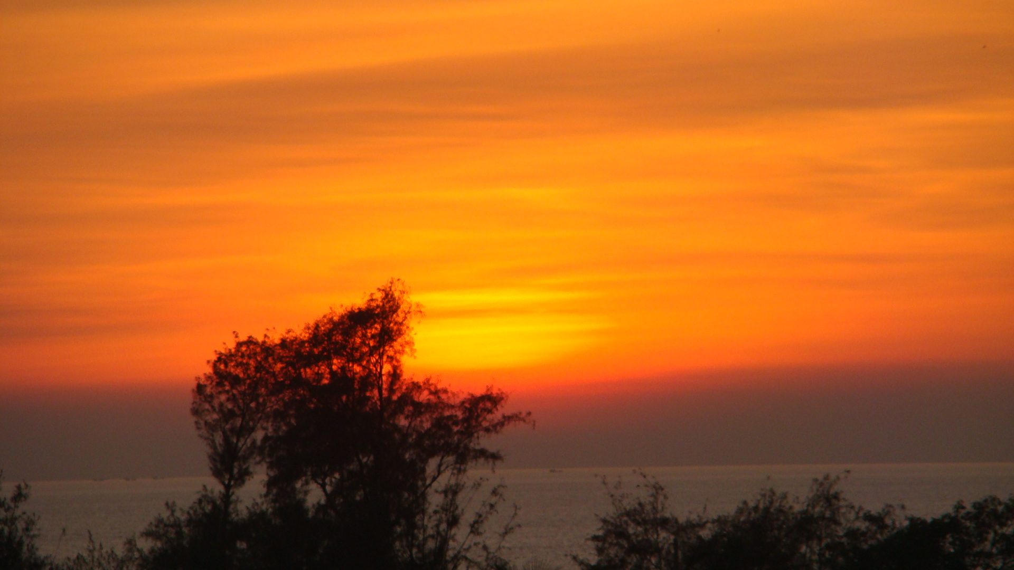

11.1 Conclusion

The significance of tourism is viewed from many angles like economic, social, cultural, political, etc. Tourism is now the fastest growing and single largest industry in the world. The industry has attained the impressive growth in the world-wide in terms of tourist arrivals and foreign exchange earnings which has led the ever increasing competition among the destination countries and gained the top priority in most of the destination countries. Every destination country is trying to attract more tourists by drawing the attention and growing the interest among the potential tourists through adopting effective marketing strategies. Promotion is an important element of marketing mix and plays a vital role in developing marketing strategies. Because of tourism is a field where the customers/tourists want to know in advance about the attractions and facilities of the destination. Marketers need to provide such necessary information to the prospective tourists through different promotional measures and thus, try to motivate and attract them to the sponsor’s destination.

Though the growth of tourism is impressive world-wide, the same in Bangladesh is not so. It is not because of lack of eye-catching tourist’s attraction to the destination of Bangladesh, rather it is the result of inadequate promotional measures. Bangladesh failed to market its incredible tourist attractions like world longest unbroken sea beach, covering miles of golden sands, soaring cliffs, surfing waves, rare conch shells, Buddhist Temples, Pagodas and enjoyable sea-food all of which are almost impossible to be found in any where of the other tourist destinations of the world; the world’s largest mangrove forests is formed at the delta of the Ganges, cultural heritage, pristine beauty of the nature etc. and leads to attract an insignificant number of tourists to its destination.

The contribution of Bangladesh tourism to the world tourism is very negligible. Even the position of the country among the SAARC countries is at the bottom line. It holds the position just above the position of Bhutan. As a result, the contribution of tourism in the economy of Bangladesh is very insignificant.

The existing literatures also show that Bangladesh tourism fails to attract more tourists and not succeeded in developing the sector up to its expectation mainly due to inadequate promotional activities. Though the international media can be effective for drawing the attention of the potential foreign tourists but it is expensive to use the same for promoting the tourism in Bangladesh. As the country has the fund constraint, it has to depend on the local media and on some low qualitative printed materials to promote the sector which do not result positively to achieve the goal from this industry.

The use of information technology in promoting Bangladesh tourism is very negligible. The web page presently used by Bangladesh Parjatan Corporation is not well-designed and attractive and can not disseminate all the necessary information to the prospective tourists.

Bangladesh tourism also needs to attempt more promotional activities to cope up with the present competition among the destination countries. The country can arrange the more tourist fairs with in the country to attract local tourists and also the foreigners who are already living in Bangladesh. Advertisement in the local newspapers and the distribution of different printed materials related to Bangladesh tourism may help to serve the purpose.

Participation in the international tourism fairs, distribution of different types of high quality printed materials among the potential foreign tourists; advertisement in some of the international newspapers covering at least the major tourists generating countries to Bangladesh etc. can be more fruitful for the promotion of the same in Bangladesh. The foreign mission offices abroad of Bangladesh can take the initiatives for encouraging the people to visit Bangladesh. The mutual arrangements with some selected foreign tour operators and providing them incentives can produce more positive result in attracting tourists to the destination of Bangladesh.

Since the potential tourists need the information regarding the destination’s attraction and facilities in advance, uses of information technology can help to a greater extent to disseminate the information among the prospective tourists. Bangladesh tourism can take the initiatives to update its present web page in a well-designed form so that the prospective tourists can get all the necessary information from the page easily. There should have sufficient online facilities so that all bookings related to tourism can be made through online. There should have some attractive offers like discounted air tickets, discount on hotel rent etc for a group visit and for a longer period visit. All these will play the motivational role for the potential tourists to select Bangladesh as a tourist destination.

The survey revealed that the main reason of not succeeding Bangladesh tourism is that the concern authority failed to realize the importance of this sector initiate the proper measures in undertaking effective promotional measures to attract the potential tourists. The allocation of promotion fund is inadequate for the sector which was only Tk.10.413 (US$150 thousand) in 2004-05 constituting only 0.25 percent of the earnings for the same year. The allocated fund is quite unreasonable to conduct any necessary promotional activity for tourism in the international level.

Due to fund constraints, the operators of tourism now are using the local media which has no effect on the foreign tourists except those who are already living in Bangladesh. The operators also depend on the printed materials like brochures, souvenir, post cards, tourists’ maps, folders etc. which have also little impact on foreign tourists because of its low quality and attractively. It is necessary to develop the quality of these printed materials to have a positive impact on the prospective tourists and need to lunch effective promotional measures by using media which have international coverage in order to attract the attention of the foreign tourists and persuade them to select Bangladesh as a tourist destination.

At the same time the effective use of promotion budget is also essential. The country also suffers from the negative images those have already been created through some international media need to be corrected by lunching extensive and effective promotional measures which again demands more fund allocation for the purpose.

Again, the participation of the private sector in a large scale along with the government sector is necessary for the promoting this backward sector. The private sector’s investment in promoting and developing this will be an added wing in the overall efforts of achieving the target from this sector.

The concern authority needs to give priority and adopt necessary effective promotional measures in order to attract a significant number of foreign tourists to visit the country. In developing strategic promotional approaches, tour-operating firms should examine and uncover carefully the factors which affect prospective tourists’ choice in selecting a destination country and which repel them in their selection process. With the present state of attractions, services, facilities, and accessibility, the promotional activities of the firms are now mainly restricted to some prospective countries of the South Asia, the resident foreigners in the country, and the domestic affluent people.

With the expansion of the base of services and facilities, improvement of existing services, development of new services, and development of the infrastructure, the firms should plan to direct its promotional activities at other new market segments. These include North America, Europe, Australia, New Zealand, Japan and Korea depending upon the potentials of the markets and the extent to which the industry can serve them. The government has already declared tourism as an industry in 1991, formulated National Tourism Policy in 1992 and undertaken some development projects.

The GOB (Govt. of Bangladesh) has also considered undertaking steps to establish Exclusive Tourist Zone (ETZ) and offered some incentives for both local and foreign investors with a view to encourage the private sector participation in the development and promotion of tourism in Bangladesh. It has also started implementing by phases the recommendations of the Strategic Master Plan formulated by the World Tourism Organization (WTO) with the assistance of the UNDP.

The effective implementation of all these steps will help Bangladesh tourism industry to experience development to a greater extent and will emerge as a major contributor to the national economy with in a very short period of time.

11.2 Direction for Further Research

This study was carried out to find out the use of promotional activities in tourism by emphasizing on the context of Bangladesh. It is tough to conduct the research on a vast area like tourism with the time frame allocated for the study. As a result, the tourist opinion from the field survey could not be used. There remains further scope to conduct the study as the replication of the present study. For example, to have in depth picture of the tourists’ opinion they can be interviewed. A comparative study can be done among the cost of visiting the destinations of different regions from the same place of origin. Because of in addition to attractions, the cost for travelling is an important element in choosing the destination place or it can be compared the promotional strategies used by the successful destinations especially the countries in the Asian regions to prescribe the more suitable strategy for the same of Bangladesh.

References

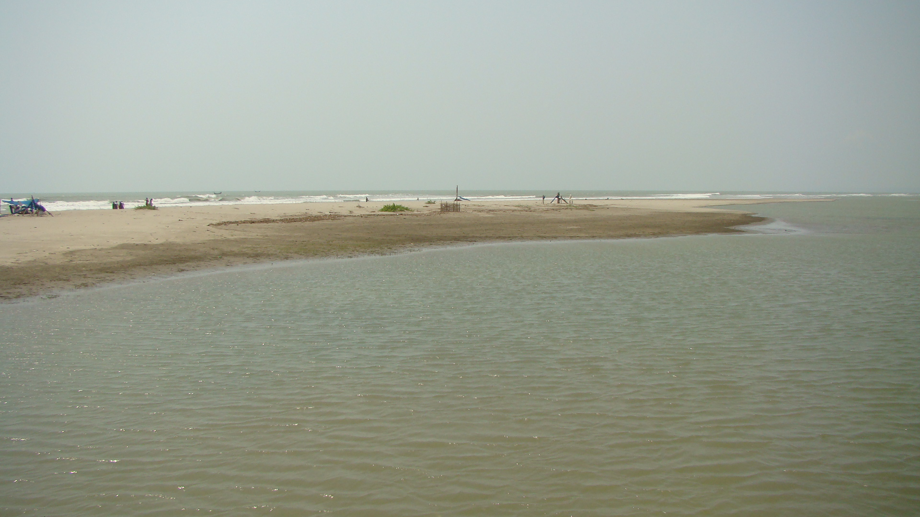

Literature references
- Ahmed, Syed Shahabuddin - Tourism in Bangladesh, Bangladesh Quarterly, Vol. 6, No. 6
- BPC - Bangladesh Tourism Vision 2020, Morshed, M. M. Rahman
- Briedenham, J. and Wickens, E. - Tourism Routes as a Tool for the Economic Development of Rural Areas
- Britton, R. - The Image of the Third World in Tourism Marketing
- Crick, M. - Representations of International Tourism in the Social Sciences
- Engel, James F., Roger D. Blackwell, and Paul W. Miniard - Consumer Behavior, 5th edition
- Fayed, H. & Fletcher, J. - 'Globalization of Economic Activity
- Fill, Chris - Marketing Communications: Context, Content and Strategies, 2nd edition
- Hasan, Syed Rashidul - Problems and Prospects of Bangladesh Tourism Industry, Bureau of Business Research, University of Dhaka
- Hossain, Md. Afjal & Hossain, Md. Jakir - Marketing Promotion Strategies of the Tourism Industry in Bangladesh
- Kotler, Philip; Wong, Veronica; Saunders, John; and Armstrong, Gary - Principles of Marketing, 8th Edition
- Mohamed, M. - Moroccan Tourism Image in France, Annals of Tourism Research
- Rao, Nina - Sex Tourism in South Asia, International Journal of Contemporary Hospitality Management
- Shamim, Ehsan - Pro-Poor Tourism, The Daily Star, 5 December, 2002
- Siddiqi, Raquib - Tourism in Bangladesh- A Thrust Sector with no Thrust, The New Nation, 4 February, 2006
- Talukdar, Aroop - Kuakata - The Natural Treasure-trove, Star Weekend Magazine, 24 January, 1997
- World Tourism Organization - Yearbook of Tourism Statistics, Vol. 1, 51st edn, 1999
- World Tourism Organization - Tourism 2020 Vision, East Asia and Pacific, Vol. 3

Online references
- Bangladesh Travel: http://www.bangladesh-travel.com
- Bangladesh Parjatan Corporation: http://www.bangladeshtourism.gov.bd
- Wikipedia- the free encyclopaedia: http://en.wikipedia.org
- World Tourism Organization (UNWTO): http://www.world-tourism.org
- Hospitality Net: http://www.hospitalitynet.org
- Ministry of Environment and Forest: http://www.moef.gov.bd
- Travels in Bangladesh: http://www.parjatan.org
- Advertising & Marketing Review: http://www.ad-mkt-review.com
- Parks and recreation in Illinois: http://www.illinoisparksandrecreation.com
- Planeta: http://www.planeta.com/ecotravel/tour/definitions.html
- Building Image of Bangladesh, the 3rd World View: http://rezwanul.blogspot.com
- Australian Taxation Office: http://www.ato.gov.au
- Roaming Around Bangladesh: http://community.iexplore.com
- Sundarban - The Mysterious Forest: http://community.iexplore.com
- Why Bangladesh Struggling to Lure Tourists: http://rezwanul.blogspot.com

Index

A
Advertising
B
Baldha Garden
Bishwa Istima
Buddha Purnima
C
Christmas
D
Dulahazra Safari Park
Durga Puja
E
Edi-ul-Fitre
Eid-e-Miladunnabi
Eid-ul-Azha
H
Himchari National Park
I
Independence Day
K
Kaptai National Park
M
Madhabkunda Eco-park
Mahasthangarh
Mainamati
Marketing
Modhupur National Park
Muharram

N
National Botanical Garden
National Mourning Day & International Mother Language Day
National Park
National Zoological Garden

P
Paharpur
Pahela Baishakh
Personal selling
Public relations
R
Rabindra and Nazrul Jayanti
Ramna Park
Ramsagar National Park
S
Sales promotion
Sitakunda
Sitakunda Botanical Garden and Eco-park
Suhrawardy Uddayan
Sundarban
T
Temples and Monastery
V,W
Victory

Appendix

Appendix I: Glossary of Abbreviations

BPC: Bangladesh Parjatan Corporation
GDP: Gross Domestic Product
NTO: National Tourism Organization
OECD: Organization for Economic Cooperation and Development
PATA: Pacific Asian Travel Association
SAARC: South Asian Association for Regional Cooperation.
TOAB: Tour Operators’ Association of Bangladesh
UNSC: United Nations Statistical Commission
USTTA: United States Travel and Tourism Administration
VTC: Virginia Tourism Corporation
WTTC: World Travel and Tourism Council

Appendix II: Comparison on Some Selected Factors among the South Asian Countries

Factors of comparison | Bangladesh | Bhutan | India | Maldives | Nepal | Pakistan | Sri Lanka
Official Name | The People’s Republic of Bangladesh | The Kingdom of Bhutan | The Republic of India | The Republic of Male’ | The Kingdom of Nepal | The Isla-mic Rep-ublic of Pakistan | The Dem ocratic Socialist Republic of Sri Lanka
Location | Southern Asia, bordering the Bay of Bengal, between Burma and India | Southern Asia, between China and India | Southern Asia, bordering the Arabian Sea and the Bay of Bengal, between Burma and Pakistan | Southern Asia, South-Southwest of India | Southern Asia, between China and India | Southern Asia, bordering the Arabian Sea, India on the east and Iran & Afghanistan on the west, China in the north | Southern Asia, Island in the Indian Ocean, south of India
Geographical coordinates | 24⁰00N, 90⁰00E | 27⁰30N, 90⁰30E | 20⁰00N, 77⁰00E | 3⁰15N, 73⁰00E | 28⁰00N, 84⁰00E | 30⁰00N, 70⁰00E | 7⁰00N, 81⁰00E
Climate | Tropical; mild winter; humid summer, humid, warm rainy monsoon | Tropical in southern plains, cool winters and hot summers in central valleys. | Tropical monsoon in south to temperate in north | Tropical: hot, humid; and dry | Summers and severe winters in north to subtropical summers and mild winters in south | Mostly hot, dry desert, temperate in northwest. | Tropical monsoon, northeast monsoon (Dec- March) and southeast monsoon (Jun- Oct)
Area (in km² ) | 144,000 | 47,5000 | 3,287,590 | 300 | 147,181 | 880,254 | 65,610
Year of Independence | 1971 | 1949 | 1947 | 1965 | 1768 | 1947 | 1948
Capital City | Dhaka  23⁰42’ N 90⁰22’ E | Thimpu  28⁰28’ N 89⁰35’ E | New Delhi  28⁰34’ N 77⁰12’ E | Male’  4⁰10’ N 73⁰30’ E | Kathmandu  27⁰42’ N 85⁰19’ E | Islamabad  33⁰40’ N 73⁰10’ E | Sri Jayewardenepura  6⁰54’N 79⁰54’ E
Nationality | Bangladeshi | Bhutanese | Indian | Maldivian | Nepalese | Pakistani | Sri Lankan
Official Language | Bangla | Dzongkhaand English | Hindi, English and 21 other Languages | Dhivehi | Nepali | Urdu and English | Sihala and Tamil
Total Population (in million) | 144.32 (2005 est) | 2.23  (2005 est) | 1,192.23  (2006 est) | 0.35  (2005 est) | 27.68  (2005 est) | 163.99  (2006 est) | 20.06  (2005 est)
Density | 1,002/km² | 45/km² | 329/km² | 1,171/km² | 196/km² | 186/km² | 305/km²
Position in terms of Population | 7th | 139th | 2nd | 166th | 40th | 6th | 53rd
Population Growth Rate | 2.09% | 2.1% | 1.38% | 2.82% | 2.17 % | 2.09% | 0.78%
Sex Ratio | 1.05m/f | 1.05m/f | 1.05m/f | 1.05m/f | 1.05m/f | 1.05m/f | 1.05m/f
Main Religion | Muslim (83%) | Lamaistic Buddist (75%) | Hindu (80.5%) | Muslim | Hindu (80.6%) | Muslim (97%) | Buddhist (69.1%)
Literacy Rate | 43.1% (2003 est) | 47% (2003 est) | 59.5% (2003 est) | 97.2% (2003 est) | 45.2% (2003 est) | 48.7% (2003 est | 92.3% (2003 est
GDP (PPP) | $280 billion (2005 est) | $2.913 billion (2005 est) | $ 3.678 trillion (2005 est) | $ 1.25 billion (2002 est) | $ 42.17 billion (2005 est) | $ 385.2 billion (2005 est) | $ 86.72 billion (2005 est)
GDP- real growth rate | 5.4% (2005 est) | 5.3% (2005 est) | 7.6% (2005 est) | 2.3% (2002 est) | 2.5% (2005 est) | 7.8% (2005 est) | 5% (2005 est)
GDP per capita (PPP) in US$ | $1875 (2005 est) | $3,330 (2005 est) | $ 3,400 (2005 est) | $ 3,900 (2002 est) | $ 1,500 (2005 est) | $ 2388 (2005 est) | $ 4,300 (2005 est)
HDI (2003 est) | 0.520 (139th) - medium | 0.536 (134th) - medium | 0.602 (127th) - medium | 0.745 (96th) - medium | 0. 526 (136th) - medium | 0.527 (135th) - medium | 0.751 (93rd) - medium
Currency | Taka (BDT) | Ngultrum (BTN) | Rupee (INR) | Rufiyaa (MVR) | Rupee (NPR) | Rupee (PKR) | Rupee (LKR)
Exchange rate ( 1US$ =) | BDT 64.32  (2005 est) | BTN 44.10 (2005 est) | INR 44.10  (2005 est) | MVR 12.8  (2004 est) | NPR 71.37 (2005 est) | 59.52 (2005 est) | LKR 100.50  (2005 est)
Inflation Rate | 6.7 % (2005 est) | 3 % (2002 est) | 4.6% (2005 est) | 1% (2002 est) | 7.8% (2005 est) | 9.2% (2005 est) | 11.2%
No. of Airports | 16 | 2 | 334 | 5 | 48 | 134 | 16
Main Ports and Terminals | Chittagong and Mongla | - | Chennai, Haldia, Kolkata, Mumbai, New Mangalore | Male’ | NA | Karachi, Port Muhammad Bin Quasim | Colombo, Galle
Time Zone | BDT (UTC+6) | BTT (UTC+6) | IST (UTC+5:30) | (UTC+5) | NPT (UTC  +5:45) | PST (UTC+5) | (UTC+6)
Calling Code | +880 | +975 | +91 | +960 | +977 | +92 | +94
Source: http://www.cia.gov/cia/publications/factbook; http://en.wikipedia.org

Appendix III: Details of Accommodation Cost
Rates are per Room per Night
Bangladesh
Name of the Hotel | Rank | Room Description |  | Rent | Rent Applicable
Sheraton Hotel, Dhaka | * * * * * | Deluxe 1 Adult  Deluxe 2 Adults |  | US$ 160  US$ 160 | October 01, 2005 - December 30, 2006  October 01, 2005 - December 30, 2006
Pan Pacific Sonargaon, Dhaka | * * * * * | Deluxe 1 Adult  Deluxe 2 Adults |  | US$ 177  US$ 177
Radisson Water Garden Hotel, Dhaka² | * * * * * | Queen Bed Deluxe  Twin Bed Deluxe |  | US$ 195  US$ 195 | NA
Hotel Swiss Park , Dhaka | * * * * | Deluxe 1 Adult  Deluxe 2 Adults |  | US$ 90  US$ 100 | October 01, 2004 - December 30, 2006
Lake Shore Hotel & Apartment, Dhaka | * * * * | Deluxe 1 Adult  Deluxe 2 Adults |  | US$ 105  US$ 105 | Oct. 01 2005 – Dec. 30 2006
Hotel Agrabad | * * * * | Executive Room  Royal Twin Room |  | US$ 147  US$ 210 | NA
Best Western La Vinci Hotel, Dhaka | * * * | Deluxe 1 Adult  Deluxe 2 Adults |  | US$ 105  US$ 105 | October 01, 2005 - December 30, 2006  October 01, 2005 - December 30, 2006  Oct. 01, 2005 – Dec. 30, 2006  NA  October 01, 2005 - December 30, 2006
Hotel Lake Castle, Dhaka | * * * | Deluxe 1 Adult  Deluxe 2 Adults |  | US$ 105  US$ 105
Hotel Sweet Dream, Dhaka | * * * | Queen Bed  Deluxe Twin Bed |  | US$ 85  US$ 95
Hotel Purbani International | * * * | Standard Room  Deluxe - Double |  | US$ 70  US$ 100
Hotel Sweet Dream, Dhaka | * * * | Superior Queen Bed  Deluxe Twin Bed |  | US$ 85  US$ 95
India
Name of the Hotel | Rank | Room Description |  | Rent | Rent Applicable
The Taj Mahal Palace & Tower, Mumbai | * * * * * | Deluxe City Facing Single Deluxe City Facing Double |  | US$ 270  US$ 286 | January 01, 2006 - April 15, 2006  January 01, 2006 - April 15, 2006
Oberoi Raj Vilas, Jaipur | * * * * * | Deluxe Room 1 Adult  Deluxe Room 2 Adults |  | US$ 536  US$ 536
Ramada Hotel Palm Grove, Mumbai | * * * * * | Standard Single Room  Standard Double Room |  | US$ 153  US$ 170 | October 01, 2005 - March 31, 2006
Cidade De Goa | * * * * * | Deluxe Room 1 Adult  Deluxe Room 2 Adults |  | US$ 232  US$ 232 | January 06, 2006 - March 31, 2006
Hotel Holiday Inn Surat | * * * * * | Deluxe Suite 1 Adult  Deluxe Suite 2 Adults |  | US$ 205  US$ 229 | January 01, 2006 - March 31, 2006
Hotel Ritz, Mumbai | * * * * | Standard Room 1 Adult  Standard Room 2 Adults |  | US$ 90  US$ 99 | October 01, 2005 - March 31, 2006
Hotel Jaipur Ashok, Jaipur | * * * * | Standard Room 1 Adult  Standard Room 2 Adults |  | US$ 52  US$ 52 | January 01, 2006 - March 31, 2006
Cama Park Plaza, Ahmedabad | * * * * | Deluxe Single Room  Deluxe Double Room |  | US$ 125  US$ 140 | October 01, 2005 - March 31, 2006
Ramee Guestline, Mumbai | * * * * | Superior Room – 1 Adult  Superior Room – 1 Adult |  | US$ 112  US$ 124 | Oct. 01 2005 - March 31 2006
The Orchid Hotel, Mumbai | * * * * | Deluxe Room 1 Adult  Deluxe Room 2 Adults |  | US$ 168  US$ 168 | October 01, 2005 - March 31, 2006
Mansingh Palace, Agra | * * * | Single  Double |  | US$ 98  US$ 98 | December 2006
Publas International Hotel, New Delhi | * * * | Single  Double |  | US$ 76  US$ 76 | December 2006
Comfort Inn Herutage, Mumbai | * * * | Single  Double |  | US$ 120  US$ 136 | December 2006
White House Hotel, New Delhi | * * * | Single  Double |  | US$ 92  US$ 114 | December 2006
Pradeep Hotel Varanasi, Varanasi | * * * | Single  Double |  | US$ 68  US$ 76 | December 2006
Nepal
Name of the Hotel | Rank |  | Room Description | Rent | Rent Applicable
The Fulbari Resort & Spa Nepal | * * * * * |  | Deluxe Room - Single  Deluxe Room - Double | US$ 87  US$ 98 | Valid till 30th September, 2006
Dwatika Hotel Kathmandu, Nepal | * * * * * |  | Deluxe Room- Single  Deluxe Room- Single | US$ 201  US$ 219 | January 1 - 30 April / Oct. 1 - 31 2006
Club Himalaya Resort, Nepal | * * * * * |  | Standard Room - Single  Standard Room - Double | US$ 69  US$ 85 | NA
Soaltee Crown Plaza, Kathmundu | * * * * * |  | Deluxe Room - Single  Deluxe Room - Double | US$ 200  US$ 210 | NA
The Everest Hotel, Kathmandu | * * * * * |  | Deluxe Room - Single  Deluxe Room - Double | US$ 200  US$ 210 | NA
Hotel Vaishali, Nepal | * * * * |  | Single Room  Double Room | US$ 51  US$ 61 | July 01, 2005 - 30 Sep 2006
Fish Tail Lodge, Nepal | * * * * |  | Standard Room – 1  Standard Room - 2 | US$ 80  US$ 85 | July 01, 2005 - 30 Sep 2006
Park Village Hotel, Nepal | * * * * |  | Standard Room - Single  Standard Room -Double | US$ 51  US$ 56 | NA
The Malla Hotel | * * * * |  | Deluxe Room - Single  Deluxe Room - Double | US$ 150  US$ 182 | NA
Hotel Woodlands | * * * * |  | Single Room  Double Room | US$ 105  US$ 115 | NA
Marshyangdi Hotel Nepal | * * * |  | Standard Room - 1 adult  Standard Room - 2 | US$ 45  US$ 52 | July 01, 2005 - 30 Sep 2006
Buddha Maya Garden Hotel, Nepal | * * * |  | Standard Room - Single  Standard Room -Double | US$ 51  US$ 56 | NA
Hotel Harati | * * * |  | Deluxe Room - Single  Deluxe Room - Double | US$ 60  US$ 80 | NA
Hotel Gangjong | * * * |  | Deluxe Room - Single  Deluxe Room - Double | US$ 80  US$ 90 | NA
Nivana Garden Hotel, Nepal | * * * |  | Single Room  Doule Room | US$ 34  US$ 38 | NA
Island Jungle Resort, Nepal | * * |  | Standard Room – 1  Standard Room - 2 | US$ 80  US$ 140 | July 01, 2005 - 30 Sept 2006
Pakistan
Name of the Hotel | Rank |  | Room Description | Rent | Rent Applicable
Serena Hotel Islamabad | * * * * * |  | Deluxe Room- Single  Deluxe Room- Double | US$ 230  US$ 230 | till December 31, 2006  till December 30 2006.
Marriott Hotel, Islamabad | * * * * * |  | Executive Room - Single  Executive Room - Double | US$ 293  US$ 293 | till December 31, 2006  till December 30 2006.
Avari Hotel, Lhore | * * * * * |  | Deluxe Room- 1 Adult  Deluxe Room- 2 Adults | US$ 200  US$ 252 | Sept. 01, 2005 – Dec. 31, 2006
Pearl Continental Hotel, Bhurban Murree | * * * * * |  | Deluxe Room- 1 Adult  Deluxe Room- 2 Adults | US$ 175  US$ 175 | June 01, 2005 - March 30, 2006
Sheraton Karachi Hotel & Tower | * * * * * |  | Classic- 1 adult  Classic- 2 adults | US$ 225  US$ 256 | till December 31 2006.
Holiday Inn, Islamabad | * * * * |  | Standard Room – 1  Standard Room - 2 | US$ 87  US$ 107 | till December 30, 2006
Shalimar Hotel, Rawalpindi | * * * * |  | Standard Room - Single  Standard Room - Double | US$ 75  US$ 90 | Dec. 21, 2005 to Dec. 31, 2006
Sunfort Hotel Lahore | * * * * |  | Standard Room – 1  Standard Room - 2 | US$ 112  US$ 125 | Dec. 20 2005 – Dec. 31, 2006
Regent Plaza Hotel & Covention Centre, Karachi | * * * * |  | Standard Room – 1  Standard Room - 2 | US$ 125  US$ 145 | Oct. 29 2005 – Dec. 31, 2006
Shangrila Resort Hotel, Murree | * * * * |  | Standard Room – 1  Standard Room - 2 | US$ 72  US$ 78 | Oct. 22, 2005 – Dec. 31, 2006
Pak Palace Hotel, Islamabad | * * * |  | Standard Room – 1  Standard Room - 2 | US$ 75  US$ 85 | till December 31, 2006
Hotel Crowne Plaaza, Lahore | * * * |  | Standard Room – 1  Standard Room - 2 | US$ 85  US$ 96 | Oct. 22, 2005 – Dec. 31, 2006
Indus Hotel, Hyderabad | * * * |  | Standard Room – 1  Standard Room - 2 | US$ 38  US$ 60 | till December 30 2006.
Hotel taj Palace, Sialkot | * * * |  | Standard Room – 1  Standard Room - 2 | US$ 41  US$ 50 | till December 30, 2006.
Days Inn Hotel, Karachi | * * * |  | Standard Room – 1  Standard Room - 2 | US$ 70  US$ 83 | till December 30, 2006
Sri Lanka
Name of the Hotel | Rank |  | Room Description | Rent | Rent Applicable
Galandi Hotel, Colombo | * * * * * |  | Standard Room - 1  Standard Room - 2 | US$ 78  US$ 80 | Nov. 01, 2005 - April 30, 2006  Nov. 01, 2005 – Dec. 30, 2006
Taj Samudra Hotel | * * * * * |  | Standard Room - 1  Standard Room - 2 | US$ 65  US$ 80
Eden Resort and Spa Beruwela | * * * * * |  | Standard Room - 1  Standard Room - 2 | US$ 100  US$ 120 | Jan 11, 2006 - Feb 28 2006
Lighthouse Hotel | * * * * * |  | Standard Room - 1  Standard Room - 2 | US$ 254  US$ 254 | Sept. 01, 2005 – Oct. 31, 2005
Hotel The Blue Water, Wadduwa | * * * * * |  | Standard Room - 1  Standard Room - 2 | US$ 175  US$ 185 | March 16, 2006 - April 30, 2006
Riverina Hotel, Beruwela | * * * * |  | Superior Room - 1 Superior Room - 2 | US$ 65  US$ 75
Induruwa Beach Hotel | * * * * |  | Standard Room - 1  Standard Room - 2 | US$ 30  US$ 42 | Oct. 01, 2004 – Oct. 31 2006
Hotel brown Beach, Negombo | * * * * |  | Standard Room - 1  Standard Room - 2 | US$ 57  US$ 62 | Nov. 01, 2005 - April 30, 2006
Mount Livinia Hotel | * * * * |  | Standard Room - 1  Standard Room - 2 | US$ 80  US$ 85 | Feb 22, 2006 - Mar 31, 2006
Hotel Club Palm Bay Marawila | * * * * |  | Standard Room - 1  Standard Room - 2 | US$ 144  US$ 156 | Jan 21, 2005 - Mar 31 2005Hotel The Reef
Lihiniya Surf Hotel, Bentota | * * * |  | Single Standard Room  Double Standard Room | US$ 67  US$ 73 | July 01, 2004 - October 31, 2004
Holiday Inn, Colombo | * * * |  | Standard Room - 1  Standard Room - 2 | US$ 82  US$ 95 | Nov. 01, 2005 - April 30, 2006
Hotel Closenberg, Galle | * * * |  | Standard Room - 1  Standard Room - 2 | US$ 67  US$ 83 | Jan 16, 2006 - April 30, 2006
Hotel Tangerine Beach | * * * |  | Standard Room - 1  Standard Room - 2 | US$ 90  US$ 95 | Jan 11, 2006 - Apr 30 2006
Grand Oriental Hotel, Colombo | * * * |  | Standard Room Gov. Wing - 1  Standard Room Gov. Wing - 2 | US$ 61  US$ 65 | November 01, 2005 - April 30, 2006
Source: Websites

Calculation of Average Cost in US$
Country | Hotel Ranking
Country | 5 Star | 4 Star | 3 Star
Bangladesh | 1 Adult: (160+177+195)/3 = 177  2 Adults: (160+177+195)/3 = 177 | 1 Adult: (90+105+147)/3 = 114  2 Adults: (100+105+210)/3 = 138 | 1 Adult: (105+105+85+70+85)/5 = 90  2 Adults: (105+105+95+100+95)/5 = 100
India | 1 Adult: (270+536+153+232+205)/5 =279  2 Adults: (286+536+170+232+229)/5 = 291 | 1 Adult: (90+52+125+112+168)/5 = 109  2 Adults: (99+52+140+124+168)/5 = 117 | 1 Adult: (98+76+120+92+68)/5 = 91  2 Adults: (98+76+136+114+76)/5 = 100
Iran | 1 Adult: (110+135+99+110+83)/5 =107  2 Adults: (149+157+142+149+98)/5 = 139 | 1 Adult: (127+112+81+80+70)/5 = 94  2 Adults: (137+135+96+105+86)/5 = 112 | 1 Adult: (48+50+65+185+50)/5 = 80  2 Adults: (68+75+88+240+65)/5 = 107
Maldives | 1 Adult: (174+274+265+605+276)/5 = 319  2 Adults: (189+304+275+617+286)/5 = 334 | 1 Adult: (206+252+141+191+130)/5 = 184  2 Adults: (254+298+187+201+173)/5 = 223 | 1 Adult: (167+55+83+199+158)/5 = 132  2 Adults: (188+55+105+215+184)/5 = 149
Nepal | 1 Adult: (87+201+69+200+200)/5 =151  2 Adults: (98+219+85+210+210)/5 = 164 | 1 Adult: (51+80+51+150+105)/5 = 87  2 Adults: (61+85+56+182+115)/5 = 100 | 1 Adult: (45+51+60+80+34)/5 = 54  2 Adults: (52+56+80+90+38)/5 = 63
Pakistan | 1 Adult: (230+293+200+175+225)/5 = 225  2 Adults: (230+293+252+175+256)/5 = 241 | 1 Adult: (87+75+112+125+72)/5 = 94  2 Adults: (107+90+125+145+78)/5 = 109 | 1 Adult: (75+85+38+41+70)/5 = 62  2 Adults: (85+96+60+50+83)/5 = 75
Sri Lanka | 1 Adult: (78+65+100+254+175)/5 = 134  2 Adults: (80+80+120+254+185)/5 = 138 | 1 Adult: (65+30+57+80+144)/5 = 75  2 Adults: (75+42+62+85+156)/5 = 84 | 1 Adult: (67+82+67+90+61)/5 = 73  2 Adults: (73+95+83+95+65)/5 = 82

Appendix IV: Hotel and Motel owned by BPC

Name of the Hotel and Category of the Room | Location | Tariff in TK. | Name of the Hotel and Category of the Room | Location | Tariff in TK.
Hotel Shaibal  AC Twin Bed W/O (Belcony)  AC Twin Bed  Royal AC Suite  Conference Hall | Cox’z Bazar | 1,600  2,000  3,000  5,000 | Hotel Abakash  AC Twin Bed Economy  AC Twin Deluxe  AC Suite  AC Conference Hall | Dhaka | 1,200  1,800  2,500  5,000
Motel Upal  Non AC Twin Bed  Ac | Cox’z Bazar | 650  1,000 | Parjatan Motel  Non AC Twin Bed  AC Twin Bed  Economy Bed  AC Conference Hall | Bogra | 400  800  100  1,500
Motel Probal  Non AC Twin Bed  Economy Room | Cox’z Bazar | 600  500 (without Geyser)  250 | Parjatan Motal  Non AC Single Room  Non AC Twin Bed  AC Single  AC Twin Bed  Non AC Suite  AC Suite  Economy Bed  AC Conference Hall | Rajshahi | 350  450  800  1,000  800  1,400  60  3,000
Motel Labonee  Non Ac Room  Conference Room | Cox’z Bazar | 600  700 (with TV)  550 (1st and 2nd Floor)  1,200 | Parjatan Motal  Non AC Twin Bed  AC Twin Bed  VIP AC Suite  Economy Bed  Ac Conference Hall- 1st Hour  Ac Conference Hall- 2nd Hour | Rangpur | 600  1,200  2,000  60  500  250
Honeymoon Cottage  Non Ac Cottage (2 bed)  Ac Cottage (2 bed) | Cox’z Bazar | 750  1,000 | Parjatan Motal  Non AC Twin Bed  AC Twin Bed  Conference Hall | Sylhet | 500  1,000  4,000 (Half day)  5,500 (Full day
Old Cottage  Non AC Cottage | Cox’z Bazar | 1,500 | Parjatan Motel  Non AC Twin Bed  AC Twin Bed | Dinajpur | 600  1,200
Panthanibas  Per Bed  Per room (2 Bed) | Cox’z Bazar | 50  120 | Parjatan Motal  Non AC Twin Bed  AC Twin Bed | Rangamati | 650  550 (Gr. Floor)  1,000
Parjatan Motal  Non AC Twin Bed  AC Twin Bed  Dormitory (per Bed) | Kuakata | 500  1,250  150 | Cottage  Non AC Cottage ( 4 Bed)  AC Cottage (8 Bed)  Auditorium  (Capacity 200 persons)  Per Hour  Maximum | Rangamati | 1,200  2,000  1,000  4,000
1 US$ = TK. 69 approximately
“Tourism Marketing”
A new prospect for Bangladesh

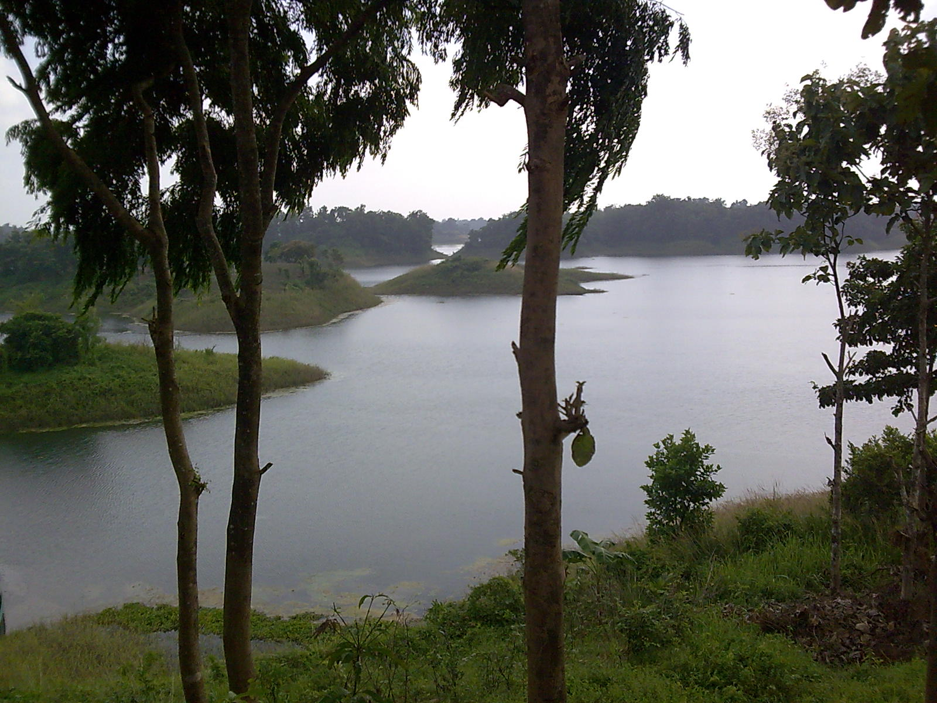
Tourism Marketing
“A new prospect for Bangladesh”
By

Fayz Ahammed
Student ID# 074256
Master of Business Administration
E-mail: fuadshahrior@gmail.com

Submitted in partial fulfillment of the requirements for the degree of MBA

To

Academic Supervisor
Md.Salah Uddin
Assistant Professor
Department of Management Studies
Faculty of Business Studies
Jagannath University

Mr. Md. Salah Uddin
Academic Supervisor
Lecturer, Department of Management Studies
Jagannath University Bangladesh
Subject: Thesis report “Problems and Prospects of Tourism Marketing in Bangladesh”.
Dear Sir,

Please accept the accompanying thesis report “Problems and Prospects of Tourism Marketing in Bangladesh” which I am submitting in partial fulfillment of the requirements for the degree of MBA.

This study is an attempt to investigate present problems and prospects of tourism marketing in Bangladesh. The investigation was conducted from both a theoretical and an empirical point of view. Many countries are now dependent on tourism sector for foreign currency earnings. The tourism industry in Bangladesh is far behind from reaching its goal though it has a vast prospect to gain maximum outcome from the industry as the country has some unique attractions. Based on the findings of the study some suggestions are also put forwarded to improve the promotion of tourism industry in Bangladesh.

Through the study, I was given the opportunity to learn much about tourism sector of Bangladesh, service marketing and promotion. I feel that this knowledge will be very much helpful for me in future studies and in my career.

Sincerely yours,
Fayz Ahammed
Student ID # 074 256
1st Batch
Master of Business Administration
Jagannath University Bangladesh.

Acknowledgement

I am indebted to a number of individuals without whose assistance this research could not have been completed in time. I would like to express my deep and sincere gratitude to my supervisor, Mr. Md. Salah Uddin, Department of Management Studies, Jagannath University Bangladesh. Her wide knowledge and constructive comments have been of great value for me. Her understanding, encouraging and personal guidance have provided a good basis for the present thesis.

I am also grateful to all other teachers of Jagannath University Bangladesh for guiding and upgrading the knowledge through fulfilling the gap between previous and up to date knowledge which will be useful in my future career. Thanks to all other staffs of my university for their nice cooperation during the whole study.

I would like to convey the thanks to the authority of Bangladesh Parjatan Corporation (BPC) for providing necessary data and related literature. Special thanks to my friends for extending their nice cooperation in questionnaire survey.

At the end, thanks to my family members who have been endlessly supporting me to complete this work.

Dedication

To my beloved Father who is living in the abode of bliss.

Declaration

I hereby declare that this thesis is a presentation of my original research work and that it has not been submitted anywhere for any award. Wherever contributions of others are involved, every effort is made to indicate this clearly, with due reference to the literature, and acknowledgement of collaborative research and discussions.

The work was done under the guidance of Mr. Md. Salah Uddin, at the Jagannath University Bangladesh.

Fayz Ahammed
Student ID # 074 256
Department of Management Studies
Jagannath University Bangladesh

Certificate of Approval

I hereby declare that this thesis is from the student’s own work and effort, and all other sources of information used have been acknowledged. This thesis has been submitted with my approval.

Supervisor: Md.S alah Uddin
Associates Professor
Department of Management Studies
Jagannath University Bangladesh

Signature:

Table of Contents

Introduction 1
1.1 Introduction 2
1.2 Importance of the Study 5
1.3 Research Areas 6
1.4 The Research Problems 7
Research Methodology and Techniques 9
2.1 The Nature of the Study Error! Bookmark not defined.
2.2 Source of Data and Data Collection Procedure Error! Bookmark not defined.
2.3 Population and Sample Size of this Study Error! Bookmark not defined.
2.4 Organization of the Study Error! Bookmark not defined.
Theoretical and Conceptual Framework Error! Bookmark not defined.
3.1 Defining Tourism and its Related Terms Error! Bookmark not defined.
3.1.1 Tourism – Meanings and Scope Error! Bookmark not defined.
3.1.2 Tourist Attractions – Meanings Error! Bookmark not defined.
3.1.3 Travelling- Meanings Error! Bookmark not defined.
3.2 Different Types of Tourism Error! Bookmark not defined.
3.2.1 Adventure Tourism 17
3.2.2 Agritourism 18
3.2.3 Ecotourism 18
3.2.4 Heritage Tourism 18
3.2.5 Sex Tourism 19
3.2.6 Space Tourism 19
3.2.7 Cultural Tourism 19
3.2.8 Alternative Tourism 20
3.2.9 Geotourism Error! Bookmark not defined.
3.2.10 Benefit Tourism Error! Bookmark not defined.
3.3 Transportation, Accommodation, Food and Drinks Error! Bookmark not defined.
3.3.1 Transportation in Tourism Error! Bookmark not defined.
3.3.2 Accommodations/ Hotels in Tourism Error! Bookmark not defined.
Tourist Attractions in Bangladesh Error! Bookmark not defined.
4.1 Geographical Location of Bangladesh Error! Bookmark not defined.
4.2 Seasons and Climate Error! Bookmark not defined.
4.3 Tourism Attractions of Bangladesh Error! Bookmark not defined.
4.3.1 Sea Beaches 26
4.3.2 Archaeological Sites Error! Bookmark not defined.
4.3.3 Historical Places and Cultural Heritage Error! Bookmark not defined.
4.3.4 Forest, Gardens and Parks Error! Bookmark not defined.
4.3.6 Fairs and Festivals Error! Bookmark not defined.
4.3.7 Hills, Rivers, Lakes and Island Error! Bookmark not defined.
Tourism Marketing in Bangladesh Error! Bookmark not defined.
5.1 Tourists’ Impressions Error! Bookmark not defined.
5.2 Effectiveness of Promotional Measures Error! Bookmark not defined.
5.3 Promotional Activities Used for Tourism Marketing Error! Bookmark not defined.
5.4 Promotional Activities Undertaken in Bangladesh Error! Bookmark not defined.
Statistics on Tourist Arrivals and Earnings Error! Bookmark not defined.
6.1 Total Tourist Arrivals in Bangladesh Error! Bookmark not defined.
6.2 Foreign Exchange Earnings from Tourism Error! Bookmark not defined.
6.3 Tourists Arrivals from SAARC Countries Error! Bookmark not defined.
6.4 Cost of Hotel/Accommodation in Bangladesh Error! Bookmark not defined.
Problems of Tourism Marketing in Bangladesh Error! Bookmark not defined.
7.1 Problems of Tourism Marketing in Bangladesh Error! Bookmark not defined.
7.1.1 Negative Impact of Security and Country's Poor Image Error! Bookmark not defined.
7.1.2 Underdeveloped accommodation and other facilities Error! Bookmark not defined.
7.1.3 Lack of Infrastructure and Government Support Error! Bookmark not defined.
7.1.4 Ineffective marketing strategies and poor promotional activities Error! Bookmark not defined.
7.1.5 Insufficient fund and government support Error! Bookmark not defined.
7.1.6 Unavailability of updated information Error! Bookmark not defined.
Prospects of Tourism Marketing in Bangladesh Error! Bookmark not defined.
8.1 Prospects of Tourism Marketing in Bangladesh Error! Bookmark not defined.
8.1.1 Tourism potential of Bangladesh Error! Bookmark not defined.
8.1.2 Potential to receive a large number of tourists Error! Bookmark not defined.
8.1.3 A competent land for tourism Error! Bookmark not defined.
8.1.4 Prospective eco-tourism Error! Bookmark not defined.
Findings Based on the Empirical Study Error! Bookmark not defined.
9.1 Findings Based on the Empirical Study Error! Bookmark not defined.
Recommendations & Suggestions Error! Bookmark not defined.
10.1 Suggestions from the Tour Operators Error! Bookmark not defined.
10.2 Recommendations to Improve the Tourism Industry Error! Bookmark not defined.
Conclusion Error! Bookmark not defined.
11.1 Conclusion Error! Bookmark not defined.
11.2 Direction for Further Research Error! Bookmark not defined.
References Error! Bookmark not defined.
Literature references Error! Bookmark not defined.
Online references Error! Bookmark not defined.
Index Error! Bookmark not defined.
Appendix Error! Bookmark not defined.
Appendix I: Glossary of Abbreviations Error! Bookmark not defined.
Appendix II: Comparison on Some Selected Factors among the South Asian Countries Error! Bookmark not defined.
Appendix III: Details of Accommodation Cost Error! Bookmark not defined.
Appendix IV: Hotel and Motel owned by BPC Error! Bookmark not defined.

List of Tables

Table 5.1 Tourist’s Impressions on the Prices of Some Important Tourism Components Error! Bookmark not defined.
Table 5.2 Effectiveness of Various Promotional Measures of Tourism in Bangladesh Error! Bookmark not defined.
Table 5.3 Foreign Exchange Earnings, Promotion Budget & Promotion Expenditure of BPC Error! Bookmark not defined.
Table 6.1 Year-Wise Total Tourist Arrivals in Bangladesh Error! Bookmark not defined.
Table 6.2 Foreign Exchange Earnings from Tourism and Travels in Bangladesh Error! Bookmark not defined.
Table 6.3 Tourists Arrivals from Member Countries of SAARC (1995-2004) Error! Bookmark not defined.
Table 6.4 Average Hotel/ Accommodation Cost (in US$) in South Asian Countries Error! Bookmark not defined.
Table 10.1 Required measures undertaken to attract more tourists Error! Bookmark not defined.
Table 10.2 Suggestions from the Tour Operators Error! Bookmark not defined.

Executive Summary

The main purpose of this study is to analyze the current position particularly the problems and future prospects of tourism marketing in Bangladesh and to highlight how the marketing activities can play the role in the tourism development of a country like Bangladesh. Considering this view, the marketing activities undertaken by the tour operators of Bangladesh have been analyzed to identify the problems and limitation of the said activities. In addition to that it was attempted to find out the types of marketing as well as the promotional activities most suited for tourism in Bangladesh. Finally, based on the findings, some suggestions have been put forwarded to the policy makers of the concerned authority.
The present research is a combination of both theoretical and empirical. For the theoretical foundation and analysis, the existing literatures were investigated. The existing literature includes published journals, periodicals, newspapers, related magazines, Internet etc. Most of the statistical data have been collected from the related web pages. To collect the primary data from the selected tour operators, a survey questionnaire has been used. To analyse the collected data, different quantitative and qualitative measures have been taken.
It is revealed that marketing plays a pivotal role in developing the tourism industry in any specific destination as the tourists wants to know in advance about the tourism attractions and facilities at the destination.
Though Bangladesh has some beautiful attractions to its destination, it fails to attract the significant number of tourists partly because of insufficient marketing plans and promotional activities. As the country lacks sufficient funds for this purpose, it can not take the necessary promotional activities for this industry. To promote the tourism of any destination one needs to launch the promotional activities through e.g. international media like satellite TV, world renowned newspapers, magazines and other world coverage media. Due to resource constraint, the country can not use the international media. As a result, the country has to depend on the local media to advertise the same which is not effective measure for attracting foreign tourists.
The country also suffers from the image problem and the international media most often highlight the country in a negative way which causes potential visitors not to select Bangladesh as a tourist destination. The real situation is different. To overcome this negative image, international media coverage in a positive way can play an important role. As it is now the country does not have enough funds, it can not launch effective marketing plans in correcting the same. The government initiative in this regard is also insufficient. All these cause the country to attracting insignificant number of tourists and resultant effect is the failure of earning sufficient amount of foreign currency.
Bangladesh also lacks the infrastructural facilities to the standard of international levels to its destination places. This important issue needs to be considered immediately and in the priority basis before going to promoting the same sector in order to develop the industry. Again it requires more investment for the same. The participation of the private sector in the same industry is not also at expected levels and even most of the private tour operators are new in this area. They also have the resource constraint to play the active role for the development of the industry. The effective steps to encourage the private sector investment from the local as well as from the foreign investors can contribute to develop the industry.
The country also lacks the coordinated efforts among different ministries related to tourism like Ministries of Home, Cultural Affairs, Civil Aviation, Communication, Health, Planning etc. which need to overcome for the overall development of the industry. The coordinated efforts can make the visit more safe, comfortable and enjoyable and can fulfil the needs of the tourists.
The marketing activities of Bangladesh tourism are inadequate to promote the industry in the world competitive market as it has to depend on only local media and some printed materials like brochures, folders, souvenirs, tourists maps, tourist guides etc. to promote the same. At the same time the quality of those printed material is not up to the mark.
In addition, the use of information technology is very negligible. The web page used by BPC needs to well-designed and updated. The ultimate effects of all these insufficient promotional steps lead to no significant growth of tourism industry in Bangladesh though the industry and its market have grown phenomenally in worldwide. It is expected that Bangladesh can enjoy a positive growth of this industry if proper steps can be taken at least regarding the marketing aspects.

