AN
INTERNSHIP REPORT
ON

ASSESSMENT OF RURAL DEVELOPMENT SCHEME- A CASE STUDY
OF
ISLAMI BANK BANGLADESH LIMITED (IBBL)

Submitted by
WWW.ASSIGNMENTPOINT.COM

This report is based on an internship program. School of Business, IIUC (DC), arranges internship program in attachment with its students after the completion of theoretical courses (i.e., after final semester) of program of Bachelor of Business Administration (BBA). Each intern must carry out a specific project, which is assigned by the concerned organization and approved by the Internship and placement committee of School of business, IIUC, (DC) consequently a report based on the project is to be submitted to the committee.

In this particular report, the author is an intern of the previously mentioned program and the concerned organization is IBBL that are a prominent private and the first Bank of Bangladesh that based on Islamic law?

Hence I was placed in the New Market Branch of Islami Bank Bangladesh Limited. In way of delegation; responsibility of carrying out the study has conferred upon the concerned intern.

1.1 Background of the Study

Banking is on of the most important sectors for a country’s wealth building activities. At present the modern business industrialization, foreign trade, investment almost all dependent on banks. But now a day the Banking sector of Bangladesh is suffering the disease of default culture which is consequence or result of bad performance of most of the banks in Bangladesh. IBBL plays an important role towards the growth and economic development of Bangladesh.

This study is an attempt to produce a constructive report performance of IBBL with special reference to the investment procedures, product, and differences with two banking systems.

1.2 Objectives of the Study

The main objective of education is to acquire knowledge. To acquired knowledge ultimately we must do some practical application in addition to theoretical knowledge. Through this report, we tried our level best to present our practical knowledge as well as –

- To make comparison of RDS of IBBL and conventional NGOs.
- To evaluate the investment of the Sample Bank under Rural Development Scheme (RDS);
- To assess the recovery position of Rural Development Scheme (RDS) of the Selected Bank;
- To identify the problems of Rural Development Scheme (RDS) of the Sample Bank &
- To suggest measure in order to overcome the identified problems.

1.3 Scope

IBBL, the Islam based commercial bank is under general special guidelines of the central bank framed for the banking system as a whole and for bank of individual sectors. The concept of Private sector bank i.e. IBBL in our country is not so old. IBBL is now giving emphasis to cerate a constructive and meaningful competition with the private sector banking.

This study makes attempt to cover with in its scope all most all the significant aspects of foreign fund for industrial credits and foreign business.

1.4 Methodology of the Study
Data can be classified into two (02) categories:
- Primary Data &
- Secondary Data.
We collected data from two sources.

These two sources are:-
- Primary Source &
- Secondary Source.

The primary sources of our information are:-
  - Direct observation &
  - Questioning the concerned persons.

The secondary sources of our information are:-
- Annual report of IBBL
- Desk report of the related department
- Other manual information
- Different reference books of the library

1.5 My Interest of Internship in Islami Bank Bangladesh

At present time there are two banking systems are running in Bangladesh. One is Interest based banking system and another is Islami banking system. Islami banking system still is a new concept. Most of the people know a little about Islamic banking system. I had an intention to know the Islamic banking system and got an opportunity through internship training and I did not misuse the opportunity to know the activities of Islamic bank. The report consist what I have been taught and worked by practically as well as many other important topics in association with a comparison between two banking systems operating in Bangladesh.

1.6 Limitations of the Study

There are some limitations in our study. We faced some problems during the study which are mentioning as below:

- Lack of Time:
The time period of this study is very short. I had only 8 weeks in my hand to complete this report, which was not enough. So I could not go in depth of the study. Sometimes the officials were busy and were busy and were not able to give me much time.

- Insufficient Data:
Some desired information could not be collected due to confidentially of business.

- Lack of Monitory Support:
Few officers sometime felt disturbed, as they were busy in their job. Sometime they didn’t want to supervise me out of their official work.

- Other limitation:
As I am newcomer, there is a lack of previous experience in this concern. And many practical matters have been written from my own observation that may vary from person to person.

2.0 Historical Backgrounds

In the early period of Islam, the financial transactions of that period were not at like as today. As such, the very word banking was not used in that period. But all the transactions in early period of Islam had been completed without resorting to interest. The Muslim world has been in a state of degeneration for a number of centuries. The Muslim world has been in a state of degeneration for a number of centuries. The social breakdown and weakness brought about by this degeneration paved the way for foreign domination which led to further disintegration and decline.

This decline is decline reflected in all aspects of Muslim life and has been accompanied by poverty, reflected in all aspects of income and wealth, socio-economic injustice, social disharmony and loss of creativity. Nevertheless, the undeniable fact is that the Muslim masses are intensely attached to Islam all over the Muslim world and sincerely crave for its revival and supremacy. The intelligentsia has been always for interest-fee economy. But political subjugation defeated them for long to succumb to interest-based economic system. However the struggle for restoration but the early period of the present century received as good manifestation for the cause of Islamic banking i.e. the Islamic economic system.

During the 1930s revival for Islamic banking has been noticed gradually since literatures on the interest-fee economy particularly interest fee banking have been developing. During the 1940s after political independence from the colonial, most of the Muslim countries faced the struggle for revival of Islamic economy particularly Islamic banking. And the 1970s took a new shape for practical materialization of Islamic banks and financial institutions.

The first attempt to establish an Islamic financial institution took in Pakistan in the 1950s. It was a local Islamic bank in a rural area of erstwhile Pakistan (Wilson, 1983) it was an experiment initiated by some pious landlords. They deposited found at no interest on the credit advanced, but they had to pay a small service charge to cover the banks operational expense. The charge was lower than the fate of interest.
Although the experience was encouraging but two main factors were responsible for its failure. First the deposits made were regarded by depositors (landlords) as once and for all deposits. With the increasing number of borrowers the gap between capital available and credit demanded was huge. Second, the bank staff did not have complete autonomy over the bank’s operation and depositors showed considerable interest in the way their money was lent out (Wilson, 1983).

The second attempt began in Egypt in 1963. It was established in a rural area of Nile Delta and was called Mit Ghamr Saving Bank. This attempt may be called the first modern experiment with Islamic banking without projecting an Islamic image, for fear of being seen as manifestation o Islamic fundamentalism which was anathema to the political regime. The pioneering effort, led by Ahmed EI Najjar, took the form of a saving’s bank based on profit sharing in the Egyptian town of Mit Ghamr in 1963. This experiment lasted until 1967 (Ready) 1981), by which time there were nine such banks in the country. These bank which neither charged nor paid interest, invested mostly by engaging in trade and industry, directly or in partnership with others and shared the profits with their deposits (Siddiqi 1988)

Thus they function essentially as saving investment institutions rather than as commercial banks. The experiment suffered by owing to changes the political atmosphere. Nevertheless, the project revived in 1971 under the name of Nasier Social Bank. The Nasir Social Bank was declared an interest-fee commercial bank, although its charter made no reference to Islam or shariah (Islamic Law). The bank offered a full range or normal banking services and wide range of investment activities through equity participation (Ashker-1987).

Islamic banking made its debut in Malaysia in 983, but not without antecedents. The first Islamic financial institution in Malaysia was the Muslim Pilgrims Savings Corporation set in 1963 to help people save for performing hajj. The reason for the establishment of this institution was the contention of the Malaysian Muslims that money spent on pilgrimage must be clean and untainted with riba. Since this was not possible by putting money with the ordinary banks. And as such, this desire led to the establishment of a special financial institution.

In 1969, this body evolved into the Pilgrims Management and fund Board or the Tabung Hajj as it is now popularly known. The Tabung Hajj has been acting as a finance company that invests the savings of would be pilgrims in accordance with Shariah, but its role is rather limited, as it is a non-bank financial institution. The success of the Tabung Hajj, however, provided the main impetus for establishing Bank Islam Malayasia Berhad (BIMB) which represents a full fledged Islamic commercial bank in Malaysia. The Tabung Hajj also contributes 12.8 percent of BIMB’s initial capital of M$80 million. BIMB has a complement of fourteen branches in several parts of the country.

A significant development in Islamic Banking took place when a license for an Islamic bank was issued by the Saudi Arabian government to the fifty-year old “Al-Rajhi Banking Investment Corporation” and has since developed active relationships with major manufacturing and trading companies in Europe and several US corporations.

Islamic Development Bank (IDB) was founded in 1975 as a multinational financial instruction by the several Muslim countries. The purpose of this bank is to support social and economic development in Muslim nations within an Islamic framework. The subscribers of the capital are the founder governments and as such it was established on government treaty.

More seven Islamic Bank and Financial institutions had been established within three years of establishment of IDB. These were (a) Dubai Islamic Bank (b) Kuwait Finance house, Kuwait (c) Faisal Islamic Bank, Egypt & (f) Islamic Development Co. Sarjah.

Islamic Development Bank:

Islamic Development Bank is an international financial institution, which was set up in Jeddah in October 1975 (1396H) by the member states of the Organization of Islamic Conference. Its purpose is to foster economic development and social progress of member countries and Muslim communities throughout the world. It started with 22 member countries but over the years it’s throughout the world. It started with 22 member countries but over the years its 2,000 million Islamic Dinars (equivalent to 2 billion Special Drawing Rights of the International Monitary Fund). The subscribed capital stands now at 1822.67 million Islamic Dinars.

The Bank has assisted in the establishment and growth of Islamic Bank in a number of member countries. It has set op a Research and Training Institute to conduct and promote research and impart training in the field of Islamic economics banking and finance.

The IDB introduced and Investment Deposit Scheme towards the end of 1400H to accept deposits from Islamic banks in order to absorb their surplus liquidity. These deposits were utilized in the foreign trade financing operating by IDB However; IDB has found it difficult to deploy all these funds and has, therefore, recently been refusing large deposits from the Islamic banks.

Dar-al-Maal al–Islami:

Dar-al-Maal al –Islami (DMI) has played a vital role in the growth and development of the Islamic finance movement.
It is designed as a holding company was established as legal entity in the form of a Trust under the laws of the Commonwealth of the Bahamas in July 1991 with an authorized capital of $ 1 billion.
The DMI has absorbed in itself the Islamic investment company and its two affiliates viz the Shariah Investment Services, Geneva and the Islamic Investment services, Geneva and the Islamic Investment company, Sharjah, which lad already been operating for a number of years.

DMI, which started operations in January 1982 with a paid up capital of $ 310 million, had given utmost attention to setting up a network of Islamic financial institutions that include Banks, Investment companies and Takafol (Islamic insurance) companies.

DMI normally invests a major portion of its funds in short tem operations trade deals. However, it plants to go in for longest tem investment projects and has committed sizeable funds for a refinery in Guinea.

The Dubai Islamic Bank:

The Dubai Islamic Bank, established in 1975, is one of the pioneers in Islamic Banking. The ranges of its investment avenues include housing industrial projects and commercial activates. The Bank has shown good profit in most if the years, and in certain years. Dubai Islamic Bank has invested substantial amounts in Kuwait Finance House, the Bahrain Islamic Bank and the Faisal Islamic Banks of Egypt and Sudan.

The Kuwait Finance House:

The Kuwait Finance House was established in 1977 to conduct banking business in accordance with the principals of Shariah “Without practicing usury in any form whatsoever” It has 49 percent participation in its share capital by Government and rest of the capital has been subscribed by private individuals. The bank has eight branches in Kuwait and transacts all kinds of banking business within the framework of Islamic Shariah.

Faisal Islamic Bank of Sudan:

Faisal Islamic Bank of Sudan was established in 1978.

Faisal Islamic Bank of Egypt:

Faisal Islamic bank of Egypt is the foremost interest-fee bank of the country. It started its operations in January, 1978. It has an impressive record of performance.

The Bank Islam Malaysia:

Bank Islam Malaysia, which was established in July 1983, is the second Islamic Bank in South East Asia. Thirty percent of its equity has been taken up by the Federal Government which has assured strong support to the Bank. Established with a paid up capital of 100 million Ringgit (43 million dollar) the bank is third largest in Malaysia. The bank at present has only one office in the capital of the country but it has an ambitious program of operating branches in all the constituent states.

Islami Bank Bangladesh Limited (IBBL):

In August 1974, Bangladesh signed the Charter of Islamic Development Bank and committed itself to reorganize its economic and financial system as per Islamic Shariah. In January 1981, Late President Ziaur Rahman while addressing the 3rd Islamic Summit Conference held at Macca and Taif suggested. "The Islamic countries should develop a separate banking system of their own in order to facilitate their trade and commerce".

This statement of Late President Ziaur Rahman indicated favorable attitude of the Government of the People's Republic of Bangladesh towards establishing Islamic banks and financial institutions in the country. Earlier in November 1982, Bangladesh Bank, the country's Central Bank, sent a representative to study the working of several Islamic Banks abroad.
In November 1982, a delegation of IDB visited Bangladesh and showed keen interest to participate in establishing a joint venture Islamic Bank in the private sector. They found a lot of work had already been done and Islamic banking was in a ready form for immediate introduction. Two professional bodies Islamic Economics Research Bureau (IERB) and Bangladesh Islamic Banker's Association (BIBA) mode significant contributed towards introduction of Islamic Bank in the country.

They came forward to provide training on Islami Banking to top bankers and economists to fill up the vacuum of leadership for the future Islamic banks in Bangladesh. They also help seminars, symposium and workshops on Islamic economics and banking throughout the country to mobilize public opinion in favor of Islamic banking.

Their professional activities were reinforced by a number of Muslim entrepreneurs working under the aegis to the then Muslim Businessmen society (now reorganized as industrialist & Businessmen Association). The body concentrated mainly in mobilizing equity capital for the emerging Islamic Bank.

At last, the long drawn struggle to establish an Islamic bank in Bangladesh becomes a reality. Islamic Bank Bangladesh Limited was established in March 1983. In which 19 Bangladeshi nationals, 4 Bangladeshi institutions, and 11 banks, financial institutions and government bodies of the Middle East and Europe Including IDB and two eminent personalities of the kingdom of Saudi Arabia Joined hands to make the dream a reality. The authorized capital of the Bank is TK. 50.00 crores and paid up capital is TK 32.00 Crores.

Inspired by the success of Islami Bank Bangladesh Limited 5 other Islamic Banks namely- ICB Islami Bank, Social Investment Bank Al-Arafa Islami Bank, Faisal Bank and Exim Bank have been established in Bangladesh. Prime Bank has established Islamic Branches.

Islamic Banks and Financial Institutions around the World:

Until now; there are 267 Islamic Banks and financial institutions around the world.

Furthermore, one Islamic Investment Company was established in Bahamas in 1977 as a multi-national holding company. Its purpose was to establish Mudraba (Partnership companies) in various parts of Islamic countries. The company has established to Mudaraba subscribers is Sharjah and Pakistan.

The second example of Islamic banking in the west comes form Luxembourg, where Islamic Banking system International holding was established in 1978 as a joint stock company. Its purpose was to establish International Islamic banks in different parts of the western countries where there are communities of Muslim interest in participating investment project in Muslim and Non-Muslims countries.

The company’s investment operations spread over different part of world. As a holding company, it established a new affiliated company in London in June 1983 under the name of Islamic Finance House and another in Denmark in 1982 under the name of the Islamic Bank International of Denmark, Dar-al-mal-al-Islami (DMI) also emerged in 1981 as a major multi national company the activities banking operations (Ashker, 1987).

The above development, gaining momentum since the second half of the 1970s, took two phases. The first one was the attempt to establish Islamic financial institutions side by side with traditional banking. In such attempts, two types of institutions were evolved. Islami banks were established mostly in Muslim countries and Islamic investment and holding companies stared operating in some Muslim but mostly in non-Muslim countries. These institutions, claimed to be operating without interest in their transactions, compete with conventional banks of attract deposits and invest these funds wherever they fund profitable in investment opportunities. The majority of these institution were established though private imitative.
The second phase took the shape of restructuring the entire financial system in line with the teachings of Islam. this course had two directions; one in which the entire economy and institutions (including financial ones) were transformed into an Islamic one, as in Islamic Republic of Iran; and the other was illumination of banking sector only, as in Pakistan (Khan & Mirakhor, 1989; Mangla & Uppal 1990).

The constitution of Iran Was embodied as “The Planning of a correct and economic system in accordance with Islamic criteria, in order to create welfare criminate poverty and abolish all forms of deprivation with respect to food housing work health care............”

Pakistan started its transition to Islamic banking to July 1979 and completed the board and quantitative with the board and quantitative perform in six years by June 1985, with effect from July 1985 the entire banking system of Pakistan stands reformed.

3.0 Islamic Banking Movement throughout the World
The expansion and unfolding of Islamic banking along with traditional interest based banking is a recent phenomenon. Islamic banking is an inseparable part of Islamic banking is an inseparable part of Islamic economy. During the fifties it was only a subject matter of research and was limited to the writings of scholars and philosophers. During the sixties actual experiments were made and in the seventies Islamic banking institutions started gaining strength .The eighties and nineties are the period of consolidation and now Islamic banking is coming up as the only welfare banking system of the modern world.

The First Attempt:
Interestingly, the concept of Islamic Banking is several decades old. The first attempt to establish an Islamic financial institution took place in Pakistan in the late 1950s with the establishment of a local Islamic bank in a rural area (Wilson 1983). Some pious landlords who deposited funds at no interest, and then loaned to small landowners for agricultural development initiated the experiment. The borrower did not pay interest on the credit advanced, but a small charge was levied to cover the bank’s operational expenses. The charge was far lower than the rate of interest.

The Second Attempt:
The second pioneer experiment of putting principles of Islamic banking and finance into practice was conducted in Egypt from 1963 to 1967 through the establishment of the Mit Ghamar Savings Bank in a rural area of the Nile Delta. The experiment combined the idea of German savings bank with the principles of rural banking within the general framework of Islamic values (Ahmed 1992). The bank’s operation was based on the same Islamic principle i.e. no-interest to the depositors or from the borrowers. Unlike the Pakistani bank, the borrower had to have deposits in the bank in order to request a loan. The experiment soon became successful; more branches were opened in different parts of the country, and the amount of deposits increased. Hence, what started as a single bank operation expanded to form a network of local savings banks. Although the project made a good start and initial results were more than encouraging, it suffered a setback owing to charges in the political atmosphere. Nevertheless, the project was revived in 1971 under the name of Nasser Social Bank. This was the first Islamic bank in an urban setting based in Cairo. The bank is a public authority with an autonomous status (Ahmed 1992). The principles of operation of the Naser Social Bank are very similar to those of the Mit Ghamr Savings Bank. However, the latter offers a full range of normal banking services and a wide range of investment activities through equity participation (Ashker 1987, pp. 18-35).

Tabunq Hajj :
A successful attempt : Islamic banking, with a very different approach contemporary to that in Egypt, emerged in Malaysia. It was a financial institution developed for the pilgrims of Malaysia. These institutions were established in response to what was the contention of the Malaysian Muslims that money spent on pilgrimage must be clean and untained ‘with Riba’. Since this was not possible created. Consequently, Pilgrims Savings Corporation was established in 1963, which was later on incorporated into the Pilgirims Management Fund Board (Tabung Hajji) in 1969 (A. Ahmad 1993).

Other Attempts:
Next to follow was the Dubai Islamic Bank in 1975. The Dubai Islamic Bank is a public limited company having its office Dubai, U.A.E. with capital of 50 million Dirhmas. Since then, a number Islamic bank and financial institutions have been established of different parts of the world and have been functioning successfully.
A significant development in Islamic banking has been the granting of an Islamic bank license in Saudi Arabia to the fifty-year old “Al-Rajhi Company”, a firm noted for its currency, exchange and commercial activities, whose assets exceed $ 5 billion. The film started operation in 1985 under the name of “Al-Rajhi Banking Investment Corporation” and has since developed active relationships with major manufacturing and trading companies in Europe and several U.S. corporations. (Mangla, Uppal & Swamy 1988, p. 54).

An example of multi-cooperation at the government level in the field of Islamic banking is the Islamic Development Bank, which was founded in 1975 as a multi-national corporation by several Muslim countries. The purpose of the bank is to support and economic development in Muslim nations within an Islamic Framework.

A second example of Islamic banking in the West comes from Luxembourg, where the Islamic Banking System International Holding was established in 1978 as a joint-stock company. Its purpose was to establish international Islamic banks in different parts of the western countries were there are communities of Muslims, and to participate in investment projects in Islamic and non-Islamic countries.

Dar-al-mal-al-Islami (DMI), based in Geneva, was established in 1981. DMI aims to foster an Islamic financial system based on equity and social justice by incorporating three types of institutions − banking of the 1970s. The movement took basically two forms. First, an attempt was made to estabish Islamic financial institutions side-by-side with traditional banking. In such attempts, two types of institutions were evolved: Islamic banks were established mostly in Muslim countries; and Islamic investment and holding companies started in some Muslim but mostly in non-Muslim countries.
Iran:
The process of Islamization of Islamic banking in Iran has proceeded in three distinct phases. Nationalization, restructuring and reorganization of the entire banking system characterized phase one taking place between 1979 and 1982. (Khan & Mirakhor 1989). The second phase began in 1982 and lasted until 1986. It was a phase primarily characterized by adoption of legislative and administrative steps in order to implement a clearly articulated model of Islamic banking (Iqbal & Mirakhor 1987, p. 106). The third phase, which continues till now, began in 1986. This phase defines the role of the Islamic banking system differently from the earlier phases. The system is now expected to be an integral part of the Islamic government, and thus a direct instrument of its policies.

Pakistan:
Pakistan adopted a policy of gradual transformation of its banking system from February 1979 after several years of study and preparation by the government-appointed Council of Islamic Ideology (CII). The process started when the President of Pakistan announced that interest was to be removed from the economy within a period of three years. Three of the specialized credit institutions − the House Building Corporation, National Investment Trust, and Mutual Trust Funds of Investment Corporation of Pakistan − were to remove interest from their financing operations immediately.

Bangladesh:
In August 1974, Bangladesh signed the Charter of Islamic Development Bank and committed itself to reorganize its economic and financial system as per Islamic system as per Islamic Shariah.
In Jnuary 1981, Late President Ziaur Rahmank while addressing the 3rd Islamic Summit Conference held at Makkah and Taif suggested, “The Islamic countries should develop a separate banking system of their own in order to facilitate their trade and commerce.” This statement of Late President Ziaur Rahman indicated favourable attitude of the Government of the People’s Republic of Bangladesh towards establishing Islamic banks and financial institutions in the country.
Earlier in November 1980, Bangladesh Bank, the country’s Central Bank, sent a representative to study the working of several Islamic banks abroad.
In November 1982, a delegation of IDB Bangladesh and showed keen interest to participate in establishing a joint venture Islamic bank in the private sector. They found a lot of work had already been done and Islamic banking was in a ready form of immediate introduction. Two professional bodies Islamic Economics Research Bureau (ERB) and Bangladesh Islamic Bankers’ Association (BIBA) made significant contributions towards introduction of Islamic banking in the country. They came forward to provide training on Islamic banking to top bankers and economists to fill-up the vacuum of leadership for the future Islamic banks in Bangladesh. They also held seminars, symposia and workshops on Islamic economics and banking throughout the country to mobilise public opinion in favour of Islamic banking.
At last, in March 1983, the long drawn struggle to establish an Islamic Bank in Bangladesh become a reality and Islami Bank Bangladesh Limited was established; which including − 19 Bangladeshi national, 4 Bangladeshi institutions and 11 banks, Financial institutes and government bodies of the Middle East & Europe including IDB, Two eminent personalities of the kingdom of Saudi Arabia.
Later, other four Islamic Banks, Islamic insurance companies and financial institution were established in the country some traditional banks opened Islamic Banking Branches in some major cities.
Al-Baraka Bank Limited, called the second Islamic Bank in Bangladesh, commenced banking business as a scheduled bank on May 20, 1987. At Present there are many Islamic Bank are working in Bangladesh.

3.1 Superiority of Islamic Bank Over Conventional Banking Systems
Through its steady progress and continuous success, IBBL has earned the reputation of being one of the leading private sector banks of the country. The distinguishing features of IBBL which are made it superior than any other conventional banks are mentioned below:
- All activities are conducted on interest-free system according to Islamic Shari’ah principles.
- Investment is made though different modes as per Islamic Shariah.
- Investment-income of the Bank is shared with the Mudaraba depositors according to an agreed upon ration, ensuring a reasonably fair rate of return on their deposits.
- Aims to introduce a welfare-oriented banking system and also establish equity and justice in the field of all economic operations.
- Extend socio-economic and financial services to individuals of all economic backgrounds with strong commitment in rural uplift.
- Plays a vital role in human resources development and employment-generation particularly among the unemployed youths.
- Portfolio of investment and investment policy have been specially tailored to achieve balanced growth & equitable development through diversified investment operations particularly in the priority sectors and in the less developed areas of the national economy.
- Islami Bank Bangladesh Limited is treated as leading Islami Banks of Bangladesh. Because this Bank is too much committed to Islami Shariah through an organization with highly motivated and qualified professionals toward Islami Shariah than any other Islami Banks of Bangladesh.
Islami Bank Bangladesh Limited (IBBL) was incorporated as the first Shariah based interest free bank in South East Asia at the 13th March 1983 as a public limited company under the Companies Act, 1913.
3.2 Vision
Our vision is to always strive to achieve superior financial performance, be considered a leading Islamic Bank by reputation and performance.
- Our goal is to establish and maintain the modern banking techniques, to ensure the soundness and development of the financial system based on Islamic principles and to become the strong and efficient organization with highly motivated professionals, working for the benefit of people, based upon accountability, transparency and integrity in order to ensure stability of financial systems.
- We will try to encourage savings in the form of direct investment.
- We will also try to encourage investment particularly in projects which are more likely to lead to higher employment.

3.3 Mission
To established Islamic Banking through the introduction of a welfare oriented banking system and also ensure equity and justice in the field of all economic activities, achieve balanced growth and equitable development through diversified investment operations particularly in the priority sectors and less development areas of the county. To encourage socio-economic uplift and financial services to the low-income community particularly in the rural areas.

3.4 Aims and Objectives
- To conduct interest-free banking.
- To establish participatory banking instead of banking on debtor-creditor relationship.
- To invest through different modes permitted under Islamic Shariah.
- To accept deposits on profit-loss sharing basis.
- To establish a welfare-oriented banking system.
- To extend co-operation to the poor, the helpless and the low-income group for their economic enlistment.
- To play a vital role in human development and employment generation.
- To contribute towards balanced growth and development of the country through investment operations particularly in the less developed areas.
- To contribute in achieving the ultimate goal of Islamic economic system.

3.5 Management of IBBL
Islami Bank Bangladesh Limited is managed by a 24-member Board. Of the Directors 8 are foreigners and 16 are local. A 9-member Executive Committee is formed by the Board of Directors a Management Committee looks after the affairs of the Bank.

3.6 Corporate Information: 2007
Secretary |  | □ Date of Incorporation | : 13th March, 1983
MD. SHOUQUAT ALI |  | □ Inauguration of First Branch  Local Office, Dhaka  (then the Main Branch) | : 30th March, 1983
 |  | - Formal Inauguration | : 12th August, 1983
Auditors |  | - Authorized Capital | : Tk.5 000.00 million
M/S. Howladar Yunus & Co. |  | - Paid—up Capital | : Tk.3801.60 million
Chartered Accountants |  | - Share of Capital
67, Dilkusha C/A. |  | (a) Local Shareholders | : 42.64%
Dhaka-1000 |  | (b) Foreign Shareholders | : 57.36%
 |  | - Equity | : Tk. 15,765.94 million
M/S. Aziz Halim Khair Choudhury |  | - Zones | : 6
Chartered Accountants |  | - Branches | : 186
‘ASIANA’ |  | - Deposits | : Tk.55,461.62 million
726/A, Satmasjid Road, Dhaka-1209 |  | - Investments (Gross) | : Tk.49,185.92 million
 |  | - Foreign Exchange Business | : Tk.65,131.00 million
 |  | - Manpower | : 8426
 |  | - Number of Shareholders | : 26488

Registered Office
Islami Bank Bangladesh Limited
Head Office
Islami Bank Tower
40, Dilkusha Commercial Area
Dhaka-1000, Bangladesh, GPO Box No. : 233
Phone : PABX-(88-02-)9563040, 9560099, 9567161, 9567162
Mobile: 88-02-01711-435638-9
Fax :88-02- 9564532, 9568634, Cable : ISLAMIBANK
S.W.I.F.T : IBBLBDDH
E-mail : info@islaibankbd.com
Web-site : www.islamibankbd.com

3.7 Shariah Council

Chairman
Moulana Mohammad Qutubuddin
President
Baitush Sharaf Anjuman-e-Ittehad, Bangladesh
Vice Chairman
Moulana Delawar Hossain Sayedee
Foremer Member of Parliament
Member Secretary
Professor Dr. Abu Bakkor Rafiq
Pro-Vice Chancellor
International Islamic University Chittagong.
Member Additional Secretary
Principal Mohammad Serajul Islam
Former Principal
Madrasha-e-Mesbahul Ulum, Motijheel, Dhaka.
Members
Mufti Sayed Ahmad
Head Mufti
Al Jamiatus Siddikiah Darul Ulum
(Madrasha-e-Furfura Sharif)
Darussalam, Mirpur, Dhaka
Abdur Raquib
Ex-Executive President
Islami Bank Bangladesh Limited
Mufti Shamsuddin (Zia)
Mufit & Muhaddith
Al-Jameatul Islamiah, Potiya, Chittagong
Advocate Mujibur Rahman
Senior Advocate
Bangladesh Supreme Court
Maulana Abdus Shahid Nasim
Director, Sayed Abul A’la Moududi Research Academy, Dhaka
Dr.Hasan Mohammad Moinuddin
Asst. Professor & Head
Deptt. Of Dawah & Islamic Studies
Darul ihsan University, Dhaka
Dr. Maulana A. Tariqul Islam
Asst. Professor, Deptt. Of Dawah & Islamic Studies
Islamic University, Kushtia
Dr. Abdus Samad
Lecturer
Deptt. Of Dawah & Islamic Studies
International Islamic University Chittagong
Dr. Manzur-e-Elahi
Astt.Professor, National University, Gajipur
Moulana Mohiuddin Rabbani
Muhaddith, Foizul Ulum Madrasha, Dhaka
3.8 Executives
Executive President
M. Fariduddin Ahmad

Deputy Executive President
Mohd. Shansul Haque
Mohammad Abdul Mannan
Md. Habibur Rahman

Executive Vice Presidents
Md. Shah Jahan | Syed Abdullah Mohammed Saleh | Rafi Ahmed Begh
Md. Shjahan Chowdhury | Fulam Moula Choudhury | Nurul Islam Khalifa
Md. Nurul Islam | Abdul Kader | Abul Hossain
Md. Setaur Rahman | A.K.M. Abdul Malek Chowdhury | Md. Jajar Ullah
Muhammad Abul Basher | Md.Habibur Rahman Bhuiyan, FCA | Md. Nurul Islam
Abu Taher Mohammad Saleh | Md. Amjad Hussain | Md. Azizur Rahman
Md. Shouquat Ali | Md. Najibur Rahman | Muhammad Ghulam Sarwar

Senior Vice Presidents
Md. Abdul Mannan | Md. Shamsul Huda | Mohammed Monirul Moula
Dr. Mahmood Ahmad | Md. Mahbub-Ul-Alam | Md. Shafiqur Rahman
Md. Nisur Rahman | Abdus Sadeque Bhuiyan | Md. Mohon Miah
Abul Basher Muhd. Mufazzal Hussain | Md. Nazrul Islam Khan | Md. Kabir Hossain
Md. Rafiqul Islam | Md. Shamsuzzaman | Abul Ahsan Muhammad Habibur Rahman
Md. Habibur Rahman | Sayed Nasir Uddin | Md. Shahidullah
Md. Ataur Rahman | Hasan Ahmed Musa | A.H.M. Latif Uddin Chowdhury
A.K.M. Harunur Rashid | Md. Abdur Rahman Banerjee | Md. Ahsan Ali
Md. Obaidul Haque | Md. Abdul Jabber | Shafiqul Mawla
Ali Asgar Md. Aslam | Asheque Ahmad Jebal | Mohammad Amirul Islam
Md. Mahfuzur Rahman | Md. Nurul Islam | Md. Mostafizur Rahman Siddiquee
Mohammad Abdul Jalil | Musharraf Hussain

3.09 Membership in International and National Bodies

International Affiliations:
This Bank is a member of the under noted Foreign Organizations:
- Accounting and Auditing Organizations for Islamic Financial Institutions (AAOIFI), Manama, Bahrain.
- General Council for Islamic Banks and Financial Institutions (GCIBFI), Manama, Bahrain and has also become member of the Executive Committee of GCIBFI.
- International Chamber of Commerce-Bangladesh.

Local Affiliations:
The Bank is also member of the under noted Local Originations:
- Bangladesh Institute of Bank Management (BIMB);
- The Institute of Bankers, Bangladesh (IBB);
- Bangladesh Foreign Exchange Dealers’ Association (BAFEDA);
- Central Shariah Board for Islamic Banks in Bangladesh;
- Islami Banks Consultative Forum (IBCF) &
- Dhaka Chamber of Commerce & Industry.

3.10 Map of Bangladesh Showing the Branches of IBBL
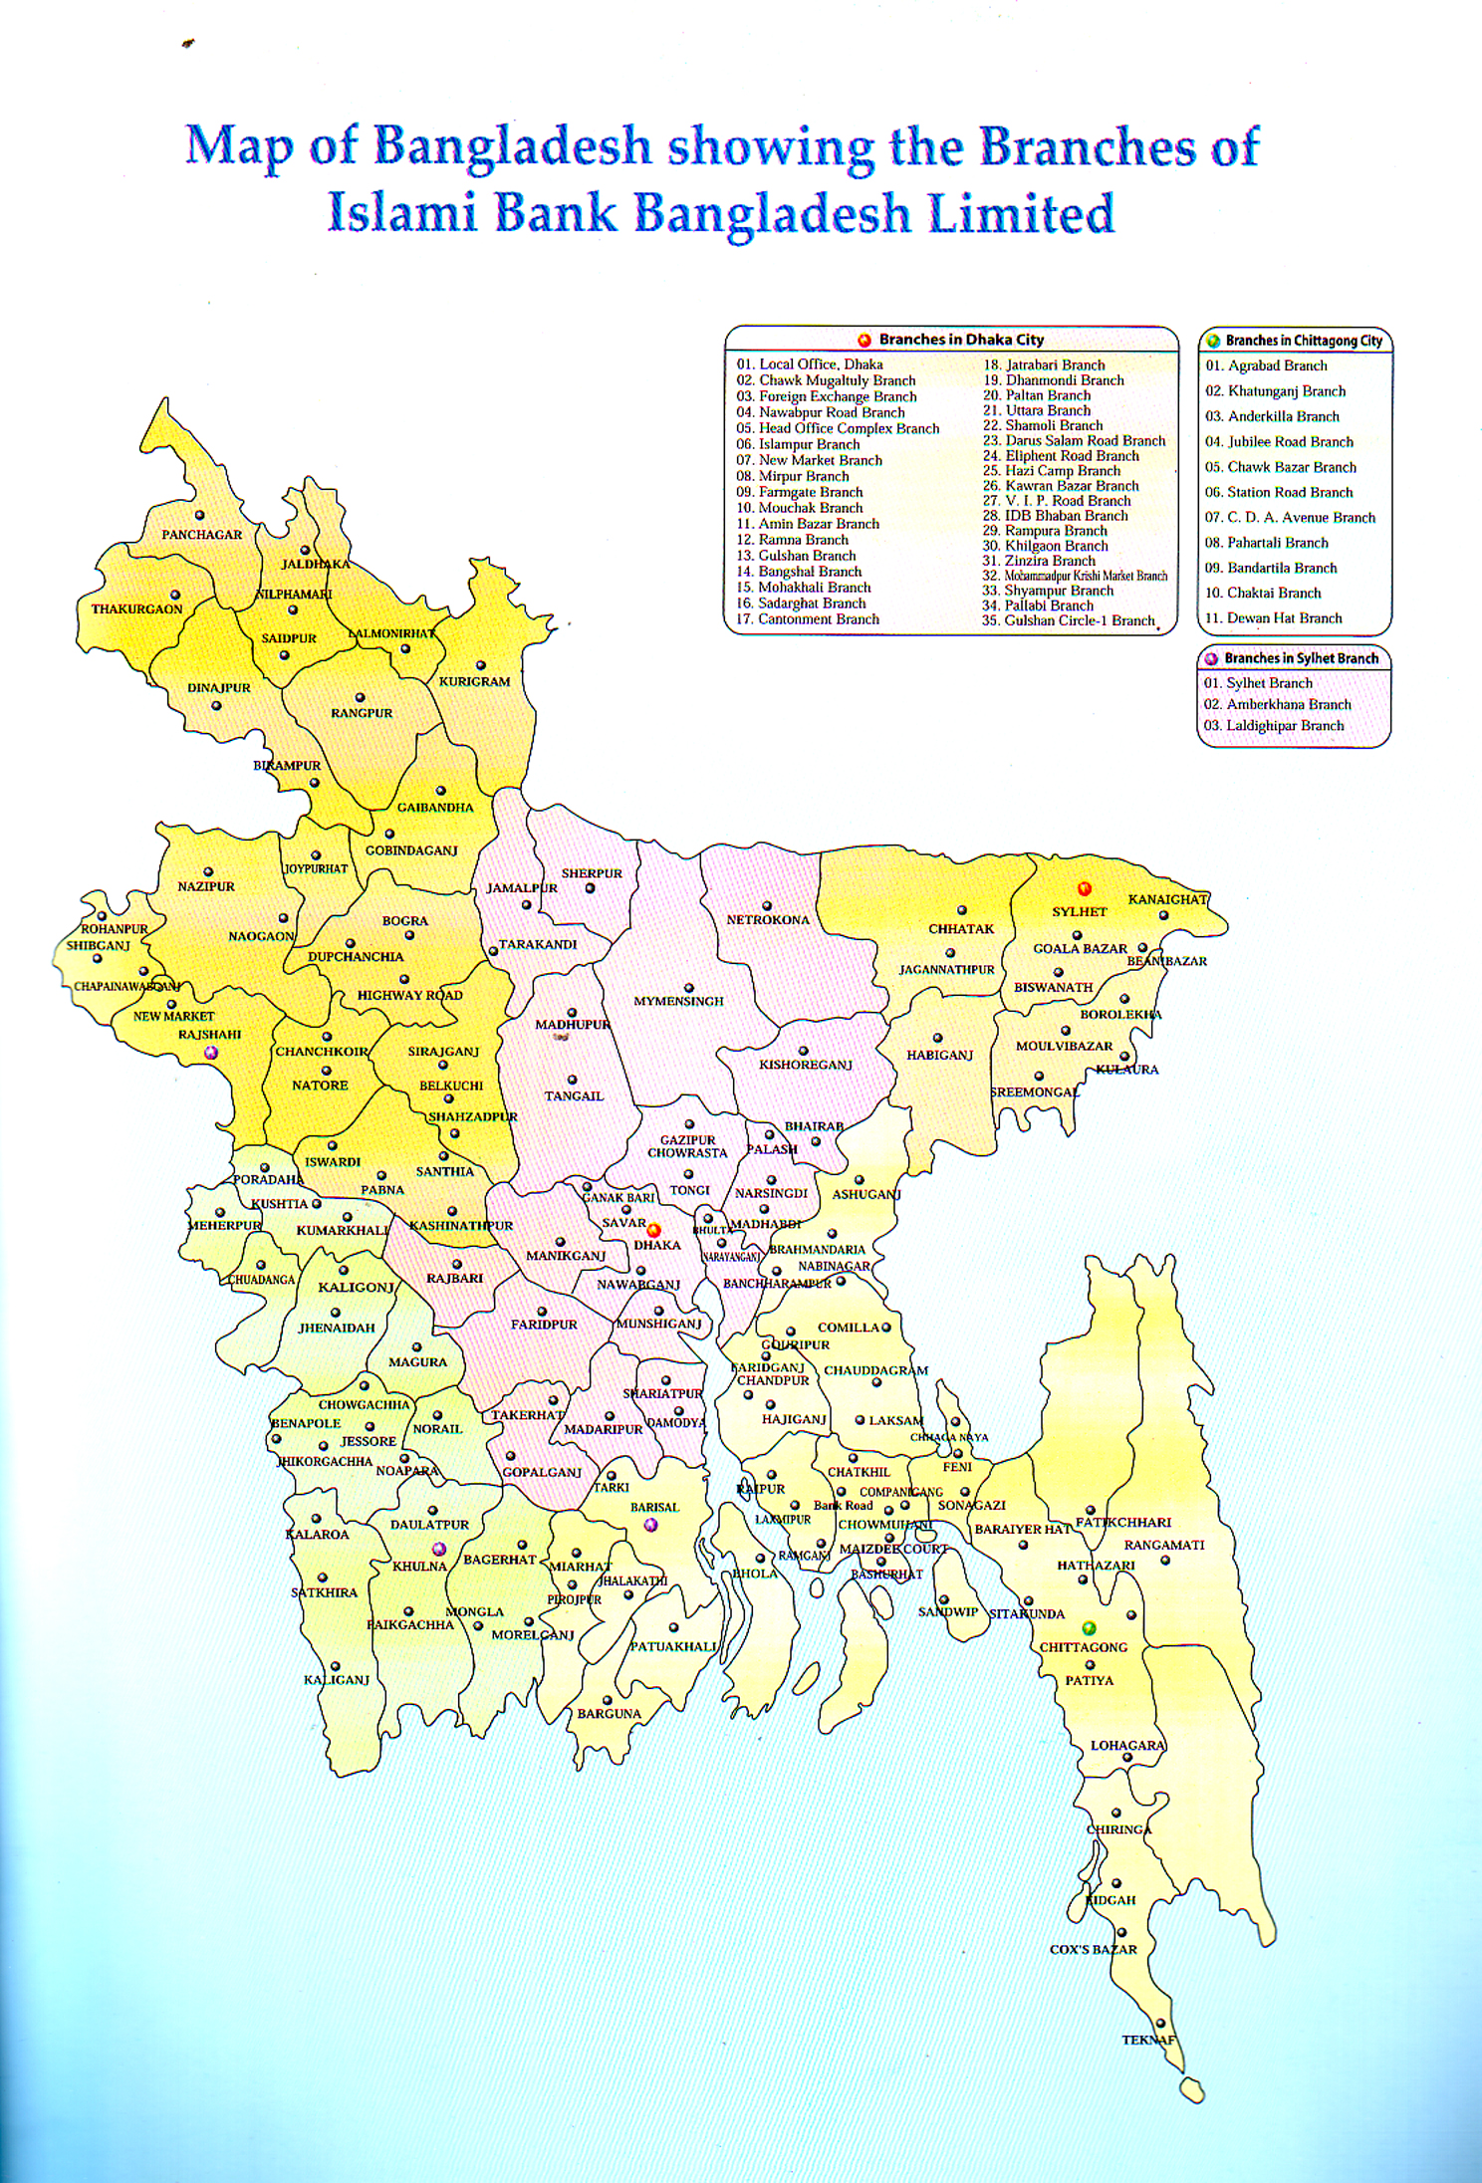
4.0 Concept of Rural Development:

Rural activities have always provided the main source of live hood in developing countries like Bangladesh. Economic viability of the rural sectors exerts a strong influence on national growth rates.

During the 1950s and 1960s rural development rural development was an important but secondary element in national development strategies which tended to emphasize centrally planned investment in basic industries and physical infrastructure.

Although development was regarded as generally desirable went in regional planning framework, it was frequently assumed that the “trickle down” effects from the development of the industrial base would provide the main source of advancement for the rural community.

During the 1970s agricultural development got greater emphasis, partly in response to first oil crisis , which led mind countries to see good self food self sufficiency as an important goal. But the integrated rural area development and basic needs projects tended to retain a “centre –down” bias and did little to motivate and empower the beneficiary groups.

Rural development efforts in the 1970s ran into a number of problems. Insufficient attention was paid to wider agricultural pricing and policy issues. The level of sustainability of rural development project was also low as a result of their essentially enclave character and their marked dependence on expatriate expertise.

Further more the benefits of projects of this type-particularly where they were linked to heavy investments in irrigation and the introduction o the “Green Revolution” technology, were often siphoned off by landlords and the rural elite and did not reach the poor section of the rural society. In the 1980s a number of new stands were woven into development project designs.
First, much more emphasis was placed on getting agricultural policies and prices right.
Second, it had become evident that the poor “bankable”. Carefully targeted projects that provide appropriate technologies and credit within a sympathetic local institutional structure can have a major impact on rural poverty at the same time it has been recognized that an exclusive commitment to “bottom up” or grass roots development is rarely justifiable.

In most cases economic growth creates new opportunities for the poor and various existing channels can be exploited to help poor groups. These channels include policy reforms, bureaucratic intervention, and the activities of (NGOs).

4.1 Define NGO

Clearly, more is at stake in such evaluations than the continued flow of benefit streams and the maintenance of stock of physical, institutional and capital. It is necessary to look at macroeconomic, fiscal and environmental effects and to take some measure of a project’s impact on the survivability of target beneficiaries and their capacity for self-help.

If a project or program has negative impact on the empowerment and motivation of the poor, it matters little that is sustainable in the conventional sense.
Rural development for Poverty alleviation:

- Rural development programs provide a useful conceptual framework for grassroots, broad based socio-economic rural development, and that multi- sectored integrated approach is generally appropriate for rural poverty alleviation initiatives.

- Rural development project cannot be implemented from the “top down” or from outside” alone but need to be initiated and sustained by the participating population itself with assistance of government institution, private development organizations and eventually external donors.
- Rural development projects need to be oriented to target groups. The access of these groups to productive resources, services and markets needs to be improved. Target groups must be able to use their own initiate to obtain access to the production, information, and markets. To this end, the target group must be organized and mobilized and planning mechanisms must be oriented toward those groups and their participation
.
- More needs to be done to clarify the factors that undermined the success of particular projects with a view to providing practical operational modes that’s can be used in the processes of participatory development , project design and implementation.

4.2 Role of Credit in Poverty Alleviation:

Many programs have instituted to improve the conditions of the poor, partly in recognition of the failure of inequitable growth to pull the poor up socio economic ladder or simply to compensate for their disadvantage position in the society.

The provision of credit to the poor has been a leading component of many of these programs because the lack of access to productive capital is thought to be one of the main factors preventing the poor from breaking away from the “poverty trap”. This trap, it is argued, makes it extremely difficult for the poor to overcome poverty without outside intervention.

In this simplest form this trap can be viewed in terms of the poor person’s low capacity to generate income, savings and investment in the economic environment that offers limited employment opportunities, which thus leaves the poor in perpetual poverty.

It is argued that providing the poor with credit can break this barrier to emancipation by giving them access to resources in particular, to –income producing or enhancing assets for small scale farmers and fishermen in rural areas. The small artisan petty traders and micro –entrepreneurs in urban area. With their thus allowing them to progressively increase their income, saving and investments through self employment and thus cross the poverty line over time.

Most government have allocated considerable amount of resources in the form of subsidized credit for the alleviation of poverty, especially in rural in areas. The rationale for subsidizing this credit is that the poor have limited capacity to repay because they have limited investment opportunities and providing them with credit services entails high transaction costs.

Subsidized credit often takes the form of government sponsored rural co-operatives, agricultural credit for the small farmer and special programs like the integrated rural development programs common in South Asia. The number of poor who have crossed the poverty line as a result of these programs is difficult to ascertain.

The impact of many of these programs is often positive and significant. Studies evaluating these programs confirm that their benefits have largely been accrued to rural elite who have been attracted by credit subsidies and used their influence over the administration of the credit delivery system to corner most of the credit resources at the cost of the rural poor.

Even the co-operative approach to credit, which had earlier been so successfully tried in Europe and North America in reaching the small farmers , and much later quickly and widely implemented in Asia largely through government initiatives , floundered badly with few exceptions.

Even the highly acclaimed Comilla co-operative model which attend considerable success during its early years when it was restricted to limited geographical coverage, on the whole failed to reach the intended beneficiaries the small farmers and suffered serious repayment and viability problems when the government replicated it nation –wide.

In the case of some other programs the failure is not so much in reaching the target group but the low repayment rates and the failure of the program to sustain the significant positive impact of credit through the provision of a follow –up credit to deserving borrowers. A good example is that of India’s Integrated Rural Development Program (IRDP) probably the most massive credit program of its kind targeted exclusively at the poor.

Government trying to provide poor farmers with access to credit often requires conventional banks to earmark a certain percentage of their outstanding loans at subsidized interest rates for the poor borrowers for whom the collateral requirement is waived. Loan guarantees are normally provided for by the government to reduce the high risk borne by the banks in lending to the poor.

4.3 Reasons for Failure of Earlier Credit Programs:

In the case of much credit co-operative that failed, a host of contributing factors acting together brought about their demise. Often cited causes are:
- Inadequate preparation of members
- Control and domination of the co-operative by powerful local elite, who often borrowed an inordinate proportion of loan funds.
- Weak management.
- Top down manner in which the co-operatives had been set up and run by the government and
- Over- dependence on outside funds rather than local saving mobilization Programs that have attempted to tap the resources of conventional banks to provide credit to poor borrowers through some form of arrangement with the government, often in the form of directives, have generally failed.

This is because they did not provide adequate incentives for the banks to make adequate profit from their loans to the poor. The primary objective of conventional banks is to make a profit on their loans.

But providing credit to the poor is staff-intensive and entails high transaction cost and risks that must be covered by interest earnings from lending and service fees. Understandably, most banks would not be willing precipitants in such programs and would accordingly try to avoid it or cut down their losses of opportunity costs by minimize their involvement.

4.4Current Achievements And Constraints

Twenty years ago the only credit available to Bangladesh’s poor came from informal sources, friend traders and money lenders. The practice was extremely usurious. Today the situation has greatly changed with large number of people having access to credit from semi-formal institution. the early experiments of the Grameen Bank, BRAC and Proshika have translated into major credit operations.

In the 1980s saw the Grameen Bank and its model dominating financial flows to the poor. Although this remains the case in 1990s, there has been increased experimentation and innovation. The efforts are essentially in line with a banking system based on interest.

4.5 Success

By late 1995, the Grameen Bank and NGOs covered around 25% of the target group households with tk. 16,568 million (USD 404 Million) in loan outstanding. Coverage varies substantially from area to area between social groups. Areas with poor roads, low level of economic activity and weak NCB infrastructure have benefited little from micro-credit.

NGOs and Grameen Bank have performed much better than government credit schemes and their achievements, compare very favorably with all other anti poverty strategies in the country. Results have been so impressive that Bangladesh has now been a centre of micro-credit ideas, although it is still a recipient of ideas of savings. Currently, most of the saving generated by these institution tend to take the form of “required fees” for receiving credit, only to be has not been experimented with by these institutions although other counties have made successful advances in this area.
4.6 Constraint:
Some of factors constrain the performance and outreach of NGOs and the Grameen Bank. These are:
- The limited accessibility of the borrowers to mobilized savings

- An over-emphasis on credit (the micro mono –culture).

- The lack of investment opportunities for the poor people and , particularly those with no asset;

- The disadvantaged position of women, who bear the additional cost of securing access to markets and information;

- The inability of this institution to operate in disadvantaged areas.

- The absence of market demand for services provided by poor borrowers.

- Natural hazards.

4.7 Success Criteria for Rural Financing Schemes:

The success of the credit program designed to alleviate poverty would have to be evaluated in the light of the program objectives. A successful program may incorporate a broad set of objectives in addition to credit, such as empowerment, “Conscientisation” education and skills training.

The following five criteria are often used to assess the effectiveness of credit for poor programs:

- Extend to which the program has reached the truly poor. This can be measured both in terms of proportion of beneficiaries who are truly poor and the number of poor borrowers reached.
- Loan recovery. This is measured by the measured by the repayment rate. Sustained high loan recovery represents the simplest and clearest indicator of a program’s success as it reflects productivity or profitability of the loan, as well as the borrower’s satisfaction and support of the program.

- Productivity of the loan. This measures the viability of the investment into which the loan was applied by the borrower. It is normally measured in terms of returns on investment or capital –output ratio.

- Impact on borrower’s income .this impact refers to the extent to which the borrower’s real income has increased as result of the credit provided.

- Sustainability. It refers to the capacity of the program to become institutionalized into a financially self supporting program, able to cover all cost and to generate sufficient profits from its operation. Sustainability is affected by such variables as the interest rate charged, repayment rate and transaction costs.

4.8 Concept of Rural Development And Rural Financing Under

Islamic Banking Framework:

The concept of rural development is an integral part of the development concept. The concept of development as used in the jargon of modern economics literature does not satisfy the characteristics as enjoined by Islam. The Islamic concept of development has been derived from four key concepts such as Tawheed (unity),Rabubiyah (sustainer), Khalifah(representative) and Tazkiyah (purification).

According to Prof. Khurshid Ahmad: the Islamic concept of development is comprehensive and includes moral, spiritual and material dimensions. Development, in Islam is a good and value oriented activity devoted to the optimization of human wellbeing in all these dimensions.
The moral and material, the economic and social the spiritual and physical are inseparable. It is not merely welfare in this world that is the objective. The welfare that Islam seeks extends to the life hereafter and there is no conflict between the two. Islam commends the value of shukr (thankfulness to God availing of the His blessing) adl (justice) and condemns kufr(denial of Allah His of His blessing and julm(injustice).

The foregone discussion leads us to a conclusion that Islam stands for a development approach where free and unlimited operation of market ensure optimum utilization of resources and encourage a distribution pattern in which resources are circuited back from the well to do to the relatively weak. In order to do that a number of interventions are brought into effect.

For example fiscal policy and monetary policies including commercial flow of investible funds are to be designed in a way that resource are to be channeled to the relatively weak and disadvantaged section of population. Also, there should be a legal and institutional set up so that wealthy people transfer regularly the due share of the poor and the needy.

In addition to voluntary transfer to ‘what they have in excess of their need’ (afwa), the institution of Zakah and Ushr is the classical means of compulsory regular transfer of income / asset from the well to do to the poor.

Further the provision of qard al hasan (i.e. benevolent loan repayable without any return) is also and institutional obligation to make available funds to the needy. Thus the above principles and provisions construction the building blocks for the rural development schemes under the Islamic banking framework.

4.9 Background of RDS of IBBL

Bangladesh with its 40% people living below poverty line and 18% living in absolute poverty is suffering from acute rural-urban economic disparity coupled with illiteracy, lack of proper health and sanitation facilities. The country's economy is basically an agrarian one with vast majority living in rural areas.

The agriculture sector is unable to provide any further scope for employment resulting in influx of rural population towards urban areas. Rural areas are characterized by stagnant agriculture and scanty industries. Underemployment and unemployment is a regular phenomenon particularly in rural areas.

The vast human resources have remained unutilized due to lack of education, proper training and concerted efforts to help grow the rural economy. These results in uneven distribution of income which causes serious set back in balanced geographical growth as well as growth of GDP.

Islami Bank Bangladesh Limited was founded with the major objective of establishing Islamic economy for balanced economic growth by ensuring reduction of rural-urban disparity and equitable distribution of income.

In view of the above, Branches of the Bank have been encouraged to invest their deposits in their respective areas and in particular for the economic enlistment of the rural people.

Accordingly, a Scheme in the name and style of 'Rural Development Scheme' has been introduced to cater to the investment needs of the agriculture and rural sector to create opportunity for generation of employment and raising income of the rural people with a view to alleviate poverty.

4.10 Objectives:

The main objectives of the Scheme are:
- To extend investment facilities to agricultural, other farming and off-farming activities in the rural areas;
- To finance self-employment and income generating activities of the rural people, particularly the rural unemployed youths and the rural poor
- To alleviate rural poverty through integrated rural development approach.
- To extend investment facilities for rural housing, keeping in view the needs of housing facilities of the rural dwellers.
- To provide educational services and safe drinking water, sanitation & Medicare facilities to the down trodden people.

4.11 Target Area:

Initially the Scheme was started as a Pilot Scheme in the rural areas of certain districts under the direct supervision of the nearby Branches of Islami Bank Bangladesh Limited. The Scheme is being gradually extended to all districts through different Branches of the Bank.

4.12 Centre Fund
Each member of the Group has to deposit minimum Tk.2.00 per week in the Centre Fund. This Fund is kept by opening a Mudaraba Savings Account in the name of the respective centre.

This Fund is utilized for the welfare of the members by way of Quard as per decision of the Centre in the weekly meeting. This account is operated by Centre Leader & Leader jointly. This fund is refundable.

4.13 Documentation
To secure Bank's investment, the following documents have to be executed:
- Group guarantee form.
- Deed of Agreement.
- Usual charge documents.

4.14 Sanction And Disbursement

On the basis of the list submitted by the Field Officers, the Investment Committee of the Branch carefully scrutinizes the applications and sanctions the investment at the Branch level. The Investment Committee consists of Manager, Project Officer and the Field Officer.

After sanction of the investment the Branch complete documentation formalities and then disburse the amount with the help of the Investment Officer and Field Officer. In the entire cases branch must ensure strict adherence to the banking and Shariah norms.

4.15 Appointment of Field Officer

Field Officers are appointed by the Head Office of the Bank. After recruitment, the Field Officers have to undergo compulsory Foundation Training for a period of two weeks so that they can perform satisfactory.

They are appointed well ahead of starting operation of the Scheme in a Branch. The concerned Branch starts operation of the Scheme after satisfactory completion of the base- line survey, formation of the Groups, motivation of the Group members and compliance of the Group disciplines etc.

4.16 The Eligible Criteria for the Field Officers are the Followings:

- Young man with initiative and drive.
- Minimum qualification: graduate or equivalent.
- Willingness to work in the rural areas.
- They are recruited as per Recruitment Policy of the Bank under a separate ‘Service Rules for the RDS Employees’.
- Their services are confirmed after one year on satisfactory performance. The performance are considered satisfactory if rate of recovery is 95% or above.

4.17 Statistics of Rural Development Scheme (2003 To 2007)

Year | No. Branch | District Covered | Thana Covered | Village  Covered | Total No of Person | Male Member  (%) | Women Member (%) | Outstanding Investment  (Million Tk) | Recovery Rate.
2003 | 69 | 45 | 111 | 3365 | 174315 | 11% | 91% | 714.93 | 99%
2004 | 69 | 45 | 125 | 5214 | 200470 | 6% | 94% | 790 | 99%
2005 | 89 | 48 | 140 | 6875 | 307225 | 6% | 94% | 1107 | 99%
2006 | 120 | 50 | 190 | 7700 | 430465 | 8% | 92% | 2242 | 99%
2007 | 129 | 61 | 220 | 10023 | 516725 | 11% | 89% | 2884.66 | 99%

The above table shows the growth of Rural Development Scheme (RDS) under Islami Bank Bangladesh Limited (IBBL). In 2003 only 69 branches of the bank are involved in the Rural Development Scheme (RDS) but at present 118 branches of the bank are involved in this scheme as designated branches. In 2003 RDS operation was involved among 3365 villages under 111 Thanas of 45 districts. Now under

4.18 Performance Of Rural Development Scheme Up To 31.12.2007

Serial No. | Areas of performance | Number/Amount
01 | Total number of Branch of IBBL | 186
02 | No. of Branch handling the Scheme | 118
03 | No. of Village | 10,023
04 | No. of District | 61
05 | No. of Centre | 18,897
06 | No. of Group | 103,345
07 | No. of Male member | 56,380
08 | No. of Female member | 459,885
09 | Total number of Members | 516,725
10 | No. of Client (Who availed investment) | 350,278
11 | Cumulative disbursement | 13,969.01
12 | Average size of investment | 0.011
13 | Present outstanding | 2,884.66
14 | No. of Field Officer | 1,819
15 | No. of Tube-well provided (Since inception) | 6,242
16 | Amount disbursed against Tube-well | 12.12 million
17 | No. of Sanitary Latrine provided (Since inception) | 3,551
18 | Amount disbursed against Sanitary Latrine | 3.51 million

Islami Bank Bangladesh limited (IBBL) envisages an economic system based on equity and justice. Taking into consideration that majority of the population below poverty line lives in rural Bangladesh, the Bank has devised a Rural Development Scheme (RDS) with a view to creating employment opportunity for them and alleviates their poverty through income generation activities.

The IBBL through its RDS project has been implementing integrated programs for the landless poor, eager laborers and marginal farmers aimed at meeting their basic needs and promoting their comprehensive development. Consciousness among the poor needs should be enhanced so that they can lift their position in the socio-economic structure of the country. In order to consolidate their economic base, invested money should be used in income generating activities so the poorer section of the population can become self-reliant. RDS works for the realization of that objective.

4.19 Agricultural Implements Investment Scheme:
Bangladesh is predominantly an agricultural country with vast majority of people living in rural areas. Most of our people for their living are dependent on agriculture. Agriculture still contributes the lion share of the gross domestic product. But we could not as yet become self-sufficient in food production. We still import a bulk quantity of food grains from abroad to meet the deficit. We must modernize our agriculture and establish more and more industries in order to minimize imports.

The Bank has introduced “Agriculture Implements Investment Scheme" to provide power tillers, power pumps, shallow tube-wells, thrasher machine etc. On easy terms unemployed youths for self-employment and to the farmers help augment production in agricultural sector.

4.20 Micro Industries Investment Scheme
Islami Bank Bangladesh Ltd. has been appreciably participating in this direction by financing industrial sector. With a view to creating wider base for industries, the Bank has decided to launch "Micro Industries Investment Scheme" through its Branches.
4.21 Efficacy of Customer Services of IBBL
The most important asset of any organization is its customers. An organization’s success depends on how many customers it has, how much they buy, and how often they buy. Customers that are satisfied will increase in number, buy more, and buy more frequently. Satisfied customers also pay their bills promptly, which greatly improves cash flow-the lifeblood of any organization.
The organizational diagram in Figure best exemplifies just how important the customer is to any organization.
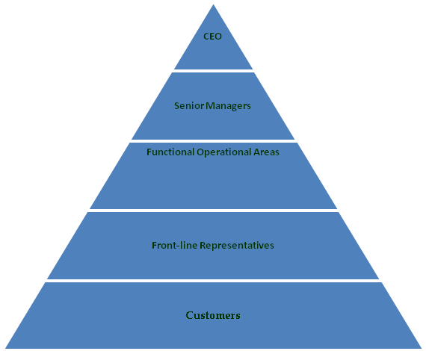

Figure: Customer Satisfaction Organizational Diagram

A company is a device for transforming inputs into outputs. The simplest measure of efficiency is the quantity of inputs that it takes to produce a given output; that is, Efficiency = outputs/inputs.

A company can increase efficiency through a number of steps. These include exploiting economies of scale and learning effects, adopting flexible manufacturing technologies, reducing customer defection rates, getting R&D function to design products that are easy to manufacture, upgrading the skills of employees through training, introducing self-managing teams, linking pay to performance building a company wide commitment to efficiency through strong leadership, and designing structures that facilitate cooperation among different functions in pursuit of efficiency goals.
To achieve superior customer responsiveness often requires that the company achieve superior efficiency, quality, and innovation. To achieve superior customer responsiveness, a company needs to give customers what they want when they want it.

It must ensure a strong customer focus, which can be attained through leadership; training employees to think like customers; bringing customers into the company through superior market research; customizing the product to the unique needs of individual customers or customer groups; and responding quickly to customers’ demands.

Customer’s satisfaction depends on Efficacy of customer service. If customers of the bank are satisfy on the banking service then the efficacy will be positive. On the other hand, if customers are dissatisfy then the efficacy will be negative.

Efficacy of customer service is related with progression of operation. We can identify the efficacy of customer service by studying the progress of IBBL from starting to at present. The progress of IBBL is very rapid with the concern of its profit making and growth of its operation within the country towards the country’s economy.

4.22 Comparison Of RDS Of IBBL & Conventional NGO:

RDS of IBBL | Conventional RDS
IBBL’s does not do the business on items harmful for societies through there are possibilities to earn more profit there against. | There is no justification as to whether the business is good or bad in conventional system. Earning interest is the only motive of this system.
Low rate of return, which is only 10% (flat) | High rate of return, which is 12%-15%.
Gestation period is 21 days. | Gestation period is only 7 days.
Rebate of 2.5% is allowed for timely payment. | Rebate is not allowed.
Other charges are not impose to the client such as-supervisory, risk fund, pass book etc | Other charges are impose to the client such as-supervisory, risk fund, pass book etc

Factors to Measure the Efficacy of Customer Services:
1. Deposits  2. Equity  3. Investment Loans and Advances  4. Investment Share and Bonds  5. Import Business  6. Export Business  7. Profit (After Tax) | 8. Paid-up Capital  9. Branches

From the following information heads we can clearly understand the progress of IBBL.

5.0 Deposits:
Table- 5.0
Year | 2000 | 2001 | 2002 | 2003 | 2004 | 2005 | 2006 | 2007
Tk. In million | 20000 | 40000 | 58000 | 75000 | 90000 | 110000 | 138000 | 175000
Rate of increase | ----- | 50.00% | 47.81% | 34.58% | 33.27% | 25.16% | 48.44% | 18.57%

Figure- 5.0
0
50000
100000
150000
200000
1
2
3
4
5
6
7
Tk. In million
20000
Rate of
increase -----

From the above deposit figure we can clearly understand that customers are mostly interested towards the IBBL. As of December 2007 total deposits of the Bank stood at TK. 1,75000 million as of the previous year which is an increase of 18.57%. This growth rate might be termed as a remarkable achievement for the Bank. The present strategy is to increase the deposit base through maintaining competitive interest rates and having low cost of funds that would ensure a better spread with a moderate lending rate.

5.1 Shareholders’ Equity:

Table 5.1

Year | 2000 | 2001 | 2002 | 2003 | 2004 | 2005 | 2006 | 2007
Tk. in million | 17272.90 | 22964.75 | 58000 | 76000.33 | 90000.27 | 111000 | 133000 | 172000
Rate of increase | ---- | 30.21% | 55.68% | 19.34% | 35.72% | 87.09% | 56.60% | 62.71%

Figure- 5.1
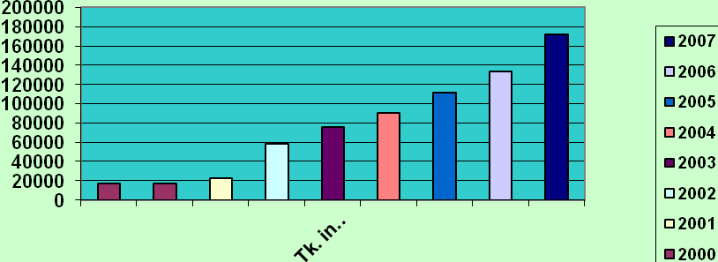

The above data shows the progress of IBBL in their operations which reflex proper customer efficiency for owners / investors.

5.2 Investment:

Table-5.2

Year | 2000 | 2001 | 2002 | 2003 | 2004 | 2005 | 2006 | 2007
Tk. in million | 28567 | 35000 | 46281 | 59007 | 75859 | 83654 | 113575 | 174358
Rate increase | ---- | 828.44% | 36.42% | 32.00% | 54.49% | 57.31% | 34.73% | 40.32%

Figure- 5.2
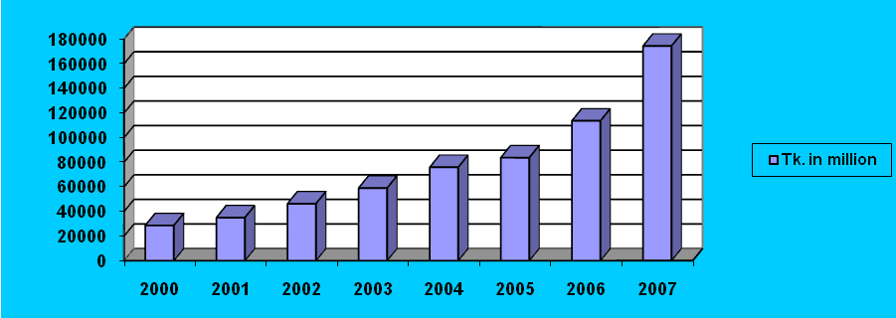
From the above table and figure we can say that, customers have a good response to the loans & advances department of IBBL. So the position of this department is very good. Loans and Advances of the Bank stood at Tk.17,4358 million as on 31st December, 2007.

Loans and Advances are the core asset of a Bank. The Bank gives emphasis to acquire quality assets and does appropriate lending risk analysis while improving commercial and trade loans to clients.

5.3 Investment (Shares and Bonds):
Table-5.3

Year | 2000 | 2001 | 2002 | 2003 | 2004 | 2005 | 2006 | 2007
Tk. in million | 12000 | 14987 | 20000 | 28876 | 34623 | 76972 | 86003 | 115674
Rate of increase | ---- | 35.22% | 57.80% | 32.16% | 67.52% | (35.00%) | 15.83% | 36.75%

Figure- 5.3
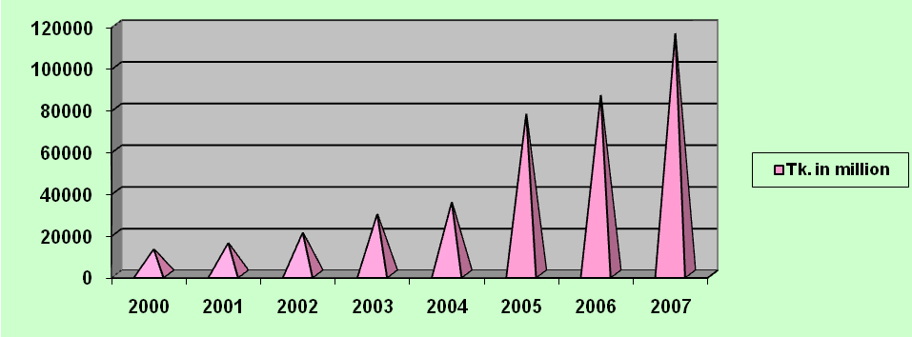

The size of the investment portfolio is at Tk. 1, 15674 million. So this rapid increase of investment shows the proper efficacy of customer services.

5.4 Import Business:
Import Business is an important segment of Foreign exchange business. The significant items of Import are Industrial Raw Materials, Consumer Goods, Machinery, Fabrics, and Accessories etc. IBBL helps its customers to import these types of goods from other countries and the bank also gives the financial help to the customer.

Table-5.4
Year | 2000 | 2001 | 2002 | 2003 | 2004 | 2005 | 2006 | 2007
Tk. in million | 17895 | 28000 | 34765 | 45098 | 61213 | 78000 | 96870 | 137086
Rate of increase | ---- | 31.57% | 44.80% | 34.38% | 41.44% | 33.05% | 34.70% | 41.52%

Figure- 5.4
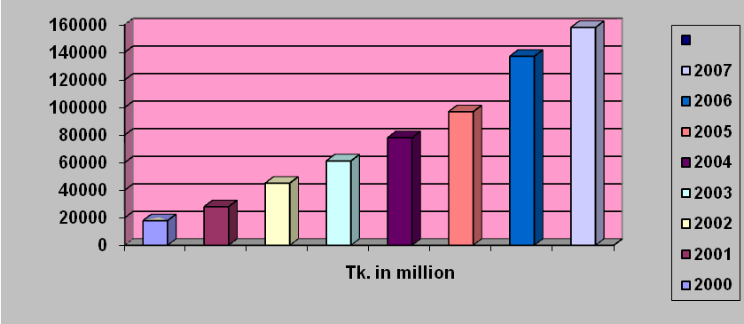
From the above table and figure we can clearly understand that the volume of import is increasing gradually. During the year 2007 the Bank opened imports letter of credit and volume stood at TK. 137086 million with a growth of 41.52comparison with previous year. This growth rate indicates the curiosity of customers towards the IBBL.

5.5 Export Business:
From the very beginning the Bank has embarked on extensive Foreign Exchange Business with a view to facilitating international trade transaction of the country. Bangladesh exports a large quantity of goods and services to foreign households. Readymade textile garments (both knitted and woven), Jute, Jute-made products, frozen shrimps, tea are the main goods that Bangladeshi exporters exports to foreign countries.

Table-5.5
Year | 2000 | 2001 | 2002 | 2003 | 2004 | 2005 | 2006 | 2007
Tk. in million | 8765 | 12343 | 18000 | 28000 | 35333 | 44182 | 51133 | 66690
Rate of increase | ---- | 39.61% | 16.00% | 35.56% | 2.92% | 28.2% | 25.33% | 23.16%

Figure- 5.5 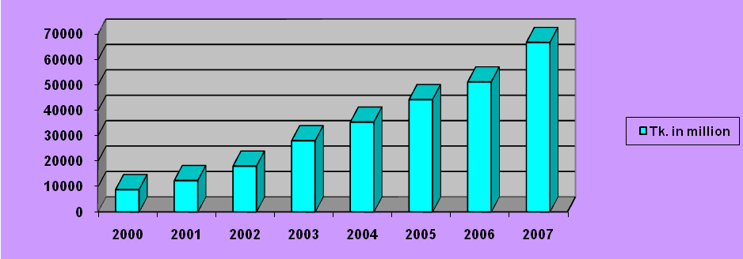
From the above table and figure we can say that the position of export business of IBBL is good. The export business during the year 2007 reached TK. 66690 million of the previous year. The growth in export business was 25.33% the above data will make the customer more interested to make himself client of IBBL.

5.6Growth in Foreign Exchange Business
Table 5.6……………………………………………………………………………….
Year | 2000 | 2001 | 2002 | 2003 | 2004 | 2005 | 2006 | 2007
Tk. in million | ---- | 23654 | 33788 | 46337 | 59804 | 74525 | 84470 | 97086
Rate of Increase | ---- | ---- | 28.31% | 27.44% | 26.50% | 39.84% | 15.45% | 19.00%

Figure- 5.6

5.7 Paid-up Capital:

Table- 5.7............................................................................................................
Year | 2003 | 2004 | 2005 | 2006 | 2007
Tk.(In million) | 1920 | 2304 | 30270 | 4000 | 5231

Figure- 5.7
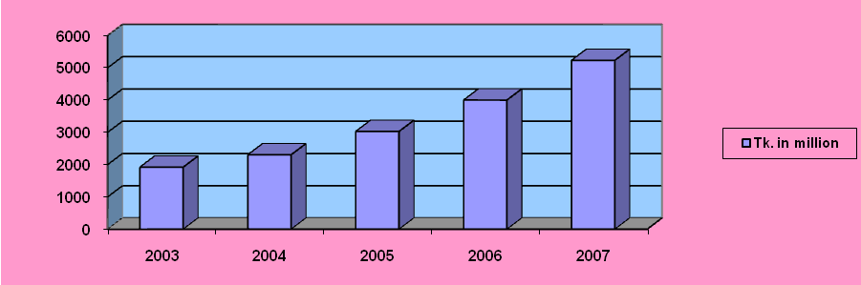
Paid-up capital at the end of the year 2007 is 5223 million Tk. which is almost greater than the previous year.

5.8 Earning Per Share:

Table- 5.8

Year | 2003 | 2004 | 2005 | 2006 | 2007
EPS in Tk. | 196 | 519 | 923 | 1221 | 1708

Figure- 5.8

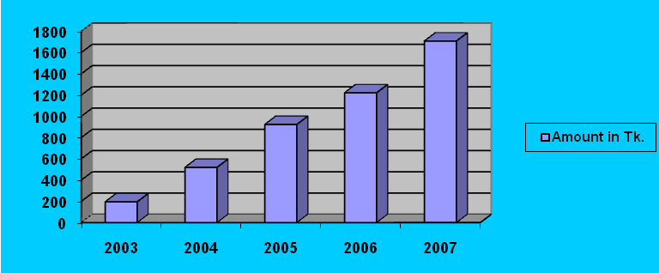

Earning per Share at the end of 2007 is Tk. 1708 million which is satisfactory EPS.

5.9 Branches:

Table- 5.9

Year | 2000 | 2001 | 2002 | 2003 | 2004 | 2005 | 2006 | 2007
No. of branches | 111 | 116 | 121 | 128 | 141 | 155 | 170 | 186

Figure- 5.9
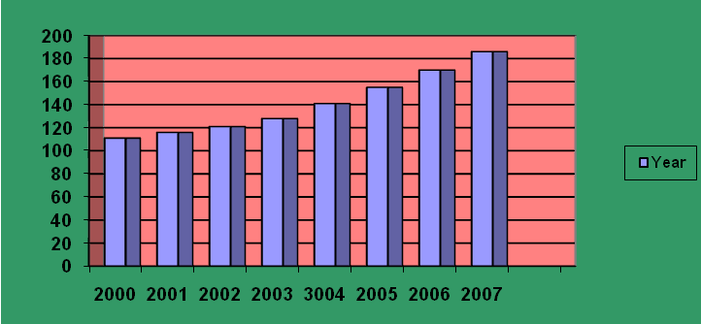

6.0 Assessment of Investment of RDS under IBBL
The following table shows the position of investment under RDS of IBBL during the study period 2003 to 2007
Table # 6.0: Investment position under RDS Tk (In million)
Year | Target | Achievement | Percentage
2003 | 2923.59 | 2865.11 | 98%
2004 | 4246.77 | 4204.03 | 99%
2005 | 6033.29 | 5972.95 | 99%
2006 | 9300.05 | 9207.04 | 99%
2007 | 10367.08 | 10263.40 | 99%
Average | 6574.156 | 6502.506
Sources – RDS news of IBBL during 2003 to 2007
The above table shown the total amount of investment target as on 2003 to 2007 is Tk. 32870.78 million and their achievements are Tk 32512.53 million.
The figure of the above table has been represented in the following graph:
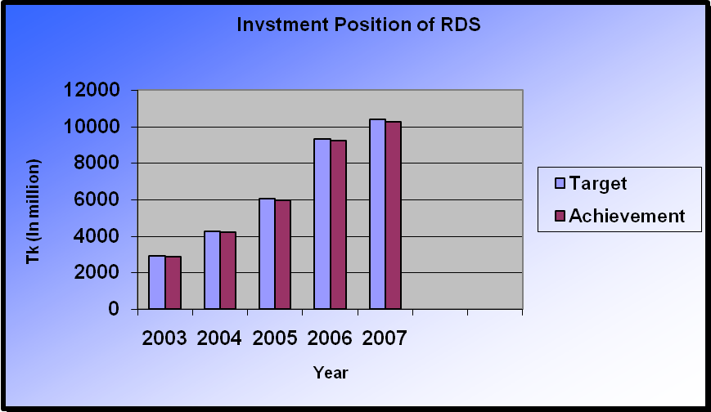
Figure: 6.0
6.1 Evaluation of Recovery Position of RDS
Table # 6.1: Recovery position of RDS Tk (In million)
Year | Target | Achievement | Percentage
2003 | 2865.11 | 2807.80 | 98%
2004 | 4204.03 | 4161.98 | 99%
2005 | 5972.95 | 5913.22 | 99%
2006 | 9207.04 | 9114.96 | 99%
2007 | 10263.40 | 10160.76 | 99%
Average | 6502.506 | 6431.744

Sources: RDS news IBBL during 2002 to 2007

The figure of the above table has been represented in the following graph:

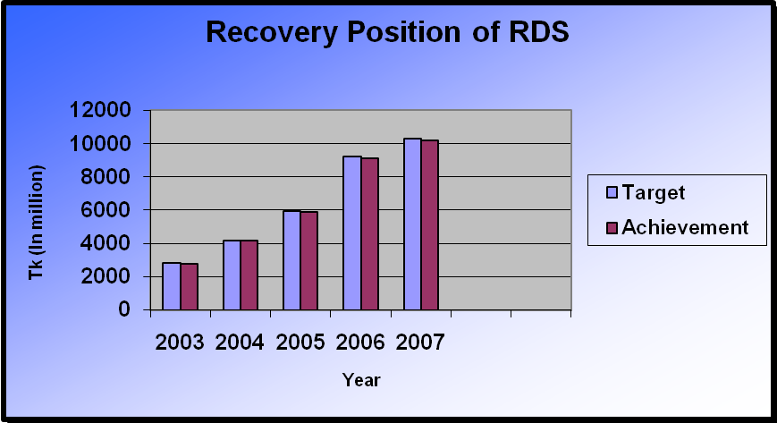

Figure: 6.1
6.2 Problem in RDS of the Selected Bank
- Bad effect of the conventional NGOs;
- The amount which is providing for small & micro investment facilities to the agricultural & rural sector is not enough.
- Their investment sanction procedure is much more lengthy than conventional NGOs;
- Gestation period is not enough to repay the investment amount with profit by the client;
- All class of people are not familiar with Shari’ah based investment;
- At present only 118 branches of the bank are involved in this scheme which is not sufficient to acquire their objective of RDS.
- Only 1,819 field officers in 18,897 centers among 10,023 villages are working which is poor number to operate their RDS smoothly.

6.3 Recommendation
It is not unexpected to have many problems in any organization. For this reason already we have found many problems of IBBL. To solve these problems, we can suggest following recommendations:
- IBBL’s investment sanction procedure should be made shorter and easier.
- They should increase their investment amount.
- They should increase their gestation period.
- To achieve their objective, they should increase their branches which will involve in this scheme.
- IBBL should appoint a sufficient number of women employees to deal women entrepreneurs and professionals and understand their needs and thus create demand for investment.
- They should take aggressive advertising policy to inform the people about Shari’ah based investment.
- To gain success in the programs like "Poverty Alleviation and "Self Reliant" especially in rural areas, this bank should provide investment facilities on the basis of individual position.
- They should increase skilled manpower so that they can perform their activities effectively and efficiently.
- IBBL needs to finance the needy entrepreneurs who have no money at all and they are newcomer in the business.
- Arrangement of monthly /quarterly training courses /workshops for the clients selected by the Branches in order to promote Investment clients of the desired level.
- The authority of IBBL should manage pressure on Government bodies to run proper and sufficient application of Islamic banking law in Bangladesh.

7.0 Conclusion
The concept of Islami banking is several decades old. The first attempt to establish an Islamic financial institution took place in Pakistan in the late 1950′s with the establishment of a local islami bank in a rural area (Wilson 1983). After 42 years, Islamic banking system is established in Bangladesh as a financial institution that is named “Islami Bank Bangladesh Limited “.

Islamic Bank Bangladesh Limited is a bank which operates it′s activities according to quaran and Sunnah. It′s banking activities based on profit \ loss sharing. It does not create any illegal pressure on client.

The strength of Islami Bank Bangladesh Limited are - employees of this bank are honest because they strongly believes in Islamic rules and Allah and they do not take any types of bribe form clients .so believes of people are increasing on the activities of Islamic bank Bangladesh limited.

The opportunity of Islamic bank Bangladesh limited is - science majority people are Islamic minded and Islamic bank Bangladesh limited is based on Islam. So many people of Bangladesh are involving with IBBL for doing their daily financial activities. So it has a bright future because it has got huge customer then other conventional bank in Bangladesh that are based on interest.

The weaknesses of Islamic bank Bangladesh limited are - although it is getting bright future but it does not operate it′s activities 100% based on Islamic shariah. Because still there is not existed an Islamic environment in the economic activities of Bangladesh. It is performing it′s daily financial transecting with other financial institution that are not based on Islam. In this case, it is involving with some non-islamic activities unintentionally. On the other hand every client is not 100% honest. So they are taking investment form ibbl and after maturity, they are showing loss on that project intentionally. So IBBL is losing some profit form their investment .For this reason, Islamic bank Bangladesh limited has closed it′s Bai - mechanism. Now it is not providing investment under this mechanism.
Threats of Islamic bank Bangladesh limited are - at this time, many financial institutions have commenced their financial activities according to Islamic shariah. This type of organization will create more competition in the financial market. So it is a threat for Islamic bank Bangladesh limited.

After all, although it is facing some problem, it has a bright future and day-by-day it is enhancing it′s financial activities over the country. Many organizations are following to IBBL and they are starting their business based on Islamic shariah in the economy in Bangladesh.

8.0 SWOT Analysis of IBBL

STRENGTH
- Unique System: 100% supervise credit Related with shariah.
- Religious Feelings of the people.
- Management System.
- High Morality of the employees and customers
WEAKNESS
- Absence of Competitors. Existing are quite weak,
- Deficiency of experienced manpower.
- Absence of Islamic money market.
- Few employee’s attitude towards customers are not satisfactory
- IBBL still remain under lower position in the world ranking.
- IBBL does not use the share mode of investment
- They have no such program to finance to the new entrepreneur or creating the same.
OPPORTUNITY
- IBBL has a verse opportunity to hold the most of the customers of Bangladesh as its banking operation is based upon Islamic Shariah.
- Providing service by Visa Card or Master Card types of cards to customers
- Rural Development Scheme of IBBL is a great chance to save the county’s poor people from being taking loan from different NGOs or few banks with higher interest rate
THREATS
- State law defers with the Islami Shariah.
- In the money market of Bangladesh there is no call money system of Islami Shariah.
- Few other conventional banks have open their Islamic banking branch

