A study on the Re-branding of djuice

Submitted by

WWW.ASSIGNMENTPOINT.COM

Chapter 1: Introduction

Origin of the Report

This report is a partial requirement of the Internship program of BBA curriculum at the Institute of Business Administration. Under the institutional supervisor, this report is prepared for internship and placement committee, based on the project assigned by Market Communication Department, Commercial Division of Grameenphone Limited.

Background

Grameenphone is the largest mobile phone operator in the country with over around 13 million subscribers and over 62% of the market share. The company, since its launch in 1997, has experienced phenomenal growth and success. Grameenphone is the only operator in the country with a separate brand targeted towards the youth segment. Grameenphone launched its youth brand “djuice” on 14th of April 05 with its own identity and value proposition tailored to the youth segment’s mobile behavior, preferences and lifestyle to strengthen its position in the youth market through a strong and differentiated mobile and lifestyle offering.

Recently “djuice” has gone through a major rebranding worldwide to strengthen its positioning as a youth life style brand. The purpose of this study is to find out the success of the rebranding of “djuice” in reinforce its positioning in the youth segment.

Research Objectives

Broad objective:

- To find out the effect of rebranding of djuice in strengthening it’s positioning as a youth lifestyle brand

Specific Objectives:

- Identify the psychographic characteristics of the sub-groups in the youth segment
- Find out the perception regarding the brand personality of djuice among different sub-groups before and after the rebranding of djuice
- Find out djuice’s performance as a lifestyle expression brand among different sub-groups before and after the rebranding of djuice
- Identify the criteria for satisfaction with djuice’s performance among the different sub-groups before and after the rebranding of djuice
- Identify the level of loyalty among the djuice users

Scope of the Study

The target market of djuice is the youth segment of the country. However, in the initial phase (Qualitative study) the youth segment of Dhaka, Khulna & Chittagong city were interviewed. For the second phase (Quantitative research) only the university students of Dhaka city was considered.

Methodology

This is a descriptive study. All the secondary information is collected from Grameenphone internal documentation and websites.

The primary Data was collected in two phases –

Phase 1: Qualitative Study:

In these phase 24 people were interviewed. 20 of them were from the youth segment (age 16 – 30) & 4 people interviewed older than that. Six Focus Group Discussions were conducted also. The interviewees and the participants of focus group discussions were mostly from Dhaka city, but a few interviews were taken in Chittagong and Khulna. The samples were selected based on convenient sampling. This phase only gave an idea about - the psychographic characteristics of the youth segment, based on which they can be sub-divided; the perception of the youth regarding djuice’s brand personality & its positioning. This information helped in forming the hypotheses and preparing a questionnaire.

Phase 2: Quantitative Study:

In this phase the hypotheses were tested on the university students of the Dhaka City. Probability sampling was used for selecting representative respondents. This study helped justify the findings of qualitative study and come to concrete conclusion.

Limitations

- djuice is still a very new product in this country and hence a concrete perception of it has not yet been created.
- The study has been mostly centered within Dhaka City and hence the perception of people living outside the city is not represented.
- All the people studied come from similar educational background (mainly in the quantitative study), hence their perspective on certain issues may provide a biased view
- Most of the survey was conducted by third party, so there is a chance of biased sample selection.

Chapter 2: Industry Overview

Overview of Global Telecommunication Industry

Historically, the global telecommunications marketplace has enjoyed tremendous growth in terms of network size, number of subscribers, number of operators, and overall revenues. While this growth has been impressive, of real importance is what is going to happen to the telecommunications market in the near future.

The following graph shows the growth trend of global telecom industry –
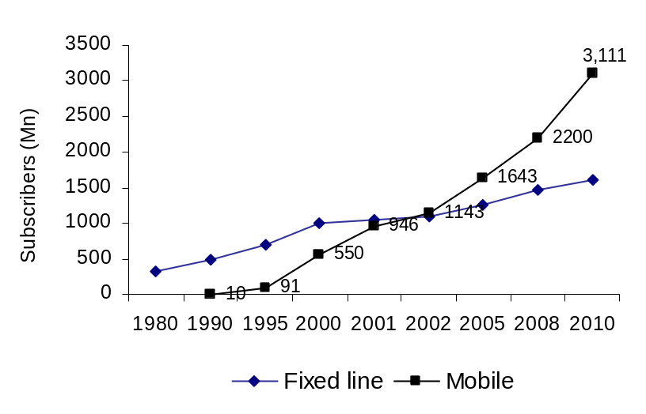
Fixed line growth
1980-90 = 54% (175Mn)
1990-00 = 100% (500Mn)
2000-05 = 27% (269Mn)
2005-10 = 27% (341Mn)
Mobile growth
1990-00 = 5400% (540Mn)
2000-05 = 199% (1093Mn)
2005-10 = 89% (1,486Mn)

Note: Data up to 2002 are actual, Fixed line data beyond year 2002 are estimated based on the growth rate achieved over previous years. Mobile phone data for year 2005 and 2008 are cited from Wireless World forum, wireless competitive intelligence website. Mobile data for year 2010 is estimated based on the growth rate for the same market driving year 2005-2008.
Figure 1: Growth trend in global telecom

The next five years will be a pivotal time for the telecommunications industry as the effects of global deregulation, the continued expansion of wireless services, and the further build out of developing countries combine to reshape the global marketplace. The build out of developing countries is critical if these countries are to increase tele-density and data capacity in order to join the 21st century.

Overview of Telecommunication Industry in Bangladesh

The telecom industry in Bangladesh is composed of a few players. The main reason for such a small numbers is the regularization of the industry by the government. For years, the Bangladesh Telegraph and Telephone Board (BTTB) had been the sole player in the market.

Bangladesh Telecom Limited (BTL) was the first entrant in the market back in 1989 when it was awarded a license to operate cellular, paging and other wireless communication networks in the country. Since then, it has been renamed to Pacific Bangladesh Telecom Limited (PBTL) and given the brand name CityCell Digital to its cellular services. Grameenphone Ltd., AKTEL and Banglalink have entered the industry with various changes in between. BTRC has formed Teletalk Bangladesh Ltd. on behalf of the government with an aim to bring price levels down and make cellular technology available to the mass public. The industry is also set to accept several more players, with licenses to operate PSTN or fixed phone lines being distributed to operators – ending the long fixed line monopoly enjoyed by BTTB.

While the market for mobile phones, specifically, has been growing steadily since its introduction back in 1993, in the past few months the market has more than doubled, growing from 1.5 million subscribers in 2003 to over 20 million at present. The following table shows the subscribers number & market penetration rate of these categories –
Table 1: Market size & Penetration rate
Factors | In numbers | Penetration
Total Telecom subscriber (GSM + CDMA + Fixed) | 21.43 million | 14.31%
Total Fixed Line subscriber | 1.23 million | 0.83%
CDMA subscriber | 1.03 million | 0.69%
GSM subscriber | 19.16 million | 13.48%

Industry Life Cycle

The telecom industry itself can be divided into three sub-groups – Mobile operator, PSTN operators, and BTTB. PSTN operators have just entered the market and are in the embryonic stage. The operators have just entered the market and are trying to create demand for their offers.

Mobile operators, on the other hand, are in the early shake out phase. They have invested high in the networks and experiencing high growth rates. The market is growing extremely fast and the companies are investing more and more to keep up to the high pace. At the same time, the companies are maturing in terms of strategies and are competing with each other for market share.

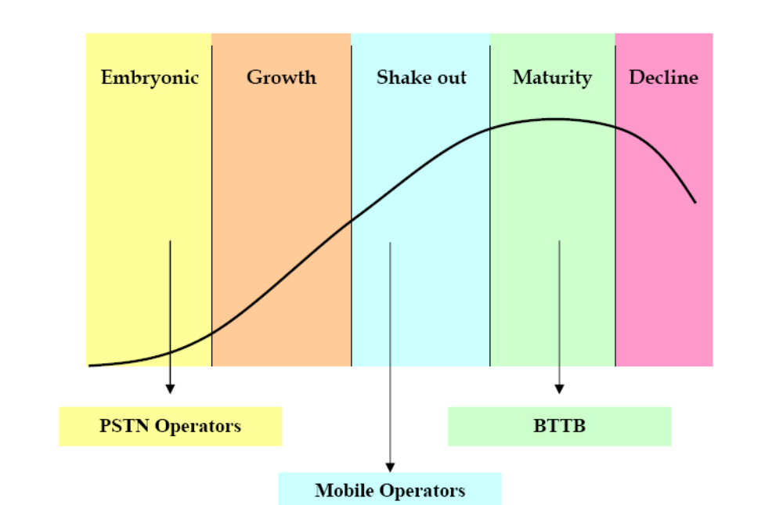
Figure 2: Industry Life Cycle

On the other hand, BTTB, the oldest telephone operator in the market is in the late maturity stage. Their demands have leveled out and it is not increasing even though they cover the rural areas. The growth of the mobile industry is the main reason for the demise of BTTB.

Major players in the Market

There are currently six telecom operators in the market. They are –
1. Grameenphone Limited
2. AKTel
3. Banglalink GSM
4. CityCell Digital
5. Teletalk Bangladesh Limited
6. Warid Telecom

AKTel

TM International is a joint venture between Telekom Malaysia Sdn. Bhd of Malayasia and A. K. Khan and Company Ltd. of Bangladesh with A. K. Khan and Company holding 30% of the share. AKTel came into operation on November 15, 1997. At the current moment, it has over 3.4 million subscribers.

Banglalink GSM

Banglalink entered the market in September 2004 with a large hype. Unlike other operators, it entered the market with an already established network by acquiring Sheba Telecom – the worst performing telecom operator then. Immediately recognizing the negative image of the previous company, the Orascom owned subsidiary re-branded itself as Banglalink. The company immediately started making heavy investments in expanding and improving the network. Its heavy spending has created a strong brand presence in the market as well. Very recently it has crossed over 2.8 million subscribers.

CityCell Digital

The oldest mobile operator in the country seems to be the most in trouble. It is the only operator with CDMA connection. Despite being the first company in the market, it had failed to reap any of the benefits of being the first entrant. With its initial exorbitant pricing, inability to use cheaply available sets from the market and a poor quality network created a really poor image for the company. Although it has recently started offering the lowest prices in the market, it failed completely to gain market share and is constantly falling behind.

Teletalk Bangladesh Limited

Teletalk Bangladesh Limited (TBL) is formed as Public limited company under the Companies Act 1994 on 26th December 2004 of the country. Therefore it is a Govt. owned company. Teletalk is the operational entity of BTTB Mobile Project. Teletalk launched its Mobile Telecom service on commercial basis on 31st March 2005.

Although a new entrant, Teletalk is staffed by experienced Telecom Engineers Committed to accessibility, quality, coverage and price Teletalk launched it's much anticipated Mobile Telecom service on commercial basis on 31st March 2005.

Warid Telecom

Owned by the Dhabi group from UK, it is the latest entrant in Bangladesh. However, Warid has very recently started its operation and is yet to create any significant impact on the market.

Competitive Scenario

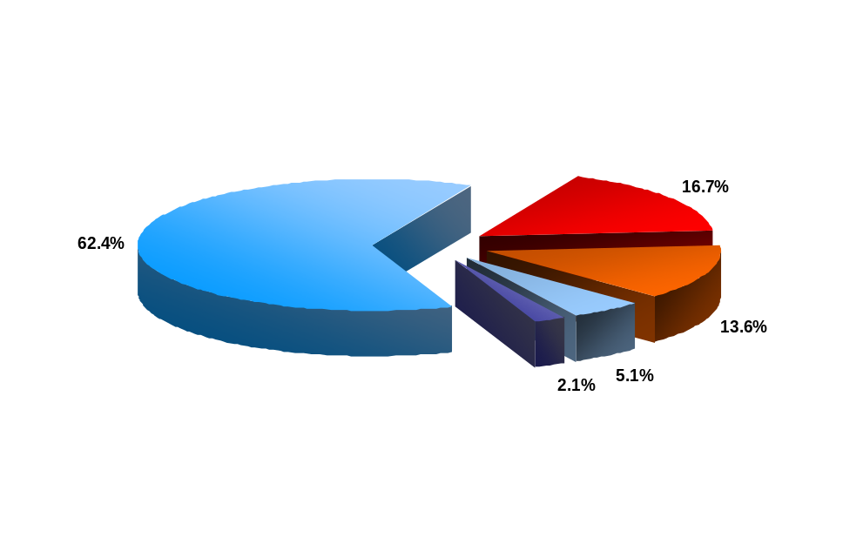




In the competitive scenario only five major players’ statistics are considered. Market information of Warid is not yet available. The present market share of the mobile operators is as follows -
Fig 3: Market Share, April 2007

The following table shows the actual number of active subscribers of each operator –

Table 2: Total number of subscribers, April 2007
Company | Total number of subscribers  (approx. Million)
GrameenPhone (including djuice) | 12.68
Aktel | 3.4
Banglalink | 2.8
Citycell | 1.02
Teletalk | 0.42
Industry | 20.3

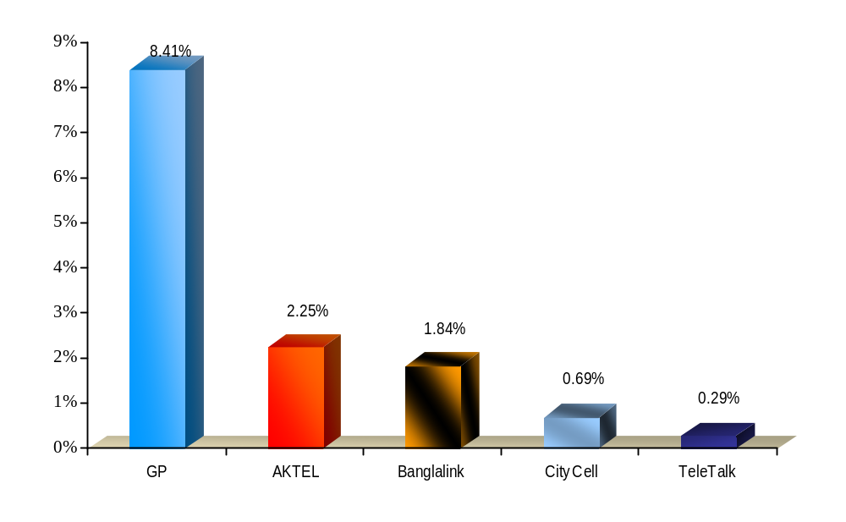Among the operators GP is most aggressively capturing market shares followed by AKTel. The next graph shows the market penetration rate of each operator –
Fig 4: Market Penetration Rate, April 2007

Product Positioning Map

The following graph shows how Grameenphone product is positioned in terms of competition. In one axis, price is the variable and on the other one, number of features is the variable. The total map represents the value provided to the subscriber by each operator. However, the shaded position in the map shows where Warid Telecom is trying to position itself but more market information is needed to find the true position of Warid.
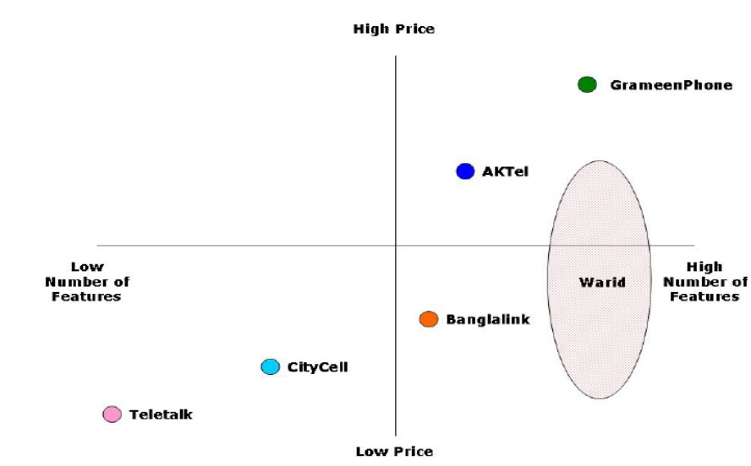
Fig 5: Perceptual Map

Chapter 3: Company Profile

Grameenphone Limited is the largest telecom operator in Bangladesh. In fact, most of the development of the telecom market of this country can be attributed to this company. At the current moment, the company has 62.8% of the mobile market share.

Purpose of the Company

Grameenphone (GP) has been established to provide high-quality GSM cellular service at affordable prices. Grameenphone has a dual purpose:

- To receive an economic return on its investment
- To contribute to the economic development of Bangladesh

Historical background

Grameenphone was offered a cellular license in Bangladesh by the Ministry of Posts and Telecommunications on November 28, 1996. The Company launched its service on March 26, 1997, the Independence Day of Bangladesh.

In 1996, Bangladesh was preparing to auction off private cell phone licenses to four companies. So at the behest of Dr. Muhammad Yunus (Grameen Bank’s founder) but completely independent of Grameen Bank, a not-for-profit private company called Grameen Telecom was created. Grameen Telecom, in turn, created a for-profit company called Grameenphone, found a foreign partner, and put in a bid; Grameenphone received one of the four licenses. Grameenphone total capitalization was US$120,000,000, including around US$50 million from IFC/CDC, and the Asian Development Bank (ADB). It also received US$60 million in equity from the four Grameenphone private partners. These were the Norwegian Telenor with a 51% share, Marubeni of Japan with a 9.5% share, and the American Gonophone at 4.5%. Grameenphone’s fourth partner is Grameen Telecom (with 35%), and Grameen Telecom borrowed US$10.6 million from the Open Society Institute to set up Village Phone. Grameenphone launched service in urban Dhaka on March 26, 1997. It makes its profits by serving wealthier urban customers. But from the point of view of the Grameen family and its strong anti-poverty mission, the for-profit, urban-only Grameenphone exists for only one reason: To fund, with its profits, the extension of cell phones into rural Bangladesh in order to provide entrepreneurial opportunity to Grameen Bank members through Village Phone. As Dr. Yunus puts it, "Grameenphone is merely what we need to do Grameen Telecom’s Village Phone."

Shareholders of Grameenphone:

Grameenphone has 2 shareholders - Telenor & Grameen Telecom

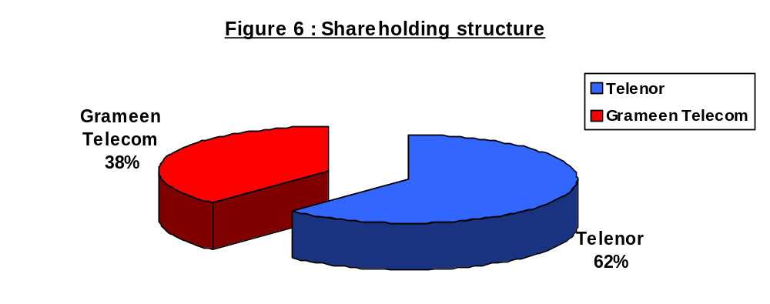

The shareholders of Grameenphone contribute their unique, in-depth experience in both telecommunications and development.

The international shareholder brings technological and business management expertise while the local shareholder provides a presence throughout Bangladesh and a deep understanding of its economy. Both are dedicated to Bangladesh and its struggle for economic progress and have a deep commitment to Grameenphone and its mission to provide affordable telephony to the entire population of Bangladesh.

Telenor Mobile Communications AS

Telenor AS is the leading Telecommunications Company of Norway listed in the Oslo and NASDAQ Stock Exchanges. It owns 62% shares of Grameenphone Ltd. Telenor has played a pioneering role in development of cellular communications. The Norwegian company is one of the world’s leading mobile operators, with owner ship interests in 13 mobile operations across Europe and Asia, constituting a total subscriber base of more than 115 million.

In the last few years Telenor has achieved tremendous growth and a significant portion of it is attributed to Grameenphone. The subscription base of Telenor is shown in the following graph –
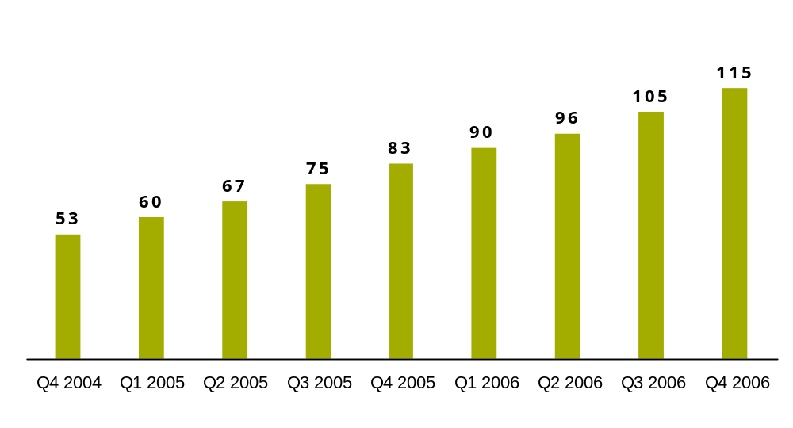Note: figures in millions

Fig 7: Subscription Base of Telenor

It has substantial international operations in mobile telephony, satellite operations and pay Television services. In addition to Norway and Bangladesh, Telenor owns GSM companies in Denmark, Austria, Hungary, Russia, Ukraine, Montenegro, Thailand, Malaysia and Pakistan. The affiliates of Telenor are –











Norway (100%)
Sweden (100%)
Serbia (100%)
Pakistan (100%)
Thailand(73.2%)
Montenegro (100%)
Denmark (100%)
Bangladesh (62%)
Hungary (100%)
Ukraine
(56.5%)
Russia(29.9%)
Malaysia (61%)
Austria (17.5%)

Figure 8: Telenor Affiliates

Grameen Telecom
Grameen Telecom, which owns 38% of the shares of Grameenphone, is a not-for-profit company and works in close collaboration with Grameen Bank. The internationally reputed bank for the poor has the most extensive rural banking network and expertise in microfinance. It understands the economic needs of the rural population, in particular the women from the poorest households. Grameen Telecom, with the help of Grameen Bank, administers the Village Phone Program, through which Grameenphone provides its services to the fast growing rural customers. Grameen Telecom trains the operators, supplies them with handsets and handles all service-related issues. Grameen Bank currently covers more than 51,000 villages which are serviced by 1326 bank branches (December’ ‘04) all over the countryside. At the end of the year, the bank had 3.78 million borrowers, 95 percent of whom were women.

Grameen Telecom’s objectives are to provide easy access to GSM cellular services in rural Bangladesh, creating new opportunities for income generation through self- employment by providing villagers with access to modern information and communication based technologies.

Vision & Values Grameenphone

Vision

We’re here to help

This means that we help our customers get the best out of communications services in their daily lives by making it easy to buy and use our services, delivering on our promises, being respectful of differences and inspiring people both inside and outside the company to reach higher goals.

Values of Grameenphone:

GP’s Values help fulfil its Vision. The values are:

Make it easy
This means – “We are all about making things easy. Easy to understand, easy to use and easy to get hold of products and services. Easy and helpful working relationships. We offer real value. We are about making things more simple and mutually-beneficial for everyone with whom we come in contact with on a day-to-day basis.”

Keep promises
This means – “We are about delivery, not over-promising. For us, actions speak louder than words. We try to clearly understand our audience’s needs and respond accordingly. We are clear, to-the-point and focused in our behaviours and actions. We deliver upon, and exceed expectations.”

Be inspiring
This means – “We are innovative and quality-driven in what we do and how we do things. We are closely involved in our community and with our employees. We lead by example; we value our customer’s relationships and feedback with us and are constantly open to new ideas. We drive the mobile communications market in Bangladesh.”

Be respectful
This means – “We are helpful, open and friendly. We are respectful and professional with all our interactions, internally, externally. We must always keep in mind that our success is based on having loyal, satisfied and supportive customers, employees and partners. We are confident, without being arrogant.”

Company Organogram

Erik Aas
Managing Director
Ahmed Raihan Shamsi
Deputy Director, Company Secretary
Syed Yamin Bakht
Head of Information
Lutfor Rahman
Acting Head of IT
N K A Mobin
Director, Projects
Kafil H. S. Muyeed
Director, New Business
Md. Shafiqul Islam
Chief Technical Officer
Md. Arif Al Islam
Director Finance
Khalid Hasan
Director Regulatory & Corporate Affairs
Emad Ul Ameen
Director Human Resources
Farhad F Ahmad
Head of Internal Audit
Frank Fodstad
Deputy Managing Director
Stein Nævdal-Larsen
Chief Marketing Officer

Figure 9: Organogram

Grameenphone Milestones

1997
March:
Began operation on the Independence Day of Bangladesh
1999
August:
Launched first Prepaid Service in the country
2003
August:
Reached One million Subscribers
October:
Launched prepaid product with PSTN connectivity
2004
August:
Reached 2 million Subscribers
2007
February:
Business Solution Re-launched
April:
Djuice Re-launched
2005
April:
Reached 3 million Subscribers, Launch of “djuice”, a youth brand, for the first time in Bangladesh
August: Reached 4 million subscribers
September: Launched EDGE and Voice SMS for the first time in Bangladesh
October: Reached 5 million subscribers
January: Launch of Business Solutions- segmented offering for the Business Segment, Reached 6 million subscribers
September: Launch of CIC
November: Celebrated 10million subs in 10 yrs & launched New Logo , Launch of Healthline
December: Launched Smile Prepaid & xplore Postpaid, Launch of Bill Pay
2006
June:
Launched mobile to mobile service (Without PSTN access)
1998

Services offered by Grameenphone

Company Service

Grameenphone believes in service, a service that leads to good business and good development. Telephony helps people work together, raising their productivity. This gain in productivity is development, which in turn enables them to afford a telephone service, generating a good business. Thus development and business go together.

Service for the Rural Poor

Establishing a nation wide network gives fair access to all geographical areas. From a business point of view, this strategy serves both the long distances as well as the rural markets. This emphasis on rural coverage brings a much-needed infrastructure in the underdeveloped rural areas. In collaboration with Grameen Bank, which provides micro-credit only to the rural poor, GP utilizes the bank borrowers to retail telecom services in the rural areas. Leveraging on Grameen Bank borrowers reduces the distribution costs of Grameen Phone's rural services, contributing to the profitability of this segment.

By bringing electronic connectivity to rural Bangladesh, Grameenphone is bringing the digital revolution to the doorsteps of the rural poor and unconnected.

Village Phone Program

The Village Phone program is Grameen Phone's unique method of bringing connectivity to the rural areas of Bangladesh. This program enables Grameen Bank's borrowers to retail telephone service in their respective villages, and has the potential to penetrate the rural areas rapidly and effectively.

A typical Grameen Bank borrower takes a loan of Tk 6000 without collateral from the Bank to purchase, say, a cow. The cow would then produce milk that the borrower could sell to her neighbours enabling her to make a living and pay off the loan. The process allows the poorest of the poor to stand up on their feet. In the case of Village Phone, a telephone also acts as an income generating mechanism for a borrower; a telephone serves as another "cow." A woman borrows about Tk 20,000 from the Bank and purchases a handset and sell telephone services to the villagers, making a living and thus paying off her loan. It creates a self-employment opportunity in each village and provides access to telephones to all.
Grameen Telecom, Grameen Bank's arm for administering the Village Phone operators, typically selects women by considering past borrowing records with the Bank. There are 2144 Village Phones in operation today and soon thousands of Village Phones around the country are expected across rural Bangladesh.

Grameenphone of Grameenphone

Grameen phone offer their products under 3 different brand names –

- Grameenphone
- djuice
- Business Solutions

The products offered are –

- xplore Package 1- Post paid with PSTN connectivity
- xplore Package 2 -Post-Paid with PSTN connectivity with monthly package fee
- SMILE M2M- Prepaid with mobile to mobile
- SMILE PSTN -Prepaid with PSTN connectivity
- djuice - Prepaid with mobile to mobile targeted for youth with life style benefits
- Business Solutions Prepaid - Prepaid with PSTN connectivity
- Business Solutions Postpaid - Postpaid with PSTN connectivity targeted for Business Segment
- GP Public Phone
  - Post-Paid with PSTN connectivity
  - targeted for PCO segment
- Village Phone
  - Postpaid with PSTN connectivity
  - subsidized tariff

Subscriber Base & growth Rate of GP
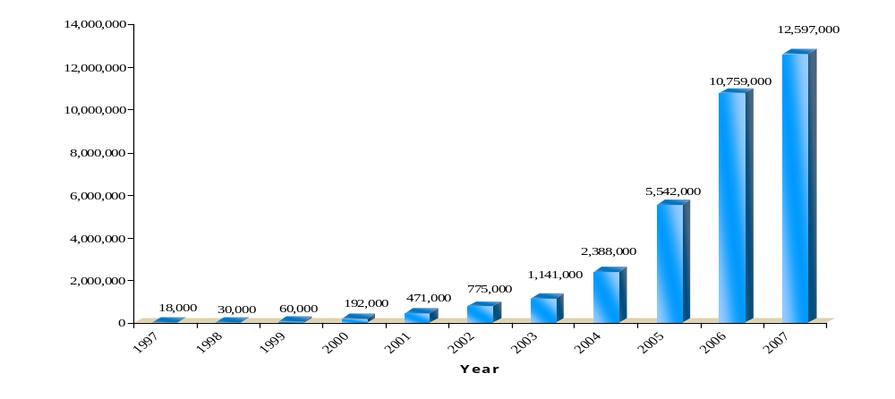
Growth:15%
Growth: 100%
Growth: 219%
Growth: 146%
Growth: 64%
Growth: 67%
Growth: 109%
Growth: 47%
Growth: 132%
Growth: 94%

Fig 10: Growth rate of GP

Value Added Services Offered By GP

Text mail
Voice Mail
1997
2005
1999
2000
2001
2002
2003
2004
2006
Info Service
Iftar & sports update
Fax/Data
WAP
IVR
Push Pull
SMS banking
SMS to e-mial
Premium Contents
Shrimp News
Cooking Recipe
SMS Web Dev
Quiz
GP Sixer
Voice SMS
GPWorld
Cell Bazaar
Opera Mini
Bangla SMS
Welcome tunes
GP IM
2007
Mobile ESPN

CSR activities of Grameenphone

The most significant CSR activity of GP is the Grameenphone Community Information Centre (GPCIC)

- GPCIC is a place where people can access information & communicate with family/friends living home/abroad through internet.
- It uses the simplest technology. The internet connection is provided by an edge modem and an edge enabled SIM.
- CICs are designed to be run independently as small businesses by local entrepreneurs. GP provides training, 3 SIM cards and marketing materials to these entrepreneurs free of cost.
- Currently 557 CICs are running in 434 Upazillas in 6 divisions.
- GP is rolling out Community Information Centers across rural Bangladesh giving people in remote areas the chance to use internet based services e.g. E-mail, browsing, voice chatting, video conferencing and so on.

Among other CSR activities there are –
- Computers to schools and institutions
- Long term funding of orphanage
- Road beautification projects
- Raising funds for tsunami victims
- Earthquake Preparedness program
- A number of socio-cultural activities

Chapter 4: Background of djuice

Background of djuice

djuice is a mobile subscription for young people who use the mobile phone for communication and entertainment. It is a registered trademark owned by Telenor, which is a leading provider of mobile voice and value added services in the Scandinavian region, Central Eastern Europe and South East Asia and embraces operation in 12 countries. djuice is currently operating in Norway, Sweden, Ukraine and Hungary.

Why djuice (and not another youth brand)

Initially many names were proposed which was felt would attract the youth (E.g. Boom). However a market research revealed interesting information that people respond to the name “djuice” which is a short form of ‘digital juice’. Whether the response ultimately has a negative or positive effect comes later, but it serves the purpose of being an instant attention-grabber. The name djuice has successfully enabled the brand to get the much-coveted attention, for every inch of which all the brands are virtually at war.

Reasons behind launching djuice

Youth segment of our country comprises 40% of the total population and they have a potential growth of about 60%. If the youth group can be attracted and they become customers when they are young, they will remain loyal as they get older and more established. Most of the urban young people are interested in technology and are high users of new technology and mobile data services. Mobile phone is the most important tool to communicate with their friends, family and acquaintances. So in order to understand their language, djuice is the appropriate tool.

Grameenphone has launched djuice with its own identity and product offerings. It is Grameenphone’s brand to strengthen the position in the youth market. djuice is the tool to sell and get new customers, increase usage and adoption of new non-voice services, increase loyalty and strengthen Grameenphone brand.

The Modern Go-getters hold 50% of the total market’s value share and it is also the segment on which Aktel had its largest share. djuice was launched in an attempt to attain this fast growing and large value share market. djuice also wanted to get Citycell’s Gen-Yo out of people’s head. The massive advertising campaign was partly in response to Citycell’s campaign for Gen-Yo. The task is to differentiate GP from competition by projecting the brand as: Status symbol, hi- tech and reflection of ‘My’ identity.

Market segmentation and target group definition for djuice before the Relaunch

In a survey conducted by Grameen Phone it was found out that the total market was broadly classified into 4 large segments:

- Self-Driven Orthodox (20%)
- Balance seekers (15%)
- Pro-modern conformist (15%)
- Modern Go-getters (50%)

djuice targeted the Modern Go-Getters.

The ‘youth’ in Bangladesh do not form a homogenous group. There are 2 distinct groups of youth.

Youth Group 1 (Primary target group)

Image conscious: This group follows an extremely busy schedule. Usually come from English Medium educational backgrounds. They are trendy, fashion conscious and enjoy fashion, music, sports. Moderate to high affluence. Hang around in fast food joints. Heavily influenced by Satellite culture. Aspiration self emulates popular western youth. Prefers cultural salad.

Youth Group 2 (Secondary target group)

Cash-strapped: Dreams primarily of economic independence. Less optimistic about future. Inherent lack of entertainment in life. Politically more active and nationalistic. Less bothered by time-constraint. Aspiration self emulates successful Bangladeshi people. Skeptic about the new things of modern culture. Reads more. Migrated to city in search of better life.

However, there are certain aspects that bind the two groups together:
They both agree that there is a lack of entertainment in their lives & want to be successful in life

The term Young-at-Heart is used to define the consumers of djuice. They fall mainly within the Modern Go-Getters. The target market is divided into two groups: primary and secondary.

The primary target market includes people from 19-26 years of age and the secondary market focuses 15-18 and 27-30 age groups, mostly males. The targeted segments are mainly from Dhaka and Chittagong metro. Most of them are students and business persons and their educational background is above HSC. Their average monthly household income is over Tk. 15,000 and most of them are from nuclear families with elders.

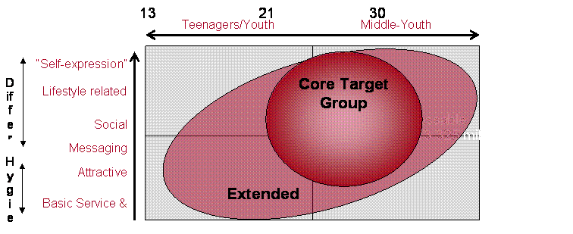
Figure 10: Youth Market segmentation and target group

djuice first time launch activities- at a glance

- Teaser Ad was published in print and electronic media to create hype among the youngsters.
- On the occasion of djuice launch, a press conference was organized at Pizza Hut on 14th April, 2005 (Bengali New Year) - highlighting the whole package, that is, not only products and features but also lifestyle benefits which has worked as a differentiator in the Market.
- Djuice website (www.djuice.com.bd) for youth was launched for the first time in Bangladesh.
- Concerts were organized (15th -20th April, 05) in Dhaka and Chittagong city with local music bands and Indian Idol.
- djuice logo visibility was ensures through Billboard, Balloons etc, especially in youth hangout places.
- Bengali New Year’s day (14th April) program was sponsored with djuice Brand in Fine Art Institute at Dhaka University and Bashundhara City (City Shopping Mall)
- Print ads were heavily published; TVCs were frequently aired and leaflets were distributed extensively at strategic locations.
- “BLACK”- a local music band, which is most popular among youths, was appointed as Brand Ambassador for djuice
- For Lifestyle benefits: Agreements with Tactical and Strategic Partners (Such as, Pizza Hut, Helvetia, Sports world etc) were signed prior to launch and is ongoing.
- Profiling was done at 10 points of sale as exclusive djuice POS
- Channel Partners were trained prior to launch for creating awareness and for education.
- Gifts were produced and distributed heavily to increase logo visibility

djuice Positioning Strategy before relaunch

djuice – a mobile lifestyle concept


High Involvement

Low Involvement

Price

Value
Lifestyle Expression
Hassle-free
basic Services
Price leader
Security & Service

Figure 11: Perceptual Map of djuice

Brand Personality of djuice before relaunch

Grameenphone wanted to portray djuice as a friend who consumers can relate to and understand. This is done to attract the target market, which includes the young people of the metropolitan cities of Dhaka and Chittagong. Grameenphone would like the consumers of djuice to think of two very important things, which are:

- Success
- Entertainment

So djuice, who is empathetic, refreshing, dynamic, challenging and socially active, is supposed to be a friend to the young people. djuice is supposed to evoke the sense of success and entertainment among the consumers.

Table 3: Brand Personality of djuice

Refreshing | - Inspiring with new ideas  - Sparkling and entertaining
Empathetic | - Insightful – Wiser and slightly wiser than me (been around town before)  - Friendly – Generous and including  - Talking with me – not to me
Dynamic | - Pro-active and active  - Deliver results
Socially active | - Outgoing with a network  - Interested and Interesting
Challenging | - Doing new things  - Brave and edgy

Product, price & promotion before rebranding

Product
The product description of old djuice was as follows:
- It provides freedom to store up-to 200 friends’ numbers through the e-phonebook feature
- Maximum forty messages can be saved
- It provides the facility of Group Message. Maximum 10 groups with maximum 25 members can be added. Subscriber will be charged as per group members
- It has dedicated djuice menu to secure easy access to attractive SMS and voice based services
- Balanced combination of several tailor-made elements/benefits
- Pre-paid with ddifferentiated feature options (group message, STK, My time, Free trials (SMS)

XTRA card
djuice has identified three focus areas around which the youth’s interest seem to lie. They are: music and movies, shopping and food. Thus, djuice has formed strategic alliance with various companies such as G-Series, Kay Craft, Pizza Hut & Fantasy Kingdom etc. to be able to provide privileged access to all djuice customers. These extra facilities are what djuice wants to use to gain customer loyalty through innovative ideas. They can be availed at the various outlets by showing the Xtra card that comes along with it.

Price
The price of djuice needed to be kept as low as possible as it is a crucial aspect for the target market that is young and hence has a limited budget. The aim was to create perception of good value for money (more for same), take the SMS position leadership with regard to services, offer differentiated tariff option as per segment requirement and build community pricing. The pricing of djuice is as follows:

- SIM card priced at TAKA 300
- TAKA 1.66 per pulse at peak time.
- 20 second pulse from the first minute.
- First 50 SMS free
- TAKA 50 free talk time at the beginning
- SMS at TAKA 1.

Promotion
The distinct feature of djuice is that no mobile phones are shown in the ads. Generally all Telecom companies advertise their product describing the product features, the price rate, pulse rates, tariff rates and other Value Added Services. But for djuice a conscious effort was taken to ensure that the advertisements do not show any mobile phone, no condescending tone is used, have no call for action and portray a particular lifestyle: that of the youth segment of our population.

The advertising approach used in its initiation was creating mass awareness, which it has done effectively. This can be attributed to two factors: The core product is good and the youth segment can connect with the ads. The main medium used were television, newspapers, magazines and billboards.

Some ambiguities about the product itself were also kept for the same purpose of arousing curiosity in people, so that they would question and talk about it. Word of mouth is the most effective tool of communication to the youth segment for which purpose this approach was used.

Chapter 5: djuice Relaunch

Background

The world is ever changing to survive and to create. To be the leading youth brand, djuice also need to constantly challenge and adjust itself with the changes of the world’s young generation. It needs to portray our brand as ever evolving, refreshing, happening and easier to understand and relate to.

The 2007 rebranding plan reflects a simpler version of the brand that anyone can find relevance and feel part of it. So that, eventually it becomes an Integral part of their life.

2007 is not a REVOLUTION for djuice … it is an EVOLUTION.
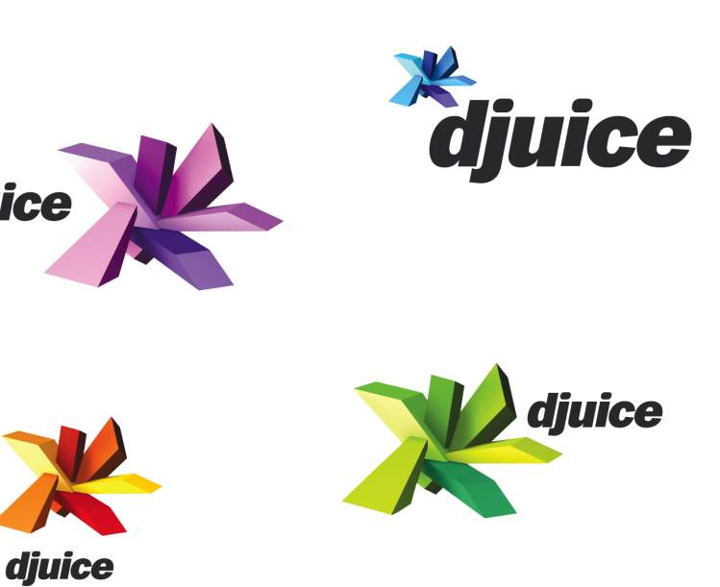


Evolution
Fig 12: djuice Evolution

Rebranding

Rebranding means changing one or more brand elements of the brand to change or modify its positioning. Usually during rebranding - a few or all of the brand values & characteristics get changed. Sometimes in rebranding every aspect of the brand is changed.

The rebranding of djuice is a partial modification. Other than the name all the brand elements are changed to reinforce the brand characteristics & modify the brand value. The ultimate objective of this rebranding is to give the brand an appropriate positioning in the mind of the target group, so that the youth segment can associate themselves with the brand.

The Vision & Mission of Djuice

Vision:

The vision of djuice is same as that of Grameenphones Mother Brand – “We are here to help”. It means –

djuice exists to help the customers get the full benefit of communications services in their daily lives. The key to achieve this vision is -

- Making it easy to buy and use our services
- Delivering on our promises
- Being respectful of differences
- Inspiring people to find new ways

Grameenphone has the same vision but djuice caters to its target segment.

Mission

The mission of djuice is –

“We bring young people the ‘ESSENTIAL MIX' to help them make most out of their mobile life”

It means –djuice is here to help young people making most of their mobile life. The key to fulfil this mission is to understand their needs, dig into their mindset and understand the mobile drivers, behaviour and attitude. And based on that design services and attach lifestyle to their mobile phone – “My mobile life”

The Brand Elements

Brand values

The djuice brand values and personalities are a reflection of the mother brand-

We are inspiring by being refreshingly different
We are respectful and keep promises by being empathetic
We make it easy by being easy to relate to

Brand characteristic of djuice

- Creative, modern and fresh
- Passionate
- Acknowledge and respect
- Loyal
- Practical
- Simple
- Trust worthy

Brand personality

- We want to know, hear, see, do more
- We are constantly evolving by surprising, defying convention, challenging
- We embrace contradiction
- We don’t brag rather under promise to over deliver
- We talk straight from heart

Target Segment

Djuice is a youth segment Brand so its obvious target is the youth. But the target segmentation has been modified since the rebranding. The following diagram shows the target segment of djuice:

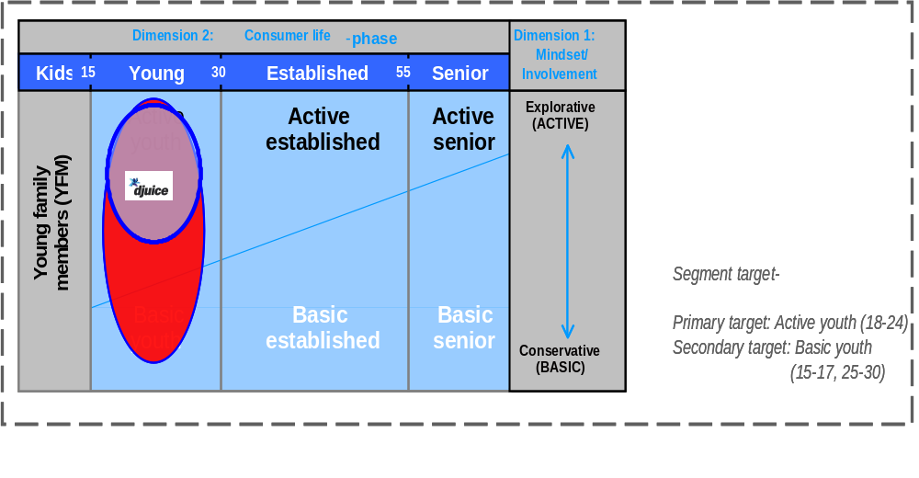
Fig 13: Target Segment of djuice

The characteristics of the primary target segment:
- Live, work and play hard
- Distinct need for entertainment
- Least likely to turn off the phone, mostly mobile-only consumer
- Placing value on keeping track of the mobile development, desire the latest, best products and services
- Possibilities and options are important.
- Risk/ adventure, materialism, status and individualism are key words

Though only two sub-groups of youth segments were mentioned – Active & Basic, in countries like Bangladesh, where people in general are not that much tech savvy yet, there is a third sub-group in the youth segment – Aspiration youth. This Aspiration group is considered to be the equivalent of the Active Youth of western countries in terms of there lifestyle. In Bangladesh the target segment of djuice is considered a pyramid –
Aspiration Youth

Active Youth

Basic Youth

Fig14: Youth segment Pyramid

Brand positioning

The current brand positioning of “offers relevant more” is often associated with VAS/mobile content as the most important brand differentiators. It is focused on quantity rather than quality and also product driven. We need to position the brand more precisely towards “experience-driven”

Fig 15: Positioning of djuice
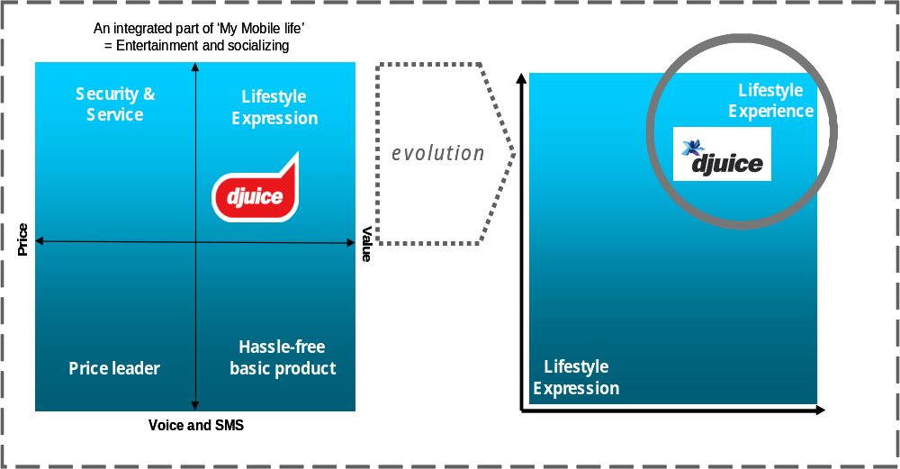
Aspiration Youth

Active Youth

Basic Youth

Even though djuice is a youth lifestyle brand, it is not positioned for all youth. Brand guideline says it should be positioned for the most trendy & tech savvy youth group. In Bangladesh that is the aspiration segment. But in our country it is actually positioned for the top end of Active youth. So there is a chance djuice will not be able to attract the Aspiration youth segment. But if they positioned it for aspiration youth, the basic youth will not be able to associate themselves with the brand. The size of basic youth is significantly high in Bangladesh, where as the Aspiration youth segment size is very low. Hence the positioning is a bit deviated from the brand guide line.

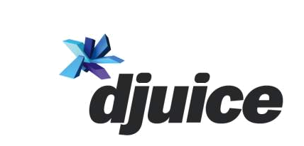

Fig 16: Position of djuice among different target segment

Djuice as a youth lifestyle brand

A youth lifestyle brand means all the brand elements will be appropriate for the youth segment. They will agree with the brand values and find similarity between their known characteristics and those of the brand. They will be influenced by the brand personality and will be willing to associate themselves with the brand. Djuice surely tries to position itself as a youth lifestyle brand.

Previously djuice was unable to do so, that is why this rebranding has occurred. In the next section conduct a research will be conducted on the rebranding to find out whether it is successful or not.

Chapter 6: Qualitative Study on the rebranding of djuice

The rebranding of djuice was targeted to better position it as a youth lifestyle brand. Worldwide it was mostly a successful effort. But in the context of Bangladesh, the success of this brand refinement is yet to be discovered. In this section a study will be discussed which was conducted on the youth segment of Bangladesh to find out the effectiveness of the rebranding of djuice

The Big Question

Every research must start with a problem. In this study the problem is that the effectiveness of the rebranding of djuice in positioning it as a youth lifestyle brand is still unknown. However, there is a good scale to measure this. The effectiveness of every brand element can be measured against that of the old djuice.

Hence the problem statement of this study is –

“The effectiveness of the rebranding of djuice as a youth lifestyle brand is still unknown”

The research steps

The study will be conducted in two phases – firstly, the qualitative study & secondly the quantitative study.

In the qualitative study, both the primary (age 18 -24) & secondary target group of djuice will be covered. In the second stage, the target group of the quantitative study will be narrowed down to statistically verify the hypothesis constructed from the qualitative study.

Qualitative Study

djuice is a youth brand. So the qualitative study will be mainly done on the youth section.

The target audience of djuice is the youth segment. This segment is sub divided in the categories-
- Basic youth
- Active Youth
- Aspiration Youth

The positioning of djuice varies based on the size of these sub-segments. In Bangladesh, basic youth is the largest group. But djuice is positioned for the active youth segment, so that the active youth market can be tapped & it turns something inspirational for the basic youth group

Objective of the Qualitative Study

- Identify the psychographic characteristics of the sub-groups in the youth segment
- Identify the criteria for satisfaction with mobile brands performance among the different sub-groups
- Find out the perception regarding the brand personality of djuice among different sub-groups before and after the rebranding of djuice
- Find out djuice’s performance as a youth lifestyle brand among different sub-groups before and after the rebranding of djuice
- Identify the level of loyalty among the djuice users

Methodology of Qualitative Study

- Population of Interest/ Scope of the Study:

The qualitative study was done on the youth segment of Country. For the study we have considered people from age 16 -30 as the youth segment. Based on their ages the youth segment was based on 3 sub-categories – Age 15 - 18; Age 18 – 24, Age 24 – 30. These 3 different age groups do not have any significance in terms of the research because the sub-groups of the youth segment will be formed based on psychographic characteristics. The age groups are formed only for the qualitative part so that people of different age groups are covered. However, the financially constrained people were not considered in the study. The population was selected form Dhaka, Chittagong & Khulna. The population was chosen from various income brackets to find out if there is any link of the sub-groups of the youth segment and there income

- Research Techniques used:

To fulfill the objectives of the qualitative study two techniques were used –
Depth Interview & Focus Group Discussion (FGD)

- Depth Interview: It was conducted on 24 people, 8 from each sub-category. Young people form Dhaka, Chittagong & Khulna were included in this study. The participants were mostly students, a few young service holders. The objective of the study is to find out – the psychographic characteristics of the youth, their criteria for satisfaction with djuice, their perception regarding the brand personality of djuice etc. Most of the information subliminal & people are hardly aware of these. So it requires a lot of probing to get this sort of information. That’s why depth inter view technique was used.

- Focus Group Discussion: Six FGDs were conducted in total. Participants of each FGD were chosen from only one age group to maintain homogeneity. FGD was conducted to find out the group view of Djuice as a life style expression brand. And its personality before and after rebranding.

Findings from the Qualitative research

1. The Psychographic characteristics of the Youth segment

Verbal Model:

The initial grouping was done based on Demographic characteristics. However, after the study, it was found that sub-groups based on psychographic characteristics would be more appropriate for targeting the youth. Even, Telenor worldwide also used psychographic characteristics to divide the target market of djuice. The categories they use are -

- Basic youth
- Active Youth
- Aspiration Youth

But the characteristics of the segments vary from country to country. From the study, these categories are created based on the following characteristics –

Aspiration Group

- Extremely tech savvy
- Informed about the new technological advancements & tries to use them all
- Have a very active life
- More inclined towards the western culture
- More adventurous & risk takers

Active Youth

- Tech savvy – uses most of the features available in their mobile phones
- Informed about the new technological advancements but use only those which are applicable and affordable
- Live, work and play hard.
- Distinct need for entertainment.
- Least likely to turn off the phone, mostly mobile-only consumer
- Risk/ adventure, materialism, status and individualism are key words
- Cultural orientation is a blend of local & western image
Basic Youth

- Not Tech Savvy
- Use their mobile phones mostly for voice calls
- More conservative
- More inclined to local culture
- Do not follow the modern trends even if they are aware of it

These sub-groups have some relations with age & household income. With increasing age people usually shit away from active youth to basic youth. Basic youth usually do not have strong financial support from family. There is also a relationship between gender and these subgroups. Usually, females tend to fall on the Basic Youth segment rather than the other two groups. However, the categories are mainly based on behavioral factors and during the quantitative study semantic deferential scales will be used to categories the participants.

Graphical Model:

The graphical representation of the main findings about the different sub-groups are shown below –

Aspiration Youth

Active Youth

Basic Youth
Financial Condition
Weak
Strong
Fig 16: Financial Condition of various Sub-groups of youth segment

The figure shows the relationship between the financial condition & the sub-groups of youth segment.

Hypothesis constructed from this section -

- Average monthly household income is higher for Active & Aspiration youth compared to basic youth.

- The average age can be a differentiating factor for the sub-groups youth segment.

- Gender can be a differentiating factor for these sub-groups of the youth segment.

2. Satisfaction Criteria:

Verbal Model:

Through the Depth interview & FGD many criteria were identified for the satisfaction level among the subgroups of the youth segment. Though most of these criteria are common for the satisfaction level of all mobile phone users, the importance put on different criteria are different for different sub-groups of the djuice target segment. The criteria selected from this section are - Quality, Technology, Value, Customer Service & Brand Personality. Brand personality is treated in a separate part. Each of these can be subdivided into multiple relevant factors factor. These are -

Quality depends on –

- RELIABILITY - The connection woks when required
- EASE OF USE - It is easy to use
- VOICE CLARITY - The other person can be heard clearly
- COVERAGE - The connection is available everywhere
- CALL DROP - The line does not drop when talking
- INTERCONNECTIVITY - Other operators can be called easily
Technology depends on –

- ADVANCEMENT - The operator is technologically up-to-date
- FEATURES - The service has state-of-the-art features
- RELEVANCE - The features are relevant to me
- INNOVATIVENESS - The operator is always coming up with new features and services
Value depends on –

- STARTUP COSTS - The startup prices are affordable
- TARIFF - The call rates are low
- PULSE - The pulse time is short
Customer Service depends on –

- COST OF SERVICE - costs is low
- WAITING TIME – Don’t have to wait long in line
- ISSUES SOLVED - Problems are usually solved
- AVAILABILITY OF SERVICE - Customer service easily available

However, different sub-groups focus on different criteria for satisfaction. For aspiration group, puts more importance on Technology. It does not mean they do not want good Quality in the connection. Rather they expect all the other satisfaction criteria as a mandatory for all operators & connections. Active youth focuses on – each of the four general criteria but not on all the sub factors. Start up cost is not a key factor for them to perceive the value of connection. INTERCONNECTIVITY (Other operators can be called easily) is not an important criteria for Aspiration or Active youth, but Basic youth consider it very serious Issue. Basic youth is more focused on - Value, Quality & customer service rather than Technology.

Graphical Model:

Quality
Customer Service
Value
Technology
Basic Youth
Aspiration Youth
Brand
Personality
Active Youth

Fig 17: Venn diagram of youth sub-groups

Hypothesis constructed from this section –

- Quality, Technology, Value, Customer Service all are important criteria for customer satisfaction among djuice target groups.

- Aspiration youth puts more emphasis on technology compared to Basic Youth.

3. Loyalty/ Retention Problem –

Almost all of the people interviewed use multiple Sim cards. So every operator in the country faces a retention threat from their youth segment customer base. Though it seems the aspiration youth group is more loyal, it can not be confirmed. However, the Basic & Active youth segment is not brand loyal to djuice. They use multiple Sims, but most of them have a djuice Sim. They use it based on specific offers of djuice.

Hypothesis constructed from this section –

- Youth segment uses multiple sim cards
- One of the multiple Sims they use is a djuice sim.
- They bought djuice sim during a special offer.

4. Brand personality of Djuice –

Brand Elements

Regardless of the sub-groups, the youth segment appreciates the new Brand personality of djuice compared to that of the old one. The level of appreciation decreases from aspiration to basic youth. In term of brand elements the preference of different sub group varies as well. The following table describes the preference of different groups in shown in the following table.

Brand Elements | Comparison with previous brand elements
Color | All groups agree it is better than old djuice color.
Logo | The Basic youth preferred the old logo, this logo is too complex for them
Communication message | All sub-groups preferred the new message (tag line) rather than the old ones. However, aspiration & active youth groups think it is still unsophisticated.
Jingle | The new one is preferred compared to old one.

Hypothesis constructed from this section –

- The color of djuice is rebranding appropriate for a youth lifestyle Brand.
- The logo of djuice after rebranding is appropriate for a youth lifestyle Brand.
- The old logo was too simple for a youth lifestyle brand.
- The new djuice message is appropriate for a youth lifestyle Brand.
- The old djuice message (Kothin vaab) was unsophisticated.
- The Jingle of djuice after rebranding is appropriate for a youth lifestyle Brand.
- The new djuice promotes freedom

Brand Characteristics –

To identify the brand characteristics of djuice, a word association technique was used. The participants identified most of the actual brand characteristics of djuice –
- Creative, modern and fresh
- Passionate
- Loyal
- Practical
- Trust worthy

However they failed to mention - Trust worthy and acknowledge & respect. According to them, djuice as a brand is not that much respectful to others. It is not trustworthy either. The other characteristics they came up with are – Smart, courageous, unconventional, sporty, fun, stylish etc. all of which can be deduced from the original brand characteristics.

Hypothesis constructed from this section –

- Brand Characteristics of djuice is – Creative, modern and fresh
- Brand Characteristics of djuice is – Passionate
- Brand Characteristics of djuice is – Respectful
- Brand Characteristics of djuice is – Loyal
- Brand Characteristics of djuice is –Practical
- Brand Characteristics of djuice is – Trust worthy

Brand Personality –

In case of brand personality, the participants of the qualitative study were asked whether they strongly agree, agree, disagree or strongly disagree with the personalities –

- We want to know, hear, see, do more
- We are constantly evolving by surprising, defying convention, challenging
- We embrace contradiction
- We don’t brag rather under promise to over deliver
- We talk straight from heart

All of them agreed to all the points. But active and aspiration youth group mentioned strongly agree. However, the basic youth segment could not associate them with – “We are constantly evolving by surprising, defying convention, challenging” & “We embrace contradiction”.

Hypothesis constructed from this section –

- Brand Characteristics of djuice is – We want to know, hear, see, do more
- Brand Characteristics of djuice is – We are constantly evolving by surprising, defying convention, challenging
- Brand Characteristics of djuice is – We talk straight from heart
- Brand Characteristics of djuice is – We are inspiring by being refreshingly different
- Brand Characteristics of djuice is – We are respectful and keep promises by being empathetic
- Youth segment can associate them with new djuice.

Chapter 7: Quantitative Study

Background of Quantitative Research

In the qualitative study we have identified a number of factors based on which the target market of djuice (youth segment) was categorized into a three sub-groups. The criteria for satisfaction with djuice for these subgroups were also identified. Their level of loyalty & their perception about the about the rebranding of djuice was also recognized. But the sample interviewed was very small. It is time to find out whether the findings are applicable for the population.

Objective of Quantitative study

Validate the hypothesis formed from the qualitative study.

Scope of the study
The scope of the study was narrowed down to the university students of Dhaka city. Since djuice is targeted towards the urban youth, university students are considered to be good representative sample of the population.

Sampling Plan:

Type of sampling

Probability sampling was used for the study, which means every university student of Dhaka city had a non-zero probability of getting selected for the study.

Sampling Frame, Element & Unit:

For probability sampling a sampling frame is required that contains the elements & sampling units. Sampling Frame is the list of elements from which the sample will be drawn. Sampling element contains the sampling units. Sampling Unit is a single element or group of elements subject to selection in the sample. The sampling frame was a list of the universities of Dhaka city, which was collected from University Grant Commission (UGC).

Sampling Method:

In conducting the research the target population was divided into 3 strata – Hons. Student, masters Students & Post-masters Students. In terms of demographic characteristics the youth segment attitude did not differ that much. That is why these strata were chosen.

The Population distributions of these strata in Dhaka city are as follow:

Strata | Population Size | Percentage
Hons. Student | 80,269 | 62%
Masters Students | 42,724 | 33%
Post Masters Students | 6,473 | 5%
Total | 129,466 | 100%

The sample size was determined as follows:

Sample size, n = z2*pq / E2

z = z value for a particular confidence level
p = probability of success
q = probability of failure
E = percentage of error

Calculation of sample size:
  - Confidence level: 95% z = 1.96
  - Percentage of error: 10% E = 0.10

Strata | p | q = 1 – p | n = z²*pq/E²
Hons. Student | 62% | 38% | 141
Masters Students | 33% | 67% | 132
Post Masters Students | 5% | 95% | 28
Total number of sampling units |  |  | 301

Six universities were chosen randomly and the number of participants from each university was in the following manner –

University | No of Student | Percentage of total student | No. of participant
BUET | 8,105 | 30% | 91
UIU | 1707 | 6% | 19
Stamford | 10,538 | 39% | 118
IUB | 3,228 | 12% | 36
University of Asia Pacific | 1,436 | 5% | 16
Eastern University | 1,879 | 7% | 21
TOTAL | 26,893 | 100% | 301

Every sixth student to enter the canteen was chosen for survey.

Questionnaire Design

Level of Scale

An interval scale has been used in most part of the questionnaire. In case of Binary answers, Nominal Scale has been used.

Level of Scale: Interval Scale

A 5-point modified Likert scale from 1 to 5, have been used, where:

1 | Highly Disagree
2 | Disagree
3 | Neither agree nor disagree
4 | Agree
5 | Highly Agree

The Questionnaire
SURVEY ON djuice REBRANDING
For Official
Purpose

Dear respondent, Thank you for giving me your valuable time. I am a student of IBA, Dhaka University doing a survey for my study purpose. Your response would be of great help in completing my study.

Name (optional): Gender: M/ F Education level: __________ Age: _________
C3
C4
C5

- Monthly household income _____________
C6

SECTION A: This section is designed to measure psychographic characteristics of a mobile phone user in the youth segment:

Please rate the following statements (2 to 13) according to the extent you agree with it.
1 = ‘highly disagree’, 2 = Disagree; 3 = Neither Disagree nor Agree; 4 =Agree & 5 = ‘highly agree’.

2 | “I look for new inventions in mobile technology” | 1 | 2 | 3 | 4 | 5 |  |  | C7
3 | “Voice calls are secondary use of mobile phone” | 1 | 2 | 3 | 4 | 5 |  |  | C8
4 | “I am a risk taker” | 1 | 2 | 3 | 4 | 5 |  |  | C9
5 | “I try to avoid conventional method” | 1 | 2 | 3 | 4 | 5 |  |  | C10
6 | “I like physical sport” | 1 | 2 | 3 | 4 | 5 |  |  | C11
7 | “I do not have sufficient entertainment in my life” | 1 | 2 | 3 | 4 | 5 |  |  | C12
8 | “I believe western culture is more trendy” | 1 | 2 | 3 | 4 | 5 |  |  | C13
9 | “I prefer western music than local music” | 1 | 2 | 3 | 4 | 5 |  |  | C14
10 | “I like to face challenges” | 1 | 2 | 3 | 4 | 5 |  |  | C15
11 | “I use MMS service” | 1 | 2 | 3 | 4 | 5 |  |  | C16
12 | “I never turn off my mobile phone” | 1 | 2 | 3 | 4 | 5 |  |  | C17
13 | “I participate in all activities to prove my self” | 1 | 2 | 3 | 4 | 5 |  |  | C18

In the analysis part the mean from these questions will be used. If the mean is over 4.5 then the participant will be considered “Aspiration Youth”. If it is below 4.5 but above 3 then “Active youth” and below 3 will be considered “Basic Youth”

SECTION B: This section is designed to measure the criteria for your satisfaction as a mobile phone user:
The broad criteria are – QUALITY, TECHNOLOGY, VALUE & CUSTOMER SERVICE

Please rate the following statements (14 to 30) according to the extent you agree with it.
1 = ‘highly disagree’, 2 = Disagree; 3 = Neither Disagree nor Agree; 4 =Agree & 5 = ‘highly agree’.

 | For Quality the followings are important -
14 | RELIABILITY The connection woks when required | 1 | 2 | 3 | 4 | 5 |  |  | C19
15 | EASE OF USE It is easy to use | 1 | 2 | 3 | 4 | 5 |  |  | C20
16 | VOICE CLARITY I can hear the other person clearly | 1 | 2 | 3 | 4 | 5 |  |  | C21
17 | COVERAGE The connection is available wherever I go | 1 | 2 | 3 | 4 | 5 |  |  | C22
18 | CALL DROP The line does not drop when talking | 1 | 2 | 3 | 4 | 5 |  |  | C23
19 | INTERCONNECTIVITY I can easily call other operators | 1 | 2 | 3 | 4 | 5 |  |  | C24
 | For Technology the followings are important -
20 | ADVANCEMENT-The operator is technologically up-to-date | 1 | 2 | 3 | 4 | 5 |  |  | C25
21 | FEATURES -The service has state-of-the-art features | 1 | 2 | 3 | 4 | 5 |  |  | C26
22 | RELEVANCE-The features are relevant to me | 1 | 2 | 3 | 4 | 5 |  |  | C27
23 | INNOVATIVENESS - The operator is always coming up with new features and services | 1 | 2 | 3 | 4 | 5 |  |  | C28
 | For Value the followings are important -
24 | STARTUP COSTS - The startup prices are affordable | 1 | 2 | 3 | 4 | 5 |  |  | C29
25 | TARIFF - The call rates are low | 1 | 2 | 3 | 4 | 5 |  |  | C30
26 | PULSE - The pulse time is short | 1 | 2 | 3 | 4 | 5 |  |  | C31
 | For Customer Service the followings are important -
27 | COST OF SERVICE - costs is low | 1 | 2 | 3 | 4 | 5 |  |  | C32
28 | WAITING TIME – I don’t have to wait long in line | 1 | 2 | 3 | 4 | 5 |  |  | C33
29 | ISSUES SOLVED - My problems are usually solved | 1 | 2 | 3 | 4 | 5 |  |  | C34
30 | AVAILABILITY OF SERVICE - I can always get customer service easily | 1 | 2 | 3 | 4 | 5 |  |  | C35

SECTION C: This section is designed to measure the loyalty among the Mobile user

31. How many mobile phone operators service do you use?
C36
a. 1 b. 2
c. 3 d. More than 3

C37
32. Do you use a djuice connection? Yes/ No

C38
33. If yes, then did you buy it due to some special offer? Yes/ No

34. If yes, then did you stop using it after the end of that offer? Yes/ No
C39

SECTION D: This section is designed to measure the effect of djuice rebranding

Please rate the following statements according to the extend you agree with it.
1 = ‘highly disagree’, 2 = Disagree; 3 = Neither Disagree or Agree; 4 =Agree & 5 = ‘highly agree’.

35 | “I like the color of new djuice logo better than the old one” | 1 | 2 | 3 | 4 | 5 |  |  | C40
36 | “I like the logo design of new djuice logo better than the old one” | 1 | 2 | 3 | 4 | 5 |  |  | C41
37 | “The old logo design was too simple” | 1 | 2 | 3 | 4 | 5 |  |  | C42
39 | “The new communication message is better than the old one”  (Duniyar shukh on my djuice) | 1 | 2 | 3 | 4 | 5 |  |  | C44
40 | “The old message was unsophisticated”  (Kothin vaab, jotil mood etc.) | 1 | 2 | 3 | 4 | 5 |  |  | C45
41 | “I can associate myself with the new Jingle” | 1 | 2 | 3 | 4 | 5 |  |  | C46
42 | “The new djuice (after re-branding) promotes freedom” | 1 | 2 | 3 | 4 | 5 |  |  | C47

Please rate them from 1 - 5 according to the already mentioned scale

43 | New djuice is - Creative, modern and fresh | 1 | 2 | 3 | 4 | 5 |  |  | C48
44 | New djuice is – Passionate | 1 | 2 | 3 | 4 | 5 |  |  | C49
45 | New djuice is - Respectful | 1 | 2 | 3 | 4 | 5 |  |  | C50
46 | New djuice is - Loyal | 1 | 2 | 3 | 4 | 5 |  |  | C51
47 | New djuice is – Practical | 1 | 2 | 3 | 4 | 5 |  |  | C52
48 | New djuice is - Trust worthy | 1 | 2 | 3 | 4 | 5 |  |  | C53
49 | New djuice says - We want to know, hear, see, do more | 1 | 2 | 3 | 4 | 5 |  |  | C54
50 | New djuice says - We are constantly evolving by surprising, defying convention, challenging | 1 | 2 | 3 | 4 | 5 |  |  | C55
51 | New djuice says - We talk straight from heart | 1 | 2 | 3 | 4 | 5 |  |  | C56
52 | New djuice says - We are inspiring by being refreshingly different | 1 | 2 | 3 | 4 | 5 |  |  | C57
53 | New djuice says - We are respectful and keep promises by being empathetic | 1 | 2 | 3 | 4 | 5 |  |  | C58
54 | I can associate myself with new djuice | 1 | 2 | 3 | 4 | 5 |  |  | C59
55 | If new djuice is a person I will definitely associate myself with him | 1 | 2 | 3 | 4 | 5 |  |  | C60

THANK YOU FOR YOUR COOPERATION.

Name of the Surveyor:
Time of Survey:
Date of Survey:
Name of the supervisor:

Sign of the Surveyor: _____________________________

Analysis

Reliability Test:

The reliability test was conducted by determining cronbach’s Alpha using SPSS Version 12.

Case Processing Summary

 |  | N | %
Cases | Valid | 294 | 97.7
Cases | Excluded(a) | 7 | 2.3
Cases | Total | 301 | 100.0
(a) List wise deletion based on all variables in the procedure.

Reliability Statistics

Cronbach's Alpha | N of Items
.716 | 52

The value was 0.716 exceeding the required value of 0.7.

In order to meet the objectives and test the hypotheses which were developed during the qualitative analysis, we used four Statistical Analysis techniques. These are:

- Descriptive analysis
- Factor analysis
- Comparison of means (ANOVA and One way T-test)

- Relationship with the Youth Segment sub-groups with age, income & gender:

Hypothesis to be tested:

- Average monthly household income is higher for Active & Aspiration youth compared to basic youth.

- The average age can be a differentiating factor for the sub-groups youth segment.

- Gender can be a differentiating factor for these sub-groups of the youth segment.

Based on the psychographic characteristics the youth segment was divided into three sub groups. All of the analysis will be done based on these sub-groups.

The total population distribution among these sub groups is –

Fig 17: Population Distribution of Different Youth Sub- groups

Active Youth
41%

Basic Youth
44%

Aspiration

Youth
15%

The avg. incomes of these groups are –

Fig 18: Avg. Monthly Household Income
41667
26045
20439
26090
0
10000
20000
30000
40000
50000
Aspiration
Active
Basic
Total Population

The average monthly household is higher for Aspiration youth group but whether it is statistically significant, needs to be tested.

The mean age distribution among these groups is shown below –
Groups | Avg. Age
Aspiration | 22
Active | 21
Basic | 22
Total Population | 22

So there is no visible difference in the average age of the groups.

 | Male | Female
Basic Youth | 75% | 25%
Active Youth | 75% | 25%
Aspiration youth | 80% | 20%
Total Sample | 75% | 25%

Again, there is no visible difference in the average age of the groups.

To find out if there are any statistically significant difference in these groups in terms of age, income & gender, ANOVA test will be conducted. SPSS generated the following tables during ANOVA test -

ANOVA

 |  |  |  |  | Sum of Squares | df | Mean Square | F | Sig.
Age | Between Groups | (Combined) |  |  | 12.872 | 2 | 6.436 | .639 | .529
Age |  | Linear Term |  | Unweighted | .793 | 1 | .793 | .079 | .779
Age |  |  |  | Weighted | 4.202 | 1 | 4.202 | .417 | .519
Age |  |  |  | Deviation | 8.670 | 1 | 8.670 | .860 | .354
Income | Between Groups | (Combined) |  |  | 15535408939.897 | 2 | 7767704469.949 | 37.822 | .000
Income |  | Linear Term |  | Unweighted | 15535390276.986 | 1 | 15535390276.986 | 75.645 | .000
Income |  |  |  | Weighted | 13645865946.617 | 1 | 13645865946.617 | 66.444 | .000
Income |  |  |  | Deviation | 1889542993.280 | 1 | 1889542993.280 | 9.201 | .003
Gender | Between Groups | (Combined) |  |  | .089 | 2 | .044 | .236 | .790
Gender |  | Linear Term | Unweighted |  | .089 | 1 | .089 | .470 | .493
Gender |  |  | Weighted |  | .075 | 1 | .075 | .400 | .528
Gender |  |  | Deviation |  | .013 | 1 | .013 | .071 | .789

To have a statistically significant difference among these sub-groups the weighted Significance level (Highlighted in gray) should be less than 0.05, which is true for only income. So, income can be the only demographic criteria based on which this sub-groups of the youth segment can be differentiated.

The correct hypothesis is –

- Average monthly household income is higher for Active & Aspiration youth compared to basic youth.

The in correct hypothesis for this analysis –

- The average age can be a differentiating factor for the sub-groups youth segment.

- Gender can be a differentiating factor for these sub-groups of the youth segment.

- Criteria for Satisfaction among djuice users:

Hypothesis to be tested –

- Quality, Technology, Value, Customer Service all are important criteria for customer satisfaction among djuice target groups.

To find out the importance of Quality, Technology, Value, and Customer Service – for customer satisfaction among djuice users, Factor analysis was conducted on the subcategories/ determinants of Quality, Technology, Value, and Customer Service. SPSS generated the following tables during factor analysis -

Total Variance Explained

Component | Initial Eigen values |  |  | Extraction Sums of Squared Loadings
Component | Total | % of Variance | Cumulative % | Total | % of Variance | Cumulative %
1 | 2.140 | 12.586 | 12.586 | 2.140 | 12.586 | 12.586
2 | 1.976 | 11.621 | 24.206 | 1.976 | 11.621 | 24.206
3 | 1.688 | 9.932 | 34.138 | 1.688 | 9.932 | 34.138
4 | 1.418 | 8.342 | 42.480 | 1.418 | 8.342 | 42.480
5 | 1.313 | 7.725 | 50.205 | 1.313 | 7.725 | 50.205
6 | 1.199 | 7.051 | 57.255 | 1.199 | 7.051 | 57.255
7 | 1.056 | 6.209 | 63.464
8 | .992 | 5.834 | 69.298
9 | .878 | 5.165 | 74.464
10 | .845 | 4.971 | 79.434
11 | .706 | 4.156 | 83.590
12 | .685 | 4.029 | 87.619
13 | .589 | 3.463 | 91.082
14 | .502 | 2.955 | 94.037
15 | .443 | 2.608 | 96.645
16 | .370 | 2.179 | 98.824
17 | .200 | 1.176 | 100.000
Extraction Method: Principal Component Analysis.

This table means that with all the sub factors of - Quality, Technology, Value, and Customer Service; SPSS could generate 6 component lists which include all of these determinants. The factor analysis actually supports the basic assumption of the model – there are 6 latent variables that determine the customer satisfaction, although all of these latent variables are composed of many other manifest variables.

The following table tries to find out which of these variables can actually be grouped as one variable.

Component Matrix (a)

 | Component
 | 1 | 2 | 3 | 4 | 5 | 6
Reliability | -.024 | -.214 | .192 | -.399 | .248 | .426
Ease of use | .241 | -.291 | .056 | -.084 | .108 | .759
Voice clarity | -.371 | .323 | .108 | .196 | .362 | .013
Coverage | -.140 | .141 | .204 | .456 | .405 | .598
Call Drop | -.363 | .091 | .258 | .364 | .300 | .062
Interconnectivity | .089 | .369 | -.557 | .090 | .205 | .341
Advancement | .141 | .663 | .443 | -.049 | -.174 | -.015
Feature | -.131 | .621 | .141 | .519 | -.214 | .163
Relevance | .203 | .463 | .033 | -.073 | .279 | .155
Innovativeness | .134 | .503 | .055 | .102 | -.612 | .040
Startup cost | .724 | -.171 | .244 | .264 | .143 | -.376
Tariff | .488 | -.278 | -.150 | .312 | -.283 | .261
Pulse | .820 | -.179 | .250 | .029 | .278 | -.135
Cost of service | .233 | .220 | .538 | -.297 | .310 | .338
Waiting Time | .053 | .293 | .581 | -.334 | -.094 | .188
Issued Solved | -.364 | -.483 | -.090 | -.371 | -.050 | -.122
Availability of service | -.252 | -.388 | .114 | -.270 | -.017 | -.037
Extraction Method: Principal Component Analysis.
(a) 6 components extracted.

The highest Eigen values are marked this show that most of the components consists of the sub-categories of the same factor. Component 1 - includes Startup Cost, tariff, & pulse – so it can be named Value Component. Component 2 covers – Advancement, Features, Relevance & Innovativeness which are all sub-categories of Technology factor. Component 3 covers most of the sub categories of Customers Service – Cost of service, waiting time & availability of service. Component 6 includes most of the sub-factors of Quality.

So, Quality, Technology, Value, and Customer Service – all are important factor for customer satisfaction of djuice.

Hypothesis Correct-

- Quality, Technology, Value, Customer Service all are important criteria for customer satisfaction among djuice target groups.
Hypothesis to be tested –

- Aspiration youth puts more emphasis on technology compared to Basic Youth.

To test this hypothesis One-way ANOVA test was conducted on the three Youth sub-groups using the sub-factors of Technology – Advancement, Feature, Relevance & Innovativeness. SPSS generated the following tables –

Descriptive table

 |  | Mean | Std. Deviation | Std. Error
Advancement | Aspiration | 4.58 | .626 | .095
 | Active Youth | 4.59 | .617 | .054
 | Basic Youth | 4.21 | 1.040 | .093
Feature | Aspiration | 4.37 | .900 | .137
 | Active Youth | 4.23 | 1.067 | .093
 | Basic Youth | 3.83 | 1.111 | .099
 | Total | 4.08 | 1.083 | .062
Relevance | Aspiration | 3.81 | 1.332 | .203
 | Active Youth | 3.80 | 1.240 | .108
 | Basic Youth | 3.43 | 1.242 | .111
Innovativeness | Aspiration | 4.79 | .412 | .063
 | Active Youth | 4.30 | 1.222 | .106
 | Basic Youth | 3.83 | 1.178 | .105

- For every sub-category the mean for Aspiration youth is much greater than that of Basic youth. But the significance level needs to be checked (below 0.05) before concluding that Aspiration youth puts more emphasis on technology compared to Basic Youth.

The following table shows –

ANOVA

 |  |  |  | Mean Square | F | Sig.
Advancement | Between Groups | (Combined) |  | 5.133 | 7.587 | .001
Advancement |  | Linear Term | Unweighted | 4.321 | 6.387 | .012
Advancement |  |  | Weighted | 7.841 | 11.591 | .001
Advancement |  |  | Deviation | 2.425 | 3.584 | .059
Feature | Between Groups | (Combined) |  | 7.350 | 6.492 | .002
Feature |  | Linear Term | Unweighted | 9.582 | 8.463 | .004
Feature |  |  | Weighted | 13.625 | 12.034 | .001
Feature |  |  | Deviation | 1.075 | .949 | .331
Relevance | Between Groups | (Combined) |  | 5.059 | 3.215 | .042
Relevance |  | Linear Term | Unweighted | 4.761 | 3.026 | .083
Relevance |  |  | Weighted | 8.144 | 5.176 | .024
Relevance |  |  | Deviation | 1.974 | 1.254 | .264
Innovativeness | Between Groups | (Combined) |  | 16.462 | 13.043 | .000
Innovativeness |  | Linear Term | Unweighted | 29.384 | 23.282 | .000
Innovativeness |  |  | Weighted | 32.905 | 26.073 | .000
Innovativeness |  |  | Deviation | .018 | .014 | .905

The significance level is below 0.05 for all 4 factors of Technology. So, Aspiration youth puts more emphasis on technology compared to Basic Youth. The hypothesis is correct.

- Loyalty or retention Problem:

Hypothesis to be tested –

- Youth segment uses multiple sim cards

100% of the sample surveyed uses multiple Sim cards. The following graph shows the no. of sim cards used by the youth segment.

The Distribution of Multiple Sim Users

Uses
3
Sim
32%

Uses more

than
3
Sims
7%

Uses
2
Sim
61%

- One of the multiple Sims they use is a djuice sim.

Only 3 participants of the survey did not have djuice sim card. Other 298 participants use or used djuice sim.

- They bought djuice sim during a special offer.

12.6% (38 out of 301) bought their djuice without any special offer. The rest bought it during special offer.

19.2 % only use their djuice sim during, only special offers.

Statistical significance is not measured for these hypotheses. But it shows the retention problem djuice faces.

In the next section we will try to figure out whether these are due to poor brand perception of djuice and if the rebranding can help solve this retention problem.

4. Brand personality of Djuice –

Hypothesis to be tested -

- The color of djuice is rebranding appropriate for a youth lifestyle Brand.
- The logo of djuice after rebranding is appropriate for a youth lifestyle Brand.
- The old logo was too simple for a youth lifestyle brand.
- The new djuice message is appropriate for a youth lifestyle Brand.
- The old djuice message (Kothin vaab) was unsophisticated.
- The Jingle of djuice after rebranding is appropriate for a youth lifestyle Brand.
- The new djuice promotes freedom
- Brand Characteristics of djuice is – Creative, modern and fresh
- Brand Characteristics of djuice is – Passionate
- Brand Characteristics of djuice is – Respectful
- Brand Characteristics of djuice is – Loyal
- Brand Characteristics of djuice is –Practical
- Brand Characteristics of djuice is – Trust worthy
- Brand Characteristics of djuice is – We want to know, hear, see, do more
- Brand Characteristics of djuice is – We are constantly evolving by surprising, defying convention, challenging
- Brand Characteristics of djuice is – We talk straight from heart
- Brand Characteristics of djuice is – We are inspiring by being refreshingly different
- Brand Characteristics of djuice is – We are respectful and keep promises by being empathetic
- Youth segment can associate them with new djuice.

Testing

The importance all the Brand elements, brand characteristics & brand values can be identified by a one sample t- test. In the t-test, test value 3 indicates neutral attitude regarding the Brand in the interval scale, so test value less than 3 for a factor/brand element or characteristics means that factor is not important. If the significance value/level of the test is more than .05, it will imply that there is a significant difference between the test value and the mean value. This will in turn imply that the factor is an important variable.

The tables generated by SPSS (using test value 3) –

One-Sample Statistics

 | N | Mean | Std. Deviation | Std. Error Mean
New djuice color better | 301 | 4.93 | .255 | .015
New djuice logo better | 301 | 4.66 | .816 | .047
Old djuice logo simple | 301 | 3.84 | 1.496 | .086
New Message better | 301 | 3.69 | .991 | .057
Old tag line unsophisticated | 301 | 4.67 | .590 | .034
New Jingle is appropirate | 301 | 4.74 | .441 | .025
New djuice promotes Freedom | 301 | 4.58 | .815 | .047
Brand Characteristics - Creative, modern & fresh | 301 | 4.68 | .706 | .041
Brand Characteristics - Passionate | 301 | 4.65 | .910 | .052
Brand Characteristics - Respectful | 301 | 4.36 | 1.025 | .059
Brand Characteristics - Loyal | 301 | 4.41 | 1.109 | .064
Brand Characteristics - Practical | 301 | 4.39 | 1.000 | .058
Brand Characteristics - Trustworthy | 301 | 3.73 | 1.034 | .060
Brand value - we want to known, hear & do more | 301 | 4.17 | .848 | .049
Brand value - we are constantly evolving by defying convention | 301 | 4.05 | 1.207 | .070
Brand value - We talk straight from the heart | 301 | 3.98 | .950 | .055
Brand value - we are inspiring by being refreshingly different | 301 | 4.32 | .851 | .049
Brand value - we are respectful | 301 | 4.45 | .740 | .043
"I can associate myself with djuice" | 301 | 4.83 | .530 | .031

One-Sample Test

 | Test Value = 3
 | t | df | Sig. (2-tailed) | Mean Difference | 95% Confidence Interval of the Difference
 |  |  |  |  | Lower | Upper
New djuice color better | 131.235 | 300 | .001 | 1.930 | 1.90 | 1.96
New djuice logo better | 35.248 | 300 | .000 | 1.658 | 1.57 | 1.75
Old djuice logo simple | 9.712 | 300 | .001 | .837 | .67 | 1.01
New Message better | 12.039 | 300 | .000 | .688 | .58 | .80
Old tag line unsophisticated | 49.138 | 300 | .000 | 1.671 | 1.60 | 1.74
Jingle | 68.403 | 300 | .000 | 1.738 | 1.69 | 1.79
New Jingle is appropirate | 33.581 | 300 | .000 | 1.578 | 1.49 | 1.67
New djuice promotes Freedom | 41.200 | 300 | .000 | 1.678 | 1.60 | 1.76
Brand Characteristics - Creative, modern & fresh | 31.401 | 300 | .000 | 1.648 | 1.54 | 1.75
Brand Characteristics - Passionate | 22.951 | 300 | .000 | 1.355 | 1.24 | 1.47
Brand Characteristics - Respectful | 22.090 | 300 | .000 | 1.412 | 1.29 | 1.54
Brand Characteristics - Loyal | 24.161 | 300 | .000 | 1.392 | 1.28 | 1.51
Brand Characteristics - Practical | 12.320 | 300 | .000 | .734 | .62 | .85
Brand Characteristics - Trustworthy | 23.860 | 300 | .005 | 1.06 | 1.07 | 1.26
Brand value - we want to known, hear & do more | 15.136 | 300 | .000 | 1.053 | .92 | 1.19
Brand value - we are constantly evolving by defying convention | 17.954 | 300 | .002 | .983 | .88 | 1.09
Brand value - We talk straight from the heart | 26.837 | 300 | .000 | 1.316 | 1.22 | 1.41
Brand value - we are inspiring by being refreshingly different | 33.876 | 300 | .025 | 1.445 | 1.36 | 1.53
Brand value - we are respectful | 59.891 | 300 | .000 | 1.831 | 1.77 | 1.89

For all variables (Brand elements, brand Characteristics & brand values) the significant level is below 0.05 & Mean difference positive (which indicates mean is greater than test value of 3). So the mean of these factors are significantly larger than the neutral point, which means the population agrees with the statements put on the questionnaire to test these.

Hypothesis to be tested:

- There is a significant difference in level of agreement regarding the brand characteristics & brand values among the different sub-groups of the youth segment.

Testing –

This will be done by ANOVA testing. SPSS generated the following tables -

Descriptive

 |  | Mean
Creative, modern & fresh | Aspiration | 4.86
Creative, modern & fresh | Active Youth | 4.84
Creative, modern & fresh | Basic Youth | 4.44
Creative, modern & fresh | Total | 4.68
Passionate | Aspiration | 4.93
Passionate | Active Youth | 4.95
Passionate | Basic Youth | 4.23
Passionate | Total | 4.65
Respectful | Aspiration | 4.44
Respectful | Active Youth | 4.45
Respectful | Basic Youth | 4.22
Respectful | Total | 4.36
Loyal | Aspiration | 4.72
Loyal | Active Youth | 4.68
Loyal | Basic Youth | 4.02
Loyal | Total | 4.41
Practical | Aspiration | 4.65
Practical | Active Youth | 4.68
Practical | Basic Youth | 4.00
Practical | Total | 4.39
Trustworthy | Aspiration | 3.88
Trustworthy | Active Youth | 3.89
Trustworthy | Basic Youth | 3.52
Trustworthy | Total | 3.73
we want to known, hear & do more | Aspiration | 4.37
we want to known, hear & do more | Active Youth | 4.34
we want to known, hear & do more | Basic Youth | 3.91
we want to known, hear & do more | Total | 4.17
we are constantly evolving by defying convention | Aspiration | 4.30
we are constantly evolving by defying convention | Active Youth | 4.36
we are constantly evolving by defying convention | Basic Youth | 3.64
we are constantly evolving by defying convention | Total | 4.05
We talk straight from the heart | Aspiration | 4.16
We talk straight from the heart | Active Youth | 4.23
We talk straight from the heart | Basic Youth | 3.67
We talk straight from the heart | Total | 3.98
we are inspiring by being refreshingly different | Aspiration | 4.58
we are inspiring by being refreshingly different | Active Youth | 4.55
we are inspiring by being refreshingly different | Basic Youth | 3.98
we are inspiring by being refreshingly different | Total | 4.32
we are respectful | Aspiration | 4.63
we are respectful | Active Youth | 4.59
we are respectful | Basic Youth | 4.23
we are respectful | Total | 4.45
"I can associate myself with djuice" | Aspiration | 4.93
"I can associate myself with djuice" | Active Youth | 4.91
"I can associate myself with djuice" | Basic Youth | 4.71
"I can associate myself with djuice" | Total | 4.83

ANOVA

 |  |  |  | F | Sig. level
Creative, modern & fresh | Between Groups | (Combined) |  | 12.755 | .000
Creative, modern & fresh |  | Linear Term | Unweighted | 11.988 | .001
Creative, modern & fresh |  |  | Weighted | 20.520 | .000
Creative, modern & fresh |  |  | Deviation | 4.991 | .026
Passionate | Between Groups | (Combined) |  | 26.732 | .000
Passionate |  | Linear Term | Unweighted | 22.207 | .000
Passionate |  |  | Weighted | 40.581 | .000
Passionate |  |  | Deviation | 12.883 | .000
Respectful | Between Groups | (Combined) |  | 1.846 | .160
Respectful |  | Linear Term | Unweighted | 1.481 | .225
Respectful |  |  | Weighted | 2.756 | .098
Respectful |  |  | Deviation | .935 | .334
Loyal | Between Groups | (Combined) |  | 14.492 | .000
Loyal |  | Linear Term | Unweighted | 13.809 | .000
Loyal |  |  | Weighted | 23.463 | .000
Loyal |  |  | Deviation | 5.521 | .019
Practical | Between Groups | (Combined) |  | 18.645 | .000
Practical |  | Linear Term | Unweighted | 15.206 | .000
Practical |  |  | Weighted | 28.057 | .000
Practical |  |  | Deviation | 9.234 | .003
Trustworthy | Between Groups | (Combined) |  | 4.595 | .011
Trustworthy |  | Linear Term | Unweighted | 3.977 | .047
Trustworthy |  |  | Weighted | 7.112 | .008
Trustworthy |  |  | Deviation | 2.077 | .151
we want to known, hear & do more | Between Groups | (Combined) |  | 10.302 | .000
we want to known, hear & do more |  | Linear Term | Unweighted | 9.994 | .002
we want to known, hear & do more |  |  | Weighted | 16.818 | .000
we want to known, hear & do more |  |  | Deviation | 3.786 | .053
we are constantly evolving by defying convention | Between Groups | (Combined) |  | 13.617 | .000
we are constantly evolving by defying convention |  | Linear Term | Unweighted | 10.373 | .001
we are constantly evolving by defying convention |  |  | Weighted | 19.834 | .000
we are constantly evolving by defying convention |  |  | Deviation | 7.400 | .007
We talk straight from the heart | Between Groups | (Combined) |  | 13.087 | .000
We talk straight from the heart |  | Linear Term | Unweighted | 9.442 | .002
We talk straight from the heart |  |  | Weighted | 18.572 | .000
We talk straight from the heart |  |  | Deviation | 7.603 | .006
we are inspiring by being refreshingly different | Between Groups | (Combined) |  | 18.402 | .000
we are inspiring by being refreshingly different |  | Linear Term | Unweighted | 17.644 | .000
we are inspiring by being refreshingly different |  |  | Weighted | 29.879 | .000
we are inspiring by being refreshingly different |  |  | Deviation | 6.925 | .009
we are respectful | Between Groups | (Combined) |  | 9.720 | .000
we are respectful |  | Linear Term | Unweighted | 9.797 | .002
we are respectful |  |  | Weighted | 16.148 | .000
we are respectful |  |  | Deviation | 3.292 | .071
"I can associate myself with djuice" | Between Groups | (Combined) |  | 5.389 | .005
"I can associate myself with djuice" |  | Linear Term | Unweighted | 5.472 | .020
"I can associate myself with djuice" |  |  | Weighted | 8.983 | .003
"I can associate myself with djuice" |  |  | Deviation | 1.795 | .181

The significant level has to be less than 0.05 for the difference to be statistically significant. Only for the Brand Characteristics – respectful, it is not less than 0.05. For all the other factors there is a significant difference in the level of agreement. Aspiration & Active youth shows higher level of agreement compared to Basic youth.

The findings from the quantitative analysis show that almost all of the findings from the qualitative study are correct. The rebranding of djuice is a success. The brand has rightly positioned itself as a youth lifestyle brand. Every segment of youth group can associate themselves with djuice. Though the level of brand liking differs among different sub-groups, all of them rated the rebranded djuice better than the old djuice. The only problem is people are not loyal to djuice even after the rebranding.

Chapter 8: Analysis findings & Recommendations

The quantitative analysis identified the djuice’s performance as a youth lifestyle brand. Djuice scored very high in terms of appropriate brand elements for youth lifestyle brands, brand characteristics & Brand values. In short the brand personality of djuice is what it should be.

However it was also identified that djuice customers were not that brand loyal. They use multiple sim cards from different operators. They use djuice and any other sim during special promotion afterwards they stop using it.

To address this, a short qualitative study was conducted once again. The study showed that once again proved that the rebranding of djuice is a successful one in terms of brand personality. The satisfaction criteria for djuice users were checked. Most of those criteria also showed a high level of satisfaction. However, finally two reasons were identified for this lack of brand loyalty problem.

Firstly, the Bangladesh telecommunication market is still a product driven market for the youth segment, not brand driven. So no matter how strong positioning a brand might have, it will also have to ensure appropriate product feature. Djuice offers lower tariff among djuice users but not in for other operators. The strategy is understandable, since the target is to build up a large youth community with djuice lifestyle. But, since the segment is not brand loyal, they use djuice connection to communicate with other djuice lines. But for callings other operators, they use other connections from different operators.

Secondly, the primary target segment of djuice is fairly small (age 18 – 24). Every year a number of people enter this segment and similarly almost equal number of people moves out of the segment. So the segment size is constant. Again djuice not targeted for all segments of the youth. Hence the customer base is not increasing that faster enough to make up for the retention problem.

To address theses problem, the following recommendations are made –

- Djuice has to offer the best package for djuice to djuice connectivity.

- Djuice needs to modify it product offering and incorporate at least one feature that is beast in the country e.g. lowest tariff, lowest SMS charge that is most significant to the youth segment.

- Finally djuice needs to incorporate some activities that will specifically attract aspiration youth segment e.g. English Premiership Match winner prediction SMS contest. The quantitative study showed aspiration youth are financially well off. So value added service can be easily used to attract them through djuice.

Additional studies are necessary to address the Retention problem of djuice but it does not fall on the scope of this study.

Chapter 9: Conclusion

The rebranding of djuice is very successful in terms of positioning it as a youth lifestyle brand. The brand elements are used properly. The target market can easily identify brand characteristics & brand values of djuice after its rebranding. The brand personality matches that of a youth lifestyle expression. More importantly, the target audience can associate themselves with this new djuice.

However, this rebranding was not sufficient to address the already prevailing retention problem of djuice. Since the target market is not that much brand loyal, djuice has to come up with superior product offering to retain its customers.

