Analyzing the Employee Retention Strategy
of
Eastern Bank Limited

Submitted by

WWW.ASSIGNMENTPOINT.COM

INTRODUCTION
The role of commercial banks in the economy of our country is inevitable. These banks are one of the major sources of funds for individuals, small and medium sized enterprises and for many other organizations. These banks are also accelerating the export-import businesses in Bangladesh through opening L/C, dual card service (VISA, debit and credit card), providing export promotion funds and other necessary assistance. In a nutshell, our commercial banks are offering full range of consumer, corporate, international trade, foreign exchange, lease finance and capital market services in Bangladesh.

Eastern Bank Ltd. is one of the leading banking institutions in private banking industry providing mainly corporate banking services to flourish its business as well as to be a profitable one. The bank has different divisions like HR, Corporate Banking, Retail Banking, Service Delivery, Credit Risk Management, Consumer Finance Center, Card Division, Treasury, NRB, etc.

Human Resources Department of Eastern Bank Ltd. is divided into three major areas which are recruitment and selection, training and development and compensation and benefits. These divisions are responsible for the recruitment of eligible employees, arrangement of different training for the employees both in home and abroad, providing compensation benefits including salary, festival bonuses, leave allowance, loan for internal employees, etc.

Employee turnover is a common scenario in any organization. There are many reasons for resignation for an employee from his/her existing organization. These may include many issues like getting a better job in terms of better compensation and better career advancement opportunity in other organization, dissatisfaction with current salary structure and other compensation packages, bad relationship with supervisor and conflict with the colleagues, rigid work environment and heavy work load, internal politics, sexual harassment, going abroad for higher study, leaving the country for abroad with family etc. Resignation of an employee initially creates some problems for organization until the vacant position is filled up by another employee. As a result of resignation the job responsibilities of the resigned employee goes to the subordinates that create extra pressure for them ultimately increasing job stress and reducing job performance for them. Yet, sometimes resignation creates some opportunities for the organization by hiring new talented employees, creating promotion opportunity for an existing employee, replacing with junior employees who cost low etc.

Having those advantages and disadvantages of resignation an organization should always implement effective retention strategy in order to motivate and retain employees as well as for the survival of the organization.

  - BACKGROUND OF THE REPORT
Any academic course of the study has a great value when it has practical application in the real life. Only a lot of theoretical knowledge will be little important unless it is applicable in the practical life. So we need proper application of our knowledge to get some benefit from our theoretical knowledge to make it more fruitful when we engage ourselves in such field to make proper use of our theoretical knowledge in our practical life. By considering the above things, Internship Program has been designed for every student after the successful completion of academic courses.

As an Intern of Human Resources Division in Eastern Bank Ltd. the report has been prepared in order to analyze the employee retention management strategy of EBL as to find out the reasons of high employee turnover in EBL and EBL’s strategy to motivate a and retain its current employees. It has helped us to understand the reasons for employee turnover and to propose some ways to implement an effective retention management strategy for the future success of the organization.

  - OBJECTIVE OF THE REPORT
The report has been prepared with a view to achieve a number of objectives. The objectives of the report have been broken down in the following ways:

1.2.1 Broad Objective:
- To analyze the employee retention strategy of Eastern Bank Ltd.

1.2.2 Specific Objectives:
- To identify the causes of high employee turnover in EBL.
- To identify the employee turnover rate in EBL.
- To identify the strategies of EBL to motivate and retain employees.
- To propose some ways to increase the retention rate and prevent high employee turnover.
- To recommend for the implementation of an effective employee retention strategy in EBL.

  - SCOPE OF THE REPORT
The report has been prepared only on the employee retention strategy of Eastern Bank Ltd. This has been done to find out the reasons for high employee turnover from EBL and EBL’s strategy to motivate and retain its current employees. The report has only covered the above issues.

  - METHODOLOGY
The report has been prepared following both qualitative and quantitative ways for which data and information have been collected from both primary and secondary sources.

1.4.1Type of Research:
As the questionnaires have been designed following both dichotomous and likert scales, the report has become both qualitative and quantitative in nature.

1.4.2 Kind of Information:
Both primary and secondary data have been collected to prepare the report.

1.4.3 Data Collection Method:
1.4.3.1 Sources of Data:
- Primary sources
- Two structured questionnaires for both the resigned employees and the HR Manager of EBL.
- Informal interview with the supervisor and concerned persons of HRD in EBL.
- Secondary sources
- Human Resources Manual
- Job description, Code of Ethics, monthly reports, journals etc.
- Financial report and relevant files & documents.
- Company website.

1.4.3.2 Nature of the Questionnaire: Two structured questionnaires have been used to collect the necessary data and information. Both of the questionnaires have been designed following open ended as well as close ended questions.

1.4.3.3 Sampling Plan:
- Target Population: Resigned employees of EBL
- Element: Individual
- Extent: Resigned employees from Head Office and all the branches of EBL
- Sampling Unit: All the resigned employees of EBL from October 2008 to January 2009
- Sample Size: A sample size of 30 resigned employees have been taken for interviewed
- Sampling Technique: Non probability convenience sampling

1.4.3.4 Scaling Technique:
Both dichotomous and likert scales have been used to analyze the questionnaires that have been designed for survey. Dichotomous scale has become helpful to analyze the qualitative questions and likert scale has been used in order to analyze the quantitative questions.

1.4.5 Analysis Plan:
In order to analyze and interpret data and information that have been collected from two structured questionnaires, two types of scaling techniques have been used. One is Dichotomous scaling technique by which qualitative questions have been analyzed and another is Likert scaling which has been helpful to analyze the quantitative questions.

Beside this a number of tables, charts and graphs have been used to analyze and interpret the collected data and information as to get the actual result of the report. Weighted average satisfaction level of different attributes of the employees has also been measured through proper scaling. Qualitative information has thoroughly been analyzed to find out the reasons for employee turnover from EBL and the any employee retention management strategy that EBL has or is going to launch. Finally, some recommendations have been provided to EBL based on the findings of the analysis to overcome the problems of frequent employee turnover and to implement an effective employee retention strategy for the future success of EBL.

  - LIMITATIONS OF THE REPORT
- Inexperience in the field of banking and HRD.
- Unavailability of resigned employees and sufficient written documents as required making a comprehensive study.
- Because of the business of the key employees, necessary data collection from them was somewhat difficult.
- Most of the Information relating to the HR is highly confidential, so there is limitation to access in depth information relating to HRD.
- Limited time for internship program.

1.6 Work Schedule:

ID | task name | Duration | finish
1 | Selection of the Report Title | 1 Day | N/A
2 | Preparation of the Proposal | 3 Days | N/A
3 | Submission of the Proposal | 1 Day | 10-11-2008
4 | Conducting Survey for the collection of Primary Data | 7 Days | 15-1-2009
5 | Reporting the Survey Report to the Supervisor for checking and approval | 1 Day | 22-1-2009
6 | Organizing the data for analysis | 3 Days | 26-1-2009
7 | Collecting Secondary Data | 5 Days | 1-2-2009
8 | Report Preparation | 5 Days | 6-2-2009
9 | Submission of Draft Copy | 1 Day | 8-02-2009
10 | Final Report Submission | 1 Day | 14-02-2009
 | Total Time | One(1) Month

2.0 PROFILE OF EBL
Eastern Bank Limited (EBL) is one of the modern, fully online and technologically superior private commercial Banks in Bangladesh. Eastern Bank markets a wide range of depository, loan & card products. These products include different types of Savings & Current Accounts, Personal Loans, Auto Loan, Debit Card, Pre-paid Cards, Internet Banking, Treasury, Syndication, Corporate Banking and SME Banking services through a network of branches & centers countrywide. Eastern Bank has its presence in major cities/towns of the country including Dhaka, Chittagong, Sylhet, Khulna and Rajshahi. Tracing its origin back to 1992, EBL is serving the individual and corporate clientele alike with remarkable success offering innovative banking services since then. Here is the brief profile of EBL:
- EBL was formed as a public limited company in Bangladesh with primary objective to carry on all kinds of banking business in and outside Bangladesh.
- The bank was formed on August 08, 1992.
- EBL commenced its business with four branches from 16 August 1992.
- The authorized capital of the Bank is Tk. 3300 million.
- The paid-up capital the Bank is Tk. 1,035 million.
- Address of Head Office of EBL: Jiban Bima Bhaban 10, Dilkusha C/A, Dhaka-1000
At present, the bank has 34 branches throughout the country with about 1300 employees. The existing Board of Directors is 10. Mr. Mir Nasir Hossain is the Chairman of Board and Mr. Ali Reza Md. Iftekhar is the Managing Director & CEO.

2.1 Brief History of EBL
The emergence of Eastern Bank Limited in the private sector is an important event in the banking industry of Bangladesh. Eastern Bank Limited was formed on August 08, 1992 and commenced its business as a scheduled bank with effect from August 16, 1992. EBL started its operation with one Head Office, two branches one in Dhaka and the other one in Chittagong. Its shares are listed with Dhaka and Chittagong Stock Exchange(s) Limited and are being quoted in the market regularly.
One of the objectives behind creation of this new bank was to give effect to the bank of Credit and Commerce International (Overseas) Limited in Bangladesh (Reconstruction) Scheme, 1992 framed by the Bangladesh Bank under section 77(4) of the Bank Company Act. EBL is listed in the Dhaka Stock Exchange Limited and Chittagong Stock Exchange Limited. Currently the bank has 34 branches, 26 own ATMs, 65(91-96) shared Q-cash ATMs (excluding ours) and 5 Bills pay machines across the country. EBL also has 68, 772 Debit Cards (first of its kind in Bangladesh), 1,228 Cool Cards and 5,845 Lifestyle Cards. The Bank has a network of 34 branches on December 31, 2008.

2.2 VISION of EBL
To become the bank of choice by transforming the way they do business and developing a truly unique financial institution that delivers superior growth and financial performance and be the most recognizable brand in the financial services in Bangladesh.

2.3 Mission StatementS

We will deliver service excellence to all our customers, both internal and external.

We will constantly challenge our systems, procedures and training to maintain a cohesive and professional team in order to achieve service excellence.

We will create an enabling environment and embrace a team based culture where people will excel.

We will ensure to maximize shareholder’s value.

2.4 Objectives of EBL

Maximization of profit along with the benefits of employees is the main objective of the bank. In addition, the other objectives are:

To be one of the leading banks of Bangladesh in terms of ROE and ROE

To be the market leader in high quality banking products and services

Achieve excellence in customer service through providing the most modern and advanced state-art technological in the different spheres of banking
- Cater to a broader and differentiated segment of retail and wholesale customers.
- To grow its credit extension service to the commercials as well industrial sector;
- To increase its diversification of loan portfolio and geographical coverage
- To curd present operating expenses further so as to increase earning before tax
- To reduce the burden of nonperforming assets

2.5 CAPITAL STRUCTURE AND SHAREHOLDERS OF EBL
In terms of Article 4 of Articles of Association and Clause 4 of the Scheme, the Authorized capital of the Bank (Initially) was Tk. 1000 million divided into 10,000,00 Shares of Tk. 100 each for subscription to the Government as “KA” Group, Financial Institutions as “KHA” Group and erstwhile BCCI depositors as Group as “GA” Group shareholders at the percentage of 20, 40 and 40 respectively but at present Authorized Capital of the Bank is Tk. 3300 Million. As per Clause 4(2) initial paid up capital was fixed at Tk. 600 million which was offered to the above groups of shareholders at the percentage mentioned above.

2.6 BOARD OF DIRECORS OF EBL

Mr. Mir Nasir Hossain
Chairman
 | Mr.Ahmed Quamrul Islam Chowdhury | Director |  |  | Ms. Aneela Haque | Director
 | Mr. Md. Showkat Ali Chowdhury | Director |  |  | Mr. Gazi Md. Shakhawat Hossain | Director
 | Mr. A. M. Shaukat Ali | Director |  |  | Mr. Asif Mahmood | Director
 | Mr. Mohd. Noor Ali | Director |  |  | Mr. Meah Mohammad Abdur Rahim | Director
Mr. Ali Reza Iftekhar
Managing Director & CEO
Mr. Safiar Rahman
Company Secretary

2.7 MANCOM MEMBERS OF EBL

MANCOM MEMBERS OF EBL  Mr. Ali Reza Md. Iftekhar | Managing Director & CEO
Mr. Mamoon Mahmood Shah | DMD & Head of Consumer Banking & SME Banking
Mr. Md. Fakhrul Alam | DMD & Head of Corporate Banking & Treasury
Mr. Md. Sirajul Islam | Head of Human Resources
Mr. Mahbubul Alam Tayiab | Head of Operations
Mr. Malick Musfique Reza | Head of Finance & Accounts
Mr. Syed Rafiqul Haq | SEVP & Corporate Area Head
Mr. Saad Zaglul Abbas | Head of Credit Risk Management
Mr. Muklesur Rahman | DMD (Operations)
Mr. Noor E Alam Chowdhury | Head of IT
Mr. Safiar Rahman | Company Secretary
2.8 MANAGEMENT HIERARCHY OF EBL
Managing Director
Deputy Managing Director
Senior Executive Vice President
Executive Vice President
Senior Vice President
Vice President
Senior Assistant Vice President
First Assistant Vice President
Assistant Vice President
Senior Principal Officer
Principal Officer
Management Trainee (Entry Level)
Senior Officer
Officer (Entry Level)
Contractual Officer (Entry Level)

2.9 Organogram of HUMAN RESOURCES DIVISION

Head of hrD

Training & Development
Operation

Compensation & Benefits
HRIS HR Policy
Recruitment & Selection
Performance & Loan Administration
HR Operations

2.10 CREDIT RATING REPORT

 | Long term | Short term | Date of rating
Entity rating 2007 | A+ | ST-3 | 15, June 2008
Entity rating 2006 | A | ST-3 | 27, June 2007

Credit Rating Information and Services Ltd. (CRISL) has upgraded the rating of Eastern Bank Ltd. to A+ from A rating in the long term and reaffirmed ST-3 rating in the short term. The above rating has been awarded on the bases of the bank’s good fundamentals such as good capital adequacy, good non funded earnings, good asset quality, good financial performance experienced top management and developed ICT.

2.11 FINANCIAL PERFORMANCE OF EBL

2.11.1 Financial Performance of the Bank: (For the year 2007)

Eastern Bank Limited has made a staggering 37.72 percent growth in Operating Profit in 2007 to BDT 1,870.40 million largely backed by a quantum growth (96 percent) of Net Interest Income (NII). Further analysis of Operating Profit 2007 reveals that EBL has been able to arrest the falling trend of Net Interest Income (NII) successfully in 2007 by managing balance sheet properly. This improvement once again reinforces the fact that EBL is clearly on the right track of solidifying its growth potential despite having lower fees income than expected. An usual growth of investment income (By 10.38 percent over 2006) to the tune of BDT 506.85 million and a comfortable growth of other operating income (By 26.59 percent over 2006) to the tune of BDT 365.92 million have outweighed the apparent shrinkage (negative growth) of Brokerage and Commission Income (By 8.13 percent in 2007) and incidental increase of operating expenses. Provision for loans and advances has increased by 161 percent in 2007 (BDT 584.74 M vs. 223.71 M) causing a negative growth of Profit after Tax by 18.33 percent to 419.14 M from 513.20 M in 2006 although Profit before Tax grew by 13.33 percent in 2007. Therefore Earning per Share (EPS) dropped to BDT 40.50 in 2007 against BDT 49.58 in 2006. Return on Assets and Return on Equity were 1.07 percent (1.62 percent in 2006) and 11.93 percent (16.07 percent in 2006) respectively. The bank has already identified the causes of default in payment by some of its major customers that contributed a huge jump in our specific provision expense during 2007. Active measures have been taken to recover the money as well as prevent new classification or downgrading in 2008. In the year ended December 31, 2007 the Board has recommended a stock dividend of 34% as compared to cash dividend @ 20% and a stock dividend @ 25% for the year 2006 and a Rights Issue @ 2:1 at par (One share for two existing shares held).

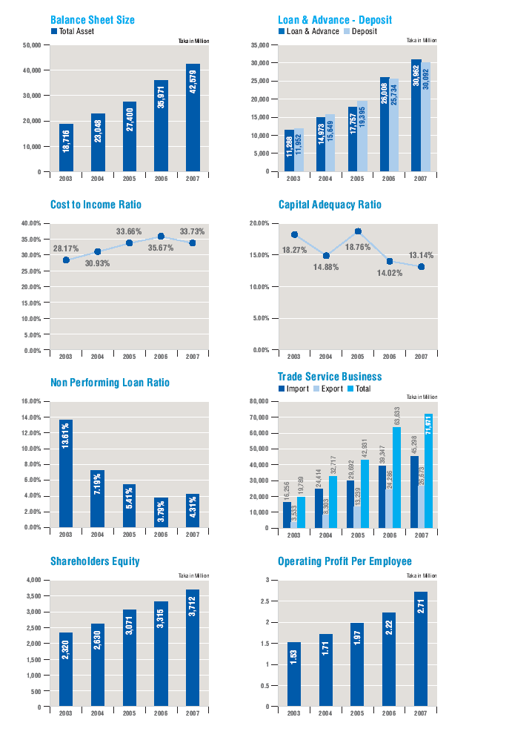
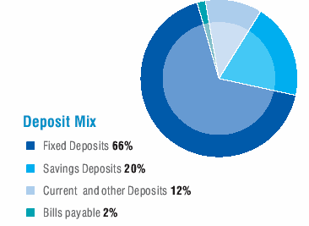 | 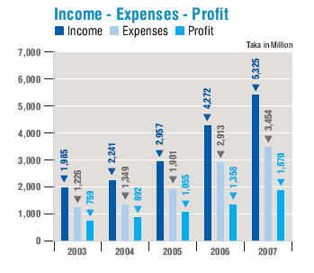
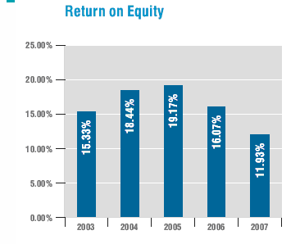 | 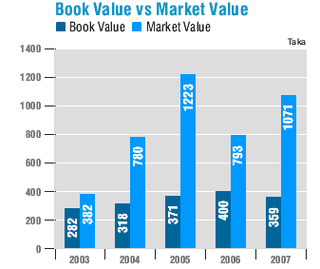

2.11.2 Financial Performance of the Bank: (As on June 2008)

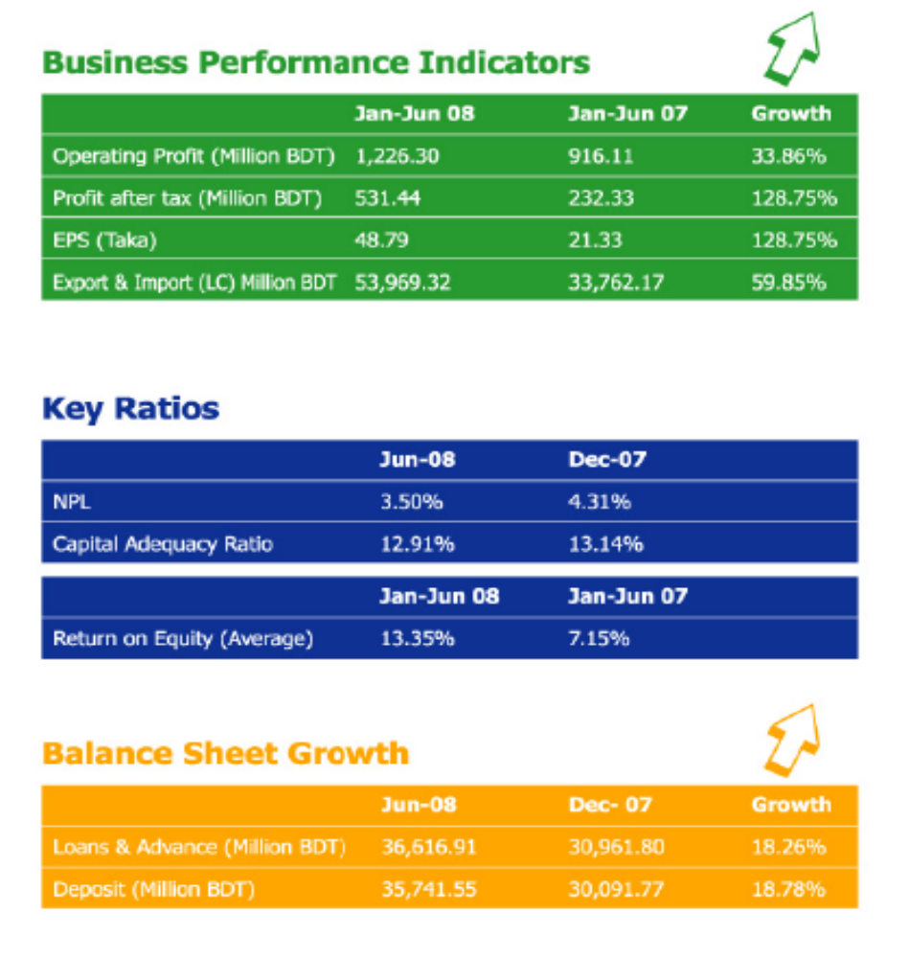

From the above table it is seen that up to June 2008, the operating profit for EBL has increased from the previous year which is 33.86% and the profit after tax for EBL is BDT 531.44 million. In the year 2007 after tax profit was BDT 232.33 million which has increased in a greater extent for the year 2008. Beside Earnings per Share (EPS) has also increased from TK. 21.33 to Tk48.79. This clearly indicates the growing performance of EBL during 2008.

Nonperforming loan of EBL has been decreased from 4.31% to 3.50% which is a very good indication of the financial performance of EBL for the year 2008. The Return on Equity (ROE) has increased from 7.15% to 13.35%.

In the year 2008 (up to June 30), EBL experienced an excellent growth in its balance sheet. The total amount of loans and advances has increased from BDT 30,961.80 million to BDT 36,616.91 million. The total amount of deposit has increased from BDT 30,091.77 million to 35,741.55 million.

2.12 DEPARTMENTS AND DIV ISIONS OF EBL
Human Resources Division | Internal Control & Compliance Division | IT
Corporate Banking | Finance and Accounts | CRM
Consumer Banking | Treasury Department | CAD
SME Banking | Brand Management Division | Operations
International Division

2.13 EXISTING SERVICES RENDERED BY THE BANK
2.13.1 Consumer Banking Products:
2.13.1.1 Loan Products:
EBL Jibandhara Loan: EBL Jibandhara Loan is an unsecured loan facility. Loan amount ranges from BDT 50,000 to BDT 1,000,000 at an attractive interest rate.
EBL Utshab Loan: Utshab Loan is a short-term festival loan facility. Loan amount ranges from BDT 50,000 to BDT 1, 50,000 and repayable in 12-36 installments.
Fast Cash: A secured loan facility against security deposit. It is a revolving credit facility and interest is charged on drawn amount.
Fast Loan: An EMI based loan secured loan facility for any emergency cash need. Any individual having an FD or other securities like Wage Earner's Bond, lCB unit certificate etc. can avail this short term personal loan with 12 - 36 months repayment period.
EBL Executive Loan: Any purpose loan facility for Salaried Executives (both private sector and government service). Loan amount ranging from minimum BDT 50,000 to maximum BDT 1,000,000 and the interest rate is highly competitive.
EBL Auto Loan: EBL Auto Loan is an EMI based loan facility for the purpose of purchasing cars. Loan amount ranges from BDT 350,000 to BDT 2,000,000.
EBL Travel Loan: Available in secured and unsecured versions, EBL Travel Loan offers EMI based loan facility for meeting the travel related financial needs. Loan amount ranges from Tk 50,000 to Tk 500,000.
EBL Education Finance Pack: EBL Education Finance Pack comprises of three unique products – EduLoan Secured, EduLoan Unsecured and EduLine. This pack is designed to meet any type of education financial need of a student. Any creditworthy person can avail the loan for his/her children or for him/herself Loan amount is maximum BDT 10, 00,000 or 95% of the cash security value.
EBL Parseloan: Partial Secured Loan facility for the individuals where one can take loan up to BDT 10, 00,000 by providing 30% or 50% cash security. Loan interest rate is highly competitive and can be repayable in maximum 60 months.
EBL Just Double: At EBL, opportunities are as simple. Hook your possibilities with us and our new deposit scheme, EBL Just Double. The amount of your deposit with us today gets double in just six years.

2.13.1.2 Deposit Products:
EBLInteresting: A savings account where interest is calculated on daily basis and credited to the account on monthly basis.
EBL Campus Account: This is interest bearing savings account for the students.
EBL High Performance Account: Daily interest bearing product with unlimited cash withdrawal facility. Minimum balance requirement Tk 20,000 and interest is credited into account twice a year.
EBL Repeat: Monthly interest payable fixed deposit scheme with 1-3 years tenure.
EBL Confidence: It is an annuity based deposit scheme with monthly installment, not exceeding Tk.20, 000 per month.

2.13.1.3 Card Products:
EBL Simple Credit Card: EBL Simple Credit Card is a complete Credit Card solution. This VISA branded card comes in gold and dual versions with both local and dual currency facility. Other than regular card features, EBL Simple Credit Card offers zero renewal fee, double insurance benefit, free cheque book and balance transfer options.
EBL Lifestyle Card: A VISA branded local currency prepaid card that can be used at any VISA POS or ATM countrywide A very popular product among the student segment.
EBL Cool Card: This is a VISA Electron Debit Card for the student banking accounts.
EBL Hajj Card: This is a VISA Prepaid Card valid only in Saudi Arabia. This card frees one from the hassles of carrying foreign currency during Hajj.

2.13.2 SME Banking Products:
2.13.2.1 Loan Products:
EBL Agrim: This is a short-term unsecured loan facility to meet immediate fund requirement for any business concern.. Loan amount ranges from Tk. 200,000 to Tk 9,50,000 with single shot repayment at the end of 1 to 6 months tenure.
EBL Uddog: EBL Uddog is intended to finance business expansion with 50% of the loan amount in the form of fixed deposit as security. Loan amount ranges from Tk 600,000 to Tk 5,000,000 with monthly installment based repayment within maximum 60 months' tenure
EBL Asha: This loan is intended to meet immediate business fund requirement. Loan amount ranges from Tk 200,000 lo Tk 1,000,000 and monthly installment can be payable within maximum 24 months’ tenure'
EBL Puji: It is a long- term loan for capital investment under collateral security. Loan amount ranges from Tk 5, 00,000 to Tk. 50, 00,000 and the loan can be repaid within 36 months.
EBL Bannijyo: Credit facility up to BDT 20,000,000 to any legitimate import business with Nil margin LC facility. 30%-40% of total limit in the form of FD as collateral required. Monthly installment based repayment facility available.
EBL Mukti: This is an unsecured loan facility is for the women entrepreneurs. Loan amount is maximum Tk. 300.000 and can be repaid in 36 installments.

2.13.2.2 Deposit Products
EBL Subidha: A daily interest bearing deposit account for SME entrepreneurs

O2.13.3 Other Services:
Corporate Banking: EBL Corporate Banking is the strongest unit of the Bank where customized corporate banking solution is offered to the local and MNC corporate; highly efficient corporate team backed by cutting-edge technology and determination to serve the customers who are the driving force behind the success of the EBL Corporate banking division.
Internet Banking: EBL Internet banking application addresses the needs of small, individual and corporate account holders of the bank. This application provides a comprehensive range of banking services such as Account Operations and Inquiries, Fund Transfers and Payments, Utility Bill Payment, Deposits, Loans, Inquiries and other services and a Session Summary.
NRB Banking: EBL offers full range money transfer facility through MoneyGram, UAE Exchange and other exchange houses from anywhere in the world
Student Banking: Other than education loans and student accounts - EBL offers students file services for the students who seek to study abroad through its dedicated student centers at Gulshan and Dhanmondi.
Hajj Remittance service: EBL's Hajj Remittance service provides convenient, secure and reliable money transfers during pilgrimage in Mecca, Madina and Jeddah for EBL account holders. Service includes handling Foreign Demand Drafts (FDDs) and Foreign Telegraphic Transfers (FTTS) in Saudi Arabian in local currency.

2.14 SWOT analysis of EBL
2.14.1 Strengths

Open HR Manual: the HR Manual is open for all the employee of EBL which gives them overall understanding of the terms and conditions of the organization. This HR Manual is uploaded in the internal website of EBL.
Strong Bonding and Belongingness: The employees of EBL have a strong sense of commitment towards organization and also feel proud and a sense of belongingness toward EBL.
Duty Doctor: Recently EBL has appointed a duty doctor to ensure the good fitness for all the employees.
Centralized Banking: Centralized banking means the core functions of business coordinated by the head office give an immense effect for reducing the internal conflicts among the branches and Head Office

2.14.2 Weaknesses

Job Description: Job description in EBL has not been yet organized.
HR Accounting: HR Accounting has not yet been established by EBL which is a strong tool for matching the benefits of each new recruitment, calculating turnover, etc.
Compensation and Benefits: Compensation and Benefits is provided by EBL through two different software named EZHR and Flexcube which are rigid to use and have some limitations.

2.14.3 Opportunities

MIS: HRD of EBL has established new MIS and using it in various manpower reporting.
HRIS: Human Resources Information System is going to broaden very soon by EBL.
Salary Survey: EBL is going to conduct a salary survey in the year 2009.
Learning & Development: EBL is going to utilize its fullest capacity of learning and development program by establishing a library, arranging extensive training module very soon.

2.14.4 Threats

Competitive Salary: The salary package of EBL is not as competitive as the market demands,
Frequent Employee Turnover: so the turnover rate of EBL is increasing day by day.

2.15 POINT OF DIFFERENCE (POD) FOR EBL
2.15.1 Fully Centralized Banking
EBL offers fully centralized banking facility for its customers which are very few in other organizations in the banking industry. Centralized banking means all the core activities of the bank will be performed through the Head Office. This helps EBL to control all the branches swiftly and create transparency in all the activities of it.

2.15.2 Performance Driven Career Development
EBL has an excellent opportunity in terms of career advancement which is totally performance oriented for the employees that distinguishes itself from other organizations. In other banking organizations employees have to wait for a certain period of time for the promotion whereas in EBL anyone can be promoted to the higher level based on his/her outstanding performance.

2.15.3 Open Door Environment
The working environment and the relationship with the colleagues and supervisors in EBL are very friendly, sound and conducive. There is no relationship gap between the entry level employees to the top level management. Everyone has the opportunity to express their opinion frankly to the top level management event to the Managing Director. This has provided EBL an extra advantage to perform the job in a friendly environment.

3.0 What is Retention Management Program?
A comprehensive retention management program must be built on accurate information about why people are leaving a particular organization. In the absence of such information, wrong conclusions may be drawn about the causes of departure and ineffective means to combat it adopted.

3.1 Why Retention Management Program?
Retention management strategy is quite necessary for any organization with a view to reducing the frequent employee turnover rate and to motivate the existing employees to be more goal-oriented. If the employee turnover rate is very frequent in any organization, it faces some problems as the duties and responsibilities of the departed employees go to the subordinates creating extra work pressure for them. Beside this an organization losses some training amount invested for the departed employee as well as the overall company reputation decreases with employee resignation. To hire and recruit a new employee is time consuming and costs the company money. So, in order to reduce the above problems and motivate the existing employees to achieve their goals, the need of an effective retention management program for any kind of organization is quiet important.

3.2 Features of EFFECTIVE Retention Management Program

- Benchmark data on retention performance, retention programs, and other HR practices in the organization and successful firms in the same industry or labor market.
- Goal setting for retention-what is the target rate for each job or department? Not all departures are preventable by the organization. Some flow from external events such as the transfer of a spouse, illness, an opportunity too good to pass up, or a decision to change lifestyle.
- A means of holding managers accountable for the retention of their staff. In addition to goals, this may include adding retention measures to their performance appraisal criteria and bonus formula.
- Many opportunities for challenging works, learning and growth. These can be provided through job rotation, secondments, special projects, lateral transfers, mentoring, career planning, promotions and so forth.
- Effective performance-contingent rewards and recognition and frequent and honest performance feedback to satisfy employees’ desire for information and appreciation.
- An innovative and competitive compensation system. Both fairness and amount of pay are important, though bear in mind that pay is not usually the only reason people leave.
- Flexibility in addressing special employee requests for job characteristics as well as work time and mode.
- Family-friendly policies such as emergency child care, flextime, leaves of absence, and so on if family responsibilities are salient cause of departures.
3.3 WHAT IS MEANT BY TURNOVER?
Voluntary turnover is a common scenario in any organization now-a-days. Various factors are responsible for frequent turnover in an organization including job satisfaction and dissatisfaction. Higher job satisfaction is associated with lower employee turnover, which is the proportion of the employees leaving an organization during a given time period (usually one year). The more satisfied employees are less likely to go through a progressive process in which they think about quitting or announce their intention to quit. Thus they are more likely to stay with their employer longer. Similarly those employees who have lower satisfaction usually have higher rates of turnover. They may lack self-fulfillment, receive little recognition on the job, or experience continual conflicts with a supervisor or peer, or they may have reached a personal plateau in their career. As a result they are more likely to seek greener pastures elsewhere and leave their employers, while their more satisfied associates remain.

Employee turnover can have several negative consequences, especially if the turnover rate is high. Often it is difficult to replace the departed employees, and the direct and indirect costs to the organization of replacing workers are expensive. The remaining employees may be demoralized from the loss of valued coworkers, and both work and social patterns may be disrupted until replacements are found. Also the organization’s reputation in the community may suffer.

However, some benefits may arise from turnover, such as more opportunities for internal promotion and the infusion of expertise from newly hired employees. In other words turnover may have functional effects.

There are different reasons for employee turnover in an organization. An employee may voluntarily resign from his/her current position due to better job offer from other employer in terms of better career advancement opportunity and better compensation packages or an employee may quit because of higher study, leaving for abroad as permanent immigrant, personal reasons etc. Beside this an employee may be terminated, discharged or dismissed from his/her current designation based on different variables.

3.4 Causes of Voluntary Turnover

Because of two classes of variables an employee quit his/her current organization. The variables are:

    - External Factors
External Factors include the unemployment rate and employee’s perceptions of the external job opportunities available to them. Turnover is higher when unemployment in the labor market is low, so that alternative employment appears readily available to job leavers.

    - Internal Factors
Internal Factors are usually based on the employee’s attitudes or perceptions with respect to the current job. The job satisfaction of an employee and organizational commitment are usually significant predictors of a decision to quit, with leavers being less satisfied and less committed than stayers. Employees are also more likely to leave if they believe that the organization treats them unfairly; if they have a poor relationship with their manager; if job requirements are conflicting, unclear or stressful; or if opportunities for growth, skill development, and promotion are lacking. If there is lack of great work environment and flexibility in working hours and dress code. Beside these an employee may leave the organization if they do not find no excitement and challenge to perform the job and think that they are not being recognized for their contributions or not being treated as a part of team. Uncertainty regarding job security and inequality in pay and benefits also lead an employee to left his/her existing organization.

  - How do Employees Decide to Quit? / Traditional Model of Deciding to Quit
Traditionally an employee decides to quit an organization whenever he/she experiences job dissatisfaction with the current job responsibilities or work environment or bad relationship with the supervisor. This feeling of discomfort leads an employee to search for better alternatives in terms of better compensation and better career advancement. After assessing the alternatives if it is found superior against the current job, an employee finally decides to quit from his/her current job. This can be easily understood from the following flow chart:

Experience job dissatisfaction |  | Assess costs of quitting and likelihood of finding a better alternative |  | If alternatives seem possible, initiate search for alternatives |  | If alternative(s) found, evaluate against current job

If alternative is superior, develop intention to quit
QUIT

3.6 Costs and Benefits of Voluntary Turnover

3.6.1 Costs of Turnover

3.6.1.1 Exit Costs

- Farewell parties on work time
- Administrative time to process final pay, close retirement accounts etc.

3.6.1.2 Replacement Costs

- Recruitment Advertising
- Selection testing, Interviewing, Reference checking
- Hiring bonuses, Relocation costs
- New employee orientation
- Administrative costs to add to payroll enroll in benefits, etc.
- Formal training
- Informal mentoring and coaching of new employees by supervisors

3.6.1.3 Other Costs:

- Lost business due to client loyalty to departing employees
- Lost business or poor quality due to short staffing before replacement, or lower skills before new hires are up to speed.
- Expenses of hiring temporaries or paying overtime while awaiting replacements.
- Reduced morale of those remaining, increased stress on those remaining while short staffed or breaking in replacements.
- Reduction in company’s reputation as an employer when many staff choose to leave; reduced ability to recruit in the labor market.
- Inability to pursue growth or other business opportunities due to lack of staff.
- Loss of training amount invested in departing employee.

3.6.2 Benefits of Turnover

- Poor performers may choose to leave and can be replaced with better employees.
- Leavers are replaced with more junior employees who cost less.
- Morale improves following departure of problematic employees.
- Leavers are replaced with people with more up-to-date technical skill.
- Vacancies are created to allow for internal promotions of other employees, thus increasing their career satisfaction and motivation.
- Receptiveness to innovation and change may increase.
- Voluntary turnover is less painful than retrenchments.

3.7 Resignation Process in EBL
A confirmed employee may resign from the services of the bank giving 3 (three) months’ notice in writing through a proper channel or 3 (three) months’ basic salary in lieu thereof. The Management may also ask to resign an employee giving him/her a 3 (Three) months’ notice or 3 months’ basic salary in lieu.
Any Partial or full waiver of notice period will be at the discretion of the Managing Director.

4.0 Current Scenario of Employee RETENTION IN EBL (IN 2008)
Eastern Bank Ltd. is a second generation bank providing all kinds of banking services to its customers. The bank has different categories of loan and deposit, cards, SME products and other products and services to serve its huge number of clients. There are different departments and divisions in EBL for which a careful HR planning is needed to recruit the best qualified employee for the job and retain them in the long-run for the constant profitability and growth of the organization. Employee retention is necessary because frequent job switching creates some problems for every organization as well as reduces the company reputation. In the year 2008 EBL experienced a considerable percentage of job switching that grabbed the attention of the Management Committee to focus on the current retention strategy of EBL.

In January 1, 2008 EBL had a total number of 1190 employees. Among the total number of employees 690 employees had been working as permanent employee and 500 employees had been working on contractual basis. The following table shows the total number of employees of EBL as on January 1, 2008:

Table: 1 Total Number of Manpower as on January 1, December 2008
Employee Category | Number | Total
Permanent Employees | 690 | 1190
Employees on Contract | 500 | 1190
Source: Secondary

During the year 2008, a total number of 273 employees left the EBL due to different reasons. It has been seen that among the total 273 resigned employees 190 employees were on contractual basis and 83 were permanent employees. The following table shows the total manpower left the EBL during 2008:

Table: 2 Total Manpower Left the EBL during 2008

Employee Category | Number | Total
Permanent Employees | 83 | 273
Employees on Contract | 190 | 273

Source: Secondary

So, from the above table it is clear that, the trend of employee turnover is quite high among the contractual employees.

From the above resigned employees the numbers of employees left the EBL from October 2008 to January 2009 are as follows:

Table: 3 Numbers of Employees Left the EBL from October 2008 to January 2009
Employee Category | Number
Vice President (VP) | 1
Senior Assistant Vice-President (SAVP) | 1
Assistant Vice-President (AVP) | 3
Senior Principal Officer (SPO) | 8
Principal Officer (PO) | 1
Management Trainee Officer (MTO) | 1
Senior Officer (SO) | 5
Officer | 10
Total | 30
Source: Secondary

From the above table it is seen that, from October 2008 to January 2009 a total number of 30 employees left the EBL due to different reasons. Clearly the above table shows that, the trend of employee turnover in EBL is quite high in the junior or entry levels of jobs such as in officer and senior officer level. Among the total 30 resigned employees 22 resigned from the entry level of EBL.

At present EBL have a total number of 1300 employees. Among them 750 are working as permanent employee and 550 are working on contractual basis. The following table shows the number of manpower in EBL as on December 31, 2008:

Table: 4 Total Number of Manpower as on 31 December 2008
Employee Category | Number | Total
Permanent Employees | 750 | 1300
Employees on Contract | 550 | 1300
Source: Secondary

4.1 Employee Turnover Rate IN ebl (2008)

During the year 2008 EBL recruited a total number of 421 employees. Among the total recruited employees 171 recruited permanently and 250 recruited on contractual basis.

Table: 5 Total Manpower recruited in EBL during 2008
Employee Category | Number | Total
Permanent Employees | 171 | 421
Employees on Contract | 250 | 421
Source: Secondary

The total number of employees as on January 1, 2008 was 1190 and the total number of employees as on December 31, 2008 were 1300. So the average number of employees during 2008 in EBL was 1245. This would be clearer from the following table:

Table: 6 Average Employees in EBL during 2008

Period | Total No. of Employees during 2008 | Average Employees during 2008
Jan 1, 2008 | 1190 | 1245
Dec 31, 2008 | 1300 | 1245
Source: Secondary

No. of employees left the EBL during 2008
Turnover Rate = ______________________________________ * 100
Average Employee in EBL during 2008

= 273 * 100
1245
= 22%

So, from the above it is seen that the turnover rate for the year 200 in EBL was 22% which is somewhat higher compared to other banking organizations. At present this is the prime concern for EBL. So, the employee retention rate in EBL during 2008 was 78%. The Management Committee of EBL is trying to increase the current employee retention ratio in order to establish a steady work environment and to motivate the current employees.

According to the HR Manager of EBL, there are some major reasons for frequent job switching in EBL. The reasons are:

- Rapid expansion of the Banking Industry
- Remodeling of Banking Industry
- Offering higher benefits to EBL employees by other organizations

The HR Manager believes that employee turnover in an organization has both some advantages and disadvantages. But frequent job switching creates some major problems for any organization. So, any organization should implement effective employee retention management strategy in order to reduce the turnover rate and to motivate the existing employees to make them completely goal-oriented.

According to the HR Manager of EBL, employee turnover creates the following advantages and disadvantages for her organization:

Costs of Turnover perceived by EBL

- Lost business opportunities
- Loss of amount incurred for employee development
- Costs associated with hiring new employees
- Loss of company reputation

Benefits of Turnover perceived by

- Hiring new talented employees
- Replacing with junior employees who costs low
- Promotion opportunity for an existing employee. In this regard, sometimes an existing grade of an employee may not be changed for promotion but functional designation can be changed.

At present EBL has some attributes like salary which is included in compensation and other benefits and performance appraisal to motivate and retain its current employees. Beside these, EBL provides attractive End of Service Benefits (EOSB) to its employees which include the following:

- Provident Fund (PF)
- Gratuity
- Encashment Facilities of Annual/Privilege Leave
- Super Annuation Fund Scheme
- Retirement Gift and
- Long Service Awards

EBL also provides attractive compensation packages for its employees to motivate them which include:

- Salaries and Increments
- Excellent Promotional Benefits
- Two types of bonuses including festival bonus and performance bonus

Beside the above issues EBL has an attractive performance appraisal process in order to reduce the turnover rate and to motivate and guide its employees toward the achievement of self as well as organizational goal.

4.2 Reasons for Leaving EBL
An employee may resign from his/her existing position due to internal factors or external factors or both of them. For the year 2008, most of the employees leave the EBL because of getting better job in terms of career advancement and higher compensation packages. It has been seen that almost 40% employees leave the EBL because they had managed better job in terms of career advancement and about 30% employees leave the EBL because of getting higher compensation packages.

It has been found that about 87% male and 13% female employees left the EBL during 2008 and 80% of them have secured jobs in other manufacturing and services organizations. The following further clarifies the reasons for leaving the EBL:

Table: 7 Reasons for Leaving EBL

Reasons | In Percentage (%)
Better Job in terms of career advancement | 39.58%
Better Compensation in terms of higher compensation | 29.16%
Tired of monotonous job | 2.08%
Leaving for higher studies | 4.16%
Deprived of | 2.08%
Medical/Health reasons | 2.08%
Found internal politics | 2.08%
Found no scope for career development | 8.33%
Other reasons | 10.41%
Source: Primary Survey

From the above table it can be easily understood that the most important and frequent reasons for employee turnover in EBL are getting Better Job in terms of career advancement and higher compensation in other organizations. The other reasons for frequent employee turnover in EBL are:
- Retirement
- Feelings of uncomforted
- Going to abroad as permanent immigrant
- Personal reasons etc.

4.3 FACTORS ATTRIBUTING THE EMPLOYEE TURNOVER IN EBL
4.3.1 Nature of Relationship with the Supervisor
A good relationship between the supervisors and the employees is very necessary for a sound, conducive and favorable work environment. If there is a conflict with the supervisor and the peers of the respective department as well as other departments, the work environment will be hampered and the dissatisfaction would be arouse among the employees.

Figure: 1 Nature of Relationship with the Supervisors
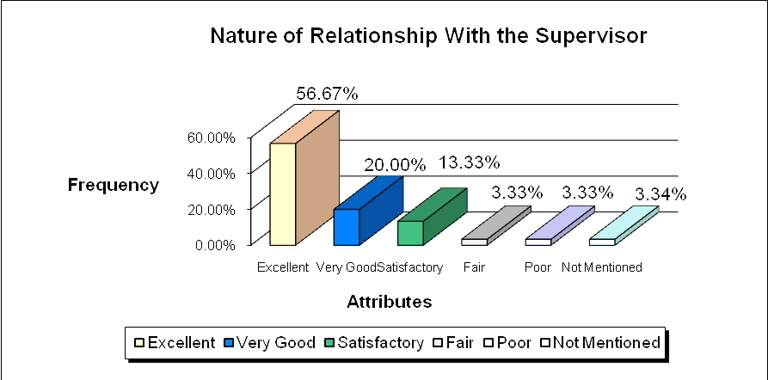
Source: Primary Survey
According to the most resigned employees the relationship between the supervisor and the employees were excellent in EBL. Almost 57% of the resigned employees told that they had an excellent relationship with their supervisors.

4.3.2 Fairness of Supervisor

Fairness in treatment of the supervisors with the employees in EBL is fair according to the most of the resigned employees. It is easy to understand from the following graph.

Figure: 2 Fairness of Supervisor
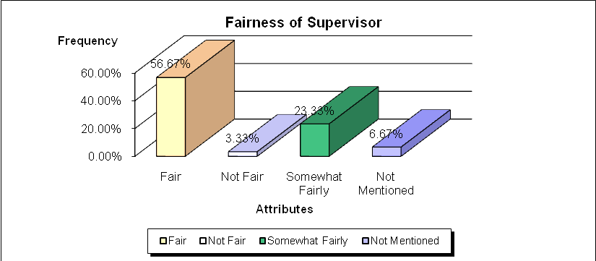
Source: Primary Survey

From the above graph it is seen that about 57% of the resigned employees had a good relationship with their supervisors or with their immediate line managers. Beside this, about 24% of resigned employees had somewhat fair relationship with their supervisors.

4.3.3 Supportiveness and Attitude of Supervisor
Everyone needs support to perform every single job. Without the proper support from the immediate line manager or the supervisor performing a job accurately would be difficult. Beside this the positive attitude of the supervisor toward the employees motivates an employee to be committed to perform his/her job. About 77% of resigned employees agreed that the Supportiveness and Attitude of Supervisor toward them in their respective department in EBL was satisfactory.

4.3.4 Co-operation, Friendliness and Respectfulness of Colleagues (own Department)
Without the Co-operation, Friendliness and Respectfulness of Colleagues of an employees’ respective department, it would be difficult to perform a job. Because to perform each and every job proper guidance from the immediate supervisor and support from the peers is necessary.
Co-operation, Friendliness and Respectfulness of Colleagues toward resigned employee in their respective department in EBL were very satisfactory. Almost 87% of the resigned employees were satisfied with the co-operation, friendliness and respectfulness of colleagues in their department.

4.3.5 Co-operation, Friendliness and Respectfulness of Colleagues (Other DepartmentS)
Co-operation, Friendliness and Respectfulness of Colleagues for an employee is also necessary from other departments. Because sometimes some jobs are interrelated with the other departments. Without the necessary help from the other department it may be very difficult to perform a job comfortably.

Co-operation, Friendliness and Respectfulness of Colleagues toward resigned employee from other departments in EBL were satisfactory. Almost 77% of the resigned employees were satisfied with the co-operation, friendliness and respectfulness of colleagues in other departments.

4.3.6 Conditions of Work Environment

The necessity of sound, conducive and favorable work environment is very important for any organization to perform the job in a timely and accurate manner. From the survey among the resigned employees it has been found that almost 87% of resigned employees agreed that they had a sound, conducive and favorable work environment for the job to perform. So, the work environment in EBL is quite satisfactory

Figure: 3 Conditions of Work Environment
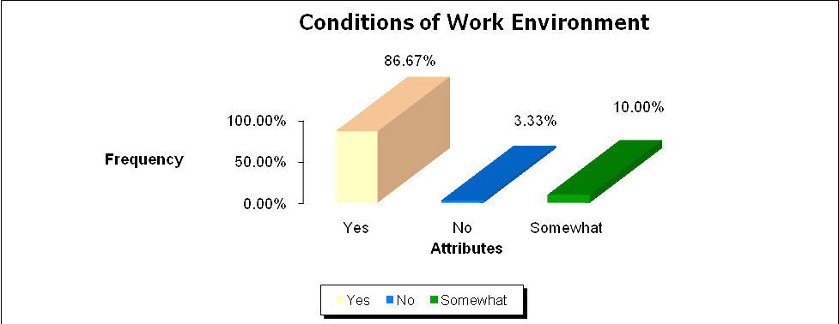
Source: Primary Survey

4.3.7 Clarity of Role Perception to perform the job

A clear role perception regarding the assigned job is mandatory to perform it successfully. Without the clear role perception about the assigned job would be difficult to perform accurately and it will create both the role conflict and role ambiguity among the employees. Role ambiguity occurs when an employee does not have enough idea about the job to perform if the job is inadequately defined. Beside this when others have different perception regarding a person’s job, role conflict arises. So, to avoid both the role conflict and role ambiguity every employee should be communicated well which is
quite satisfactory in EBL. About 84% of resigned employees were agreed that they had been communicated well by their supervisors to perform the job on time and accurately.

4.3.8 Authority to perform the job
Without proper authority it is almost impossible to perform job. So, enough authority should be provided by the employer to the subordinate regarding the respective job.

Figure 4: Authority to Perform the Job
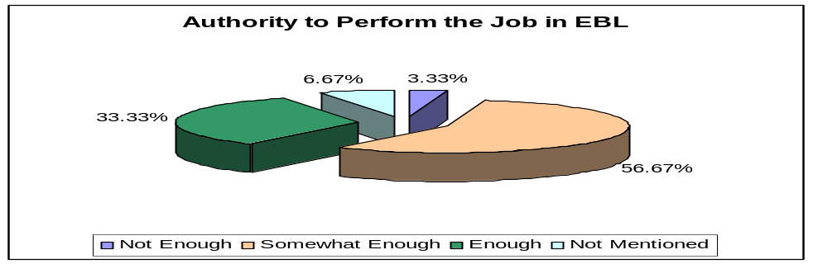
Authority to Perform the Job

Source: Primary Survey
In EBL, 56% of resigned employees said that they got somewhat enough authority to perform the assigned jobs. Only 33% employees are quite satisfied about the authority provide to them. Yet, EBL should ensure an environment for all the employees where they will be able to perform the job by applying their own decision making ability and without any disruptions of others. EBL should also ensure the proper direction from the top level management to eliminate the role conflict.

4.3.9 Freedom to perform the job

Freedom as like as proper authority is also needed to do a job in a satisfactory manner. If an employee cannot exert his/her decision making ability or own judgment regarding a specific job, the job will be a incomplete one and dissatisfaction among the employees will be also arouse.

Figure: 5 Freedom to Perform the Job
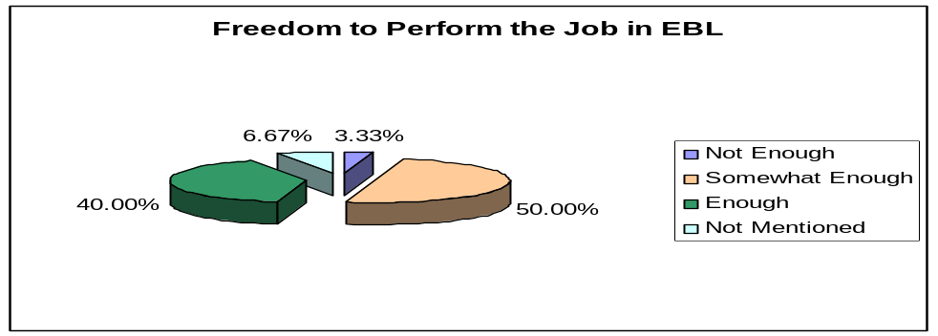
Freedom to perform the job
Source: Primary Survey

From the above graph, the condition of freedom to perform a job in EBL can be easily understood. It can be seen that 50% of the resigned employees expressed their opinion regarding job freedom that they had found somewhat enough authority to perform their assigned job. A very few of resigned employees expressed their dissatisfaction regarding job freedom in EBL.

4.3.10 Fairness in distributing job responsibilities

Fairness in case of distributing job responsibilities among the employees is a crucial factor for both the employer and the employees. Job responsibilities should be distributed among the employees based on the experience of the employees, professional training achieved in related fields and the level of education of the employee to practice the fairness and equality and to eliminate the dissatisfaction of the employees.

Figure: 6 Fairness in Distributing Rob Responsibilities

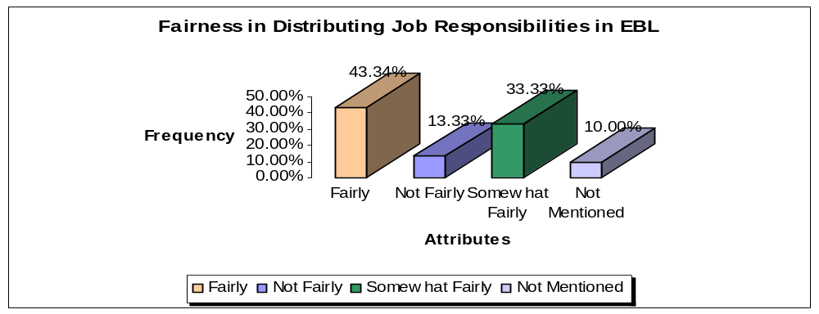
Fairness in distributing job responsibilities
Source: Primary Survey
Regarding fairness of distributing job responsibilities in EBL, about 44% employees expressed their satisfaction which is not a big percentage from the bank’s perspective. Because about 14% of the resigned employees was totally dissatisfied about the issue and 10% of the resigned employees did not mention their opinion regarding fairness of distributing the job which is an indication of dissatisfaction of employees. So, EBL need to be more concerned about the fairness in distributing the job.

4.3.11 recognition of Contributions of employees

Job recognition for the job well done is a strong motivational factor for every employee. It stimulates the internal need of an employee that leads him/her to dive and achieve the goals for him/her as well as for the organization. Beside this constructive criticism about the poor performance of an employee influences him/her to be optimistic and goal oriented. If the immediate supervisor continuously monitor and measure the performance of an employee and provides timely feedback, the employee would be guided properly to the productivity of the organization.

Figure: 7 Recognition of Contributions of Employees
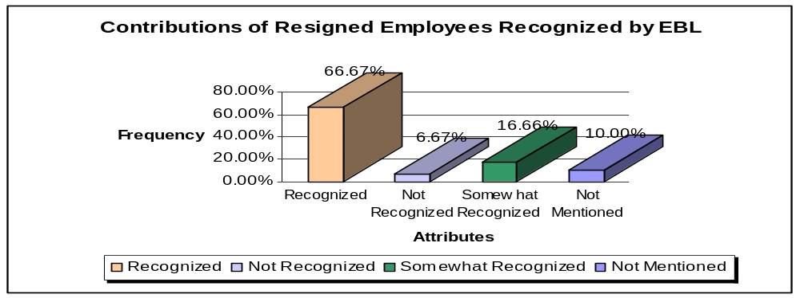
Recognition of Contributions of Employees
Source: Primary Survey
The above graph clearly states that a considerable percentage (about 67%) of employees was properly recognized by their immediate supervisors for their contributions in EBL though satisfaction of the remaining percentage of employees regarding job recognition was not up to the mark. Beside these 10% of the resigned employees did not mention their opinion regarding job recognition which is an indication of dissatisfaction of employees.

4.3.12 Level of employee morale in EBL

Employee morale and honesty is quite necessary in every aspects of the job which is highly satisfactory in EBL according to 67% (approximately) of the resigned employees. About 27% of the resigned employees found somewhat employee morale in EBL.

4.3.13 Adequacy of Training for Employee Development
Training for employee learning and development is very necessary. Without proper training an employee cannot perform the respective job fairly. For this purpose every organization arranges both the in-house training and foreign training for their newly recruited employees.

EBL’s Training program:

EBL provides minimum six (6) months probation period for a newly hired employee for learning and development. Based on the performance of the probation period an employee may be recruited as an permanent employee or he/she may be placed for another probation period. Beside this EBL provides two kinds of training for their employees:
- In-house training
- Foreign training
The management of EBL believes that they arrange necessary training programs for employee development for higher productivity of the employee.

Figure: 8 Adequacy of Training for Employee Development
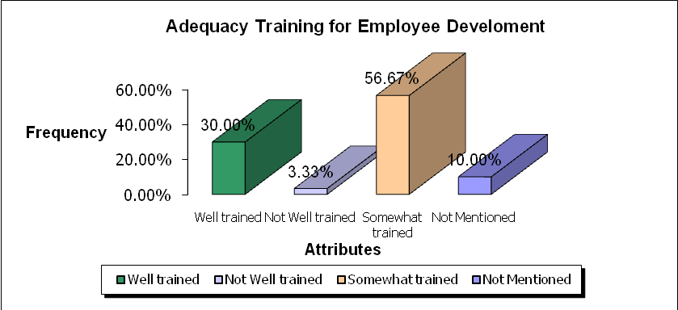Source: Primary Survey
The above graph shows that the percentage of employees who seemed that they had been well trained for every job is not satisfactory. Almost 57% of the resigned employees agreed that they were somewhat trained for performing the job.

4.3.14 Flexibility in working hours

Flexibility in working hours should prevail to eliminate the monotony of doing the job. Work in a stretch creates job stress for the employees and ultimately reduces the productivity of the employee.

Figure: 9 Flexibility in Working Hours
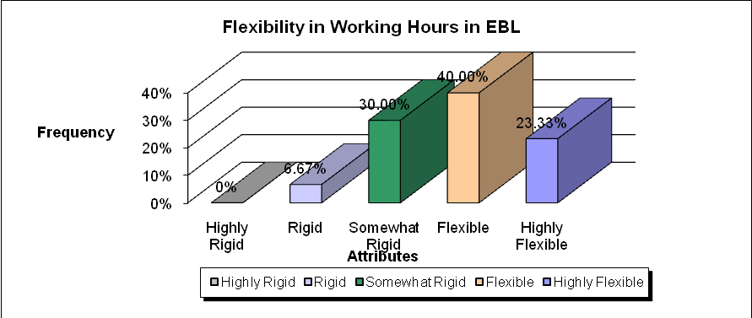
Source: Primary Survey

According to the most of the resigned employee the working hour was flexible for them. Beside this 30% of resigned employees found somewhat rigidity in working hours while working in EBL.

4.3.15 Level of job security

According to the management of EBL Job security in EBL is quiet high and fully secured for an employee if he/she does not commit any offensive work that violates the code of conduct or treated as misconduct as per the policy of EBL. It is also dependent on the performance and honesty of an employee and the compliance with the process and procedures of EBL.

Figure: 10 Level of Job Security
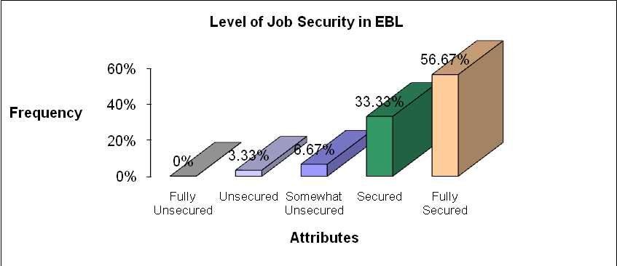
Source: Primary Survey

Almost 57% employees found the job in EBL as fully secured and about 34% considered the job in EBL as secured which is a clear indication that the level of job security in EBL is quiet high if any employee does not violates the code of conduct of the bank or commit any other offensive work.

4.3.16 Career advancement opportunity

Career advancement opportunity in EBL is totally dependent on the performance of the employee. If an employee can perform the job up to the mark that meet up the expectations of the employer, he/she has an excellent career advancement opportunity with the EBL.

Figure: 11 Career Advancement Opportunity
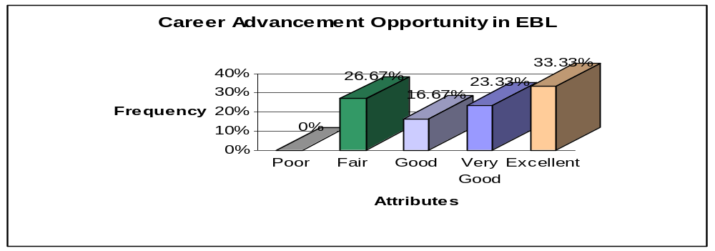
Career Advancement Opportunity
Source: Primary Survey

From the graph it is seen that about 34% of the resigned employees found excellent career advancement opportunity in EBL whereas about 27% employees found fair opportunities for career advancement opportunity in EBL. So, EBL should specify a clear career path for the employees.

4.3.17 Employee Loan

EBL currently provides two types of loan facilities for its internal employees. These are

4.3.17.1 House building Loan Scheme for EBL employees
The scheme shall be called the “Eastern Bank Limited staff House Building Loan Scheme”. To be eligible to get the HBLS an employee must be a permanent member of staff and has a minimum 60 months’ service to retire. Beside this he/she has 5 (five) years of continuous service in EBL or 5 (five) years of continuous banking service including 2 years in EBL. His/her overall performance is considered satisfactory (not below rating 3).In case both the husband and wife are employees of the bank, only one of them shall be entitled to avail loan under this scheme. Rate of Interest for this loan scheme is 3% (three percent) subject to change and the repayment arrangement for the loan shall be made within maximum 20 (twenty) years.

4.3.17.2 Car Loan Scheme
The Board of Directors in its 297th Meeting held on September 07, 2004 has approved the Revised Car Loan Scheme-2004 for the EBL employees. In this scheme the “Borrower” means any employee (AVP-SEVP) availing of the loan facility. To avail the car loan one must have to be a permanent employee of the bank and has minimum 60 months’ service to retire. The borrower has to pay 4% (four percent) interest per annum and the loan shall be repaid within 5 (five) years from the date of disbursement on monthly installment basis to be deducted from his salary and/or from other sources.

The weighted average satisfaction level regarding the above two kinds of employee loan facility among the resigned employees was 2.73 which is dissatisfactory to them. The criteria to be eligible to get the loan facilities were too rigid to the maximum employees especially in the junior or entry level of jobs.

4.3.18 Leave facilities
The weighted average satisfaction level regarding the leave facilities of EBL was 3.57 which mean that employees are neither satisfied nor dissatisfied with the current process of leave facilities. There are four categories of leave facilities available for the employees of EBL which are discussed below:

4.3.18.1 Annual Leave
“Annual Leave” means any working day’s leave taken by a permanent employee. Every employee shall earn Annual/Privilege leave with full pay after completion of one year service. Every employee shall have to avail at least 15 (fifteen) days privilege leave every year. Any extension of leave will be at the discretion of competent authority.

4.3.18.2 Sick Leave
Sick leave will be given on the basis of actual need of staying away from work due to illness. This shall however, not exceed 14 days in a calendar year. Application for sick leave for more than 3 (three) days must be accompanied by a medical report and prescription from his/her attending physician.

4.3.18.3 Maternity Leave (Not Accruable)
Only the confirmed female employee will enjoy maternity leave for 45 (forty five) days immediately preceding and 45 (forty five) days following the date of delivery with admissible benefits. This leave will not be debited from her leave account. A certificate from a doctor will be required at the time of applying maternity leave stating the expected date of delivery. The extension/continuation of maternity leave for more than 1 (one) month may be granted/allowed by the DMD/MD on submission of medical certificate with full pay.

4.3.18.4 Extraordinary Leave
Extra ordinary leave can only be granted to an employee on an emergency case when no other leave is available to him/her leave account. Managing Director at his discretion can approve the extraordinary leave up to 180 days without pay.

4.3.19 Medical Facilities
Hospitalization Reimbursement
The above facility will be limited only to the confirmed employees and his/her immediate family members which include wife/husband and dependent sons and daughters only. Children attaining 18 years of age or on getting married, whichever is earlier, will not be entitled to reimbursement of the cost of medical treatment. For hospitalization/surgical treatment, the bank will reimburse two (2) basic salaries for self/spouse/children up to the age of 18 years. The claim of hospitalization bills must be supported by original bills of reputed hospital/clinic.

Regarding the amount of health care facilities the resigned employees of EBL were somewhat satisfied which they provide an average point of 3.77.

4.3.20 Retirement/Terminal Benefits
Every organization provides some retirement or terminal benefits for its employees who have served the organization for a long period of time and going for the retirement. These facilities may also be termed as End of Service Benefits for the employees. In EBL, there are different numbers of retirement benefits including PF, Gratuity, Encashment facilities etc.
From the analysis of the report it has been found that the weighted average satisfaction regarding the retirement benefits among the resigned employees was in neutral position which means that they are neither satisfied nor dissatisfied with the current retirement plan benefits.

4.3.20.1 Provident Fund
Members on confirmation, in regular employment with the Bank, are required to join the Provident Fund to which members contribute 10% of their Basic Salaries and the Bank makes a matching contribution.

4.3.20.2 Gratuity
The Bank shall create a gratuity fund every year for adequate amount required for the purpose.
Managing Director and Deputy Managing Director would be eligible to receive Gratuity after completion of 5 years of service with the bank. Members become eligible to receive Gratuity on completion of 10 years of continuous confirmed services with the bank.

4.3.20.3 Encashment Facilities of Annual/Privilege leave
Annual/privilege leave encashment facilities may be allowed to the employees for a maximum of 90 days at the time of his/her leaving the bank other than dismissal. While allowing the facilities, the last basic pay, house allowance/ceiling and medical allowance will be taken into consideration.

4.3.20.4 Superannuation Fund Scheme
This includes Admissible Benefits such as death and survival benefits, Coverage and Inadmissible Benefits such as suicide and death sentence.

4.3.20.5 Retirement Gift
Suitable retirement gift will be made to the members on their normal retirement the cost of which will not exceed TK. 20,000/=.The presentation of the gift will usually be made at an appropriate place and time.

4.3.20.6 Long Service Awards
Suitable presentation of Long Service Awards will be made to the members on completion 10 (ten) years of continuous service with the Bank. The gift amount will not exceed Tk. 15,000/- .

4.3.21 Level of Satisfaction regarding compensation packages

      - Salaries
Salaries are confidential between the employees concerned and the Management. Employees joining against a post will be receiving the salary as per the grade they join in. The annual salary revision is decided by the Managing Director with approval of the Board of Directors based on, individual performance, market movement, Bank’s affordability, Individual’s relative position in a particular salary range etc.

4.3.21.2 Promotional Benefits
In the event of Promotion/Up-gradation to a higher Job Grade, the employee will receive an increase of 10% of his/her previous basic salary and all other allowances applicable in the higher grade.

      - Increments
Salary increases are awarded once a year on the basis of Increment Policy to all employees who have performed satisfactorily in the given year for a minimum period of 180 days after confirmation of service. One may not receive any increment on a given year as a penalty on account of any offence/disciplinary measure. Increments are awarded to the employees as per Rating of the Annual Performance Appraisal.

4.3.21.4 Promotion
Promotion depends on the availability of a position in the higher grade and a proven track record of an individual’s capabilities of taking over higher responsibilities. Promotion may also take place if the job size increased and the Management committee decides to upgrade the job.

4.3.21.5 Bonuses
EBL provides two types of bonuses for its employees- one is festival bonus and another one is performance bonus which is totally based on the outstanding performance of an employee for a given period of time. The performance of an employee is measured with appropriate performance appraisal processes of EBL.
Regarding the availability of employee bonus the resigned employees of EBL was not satisfied. Their satisfaction level regarding employee bonus is 3.23 that means they are dissatisfied with the current process of bonus of EBL.

4.3.21.5.1 Festival Bonus
The following Employees normally to receive festival bonus as under:
 | Employment Category | Payment System
1. | All regular Officers and Staff | One month’s basic pay both in Eid-ul-Fitre & Eid-ul-Azha.
2. | All regular Officers and Staff (non-Muslim) | One month’s basic pay both in Eid-ul-Fitre & Eid-ul-Azha or two months’ basic pay at the time of the main festival with the approval of the management.
3. | Officers on Contract/(In Bank’s Pay role) | As per contract/50% of monthly consolidated pay
4. | Officers/employees on probation or who have not completed six(6) month’s service | 50% of basic.
5. | Executives’ personal Drivers/ outsourced employees/workers | Monthly consolidated wages

Officers and employees under any disciplinary action will not receive any festival bonus.

4.3.21.5.2 Performance Bonus
This bonus will only be awarded to those who have completed 180 (one hundred and eighty) days’ confirmed service with the Bank and made significant contribution towards achieving the profit target over and above the normal target. The contribution measurement will be coming from the Performance Appraisal System. The employees who are rated four (4) in the appraisal process are not eligible for Performance Bonus.

Figure: 12 Level of Satisfaction Regarding the Compensation Packages
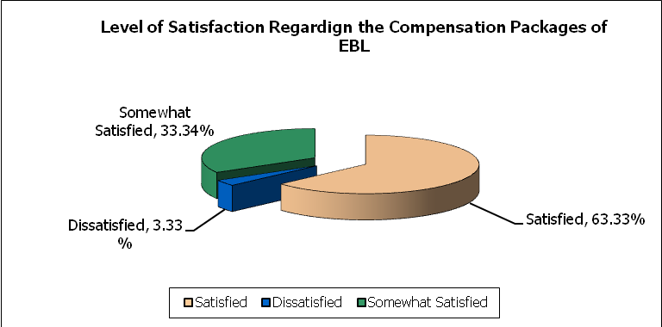
Source: Primary Survey
From the pie chart it is seen that almost 64% of the resigned employees were satisfied with the compensation packages of EBL. About 34% employees were somewhat satisfied with the process whereas only 3% employees expressed their dissatisfaction regarding the compensation packages of EBL.
4.3.22 Level of Satisfaction with the performance appraisal Process
Performance Appraisal System (PAS) is the tool by which EBL measures the performance of an individual and identify the gaps and plan future developments in order to enable a better fit between the jobs & the incumbent. Performance Appraisal System is quite structured that it can measure or assess both goals (what) and the management competencies (how). A management competency is a skill, ability or trait that predicts success to perform a job.

The Performance Appraisal needs to be implemented as per the PAS format which will be circulated by HR at the beginning of the year. The definition of rating in Performance appraisal is given below for reference:

1= The individual who has exceeded 125% and above of his target in all of his key result areas is eligible for rating 1.
2 = The individuals who has exceeded 105% - 110%of his target in all of his key result areas is eligible for rating 2.
3 = The individual who has achieved 90%-100% of his target in all of his key result areas is eligible for rating 3. The employee achieved the essential requirement of day to day job.
4 = The individual failed to perform within the set objective.
5 = The individual who has failed to demonstrate his performance in all of his key result areas to be rated 5 and he/s will be treated as non performer.
Those who are rated 1 to 3 are eligible for incentive bonus:

Figure: 13 Level of Satisfaction with the Performance Appraisal Processes
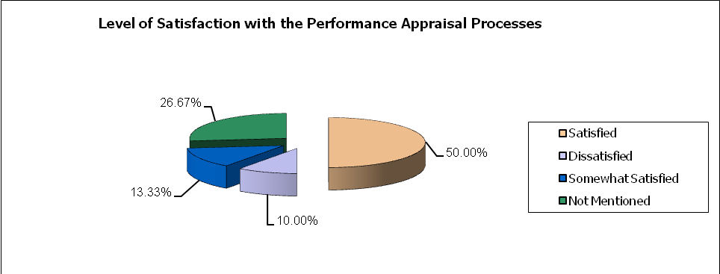
Source: Primary Survey

From the above pie chart it can be seen that 50% of the resigned employees were satisfied with the performance appraisal process of EBL while almost 27% of resigned employees did not mention their satisfaction or dissatisfaction level. Beside these 10% employees were dissatisfied with the current performance appraisal processes of EBL in which contractual employees are in a greater number.
4.4 Expectations met by resigned employees during the tenure in EBL
Everyone joins in a organization in order to meet some of his/her expectations as well as the goal of the organization. If the respective organization can provide excellent career advancement opportunity, good compensation and benefits packages, sound, conducive and supportive work environment, the expectations of the employees definitely will be met up.
Figure: 14 Expectations met by Resigned Employees in EBL
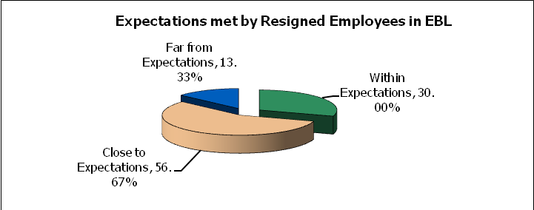
Source: Primary Survey
It is seen that about 57% of the resigned employees told that their achievements in EBL was close to their expectations. 30% resigned employees found everything in EBL within their expectations. Almost 14% resigned employees found everything far from their expectations in EBL which is also a matter of concern.

4.5 Level of Satisfaction among the resigned employees regarding the overall company policy
The overall company policy of an organization should be somewhat flexible for the employees. If the company policy is too rigid, the compliance with the policy would sometimes be difficult for the employees. So, overall company policy of an organization should be in a flexible and structured way.
Figure: 15 Level of Satisfaction Regarding the Overall Company Policy of EBL
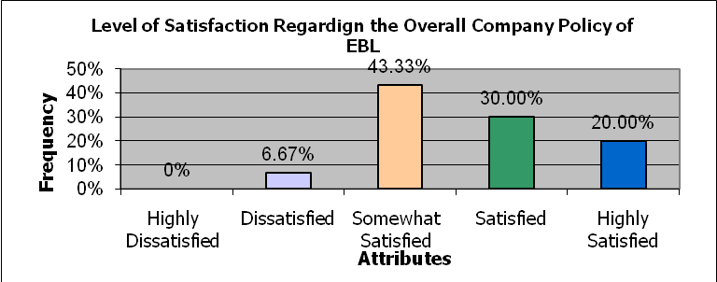
Source: Primary Survey

In, EBL almost 44% of the resigned employees were somewhat satisfied with the overall company policy. 30% employees found the EBL’s policy as quite flexible. A minimum percentage of employees were dissatisfied with the overall company policy of EBL.
5.0 SUMMARY OF THE FINDINGS

After analyzing all the relevant data and information the researcher has found a number of issues as the major findings of the report. Here is the summary of these key findings:

- The total number of manpower recruited in EBL in 2008 was 421 and the number of manpower left the EBL in 2008 was 273. Among the 273 resigned employees 30 employees left the EBL from October 2008 to January 2009. The percentage of male and female resigned employees from October 2008 to January 2009 is 86.67% and 13.33% respectively.
- Among the 421 employees recruited in 2008, 171 were recruited as permanent employees and 250 were recruited on contractual basis.
- The majority of employees who left the organization were recruited on contractual basis.
- Employee turnover ratio in EBL for the year 2008 was 22%.
- Among the total resigned employees 80% have confirmed their job in other manufacturing and services organizations.
- Better job offer in terms of career advancement and higher compensation were the main reasons for frequent employee turnover in EBL. Beside these, there were some other reasons for turnover including monotonous job, leaving for higher studies, deprivation, medical/health reason, internal politics, less scope for career advancement, retirement, leaving the country for abroad as an immigrant etc.
- About 57% resigned employees had excellent relationship with their line manager or immediate supervisor. Almost 67% employees agreed that their supervisor had treated them fairly and 77% told that their supervisors were supportive and had shown good attitude toward them.
- Co-operation, friendliness and respectfulness of colleagues in respective department and other departments were excellent toward the resigned employees.
- According to the most of the resigned employees job environment was sound, conducive and favorable.
- Although most of the employees had clear role perception about their job, authority and freedom was not enough to perform their respective jobs.
- Fairness in distributing job responsibilities in EBL is not satisfactory.
- Almost 67% employees were recognized by their supervisors for the job well done.
- Employee morale in EBL is quite high. It has been seen that about 67% employees are satisfied regarding the employee morale in EBL.
- About 57% employees were somewhat trained for the job that had been assigned on them which is not satisfactory to perform the job effectively.
- Working hour in EBL is flexible though a considerable percentage of employees found somewhat rigidity in working hours which is a matter of concern for the employees.
- Job security in EBL is quite high and fully secured for an employee if he/she does not commit any offensive work that violates the code of conduct or treated as misconduct as per the policy of EBL. It is also dependent on the performance and honesty of an employee and the compliance with the process and procedures of EBL.
- Career advancement opportunity in EBL is somewhat excellent and it is totally performance oriented.
- More than 60% employees were satisfied with the compensation packages of EBL and 50% employees were satisfied with the performance appraisal process of EBL. A considerable percentage of employees did not mention their opinion regarding performance appraisal process of EBL.
- Weighted average satisfaction level regarding adequacy of bonus, leave facilities, health care facilities and retirement plan benefits is somewhat satisfactory while dissatisfaction arouse regarding existing loan facilities for internal employees.
- According to 57% resigned employees everything was close to their expectations during their tenure in EBL.
- The overall company policy of EBL was somewhat satisfactory among the resigned employees which are about 44% of total resigned employees.

6.0 CONCLUSION
Eastern Bank Ltd. is one of the leading commercial banks providing all kinds of banking facilities to its customers. The bank provides fully centralized and retail banking services through its 34 branches throughout the Bangladesh. The financial performance of the bank is satisfactory for the last year. Inaugurating four new branches indicates the bank has a very potential business in coming future. Beside this
Though EBL is not a high payee organization compared to market leaders, the excellent and open door work environment and totally performance driven career advancement opportunity have made many of the people to be a wining member of EBL. This is the key success factor of EBL.

7.0 RECOMMENDATIONS

7.1 Recommendations of the MANCOM Members going to be implemented in EBL
The MANCOM Members of EBL has concerned with the turnover rate of EBL and providing emphasize on increasing the current retention rate of EBL. For this purpose, Management Committee of EBL has already implemented new job dimension to create internal motivation among the employees. Beside this for the year 2009, EBL is going to implement the following issues in order to increase the employee retention rate:

Salary Survey
In the year 2009, EBL is going to conduct a salary survey among all the employees and based on the recommendations of the survey, the existing salary structure would be revised.
Clear Career Path
A clear goal-oriented career path is going to be set-up for contractual employees in order to reduce the turnover rate among them.
Internal Job Rotation
Implementing internal job rotation for eliminating monotony of doing same job and providing an opportunity to gain new experiences.
In-house Talent Build-up
Initiating internal job search in order to build up in-house talent in EBL
Review of Performance Bonus and Increment
Reviewing performance bonus and increment for the year 2009.
Review of Recruitment and Selection Policy
Introducing policy regarding recruitment & selection, MTO, talent hunt and internship policy has just been reviewed and waiting for Board of Director’s approval.

7.2 Recommendations of the Researcher

After collecting all the relevant data and information and the careful analysis of these, some key issues have come front as the relevant findings of the report. Based on those findings, the researcher has recommended some key issues in order to reduce employee turnover and increase the employee retention rate of EBL:

Introducing more facilities for contractual employees
The trend of turnover in EBL is quiet high among the contractual employees for the last year. So, EBL should provide utmost care to reduce the turnover of employees who are working on contractual basis. The consolidated amount paid to the contractual employees should be increased with the consent of Management Committee of EBL
Introducing policy to reimburse the training amount
As EBL does not have any bond or agreement with the employees while recruiting, for this reason turnover is quiet frequent in EBL compared to other organizations. So, EBL should impose policy regarding the departing employees that they should at least reimburse the amount that had been incurred for training and development.
Reducing probation period for contractual employees
The tenure (2 years) of contractual employees should be decreased to reduce the dissatisfaction of them to be recruited as permanent employees. It may be reduced from two (2) years to one (1) year and provide them opportunity to be a permanent employee.
Reviewing the compensation and benefits packages
The current structure of compensation and benefits packages of EBL should be revised as well as a clear career path should be mentioned both for contractual and permanent employees in order to eliminate the uncertainty regarding career advancement opportunity in EBL. For this purpose, in the year 2009, EBL is going to conduct a salary survey among all the employees and based on the recommendations of the survey salary structure would be renewed.
Practicing fairness in distributing job responsibilities
Fairness in distributing the job among the employees should be strictly maintained. Functional designation and the grade of an employee should be allocated based on the previous experience and professional training in the relevant fields and the educational level of an employee.
Reducing rigidity regarding employee loan facilities
Rigidity regarding the loan facilities (HBL & Car Loan) of EBL may be done somewhat flexible. Eligibility criteria to get the loan should be comfortable for the employees.
Providing enough freedom and authority to perform the job
Enough freedom and authority with proper direction from the immediate supervisor or line manager are needed to perform the job effectively as well as efficiently. So, EBL should properly ensure the above issue.
Initiating flexibility in working hour Flexible working hours and company policy should be initiated in order to reduce frequent employee turnover and implement effective retention management strategy in EBL.

