Consumer Behavior and Branding
Strategy of Nokia Xpress Music

Submitted by

WWW.ASSIGNMENTPOINT.COM

CHAPTER 1: INTRODUCTION

This report has been made as part of our Principles of Marketing course to depict the relationship between Consumer Behavior and Branding Strategy for Nokia XpressMusic.

1.1 Background

Nokia has been a leading player in mobile communications in the Asia Pacific since early 1980s. It has established a leading brand presence in many local markets, and business has expanded considerably in all areas to support customer needs and the growth of the telecommunications industry in the region since then. Though this cellular giant brings our dozens of phones every year, it wasn't until the Nokia XpressMusic that the company explored cell phones concentrating on providing excellent music experience to its users. This new range of mobile phones is packed with an array of multimedia features which comes in a sharp, slim package. “One touch to music, video and more”, “Featuring you, your friends, and powerful 3.5G connections”, “Crystal-clear sounds with dedicated chip”, “Big on sound, small on the pocket”- these are some of the words that are being used to describe this new range of mobile phones. But ultimately the success of any product depends on the acceptance of consumers. Thus, this report “An Analysis of the Consumer Behavior and Branding Strategy of Nokia XpressMusic” will be looking upon the various behavioral aspects of the consumers of Nokia XpressMusic Mobile Phone and recommend guidelines based on survey conducted. This report has been prepared as a partial requirement of the course Principle of Marketing for the course teacher, Ms. Momena Akter.

1.2 Objectives

- To analyze the external and internal influences that affect decision process of the consumers of Nokia XpressMusic mobile phone.
- To recognize the brand personality, brand equity and brand image of Nokia XpressMusic mobile phone.

- To identify the position of Nokia XpressMusic mobile phone in the consumer’s minds relative to its competitors.
- To find out which criteria are relevant for its consumer’s evaluation process.
- To understand the concepts of consumer behavior that I have learnt in my course and to apply them to my chosen product.
- To make recommendations on how Nokia XpressMusic mobile phone can improve its position in the market based on the analysis on consumer behavior.

1.3 Scope
This report covers the external and internal influences that affect the decision process of the consumers of Nokia XpressMusic mobile phones and intends to look for the future steps required by Nokia based on this analysis. The report also includes the branding strategy of Nokia XpressMusic.

1.4 Methodology

In preparing this report most of the data was obtained through primary sources. A key informant interview was conducted of Ms. Moutushi Kabir, Communications Manager, Nokia EA Limited. We also conducted a survey on the consumers of Nokia XpressMusic mobile phone to find out important information regarding their perception about Nokia XpressMusic mobile phone. Websites, newspapers and magazines served as secondary sources of information.

1.5 Limitations
Due to time constraints, I could complete the survey of fifty-five (55) consumers. We could have obtained a better picture of various behavioral aspects of the consumers if we could gather information from more survey respondents.

The concerned official of Nokia Bangladesh was not willing to share any information related to their market share in the mobile phone market of Bangladesh or the status of the market itself. This information could have provided a better focus of the report and help me alongside.
CHAPTER 2: THE COMPANY

Nokia is engaged in the manufacturing of mobile devices and in converging Internet and communications industries, with 128,445 employees in 120 countries, sales in more than 150 countries and global annual revenue of EUR 50.7 billion and operating profit of 5.0 billion as of 2008. It is the world's largest manufacturer of mobile telephones: its global device market share was about 37% in Q1 2009, down from 39% in Q1 2008 and unchanged from Q4 2008. Nokia produces mobile devices for every major market segment and protocol, including, CDMA, and W-CDMA (UMTS). Nokia offers Internet services that enable people to experience music, maps, media, messaging and games. Nokia's subsidiary Nokia Siemens Networks produces telecommunications network equipment, solutions and services. The company is also engaged in providing digital map information through its wholly-owned subsidiary Navteq.

Nokia has sites for research and development, manufacture and sales in many countries throughout the world. As of December 2008, Nokia had R&D presence in 16 countries and employed 39,350 people in research and development, representing approximately 31% of the group's total workforce. The Nokia Research Center, founded in 1986, is Nokia's industrial research unit consisting of about 500 researchers, engineers and scientists. It has sites in seven countries: Finland, China, India, Kenya, Switzerland, the United Kingdom and the United States. Besides its research centers, in 2001 Nokia founded (and owns) INdT – Nokia Institute of Technology, a R&D institute located in Brazil. Nokia operates a total of 15 manufacturing facilities located at Espoo, Oulu and Sal, Finland; Manaus, Brazil; Beijing, Dongguan and Suzhou, China; Farnborough, England; Komárom, Hungary; Chennai, India; Reynosa, Mexico; Jucu, Romania and Masan, South Korea. Nokia's Design Department remains in Salo, Finland.

2.1 Nokia: An Introduction

Everyone has a need to communicate and share. Nokia helps people to fulfill this need and they help people feel close to what matters to them. They focus on providing consumers with very human technology – technology that is intuitive, a joy to use, and beautiful.

2.1.1 Nokia’s First Century: 1865-1967

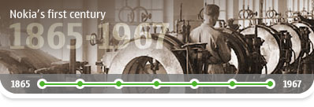
The first Nokia century began with Fredrik Idestam's paper mill on the banks of the Nokianvirta river. Between 1865 and 1967, the company would become a major industrial force; but it took a merger with a cable company and a rubber firm to set the new Nokia Corporation on the path to electronics...
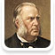
1865: The Birth of Nokia
Fredrik Idestam establishes a paper mill at the Tammerkoski Rapids in south-western Finland, where the Nokia story begins.
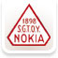
1898: Finnish Rubber Works Founded
Eduard Polón founds Finnish Rubber Works, which will later become Nokia's rubber business.

1912: Finnish Cable Works Founded
Arvid Wickström starts Finnish Cable Works, the foundation of Nokia's cable and electronics businesses.

1937: Verner Weckman, Industry Heavyweight
Former Olympic wrestler Verner Weckman becomes President of Finnish Cable Works.

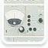
1960: First Electronics Department
Cable Works establishes its first electronics department, manufacturing, selling and operating computers.

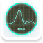
1962: First In-house Electrical Device
The Cable Works electronics department produces its first in-house electrical device - a pulse analyzer for nuclear power plants.

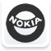
1967: The Merger
Nokia Ab, Finnish Rubber Works and Finnish Cable works formally merge to create Nokia Corporation.

2.1.2 The Move to Mobile: 1968-1991

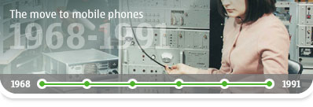
The newly formed Nokia Corporation was ideally positioned for a pioneering role in the early evolution of mobile communications. As European telecommunications markets were deregulated and mobile networks became global, Nokia led the way with some iconic products...
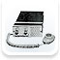
1979: Mobira Oy, Early Phone Maker
Radio telephone company Mobira Oy begins life as a joint venture between Nokia and leading Finnish television maker Salora.
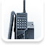
1981: The mobile era begins
Nordic Mobile Telephone (NMT), the first international mobile phone network, is built. Thus the new era begins.
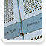
1982: Nokia makes its first digital telephone switch
The Nokia DX200, the company’s first digital telephone switch, goes into operation successfully.
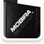
1984: Mobira Talkman launched
Nokia launches the Mobira Talkman portable phone, the first mobile phone call in England in 1985.
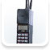
1987: Mobira Cityman – birth of a classic
Nokia launches the Mobira Cityman, the first handheld mobile phone for NMT networks and a model that was to become a classic.
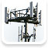
1991: GSM – a new mobile standard opens up
On July 1, 1991, Finnish Prime Minister Harri Holkeri made the world’s first GSM call, using Nokia equipment.
2.1.3 Mobile Revolution: 1992-1999

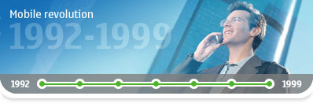

In 1992, Nokia decided to focus on its telecommunications business. This was probably the most important strategic decision in its history.

As adoption of the GSM standard grew, new CEO Jorma Ollila put Nokia at the head of the mobile telephone industry’s global boom – and made it the world leader before the end of the decade...


1992: Jorma Ollila becomes President and CEO
Jorma Ollila becomes President and CEO of Nokia, focusing the company on telecommunications.
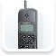
1992: Nokia’s First GSM Handset
The Nokia 1011 was the first mass-produced GSM phone. The Nokia 1011 continued production until 1994.

1994: Nokia Tune is launched
Nokia launches the 2100, the first phone to feature the Nokia Tune, the most popular ringtone featured by any cell phone manufacturer.
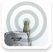
1994: World’s First Satellite Call
The world’s first satellite call is made, using a Nokia GSM handset with the help of satellite network.

1997: Snake – a Classic Mobile Game
The addictive game was launched on the Nokia 6110 and is rightly considered a classic. Snake and its successors are now available on an estimated 350 million mobile phones.
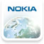
1998: Nokia Leads the World
Nokia becomes the world leader in mobile phones. The 1990s also saw unparalleled growth in global sales. Between 1996 and 2001, Nokia’s turnover increased almost fivefold from EUR 6.5 billion to EUR 31 billion.
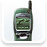
1999: The INTERNET Goes Mobile
Nokia launches the world's first WAP handset, the Nokia 7110.

2.1.4 Nokia Now: 2000-Today

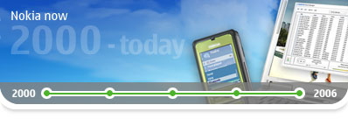

Nokia’s story continues with 3G, mobile multiplayer gaming, multimedia devices and a look to the future...

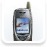
2002: First 3G Phone
Nokia launched its first 3G phone, the Nokia 6650, in 2002. A vintage year for innovation, 2002 also saw the launch of Nokia’s first phone with a built-in camera, the Nokia 7650, and its first video capture phone, the Nokia 3650.

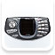
2003: Nokia Launches the N-Gage
he N-Gage is a mobile telephone and handheld game system by Nokia, based on the Nokia Series 60 platform, released in October 2003. It began sales on October 7, 2003.
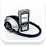
2005: The Nokia Nseries is Born
Nokia introduces the next generation of multimedia devices, the Nokia Nseries. The easy-to-use devices combine state-of-the-art technology with stylish design, creating complete entertainment and communication packages.
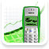
2005: The Billionth Nokia Phone is Sold
Nokia sells its billionth phone – a Nokia 1100 – in Nigeria. Global mobile phone subscriptions pass 2 billion.

2006: A New President and CEO – Nokia Today
Olli-Pekka Kallasvuo becomes Nokia’s President and CEO; Jorma Ollila becomes Chairman of Nokia’s board. Nokia and Siemens announce plans for Nokia Siemens Networks.
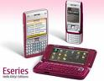
2006: The Birth of Nokia Eseries
The Nokia Eseries consists of business-oriented smartphones, with emphasis on enhanced connectivity and support for corporate e-mail push services. All devices have advanced office features.
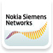
2007: Introduction of Nokia Siemens Networks
Nokia recognized as 5th most valued brand in the world. Nokia Siemens Networks commences operations. Nokia launches Ovi, its new internet services brand.

2008: OVI
Nokia's three mobile device business groups and the supporting horizontal groups are replaced by an integrated business segment, Devices & Services.
2.2 Nokia in Bangladesh

Nokia started its own sales and distribution channel in Bangladesh in June 2006. Nokia offers the most comprehensive product portfolio ranging from voice centric entry devices to multimedia centric N-series and enterprise solutions centric E-series. Around 100 new devices have been introduced in Bangladesh since 2006. Nokia introduced the first Bengali user interface enabled device in the country and continue to introduce new mobile devices and services specifically targeted to serve the unique needs of consumers of Bangladesh. Nokia devices are widely available through its four Nokia stores, five premium partner outlets and more than 6500 retail outlets spread across the country. Nokia currently operates 28 Customer Care Centers ensuring world-class after sales service for its valued consumers.

Nokia has been pioneering a number of worthy causes in Bangladesh. Nokia has played a significant role in supporting Breast Cancer Awareness in the country along with Bangladesh Cancer Foundation Hospital. Part of the sales proceeds from Nokia 6300 crimson red phone has also been contributed to this cause. Nokia also stood behind the victims of natural disasters in trying times.

Nokia is strongly attached to the value of Corporate Social Responsibility and concentrates on our society through its comprehensive programs. One of the major societal activities was to increase awareness regarding Breast Cancer among mass people. Nokia and CCRP jointly arranged a significant campaign on Breast Cancer Prevention. In October 2008, Nokia started its campaign with CCRP in 21 districts in Bangladesh. Nokia, Exim Bank, BRAC Bank collectively supported a unique conference on “Autism”. Welfare of Autistic Children arranged a conference named “Third South Asian Conference on Autism” on 16the and 17th January 2009. This is the first ever conference on autism in Bangladesh.

Considering Bangladesh as one of the most exciting markets in Asia, Nokia, one of the largest cell phone producers in the world, plans to expand its business and services in 'Emerging Asia' with headquarters to be based in Dhaka.
CHAPTER 3: PRODUCT OVERVIEW & CONSUMER ANALYSIS

3.1 Product Overview

A music cell phone consolidates two great devices, an attractive cell phone and a definitive portable audio player into one device. All music cell phones can play MP3s and most work with major music providers like iTunes, Yahoo Music, Sprint Music and more. Just because these phones are fun doesn’t mean they are not functional, most music phones include advanced cell phone features like a speakerphone and multimedia text messaging (MMS). For exceptional connectivity all music phones offer Bluetooth and they also include other multimedia elements like a camera and video playback, email support and instant messaging. But as audio playback is the main feature of music cell phone, all portable audio players are its competitor.

In the race of Xpress music smart phones the user can come to know that all these has wide TFT resistive touch screen. Furthermore, these comes with proximity sensor for auto turn-off, accelerometer sensor and handwriting recognition. Such features make them more interesting in it. Apart from all, these are equipped with standard rechargeable battery which provides good battery back-up system. So, an individual need not charge them again and again after every short span of time.

The Xpress music phones are music handsets. These smart phones come with massive memory storage space which can be easily expanded by simply inserting memory card. Moreover, the Nokia 5530 has built-in 3.15 mega pixel camera with features like autofocus, LED flash, photo editor and many more. Whereas, the 5800 has integrated 3.15 mega pixel camera with Carl Zeiss optics, autofocus, LED flash, photo editor, TV-Out. Apart from all, both come with stereo FM radio with RDS feature. So, in the spare time, one can anytime and anywhere tune into radio. All the above mentioned mobile phones come with Bluetooth and USB. So, an individual can upload as well as download lots of data from the other handsets to the Xpress music phones without any hassle. Moreover, these handsets come with internet facility. By this feature, user can access various social networking website like Orkut, Facebook etc. An individual can therefore, experience the high speed internet browsing connectivity.

These mobile phones come with various messaging features through which one can interact with others without even calling them. By email and instant messaging, an individual can be in touch with others at online. Moreover, the user can send, create and receive simple text message via SMS. With the help of multimedia messaging service (MMS), one can share pictures, videos, music files etc among his friend circle. In fact, these features make the communication process more interesting. While comparing the Nokia N97 vs. Xpress music phones, one can conclude that these smart phones can actually thrill the users mind with excitement. These mobile phones are especially designed as per the requirements of the hi-tech generation.

These are covered in a rubberized skin, which makes them quite tactile and easy to find by feel. A five-way toggle also acts as a shortcut to four-user defined functions, and there's a selection of additional shortcuts on the standby screen as well. There are also two soft keys, which are programmable for one-touch access, and the Talk and End buttons. Our only complaint was that the backlighting on these keys is a bit dim. To reveal the keypad buttons, just slide up the front face. Spacious and brightly backlit, the individual buttons are raised above the surface of the phone. Such texture is unique for a slider phone, but it's a welcome change as the keys are easy to use even if they are a tad slippery.

Lining the immediate left side of the display are dedicated music controls that give easy access to the music player. Once inside, you can play, pause, fast-forward, and rewind your tracks. Fortunately these buttons are also covered in the rubber skin, so they're every tactile and easy to find when you're not looking at the phone. The left-facing keys may be unintuitive to some users, but we didn't mind. On the right spine of the bottom half of the slider is a volume rocker and a dedicated camera shutter. The rubber texture extends here as well, and raised ridges make the volume rocker easily accessible when holding the phone to your ear. As with many other camera phones, the Nokia 5300's ergonomics give it a camera-like feel when you hold the phone horizontally with the shutter control facing up. The camera lens sits on the back of the phone, with a self-portrait mirror, but we're disappointed there's no flash. The infrared port sits on the right spine, while the power control and ports for the mini-USB cable and the charger rest on the phone's top end. Finally, the headset jack is in the top-left corner.

Nokia always tries to cater the needs of different segments of the market with diversified personality and wants. The XpressMusic targets the music lovers. Nokia XpressMusic emphasizes on music and there are other sets of different companies that also offer music as their core feature. Some of the potential competitors are:

- Sony Ericsson Walkman phone.
- Moto Rokr by Motorola.
- Samsung’s BEAT450.
- Ipods and other mp3 players.

3.2 Cell Phone Users in Bangladesh Prefer Style over Features

A latest study conducted by Nokia pointed out that the people in Bangladesh prefer style more than the need of being connected. The study says that the new devices combined with a attractive fold design with quick cover keys is bringing out substance to style, which is more acceptable in Bangladesh as compared to other markets in the region of Asia and Asia Pacific. The study said that for innovation-conscious users “we need to offer intelligent and entertaining multimedia functionality in an easy to use, ultra slim package”.

Talking about the study and cell phone users’ preference for Nokia in Bangladesh, Ms. Moutushi Kabir, Communications Manager, Nokia EA Limited said that the users in Bangladesh had surpassed others in the demand for innovation in technology.
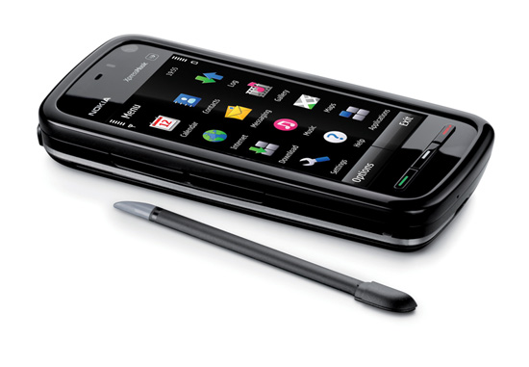
She said that the cell phone users in Bangladesh were involved more in style, which was beyond their expectations. He said the users in Bangladesh needed style and design more than other features.

She said that Nokia was considering of doubling its investment in Bangladesh looking at the response. He said that Nokia has conducted a comprehensive and detailed study of mobile phone users and Bangladeshi users have surpassed their forecast in the market.

Moutushi said that youngsters demanded innovation in multimedia computer that brings the complete experience to a sleeker body. He said that Nokia has created a very eye-catching device using premium materials to enclose world-class features and experiences.
The credibility of Nokia handset can be easily judged through their huge sale in the mobile phone market. This is not over, the availability of Nokia phones in various series and ranges are also commendable and come under the budget of every common handset user. The related handset series of this Nokia phones are Nokia Supernova, Classic, XpressMusic, E-Series, N-Series etc. The devices come under such series are in huge demand by many present day handset freaks. But big revolution has been come in the outstanding sale of Nokia's XpressMusic phones. There are huge music lovers of XpressMusic devices across the world, who are crazy about such wonderful musical assets from long time.
The Nokia XpressMusic handset range conclude several outstanding musical phones like Nokia 5800, 5230, 5330, 5630, 5730 and many more. These handsets are specially meant for its outstanding music and promise for the high end musical fun to the owner of this gizmo. Apart from its musical fun, the elegant designs and built up of high end features are also big deals available in them. Among all such great musical devices, most music lovers love to purchase Nokia 5800 XpressMusic handset. Because the awesome music of this handset has proven its quality and its stunning look is also eye catching.

Talking about the look of this musical phone then one will surely influenced through its red color face, which gives a nice impression to it. Furthermore, the thrilling music of this gizmo is a major part of concern, which can be easily enjoyed through its inbuilt music player. This valuable player has ability to play the user's favorite songs with surround sound. In addition the fun of music can also get doubled through its embedded FM radio with RDS and profitable provisions of MP3 & AAC and polyphonic ringtones. The integrated speakers of this device ensure one to experience all types of awesome music with huge clarity.
This device is also loaded with a 3.2 MP quality camera, which got the blessings of dual LED flash and autofocus facilities. So, with such capacities, this camera looks much reliable to capture decent pictures with bright colors. Even more, this camera also looks able for TV out, video calling, video recording, video playing through a player etc. The innovation of this Nokia 5800 XpressMusic also depicts through Internet facility in it. Its inbuilt connectivity features like 3G HSDPA, WLAN Wi-Fi and EDGE are powerful provisions that ensure one for the rapid speed Internet connectivity with ease. Besides it, the user will also be benefited for the Bluetooth features in this musical phone, which is well known provision to share songs, video clips, wallpapers and other data to the Bluetooth supportive handsets of others.
The power of this handset also proved through its GSM network compatibility, which comes from its inbuilt GSM Quad band (GSM 850, 900, 1800 & 1900). The utility of this GSM band ensures one to avail the hassle free network coverage anytime and anywhere. This handset is also blessed with remarkable battery, which permits one experience the facility of 8.8 hours of GSM talk time and 406 hours of GSM standby time. Physically, this device looks very handy, it has been proven through its impressive dimensions like 111 x 51.7 x 15.5 mm and it weighs only 109 grams. Undoubtedly, the creativity of above discussed features of this Nokia 5800 Xpress Music, preferably its musical fun is simply mind blowing.

3.3 Target Market

Nokia segments its consumers based on the following two criteria which they think is relevant for the mobile handset market:
- Economy
- Approach to technology

They have 13 very detailed consumer segments and a total of four categories of products currently in the market:

  - Entry: These are the basic and affordable handsets which are simple in nature and have only the basic features such as voice and SMS services. These are aimed at consumers who are ‘simplicity seekers’.

  - Explore: These are the N-series phones which are characterized as being high-end phones with additional features such as multimedia, good camera, etc. these phones are aimed at people who are outgoing, fun-loving and adventurous in nature and who love to share their experiences with others which can be done through N-series phones.

  - Achieve: These phones are aimed at business professionals and have the features of an e-mail client. These phones fall in the E-series category with features such as e-mailing and synchronization with the user’s laptop or computer.

  - Live: These are the phones that are targeted towards mostly the young generation who have a love for life, music, entertainment, clubbing, etc. The XpressMusic series phones fall in this category with features such as music and video players.

The Nokia XpressMusic range falls under the Live Category. The target market for this range is mainly the youth who love music and entertainment. This segment likes to play and create music and share with friends and seek online sharing. Music is a crucial part of their lifestyle and they listen to music every single day. They like to go to parties and are social and outgoing. They use the Nokia XpressMusic as an extension of their personality and lifestyle.
CHAPTER 4: EXTERNAL AND INTERNAL INFLUENCES ON CONSUMER BEHAVIOR

4.1 External Influences on Consumer Behavior

4.1.1 Cultural Values

Bangladesh has a culture that is rich in music and festivities. As such, Nokia XpressMusic fits in quite well with the cultural values and accepted norms of the society. The youth of Bangladesh are generally music lovers which influence their consumption pattern of music devices and as such Bangladeshis form a huge market for Nokia XpressMusic phones. To understand the effects of culture on the consumption pattern of Nokia XpressMusic, a detailed analysis of each sub-cultural factor has been done which is discussed below.

- Individual/Collective: Bangladesh is regarded to be a very collective society with a lot of festivals that are enjoyed in large groups. As such, music phones, particularly ones with loud speakers which is a common feature of Nokia XpressMusic phones, are very popular and highly demanded. Nokia can highlight this feature in terms of collective enjoyment to promote their phones.

- Youth/Age: The majority of the people of Bangladesh are significantly traditional in their values and even today purchase decisions of high involvement goods are influenced greatly by the elders of the house in most households, like parents. However, in the case of mobile phones which falls in the category of ‘new technology’ in Bangladesh, the purchase decisions are more influenced by the young members of the house since they are considered to be more ‘tech-savvy’. Therefore, Nokia’s marketing efforts should be directed towards the young generation who play the role of ‘opinion leaders’ in this case.

- Extended/Limited Family: Most of the families in Bangladesh are extended families, although a recent shift towards limited families has been noticed in urban regions. In either case, this factor does not play a significant role in purchase decisions of Nokia XpressMusic phones.

- Masculine/Feminine: Gender roles in youth are slowly blurring and Bangladesh is no exception.

- Tradition/Change: Bangladesh as a nation is resistant to change. However, this issue does not influence consumer behavior for Nokia XpressMusic phones.

- Active/Passive: Bangladesh is quite a passive nation. However, since music can be a part of both active and passive lifestyles, in both scenarios Nokia XpressMusic phones can become an integral part of people’s lives.

- Sensual Gratification/Abstinence: The people of Bangladesh are greatly hedonistic in nature. This shapes the consumer behavior towards Nokia XpressMusic phones favorably.
- Material/Nonmaterial: Bangladesh is culturally very materialistic and having latest high-end mobile phones with a wide variety of features is regarded to be a symbol of status.

- Postponed gratification/Immediate gratification: The members of the young population are spenders in nature and tend to go for immediate gratification which favors the consumption pattern of Nokia XpressMusic.

4.1.2 Group Influence

In the consumption pattern of Nokia XpressMusic phones, group influence plays a very vital role. Reference group refers to the group of people whose perceptions are taken to be the accepted basis of an individual’s behavior. Reference group influence is higher when the product/service is visible which is true in this case. Informational influence from the reference group plays a significant role in the purchase decision of phones. High-end phones are High Involvement goods in Bangladesh and so before a phone is purchased, detailed information regarding it is sought out from opinion leaders and reference group members. Normative influence also plays an important role. When an individual decides to buy a phone, the features that he/she desires, are greatly influenced by the accepted norms of his/her reference group. For example, if an individual’s reference group values camera features superior to music playing features, he/she will be influenced to buy a camera phone rather than Nokia XpressMusic phones.

Since reference group influence is quite high for Nokia XpressMusic phones due to its high visibility and non-necessity, a number of marketing strategies can be used. Personal Selling can be helpful in providing important information regarding the phones and its features. The acceptability and popularity of Nokia XpressMusic phones can be showed in advertisements to give the feel of its acceptance in groups. Opinion leaders can be created who will advocate for the phones, providing helpful information and ‘creating the buzz’.

4.2 Internal Influences on Consumer Behavior

Internal influences to Nokia XpressMusic are factors such as perception, learning, memory, motivation and personality.

4.2.1 Perception:

Perception consists of those activities by which an individual acquires and assigns meaning to stimuli. Consumers’ brand preference is built around the brand image which is based on the perception of the consumers. For a mobile phone that enhances the lifestyle of people, word of mouth is the strongest media for exposure. Our survey shows that 65% of the consumers came to know about Nokia XpressMusic from family and friends. About 20% of the consumers came to know from Newspaper Advertisements, 5% from TVC and 10% from billboards. This shows that word-of-mouth and opinion leaders are extremely vital for the exposure of Nokia XpressMusic.

Nokia uses all the popular media of communication. According to the respondents of the survey we found out that 30% could remember the brand, features and co-branding partners, 50% could remember the brand and co-branding partner; whereas, 20% of them could only remember the brand name.

The consumers interpret Nokia XpressMusic advertisements as portrayal of a young personality. The main reason behind this perception is the communication and features of the product. Our survey shows that consumers also see Nokia XpressMusic as cool and trendy brand which is associated with music.

4.2.2 Learning & Memory

In the survey we conducted, respondents were asked to write down the first word that comes to their mind when thinking about Nokia XpressMusic and were also asked to describe Nokia XpressMusic. Based on these questions the following schematic diagram was drawn:

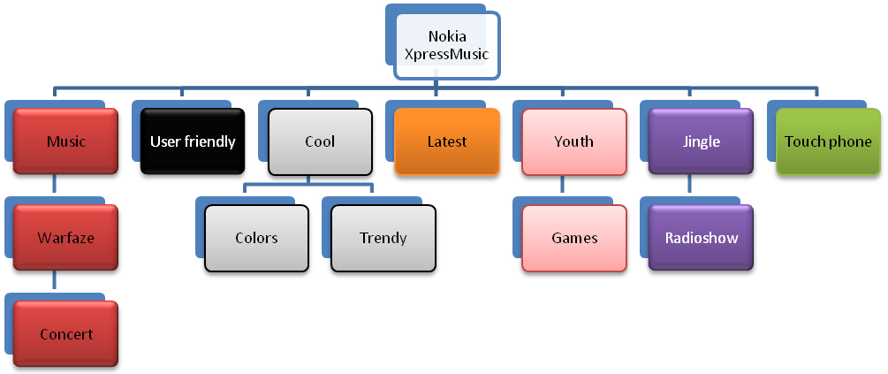
Figure: Schematic Diagram

When asked to name only one model among the whole range of Nokia XpressMusic, 90% of the respondents could recollect the Nokia XpressMusic 5800, which shows the amount of excitement it could create through its promotion and touch screen feature.

4.2.3 Motivation and Personality

Through our focused group discussion we have found out that manifest motive is the main reason behind purchasing Nokia XpressMusic. People purchase Nokia XpressMusic sets because it is perceived that the product is young, cool and trendy. This perception is centered around its primary feature of quality audio device and its communication in different media. So it can be said that Nokia XpressMusic falls under Esteem need of Maslow’s Need Hierarchy for those people who would like to identify themselves as being different and stand out in the crowd. Several psychological needs is also connected with the need of the consumers. Need for Expression can be identified as consumers seek to express themselves through this product.

Affective motives deal with the need for satisfying feeling states and reaching personal goals. Consumers have the need for tension reduction to alleviate the stressful situations of daily life. Thus they seek out entertainment through music.

4.2.4 Self Concept and Lifestyle

Previously, people used cell phones only for the purpose of communication. But as the days went on, people wanted more features in the cell phones. The need for features depends on factors like utility, entertainment, features etc. This changing value is effecting the purchase decisions of the consumers. If we look at the lifestyle of consumers of Nokia Xpressmusic, they will fall under the following VALS segmentations:

[

Achievers & Strivers
Status oriented consumers who are successful career and work oriented people, falls under this segment. As the high priced Nokia XpressMusic sets are expensive as well as value expressive, the achievers fall under this category. The Nokia XpressMusic actually shows-off lifestyle which people in this category want to do. As the strivers follow the achievers, they also want to purchase Nokia XpressMusic.

Experiencers
Experiencers are young, vital, enthusiastic, impulsive and rebellious. They often welcome new and innovative products. As the Nokia XpressMusic is trendy and fashionable the experiencers want to purchase such sets. But experiencers are not that well-off so they would prefer to buy the lower range Nokia XpressMusic sets.
CHAPTER 5: BRAND IMAGE, BCG MATRIX & SWOT ANALYSIS

5.1 Brand Image and Personality

There is no single personality attached to the brand XpressMusic. It is portrayed to have an exciting and fun sharing personality. The brand is actually a music phone for youth. The characteristics that are portrayed to create the exciting personality are loud music device, sharing music with friends and peers, association to senses of touch and sound, vibrant colors, etc. All the XpressMusic phones are designed with touches of bright and vibrant colors such as red, lemon green and flashy blue. The campaigns are designed using these colors. Since the phone is a music phone, all campaigns of the product feature latest and trendy music. The brand promotes peer activities such as sharing music with friends through Bluetooth and online music sharing and downloads from Nokia Music store.

The phone associates with the personality attributes of the young generation. It promotes its users to be on the move with music, to be with music all the time and to “groove” with loud music. Matching with the personalities of the youth, the brand also has cameras incorporated in the phones. Since the personality of youth includes taking pictures and videos and sharing them, that ISs what XpressMusic has targeted as well.

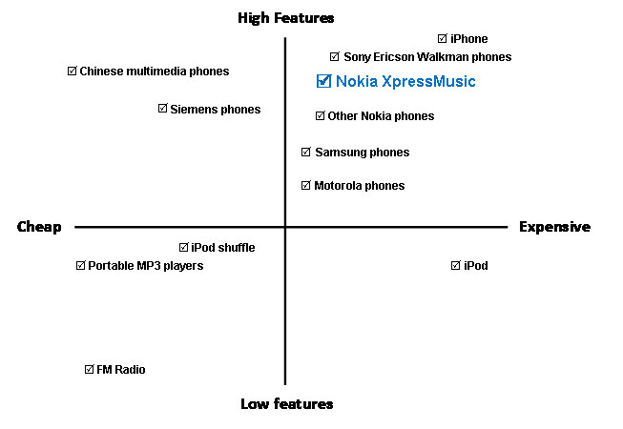
Figure: Perceptual Map

5.2 BCG Matrix

The BCG Growth-Share Matrix is a portfolio planning model developed by Bruce Henderson of the Boston Consulting Group in the early 1970's. It is based on the observation that a company's business units can be classified into four categories based on combinations of market growth and market share relative to the largest competitor, hence the name "growth-share". Market growth serves as a proxy for industry attractiveness, and relative market share serves as a proxy for competitive advantage. The growth-share matrix thus maps the business unit positions within these two important determinants of profitability.

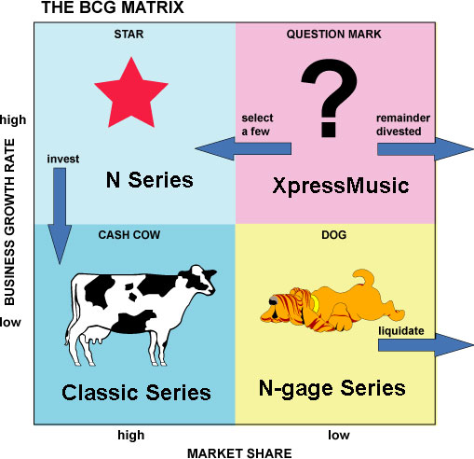

- Dogs - Dogs have low market share and a low growth rate and thus neither generate nor consume a large amount of cash. However, dogs are cash traps because of the money tied up in a business that has little potential.
N-gage series is dedicated mainly to gamers who prefer a portable device like mobile phone friendlier in playing video games. That is why this series has a lower market share as well as low business growth rate.

- Question marks - Question marks are growing rapidly and thus consume large amounts of cash, but because they have low market shares they do not generate much cash. The result is large net cash consumption. A question mark (also known as a "problem child") has the potential to gain market share and become a star, and eventually a cash cow when the market growth slows. If the question mark does not succeed in becoming the market leader, then after perhaps years of cash consumption it will degenerate into a dog when the market growth declines. Question marks must be analyzed carefully in order to determine whether they are worth the investment required to grow market share.
Being a dedicated music Smartphone the XpressMusic series has the high business growth rate but it has grabbed a lower market share which indicates that this series is under Question Mark.

- Stars - Stars generate large amounts of cash because of their strong relative market share, but also consume large amounts of cash because of their high growth rate; therefore the cash in each direction approximately nets out. If a star can maintain its large market share, it will become a cash cow when the market growth rate declines. The portfolio of a diversified company always should have stars that will become the next cash cows and ensure future cash generation.
N-series has both high growth rate and market share.

- Cash cows - As leaders in a mature market, cash cows exhibit a return on assets that is greater than the market growth rate, and thus generate more cash than they consume. Such business units should be "milked", extracting the profits and investing as little cash as possible. Cash cows provide the cash required to turn question marks into market leaders, to cover the administrative costs of the company, to fund research and development, to service the corporate debt, and to pay dividends to shareholders. Because the cash cow generates a relatively stable cash flow, its value can be determined with reasonable accuracy by calculating the present value of its cash stream using a discounted cash flow analysis.

5.3 SWOT Analysis

STRENGTHS
- Large TFT Screen
- Dedicated Music Key
- GPS Navigation System
- 3G Connectivity
- Wi-Fi Connectivity
- Built-in MP3 digital music player
- Video Recorder
- Video Player
- Stereo Speakers with Surround Sound Output
- Built-in Handsfree
- Durability
- Long Better Life
- Global Expansion
- Brand Loyalty

WEAKNESS
- Low HSPDA
- Market Skimming Prices of High Sets
- Heavy sets
- Low Battery Life in Some Models

OPPORTUNITIES
- Mobile with Computer
- New Market
- Well Designed and Style Set

THREAT
- iPhone and iPod
- Samsung SGH-i450
- Motorola E 8 and MOTOROKR E6 Music Edition
- China Mobiles
- Country Situation

CHAPTER 6: CURRENT MARKETING STRATEGY

6.1 Product

The Nokia XpressMusic range has a number of phones catering to the needs of music lovers. The Nokia XpressMusic 5300 and Nokia XpressMusic 5200 were introduced for youthful music lovers and a low price was set for them. After that, new phones were introduced to the existing series with additional or less features to suit the target consumers, which includes Nokia XpressMusic (3250, 5530, 5730, 5330, 5630, 5130, 5800, 5320, 5220, 5610, 5700 and 5310)
A brief description of the features of selected phones from the Nokia XpressMusic range is given below.

Nokia XpressMusic 3250:
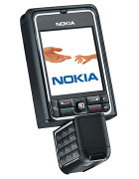This was the first phone in the range of Nokia XpressMusic phones.

Nokia XpressMusic 5310:
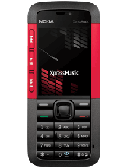This is the basic XpressMusic phone of the series. In addition to have the fundamental function of a music phone, Nokia XpressMusic 5310 has an internal memory of 30 MB which is extendable to 8 GB so as to accommodate a wide array of music files. It also has dedicated music keys to provide easy access to the music player. This music phone also comes with a camera with 2.0 MP to give the user the opportunity to share his/her experiences. Nokia XpressMusic 5310 has Stereo FM Radio and comes in the following four colors- Red, Blue, Pink and Black.

Nokia XpressMusic 5730:
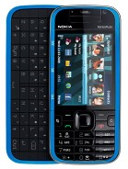Along with all the functions of Nokia XpressMusic 5310, this phone has some additional features along with some new ones. It has 100 MB internal memory which is extendable to 16 GB. It has a better camera with 3.15 MP and autofocus function.

Nokia XpressMusic 5700:
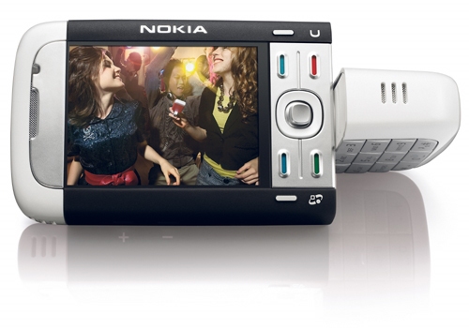
This phone has very basic features of a music phone with an internal memory of 35 MB with external memory extendable to 2 GB. The camera feature is also very basic, the phone being relatively low-priced.

Nokia XpressMusic 5800:

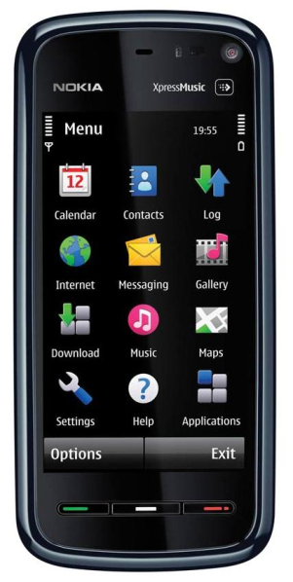

This phone has additional features such as a camera with 3.2 MP with auto focus and video options. It has a memory of 81 MB, extendable to 16 GB.

6.2 Price

The Nokia XpressMusic series are aimed at the young generation and so the price has been set accordingly. The price ranges from BDT 7,500 to BDT 27,500. This is done to ensure that the price is within the reach of the young population who make up the target market.

Nokia Xpress Music Model | Price
Nokia XpressMusic 3250 | Tk. 20,500
Nokia XpressMusic 5310 | Tk. 8,650
Nokia XpressMusic 5730 | Tk. 21,500
Nokia XpressMusic 5700 | Tk. 16,000
Nokia XpressMusic 5800 | Tk. 19,500

6.3 Place

Nokia has three categories of outlets.
6.3 Place
Nokia has three categories of outlets.
- Nokia Showrooms: There are four Nokia showrooms in Bashundhara City; North Tower, Uttara; Shopper’s World, Gulshan and Happy Arcade, Dhanmondi. The showrooms are exclusively designed so, as to create an ambience reflecting the sophistication of Nokia. All these showrooms are quite spacious and the customers can freely pick up model phones to get the feel of the phone in their hands. In these stores Nokia employs brand promoters who are assigned particular series and they assist the customers by providing information regarding the phones and its features.

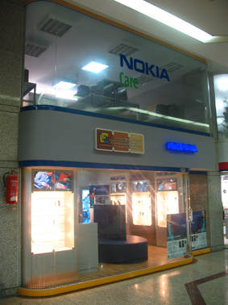
Photo: Nokia Showroom

- Nokia Care: Nokia has some retailers who sell Nokia phones exclusively and these stores fall in this category. They are similar to Nokia stores in their design and arrangements.
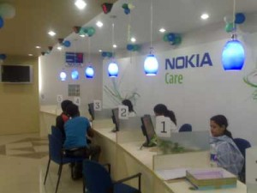
Photo: Nokia Premium Partner Outlets

- Retail Outlets: The mobile vendors that are scattered all around the country belong to this category. There are about 6500 such retail outlets for Nokia. All the mobile phone shops in shopping centers fall in this category.

6.4 Promotion:
The promotional mix of Nokia involves a wide assortment of tools which are discussed below.
- Public RelSations: All device launches of Nokia are started with media launches and then press advertisements go out. The XpressMusic was not an exception either. For every phone that Nokia launches in this series, they call for a media launch and create the hype about the new phone.

Photo: Launching New Model

- Co-Branding with Warfaze: In order to create hype about their latest phones 5800 and 5130, Nokia formed a co-branding with Warfaze by offering some of the songs from their unreleased album. The album itself was launched a month after the phone’s launch.

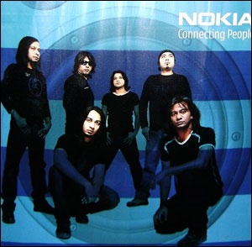
Photo: Album Cover Page of the New Warfaze Album

- Music Caravan: For the XpressMusic range, Nokia partnered with Radio Foorti and formed a Music Caravan called ‘Nokia Foorti XpressMusic’. The caravan went around all the youth hubs of Dhaka city including all universities. A Radio Jockey (RJ) from Radio Foorti accompanied the caravan and interacted with people regarding music and the new music phone from Nokia.

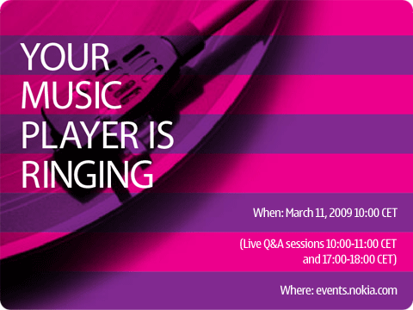
Photo: Advertisement of Music Caravan

- Event: Currently Nokia is hosting a series of concerts called the XpressMusic concert in each of the 6 division cities of Bangladesh in turn. The first concert was in Kamal Ataturk, Banani in Dhaka on the event of ‘Pohela Boishakh’. Also, they occasionally host concerts to promote the music phones.

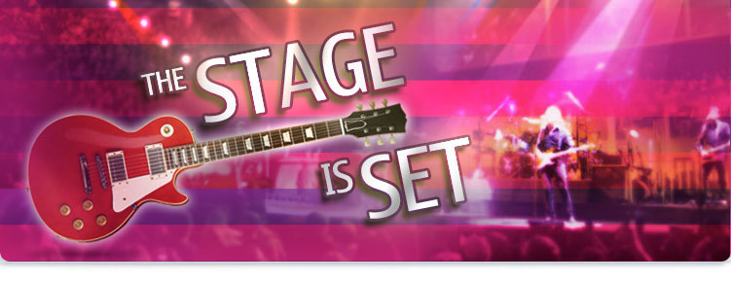
Photo: Concert Sponsored by Nokia

- TV Show: To promote XpressMusic phones, Nokia hosted a music show on NTV, a private satellite channel, called Nokia Music Lounge for 6 months. It was anchored by John, a member of the band ‘Black’. It was a live show and the theme was that the audience could select a song from a list and ask John to play it right then by calling in to the show. They also brought in bands and singers with whom the audience could interact.

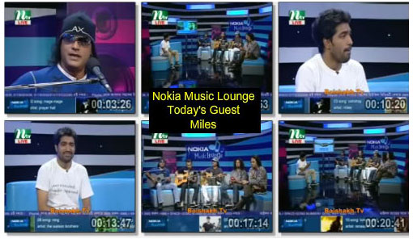
Photo: Hosted Music Show on NTV

- Radio: Nokia also runs a radio jingle for the XpressMusic range.

- Billboards: Nokia extensively uses billboards as a promotional tool. They have billboards featuring the XpressMusic range phones including their latest phones with the unreleased albums of Warfaze. They place these billboards all around Dhaka city where they are easily visible. The ads are designed to give the ambience of a club.


Photo: A Billboard in Dhaka City

- Points-of-Sale: They have leaflets and brochures available at all points-of-sale.

- Print Advertisements: Nokia regularly runs Print Advertisements in newspapers featuring all their phones along with price quotations. For XpressMusic ranges they ran special ads consistent with the theme. They also run advertisements in lifestyle magazines such as ICE Today.

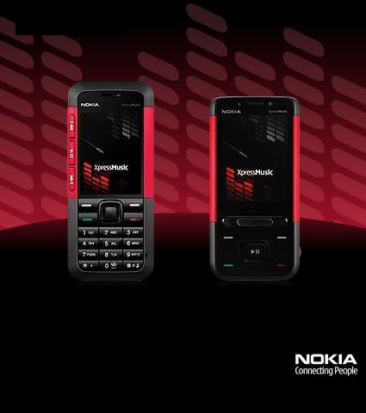
Photo: Printed Advertisement of Nokia XpressMusic
6.4.1 Promotion Strategies: Push or Pull?
Marketing theory distinguishes between two main kinds of promotional strategy - "push" and "pull".
Push:
A “push” promotional strategy makes use of a company's sales force and trade promotion activities to create consumer demand for a product. Nokia promotes the product to wholesalers, the wholesalers promote it to retailers, and the retailers promote it to consumers. For example Nokia promotes XpressMusic via retailers. Personal selling and trade promotions are often the most effective promotional tools for companies such as Nokia - for example offering subsidies on the handsets to encourage retailers to sell higher volumes. A "push" strategy tries to sell directly to the consumer, bypassing other distribution channels (e.g. selling insurance or holidays directly). With this type of strategy, consumer promotions and advertising are the most likely promotional tools.
Pull:
A “pull” selling strategy is one that requires high spending on advertising and consumer promotion to build up consumer demand for a product. If the strategy is successful, consumers will ask their retailers for the product, the retailers will ask the wholesalers, and the wholesalers will ask the producers.
NOKIA XpressMusic chose both Strategies:
Nokia chose both strategies because we know if they don’t use both strategies they will be unable to promote new product. When they want to promote their product worldwide; it is impossible if they don’t use both strategies. NOKIA is a large company and they have the ability to promote its product widely through both strategies.
CHAPTER 7: SPECIAL PROMOTIONS IN BANGLADESH


7.1 Uttaradhikar – The Inheritance

Uttaradhikar (The Inheritance) is a reality TV programme broadcast on Channel i in Bangladesh. The reality show is about a group of celebrities who lock themselves up in a Zamindar Bari (Landlord Palace), and undergoes tasks, games and challenges to clinch the title of "Uttaradhikar" ("heir"). Ten celebrities compete to win the inheritance of the 100-year old Zamindar Palace. The winner is awarded a big cash prize. Nokia is the official sponsor of this show.
The story of Uttaradhikar starts in a century-old Zamindar palace. The landlord of the palace made his estate so prosperous that news of his Golden Era spread far and wide. But alas, he passed away one day, leaving behind no children to inherit his property. Till today, his spirit roams around the lonely corridors and dark rooms of the Zamindar palace, in search of the elusive person who can be trusted to inherit his palace. As our landlord searches, we also wonder…Who will be the inheritor? Based on the spirit of this story, 10 renowned celebrities will lock themselves in a battle royale to win the inheritance of this 100-year old Zamindar Palace. Uttaradhikar – is a live battle packed with excitement, challenges, suspense and fun.

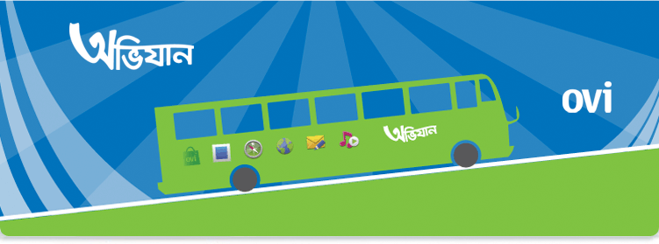
7.2 Empowering Bangladesh through Internet

Nokia, on October 18, in an inaugural ceremony announced its new campaign 'Ovijaan' a journey across the Bangladesh aimed at empowering youth with greater access to information technology. 'Ovijaan' comprising two environment friendly 'cyber buses' are equipped with solar panels and internet set-up for 5 Nokia handsets and 5 computer stations. Nokia has launched the journey with a vision to drive internet literacy and create email identities for next generation in the country.
Two Ovijaan buses will visit high schools and colleges across the country to introduce students to the world of the Internet. Facilitators on the bus will help students activate their own Ovi Mail accounts, show them how the Internet can be a great enabler in bringing prosperity to their lives, and help them access Ovi services on mobile devices.
Through this initiative, Nokia aims to facilitate the transformation of Bangladesh into a digital state, where information technology drives economic advancement and prosperity.


7.3 Ovi Store

Nokia will start connecting content providers with consumers through a one-stop shop, the Ovi Store, which will offer consumers relevant, targeted media through their social connections and their physical location information. When it opens in May, the Ovi Store is a scalable media distribution network unrivaled in size and opportunity, with advanced content targeting capabilities and monetization options that allow content providers and application developers to leverage the power of Nokia's global scale in devices.
In Ovi store there will be up to 10 popular Gameloft titles available for download including Assassin’s Creed, Prince of Persia, Paris Nights, Ryman, Platinum Sudoko 2, Rabbits TV Party, Zombie Infection, Brain Challenge, Block Breaker Deluxe 2 and Texas Hold’em Poker.
Gameloft is a leading international publisher and developer of video games for mobile phones. Established in 1999, it has emerged as one of the top innovators in its field. Partnership agreements with leading licensors and sports personalities such as Ubisoft Entertainment, Universal Pictures, Dreamworks Animations SKG, Endemol, 20th Century Fox, Viacom, Sony Pictures, Warner Bros., FifPro, Lamborghini, Vans, Paris Hilton, Derek Jeter, Vijay Singh, Reggie Bush or Lleyton Hewitt allow Gameloft to form strong relationships with international brands. Through agreements with major wireless carriers, handset manufacturers, specialized distributors and its online shop, Gameloft has a distribution network in over 75 plus countries.
All free games will be the latest and full version and be free of charge and a further 100 ringtones along with 80 wallpapers will also be made available for free from the Nokia Ovi Store until January 31st, 2010.

Assassin's Creed Asphalt 4

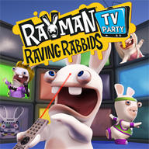
RRR TV Party Texas Hold'em Poker


Prince of Persia BBD 2

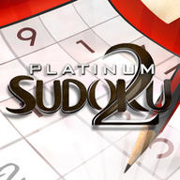
Zombie Infection Platinum Sudoku 2


Paris Nights Brain Challenge 2
CHAPTER 8: REASONS WHY NOKIA RULES
THE MOBILE PHONE MARKET

In spite of the presence of big names in consumer electronics like Samsung, LG, Sony-Ericsson and Motorola, Nokia really rules the mobile phone market all over the world with nearly 40% of the market share with no close competitors. Nokia is certainly the king when it comes to brand value, service and experience. The Finnish mobile giant is clearly No. 1 choice in South East Asia including India and China. How they could reach the top position? Let’s find out.

1. Call Quality
Nokia is known for its circuitry to handle the RF Reception and providing the best call reception quality. Users rarely complain much about the noise or the disturbances within Nokia phones unless it is a problem of the telecom service provider. So, the primary objective of a mobile phone i.e. to serve us with better and clearer sound when we talk is served by Nokia perfectly. And if you are a person who is accustomed to other mobile phone manufacturers, then you know that even Apple phone and Sony Ericsson are guilty of it.

2. Hardware
You can be assured of the quality that Nokia provides in your phone hardware. The circuits are far more durable and reliable than any of the other mobile phone available in the market. I am using a single Nokia phone for 6 years and I had to take it to the service centre only once during this period for a trivial problem. That speaks for the truth I am talking about.

3. Battery
The battery life of Nokia mobile phones is longer than many other cellphones available in the market. People who talk a lot prefer Nokia than any other brands. They always know that the battery will not run out in the middle of the call. iPhone has had this problem with battery life in the past and that hasn’t been solved yet. Nokia leaves others miles behind when we consider the longevity of the battery.

4. Robustness
Everyone knows that Nokia mobiles are truly rock solid. I want to share my own experience with respect to this. I dropped my Nokia the very next day I bought it. I dropped it on the staircase and it bounced to nearly 12 steps down. My heart pumped out with the fear of losing the phone on the second day. But what I found when I reached downstairs is that the phone is fully functional and it only had a few scratch in its body. Since then, it slipped off my hand many a times but it did not refuse to function. Thanks to Nokia for making such rugged phones. It would really be the worst thing if I had to take my phone to service centre or had to buy a new one every time I dropped my phone.
5. Wide Product Range
Nokia has a vast and huge list of mobile phones. Nokia mobile phones are available for every consumer groups, starting from simple and durable phones for the low income groups and high-end phones for those who can afford to spend money. So regardless of you being a corporate or a fresher into the world of economy, Nokia has something for you. The sheer range of products is enviable and at the same times the success mantra of Nokia’s dominance.
6. Customer Service
The Customer Care of Nokia which they call the Nokia Care, handles the complaints very efficiently satisfying their customers. Its just the trust they implement on the customer’s mind, is really appreciable.
7. Reliability
Nokia really has become a brand that people can trust upon. The error rates or crash rates of Nokia phones are very low. It will not dump you when you need this phone. People can blindly trust Nokia in Asian Countries. And not to mention, Nokia has deservingly earned this place.
8. Price
The price tags of every Nokia mobile phone are very reasonable. One can still get a GSM mobile phone for as less as Tk. 1800 in Bangladesh with all the basic features.

9. Experience
Nokia is the largest cell phone manufacturer in the world with about 40% of market shares with its competitors nowhere near its sales volume. They know the world of mobile phone more than any other. They have ages of experience, hundreds of success stories and dozens of smart handsets in current portfolio. That helps them to evolve and thereby nourish our needs.

CHAPTER 9: FINDINGS & RECOMMENDATIONS

In order to boost the popularity of XpressMusic, Nokia can make use of the following recommendations.
- A TVC can be made for Nokia XpressMusic catering to the Bangladeshi market.
- Association with more popular and youth oriented brands of the country such as Djuice, different lounges and youth hubs like TSC, Bashori, Cofi 11, etc.
- The users of XpressMusic can be given the access to an online music directory which will include not only Bangla songs, but also songs of other popular international artists.
- The ‘pre-order’ system can be made available with the all the upcoming phones.
- Nokia XpressMusic can sponsor various youth events such as Valentines Day Music Night, New Year’s Eve and other university events.
- The ‘XpressMusic Concerts’ should be held not only in the divisional cities, but also in some other urban youth hubs.

CHAPTER 10: CONCLUSION

Since 1980, Nokia has been trying to create their brand image through quality, easy-to-use and secure products. Nokia has been successful to attain the brand loyalty and they have loyal customers worldwide. Through their wide and differentiated product line for all groups of people, some segments of their customers consider Nokia to be highly long-lasting in spite of its low price and to some; it carries a symbol of status. The formula behind their success is the marketing plan they adopt for their different product lines and they choose their media mix accordingly that proves to be beneficial for their product. Their media plan for Nokia XpressMusic has created a vibe not only among the youth but also among the music lovers of Bangladesh. From our point of view, XpressMusic is at the peak of their product life cycle and if they want to maintain this position in the long run, they have to modify their promotional strategy based on the situation.


