Consumer Perception

of

Keya Cosmetics Limited

Submitted by

WWW.ASSIGNMENTPOINT.COM

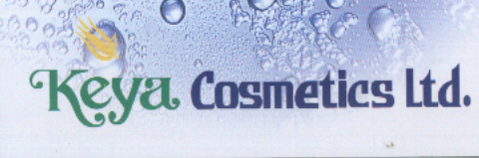

CHAPTER –O1

Introduction Part

1.1 Introduction

The Keya Cosmetics Ltd. is one of the largest and high quality cosmetic companies in Bangladesh located at Jarun, Konabari, Gazipur. It come into begin in 1996 at a cost of Tk. 120 million and launched production in early 1997 as a sister concern of the Khaleque Group of Industries. Converted into public Ltd. Company in the year 1999.
Quality comes first- keeping this principle in mind; the company aim at producing guarantied international quality cosmetics and toiletries for quality conscious people of home and abroad.
In this chapter, Background of the study, Objective of the Study, Organization of the study, Duration of the study, Limitation of the study etc. have been highlighted.
1.2 Background of the Study
The Keya Cosmetics Ltd. is one of the largest and high quality cosmetic companies in Bangladesh. Quality comes first- keeping this principle in mind; the company aim at producing guarantied international quality cosmetics and toiletries for quality conscious people of home and abroad. Since this a product oriented company various kinds of marketing activities are necessary to operate this company successfully. As a student of BBA whereas major subject is marketing; practical knowledge about marketing sector is very much necessary for By doing Internship in this company it has been possible to gain practical knowledge about marketing sector. So, The objective of this study is to achieve practical knowledge about marketing sector so that it may help me in future by providing experience while I will engage in any marketing related job in any company.

1.3 Objective of the Study
Main objectives of the study are as follows:
* To know the Consumer Perception (Trade and Final Consumer) Of
Keya cosmetics Ltd.
* To know the various products and services of the organization
(Trade and Final Consumer).
* To know the activities of the organization.

1.4 Duration of the Study
The total duration of the study was Three month and this duration is from February 22, 2010 to May 15, 2010.

1.5 Methodology
In this report the qualitative research procedure is used to collect the information of the report. The direct approach is utilized to gather the information. Here the employees of the Keya Cosmetics Ltd. are asked different type of questions relating to the report to helping the making of this report. The direct approach, the depth interview which is the method of research procedure, is applied. Here the Assistant General Manager of marketing department is asked different questions and to explain different issues in an unstructured, direct and in a personal manner to give his opinion about the topic of the report.

Primary Sources:
- Face to Face conversation with the respective client, officers and staffs.
- Structured Survey on customers
- Interviewing officers and staffs
- In-depth study of selected cases.
- Sharing practical knowledge of officials.
- Related files, books study provided by the officers concerned.
- Practical Desk work
- Direct observation

Primary data collection through depth interview
Qualitative Research Procedure
Direct
(No disguised)
Indirect
(Disguised)
Focus
Group
Depth
Interview
Construction
Technique
Expressive
Technique
Completion
Technique

Association
Technique

Chart 4.1: Methodology of Depth Interview

Secondary data
Secondary data are those data that have already been collected for the purposes other than problem at hand. In this report both the internal and the external data is used to collect the information about the Existing Marketing Strategy of Keya Cosmetics Ltd. The internal data have been collected from the available data within the organization such as Konaberi Office and Banani Office of Keya cosmetics Ltd. whereas the external data have been collected from the external source such as published materials, internet etc.
Secondary Sources:
- Annual Report, Audit Reports of Keya Cosmetic Ltd.
- Relevant books, Research papers, Newspapers and Journals.
- Website of Keya Cosmetic Ltd.
- Vouchers, Instruments, Forms & Circulars

Secondary Data Collection
Secondary Data
Internal
External
Ready to
Use
Requires
Further
Processing

Syndicated
Services
Computerized
Database
Published
Materials

Flow chart of Methodology

Data collection through depth interview
Data from questionnaire survey
Data from secondary source

Raw data
Cross-checking data
Data analysis
Report writing

Action Plan
Sl No. | Activities | Week-  1-2 | Week-  3-4 | Week-  5-6 | Week-  7-8 | Week-9-10
01 | Preparation of Study
02 | Meeting of Stuff
03 | Primary Data Collection
04 | Secondary Data Collection

1.6 Limitation of the Study
When I was running my Internship I faced some problems, which have been considered as limitation of the study. The limitations are:
- Due to time limitation several information about Keya Cosmetics Ltd. cannot be provided.
- Even due to shortage of time, several distributors and retail stores have not been visited.
- The study is mostly based on secondary data. Primary information has been collected only through depth interview method.
- No questionnaire interview has been conducted for this study.
- Data collection through Focus Group Discussion (FGD) has not been conducted for this study. Keya Cosmetics Ltd. is one of the largest companies in Bangladesh. It is providing the people of our country the best product at affordable price. “No compromise with the Quality” is the key policy of the Top Management.

Chapter: 2
Organizational Overview

2.1 Introduction
The Keya Cosmetics Ltd. is one of the largest and high quality cosmetic companies in Bangladesh located at Jarun, Konabari, Gazipur. It come into begin in 1996 at a cost of Tk. 120 million and launched production in early 1997 as a sister concern of the Khaleque Group of Industries. Converted into public Ltd. Company in the year 1999.

Quality comes first- keeping this principle in mind; the company aim at producing guarantied international quality cosmetics and toiletries for quality conscious people of home and abroad.

2.2 Objective of the company
To manufacture and sell high quality Cosmetics and Toiletries products to the people of all age group within an affordable price. “No compromise with the Quality” is the key policy of the Top Management. They do believe that, they are reasonable and accountable to all concern with whom they deal; namely; their business associates, their employees, their customers and their shareholders.

2.3 Company Background
By dint of their stewardship, since intention to win the hearts and minds of the populace, taking the right strategy with quality and price, Keya products achieved on upsurge in customer demand within a short span of time. The company, as a result, expanded by adding Euro based most sophisticated machinery. Keya cosmetics occupy a huge position in the cosmetics world of Bangladesh and its heart and mind pacifying fragrance has spread over the foreign territories as well. Now the project is cosmetics and toiletries products within the competitive range of price. The research team of the company is trying hard to develop new product in the existing product line. Backward linkages industries named, “Keya Soap Chemicals Ltd.” is being constructed to for having easy supply of raw materials for Keya Beauty Soap and Laundry Soap (sodium salt of Palma tic acid) at the estimated cost of Tk. 85 core.

Companies’ international standard production unit is equipped with modern quality control product and microbiological lab with the latest technology and a group of top professionals. All of the cosmetics and toiletries are marketed under the brand name of “ Keya”. Each stage of production undergoes rigorous testing and quality control process. The finish products are gain tested to ensure the desired standard of quality before placing of products in the market. The raw materials and active ingredients of products of Keya Cosmetics Ltd. art improved from required manufactures of Malaysia, Indonesia, Italy, France, Germany, Singapore, England, Switzerland, and USA.

2.4 Company Profile

Corporate Headquarter Jarun, Konabari, Gazipur
Liaison Office Priyo Prangon Tower,
Apt. No.6/13, House#19,
Road No.17
Kamal Ataturk Avenue,
Banani, Dhaka-1214
Factory Jarun, Konabari, Gazipur
Year of Establishment 1996
Commercial Production 1997
Converted into Public Ltd. Co. 1999
Initial Public Offering (IPO) 2001
Stock Exchange Listing:
Dhaka stock Exchange 2001
Chittagong 2001
Status Public Limited Company
Business Lines Manufacturing and Marketing, Selling
of Cosmetics & Toiletries Products.

Deports Chittagong, Sreemangle
Barisal, Jessore & Bogra
Exports Outlets India, Bhutan, UAE, Nepal, Kuwait, Saudi Arabia, and Myanmar
Authorized Capital 700 Million Taka
Paid-up Capital 288 Million Taka
Turnover (net) in Taka of 2008-09 1,157.42 Million
Number of Shareholders 8,929 (as on 30.06.2008)
Number of Employees 5475
The Keya Cosmetics Ltd. would be defined in a huge margin after the successful completion of the projects. Remarkable benefits are mentioned bellow:

- It is ensure easy supply of raw materials soap nodules at the least price
- It is not be required to mentioned huge stock of soap nodules
- It is sustainable decrease financial cost incurred for utilizing huge stock of soap nodules

2.5 Report of the Directors to the Shareholders
For the year ended 30 June 2009
The directors have pleasure in presenting their report together with the audited accounts for the year ended 30 June 2008 together with auditor’s report thereon. The financial results of the company for the year 2007-2008 as compared to previous.
 | Figure in `000 Taka
 | 30/06/2008 | 30/06/2007
Net profit before tax | 102,306,150 | 45,125,991
Less: Provision for income tax | (14,301,393) | (5,019,790)
Not profit after tax | 88,004,757 | 40,106,201
Profit brought forward | 66,449,669 | 65,860,812
Profit available for appropriation | 154,454,426 | 105,967,013
Recommended for appropriation:
Tax holiday reserve | (21,853,936) | (11,357,343)
Proposed divided  (Tk. 5.00/share on 1,60,00,000 shares i.e. bonus share 2:1) | (80,000,000) | (25,600,000)
Provision for dividend distribution tax @ 10% on dividend | - | (2,560,000)
Profit Carried Forward | 52,600,490 | 66,449,670

Before you some competitive information and graph for better understanding:

Year | Turnover | CGS | GP | NP before tax | NP after tax
2008 | Tk.  1,207,235,409 | Tk.  909,655,105 | Tk.  297,580,259 | Tk.  45,125,991 | Tk.  40,106,201
2009 | Tk.  1,1157,417,211 | Tk  895,652,830 | Tk.  261,764,381 | Tk.  102,306,150 | Tk.  88,004,757

Chapter: 3
Marketing Mix of
Keya Cosmetics Ltd.

3.1 Existing Products of Keya Cosmetics Ltd.
Product Name | SKU | Unit | Color
Keya Coconut Oil Tin | 200 | ml
Keya Coconut Oil Tin | 400 | ml
Keya Pumkin Oil | 200 | ml
Keya Pumkin Oil | 100 | ml
Keya Talcum Powder | 100 | gm | White
Keya Talcum Powder | 50 | gm | White
Key Pickly Heat Powder | 50 | gm
Key Pickly Heat Powder | 100 | gm
Keya Ice-cold magic P. heat Powder | 100 | gm
Keya Super Beauty Soap | 125 | gm | Green
Keya Super Beauty Soap | 125 | gm | Pink
Keya Super Beauty Soap | 125 | gm | Purple
Keya Super Beauty Soap | 125 | gm | White
Keya Super Beauty Soap | 85 | gm | Green
Keya Super Beauty Soap | 85 | gm | Pink
Keya Super Beauty Soap | 85 | gm | Purple
Keya Super Beauty Soap | 85 | gm | White
Keya Super Beauty Soap | 50 | gm | Green
Keya Super Beauty Soap | 50 | gm | Pink
Keya Super Beauty Soap | 50 | gm | Purple
Keya Super Beauty Soap | 50 | gm | White
Keya Super Lemon Soap | 125 | gm | Yellow
Keya Super Lemon Soap | 85 | gm | Yellow
Keya Super Lemon Soap | 50 | gm | Yellow
Keya Super Lemon Soap | 35 | gm | Yellow
Keya Jasmine Beauty Soap | 90 | gm | White
Keya Fairness Beauty Soap | 90 | gm | Pink
Keya Skin Care Beauty Soap | 90 | gm | Green
Keya Herbal Beauty Soap | 90 | gm | Green
Keya Herbal Beauty Soap | 40 | gm | Green
Keya Baby Soap | 90 | gm | Yellow
Keya Baby Soap | 90 | gm | Orange
Keya Baby Soap | 50 | gm | Orange
Keya Mini Super Beauty Soap | 40 | gm | Green
Keya Mini Super Beauty Soap | 40 | gm | Pink
Keya Mini Super Beauty Soap | 40 | gm | Purple
Keya Mini Super Beauty Soap | 40 | gm | White
Keya Natural Hotel Soap | 25 | gm
Keya Gly. Laundry Soap | 140 | gm | Green
Keya Gly. Laundry Soap | 140 | gm | Yellow
Keya Gly. Laundry Soap | 145 | gm | Green
Keya Gly. Laundry Soap | 145 | gm | Yellow
Keya G.M. Tooth Paste | 100 | gm | White
Keya G.M. Tooth Paste | 75 | gm | White
Keya G.M. Tooth Paste | 45 | gm | White
Keya G.M. Tooth Paste | 200 | gm | White
Keya G.M. Tooth Paste | 140 | gm | Green
Keya G.M. Tooth Paste | 140 | gm | Red
Keya G.M. Tooth Paste | 70 | gm | Green
Keya G.M. Tooth Paste | 70 | gm | Red
Keya Active Toothpaste (Gel) | 140 | gm
Keya Active Toothpaste (Gel) | 70 | gm
Keya Active Tooth past | 45 | gm
Keya Active Tooth past | 100 | gm
Keya Active Toothpaste | 200 | gm
Keya Petroleum Jelly | 15 | gm
Keya Petroleum Jelly | 50 | gm
Keya snow | 50 | ml
Keya Lip-Gel | 10 | gm | Pink
Keya Lip-Gel | 10 | gm | Purple
Keya Glycrine | 125 | ml
Keya Glycrine | 60 | ml
Keya Shaving Cream | 50 | gm | White
Super saloon lather saving cream | 100 | gm
Keya Lemon Detergent | 500 | gm
Keya Lemon Detergent | 180 | gm
Keya Lemon Detergent | 40 | gm
Keya Lemon Detergent | 1 | Kg
Keya Super Excel | 500 | gm
Keya Super Excel | 20 | gm
Keya Super Jet | 20 | gm
Keya Super Jet | 110 | gm
Keya Super Jet | 50 | gm
Keya Super Jet | 225 | gm
Keya Super Jet | 450 | gm
Keya Super Jet | 1 | Kg

3.2 Details about Some Important Products

KEYA SUPER BEAUTY SOAP

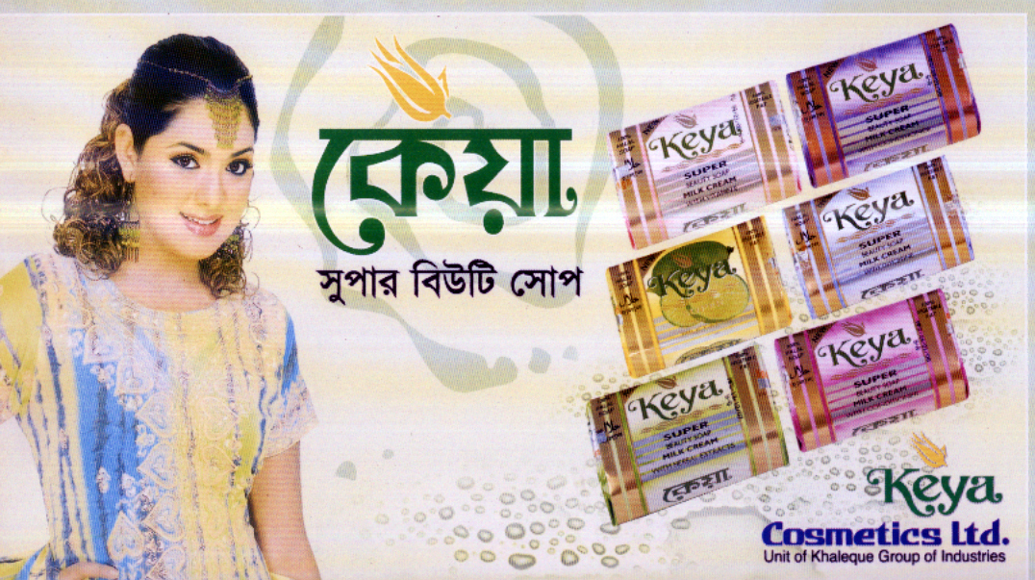

Keya Super Beauty Soap is mode of 100% vegetable fat and widely accepted by people of all age group and races for its purity, high quality and brilliant look. It is a matter of gratification for us that international community has shown interest on this sensational beauty soap as well.

Ingredients
A. Sodium salt of Palmatic Acid:
High graded sodium salt of Palma tic Acid (100%) vegetable fat imported from Malaysia in noodles form.
B. Perfume: World famous Swiss perfume is used in Keya Super Beauty Soap.
C. Coloring Agents: The world renowned SANDOZ of Switzerland is the producer of Viscofil brand soap color. This high quality and expensive Viscofil brand soap color used in Keya Super Beauty Soap.
D. Glycerin: Glycerin is used as huemachant in Keya Super Beauty Soap to protect the skin from roughness.
E. Milk Cream: Used to nourish softness of skin.
F. Vitamin E: Maintains brightness of skin and used as age defer.
The whole process of producing soap is fully automated. Italy’s Mazoni Lab double molding most sophisticated soap producing machine is used to mix imported raw materials.
CHEMICAL test is OK.
Impressive wraps of products are printed in Indonesia.

KEYA SUPER LEMON SOAP

This soft and cleansing lather producing soap enriched with fresh lemon perfume has indeed received a great deal of opportunity. It has come as blessings on skin and sprit. This soap is produced with active green lemon perfume and with same ingredients of Keya Super Beauty Soap.

KEYA TALCUM POWDWR

Keya Talcum Powder contains essential ingredients to absorb moisture and bring breeze of freshness of body and mind. This heart soothing perfumed talc keeps the skin smooth and dries it hot and humid summer days.

Special Test
Though sterilize talc is used in Keya Talcum Powder, nevertheless, it is tested in the microbiological lab to make sure its freshness from bacteria. World famous Swiss perfume imports a perfumed touch of richness and luxury to Keya Talcum Powder and people of both sex and all age groups simply get down to it.

KEYA PURE COCONUT HAIR OIL

Keya pure coconut oil is a symbol if purity. Is raw materials are directed imported from Colombo? In order to ensure purity and quality the raw materials are tasted our own laboratory.
The are accomplished with British Pharmacomia (BP) and United States Pharmacomia (USP).

Things considered at the time of physical testing:
- Refinement of Oil
- Perfume Contents
- Refractive Index
- Specific Gravity
Things considered at the time of chemical testing:
- Saponification Value
- Lodine Value
- Acid Value

The rich natural ingredients and takoferol make Keya pure coconut oil a high quality product and the people cover it. High acid value in the oil jeopardizes refinement, purity; natural flavored and obviously such oil does a dreadful mischief to hair. In Bangladesh standard acid value fixed by BSTI is 0.5%. Having passed all tests, Keya pure coconut oil is filtered again and this is how we maintain significant purity in Keya pure coconut oil.

The tin container of Keya pure coconut oil is sealed in an automated process with a view to making it totally rusts free. Keya pure coconut oil was marketed in 1977 and since then we have been strictly maintain the quality. No wonder the women of Bangladesh love this product and most favorite one of them.

KEYA PETROLEUM JELLY

Skin cries for apt cosmetics for specific time. Consumers handle with Keya Petroleum Jelly.
As winter dries out moisture of human body, mainly palm and hill suffer from less oil vascular and chap. These jellies adroitly supplement this deficiency by creating special type of protecting wall on the skin that preserves the moisture.

KEYA LAUNDRY SOAP

Keya Laundry Soap has earned much fame by virtue of its full freshness from animal fat. Its natural ingredients not only look after your cloth but also your priceless skin.

KEYA LIP GEL

Keya Lip Gel gives full protection to lips from chapping in cold seasons and keeps lips extra soft.
Effective Ingredient:
Alovera Gel: This stuff takes extra care of lips. It strongly guards the lips from good deal of hazards that come about in the winter.
Keya Lip Gel contains digestive flavor. So, do not worry you happen to swallow it. It is produced in two colors.

Keya Power Ball Soap

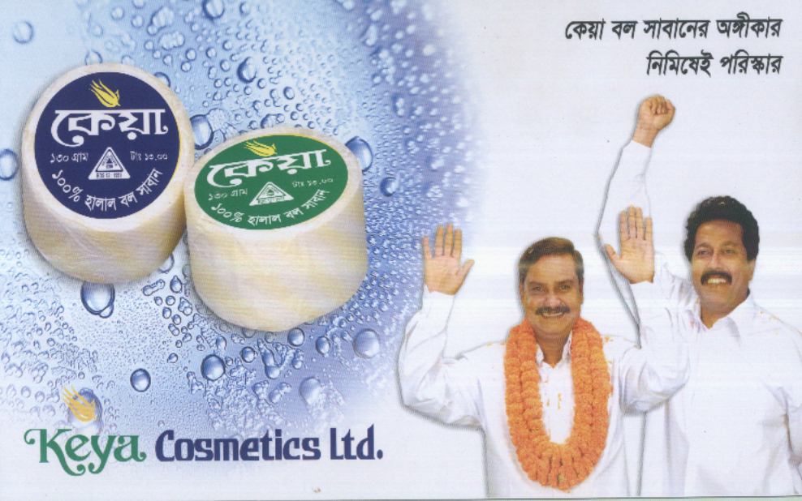

Weight –100 gm,130 gm, 150 gm
Colour –White
Ingredients- sodium palmitate, sodium palm,, Kermelate or cocoate, Aqua. Perfume, preservative.

Keya Pumpkin Oil


Weight –200ml & 400ml
Colour –Natural
Ingredients- Coconut Oil

Keya Glycerine Laundry Soap

Weight –60 gm,100 gm, 130 gm&150 gm
Colour –Green & Yellow
Ingredients- sodium palmitate, sodium palm,, Kermelate or cocoate, Aqua. Perfume, colour, preservative.

Keya Lather Saving Cream



Weight –50 gm
Colour –White
Ingredients- Stearic acid, glycerine, potassium hydroxide, perfume, coconut oil, boric acid, formine agent.

Keya Glycerine
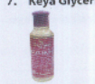
Weight –60 gm,125 gm
Colour –Natural
Ingredients- Purified glycerine

Keya Pomade
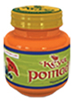

Weight – 50ml
Colour –Orange
Ingredients-White petroleum jelly, paraffin oil, colcur & flavour

Keya Active Tooth Paste
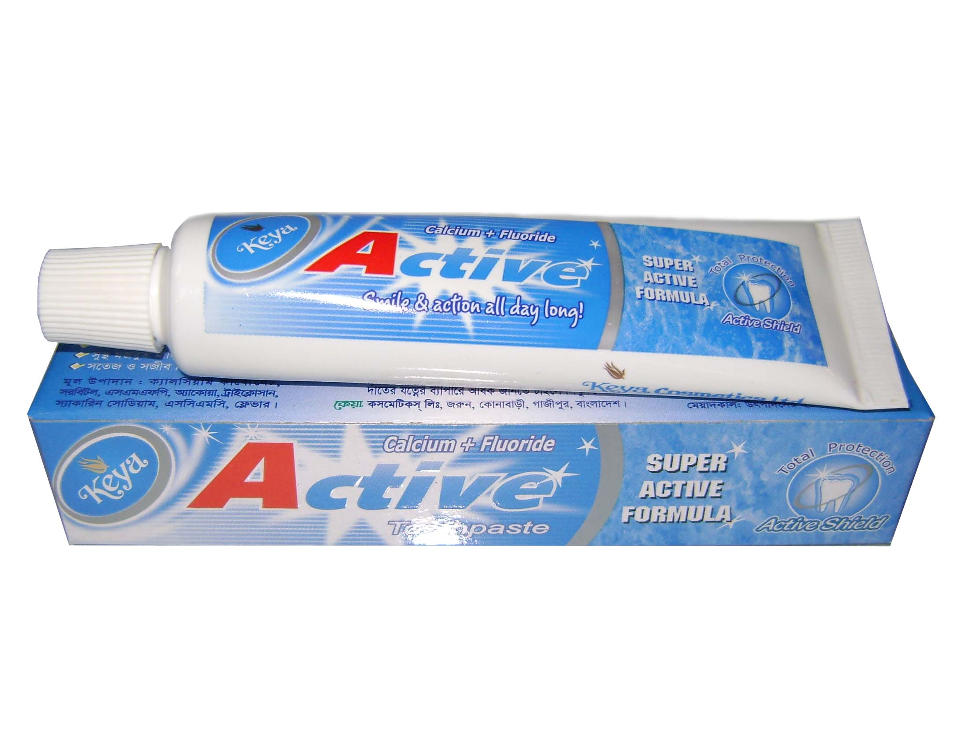

Weight – 45 gm,100 gm,200 gm
Colour –White
Ingredients- Calcium carbonate PPT, Nipagin M sodium, Nipasol M sodium, PEG-600, sodium Monofluoro Phosphate, saccharin sodium ,sodium cmc.

Keya super saloon lather saving cream

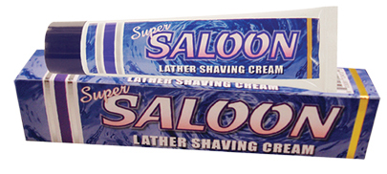

Weight –100 gm
Colour –White
Ingredients- Stearic Acid, coconut oil, boric acid, potassium hydroxide, glycerin, foaming agent & perfume.

Keya Snow
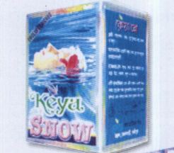
Weight –50 gm
Colour –White
Ingredients- Stearic acid, cetyl alcohol, postassium bi-carbonate, perfume & Nipazin-m-sodium.
3.3 Existing Price of Products of Keya Cosmetics Ltd.
Product Name | SKU | Unit | Color | Qty/ctn | Price/ctn(Tk)
Keya Coconut Oil | 200 | ml |  | 24 | 951
Keya Coconut Oil | 400 | ml |  | 12 | 828
Keya Talcum Powder | 100 | gm | White | 12 | 325
Keya Talcum Powder | 50 | gm | White | 24 | 410
Keya Super Beauty Soap | 125 | gm | Green | 72 | 994
Keya Super Beauty Soap | 125 | gm | Pink | 72 | 994
Keya Super Beauty Soap | 125 | gm | Purple | 72 | 994
Keya Super Beauty Soap | 125 | gm | White | 72 | 994
Keya Super Beauty Soap | 90 | gm | Green | 72 | 886
Keya Super Beauty Soap | 90 | gm | Pink | 72 | 886
Keya Super Beauty Soap | 90 | gm | Purple | 72 | 886
Keya Super Beauty Soap | 90 | gm | White | 72 | 886
Keya Super Beauty Soap | 50 | gm | Green | 72 | 432
Keya Super Beauty Soap | 50 | gm | Pink | 72 | 432
Keya Super Beauty Soap | 50 | gm | Purple | 72 | 432
Keya Super Beauty Soap | 50 | gm | White | 72 | 432
Keya Super Lemon Soap | 125 | gm | Yellow | 72 | 994
Keya Super Lemon Soap | 90 | gm | Yellow | 72 | 886
Keya Super Lemon Soap | 50 | gm | Yellow | 72 | 432
Keya Super Lemon Soap | 40 | gm | Yellow | 72 | 368
Keya Jasmine Beauty Soap | 90 | gm | White | 72 | 886
Keya Fairness Beauty Soap | 90 | gm | Pink | 72 | 886
Keya Skin Care Beauty Soap | 90 | gm | Green | 72 | 886
Keya Herbal Beauty Soap | 90 | gm | Green | 72 | 886
Keya Herbal Beauty Soap | 40 | gm | Green | 72 | 368
Keya Baby Soap | 90 | gm | Yellow | 72 | 886
Keya Baby Soap | 90 | gm | Orange | 72 | 886
Keya Baby Soap | 50 | gm | Orange | 72 | 432
Keya Mini Super Beauty Soap | 40 | gm | Green | 72 | 368
Keya Mini Super Beauty Soap | 40 | gm | Pink | 72 | 368
Keya Mini Super Beauty Soap | 40 | gm | Purple | 72 | 368
Keya Mini Super Beauty Soap | 40 | gm | White | 72 | 368
Keya Natural Hotel Soap | 25 | gm |  | 144 | 518
Keya Gly. Laundry Soap | 140 | gm | Green | 72 | 581
Keya Gly. Laundry Soap | 140 | gm | Yellow | 72 | 581
Keya Gly. Laundry Soap | 145 | gm | Green | 72 | 581
Keya Gly. Laundry Soap | 145 | gm | Yellow | 72 | 581
Keya G.M. Tooth Paste | 100 | gm | White | 48 | 1139
Keya G.M. Tooth Paste | 75 | gm | White | 48 | 1025
Keya G.M. Tooth Paste | 45 | gm | White | 72 | 820
Keya G.M. Tooth Paste | 200 | gm | White | 24 | 1025
Keya G.M. Tooth Paste | 140 | gm | Green | 24 | 1025
Keya G.M. Tooth Paste | 140 | gm | Red | 24 | 1025
Keya G.M. Tooth Paste | 70 | gm | Green | 48 | 1275
Keya G.M. Tooth Paste | 70 | gm | Red | 48 | 1275
Keya Petroleum Jelly | 15 | gm |  | 144 | 1196
Keya Petroleum Jelly | 50 | gm |  | 48 | 809
Keya Lip-Gel | 10 | gm | Pink | 144 | 1845
Keya Lip-Gel | 10 | gm | Purple | 144 | 1845
Keya Shaving Cream | 50 | gm | White | 48 | 1230
Keya Lemon Detergent | 500 | gm |  | 48 | 783
Keya Lemon Detergent | 180 | gm |  | 120 | 834
Keya Lemon Detergent | 40 | gm |  | 144 | 212
Keya Lemon Detergent | 1 | kg |  | 24 | 748
Keya Super Excel | 500 | gm |  | 24 | 1427
Keya Super Excel | 20 | gm |  | 144 | 339
Keya Super Jet | 20 | gm |  | 144 | 348
Keya Super Jet | 110 | gm |  | 72 | 656
Keya Super Jet | 50 | gm |  | 72 | 366
Keya Super Jet | 225 | gm |  | 48 | 798
Keya Super Jet | 450 | gm |  | 36 | 1149
Keya Super Jet | 1 | kg |  | 12 | 783

3.4 Difference between company rate and retail price
(Some products have been highlighted as example.)
Product | SKU | Company Rate (Tk.) | MRP (Tk.) | Difference (Tk.)
Keya Coconut Oil | 400 ml | 69.00 | 75.00 | 6.00
Keya Super Beauty Soap | 125 gm | 13.80 | 20.00 | 6.20
Keya Petroleum Jelly | 50 gm | 16.85 | 23.00 | 6.15
Keya Lip-Gel | 10 gm | 12.81 | 15.00 | 2.19
Keya Lemon Detergent | 500 gm | 16.31 | 21.00 | 4.69
Keya Super Jet | 450 gm | 31.91 | 40.00 | 8.09
Keya Super Excel | 500 gm | 59.45 | 75.00 | 15.55

Here it has been observed that the difference between company rate and retail price varies on the basis of product’s category. The differential amount is divided into two portions, one for distributors and another for retailer. Their profit depends on this differential amount.

3.5 Comparison of Keya’s Product with Other Competitors’ product on the Basis of Market Price
For this portion comparison of all products with Keya cosmetics are not possible. So, only six items has been shown here:

Coconut Oil

Keya Cosmetics Ltd. | SKU | MRP (Tk.) | Competitor’s Products | SKU | MRP (Tk.)
Keya Coconut Oil | 400 ml | 75.00 | Jui Coconut Oil | 400 ml | 88.00

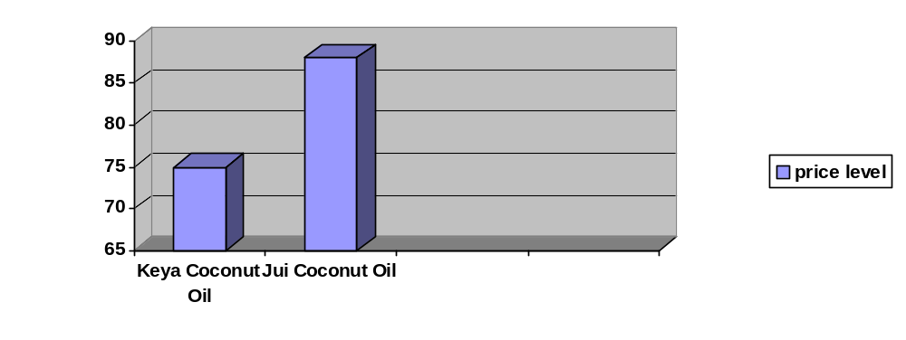
Here it has been found that both a type of oil contains 400 ml, but the price is different. On the other hand the quality of both products is same. So, the findings is Keya provide better quality at lower cost.

Detergent
Keya Cosmetics Ltd. | SKU | MRP (Tk.) | Competitor’s Products | SKU | MRP (Tk.)
Keya Lemon Detergent | 500 gm | 21.00 | Wheel Lemon Detergent | 500 gm | 21.00

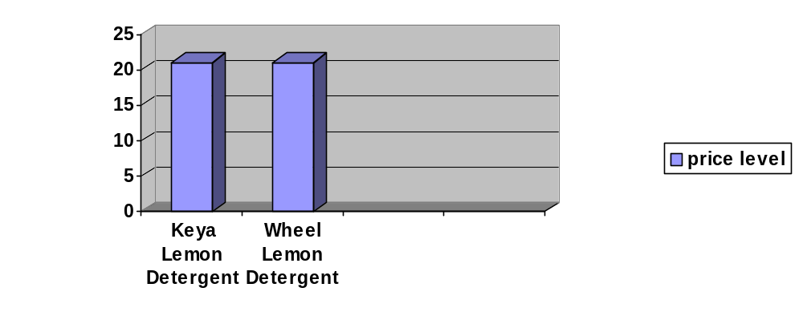
Here the price and quantity of both products is same. Keya do not charge more prices for similar product then its competitor’s product.

Super Excel
Keya Cosmetics Ltd. | SKU | MRP (Tk.) | Competitor’s Products | SKU | MRP (Tk.)
Keya Super Excel | 500 gm | 75.00 | Surf Excel | 500 gm | 80.00

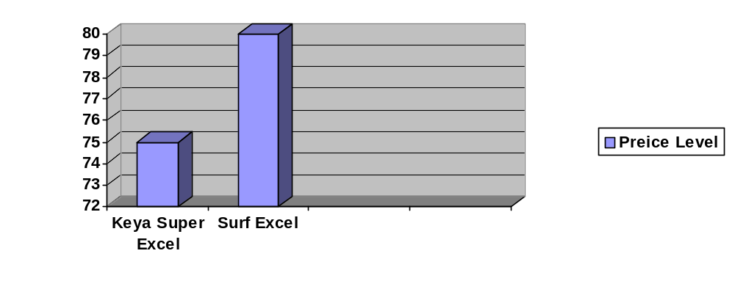Here it has been found that both types of products contain 500 gm, but the price is different. On the other hand the quality of both products is same. So, the findings are that Keya provide better quality at lower cost.

Beauty Soap

Keya Cosmetics Ltd. | SKU | MRP (Tk.) | Competitor’s Products | SKU | MRP (Tk.)
Keya Super Beauty Soap | 90 gm | 14.00 | Lux Beauty Soap | 90 gm | 15.00
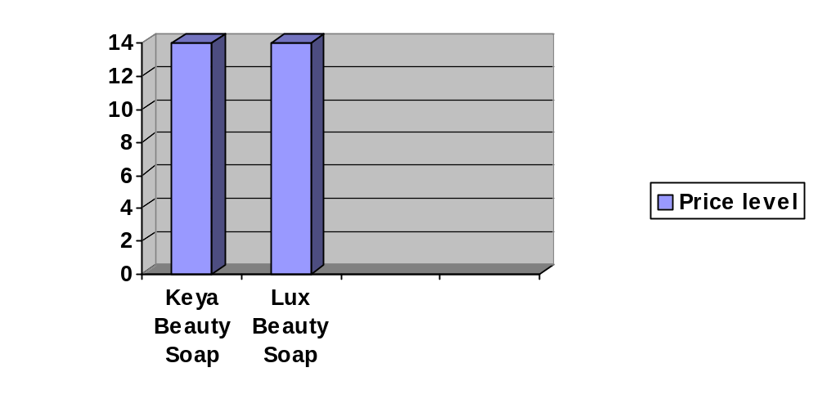
Here the price and quantity of both products is same. Keya do not charge more prices for similar product then its competitor’s product.

Laundry Soap
Keya Cosmetics Ltd. | SKU | MRP (Tk.) | Competitor’s Products | SKU | MRP (Tk.)
Keya Gly Laundry Soap | 120 gm | 8.00 | Wheal Laundry Soap | 120 gm | 10.00
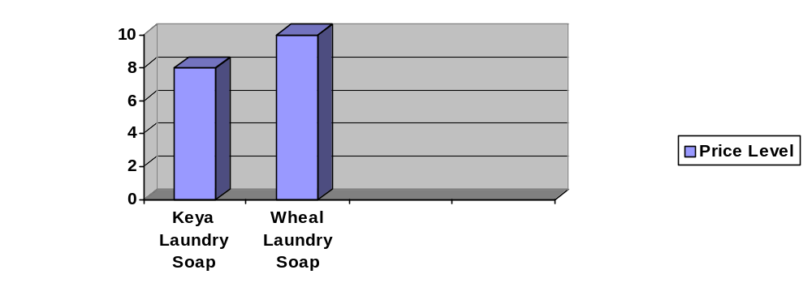

As it is seen in the diagram that the price of Keya laundry soap is quite less than that of wheal laundry soap though the volume and quality are same.

Lip Gel
Keya Cosmetics Ltd. | SKU | MRP (Tk.) | Competitor’s Products | SKU | MRP (Tk.)
Keya Lip Gel | 10 gm | 15.00 | Meril Lip Gel | 10 gm | 15.00
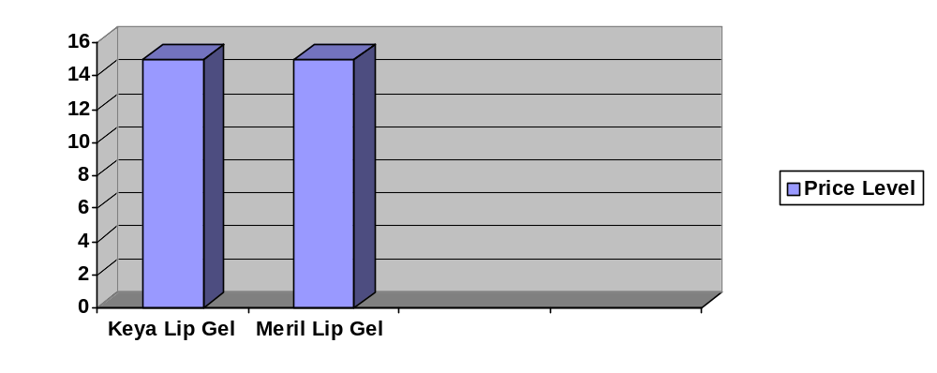
Here the price and quantity of both products is same. Keya do not charge more prices for similar product then its competitor’s product.

3.6 Existing Promotional Activities of Keya Cosmetics Ltd.

Advertising
Any paid form of non-personal presentation and promotion of ideas, goods, or services by an identified sponsor.

Examples: Print ads, radio, television, billboard, direct mail, brochures and catalogs, signs, in-store displays, posters, motion pictures, Web pages, banner ads, and emails.
Keya Cosmetics Ltd. provides advertisement in several commercials such as:

Advertising
TV
Radio
News Paper
Billboard
Magazine

Personal selling
A process of helping and persuading one or more prospects to purchase a good or service or to act on any idea through the use of an oral presentation.
Examples: Sales presentations, sales meetings, sales training and incentive programs for intermediary salespeople, samples, and telemarketing. Can be face-to-face or via telephone.
Keya Cosmetics Ltd has conducted personal selling. The Sales Officers (SO) of Keya Cosmetics Ltd reach to every retail shop in order to recognize their products and also to collect order.
Sales Promotion
Incentives designed to stimulate the purchase or sale of a product, usually in the short term.
Examples: Coupons, sweepstakes, contests, product samples, rebates, tie-ins, self-liquidating premiums, trade shows, trade-ins, and exhibitions.
Keya Cosmetics Ltd. Has been provided two types of sales promotion- (a) Customer – Oriented Sales Promotion (b) Trade – Oriented Sales Promotion.

Customer – Oriented Sales Promotion
It is targeted to the ultimate users of a product or service and includes couponing, sampling, rebates, contests etc. These promotional tools encourage customers to make an immediate purchase and thus can stimulate short term sales.

Keya offers to its customers the following promotions:
- One (1) pice Keya Glycerine Laundry Soap (120gm) free with two (2) pice of Keya Super Beauty Soap (90gm).
- One (1) pice Keya Glycerine Laundry Soap (70gm) free with one (1) pice of Keya Super Beauty Soap (90gm).
- 100gm free (500+100) with Keya Lemon Detergent (500gm).
- Jar and one (1) pice Keya Super Lemon Soap (90gm) with one pice of Keya Super Excel (500gm).

Trade – Oriented Sales Promotion
It is targeted towerd marketing intermediaries such as wholesalers, distributors, retailers. Price deal, sales contests etc. are some of the promotional tools.

Keya offers to its retailers the following promotions:
- 2 pice Keya Super Beauty Soap (90gm) and 1 pice Life Gard Gold free with 24 pice Keya Super Beauty Soap (90gm).
- 3 pice Keya Lemon Detergent (400gm) free with 12 pice Keya Lemon Detergent (500gm).

Public Realations

Non-paid non-personal stimulation of demand for a product, service, or business unit by planting significant news about it or a favorable presentation of it in the media.
Examples: Newspaper and magazine articles/reports, TV and radio presentations, Charitable contributions, speeches, issue advertising, and seminars.

3.7 Distribution Policy of Keya Cosmetics Ltd.
Name of the distributors of Dhaka Head Office (A zone)
Sl. NO. | Distributors Name | ID
01. | A to Z Marketing Company | 001
02. | Al Modina General Store | 026
03. | Fahad Enterprise | 019
04. | Crystal Media | 003
05. | Suma Variety Store | 002
06. | Ornab Enterprise | 018
07. | Hazi Enterprise | 020
08. | Jesmin Store | 025

Distributors
Zone | NO. Of Distributor | % Of Distributor
A | 82 | 62.60
B | 49 | 37.40
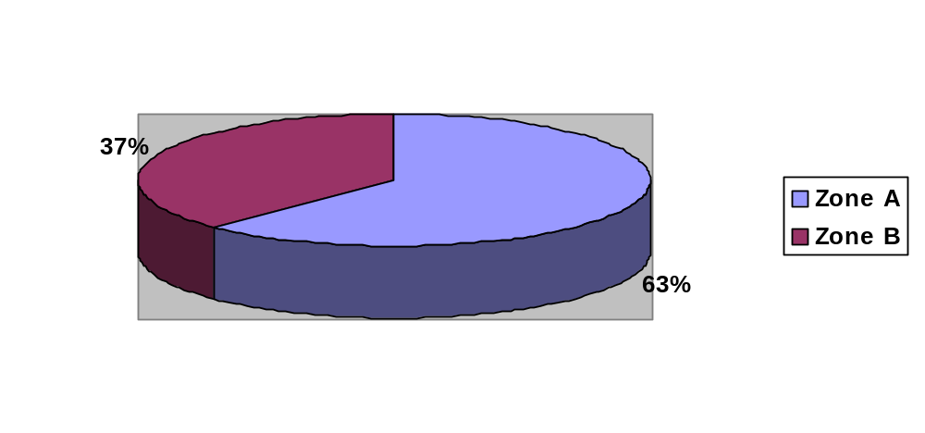
Target
Zone | Target | % Of Target
A | 73,941,457 | 51.70
B | 69,066328 | 48.30
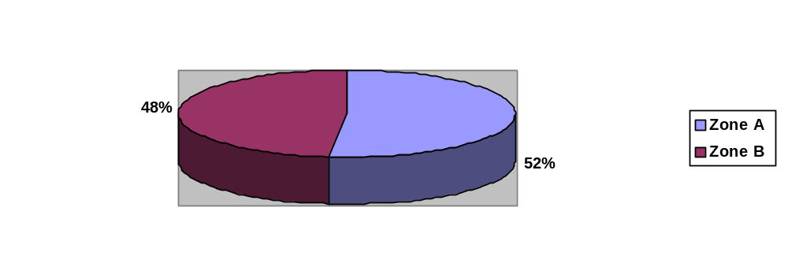

Distribution Process:

FACTORY
WHOLESALER/ DISTRIBUTOR
RETAILER
CUSTOMER

Chapter: 4
SWOT Analysis

4.1 SWOT Analysis:

SWOT Analysis is an important tool for evaluating the company’s Strengths, Weaknesses, Opportunities and Threats. It helps the organization to identify how to evaluate its Perception and scan the macro environment, which in turn would help the organization to navigate in the turbulent ocean of competition. The SWOT analysis of Keya Cosmetic Ltd. Are presented below:

STRENGTH

Very much concerned with quality of its products
Maintains freshness of its products
Skilled workers
Employees are sufficient educated
Offers products at affordable price
Believes in purity

WEAKNESS

Employees are very much under pressure
Top managements are all in all for taking decisions
Weak delivery system provided by distributors
Unskilled Delivery Officer appointed by distributors
Small product variety
OPPORTUNITY

Potential buyers of Middle East countries
New product will be found in the market within few days

THREism
Plitical unrest
Local and foreign competitors in this busuness

Chapter: 5

FINDINGS

5. Findings:

Keya cosmetics ltd has been standing as an emblem of the purity and cleanliness and offering the purest and cleanest and the most effective cosmetics and toiletries products to its huge and vast markets throughout Bangladesh and abroad. The commitments of the company are:
- To provide best quality products by using finest ingredients
- To understand and to meet the requirements of the consumers.
- To use highly skilled, efficient, professional and expert manpower.
- To adopt ultra modern and latest technologies
- To maintain the world class standard of the products.

The company began its journey with most modern and sophisticated machineries and adopted latest technologies and within a short time, has occupied a glorious position in the cosmetics market. Cosmetics products are manufactured with the finest ingredients of highest quality and marketed with attractive packaging. The company has obtained ISO 9001, the 21st century’s worldwide standard for quality control and quality assurance. The company understands that the quality of its products is not only a reflection of the company but also of its valued customers. Each stage of production under goes rigorous testing and quality process. The finished products are again tested to ensure the desired standard of quality before placing products in the markets. The company has state of the art R & D laboratories with a group of experts to supervise the entire gamut of activity pertaining to the manufacturing of the products. There are scores of relevantly qualified and experienced professionals to work under highly experienced supervisors to undertake the preparation of the products with minute attention given to every aspect of them. After the preparation is over, the products are tested for efficiency and safety. Before leaving for the market, the products are tested for their odor and usability. Our experts take a lot of pain before giving final approval to the cosmetics and to achieve international standards.

The entire production process from research and development, compounding, filling to packaging and shipping is inspected and monitored, assuring consistent quality products. Attention to detail in production is a vital and important element of day to day activities of professionals of Keya Cosmetics Ltd. Quality control personnel carefully review each phase of production to ensure that and consumers are provided with the finest products.

Consumer preference

- Do you know about Keya Cosmetics Products?

YES | NO
98% | 2%

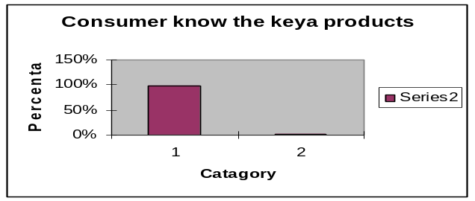

Decision: Almost all people know the Keya products.

- From which sources you have known about Keya’s product?

TV advertising | Bill Board | Newspaper | Hand Bills/ Poster
50% | 20% | 16% | 14%

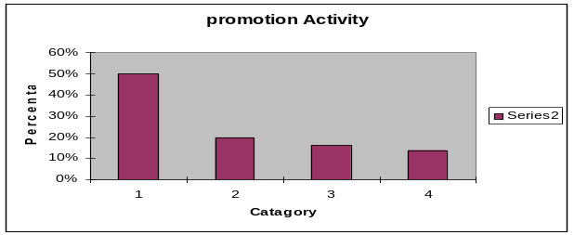

Decision: From the above percentage we see that newspaper and hand Bills advertising are very low, so it need to improve.

- Do you think that the above mention advertising of Keya Cosmetics Product influence you?

YES | NO
70% | 30%

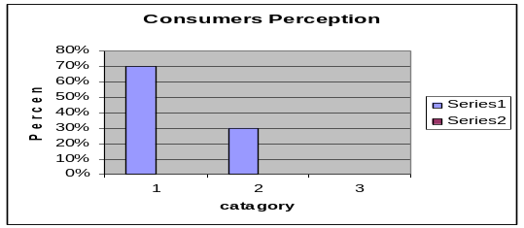

Decision: Most of the people say positively.

- Have you seen the present advertising of Keya super Beauty Soap on TV Channels?

YES | NO
80% | 20%

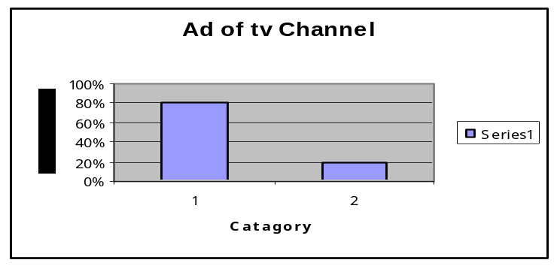

Decision: Maximum people saw the advertisement.

- Who recommended you to use the product?

Friend | Self | Sales Representative | Relative
20% | 40% | 30% | 10%

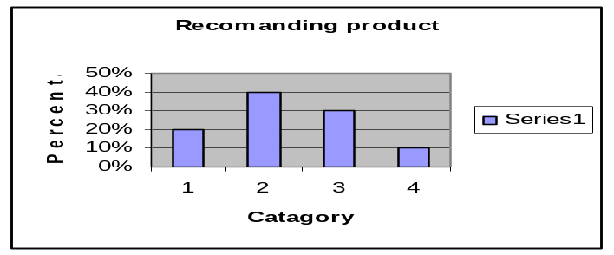

Decision: Need to improve Sales Representatives visibility to influence the Product.

- Which Product you prefer to use? (If your answer A than continue 7-9 Question if NO than ignore it)

Soap | Toot paste | Talcum Power | Detergent
70% | 7% | 9% | 14%

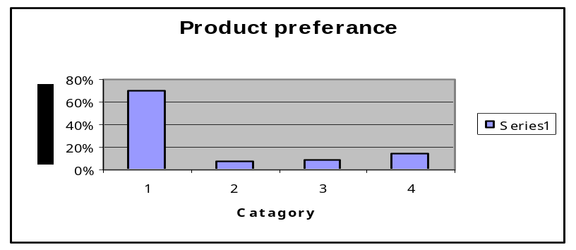

Decision: Quality of tooth paste and Talcum Power are very low. So it need to improve the quality.

- Which Type of soap is you use?

Keya super lemon | Keya super Beauty
60% | 40%

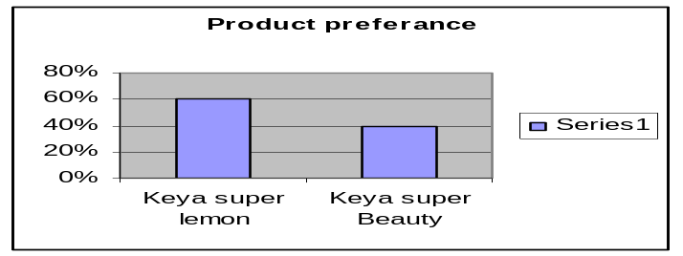

Decision: We find out most of the people use Keya super lemon but another product needs to improve.

- Which prices are you satisfied?

7 | 14 | 20 | 25
30% | 40% | 16% | 14%

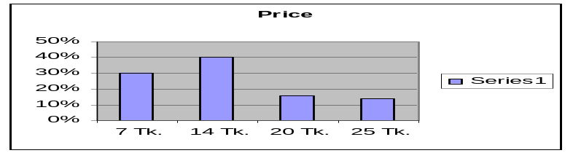

Decision: Price of the product of 14 TK. Is frequently used, so it
Should be maintaining the price.

- What are you think about the quality of Keya’s Product?

Good | Moderate | Better | Poor
65% | 20% | 10% | 5%

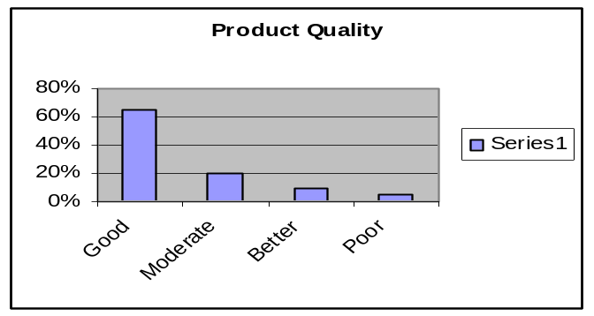

Decision: Product quality not bad.

- Are you satisfied about our present Consumer promotion?

Yes | No
80% | 20%

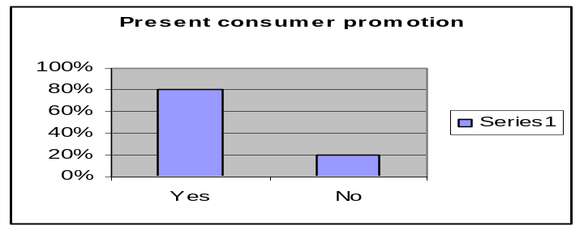

Decision: Maximum consumer satisfied current Consumer promotion

Traders’ preference

- Do you sell Keya Cosmetics Product?

Yes | No
99% | 1%

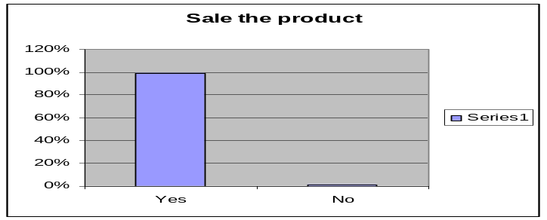

Decision: Almost all shoppers are sales the product

- Are you satisfied about the product price?

Yes | No
60% | 40%

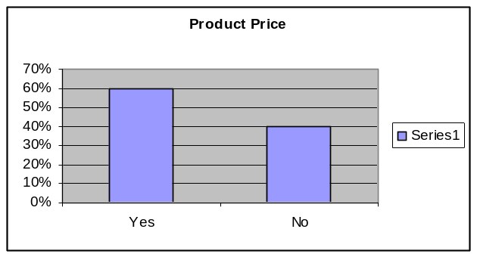

Decision: From view maximum customer are satisfied and those customer not satisfied need more price incentive .

- What you think about the quality of our Keya’s Product? (If Ans Will b & c than go to the question number 4.)

Good | Moderate | Poor
40% | 30% | 30%

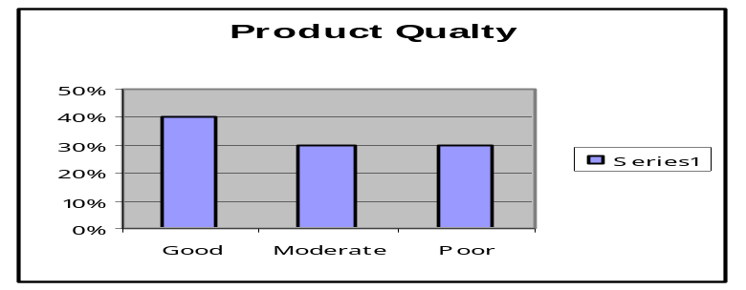

Decision: Product quality is good. But if you competitive market so need to improve quality.

- Are you getting the product on time?

Yes | No
60% | 40%

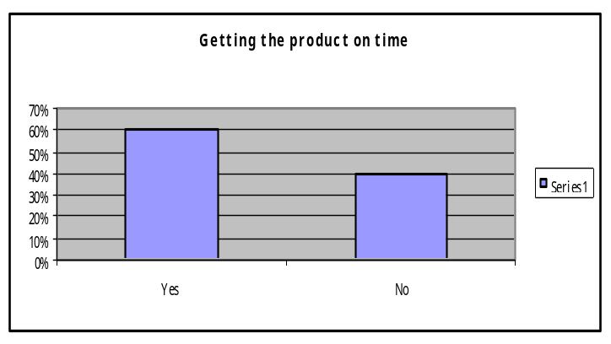

Decision: Maximum survey we find that they get product ontime.

- Are you satisfied on our present discount policy?

Yes | No
48% | 52%

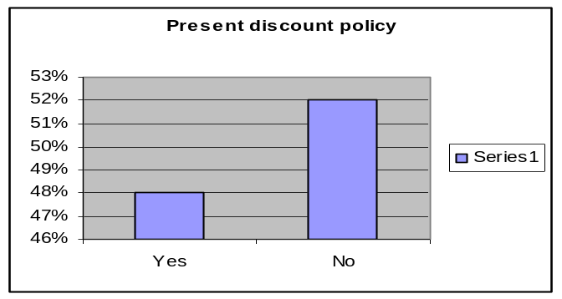

Decision: Discount Policy need to improve.

- Do you think we will offer you more Bonuses?

Yes | No
70% | 30%

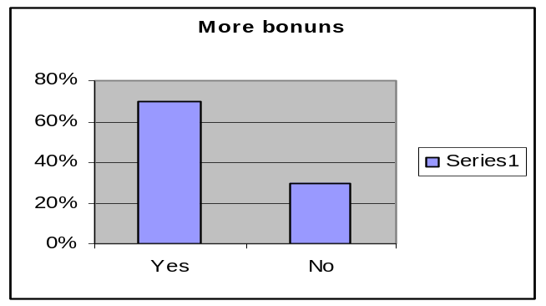

Decision: Everybody said that if give more bonus that will increase sale.

- Are you satisfied about our product promotion policy?

Yes | No
65% | 35%

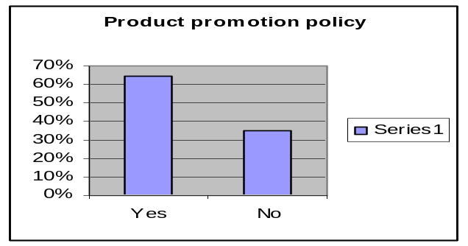

Decision: From survey result we find that most of the customer are Satisfied.

- What type of advertising are you prefer for our product?

TV | News paper | Bill Broad
68% | 30% | 12%

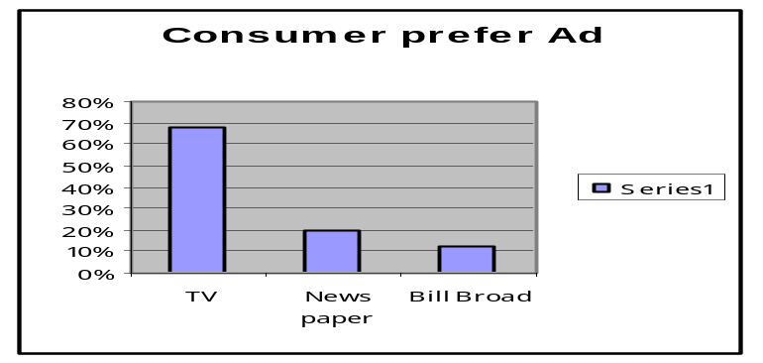

Decision: maximum trader prefers TV advertisement, so I think increase the TV advertisement.

- What is your opinion regarding consumer’s preference to buy Keya’s Product?

Flavor | Price | Availability | Others
35% | 40% | 20% | 5%

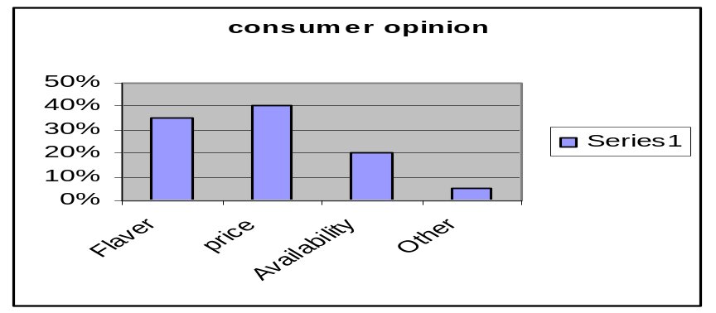

Decision: Need to maintain quality & should to ensure reasonable price.

- Do you think present sales policy is creating enough awareness to the traders?

Maximum Level | Average Level | Poor Level
30% | 50% | 20%

Current sales policy
0%
10%
20%
30%
40%
50%
60%
Maximum
Level
Average
Level
Poor
Level
Series1
Series2

Decision: Present sales policy creating average awareness.

Chapter: 6

Recommendation,

Conclusion,

6.1 Recommendation
Keya Cosmetics Ltd. is one of the largest companies in Bangladesh. Quality comes first- keeping this principle in mind; the company aim at producing guarantied international quality cosmetics and toiletries for quality conscious people of home and abroad.
Few suggestions and recommendations have been provided here so that it can survive better in future.

- Diversification of product should be conducted as soon as possible so that people can get their necessary products from this company.
- Distributors are not as much as obedient to follow the instruction of the company. So, it should be consider carefully.
- Delivery Officers have poor knowledge about market. So, they should be trained properly.
- Promotion facility of the employees should be increase so that they can more motivate to their job.
- It will more benefit if the company appoints the Delivery Officer.
- In case of Shopping Mall, delivery of products should be provided directly by the Company.
- Some retailers are not much aware about Keya’s product. They should provide awareness about it.
- Create more awareness to the people about the products of Keya Cosmetics Ltd.

6.2 Conclusion

The Keya Cosmetics Ltd. is one of the largest and high quality cosmetic companies in Bangladesh. Quality comes first- keeping this principle in mind; the company aim at producing guarantied international quality cosmetics and toiletries for quality conscious people of home and abroad. Since this a product oriented company various kinds of marketing activities are necessary to operate this company successfully. As a student of BBA whereas major subject is marketing; practical knowledge about marketing sector is very much necessary for By doing Internship in this company it has been possible to gain practical knowledge about marketing sector.

The findings and analysis of the research are about Keya’s environment, its people, its work, its products and its service provided to its distributors. Also the main findings about Existing Marketing Strategy of Keya Cosmetics Ltd. have been provided. Marketing sector plays a vital role in Keya Cosmetics Ltd. The existence and fruitful work of Existing Marketing Strategy have made Keya a market leader in the product sector of Bangladesh.

Keya Cosmetics Ltd. is providing us the best and fresh products. It can gives us this quality products wherever, whenever and however due to the determination and the of team of Keya. The smooth, prompt and fast communication and also good understanding between the top management and the employees have made Keya Cosmetics Ltd. to reach up top.

