Customer Service
In
Grameenphone Limited

Submitted by

WWW.ASSIGNMENTPOINT.COM
Introduction:

Origin of the Report:

BBA academic program is the building up of the theoretical knowledge about business administration which is the base of practical knowledge. BBA project work is an attempt to provide business students an orientation to a real life business situation in which we can observe and evaluate the use and applicability of the theoretical concepts which were taught in the classrooms. As per norm this report is the requirement of the fulfillment of the project work. This report is the out come of our work in GrameenPhone Ltd.

Objectives of the study:

The objective of this report is as follows:

The main objective is to discuss about the customer service in GrameenPhone Ltd. In order to this, I had to,
- examine the customer service units in GrameenPhone Ltd. and their working area.
- know about the payment and recharge method in GrameenPhone Ltd.
- understand the products and services and also value added services given by GrameenPhone Ltd.
- learn and discuss about the automated tools used in GrameenPhone Ltd. to serve customers.

Scope of the Study:

The scope of the study is limited within telecommunication business in Bangladesh. It is also limited within the organization of GrameenPhone Ltd. and for that reason that information was very much restrictive within the organization as the telecommunication business is going to be very much competitive. Here we discuss with the topics related to the profile of the organization, Human Resources activities of GrameenPhone Ltd.

Limitations:

- The company does not have sufficient source of secondary data and collecting of data was not smooth.

- Analyzing financial data is much more confusing and complicated than any other data.

- It was really difficult for me to accumulate confidential financial data.

Methodology:

For the purpose of the study data and information have been collected from both primary and secondary sources. The relevant information collected from primary sources is collected in an informal way. Our work experience in GP helped us a lot. Besides this, regular conversations with many GP employees and we have interviewed and taken some suggestions orally from the personnel of GrameenPhone Ltd. The secondary sources for data collection were published annual reports, monthly financial newsletters of GP and monthly newsletters of GrameenPhone Ltd.

HISTORY OF CELL PHONE

GENERAL

Cell Phones are everywhere and their use is growing. Basically a cell phone is a radiotelephone and its application is growing because of the rapid rise of digital computers and very small and powerful microprocessors. One of the most important advantages of microprocessors is their ability to do very complicated operations with high reliability.

The problem with early radiotelephones was that they quickly ran out of available frequencies, i.e. channels. Often a wealthy individual with a radio telephone in his car would have one of his employees make a series of calls starting very early in the morning to reserve a channel for himself and guarantee that he could have his radio telephone available as he was being driven to work.

The problem was that to be useful, a radiotelephone had to work throughout a whole metropolitan area, and a large area even back then made for a large number of users. The problem could be solved by having many small areas (now called cells) which all shared the same frequencies. A small area only had a small number of users so that the number of frequencies was adequate. In principle doing automatic switchovers from one cell to another could solve this problem, but such automatic switches were very complicated to implement. Enter the digital computer, it was capable of doing the complex job of managing the switchover so that the call would not be lost, and the modern cell phone was born.

At first the speech was analog, and the logic to manage the switchover was digital (i.e. done by a digital computer). These types of cell phones are known today as analog phones even though the switching is digital. A true all digital cell phone, however, would also represent the speech as a series of numbers, i.e. in digital form. A cell phone which also digitizes the speech improves the sound quality; gets rid of static on the line, and incidentally, increases the battery life by 3 to 5 times.
Since also making the speech digital was even more complicated than just making the switchover digital, the true all digital cell phone had to wait for microprocessors to get smaller and more powerful. This has now been achieved, and one can have truly high quality cell phone service with the new digital units. All digital cell phones have now become so capable, the call rates so low, and the battery life so long that it makes sense for some businesses to have only cell phones for their business extensions.

INVENTOR OF CELL PHONE

The cell phone was invented by Bell Labs from about 1947 to 1967, but a controversy has arisen about this. According to an Associated Press Article in the April 12th issue of the San Francisco Chronicle, Page D3 and an April 3, 2003 Chronicle Article, the Cell Phone was invented by Martin Cooper who at that time was a vice-president at Motorola. Both articles state that he made the first cell phone call in 1973 on a street corner in New York using a base station at the top of a tall building in that city. Motorola introduced its cell phone in 1983 after five generations, 15 years, and $90 million; but as mentioned above, the first commercial cell phone service was started by NTT in Japan on December 3, 1979.

This by no means the whole story, however, Cooper himself in the 10th paragraph of the April 3rd Chronicle article states that “Bell Labs had invented this thing called Cellular Technology”. What Martin Cooper apparently did was build a relatively small radiotelephone, which could be carried by a person. He did not develop the idea and the mechanism for automatically switching over when a phone went from one cell to another. The true inventor of the cell phone is the person or group who developed the concept of small cells and implemented the automatic switchover system and this was Bell Labs.

Finally the explosion of cellular technology, which we now see around us today, was caused by the Microprocessor, i.e. a computer on a small single chip. Intel primarily pioneered this although Motorola and AMD have played significant roles.

BANGLADESH & THE CELL PHONE INDUSTRY

ECONOMIC CONDITION OF BANGLADESH

To understand the potential demand for cell phones in Bangladesh, let us look at some of the key macro-indicators of the country. With a population of nearly 147 million people living in an area slightly larger than the United Kingdom, Bangladesh (total land area 133,910 square kilometer) is the most densely populated country in the world, with roughly 1079 people per square kilometer. More than 80% of its population lives in the rural areas, where two thirds of the population is engaged in agricultural activities. Its standing in the Human Development Index (HDI) remains almost unchanged at 137th position, according to the United Nations Development Report released last year.

Bangladesh is also one of the world's ten poorest countries, with a GDP per capita of USD$ 421 with a lower average of USD$ 171 for rural areas. However, the GDP per capita PPP is USD$ 2,000, with a growth rate of nearly 5% in the last 5 years. It has been often cited that Bangladesh’s low level of income is the main reason for its low level of penetration.

In a country such as Bangladesh where the state owned operator, the Bangladesh Telegraph & Telephone Board (BTTB), dominates the landline telephone system and provides poor services and infrastructure, cellular phones tend to be substitute for landlines. According to the year end review of BTRC in 2006, there were approximately 1.5 million fixed line and 17 million mobile subscribers available in the country.

For poor countries and rural areas, it is cheaper to build mobile infrastructure than fixed line communications. In terms of topography, Bangladesh is a flat country where 90% of the country is dominated by alluvial river plains, which does not raise more than 10 meters above sea level. The highest peak is Keokradang (1230 Meter), 80 K. M. South-West of Chittagong in the Hill Tracts. The flatness facilitates the construction of base stations and improves its coverage area.
Besides reviewing the macro indicators to identify potential demand, consumer demand for cellular services has also been studied. A case study conducted by the Telecommunications Development Group for the “Canadian International Development Agency (CIDA)”, found that there was a consumer willingness to pay for cellular phone services and a significant consumer surplus experienced by the villagers. According to the report, the consumer surplus for a single phone call from a village to Dhaka (the costs of a call that replaces the physical trip to the city and the costs of wages) ranges from 2% to 12% of mean monthly household income, which translates to a saving of 132 to 490 TK.

CELL PHONE INDUSTRY OF BANGLADESH

The number of mobile subscribers in Bangladesh grew by more than twelve million, or 120%, in 2006, to stand at 22 million at the end of the year, according to the Telecommunications Regulatory Commission. The regulator reported that the country’s five cell phone companies signed up 2.56 million new subscribers in December alone.

Doubling (or bettering that) the number of cell phone subscribers has become the standard throughout the developing world, so let’s project another doubling in 2007, which would bring the number of subscribers to 44 million. That’s nearly one cell phone for every three people. Before GrameenPhone started service, Bangladesh counted one phone for every 500 people. That’s night and day-a whole new country.

GrameenPhone still maintains its lead position in the country's expanding cell phone market, notwithstanding a tough competition among the existing operators to attract new users. Until December 2006, the country's total number of cell phone users stood at 21.76 million and the number of the GP subscribers reached 10.76 million, according to the year end review by the telecom watchdog - Bangladesh Telecom Regulatory Commission (BTRC). GP had 5.54 million users until December 2005 when the number of total cell phone connections was 9.26 million throughout the country. GP, according to the figures available from the BTRC review, achieved 94% growth in 2006. Its market share, however, came down to 50% during the calendar year under report from 60% in 2005. In calendar 2006, the number of total cell phone connections grew by 136% in the country. GrameenPhone’s total subscribers is around 12.6 million as of February 2007.

AKTel and Banglalink, two other main competitors of GP in the market, witnessed 190% and 253% growth respectively in their user base in the last calendar year. AKTel that had 2.07 million users at the beginning of 2006 raised the number to 6.0 million at the end of the same year. The Egypt based Orascom Telecom Holding (OTH) that took over local operator Sheba in 2004 and renamed as Banglalink had 1.03 million connections until December 2005. The number of Banglalink cell phone users increased by more than 253% and stood at 3.64 million at the end of 2006. As of February 2007, AKTel and Banglalink’s total subscriber base is around 6.0 and 3.7 million respectively. Market analysts said the cell phone market will be bracing for further competition among the service providers in 2007 when another private operator - Warid Telecom, will start operation. The United Arab Emirates based “Warid Telecom” obtained operating license at a cost of US$ 50 million and is expected to join the fray by the middle of this year.

TeleTalk expanded its coverage by about 216% to reach 0.39 million subscribers in 2006 from 0.18 million in 2005. This expansion took place on a low user base of the state-owned operator that started its operations, last of all among the existing operators. According to BTRC, there were total 0.5 million TeleTalk subscribers in the market, till February 2007.

From a subscriber base of 0.44 million until December 2005 CityCell, the country's first private operator in the sector, managed to grow at only 4.45% during the year under report. The number of users of its services stood at 0.97 million at the close of calendar 2006, according to the BTRC's year-end review. Though the majority share of the company was taken over by Singapore based SingTel, it had to contend itself with the lowest growth in its user base among all its competitors in the market. Currently total subscriber base of CityCell is around 1.1 million calculated on February 2007. The total market size of the mobile industry is 24 million approximately, as of February 2007. Of this 52.72% of the market share is occupied by GrameenPhone, 25.10% by AKTel, 15.48% by Banglalink, 4.60% by CityCell and 2.09% by TeleTalk.

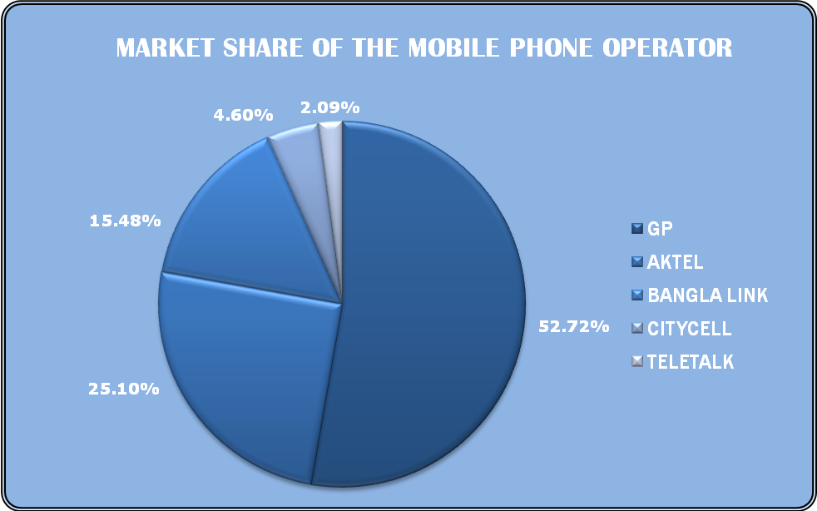
Figure: Market Share of the Mobile Phone Operators

At present GrameenPhone has a huge subscriber base of 1,26,47,781 up to March 18, 2007, among which total 1,20,71,319 subscribers are using GP’s Pre Paid products (Smile M2M, Smile PSTN & Djuice) and total 5,76,462 subscribers are using Post Paid products (Xplore). Among the five products offered by GP, the Pre-Paid Mobile To Mobile subscription, Smile M2M & Smile PSTN, has the majority of subscribers amounting to some 10,00,86,64 as of March 2007. The newly launched “Djuice” brand has climbed up to take the second position in only 23 months with some 20,62,655 subscribers. Another very popular subscription is Xplore P1, Post Paid with NWD & ISD connectivity, which has around 46,11,77 subscribers as of March 2007. The popular Village Phone program managed by Grameen Telecom in cooperation with Grameen Bank and GrameenPhone, has acquired 2,52,229 subscribers under its program as of March 2007.

From the market share point of view it is clearly visible that GrameenPhone is leading the market of mobile telecommunication industry with a sharp distance and expected to lead the market for next couple of years with the right kind of efforts from their extremely dedicated work force.

The mobile communication industry in Bangladesh will likely be forced to transform itself due to extreme price erosion, disruptive changes in technology and business models. In order to survive and to grow in a challenging environment and on top of it, in order to add value to the society, key people in GrameenPhone have realized that being best today is not enough. Considering the future challenges, GP has initiated a portfolio of projects in the following three areas:

- Maximizing revenue within existing business model;
- Optimizing the cost for the current GP value chain;
- Developing and implementing new Business Models;

Cross-functional Teams will be involved to implement the various initiatives/ projects embedded in the three areas mentioned above. In order to ensure the successful implementation of these initiatives/projects, a core team will steer and guide this portfolio of projects.

GRAMEENPHONE LTD.

HISTORY

November 28, 1996: GrameenPhone was offered a cellular license in Bangladesh by the Ministry of Posts and Telecommunications;

March 26, 1997: GrameenPhone launched its service on the Independence Day of Bangladesh;

June 1998: GP started its services in the port city of Chittagong, the second largest city in the country. Cell to cell coverage in the Dhaka-Chittagong corridor also enabled GP to introduce its service in a number of other districts along the way;

September 1999: GP started its service in the industrial city of Khulna. Once again, a number of other districts came under coverage of GP because of the cell to cell coverage between Dhaka and Khulna. Earlier in September 1999, it introduced the EASY pre-paid service in the local market. It also introduced the Voice Mail Service (VMS) and the Short Message Service (SMS) and other Value Added Services (VAS);

June 2000: GrameenPhone started its services in Sylhet, Barisal and Rajshahi, bringing all six divisional headquarters under the coverage of its network. The service in Barisal region was started after the microwave link between Khulna and Chittagong was completed;

August 2003: After six years of operation, GrameenPhone has more than one million subscribers;

November 2005: GrameenPhone continues to being the largest mobile phone operator of Bangladesh with more than 5 million subscribers;

November 16, 2006: After almost 10 years of operation, GrameenPhone has over 10 million subscribers.
GrameenPhone has built one of the most extensive infrastructures of Bangladesh and is a major contributor to the development of the national economy. GrameenPhone is one of the largest private sector investments in the country with an accumulated investment of BDT 5200 crore up to December 2005. GrameenPhone is also one the largest taxpayers in the country, having contributed nearly BDT 5000 crore in direct and indirect taxes to the Government Exchequer over the years of which is amount, BDT 1670 crore was paid in 2005 alone.

GP was also the first operator to introduce the pre-paid service in September 1999. In addition to core voice services, GrameenPhone offers a number of value-added services, in each case on both a contract and prepaid basis. It established the first 24-hour Call Center, introduced value-added services such as VMS, SMS, Fax & Data Transmission Services, International Roaming Service, WAP, SMS - based Push-Pull Services, EDGE, personal ring back tone and many other products and services.

GrameenPhone nearly doubled its subscriber base during the initial years while the growth was much faster during the later years. It ended the inaugural year with 18,000 customers, 30,000 by the end of 1998, 60,000 in 1999, 193,000 in 2000, 471,000 in 2001, 775,000 in 2002, 1.16 million in 2003, 2.4 million in 2004 and it ended 2005 with 5.5 million customers.
GrameenPhone offers the widest coverage in Bangladesh. The population coverage has increased from approximately 85% in 2005 to above 90% in 2006. In addition, GrameenPhone also offers GPRS in most of the country and EDGE in urban areas.

From the very beginning, GrameenPhone placed emphasis on providing good after-sales services. In recent years, the focus has been to provide after-sales within a short distance from where the customers live. There are now more than 600 GP Service Desks across the country covering nearly all sub-districts of 61 districts. In addition, there are nine GP Customer Centers in all the divisional cities and they remain open from 8am-8pm every day including all holidays.

GrameenPhone has generated direct and indirect employment for a large number of people over the years. The company presently has more than 4,500 full-time, part-time and contractual employees. Another 70,000 people are directly dependent on GrameenPhone for their livelihood, working for the GP dealers, retailers, scratch card outlets, suppliers, vendors, contractors and others.

In addition, the Village Phone Program, also started in 1997, provides a good income-earning opportunity to more than 200,000 mostly women Village Phone operators living in rural areas. The Village Phone Program is a unique initiative to provide universal access to telecommunications service in remote, rural areas. Administered by Grameen Telecom Corporation, it enables rural people who normally cannot afford to own a telephone to avail the service while providing the Village Phone operators an opportunity to earn a living.

The Village Phone initiative was given the “GSM in the Community” award at the Global GSM Congress held in Cannes, France in February 2000. GrameenPhone was also adjudged the Best Joint Venture Enterprise of the Year at the Bangladesh Business Awards in 2002.

GrameenPhone considers its employees to be one of its most important assets. GP has an extensive employee benefit scheme in place including Gratuity, Provident Fund, Group Insurance, Family Health Insurance, Transportation Facility, Day Care Centre, Children’s Education Support, Higher Education Support for employees, In-House Medical Support and other initiatives.

THE PEOPLE

The people of GrameenPhone are young, dedicated and energetic. All employees are well educated at home or abroad, with an even distribution of males and females and social groups in Bangladesh. They know in their hearts that GrameenPhone is more than phones. This sense of purpose gives them the dedication and the drive, producing the biggest coverage and subscriber-base in the country. GrameenPhone provides equal employment opportunities and recognizes the talents and energy of its employees.

THE SERVICE

GrameenPhone believes in service that leads to good business development. Telephony helps people work together, raising their productivity. This gain in productivity is development, which in turn enables them to afford a telephone service, generating good business. Thus development and business go together.

THE TECHNOLOGY

GrameenPhone’s Global System for Mobile or GSM technology is the most widely accepted digital system in the world, currently used by over a billion people in 172 countries. GSM brings the most advanced developments in cellular technology at a reasonable cost by spurring severe competition among manufacturers and driving down the cost of equipment. Thus, consumers get the best for the least.

GrameenPhone is now the leading telecommunications service provider in the country with more than 10 million subscribers as of January 2007. Presently, there about 15 million telephone users in the country, of which, a little over one million are fixed-phone users and the rest mobile phone subscribers.

Starting its operations on March 26, 1997, the Independence Day of Bangladesh, GrameenPhone has come a long way. It is a joint venture enterprise between Telenor AS (62%), the largest telecommunications service provider in Norway with mobile phone operations in 12 other countries, and Grameen Telecom Corporation (38%), a non-profit sister concern of the internationally acclaimed micro-credit pioneer Grameen Bank.

Over the years, GrameenPhone has always been a pioneer in introducing new products and services in the local market. GP was the first company to introduce GSM technology in Bangladesh when it launched its services in March 1997. The technological know-how and managerial expertise of Telenor AS has been instrumental in setting up such an international standard mobile phone operation in Bangladesh. Being one of the pioneers in developing the GSM service in Europe, Telenor AS has also helped to transfer this knowledge to the local employees over the years.

GRAMEENPHONE CORPORATE GOVERNANCE

In the fast-paced world of telecommunications, vibrant and dynamic Corporate Governance practices are an essential ingredient to success. GrameenPhone believes in the continued improvement of Corporate Governance. This in turn has led the company to commit considerable resources and implement internationally accepted Corporate Standards in its day-to-day operations.

Being a private limited company, the Board of Directors of GrameenPhone have a pivotal role to play in meeting all stakeholders’ interests. The Board of Directors and the Management Team of GrameenPhone are committed to maintaining effective Corporate Governance through a culture of Accountability, Transparency, Well-Understood Policies and Procedures. The Board of Directors and the Management Team also persevere to maintain compliance of all laws of Bangladesh and all internally documented regulations, policies and procedures. GrameenPhone is a truly transparent company that operates at the highest levels of integrity and accountability on a global standard.

CORPORATE SOCIAL RESPONSIBILITY; AN INTEGRAL PART OF GP

GrameenPhone started its journey 10 years back with a believe that- “Good development is good business”. Since its inception, GrameenPhone has been driven to be inspiring and leading by example, when it comes to being involved in the community. GrameenPhone believe that, sustainable development can only be achieved through long term economic growth. Therefore, as a leading corporate house in Bangladesh GP intend to deliver the best to their customers, business partners, stakeholders, employees and society at large by being a partner in development.

GrameenPhone defines Corporate Social Responsibility as a complimentary combination of ethical and responsible corporate behavior as well as a commitment towards generating greater good in society as a whole by addressing the development needs of the country.

To interact effectively and responsibly with the society and to contribute to the socio-economic development of Bangladesh, GrameenPhone has adopted a holistic approach to Corporate Social Responsibility, i.e. Strategic & Tactical. Through this approach GP aims to, on the one hand involve itself with the larger section of the society and to address diverse segments of the stakeholder demography, and on the other remain focused in its social investment to generate greater impact for the society.

GrameenPhone focuses its Corporate Social Responsibility involvement in three main areas - Health, Education and Empowerment. They aim to combine all their CSR initiatives under these three core areas to enhance the economic and social growth of Bangladesh.

Health

Helping and caring for the community is an essential component of GrameenPhone’s Corporate Social Responsibility; therefore they endeavor to make a positive contribution to the underprivileged community of Bangladesh by helping in improvement of the health perils in the country as much as possible.

Healthcare is still inaccessible for many Bangladeshis. Almost half of the country's population live below the poverty line and cannot even afford basic healthcare. Only 35% of the rural population use adequate sanitation facilities and 72% have access to clean drinking water. Moreover the people of the flood-prone areas suffer from many waterborne diseases.

The major problem in this sector is the significant gap between healthcare knowledge and practice and availability of the healthcare services. Therefore, all possible sources, be it public or private, should mobilize their efforts to make healthcare services available to the people who need it most, and thus help in achieving the MDG goals. GP’s plan is to engage in programs, especially in the rural areas, that will assist in creating awareness about healthcare and healthcare services and help improve the overall quality of life.

Keeping their vision in mind - We are here to help; GrameenPhone aim to extend their contribution to the development of the healthcare system and work to provide a brighter and healthier future for the people of Bangladesh.

Education

Education is the key to prosperity and good life. Every human being should have the opportunity to make a better life for him or herself. One of the Millennium Development Goals (MDG) for Bangladesh is to achieve universal primary education; unfortunately too many children in Bangladesh today grow up without this opportunity, because they are denied their basic right to even attend primary school. The country’s low literacy rate of 41% (2004 UNESCO Report), may indicate that we are far away in pursuit of sustainable development, but at the same time the gradual increase in the adult literacy rate gives us the hope that our nation has the potential to improve in this sector.

The marginalized and disadvantaged groups in general - particularly the rural and urban-poor of Bangladesh - have significantly less access to education than other groups. Though initial enrollment in primary school is high, the completion rate is notably low; approximately 65% (World Bank Report 2004) and a smaller percent of that even complete secondary school. Bangladesh government has provided lot of incentives, such as, free distribution of textbooks in primary schools, secondary stipend program for 100% of the girls, Food for Education project, to encourage and improve the educational sector of the country, which has helped in improvement in the literacy rate. But still we have a long way to go to make our country illiteracy free, thus GP look forward to support this sector, which will eventually help to build a developed country.

Providing access to education, especially for children from disadvantaged backgrounds who might not otherwise get the opportunity, is the main goal of GrameenPhone’s CSR education initiatives. Many people in Bangladesh still lack the basic technological knowledge and marketable skills, thus GP plan to focus further to develop an educated and skilled workforce through creating opportunity in capacity development; skilled workforce would in turn be able to create and share knowledge and contribute to the economy of Bangladesh.

Empowerment

Lack of empowerment and poverty is a chronic and complex problem for Bangladesh. According to UNDP HDI Report 2006, which measures the average progress of a country in human development, in terms of, life expectancy, adult literacy and enrolment at the primary, secondary and tertiary level, Purchasing Power Parity (PPP), etc., Bangladesh ranks 137th among 177 countries. Moreover, 50% of the total population of Bangladesh lives below the poverty line, defined by less than a dollar a day.

Some of the major factors contributing to this situation are inequality in income distribution, lack of access to resources, lack of access to information and inadequate infrastructure. The rural people of Bangladesh especially are deprived of these facilities, which is a major issue to break out from the shackles of poverty prevailing in the country.

Empowerment is a key constituent towards poverty reduction, and it is a key driver for sustainable economic development. Empowerment is a process of enhancing the capacity of individuals or groups to make choices and to transform those choices into desired actions and outcomes, which in turn helps them to secure a better life.

GP acknowledge that development and poverty reduction depend on holistic economic prosperity; therefore their aim is to increase development opportunities, enhance development outcomes and contribute towards development of the quality of life of the people through their CSR initiatives and innovative services. They would like to facilitate empowerment opportunities to the vulnerable people of Bangladesh, so that it enables them to better influence the course of their lives and live a life of their own choice.

SHAREHOLDERS OF GRAMEENPHONE LTD.

The shareholders of GrameenPhone contribute their unique, in-depth experience in both telecommunications and development. The international shareholder brings technological and business management expertise while the local shareholder provides a presence throughout Bangladesh and a deep understanding of its economy.

ABOUT TELENOR AS

Telenor AS is the leading Telecommunications Company of Norway listed in the Oslo and NASDAQ Stock Exchanges. It owns 62% shares of GrameenPhone Ltd. Telenor AS have played a pioneering role in development of cellular communications. It has substantial international operations in Mobile Telephony, Satellite Operations and Pay Television Services. In addition to Norway and Bangladesh, Telenor AS owns GSM companies in Denmark, Austria, Hungary, Russia, Ukraine, Montenegro, Thailand, Malaysia and Pakistan.

ABOUT GRAMEEN TELECOM

Grameen Telecom Corporation, which owns 38% of the shares of GrameenPhone Ltd., is a non-profit company and works in close collaboration with Grameen Bank. The internationally reputed bank for the poor has the most extensive rural banking network and expertise in micro finance. Grameen Telecom, with the help of Grameen Bank, administers the Village Phone Program, through which GrameenPhone provides its services to the fast growing rural customers.

Grameen Telecom’s objectives are to provide easy access to GSM cellular services in rural Bangladesh, creating new opportunities for income generation through self- employment by providing villagers with access to modern information and communication based technologies.

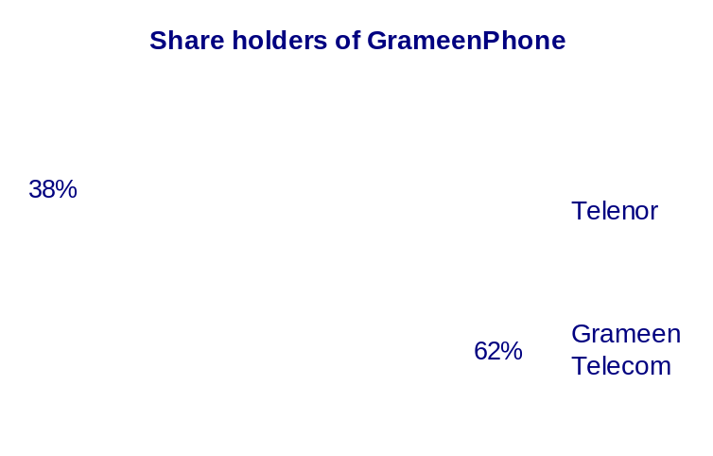

MANAGEMENT OF GRAMEENPHONE LTD.

The top management of GrameenPhone Ltd carried out their management roles comprehensively over the years. There has been replacement or changes in the positions but all have worked together to increase the overall performance of the organization. Management Team of GrameenPhone comprises of the Managing Director, the Deputy Managing Director and the Divisional Heads of the company.
ORGANIZATIONAL STRUCTURE
N K A MOBIN
DIRECTOR, PROJECTS
MD. ARIF AL ISLAM
DIRECTOR, FINANCE
EMAD UL AMEEN
DIRECTOR, HUMAN RESOURCES
FARHAD F AHMAD
HEAD OF INTERNAL AUDIT
FRANK FODSTAD
DEPUTY MANAGING DIRECTOR
STEIN NÆVDAL-LARSEN
CHIEF MARKETING OFFICER
AHMED RAIHAN SHAMSI
DEPUTY DIRECTOR, COMPANY SECRETARY
SYED YAMIN BAKHT
HEAD OF INFORMATION
LUTFOR RAHMAN
HEAD OF INFORMATION TECHNOLOGY
KAFIL H. S. MUYEED
DIRECTOR, NEW BUSINESS
MD. SHAFIQUL ISLAM
CHIEF TECHNICAL OFFICER
KHALID HASAN
DIRECTOR, REGULATORY & CORPORATE AFFAIRS
Anders Jensen
DIRECTOR

At present, Mr. Anders Jensen is the CEO; Frank Fodstad, Deputy Managing Director; Stein Naevdal Larsen, Chief Marketing Officer; Md. Arif Al Islam, Chief Financial Officer; Khalid Hasan, Director Regulatory & Corporate Affairs; Kafil H. S. Muyeed, Director New Business; Md. Shafiqul Islam, Chief Technical Officer; Lutfor Rahman, Head of IT; N K A Mobin; Director Projects; Emad Ul Ameen, Director Human Resources of GrameenPhone Ltd. They equally contributed to GrameenPhone’s superior leadership, by carrying out their unique roles. They worked well together, respecting each other’s abilities, & arguing openly & without any rancor when they disagreed.

DIVISIONS AT GRAMEENPHONE LTD.

GrameenPhone Ltd. has approximately 5000 employees working at different levels of organizational hierarchy. There are 9 functional departments engaged in managing these employees- with the aim to meet organizational objectives. GrameenPhone follows a mix of centralized and decentralized decision making process-where the top management mainly takes all the strategic decisions while the functional managers have flexibility to take decisions by themselves on a day to day basis. At GrameenPhone the Managing Director is assisted by 9 Senior Executives who are heading different departments in the strategic decision making process. The departmental names of GrameenPhone are given below:

Commercial Division
DMD’s (Deputy Managing Director) Division
Finance Division
New Business Division
Human Resource Division
Information Technology
Technical Division
Information
Regulatory & Corporate Affairs

GrameenPhone follows a 3-layer management philosophy in Bangladesh. These are Directors, Managers and Officers. The CEO is the top most authority of all the levels. Directors are the departmental heads that are responsible for the activities of their departments. Managers have the authority next to directors. These two layers represent the management level of GrameenPhone. Officers are the next persons to stand in the hierarchy list. They are the typical mid-level employees of GrameenPhone’s organizational hierarchy. These officers are responsible for managing the operational activities and operating level employees.
COMMERCIAL DIVISION OF GRAMEENPHONE

Head of Function: Stein Naevdal
Reporting To: Anders Jensen , CEO

Main Objective

Within the direction from the CEO of GrameenPhone, the Head of Commercial Division/Chief Marketing Officer shall ensure that the Commercial function within GrameenPhone at all times is aligned with and supports the realization of GrameenPhone’s business objectives.

Main Responsibilities

Develop, maintain and implement strategies, policies and procedures for the functional areas, which include:
- Marketing
- Sales & Distribution
- Customer Management
- Customer Relationship Management
- Village Phone

Monitor and control company-wide commercial activities;
Provide support and consulting within scope to all divisions in the company, in order to ensure coordination, business alignment and adaptation of best-practices;
Develop and maintain descriptions of departments reporting to the Head of Commercial Division/Chief Marketing Officer, defining their responsibilities and how work is organized between these departments;
Ensure awareness of, and ability to comply with, legal requirements applicable for procurement activities and its governance documents, including SOA-required internal controls and Codes of Conduct;
Ensure necessary capabilities company wide to perform the functions responsibilities.

DMD’S DIVISION OF GRAMEENPHONE

Head of Function: Frank Fodstad
Reporting To: Anders Jensen, CEO

Main Objective

Within the direction from the CEO of GrameenPhone, the Deputy Managing Director shall ensure that the Deputy Managing Director’s function within the company at all times is aligned with and supports the business objectives.

Main Responsibilities

Develop, maintain and implement company strategies, policies and procedures for the functional area, which includes:

- Revenue Assurance & Fraud Management
- Fiber Optic Network
- Legal & Compliance Unit
- Administration
- Corporate Headquarter Project
Monitor and control Deputy Managing Director’s divisional activities;
Provide support and consulting to all other functions within scope, in order to ensure coordination, business alignment and adaptation of best-practices;
Develop and maintain descriptions of departments reporting to the Deputy Managing Director, defining their responsibilities and how work is organized between these departments;
Ensure awareness of, and ability to comply with, legal requirements applicable for the company and its governance documents, including SOA-required internal controls and Codes of Conduct;
Ensure necessary capabilities within function to ensure that the organization is able to meet its current and future business objectives.

FINANCE DIVISION OF GRAMEENPHONE

Head of Function: Arif Al Islam
Reporting To: Anders Jensen, CEO

Main Objective

Within the direction from the CEO of GrameenPhone, the CFO shall ensure that the Finance & Supply Chain Management function within GrameenPhone at all times is aligned with and supports the realization of GrameenPhone’s business objectives. The CFO must prepare financial statements with reasonable assurance that statements are not materially misstated at the consolidated group level and for local statutory accounts.

Main Responsibilities

Develop, maintain and implement company strategies, policies and procedures for the functional area, which includes:

 Treasury  Financial Reporting & Controlling  Tax
 Risk Management Supply Chain Management Investor Relations

Monitor and control company-wide Finance & Supply Chain Management activities;
Provide support and consulting within scope, to all other divisions in the company, in order to ensure coordination, business alignment and adaptation of best-practices;
Develop and maintain descriptions of departments reporting to the CFO, defining their responsibilities and how work is organized between these departments;
Ensure awareness of, and ability to comply with, legal requirements applicable for the functional area and its governance documents, including SOA-required internal controls and Codes of Conduct;
Ensure necessary capabilities within the function to ensure that the organization is able to meet its current and future business objectives.

NEW BUSINESS DIVISION OF GRAMEENPHONE

Head of Function: Kafil H. S. Muyeed
Reporting To: Anders Jensen, CEO

Main Objective

Within the direction from the CEO of GrameenPhone, the Head of New Business shall ensure that right emphasis is put on community relations, CSR activities and new business based on current and future technological developments and these areas are aligned with and supports the realization of GrameenPhone’s business objectives.

DIRECTOR
NEW BUSINESS DIVISION
OFFICER
Strategy Coordination & Process
DEPUTY MANAGER
Coordination
ADDITIONAL GENERAL MANAGER
New Business Development
MANAGER
DEPUTY MANAGER
OFFICER
ADDITIONAL GENERAL MANAGER
Corporate Social Responsibility
MANAGER
Projects &
Partnerships
DEPUTY MANAGER
OFFICER
OFFICER
Reporting & Evaluation
MANAGER
Reporting & Evaluation

Figure: Organogram of New Business Division

Main Responsibilities

Develop, maintain, and implement strategies and policies for the areas which include:

- Community Relations
- Corporate Social Responsibility activities
- New businesses based on current and future technological developments
- Strategy processes co-ordination across the organization

Monitor and control activities within own area;
Develop and maintain descriptions of functions reporting to the Head of New Business, defining their responsibilities and how work is organized;
Ensure awareness of, and ability to comply with, legal requirements applicable for this function, including SOA-required internal controls;
Ensure necessary capacity, competence and capabilities to perform the function’s responsibilities.

HUMAN RESOURCE DIVISION OF GRAMEENPHONE

Head of Function: Emad Ul Ameen
Reporting To: Anders jensen, CEO

Main Objective

Within the direction from the CEO of GrameenPhone, the Head of HR shall ensure that the HR function within GrameenPhone at all times is aligned with and supports the realization of GrameenPhone’s business objectives. The Head of HR shall optimize the human resources in GrameenPhone, through individual performance management and organizational development, as well as nurturing a culture supporting the realization of the vision and values. In order to achieve this, leadership excellence is a key focus area for HR.

The units in HR Division include:
- HR Operations;
- Recruitment & Selection;
- HR Development;
- Health, Safety & Environment
- Expatriate and Travel Support.

Main Responsibilities

Develop, maintain and implement company HR strategies, policies and procedures in order to establish organizational capabilities company-wide to meet current and emerging business needs, which include:

- Leadership
- Employee Capabilities
- Organizational Design
- Collaboration
- Recruitment
- Compensation & Benefits
- Employee relations and Health, Safety & Working Environment

Monitor and control company-wide HR activities;
Provide support and consulting within scope, to all divisions in the company, in order to ensure coordination, business alignment and adaptation of best-practices;
Develop and maintain descriptions of departments reporting to the Head of HR, defining their responsibilities and how work is organized between these departments;
Ensure awareness of, and ability to comply with, legal requirements applicable for the function and its governance documents, including SOA-required internal controls and Codes of Conduct;
Ensure necessary capabilities company wide to ensure that the organization is able to meet its current and future business objectives.

INFORMATION TECHNOLOGY DIVISION OF GRAMEENPHONE

Head of Function: Lutfor Rahman
Reporting To: Anders Jensen, CEO

Main Objective

Within the direction from the CEO of GrameenPhone, the Head of IS/IT shall ensure that the Information Security/Information Technology function within GrameenPhone at all times is aligned with and supports the realization of GrameenPhone’s business objectives. The Head of IS/IT shall ensure the realization of the business objectives through delivering services and information with sufficient quality.

Main Responsibilities

Develop, maintain and implement company strategies, policies and procedures for the functional area, which includes:
- Strategy and Architecture
- IS/IT Governance
- IT Quality and Risk Management
- IT Sourcing (In compliance with Company Procurement Policy)

Monitor and control company-wide IS/IT activities to create transparency and facilitate best practice within IT.
Provide support and consulting to all divisions in the company, in order to ensure coordination, business alignment and adaptation of best-practices.
Develop and maintain descriptions of departments reporting to the Head of IS/IT, defining their responsibilities and how work is organized between these departments.
Ensure awareness of, and ability to comply with, legal requirements applicable for the functional area and its governance documents, including SOA-required internal controls and Codes of Conduct.
Ensure necessary capabilities within the function to ensure that the organization is able to meet its current and future business objectives.
HEAD OF IT
INFORMATION TECHNOLOGY
IT Security
Projects & Change Management
Controlling & Administration Support
Revenue Management Systems
IT
Operations
Architecture & Business Process
Business Support & Service Management

Figure: Organogram of Information Technology Division

TECHNICAL DIVISION OF GRAMEENPHONE

Head of Function: Shafiqul Islam
Reporting To: Anders Jensen, CEO

Main Objective

Within the direction from the CEO of GrameenPhone, the Head of Technical/CTO shall ensure that the technical function within the company at all times is aligned with and supports the business objectives. There are five departments within the Technical Division:
- Planning: The purpose of this unit is to plan the entire GP Telecom network including Core Network Planning, Integrated Network Planning, Service Network Planning, Transmission Planning and Radio Planning.
- Implementation: The task of the Implementation Department is to build the GP telecom network or execute the plan of the Planning Department in the field.
- Operation: This department is responsible for running the network. This includes Operation and Maintenance of the network.
- Network Quality & Performance: The purpose of this department is to monitor and improve Network Quality and Performance.
- Network Advancement: The purpose of this department is to provide Technology Strategy Planning; adopt new technology considering midterm and long term technology evolution and new business opportunities; technology evaluation and Industry update; and review network plans and architecture for constant renewal.

Main Responsibilities

Develop, maintain and implement company strategies, policies and procedures for the functional area, which includes:

- Network Planning
- Network Expansion and Advancement
- Network Operations

Monitor and control the Technical functions activities;
Provide support and consulting to all functions within scope, in order to ensure coordination, business alignment and adaptation of best-practices;
Develop and maintain descriptions of functions reporting to the Head of Technical/CTO, defining their responsibilities and how work is organized between these functions;
Ensure awareness of, and ability to comply with, legal requirements applicable for the company and its governance documents, including SOA-required internal controls and Codes of Conduct;
Ensure necessary capabilities within function to ensure that the organization is able to meet its current and future business objectives.

REGULATORY & CORPORATE AFFAIRS DIVISION OF GP

Head of Function: Khalid Hasan
Reporting To: Erik Aas, CEO

Main Objective

Within the direction from the CEO of GrameenPhone, the Head of Regulatory & Corporate Affairs shall ensure that the Regulatory & Corporate Affairs function within the company at all times is aligned with and supports the business objectives.
DGM
External Relations
MANAGER
Government Agencies
DEPUTY MANAGER
Government Agencies
OFFICER
Government Agencies
DGM
Regulatory & Interconnection
OFFICER
Regulatory
MANAGER/DEPUTY MANAGER
Regulatory & Interconnection
OFFICER
Regulatory & Interconnection
HEAD OF EXTERNAL AFFAIRS
DIRECTOR
REGULATORY & CORPORATE AFFAIRS
ADVISOR
Coordination
OFFICER
Regulatory & Corporate Affairs
DEPUTY MANAGER
Coordinator
ADVISOR
MOPT & BTRC

Figure: Organogram of Regulatory & Corporate Affairs Division

Main Responsibilities

Develop, maintain and implement company strategies, policies and procedures for the functional area which includes:

- Regulatory & Corporate Affairs
- External Relations

Monitor and control Regulatory & Corporate Affairs activities;
Provide support and consulting to other functions within scope, in order to ensure coordination, business alignment and adaptation of best-practices;
Develop and maintain descriptions of departments reporting to the Head of Regulatory & Corporate Affairs, defining their responsibilities and how work is organized between these departments;
Ensure awareness of, and ability to comply with, legal requirements applicable for the company and its governance documents, including SOA-required internal controls and Codes of Conduct;
Ensure necessary capabilities within function to ensure that the organization is able to meet its current and future business objectives;

INFORMATION DEPARTMENT OF GRAMEENPHONE

Head of Function: Yamin Bakht
Reporting To: Erik Aas, CEO

Main Responsibilities

The Department is responsible for:

- Maintaining Public Relations;
- Maintaining Media Relations;
- Publishing GP Newsletters;
- Publishing Annual Reports;
- Maintaining the content of GrameenPhone website;
- Maintaining the content of grameenphone@work Intranet site.

The department consists of three people and is headed by a General Manager.

GENERAL MANAGER
INFORMATION DEPARTMENT
DAPUTY GENERAL MANAGER
DEPUTY MANAGER
OFFICER

Figure: Organogram of Information Department

GRAMEENPHONE’S STRATEGY, VISION & VALUES

GrameenPhone’s basic strategy is coverage of both urban and rural areas. In contrast to the “island” strategy followed by some companies, which involves connecting isolated islands of urban coverage through transmission links, GrameenPhone builds continuous coverage, cell after cell. While the intensity of coverage may vary from area to area depending on market conditions, the basic strategy of cell-to-cell coverage is applied throughout Grameen Phone’s network.

GrameenPhone’s Vision recognizes that they exist to help their customers get the full benefit of communications services in their daily lives. In short:

“We're here to Help”

The key to achieving this is that they work together and draw on their Values and build them into guiding light behaviors in their workplace, wherever that may be:

Make It Easy. Keep Promises.
Be Inspiring. Be Respectful.

Let's look at each of the four values, and see some examples on how they will affect their customers, employees and the company's shareholders.

MAKE IT EASY

We're practical. We don't over complicate things. Everything we produce should be easy to understand and use. No waste. No jargon. Because we never forget we're trying to make customers' lives easier.

For our customers, making it easy will be addressing some very fundamental customer needs. They need simplicity. Solutions and services that are easy to buy, easy to use and are built to meet their needs. Solutions and services that work well.
For GrameenPhone employees everywhere, this means the following... No jargon, be direct and simple. Show transparency. Push for simplicity in tools and in logistics. Share best practices. Adopt clearly defined roles and responsibilities.

For our shareholders, this will mean cost efficiency and return on investment and a move away from tactical investments to an increased focus on long-term strategy.

KEEP PROMISES

Everything we set out to do should work, or if you don't get it, we're here to help. We're about delivery, not over promising - actions not words.

For our customers, this will mean they can build trust in us. The solution or service works - if not, we are there to make it work. They need us to deliver on time, to expected levels of quality, and at a fair price. They need us to be strong on action, not on fine words!

For employees everywhere, this means... We follow through. We never launch something new before it works as it should work. We arrive on time and we deliver on time. We commit to concrete, realistic promises to our customers - and deliver on our promises.

For our shareholders, this will mean that we lead the industry in customer satisfaction, and win industry recognition for follow-through and delivering on our promise.

BE INSPIRING

We are creative. We strive to bring energy into the things we do. Everything we produce should look good, modern and fresh. We are passionate about our business and customers.

For our customers, this will mean they will want to engage with us, will appreciate our innovative and modern approach, will appreciate our future proofed solutions and services, and will acknowledge our category leadership.
For Telenor AS employees everywhere, this means... that we live up to the challenge and inspire our colleagues and customers ' walk the talk! We must call for creativity at every level, show care, energy and passion. Be fresh and direct, and demonstrate a can-do attitude.

For our shareholders, this will mean leadership in our focused category, and a business model that is sustainable into the future.

BE RESPECTFUL

We acknowledge and respect local cultures. We do not impose one formula worldwide. We want to be a part of local communities wherever we operate. We believe loyalty has to be earned.

For our customers, this will mean each of them can expect to be treated like an individual. Each of them will feel valued, understood and listened to, and their needs acted upon.

For Telenor AS employees everywhere, this means we sign up for using customer feedback as a means to improve. We value the individual and diversity, we act as a team. Our behaviors are infused with honesty and strong ethics.

For our shareholders, this will mean they can count on clear codes of conduct across our organization.

CUSTOMER SERVICE AT GRAMEENPHONE

With the increased importance being laid on customer satisfaction in today’s business climate, many companies today are focusing on the notion of customer satisfaction and loyalty as the key to increasing market share and enhancing bottom line results. A company that enjoys a high customer satisfaction and thus a higher customer loyalty also enjoys a competitive advantage and a corporate profitability. Today, companies need to hold on to every customer. It is a lot easier to retain and expand existing relationships than acquire new business. Customer satisfaction and loyalty management systems not only point out customer problems but lead the way towards solutions.

As GrameenPhone is a service oriented company, it always aims to retain it’s customers through quality customer service. Even though customer loyalty is possible through customer relationship management, there is always room for customer dissatisfaction, which hampers customer loyalty. Hence, in order to maintain loyalty it is very important to maintain a good relationship with the customer.

The telecommunication industry is becoming more and more competitive in Bangladesh and customer service is the main player in this fast growing industry. Mobile companies are also giving highest priority in the customer service area. Call rates and SIM prices are reducing dramatically because of the increasing competition among the operators. At present all the operators have wide network coverage throughout the country and the call rate they are offering is also more or less the same. Under the above circumstances customer service is the most distinguishing factor for the mobile companies in order to survive in the competition.

The Customer Service Department of GrameenPhone Ltd. provides a full range of after-sales service customized to the needs of the valued customers. Efforts are made to offer complete service through all the contact points dedicated for GrameenPhone customers at every opportunity through Call Management Center, Customer Centers, GrameenPhone Service Desks (GPSD), GrameenPhone Centers (GPC) and Customer Communication. The trained team of Customer Service Department strives to ensure service with an aim to content the subscribers through “You First” attitude and solution. Their strategy is to connect Bangladesh with “Ease & Care” at every contact through professional and pro-active service.

CALL MANAGEMENT CENTER

The centralized Call Management Center in Dhaka is manned by trained professionals and is open round-the-clock, responding to subscribers’ queries from all over the country where GrameenPhone has its coverage. GrameenPhone Ltd has recently introduced a single dedicated hotline number 121 for all of its subscribers to provide instant service. At present there are more than 450 dedicated and energetic employees are working to provide instant over phone service to the subscribers. Call Management Center is well equipped with state of the art software’s and other important tools through which most of the problems of the subscribers can be solved instantly. Call Management Center remains open 365 days a year and 24 hours a day.

Recently GrameenPhone introduced dialect based hotline for the first time in the region, to provide more customized service to its subscribers. Through this innovative service GP subscribers can communicate with the Customer Managers at their own dialect. At present GP provide services through all the major dialects of the country- Chittagong, Sylhet, Rajshahi, Khulna and Barisal.

CUSTOMER CENTER

The Customer Centers offer various after-sales service like SIM Replacement, Reconnection, Bill Payment, Address Change, Migration, Ownership change etc that requires physical presence of the subscriber. At present the eight (8) centers are conveniently located in the 6 divisional cities where the valued subscribers have easy accessibility to walk-in and get personalized and pro-active service. The Customer Centers of Grameen Phone remains open 7 (seven) days a week from 8 AM to 7 PM.

GRAMEENPHONE CENTER (GPC)

GrameenPhone Center (GPC) is the most recent innovation of GrameenPhone with the aim to provide all kinds of mobile phone related services to its subscribers. For the first time in Bangladesh subscribers will get both SIM and handset related services from the GrameenPhone Centers. So far Grameen Phone introduced 39 well decorated GPC in the country. All these GPC are not only providing after sales services but also working as the main sales channel of the company. Within each GPC there is a separate section allocated for selling and repairing handsets at an affordable cost. GrameenPhone Centers are open from 08:00 AM to 07:00 PM everyday.

GRAMEENPHONE SERVICE DESK (GPSD)

Previously people at the rural areas had to come in the major cities to get customer service, which is a real hassle and time consuming process for them. To solve this problem GrameenPhone introduced Service Desk with a vision to provide service at the rural and remote areas. At present GrameenPhone have total 607 Service Desk around the country through which it provide service at grass root level. All these GPSD remain open from 09:00 AM to 05:00 PM in five days a week.

CUSTOMER COMMUNICATION

The centralized Customer Communication located in Dhaka, handles written requests of subscribers, both verbally and in writing 7 (seven) days a week from 8 AM to 8 PM. Customer Communication deals with all sorts of written complain received through fax, letter by post and e-mail. It also builds relationship with the valued subscribers on a regular basis. The major responsibility of the unit is to maintain relationship with the high users and ensure that the present subscribers are not going to switch to other operator.

TRAVELERS TO CUSTOMER

“Travelers to Customer” is another recent addition of service in Customer Service Department which is also the first time of its kind in the country. The major responsibility of this unit is to provide service at the customer’s doorstep with the slogan of “Let’s not expect the customers to travel to get the service rather let service travel to the customers”. Currently it’s providing service in the major cities of the country and to the high volume users of GrameenPhone. OUTBOUND CALLING CENTER

Outbound Calling Center is another addition of innovative service of Customer Service Department. A group of young, energetic and well trained employees are working in Outbound Calling Center and they are responsible to call back the subscriber to get feedback about the service quality. One of the major responsibilities of the unit is to identify all the dissatisfied customer and try to bring them back so that they stay with GrameenPhone. Moreover the unit is also responsible to provide service to all those subscribers who have repeatedly accessed hotline, with the same kind of problem. In this way outbound calling center plays a major role in holding the existing subscribers.

CORPORATE CUSTOMER CENTER

The Corporate Customer Center aims to provide quality customer service to the country’s preferential business customers. A professionally trained team is dedicated to provide After Sales Services and Solutions customized to the need of the business customers and initiate pro-active visits as a part of routine contact to look into the needs with an aim to build long-term professional relationships. Their professional customer care team is available to help seven days a week, 365 days of the year - whether for general queries, or to assist with any problems subscribers may possibly face. Their dedicated relationship managers are assigned to provide personalized service right from the beginning of the relationship.

PRODUCTS & SERVICES GRAMEENPHONE

GrameenPhone offers a wide range of products and services based on the demand of the subscribers. Currently GrameenPhone is offering seven different products which are designed to fulfill the demand of the various customer segments. Moreover they frequently modify their product offerings and add more attractive features according to the customer expectations. In this regard, GrameenPhone recently offered four brand new products named- Smile M2M, Smile PSTN, Xplore P1 and Xplore P2, to fulfill the changing expectation of the subscribers. All the existing Easy Pre-Paid, Easy Gold, GP National and GP Regular subscribers were automatically migrated to Smile M2M, Smile PSTN, Xplore P1 and Xplore P2 respectively.

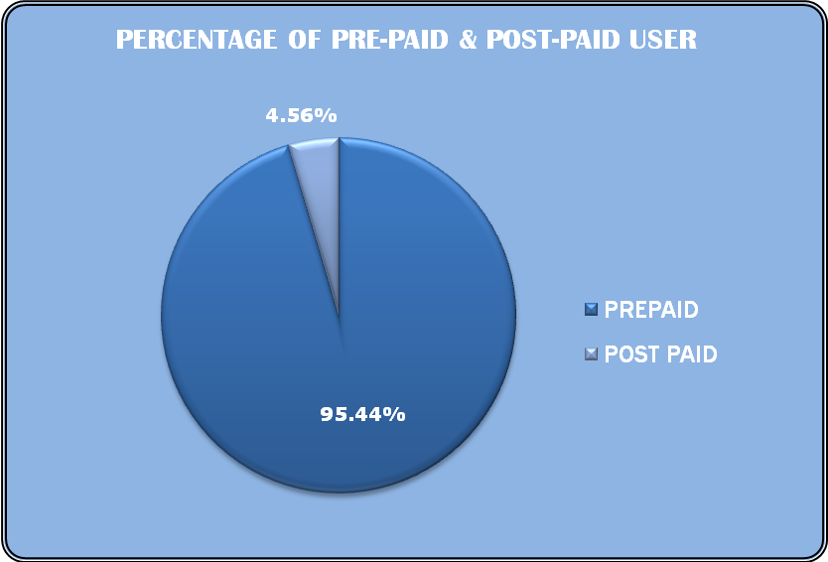
At present there are seven different GP products which are available in the market. The whole product line of GrameenPhone is divided in to two broad categories. These are: Pre-Paid & Post Paid. Among these two categories Pre-Paid products are more popular than the Post-Paid products. Currently in total 12,071,319 subscribers are using GrameenPhone’s Pre-Paid products and the rest of 576,462 subscribers are using the Post-Paid products.

GrameenPhone is the first company to offer Pre-Paid products in mobile phone. Pre-Paid products are particularly targeted to the rapidly growing middle class segment and largest young generation of the country. The charging policy of Pre-Paid products is “Pay as you go”; which subscribers have to recharge their account first and then they will be able to make call. They can also check their account balance immediately after finishing a call. In this way they can easily keep track of their account balances and control over the usage. Moreover there is no monthly line rent involved which is another reason behind the popularity of Pre-Paid products. A more detail description of these categories are discussed below:

GRAMEENPHONE’S PRE-PAID PRODUCTS

There are two different GP Pre-Paid products currently available in the market. These are:
Smile (M2M & PSTN)
Djuice
These prepaid products have different features, attributes and tariff plan, so that customers can choose the appropriate product according to their requirement.

Smile M2M & Smile PSTN

GrameenPhone recently introduced Smile Pre-Paid connection (Smile PSTN & Smile M2M) for its subscribers. All the existing EASY and EASY Gold subscribers automatically migrated to Smile M2M and Smile PSTN respectively. Smile offers some new attractive features and reduced tariff plan along with all the previous features of EASY connection.


Smile M2M is a mobile to mobile connection and it has been designed to keep the customers smiling. It offers great rewards and benefits, amazing rates, and exciting new features. Smile customers are enjoying great Friends & Family rates through which they can talk at only TK 0.50 per minute and SMS at only TK 0.50 to one Friends & Family number. SMILE subscribers also enjoying reduced tariff of only TK 2.0 per minute all day for all GP to GP calls and TK 2.5 per minute to any other operator. SMS to any GP-GP number is TK 1.5 and to other local and international operators is TK 2. Through Smile, GP brought an unique and innovative feature called Group-Talk, in which Smile subscribers can create a group of 3 Smile user & talk with each other only at TK 1.5 per minute.

On the other hand Smile PSTN offers all the features of Smile M2M along with ISD and BTTB connectivity. In addition, Smile PSTN offers Economy ISD through which subscribers can call to any ISD number at an economy rate just by dialing 012 followed by desired numbers.

Djuice


Djuice is another popular pre-paid Mobile to Mobile product of GrameenPhone which was introduced in Bangladeshi market on 14th April 2005. In addition to the basic cellular options, it has some additional lifestyle benefits, specially tailored for the young people who use their mobile phones for communication and entertainment. Within 2 years of operation it has gained huge popularity in the market especially to the young generation.

Djuice offers great tariff rates through which subscribers can talk at only TK 1 per minute and SMS at only TK .50 to any Djuice number. They are also enjoying reduced tariff of only TK 2.50 per minute all day for all GP and any other operator calls. Beside this Djuice subscribers can also call to any mobile at only TK 0.80 per minute during the off peak hours.

Djuice subscribers can enjoy some attractive features such as Group SMS, SMS Chat, SMS Dictionary, Beauty Tips, Top music/movie chart and many more. In addition Djuice offers free TK 50 pre-loaded talk time, 50 Djuice to Djuice free SMS and one XTRA Card with every new Djuice connection. XTRA Card holders will get discount or benefit in different places such as food shops, cafes, clothes shops, CD and DVD stores etc.

GRAMEENPHONE’S POST-PAID PRODUCTS

Post-paid products are quite different in nature than pre-paid. In case of post-paid, subscribers receive a monthly bill which is based on his usage throughout the month. In addition subscribers have to pay a fixed monthly line rent for his connection. However postpaid subscribers are allowed to use their phone first and pay at the end of the month but there is a certain credit limit assigned with every SIM card by the service provider. If subscriber’s usage cross the limit before the billing date then his connection is temporarily become disconnected. All the GP post paid connection has a default credit limit of 500TK. But subscribers can increase their credit limit by paying in advance as security deposit .GrameenPhone currently offering two different post-paid products to the subscribers. These are:

Xplore

These postpaid products have different features, attributes and tariff plan, so that customers can choose the appropriate product according to their requirement.

Xplore P


Xplore P is a new post-paid product with BTTB (Local, NWD, ISD and Economy ISD) connectivity. Other attractive features of this product are both way BTTB access Local, NWD and ISD facility, free BTTB incoming, 30 seconds pulse from the 1st minute, Economy ISD calling facility, Friends & Family options for 3 GP numbers, International Roaming facility and many more. Moreover there are some new value added services included for Xplore P1 subscribers such as SMS Roaming, Breakfast News, Pre- activated EDGE etc. Beside this there is an attractive start up offer with every new Xplore P1 connection

BUSINESS SOLUTION

The GP Business Solutions is an integrated telecommunications service specially designed for the business entities of Bangladesh, providing customized telecommunications solutions through a consultative approach, tailored to the needs of individual businesses. Comprising of modern mobile telecommunications services for any business needs, the GP Business Solutions provides voice, text messaging and mobile data and internet services. Also on offer will be a complete Mobile-Office Solution, including Mobile Email, Mobile High-Speed Data Access, Internet Access, Mobile Fax and more, providing the freedom to work from anywhere within GrameenPhone wide coverage area.

The Business Solutions offers a suite of specialized products and services providing complete communication solutions for professionals, small to medium sized enterprises and large corporations, enabling them to increase their efficiency, productivity and gain a competitive edge.

SIM PRICE

GrameenPhone offers their various products in a very competitive price in the market. Current price of the various GrameenPhone products are given below:

PRODUCTS | SIM PRICES
Smile M2M | TK 150
Smile PSTN | TK 300
Djuice | TK 150
Xplore P | TK 800
Business Solution Pre-Paid | TK 400
Business Solution Post-Paid | TK 400

THANK YOU PROGRAM

A GrameenPhone connection is not just simply a mobile connection; it is the beginning of a new relationship. Since the start of operations in 1997, GP believe that a special relationship is formed with each new connection, a time-nurtured attachment that deepens with every call the customers make and receive. Thank You is GrameenPhone’s way of expressing their gratitude because their customers’ loyalty touched them and also made them the preferred mobile operator in country. Their Thank You program provides customers with a number of rewards that will make their mobile phone experience with GP even more satisfying. Under Thank You Program GrameenPhone shows their gratitude to the customers in three different ways:
- SMS Discount
- Thank You Crown

SMS Discount

With Thank You SMS Discounts, GP provides shopping surprises to the customers with every SMS. Through Thank You Discount GP customers can shop with any one of Thank You Partners and send an SMS (with the store code) at the cash counter and receive an immediate discount at the store. At present there are more than 300 Thank You Partner locations available including selected national and foreign hospitals. Active GrameenPhone subscribers can avail benefits from the Thank You Partners upon using their GP connections for at least 180 days.

Thank You Crown

GrameenPhone offers the prestigious Thank You crown membership to especially cater to their valued subscribers. To enrich their life, GP offers premium services and exclusive discounts. Thank You crown membership offers customers special personal service and care. Whenever they experience any problems, they can get prompt and on the spot solution simply dialing 121. GP’s dedicated customer manager will promptly attend to their needs and resolve their difficulty. Crown members also enjoy exceptional service at all GrameenPhone customer touch-points. They just need to introduce themselves with their GrameenPhone number and put their feet up! Customer Managers will take care of their problem while they are relaxing.

Moreover, Crown members can enjoy a wide variety of wonderful discounts with their Thank You Crown Membership at various exclusive local and international Thank You Crown Partners. As an esteemed Crown Member, they will enjoy special discounts at Seagull Hotel of Cox's Bazaar as well as various International Hospitals, including Bangkok Medical Centre, Thailand and The Raffles Hospital, Singapore, with many more to come. They will also enjoy wonderful discounts at more than 200 Thank You partner locations in Bangladesh.

MEMBERSHIP | AVG MONTHLY USAGE OVER LAST 6 MONTHS | HOME SERVICE | DISCOUNT ON SIM REPLACEMENT
PLATINUM | BDT 6500 & ABOVE | Earliest Available Time | 100%
GOLD | BDT 4500 TO 6500 | N/A | 75%
SILVER | BDT 2500 TO 4500 | N/A | 50%

Table: Thank You Crown Membership Criteria
Based on average monthly usage, membership would be reassigned after every three months from last status change.

COMMUNITY INFORMATION CENTER (CIC)

Set up with technical assistance from the GSM Association, the GrameenPhone Community Information Centers (GPCICs) are equipped with the minimum of a computer, a printer, a scanner, a web cam and an EDGE-enabled modem to access the Internet using the EDGE connectivity.

The GPCICs are designed to be run independently as small businesses by local entrepreneurs. The GPCICs are set up on shared premises in select rural areas around the country. The computers in the 16 centers of the pilot phase were used by an average of 30 people a day, who pay a small fee to access E-mail or Web pages. Currently there are 80 CICs operating in as many Upazilas of the country.

Beneficiaries use the centers for a wide variety of business and personal purposes, from accessing health and agricultural information to using government services to video conferencing with relatives overseas. GrameenPhone trains the entrepreneurs so that they become aware of the full potential of business through GPCIC.

To help the entrepreneurs to earn more Community Information Centers also provide local people with other GrameenPhone services, such as payphones (again using GrameenPhone's mobile network) and electronic recharges for prepaid mobile accounts.

Through GPCIC from the Government websites, access to passport forms, birth and death certificates forms and other related information are available. Market prices of agricultural produce are also available through the website of the Agricultural Extension Department.

The GPCICs are also of help to students and professionals for gathering reports and news suiting their requirements. Information relating to local and foreign job search sites is available at the centers. Many services which would continue to remain beyond the reach of an individual in rural areas would now be available at the GrameenPhone Community Information Centers.

Health and medical information will also be made available through the GPCICs soon. In addition, other useful content will also be added gradually. The ranges of services that are available at GPCICs include:

- Internet surfing and E-mailing;
- Chatting with Voice, Picture;
- Video Conferencing;
- Computer Composing;
- Scanning, Printing, Fax & CD Writing;
- Commercial Mobile Call;
- E-governance Services;
- GP Value Added Services such as FlexiLoad, Ring Tones Downloading etc;
- Telemedicine Services;
- Content on Health & Agriculture;
- Multimedia Education for Children;
- Directory Services
GrameenPhone is rolling out Community Information Centers across rural Bangladesh, giving up to 20 million people the chance to use the Internet and E-mail for the first time. GrameenPhone is teaming up with local entrepreneurs to set up approximately 500 centers in communities throughout the country by the end of 2007.

GrameenPhone has delivery partners such as Grameen Telecom Corporation and Society for Economic & Basic Advancement (SEBA); that are involved in site and entrepreneur selection. GrameenPhone takes care of training, marketing and logistic support. GrameenPhone also provides the GSM infrastructure and the initial services. The micro-financing partners, if required, provide small loans to entrepreneurs who render the services to the local rural community. It takes around USD 1000 to establish a GPCIC. An expected revenue of USD 6-7 per day would make a GPCIC financially viable and it would reach break-even in about a year’s time.

PAYMENT & RECHARGE METHODS

GrameenPhone always try to bring the best of communication services for their customers. They always listen to customer needs closely, so that they can serve better. To reflect that commitment, they want to reduce the hassles of paying bills. Therefore, the valued customers can pay their bills through any of the following methods:

FlexiLoad
Scratch Card Recharge
Auto-Debit Facility

FLEXILOAD

To reflect GP’s continuous commitment towards providing customers with superior services, they brought FlexiLoad for the valued customers. It allows customers to pay their bills without any hassle and inconvenience. GP offers two types of FlexiLoad facilities. These are:

- FlexiLoad for Prepaid
- FlexiLoad for Postpaid

FlexiLoad for Prepaid

GP subscribers can reload their pre-paid account anytime with FlexiLoad with any amount between TK 10 to TK10000. To reload their pre-paid account customers need to visit any of the nearest GrameenPhone authorized scratch card retail outlets or Points of Sale displaying the FlexiLoad sign. They can choose any amount between TK 10 to TK 10000 make the payment to the retailer and the retailer will instantly reload their account from his mobile handset. After a successful reload, customers will receive instant confirmation on their mobile handset through SMS.

The validities of recharge through FlexiLoad for pre-paid products are:

RECHARGE DENOMINATION | VALIDITY
TK 10 To TK 299 | 30 Days (Both Incoming & Outgoing)
TK 300 To TK 10,000 | 365 Days (Both Incoming & Outgoing)

FlexiLoad for Postpaid

For the first time in Bangladesh, GP introduced the innovative electronic bill payment system FlexiLoad, for their valued Post-Paid subscribers. All the postpaid subscribers have the freedom to pay their bill of any amount starting from TK 50 to TK 50,000 at any time of the day. They don’t need to face a long queue or miss the time to the bill payment at the Bank. Moreover, barred phones will be automatically unbarred within a few minutes of paying bill through the FlexiLoad system.

To pay GP post-paid bill through this system, subscribers need to visit their nearest GrameenPhone authorized FlexiLoad retail outlets or Point of Sale with the FlexiLoad Post Paid signage. Upon choosing any amount between TK 50 to TK 50000 customers provide their phone number to the retailer, the retailer will initiate the bill payment process from his mobile phone handset. After successful completion of the payment, both the customer and the retailer will receive a confirmation SMS. Once subscribers received the SMS their bill have been paid. Post-paid subscribers of GrameenPhone namely Xplore P1, Xplore P2 and Business Solutions subscribers can enjoy this FlexiLoad service.

SCRATCH CARD RECHARGE

GP prepaid subscribers can recharge their connection easily and conveniently by using scratch cards. Validity of a scratch card depends on the value of that scratch card. When the validity period is over, the mobile will become inactive for making and receiving calls. But they will be able to recharge their account at any point of time. Scratch cards denomination, validity & grace period for incoming calls are:

RANGE | VALIDITY | GRACE PERIOD (INCOMING ONLY)
TK 50 | 3 Days | ~~~
TK 300 | 365 Days | 7 Days
TK 600 | 365 Days | 7 Days

AUTO DEBIT FACILITY

GrameenPhone offers their customers an extensive bill collection network in cooperation with different banks and financial institutions. GP subscribers can pay all types of GP charges through these banks during banking hours. Some of the banks have electronic payment options where payment can be made at any convenient time.

PAYMENT METHOD | DESCRIPTION
Bill Copy | Can pay bill through the Bill Copy in GP enlisted banks.
Deposit Slip | Can pay bill, security deposit, and other fees through GP Deposit Slips available in banks.
ATM | GP subscribers having Standard Chartered ATM, Dutch Bangla Bank ATM, or Credit Card (Auto Debit), LankaBangla Finance (Auto Debit) and ETN E-Cash Card can pay their bills through ATM machines & the respective cards.
Auto Bills Pay | Standard Chartered account holders can avail the facility of “Auto Bills Pay”. The mentioned services require prior arrangement with respective bank & card authority.
Easy Pay | HSBC has 24-hours “Easy Pay” service for GP subscribers to pay their bills.
Internet Banking | Offered exclusively for GP subscribers by Dutch Bangla Bank Ltd., Eastern Bank Limited and Commercial Bank of Ceylon.

VALUE ADDED SERVICES (VAS)

Now a day’s mobile phone is not only a communication device but also it can be used for many other purposes than making voice calls. Through GrameenPhone’s Value Added Services (VAS), subscribers can use their mobile phone to:

- Send and receive Text Messages, Picture Messages, Voice Messages
- Download Ring Tones, Logos, Wallpapers
- Obtain News Updates, Cricket Score Updates
- Browse the Internet and also send and receive E-Mails
- Transfer Data and Send Fax
- Participate in competitions and vote for your opinions

Subscribers can use all these services whenever they need, wherever they are. All they need is to have a GP mobile phone to get these services. Various Value Added Services offered by GP are discussed below:

GP INSTANT MESSAGING (IM)

GrameenPhone offers world’s latest innovation in mobile messaging for its subscribers. With this innovative service subscribers will be able to use PC style instant messaging and presence on mobile phones through GP’s own Chat Software. This also allows a GP user to chat with other IM buddies around the world. The unique features of Instant Messenger are:

- GP To GP Chat
- Broadcast Message
- Off-Line Messages
- Presence Status Display
- Chat Rooms
- Settings Wizard

MESSAGING SERVICES

There are three types of messaging services offered by GrameenPhone. These are Text Message (SMS), Multimedia Message (MMS) and Voice Message (VMS). More details of theses messaging services are discussed below:

Text Message (SMS)

GrameenPhone subscribers can send and receive text messages in any local or international mobile phone at a cheaper rate. Subscribers just need to open message Option from their handset, write new message, enter the recipient mobile number and press Send. One can send text message up to 160 characters to any mobile number. The Message Service Centre (SMSC) number is +8801700000600 and it is by default stored in all GP SIM card. Handset must be configured by this SMSC number to send text messages. Any GP user can also send SMS to more than 100 million GSM subscribers all over the world. It costs much less than making a call and is quite convenient to send. Sending International SMS is same as the local SMS. The only difference is, subscriber needs to enter the recipient's mobile number with the Country Code with a ‘+’ sign. For example, to send an SMS to Canada they need to enter the mobile number as +1 XXXXXXXXXX. Now a day’s text message service is very popular to the young generation of the country because of its cheaper rate.

Multimedia Message (MMS)

Multimedia Messaging Service (MMS) is an exciting way to share special moments such as birthdays, weddings and holiday pictures with the loved ones. GrameenPhone subscribers can even send pictures and video clips to e-mail addresses. They can customize their messages with texts, pictures, animations, music, video clips (Up to 100 KB). They can also record special moments and save it for the future - in their phone, e-mail inbox or even mail it to another user.

Voice Message (VMS)

Voice SMS is another recent innovation of GrameenPhone. Voice SMS is a unique service which enables the subscribers to record a message or greeting and send it instantly. In order to sent a voice SMS subscribers just need to dial “*” followed by the desired number. After recording the voice within 30 seconds they will disconnect the line and the Voice SMS will automatically be delivered to his desired number. To hear a voice SMS subscriber just need to dial “*0*”. Beside this they can store up to 20 Voice SMS in their number.

SMS BASED ALERTS/SERVICES

GrameenPhone offers various Push Pull SMS based alerts and services for its subscribers. Some of the popular SMS Based Push Pull services are discussed here:
Cricket Alerts

GP subscriber’s can get cricket updates in their mobile phone by subscribing to Cricket Alert Service. To get the alert service, they need to type "CRIC ON" and send it to 2002. To unsubscribe from the service, type "CRIC OFF" and send it to 2002. Subscribers will get SMS alerts for fall of every wicket, milestones (like player or team 50s and 100s) and match summary.

Cricket Score Updates

Subscriber can also get the live scores through Push-Pull SMS, by typing "CRIC" and send it to 2002. In return they will get the updated scores.

More SMS Services

Subscribers can get information on updates of their Mobile Bills and various important and emergency Telephone Numbers like ambulances, hospitals, blood banks, police stations etc.

VOICE BASED SERVICES

GrameenPhone also offers various voice based services for its subscribers. Among these News Updates from the major TV channels and newspapers is most popular. Subscriber can also hear the latest national and international sports updates by dialing 2002.

INTERNET SERVICES (EDGE)

For the first time in the country, GrameenPhone brings EDGE (Enhanced Data Rates for Global Evolution) Service for its subscribers. EDGE is an advanced mobile technology which enables high speed mobile internet and data services. It is about 8 times faster than GPRS. Subscribers need to have an EDGE/GPRS and MMS enabled handset to send and receive MMS, connect to the Internet and download contents. Handset must also be configured to the GrameenPhone EDGE Network. GP is offering the following EDGE services:
- Web surfing (Yahoo, Google etc);
- Send and receive MMS (Pictures, Audio Clips, and Video Clips);
- Download games, animations, wallpapers, video and audio clips, polyphonic tones, true tones, themes, color logos etc.
- In addition, subscribers can also connect to the internet from their PC or laptop by using their handset as a modem.

Benefits of EDGE

- Get internet access any time, remain connected all the time wherever they are, and have a great web surfing experience;
- Surf the internet with super fast speed from their handset;
- Browse contents more easily on mobile phone;
- Send and receive E-Mails through mobile phone;
- Send and receive Multimedia (Pictures, Sounds) Messages;
- Download better quality contents such as high quality ring tones, wallpapers, songs, movie clips, videos, animated logos, and themes to customize handsets in many ways;
- Receive incoming calls even while browsing. Once the call ends, the data transfer will resume automatically from the place it stopped.

TUNES & TONES

In Bangladesh GrameenPhone is the first operator to introduce caller tunes for the subscribers. The service is named as Welcome Tune and so far this is the most popular Value Added Service of GrameenPhone instead of its higher charge. Each time a caller call to a GP number (which is provisioned for Welcome Tune Service) will hear various popular songs, which are selected by the subscriber. Subscribers can select to play popular songs from wide range of latest Bangla, Hindi and English hits, Whacky Sounds or Pure Instrumental and many more. Subscribers can also record their own voice and play it for their friends. They can either set one common tune for all or customize a tune for individual callers.

Other than the above services GrameenPhone also offers various Push-Pull services in collaboration with various Mobile Phone Content Providers of the country.

VOICE MAIL SERVICE

The main feature of Voice Mail Service is, when the user is unavailable for any reason (Busy, Beyond Network Coverage and Mobile remain Switched-off etc), he can just divert his incoming calls to the desired option. Later on, the user can retrieve the caller’s number and/or any messages left by the caller during that unavailable period. All the GP subscribers can avail this service. To avail the service, subscribers just need to keep a request to any customer touch points (Call Center & Customer Center) and the customer service representative will activate Voice Mail Box of that respective mobile within 24 hours.

AUTOMATED TOOLS USED IN WORK

The following section contains basic information of some of the systems –
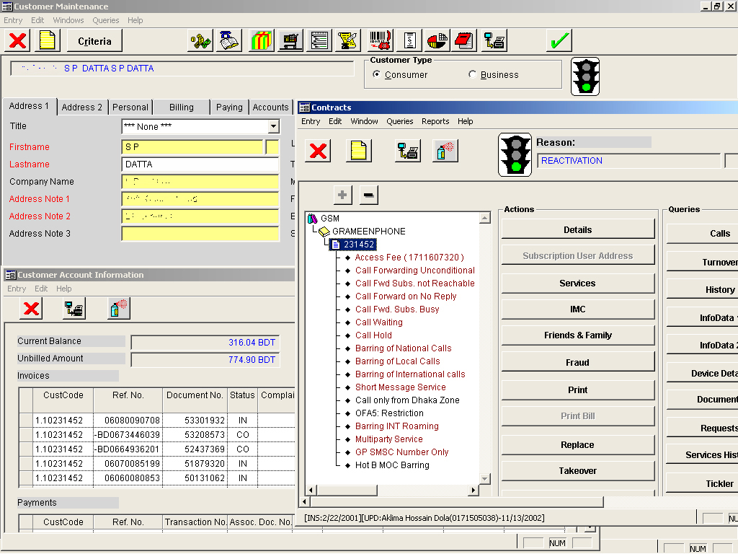
BSCS: The bill generating, connectivity and service controlling system for post-paid products. This system helps to visualize the generated bills of the subscribers as well as helps to provide connection and service barring and unbarring facilities.
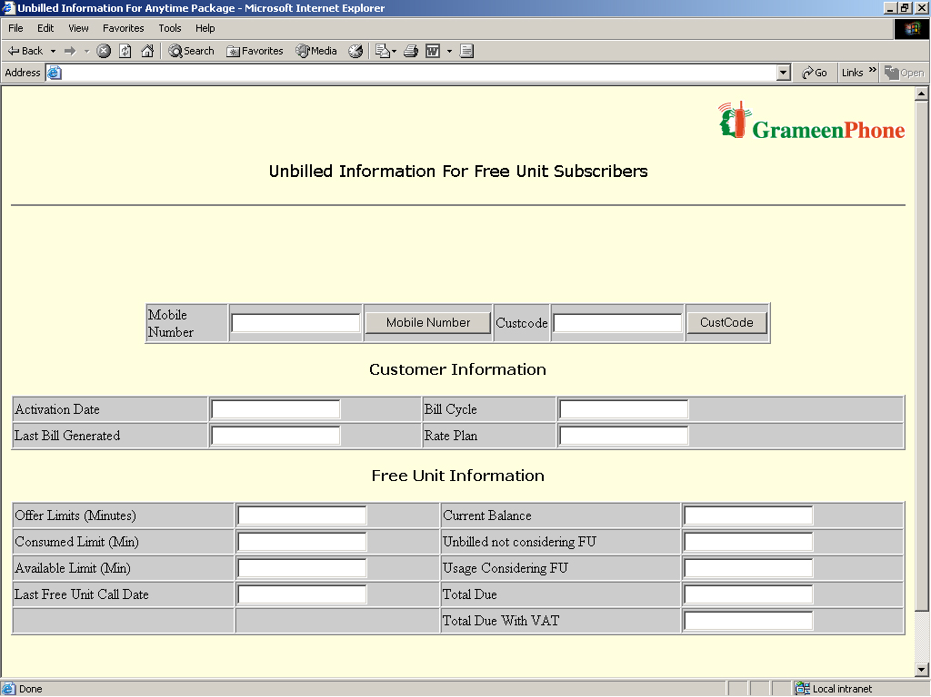
FUP Tool: The web based tool that helps to visualize the generated bills of the subscribers of a particular post-paid product-Xplore 2..

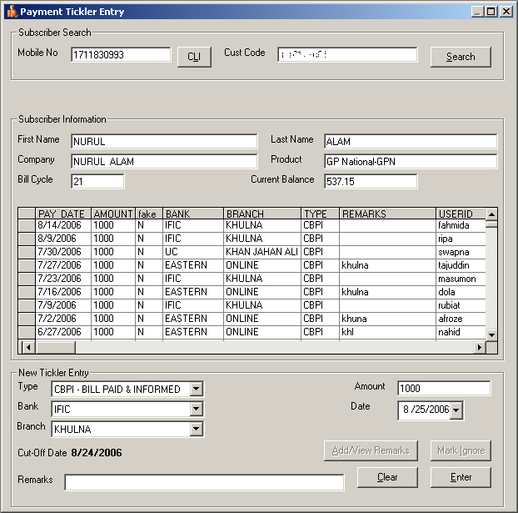
Bar List Generation: This system helps the employees to keep records and visualize subscribers’ bill payment information.
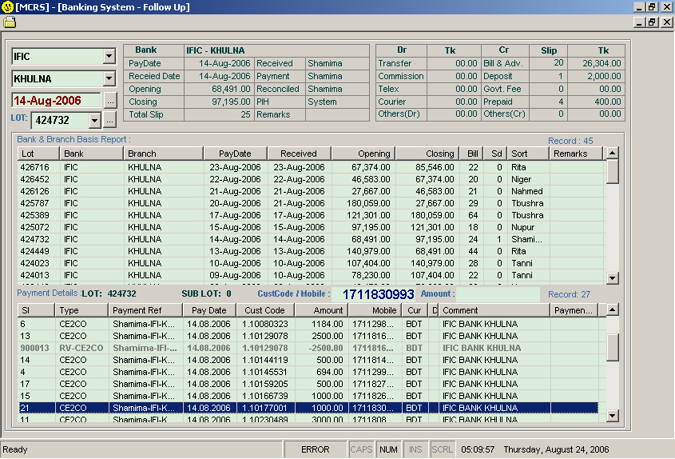
MCRS: This system helps the employees to keep records and visualize subscribers’ payment posting information from bank.

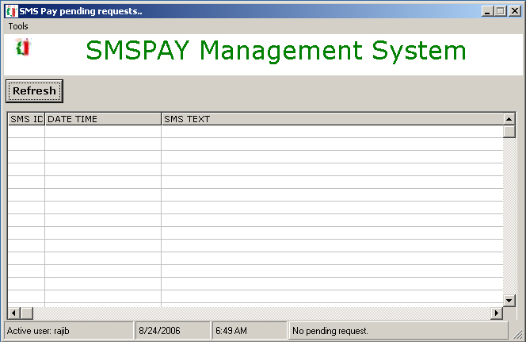
SMSPAY: Using this system, the bill payment information are collected that subscribers used to send through short message service or SMS from their handsets.

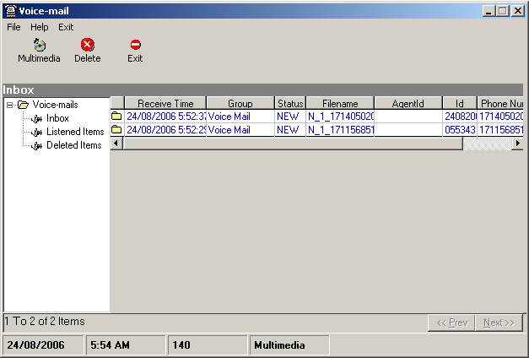
VMSPAY: Using this system, the bill payment information are collected that subscribers used to send through voice message service or VMS from their handsets.

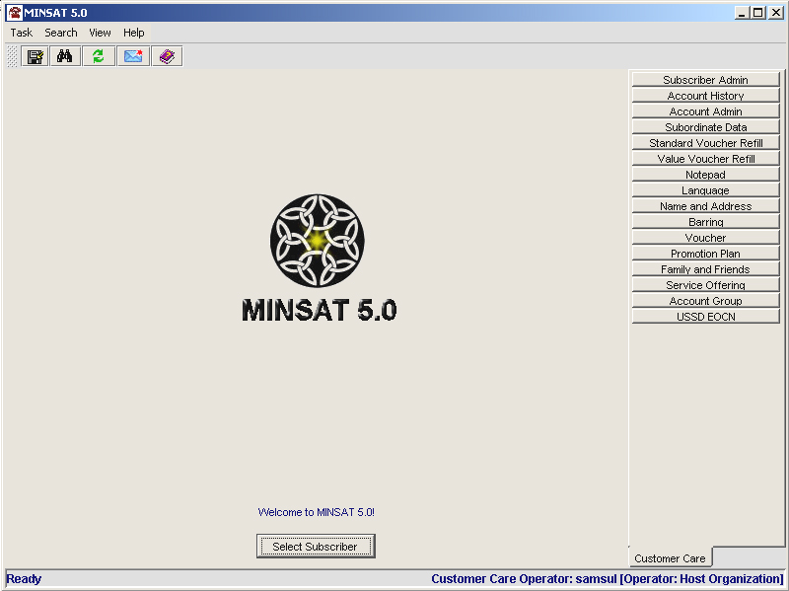
MINSAT: Like BSCS, MINSAT is the card recharging, connectivity and service controlling system for pre-paid products. This system helps to visualize the recharged, transferred and adjusted balance of the subscribers. It also provides connection and service barring and unbarring facilities.
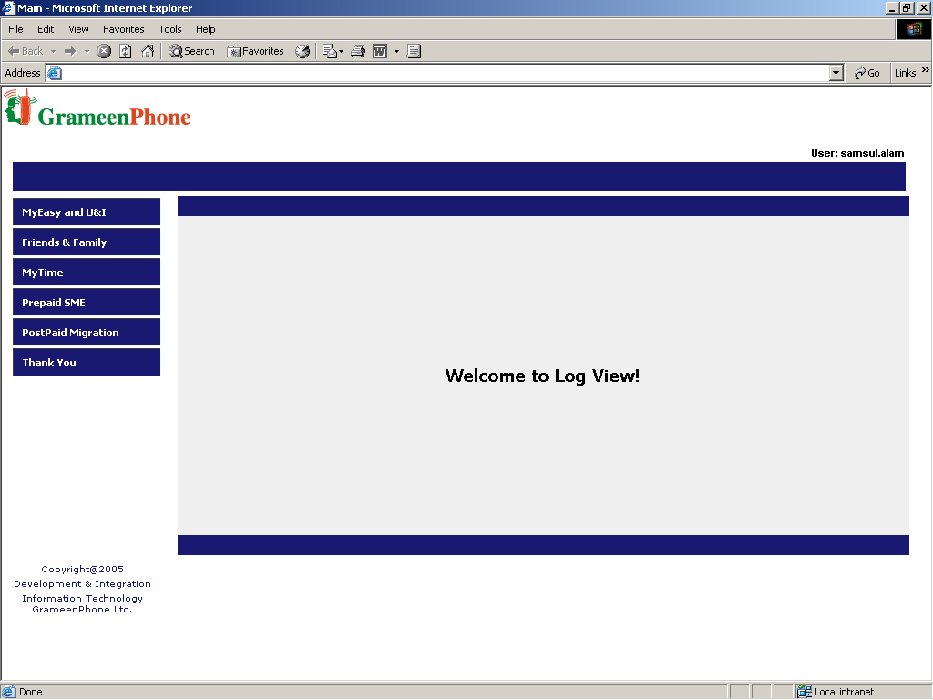
Log View: The Log View shows the service requesting SMS that subscribers send to enable different pre-paid services like My Time, My Easy, My Choice, etc into their connection.

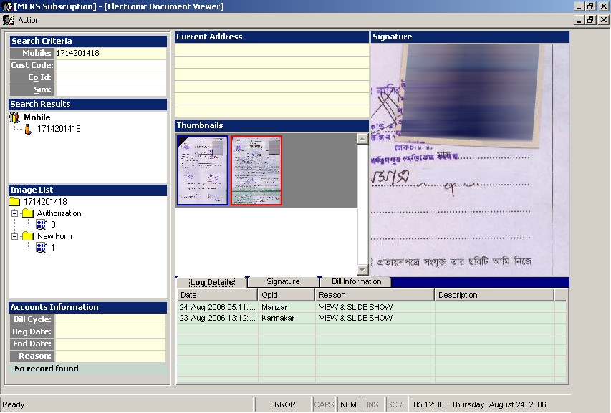
MCRSS: MCRSS is the other version of MCRS that helps to keep personal records of pre-paid subscribers and also to visualize them when necessary.

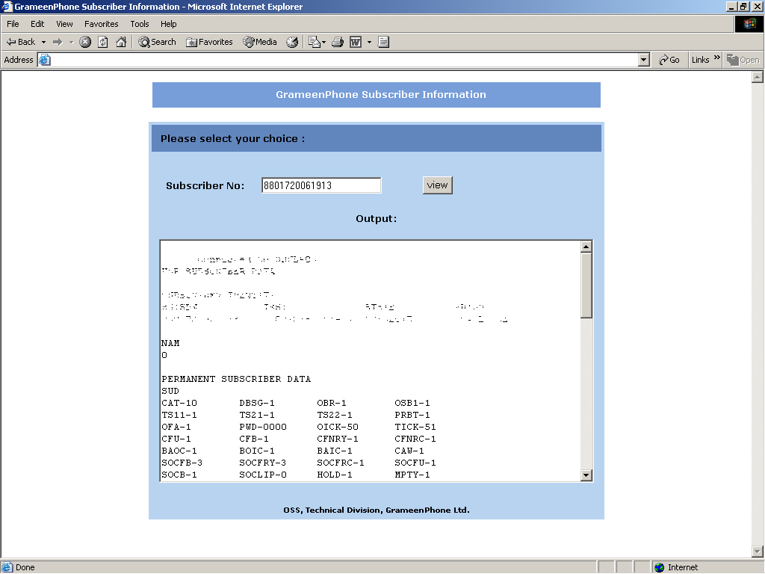
OSS View: OSS View shows every detail about the connection and service status of a particular subscriber’s SIM card.

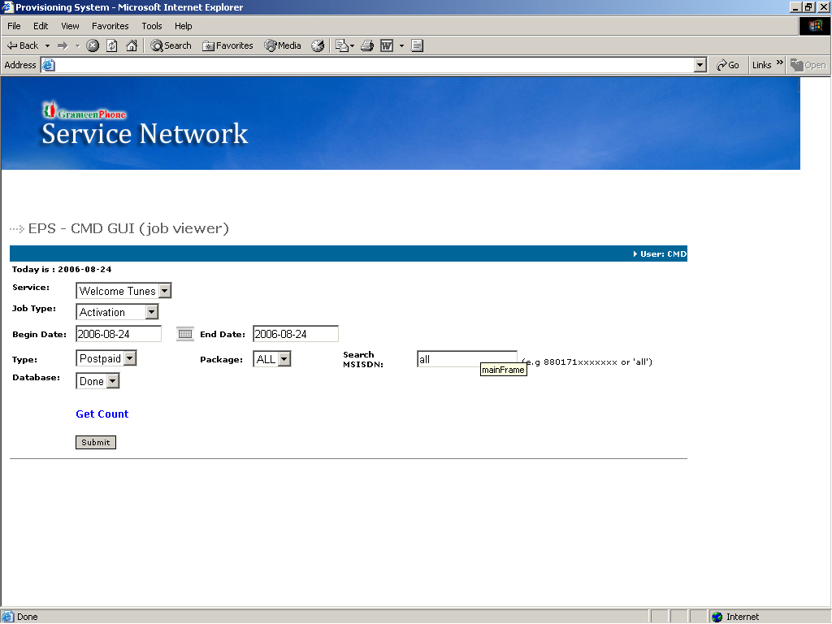
EDGE GUI: This tool helps to see the EDGE service activation / deactivation status of a particular subscriber which can also be seen from the OSS View and BSCS.

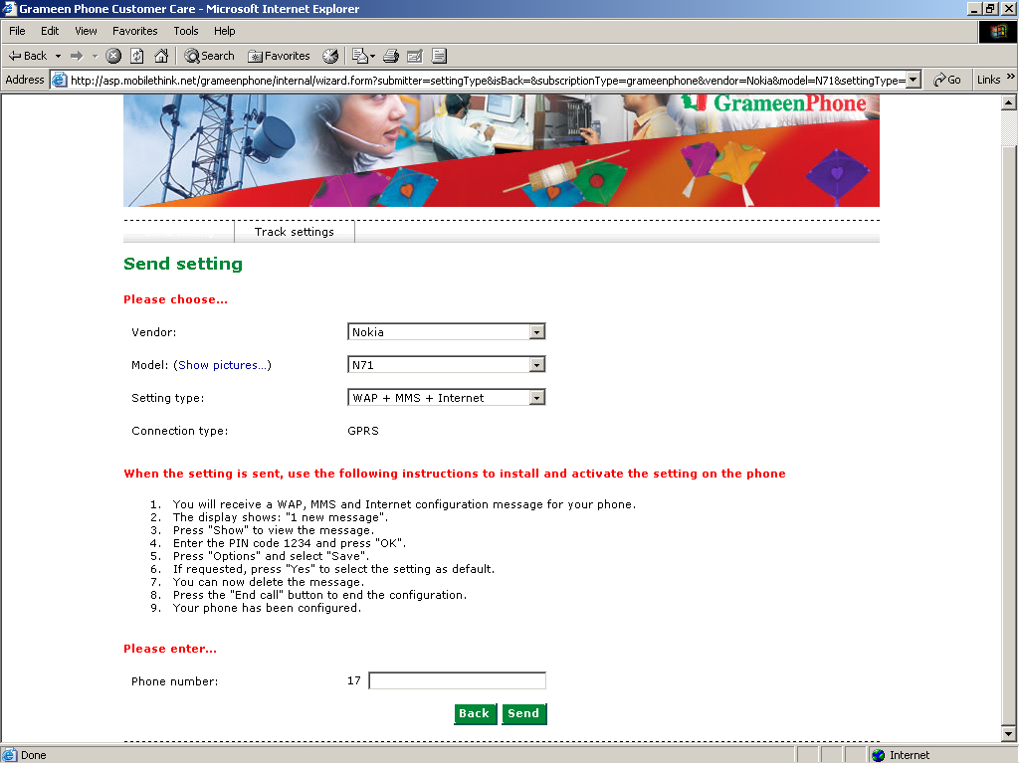
OTA GUI: This tool is used to send handset configurations to the subscribers so that they can configure their handsets automatically according to the EDGE service requirements.

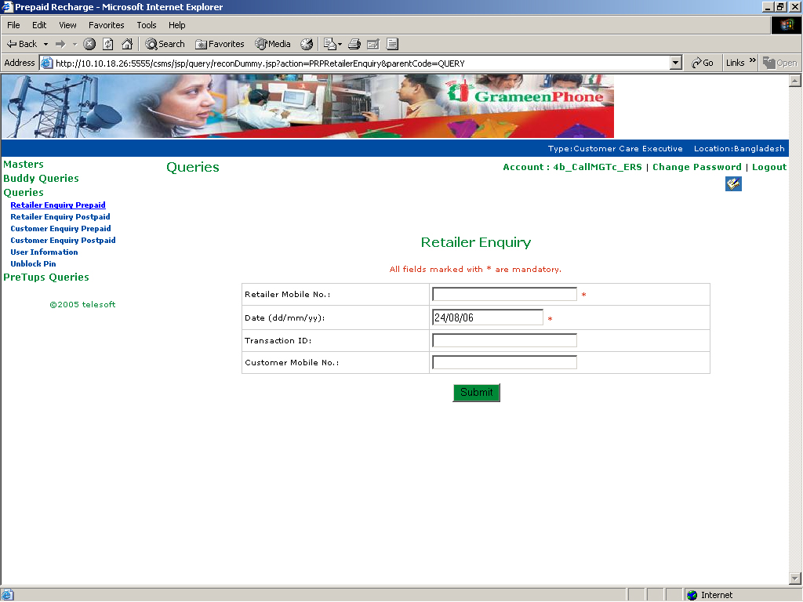
ERS GUI: This tool shows every details of balance transfer activities of GramennPhone’s subscribers. This also shows whether a subscriber’s balance transfer service is activated, blocked or canceled.

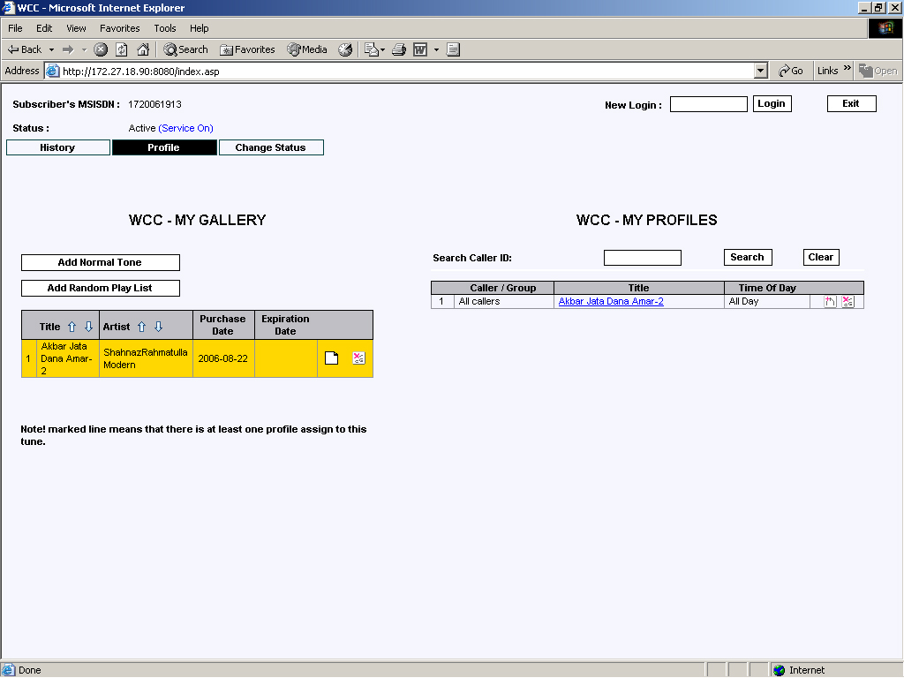
PRBT GUI: This tool is used to check the status of Welcome Tune service of a particular subscriber. It shows whether the service is on or off, activated or canceled.It also shows the song list of the subscribers and provides control to include or delete songs from the song list and to activate or deactivate the service manually.
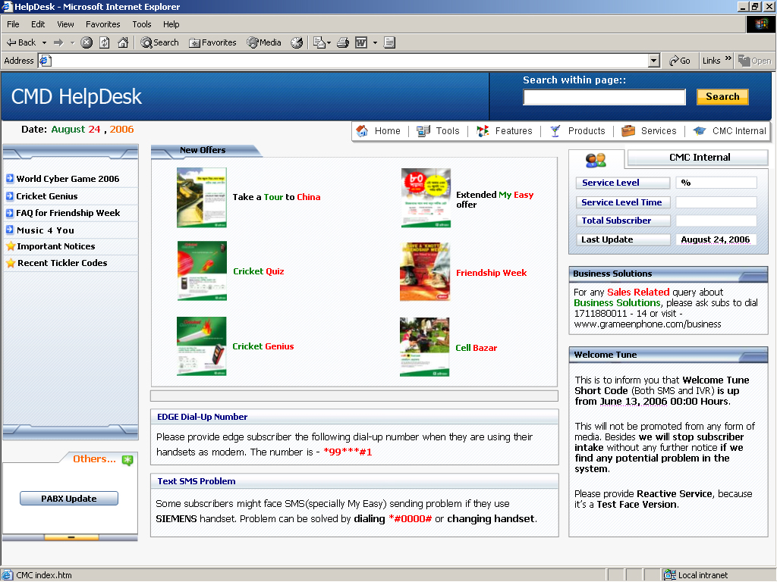
CMD HelpDesk: The information web portal that contains service related information and important links of different tools, folders and files. Employees of different units of CMD, especially the Call Management Center uses this web portal frequently to provide accurate and instant service to the subscribers over the hot line.
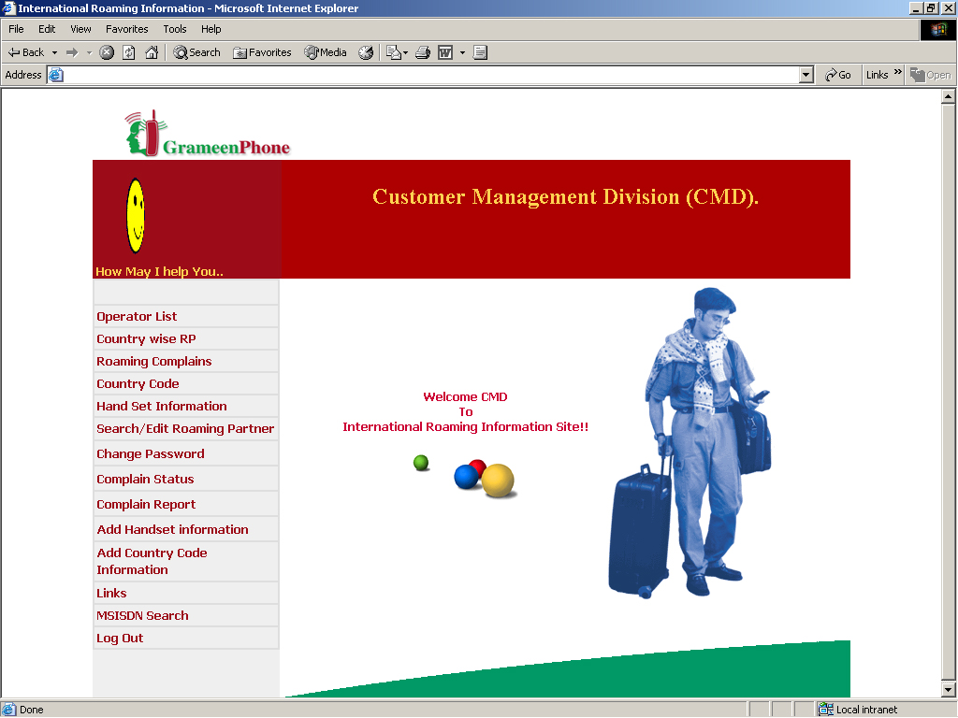
IR Database: Another information web portal that only contains information related to International Roaming service.

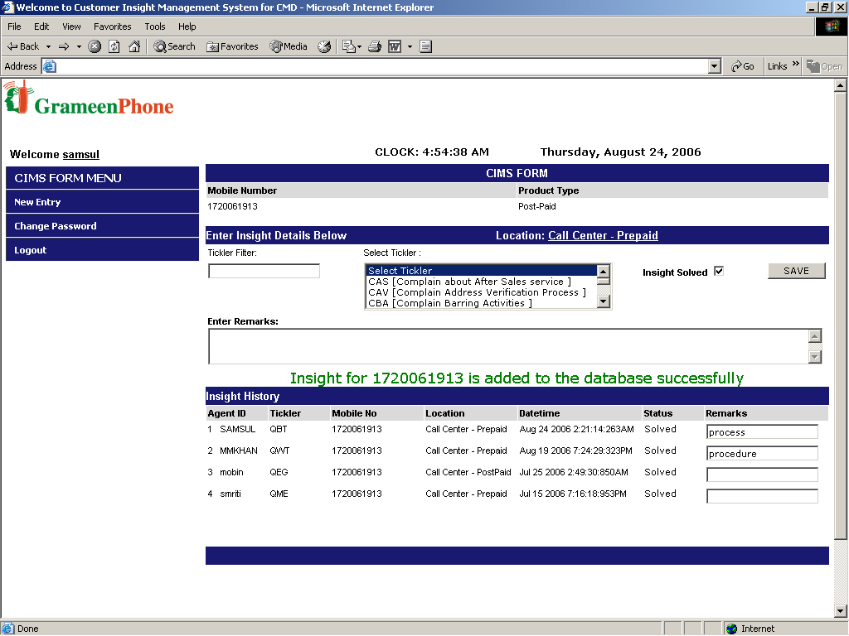
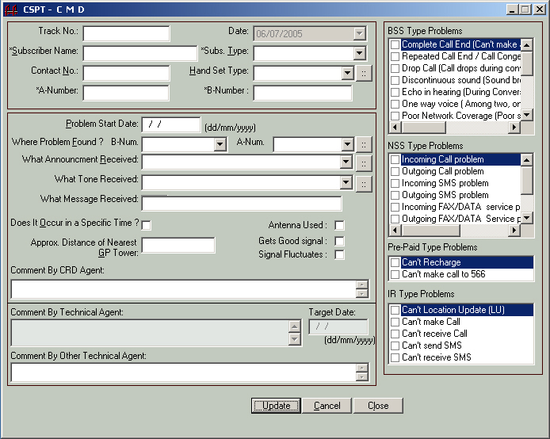
CIMS: Mainly this tool is used to capture subscribers’ complains, requests and queries regarding GrameenPhone’s products and services. Other part of this tool provides the control to keep and visualize information regarding SIM card change/replacement and activation.

CSPT: Through this system, records of high end technical problem that can not be solved from CMD are kept and send to the concerned departments or divisions to solve them.

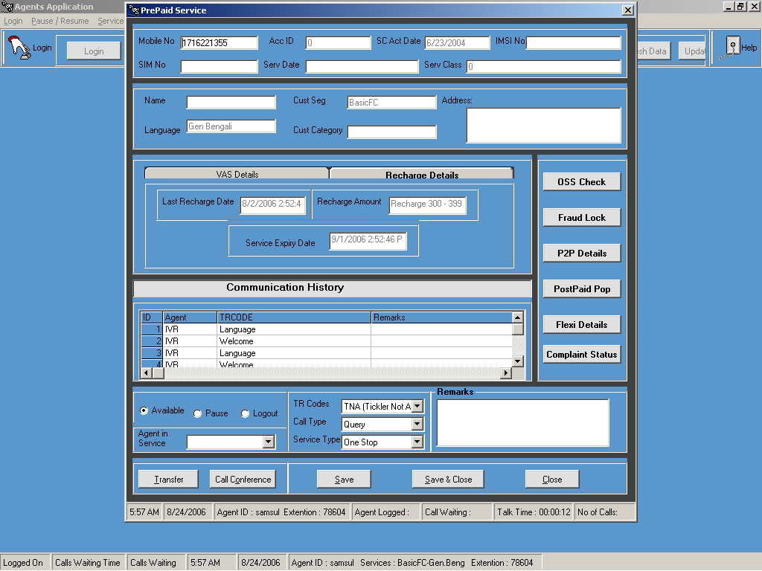
Agent Application: Agent Application is the automated system that is directly connected to the hot line of GrameenPhone. Basically it is used in the Call Management Center. Through this system, employees of the Call Management Center get connected to the hot line to provide customer service.

So, the working in the Customer Service can be pictured as given below –

Drawing 1: Imagined working environment in CS
BSCS
Bar Lsit Gen.
FUP Tool
MINSAT
MCRS
MCRSS
OTA GUI
EDGE GUI
Agent Applicati- on
OSS View
CMD HelpDesk
Log View

where each employee work within the invisible boundary of automated systems

SWOT ANALYSIS OF GRAMEENPHONE

STRENGTHS

Market leader in Bangladeshi mobile market for a long period;

Strong global reputation of the mother company-Telenor AS;

Collaboration with internationally acclaimed Nobel Piece Prize winner Dr. Younus and Grameen Bank;

Good Human Resource and Infrastructure Installation all over the country through Bangladesh Railway and Grameen Bank;

Highest tax paying company of the country;

Availability of Fiber Optic Backbone Network;

Largest Geographical Coverage;

The first and only company which crossed the 10 million subscribers mark; at present their total subscriber is near about 13 million which is more than the total of other 4 operators subscriber base;

GrameenPhone is the only company which operates in rural areas of the country through the Village Phone Program;

Access to the widest rural distribution network through Grameen Telecom;

Wide operating span; all geographic segments are currently availing the products of GrameenPhone because of wide-uninterrupted network coverage and best customer service;

Double digit growth rate are targeted every year and attained;

The only company of the country which provides customer service 365 days of the year through hotline (121) and GrameenPhone Center (GPC);

Innovation has been a primary factor accounting for GrameenPhone's success so far. GP has a wide range of products and services to fulfill the demand of different age, sex and class of people. Moreover, the company has a strong reputation for offering innovative products and services;
The only operator which has service desk in almost every Upazilas (or Sub Districts) of the country;

GrameenPhone’s market share is more than double of its nearest competitor;

Strong nationwide marketing and distribution channels; GP has an active presence throughout the country;

Strong Brand Image and Awareness;

Loyal and large dealer base;

Strong employee bonding and belongingness is one of the major assets of the company. GrameenPhone employees have strong positive reputation in the society. They have strong sense of commitment towards organization and also feel proud and a sense of belonging towards GrameenPhone;

Comprehensive Knowledge of the local market and customers;

Ready to meet the challenges posed by the changing scenario in the cell phone industry and globalization of economies through effective succession plan; which has proven to be successful over the years. It’s a learning company where structures, systems and processes consistently evolve and are adapted to meet the changing requirements of the market;

GrameenPhone's “Health Line Service” has recently awarded by the GSM Association for using mobile phone as an important tool of social development. GP is the only operator in the country which provides health line services through mobile phone.

The human resource of GrameenPhone is extremely well planned and perfectly managed. GP believes in empowering employees and the top management refuses to put their finger in every part of the pie. This empowered environment makes GP one of the best working places for the employees. Moreover, as GP is a multinational company, employees don’t want to leave their jobs because of the reputation outside and thus, the employee turnover rate is very low. The employees are not suffocated with authority but are able to grow as the company matures;

Excellent relationship with media, government and regulatory bodies (BTRC).

WEAKNESSES

Poor interconnection with BTTB is one of the great weaknesses of GP. 80% subscribers of GP are Smile M2M and Djuice user. But GrameenPhone is still unable to provide BTTB connectivity in these two popular products while other existing operators are providing BTTB accessibility to the majority of their subscribers;

Complicated price structure of the products is another weakness for the company;

Recent conflict with Dr. Younus regarding the share of GrameenPhone created negative impression about the company among Bangladeshi people.

Lack of consistency and short duration of the promotional offers creates dissatisfaction among the customers;

GrameenPhone’s call rate and price of the products are relatively higher than the competitors. Since Bangladeshi people are more price sensitive therefore GP’s high tariff plan influencing huge number of existing customer to switch in other operator;

Although GrameenPhone serving all the geographic segments, but they are mostly concentrating on the market of major cities of the country.

OPPORTUNITIES

Huge growth of the telecommunication industry will help GP to capture more market share in upcoming years;

Activities in most of the rural areas are very little; to increase substantial market share GP can focus on this segment and reduce threat of new entrance in the industry.

GP has the opportunity to diversify in the corporate segment. They can focus on to capture the market share of the corporate segment by using their competitive advantages and good reputation;

Declining price of the handset will increase the number of cell phone user in upcoming years. GrameenPhone can offer various handsets based promotional offer to utilize the opportunity;

The giant handset manufacturer Nokia is planning to establish their production plant in Bangladesh. GrameenPhone can offer their various offer in collaboration with Nokia;

Introduction of cell phone dependent projects like “Community Information Center (CIC)” and “Bills Pay” opened up massive opportunities for the company to earn huge revenues in the near future. Moreover the CIC project has already been considered as an important contribution to the rural and social development of the country.

THREATS

The entrance of world’s third largest telecommunication company “Warid Telecom” in the Bangladeshi market is a big threat for GrameenPhone. Warid Telecom has entered into the market with a huge amount of investment in order to capture the market share of GP and become the leading cell phone company of the country;

Strict policy and monitoring of the government regulatory bodies are threatening the companies to operate efficiently;
Recent price war and aggressive marketing of the competitors;

Warid Telecom’s presence will generate more intense competition among the operators which ultimately may lead the company’s to merge in future;

Government’s continuous pressure to introduce share in the stock market;

Until last few weeks, getting a mobile phone connection was not a problem for anyone as the mobile phone companies did not ask for much information from their customers. Now the government has ordered all the mobile companies to enlist their existing subscribers with detailed information so that the government can keep track if terrorists mobile phone for their destructive purposes. The government has also ordered the companies to follow this system for the new subscribers too. Since GrameenPhone’s subscriber base is higher than the total of all other operators’ subscriber therefore it has become a tough job for GP to enlist all the existing subscribers.

FINDINGS AND RECOMMENDATIONS

Findings:

Working in Grameenphone Customer Service I have found that there are lots of work load on each and every customer manager as customers increasing a lot, comparing with that customer managers are not increasing. Another finding is at present more than 20 automated tools are running in customer service to support different activities and some of them are used in same functionalities.

Recommendations:

- Need to increase employee in customer service.
- It is necessary to find a single tool for a single function rather than using two or more automated tools for the same function.
- All the 20 automated tools may be combined as a single tool and only one window may be used for customer service.

CONCLUSION

Competition is increasing in cellular market day by day as there are mainly six companies are operating this business in Bangladesh. All of them are trying to increase their market share giving lots of facilities. In future as a market leader GrameenPhone Ltd. should focus more on customer service area to keep customers loyal. After a certain period the sale may decrease but importance on customer service will increase day by day.

