Evaluate The Customer Service

of

The Southeast Bank Limited

Submitted by

WWW.ASSIGNMENTPOINT.COM

1.0 CHAPTER ONE: INTRODUCTION

1.1 INTRODUCTION

Generally by the word “Bank” we can easily understand that the financial institution deals with money. But there are different types of bank like; Central Banks, Commercial Banks, Savings Banks, Investment Banks, Industrial Banks, Co-operative Banks, etc. But when use the name term “Bank” without any prefix, or qualification it refers to the Commercial banks. Commercial Banks are the primary contributor to the economy of a country. So we can say Commercial Banks are a profit making institution that holds the deposit of the individuals & business in checking & saving account and than uses these funds to make loans. For these, people and government are very much dependent on these banks as the financial intermediary. As banks are profit earning concern; they collect deposit at the lowest possible cost and provide loans and advanced a higher cost. The differences between two are the profit for the bank.

Banking sector is expanding its hand in different events every day. At the same time the banking process is becoming faster, easier, and the banking area becoming wider. As the demand for better service increases day by day, they are coming with different innovative ideas and products. In order to survive in the competitive field of the banking sector, all banking organization are looking for better service opportunity to provide their fellow clients. As a result, it has become essential for every person to have some idea on the bank and banking procedure.
Southeast Bank Limited is a scheduled commercial bank in the private sector established under the ambit of Bank Company Act, 1991 and incorporated as a Public Limited Company under Companies Act, 1994 on March 12, 1995. The Bank started commercial banking operations on May 25, 1995. During this short span of time the Bank is successful in positioning itself as a progressive and dynamic financial institution in the country. The bank had been widely acclaimed by the business community, from small entrepreneurs to large traders and industrial conglomerates, including the top-rated corporate borrowers for its forward - looking business outlook and innovative financial solutions. Thus within this very short period of time it has been able to create animage and earn significant reputation in the country's banking sector as a Bank with Vision. Presently, it has 43 branches.
Southeast Bank Limited has been licensed by the Government of Bangladesh as a Scheduled commercial bank in the private sector in pursuance of the policy of liberalisation of banking and financial services and facilities in Bangladesh. In view of the above, the Bank within a period of 10 years of its operation achieved a remarkable success and met up capital adequacy requirement of Bangladesh Bank.
It has been growing fast as one of the leaders of the new generation banks in the private sector in respect of business and profitability as it is evident from the financial statements for the last 10 years.

These transactions are held through the maintenance of ‘Nostro Account’ with group banks and other foreign banks. These transactions are usually processed through the issuance of TT (Telegraphic Transfer), DD (Demand Draft), and CO (Cashier’s Order). SBL Bangladesh is making significant remittance business with inward remittance service. In the recent financial year 2004-05, remittance collected by SBL was worth of US Dollars 96,930,340.02, which was about 2.51% of the total remittance inflow in Bangladesh.

1.2 Background of the Study

The internship program which is necessary to complete the BBA program exercise a significant importance as it enables a student to familiar with the practical business activities. The student work closing with the people of an organization and learn about the function of that organization. This program enables a student to develop his analytical skills and scholastics attitude.

1.3 Sources of Data Collection

The Primary sources are as follows:

Face-to-face conversation with the respective offices and stuffs of the branch and head office.

Face-to-face conversation with clients visited the branch.

Practical with experience in the different desk of the department of the branch covered.

Relevant field study as provided by the officer concern.

The “secondary Sources” of data and the information are:

Annual Report of Southeast Bank Ltd (2008).

Website of the Southeast Bank Ltd (www.sebankbd.com).

Various book articles regarding general banking functions, Foreign exchange operations and credit policies.

Different procedure manual published by Southeast Bank Ltd

Different circular sent by head office of Southeast Bank Ltd. and Bangladesh Bank.

1.4 Rationale of the Study

With the growing competition among nationalized, foreign and private commercial banks as to how the banks operates it banking operation and how customer service can be made attractive. Commercial or private banks are trying to evaluate their traditional banking service to a better standard, to meet the challenging needs. So they pay attention on better performance and existence. Under the above circumstances, it has become necessary for Southeast Bank Limited, one of the private commercial banks, to focus its attention towards the improvement, who are actually executing the policies undertaken by the top management will have a chance to communicate their feelings and will have the feedback about their dealings from the customer.

1.5 Objective of the Report

1.5.1 The primary objective:

The primary objective of preparing this report is to represent the Southeast Bank Limited and to have a clear conception about all of the essential parts of the internship program.

1.5.2 Secondary objective:

To evaluate the customer service of the Southeast Bank Limited

Identify the statistical performance of Southeast Bank Ltd.

Discussion on function and operation of each level of the organization of the Southeast Bank Ltd.

Overview of the Southeast Bank Ltd.

To identify the problem facing by the Southeast Bank Ltd.

To relate theoretical knowledge with practical experience in several functions of the Southeast Bank Ltd.

The present study will help SBL to better understand their level of performance in generating inflow of remittances.

This proposed study will also help SBL to compare their current remittance status with the aggregate remittance inflow in Bangladesh. Comparing with the proportion the bank can take necessary actions to perform the remittance business more efficiently and effectively.

From the perspective point of view, the importance and role of remittances as a major proportion of GDP, export, import and utilization of remittances as savings, investment and consumption can be better understood from this proposed study.

This study will encourage further study in the area of identifying effect of foreign remittance inflow on Bangladesh economy and will provide useful guidelines for similar types of researches.

1.6 Scope of the Study/Report

As I was sent to the Southeast Bank, Motijheel Branch, the scope of the study is only limited to this Branch. The report covers the topic on “Effect of Foreign Remittance Inflow severed by Southeast Bank Ltd on Bangladesh Economy”.

To conduct a study on what is Banking concept I have gathered valuable information from AUB library & Southeast Bank Limited. I have also got some information from web site.

1.7 Origin of the Report

To complete a BBA degree it is necessary to perform an internship program under any reputed organization. This program actually makes a relationship between theoretical and practical knowledge. As a part of the requirement of the BBA Program of the Faculty of Business Administration of Asian University of Bangladesh (AUB) the project was assigned on May 01, 2009. The topic is on “Inward foreign Remittence Management Stady Southeast Bank Limited”.

1.8 Limitations

I had to face different problems while preparing this internship report. At the same time I tried to make an adjustment with those problems.

Those problems are as follows;

It was very difficult to collect the information from various personnel for the job constrain.

Bank policy was not disclosing some data and information for various reasons.

The department people always remain busy due to lack of supporting employees so they could not dedicate their full efforts

Because of the limitation of information some assumption was made. So there may be some personal mistake in this report.

The time 3 months are not sufficient to know all activities of the branch to prepare the report.

I had no opportunity to verify the satisfaction level of clients and receive their suggestions in banking activities.

Unavailability of statistical data on inward and outward remittance through informal channels can be considered as a major limitation.

The study has drawn from the perspective of Bangladesh. The global issues are not considered in this study.

Comparatively few researches have been conducted in Bangladesh in the field of foreign remittance. Therefore, some previous studies that were carried out in a different environment are reviewed in the study. As a result, the findings from those studies may not fit all the time with Bangladesh scenario.

Remittance is associated with other international, political, foreign policy and other related factors which are not considered because of the simplicity of the proposed study.

1.9 Methodology

This report has been prepared on the basis of experience gathered during the period of internship. For preparing this report, I have also get information from annual report and website of the Southeast Bank Ltd. I have presented my experience and finding by using different charts and tables, which are presented in the analysis part.

The details of the work plan are furnished below:

Data collection method

Relevant data for this report has been collected primarily by direct investigation of different records, papers, Documents, operational process and different personnel. . No structured questionnaire has been used. Information regarding office activities of the bank has been collected through consulting and discussion with bank personnel.

Data sources

Both primary and secondary source of data are used to complete this study. These two sources are explained below:

Primary sources:

Face to face conversation with the bank officers and staffs

Conversation with the clients

Different manuals of Southeast Bank Ltd.

Different circulars of Southeast Bank Ltd.

Secondary sources:

Producer manual published by the Southeast Bank Ltd.

Files and documents of the Branch.

Annual report of Southeast Bank Ltd 2008.

Different paper of Southeast Bank Ltd.

Unpublished data.

Different text books.

CHAPTER TWO: OVERVIEW OF BANKING SYSTEM
AT A GLANCE OF SEBL

2.1 AT A GLANCE OF SBL AS ON 30TH JUNE, 1999

Business Reporter

Southeast Bank Limited performed well in the first half despite the difficult economic environment with an increase in operating Profit by 102% to Tk. 138.78 Million compared to the same period last year. The Bank also made its mark in efficiently managing its loan portfolio by keeping the Classified Loans and Advances at 1.98% being one of the lowest in the Banking Sector of the country, says a press release The Board of Southeast Bank Limited (SEBL) takes the privilege to welcome you all to the Fifth Annual General Meeting and has the pleasure to present the Fifth Annual Report of the Bank along with the Annual Account and Auditors Report for the year 1999.

SEBL Performance
Southeast Bank Limited at a Glance | * (Taka in million)
Particulars | 2007 | 2006 | 2005 | 2004 | 2003 | 2002 | 2001 | 2000 | 1999 | 1998
Authorised Capital | 3,500.00 | 3,500.00 | 2,500.00 | 2,500.00 | 2,500.00 | 2,500.00 | 500.00 | 500.00 | 500.00 | 500.00
Paid-up Capital | 2,281.76 | 2,112.74 | 1,056.37 | 880.31 | 677.16 | 399.30 | 363.00 | 330.00 | 300.00 | 150.00
Reserve Fund | 4,186.60 | 2,828.18 | 1,180.47 | 769.13 | 622.99 | 571.66 | 394.20 | 235.28 | 145.70 | 85.13
Equity Fund (Capital and Reserve) | 6,468.36 | 4,940.92 | 2,236.84 | 1,649.44 | 1,300.14 | 970.96 | 757.20 | 565.28 | 445.70 | 235.13
Deposit | 55,474.05 | 46,056.18 | 38,258.15 | 27,930.84 | 20,118.82 | 16,598.45 | 12,630.25 | 10,309.70 | 7,512.49 | 5,483.39
Advance | 48,164.60 | 41,147.28 | 32,551.09 | 22,001.70 | 15,548.11 | 13,027.13 | 9,178.03 | 7,061.87 | 5,051.88 | 3,402.21
Investment | 8,462.86 | 6,265.55 | 5,113.14 | 3190.15 | 2,581.61 | 2,282.08 | 1,727.44 | 1,369.92 | 971.81 | 509.73
Import Business | 38,470.34 | 35,125.12 | 29,079.30 | 20,229.62 | 16,270.80 | 12,817.01 | 12,187.37 | 11,239.14 | 8,228.50 | 6,852.19
Export Business | 28,771.36 | 25,874.61 | 13,511.10 | 6,761.93 | 3,033.79 | 2,263.45 | 2,675.05 | 1,319.51 | 704.47 | 353.43
Guarantee Business | 9,008.32 | 8,656.80 | 7,975.00 | 4,717.82 | 3,391.19 | 2,502.48 | 1,854.50 | 1,306.24 | 907.18 | 744.92
Total Income | 8,670.47 | 6,766.11 | 4,689.55 | 3,043.49 | 2,772.52 | 1,936.54 | 1,748.18 | 1,259.03 | 862.86 | 727.53
Total Expenditure | 5,754.27 | 4,703.45 | 3,216.11 | 2,234.83 | 2,107.36 | 1,443.98 | 1,256.05 | 921.70 | 661.02 | 556.87
Operating Profit | 2,916.20 | 2,062.66 | 1,473.44 | 808.66 | 665.16 | 492.56 | 492.13 | 337.33 | 201.84 | 170.66
Net Profit afterTax and Provision | 1,222.97 | 909.88 | 374.20 | 294.69 | 256.06 | 253.56 | 270.74 | 172.84 | 85.48 | 98.01
Fixed Assets | 1,708.11 | 1,300.39 | 790.62 | 313.73 | 288.02 | 48.81 | 36.26 | 71.13 | 78.37 | 85.92
Total Assets | 64,370.69 | 54,824.83 | 43,294.81 | 33,744.96 | 23,142.35 | 18,882.48 | 14,468.66 | 11,710.56 | 8,336.17 | 5,962.71
* * * * * * * * * * * * * * * * * * * * * * * * * * * * * * * * *
Earning per Share (Taka) | 53.60 | 67.16 | 42.51 | 43.52 | 45.38 | 69.85 | 82.04% | 57.61% | 56.99% | 45.38%
Dividend Cash (%) | 15%- | 20%- | - | - | 20% | 20% | 30% | 25% | 15% | -
Bonus Shares | 25% (4:1) | 8% (12.5:1) | 20% (5:1) | 30% (10:3) | 20% (5:1) | 10%(10:1) | 10% (10:1) | 10% (10:1) | - | 20% (5:1)
Return on Equity (ROE) | 19.90% | 19.62% | 17.64% | 17.87% | 19.69% | 26.11% | 35.76% | 30.58% | 19.18% | 41.68%
Return on Assets (ROA) | 1.90% | 1.66% | 0.86% | 1.00% | 1.11% | 1.34% | 1.87% | 1.48% | 1.03% | 1.64%
Non performing Loans as % of Total Loans | 3.77% | 3.97% | 4.37% | 4.96% | 2.09% | 1.99% | 2.78% | 2.95% | 3.75% | 4.25%
Capital Adequacy Ratio | 13.02% | 11.05% | 6.90% | 7.83% | 9.20% | 8.23% | 8.77% | 8.40% | 9.52% | 8.16%
* * * * * * * * * * * * * * * * * * * * * * * * * * *
Number of Correspondent Banks | 140 | 138 | 130 | 122 | 80 | 45 | 40 | 39 | 34 | 32
Number of Foreign Correspondents | 598 | 536 | 507 | 463 | 350 | 295 | 280 | 269 | 253 | 238
Number of Shareholders | 9,636 | 8,855 | 5750 | 4704 | 2912 | 1,666 | 1,429 | 1,266 | 1,129 | 27
Number of Employees | 1116 | 998 | 913 | 835 | 701 | 595 | 575 | 528 | 480 | 447
Number of Branches | 38 | 31 | 31 | 27 | 23 | 19 | 13 | 12 | 12 | 12

- Bangladesh Economy-an Overview

Bangladesh is pursuing a prudent monetary and fiscal policy in order to achieve higher economic growth as well as maintaining macro-economic stability. The country has been largely successful in implementing the rehabilitation programs to make up the colossal damage caused by the devastating flood of 1998 and achieved 5.2 percent GDP growth in FY 1999 as against 5.7 percent in the previous year. The inflation rate has come down significantly to 7.2% at the end of November 1999 mainly due to bumper crop production. The monetary and credit policy for FY 2000 has been formulated with the objective of keeping foreign exchange reserves at a satisfactory level and rate of inflation at a tolerable limit. Adoption of measures like massive agricultural credit disbursement and increased input supply have contributed a lot to bumper crop production in FY 1999. Similar measures have also been undertaken to maintain higher growth in agriculture in current FY 2000.

Performance of the Industrial Sector, however, was not satisfactory during the year. After growing by 9.5% in 1997-98, industrial production fell to 2.5% in 1998-99. The total value of GDP, however, increased to US$ 36503 million compared to US$ 34059 million in the previous year increasing per Capita GDP to US$ 282 compared to US$ 268 in last year.

ii) Money and Banking

Monetary and credit policies in Bangladesh were pursued with a view to accelerate the pace of economic activities during FY 1999. Total domestic Credit during the year rose by 13.1% compared to 12.6% in 1998-99, net credit to private sector increased by 13.8% compared to 13% increase in 1997-98. Money supply growth was 8.6% in 1998-99 compared to 4.8% in 1997-98. During the year, Bank deposits increased by 14.2% to Tk. 592340 million which was 11.3% in the preceding year.

Total export earnings during the year 1998-99 was US$ 5324 million compared to US$ 5172 million in 1997-98 showing a growth of 2.9% Total import payment for 1998-99 was US$ 8018 million which was 6.6% higher than that of the previous year. The current account deficit increased to US$ 394 million from US$ 253 million in the preceding year due to increase in import payment during the year.

Bangladesh Bank reduced Bank Rate (the rate at which it lends to Commercial Banks) to 7% from 8% with effect from August 29, 1999. The minimum Cash Reserve Requirement (CRR) of the scheduled banks to be maintained with Bangladesh Bank has been reduced from 5% to 4% However, Statutory Liquidity Requirement (SLR) remained unchanged at 20%.

Bangladesh Bank also placed severe restriction with regard to credit allocation to the Directors of Private Banks (Incidentally since inception, the Directors of Prime Bank do not borrow from their own Bank as a policy decision decision of the Board).

iii) Southeast Bank Limited

Southeast Bank Limited (SEBL) witnessed a considerable improvement in its overall business performance during the year 1999. The Bank achieved satisfactory progress in all areas of its operation and earned an operating Profit of Tk. 360.51 million showing a growth of 63% over the previous year. The Bank, as a prudent measure, marked down the value of investment in shares and securities to market price as on 31-12-99 by complying with International Accounting Standard (IAS-30)

After making full provision, the net pre tax-Profit of the Bank for the year stood at Tk. 316.77 million compared to Tk. 17.39 million in 1998. The return on Assets (ROA) was 5.30% well above the industry average.

iv) Capital Funds

The Authorized and Paid up Capital of the Bank are Tk. 1000.00 million and Tk. 400.00 million respectively. The Bank raised its paid up capital from Tk. 200.00 million to Tk. 400.00 million during the year through Public Issue of 2,000,000 ordinary shares at par value of Tk. 100.00. With the increase of Paid-up Capital to Tk. 400.00 million, the capital base of Southeast Bank Limited (SEBL) has become one of the strongest. The total Capital Funds of the Bank at the year end stood at Tk. 719.23 million against Tk. 293.70 million in the previous year. The Capital Adequacy Ratio is 15.14% as on 31-12-99, which is well above the stipulated 8% required for Banks in Bangladesh. The ratio of Tierl capital is 14.06%.

v) Deposits
Deposits of the Bank grew by 44% to Tk. 7660.02 million as at 31st December 1999 as against national average of 14.20%. The Bank introduced several deposit schemes to encourage and mobilize savings. Major savings schemes include the following :-
• Contributory Savings Scheme
• Monthly Benefit Deposit Scheme
• Special Deposit Scheme
• Education Savings Scheme
• 30 Day's Term FDR

Our various purpose-oriented deposit schemes have been appreciated by the Public and have gained good popularity. As on 31-12-99, deposits under above schemes stood at Tk. 1005.57 million as against Tk. 812.37 million in the last year showing an increase of 24% over the preceding year.

vi) Loans and Advances

Loans and Advances of the Bank stood at Tk. 5027.37 million as on 31-12-99 against Tk. 3127.77 million last year. During the year under review, the Bank extended loans and advances of Tk. 1899.60 million to the private sector for domestic and international trade as well as for project finance and working capital. Due to liberal Credit to Export Sector, the Bank was able to handle larger volume of Foreign Exchange Business. The Bank also extended a number of project finance and industrial loans in syndication with other Banks.

vii) Leading in Consumer Banking

Southeast Bank Limited(SEBL) is a leading Bank for consumers and small business with a commanding presence in Consumer Credit, Hire Purchase and Lease Finance. The Consumer Credit Scheme of the Bank, which aims to help the fixed income group in raising standard of living, has been widely appreciated. Total 10618 customers have enjoyed Credit facility to the extent of Tk. 480.41 million under the Scheme. The rate of recovery of loan under the scheme is 96%. The Bank also recently introduced Credit Card both domestic and international as principal member of Master Card International.

viii) Quality of Risk Assets

In order to maintain high quality of risk assets, utmost efforts are made by the Board of Directors and by the Management on an ongoing basis. A Credit Committee at Bank's Head Office sits every day to monitor the quality of loans. As on 31-12-99, the Bank's ratio of classified loans to total loans is only 1.63% as against 1.77% in the last year which is one of the lowest in Bangladesh. The Bank has made full provision against classified loans in addition to making provision of 1% against unclassified loans.

Southeast Bank Limited(SEBL) follows International Accounting Standard (IAS-30) in assessing the value of its investment in shares at the year end.

3.0 CHAPTER THREE
BACKGROUND

3.1 Overview of Company Background

Southeast Bank Limited is a scheduled commercial bank in the private sector established under the ambit of Bank Company Act, 1991 and incorporated as a Public Limited Company under Companies Act, 1994 on March 12, 1995. The Bank started commercial banking operations on May 25, 1995. During this short span of time the Bank is successful in positioning itself as a progressive and dynamic financial institution in the country. The bank had been widely acclaimed by the business community, from small entrepreneurs to large traders and industrial conglomerates, including the top-rated corporate borrowers for its forward - looking business outlook and innovative financial solutions. Thus within this very short period of time it has been able to create animage and earn significant reputation in the country's banking sector as a Bank with Vision. Presently, it has 41 branches. .

Southeast Bank Limited has been licensed by the Government of Bangladesh as a Scheduled commercial bank in the private sector in pursuance of the policy of liberalisation of banking and financial services and facilities in Bangladesh. In view of the above, the Bank within a period of 10 years of its operation achieved a remarkable success and met up capital adequacy requirement of Bangladesh Bank.

It has been growing fast as one of the leaders of the new generation banks in the private sector in respect of business and profitability as it is evident from the financial statements for the last 10 years.

Southeast Bank Limited emerged as a new commercial bank to provide efficient banking services and to contribute socio-economic development of the country. . Southeast Bank Limited(SEBL) was established on 17th April, 1995 with an Authorized Capital of Tk. 1000 Million and Paid up Capital of Tk. 100 Million (raised to Tk. 200 Million in 1997) by a group of highly successful entrepreneurs from various fields of economic activities such as shipping, oil, finance, garments, textiles and insurance etc. It is a full licensed scheduled Commercial Bank set up in the private sector in pursuance of the policy of the Government to liberalize Banking & Financial services.

The Chairman of the Bank, Mr. Md. Nader Khan is a renowned business elite of Chittagong. He is also the Chairman of Drum Kulshi Girls High School, Fatikchari, Chittagong and Vice-President of the Governing Body of CIDER International School and also a member of the CIDER Trust. He has also been elected as Vice-District Governor of Lion District 315 B4 for the year 1999-2000.

The former Government of the Bangladesh Bank Mr. Lutfar Rahman Sarkar was the first Managing Director of the Bank. The Bank is being managed by highly professional people having wide experience in domestic and international Banking.
The present Managing Director Mr. Kazi Abdul Mazid has long experience in domestic and international Banking. The Bank has made significant process within a very short time due to its very competent Board of Directors, dynamic management and introduction of various customer friendly deposit and loan products.
The Authorized Capital of the Bank is Tk. 3000 million and the Paid -up Capital is Tk. 1199.12 million.

The Bank provides a broad range of financial services to its customers and corporate clients. The Board of Directors consists of eminent personalities from the realm of commerce and industries of the country.

The Bank is manned and managed by qualified and efficient professionals. The name of the honorable chairman is Md. Abdul jalil, Mr. Shah Md. Nurul Alam is the Managing Director and CEO of the bank. He brings with him a wealth of experience of managing private sector banks in the country.

The Bank is not depending only on interest earnings; rather it strives hard to go for fee-based income from non-fund activities of the bank. This type of business include capital market operations like underwriting, portfolio management, mutual fund management, investors' account as well as commission-based business like Letter Of Guarantee, Inland remittance, Foreign remittance etc. These businesses usually do not involve Bank's fund, but on the contrary, offer immense opportunity and scope to expand bank services to the members of public at large. The head office of the Bank is situated at 61, Dilkusha Commercial Area, Dhaka-1000.

Board of Directors:

Name | Designation
Mr. Alamgir Kabir (FCA) | Chairman
Abdul Hye, Representing Tillaghar Holdings Limired | Vice Chairman
Sultana Kashem,MK Holdings Limited represented | Director
Farzana Azim,AD Holdings Limited represented | Director
Tanveer Harun,Bangla Capital Limited represented | Director
Rehena Rahman | Director
Mrs. Sirat Monira | Director
Dewan Musraq Majid Karnafuli Tea Co. Ltd, represented | Director

Managing Director:

Name | Designation
Mr. Neaz Ahmed | Managing Director.

Company Secretary:

Name | Designation
Muhammad Shahjahan | Company Secretary

Executive Committee:

Name | Designation
Mr. Alamgir Kabir (FCA) | Chairman
Abdul Hye | Member
Sultana Kashem | Member
Farzana Azim | Member
Tanveer Harun | Member
Neaz Ahmed | Member
Audit Committee:

Name | Designation
Abdul Hye | Chairman
Sultana Kashem | Member
Farzana Azim | Member

Shariah Council:

Name | Designation
Moulana MD. Aminul Islam | Chairman
Professor Moulana Mohammad Salah- Uddin | Vice Chairman
A.S.M. Fakhrul Ahsan | Member
Alamgir Kabir, FCA | Member
M.A.Kashem | Member
Ragib Ali | Member
Azim Uddin Ahmed | Member
Neaz Ahmed | Member

3.2 Head Office and Branch Network:

Head Office

Address : 52-53, Dilkusha C/A (Level - 2,3 & 16), Dhaka - 1000, Bangladesh.

Telephone : (88-02)9571115, 7160866, 9555466, 7173793

Telex : 632425 SBANK BJ

Fax : 88-02-9550093

E-Mail : info@sebankbd.com

Web site : www.sebankbd.com

SWIFT : SEBD BD DH

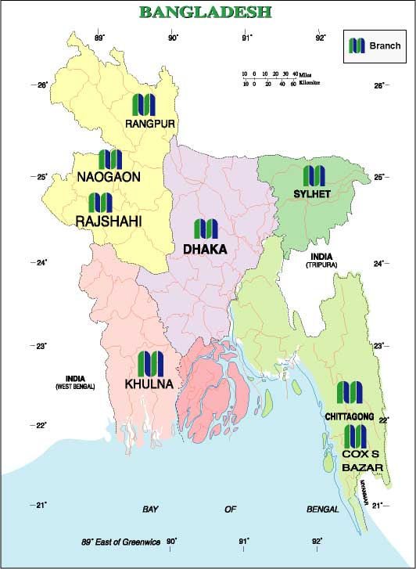

 | Branch Name
 | Name | Address
01. | Main Branch | Dhaka
02. | Principal branch | Dhaka
03. | Khatunganj Branch | Chittagong
04. | Agrabad Branch | Chittagong
05. | Laldighipaar Branch | Sylhet
06. | Imamganj Branch | Dhaka
07. | Jubilee Road Branch | Chittagong
08. | Bangshal Branch | Dhaka
09. | Sylhet Branch | Sylhet
10. | Moulvibazar Branch | Chittagong
11. | Gulshan Branch | Dhaka
12. | Khulna Branch | Khulna
13. | Dhanmondi Branch | Dhaka
14. | Uttara Branch | Dhaka
15. | Chouhatta Branch | Sylhet
16. | Kawran Bazar Branch | Dhaka
17. | Halishahar Branch | Chittagong
18. | Shahjalal Uposhahar Branch | Sylhet
19. | New Eskaton Branch | Dhaka

20. | New Elephant Road Branch | Dhaka
21. | Agargaon Branch | Mohammadpur
22. | Chhagainaiya Branch (Islamic Banking) | Chhagainaiya
23. | Cox’s Bazar Branch (Islamic Banking) | Cox’s Bazar
24. | Bandar Bazar Branch (Islamic Banking) | Bandar Bazar
25. | Banani Branch | Dhaka
26. | Khulna Branch | Khulna
27. | Feni Branch | Feni
28. | Motijheel Branch (Islamic Banking) | Motijheel
29. | CDA Avenue Branch (Islamic Banking) | Chittagong
30. | Hetimgonj Branch | Sylhet
31. | Aganagar Bazar | Dhaka
32. | Corporate Branch | Dhaka
33. | Pathantula Branch | Sylhet
34. | Shymoli Branch | Mohammadpur

3.4 Southeast Bank Limited

Vision:

Would make finest corporate citizen.

Mission:

Will become most caring, focused for equitable growth based on diversified development of resources, and nevertheless would remain healthy and gainfully profitable Bank.

Objectives:

Strategic objectives

To achieve positive Economic Value Added (EVA) each year.

To be market leader in product innovation.

To be one of the top three Financial Institutions in Bangladesh in terms of cost efficiency.

To be one of the top five Financial Institutions in Bangladesh in terms of market share in all significant market segments we serve.

Financial objectives

To achieve a return on shareholders’ equity of 20% or more, on average.

Core values:

For the customers: Providing with caring services by being innovative in the development of new banking products and services.

For the shareholders: Maximizing wealth of the Bank.

For the employees: Respecting worth and dignity of individual employees devoting their energies for the progress of the Bank.

For the community: Strengthening the corporate values and taking environment and social risks and reward into account.

New technology: Adopting the state-of-art technology in banking operations.

3.5 Corporate Information (Southeast Bank limited) At a Glance

(Information as per last Annual Report 2008)

Name of the bank : Southeast Bank Limited

Status : Private Limited Company

Date of Incorporation : 2nd June, 1999

Head Office : 61, Dilkusha Commercial Area Dhaka-1000

Chairman : Md. Abdul Jalil

Managing Director : Mr. Shah Md. Nurul Alam

Authorized Capital : Tk. 3000 million

Paid up Capital : Tk. 1199.12 million.

Director : 18

Number of Branches : 34

Proposed Branches (2006) : 3

Deposits : 28319.21

Investment : 26046.34

Number of Employees : 1204 (Approx)

3.6 Different Wings of Southeast Bank Limited

Head Office

Chairman's Secretariat

Managing Director's Secretariat

Board Department

Share Department

MIS & Computer Department

Human Resources Division

Personnel Department

Training Institute

Establishment Department

Stationary & Records Department

Transport Department

Test Key Department

Disciplinary Department

Marketing Division

Business Development Department

Branches Department

Engineering Department

Public Relations Department

Credit Division

Credit Operation Department

Recovery Department

Lease Financing Unit

Consumer Investigation Bureau ( C I B Unit)

Central Accounts Division

Accounts Department

Statistics Department

Reconciliation Department

Expenditure Control Department

Audit and Inspection Division

Internal Audit Department

External Audit Department

International Division

Treasury Department

Dealing Room

3.7 Hierarchy of Position Structure of Southeast Bank Ltd.
Chairman Advisor Board of Director

Managing Director

Additional Managing Director

Deputy Managing Director

Senior Executive Vice President

Executive Vice President

Senior Vice President

Vice President

Senior Assistant Vice President

Assistant Vice President

Senior Principal Officer

Principal Officer

Executive Officer

Junior Officer

Assistant Officer

4.0 CHAPTER FOUR

TOPIC ANALYSIS

4.1 A Brief Profile of Southeast Bank Ltd, Motijheel Branch:

I am doing my Internship in Motijheel Branch. The branch is located at Eunoos Trade Center 52 – 53, Dilkusha C/A, Dhaka – 1000, Bangladesh. The office floor is nicely specious that can accommodate good number of customer comfortably.

The branch has efficient human resources that can meet up customer’s needs. Otherwise workload is distributed properly. Besides this interpersonal relationship is remarkable. Most noted strength is customer service. Prompt, cordial & enthusiastic service satisfies most of the customers. Flexible banking service attracts more clients doing banking transactions with the branch. In some cases, customers coming outside the banking hour can honor the cheque & others without delay. Everybody performs his works very well. Under all of their efficient handling, the branch has already been able to introduce itself as one of the best performers among all other branches of Southeast Bank Limited. Southeast Bank Ltd gives interns a good value. They assign some specific jobs that are to be done which a fixed period of time. With the initiation of good job in Southeast Bank Limited of Motijheel branch, they reposed confidence on me and therefore assigned foreign exchange. In fact overall banking practices were entrusted to me within this short period of three months.

The good part of working in Southeast Bank Limited is that, it takes very little time for a new person to get himself familiar with the condition because of the environment of the bank. The environment is very friendly. The staffs are very cooperative which enables a newcomer to feel comfortable and be free very quickly.

General Banking
Motijjheel
Branch
Advance
Foreign Exchange

Import
Export
Foreign Remittance
4.2 Organ gram of Motijjheel Branch

Manager

Manager (Operation)

Credit in Charge

Foreign Exchange in Charge

General Banking in Charge

Total Number of Employees: 60 (Sixty)

Department of Mitijheel Branch

General Banking Division

Credit Division

Foreign Exchange Division

4.3 GENERAL BANKING

4.3.1 THE BANKER-CUSTOMER RELATIONSHIP

The Banker-Customer relationship is essentially a debtor-creditor contractual relationship. This relationship may be divided into two categories

Legal relationship

Behavioral relationship

After the contractual relationship is established between the banker and customer, they have to avoid by some implied conditions of the contract as well as practices of the bank.

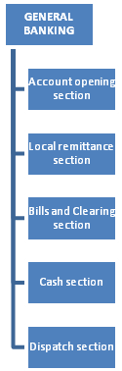

Some of the conditions and practices are as follows:

Customer is to use cheque books while demanding payment from his account.

Customer should keep cheque books in his safe custody.

Customer must inform the bank on time for any loss of cheque leaf or cheque books.

Customer while depositing money or presenting cheque, they must do that during business hour of the bank.

Banker also should give necessary banking advice and help the customer in various banking activities.

4.3.2 Rights of the Customer and Bank
Rights of a customer | Duties & obligations of a bank
Right to deposit money in his A/C on time | Must credit the deposited amount to the customer’s A/C
Right to demand repayment by issuing cheque or written order properly in proper time and place | Must honor cheque if otherwise in order
Right to get pass book/statement of A/C | Must supply pass book/statement of A/C as demanded
Right to stop payment on his cheque | Must abide by the stop payment order
Right to give standing instructions | Must abide by the instructions
Right to claim interest of his deposit balance in the interest bearing account | Must pay/credit interest as per rule
Right to have secrecy of his account | Must maintain secrecy of customer’s A/C if the banker’s not bound to disclose it under certain conditions
Right to claim damages of any loss and for defamation due to wrongful/willful dishonor of cheque by the bank | Must compensate the loss
Right to demand the proceeds of the instrument deposited for collection and collected accordingly | Must collect the proceeds of the instrument in customer’s A/C and honor the cheque drown against the amount
Right to claim money paid by bank from his A/C wrongly or payment is not made in due courses. | Payment should be made in due courses in good faith and without negligence
Right to return deposit if not in proper manner and time | Must deposit the amount properly and in time
Right to return the cheque if not drown properly or in time or for some other reason | Must demand payment by issuing cheque or written order properly

4.3.3 Termination of Banker-Customer Relationship

The legal relation between banker and customer may be terminated with a notice given by both of them with a view to close the account. Beside, there are some reasons for termination of legal relationship. Some of these are stated below:

After the death of customer

When a customer declared insolvent by the court

When a customer become lunatic etc.

4.3.4 Forms of Deposit, Opening and Operation of Deposit Accounts and their legal Aspects

The relationship between the banker and the customer begins with the opening of an account by the customer. Initially all the accounts are opened with a deposit money by the customer and hence these accounts are called deposit account. Actually in our country the bank deposits take three different forms:

Current or Demand Deposit

Savings Deposit

Fixed or Time Deposit

4.3.5 Current or Demand Deposit

Current account is purely a demand deposit account. It is a running and active account, which may be operated upon any number and the amount of withdrawal from a current account. It is noted that the bank does not provide any interest on current account. The special characteristic of a current account are as follows:

The primary objective of current account is to save big customers as big businessman, joint stock companies, private limited companies, public limited companies etc from the risk of handling cash themselves.

The cost of providing current account facilities is considerable to the bank since they undertake to make payments and collects the bills, drafts, cheques for any number of times daily. The bank therefore does not pay interest on current deposit while on the other hand some banks charge for incidental charges on such account.

For opening of a current account minimum deposit of Taka 1000/= is required. Introductory reference is also required for opening of such account.

4.3.6 DOCUMENTATION

PROPRIETORSHIP;

Trade License

Photograph

PARTNERRSHIP;

Trade License

Photograph

Partnership Deed

PRIVATE LIMITED;

Trade License

Photograph of Directors

Certified copy of Memorandum and Articles of Association

Certificate of incorporation

List of Directors as per return of joint stock company with signature

Resolution for opening account with the bank

PUBLIC LIMITED;

Trade License

Photograph of Directors

Certified copy of Memorandum and Articles of Association

Certificate of incorporation

Certificate of commencement of business

List of Directors as per return of joint stock company with signature

Resolution for opening account with the bank.

4.3.7 FORMALITIES

4.3.7.1 Application on the prescribed form

The person desiring to open a current account with the bank has to make application in the prescribed form. This form must be properly filled up and signed by the applicants.

Introduction of the application

The applicant also required to furnish in the application form the names of the referees from whom the banker may make inquires regarding the character, integrity and respectability of the applicants. In most cases the introduction is done by the customer of the bank of some other person known to the bank by signing on the application form with his/her account number (if any).

Specimen Signature

Every customer is required to supply to the bank with one or more specimens of his/her signature. These signatures are taken on cards, which are preserved by the bank, and the signature of the account holder on the cheques is compared with the specimen signature.

Mandate for operation of the account by an agent

In case a customer desires to get his/her account operated upon by another person then the bank will obtain a mandate in writing to that effects as well as the specimen signature of the person in whose favor the mandate is given.

Opening and operating the account

After the above formalities are over, the banker opens an account in the name of applicant. Generally the minimum amount to be deposited initially is Taka 1000.00 for opening a current account. Then the bank provides the customer with:

A Pay-in-Slip/Deposit Book:

With a view to facilitate the receipt of credit items paid in by a customer, the bank will provide him/her pay-in-slip either loose or in a book forms. The customer has to fill up the pay-in-slip at the time of depositing the money to the bank. The cashier with his/her initials and stamps will return the counterfoil to the customer on the receipt of the money.

Chequebook:

To facilitate withdrawals and payment to third parties by the customer, the bank will also provide a Chequebook to the customer. But it is noted that to get a Chequebook, the customer has to dully fill up the cheque requisition slip to the banker.

4.3.8 SAVINGS ACCOUNT (SB)

A savings bank is meant for the people of the lower and middle classes who have to save a part of their incomes to meet their future need and intend to earn an income from their savings. It aims at encouraging savings of non-trading person(s), institution(s), society, clubs etc by depositing small amount of money in the bank. Both the elements of time and demand deposit are present in this account.

RESTRICTION ON WITHDRAWALS AND DEPOSIT

Frequent withdrawal is not encouraged

Minimum amount of Tk. 1000.00 is required as initial deposit

Normally withdrawal not allowed more than 1/4th of the balance

The rate of interest is 8.5% against S.B. Account.

PAYMENT OF INTEREST

The rate of interest payable by the Bank’s on deposit mention in the savings account will determine by the respective Bank. Interest is now calculated in the minimum balance to the credit of the account during the period from 1st to the last day of each calendar month on every half year at the end of JUNE and DECEMBER. In this regard Southeast Bank Ltd. is providing 8.5% interest on savings account.

Opening a Savings Account

For opening a savings account these documents are required:

Documents:

Two copies of passport size photographs

Introductory reference

Account opening and closing formalities of Savings Account

Formalities for savings account opening and closing are same as current account.

4.3.9 FIXED DEPOSIT ACCOUNT (FDR)

These are the deposit, which are made with the bank a fixed period specified in advance. It is purely a time deposit account. The bank does not maintain cash reserves against these deposits and therefore the bank offers higher rates of interest on such deposits. Interest is paid at rate determined by the length of the period of deposit; the higher is the rate of interest. Loan is sanctioned against FDR.

OPENING AND OPERATION OF FIXED DEPOSIT ACCOUNT

The depositor has to fill in an application from wherein he/she mentions the amount of deposit, the period for which deposit is to be made the name(s) in which the fixed deposit receipt is to be issued. In case of deposit in joint names, the banker also takes the instructions regarding payment of money on maturity of deposit i.e. whether payable jointly or payable to either or survivor etc. the banker also takes the specimen signature of the depositor(s). A Fixed deposit Receipt is then issued to the depositor acknowledging receipt of the sum of money mentioned therein. It also contains the rate of interest and the date on which the deposit will fall due for payment. In this account no transaction is allowed and no cheque book is issued. Customers are given Fixed Deposit Receipt only.

4.3.10 OTHER TYPES OF DEPOSIT ACCOUNTS

There are some other types of deposit account maintained by the bank as well as Southeast Bank Limited. Such as:

Short Term Deposit (STD)

It is also a time deposit account. The formalities for opening of this account are similar to those required for current account. The only difference is that 7 (seven) days notice is required for withdrawal of any sum and interest is paid. If the withdrawal on demand is desired, it may be paid to the for-feature of interest for the period of notice or the expired period of notice.

Call Deposit Account (CDA)

Mainly open by organization calling tender in which (the supplier, contractors etc) deposit requisite amount of earnest money favoring the organization calling tenders. It is termed as Call Deposit since organization which opens this account may call withdrawal of the deposited account any time after expiry of the tender period. No interest is allowed here.

4.3.11 CROSSING

Crossing of cheques, which is now universally adopted had its origin in LONDON CLEARING HOUSE. The name of the bank, whose claim was cleared, was written across the face of the cheque within two parallel lines. In the beginning of 19th century, this practice becomes common even outside of clearing house, as all elements of safety.

Normally two types of cheque used in the bank. Such as;

Open Cheque: A cheque, which capable of being paid over the counter is cash, is known as open cheque.

Crossed Cheque: Those, which can only be paid to the banker for crediting the proceeds to the amount of its payee.

FORMS OF CROSSING

General Crossing

Under section 123 of Negotiable Instrument Act 1881, a cheque crossed generally is defined as under:

“Where a cheque bears across its face an addition of the words ‘and company’ or any abbreviation thereof, between two parallel transverse lines or of two parallel transverse lines simply, either with or without the words ‘not negotiable’ that addition shall be deemed a crossing and the cheque shall be deemed to be crossed generally.”

Special Crossing

Where a cheque bears across its face an addition of the name of the bank, either with or without the words ‘not negotiable’ that addition shall be deemed a crossing, and the cheque shall be deemed to be crossed specially and to be crossed to the banker.

A cheque may be crossed by any of the following:

The drawer of a cheque

The holder of the cheque. Where a cheque is issued uncrossed, its holder may cross it generally or specially.

The banker, in whose favor the cheque has been crossed specially, may again cross it especially in favor of another banker. The later bank in such case acts as the agent of the former.

Stopped Cheques

The stopped cheques register will be kept by the manager or the accountant. Immediately or receipt of a letter or telegram to stop payment of a cheque, the time of its receipt should be noted there or under the initial of the manager or the accountant. The ledger keeper concerned and he passing officials should be informed immediately and particulars of the cheques register under authentication of the manager or accountant.

4.3.12 ENDORSMENTS

An endorsement is the mode of negotiating a negotiable instrument. According to the section 15 of the Negotiable Instrument Act, 1881, an endorsement is “when the maker or holder of a negotiable instrument sign the same, otherwise then as such maker, for the purpose of negotiation, on the back or face thereof or on a slip of paper annexed thereto………………he is said to endorse the same and is called the endorser.”

Essentials of a valid endorsement

An endorsement in order to operate, as a negotiation must comply with the following conditions:

It must be written on the instrument itself and be signed by the endorser.

The endorsement must be of the entire instrument.

Where a negotiable instrument is payable to the order of two or more payees or endorsees that are not partners, all must endorse unless the one endorsing has authority to endorse for the others.

Where in a negotiable instrument payable to order, the payee or endorsee is wrongly designated or his name miss-spelt, he/she should sign the instrument in the same manner as the given in the instrument. Though he/she may add, if he/she thinks fit, his/her proper signature.

Where there are two or more endorsements on an instrument, each endorsement is deemed to be made in the order in which it appears on the instrument, until contrary is proved.

An endorsement may be made in blank or special. It may also be restrictive.

4.3.13 CLEARING

The clearing house is an assembly of the locally operating scheduled banks for exchange of cheques, drafts and other demand instruments drown on each other and received from their respective customers for collection. The house meets at the appointed hour on all working days under the chairmanship of the Central Bank or its agent as the case may be, and works within the regulations framed therefore on the basis of prevailing banking practices. In Bangladesh, clearing house sites at Bangladesh Bank but where there is no office of the Bangladesh Bank, Sonali Bank acts as an agent of Bangladesh Bank.

There are mainly two types of banking systems in Bangladesh, such as:

Internal Clearing or Inter-------branch Clearing.

External Clearing or Inter------banks Clearing.

How it works:

All the member of banks representative daily conduct two meetings at a fixed time. In their first meeting they handover cheque, drafts etc passed, which are drawn upon them. In case there are certain cheques, which could not be honored the same are returned to the presenting banks with the reasons of nonpayment in the second meeting at the clearing house.

In this meeting also the final position of house is prepared and respective accounts of the member banks are debited or credited depending upon their individual payments or collection position. After that the bankers individually debit the accounts of their customers with cheques, with cheques, which are returned unpaid.

4.3.14 DISPATCH

Dispatch includes all correspondence, letters, statements and returns and telegrams. This dispatch is also known as mail. The dispatch is primarily divided into two categories:

Inward: It means what are receives from the outside.

Out Ward: It means what are sent to the outside.

This dispatch also divided into (a) Ordinary, (b) Registered and (c) Local. Every correspondence should have an office copy and one additional copy is also retained in the master file of the office.

Working procedure for inward mail:

Registered the inward mail registered.

A local mail registered.

Currency note received & money order will be entered in a special notebook.

Working procedure for out word mail:

Registered the mail in the out word register and put the dispatch number.

Equitable sum is advanced for postages by debit to charge account and credit to postage book under the authentication of the manager.

4.3.15 BANK RECEIPTS AND PAYMENTS (CASH)

Cash Receipt

Money deposited in cash by the constituents at the cash counter of bank excluding that of government transaction is known as Bank Receipt (Cash). Different types of forms are used for cash deposits for different types of accounts. Particulars of some forms are furnished below:

Current or Savings account pay-in-slip

Application for fixed deposit receipt

Credit Voucher

Draft or mail transfer application form

T.T, Pay Order application form

Call deposit application form

Demand loan pay-in-slip

Cash Payments

Banks payment includes all kinds of payments excluding those of treasure section. Extreme precautions must be taken at all levels through, which instruments like cheques, drafts, etc is disposed of. All the instruments received at the general banking counter will be preliminary checked by the dealing officer who will enter the instruments in the respective ledger. In case of cheques the following particulars will be scrutinized:

Date (Whether postal dated or anti dated)

Amount in word and figure

Crossed or Open

Bearer or Order

Style of signature as available in the ledger

Prohibitory or Stop payment of cheque.

Late Payments

Incase of any late payments instruments must be debited in the ledger and passed in the usual manner. It will be entered in the cash paid sheet in the above manner and cash book under authentication of the manager and the cash officer. It must be noted with “Late” mark under initial of the manager with date.

4.3.16 PAYMENTS AND COLLECTIONS OF CHEQUES

In the banking sector, bill of exchange is one of the important instruments. “A Bill of Exchange is an instrument in writing containing an unconditional order, signed by the maker, directing a certain person to pay on demand or at a fixed determinable future time a certain sum of money only to or to the order of a certain person, or to the bearer of the instrument”. But cheque is the most important instrument in the bill of exchange. ‘A cheque is a bill of exchange drawn on a specific bank and not expressed to be payable otherwise than on demand’.

There are two types of cheque in the bank. Such as:

Open Cheque: A cheque capable of being paid over the counter in cash is known as open cheque.

Crossed Cheque: Those, which can only be paid to a banker for crediting the proceeds to the accounts of its payee is called Crossed Cheque.

Essential elements/requisites of a cheque

It must be written

It must contain an order to pay on demand or at fixed or determinable future

The order must be an unconditional one

The drawer must sign it

The drawee must be certain

The sum payable must be certain

The instrument must contain an order to pay a certain sum

The payee must be certain

Payments of Open Cheque

An open cheque may either be bearer or order. Where the cheque payable to order purports to be indorsed by or on behalf of the payee, the drawee is discharged by payment in due course. Where a cheque is originally expressed to be payable to bearer the drawee is discharged by payment in due course to the bearer thereof; not withstanding any endorsement whether in full or in blank appearing therein and not withstanding that such endorsement purports to restricts or exclude further negotiation.

Payments of Crossed Cheque

Where a cheque is crossed generally the banker on whom it is drawn shall not pay it otherwise than to a banker. Where a cheque is crossed specially to more than one bank except when crossed to an agent for the purpose of collection of the banker on whom it is drawn shall refuse payment thereof.

Where the banker on whom a crossed cheque is drawn has paid the sum in due course the banker paying the cheque and the drawer thereof respectively the entitled to the same rights and be placed in the same position in all respects as they would respectively be entitled to and placed in if amount of the cheque had been paid to and received by the owner thereof.

Collection of Cheques

There is no legal obligation on a banker to collects cheque drawn on other banks for a customer. But as a practice the collection of cheques and bills on behalf of the customer has become one of important function of o bank. A banker collecting a cheque for a customer has no better title than that of his customer a cheque belonging to another person can be held liable for conversion.

A banker who has good in faith and without negligence received payment for a customer of a cheque crossed generally or specially to himself shall not, in case the title of the cheque proves defective incur any liability to the true owner of the cheque by reason only of having received such payments. Thus the statutory protection given to the collecting banker can be claimed only for crossed cheques.

4.3.17 LOCAL REMITTANCE

Sending money from one place to another for customers is another important service of banks and this service is an important part of countries payment system. For this service, people especially businessmen can transfer funds from one place to another very quickly. There are four types of remitting money, such as:

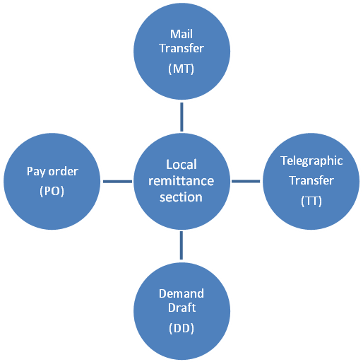

Pay Order (PO):

Pay Order gives the payee the right to claim payment from the issuing bank. It can be en-cashed from issuing bank only. Unlike cheque, there is no possibility of dishonoring pay order because before issuing pay order bank takes out money of the pay order in advance. Pay order cannot be endorsed or crossed and so it is not negotiable instrument.

Demand Draft (DD):

Demand Draft is an order of issuing bank on another branch of the same bank to pay specified sum of money to the payee on demand. It is generally issued when customer wants to remit money in any place, which is out side of the clearinghouse area of issuing branch. Payee can be purchaser himself or another mentioned in the DD. It is a safe technique of transferring money from one place to another. Bearing money may be risky. It is a negotiable instrument and it can be crossed or not.

For payment of DD, paying branch first has to be confirmed that the DD is not forged one. First bank checks the “Test Code” mentioned on the draft. If “Test Code” agrees then believe that DD is not forged and make payments. For further confirmation, the issuing bank sends an advice about the DD to the paying branch. Without advice the paying branch generally does not pay.

Telegraphic Transfer or Telephonic Transfer (TT):

By this method money is transferred to another place by telegraphic messages. The sender branch will request another branch to pay required payee on demand. Generally for such kind of transaction payee should have account with the paying bank. Otherwise it is very difficult for the paying bank to recognize the exact payee. Test Code is also furnished on the TT message for the protection of it.

When sending money is urgent the bank use telephone for remittance. This service is only providing for valued customers, who is very reliable and with, which banks have long standing relationship.

Mail Transfer (MT):

It is the least used technique for transferring fund. Where there is no telex machine or telephone line then this method is used. It is also time consuming and risky because mail may be missed.

Clear Cash Book:

The clear cash book which is the abstract of each day’s transactions classified under the general ledger heading. It will be complied from the totals of the various books subsidiary to the clear cash book including the day books in which the relative vouchers have been entered in details under authentication and will be checked there form by unauthorized official.

Clear Cash Book is written to:

Test the arithmetical accuracy of one day transaction.

Consolidate one day transaction

Help position in the general ledger

Test the closing each balance of the branch.

R&D: Investment into the Future

Excellent in banking operation depend largely on a well equipped and efficient Research and Development Division. Such activities require the investment of substantial resources and a set of qualified personnel with multidisciplinary background. Although it is not possible at this stage to undertake R&D activities similar to those of the banks in the developed countries, Southeast Bank has established a core Research and Planning Division comprising skilled persons form the very inception of the Bank.

Information Technology

Banking operations of the branches have been computerized to minimize costs and risks and to optimize benefits and increase overall efficiency for improved services. The Bank generates the relevant financial statements at the end of the day. The Bank has installed Reuters Screen for smooth operation of foreign currency dealings. The Bank has also hosted a web page of its own to take a place in the World Wide Web. On-line Banking has been introduced by the Bank to provide better services to the customer. The Bank has introduced ATM ‘Q-Cash’. The Bank has installed SWIFT to facilities quick international trade and payments arrangement. The Bank has already introduced VISA debit and credit cards.

4.4.1 Principal of Advances

The granting of advances is one of the most important functions of a Bank and the test of Bank strength depends considerably on the quality of its advances and proportion they bear to the total deposit. Although receipt from exchange, commission and Banks charges contribute a fair amount of the profits or commercial Banks, its earning are chiefly derived from interest charged on loans and discount. A wise and prudent policy with regard to advances is therefore considered an important factor inspiring confidence in the depositors and customers of a Bank. Traditionally Banks have been following three cardinal principal of lending they are: Safety, Liquidity and Profitability. Loans and advances may be made either of the borrowers and the latter is called secured advances. Confidence in the borrower is the basis of unsecured advances.

4.4.2 Different Type of Loans and Advances

As initiated by Bangladesh Bank vide BCD circular no: 33 dated 16/11/89 different kinds of lending were subdivided into 11 categories w.e.f. 01/01/90 which was subsequent reduced to 9 vide BCD circular no: 23 dated 09/10/93 and again to 7 prime sectors vide BCD circular no: 8 dated 25/04/94 for fixation of rates of interest by the individual Banks on competitive basis depending on the cost of funds, prevailing marketing condition and monetary policy of the country. Loans and advances have primarily been divided into two major groups:

Fixed term loan

There are the advances made by the bank with fixed repayment schedules. The term of loan are defined as follows:

Short term : Up to 12 months

Medium term : more than 12 and up to 36 months

Loan term : More than 36 months

Continuous Credits

These are the advances having no fixed repayment schedule, but have an expiry date of which it is renewable on satisfactory performances. Depending on the various nature of financing, all the lending activities have been brought under the following major heads.

Cash Credit Hypothecation

A cash credit is an arrangement by which the customer is allowed to borrow money up to a certain limit. This is a permanent arrangement and the customer need not draw the sanctioned amount at once, but draw the amount as and when required. He can back surplus amount, which he may find with him. Thus cash credit is an active and running A/C which deposits and withdrawals may be affected frequently. Interest is charged only for the amount withdrawn and not for the whole amount charged. Cash credit arrangements are usually made adjust pledge or hypothecation of good.

Overdraft (OD)

Overdraft is an arrangement between a bank and his customer, which the latter is allowed to withdraw over and above his credit balance in the current up to an agree limit. This is only temporary accommodation usually granted against securities. The borrower is permitted to draw and repay any number of times, provided the total amount overdrawn doesn’t exceed limit. The interest is charge for the amount drawn and for the amount sanctioned. A cash credit is used for long term for the businessmen are doing regular business whereas overdraft is made occasionally and for short duration.

SOD (Other)

Advances allowed against assignment of work order for execution of contractual works falls under this head. The advance is generally allowed for a specific purpose. It is not a continuous loan.

SOD (General)

Advances allowed to the individuals/firms against the financial obligations i.e. line of F.D.R. or Defense Savings Certificate, ICB unit certificate etc.

Secured Overdraft (SOD)

It is a continuous advance facility. By this agreement the bankers allowed his customer to overdraft his current A/C up to his credit limits sanctioned by the bank. The interest is charged on the amount, which he withdraws, not on the sectioned amount. SEBL sections SOD against different security. Based on different types of security, we can divide the following category of the facility.

SOD (Export)

Advance allowed purchasing foreign currency for payment against L/Cs (Back to Back) where the exporter cannot materialize before the date of import payment.

IBP (Inland Bill Purchase)

Payment made through purchase of inland bills/cheques to meet urgent requirement of the customer falls under this type of credit facilities. This temporary advance is adjustable from the proceeds of bills/cheques purchased for collection. It falls under the category ‘commercial lending’.

Packing Credit (P.C.)

Advance allowed to a customer against specific L/C firm contract for processing/ packing of goods to be exported falls under this head and is categorized as ‘Packing Credit’. The advances must be adjusted form proceeds of the relevant exports within 180 days. It falls under the ‘Export Credit’.

F.D.B.P. (Foreign Documentary Bill Purchase)

Payment made to a customer through purchase/negotiation of a foreign documentary bill falls under this category. This temporary advance is adjustable from the proceeds of the shipping/export documents. It falls under the category ‘Export Credit’.

F.D.B.P. (Local)

Payment is made against documents representing sell of goods to local export oriented industries, which are deemed as exports as which are denominated in Local Currency / Foreign Currency falls under this category. This liability is adjustable form proceeds of the bill.

F.B.P. (Foreign Bill Purchase)

Payment made to a customer through purchase or foreign currency Cheques / Draft falls under this head. This temporary advance is adjustable form the proceeds of the cheque / draft.

L.D.B.P. (Inland Documentary Bill Purchase)

Payment made to a customer through purchase of inland documentary bills. This temporary liability is adjustable from proceeds of the bill.

Financial Products and Services

The Bank has launched a number of financial products and services since its inception. Among them Monthly Savings scheme, Family Maintenance Deposit, Double Benefit Deposit Scheme, Special Saving Scheme, Pension and Family Support Deposit, Staff Loan, Consumer Credit Scheme, Small Loan Scheme, Hire Purchase, Lease Finance, Doctors’ Credit Scheme, Rural Development Scheme, Women Entrepreneurs Development Scheme, SME Financing Scheme, Project Loan, Personal loan Scheme, Car Loan Scheme have attained wide acceptance among the people.

Staff Loan

The bank provides advances to the staff are known as Staff Loan. Rate of interest is the bank rate. The loan is adjusted from the employee’s salary.

Consumer Credit Scheme

Consumer Credit Scheme is a relatively new field of micro-credit activities. People with limited income can avail of this credit facility to buy any household effects including car, computer and other consumer durable. It is special credit scheme and the customers allow the loan on soft terms against personal guarantee and deposit of specified percentage of equity.

Performance review:
 |  | (BDT in million)
Type | Volume | %
Deposits Under Scheme | 10,278.58 | 39.95
FDR | 8,787.53 | 34.16
Call Deposits | 640.00 | 2.49
Savings | 1,473.58 | 5.73
Current | 840.35 | 3.27
STD | 744.76 | 2.89
Others | 2,962.63 | 11.52
Total | 25,727.43 | 100

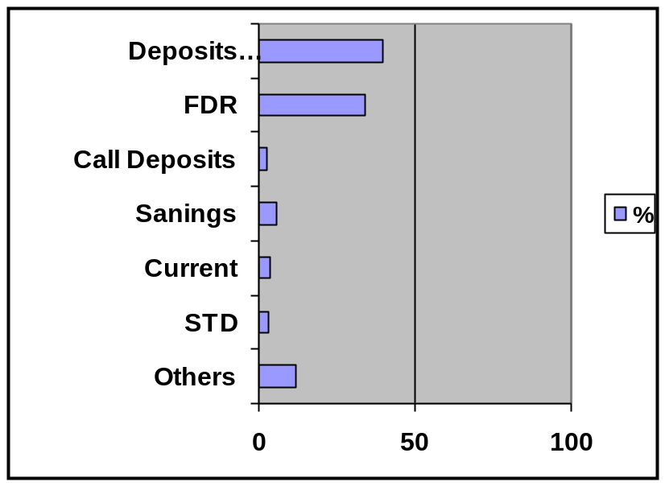

Source: Annual report 2005 Southeast Bank Limited.

* Liquid Assets =Cash + Balance with Bangladesh Bank + Deposit with other Banks+ Money at Call and Short Notice + Investments.

4.4.10 Steps of Investment analysis

CIB report analysis

Credit Information bureau (CIB) was set up a decade ago (August 18,1992) in Bangladesh bank to act as an unfailing cure to the devil of bad debt. Subsequently, Since December, 1992 CIB has been collecting detailed credit information in respect of individual borrower/owners vide various prescribed forms developed and designed from time according to the need arising out of the changing circumstances influencing the banking and financial system of the country. CIB reports are provides all the transaction/Account information of individual/firm with other banks or financial institutions.

The basic objectives with which CIB was established is to reduce the credit risk and the extent of the default loan by extending lending and other facilities only to the genuine borrowers.

After getting the CIB report from the Bangladesh bank the investment division of SEBL bank will analyze the report. If the investment division found clean/well transaction record with the previous banks then they will send it to the Head office for further investigation. If the head office found the client solvent enough for provide loan then the head office will provide sufficient direction to the branch officer for dealing with the client.

4.4.11 Operation of the Bank

Deposits

The Bank mobilized total deposits of BDT 25,727.43 million as of December 31, 2005 as compared to BDT 22, 385.19 million in 2004. Competitive interest rates, attractive deposit products, deposit mobilization efforts of the Bank and confidence reposed by the customers in the Bank contributed to the notable growth in deposits. The Bank evolved a number of attractive deposit schemes to cater to the requirement of small and medium savers. This improved not only the quantum of deposits; it is also brought about qualitative changes in the deposits structure.

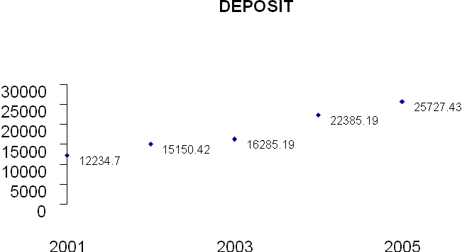

Source: Annual Report 2005, SEBL

Advances

The Bank has formulated its policy to give priority to small and medium businessmen while financing large-scale enterprise through consortium of Banks. Total loans and advances of the Bank stood at BDT 21,857.05 million as of December 31, 2005 as compared to BDT 17,669.29 million in 2004. Trade and commerce, garments industry, large and medium scale industries and construction are major sectors in which the Bank extended credit.

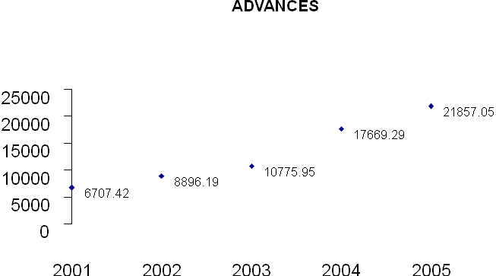

Source: Annual Report 2005, SEBL

Import Business

From the very beginning the Bank has embarked on extensive foreign exchange business with a view to facilities international trade transactions of the country. The Bank has established 14,852 Letters of Credit amounting to BDT 33,271.90 million as of December 31, 2005 as against 13,285 Letters of Credit amounting to BDT 28,325.20 million in 2004. Items of imports financed by the Bank included capital machinery, Hot Roll Steel, electric equipments, rice, wheat, seeds, CDSO, palmolein, cement clinkers, dyes, chemicals, raw cotton, garments accessories etc.

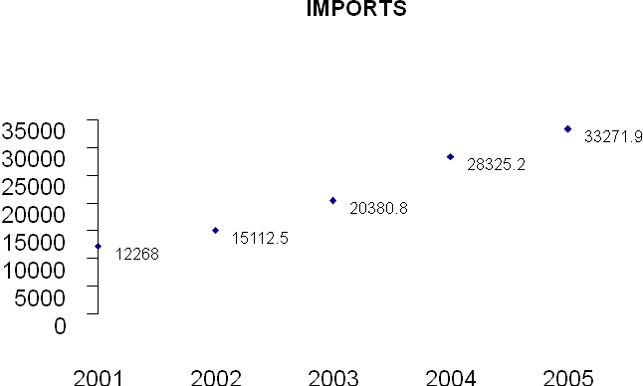

Source: Annual Report 2005, SEBL

Export Business

The total export business handled by the Bank amounted to BDT 24,108.57 million as of December 31, 2005 as compared to BDT 17,411.00 million in 2004. The Bank has made significant contribution to Readymade Garments sector, which was 74.15% of total exports of the country in 2004-2005. Readymade Garments not only generated employment of men and women, it has also led to emergence of forward looking entrepreneurs in the country thus removing a constraint to development efforts

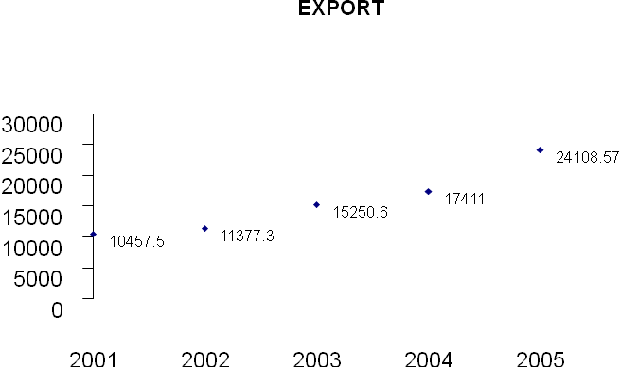

Source: Annual Report 2005, SEBL

FOREIGN REMITTANCES

Foreign remittances handled by the Bank stood at BDT 679.10 million as of December 31, 2005 as against BDT 671.30 million in 2004. The Bank has already made foreign remittance arrangement with UniCredito Italiano, Italy and ICICI Bank Canada to expedite inward foreign remittances. The Bank has established Drawing Arrangement with UCBL and AB Bank Limited for the prompt delivery services of remittances to the beneficiaries located any corner of Bangladesh.

Operating Revenue

The operating revenue of the Bank stood at BDT 967.23 million in 2005 as against BDT 821.76 million in 2004. After necessary provision net profit after tax stood at BDT 312.58 million in 2004. An amount of BDT 316.50 million has been set aside for income tax contribution to National Exchequer as compared to BDT 241.68 million in 2004.

Total Income

Total income increased from BDT 2,717.67 million in 2004 to BDT 3,472.51 million in 2005. Interest income accounted for 78.34%, commission 8.66%, exchange gains 7.46% and other income 5.54% to total income in 2005 as against 78.04%, 7.99%, 9.87% and 4.10% respectively in 2004.

Total Income | (BDT in million)
Components | Amount | % of Total
Interest Income | 2,720.38 | 78.34
Commission | 300.61 | 8.66
Exchange gains | 259.20 | 7.46
Other Income | 192.32 | 5.54
Total | 3,472.51 | 100.00

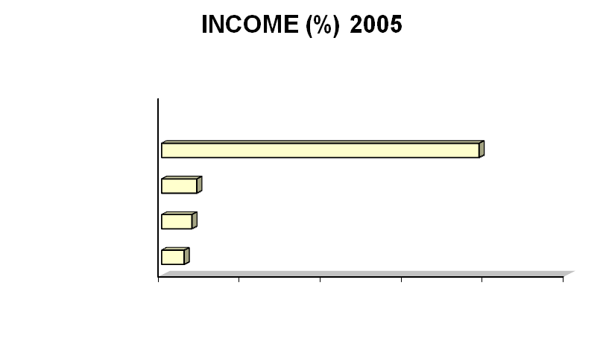

Source: Annual Report 2005, SEBL

Interest Income

Interest income increased form BDT 2,120.82 million in 2004 to BDT 2,720.38 million in 2005. Interest on loans and advances accounted for 84.53%, interest on Treasury Bills 6.97%, interest on deposits with other Banks 3.88%, interest on treasury and T & T Bond 2.17%, interest on Treasury Line 2.04% and other interest income 0.41% of total interest income in 2005 as against 82.79% , 8.65%, 7.65%, 0.82%, 0.00% and 0.09% respectively in 2004.

Interest Income | (BDT in million)
Components | Amount | % of Total
Interest on loans and advances | 2,299.55 | 84.53
Interest on Treasury Bills | 189.60 | 6.97
Interest on deposits with Banks | 105.49 | 3.88
Interest on Treasury and T & T Bond | 59.09 | 2.17
Interest on Treasury Line | 55.41 | 2.04
Other interest income | 11.24 | 0.41
Total | 2,720.38 | 100.00

Interest Expenses

Interest Expenses moved up from BDT 1509.00 million in 2004 to BDT 1,987.16 million in 2005. Interest on deposits under scheme was the largest component of interest expenses and accounted for 52.86% of total interest expenses in 2005 as compared to 55.85% in 2004. Interest on FDR accounted for 36.69%, interest on savings deposits 3.87%, interest on call deposits 3.25%, interest on short-term deposits 1.91% and other interest expenses 1.42% of total interest expenses in 2005 as against 36.23%, 3.61%, 2.55%, 1.52% and 0.24% respectively in 2004.

Interest Expenses | (BDT in million)
Components | Amount | % of Total
Interest on deposits scheme | 1,050.358 | 52.86
Interest on fixed deposits | 729.15 | 36.69
Interest on saving deposits | 76.80 | 3.87
Interest on call deposits | 64.66 | 3.25
Interest on short term deposits | 38.02 | 1.91
Other interest expenses | 28.15 | 1.42
Total | 1,987.16 | 100.00

Net Interest Income

Net interest income increased form BDT 611.82 million in 2004 to DT 733.33 million in 2005. Gross interest of the Bank amounted to BDT 2,720.38 million and interest expenses amounted to BDT 1,987.16 million in 2005.

Net Interest Margin

Bank’s net interest margin, which is derived by net interest income divided by average earning assets, was 3.05% in 2005 as compared to 3.24% in 2004. Net Interest Margin (NIM) decreased as the lower spread is being resulted from the higher deposit rate and lower yield on risk assets.

Non-Interest Income

Non-Interest Income increased form BDT 596.85 million in 2004 to BDT 752.13 million in 2005. Non-interest income was 21.66% of the total income in 2005 as compared to 21.96% in 2004. Commission accounted for 39.97%, exchange gains 34.46% and other non-interest income 25.57% of non-interest income in 2005 as against 36.38%, 44.94% and 18.68% respectively in 2004

Non-Interest Income | (BDT in million)
Components | Amount | % of Total
Commission | 300.61 | 39.97
Exchange gains | 259.20 | 34.46
Other non- interest income | 192.32 | 25.57
Total | 752.13 | 100.00

Total Expenses

The total expenses of the Bank stood at BDT 2,505.28 million during 2005 as compared to BDT 1,895.91 million in 2004. Interest expenses accounted for 79.32%, salaries and allowances 11.29%, rent, rates, taxes etc. 2.78%, stationary, printing and advertisements 1.33%, depreciation and repair 1.21%, postage, stamp and telecommunication 0.65% and other expenses 3.42% of total expenses in 2005 as against 79.59%, 11.43%, 2.91%, 1.36%, 1.05%, 0.69% and 2.97% respectively in 2004.

Total Expenses | (BDT in million)
Components | Amount | % of Total
Interest Expenses | 1,987.16 | 79.32
Salaried and Allowances | 282.88 | 11.29
Rent, Rates, Taxes etc | 69.65 | 2.78
Stationary, Printing and Advertisements | 33.37 | 1.33
Depreciation and Repairs | 30.33 | 1.21
Postage, Stamp and Telecommunication | 16.22 | 0.65
Other Expenses | 85.67 | 3.42
Total | 2,505.28 | 100.00

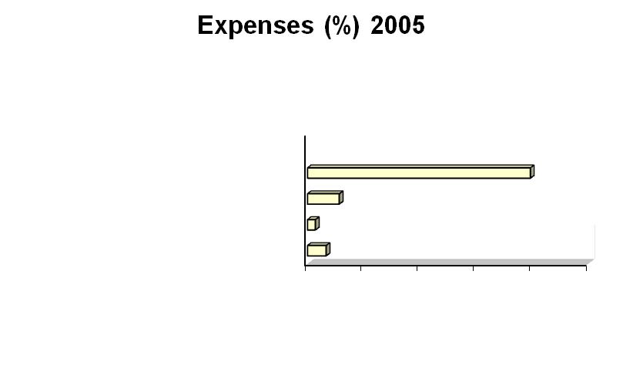

Source: Annual Report 2008, SEBL

4.5 Foreign Exchange

Foreign Exchange Department is international department of the bank. It deals globally. It facilitates international trade through its various modes of services. It bridges between importers and exporters. If the branch is authorized dealer in foreign exchange market, it can remit foreign exchange from local country to foreign country. This department mainly deals in foreign currency. The term foreign exchange has different connotations in different contexts. Sometimes it is referred to as the process of conversion of one currency into another, some times as the process of transferring money from one country to another. In Bangladesh is has a legal definition too. In terms of section 2(d) of the F. E. R. Act 1947, as adapted in Bangladesh, foreign exchange means foreign currency and includes instruments expressed in foreign exchange, all deposits, credits and balance payable in foreign currency as well as foreign currency instruments such as Draft, TC, Bill of Exchange, promissory note, and Letter of Credit payable in any foreign currency. The business of foreign exchange is getting increasingly complex and intensely competitive. This is the Institution that facilitates international trade payment as banking channel is the way of settlements. Besides, banks meet the other need of foreign exchange transactions of the people of the country as they are authorized to deal in foreign exchange upon receipt of permission from Central Bank under Foreign Exchange Regulation Act. On the other hand they make the payment for the importer done by the people of Bangladesh. Side by side, they provide funded and non funded credit facility in execution of International Trade.

Need for Foreign Trade

The Foreign Trade of a country refers to its imports and exports of merchandise from and to other countries under contract of sale. No country in the world produces all the commodities it requires. On the contrary, a country may produce more of those commodities in the production of which it has a greater or comparative advantage, and may or may not produce smaller quantities of those in the production of which it has a greater or comparative disadvantage. The commodities which a country can economically produce it exports, while those in producing which it has greater disadvantage it imports. Foreign trade constitutes a sizable portion of international transaction of a country.

A country, therefore, enters into trade relations with other countries on account of certain basic differences due to topographical reasons in its economy from others. The first of these differences is that of natural resources. A country which lacks in mineral products has to import them from other countries. Climatic and soil conditions may not suit the production of some essential raw materials and foodstuffs. There may not be enough land for the production of all its requirements of agricultural commodities, or the productivity of land may be low. In all such conditions a country imports various primary products and has to export other commodities in exchange.

Secondly, differences in size and density of population also give rise to trade between countries. A country with a population which is too large and dense in relation to its resources has to import food, clothing and other consumer goods. It may specialize in the production of commodities which need large amount of labor and capital in relation to land and other natural resources and import commodities which require comparatively large amount of natural resources.

Thirdly, the stage of industrialization and technical and scientific development generates foreign trade. A highly industrialized country exports capital goods but may have to import raw materials and semi –processed goods. An industrially backward country, on the other hand, imports industrial products. A country which is in process of industrialization imports machinery and equipments.

A country maintains and develops trade relations with other countries because it gains by doing so. Commodities are imported because either they can not be produced in the country at all or can be produced at a very high cost. Import of such commodities by the country is, therefore, convenient and cheaper. In exchange for imports, the country has to export certain commodities which it can produce but which are not produced in some other countries, and for the production of which its resources are well suited. Thus foreign trade is a source of considerable gain for a country.

Functions of Foreign Exchange Department:

Foreign Exchange Department performs many functions to facilitate the foreign exchange transactions. These are:

Facilitating Import Trade

Facilitating Export Trade

Providing Funded and Non-funded Credit Facility.

Provide Non Commercial Remittance

Maintaining Foreign Currency Accounts

Selling of Foreign Currency Bond

Preparation and Submission of Statements

The above mentioned functions are done by three sections namely:

Import Section

Export Section

Foreign Remittance Section.

4.5.1 IMPORT

Import is the flow of goods and services purchased by economic agent staying in the country from economic agent staying abroad. We can simplify Import as a means purchase of goods and services from the foreign countries into Bangladesh. Normally consumers, firms and Government of Bangladesh import foreign goods to meet their various necessities. Import section helps business and other people to import goods. In international environment, buyers and sellers are most of the cases unknown to each other. So seller always seeks guarantee for the payment for his goods exported. Here is the role of bank. Bank gives export guarantee that it will pay for the goods on behalf of the buyer. This guarantee is called Letter of Credit. Thus the contract between importer and exporter is given a legal shape by the banker by its ‘Letter of Credit’. When a buyer goes to import some goods from a foreign buyer, he request his bank makes payments to the exporter of goods. And the bank recovers the amount from the importer.

Letter Of Credit

Letter of Credit is a guarantee or undertaking or commitment to the beneficiary/exporter for making payment issued by the issuing bank on behalf of the importer upon fulfillment of some conditions. As distance involved in international trade, buyers and sellers do not know each other. It is difficult for both the buyers and seller to appreciate each others’ integrity and credit worthiness. Apart from this it is also difficult to know various regulations prevailing in their respective countries regarding export and import. Thus the buyer wants to be assured of goods and sellers want to be assured of payments. Central Banks, therefore assure these things to happen simultaneously by opening Letter of Credit guaranteeing payments to seller and goods to buyer. By opening a Letter of Credit on behalf of buyer in favor of seller, commercial banks undertake to make payments to a seller subject to submission of documents drawn on in strictly compliance with Letter of Credit terms giving title of goods to the buyer. It is a conditional guarantee. The Letter of Credit thus constitutes one of the most important methods of financing foreign trade.

The expression “Documentary Credit(s)” and “Standby Letter(s)” means any arrangements, however named or described, whereby a bank (“the issuing bank”) acting at the request and on the instruction of a customer (the “Applicant”) or on its own behalf,

i. Is to make a payment to or the order of a third party (“the Beneficiary”), or is to accept and pay bills of exchange (Draft’s) drawn by the Beneficiary,

Or

ii. Authorizes another bank to effect such payment, or to accept and pay such bills of exchange (Draft(s)),

Or

iii. Authorizes another bank to negotiate,

Against stipulated document(s), provided that the terms and conditions of the Credit and complied with.

On the other hand Letter of credit can be defined as a “Credit Contract” whereby the buyer’s bank is committed (on behalf of the buyers) to place an agreed amount of money at the seller’s disposal under some agreed conditions. Since the agreed conditions include amongst other things, the presentation of some specified documents, the letter of credit is called Documentary letter of credit. The uniform customs and practices for documentary Credit (UCPDC) published by international Chamber of Commerce (1993) revision, publication no 500 define Documentary Credit:

a) Any arrangement however named or described whereby a bank (the issuing bank) acting at the request and on the instructions of a customs (the Applicant) or on its own behalf,

b) Is to make a payment to or to the order of a third party (the beneficiary) or is to accept and pay bills of exchange (Drafts) drawn by the beneficiary or

c) Authorize another bank to effect such payment or to accept and pay such bills of exchange (Drafts)

d) Authorize another bank to negotiate against stipulated documents provide that terms and conditions are complied with.

Types of Letter Of Credit:

There are many types of Letter of Credits that are used in different countries of the world. But International Chamber of Commerce (ICC) vides their UCPDC- 500, which denotes only two types of LETTER OF Credits:

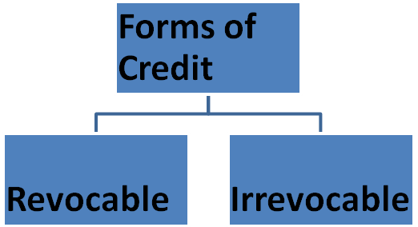

Figure: Forms of Letter of Credit

Recoverable Letter Of Credit

A revocable credit may be amended or cancelled by the issuing bank at any moment and without prior notice to the beneficiary. That is to say, this type of letter of credit can be revoked or cancelled at any time without consent of, or notice to the beneficiary. In case of seller (beneficiary), revocable credit involves risk, as the credit may be amended or cancelled while the goods are in transit and before the documents are presented, or although presented before payments has been made. The seller would then face the problem of obtaining payment on the other hand revocable credit gives the buyer maximum flexibility, as it can be amended or cancelled without prior notice to the seller up to the moment of payment buy the issuing bank at which the issuing bank has made the credit available. In the modern banking the use of revocable credit is not widespread.

In this case the issuing banks must perform the following two roles:

i. Reimburse another bank with which a revocable Credit has been made available for sight payment, acceptance or negotiation – for any payment, acceptance or negotiation made by such bank – prior to receipt by it of notice of amendment or cancellation, against documents which appear on their face to be in compliance with the terms and conditions of the Credit;

ii. Reimburse another bank with which a revocable Credit has been made available for deferred payment, if such a bank has, prior to receipt by it of notice of amendment or cancellation, take up documents which appear on their face to be in compliance with the terms and conditions of the Credit.

Irrevocable Letter Of Credit

An irrevocable credit is a documentary credit, which cannot be revoked, varied or changed/amended or cancelled without the consent of all parties- buyer (Applicant), seller (Beneficiary), Issuing Bank, and Confirming Bank (in case of confirmed Letter of Credit). Irrevocable Credit gives the seller greater assurance of payments, but he/she remains dependent on an undertaking of a foreign bank. In the issuance of Irrevocable Letter of Credit both the Issuing and Conforming Bank have some liability, mentioned bellow, as per UCPDC -500:

Parties of a Letter Of Credit

Applicant for The Credit: The importer or buyer on whose request and on whose behalf the letter of credit is opened is called the applicant

Issuing Bank/ Opening Bank: The bank that opens a Letter of Credit, at the request of the importer, is known as Issuing Bank. The Issuing Bank is the buyer’s bank and is also called opening bank.

Beneficiary: The party, normally the supplier of the goods, in whose favor the Letter of Credit is opened is called beneficiary. The seller, after shipping the goods as per terms of the credit, presents the documents to negotiating bank/conforming bank for negotiation.

Advising Bank: The bank is the exporter’s country, usually the foreign correspondent of the importer’s bank; through which Letter of Credit is advised to the supplier is called the ‘advising bank’.

Conforming Bank: If the advising bank also adds its own undertaking to honor the credit while advising the same to the beneficiary, it becomes the conforming bank. The conforming bank, in addition, becomes liable to pay for documents in conformity with the Letter of Credit terms and conditions.

Negotiating Bank: The Bank, which negotiates the bill (draft) of the exporter drawn under the credit, is known as negotiating bank. If the advising bank is also authorized to negotiate the bill (draft) drawn by the exporter it itself becomes the negotiating bank.

Accepting Bank: A bank that (as specified in the Letter of Credit) accepts time or Usance drafts on behalf of the importer is called the accepting bank. The Letter of Credit issuing bank can also take on the responsibility of an accepting bank.

Paying Bank: The bank that effects payment to the beneficiary (as named in the Letter of Credit) is known as paying bank/drawee bank.

Reimbursing Bank: If the issuing bank does not maintain any account with The Negotiating bank an alternate arrangement is made to reimburse it for the amount payable under a credit form some other bank. The later bank is termed as reimbursing bank. An authority to debit his account is sent to the bank with whom the account is maintained to honor the claims placed by a negotiating bank.

Documentary requirement for opening L/C

Import shall submit following documents for opening L/C

Valid import registration certificate (commercial/ industrial).

TIN certificate.

VAT registration certificate.

Membership certificate of a recognize Trade Association as per IPO.

A declaration that the importer has paid income tax or submitted income tax return for the preceding year.

Performa invoice or indent duly accepted by the importer.

Insurance Cover Note with Money Paid Receipt covering value good to the imported plus 10% above.

L/C application form duly signed by the importer.

Letter of Credit Authorization form (LCAF) commercial or industrial as the case may be, duly signed by the importer and incorporating. New ITC number at least 6 digit under Harmonized System as given in the Import Trade Control Schedule 1998.

IMP form duly signed by the importer.

Back To Back Letter Of Credit and its Operation

Introduction:

Back to Back letter of credit is defined as credit which is opened as the instruction and the request of the Beneficiary of the Original Export Letter of Credit on the strength credit.

Back to Back is a term given to an ancillary credit which arises where the seller the credit granted to him by the Issuing Bank to his supplier?

Sometimes Back to Back credits are called Counter Veiling Credits, (Credit and counter credit)

There are two types of Back to Back credits:

Foreign Back to Back credit

Local Back to Back credit

4.5.2 EXPORT

Legal Requirements: Although payment aspects of exports are Bangladesh Bank’s concern, the export policy Order announced by the Ministry of Commerce controls physical aspects. Bangladesh Bank has set out elaborate procedure and laid down detailed rules and regulations concerning Export and Export payments. All exports, to which the requirement of declaration applies, must be declared on the Exp Form. The brunch should before certifying any export form, consider and take notice of the following:

The intended exporter shall have valid Export Registration Certificate.

Payment for goods exported from Bangladesh should be received through the branch in freely convertible foreign currency or in Taka from a non-resident Taka account of a bank branch or correspondent abroad.

Commission, brokerage and other trade charges are admissible only up to a maximum of 5% of the value of goods. The charges beyond 5% may be admissible subject to prior approval of the Bangladesh Bank.

In order to avoid any loss of foreign exchange to the country, the branch should see that

Arrangements have been made for realization of export proceeds within prescribed period of 4(four) months.

Arrangement has been made for receipt of title to goods like Bill of Landing, Airway Bill etc, by the branch on shipment of goods.

The Exp Form is signed either by the exporter or one holding valid legal power of attorney from exporter and the terms of the power of attorney are such that both the exporter and the attorney may be held responsible jointly and severally for realization of export proceeds.

In respect of export of goods by land route or by sea, the Bill of Landing, Railway Receipts and other documents of title to cargo should be drawn only to the order of Southeast Bank Limited.

In respect of export of goods by air, the Airway Bills and any other documents of title to cargo should be drawn to the order of a bank in the country of important nominated by the branch.

Exceptions: In case of export of goods against advance payment, the Bill of Landing, Airway Bill and other transport documents may be endorsed by the branch in favor of foreign importers or the branch may allow the carrier company to drawn the documents in favor of the foreign importers and the same may be sent directly to the importers abroad by the branch.

Export of fresh fish, vegetables, fruits, poultry and other goods of perishable nature is also exempted from this directed.

Type ‘A’ industries in the EPZ may also draw the documents of title to cargo in favor of the consignee /LC opening ban.

The branch to whose order the relative Railway Receipts, Bills of Landing etc. are drawn shall endorse the same to the order of their foreign correspondents but in no case they obtained specific or general approval of Bangladesh Bank.

Exception: In case of type ‘A’ industries in EPZ, the branch may blank endorse or endorse in favor of the consignees as per terms of the export L/C or export contract.

Negotiation: If the documents are found in order or if the discrepancies are covered by the indemnity of the exporter of by negotiation authorization of the issuing bank, a proposal sheet for negotiation would be prepared as per bank’s format indicating the full particulars of shipment/export and discrepancies, if any. Under the signature of authorize person and should be placed to the manager for disposal instruction/sanction. Format of Negotiation proposal is given bellow: will have to type. Particulars of export bills and negotiation are to be recorded in the Foreign Bill Purchase Register assigning a number to each export bill. The branch then, may make payment to the party b passing the vouchers as per calculations as shown in the negotiation proposal as O.D. sight (export) buying rate or at usance buying rate as per respective tenor of the usance bills. The branch will realize overdue interest@16% per annum from all export bills after 21 days from the date of negotiation to the date of realization of proceeds.

Transfer L/Cs: The branch at the request of the original beneficiary (first beneficiary) may execute transfer of L/Cs to the subsequent beneficiary (second beneficiary). For doing so, the first beneficiary must maintain an accounting relationship with the branch and the branch will verify his/her signature on the request letter. A Letter of Credit can be transferred only if it is expressly stated, as “transferable” by the issuing bank and transfer is not restricted to any other bank. The L/C can be transferred only on the terms and conditions specified in the Original L/C with the exception of L/C amount, unit price, expiry date, presentation time of documents and shipment validity, any of all of which may be reduced or curtailed. In addition, the name of first beneficiary can be submitted for that of the applicant, but if the name of the applicant is specially required by the original L/C to appear in any documents other than the invoice, such requirement must be fulfilled.

4.5.3 FOREIGN REMITTANCE

Types of Remittance:

There are two types of foreign remittance

Foreign Inward Remittance

Foreign Outward Remittance

Foreign Inward Remittance: The Remittance is freely convertible to foreign currencies which are receiving form abroad against which the Authorized Dealers payment in local currencies to the beneficiaries may be termed as Foreign Inward Remittance.

Inward Remittance

Telegraphic Transfer (TT)

Mail Transfer (MT)

Foreign Draft (FD)

Payment Order (PO)

Travelers Check (TC)

Foreign Currency Notes

Mode of Inward Remittance

The purposes of Remittance are of various reasons, such as

For family maintenance

Realization of export proceeds

Gift

Donation

Export broker commission etc

Payment procedure of TT

To verify the test number

To inform the beneficiary for submission of form “C”

To confirm the Issuing bank / Reimbursing bank

To covert the foreign currency into Bangladeshi TK. With TT (CLEAN)

To make entry in T.T’s, Draft’s, MT’s receiving register

To prepare FET schedule

Purchase of Drafts & Checks

Authorized Dealer may purchase Drafts and Checks which are not drawn on Sonali Bank at the request of the beneficiary. Procedures of purchase are as follows

To obtain an application / undertaking from the beneficiary with form “C”

To verify the signature of the Drafts

To make entry in the register for Drafts and TC purchased

To convert foreign currencies in to Bangladeshi currencies

To prepare voucher

To prepare FET schedule

To send the instrument for collection

Payment for Foreign Currency Note

To check the custom declaration

To convert Foreign Currency in to Bangladeshi TK

Prepare vouchers

Cancellation of Inward Remittance

In the event of any inward remittance which has already been reported to the Bangladesh Bank, being subsequently cancelled, either in full or part, because of non-availability of beneficiary

Authorized Dealer must report the cancellation of inward remittance as an outward remittance of form “T/M” required document are

The date of return in which the inward remittance was reported

The name and address of the beneficiary

The amount of the purchase as effected

Reasons for cancellation

Foreign Outward Remittance: The remittance in foreign currency which are being made from our country to abroad is known as Foreign Outward Remittance

Telegraphic Transfer (TT)

Mail Transfer (MT)

Foreign Draft (FD)

Payment Order (PO)

Travelers Check (TC)

Foreign Check (FC)

Foreign Currency Notes

Approval in Bangladesh Bank

Bangladesh is always in scarcity of foreign exchange and foreign exchange business is restricted can be transferred outside Bangladesh prior permission of Bangladesh Bank. Following document is required for approval

IMP Form

T/M (Traveling and Miscellaneous ) Form

Procedure of FD, MT, TT

Verify the approved T/M form or Bangladesh Bank permit letter

Prepare vouchers and instrument

Make entry in DD, MT, TT issuing register

Prepare Draft Advice in duplicate one for Drawee Bank and one for Reimbursing Bank.

Foreign Currency Exchange Rates

Indicative Rates to customers:FCY in Terms of Bangladesh Taka

Spot Selling |  |  | Spot Buying
TT & OD | B.C. | Currency | TT Clean
69.4200 | 69.4500 | USD | 68.4500

Transaction Rates

  Cash Currency Transaction
  Currency Name | Selling | Buying
  GBP | 97.2466 | 91.9263
  EUR | 90.4544 | 84.8061
  USD | 69.1000 | 67.8500
  Travellers Cheques Transaction
  Currency Name | Selling | Buying
  USD | 68.7711 | 67.5211
Interest Rate On NFCD/RFCD/FC(Time) Deposit in.

Interest Rates for USD
1 Month | 3 Months | 6 Months | 1 year
0.40 | 0.70 | 1.00 | 1.40

Details of Exchange House :

No | Exchange House | Country | Pay Type
1. | Al Ahalia Money Exchange Bureau | United Arab Emirates | DD | TT
2. | Al Fardan Exchange | United Arab Emirates | CC: Infrequent, 9 digit Numeric | TT
3. | An Express LTD | United Kingdom |  | TT
4. | Bangladesh Money Transfer LTD (UK) | United Kingdom |  | TT
5. | Eastern Money Exchange LTD | United Kingdom | CC: 9 digit started by EMELC | TT
6. | Khan Enterprise Money Transfer LTD | United Kingdom | CC: 4 digit started by UKSB or UKME | TT
7. | KMB Enterprise Money Transfer LTD | United Kingdom | CC: 4 digit | TT
8. | KF Enterprise Money Transfer | United Kingdom | CC: 4 digit | TT
9. | Monor Money Transfer | United Kingdom | CC: 6 digit started by MC | TT
10. | Neno LLC | USA | CC: Infrequent; Numeric | TT
11. | Rumana Money Services | United Kingdom | CC: 8 digit | TT
12. | Saajan Worldwide Money Transfer | United Kingdom | CC: 6 digit numeric started by 10 | TT
13. | Wall Street Exchange Center LLC | United Arab Emirates |  | TT
14. | Xpress Money Services LTD | United Arab Emirates | CC: 16 digit numeric | TT
15. | Western Union | USA | CC: 10 digit numeric | TT
16. | Oman & UAE Exchange Center & Co. LLC | Sultanate of Oman |  | TT
17. | Al Ansari Exchange | United Arab Emirates | CC: Infrequent, 6 digit started by GIT | TT
18. | First Solution Money Transfer LTD. UK | United Kingdom | CC: 8 digit started by FSC | TT
19. | Bex Money Bahrain Exchange | Baharain |  | TT
20. | Asia Express Exchange | Sultanate of Oman | CC: No particual format, client suffers, This is normal | TT
21. | Habib Exchange Company LLC | United Arab Emirates | CC: No particual format, client suffers, This is normal | TT
22. | National Commercial Bank, K.S.A | K.S.A |  | TT
23. | Megna Exchange | Canada | CC: Alpha Numeric | TT
24. | Al Rajhi Bank | K.S.A | DD | TT
25. | Exchange Solution Inc. | USA, Canada, UK, Sweden | CC: 9 digit started by US | TT

5.0 CHAPTER FIVE : LITERATURE REVIEW

Literature Review

As Siddiqui (2003) states, Bangladesh has a long history of migration. Migration has shaped and is still shaping Bangladeshi society. Although this report does not focus on migration, it must be acknowledged that most migratory movements happen within the country. Some micro-level studies give an idea of the importance of migration in rural villages. A study in sixty two (62) villages in Bangladesh by Rahman, Hossain and Sen in the early 1990s (cited in Afsar, 2003), showed that three-quarters of those migrating from rural areas migrate internally, and some twenty four per cent (24%) migrate overseas, while Hossain’s study (Hossain, 2001) in rural villages in the district of Comilla showed that internal migration accounted for sixty three per cent (63%) the total migratory movements within that area.

International remittances come mainly from three large, but distinct types of migrant. Firstly, there is an important, mainly American and British, diaspora of well-educated, high or middle income earners. Secondly, there is a diaspora of Bangladeshi origin, in the same countries and other industrialized countries, belonging to the low-income or unemployed segments of the population. Thirdly, there is a major group of migrant laborers, residing for a specific period in Middle Eastern, South-East Asian and some industrialized countries. These migration movements are not unique for Bangladesh, but show similarities with other South and East Asian countries (Skeldon, 2003; Waddington, 2003; Wickramasekera, 2002).

According to the International Organization for Migration (IOM, 2004) there are about three million Bangladeshi migrants working abroad sending remittances more or less regularly to their families and friends at home. In addition, there are about one million Bangladeshis permanently residing abroad. They also send remittances to their families. The temporary and permanent migrants together represent about four million families in Bangladesh. In 2003, approximately three billion US Dollars (US$ 3 Billion) came into Bangladesh as remittance and that is only through the official channels. It is estimated that an equal amount came in through informal channels. At the national level, the implications of this remittance flow are enormous. The country’s foreign currency reserve is supported by this remittance therefore remittance is playing a crucial role in supporting the balance of payment. Remittance also accounts for thirty per cent (30%) of the national savings. Research also shows positive impact of remittance on consumption, investment and imports.

Transfer of remittances takes place through different methods. Forty six percent (46%) of the total volume of remittance has been channeled through official sources, around forty (40 %) through hundi, four point six one per cent (4.61%) through friends and relatives, and about eight per cent (8%) of the total was hand carried by migrant workers themselves when they visited home (Siddiqui & Abrar 2001).

Banks are the major actors in remittance transfer. On the issue of transfer of remittance the banking services have to be made more attractive to wean clients away from hundi. Banks have to match the level of services currently provided by the hundi operators such as cost and speed. Different steps may be undertaken to improve the quality of services provided by the banks (Siddiqui & Abrar 2001).

According to the Guidelines for Foreign Exchange Transaction, Volume-1 (cited in BIBM reading materials), foreign remittance refers to remittance of foreign exchange that are received in and made out abroad. Foreign remittance also includes purchase and sale of freely convertible foreign bills and currencies. There are two types of foreign remittance:

Foreign inward remittance: Remittance of foreign currency being received in the country from abroad is called inward foreign remittance.

Foreign outward remittance: Foreign currency being made out abroad may be termed as foreign outward remittance.

The modes of foreign inward remittance are telegraphic transfers (T.T), demand draft (D.D), and mail transfer (M.T) and travelers cheque (T.C). These are the common modes of foreign inward and outward remittances.

Beside these foreign inward remittances also include remittances on account of export purchase of bills, purchase of draft, purchase of T.C foreign currency notes and coins, cheques issued on foreign banks in favor of beneficiaries in Bangladesh etc. Local currency debited to non-resident taka accounts of foreign banks or convertibles taka accounts constitute inward remittances of foreign exchange. Local currency credited to Non Resident Taka account of foreign banks or convertible Taka accounts constitute outward foreign remittance. Outward foreign remittance also comprises remittance on account of import and private remittance on sundry items.

Formal transfer methods

The statistics of the Bangladesh Bank only reflect the formal remittance flow. According to a study of Mahmud (cited in Puri and Ritzema, 1999), twenty per cent (20%) of the total amount of remittances are informal remittance in Bangladesh. A study of Siddiqui and Abrar (2001) among labor migrants to the UAE revealed that forty six percent (46%) of the total volume of transactions has been channeled through official methods around forty percent (40%) through the hundi system, five per cent (5%) through friends and relatives and eight per cent was hand carried by migrants themselves.

Official channels refer to demand drafts issued by a bank or an exchange house, traveller’s cheques, telegraphic transfers, postal orders, account transfers facilities and electronic transfers. Of these, demand drafts are most popular (Siddiqui and Abrar, 2001). Expatriates and migrants using official channels have quite a few options. Firstly, they can send money from a bank in the destination country to a bank in Bangladesh. The former bank must have a correspondent relationship with the latter. Secondly, they can send money through branches or subsidiaries of a Bangladeshi bank in the destination country. Thirdly, money can be remitted through exchange houses or banks in the destination country with which a Bangladesh bank has a taka drawing arrangement. Due to the direct link between the bank or exchange house in the destination country and the one in Bangladesh in the last two cases, the transaction time should be shorter. The Bangladesh financial system consists of the

Bangladesh Bank (BB), nationalized commercial banks (NCB), and government owned specialized banks, private commercial banks (PCB), foreign banks and non-bank financial institutions. The BB is the central bank of Bangladesh, which supervises and regulates all the other banks. In order to deal with foreign exchange, banks need authorization from the BB. Banks that are allowed to deal with foreign exchange either has their own exchange branches in the destination countries or link up with international banks or money exchange companies, like Western Union. Importantly, private banks are not allowed to have branches in cities abroad here as NCB’s already have branches. However, they can have correspondent banks. While all four NCBs, Janata, Sonali, Pubali and Agrani Bank, have branches abroad or are linked up with other banks, only one specialized bank, i.e. Bangladesh Krishi Bank, and half of the PCBs have similar arrangements. Krishi Bank was established to meet the credit needs of the agricultural sector. None of the non-bank financial institutions are allowed to deal with remittances. These include the micro-finance institutions (MFIs) such as Grameen Bank, BRAC, ASA, and Proshika. Most of these institutions have an explicit social agenda and cater to the needs of the poorest section of the population. Mostly they provide credit to women. Recently, BRAC created the BRAC Bank. Importantly, this is not an MFI, but a PCB. However, it makes use of the vast network of the MFI BRAC. Currently, MFIs are not allowed to make financial transactions and deal with foreign exchange, making the involvement of MFIs in remittance transfer very difficult. BRAC Bank illustrate that the majority of official remittances is channeled through NCBs (about 58%), while PCBs dealt with thirty eight per cent(38%), foreign banks with about three per cent (3%) and specialized banks with less than one per cent (1%) of the remittance flow in 2003. On the basis of an interview with the governor of BB, Siddiqui and Abrar (2001) come to quite different figures for 2000. According to the governor of BB, about seventy three (73%) of the remittances were channeled through official banks, and more than twenty six per cent (26%) through PCBs. In terms of volume of remittances, the most important commercial bank would be Islami Bank of Bangladesh Limited (IBBL). Other noteworthy PCBs in terms of outlets abroad include Uttara Bank, Arab Bangladesh Bank and National Bank Ltd.

Informal Transfer Method:

Hundi system is the most important informal way in which money is transferred to Bangladesh. In the hundi system the migrant gives money to an intermediary, who contacts an agent in Bangladesh. The agent in Bangladesh is responsible for giving the equivalent of the money that the migrant has given to the intermediary to the recipient in Bangladesh. An Informal Exchange rate is used to determine the amount of money the recipient gets. The recipient can take the money from the agent by using a code that s/he receives from the migrant. Because there are no official documents used in the process – although informally it is often documented – the system is clearly based on trust (Berlage, 2003, El-Qorchi, 2002).

Using the informal channel some problems have been created in the economy of the country. These are:

Funds that transfer illegally through banks and other financial institutions threat the integrity and stability of financial system and even weaken the government.

Significant amount of illegal proceeds invests in the real estate.

Informal channel of transfer money can create liquidity problem.

Mysterious changes in demand of money and increase of volatility in the international capital flows, interest and exchange rate may occur due to use of informal channel.

Comparison and Rationale behind using formal and informal channel:

Officially recorded remittances received by developing countries are estimated to have exceeded $93 billion in 2003. They are now second only to foreign direct investment (around $133 billion) as a source of external finance for developing countries. In 36 out of 153 developing countries, remittances were larger than all capital flows, public and private. (World Bank,2005).

People use informal channel rather than formal channel because of easier means of transaction and lower cost. The costs of receiving remittance through official and hundi channels were calculated. For official channel these included service charge, speed money, conveyance and other costs. The average cost per official transaction was found to be Tk.136.50. For hundi, at the receiving end, the costs involved phone charges, conveyance and remittance lost. For the 100 households such costs on average stood at Tk.75.53 per transaction. Under official transaction, the time required for receiving cash after depositing the draft in the bank was 12.83 days. For hundi, the average time per transaction following receipt of information was 3 days. (Siddiqui & Abrar, 2001)

Informal remittance systems are widely used because of their speed, low cost,

convenience, versatility, and potential for anonymity. Effective regulations should not

impede the flows of remittances nor drive remittance systems underground. Implementation of remittance regulations is likely to take some time. In cash-based and low-income countries, implementation of an effective regulatory framework will be especially difficult because access to banking and other financial services is limited, and supervisory capacity is weak. There is extensive ongoing work by the World Bank, other IFIs, and national government agencies and academia on projects to promote the use of banking channels for remittances. Other work is addressing the macroeconomic impact of remittances and their links to the trade and foreign exchange areas.

The flow of official remittances in Bangladesh between 1996 and 2002 was about US dollar 23.7 billion. This figure represents the remittances officially recorded by the central bank of Bangladesh. However, it has been variously reported in the media and in the banking channels that a significant amount of remittance is made outside the banking channel for reasons of better exchange rate, time saving, low transaction cost and ease of remittance. Some sources, estimate that the size of unofficial remittance may be around the same amount as the remittance made in the official channel. The remittances make significant contribution to the GNP and helps in offsetting the unfavorable balance of payments by providing about 30 percent of the export earnings and 20 percent of the import payments. The remittances of the migrant workers constitute about 30 percent of the national savings of the country.

Positive and negative impacts:

One school of thought suggests that remittances are beneficial at all levels including the individual, household, community and national levels. They increase disposable incomes and demand for local goods and services and play a vital role in developing local capital markets and infrastructure. Another school of thought sees remittances as contributing to dependent relations between the sending and receiving countries. Within countries, remittance increases inequality between households and cause macro-economic stability problems for countries with low GDP. A third school of thought, the emerging trans-migrant school, and links these two positions by focusing on how social networks link local and global processes. This approach does not restrict itself to looking at money flows but also considers the flow of goods and new ideas that impact on the social fabric and structures of the home communities. It focuses on how remittances are embedded within an emerging structure where many economic, social and even political transactions take place.

Literature from this perspective takes a balanced view of the impacts. Although

Critical of the structure within which migrants remit, it allows that positive impacts can occur. While the overall effect on poverty can be ambiguous, empirical studies overwhelmingly support the idea that remittances contribute powerfully to reducing poverty in most households and communities. While they do increase inequality at the local level, at the international level they transfer resources from developed to developing countries and so help to reduce inequality. However, where countries have many migrants and a low GDP, remittances can decrease macroeconomic stability and cause poverty especially for those who do not receive remittances.

Economic Impact and cost benefit analysis:

The costs and benefits issues in international migration can be looked at the private, social and macro-economic levels. This phenomenon has an overall impact on economic development of migrant sending countries in terms of employment, balance of payment, commodity exports, business profits and the government revenues. The migrant remittances create avenue for optimism in terms of productive investments through multiplier effects of increased expenses for housing and current consumption, investment in land creates proceeds for other productive uses and constant flows of remittances become important source of funds for investment loans from financial institutions. On the negative side, one can raise issues of enrichment of private individuals, low dependency as a source of foreign exchange earning and turbulent nature of remittance due to uncertainty in the host country.

Traditional neoclassical economics attributes individual personal tastes or decision-making to international migration; people move to improve their income. The fundamental basis revolves around equilibrium and the market’s natural inclination towards it. In relation to immigration, individuals looking for a higher wage migrate out of their originating low-wage region. It is assumed that the search for a higher wage is the prime reason for migration, with other factors playing a comparatively minor role. At this point, neoclassicists point to a closure of the wage gap between the sending and receiving regions which should virtually put an end to migration.

Remittance in Bangladesh

According to official data of the Bangladesh Bank and Bureau of Manpower Employment and Training (BMET), Bangladesh received about a total of thirty thousand four hundred million US Dollars (US$ 30,400) in remittances between 1976 and 2004. Figure below shows that the official flow of remittances to Bangladesh has increased dramatically in the last twenty nine (29) years. While in 1976 only twenty four million US Dollars (US$ 24 million) entered the country through official channels, this number stood at more than two thousand six hundred million US Dollars (US$ 2600 million) in 2002. Until the early 1980s remittances increased steadily, reaching around six hundred thirty million US Dollars (US$ 630 million) in 1983. The next year the remittance flow decreased, but from 1986 onwards the growth started again. In the last twelve (12) years a major increase in the amount of remittances has taken place, from just under eight hundred million US Dollars (US$ 800 million) at the end of 1990s to more than two thousand million US Dollars (US$ 2000 million) in 2001 and even surpassing three billion US Dollares (US$ 3 billion) two years later. In 2003, official remittances stood at three billion eighteen million US Dollars (US$ 3.18 billion) according to BMET figures. In the first nine months of 2004, two billion thirty five million (US$ 2.35 billion) in official remittances entered the country.

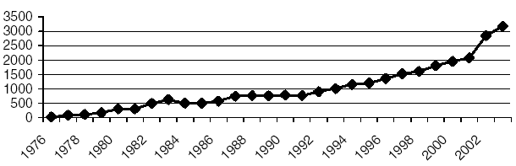
Remittance from migrant
(In million US$)
Year
Fig 1: Remittance flow to Bangladesh (1976 - 2003)

According to Berlage (2003), who have compiled data from a number of information sources, in 1999 Bangladesh was the sixth remittance receiving country in the world in absolute figures. Kuddus (2003) reports that the remittance flow to Bangladesh represents two per cent of the global remittance flow.

Offering an explanation for the evolution in remittances is not easy. Of course the flow of remittances is very much linked to the migration rate. The increase of labor migration to the Middle East in the second half of the 1970s has had its effects on the remittance flow. However, the correlation is not a straightforward one. There is always a time lag: the migrant needs time and money to settle him or herself in the host country. Siddiqui (2003) argues that the emigration rate has been higher than the growth of remittances. She identifies lower wage rates as explanatory factors: Bangladesh has recently

experienced emigration of more unskilled and semi-skilled migrants, whose wages are lower in comparison with the previous wave of skilled emigrants, and simultaneously wage rates in destination countries have fallen drastically in the last decade.

Political turmoil in the countries of destination has also affected the remittance flow. The sluggish growth in the mid-1980s may be attributed to the Iran-Iraq war of that time. A similar correlation might exist between the slow growth rate at the beginning of the 1990s and the Gulf War (Afsar, 2002). It is also assumed that the recent increase is a result of more people sending money through official channels, given the increased attention to anti-terrorism policies.

Puri and Ritzema (1999) list a number of other factors that influence the size of remittances, such as exchange rates, macroeconomic policies, the marital status of the migrant, and the economic activity in the host or sending region or country. Furthermore, the figures of the Bangladesh Bank only reflect the formal remittance flow.

Remittance saw a strong boost in the just concluded 2004-05 financial year, recording a healthy 14.5% growth. According to the Bangladesh Bank (BB) statistics, non-recident Bangladeshis (NRBs) sent US$3866.63 million in the 2004-05 fiscal year, crossing the target by more than $246 million. The target for remittance income for the 2004-05 financial year was set at $3620 million. Remittance inflow maintained a substantial growth in most of the months and in March 2005 it was an all time single month high, amounting to $401 million. NRBs sent $349 million in June 2005. According to a top official of the central Bank, Remittance service through banking channel has improved significantly in the recent years. Besides, anti-money laundering act is becoming stringent in different countries, discouraging people to send money through hundi. Private and Foreign banks are also taking different measures to increase their earnings from remittance service and signing deals with the service providers who have strong networks across the globe. These banks are marketing remittance services very aggressively and providing quick and secured services for their clients, which would push remittance inflow in the coming months.

Currently overseas manpower mostly unskilled labor remittances are major source of our import payments. Remittances from overseas Bangladeshi workers increased significantly from US$1088.72 million in 1993/94 to US$1705.02 million in 1998/99. During 2001/02 remittances stood at US$ 2501.13 million which was US$ 1882.10 million in 2000/01.

NRBs sent $3371.917 million in the 2003-04 financial year. The remittance inflow crossed the three billion mark, amounting to $3061.97 million in the 2002-03 fiscal year for the first time. Besides, NRBs sent $2501.13 million in the 2001-02 fiscal and $1882.10 million in the 2000-2001 fiscal. According to BB statistics remittance inflow saw a negative growth of 3.45% in the 2000-01 financial year. SM Aminur Rahman, managing director of Janata Bank, stated that Increase in the number of remitters apart, new initiatives by banks including opening exchange house abroad, signing deals with other service providers are some of the reasons for augmenting remittance inflow in the last fiscal year. The bank which linked a deal with Western Union last year, will also bring another 150 outlets under its network shortly. Its remittance service recorded over 100 percent growth in the last five months on an average.

Monthly inflow of Remittance
Month | FY 2004-05  US$ million | FY 2003-04  US$ million
July | 286.67 | 258.08
August | 271.68 | 227.68
September | 275.37 | 248.30
October | 297.03 | 308.18
November | 267.30 | 245.41
December | 379.19 | 289.69
January | $316.25 | 357.06
February | $329.05 | 256.32
March | $401.44 | 311.39
April | $373.9 | 283.29

May
June | $349

Source: Bangladesh Bank

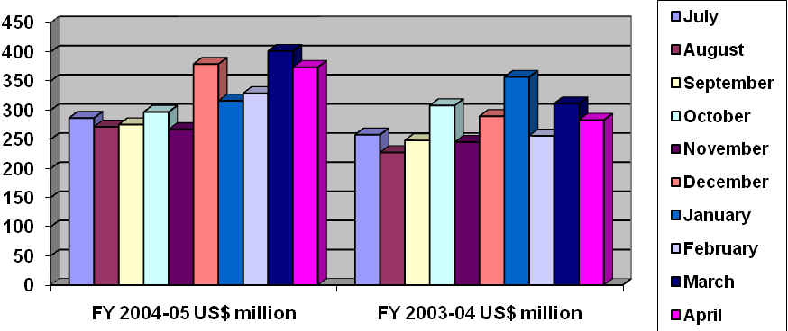

Remittance inflow during the July-April period of the current fiscal year (2004-05) crossed $3 billion mark recording a 14.7% growth over the same period of the previous fiscal year. Statistics available with the Bangladesh Bank revealed that remittance inflow in 10 months of the current fiscal rose to $3.19 billion from $2.78 billion compared to the same period of the previous fiscal. Robust growth of Remittance is maintaining a trend required to achieve the amount programmed in the mid-term macroeconomic framework in the Poverty Reduction Strategy paper which projects $3.6 billion remittance in the current fiscal.

The overseas Bangladeshis have remitted some $373.9 million in April while in March the amount was $401 million. The vibrant remittance flow has played a contributory role in keeping the foreign exchange reserve above $3 billion mark. Over the years, remittance appeared as a significant life line of the economy lowering the pressure on balance of payment.

Country-wise remittance flow into Bangladesh:

The boom in oil revenues in the middle-eastern countries since mid-1970s created large job opportunities for the Bangladeshi workers. According to the official data of Asian Development Bank (ADB), In terms of flows of migration by country of employment from 1976 to 2001, the share of Saudi Arabia is 47 percent, Kuwait 9 percent and UAE 11.5 percent. Currently, nearly 50 percent of the remittances come from Saudi Arabia alone, followed by 15 percent from USA, UK, Germany taken together, 13 percent from Kuwait, and 8 percent from UAE. The share of the middle-eastern countries increased over time accounting for 80 percent of the total remittances in FY2001. Japan and Malaysia together accounted for 4.5 percent of the remittances in FY2000, but only a little over 2 percent of the remittances in FY2001. Country-wise total amount of remittance flow is shown in the figure below.

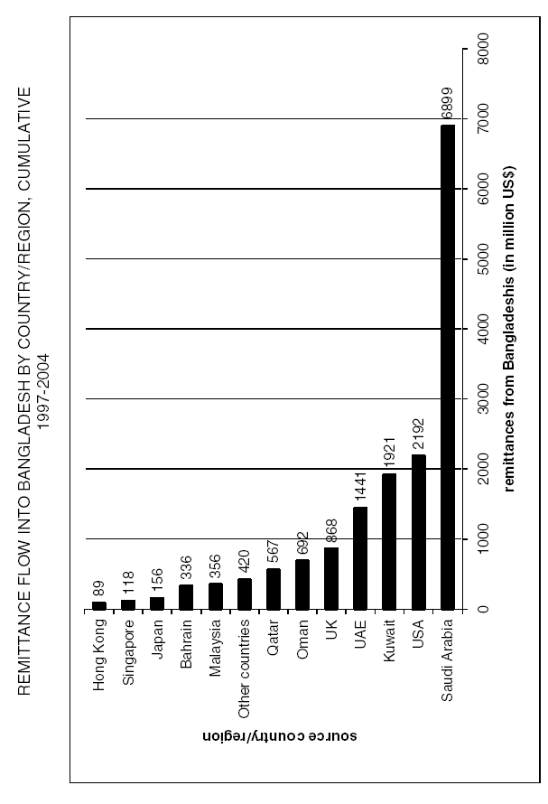

Comparison of remittance flow to Bangladesh and it’s contribution of SEBL:

SEBL is involved with both the form transactions of inward and outward remittance processing service. SEBL started its remittance business in Bangladesh since December, 1996. SEBL tries their level best to increase the flow of remittance through banking channel. Information provided in (Table-1) shows that remittances from migrant Bangladeshi workers increased significantly from US Dollars 3,061.97 million in FY 2002-03 to US Dollars 3,866.63 million in FY 2004-05. Moreover, the inflow of remittances coming through SEBL also increased appreciably from US Dollars 53.95 million in FY 2002-03 to US Dollars 96.93 million in FY 2004-05. In FY 2002-03 the contribution of remittances coming through SEBL was 1.76% of total inflow, where as it stood 2.51% of total inflow in the recent FY 2004-05. During 2003-04 remitting amount was US Dollars 3,371.97 million, where as remittance inflow from SEBL stood at US Dollar 66.34 million which was 1.97% of total inflow. The following statistics shows that remittance flow to Bangladesh has increased through years as well as the inflow coming through SEBL has increased than the past years. Therefore, the percentage of remittance inflow through SEBL also shows a gradual increase.

Table-1:

Comparison of SEBL’s remittance inflow with total foreign remittance inflow in Bangladesh

Year | Foreign Remittance Inflow in Bangladesh (US$ million) | Foreign Remittance Inflow through SEBL (US$) | Foreign Remittance Inflow through SEBL (US$ million) | Remittance percentage of SEBL with total remittance inflow in Bangladesh
FY 2002-2003 | 3,061.97 | 53,948,160.78 | 53.95 | 1.76
FY 2003-2004 | 3,371.97 | 66,344,704.83 | 66.34 | 1.97
FY 2004-2005 | 3,866.63 | 96,930,340.02 | 96.93 | 2.51

Source: Bangladesh Bank and Remittance Department of SEBL

Note: Calculation:

Remittance % of SEBL with total remittance inflow in Bangladesh

Foreign Remittance Inflow through SEBL (US$ million)

= Foreign Remittance Inflow in Bangladesh (US$ million) * 100

Comparison of Remittance Inflow through Foreign, Private and Public Banks:

Public banks are more active and aggressive in remittance business comparing with foreign and private banks operating in Bangladesh. Sonali Bank, Agrani Bank and Pubali bank is major player in this field. According to the Bangladesh Bank statistical data, the leading bank in the remittance business is Sonali Bank. In 2001, remittance collected by Sonali Bank was about 42.25% of total inflow. Data presented in (Table-4) revealed that in 2002, remittances came through Sonali Bank stood at US Dollars 740,862.06 thousand which was US Dollars 741,551.72 thousand in 2003. Branches of the public banks are spreading over the urban and remote rural areas of Bangladesh. Sonali Bank has 1,294 local branches throughout Bangladesh. Public banks are promoted with their excellent remitting services and wide network to facilitate homebound remittance. Public banks have their subsidiary company, representative and agency offices in most of the middle-eastern countries and in UK and United States.

Table-4:

Comparison of Remittance Inflow of Foreign, Private and Public Banks:
Type of Bank | Year  Bank | FY 2002-2003  (In thousand US$) | FY 2003-2004  (In thousand US$)
Foreign Bank | SEBL | 53,948.16 | 66,344.70

Type of Bank | Year  Bank | 2002  (In thousand US$) | 2003  (In thousand US$)
Private Bank | Southeast Bank | 7,859.17 | 10,273.28
Public Bank | Sonali Bank | 740,862.06 | 741,551.72

Source: Foreign Remittance Section of authorized banks.

Remittances coming through foreign banks are higher than the amount comes from private banks. Among the private banks Islami bank limited is the major player in handling remittance. BRAC Bank limited has already installed online system in 300 outlets of total 1,400 outlets across the country and extended it’s remittance service to rural areas. Remittance inflow from Southeast bank was US Dollars 7,859.17 thousand in 2001 and US Dollars 10,273.28 in 2002. Where as, remittances came through SEBL was US Dollars 53,948.16 thousand in FY (2002-03) and US$ Dollars 66,344.70 thousand in FY (2003-04). Public banks have their outlets in urban as well as in remote rural areas that foreign banks does not have. To place the remitting amount to rural areas transactions are drawn on the third bank and most of the time on public banks.

Remittance Process at SEBL:

Transfer of funds from one country to another country goes through a process which is known as remitting process. The bank has corresponding relationship with the group banks and maintaining ‘Nostro Account’ with other foreign banks in US Dollars. Bangladeshi expatriates are sending foreign remittances to their local beneficiaries through that account. Therefore, when the Bangladeshi expatriates through other banks of different countries or through the group banks of SEBL remit the fund to their ‘Nostro Account’ then the remittance department of SEBL receives online messages. These messages are hold into the pending files according to different currency. After verifying signature, checking the account number, reference number, and name of the beneficiary, the remittance section transfers the amount to the account of the beneficiary. SEBL has four branches in Dhaka and one in Chittagong and does not have any branch in other urban and as well as in the remote rural areas. Therefore, the complexity arises, if the beneficiary does not maintain his/her account with any of the branches of SEBL. In these cases SEBL has to take help from a third bank, which has branch over there, where the beneficiaries maintain their accounts.

Foreign inward remittance transactions are held through TT (Telegraphic Transfer), DD (Demand Draft), (M.T) Mail Transfer and CO (Cashier’s Order). Besides these, inward remittances transactions also constitute purchases of bills, purchases of drafts under Travellers' Letters of Credit (L/C) and purchases of Travellers' Cheques (T.C).

MBL, Bangladesh
Nostro Account
Group Bank/ Other Foreign Bank

Beneficiary
Remitter

Fig-3: Transfer of funds through remitting process

SEBL as a foreign bank divide their daily transactions into two parts through sorting. Remittances comes through their group banks which indicates from other country’s SEBL bank are keep separated and Remittances comes through non group bank which means from other foreign banks are separated to check the cover; where amount, reference numbers, date are checked. In case of non group bank payments are given upto this date. During the time of sorting foreign currency to foreign currency and foreign to local currency transactions are keep separated and processed separately. Other things being considered in the time of sorting are whether these transactions are held between person to person, person to company, company to company, or company to person. In case of person to person payment will be given directly. If the amount is equivalent to $2000 and above, then the bank will issue Proceed Realization Certificate (PRC). If transactions are held between person to company then bank will ask for ‘Form C’ to know the purpose. For company account if the transactions are held equivalent to $2000 or above then the company should provide ‘Form C’ to declare the purpose. SEBL group banks and some other foreign banks maintains ‘Vostro account’ in Bangladeshi local currency (Taka) with SEBL Bangladesh for the smooth transaction of foreign to local currency amounts. On the other hand, SEBL Bangladesh also maintains ‘Nostro account’ in foreign currencies with other foreign banks and with their group banks. SEBL tries to provide better remitting service to their customers by offering attractive exchange rate. They consider some special corporate customers to whom they provide special consideration by offering higher exchange rate than normal. SEBL as a foreign bank operating in Bangladesh looking forward and trying to generate more remittance inflow by providing smooth remitting facilities.

Introduction:

GDP equals the sum of the four types of expenditure algebraically as:

Y= C+I+G+NX, where Y=gross domestic product or output.

C= consumption expenditure.

I= private sector Investment

G= government purchases

NX= net exports.

GDP and as well as the components of GDP as exports, imports, consumption and investment is greatly affected by the foreign remittance inflow of a country. Considering Bangladesh economy, remittance is a major contribution of GDP, export and import. In 1999, remittance inflow was 4.21% of GDP, 28.10% of export and 19.88% of import. In FY-2001 Remittances into Bangladesh were equivalent to 29% of merchandise exports and was 4.2% of GDP. In Bangladesh, 4.8% of remittances are used for investment in business and 3.1% is used for savings (Afsar, 2001). The trend, contribution and effect of remittance on GDP, exports, imports, consumption, savings and investment is discussed in the paper considering the Bangladesh economy.

Remittance and it’s contribution to GDP:

Puri and Retzema (1999) revealed that the role of remittance is frequently understood by calculation of remittances as a percentage of the macroeconomic indicators such as gross national product (GNP), gross domestic product (GDP) or government expenditures. The most meaningful comparison is with exports and imports, a comparison which stresses the relative contribution of remittances to foreign exchange earnings, the importance of the ‘labour export industry’ and the role of remittances in the consumption, savings and investment scheme. Remittances are above 5% of GDP for 19 countries in the sample studied.

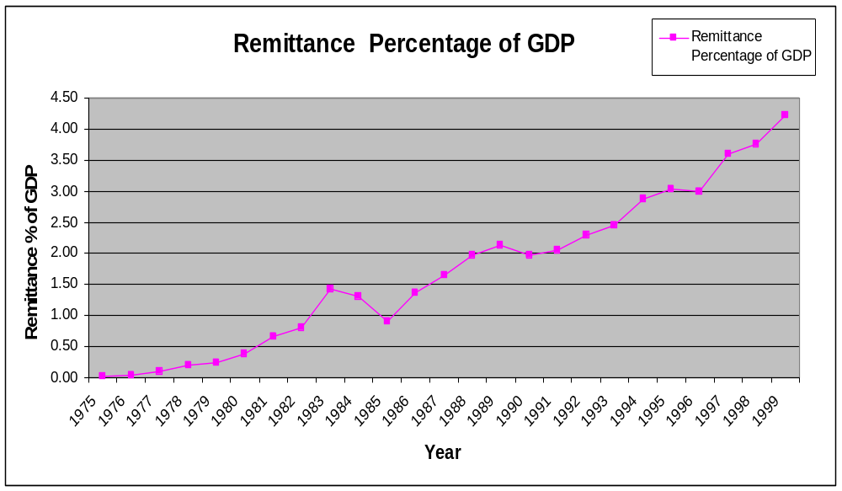

Fig-1: Remittance as a Percentage of GDP

Bangladesh’s overseas workers contribute immensely to the economy with strong positive impact on economic growth, employment, and balance of payments. Since 1976, about 3.3 million workers went abroad and cumulative remittances since then amounted to around $21 billion. (ADB, 2001). Contribution of remittance on GDP is gradually increasing. Comparing the data from 1975 to recent data it is found that the contribution of remittance on GDP is higher and increasing gradually from the past years. From (Fig-1) and according to the information available in (Appendix-C); it is found that in 1975 total amount of remittance was US$ 8.5 million, which was 0.01% of GDP. While in 1980, remittances became US$197.4 million or 0.38% of GDP and the real GDP stands for US$ 52,010.05 million. In the year of 1985, the amount of remittance though slightly reduced to US$ 363.7 million than the previous year amount of US$ 526.6 million in 1984. The contribution of remittance inflow on GDP was 0.90%. After 1985, the inflow of remittance was again increased gradually.

The amount of real GDP is declining than the past years. In 1970, the amount was in the peak and stands for US$ 144,345.43 million, which is the ever highest total so far. Since 1965 to 1975 the total amount of real GDP was comparatively higher, which was US$ 122,544.40 million and US$ 74,030.15 million respectively. After that the real GDP fluctuates in a constant manner. From 1976 to 1999 Real GDP holds on US$ 46,126.08 and 40,469.65 respectively.

The contribution of remittance in the economy is higher than the past. Regarding the foreign Remittance inflow on GDP, the percentage was 0.90, 1.98, 3.03 and 4.21 in the year 1985, 1990, 1995 and 1999 respectively. The impact of remittance in the economy provides a positive indicator. According to ADB, the remittances rose to $ 2.0 billion or 4.2% of GDP in 2001, implying an average annual growth rate of 8.6%.

The amount of real GDP fluctuates in a constant manner. On the other hand, the amount of remittance is increasing gradually. So, the remittance percentage of GDP is higher than the past years and gradually increasing.

Remittance and it’s contribution to Exports:

Remittance can be considered as a form of export. Every year Bangladesh earns a huge amount of foreign earnings through exporting manpower to other countries. In the recent financial year (2004-05) the amount stands for US$3,866.63 million.

Through Exporting manpower from Bangladesh to many countries, the country earns a huge amount of foreign earnings. Haque (2004) connoted that remittance from the Bangladesh National working abroad is now the highest source of foreign exchange earning of the country as the earnings from the major exporting sector of readymade Garment (RMG) has already decreased in the recent period. On the other hand, earning from RMG is not net. But the earning from remittance is net. The importance of remittance for the national economy has become more pronounced in the wake of pre quota-free period of readymade garment sector.

Athukorala (1993), Swamy (1981), and Brown (1995) suggest that, for a number of countries, the level of remittances is very significant in proportion to the country’s merchandise exports. In Bangladesh, remittances were equivalent to about 44 percent of total merchandise exports in 1993. The contribution of remittance in Bangladesh is much higher than other Asian and South Asian countries. In India, remittances were equivalent to about 13 per cent in 1990; in the Philippines, about 22 per cent in 1993; and in Pakistan, about 24 per cent in 1993.

Russell 1986, Keely and Tran 1989, Massey 1992, Taylor and Irma (1996) revealed that at a macroeconomic level, remittances often provide a significant source of foreign currency, increase national income, finance imports and contribute to the balance of payments.

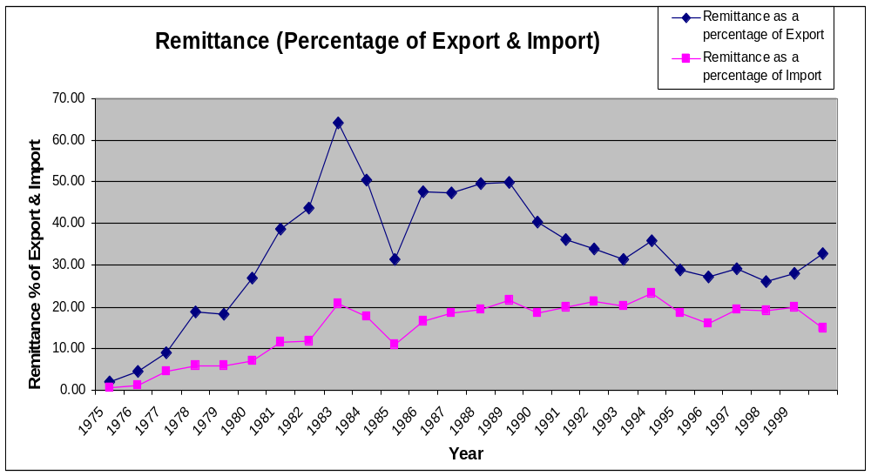

Fig-2: Remittance (Percentage of Export & Import)

The amount of remittance grew in the recent years. It has a major contribution to the total export earnings of the developing country Bangladesh. Export earnings from goods & services are also increasing than the past years. From (Fig-2) and according to the information available in (Appendix-D); it can be stated that in the year of 1975, remittance receipts was $8.5 million, export earnings stands for $ 412.66 million and the inflow of

remittance was 2.06% of Export. In 1980 this percentage increased to 26.99% of export. At the same time, remittance inflow is rising and this resulted in a gradual increase in the share of contribution with export. Regarding the contribution of foreign remittance inflow with export earnings, the percentage was 31.24, 40.44, 28.91 and 28.10 in the year 1985, 1990, 1995 and 1999 respectively. In average remittances are equivalent to 32.75% of the total exports. In the year of 1983, the rate of percentage was ever time peak, which was 64.17% of export so far.

Export earnings from goods and has increased than past years and gradually increasing. The amount of total earnings from export were US$ 731.41 million, US$ 1164.26 million, US$ 1881.68 million, US$ 4,143.90 million, US$ 6,063.80 million in the year 1980, 1985, 1990, 1995 and 1999 respectively. Export earnings are increasing and remittance as a part of export earnings is also gradually increasing in the same manner. According to the ADB report the current level of remittances is able to offset 65 percent of the trade deficit of the country. Remittances into Bangladesh were equivalent to 29 percent of merchandise exports and 144 percent of official reserves in FY2001.

Remittance and it’s contribution to Imports:

Moreover, these researchers view remittances as unpredictable and as a cause of increasing inequality. Also remittances are frequently spent on imported consumer goods, rather than locally produced ones, decreasing the potential multiplier effect of the money and increasing import demand and inflation (Russell, 1986 & Martin, 1990). The availability of foreign exchange, together with growing demand for consumer goods not available in the domestic market, has been linked with a rising demand for imported goods.

The availability of foreign exchange, together with growing demand for consumer goods not available in the domestic market, has been linked with a rising demand for imported goods. (Puri & Retzema 1999).

According to the ADB report, Bangladesh’s current ratio of import to GDP is around 20 percent and debt service payments are equivalent to 7.5 of foreign exchange earnings. Remittances financed 20 percent of the imports in FY2001.

Remittance increased the demand of import goods and creates inflation can be considered as the negative impact in the economy. Though the export earnings are increasing gradually but at the same time the import amount is also increasing. Import is always exceeded the amount of export. The import amount was US$ 1,346.65 million, US$ 2,776.50 million, US$ 3,346.27 million, US$ 4,108.87 million, US$ 6,448.70 million, US$ 8,572.38 million in the year of 1975, 1980, 1985, 1990, 1995 and 1999 respectively. Where as export

amount stands for US$ 412.66 million, US$ 731.41 million, US$ 1,164.26 million, US$ 1,181.68 million, US$ 4,143.90 million, US$ 6,063.80 million in the year of 1975, 1980, 1985, 1990, 1995 and 1999 respectively.

From (Fig-2) and according to the information provided in (Appendix-D); it can be revealed that remittances contribute a major share of total import. Remittances financed 0.63, 7.11, 10.87, 18.52, 18.58, 19.88 percent of the imports in the year of 1975, 1980, 1985, 1990, 1995 and 1999 respectively. In average remittances are equivalent to 14.76% of the total imports.

Without the remittances, either the country’s imports would have to be drastically cut down or its current account deficit risen to highly unsustainable levels. Currently, remittances are higher than the combined flows of foreign aid disbursements and foreign direct investments. Overall, remittances are supporting economic development of the country in a significant way. (ADB report, 2001).

CHAPTER SIX

FINANCIAL STATEMENT

PARTICULARS OF FINANCIAL STATEMENT (2001-2005)

(In Million Taka)

(BDT in Million)
Particulars | 2001 | 2002 | 2003 | 2004 | 2005
Income Statement
Interest Income | 964.59 | 1281.19 | 1558.67 | 2120.82 | 2720.38
Interest Expenses | 700.99 | 923.11 | 1115.82 | 1509.00 | 1987.16
Net Interest Income | 263.60 | 358.08 | 472.85 | 611.82 | 733.22
Non- Interest Income | 304.31 | 311.11 | 404.05 | 596.85 | 752.13
Non- Interest Expenses | 163.75 | 207.95 | 298.58 | 386.91 | 518.12
Net Non- Interest Income | 140.56 | 103.16 | 102.47 | 209.94 | 234.01
Profit Before Provision and Tax | 404.16 | 461.24 | 575.2 | 821.76 | 967.23
Profit After Provision Before Tax | 374.96 | 429.04 | 427.32 | 554.26 | 703.33
Profit After Tax | 214.96 | 256.54 | 215.91 | 312.58 | 386.83
Balance Sheet
Authorized Capital | 1200.00 | 1200.00 | 1200.00 | 1200.00 | 1200.00
Paid-up capital | 276.85 | 319.77 | 639.53 | 799.41 | 999.27
Total Capital | 596.44 | 684.56 | 1235.23 | 1617.81 | 2045.85
Deposits | 12234.70 | 15150.42 | 16285.19 | 22385.19 | 25727.43
Loans and Advances | 6707.42 | 8896.19 | 10775.95 | 17669.29 | 21857.05
Investment | 882.47 | 1382.29 | 2107.26 | 3108.51 | 3517.68
Fixed Assets | 67.76 | 69.55 | 81.50 | 103.54 | 366.80
Total Assets | 13085.86 | 16383.17 | 18324.73 | 24098.09 | 28890.48
Foreign Exchange Business
Import | 12268.00 | 15112.50 | 20380.80 | 28325.20 | 33271.90
Export | 10457.50 | 11377.30 | 15250.60 | 17411.00 | 24108.57
Remittance | 308.40 | 496.30 | 474.00 | 671.30 | 679.10
BIS Capital Measures
Total Risk Weighted Assets | 6170.50 | 8437.55 | 11788.09 | 15793.41 | 19693.04
Core Capital (Tier l) | 527.19 | 594.09 | 1129..77 | 1442.35 | 1829.19
Supplementary Capital (Tier ll) | 69.25 | 90.46 | 105.46 | 175.46 | 216.66
Tier l Capital Ratio | 8.54% | 7.04% | 9.58% | 9.13% | 9.29%
Tier ll Capital Ratio | 1.12% | 1.07% | 0.90% | 1.11% | 1.10%
Tota Capital Ratio | 9.66% | 8.11% | 10.48% | 10.24% | 10.39%

Source: Annual Report 2005, SEBL
(BDT in Million)
Particulars | 2001 | 2002 | 2003 | 2004 | 2005
Credit Quality
Non-Performing Loans (NPLs) | 5.16 | 37.49 | 444.02 | 726.17 | 905.74
Provision for Unclassified Loans | 66.94 | 88.14 | 103.14 | 173.14 | 214.34
Provision for Classified Loans | 1.30 | 12.30 | 145.30 | 342.80 | 523.00
% of NPLs, Total Loans &  Advances | 304.31 | 311.11 | 404.05 | 596.85 | 752.13
Share Information
Share price (BDT) |  |  |  | 540.00 | 390.75
No. of share outstanding (‘000) | 2768.50 | 3197.65 | 6395.30 | 7994.12 | 9992.65
Earning per share (BDT)
Basic | 70.59 | 84.24 | 57.88 | 31.28 | 38.71
Diluted | 70.59 | 84.24 | 57.88 | 31.28 | 38.71
Dividend per share (BDT) | 40.00 | 40.00 | 25.00 | 25.00 | 25.00
Cash (BDT) | 30.00 | 35.00 |  |  | 5.00
Stock | 1:10 | 1:20 | 1:4 | 1:4 | 1:5
Dividend Yield (%) |  |  |  | 4.63% | 6.40%
Dividend Payout Ratio | 56.67% | 47.448% | 43.19% | 63.94% | 64.58%
Market Capitalization |  |  |  | 4316.83 | 3904.63
Book Value Per Share (BDT) | 215.44 | 214.08 | 193.16 | 202.38 | 204.74
Market Value Book Value Multiple |  |  |  | 2.67x | 1.91x
Price Earning Multiple |  |  |  | 17.26x | 10.09x
Operation Performance Ratio
Net Interest Margin | 3.13% | 3.16% | 3.36% | 3.24% | 3.05%
Net Non- Interest Margin | 1.67% | 0.91% | 0.73% | 0.74% | 0.97%
Earning Base in Assets | 96.35% | 93.26% | 91.59% | 93.88% | 90.40%
Operating Efficiency Ratio | 68.15% | 71.06% | 71.09% | 69.76% | 72.15%
Credit Deposit Ratio | 92.55% | 89.20% | 74.38% | 89.30% | 91.68%
Cost of Funds | 8.42% | 8.32% | 8.24% | 8.10% | 8.42%
Return on Assets | 1.91% | 1.74% | 1.24% | 1.47% | 1.46%
Return on Equity | 43.58% | 40.05% | 22.49% | 21.91% | 21.12%
Equity Multiple | 21.94x | 23.93x | 14.84x | 14.90x | 14.12x
Other Information
No. of Branches | 14 | 15 | 20 | 25 | 28
No. of Employees | 305 | 363 | 492 | 544 | 663
No. of foreign Correspondents | 145 | 215 | 240 | 255 | 266

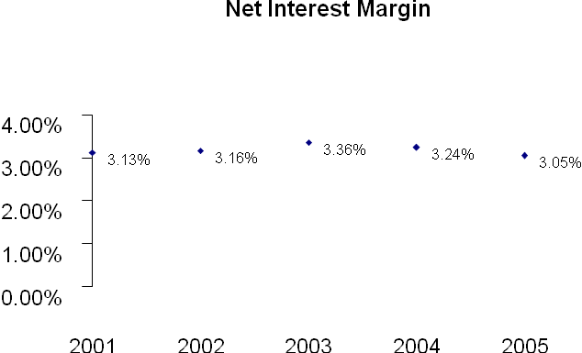

Source: Annual Report 2005, SEBL

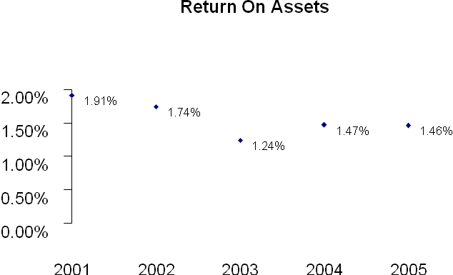

Source: Annual Report 2005, SEBL

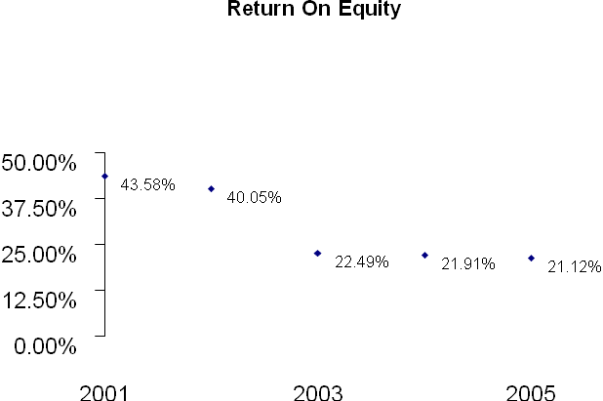

Source: Annual Report 2005, SEBL

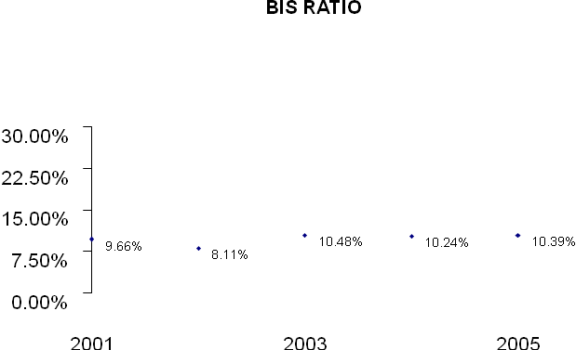

Source: Annual Report 2005, SEBL

Balance Sheet

As at December 31, 2005

(BDT in million)
 | 2004 | 2005

Property and Assets
Cash | 1,013,170,468 | 1,878,414,994
Cash in hand (Including Foreign Currencies) | 179,769,611 | 208,905,722
Balance with Bangladesh Bank and Sonali Bank  (Including Foreign Currencies) | 833,400,857 | 1,669,509,272
Balance with other Banks and Financial Institutions | 513,571,708 | 118,193,803
In Bangladesh | 478,580,016 | 48,427,752
Outside Bangladesh | 34.991.692 | 69,766,051
Money at Call and Short Notice | 1,332,000,000 | 625,000,000
Investments | 3,108,512,490 | 3,517,678,890
Government | 2,973,512,490 | 2,549,191,890
Others | 135,000,000 | 968,487,000
Loans and Advances | 17,669,292,271 | 21,857,054,328
Loans, Cash Credit, Overdraft etc | 16,766,308,540 | 20,065,170,273
Bills Purchased and Discounted | 902,983,731 | 1,791,884,055
Fixed Assets Including Premises, Furniture and Fixture | 103,542,046 | 366,799,715
Other Assets | 358,004,300 | 527,342,014
Non Banking Assets | - | -
Total Assets | 24,098,093,283 | 28,890,483,744

Liabilities And Capital

Liabilities
Borrowing form other Banks, Financial  Institutions and Agents | 14,700,000,000 | 640,000,000
Deposits and other Accounts | 19,754,174,237 | 24,661,152,142
Current Accounts and other Accounts | 2,539,936,957 | 3,684,669,671
Bills p\Payable | 359,406,512 | 415,449,115
Savings Bank Deposits | 1,199,958,915 | 1,473,576,664
Fixed Deposits | 6,971,499,286 | 8,787,553,771
Bearer Certificates of Deposits | 25,239,025 | 21,343,516
Deposits Under Scheme | 8,658,133,542 | 10,278,579,405
Other liabilities | 1,201,567,289 | 1,760,146,200
Total liabilities | 22,655,741,526 | 27,061,298,342

Capital/Shareholders’ Equity
Paid-up Capital | 799,412,500 | 999,265,600
Statutory Reserve | 391,882,622 | 532,549,402
Other Reserve | 45,680,250 | 45,680,250
Surplus in Profit and Loss Account | 205,376,385 | 251,690,150
Total Shareholders’ Equity | 1,442,351,757 | 1,829,185,402
Total Liabilities and Shareholders’ Equity | 24,098,093,283 | 28,890,483,744

Source: Annual Report 2005, SEBL

Off Balance Sheet Items

As at December 31, 2005

(BDT in million)
 | 2004 | 2005

Contingent Liabilities
Acceptance and Endorsements | 3,662,893,640 | 5,918,108,640
Letter of Guarantee | 1,180,312,925 | 2,702,164,347
Irrevocable Letter of Credit | 6,411,295,819 | 6,021,240,691
Bills for Collection | 43,604,165 | 32,733,864
Other Contingent Liabilities | - | -
Total | 11,298,106,549 | 14,674,247,542

Other Commitments
Documentary credit and short term trade related transaction | - | -
Forward assets purchased and forward deposits placed | - | -
Undrawn note issuance and revolving underwriting facilities | - | -
Undrawn formal standby facilities, credit lines and other  commitments | - | -
Total | - | -
Total Off-Balance Sheet Items including contingent liabilities | 11,298,106,549 | 14,674,247,542

Profit and Loss Account

For the year ended December 31, 2005

(BDT in million)
 | 2004 | 2005
Interest Income | 1,918,808,684 | 2,405,443,584
Less: Interest Paid on Deposits, Borrowings etc. | 1,508,998,033 | 1,987,160,265
Net Interest Income | 409,210,651 | 418,283,319
Investment Income | 219,810,099 | 314,935,036
Commission, Exchange and Brokerage | 485,357,039 | 559,813,747
Other Operating Income | 94,289,760 | 192,323,014
 | 799,456,898 | 1,067,071,797
Total Operating Income | 1,208,667,549 | 1,485,355,116
Salaries and Allowances | 214,607,313 | 278,131,091
Rent, Tax, Insurance, Electricity, etc. | 55,206,395 | 69,653,97
Legal Expenses | 527,270 | 2,485,159
Postage, Stamp, Telecommunication, etc. | 12,990,096 | 16,215,951
Stationary, Printing, Advertisements etc. | 25,777,355 | 33,365,394
Chief Executive’s Salary and Fees | 2,027,775 | 4,750,000
Directors’ Fees | 1,504,225 | 1,349,700
Auditors’ Fees | 100,00 | 250,000
Depreciation and Repair of Fixed Assets | 19,961,539 | 30,327,854
Other Expenses | 54,204,155 | 81,592,100
Total Operating Expenses | 386,906,123 | 518,121,216
Profit Before Provision | 821,761,426 | 967,233,900
Provision for Classified Loans and Advances | 197,500,000 | 180,200,000
Provision for Unclassified Loans and Advances | 70,000,000 | 41,200,000
Provision for Fixed Assets | - | 42,500,000
Total Provision | 267,500,000 | 263,900,000
Total Profit Before Taxes | 554,261,426 | 703,333,900
Provision for Taxation | 241,680,000 | 316,500,255
Net Profit After Taxation | 312,581,426 | 386,833,645
Retained Surplus brought forward from previous year | 3,644,959 | 5,523,285
 | 316,226,385 | 392,356,930

Appropriations
Statutory Reverse | 110,850,000 | 140,666,780
Retained Surplus | 205,376,385 | 251,690,150
 | 316,226,385 | 392,356,930
Earning Per Share (EPS) | 31.28 | 38.71

Source: Annual Report 2005, SEBL

Statement of Changes in Equity

For the year ended December 31, 2005

(BDT)
 | Paid-up  Capital | Statutory  Reverse | Other  Reserve | Surplus  Profit/(Loss) | Total
Balance as at 01 January 2005 | 799,4121,500 | 391,882,622 | 45,680,250 | 205,376,385 | 1,442,351,757
Changes in Accounting Policy | - | - | - | - | -
Restated Balance | - | - | - | - | -
Surplus/Deficit on Account of revaluation of properties | - | - | - | - | -
Surplus/Deficit on Account of revaluation of investment | - | - | - | - | -
Currency transaction difference | - | - | - | - | -
Net gains and losses not recognized in income statement | - | - | - | - | -
Net profit for the year after taxation | - | - | - | 386,833,645 | 386,833,645
Transfer | - | 140,666,780 | - | (140666,780) | -
Issuance of Bonus Share | 199,853,100 | - | - | (199853,100) | -
Bonus Share Premium | - | - | - | - | -
Proposed Cash Dividend | - | - | - | - | -

7.0 CHAPTER SEVEN

ANALYSIS AND FINDINGS

7.1 SWOT ANALYSIS

Not surprisingly, in the competitive arena of marketing era SWOT analysis is a must based on Product, Price, Place and Promotion of a financial institution like private bank. SWOT analysis helps the bank reconstruct different sorts of shortcomings of the bank. From the SWOT analysis we can figure out ongoing scenario of the bank. So to have a better view of the present banking practices of SEBL, I did the SWOT analysis.

In SWOT analysis two factors act as prime movers:

Internal factors, which are prevailing inside the concern, which include strength and weakness.

On the other hand another factor is external factor, which act as opportunity and threat.

Strength related to Credit operation: Huge Capital Fund: Southeast Bank Limited has a authorized Capital of Tk. 3000 million and the Paid -up Capital of Tk. 1199.12 millions. Practically this is the second largest bank in the private sector in terms of capital fund and is next to Islamic Bank Bangladesh Limited. This huge capital fund has increased the business power of the company as the maximum amount of loan that can be disbursed to a single customer or group depends on the capital fund. This is because no bank can give funded facility more than 15% of its capital fund to a single customer as per central bank directive which was done to avoid concentration of credit and risk exposure.

Delegation of Credit sanctioning authority: Unlike many other banks Southeast Bank Limited believes in the authority delegation among the executives of the bank depending on the hierarchy. The bank has authorized its executives and branch managers to sanction and disburse loans depending upon the security offered by the customer. This has improved the processing of loans and accelerated credit approval. Customers do not have to wait for long time indecisively. This faster service has been successful to address the immediate fund requirement of the customers.

Segregation of Corporate division from the credit risk management and credit Administration unit: The Bank in line with the Bangladesh Bank directive has segregated credit risk management unit from credit administration and sanctioning unit. Corporate division functions as the credit marketing unit and sends the potential lending proposals to the credit risk management unit where the lending proposals are meticulously scrutinized to judge the financial feasibility and repayment capacity of the customer. Credit administration unit monitors the repayment of the loans and supervises documentation. This has helped to improve asset quality of the bank and reduce default loans.

Involvement of high caliber young personnel: Southeast Bank believes in the power, speed and capacity of younger generation. The bank has thus involved very young and promising young in its credit operation. These people with great analytical ability and speed have significantly bettered the credit processing.

Sectoral Allocation of Credit: The Board of Directors of the bank has put the ceiling on the amount of loan that can be sanctioned in a single industry. This has great significance as the bank loan is diversified among different industries. So the possibility of failure due to down turn in any industry is low.

Efficient Fund Management: The treasury department of the bank is very skilled in fund raising in terms of matching the maturity of its deposit and loans. The bank takes deposits with the minimum interest rate to maintain the spread.

Emphasis on Small and Medium Enterprises: Small and Medium Enterprises are expected to be the growth engine of the economy of all developing countries in the near future. This is because these countries suffer from lack of sufficient investment capital and technology to compete with the developed countries. Southeast Bank Limited eyeing the opportunities for growth in the sector has formed a special small and medium enterprise unit. This unit takes care of all investment proposals under the head of SME finance. These customers are highly remunerative as they not tough bargainers and stay loyal to the bank. And the possibility of bank’s failure due to default is less.

Augmented focus of Retail Credit: Since all the big customers are highly price sensitive they are not highly remunerative to the bank. Southeast Bank has formed a retail credit unit to look after the retail credit aimed at increasing the living standard of the people. The bank is trying to inflate the retail credit portfolio. Although the possibility of default is to some extent higher retail credit is remunerative. Again the possibility of bank’s failure is low.

Weaknesses

Non-availability of high technology: Southeast Bank has not yet installed any state-of-the art software and ATM machines. This has created some difficulties for the marketing as the customers now want all services under one roof. Southeast Bank is dealing with some foreign companies to install its high technology software.

Reliance on Sufficient Collateral: Southeast Bank Limited is reluctant to sanction loan in favor of business firms with insufficient collateral security. This is practically important for small customers who are new to the bank. The requirement of collateral security in many cases keeps firms away from bank’s credit which has reduced profitability.

Absence of Recovery agent: There is no external firm for recovery of stuck up loans. Thus many officers of the branch are engaged in recovery which retards service to customers and productivity.

Opportunities

Government Support: Government of Bangladesh has rendered its full support to the banking sector for a sound financial status of the country, as it has become one of the vital sources of employment in the country now. Such government concern will facilitate and support the long-term vision of Southeast Bank Limited.

Evolution of E-Banking: Emergence of e-banking will open more scope for the bank to reach the clients not only in Bangladesh but also in the global banking arena. Although the bank has already taken step to enter the world of e-banking but yet to provide full electronic banking facilities to its customer.

Banking and information technology: Banking and information technology might give the bank leverage to its competitors. Nevertheless there are ample opportunities for Southeast Bank to go for product innovation in line with the modern day need.

Threats

Mergers and Acquisition: The worldwide trend of merging and acquisition in financial institutions is causing concentration. The industry and competitors are increasing power in their respective areas.

Poor Telecommunication Infrastructure: As previously mentioned, the world is advancing e-technology very rapidly. Though Southeast Bank Limited has taken step to join the stream of information technology, it is not possible to complete the mission due to the poor technological infrastructure of our country.

Frequent Currency Devaluation: Frequent devaluation of Taka and exchange rate fluctuations and particularly South-East Asian currency crisis adversely affects the business globally.

Emergence of Competitors: Due to high customer demand, more and more financial institutions are being introduced in the country. There are already 52 banks of various types are operating in the country. Many banks are entering the market with new and lucrative products. The market for banking industry is now a buyer dominated market. Unless Southeast Bank Limited can come up with attractive financial products in the market, it will have to face steep competition in the days to come.

7.2 Highlights

For the year 2006 and 2005

(BDT in Million)
Particular | 2006 | 2005
Paid-up Capital | 1,199.12 | 999.27
Total Capital Fund | 2,554.29 | 2,045.85
Capital Surplus (Deficit) | 401.50 | 273.47
Total Assets | 37,159.65 | 28,890.48
Total Deposits | 33,317.65 | 25,727.43
Total Loans and Advances | 26,842.14 | 21,857.05
Total Contingent Liabilities and Commitments | 20,627.47 | 14,674.25
Credit Deposit Ratio (%) | 85.16 | 91.68
Percentage of Classified Loans against Total Loans and advances (%) | 3.79 | 4.14
Profit after Tax and Provision | 494.22 | 386.83
Amount of Classified Loans during the year | 112.25 | 179.57
Provision kept against Classified Loans | 594.00 | 523.00
Provision Surplus (Deficit) | 0.0081 | 0.18
Cost of Fund (%) | 9.00 | 8.42
Interest earnings Assets | 32,882.99 | 26,117.92
Non interest Earning Assets | 4,276.66 | 2,772.55
Return on Investment (%) | 8.76 | 9.51
Return on Assets (%) | 1.50 | 1.47
Income from Investment | 369.12 | 314.94
Earning Per Share (BDT) | 41.22 | 32.26
Net Income Per Share (BDT) | 41.22 | 32.26
Price Earning Ratio | 9x | 10x

Source: Annual Report 2006, SEBL

7.3 Findings

Southeast Bank is an authorized dealer branch. Though customer are satisfy there not highly satisfy with there services. All kinds of transaction are occurred here. But they have to face different kinds of problems in this Branch, Like in General Division, Advance Division, Foreign Exchange Division all of three division finding some problems are as below :

Delay in transaction and over the counter for this reason the customer very finds that there is long queue in the counter. The reason of such queues due to the lack of initiative of the concern officers.

Absence of modern technology so works delay and it does not compete with other Bank.

In Foreign remittance previously customer need only nationality certificate. But now change of the rules they need passport and ICDC Number. So sometime people face problem for this new rules.

Discourteous Behavior by staff and officers very often it is found that customer and a member including branch manager on some occasion are found in heated discussion.

Lack of Team work is a major problem in general section. It is one of the most important criteria for development of customer service in this branch.

In Advance Division they face the various problems to recovery the loan installment. The loan installment does not realize in the proper time for that reason this branch may be assign as a problem bank.

IBP (Inland Bill Purchase) is a risky business it is one of the main business in this branch. There are many IBP party in this branch but there not big party. IBP limit is very small so many times then face some problem. For that reason advance is not increase. Big L/C amount and the bank Purchase the big amount.

The limit of UHRL (Uttara House Repairing Loan) only 15 lacs.

Sometimes the valuation of properties are does not calculate properly for that reason customer is sufferer. It does not offer various loan projects than other Bank.

In Foreign Exchange Division there main problems is lack of manpower for that reason the employee does not complete the job in time.

In the Foreign Exchange document systems are not moderns so employee wastes their time for looking document for in time.

Decisions are centralized.

As an authorized dealer branch, they always need to correspondent with others.

In credit and foreign exchange section has to proper different types of loans and L/C proposal. But they have only three computers in the whole branch.

Broad Band line is suitable instead of on line care systems. Lack of on line banking the work is slow.

In general banking system they follow the traditional banking system. The entire general banking procedure is not fully computerized.

Lack of verity of services is also a drawback of the general banking area of the Southeast Bank. The bank provided only some traditional limited services to its clients. As a result the bank is falling behind in competition.

They are not using Data Base Networking in IT department. So they have to transfer data form branch to branch and branch to Head Office by using floppy disk and it is not a good system.

In cash of online banking service Mercantile Bank charge is Tk.1000.00 yearly, which is high compare with the other bank.

According to some clients, opinion introducer is one of the problems to open an account. If a person who is new of the city wants to open account, it is a problem) or him/her to arrange an introducer of SB or CD accounts holder.

The loans and advance department takes a long time to process a loan because the process of sanctioning loan is done manually.

Bankers face enormous problem to fill up loan related paper like parties loan application, stock report, Net worth valuation report etc.

CIB inquiry form does not provide information about new client of the bank.

CIB report is not readily available from Bangladesh Bank.

Political influence is one of the major problems in Bangladesh. Due to political intervention, the bank becomes obliged to provide loans in most of the cases, which are rarely recovered. Bank has to face this in convenience situation almost every year.

There is no central generator. So due to load shading every day employees can’ not work.

Space shortage is another major problem in Foreign Exchange Department.

Modem technical equipment such as computer is not sufficient in each department. As a result, the process makes delay and it is also complicated.

In foreign exchange department it is required to communicate with foreign banks frequently and quickly. To make the process easy modem communication media for example e-mil, Fax and win fax, Internet etc. Should be used. But the bank doesn't have mass use of this medium of communication.

In some cases the number of employee engaged in rendering specific services is insufficient.

Employees are exposed to customer excessively which is an obstacle in systematic and prompt service.

The location of this branch is main constraint to give its customer proper and full service. There is no easy way to go to the branch. People who want service from this branch don’t feel interest because of location.

The findings of the study suggest that, the trend of the foreign remittance inflow shows a gradual increase in remitting amount through years, which is a major contribution of country’s GDP. In 2001, remittance inflow was 4.2% of GDP. Through exporting manpower from Bangladesh to other countries, the country earns a huge amount of foreign earnings. In the recent financial year (2004-05) the remittance amount stands for US$3,866.63 million. On the other hand, it is of no doubt that the remittance inflow generated by migrants helps to stabilize the foreign currency reserve of the country, which is important for import based country like Bangladesh. Remittances into Bangladesh were equivalent to 29% of merchandise exports and 144% of official reserves in FY-2001. The proportion of the remittances can be used for savings, investments and consumption. In Bangladesh, 4.8% of remittances are used for investment in business and 3.1% is used for savings (Afsar, 2001).

A huge amount of unrecorded remittance inflow transaction occurs through informal channel. In Bangladesh, in the period of 1981-86 the unrecorded remittance was 20% of total remittances (Mahmud, 1989). Remittance contribution of GDP, export and import will be much higher if this unrecorded amount will be added. To motivate migrants to use formal channel, the complexity of remitting process through formal channel need to reduce. On the other hand, government should take necessary steps to encourage remitters, foreign investors and beneficiaries to use formal channel which will generate more revenue, increase foreign currency reservation and even export, import and GDP contribution of the country.

8.0 CHAPTER EIGHT

CONCLUSION

Modern Commercial Banking is exacting business. The reward are modest, the penalties for bad looking are enormous. And Commercial bank's are great monetary institutions, important to the general welfare of the economy more than any other financial institution. It has a vastly sobering and exacting responsibility.
Southeast Bank Limited (SEBL) playing a vital role in financing import and exports of the country. Without Bank's co-operation, it is not possible to run any business or production activity in this age. Exports and import need finance in various stages of their activities. Export and import financing are letter of credit (L/C), payment against documents (PAD), loan against imported merchandise (LIM) etc. All these facilities are provided by SEBL. For this purpose Bank's consider the borrower's business standing, integrity, liability with the bank term and conditions of the L/C. There are lot of risks involved in foreign business. So, the Southeast Bank Limited (SEBL) have to clearly justify the customers from a neutral point and gather the current information about the market.

