Foreign Exchange Transaction System followed
By
Standard Bank Limited

Submitted by

WWW.ASSIGNMENTPOINT.COM

Chapter -1
Introduction

1.1 Background of the study
The ending programme of Bachelor of Business Administration (BBA) of Dhaka University, is considered necessary to prepare a dissertation report for partial fulfilment of the degree. Being a student of BBA, I have been assigned to prepare a report on “Foreign Exchange mechanism & It’s Risks”- A study on Standard Bank Limited. I am confident that theoretical knowledge makes better sense when it is associated with practical experience. For this reason, this report is very much detailed though I prepared a short brief about other topics of Standard Bank Limited.
1.2 Origin of the report
As a student of BBA I have to prepare a internship report for the fulfilment of my BBA. So for this purpose I join as an internee at Principal branch of Standard Bank Ltd. in Dhaka. I worked there for three months and gather a huge practical knowledge and acquaint with the work environment.
Modern Bank plays an important part in promoting economic development of a country. Banks provide necessary funds for executing various programs underway in the process of economic development. They collect savings of large masses of people scattered through out the country, which in the absence of banks would have remained idle and unproductive. These scattered amounts are collected, pooled together and made available to commerce and industry for meeting the requirements. Economy of Bangladesh is in the group of worlds most undeveloped economies.
One of the reasons may be its undeveloped banking system. Government as well as different international organizations have also identified that undeveloped banking system causes some obstacles to the process of economic development. So they have highly recommended for reforming financial sector. Since 1990, Bangladesh government has taken a lot of financial sector reform measures for making financial sector as well as banking sector more sound and transparent, and formulation and implementations of these reform activities have also been participated by different international organization like World Bank, IMF, ADB etc.
In 1996, World Bank published “Bangladesh Agenda for Action” in which it has suggested a lot of recommendations for economic development of our country. These recommendations included special presentation for reforming banking sector. In this agenda, World Banks recommendation says: “Professionals in the banking business will generate large, long term payoffs in the form of a more efficient banking system apart from function and technology-related training required at Bangladesh Bank and the commercial banks”.
After completion of BBA program, every students of BBA program are required to submit Assignment report. This report has been designed for gaining practical knowledge. Having completed practical orientation, all the students are also required to submit a report on their experience. Because of feeling the banking sector role in a country of economy have conducted my dissertation on a bank.

1.3 Objectives of the study

To analysis the pros and cons of the Foreign Exchange including import and export is provided by the bank in Foreign trade. Without the specific objectives, any case study cannot become the fruitful one. Before preparing the report, I would like to set up the objective of my study as more especially the objectives of the program are as follows:

- Understanding the overall procedure of export & to familiarize with the issues in international trade.
- Understanding & identifying the functions of Foreign Trade in Standard Bank Limited.
- Over viewing & analysis of the performance of International Trade & foreign exchange.
- To acquaint with the Techniques, Laws, Principles, documents & precedence, adapted in financing the export & import business.
- Foreign Remittance.
- Risk study.

1.4 Methodology of the Study

In order to complete this report I proceeded through a work plan. I physically visited and discussed with executives and top-level management of Standard Bank Limited. The present study is based on theoretical analysis. Collected data & information’s were tabulated, processed & analysed critically in order to make the programme more information, fruitful & purposeful one.
The details of the work plan are furnished below:
i) Data Collection Method:
Relevant data for this report has been collected primarily by direct investigations of different records, papers, documents etc., operational process and different concerned personnel. The interviews were administered by formal and informal discussion. Information regarding office activities of the bank has been collected through consulting bank records and discussed with office personnel.

ii) Data Sources:
The information and for this report have been collected from both primary and secondary sources are;
a) Contestation with relevant personal.
b) The various manned of Standard Bank Limited.
c) Printing materials like broacher’s news.
d) Annual report of Standard Bank Limited.

iii) Data Processing:
Data collected from secondary sources have been processed manually and qualitative approach has been used throughout the study.

iv) Data Analysis & Interpretation:
Quantitative and qualitative approaches have been adopted for data analysis and interpretation. So the report relies primarily on an analytical judgement and critical reasoning.

1.5 Limitations of the study
The main objectives of my short time practical learning were basically to acquaint related laws, principles, documentations, procedures & practical knowledge regarding Export & Import business of Bangladesh. Since it was a very short period of time, I wasn’t able to collect more data to acquire deep understanding.
Since these topics related to export import policy order, guidelines issued by Bangladesh Bank & practical information’s based on Standard Bank Limited, It wasn’t easy to collect all the data’s easily within the short spon of time.
- The data and information related with the topic was not easily available.
- Supply of more practical and contemporary data is another shortcoming.
- The study was not done very successfully due to inexperience.
- Another limitation of this report is Banks policy of not disclosing some data and information for obvious reason, which could be very much useful.

Chapter -2
Company Profile
An Overview of Standard Bank Ltd.

2.1 Standard Bank Limited:
Standard Bank Limited (SBL) witnessed a considerable growth in its overall business performances during the years 2004 to 2008. Standard Bank Limited (SBL) was incorporated as a Public Limited Company on May 11, 1999 under the Companies Act, 1994 and the Bank achieved satisfactory progress from its commercial operations on June 03, 1999. The Bank witnessed a considerable improvement in its overall business performance during the years 2004 to 2008. SBL has introduced several new products on credit and deposit schemes. It also goes for Corporate and Retail Banking etc. The Bank also participated in fund Syndication with other Banks. Through all these myriad activities SBL has created a positive impact in the Market and in the banking sector.
Vision
The bank would serve as partner and advisor of the clientele to trade, commerce and industry.
Mission
The mission of the Bank is to be utmost trustworthy, stakeholder, careful, committed for equitable and sustainable growth based on diversified deployment of fund/resources leading the bank to the peak of healthy and wholesome financial institution.
2.2 Objective of the bank:
The motto of the Standard Bank Limited is to explore a new horizon of innovative modern banking creating an automated and computerized environment providing one stop service and prepare itself to face the new challenges of globalization and 21st century. One of the main objectives of the Bank is to be a provider of high quality products and services t attracts its potential marker. The Bank also caters to the needs of its corporate clients and provides a comprehensive range of financial devices to national and multinational companies. The growing technological revolution in the bank is not so-distant future. We have already introduced SWIFT, online banking and we are also going to introduce ATM services and Credit Card services within the shortest possible of time.
The main objective of the bank is:
- To be a dynamic leader in the financial market in innovating new products as to the needs of the society.
- To earn positive economic value addition (EVA) each year to come.
- To top the list in respect of cost efficiency of all the commercial Banks.
- To become one of the best financial institutions in Bangladesh economy participating in the most significant segments of business market that we serve.

2.3 Organization and Management:
Standard Bank Ltd is one of the big organizations in banking sector organized by a board of directors under the leadership of an elected chairman.
The Managing Director is the Chief Executive of the bank. Policies adopted by the board of directors are implemented by the Managing Director who works with a group of highly qualified banking personnel.
Organogram of SBL
Chairman
Board of Directors
Managing Director
D.M.D.
S.E.V.P
E.V.P
S.V.P
V.P.
A.V.P
The Management team of the Bank is consists of highly motivated, well educated and highly skilled and dynamic executives who have been contributing substantially in the continued growth and progress of the bank. The management is ably supported and assisted by well-motivated and experienced officers and members of staff.
The Managing director of the Bank Mr. S.A. Farooqui is one of the senior bankers having meritorious performance and distinctive competence in his 35 years of long banking career. He is well known as an innovative, efficient and an all rounder banker to his colleagues and customers, in his multigreeted banking service. Mr. S.A. Farooqui participated in many courses and training program on banking at home and abroad.
2.4 Division and their activities:
a) HR and Admin Division:
Deals in Development of human resources, controls total administration appoints banking personnel, promotes officers, maintains inter-branch transfer and works for staff and officers welfare.

b) General Banking Division (GBD) :
Implements Banking law and rules over all the department and branches. Mobilize the different deposit schemes and project through the branches, controls ATM Booth, Online banking etc.

c) Loan and Advances Division :
Provides loan and advances to different client on the basis of the recommendations of the branch managers.
Deals in SME Banking, Credit restriction & Credit risk analysis, produces credit data’s retail banking etc.

d) Foreign Exchange:
This is call the International Division which controls the Authorized Dealer (AD) branches, Approves Import and Export credits, receives foreign remittances, deals in foreign currencies, Negotiate the documents of exporters, deals in Foreign Trade & Foreign Exchange, maintains International Foreign banking agents etc.

e) Accounts Department :
Collects different accounting information from different branches through different periodical statements. Prepares weekly & monthly statement of affairs, maintain Profit and Loss A/cs Assets and liabilities A/cs, Furniture and fixture A/cs, prepares yearly balance sheet of the bank etc.

f) Capital Market Department :
Deals in share, control share marketing issues dividend, bonus shares etc to the share holders.

g) Audit and Inspection Department :
A group of skilled bankers inspect the branches round the year and audits the books of accounts, advances, foreign exchange dealers & performances of the branches and prepare reports on the aforesaid tropics to this department. Major irregularities are detected and reported to higher management for their next course of action.

h) IT Division :
Uses modern electronic devices to maintain and produce different datas by inputting different information from different braches. Control Online Banking System etc.
2.5 Financial Performances :
a) The Bank has commenced its operation on 3rd June, 1999 with an authorized capital of Tk 750 million and paid up capital of Tk 200. The authorized capital of the Bank has been enhanced to Tk 3000 million and the paid up capital amounted to Tk 1092.96 million as on December 31st, 2006. The total shareholders equity and reserve stood at Tk 1917.44 million.

b) Capital and capital adequacy ratio:
The capital adequacy ratio of the bank as on December 31st, 2006 was 16.68% as against the minimum requirement of 9% of which core capital was 15.34% against minimum requirements of 4.50% and supplementary capital was 1.33% which testifies to the sound capital base of the b bank. The capital adequacy ratio of the bank in the year 2005 was 14.46% of which core capital was 13.48% and supplementary capital 0.98%
The latest position of Capital are being shown graphically as under up-to 2008.
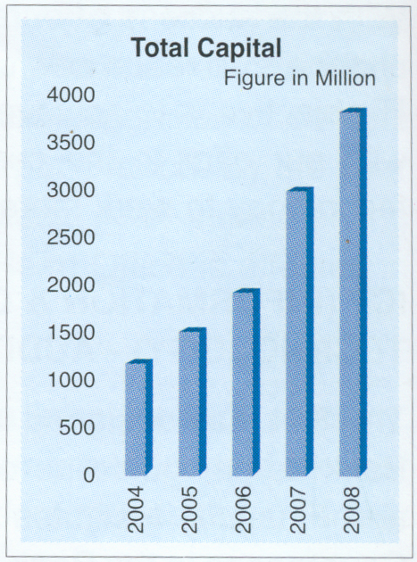
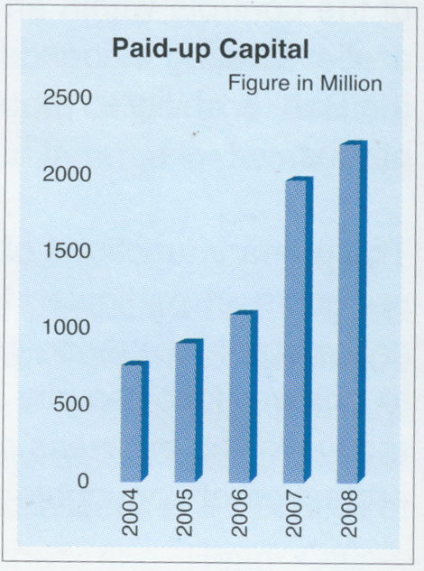

c) Profit and operational result:

Figure: Total Capital Figure: Paid-up Capital
c) Profit and Operational Result:
The Bank has earned an operating profit 733.05 million during the year 2006 compared to Tk 616.34 million during the year 2005, showing an increase of 18.94%. The Bank has earned substantial amount profit during the last year compared to preceding year. The progress was possible due to the pragmatic policies and right direction of our Board of Directors as well as active support and co-operation of our valued client and Shareholders.
The latest position of profit before provision of tax up-to 2008 are being shown graphically as under:
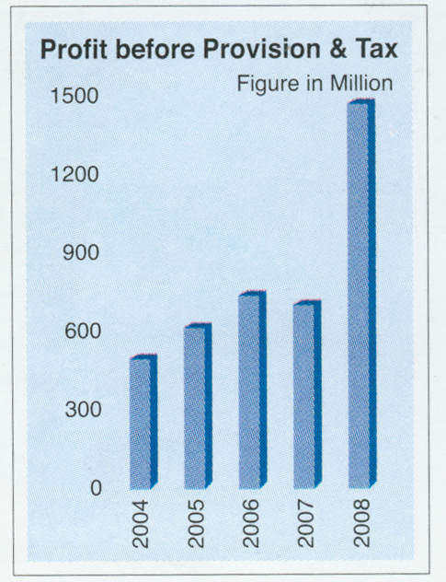

Figure: Profit before Position and Tax.
d) Deposits:
The deposit base of the bank continue to register steady growth and stood at Tk. 14220.80 million as on December 31st ,2006 as against Tk. 12062.40 million as on December 31, 2005. It is an increase of 17.89%, the Bank has by this time achieved a stable and sizable deposit base and has managed its deposit and investible fund efficiently for the purpose of both liquidity and profitability. In addition to the normal deposit scheme, the bank introduce highly lucrative and attractive deposit scheme, to encourage and mobilize the deposit as well as for the benefit of the people.
Our various purpose oriented deposit schemes have been appreciated by general people and have received popular response. Steps are being taken to further increase the deposit base continuously at a reduced average cost of funds.
The latest position of deposit are being shown below graphically up-to 2008.
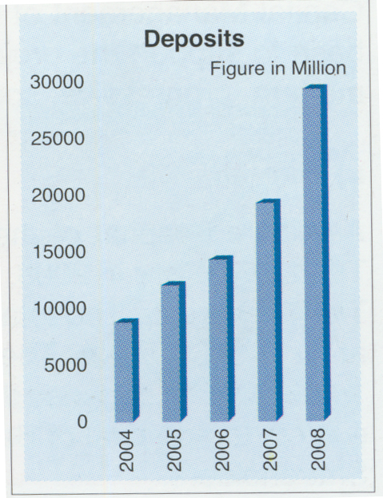
Figure: Deposits
e) Loans and advances:
The total loans and advances of the Bank stood at Tk. 12634.12 million including bill purchase and discounted as on December 31, 2006 compared to Tk. 10183.9 million as of December 31st, 2005 showing an increase of 24.06%. The bank has been continuing to explore and diversity the area of operation to extend credit facilities throughout the year to the various sector of the economy. In distributing loans the Bank mainly concentrated on agriculture and fishery sector, wholesale and retail trading, hotel, restaurant, teal estate and service sector and transport sector. The total loans are grouped in Tk. 12507.32 million as unclassified loans and Tk. 126.80 million as bad/loss loan.
The latest position of Loan and Advances are being shown below graphically up-to 2008.
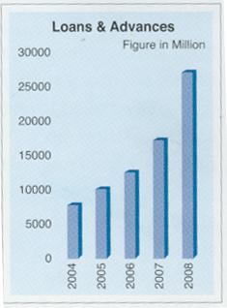
Figure: Loans and advances
f) Investment:
The investment has always an inverse relationship with capital adequacy ratio although if contributes to the desired bottom figure. The size of the investment portfolio in the year 2006 rose at 1623.35 million including Government Treasury Bill and the other security bonds against tk. 1272.46 million showing an increase of 27.58%.
The latest position of Investment are being shown below graphically up-to 2008.
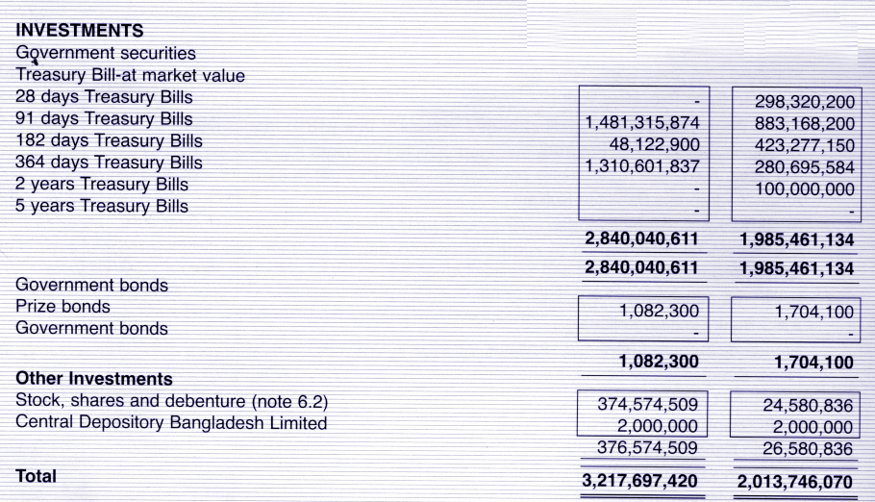

Figure: Investment
g) International trade:
Foreign exchange operation of the bank played a significant role in the overall business of the bank. During the year 2006, the bank has contribution in the country’s national economy after successfully handling of foreign exchange transaction viz. Import, Export and Remittance. In 2006 volume of import has significantly increased from tk. 16144.65 million to tk. 18269.57 million, which is 13.69% higher than last year, the volume of export business has tremendously increased from tk. 7569.13 million to tk. 10707.48 million which is 41.46% higher than last year and foreign remittance business also remarkable increased from tk. 204.26 million to tk. 565.12 million which is 176.67% higher than last year. The volume of total foreign exchange business has significantly increased from tk. 25879.68 to tk. 34003.77 million, which is 31.39% higher than previous year.
The latest position of International & Trade are being shown below graphically up-to 2008.

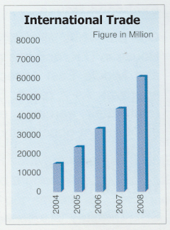
Figure: International trade

The General Highlights on different A/cs are being shown below up-to 2008.
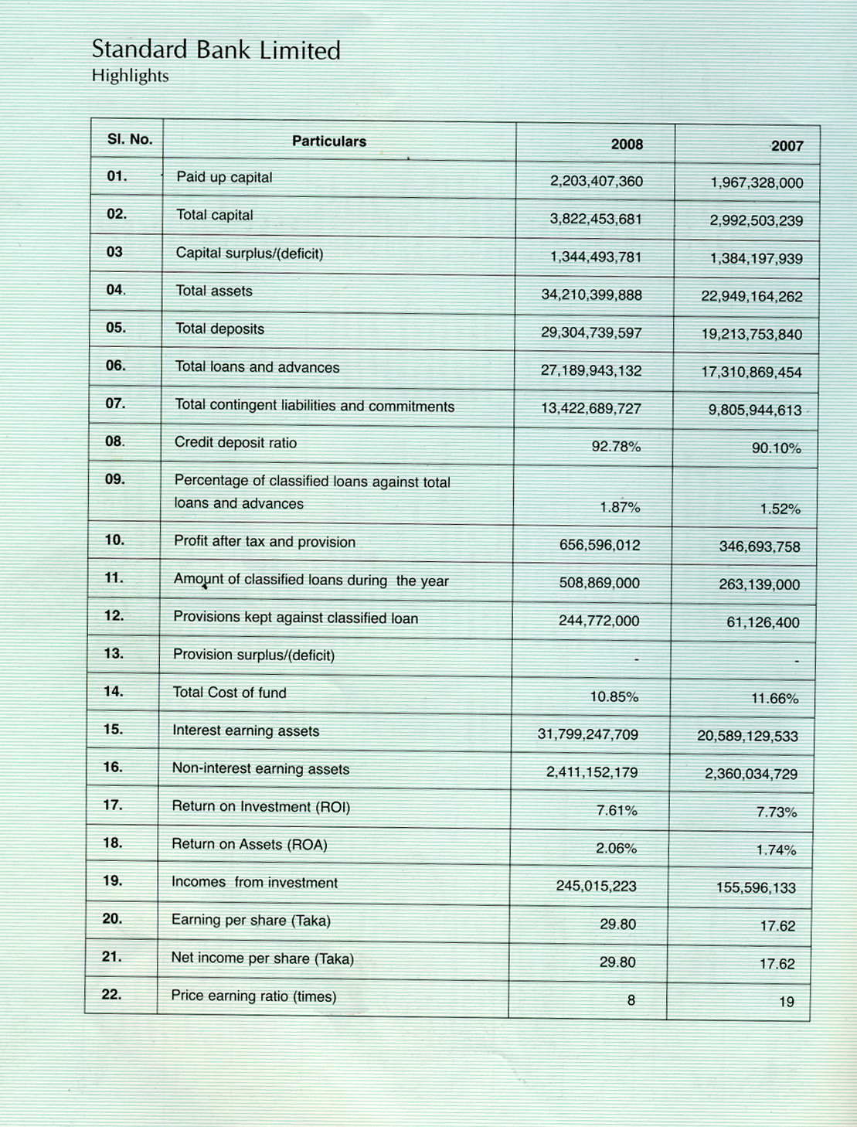

Chapter -3
Body of the report
Foreign Exchange Transaction System

3.1 What is Foreign Exchange?
Foreign Exchange as the means and methods by which rights to wealth expressed in terms of the currency of one country are converted into rights to wealth in terms of the currency of another country.
Foreign Exchange means exchange of foreign products, services and currency between two countries. If we consider “Foreign exchange” as a subject then it means all kind of transactions related to foreign currency. In other wards foreign exchange deals with foreign financial transaction.
Foreign exchange department is international department of the bank. It deals with globally and facilities international trade through its various modes of services. It bridges between importers and exporters. Bangladesh bank issues license to scheduled banks to deal with foreign exchange. These banks are known as authorized dealers. If the branch is authorized dealer in foreign exchange market, it can remit foreign exchange from local country to foreign country. This department mainly deals with foreign currency. This is why policy is department is called foreign exchange department.
3.2 STEPS IN FOREIGN EXCHANGE (EXPORT)
a) Necessity of Foreign Exchange
No country is self-sufficient in this world. Every one is, more or less, dependent on another, for goods or services. Say, Bangladesh has cheap manpower whereas Saudi Arabia has cheap petroleum. So Bangladesh is dependent on Saudi Arabia for petroleum and Saudi Arabia is dependent on Bangladesh for cheap manpower.
People of one county are going to abroad for education, Medical service etc. Thus there is exchange of foreign currency.
b) Activities of Foreign Exchange
There are three kinds of foreign exchange transaction:
    - Export
    - Import
3. Remittance
c) Export
1. Concept of Export
Export/Exporter: Export means flow of goods and services produced within Bangladesh but purchase by economic agent i.e. individuals, firms, governments of other countries. The persons/Firms sales the goods & services to another country is called exporter.
An exporter of a country having a trade relation with an importer of another country may not have enough money to conclude the deal. He may as such need finance from the Bank.

2. Export Policy of Bangladesh
Export policy of Bangladesh is formulated by the Ministry of Commerce to provide the overall guideline and incentives for promotion of exports. It has been decided to formulate this policy to cover a three-year period to make then contemporaneous with the five plans and to provide continuity to the policy regime. However, the policy will be valid until the next export Policy is announced. If required, Government may review this Policy once in every year and may take decision as deemed fit.

3. Structural weakness of export sector of Bangladesh:
X) Commodity concentration: Very few commodities are occupying major share of our export. Only five exportable items i.e. Readymade Garments, Knitwear, Jute Goods, Frozen Foods, Leather provide more than 90% of total export earning of Bangladesh.
Y) Geographical concentration: The periphery of our export market is very narrow. More than 80% of our total exports to USA and EEC countries.

4. Objectives of Export Policy:
a) To achieve higher growth rate of export by increasing exports to regional and international markets.
b) To reduction of trade deficit by achieving exports target.
c) To assist production of export items in competitive price to protect existing market and explore new markets.
d) To make efforts for exploiting new opportunities offered by the liberalization and globalisation process in world economy.
e) To diversify and improve the quality of exportable items.
f) To simply the export procedures and rationalize the incentive structure to exporters.
g) To develop the export-trade infrastructure and trained manpower.

5. Regulatory/Promotional organs of Export
1. National Committee for Export: Headed by the Prime Minister and comprising Ministers of Foreign Affairs, Finance, Commerce, Industries, Planning, Jute and Textile. The committee will review the export situation and provide necessary direction and resolved problems.
2. Export Council: Consultative body comprising of Chambers, Exporter’s Associations and institutions of public sector.
3. Export Promotion Bureau (EPB).
Main functions of EPB:
- Quota allocation for export of RMG.
- Participation in international trade fairs.
- Arrangement of fair and exhibition both at home and abroad.
- Arrangement of training programs for boost up exports.

6. Export Incentives:
To achieve the objectives of the Export Policy 1997-2002 several incentives and facilities have been made available to the exporters. Some of the incentives as offered are describe below:
Convertibility of Taka:
Taka has been made convertible in the current account from March 26, 1994 in line with the policy of export-led growth in the liberalized world market. Under this arrangement, exporters are getting following facilities:
7. Fiscal Incentives:
The government has taken lots of fiscal measures to boost up export earnings of Bangladesh. Some of the important fiscal incentives provided by the Government are enumerated below:
a) Duty Draw Back: Exporters of manufactured products are entitled to drawback after the export is effected the amount of customs duties and sales tax already paid at the time of importing raw materials. Duty may be returned under any of the three systems, namely Actual drawback, notional drawback and flat rate drawback. However, the flat rate method is a simply system of getting drawback and preferred by most of the exporters. In these systems payments will be made by the commercial banks immediately on receipt of exports proceeds on the basis of the principles laid down by the National Board of Revenue.
b) Duty-free import of Credit Machinery: 100% export oriented industries located elsewhere in the country is allowed to import capital equipment without paying any customs duty.
c) Bonded Warehouse Facility: Bonded warehouse facility has extended to all industries recognized as 100% export oriented industries. A bonded warehouse is a warehouse under Custom’s control. Imported raw materials are stored in the bonded warehouse without payment of duty and taxes on the first importation and subsequent exportation of finished goods.
d)Sale of Goods Rejected for Exportation: 20% of the rejected goods of the 100% export oriented industries including leather goods and readymade garments will be admissible for sale in the local market subject to payment of usual duties and taxes.
e) Duty-free Import of raw Material for Export Oriented Leather Industries: To encourage increase in including production of finished leather and export at competitive prices, customs duty and LCA/permit fees leviable on import of well blue and pickled leather by export oriented leather industries will be exempted.
f) Income Tax Rebate on Export Earnings: 50% rebate on taxable income generated from export earnings is exempted through incorporation of a new provision in the income Tax Ordinance.

Cash Incentives:
Government used to give cash benefit in lieu of bonded warehouse facility or duty drawback for export oriented domestic textile sector and readymade garment industries. At present 25% compensatory assistance in cash is admissible, in case of imported inputs, if the duty drawback facility has not been utilized, or if local is used by a garment cum manufacturer of fabric’s i.e. composite textile mills. For this purpose domestic handloom sector is admissible to get 10% cash incentives. If the exporter is an intermediary buyer, the facility will go to the original producer of the input. For quick disbursement of cash incentive to the exporter placement of fund in advance made by the Bangladesh Bank to the head office Authorized Dealer banks. Cash incentive is also admissible against export of artificial and natural flower, quilt, leather goods and jute goods at the rate of 10%

8. Extension of Export Credit Period:
Presently export credit is allowed at confessional rate of interest (10%) for a maximum period of 180 days. The time limit for repayment of export credit has been extended from 180 days to 270 days for credit to frozen food, tea and leather sectors by way of relaxing the condition of submission of firm contract/LC and treating working capital as export credit.
Limit of Export Credit:
Exporter may obtain credit from the commercial banks up to 90% of the value of their irrevocable letter of credit/firm contract. No overdue interest will be changed by the commercial banks in case of export against irrevocable letter of credit on sight payment basis in such a cases, however exporters will be required to submit necessary export documents within a specified time.

9. Export Development Fund:
As per agreement between International Development Association (IDA) and Government of Bangladesh, Export Development Fund (EDF) in foreign exchange have been created in Bangladesh Bank to finance import payment against import of raw materials of 100% export oriented industries on sight payment basis. An exporter is eligible to avail of EDF facilities on the basis of the following conditions:
- He must bean exporter of non-traditional manufacturing items.
- The loan should be utilized in the case of importing raw materials for Manufacturing the exportable products.
- The exporter must have an export LC.
- He must create a back to back LC for importing raw materials.
- The period of loan is 180 days.
- The exporter can borrow as many times as he likes in a year.
- An exporter can borrow an amount an US$ 500,000 in a single case but outstanding should not be over US$ 1,000,000.
- He has to obtain Export Credit insurance through ECGS.
As for banker, the EDF allows a spread between 2.5% for the established exporters and 3.5% for the new exporters for every loan for the client.

10. Export Credit Guarantee Scheme (ECGS):
The Export Credit Guarantee of Sadharan Bima Corporation provides guarantee to bankers and exporters against possible losses resulting from the advances give and against overseas commercial and political risks respectively. Currently three types of Guarantee e.g. the Export Finance Guarantee (Per-shipment), Export Finance Guarantee (Post-shipment) and Export Payment Risk Policy (Comprehensive Guarantee) are available to the bankers, the find one is extended directly to exporter.

Other Incentives:
1. Reduced airfreight for export of all crash program items including Fruits and vegetables.
2. Special premium rebates are allowed on fire and marine insurance covers to export oriented industries of non-traditional items.
3. Local raw materials used as direct input for export products are regarded as deemed export, and qualify for all export incentives and benefits.

11. Export from the Export Processing Zones
Export Processing Zones (EPZs) have been established by an Act namely, Bangladesh Export Processing Zone Authority Act, 1980. The following types of industrial units operate in the EPZs:
- Type A: 100 percent foreign owned including those owned by Bangladesh Nationals ordinary resident abroad;
- Type B: Join venture projects between foreign and Bangladeshi entrepreneurs resident in Bangladesh.
- Type C: 100 percent Bangladeshi entrepreneurs resident in Bangladesh.
The board guidelines relating to the operation of industrial enterprises in the EPZs are contained in the “Principles and Procedures governing setting up of industries in EPZ” issued by the Bangladesh Export Processing Zone Authority (BEPZA).
Repatriation of proceeds of exports from the EPZ:
Exports from EPZ are Subject to the usual requirement of declaration of exports in EXP Forms for these exports should be rubble stamped or overprinted with words “EXPORT FROM EPZ” in bold letters.
The following procedure shall apply to release of forcing exchange to the enterprises against export made form the EPZs.

Export procedure in flow chart
EXPORT PROCEDURE IN FLOW CHART
EXPORTER: OBTAINING EXPORT REGISTRATION CERTIFICATE (ERC) FROM CCI & E
EXPORTER: SECURING EXPORT ORDER FROM BUYER DIRECTLY OR THROUGH AGENT.
EXPORTER: RECEVING L/C FORM BUYER’S BANK THROUGH AN ADVISING BANK IN BANGLADESH
BANK: CERTIFICATION OF FROM AUTHORISED DEALER (BANK)

WILL THE EXPORTER BE ALLOWED ANY PRESHIPMENT CREDIT FACILITY

12. Export Procedures
The import and export trade in our country are regulated by the Import and Export (Control) Act, 1950.
Under the export policy of Bangladesh the exporter has to get valid Export registration Certificate (ERC) from Chief Controller of Import & Export (CCI&E). The ERC is required to renew every year. The ERC number is to incorporate on EXP forms and other papers connected with exports.
Registration of Exporters:
For obtaining ERC, intending Bangladeshi exporters are required to apply to the controller/ Joint Controller/ Deputy Controller/ Assistant Controller of Imports and Exports, Dhaka/ Chittagong/ Rajshahi/ Mymensingh/ Sylhet/ Comilla/ Barishal/ Bogra/ Rangpur/ Dinajpur in the prescribed form along with the following documents:
- Nationality and Assets Certificate;
- Memorandum and Article of Association and Certificate of Incorporation in case of Limited Company;
- Bank Certificate;
- Income Tax Certificate;
- Trade License etc.
Securing the Order:
After getting ERC Certificate the exporter may proceed to secure the export order. He can do this by contacting the buyers directly or through agent.
In this purpose the exporter may get help from:
- License Officer;
- Buyer’s Local Agent;
- Export Promoting Organization;
- Bangladesh Mission Abroad;
- Chamber of Commerce (local & foreign)
- Trade Fair etc.
Signing the Contract:
After communicating buyer, exporter has to get contracted (writing or oral) for exporting exportable items from Bangladesh detailing commodity, quantity, price, shipment, insurance and marks, inspection and arbitration etc.
Receiving Letter of Credit:
After getting contract for sale, exporter should ask the buyer for Letter of Credit (L/C) clearly stating terms and conditions of export and payment.
The following are the main points to be looked into for receiving/ collecting export proceeds by means of Documentary Credit:
- The terms of the L/C are in conformity with those of the contract;
- The L/C is an irrevocable one, preferably confirmed by the advising bank;
- The L/C allows sufficient time for shipment and negotiation.
(Here the regulatory framework is UCPDC-500, ICC publication)
Terms and conditions should be stated in the contract clearly in case of other mode of payment:
- Cash in advance;
- Open account;
- Collection basis (Documentary/ Clean)
(Here the regulatory framework is URC-525, ICC publication)

Procuring the materials:
After making the deal and on having the L/C opened in his favor, the next step for the exporter is to set about the task of procuring or manufacturing the contracted merchandise.

Shipment of goods:
Then the exporter should take the preparation for export arrangement for delivery of goods as per L/C and incoterms, prepare and submit shipping documents for Payment/ Acceptance/ Negotiation in due time.

Import
3.3 Step in Foreign Exchange (Import)
1. Concept of Import
Import means the goods & services purchase by economic agent located in Bangladesh from economic agent of other countries.
Financing of Import business stores with the contractual obligation between buyer & the Bank. Financing of import business is a major area of investment of a Bank.
Import policy order
Import is the goods and services purchased by economic agent located in Bangladesh from economic agent of other countries.

Necessity for Import Regulation:
- To protect domestic industries;
- To save foreign exchange;
- On health and safety grounds;
- To reduce smuggling etc;

2. Import policy
Under the Import and Export (Control) Act, 1950 the Government of Bangladesh formulates the Import Policy through Ministry of Commerce.
It has, now, been decided to formulate these policies to cover a three-year period to make them contemporaneous with the three-year plans and to provide continuity to the policy regime. It can be reviewed every year if needed.
Import Licensing: Import licensing for commercial importers and industrial importers is necessary.

3. General Conditions for Commodity Import:
- Using of eight-digit H.S Code (Harmonized System of Coding & Commodity Description) is compulsory according to Import Trade Control Schedule, 1998.
- No goods be imported from Israel or produced in Israel and transportation by the Israeli flag carrying ships is prohibited (also from UN sanctioned countries – Serbia & Montenegro, Lrak)
3. Goods must be imported through Bangladesh flag carrying ships. For individual importers maximum 20 ton and for group importers maximum 100 ton is allowed to be transported through foreign ships, In other cases, if foreign ship is required, the Certificate of Waiver must be taken from Directorate of Sea Transportation. General waiver if Bangladeshi vessels have no route in those ports. If within 7days Bangladeshi vessels would not be available, then certificate of waiver within 24 hours (otherwise automatically). Import under foreign aid – foreign shipping lines can be used.
4. In case of export-oriented industries, shipment is permitted through ships of other countries.
5. Import must be made at highest competitive price.
6. Importers are bound to submit import-related documents at any time to Chief Controller of import and Export if required.
7. Radioactivity certificate is compulsory for the import of food items (except Cigarettes, Cigarette paper, pipe tobacco, wine, spices, drugs).
8. Production and expiry date is compulsory for food items.
9. Country of origin should be mentioned clearly in case of all imports (excluding coal and
export-oriented industries under bonded ware house facilities).
10. Per-shipment inspection is compulsory for all imports of goods and services excluding
public sector imports.

4. Import procedure
As an Authorized Dealer, Principal Branch is always committed to facilitate import of different goods into Bangladesh from the foreign countries. Import Section, which is under Foreign Exchange Department of the branch, is assigned to perform this job. And to serve its client’s demand to import goods, it always maintains required formalities that are collectively termed as The Import Procedure.
1. At first, the importer must obtain Import Registration Certificate (IRC) from the CCI&E submitting the following papers:
  - Up to date Trade License.
  - Nationality and Asset Certificate.
  - Income Tax Certificate.
  - In case of company, Memorandum & Articles of Association and Certificate of Incorporation.
  - Bank Solvency Certificate etc.
2. Then the importer has to contact with the seller outside the country to obtain the
Proforma Invoice. Usually an indenter, local agent of the seller or foreign agent of
the buyer makes this communication. Other sources are:
- Trade fair.
- Chamber of Commerce.
- Foreign Missions in Bangladesh.
- Journals etc.
3. When the importer accepts the Proforma Invoice, he/she makes a purchase contract with the exporter detailing the terms and conditions of the import.
4. After making the purchase contract, importer settles the means of payment with the seller. And import procedure differs with different means of payment. The possible means are Cash in Advance, Open Account, Collection Method and Documentary Letter of Credit. In most cases, the Documentary Letter of Credit in our country makes import payment. Purchase Contract contains which payment procedure has to be applied.
Different Means of Payment:
a) Cash in advance: Importer pays full, partial or progressive payment by a foreign DD, MT or TT. After receiving payment, exporter will send the goods and the transport receipt to the importer. Importer will take delivery of the goods from the transport company.
b) Open Account: Exporter ships the goods and sends transport receipt to the importer. Importer will take delivery of the goods and makes payment by foreign DD, MT, or TT at some specified date.
c) Collection Method: Collection methods are either clean collection or documentary collection. Again, Documentary Collection may be Document against Payment (D/P) or Document against Acceptance (D/A). The collection procedure is that the exporter ships the goods and draws a draft/ bill on the buyer. The exporter submits the draft/bill (only or with documents) to the remitting bank for collection and the bank acknowledges this. Then the remitting bank sends the draft/bill (with or without documents) and a collection instruction letter to the collecting bank. Acting as an agent of the remitting bank, the collecting bank notifies the importer upon receipt of the draft. The title of goods is released to the importer upon full payment or acceptance of the draft/bill.
d) Letter of credit: Letter of credit is the well-accepted and most commonly used means of payment. It is an undertaking for payment by the issuing bank to the beneficiary, upon submission of some stipulated documents and fulfilling the terms and conditions mentioned in the letter of credit.
e) Requesting the concerned bank (importer’s bank /issuing bank) to open a L/C (irrevocable) on behalf of importer favoring the exporter/seller.

5. Principle follows for documentation in foreign exchange
Import financing & mechanism
Financing of import is a major area of investment of a bank Financing of import business starts with the contractual obligation between an importer and the bank. The initial contract for this type of business starts with the merchandise to be imported.
Forms of Import Financing:
Financing of import business takes the following forms:
1. Opening Letter of Credit.(L/C)
2. Payment against documents.(PAD)
    - Loan against imported merchandise.(LIM)
    - Loan against Trust Receipt.(LTR)

Letter of credit (Inland)
Inland L/C defined: Inland letter of credit is a written undertaking given by a bank on be half of its customers to pay up to certain amount of money to a supplier within the country on presentation of documents evidencing dispatch and receipt of merchandise in accordance with terms and conditions contained therein.
Opening of inland L/C: Inland letter of credit is generally opened in favor of reputed and established firms, industries, agencies etc. for supply of merchandise against firm contract/ letter of intent /allotment letter.
Application of the Party. A reputed party who is acceptable to the Bank shall apply for opening letter of credit along with a firm contract or letter of intent embodying the terms of the deal.
Preparing L/C: Letter of credit shall be typed in quadruplicate, cheered and entered in the register duly numbered. In preparing letter of credit it shall be ensured that:
- The letter of credit is addressed to the supplied .
- The description of goods and the amount are clearly mentioned in the L/C as per stipulations embodied in the firm contract/letter of intent.
- Documents to be submitted on dispatch of the goods are clearly mentioned.
- Dispatch arrangements are mentioned.
- Delivery arrangements and payment terms are clearly noted.
- Expiry date is mentioned.
- Instruction for the negotiating bank is a properly given.
Obtaining approval: If the branch is satisfied with the particulars mentioned above and the credibility of the party, L/C shall be opened with prior approval of the competent authority.
Margin and Insurance::On getting approval , the party shall be informed and advise to deposit the requisite margin as stipulated in the letter of approval of the authority.
Transmission of Letter of credit : The letter of credit on its presentation should be properly checked and signed by two officials and sent in duplicate to the nearest branch of the bank at supply point or to supplier’s bank under registered cover for onward delivery to the supplier.
Realization of L/C opening charge: Opening charges (commission and postage) shall be realized from the account of the client and credited to the respective head of account i.e.
1) Income A/c Commission of L/C (Inland)
2) Income A/c postage.
Steps at Advising/ Negotiating Branch: The advising /negotiating branch on receipt of the L/C should.
- Verify its genuineness/ signatures.
- Enter particulars of the L/C in register.
- Delivery original copy to the beneficiary.
- Realize advising commission as per schedule.

c) Steps to the adopted L/C by the branch opening L/C: When documents are received by the branch under inland L/C opened by them and the documents conform to the terms of the L/C, entry shall be made in the IDBC register under intimation given to the applicant for immediate payment/retirement.
Steps in respect of L/C opened by other branch: When documents are received by a branch under letter of credit opened by other branches of this Bank the following steps shall be taken:
- Documents are properly checked and if found in order, the same shall be entered in O.D.B.C. register.
- Documents shall be sent for collection to the branch opening the L/C.
Checking of documents by the opening branch: Documents shall be scrutinized by the opening branch to see that these are drawn in terms of L/C. If found in order, IBTCA for full amount of the bill should be sent to the branch forwarding the bill.
Reversal of L/C liability centre: At the time of retirement of the bill liability entry passed at the time of opening the L/C shall be reversed.

Letter of credit (Foreign)
Letter of Credit defined : A letter of Credit (foreign) is a written undertaking given by a bank on behalf of its customer (importer) to pay up to certain amount to a supplier (Exporter) of another country within prescribed time limit or to the order of a third party (beneficiary), or to accept and pay the bill(s) of exchange (drafts) drawn by the beneficiary or authorize another bank to effect such payment or to accept drafts or negotiate stipulated documents provided that the terms and conditions of credit are complied Foreign letter of credit may either be clean or documentary.
Documentary credit may either be:
- Revocable or.
- Irrevocable.
Revocable L/C: This type of credit can be cancelled or amended at any time by the issuing bank without prior notice to the seller. In modern business the Revocable credit is not use.
Irrevocable credit: This type of credit can not be cancelled or amended by the issuing bank without the agreement of parties concerned thereto. All the credits issued in our country are of irrevocable nature. In modern business the irrevocable credit is very much use.
Parties to L/C: The following are the parties to L/C:
Importer/Buyer/Purchase/Applicant/Opener.
- Opening/Issuing Bank.
- Exporter/Seller/Beneficiary/Supplier.
- Advising/Notifying/Bank.
- Confirming Bank, if required.
- Negotiating Bank.
L/C to be opened on behalf of importer only: When approached for opening of L/C , it should be ascertained that the proposed opener is a bonafide importer in evidence of which the following papers shall be obtained:
- IRC (Import Registration Certificate)
- Specific permission/Prior permission/IEC (Import Entitlement Certificate) in case of industrial consumer.
- Proof of payment of renewal fees for import registration certificate (where applicable).
- For import of drugs and medicine , valid indent/Performa invoice duly approved by the Director of Drug Administration for import of drugs and medicines.
- For pharmaceutical raw and packing materials , approval of Block list with corresponding amount from the Director, Drug Administration.
- Income tax payment certificate/ Income tax declaration/ Tax Identification Number (TIN).
- Membership certificate from registered organization/ Trade Associations/Chamber of Commerce and Industries.
- Any other documents as may be required under order from the appropriate authority.
- VAT (Value Added Tax) Certificate.
- Additional documents to be obtained for public sector importer:

Credit enquiry: Records of the bank are properly checked to ensure that:
- The proposed importer is a good and reliable constituent.
- The constituent is not a defaulter of the Bank nor is the guarantor a defaulter.
- There is no adverse information about the party/guarantor.
- The constituent is a man of commitment.
- The importable item is not banned as per the current import policy.
Documents to be obtained: On being satisfied the following papers/documents shall beobtained from the proposed importer.
- Application of importer for issuance of LCAF (L/C authorization Form).
- L/C authorization form and L/C application form duly filled in and signed by the importer.
- 3 copies of indent/proforma invoice/contract duly signed by the importer as a token of acceptance.
- IMP form duly signed by the importer.
- Marine Insurance cover note with bank clause along with premium paid receipt.
- Any other paper/documents that may be requested as per instruction of the appropriate authority.
Obtaining approval: On getting the papers/ documents duly filled in, signed by the party and completing all formalities, proposal shall be sent to the competent authority. On obtaining approval of the authority the same may be informed to the importer.
Preparing L/C:
All the terms and conditions as embodied in the L/C application of the importer are typed in the L/C proforma in manifold.
Entry in Register: If the L/C is found in order , amongst others the following particulars are recorded in the L/C opening register.
- Date and L/C No.
- Name of the party.
- Amount in foreign currency and equivalent Bangladesh taka.
- Merchandise to be imported and the country of origin.
- Name of advising Bank.
- Tenor & expiry date.
- Percentage of margin and amount of margin.
- Amount of commission, postage charge, vat on L/C commission cable/telex/charges and Data max charges.
Disposal of L/C copies: L/Cs typed in the printed form shall be disposed in the following manner:
- First two copies to be sent to the advising bank. (Original for beneficiary and 2nd copy for advising bank.)
ii) One copy is sent / delivery to the party (importer)
iii) One copy is sent to C.C.I and E.
iv) One copy is retained as office copy.

6. Payments against import documents (PADs)

i) Advances against import Bills originate from the lodgment Shipping documents received from foreign correspondents/ negotiating bank, against letter of credit established by the Bank on be half of its customers.
ii) These Bills are lodged by debiting PAD Account and crediting Foreign correspondents accounts or any designated bank’s account or Bangladesh Bank’s account (in case of imports under AID/Loan/Credits/STA/Barter where counter part taka funds are required to be deposited with Bangladesh Bank).
Invoices:
- Invoice in the name of beneficiary (usually printed heading).
- Name and address of the importer are in conformity with those mentioned in the L/C.
- Description of merchandise agrees exactly with that mentioned in the L/C.
- Quantity agrees with that mentioned in the L/C (refer UCPDC Article 39 for tolerance if any that may be allowed).
- Price & price basis (FOB, CIF,C&F etc.) is strictly as per terms of L/C.
- Invoice signed properly and presented in correct number of copies.
- Identifying marks of shipment, number of packages, gross & net weights if any agree with all other documents.
- Certification, if any, appeared in conformity with the L/C.

Bills of lading/post parcel receipt/ air way bill/truck receipt:
- Unless otherwise specified in L/C, the B/L must state “shipped on Board and clean”.
- Port of shipment, port of destination, date of shipment, consignee, notify party as specified in L/C.
- The Bill of Lading /post Parcel Receipt/ Airway Bill / Truck Receipt is drawn to the order and endorsed in favor of the consignee’s bank (L/C opening bank), notifying the opener and L/C opening bank.
- Must cover merchandise as specified in invoice as well as L/C but it may be described in general terms only. However, the description must not include any additional description terms not included in the L/C.
- Must be presented within the period as specified in the L/C.
- The Bill of lading /post parcel receipt / Airway Bill / Truck Receipt contains national freight-paid of freight to pay as called for in the letter of credit.
- Numbers of packages, marks agree with invoice and other documents.
- Any alteration to be authenticated by stamp and initial of shipping company of it’s authorized agent.
- In case of transport, by post / Airway please check that transport by such means is authorized in the L/C.
- Airways Bill should indicate L/C opening bank as consignee, flight number and date.
- Caused and state Bill of lading not acceptable.
- Short form Bill of lading not acceptable unless otherwise stipulated in the L/C.
Certificate of Origin/ Packing List/ Weight List/Inspection /Insurance Policy certificate:
Please check the documents presented and ensure that the same have been drawn strictly as per terms of the L/C.
- Certificate of origin must be issued by the competent/ recognized body if not otherwise mentioned in the respective L/C. Certificate of origin issued by the supplier usually not acceptable unless otherwise specified in the L/C.
- Packing list is drawn in conformity with the L/C term for the merchandise as mentioned in invoice and other documents.
- Weight list is drawn exactly as per weight as specified in the invoice and other documents where price / cost is quoted on weight basis.
- Inspection certificate is issued by the authorized agent as mentioned in the L/C.
- A copy of the insurance declaration is attached to the documents which should be sent by exporters to insurance company immediately after the shipment is taken place.
- All other documents, provided in the letter of credit are received in accordance to L/C terms and conditions.

7. Usance bills:
Usance Bills: Sometimes as per terms and conditions of the letter of credit documents may be drawn on Usance basis with maturity of 30,60,90 and 120 days (as the case may be ) after the date of acceptance.
Payment and realization of charges: On receipt of payment / replenishment of funds from the paying authority, Tasted Telex may be sent to whom the account of the respective currency is maintained by the Head Office after realizing necessary charges as per prescribed rates of the Bank with an intimation to the collecting bank/ negotiating bank.

8. Back to back letter of credit:
An Export who has received an export L/C from an overseas buyer (importer) may not be the actual supplier /manufacturer of the exportable goods. he may have to get the goods supplied by some body else or require procuring necessary raw materials either from inland or overseas to process ad manufacturing the exportable items. Under such a situation the exporter may be accommodated with interim letter of credit to arrange for fulfillment of his export commitment either through another supplier or procurement of raw materials for processing/manufacturing of finished goods. This is done by opening a fresh letter in favor of the supplier on the strength of the export letter of credit keeping the same under lien.
The opening of one letter of credit backing on another letter of credit is know as “Back to Back Letter of Credit”. This is one of the pre-shipment forms of advances allowed to the exporters/export oriented industries.
Back to Back L/C may be of the following two categories:
i) Inland back to back L/C.
ii) Foreign back to b back L/C.
Procedure of opening back to back L/C:
1 When and approach is made by a customer (exporter) for opening a back to back L/C (inland or foreign) it shall be ensured that:
a) The customer is a valued constituent of the branch.
b) He is not a defaulter of the bank or the guarantor (if any) is a defaulter.
c) Bank does not have any adverse information about the party. Integrity, credit worthiness and reputation of the exporter are satisfactory.
d) The party has got valid export registration certificate issued by the CCI & E and valid bonded warehouse license issued by the custom authority.
e) The constituent has got valid irrevocable unrestricted export L/C obtained from reputed foreign bank.
f) The party has no liability with other banks in respect of the specific business.
Forwarding proposal: If export L/C issuing bank is not our correspondent, (Which must not exceed the permissible percentage of the F.O.B. value of the export L/C as may be advised from time to time) shall be sent to the sanctioning authority with specific recommendation of the branch manager.
The following papers, amongst others, shall be enclosed with the proposal:
a) Prayer of the party.
b) Copy of export L/C.
c) Copy of indent/proforma invoice supplied by the exporter, in whose favor import L/C is to be opened.
d) Credit report of the party.
e) All other paper/documents as required by the sanctioning authority.
Approval of. If the papers sent by the branch are found to be adequate and in order the competent authority may approve the loan proposal and advise the branch accordingly.

On receipt of the approval the branch shall ensure that:
a) Export L/C is kept under lien.
b)The difference of value between the export L.C in hand and proposed back to back L/C is not less than the minimum amount admissible as per export policy announced by the Govt.
c) The import L/C opened on since basis covering since period ranging from 30/90/120/180 days but not less than the period of the export L/Cs so that the liability
On account of back to back L/C does not mature before repatriation of export proceeds.
d) Export L/C remains valid for a reasonable time to cover shipment of merchandise after completion of manufacturing process.
e) Import L/C shall not be opened against export L/C received under BARTER/STA, without permission of Bangladesh Bank.
f) The terms and conditions of the back to back L/C are similar to those of the export L/C except:
- The supplier of the goods under import L/C is the beneficiary.
ii) Credit amount of the back to back L/C, is less than of the Export L/C.
iii)Validity period of the Import L/C is Reasonably Earlier than that of the Export I/C.
G) If any a amendment of export L/C is required, the back to back L/C shall not be opened before such amendment has been made by the Opening back.
Opening of the L/C: Letter of Credit shall be Issued incorporating all the terms and conditions of the deal and stipulating the documents to be submitted. the liability voucher shall be passed and L/C. commission realized and credited to income account.

9. Negotiation of documents:
Negotiate documents when in order:
i) Negotiate the documents if they are in order.
ii) If the documents are not in order, immediately advise the exporter to rectify the discrepancies without any loss of time.
iii) After the rectification of the discrepancies negotiate the documents.
When discrepancies not rectified promptly: If the discrepancies can not be rectified promptly the documents may be negotiated by the Bank handled in the manner provided here under:

Cable to opening bank for accepting documents:
i) At the request of the exporter send a cable to the L/C opening bank advising the nature of discrepancies in the documents and seeking their confirmation to accept the documents.
ii)If confirmation is received , negotiate the documents , otherwise , send them to the opening bank on collection basis with the consent of the exporter.

Negotiation under reserve on obtaining indemnity bond: :Alternative, at the request of the exporter the Bank under reserve may negotiate the documents after obtaining an indemnity bond from them , to reimburse the amount to the Bank on demand, If the openers of the letter of credit do not accept the documents.

10. Submission of export form to Bangladesh Bank

Original EXP form with customs:The original of export form is retained by the customs authorities for completing the customs formalities, and is submitted directly by them to the Bangladesh Bank immediately after the shipment is made.
Duplicate EXP: After dispatch of the documents to the foreign correspondents submit to the Bangladesh Bank duplicate EXP. Form along with a copy of the invoice, within 14 days from the date of shipment.
Third copy of EXP Form: Submit the triplicate Export form to Bangladesh Bank immediately on realization of the full and final proceeds.
Quadruplicate copy: Retain the quadruplicate copy with the branch as an office copy.

11. Document required for foreign exchange:

Documentary credit relating to import and export business:
Letter of Credit:
Letter of credit is the most important document for settlement of international transaction. It is basically a guarantee give by a bank, at the behest of its client, to make payment to a third party, called beneficiary, for goods supplied or service rendered on fulfilment of stipulated conditions. The staff should carefully study all aspects of letter of credit to avoid any controversy, confusion and disputes with clients and correspondents.
L/C is called documentary letter of credit, because the undertaking of the issuing bank is subject to presentation of some specified documents.
Parties to a Letter of Credit:
i) Applicant for the Credit
The importer or buyer on whose request and on whose behalf the letter of credit is opened is called the applicant.

ii) Issuing Bank/Opening Bank
The bank that opens a letter of credit, at the request of the importer, is known as Issuing Bank. The issuing bank is the buyer’s bank is also called opening bank.
iii) Beneficiary
The party, normally the supplier of the goods, in whose favour letter of credit is opened, is called beneficiary. The seller, after shipping the goods as per terms of the credit, presents the documents to negotiating bank/confirming bank for negotiation.
iv) Advising Bank
The bank in the exporter’s country, usually the foreign correspondent of the importer’s bank, through which letter of credit is advised to the supplier is called the ‘advising bank’.
v) Confirming Bank
If the advising bank also adds its own undertaking to honour the credit while advising the same to the beneficiary, it becomes the confirming bank. The confirming bank, in addition, becomes liable to pay for documents in conformity with the LC terms and conditions.
vi) Negotiating Bank
The bank, which negotiates the bill (draft) of the exporter drawn under the credit, is known as negotiating bank. If the advising bank is also authorised to negotiate the bill (draft) drown by the exporter it itself becomes the negotiating bank.
Vii) Accepting Bank
A bank that (as specified in the Letter of Credit) accepts time or usance drafts on behalf of the importer is called the accepting bank. The LC issuing bank can also take on the responsibility of an accepting bank.
Viii) Paying Bank
The bank that effects payment to the beneficiary (as named in the letter of credit) is known as paying bank/drawee bank.
ix) Reimbursing Bank
If the issuing bank dose not maintains any account with the negotiating bank an alternate arrangement is made to reimburse it for the amount payable under a credit from some other bank. The latter bank is termed as reimbursing bank. An authority to debit his account is sent to the bank with whom the account is maintained to honour the claims placed by a negotiating bank

12. Credit instruments used in foreign trade:

i) T.T. (Telegraphic Transfer):
T.T. Is an order for payment of money sent by telex or other instant electronic media. Funds are paid to the beneficiary in the foreign centre usually on the same day. No loss of interest or expenses on stamp duty etc. is involved. T.T. rate is the bank’s finest or basic rate of exchange on the basis of which all other rates of exchange are built.
ii) T.T. (Mail Transfer):
M.T. is an order issued in the form of a letter for payment of money, sent by mail. The purchaser pays cash while buying but the beneficiary at foreign centre gets payment on arrival of the mail advice. This involves loss of interest to the purchaser and hence banks can afford to make M.T. rate cheaper than T.T. rate.
iii) D.D. (Demand Draft):
A foreign demand draft is an order for payment of money, drawn by a bank on another bank or a branch of the same bank in a foreign centre, on presentation of the draft.
iv) T.C. (Travellers Cheque):
People usually use TC s to meet their expenses for overseas travels. It reduces the risk of carrying currency notes. These are drawn in freely convertible currency such as US Dollar and pound sterling for fixed denominations, which can be encased into local currency at the foreign centre, at the ruling rate of exchange. The purchaser puts his signature at the space provided for the purpose which purchasing the same and again signs at the prescribed space in the presence of the paying banker at the time of encashment. If both the signature tallies, payment is made.
v) Letters of Credit:
Letters of Credit is an instrument issued by the bank on behalf of the importer at his request, in favour of the foreign supplier or his banker, authorizing the exporter’s bank to pay/negotiate or accept the bill or exchange (draft) drawn by the foreign supplier for specified amount covering the shipment of specified items and quantity of goods within stated period under certain terms and conditions and undertaking to reimburse or make payment of the amount of the relative bill on production, if found otherwise in order and in accordance with the terms of LC.
vi) Documentary Trade Bills:
When a bill of exchange (draft) is accompanied by documents of title to goods (B/L etc.) and other shipping documents, it is called documentary bills. A documentary trade bill may be drawn either payable at sight or after a fixed period of time.
vii) Sight Bills (Sight Drafts)/Usance Bills:
Trade bills payable at sight on demand is called sight bills or sight drafts while bills drawn payable after a certain period of time is called usance bills.
ix) Short Bill/Long Bill:
A D bill that has only a few days to run towards maturity is called short bill while a bill having usance of one month or more is called a long bill.
v) Bank Bill/Trade Bill:
A Bill, who bears the acceptance of a bank, is called Bank bill, while a bill drawn and accepted by commercial firm or company is called trade bill.

***** ****** *****

3.4 Documentation Used in Foreign Trade:
Other Documents: (If Necessary)
Although no specific reference to other documents is made in the UCP, it is important that these documents also satisfy the credit conditions. It should be mentioned once again that, failing specific instructions, banks will accept other documents as they are presented as long as the requirements stipulated in Article 13 and 21 of the UCP are fulfilled.

Documents for shipment:
- EXP form,
- ERC (valid),
- L/C copy,
- Customer Duty Certificate,
- Shipping Instruction,
- Transport Documents,
- Insurance Documents,
- Invoice,
- Other Documents,
- Bills of Exchange (if required)
- Certificate of Origin,
- Inspection Certificate,
- Quality Control Certificate,
- G.S.P. Certificate,
- Phyto-sanitary Certificate.
Final Step:
Submission of the documents to the Bank for negotiation.

***** ****** *****
3.5 ACCOUNTING ENTRIES FOR FOREIGN EXCHANGE

3.4 Entries endorse L/C: Pass the following entries:
Debit: FDBP Account
Credit: Party’s Account
Endorse, on the reverse of the letter of credit, the amount for which the documents are negotiated.

Endorsement: Endorse, the Bill of Exchange Bill of lading and the insurance Policy assigned to the Bank, as required in the letter of credit.

Entries on receipt of payment: On receipt of payment from the foreign correspondent reverses the entries in the following manner.
Debit: FDBP Account
Credit: I/A – Exch. Earnings
Taka equivalent of the respective currency should be calculated at a on realization of the bill should be reversed for the same amount, which was recorded earlier at the time of lodgment or negotiation of the bill.

If payment delayed due to discrepancies in documents charge interest from Exporters: If the payment is received within 21 days of negotiation due to any discrepancy in the documents which were guaranteed by the exporters, charge interest from them at the usual rate for the period of delay in payment.

3.6 HOW TO IMPROVE THE PROCESS OF FOREIGN EXCHANGE

Solutions:
- Substantial credit checking of counter parties; demanding references
- Negotiating firmly for minimum legal protection, or refusing deal
- Well-drafted contracts and general terms and conditions, including provision for
Choice of law/forum, arbitration
- Specify Inciters 1990
- Well-researched and well-prepared contract negotiations
- Suitable payment securities, such as the documentary credit under UCP 500
- Alternative: open account terms backed by standby credit
Requirement of inspection certificates made out by recognized authorities
- Partial advance payment, bank guarantees, standby credits: also, use of performance bonds
- Sufficient insurance coverage against all likely contingencies, and attention to stipulation in the bill of lading
- The contract of carriage
- Proper packaging and shipment instruction
- Thorough credit investigations of prospective partners
- Membership in and/or utilization of ICC Commercial Crime Services.

Chapter -4
Summery & Recommendation

4.1 Summery Of Lesson Learned
SBL is well positioned to meet the challenge and will seize the opportunity of benefit from economic growth. The bank would serve as partner and advisor of the clientele to trade, commerce and industry. This strategy is supported by wide spectrum of products and services.
The mission of the bank is to be utmost trustworthy stakeholder, careful, committed for equitable and sustainable growth based on diversified deployment of fund/resources leading the bank to the peak of healthy and wholesome financial institution. If the bank is going to succeed internationally, we must know as much or more than our customers and our competitors. A single misstep may not only cost our company business, it can lead to big delays and stiff fines. Unfortunately, most information about international trade is targeted at big companies with large logistics and legal staffs that know how to navigate the maze of import-export rules and regulations. Small and midsize companies lack the resources - and often the training - of larger corporations.

The bank is maintaining a well-structured communication from top to bottom level. Each official should be valued and treated as a part of the bank and they must have the privilege to devote themselves for the betterment of service of the bank. SBL places utmost importance on managing foreign exchange. The whole process includes management of export, import, remittance, Foreign Exchange Risk, and successful completion of trade.
The bank always tries to increase its foreign exchange. Every year this branch of SBL contributes 15% of total foreign exchange. As the bank is located in commercial area it is a great opportunity for the bank to attract customer. Though it has some problem with its foreign exchange department, it is always trying to accelerate its foreign trade.

The 9 years success story though helped the bank to attain a leading role but to remain unrivalled among new generation banks, the bank must face new challenges.

Overall, the bank must make a positive attempt to be more outward looking in their goals and aware of what is happening. They must also emphasize on the domestic scenario more closely and analyze any certain trends and strategies of their competitors. The bank must accept any failures and think of them as an objective to pursue future goals instead of blaming such failures on other factors.
4.2 Analytical Report

SWOT analysis of Standard Bank Limited

STRENGTH:
- There are some qualified Executives & Officers to handle Import & Export Business efficiently.
- SWIFT service for faster Transactions & communications.
- Quality Customer Services.
- Customer satisfaction is great concern.
- Foreign exchange division is well accommodated
- Inter personal relationship is great.
- Membership with SWIFT

WEAKNESS:
- For not Introducing E. banking fully.
- Marketing & promotional activities is not well set up.
- For not implementing online banking.
- Poor foreign correspondent relationship and Branch net work.
- KYC process not implemented properly.
- “Core Risk in Banking” not followed meticulously.
- Want of Highly qualified and dynamic leadership.

OPPORTUNITIES:
- Organizing seminar, workshop marketing on regular basis, can increase promotional activities.
- Can set up more correspondent relationship & Branch network in potential areas.
- On line, E. Banking, ATM, Credit Card can be introduced fully on urgent basis.
- Foreign Exchange Business can be increased to a great extent.
- Strategies/policies to be adopted matching the changing needs.

THREATS:
- Unstable political situation.
- Unhealthy and illegal competition
- Global Economy.
- Other bank use new technology which make a difference.
- Natural disaster.
Bank’s income from foreign exchange:
Foreign exchange operation of the bank played a significant role in the overall business of the bank. During the year 2006, the bank has contribution in the country’s national economy after successfully handling of foreign exchange transaction viz. Import, Export and Remittance. The volume of total foreign exchange business has significantly increased from tk. 25879.68 to tk. 34003.77 million, which is 31.39% higher than previous year.

Branch contribution to the whole bank’s foreign exchange:
Import
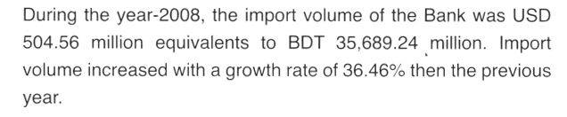

Export:
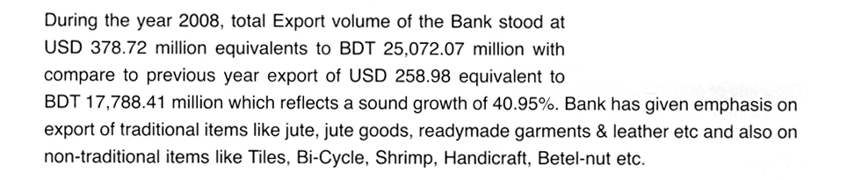

Foreign remittance
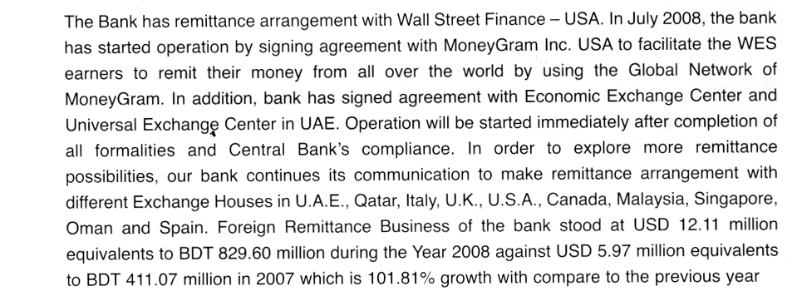

Branch Earnings:
Branch earns money through foreign exchange every year. It earns by commission of export, import and remittance. It also earn by doing some task on behalf of the clients.

Year | Earnings(Tk)
2004 | 65211210
2005 | 35468566
2006 | 59100344
2007 | 7,68,30,447 (Approxi)
2008 | 9,98,79,581 (Approxi)

Table: 4.4: Branch earnings of SBL
The earnings of this branch vary year to year. The trend shows that earnings increases from previous year.

-----------------------------------------------------------X---------------------------------------------------

4.3 Recommendations for SBL:
There are some recommendations for the improvement of the service and faster the service of the Branch.
- If they establish networking system within their branches then it can easily transfer data within a short period of time.
- In foreign exchange department it is require communicating with foreign bank frequently and quickly. To make the process easy and quick the whole bank should be computerized and use faster communication system.
- Margin and commission on L/Cs varies from customer to customer. A customer is allowed to open a L/C ever with nil margins, I think that the bank should review the customer’s transaction behavior for a period of time and should develop a certain policy in this regard.
- They can arrange training program for the employees who are not able to handle modern technology.
- They should use computer instead of register to keep record of transaction and foreign exchange documents.
- Bank should offer new packages to attract new customer as well as existing customer.
- It should open new branches for increasing its customer.
- It should take some steps to increase its volume of foreign exchange because it is declining from the last year.
- Bank should start ATM service as soon as possible.
- It should increase its promotional activities to attract its customer.
- Bank should use faster internet service for speeding its work.

I think management should employ at least few more employees in foreign trade department. I have seen from my practical experience that many customers wait for some time for any service as they see that the officials are doing their best to meet the requirements of the customers. But as the foreign trade procedure is designed with many small tasks. There is a burning need for some additional employees. Management may reduce the workload by appointing a good number of interns in several times in a year

Chapter- 5
Findings and Recommendation

5.1 Findings:
In doing my internship in this Branch I saw some problem which may create problem. These are:
- In foreign exchange department it is required to communicate with foreign banks and other international organization. To make the process easily, modern communication system such as e-mail, fax etc. is used. Bank has these equipment but not satisfactory enough.
- Modern technology is not used to maintain documentation in this bank, yet they are using register based document.
- Lack of manpower in Foreign Exchange Department. In export division of Agrabad branch there is lacking of manpower. The manpower of that section is not sufficient for prompt service.
- Time consuming nature to find out old documents easily for using register based document.
- The bank does not follow online banking system so that customer can not get faster service. Customer also faces problem in anywhere banking.
- There is no ATM service provided by the bank
- Lack of available branches in remote areas of business and services.
- Lack of promotional initiatives to expand the Foreign Exchange business
- Marketing & promotional activities is not well set up.
- There are few packages to attract its customer.
- Though the foreign exchange volume is increasing in the bank but import and export volume is declining in this branch relative to the previous year.
- Internet service is not satisfactory. Sometimes it may create problem to work as such the speed of work become slow down.
- All the employees are not well trained to handling technology such as computer, internet etc.

