Marketing Mix on Pharmaceutical Industry
on
Biopharma Laboratories Ltd

Submitted by

WWW.ASSIGNMENTPOINT.COM

CHAPTER ONE
INTRODUCTION OF THE REPORT

  - BACKGROUND OF THE REPORT
The internship program is an integral part of Bachelor of Business Administration (BBA). Knowledge and learning become perfect when it is associated with theory and practice. This program creates a unique opportunity for the students to apply their theoretical knowledge into practice and gain valuable real world business experience. During the program, student can also realize existing business condition apart from having opportunities to solve the problem using various analytical tools.
To fulfill this requirement I was worked as an intern in Biopharma Laboratories Ltd. for three months. I was appointed as an internship trainee in the Head Office of Biopharma Laboratories Ltd. after facing the viva-voce
I have tried to find out the marketing mix (product, price, promotion and place, people, process, physical environment) of Pharmaceutical industries in Bangladesh, a case study on Biopharma Laboratories Ltd.” which is assigned by my supervisor in department. I have tried my level best to relate the theoretical knowledge with the practical work situation when I have prepared this report.

1.2. SIGNIFICANCE OF THE REPORT
Theoretical knowledge gets its perfection with practical application. And Education will be most effective when theory and practice blends. Internship is designed to bridge the gap between the theoretical knowledge and real application. Since our educational system is mostly text based, inclusion of practical orientation program as an academic component is essential. Bangladesh has a significant number of unemployed educated graduates and most of them have no internship experience. Normal professional experience to establish networking system is important in getting a desirable job. In such state of affairs, the report is done through analyzing the experience of practical orientation related to an appraisal Biopharma Laboratories Ltd. Pharmaceutical sector in Bangladesh is one of the rising sectors which start its journey in 1950 in this sub-continent. At present there are more than 200 pharmaceutical companies in Bangladesh and from that company there are thirty to forty company are in good position in production of pharmaceutical products.

1.3 OBJECTIVES OF THE REPORT
Broad Objective: To describe the marketing pattern of pharmaceuticals industry in Bangladesh by analyzing the marketing mix of Biopharma Laboratories Ltd.
Short/Specific Objectives: The report contains the following specific objectives-
- To describe all types of products those are produced by Biopharma Laboratories Ltd.
- Describing the pricing procedure and price list of Biopharma Laboratories Ltd.
- To describe all types of promotional tools used by Biopharma Laboratories Ltd.
- To study the procedure and managing of promotional tools use by Biopharma Laboratories Ltd. as well as other company.
- To describe the distribution system of Biopharma Laboratories Ltd.
- To raise possible recommendation and related justification (if required) for smooth and accurate implementation concerning the marketing mix of Biopharma Laboratories Ltd.

1.4 METHODOLOGY

1.4.1 Types of Study
The study is descriptive in nature because here I have tried to know the products, price, promotion, place, people, process and physical environment of the pharmaceuticals industry by the Biopharma Laboratories Ltd. I have emphasized on the practical experience. Almost the entire report consists of my practical experience.

1.4.2 Sources of Data
Data have been collected from both primary and secondary sources.
Sources of Data
Primary Data
Secondary Data
- Primary sources of data
  - Face to face conversation with the company officers and staffs.
  - Informal conversation with the doctors, MPO, RMP.
  - Exposure on different desk of the organization

- Secondary sources of data
  - Annual report of Biopharma Laboratories Ltd.
  - Different manuals of Biopharma Laboratories Ltd.
  - Different circulars of Biopharma Laboratories Ltd.
  - Brochures of Biopharma Laboratories Ltd.
  - Unpublished data.
  - News papers, different textbooks
  - Official websites.
  - Bangladesh Economic Review-2008.

1.5 LIMITATIONS
Like any other study the limitations of this study is not out of questions. But the following factors seem to me as the some points of weakness of this study, despite all out co-ordination from the organization.
- It was very difficult to collect the information from various personnel for their job constraint.
- Another limitation of this report is enterprise’s policy of not disclosing some data and information for obvious reason, which could be very much useful.
- Entrance to every nock and corner of the organization was not possible by me.

CHAPTER – TWO
PHARMACEUTICAL INDUSTRY IN BANGLADESH

2. AN OVERVIEW OF PHARMACEUTICAL INDUSTRY IN BANGLADESH
Beginning in the 1950s, now over 200 companies produce medicines in Bangladesh. Pharmaceutical sector is one of the most developed hi tech sector which is contributing in the country's economy. Due to recent development of this sector we are exporting medicines to global market including European market. This sector is also providing 95% of the total medicine requirement of the local market.
In 1981, there were 166 licensed pharmaceutical manufacturers in the country, but local production was dominated by eight multinational companies (MNCs) which manufactured about 75% of the products. There were 25 medium sized local companies which manufactured 15% of the products and the remaining 10% were produced by other 133 small local companies.

There are three public sector drug manufacturing units. Two of them are the Dhaka and Bogra units of Essential Drug Company Ltd. (EDCL), which is functioning as a public limited company under the Ministry of Health and Family Welfare. Besides, out of the total domestic requirement of medicines almost 95 per cent is met by the local manufacturing and Bangladesh also exports formulations to 27 countries around the world. The current turnover of the industry in Bangladesh is Tk. 3,000 crore. Turnover from pharmaceutical sector is encouraging which about 14% of total industry turnover. The pharmaceutical sector's overall sales crossed Tk 4,000 crore in 2008 for the first time, registering a record double-digit growth by many of the country's 258 companies. The growth rate and sales are given as Table

Year | Sales (in crore) | Growth rate
2005 | 3380 | 18%
2006 | 3519 | 4.10%
2007 | 4075 | 15.80%
2008 | 4673 | 14.70%
2009 | 5126 | 9.7%

Table: 2.1. The growth rates of pharmaceutical industry in Bangladesh.

The growth rates of pharmaceutical industry in Bangladesh are shown in graph:
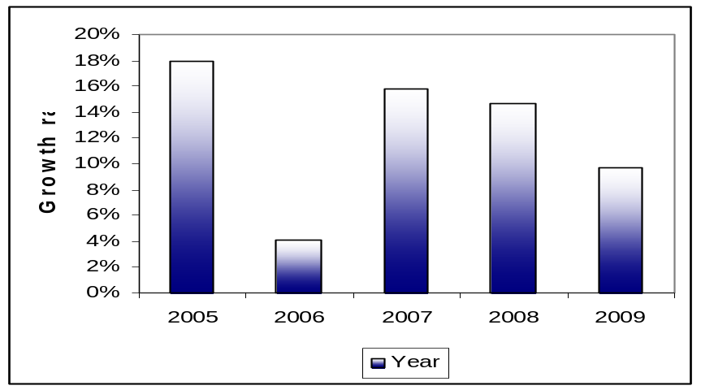
Figure-2.1: Growth rates of pharmaceuticals industry in Bangladesh

According to industry sources, the formulation industry in Bangladesh currently grows at the rate of 22 percent. According to Intercontinental Marketing Services (IMS), a global pharmaceutical market intelligence agency, Bangladesh medicine sales reached Tk 4,673 crore in 2008 and Tk 4,075 crore in 2007. With this estimate, the expected business in year 2009 is 5,126 crore Tk.

Sales growth of different companies in 2008 are given below,
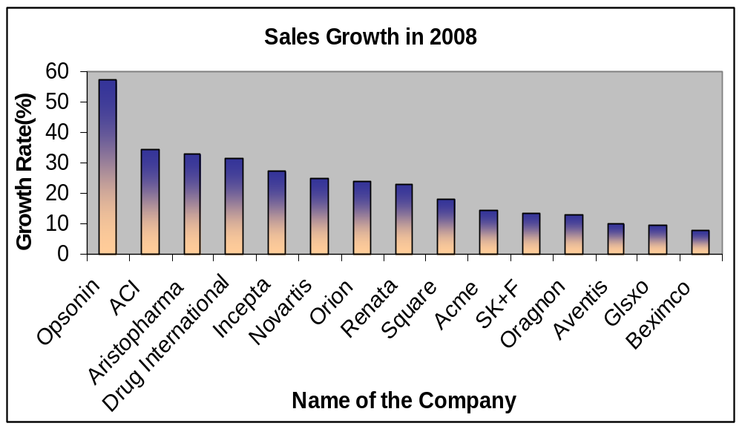
Figure-2.2: Sales growth in 2009

Presently top pharmaceutical companies in Bangladesh are also in the process of getting into bulk drug production with collaborative technology, technology transfers and joint venture basis. The large-scale players in the Bangladesh pharmaceutical industry currently include Square Pharma, Incepta, Beximco, Opsonin, Alma, Apson Chemicals, FEI, Araneta, General Pharma, Hudson Pharma, Biopharma and SKF among others. The MNCs that have a major presence in the country's pharma sector are Aventis, Pfizer, Novartis, Glasko-Smith and Astra Zeneca.

Today, Bangladesh is exporting its pharmaceuticals to various countries like Bhutan, China, Columbia, European Union, Ecuador, Georgia, Germany, Hong Kong, India, Iran, Kenya, Kuraso, Kampuchea, Malaysia, Myanmar, Maldives, Mauritius, Mexico, Nepal, Pakistan, Philippines, Russia, Singapore, Sri Lanka, Sudan, South Korea, Laos, Tazakistan, Taiwan, Thailand, Tunisia, Uzbekistan, Ukraine, USA, Vietnam, and Yemen. Apart from exporting tablet, capsule, syrup, suspension, ointment etc., it also exports 'High Tech and Specialized products' like Metered Dose Inhalers (MDIs), Nasal Sprays, Suppositories, Large Volume Potentials (LVP) and small Volume Potentials (SVP).

2.1 HISTORY OF PHARMACEUTICAL INDUSTRY
In Bangladesh Pharmaceutical sector is one of the most developed hi tech sector which is contributing in the country's economy. After the promulgation of Drug Control Ordinance - 1982, the development of this sector was accelerated. The professional knowledge, thoughts and innovative ideas of the pharmacists working in this sector are the key factors for this developments. Due to recent development of this sector we are exporting medicines to global market including European market. This sector is also providing 95% of the total medicine requirement of the local market. Leading Pharmaceutical Companies are expanding their business with the aim to expand export market. Recently few new industries have been established with hi tech equipments and professionals which will enhance the strength of this sector.

CHAPTER – THREE
ORGANIZATION SYNOPSIS
3.1 AN OVERVIEW OF BIOPHARMA LABORATORIES LTD.
BIOPHARMA was established in 1973 as limited company. It sailed its new journey in 1999 with the involvement of a group of physicians with innovative mission and global conception. Biopharma is one of the fast growing pharmaceutical companies in Bangladesh. Biopharma is now manufacturing more than 150 products including life saving drugs at affordable price and committed to serving the need of ailing community with products of excellent quality, safety and efficacy complying the guideline of WHO cGMP and Quality Management System. Biopharma has gained a leading edge in many important therapeutic groups including Antibiotics, Antiulcerants, Laxative, Bronchodilator, NSAIDs, Vitamins & minerals, Cardiovascular and Dermatological products. BIOPHARMA is always committed to assure the best quality pharmaceutical products and best services to the customers. Our mission is to serve the mankind, especially the distressed and poor ailing people and our vision is to be regarded globally as a Quality pharmaceutical manufacturer through the best quality pharmaceutical products. Bearing this in mind, our technical experts (pharmacist, Chemists, Biochemists, Microbiologists Analysts and other professionals ) skilled and trained staffs always try to leave no stone unturned in their professional works by following the US cGMP, British & WHO GMP guidelines and the guidelines & instructions of the Drug Administration & Licensing Authority of Bangladesh to ensure the production of quality medicine. Ever since we at GLP (Good Laboratory Practices) have always been performing with a strict discipline to follow our professional ethics. By virtue of the highest quality of drugs, the company has already obtained the confidence and trust of doctors and patients all over Bangladesh and earned excellent reputations in the market through introducing very exciting new molecules and dosage forms in many therapeutic areas. We are now producing a wide range of Biological and pharmaceutical products in different dosage forms and presentations including tablets, capsules, syrups, suspensions, powder for suspensions, pediatric drops, sterile creams & ointments and injectable preparations.

3.2 BIOPHARMA LABORATORIES LIMITED PROFILE
Biopharma Laboratories Limited, one of the fast growing pharmaceutical companies in Bangladesh, Has been manufacturing and marketing a wide range of pharmaceutical finished products with strict standard of safety, quality and efficacy to ensure public healthcare through uncompromising scientific and professional approach since 1999. The company has sailed its journey with the involvement of a group of physicians, inspired with love for mankind, with innovative mission and global conception. Since then, the company has been running in full swing bearing its glory for innovation and ethical practice in pharmaceutical sector of Bangladesh.

3.3 VISION:
Biopharma’s vision is to play the leading role in the country’s health sector by providing safe and effective medicine of high quality which will bring benefit to patients through improved longevity and quality of life.

3.4 MISSION
Biopharma mission is to build strength carefully in important areas that offer the resources for tomorrow’s business opportunities.
- To build customer’s trust as “Quality Company” both in products and services.
- To ensure healthy and sustainable growth of the company
- To maintain the quality in all areas of operations by continuous development of Human Resources.
3.5 OBJECTIVE
a) Broad Objective
The broad objective of the report is very important to complete Internship report so I complete my Internship period based on Marketing Mix on Biopharma Laboratories Ltd. Bangladesh
b) Specific objective
The objectives of the report have been given bellow.
▪ To analyze the existing cost accounting system.
▪ To analyze the product costing on the basis of ABC
▪ To identify subsystem of existing cost accounting system (CAS).
▪ To illustrate the activities of these subsystem of existing (CAS).
▪ Problems and prospects in implementing Activity Based Costing (ABC).
▪ Difference between ABC systems Vs. Traditional costing system.
3.6 Performance Analysis Biopharma Laboratories Ltd.

Total Assets: In this graph I show the change in Total assets from 2006 to 2010. Here you can see the raising trend of total assets which is indicates a good financial position of Biopharama Laboratories Ltd.

Year | 2006 | 2007 | 2008 | 2009 | 2010
Total Assets | 11912.5 | 11953.4 | 14819.7 | 19891.9 | 21372.4

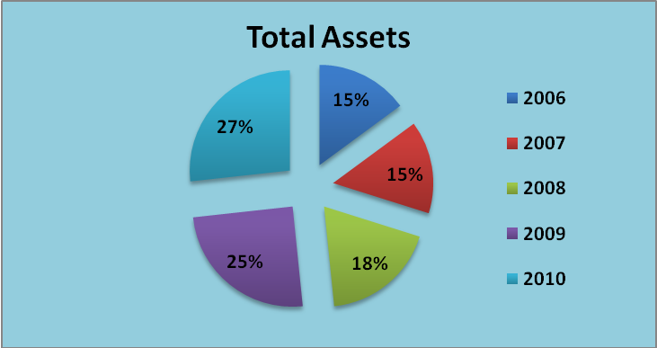
Figure . 3.1

Total Liabilities: In this graph I show the total liabilities of the company. A low portion of liability is good for any company. In 2010 the Beximco company reduce it’s liability from 9006.2 to 5398.3 which is a huge improvement for the company.

Year | 2006 | 2007 | 2008 | 2009 | 2010
Total Liabilities | 3962.5 | 3702.5 | 4369.5 | 9006.2 | 5398.3

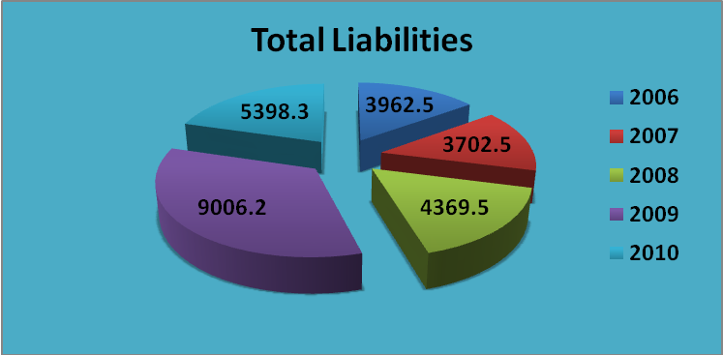
Figure : 3.2

Total Turnover: In this graph I show the total turnover for year 2006 to 2010.

Year | 2006 | 2007 | 2008 | 2009 | 2010
Turnover | 3702.3 | 3597 | 4010.2 | 4868.3 | 6490.8

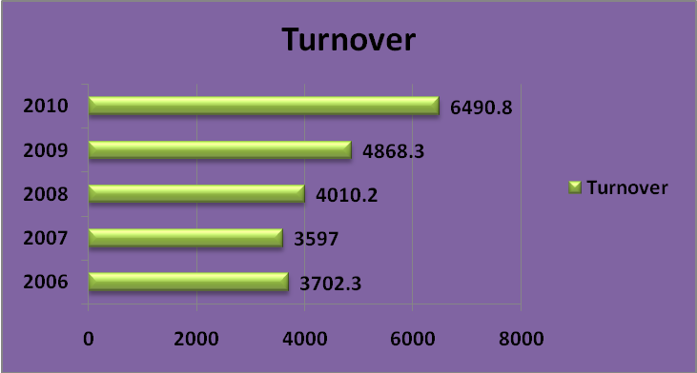
Figure : 3.3

Gross Profit: In this graph I show the gross profit for 2006 to 2010 which is in a raising trend and very helpful to increase it’s production.

Year | 2006 | 2007 | 2008 | 2009 | 2010
Gross Profit | 1731.1 | 1608.6 | 1988.6 | 2280 | 3173.2

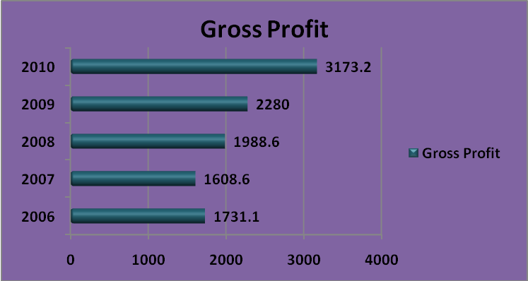
Figure : 3.4

Net Income after tax: In this graph I show the net profit which is earn by the company after paying the tax to the government.

Year | 2006 | 2007 | 2008 | 2009 | 2010
Net Income after tax | 470.7 | 353.1 | 545.3 | 624.7 | 1051.6

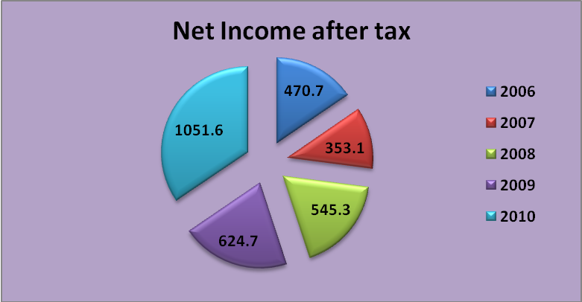
Figure : 3.5

Current Assets & Liabilities for the half yearly 2010-2011:

Year | 2011 | 2010
Current Assets | 6,565,112 | 6,191,667
Current Liabilities | 2,538,058 | 2,513,156

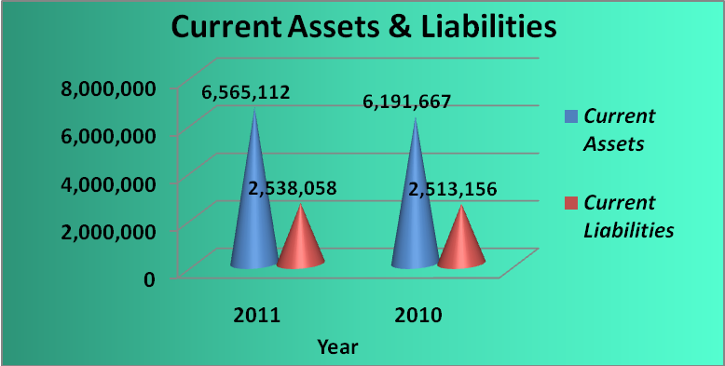
Figure : 3.6

Creditor & Debtor for the half yearly 2010-2011:

Year | 2011 | 2010
Accounts Receivable | 895,370 | 821,356
Creditors and other Payables | 461,263 | 432,315

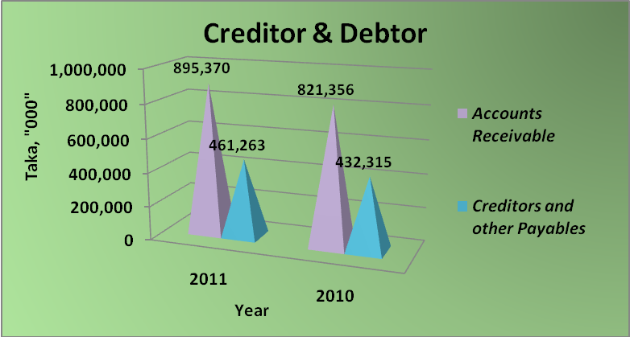
Figure : 3.7

Total Assets & Shareholders’ Equity for the half yearly 2010-2011:

Year | 2011 | 2010
Shareholders' Equity | 16,492,664 | 15,974,087
Total Assets | 22,066,368 | 21,372,399

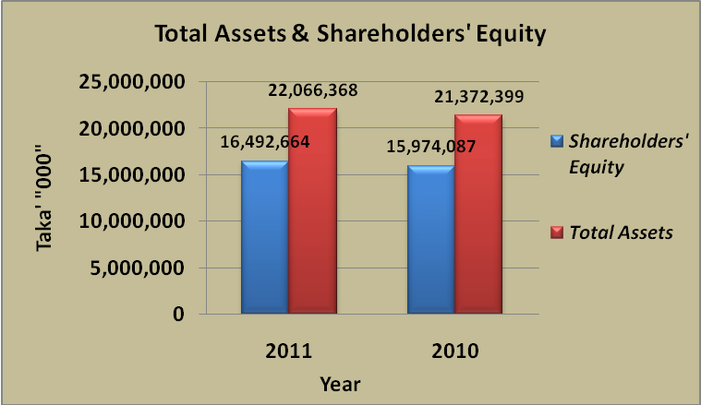
Figure : 3.8

This chapter gives an introduction to this internship report. A general background of the subject is followed by the thesis purpose and question, limitation of the study, thesis out line. The questions are followed by the purpose of this internship report.

CHAPTER FOUR
MARKETING MIX

7P'S OF THE MARKETING MIX
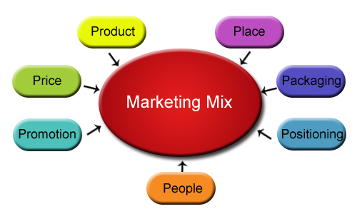

Figure: 4.1: Marketing Mix
Marketing professionals and specialist use many tactics to attract and retain their customers. These activities comprise of different concepts, the most important one being the marketing mix. There are two concepts for marketing mix: 4P and 7P. It is essential to balance the 4Ps or the 7Ps of the marketing mix. The concept of 4Ps has been long used for the product industry while the latter has emerged as a successful proposition for the services industry.

4.1 PRODUCT:
Product
Customer wants and needs
A product is anything that can satisfy the need, want, or demand of the customer.The product aspects of marketing deal with the specifications of the actual goods or services, and how it relates to the end-user's needs and wants. The scope of a product generally includes supporting elements such as warranties, guarantees, and support.

4.1.1 Pharmaceutical Products:
Pharmaceutical products are those products which meet the medical need of the customer.Pharmaceutical product is a drug, broadly speaking, is any substance that, when absorbed into the body of a living organism, alters normal bodily function.
These products are dosage form containing one or more drugs (medicines) along with other substances included during the manufacturing process.

4.1.2 Product strategies of Biopharma Laboratories Ltd.:
Biopharma Laboratories Ltd. has its own production capacity at Tongi, Gazipur to produce vast ranges of product. They are always conscious about the quality of the product. Biopharma Laboratories Ltd. always conducts market research to introduce new and innovative medicine to remedy the disease of people. When they introduce a product then if the product can cure more than 51% patient then they introduce the product in the market. On the other hand they study market that which product has highest demand in the market and also has an increasing rate of demand and also forecast the market that which product demand will increase in near future.
Biopharma Laboratories Ltd. produce those product that has a good demand in near future, that has increasing market trends, that may increase the image of the company. Sometime Biopharma Laboratories Ltd. found that some product has no return or profit and also loss or low price rather than its production cost but the product has a great demand in market and also with that product they can make demand of other product and also this type or category product has a contribution to create a good image of the company. In that situation they never stops rather continue their production.
Sometime Biopharma Laboratories Ltd. has no contribution on product invention. They just prepare the product for foreign buyer or product for several organizations. They provide Biopharma Laboratories Ltd. the formula of production and also the raw material of the product and they just make it as finished goods following the formula.
Biopharma Laboratories Ltd. enrich its product list by innovating new and time oriented medicine in its product list to enter new and potential market and also increase the international market. On the other hand through new innovation it helps to compete in pharmaceutical market in Bangladesh. Biopharma Laboratories Ltd. collects all of its raw material to produce finished products from abroad and for that cost of production is high. If the raw material is collected from Bangladesh then the production cost of the product will decrease at the same time the price of medicine will also decrease.
4.1.3 Products of Biopharma Laboratories Ltd.

Antibiotics
Anti-Fungal-Drugs |  | Anti-Protozoal-Drugs
Anti-Histamines |  | Anti-Emetic
Anthelmintics |  | Antacid & Anti Ulcerants
Laxative Drug |  | Anti-Oxidant
Vitamins & Minerals |  | NSAIDs
Bronchodilators |  | Expectorants
Anti-Diabetic Drugs |  | Anti Depressants & Anxiolytics
Cardiovascular Drugs |  | Dermatological Products
ANTIBIOTICS

 | 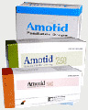
  AMOTID
  Amoxicillin BP 250 capsule
  Amoxicillin BP 500 capsule
  Amoxicillin BP dry powder for suspension 100ml (125mg/5ml)
  Amoxicillin BP dry powder for suspension 100ml (250mg/5ml)
  Amoxicillin BP pediatric drops 15ml (100mg/5ml)

 | 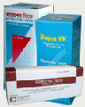
  BIOPEN VK
  Phenoxymethyl penicillin BP 250mg tablet
  Phenoxymethyl penicillin BP dry powder
  suspension 50ml (125mg /5ml)
  Phenoxymethyl penicillin BP dry powder
  suspension 100ml (125mg /5ml)

REVISTAR
Flucloxacillin BP 250 mg capsule
Flucloxacillin BP 500 mg capsule
Flucloxacillin BP dry powder for suspension 60ml (125mg /5ml )
Flucloxacillin BP dry powder for suspension 100ml (125mg /5ml)

 | 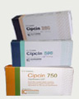
  CIPCIN
  Ciprofloxacin USP 250mg film coated tablet
  Ciprofloxacin USP 500mg film coated tablet
  Ciprofloxacin USP 750mg film coated tablet
  Ciprofloxacin USP powder for suspension
  60ml (250mg /5ml)
  Ciprofloxacin USP powder for suspension
  100ml (250mg /5ml)
LIFCIN
Levofloxacin INN 250 mg film coated tablet
Levofloxacin INN 500 mg film coated tablet

SUPRACEF
Cephradine BP 250mg capsule
Cephradine BP 500 mg capsule
Cephradine BP dry powder for suspension 100ml (125mg /5ml
Cephradine BP dry powder for suspension 100ml (250mg /5ml)
Cephradine BP paediatric drops 15ml (100mg /ml )

 |  | 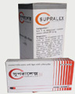
  SUPRALEX
  Cefuroxime BP 250mg capsule
  Cefuroxime BP 500mg capsule
  Cefuroxime BP powder for suspension 100ml

 | 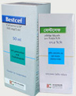
  BESTCEF
  Cefixime USP 200mg capsule
  Cefixime USP drypowder for suspension 37.5ml
  (100mg /5ml)
  Cefixime USPdrypowder for suspension 50ml
  (100mg /5ml)
MEXTIL
Cefuroxime BP 125 mg tablet
Cefuroxime BP 250 mg tablet
Cefuroxime BP powder for suspension 70ml (125mg /5ml )

 | 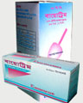
  BIOTRIM
  Cotrimoxazole (Sulphamethoxazole BP 400mg &
  Trimethoprim BP 80 mg ) tablet
  Cotrimoxazole BP dry powder for suspension 60ml
  (SMZ 200 mg/ 5ml & TMP 40 mg /5ml)

 | 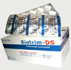
  BIOTRIM DS
  Cotrimoxazole double strength
  (Sulphamethoxazole BP 800mg & Trimethoprim BP 160 mg ) tablet

 | 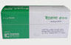
  EROSA
  Erythromycin USP 250 mg film coated tablet
  Erythromycin USP 500 mg film coated tablet
  Erythromycin USP powder for suspension 100ml (125mg /5ml)
  Erythromycin USP paediatric drops 15ml (100mg /ml )
  Erythromycin USP paediatric drops 30ml (100mg /ml )

MACZITH | 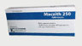
  Azithromycin USP 250 mg capsule
  Azithromycin USP 500mg film coated tablet
  Azithromycin USP dry powder for suspension 15ml
  (200mg /5ml)
ANTI-FUNGAL DRUGS

FUNGATA | 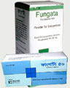
  Fluconazole BP 50 mg capsule
  Fluconazole BP 150mg capsule
  Fluconazole BP dry powder for suspension 35ml (50mg /5ml)
  Fluconazole BP dry powder for suspension 60 ml( 50mg /5ml)
ANTI - PROTOZOAL DRUGS

BIOZYL
Metronidazole BP 400mg film coated teblet
Metronidazole BP suspension 60ml (200mg/5ml)

ANTI – HISTAMINES

 | 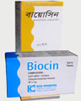
  BIOCIN
  Chlorpheniramine maleate BP 4mg tablet
  Chlorpheniramine maleate BP syrup 100ml(5mg/5ml)

LORFAST | 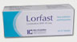
  Loratadine INN 10mg tablet
  Loratadine INN suspension 60ml (5mg/5ml)
ANTI - EMETIC

ESOGUT
Domperidone BP 10 mg film coated tablat
Domperidone BP suspension 30 ml ( 5mg /5ml)
Domperidone BP suspension 60 ml ( 5mg /5ml)
Domperidone BP paediatric drops 15ml (5mg /ml )
Domperidone BP paediatric drops 30ml (5mg /ml )

AVERT
Meclizine HCI USP 50mg tablet

ANTHELMINTICS

 | 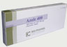
  AZOLE
  Albendazole USP 400mg chewable tablet
  Albendazole USP suspension 10ml (200mg/5ml)

BIOTREX | 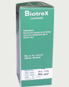
  levamisole BP syrup 30ml (40mg/5ml)
ANTACID & ANTI-ULCERANTS

 | 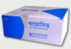
  BIOCID
  Antacid (Aluminum Hydroxide BP250mg + Magnesium Hydroxide BP 500mg chewable tablet)
BIOCID MH
(Aluminum Hydroxide BP +Magnesium Hydroxide BP ) suspension 200 ml

BIOCID PLUS
(Aluminum Hydroxide BP +Magnesium Hydroxide BP + Simethicone BP) suspension 200 ml

 |  |  | 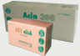
  ACIN
  (Ranitidine USP 150mg film coated tablet Ranitidine USP 300mg film coated tablet

 | 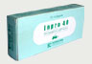
  INPRO
  Omeprazole BP 20mg capsule
  Omeprazole BP 40mg capsule

 | 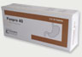
  PANPRO
  Pantoprazole INN 20mg enteric coated tablet
  Pantoprazole INN 40mg enteric coated tablet

ESOM
Esomeprazole INN 20mg film coated tablet
Esomeprazole INN 40mg film coated tablet

LAXATIVE DRUG

LACTU | 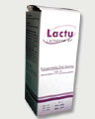
  Lactulose BP solution 100ml (3.35g/5ml) Lactulose BP solution 200ml (3.35g/5ml)
ANTI-OXIDANT

 | 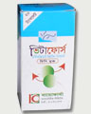
  VITAFORCE
  (Vitamin - E BP 50 mg + Vitamin - C BP 200 mg + Beta carotene USP 6 mg) film coated tablet
VITAMINS & MINERALS

 | 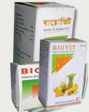
  BIOVIT
  Vitamin B - Complex capsule
  Vitamin B - Complex syrup 100 ml
  Vitamin B - Complex syrup 200 ml
  Multivitamin pacdiatric drops ( vitamin B - complex BP +C BP +Vit- D USP + Vit - A USP + Calcium - D - panto thenate USP ) 15ml

 | 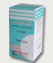
  BIOVIT -M
  Multivitamins & minerals tablet

BIOVIT -E
Vitamin -E BP 200mg film coated chewable tablet

 | 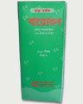
  BIORON
  Ferrous sulphate BP syrup (200ml/ 5ml )

 | 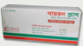
  BIRON PLUS
  Ferrous sulphate BP +Zinc sulphate USP + Folic acid BP ) capsule

CEVALIN
Ascorbic acid BP 250mg chewable tablet

FIVITA
(Ferrous sulphate BP+Folic acid BP + Vitamin - C USP + Vitamin B -Complex BP ) capsule

 | 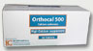
  ORTHOCAL
  Elemental Calcium USP 500mg ( as Calcium carbonate USP ) film coated tablet

ORTHOCAL -D
Elemental Calcium USP 500mg as Calcium carbonate +Vitamin D USP 5mcg ) film coated tablet

 | 
  ZINGA DS
  Zinc sulphate BP syrup 100 ml (zinc BP 10mg / 5ml)
NSAIDs

 | 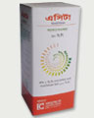
  ACETA
  Paracetamol BP 500 mg tablet
  Paracetamol BP suspension 60 ml ( 120mg /5ml)
  Paracetamol BP pediatric drop 15ml (80mg /ml )
  Paracetamol BP pediatric drop 30ml (80mg /ml )

 | 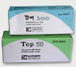
  TOP
  Ketoprofen BP 50mg enteric coated tablet Ketoprofen BP 100mg enteric coated tablet

VOLCAN
Diclofenac sodium BP 50mg enteric coated tablet

VOLCAN TR
Diclofenac sodium BP100mg timed release capsule

CLOF | 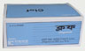
  Aceclofenac BP 100mg enteric coated tablet
BRONCHODILATORS

SALBU
Salbutamol BP 2 mg tablet
Salbutamol BP 4 mg tablet
Salbutamol BP 60ml syrup ( 2mg /5ml)
Salbutamol BP 100ml syrup ( 2mg /5ml)

EXPECTORANTS

KOFED
(Pesudoephedrine BP + Guaiphenesine BP + Triprolidine BP) syrup 100ml

MUCUT
Bromhexine HCI BP syrup 100ml ( 4mg /5ml )

ANTI - DIABETIC DRUGS

 | 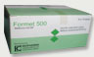
  FORMET
  Metformin HCI BP 500mg film coated tablet
  Metformin HCI BP 850mg film coated tablet

GLUCOSTAT
Gliclazide BP 80mg tablet

ANTI - DEPRESSANTS & ANXIOLYTICS

 | 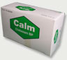
  CALM
  Clobazam BP 10 mg tablet

EUPHOR
( Nortriptyline HCI( BP 10 mg + Fluphenazine
HCI BP 0.5 ml ) film coated tablet

BENZIT
(Flupentixol INN 0.5 mg +Maletracin INN 10mg )
film coated tablet

CARDIOVASCULAR DRUGS

 | 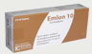
  EMLON
  Amlodipine BP 5mg tablet
  Amlodipine BP 10mg tablet

DERMATOLOGICAL PRODUCTS
TERMIDER cream 15g
(Terbinafine HCI INN 1%) in Aluminium Tube.
ETNOL
Antenolol BP 50mg tablet
Antenolo
LOPO
Losartan Potassium INN 25mg film coated tablet
Losartan Potassium INN 50mg film coated tablet l BP 100mg tablet
Topical Corticosteroids
XDERM Cream 10g
(Clobetasol propionate USP 0.5% ) in Aluminum tube )
XDERM Ointment 10 g
(Clobetasol propionate USP 0.5% ) in Aluminum tube )
MEXIDERM Cream 15 g
(Betamethasone valerate BP 0.1%) in Aluminum tube
MEXIDERM Ointment 15 g
(Betamethasone valerate BP 0.1% ) in Aluminum tube
Topical corticosteroids
SCAPER cream 15 g
(permethrin BP 5%) in Aluminium tube
SCAPER cream 30 g
(permethrin BP 5%) in Aluminium tube
Topical Anti-infective
NUBA Ointment 20g
(Neomycin sulphate BP 0.5% & Bacitracin zinc BP 500 i.u/g) in Aluminium tube
Topical Anti-infectives with corticosteroids
MEXIDERM-N cream 5g
(Betamethasone valerate BP 0.1% & Neomycin sulphate BP 0.5%) in Aluminium tube
MEXIDERM-N Ointment 5g
(Betamethasone valerate BP 0.1% & Neomycin sulphate BP 0.5%)in Aluminium tube
Topical anti-fungals
ENAZOL PLUS cream 10g
(Econazole nitrate BP 1% & Triamcinolone acetonide BP 0.1%)in Aluminium tube

4.2 PRICE:
Price
Cost to Satisfy
The amount of money charged for a product or service, or the sum of the values that consumers exchange for the benefit of having or using the product of service.
Pricing is a fundamental aspect of financial modeling, and is one of the four Ps of the marketing mix. Price is the only revenue generating element amongst the four Ps, the rest being cost centers. Pricing factors are manufacturing cost, market place, competition, market condition, quality of product.
4.2.1 GENERAL PRICING APPROACHES THAT ARE USED BY PHARMACEUTICALS INDUSTRY

General pricing Approaches

Value Based Pricing

Cost Based pricing

Competitors Based pricing
Figure 4.2: General Pricing Approaches

Value Based pricing:
Value Based pricing means setting the price based on buyers’ perceptions of value rather than on the seller’s cost.

Customer

Value

Price
Cost
Product

Value based pricing starts with the customer and ends to the products Value Based Pricing set the price based on the considering the following factors-
- Focus on customer
- Target Market and Competition
- Fits with Strategy Planning

Value Based Pricing
Focus on customer requirements
Target Market and Competition
Fits with Strategy Planning

Cost Based Pricing:
Cost based pricing starts with the product and ends to the customers. According to the cost of the production and adding the profit margin they set the price of the products. In Bangladesh as there are more than 200 companies so here the competition is very high so based on the competitors products price pharmaceuticals product price are set.

Custome
Product
rs

Price
Value
Cost

4.2.2 GENERAL PRICING APPROACHES USED BY BIOPHARMA LABORATORIES LTD.
For most of the new and innovative products Biopharma Laboratories Ltd. used value based pricing. For setting price the research and development departments of Biopharma Laboratories Ltd. perceive the price of the product for the customers than set price based on the perception of the customers.

Product
Customers

Price
Cost
Value

For most of the existing product and where the competition is very stiff Biopharma Laboratories Ltd use cost based pricing. According to the cost them and adding the profit margin they set the price of the products. In Bangladesh as there are more than 200 companies so here the competition is very high so based on the competitors products price Biopharma Laboratories Ltd set cost based pricing.
Customers
Product
Price
Value
Cost

4.2.3 PHARMACEUTICAL PRICING STRATEGIES IN A COMPETITIVE MARKET:
In new production pricing there are two types of pricing strategies that are widely used in pharmaceutical products pricing. The two pricing strategies are shown in figure,
New Product pricing strategies
Penetration Pricing
Skimming Pricing
a. Penetration pricing strategies:
In penetration pricing the firm set a low price for a new product in order to attract a large number of buyers and a large market share. Here the company set a low initial price in order to penetrate the market quickly and deeply to attract customer. The high sales volume results in falling costs, allowing the company to cut its price even further. Several conditions must be met for this low-price strategy to work. First, the market must be highly price sensitive so that a low price produces more market growth. Second, production and distribution costs must fall as sales volume increases. Finally, the low price must help keep out the competition, and the penetration price must maintain its low price position otherwise, the price advantage may be only temporary. Pharmaceutical product pricing may be depended on penetration pricing. When an organization introduce a new product which has already in the market then the firm set a low price than its competitors to gain more market share in the market. In some situation Biopharma Laboratories Ltd. use penetration pricing for setting price in a competitive market.

b. Skimming pricing:
Skimming pricing means setting a high price for a new product to skim maximum revenues layer by layer from the segments willing to pay the high price; the company makes fewer but more profitable sales. Market skimming makes sense only under certain conditions. First, the product’s quality and image must support its higher price, and enough buyers must want the product at that advantage of charging more. Finally, competitors should not be able to enter the market easily and undercut the high price. When Biopharma Laboratories Ltd. innovate new product in the market then they use skimming pricing strategies.

In the interest of maximizing profits, the manufacturer of a new pharmaceutical product can adopt two alternative strategies in pricing in a competitive market. So-called “skimming pricing” occurs when a manufacturer sets an entry price at the highest possible level (resulting in fewer sales at a higher price) and then gradually reduces the price to capture more of the market. The first strategy is likely to be chosen for innovative drugs for which patients (and their insurers) will have a higher willingness to pay, i.e., those with clear advantage in therapeutic benefit as compared with existing therapies. The second approach, so-called “penetration pricing”, occurs when a manufacturer offers a price below that of comparable products in an effort to gain market share, then subsequently raises prices. This approach will be reserved for products that offer little or no advantage in therapeutic benefit as compared with existing therapies.
Pricing strategies differ for pharmaceuticals used in acute versus chronic conditions. Treatment for acute conditions tends to obtain relatively high price premium at market entry, with little subsequent change in price. On the other contrary, penetration pricing is more used for treatments of chronic conditions with high increases in the eight years after introduction. Only two studies taking an empirical look at pricing strategies on the pharmaceutical market were found, neither of which is recent. Very innovative products were introduced at relatively high prices, by comparison with prices of their competitors, while drugs which were minor variations of existing drugs were priced lower than their competitors. This study found some price convergence after four years of marketing of a product, due both to the decrease of entry price and to the prompt price cuts of competitors in reaction to entry of products with penetration prices. The emergence of managed care in the market may well have altered pricing strategies.

4.2.4 PRICE LIST OF BIOPHARMA LABORATORIES LTD.

PRICING STRATEGY

Pricing strategy refers to method companies use to price their products or services. Almost all companies, large or small, base the price of their products and services on production, labor and advertising expenses and then add on a certain percentage so they can make a profit. There are several different pricing strategies, such as penetration pricing, price skimming, discount pricing, product life cycle pricing and even competitive pricing.

PENETRATION PRICING
A small company that uses penetration pricing typically sets a low price for its product or service in hopes of building market share, which is the percentage of sales a company has in the market versus total sales. The primary objective of penetration pricing is to garner lots of customers with low prices and then use various marketing strategies to retain them. For example, a small Internet software distributor may set a low price for its products and subsequently email customers with additional software product offers every month. A small company will work hard to serve these customers to build brand loyalty among them.

PRICE SKIMMING
Another type of pricing strategy is price skimming, in which a company sets its prices high to quickly recover expenditures for product production and advertising. The key objective of a price skimming strategy is to achieve a profit quickly. Companies often use price skimming when they lack financial resources to produce products in volume, according to the article "Pricing Strategy" at NetMBA.com. Instead, the company will use the quick spurts of cash to finance additional product production and advertising.

PRODUCT LIFE CYCLE PRICING
All products have a life span, called product life cycle. A product gradually progresses through different stages in the cycle: introduction, growth, maturity and decline stages. During the growth stage, when sales are booming, a small company usually will keep prices higher. For example, if the company's product is unique or of higher quality than competitive products, customers will likely pay the higher price. A company that prices its products high in the growth stage also may have a new technology that is in high demand.

COMPETITIVE-BASED PRICING
There are times when a small company may have to lower its price to meet the prices of competitors. A competitive-based pricing strategy may be employed when there is little difference between products in an industry. For example, when people purchase paper plates or foam cups or a picnic, they often shop for the lowest price when there is minimal product differentiation. Consequently, a small paper company may need to price its products lower or lose potential sales.

TEMPORARY DISCOUNT PRICING
Small companies also may use temporary discounts to increase sales. Temporary discount pricing strategies include coupons, cents-off sales, seasonal price reductions and even volume purchases. For example, a small clothing manufacturer may offer seasonal price reductions after the holidays to reduce product inventory. A volume discount may include a buy-two-get-one-free promotion.

Tablet
Sl No. | Name of the Products | Generic Name | Pack  Size | Trade  Price | Invoice  value | M.R.P.
 |  |  |  |  | 13% | M.R.P.
1 | ACETA Tablet 500mg | Paracetamol | 200's | 120.00 | 136.20 | 160.00
2 | ACETA-X Tablet | Paracetamol | 100's | 100.00 | 113.50 | 150.00
3 | ACIN 150mgTablet | Ranitidine | 100's | 151.00 | 171.39 | 200.00
4 | ACIN 300mg Tablet | Ranitidine | 50's | 132.00 | 149.82 | 175.00
5 | AZOLE Tablet | Albendazol | 20's | 57.40 | 65.15 | 80.00
6 | AVERT 50mg Tab. | Meclizine HCL | 50's | 94.50 | 107.26 | 125.00
7 | BENZIT Tab. 500mg. | Flupentixol Melitracin | 100's | 226.00 | 256.51 | 300.00
8 | BIOCID Tablet | Antacid | 200's | 68.00 | 77.18 | 90.00
9 | BIOCID Plus Tab | Antacid + Semithecon | 200's | 136.00 | 154.36 | 180.00
10 | BIOCIN Tablet 4mg | Chloropheniramine Maleate | 100's | 15.00 | 17.03 | 20.00
11 | BIOPEN VK Tab. 250 mg | Phenoximethyle Pennicillin | 100's | 113.00 | 128.26 | 150.00
12 | BIOTRIM Tablet 480mg | Sulphamethoxazole + Trimethoprim | 100's | 98.11 | 111.35 | 140.00
13 | BIOTRIM DS Tab. 960mg | Sulphamethoxazole 800mg + Trimethoprim 160mg | 100's | 130.00 | 147.55 | 200.00
14 | BIOVIT -E Tablet | Vitamin E | 15's | 33.90 | 38.48 | 45.00
15 | BIOVIT M Tablet | Multivitamin + Mineral | 30's | 22.50 | 25.54 | 30.00
16 | BIOVIT Gold Tablet | Vitamine A to Z | 15's | 67.92 | 77.09 | 90.00
17 | BIOVIT Gold Tablet | Vitamine A to Z | 30's | 139.90 | 158.79 | 180.00
18 | BIOVIT PN Tablet | Vitamine A to Z | 15's | 56.56 | 64.20 | 75.00
19 | BIOVIT PN Tablet | Vitamine A to Z | 30's | 113.35 | 128.65 | 150.00
20 | BIOVIT Silver Tablet | Vitamine A to Z | 15's | 67.92 | 77.09 | 90.00
21 | BIOVIT Silver Tablet | Vitamine A to Z | 30's | 135.90 | 154.25 | 180.00
22 | BIOZYL Tablet 400mg | Metronidazole | 100's | 75.00 | 85.13 | 100.00
23 | BROZE Tablet 10mg | Bromazepam | 50's | 113.35 | 128.65 | 150.00
24 | CALM Tablet 10mg | Clobazam | 100's | 189.00 | 214.52 | 250.00
25 | CEVALIN Tab. 250mg | Vitamin C | 200's | 198.00 | 224.73 | 262.00
26 | CIPCIN 250mg Tablet | Ciprofloxacin | 30's | 181.20 | 205.66 | 240.00
27 | CIPCIN 500mg Tablet | Ciprofloxacin | 30's | 294.30 | 334.03 | 390.00
28 | CIPCIN 750mg Tablet | Ciprofloxacin | 12's | 153.96 | 174.74 | 204.00
29 | CLOF Tablet 100mg | Aciclofenac | 100's | 155.00 | 175.93 | 250.00
30 | CLOMA 0.5 mg Tablet | Clnazepam | 50's | 75.50 | 85.69 | 100.00
31 | CLOMA 2 mg Tablet | Clnazepam | 30's | 90.60 | 102.83 | 120.00
32 | EMLON Tablet 5mg | Amlodipine | 50's | 170.00 | 192.95 | 225.00
33 | EMLON Tablet 10mg | Amlodipine | 30's | 124.50 | 141.31 | 165.00
34 | EMLON Plus Tablet | Amlodipine 5mg + Atenolol 50mg | 30's | 90.56 | 102.79 | 120.00
35 | EROSA Tablet 250mg | Erythromycin Stearite | 100's | 302.00 | 342.77 | 400.00
36 | EROSA Tablet 500mg | Erythromycin Stearite | 50's | 302.00 | 342.77 | 400.00
37 | ETNOL Tablet 50mg | Atenolol | 100's | 58.00 | 65.83 | 77.00
38 | ETNOL Tablet 100mg | Atenolol | 100's | 103.00 | 116.91 | 137.00
39 | ESOGUT Tablet 10mg | Dompiridon | 100's | 130.00 | 147.55 | 200.00
40 | EUPHOR Tablet 10.5mg | Nortriptyline+Fluphenizine | 100's | 60.00 | 68.10 | 80.00
41 | FORMET Tablet 500 mg | Metformin HCL | 100's | 83.00 | 94.21 | 110.00
42 | FORMET Tablet 850 mg | Metformin HCL | 50's | 94.50 | 107.26 | 125.00
43 | GOUTEX Tablet 100mg | Alupurinol | 100's | 189.00 | 214.52 | 250.00
44 | GLUCOSTAT Tab. 80mg | Gliclazide | 50's | 170.00 | 192.95 | 225.00
45 | LIFCIN Tablet 500mg | Levofloxacin | 20's | 196.20 | 222.69 | 260.00
46 | LOPO Tablet 25mg | Losartan Potassium | 30's | 79.20 | 89.89 | 105.00
47 | LOPO Tablet 50mg | Losartan Potassium | 30's | 135.90 | 154.25 | 180.00
48 | LORFAST Tablet 10mg | Loratadine | 50's | 113.00 | 128.26 | 150.00
49 | MACZITH 500mg Tablet | Azithromycin | 6's | 135.84 | 154.18 | 180.00
50 | MEXTIL Tab. 125mg | Ceforoxime Exetel | 20's | 226.40 | 256.96 | 300.00
51 | MEXTIL Tab. 250mg | Ceforoxime Exetel | 20's | 377.40 | 428.35 | 500.00
52 | ORTHOCAL Tab. 500mg | Calcium Carbonate | 50's | 75.50 | 85.69 | 100.00
53 | ORTHOCAL-D Tablet | Calcium Carbonate | 15's | 37.35 | 42.39 | 49.00
54 | ORTHOCAL -D Tablet | Calcium Carbonate | 30's | 74.70 | 84.78 | 99.00
55 | PANPRO Tablet 20mg | Pantoprazole | 50's | 113.35 | 128.65 | 150.00
56 | PANPRO Tablet 40mg | Pantoprazole | 50's | 188.75 | 214.23 | 250.00
57 | PERILAC Tab. 10mg | Ketorolac | 10's | 151.00 | 171.39 | 200.00
58 | SALBU 2mg Tablet | Salbutamol | 100's | 20.00 | 22.70 | 26.00
59 | SALBU 4mg Tablet | Salbutamol | 100's | 23.00 | 26.11 | 30.00
60 | TOP 50 mg Tablet | Ketoprofen | 50's | 132.00 | 149.82 | 175.00
61 | TOP 100 mg Tablet | Ketoprofen | 30's | 135.90 | 154.25 | 180.00
62 | TROVA 10mg Tab | Atorvastatin Calcium | 30's | 181.20 | 205.66 | 240.00
63 | TROVA 20mg Tab | Atorvastatin Calcium | 10's | 113.20 | 128.48 | 150.00
64 | UROSPIN Tab 20mg | Spironolactone 50mg + Furosemide 20mg | 30's | 135.90 | 154.25 | 180.00
65 | VITAFORCE Tab. | Antioxidant Vitamins | 20's | 37.80 | 42.90 | 50.00
66 | VITAFORCE S Tablet | Super Antioxidant Vitamins | 15's | 45.30 | 51.42 | 60.00
67 | VITAFORCE S Tablet | Super Antioxidant Vitamins | 30's | 90.60 | 102.83 | 120.00
68 | VOLCAN Tab. 50 mg | Diclofenac Sodium | 100's | 60.00 | 68.10 | 80.00
69 | VOLCAN SR Tab. 100 mg | Diclofenac Sodium | 50's | 94.50 | 107.26 | 125.00
70 | ZINGA Tablet 20's | Zinc Sulphate | 50's | 56.50 | 64.13 | 75.00

Capsule

Sl No. | Name of the Products | Generic Name | Pack | Trade | Invoice value | M.R.P.
Sl No. | Name of the Products | Generic Name | Size | Price | 13% | M.R.P.
1 | AMOTID 250mg Cap. | Amoxicillin | 100's | 226.90 | 257.53 | 300.00
2 | AMOTID 500mg Cap. | Amoxicillin | 100's | 416.00 | 472.16 | 560.00
3 | BESTCEF Cap. 200mg | Cefixime | 10'S | 226.40 | 256.96 | 300.00
4 | BIRON PLUS 445mg Cap. | Ferrus Sulphate + Folic Acid+Zinc Sulphate | 30's | 65.70 | 74.57 | 87.00
5 | BIOVIT Capsule | Vitamin B Complex | 200's | 86.00 | 97.61 | 114.00
6 | FUNGATA Cap. 50 mg | Fluconazole | 30's | 135.90 | 154.25 | 180.00
7 | FUNGATA Cap. 150 mg | Fluconazole | 10's | 113.20 | 128.48 | 150.00
8 | FIVITA Capsule | Ferrus Sulphate + Vit - B Complex+Vita C+Folic Acid | 100's | 226.00 | 256.51 | 300.00
9 | FIVITA Capsule | Ferrus Sulphate + Vit - B Complex+Vita C+Folic Acid | 30's | 67.80 | 76.95 | 90.00
10 | INPRO 20mg Capsule | Omeprazole | 60's | 181.20 | 205.66 | 240.00
11 | INPRO 40mg Capsule | Omeprazole | 20's | 90.60 | 102.83 | 120.00
12 | MACZITH 250mg Capsule | Azithromycin | 6's | 90.54 | 102.76 | 120.00
13 | REVISTAR Cap. 500 mg | Flucloxacillin | 28's | 211.40 | 239.94 | 280.00
14 | REVISTAR Cap. 250 mg | Flucloxacillin | 28's | 116.20 | 131.89 | 154.00
15 | SUPRACEF Cap. 250mg | Cephradine | 28's | 141.68 | 160.81 | 187.60
16 | SUPRACEF Cap. 500mg | Cephradine | 28's | 264.04 | 299.69 | 350.00
17 | SUPRALEX Cap. 250mg | Cephalexin | 30's | 108.00 | 122.58 | 195.00
18 | SUPRALEX Cap. 500mg | Cephalexin | 30's | 271.80 | 308.49 | 360.00
19 | VOLCAN TR Cap. 100 mg | Diclofenac Sodium | 100`s | 226.00 | 256.51 | 300.00

Syrup
Sl No. | Name of the Products | Generic Name | Pack | Trade | Invoice value | M.R.P.
Sl No. | Name of the Products | Generic Name | Size | Price | 13% | M.R.P.
1 | ACIN 100ml Sup | Ranitidine | 100ml | 33.96 | 38.54 | 45.00
2 | BIOCIN Syrup | Chloropheniramine Maleate | 100ml | 10.57 | 12.00 | 14.00
3 | BIORON Syrup | Ferrus Sulphate | 200ml | 19.62 | 22.27 | 26.00
4 | BIOTREX Syrup | Levamisole | 15ml | 6.04 | 6.86 | 8.00
5 | BIOTREX Syrup | Levamisole | 30ml | 9.06 | 10.28 | 12.00
6 | BIOVIT Syrup 100ml | Vitamin B Complex | 100ml | 15.70 | 17.82 | 20.80
7 | BIOVIT Syrup 200ml | Vitamin B Complex | 200ml | 28.68 | 32.55 | 38.00
8 | KOFED Syrup | Expectorant | 100ml | 22.64 | 25.70 | 30.00
9 | LACTU Syrup | Lactulose | 100ml | 67.92 | 77.09 | 90.00
10 | LACTU Syrup | Lactulose | 200ml | 120.75 | 137.05 | 160.00
11 | MUCUT Syrup 4mg./5ml | Bromhexine HCL | 100ml | 20.38 | 23.13 | 27.00
12 | SALBU Syrup 60ml | Salbutamol | 60ml | 8.30 | 9.42 | 11.00
13 | SALBU Syrup 100ml | Salbutamol | 100ml | 11.32 | 12.85 | 15.00

Suspension
Sl No. | Name of the Products | Generic Name | Pack | Trade | Invoice value | M.R.P.
Sl No. | Name of the Products | Generic Name | Size | Price | 13% | M.R.P.
1 | ACETA Suspension | Paracetamol | 60ml | 12.26 | 13.92 | 16.25
2 | AZOLE Suspension | Albendazol | 10ml | 11.32 | 12.85 | 15.00
3 | BIOCID M-H Susp | Antacid | 200ml | 24.38 | 27.67 | 32.30
4 | BIOCIDPlusSusp | Antacid | 200ml | 34.72 | 39.41 | 46.00
5 | BIOTRIM Suspension | Sulphamethoxazole + Trimethoprim | 60ml | 16.21 | 18.40 | 21.48
6 | BIOZYL Suspension | Metronidazole | 60ml | 16.30 | 18.50 | 21.60
7 | ESOGUT Suspension | Dompiridon | 60ml | 21.13 | 23.98 | 28.00
8 | LORFAST Suspension | Loratadine | 60ml | 19.62 | 22.27 | 26.00

Dry Syrup
Sl No. | Name of the Products | Generic Name | Pack | Trade | Invoice value | M.R.P.
Sl No. | Name of the Products | Generic Name | Size | Price | 13% | M.R.P.
1 | AMOTID Dry Syrup | Amoxicillin | 100ml | 36.00 | 40.86 | 45.00
2 | AMOTID - F Syrup | Amoxicillin | 100ml | 55.00 | 62.43 | 65.00
3 | BESTCEF D/S 37.5ml | Cefixime | 37.5ml | 98.11 | 111.35 | 130.00
4 | BESTCEF D/S 50ml | Cefixime | 50ml | 120.75 | 137.05 | 160.00
5 | BIOPEN VK D/S 50ml | Phenoximethyle Pennicillin | 50ml | 13.74 | 15.59 | 18.21
6 | BIOPEN VK D/S 100ml | Phenoximethyle Pennicillin | 100ml | 21.74 | 24.67 | 28.80
7 | CIPCIN Dry Syrup | Ciprofloxacin | 60ml | 60.38 | 68.53 | 80.00
8 | EROSA Dry Syrup | Erythromycin Stearite | 100ml | 41.51 | 47.11 | 55.00
9 | FUNGATA Dry Syrup | Fluconazole | 35ml | 56.60 | 64.24 | 75.00
10 | MACZITH D/S | Azithromycin | 35ml | 98.11 | 111.35 | 130.00
11 | MEXTIL D/S 70ml | Ceforoxime Exetel | 70ml | 150.94 | 171.32 | 200.00
12 | REVISTAR Dry Syrup | Flucloxacillin | 100 ml | 45.28 | 51.39 | 60.00
13 | SUPRACEF Dry Syrup | Cephradine | 100ml | 60.38 | 68.53 | 80.00
14 | SUPRACEF-F Dry Syrup | Cephradine | 100ml | 90.57 | 102.80 | 120.00
15 | SUPRALEX Dry Syrup | Cephalexin | 100ml | 50.00 | 56.75 | 77.00
16 | ZINGA DS Syrup 200mg | Zinc Sulphate | 100ml | 19.62 | 22.27 | 26.00

Cream
Sl No. | Name of the Products | Generic Name | Pack | Trade | Invoice value | M.R.P.
Sl No. | Name of the Products | Generic Name | Size | Price | 13%
1 | ENAZOL PLUS Cream. 10gm. | Econazole Nitrate 1% & Triamcinolone Acetonide 0.1% | 10gm | 25.66 | 29.12 | 34.00
2 | MEXIDERM Cream 15gm | Betamethason Valerite | 15mg | 18.87 | 21.42 | 25.00
3 | MEXIDERM-N Cream 5gm | Betamethason Valerite | 5gm | 11.32 | 12.85 | 15.00
4 | SCAPER Cream 15gm | Permethrin | 15gm | 18.87 | 21.42 | 25.00
5 | SCAPER Cream 30gm | Permethrin | 30gm | 30.19 | 34.27 | 40.00
6 | TERMIDER Cream 10gm | Terbinafine HCL 1% | 10gm | 37.74 | 42.83 | 50.00
7 | TERMIDER Cream 5gm | Terbinafine HCL 1% | 15gm | 22.64 | 25.70 | 30.00
8 | XDERM Cream 10gm | Clobetasol Propionate 0.05% | 10gm | 33.96 | 38.54 | 45.00

Ointment
Sl No. | Name of the Products | Generic Name |  | Pack | Trade | Invoice value |  |  | M.R.P.
Sl No. | Name of the Products |  |  | Size | Price | 13% |  |  | M.R.P.
1 | MEXIDERM Oint. 15gm | Betamethason Valerite |  | 15gm | 21.13 | 23.98 |  |  | 28.00
2 | MEXIDERM-N Oint. 5gm | Betamethason Valerite |  | 5gm | 11.17 | 12.68 |  |  | 14.80
3 | NUBA Ointment | Neomycin Sulphate |  | 20gm | 30.19 | 34.27 |  |  | 40.00
4 | XDERM Oint. 10gm | Clobetasol Propionate 0.05% |  | 10gm | 37.74 | 42.83 |  |  | 50.00
Injection
Sl No. | Name of the Products |  | Generic Name | Pack | Trade |  | Invoice value | M.R.P.
Sl No. |  |  | Generic Name | Size | Price |  | 13%
1 | PERILAC Inj 10mg IM |  | Ketorolac | 1 X 5 | 113.20 |  | 128.48 | 150.00
2 | PERILAC Inj 30mg IM |  | Ketorolac | 1 X 5 | 188.70 |  | 214.17 | 250.00
3 | SUPRACEF 1gm Inj IVIM |  | Cephradine | 1gm | 55.85 |  | 63.39 | 74.00
4 | SUPRACEF 250mg Inj IVIM |  | Cephradine | 250mg | 25.66 |  | 29.12 | 34.00
5 | SUPRACEF 500mg Inj IV/IM |  | Cephradine | 500mg | 36.98 |  | 41.97 | 49.00
6 | WINNER 1gm IM Inj |  | Cetriaxone | 1gm X 1 | 135.85 |  | 154.19 | 180.00
7 | WINNER 500mg IM Inj |  | Cetriaxone | 500mg X 1 | 90.57 |  | 102.80 | 120.00
8 | WINNER 250mg IM Inj |  | Cetriaxone | 250mg X 1 | 67.92 |  | 77.09 | 90.00
9 | WINNER 1gm IV Inj |  | Cetriaxone | 1gm X 1 | 135.85 |  | 154.19 | 180.00
10 | WINNER 250mg IV Inj |  | Cetriaxone | 250mg X 1 | 67.92 |  | 77.09 | 90.00
11 | WINNER 500mg IV Inj |  | Cetriaxone | 500mg X 1 | 90.57 |  | 102.80 | 120.00

Drops
Sl No. | Name of the Products | Generic Name | Pack | Trade | Invoice value | M.R.P.
Sl No. | Name of the Products | Generic Name | Size | Price | 13% | M.R.P.
1 | ACETA P/D | Paracetamol | 15ml | 9.25 | 10.50 | 12.25
2 | AMOTID P/D | Amoxicillin | 15ml | 22.00 | 24.97 | 28.00
3 | ESOGUT P/D | Dompiridon | 15ml | 15.09 | 17.13 | 20.00
4 | MACZITH D/S | Azithromycin | 15ml | 64.15 | 72.81 | 85.00
5 | SUPRACEF P/D | Cephradine | 15ml | 37.74 | 42.83 | 50.00
6 | BIOVIT Drops | Multi Vitamin | 15ml | 11.32 | 12.85 | 15.00

4.3 PHARMACEUTICAL PROMOTION
Promotion
Communication
“Promotion is all about companies communicating with customers”.
Promotion involves disseminating information about a product, product line, brand, or company. It is one of the four key aspects of the marketing mix. The promotion of pharmaceutical products is the linchpin of the marketing mix. Promotion is the vehicle by which the product, its price and methods of distribution should be described to the firm’s audience in a way that is both coherent and persuasive.

Promotion, especially advertising, tends to have more glamour than do the other mix components. It is certainly more visible and often appears to be more creative. The other elements are of little value unless their advantages are communicated to those who need to know. On the other hand, promotion cannot long succeed if the other elements of the marketing mix are unsatisfactory.

4.3.1 TOOLS OF PROMOTION:
A successful product or service means nothing unless the benefit of such a service can be communicated clearly to the target market. An organisations promotional mix strategy can consist of:
Types of promotion | Explanation
Advertising: | Any non personal paid form of communication using any form of mass media.
Public relations | Involves developing positive relationships with the organisation media public. The art of good public relations is not only to obtain favorable publicity within the media, but it is also involves being able to handle successfully negative attention.
Sales promotion: | Commonly used to obtain an increase in sales short term. Could involve using money off coupons or special offers.
Personal selling: | Selling a product service one to one
Direct Mail | Is the sending of publicity material to a named person within an organisation  Direct mail allows an organisation to use their resources more effectively by allowing them to send publicity material to a named person within their target segment. By personalising advertising, response rates increase thus increasing the chance of improving sales. Listed below are links to organisation who's business involves direct mail.
Internet Marketing | Promoting and selling your services online using various forms of online marketing techniques such as banner advertisments, videos or social media.
Sponsorship | Where you pay an organisation to use your brand or logo. This organisation usually has a high profile so that you know that your brand will be seen by a large audience. Most common use of sponsorship is with sporting events. The 2012 Olympics being held in London is being sponsored by a number of organisations such as Mcdonalds and Coca-Cola as the event will attract a world wide audience that will run into hundreds of millions.

Promotion is generally subdivided into two parts that are given as figure,

Above the line Promotion
Promotion
Merchandising
Sales Promotion
Endorsements
Product Placement
Sponsorship
Mobile Phone
Internet
Newspaper
Radio
TV
Below the line Promotion
Above the line promotion
Direct Mail
Personal Selling
Public Relations
Trade Shows
Figure 4.3: Types of Promotion

Above the line promotion:
Promotion in the media (e.g. TV, radio, newspapers, Internet and Mobile Phones) in which the advertiser pays an advertising agency to place the ad.
Below the line promotion:
All other promotion much of this is intended to be subtle enough for the consumer to be unaware that promotion is taking place. E.g. sponsorship, product placement, endorsements, sales promotion, merchandising, direct mail, personal selling, public relations, trade shows.
Drug promotion method:
The aim of drug promotion is to persuade people to buy more drugs and/or to pay higher prices. This is done by increasing the perceived value of the drug via one or more of several approaches including-
- Widening the indications to include more people.
- Increasing the perceived likelihood and magnitude of benefits.
- Increasing the perceived frequency and/or severity of the indications.
- Decreasing the perceived likelihood and magnitude of harms.
The main aim of promotion is not to inform but to persuade. Consumer goods advertisements rarely convey much information about the feature of the product. Instead the emphasis of much advertising is on associating consumption of the product with positive feeling.

Doctors are the main targets for the promotion activities of drug companies in developing countries. With the power to prescribe and a high status in society and their opinion of a drug very often determines its sales success. It is therefore not surprising that the majority of marketing expenditure by industry leaders go towards direct-to-direct (DTD) promotion.

Health professionals are targeted by companies mainly via medical representatives and advertisements placed in medical journals or brochures that are sent directly to the doctors.
Most of the drug manufacturers try to identify the customers’ behavioral pattern as sophisticated marketing techniques to motivate them to move one or more stages towards repeat use of their drugs. Each move requires motivation and decision making, so drug companies study how to understand human motivation and decision-making.

4.3.2 PROMOTIONAL MIX:
Advertising is defined as a non personal, paid communication about an organization, product, or idea by an identified sponsor. Personal selling is direct communication with customers to generate a response and/or a transaction. Public relation is the evaluation of public attitudes and the execution of plans to gain public understanding and acceptance. Furthermore, sales promotion is providing extra value or incentive to customers to purchase a product. The characteristics of each of these promotional channels as they relate to the pharmaceutical marketing are summarized in the tabl

P  A  I  D | Advertising  Direct marketing  Sales promotion  In-pharmacy display | Personal selling
U  N  P  A  I  D | Publicity | Word-of-mouth
 | Non-personal | Personal
Figure 4.5: Communication tactics in promotion mix of pharmaceutical.

4.3.4 TYPES OF PHARMACEUTICAL PROMOTION MIX:
There are mainly four types of pharmaceutical promotion mix that are given as figure,
Promotional mix
Advertising
Personal selling
Sales promotion
Public relations
Print ads
Radio
Television
Billboard
Direct Mail
Brochures and Catalogs
Signs
In-Store Displays
Posters
Motion Pictures
Web Pages
Banner Ads
Emails
Sales
Presentations
Sales Meeting
Sales Training and Incentive
Samples

Coupons
Sweepstakes
Contests
Product Samples
Rebates
Tie-Ins
Self-Liquidating Premiums
Trade Shows
Trade-Ins
Exhibitions

Newspaper and Magazine articles/reports
TVs and Radio Presentations
Charitable Contributions
Speeches
Issue Advertising
Seminars
Telemarketing

Figure 4.6: Elements in Promotional mix.

Above the four promotional tools are the main promotional tools in pharmaceutical promotion mix but there are another two promotional tools in promotion mix that are direct marketing and sponsorship.

A. Advertising
Any paid presentation and promotion of ideas, goods, or services by an identified sponsor. There are several types of advertisement for example, Print ads, radio, television, billboard, direct mail, brochures and catalogs, signs, in-store displays, posters, motion pictures, Web pages, banner ads, and emails.

Advertising can have a number of objectives; these are shown in the figure:
Objective of the Advertising
To Remind
To Persuade
To Promote

To Compete

To Support

Figure 4.7: Objectives of advertising
B. Personal Selling
A process of helping and persuading one or more prospects to purchase a goods or services or to act on any idea through the use of an oral presentation. Personal selling involves selling a product or service on a one to one basis. This can either be done face to face or over the phone. If the organization is using a pull strategy to sell the product a sales force will be required to make sure that retail outlets are looked after well, that they have enough stock, are trained well so they can push the product onto the consumer. With a push strategy the sales force will need to try and persuade retail outlets to carry stock of ones product. Examples: Sales presentations, sales meetings, sales training and incentive programs for intermediary salespeople, samples, and telemarketing. Can be face-to-face or via telephone.

C. Sales promotion
Media and non-media marketing communication are employed for a pre-determined, limited time to increase consumer demand, stimulate market demand or improve product availability. The aim of sales promotion is to increase short term sales and increase in-store or web traffic. Examples: Coupons, sweepstakes, contests, product samples, rebates, tie-ins, self-liquidating premiums, trade shows, trade-ins, and exhibitions.

D. Public relations
Paid intimate stimulation of supply for a product, service, or business unit by planting significant news about it or a favorable presentation of it in the media. Managing public relations is very important for the organization. Image in marketing is everything. Having a good image helps the organization develop a trust and a bond between themselves and their customers. This good will is invaluable. Examples: Newspaper and magazine articles/reports, TVs and radio presentations, charitable contributions, speeches, issue advertising, and seminars.

E. Sponsorship
Sponsorship is about providing money to an event, in turn the product or company is acknowledged for doing so. For example in different trade show sponsors all the arranging cost or part of the cost to that show.

F. Direct Marketing
The aim of direct marketing is to create one to one relationships with the organizations target market. Direct marketing can come in the form of post, email, telephone calls and mail order. The company usually contacts a named person at the address.

G. Viral Marketing
Viral marketing occurs when consumers pass on or recommend your product/company/website to others. This could be via email, or bulletin boards or word of mouth. There have been many well known online viral marketing campaigns. These include The Blair Witch Project and the establishment of Hotmail as a leading free email provider.

4.3.5 CRITERIA FOR DETERMINING PROMOTION MIX IN PHARMACEUTICAL COMPANIES:
There are several factors that affect the promotional mix are given as figure-

Promotional Mix
Product Factor

Market Mix Factor
Market Factor

Budget Factor

Customer Factor

Environmental Factor

Figure 4.8: Factors affect in promotional mix.
a) Product factors:
The product factor that influence the promotional mix of pharmaceutical products are given below,

- Nature of product
In deciding the proper promotional mix pharmaceuticals company should consider the nature of the product because the promotional tools and strategy differ from product to product.
- Risk/benefit relationship
In risk and benefit relationship here the pharmaceuticals firm should consider and measure the risk and benefit relationship of the product.
Other products factors are-
- Degree of exploration required for successful use
- Potential for demonstration.

b) Market factors:
The major market factor that should consider in setting promotional tools for pharmaceutical product are given as below,
- Position in the life cycle
If the product is at its introduction and growth stage then the promotional budget should increase. On the other hand if the product is at maturity and decline stage then the promotion should be decrease or in constant rate.
- Market share
In deciding the promotional mix the firm should decide the market share of the product. If it wants more market share then the promotional mix should increase.

- Industry concentration:
The promotional mix varies from industry to industry. For example the promotional tools for pharmaceutical industry and the promotional tools for mobile industry are not same.
Other market factors are-
- Intensity of competition
The effects of intensity of product market competition on R&D incentives are analysed in a model capturing the strategic interactions between firms with different cost levels. First, four axioms are proposed that a measure of intensity of competition should satisfy. Then the effects of intensity of competition on the value of the innovation are analysed. And it is shown that the axioms imply the existence of a non-monotone relation between intensity of competition and the value of an innovation.

- Demand perspectives
The total amount of goods and services demanded in the economy at a given overall price level and in a given time period. It is represented by the aggregate-demand curve, which describes the relationship between price levels and the quantity of output that firms are willing to provide. Normally there is a negative relationship between aggregate demand and the price level. Also known as "total spending".

- Generic competition
The PhD in Exploration Systems Design offers students an advanced systems approach for developing scientific exploration technologies in a wide range of demanding environments on the Earth, planets, moons, and space. This transdisciplinary degree program provides a unique platform to train systems engineers targeting technological development for exploration science. This degree is offered in collaboration with the Fulton Schools of Engineering (FSE). Students enrolled in this program are required to select a concentration from below:
• Instrumentation
• Sensor Networks
• Systems Engineering
c) Customer factors:
Customer is the king of any types of company. In terms of promotional mix of pharmaceutical company the firm should consider some customer factor that are given as below,
- Hospital or drug store
In terms of pharmaceutical promotional tools the company should consider from where the customer will collect their product.

- Customer power
For pharmaceutical product here the bargaining power of customer is lower than other types of product.

- Physical distribution considerations
In pharmaceutical promotion the firm should consider the physical distribution system of the firm.

d) Environmental factors:

Environmental factors include-

- Regulatory controls.

- Social climate

e) Budget Factors:
- Financial resources of the organization
In terms of pharmaceutical promotion the firm should consider the financial resources of the organization.

- Traditional promotional perspectives
So the pharmaceutical company should consider the traditional promotional perspective like gift items and other incentives of the company’s product.

f) Market mix factors:
Relative price/relative quality
In terms of pharmaceutical promotional mix there should be consider the relative price of the product and also the relative quality of the product.

4.3.6 PROMOTION TOOLS USED BY BIOPHARMA LABORATORIES LTD:
The promotion tools that are used by Biopharma Laboratories Ltd. are given below,
Promotional mix
Advertising
Personal selling
Incentive
Public relations
Print ads
Direct Mail
Brochures,Catalogs
In-StoreDisplays
Posters
Web Pages
Banner Ads
Emails
SalesPresentations
Sales Meeting
Sales Training
Sales promotion

Pen
Diary
T-Shirt
Mug
Bag

Newspaper,Magazine
Charitable contributions
IssueAdvertising
Seminars
Samples
Newspaper
Magazine
Journal
Show Card
To Doctor
To RMP
To MPO
Pharmacy
Telemarketing
Conference
Reception Program
Contests

Product
Rebates
Trade Shows

Exhibitions

Others

Pad
Calendar
Key ring
Wall clock
Paper weight
Figure 4.9: Promotional mix of Biopharma Laboratories Ltd.
A) Advertising:
Advertisements used by Biopharma Laboratories Ltd. are given as below.

a) Print ads
In pharmaceutical industry it is strictly maintain some rules and regulations for printed advertisement. Biopharma Laboratories Ltd. use some printed materials for their advertisement for example printed advertisement for medicine store and RMP chamber and also some place where all the activities are surround to pharmacy.
In terms of printed advertisement Biopharma Laboratories Ltd. use several media for their printed advertisement that are given as below,
- Newspaper
Biopharma Laboratories Ltd. provides its advertisement in newspaper in terms of recruiting new employee most of the time for recruiting MPO. As of government rules and regulation no pharmaceutical company can not display their product advertisement through newspaper. So the company provide newspaper advertisement when it published any vacancy announcement.
- Magazine
In terms of pharmacy related magazine Biopharma Laboratories Ltd. provides advertisement in those magazine. Here the company can provide an overview of the company and also the product catalogue.
- Journal
With the help of medical journal most of the pharmaceutical company provides their advertisement and also try to involve with that magazine. Biopharma Laboratories Ltd. involved them in publishing such types of journal and provides information for their customers.
- Show card
Show card are one type of broachers that are given by the company to its drug promoter to get knowledge about the new and upcoming product. Show card also help the firm to increase the sales of the company.
b) Direct Mail
Biopharma Laboratories Ltd. sometimes uses direct mail as tools for promoting their product both in country and in foreign market. They mail to the doctor, and other party in foreign market who are involved in trading pharmaceutical product.

c) Brochures and Catalogs:
Biopharma Laboratories Ltd. use brochures and catalogs for introducing their product in new market. They provide catalog which contain the product name and price and also contains overall information about the product. These types of promotional material are widely used in international marketing. As brochures and catalogue Biopharma Laboratories Ltd. use leaflet and show card.

d) In-Store Displays:
At present Biopharma Laboratories Ltd. use in-store promotion for promoting their product. In in-store promotion here Biopharma convince the pharmacy owner and take space in shelf for placing the Biopharma Laboratories Ltd.’s product.

e) Posters:
In several trade show and product inauguration ceremony and launching new or existing product in international market Biopharma Laboratories Ltd. use posters as tools for promoting the products.

f) Web pages:
Now a day’s online advertisement is widely used for promoting pharmaceutical products. Biopharma Laboratories Ltd. has its own website for promoting their products and also places their product in some sites for exploring new international market.

g) Banner Ads,
Biopharma Laboratories Ltd. uses banner in several pharmacy and sometimes they use banner ad for increasing public awareness in several issue and also they use banner ads in several trade shows and also promote their products in international market.

h) E-mail:
Biopharma Laboratories Ltd. uses e-mail as a tool for promoting their products. Through e-mail Biopharma Laboratories Ltd. mail doctors and pharmacists and also foreign delegates in several occasions.
B) Personal selling:
a) Sales presentations
Biopharma Laboratories Ltd. arranges sales presenting in several times with their Medical Promotion Offices and it also helps the MPO to explore new tactics for promoting the company products.

b) Sales Meetings:
Sales meeting is one of the effective means of promotion. Company arrange sales meeting with the MPO, regional sales manager, and employee of the sales department and the employee of PMD. Through sales meeting the company gives incentive to the successful sales personal and the successful MPO of the year and this types of program motivate other employee of the company and they always try to improve or increase the company sales.

c) Sales Training and Incentive Programs for Intermediary Salespeople:
Many company use training as a promotion tool. Biopharma Laboratories Ltd. use training as an effective tools of promotion. As a means of promotion Biopharma Laboratories Ltd. train up to its MPO, RMP, doctors and pharmacy owner. Training arranged by Biopharma Laboratories Ltd. are given as below,
- Training to MPO
Biopharma Laboratories Ltd. provide training to its Medical Promotion Officer (MPO) to provide better knowledge about the new and existing medicine of the company product and the product from the competitors. Through the training the company also teaches their MPO’s new technique about promoting the company product at the same time increase the sales of the company.
- Training to RMP
To promote the company product the company arranges training to the Rural Medicine Practitioner (RMP) to get introduce them to the invention of the company product. Those types of activities attract more to the RMP and they prescribe or provide the company product to their customer.

- Training to doctors’
Biopharma Laboratories Ltd. arranges frequent training for the doctors to introduce their product to the doctor. Through those types of promotion the company able to get attention from doctors and those types of promotion activity increases the prescription of the company’s product.
- Training to pharmacy shop keeper
Sometimes Biopharma Laboratories Ltd. arrange training for the pharmacy shop keeper to get attention of them and the company train to those people about how they protect medicine from hamper, how they assort the medicine in their store, and how they find out the medicine in a very short time.

Biopharma Laboratories Ltd. provides some incentives and gift items for promoting their products to doctor, clinic, hospital, pharmacy, MPO and RMP. The incentive given to the intermediary sales people are given as below,
- Pen
The widely used gift item in pharmaceutical promotion is pen. Biopharma Laboratories Ltd. use over 100 types of pen to promote its product in market to the chemist, doctors, consultant, RMP, and other people who are involved with pharmaceutical distribution.
- Pad
Pad is a widely used promotional material for promoting every new and existing product with the basic information of the product. Sometimes the pad is printed for the RMP to prescribe their patient and it helps doctors to get knowledge overview about the product. Pad also work as a gift item for the pharmacy store and also the MPO of the company.
- Diary
Diary is other type of promotion used to promote the company as well as the company product. In diary the company name and addressed is provided at the top of it. Diary is provided to the high satisfied or high involved people of the organization.

- Wall clock
Wall clock is provided to different pharmacy store, medical center, hospital, clinic, and RMP with a purpose of promoting the company product as well as promoting the company itself.

- Calendar
In pharmaceutical promotion their used several types of calendar to promote the company product as well as the company itself. The main types of calendar that are provided as a tool for pharmaceutical promotion are pocket calendar, wall calendar, and table calendar.
The entire calendars are printed with the company name, logo and the head office address. Calendar is provided to clinic, hospital, medical center, doctors’ room, pharmacy store, and RMP chamber.
- Key ring
Key ring is other types of promotion tools widely used in pharmaceutical industry. Biopharma Laboratories Ltd. widely uses this gift items to introduce its new product in the market and also the existing product.
- Mug
Mug is mainly provides to the doctors, RMP, pharmacy, and the MPO of the company. The mug is designed with the product name and also the company logo.
- Bag
Bag is other types of promotion tools used by pharmaceutical company in our country and also used by Biopharma Laboratories Ltd. Bag is mainly provide to MPO, Internee doctor, RMP, and prescribed of the company product.
- T-shirt
T-shirt is rarely used in pharmaceutical promotion. But some companies now use t-shirt to promote their product. With the help of t-shirt the company uses its product name and logo of that company they promote their product.
- Paper weight
Paper weight is provided to the doctors and RMP with the name of the product and the logo of the company to promote the product at the same time to improve the image of the company.

- Others:
There are also other gift items provided by Biopharma Laboratories Ltd. but they do not mentioned because those gift items are confidential.

d) Samples:
In pharmaceutical promotion sample is widely used and most of the time sample cost the highest for promoting a new or existing product. In terms of sample the company provides free medicine to the doctors and the RMP and also to hospital and clinic to prescribe their product and at the same time it also use this tools to capture more market share in the pharmaceutical industry. Sample is the most effective way for promoting a new product.

e) Telemarketing:
Biopharma Laboratories Ltd. sometimes uses telemarketing in terms of promoting their products in international market. This method is not widely use in the pharmaceutical product promotion.

C) Sales promotion:
The sales promotion tools used by Biopharma Laboratories Ltd. are given as below,

a) Contests:
Biopharma Laboratories Ltd. sometimes arranges contests among the MPO for selling more product in a specific region or in international market and provide incentives for those who win in the contest.

b) Product Samples
Product sample is one of the widely used promotional tools used in pharmaceutical product promotion. Biopharma Laboratories Ltd. provides samples to doctors, hospitals, clinics and RMP to prescribe their products. There are some requirements in samples that are given as below:
- Samples requires state licensing of wholesale distributors include minimum standards of storage, handling, and record keeping.
- It bans the reimportation of drugs product in other countries when reimported by the manufacturer or for emergency use.
- It bans the sale, trade, of purchase of drug samples.
- It bans trafficking in or counterfeiting of drug coupons.
- It requires practitioners to ask for drug samples in writing.
- It prohibits, with certain exceptions, the resale of drugs purchased by hospitals or health-care facilities.
c) Rebates
Biopharma Laboratories Ltd. sometimes provide rebate to some clinic, pharmacy, hospital or RMP to increase the sales or prescription of their products.

d) Trade Shows
Trade show is the most effective promotion tools for promoting the company product in international market. Biopharma Laboratories Ltd. attends different trade show arranged by Bangladesh govt. or Export Promotion Bureau or Bangladesh Ousad Shilpa Shamiti and other country. Biopharma Laboratories Ltd. attend most of the trade show in country of abroad relating to pharmaceutical and this help them to promote their product.

e) Exhibitions
Biopharma Laboratories Ltd. attend most of the exhibitions held both in home or abroad and also they get more export orders from that exhibitions and it is considered as a tools for promoting the products in international market.

D) Public Relations & Publicity
In pharmaceutical product promotion the public relation tools used by Biopharma Laboratories Ltd. are given as below,

- Newspaper and Magazine Articles/Reports
Sometimes Biopharma Laboratories Ltd. use magazines for publishing articles and report related to their growth or their product in several pharmaceutical related magazine and it helps them to create a strong relationship with those who use this types of product.

- Charitable Contributions:
Biopharma Laboratories Ltd. sometimes donate or provide money or other items to help the society in any types of natural calamity or other disasters and it is referred as charitable contribution that creates a strong public relation.

- Issue Advertising:
Sometimes there prevails some social issue which is harmful for the society and in that time there need some consciousness in that situation Biopharma Laboratories Ltd. use issue advertisement for promoting their own company and creates strong public relation. For example achieving consciousness for Soain Flue.

- Seminars
Biopharma Laboratories Ltd. arrange several seminars targeted to the doctors, pharmacy owner, clinic worker, hospital worker and RMP for developing their skill to inform them in several issue for using several medicine or some special moment situation and all these help Biopharma Laboratories Ltd. to create a strong public relation in society.

- Conference
In times Biopharma Laboratories Ltd. arrange conference with foreigner to increase the export of the company product. On the other hand the company arranges conference with the renounce doctors to promote the company product and at the same time they arrange conference with the MPO and RMP to promote the company product.

- Reception program
Biopharma Laboratories Ltd. arrange reception programs for internee doctors and sometimes foreigner who are visited to Bangladesh to know about the pharmaceutical sector of Bangladesh and also want to import medicine from Bangladesh and this types of program helps the company to expand the export market. These types of program help Biopharma Laboratories Ltd. to increase the public relations in market.

From the above promotion tools Biopharma Laboratories Ltd. uses seasonal promotional tools for increasing the sales of the company,

- Seasonal Promotion:
Several month the demand for medicine increase and some month demand for medicine decreases. As the increase and decrease of demand Biopharma Laboratories Ltd. use two types of promotion namely off season promotion and peak season promotion.

- Off season promotion
In off season promotion here the demand for medicine is lower than other period of the year. Biopharma Laboratories Ltd. increases the promotion in this season so that they can hold the demand of the peak season. If the company hold the demand of peak season in off season then the demand of peak season also increase.

- Peak season promotion.
In peak season the demand for medicine is high and most of the pharmaceutical company are very much conscious about new market and gain the maximum market share in the market. So as the demand of medicine is higher than that of other month here Biopharma Laboratories Ltd. uses different special promotion program to keep pace with the market. Here the company increases its promotion budget to get more market share.

4.3.7 PROMOTION AND ITS EFFECT ON SALES:
Sales of Biopharma Laboratories Ltd. varies from month to month and due to promotion has a great contribution on sales of Biopharma Laboratories Ltd. product.

The sales and advertising expense of Biopharma Laboratories Ltd. in 2009 are given as below-
Sales in Lac
Month | Sales | Promotion  Expense | Change  in sales
January | 510.88 | 127.72
February | 531.91 | 85.11 | 1.04
March | 545.09 | 81.76 | 1.02
April | 578.01 | 86.70 | 1.06
May | 610.90 | 73.31 | 1.06
June | 670.81 | 147.58 | 1.10
July | 723.09 | 173.54 | 1.08
August | 816.37 | 212.26 | 1.13
September | 834.62 | 208.66 | 1.02
October | 648.75 | 77.85 | 0.78
November | 427.59 | 89.79 | 0.66
December | 396.45 | 99.11 | 0.93
Total | 7294.47 | 1463.39
Table 4.1: Monthly sales and advertisement expense of Biopharma Laboratories Ltd
From the above table we find that the sales of Biopharma Laboratories Ltd in 2009, that at August and September sales has the height position. We can show it figure,

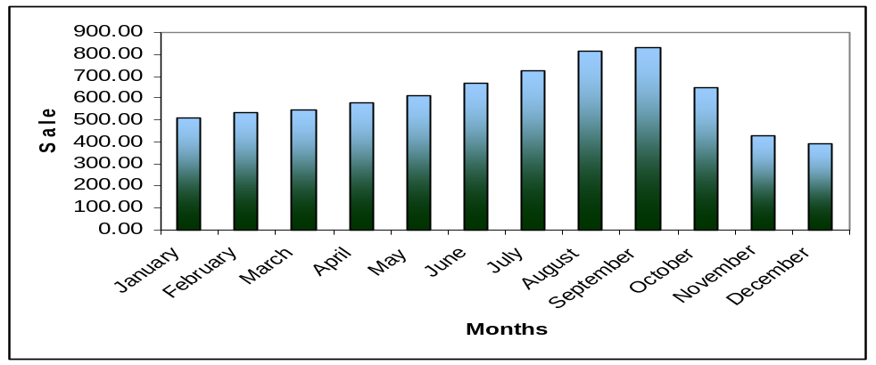
Figure: 4.10: Monthly sales of Biopharma Laboratories Ltd
On the other hand the advertisement expense of Biopharma Laboratories Ltd. also depends on month to month sales increase and decrease. On the other hand in one month promotional expenses are not fully expensed some are remained and those are expensed in next month.
With the help of figure we can compare the relationship of sales and promotion expense of Biopharma Laboratories Ltd.

The Effect of Promotion:
- Increase product demand
- Increase sales
- Increase market share
- Increase profit

The effect of promotion on sales are shown in the table-

Year | Sales | Promotional  Expense | Change  in sales | % change due  to Promotion
2008 | 6800.00 | 120.12 | .80 | 21.40
2009 | 7294.47 | 1463.39 | 1.07 | 33.30
Table:4.2 The effect of promotion on sales of Biopharma Laboratories Ltd

4.4 DISTRIBUTION OF PHARMACEUTICALS PRODUCTS:
Distribution (Place)
Convenience to Buy
Distribution (or Placement): refers to how the product gets to the customer; for example, point-of-sale placement or retailing. This third P has also sometimes been called Place, referring to the channel by which a product or service is sold (e.g. online vs. retail), which geographic region or industry, to which segment (young adults, families, business people), etc. also referring to how the environment in which the product is sold in can affect sales.
4.4.1 DISTRIBUTION CHANNEL OF PHARMACEUTICALS PRODUCTS IN BANGLADESH:

If we look into the channel of distribution we find the process normally as below,
Local manufacture
Export
Donation
Distributors
Wholesaler
Armed forces & govt. hospital
Private
Hospital/clinic
Private retail
Pharmacy
Dispensing
Doctors
General
Dealers
Figure 4.11: Distribution process of pharmaceutical products.
The above chart details the average percentage of products usually consumed in an area. This figure would be very much helpful for a pharmaceutical company in deciding promotional effort that is where to work and how much to work. This channel will be helpful for a new pharmaceutical company particularly for deciding its marketing strategy.

4.4.2 THE DISTRIBUTION PROCESS OF BIOPHARMA LABORATORIES LTD.:

The distribution process of Biopharma Laboratories Ltd.is given as figure,

Factory Warehouse
Central Warehouse
Depot
Drug Store

Figure: 4.12 The distribution process of Biopharma Laboratories Ltd

The factory warehouse of Biopharma Laboratories Ltd. situated at Tongi, Gazipur. Form the factory warehouse they send the goods to the depot of Mymensingh because it is very easy to transport from there. But for the further distribution they store the goods in their central depot which are situated in different districts of the country and according to the needs of the depot the sent the goods to the depot .finally form the depot they distribute the goods to the end store which is known as drugstore for retail selling.

4.4.3 TOTAL DEPOTS OF BIOPHARMA LABORATORIES LTD.
Biopharma Laboratories Ltd. has 21 depot across the country and the depot are categorized namely A, B, C, and D. according to the sales of those depot. Category A is the highest position and D is in the lowest position. We can show it by using the following figure-
Central Depot
Category A
Category B
Category C
Category D
Chittagong
Comilla
Dhaka
Sylhet
Barisal
Noakhali
Cox’s -Bazar
Mymensingh
Kushtia
Feni
Bogra
Brahmanbaria
Narayanganj
Rangpur
Khulna
Jessore
Rajshahi
Gazipur
Moulovibazar
Faridpur
Madaripur

Figure 4.13 Total depots of Biopharma Laboratories Ltd

Location of the depots of Biopharma Laboratories Ltd. are shown in the map of Bangladesh:
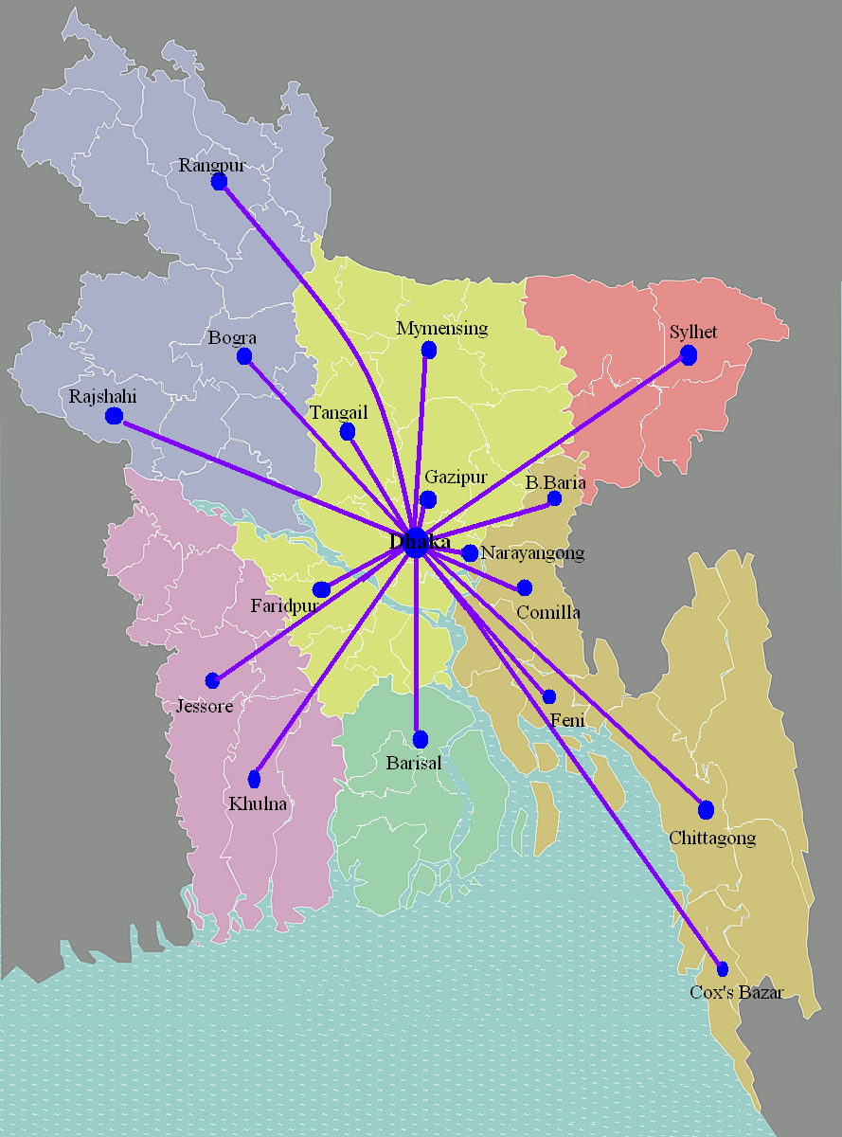
Figure: 4.14 Location of the depots of Biopharma Laboratories Ltd. in the map of Bangladesh

4.4.4 CHANNEL MEMBERS OF BIOPHARMA LABORATORIES LTD.:
Biopharma Laboratories Ltd. has direct distribution system; they do not use any wholesaler or middleman in their distribution system. Distribution system of Biopharma Laboratories Ltd. includes three channel members-
- Distribution Department
- Sales representative
- Drug tore
Busing the sales representative they collect information about the requirements of the drug store and inform the distribution department of the Biopharma Laboratories Ltd. after analyzing the information send by the sales representative the distribution department takes decision and sends goods to the depot and from the depot the goods are sent to the drugstore which is known as end of the distribution system of Biopharma Laboratories Ltd. we can show the distribution system of Biopharma Laboratories Ltd. in graphically,
Sales
Representative
Drug Store
Distribution Department
Channel Members of Biopharma
Figure: 4.15 Channel members of Biopharma Laboratories Ltd.

4.4.5 KEY POINTS OF DISTRIBUTION

- Products are Stored as per requirement considering temperature/sunlight, moisture etc.
- Delivery schedules are developed and prepared in consultation with the sales force.
- Receipt of order and allocation of stock is impartial/realistic.
- Execution of order (Invoicing) is done in time.
- Issue of goods in line with FIFO
- Packing of the stocks is properly done.
- Physical delivery is arranged as per schedule.
- Collection and depositing of sales proceeds are sent to the bank.
- Vigilance towards market demand for managing the right product at the right time.
- Cash and stock balance are checked on regular basis/daily.
- Restrict entrance to the Godown and Computer room is followed.
- Sales order must be signed.
- Daily sales performance should be sent through FAX to national sales manager or IT department.
- Control office expense and overtime are restricted.
- Temperature recording of the godown through maximum minimum thermometer is done regularly.
- Drug license, trade license and fire license are always in order.

4.4.6 ORGANIZATION STRUCTURE OF THE DISTRIBUTION DEPARTMENT OF BIOPHARMA LABORATORIES LTD.:

Loaders/packers-4
Drivers-2/3
Casual worker-2
Store keeper-1
Driver-2/3
Packers-2
General laborers-2
In-charge/Depot manager/Sales officer
Office assistant 2
Distribution officer central store
Store officer factory
National distribution manager
Peon-1
Security guards-2
Ckeaner-1
Cashier cum office assistant-1 Invoice assistant/computer operation -1 Store assistant -1 SR/Delivery General labourers-2Guards-2
Cleaner-1
Figure 4.16: Structure of Distribution system of Biopharma Laboratories Ltd.

4.4.7 TRANSPORT MANAGEMENT IN DISTRIBUTION SYSTEM OF BIOPHARMA LABORATORIES LTD.
It is one of the major areas where special attention is required for ensuring availability of products in time cost – effectively. Two major points in Biopharma Laboratories Ltd. viz,
- Timely availability of all products at the point of sale and
- Maintaining the deliveries within the approved Expense-budget is the prime consideration from a business point of view in respect of Transport management.
Transport management starts from factory site to delivery of goods/products to the chemists’ shelves or point of sale. Here mainly two phases are involved,-
- Delivery of stock to sales offices from factory via central store and
- Delivery of stock to the chemists’ from sales offices. In managing these jobs the following methods may be followed considering scope, availability of facilities and finally economy.
There are three types of transportation method used in pharmaceutical distribution system as well as Biopharma Laboratories Ltd. that are given as below,
Transport Management
Own Transport
Courier Service
Hired Van / Transport
Figure 4.17: Transport management
  - Own transport: It is the best way to manage distribution activities effectively because the vehicles and deliveries are maintained properly. Owned vehicles are maintained well through regular follow-up of engine condition, fuel consumption and use of accessories and parts. The drivers are maintaining log book and a monthly transport report is filled in on that basis and sent to distribution department by the respective in charge of the sales depot. All documents of the vehicle are kept up-dated always. To maintain this situation Biopharma Laboratories Ltd. has 3 big covered vans. And 6 small covered vans.
Fuel for vehicles is procured from a reliable pump through requisition slip. Payment of bill is done on monthly basis. By using CNG Biopharma Laboratories Ltd. save the cost of fuel.

  - Courier service-Courier service has greatly developed in our country in the recent past. By using a reliable and experienced one Biopharma Laboratories Ltd. avail this service. .An agreement is made with the company for better service and recovering the loss, if any. Biopharma Laboratories Ltd. sometimes use courier for sending immediate and small bulk to the depot.
  - Hired van/trucks- On special cases Biopharma Laboratories Ltd. use these types of transportation because it costly method to distribute the goods. Biopharma Laboratories Ltd. has some reliable contractor for this purpose comparing market-rate.

4.5 PHYSICAL EVIDENCE
Physical evidence refers to the environment in which the service is assembled and in which the seller and customer interact, combined with tangible commodities that facilitate performance or communication of the service. The physical evidence of service includes all the tangible representations of service such as brochures, letterhead, business cards, reports, signage, internet presence and equipment. For example, in the hotel industry, the design, furnishing, lighting, layout and decoration of the hotel as well as the appearance and attitudes of its employees will influence customer perceptions of the service quality and experiences. Because of the simultaneous production and consumption of most services, the physical facility i.e. its servicescape can play an important role in the service experience.
- Office outlet
- Production plan
- Medicine
- Pad
- Diary
- Medical Literature

4.6 PROCESS
Process is referred to the procedures, mechanisms and flow of activities by which the service is delivered i.e. the service delivery and operating systems. The process of travelling with a budget airline, is very different from that with a full-fledged premium airline. Because services are performances or actions done for or with the customers, they typically involve a sequence of steps and activities. The combination of these steps consitute a service process which is evaluated by the customers.

Top Management

Decision

Specified division

Purchasing Committee

Supplier Wear Housing Quality control division Production
Raw Malarial
Packaging

End-user/Customer
Figure 4.18: Process of Biopharma Laboratories Ltd.

4.7 PEOPLE
People are all people directly or indirectly involved in the service encounter, namely the firm's contact employees, personnel and other customers. Due to the inseparability of production and consumption for services which involves the simultaneous production and consumption of services, service firms depend heavily on the ability of contact employees to deliver the service. Contact employees contribute to service quality by creating a favorable image for the firm, and by providing better service than the competitions. Service providers (such as hair stylists, personal trainers, nurses, counselors and call centre personnel) are involved in
real time production of the service. They are the “service”. Much of what makes a service
special derives from the fact that it is a lived-through event.
Service firms must find ways in which they can effectively manage the contact employees
to ensure that their attitudes and behaviors are conducive to the delivery of service quality.
This is especially important in services because employees tend to be variable in their
performance, which can lead to variable quality i.e. heterogeneity in the performance of
services. The quality of a service (a visit to a hospital for medical check-up, having a meal
at the restaurant, accountancy and consulting services) can vary from service providers
and customers among many other factors. This lack of homogeneity in services creates
difficulties for the service firms. As delivery of services occurs during interaction between
contact employees and customers, attitudes and behaviors of the service providers can
significantly affect customers' perceptions of the service. This is important, because
customers' perceptions of service quality and its value can influence customer satisfaction,
and in turn, purchase intentions.
- Qualifications: people must complete Hons, Masters, BBA & MBA on any recognized University & have good result.
- Requirement process
- Providing add
- Collecting CV
- Shorting CV
- Selection
- Written test
- Interview
- Training
- 3 months training on Products
- When new product launch on the market
- Seminar
- Conference
- Motivation
- Executive Salary
- Inventive
- Bonus
CHAPTER FIVE
SWOT ANALYSIS

5.1 SWOT ANALYSIS OF BIOPHARMA LABORATORIES LTD.
This analysis will give a picture of the competitiveness of this company in comparison to that of its competition.

5.1.1 Strength of the Biopharma Laboratories Ltd.
  - A new innovative product and service.
  - Location of the business
  - Uses of modern technology.
  - A proven tract record in defect-free manufacturer.
  - Expertise in providing consistently good customer service.
  - Proprietary technology and registered trade mark.
  - Highly experiences and efficient employees in key areas.
  - Long term collective learning and managerial know-how.
  - Reputation of the company.
  - An Attractive remuneration package and benefits for employee retention positive work climate and organization culture.

5.1.2 Weakness of the Biopharma Laboratories Ltd.
Biopharma Laboratories Ltd. has weakness in the following competitive field. These weaknesses are reducing the competitiveness in the battle with the competitors:
  - Undifferentiated products.
- Cost of raw materials is increasing day by day.
- Countrywide distribution network is not as strong as competitors.
- Sarong adherence to ethics resulting in inflexibilities.
- Higher production cost.

5.1.3 Opportunities of the Biopharma Laboratories Ltd.
A market vacated by an ineffective competitor.
- Moving into new market segments like international market that offer improved profits.
- Serving additional customer group in the existing geographical market.
- Expanding into new geographic markets.
- Strength in export oriented products.
- Transferring sector’s skill or technological know-how to a new business or a new product.
- Expanding the company’s product line to meet a broader range of customer needs.

5.1.4 Threats of the Biopharma Laboratories Ltd.
- A lot of competitors in the market.
- Government regulation on price of drug.
- Likely entry of the potential new competitors.
- Growing bargaining power of suppliers.
- Adverse shift in foreign exchange rate.

5.2 Key challenges for Biopharma Laboratories Ltd.:
- Defining the equitable way for sharing the economic burden of pharmaceutical development among the various segments of society.
- To discover, develop and successfully market innovative products to cure diseases, to ease suffering and to enhance the quality of life.
- Ensuring that research, development and application of pharmaceuticals are conducted in harmony with society’s ethical and cultural standards.
- Ensuring the humanity continues to benefit from pharmaceutical innovation.
- To discover, develop and successfully market innovative products to cure diseases, to ease suffering and to enhance the quality of life.
- To ensure that humanity continues to benefit from pharmaceutical innovation.
- To define an equitable way for sharing the economic burden of pharmaceutical development among the various segments of society.
- To ensure that research, development and application of pharmaceuticals are conducted in harmony with society’s ethical and cultural standards.
- Other key challenges include the issues of marketing practices, animals used in research and development, and accountability for our suppliers and contractors.

CHAPTER – SIX
FINDINGS OF THE REPOTS

6.1 FINDINGS OF THE REPORT:
Biopharma Laboratories Ltd. has highly skilled and motivated employee in head office and also in the field to fulfill the objectives.
- Biopharma Laboratories brings innovative and new products by market research.
- They produce different types of products like tablet, capsule, syrup, suspension, dry syrup, cream, ointment, injection and drops.
- They use value based pricing for most of the innovative or new products.
- For existing products thy use Cost and competitive based pricing.
- Maintaining strict quality whatever the cost.
- Promotional mixes of Biopharma Laboratories Ltd. include advertisement, sales promotion, personal selling, direct marketing, public relations, sponsorship, and trade show.
- Field force produces differentiation in the market through strong product knowledge and skill.
- Developing service concept in a highly product oriented marketing approach in the industry.
- Conducting clinical trial in the country which is rarely practiced by other companies.
- Maintaining strict guidelines for ethical promotional activities investing significant amount of money to train and develop physicians.
- Biopharma Laboratories Ltd. has a technological edge over its competitors.
- They use 16 depots all over the country for conventional pattern of distribution.
- The location of the business of is also favorable for the distribution of the products.
- The distribution patterns of Biopharma Laboratories Ltd. which starts from the production plants and ends to the departmental store for smooth flow of products.
- Finally the marketing mix strategy of Biopharma has created a stronger position in the market of pharmaceuticals industry.

CHAPTER – SEVEN
RECOMMENDATIONS AND CONCLUSION

7.1 RECOMMENDATION FOR BIOPHARMA LABORATORIES LTD.
- Biopharma Laboratories Ltd should look for cost effective sources of raw materials for minimizing the production cost.
- Acquisition of local or global firms to add strong growth.
- Biopharma Laboratories Ltd. should presence more in the district town. In some important rural areas as these markets are still untapped.
- Though the products of Biopharma Laboratories Ltd. are cost effective than that of rivals, still opportunity for institution based sales should be looked into.
- More strategies collaboration with other foreign manufacturers is needed to gain access to technology and resources
- Biopharma Laboratories Ltd. should adopt flexible functional policies are needed to match the changing environment of the industry.
- Biopharma Laboratories Ltd. should emphasis on service oriented approach to overcome price objection by doctors through relationship building.
- To further develop and strengthen institution business through innovative product should continue by Biopharma Laboratories Ltd.

7.2 CONCLUSION:
Biopharma Laboratories Ltd. is one of the innovative and emerging companies in the sector of pharmaceuticals in our country. It uses different strategies in production like bringing new and innovative products, for price they set the price according to the cost, perceptions of the customers or on the basis of competitors’ price which create a sustainable advantage for the company. Other aspects of marketing mixes are promotion and distribution. Biopharma Laboratories Ltd. uses Promotional activities like advertisement, sales promotion, personal selling, direct marketing, public relations, sponsorship, trade show of which is the key function of the company for selling more products and also gaining a competitive market share. Under the distribution patterns Biopharma Laboratories Ltd. ensures smooth flow of precuts that starts from the production plant, or form central warehouse or form the depots which are situates in the different parts of he country and ends to the departmental store or ends users. In the marketing mix Biopharma Laboratories Ltd is trying to get a relatively comfortable path for doing business; of course modification may be needed for adjustment according to company internal situation.

It is evident that Biopharma Laboratories Ltd. will be maintaining its position and also trying to gain a competitive market share by implementing innovative strategies in the coming years as it is demanded by the highly competitive local and global pharmaceutical industry environment by its innovative and proper blend of marketing mix.

