Marketing Practices
of
Uttara Bank Limited

Submitted by

WWW.ASSIGNMENTPOINT.COM
Chapter – 1

Introduction

  - Origin Of The Report

The report title Marketing Practices of Uttara Bank Ltd.” has been prepared as a partial fulfillment of BBA Program in Northern University Bangladesh. Student are required to undertake internship program. For this purpose each of the students is required to attach with an organization. During the internship period, a student has to prepare a report on the organization where he is assigned. He has also to undertake and involve in investigation on the organization for detailed study.

The basic purpose of this attachment is to expose the student to the real business world. This exposure acquaints his with the practices of modern business world. This exposure is very helpful is seeing for oneself how things move and to find the gap as well as the similarities between theoretical and practical knowledge.

1.2 The Objectives of the Report
The prime objectives of the report is to get practical exposure to organizational environment as well as to understand the system and methodology adopted in conducting day to day banking by The Uttara Bank Limited. Besides this report has been composed to obtain the following objectives:
- To analyze the marketing practices of Uttara Bank Limited
- To point out the tools of marketing mix adopted by Uttara Bank Limited
- To provide some suggestions and recommendations to improve their performances of marketing.

1.3 Methodology of the study
This study aims to analyze marketing practices of Uttara Bank limited. Basically this is a theoretical study. Also, there are some quantitative information incorporated to pin point the reality.

1.3.1 Sources of data & information
Data and information are mainly collected from secondary sources i.e. Policy Guidelines, records, manuals and publications of Uttara Bank Ltd.; printed materials of Bangladesh Bank, Text book, website etc. The collection of data was mainly concentrated on the marketing practices of the Uttara bank and data from different branches were colleted from different departments.

1.3.1.1 Primary Sources:
The Primary data has been gathered by formal discussion with the officials of the banks, depositors, borrowers.

1.3.1.2. Secondary Sources:
Secondary data has also been collected to make the report move concrete. These data has been collected from different financial statements, annual reports/ research reports, electronic media, bank document etc.
1.4 Scope of the study
The study will analyze the exiting marketing practices of Uttara Bank Ltd. to satisfy wide ranges of customer throughout the country. There is no attempt made to investigate why a particular policy and practice is adopted rather prevailing practice is just try to identify.. The fundamental concept of marketing policies and strategies undertaken would be revealed in a descriptive research method.

1.5 Limitations
The Internship report is made employing three months or so, is likely faced the following limitations:

- Due to shortage of time and inadequate information, in-depth analysis
could not be done in the report.
- Most of the staffs are cooperative but have little time to share information
- In most of the cases, they do not use modern equipment to record the
databases regarding the customers and clients.

Rationale for the study:
Marketing practice is very much important for the Banking sector in recent years. I think that from my study, Uttara Bank will be benefited. I have provided some suggestions and recommendations that will be very helpful for Uttara Bank as well as my experiences.

Chapter – 2
PROFILE OF UTTARA BANK LTD.
2.1 Background History
UTTARA BANK LTD. started its operation from 3rd August 1999. This is a scheduled private commercial bank, which was established on May 20, 1999 under Bank Companies Act 1991. In 1st July 2004 UTTARA BANK LTD. converted full pledged Islamic bank from conventional bank. At present, there are 30 branches in operation spread all over the country. Within a very short period of time, UTTARA BANK LTD. has been able to create an image for itself and has earned significant reputation in the banking sector of Bangladesh. This institution attracted the customer’s attention through its different schemes. All these efforts ultimately lead to the profit generation for the Bank. For survival and growth of any business institution profit generation is must. Like other commercial banks, UTTARA BANK LTD. has specific target for collecting as well as distributing those deposits through different Credit programs for consumers and businesses. Prudent investing by the management and constant monitoring helps the Bank to attain its target and contributes to the growth of the bank as a whole and particularly its branches.

Graph:1 Gradual Increase of Branches, Uttara Bank Ltd.
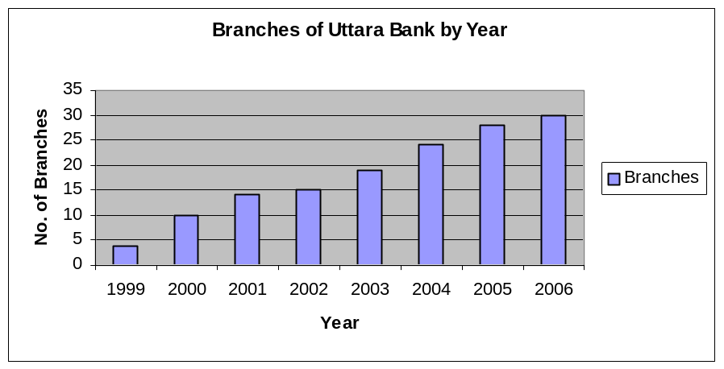
Source: UTTARA BANK LTD., Annual Report

The Bank started its Journey with an authorized capital of Taka 1000 million and a paid up capital of Taka 313 millions contributed by the sponsors. The sponsor directors of the bank are well-established businessman and professionals of the country having business in and out Bangladesh. The company philosophy –“Local Bank global network “ has been precisely the essence of the legend of the banks success.

2.2 Mission Statement of Uttara Bank Ltd.
- “To assist in bringing high quality service to our customers and to participate in the growth and expansion of our national economy.
- To set high standards of integrity and bring total satisfaction to our customers, shareholders and employees.
- To become the most sought after bank in the country, rendering technology driven innovative services by our dedicated team of professionals.”
Uttara Bank Ltd. aims at excellence and has a new vision to fulfill and a new goal to achieve. The bank has following objectives:
  - To provide a wide range of quality products and services comparable with those available with any modern bank in the world
  - To explore the needs of the common people including businessman and professionals
  - Extend Credit to private sector of economy
  - To serve with quality at a price competitive to any one in the financial market
  - Contribute to the GDP of the country
  - To develop a youthful and exuberant management team who are technologically sound and rich in experience
  - Highly personalized service.
  - Customer-driven focus.
  - Total commitment to quality.
  - Contribute in the economy.
  - Quality of human resources.
The company believes that communication with, and feedback from, its clients help it achieve its goal of providing world-class products and services. UTTARA BANK LTD. regularly conducts client satisfaction surveys and make immediate accommodations and adjustments where needed. It also constantly monitors its standards, and strives to meet clients’ requirements.
2.3 Organizational Setup
Uttara bank follows the following organizational structure:
Figure: 11
Chairman
Vice Chairman
Directors
Managing Director
Additional Managing director
Deputy Managing Director
Assistant Managing director
General Manager
Deputy General Manager
Assistant general Manager

Senior Principal Officer
Principal Officer
Officer Grade-I
Officer Grade-II
Assistant Officer
Board of Directors
Top & mid level
Management

Lower level Management

Source: Uttara Bank Ltd., Head office, 2010

2.4 The Principal Businesses of Uttara Bank Ltd.
2.4.1 Trade Financing
After setting up UTTARA BANK LTD. added new strength in its trade financing activities. Previously there was limited used of “SWIFT” which is very crucial in efficient modern banking correspondence. Now UTTARA BANK LTD. bank has correspondence with over 800 financial institutions worldwide. UTTARA BANK LTD. bank provides L/C payment, L/C advising, negotiation, reimbursement, shipping guarantee, export bill collection services to its valued clients. UTTARA BANK LTD. Bank’s one of the strongest international banking arms, helping to serve their clients through its global network.
2.4.2 Corporate Banking
Uttara bank Ltd. Bank corporate banking arm provides a range of products and services that address the financing needs and transaction structuring requirements of large and mid-sized corporate customers. Services provided include loan syndication and asset sales, corporate advisory, trade finance, and working capital and term financing. Working closely with the Bank’s trading professionals; Corporate Banking also provides a range of foreign exchange, interest rate management and risk management products.
2.4.3 Private Banking

The Private Bank at UTTARA BANK LTD. Bank meets client needs with a line of discretionary portfolio management, custodial services, foreign exchange, deposit services, credit facilities, and personal banking services.

2.4.4 Retail Banking
Retail Banking at UTTARA BANK LTD. Bank provides all types of clients with typical banking services such as, savings accounts, current accounts, call and short-term deposit accounts, fixed deposit accounts, time deposits, foreign currency accounts and secure locker services.

Figure: 12 Management OF UTTARA BANK LTD., (Head Office)
Deputy Managing Director
Senior Executive Vice President
Executive Vice President
Senior Vice President
Senior Assistant Vice President
Assistant Vice President
Senior Executive Officer
Executive Officer
Assistant Executive Officer
Senior Officers
Officers
Junior Officer
MTO

Chapter - 4

Source: Annual Report Uttara Bank Ltd.

CHAPTER-3
Internship Positions and Duties

I have joined Uttara bank Ltd Elephant road branch after completing 123 credits of my BBA Program at the northern University Bangladesh. During my internship position with the Uttara bank Ltd. I have worked as a assistant of the officer and my duties covered various tasks relating to ensuring smooth and quality services. My duties covered the followings;
- To observe and ensure the work environment of the bank.
- Reporting of the current situation of the work.
- To collect the quality requirements from the customer regarding the Banking services.
- Checking the accuracy and security measure especially Cheque..
- Helping the clients in opening the bank accounts and giving relevant information about the credit and other services.
- Working in the foreign exchange departments and confirming the quick delivery of transected money.
I must add here that being a quality officer I had to have clear idea about all the department and their functions. I do believe that this earned me the experience to ensure a satisfactory job in this high growth industry.

Chapter-4:
Conception about marketing of Banking Services.
4.1 Evolution of the Marketing Concept
The Role of marketing in the banking industry continues to change. For many years the primary focus of bank marketing was public relations. Then the focus shifted to advertising and sales promotion. That was followed by focus on the development of a sales culture.

Although all the elements of the marketing concept – customer satisfaction, profit integrated framework and social responsibility – will remain important, customer satisfaction must receive the greatest emphasis in the years ahead.

The chief concerns of most bank executives still focus on legal and regulatory issues, according to most surveys. Community banks are particularly concerned with eliminating barriers that give unfair advantages to financial services competitors, such as credit unions. However, another concern pertains to technology: keeping nonblank
competitors out of the payment system.

Table: 1 Bankers Identify Near-Team and Long Term Concerns
1991 | 2015
Maintaining profitability  Credit Portfolio Management  Service Quality  Regional Economy  Cost Management / Expense reduction  Declining Earnings/ more failures  Market / customer focus  Capital adequacy  Stock market value  Industry Overcapacity | Service quality  Maintaining profitability  Market / customer focus  Operations/systems/technology  Credit portfolio management  Productivity improvement  Investment to stay competitive  Stock market value  Asset/liability management  Electronic Banking
When this gateway system was first proposed, access to the Internet was very new and few banks had the resources and knowledge to set up their own direct-access lines for customers. Customers have shown a growing interest in online banking services, and banks have responded quickly putting in place proprietary sites on the World Wide Web and offering PC banking.

Within the next five years, 93 percent of community bank executives surveyed say they plan to offer telephone banking, and 79 percent plan to offer PC banking.

When asked which technology holds the most potential for the future, bank executives identified call centers first. As customers continue the transition the transition into a high-tech world in which they want information and answers more quickly and accurately than ever before, call centers offer the ideal bridge. With 24-hour access to either automated information or live operators, customers do everything from check their accounts to apply for a loan. Bank executives also identified PC banking as having the most promise for the future, followed by Interest access and broad function kiosks.

4.2 Marketing and Competition

In view of the declining profitability and productivity of the banking sector and extremely low rate of profit percentage, the determination of the financial health of the system requires drastic remedial measures not only to build up investor confidence but also to combat competition from all over. It is time that the pros and cons of the oncoming banking era are properly understood and advantage taken of various opportunities. This will require an efficient marketing approach to bank management in which target markets will be tackled successfully along with effective satisfaction levels and in which the usual basic elements – product, pricing, promotion and distribution will be taken care of in a proper format of an efficiently working marketing organization.

The nationalized banks must face competition from private banks, non-banking financial institutions, foreign banks and others. The competition is in the fields of deposits and credits, foreign trade, consumer credit and miscellaneous banking activities. The competition will benefit customers and force the banking system to raise its productivity, minimize expenses, and remain sensitive to evolving issues. Narasimham Committee Reports while recommending internal autonomy long with compliance with prudential norms suggested rule-based credit policies, fiscal balance and a gradual movement towards liberalization.

To deal with the competition from foreign banks, the Indian banks should go in for diversification and extension of services as well as expansion of products and business. Economic freedom and innovative spirit have contributed greatly to the success of the market-oriented financial sector in the Western countries. Directed credit and investment has done just the opposite. Interventionism is not necessarily bad provided it is associated with a committed leadership. Indian financial sector had for more than four decades, neither full economic freedom nor a well disciplined interventionism so that it cost operational flexibility as well as functional autonomy both of which were concerned with profitability performance and related factors.

4.3 Marketing Concepts
Its application to Banking, when we apply marketing to the banking industry, the bank marketing strategy can be said to include the following –
- A very clear definition of target customers.
- The development of a marketing mix to satisfy customers at a profit for the bank.
- Planning for each of the ‘source’ markets & each of the ‘use’ markets (A Bank needs to be doubly market – oriented – it has to attract funds as well as were of funds & services.
- Organisation & Administration.

4.4 Bank Marketing
We define bank marketing as follows: “Bank marketing is the aggregate of functions, directed at providing services to satisfy customers’ financial (and other related) needs and wants, more effectively and efficiently that the competitors keeping in view the organizational objectives of the bank”. Bank marketing activity. This aggregate of functions is the sum total of all individual activities consisting of an integrated effort to discover, create, arouse and satisfy customer needs. This means, without exception, that each individual working in the bank is a marketing person who contributes to the total satisfaction to customers and the bank should ultimately develop customer orientation among all the personnel of the bank. Different banks offer different benefits by offering various schemes which can take care of the wants of the customers.

Marketing helps in achieving the organizational objectives of the bank. Indian banks have duel organizational objective – commercial objective to make profit and social objective which is a developmental role, particularly in the rural area.

Marketing concept is essentially about the following few thing which contribute towards banks’ success:
- The bank cannot exist without the customers.
- The purpose of the bank is to create, win, and keep a customer.
- The customer is and should be the central focus of everything the banks does.
- It is also a way of organizing the bank. The starting point for organizational design should be the customer and the bank should ensure that the services are performed and delivered in the most effective way. Service facilities also should be designed for customers’ convenience.
- Ultimate aim of a bank is to deliver total satisfaction to the customer.
- Customer satisfaction is affected by the performance of all the personal of the bank.

All the techniques and strategies of marketing are used so that ultimately they induce the people to do business with a particular bank. Marketing is an organizational philosophy. This philosophy demands the satisfaction of customers needs as the pre-requisite for the existence and survival of the bank. The first and most important step in applying the marketing concept is to have a whole hearted commitment to customer orientation by all the employees. Marketing is an attitude of mind. This means that the central focus of all the activities of a bank is customer. Marketing is not a separate function for banks. The marketing function in Indian Bank is required to be integrated with operation.

Marketing is much more than just advertising and promotion; it is a basic part of total business operation. What is required for the bank is the market orientation and customer consciousness among all the personal of the bank. For developing marketing philosophy and marketing culture, a bank may require a marketing coordinator or integrator at the head office reporting directly to the Chief Executive for effective coordination of different functions, such as marketed research, training, public relations, advertising, and business development, to ensure customer satisfaction. The Executive Director is the most suitable person to do this coordination work effectively in the Indian public sector banks, though ultimately the Chief Executive is responsible for the total marketing function. Hence, the total marketing function involves the following:

- Market research i.e. identification of customer’s financial needs and wants and forecasting and researching future financial market needs and competitors’ activities.
- Product Development i.e. appropriate products to meet consumers’ financial needs.
- Pricing of the service i.e., promotional activities and distribution system in accordance with the guidelines and rules of the Reserve Bank of India and at the same time looking for opportunities to satisfy the customers better.
- Developing market i.e., marketing culture – among all the customer-consciousness ‘Personnel’ of the bank through training.

Thus, it is important to recognize the fundamentally different functions that bank marketing has to perform. Since the banks have to attract deposits and attract users of funds and other services, marketing problems are more complex in banks than in other commercial concerns.

4.5 Increasing Importance of Marketing in Banking Industry

The various other factors which have led to the increasing importance of marketing in the banking industry are categorized as follows:

4.5.1 Government Initiatives
The Bangladeshi economy embarked on the process of economic reform and various policy measures initiated by the government resulted in the increasing competition in the banking industry, thereby highlighting the importance of effective marketing. The standing Committee Report evidence of the Government’s desire to ‘re-regulate’ the banking industry so as to encourage efficiency through competition. The Government initiatives include:
4.5.2 Deregulation of Interest Rates
The bank may reduce their Minimum Lending Rates so as to attract customers (individual and corporate). Such reduction in lending rates reduce the spread between the deposit rates and lending rates, i.e. the banks margins would decline and they would have to increase their volumes or provide attractive services so as to maintain profits. This calls for bank marketing.

4.5.3 Increasing Emphasis on Bank Profitability:
With the Bangladesh Bank Report, banks have been directed to improve their efficiency, productivity and profitability. Banks are required to be self-sufficient. In fact, the report has adopted the BIS standards of capital adequacy (though in a phased manner).

4.5.4 Foreign Banks
Foreign banks offer stiff competition to the Bangladeshi Banks and with their superior services and technologies offer them a competitive advantage. Thus indigenous Banks have to effectively apply marketing concepts to attract customers.

4.5.5 Entry of New Private Banks
In the early ‘90s new competition emerged in the form of new Private Banks, who brought along with them a high technology-based banking matching with International Standards and have made a significant dent in the banking business by capturing substantial share in the profits of the banking industry.

4.5.6 Reduction of Statutory Liquidity Ratio:
With the Government’s aim of reducing the SLR to 25 percent, the banks will have surplus funds for which they will have to attract users.

4.5.7 Social Environment
4.5.7.1 Increasing Urbanization, Education and Awareness: The higher literacy level, migration to urban areas and higher awareness due to the boom in the mass media have important implications for the retail banker. He needs to be conscious of the fact the increasing proportion of people are aware of financial service and are, therefore demanding and expecting higher quality services.
4.5.7.2 Increasing Urbanization, Education and Awareness: The higher literacy level, migration to urban areas and higher awareness due to the boom in the mass media have important implications for the retail banker. He needs to be conscious of the fact the increasing proportion of people are aware of financial service and are, therefore demanding and expecting higher quality services.

Decline in Traditional Indian Values (Borrowing as Taboo), Rising Consumerism, Rise in the Percentage of Working Women.

4.5.8 Technology Development
Modernization of Technology has facilitated the introduction of new banking services as to attract new customers. An example of this is the ‘Automated Teller Machines’ or the facility of ‘Any Time Money’. Also in foreign countries, banks are experimenting with money transmission at Point of sale, e.g., petrol station linked with banking network.

4.5.9 Credit is Easier to Obtain
2.5.9.1 Growing Importance of Non-Banking Financial Institutions: Fixed Deposits being offered by the NBFC’s are very attractive for the public, because of the wide gap of interest rates offered by banks on term deposits and that offered by the NBCS’s. further, they offer a variety of specialized services to their customers so as to attract and retain them.

4.5.9.2 Disintermediation: The increasing role of capital markets in mobilizing funds is reducing the importance of banks as intermediaries. Companies are directly approaching the savers through the capital markets. Mutual funds help in attracting the small investors who do not want to take much risk.

4.6 Marketing Concepts – Its Application to Banking
When we apply marketing to the banking industry, the bank marketing strategy can be said to include the following:
- A very clear definition of target customers.
- The Development of marketing mix to satisfy customers at a profit for the bank.
- Planning for each of the ‘source’ markets and each of the ‘user’ markets (A bank needs to be doubly market – oriented – its has to attract funds as well as users of funds and services).
- Organization and Administration.

4.7 Consumer Behavior and Segmentation
4.7.1 Need for segmentation
Philip Kotler has described the dilemma of the seller (especially, a seller dealing with masses, e.g. banks) as follows:

“How the seller determines which buyer’s characteristics produce the best partitioning of a particular market? The seller does not want to treat all customers alike nor does he want to treat them all differently”.

Banks deal with individuals, group of persons and corporates, all of whom have their likes and dislikes. No bank can afford to assess the needs of each and every individual buyer (actual or potential).

Segmentation of the market into more or less homogenous groups, in terms of their needs and expectations from the banking industry, provides a solution to this problem.
This involves dividing the market into major market segments, targeting one or more of this segments, and developing products and marketing programs tailor-made for these segments.

In the first segmentation, the market is divided from a unitary whole, to groups of buyers who might require separate products and marketing mix. The marketer typically tries to identify different segments in the market and develop profiles of resulting market segments.
The second step is market targeting in which each segment’s attractiveness is measured and a target segment is chosen based on tits attractiveness.

The third step is product positioning which is the act of establishing a viable competitive position of the firm and its offer in the target segment chosen.

In the process of segmentation, the market can be divided into major segments which are gross slices of the market, or into smaller specially formed segments, otherwise known as niches. Niche customers have a specific set of needs which the markerter tries to address. While a market segment attracts several competitors, a niche attracts fewer competitors and therefore, a company should clearly define its target segment and devise strategies to target the customer, so that it has a competitive advantage in the segment.

These concepts can be applied in personal banking by an Indian Bank. Traditionally, Indian Banks have not had any conscious strategy for selecting customers from the personal banking area, apart from some banks which have a geographic concentration strategy such as concentrating on a particular region or state. These banks will have to segment the market on certain basis, and identify market segments or niches which they want to cater to. For example, a bank like SBI may not be able to cater high income groups (say, managers, professional, NRIs, etc. who earn above Rs. 4,00,000 p.a. and who want a higher quality of products / services and who are willing to pay for them), as the services required by such a profile of customers are entirely different from the kind of products / services SBI can offer.

4.7.2 Initiation of Segmentation in Bangladesh
The private commercial banks of Bangladesh has already initiated to adopt the market segmentation concept. They actually segmented on the basis of major market segments dividing customers on the basis of activity and carved out 4 major market segments, viz. Commercial and Institutional, Small Industries and Small Business Segment, Agriculture, Personal and Services Banking. The objectives of this scheme were:
- Deeper penetration and coverage of market by looking outwards.
- Adequate flexibility of organization to accommodate growth and rapid change,
- Delegation of work for releasing senior management for more futuristic tasks.

2.7.3 Criteria for Segmentation
Segmentation in a right fashion makes the ways for profitable marketing. This helps policy planner in formulating and innovating the policies and at the same time also simplifies the task of bank professionals while formulating an innovating the strategic decisions. The following criteria make possible rig segmentation.

An important criterion for market segmentation the economic system in which we find agricultural sector, industrial sector, services sector, household sector, institutional sector and rural sector requiring of weightage while segmenting.

Agricultural Sector: In the agricultural sector, there are four category rise since the needs of all the categories cant’s be identical.
Figure: 1
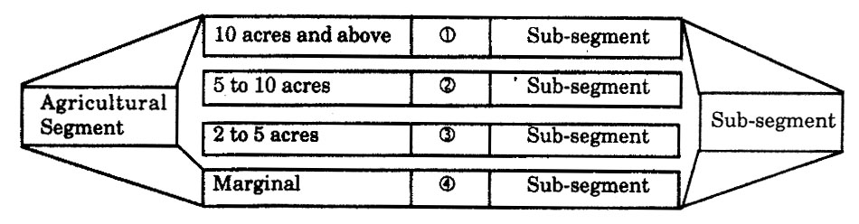
The mechanization of agriculture, the improved or scientific system of activation, the help of nature, the magnitude of risk, the availability infrastructural facilities influence the level of expectations vis-à-vis the needs and requirements. The banking organization are supposed to know and under stand the changing requirements of different categories of farmers.

Industrial Sector: The banking organizations subserve the interests of the industrial sector. The large-sized, small-sized co-operative and tiny industries use the services of banks. The expectations of all the categories cant’s be uniform.
Figure:: 2
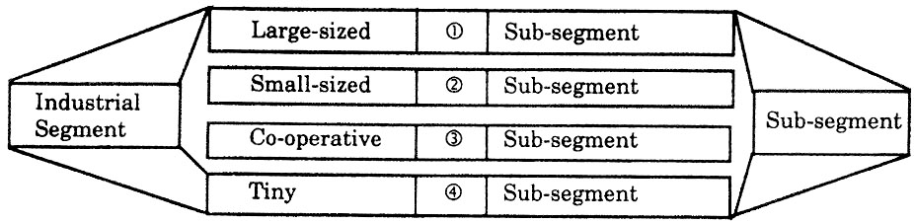

The banking organizations are supposed to have an indepth knowledge of the changing needs and requirements of the industrial segment.

Services sector: It is an important sector of the economy where the banking organizations get profitable business. The two categories of organizations such as profit-making and not-for-profit making are found important in the very context.
Figure::3
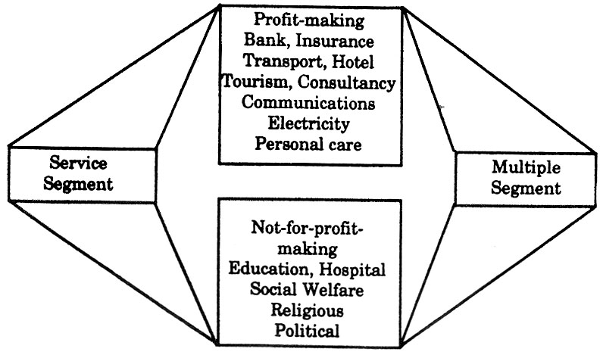
The banking organizations need to identify the changing needs and requirements of the services sector. With the frequent use of information technologist and with the mounting pressure of inflation and competition, we find a change in the hierarchy of needs.

Household Sector: This is also constitutes an important sector where different income group have different needs and requirements. in below figure we find the different segments of the household sector.
Figure:4
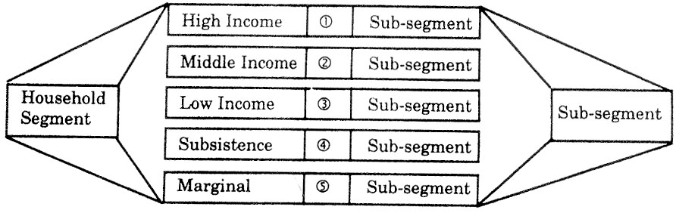

Household Segment: The high income group, middle income group, low income group, substance level group and marginal income group have different hierarchy of need which influence the level of their expectations.
Gender Segment: In the gender segments, we find male and female having different needs and requirements. The banking organizations are supposed to identify the level expectations of both sexes.
Figure: 5
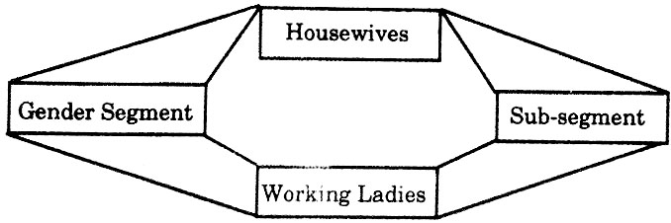

Some of the women are housewives and therefore they have different need and requirements whereas some of them are working ladies having different needs and requirements.

In the profession segments, we find different categories of professions an therefore we find a change in their needs and requirements.
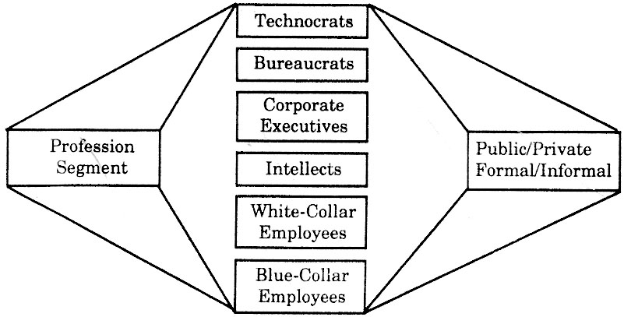
Figure: 6

The technocrats, bureaucrats, corporate executives, intellects, white and blue – collar employees have different needs and requirements and therefore the banking organizations should know their expectations.

Some of the organizations are known as cultural organizations, some of them are not for –profit making, some of them are philanthropic and some of them are related to trade and commerce. The emerging trends in the social transformation process determine the hierarchy of needs.
Figure::7
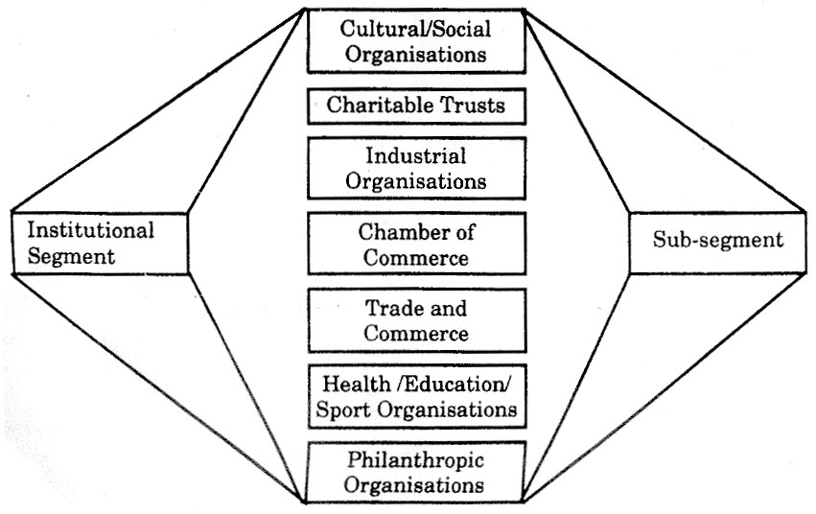

Markets segmentation thus simplifies the task of understanding the customers/prospects. The bank professional find it convenient to formulate and innovate the marketing mix of world class which simplify the process of excelling competition.

In the Indian perspective where we find agrarian economy contributing substantially to the transformation of national economy, it is pertinent that the banking organizations assign due weightage to the rural sector of the economy where we find tremendous opportunities.

The urbanization is likely to gain the momentum and villages, outskirts of big towns and cities are to be developed on a priority basis. Almost all the organizations are to get tremendous opportunities there. The marketing resources if of innovative nature would make the ways for capitalizing on the same profitably.

4.8 Marketing Mix for Banking Services

The formulation of marketing mix for the banking services is the prime responsibility of the bank professional who based on their expertise and excellence attempt to market the services and schemes profitably.

The bank professionals having world class excellence make possible frequency in the innovation process which simplify their task of selling more but spending less. The four submixes of the marketing mix, such as the product mix, the promotion mix, the price mix and the place mix, no doubt, are found significant even to the banking organizations but in addition to the traditional combination of receipts, the marketing experts have also been talking about some more mixes for getting the best result. The “People” as a submix is now found getting a new place in the management of marketing mix. It is right to mention that the quality of people/employees serving an organization assumes a place of outstanding significance. This requires a strong emphasis on the development of personally-committed, value-based, efficient employees who contribute substantially to the process of making the efforts cost effective. In addition, we also find some of the marketing experts talking about a new mix, i.e. physical appearance. In the corporate world, the personal care dimension thus becomes important. The employees re supposed to be well dressed, smart and active. Besides, we also find emphasis on “Process” which gravitates our attention on the way of offering the services. It is only not sufficient that you promise quality services. It is much more impact generating that your promises reach to the ultimate users without any distortion. The banking organizations, of late, face a number of challenges and the organizations assigning an overriding priority to the formulation processes get a success. The formulation of marketing mix is just like the combination of ingredients, spices in the cooking process.
4.8.1 The Product Mix: The banks primarily deal in services and therefore, the formulation of product mix is required to be in the face of changing business environmental conditions. Of course the public sector commercial banks have launched a number of polices and programmers for the development of backward regions and welfare of the weaker sections of the society but at the same it is also right to mention that their development-oriented welfare programmes are not optimal to the national socio-economic requirements. The changing psychology, the increasing expectations, the rising income, the changing lifestyles, the increasing domination of foreign banks and the changing needs and requirements of customers at large make it essential that they innovate their service mix and make them of world class. Against this background, we find it significant that the banking organizations minify, magnify combine and modify their service mix.

It is essential that ever product is measured up to the accepted technical standards. This is due to the fact that no consumer would buy a product which contains technical faults. Technical perfection in service is meant prompt delivery, quick disposal, presentation of right facts and figures, right filing proper documentation or so. If computers starts disobeying the command and the customers get wrong facts, the use of technology would be a minus point, and you don’t have any excuse for your faults.

Product Portfolio: The bank professional while formulating the product mix need to assign due weightage to the product portfolio. By the concept product portfolio, emphasis is on including the different types of services/ schemes found at the different stages of the product life cycle. The portfolio denotes a combination or an assortment of different types of products generating more or less in proportion to their demand. The quality of product portfolio determines the magnitude of success. It is excellence of bank professionals that help them in having a sound product portfolio.
Figure: 8
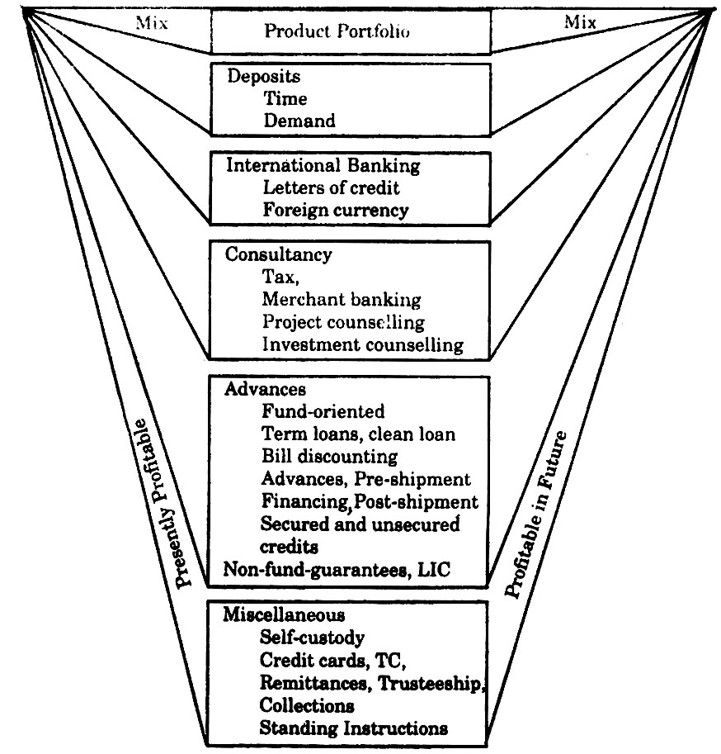
We find the composition of a family sound, if members of all the age groups are given due place. Like this, the composition or blending of a service mix is considered to be sound, if well established and likely to be profitable schemes are included in the mix. It is against this background that a study and analysis of product portfolio is found significant. The bank professionals are supposed to perform the responsibility of composing the same. A sound product portfolio is essential but its process of constitution is difficult. An organization with a sound product portfolio gets a conducive environment and successes in increasing the sensitivity of marketing decisions. The banking organizations need a sound product portfolio and the bank professionals bear the responsibility of getting it done suitably and effectively.
If the banks rely solely on their established services and schemes, the multidimensional problems would crop up in the long run because when the well established services/schemes would start saturating or generating losses, the commercial viability of banks would of course, be questioned. The banking organizations relying substantially on a profitable scheme and ding nothing for new scheme likely to get a profitable market in the future is to face is to face a crisis like situation. It is in this context, that we find designing of a sound product portfolio essential to an organsition. We can’t deny that the product portfolio of the foreign banks is found sound since they keep their eyes moving. The innovation, diffusion, adoption and elimination processes are taken due care. The public sector commercial banks need to innovate their service and this makes a strong advocacy in favour of analyzing the product portfolio.

Designing an Attractive Package
In the formulation of product mix for the banking organization, the designing of package is found important. In this context, we find packaging decision related to the formulation of a mix of different schemes and services. Developing an attractive package required professional excellence and therefore, the bank professionals are required to be aware of the different key issues influencing the formulation process. What the package should basically be or do for the particular target. We re aware of the fact that a number of schemes and services are included in the service mix of bank product and all the services or schemes can’t be preferred by all. Of course we find some of the public sector commercial banks now evincing stage. This makes it essential that a bank manager thinks in favour of developing a package. The importance of packaging can’t be underestimated considering the functions it performs and the effects which we witness in the process of attracting and satisfying the customers. In addition to other aspects, it is also pertinent that a bank manager is familiar with the package developed by the leading competitive banks since this would help them in innovating the package. It is an important component of the product mix and a bank manager while formulating or designing a package needs to assign due weightage to the formulation process. While developing a package, it is essential that the packages offered are efficacious in establishing an edge over the packages of competitors. Thus needs and preferences of the target market in addition to the packages offered by the competitors need due weightage while designing a package.

In the designing process the bank professionals can make a package, an ideal combination of both, the core and peripheral services. The main thing in the process is to make it profitable, convenient and productive to the customers so that they prefer to transact with the bank. For the bank professional, it is an important persuasive efforts that helps in increasing the business even without developing or innovating the services or schemes.

Product Development: In almost all the services, the development of a product is an ongoing process. The banking organizations also need to develop new services and schemes. We can’t deny that the development of product specially in the banking services is found difficult since they don’t have any discretion, however they can do it, of course in a limited way. By minifying, combining, modifying and magnifying, the banking organizations can give to the services or scheme a new look. The regulations of the Reserve Bank of India, no doubt stand as a barrier but professionally sound marketers make it possible even without violating the rules and regulations. The banking organizations in general have been found developing product by including some new properties or features. Generally we find two processes for the development of product. The first process is found proactive since the needs of the target market are anticipated and highlighted. The second process is reactive and in this context the banks respond to the expressed needs of the target.

Proactive Process: In the pro-active process, we find product to market needs. This makes it essential that the branch managers are aware of the changing needs of the target market. There are six stages for the development of the product, such as idea generation, screening of the concept, assessing of market potential, analyzing the cost, test marketing and final commercial launching. The bank professionals have to be careful at all the stages so that whatever the services or schemes are developed are found instrumental in getting a positive response. The customers and competitors help bank professional substantially in generating a new idea. The screening of the product concept focuses on the process of narrowing down the list of the ideas generated to a small number of concepts.

The assessment of market potential is the third stage in which we find scanning of the market potentials at the apex level. The branch managers can assess the potential sin their command areas.

The fourth stage draws our attention on analyzing the cost on the basis of a cost-benefit analysis and the fifth stage before launching is test marketing which is found instrumental in minimizing the risk element. And finally, we find commercial launching. The Reserve Bank of India is also required to make the regulations liberal so that the pubic sector commercial banks get an opportunity to make their services or schemes internationally competitive. The unfair practices, illegitimate steps should be checked but fair practice should essentially be promoted to make the business environment conductive.
2.8.2 Promotion Mix
In the formulation of marketing mix the bank professionals are also supposed to blend the promotion mix in which different components of promotion such as advertising, publicity, sales promotion, word-of-mouth promotion, personal selling and telemarketing are given due weightage. The different components of promotion help bank professionals in promotion the banking business.

Advertising: Like other organizations, the banking organizations also us this component of the promotion mix with the motto of informing, sensing and persuading the customers. While advertising, it is essential that we know about the key decision making areas so that its instrumentality helps bank organization both at micro and macro levels.
Finalising the Budget: This is related to the formulation of a budget for advertisement. The bank professionals, senior executives and even the police planners are found involved in the process. The formulation of a sound budget is essential to remove the financial constraint in the process. The business of a bank determines the scale of advertisement budget.

Selecting a Suitable vehicle: There are a number of devices to advertise, such as broadcast media, telecast media and the print media. In the face of budgetary provisions, we need to select a suitable vehicle. The latest developments in the print technology have made print media effective. The messages, appeals can be presented in a very effective way.

Making Possible creativity: The advertising professionals bear the responsibility of making the appeals, slogans, messages more creative. The banking organizations should seek the cooperation of leading advertising professionals for that very purpose.

Instrumentality of branch managers: At micro level, a branch manager bears the responsibility of advertising locally in his / her command area so that the messages, appeals reach to the target customers of the command area. Of course we find a budget for advertisement at the apex level but the business of a particular branch is considerably influenced by the local advertisements. If we talk about the cause-related marketing, it is the instrumentality of a branch manager that makes possible the identification of local events, moments and make advertisements condition-oriented.

Public Relations: Almost all the organization need to develop and strengthen the public relations activities to promote their business. We find this component of the promotion mix effective even in the banking organizations. We can’t deny that in the banking services, the effectiveness of public relations is found of high magnitude. It is in this context that we find a bit difference in the designing of the mix of promoting the banking services. Of course in the consumer goods manufacturing industries, we find advertisements occupying a place of outstanding significance but when we talk about the service generating organizations in general and the banking organizations in particular, we find public relations and personal selling bearing high degree of importance. It is not meant that the banking organizations are not required to advertise but it is meant that the bank executives unlike the executives of other consumer goods manufacturing organizations focus on public relations and personal.

Personal Selling: The personal selling is found instrumental in promoting the banking business. It is just a process of communication in which an individual exercise his/her personal potentials, tact, skill and ability to influence the impulse buying of the customers. Since we get in immediate feed back, the personal selling activities energies the process of communication very effectively.

The personal selling in an art of persuasion. It is a highly distinctive form of promoting sale. In personal selling, we find inter-personal or two-way communication that makes the ways for a feed back. There is no doubt in it that the goods or services are found half sold when the outstanding properties are well told. This are of telling and selling is known as personal selling in which an individual based on his/her expertise attempts to transform the prospects into customers.

Dynamics of Personals Selling
The dynamics of personal selling are found instrumental in activating the selling activities. Sales preparations are considered most crucial for the actual sales. Pre-sale activities and post-sale services can’t be left neglected to improve the marketing activities. The customers may be interested in knowing the main features of the services, how a particular service would help them, rationale behind the technical services and proof in regard to its uses. The pre-sale activities would bring the positive results, if preparations are adequate.

Some of the customers are found highly aware of the developments, they are found well informed. On the other hand, we also find other category of customers who are in dark. Here, the branch managers are expected to match the level of awareness of customers. As for instance, Mr. A goes up the matrix but Mr. B has not enough time for the branch managers. The branch managers are supposed to prepare a synopsis of their sales talk. Not surprisingly the highly aware customers are found in apposition to make independent decisions and know all about. While selling to the less aware customers, the managers should stress on the main features of the services and the expected benefits of these services.
Figure: 9
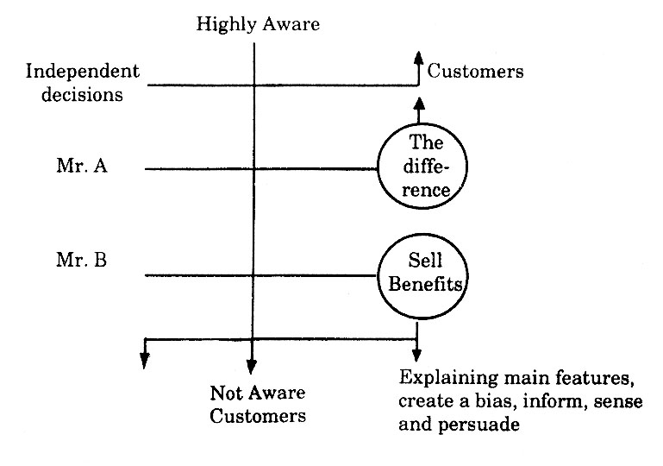
2.8.4 Sales Promotion: It is natural that like other organisations, the banking organizations also think in favour of promotional incentives both to the bankers as well as the customers. The banking organizations make provisions for incentives to the bankers and call this bakers’ promotion. Like this, the incentives offered to the customers are known as customers’ promotion. There are a number of tools generally used in the different categories of organizations in the face of the nature of goods and services sold by them. The gift, contests, fairs and shows, discount and commission, entertainment and traveling plans for bankers, additional allowances, low interest financing and retalitary are to mention a few found instrumental in promoting the banking business.

As and when the banking organizations offer new services and schemes, the tools of sales promotion are required to be innovated. This is with the motto of stimulating the new and old customers. An important thing in the very context is the changing needs and requirements of customers/prospects. The bank professionals bean outstanding task of studying the competitors’ strategies which would he them in initiating the process of innovation. Here it is important to mention the promotional incentives to the customers would focus on decisions related to the selection of a tool. There are a number of considerations to streamline the process. The bank professionals are supposed to study the market conditions and make necessary suggestions, specially regarding the incentives.

It is a blending process and bank professional have to be sure the whatever the provisions, they make are fulfilled on priority basis. More incentives more efficiency or a vice-versa conditions more efficiency, more-incentives motivate bankers substantially.

Word-of-Mouth Promotion: Much communication about the banking services actually take place by word-of-mouth information which is also known as word-of-mouth promotion. In the banking industry, we find use of different components of promotion and in the context it is essential that we also talk about word-of-mouth communication which makes the process of influencing the prospects effective by sensitizing the word-of-mouth recommendations. The persons engaged in communication, the hidden salesforce who play an incremental role in increasing the demand. An important question regarding the word-of-mouth communication is related to its intensity of sensitizing the persuasion process.

The problem before the bank professionals is to identify the persons to be included in the list of word-of-mouth promoters. It is supposed that a bank manager is well aware of the social composition of his/her command area. The oral publicity plays an important role in eliminating the negative comments and improving the services. This helps you know the feed back which may simplify the task of improving the quality of services.

It is important that a branch manager has an in-depth knowledge of his/ her command area and a list of word-of-mouth promoters is prepared. Organizing dinner, offering to them a gift and seeking their cooperation are the process to use this tool of promotion. A satisfied group of customers is considered to be the most successful hidden promoters. A branch manager showing his/her excellence in improving the quality of services in his/ her command area, establishing an edge over the services of the competing banks, promoting LGD marketing (lunch, golf, dinner marketing) successds in instrumentalising the word-of-mouth promotion. It is against this background that this component of the promotion mix is found getting due place.

In this component of the promotion mix, we find two important considerations, first the bank professionals are required to make it sure that the promised services reach to the ultimate users and second, the word-of-mouth promoters are offered small but new incentives which have not been offered by their competitors. The list of word-of-mouth promoters is to be based on a survey result or on the personal experiences of a branch manager. A revision in the list is made possible as and when circumstances necessitate so. The innovative peripheral services offered by the banks are well publicized and the word-of-mouth promoters focus on the same intelligently.
4.8.3 The Price Mix
In the formulation of product mix, the pricing decisions occupy a place of outstanding significance. The pricing decisions or the decisions related to interest and fee or commission charged by banks are found instrumental in motivating or influencing the target market. The Bangladesh Bank and the Banking Association are concerned with the regulations. The rate of interest is regulated by the BB and other charges are controlled by the Banking Association. To be more specific in the Bangladesh setting, we find this component of the marketing mix significant because the banking organizations are also supposed to subserve the interests of weaker sections and the backward regions. The public sector commercial banks in particular are supposed to play developmental role with societal approach. It is natural that this specific role of the public sector commercial banks complicate the problem of pricing.
Pricing policy of a bank is considered important for raising the number of customers vis-à-vis the accretion of deposits. Of course, there are a number of factors to influence the process but it is also right to mention that the key role in the entire process is played by the Bangladesh Bank. A National Consumer Survey Conducted by the L.H. Associates reveals that the quality of Consumer service was one of the three top issues and the consumers ranked the quality of their bank relationships as even more important as the fees charged for the services. To be more specific when we find a number of domestic and foreign banks working in the Bangladeshi economy, the Bangladesh Bank bears the responsibility of making the business environment conductive. The non-banking organizations and foreign banks have been found attracting customers by offering to them a number of incentives. The potential customers or investors frame their investment plans in the face of pricing decisions made by the banking organizations. While formulating the pricing strategies, the banks have also to take the value satisfaction variable into consideration. The value and satisfaction can’t be quantified in terms of money since it differs from person to person, keeping in view the level of satisfaction of a particular segment, the banks have to frame their pricing strategies. The policy makers are required to be sure that the service offered by them is providing satisfaction to the customers concerned. The pricing decisions may be to bit liberal, if the potential customers are found shifting to the non-banking investments. In this context, it is pertinent that pricing is used as motivational tool.

The banking organizations are required to frame two-fold strategies. First, the strategy is concerned with interest and fee charged and second, the strategy is related to the interest paid. Since both the strategies throw a vice-versa impact, it is pertinent that banks attempt to establish a correlation between the two. It is essential that both the buyers as well as the sellers have a feeling of winning as shown in figure.

The banks have to take the value satisfaction variable into consideration while designing the pricing strategies. McIver and Naylor opine that a marketing manager has to regard price as a variable to be traded off against product quality and promotion rather that as an absolute where the lowest price is not desirable.
Figure: 10
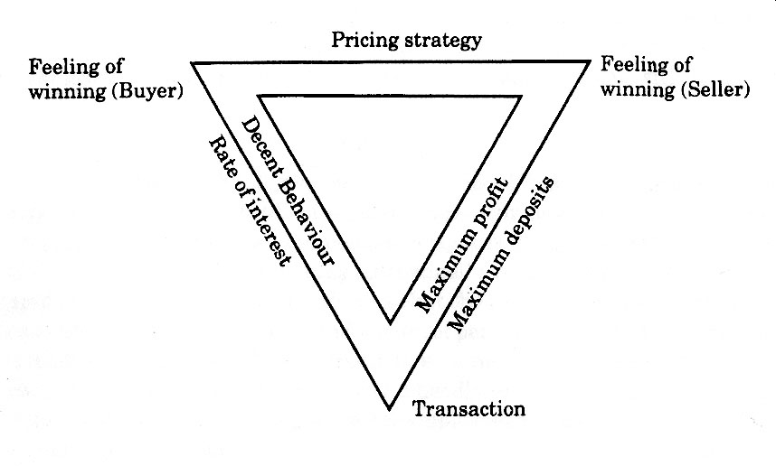
The BB has to be more liberal so that the public sector commercial banks make decisions in the face of changing business conditions. There is no doubt in it that the commercial banks bear the responsibility of energizing the social marketing, they are also supposed to bear the social costs. It is also right that the foreign banks have been found making the business environment more competitive. These emerging trends necessitate a close look on the pricing problem. The policy makers find it difficult to bring a change since the regulations of the BB make things more critical. The expenses are not regulated by the BB and the banking organizations are forced to increase the budgetary provisions. The sources of revenue are regulated which complicates the task of bank professionals. This makes it essential that the Bangladesh Bank , the Government of Bangladesh and the banking organizations thing over this complicated issue with a new vision.
4.8.4 The Place Mix
This component of the marketing mix is related to the offering of services. The two important decision making areas are making available the promised services to the ultimate users and selecting a suitable place for bank branches.

The selection of a suitable place for the establishment of a branch is significant with the viewpoint of making the place accessible and in addition, the safety and security provisions are also found important. The banking organizations are not free to open a branch since the Bangldesh Bank regulates the subject of branch expansion but so far as the management of branch is concerned, the branch managers have option to select a place which is convenient to both the parties, such as the users and the bankers. In the Bangldeshi perspective, the protection to the bank’s assets and safety to the users and bankers need due weightage. The vulnerable area or regions need adequate provisions to make the branch safe. The management of office is also found significant with the viewpoint of making the services attractive. The furnishing, civic amenities and parking facilities can’t be overlooked.

Another important decision making area is related to the offering of services. This draws our attention on the behavioral profile of bankers. The bankers in general and the front-line-staff in particular bear the responsibility of making available the services-promised to the ultimate users without any distortion often a gap is found generated by front-line-staff that makes an invasion on the image of bank. The bank professionals or a branch manager is required to be sure that whatever the promise has been made regarding the quality of services are not distorted. The BB and the different public sector commercial banks are required to manage the distribution process intelligently and professionally. Thus, the place mix is found to be an important decision making area which requires due attention, both at macro and micro levels. If the banking organizations sell the promises it is essential that the end users get the same without any distortion.

2.8.5 The People
Sophisticated technologies, no doubt, inject life and strength to our efficiency but the instrumentality of sophisticated technologies start turning sour if the human resources are not managed in a right fashion. Generation of efficiency is substantially influenced by the quality of human resources. It is against this background that a majority of the management experts make a strong advocacy in favour of developing quality people and late, the people management has been include dint he marketing mix of organizations is general and the service generating organizations in particular.

Not only the public sector commercial banks but almost all the public sector organization and albeit other government departments, of late, have been facing the problem of quality people resulting into inefficiency, deceleration in the rate of overall productivity and profitability or so. The front-line staff are rough and indecent, the branch mangers are helpless and even the bankers have been found involved in the unfair practices. The public sector commercial banks need to assign on overriding priority to the development of quality people majority of the management of the experts have realized the significance of quality people in the development of an organization and the boardrooms are also found changing their attitudes. The first task before the banking organisatoins at the apex level is to overhaul the recruitment processes. While fixing criteria for selection, they need to assign due weightge to the ethical values. The education and training facilities are required to be innovated. The process of identification and inculcation need to be managed carefully.

The foreign banks and the private sector commercial banks reward for efficiency and at the same time also demonstrative the inefficient bankers. This helps them in improving the efficiency of even the inefficient people. The development of human resources makes the ways for the formation of human capital. Incentives, of course, inject efficiency and the organizations offering more incentives succeed in motivating the people.

- Having better and cost-effective control over operations.
- Enriching the job content of employees at all level (by reducing the drudgery of mundane operations and increasing the analytical content of their work).
- Improving the quality of decision-making, a must in the fast changing environment.

Thus, the key focus areas in which information technology can be employed are:
- Automated processing of back-office operations like processing of forms, policy customerization and product selection, pricing and preparation of quotations, etc.
- Computer assisted telephone and intelligent voice processing for customer call handling, new business marketing or handling after office hours enquires.
- Image processing for documents storage and retrieval, folder management (or all documents related to a customer), and workflow management for the movement of documents with the bank.
- Artificial intelligence and expert systems for complex decision-making like the appraisal of the creditworthiness of clients, designing of innovative instruments and strategy formulation.
- Relational Database Management System (RDBMS) for the systematic use of information which would facilitate the cross-selling of products.
- Electronic Data Interchange (EDI) for company-wise communication and inter-connection of systems for the benefit of both the bank’s MIS and the customer.
- Office Management Systems for accounting and administrative support.
All the above systems should be “client-based systems” and not “line-of-business systems” since these would provide better marketing and service to clients, facilitate cross-selling and customerization of schemes and hence, a better packaging for the product. This would help Indian banks “thing customer”.

All these would, thus, help in the effective management of time. Recourse to mechanized systems like ledger posting machine, cash counting machine and cheque sorting machine would result in reduction in the number of tedious and routine jobs to be handled manually saving time for the people to focus on the customer

4.9 Strategies for Effective Bank Marketing in Bangladesh
Since the inception of globalization in Bangladesh, banking sector has undergone various changes. Introduction of asset classification and prudential accounting norms, deregulation of interest rate and opening up of the financial sector made Bangladeshi banking sector competitive. Encouragement to foreign banks and private sector banks increased competition for all operators in banking sector. The protective regime by the authority is over. Bangladeshi banks are exposed to global competition. Even competition within the country has increased manifold. The almost monopoly position enjoyed by the public sector banks of Bangladesh is no more existence. Under this development Bangladeshi banks needs to reinvent the marketing strategy for growth.

The spread of the bank in Bangladeh rural and semi urban areas are highly different from state to state and region to region. Many devision have fewer networks of bank branches in the rural areas. Under such scenario different marketing approach for different areas is required. If the bank follows the same marketing strategy for all areas the success would be difficult.
Marketing approach for urban area: The urban areas of Bangldesh are developed taking into account all parameters of development. The level of income of the people, the literacy rate and level of education as well as awareness of the people about rights of the customer are higher than that of the rural and even semi urban areas. Thus here for effective bank marketing different approach is necessary than that of rural areas.

The marketing strategy should be based on customer service and the use of modern technology in banking. Under competitive environment for the success of the business, better customers and retaining existing customers is possible only with customer service. Use of modern technology in urban areas will also go long way for marketing of banking services. Technology based service like credit card, debit card, ATM, anywhere banking, internet banking, and mobile banking are necessary for urban areas. This is because it enables customers to perform banking transactions at their convenience. Business hours of a bank are also an important factor for urban banking. India many private sector banks, especially co-operative banks and now even some of the public sector banks have also started this practice and they find it successful. To attract business and wholesale customers, banks need to adopt technology based product and service which is suitable to such class of customer. For instance RTGS, collection of out station cheques, issuing the cheques at par at any branch in the country, cash management facility, DD butiques etc. are necessary.

Marketing approach for rural areas:
Banks need t develop some scheme which would attract them to bank with. For loans and advances products which are suitable to tarmers, small traders, small scale agro based rural industries are already in existence. Banks need to see the how value addition can be mad to these existing scheme. Banks also needs to tie up with Non Government Organisations and various Self Help Group for different types of loans, micro financing etc. This will help the bank for building good image and reputation in the rural areas over and above the business. Another potential area which can be explored by the banks in the rural area is retail banking. With the steady increase in the income of the rural people there is ample scope for retail loan products like housing loans and loan for consumer durables.
Marketing through customer services in rural areas is different from that of urban areas. Here personalized banking is the success mantra for banks. Because of high level of illiteracy people prefer to undertake banking transaction themselves. They hesitate to depend upon technology based service. For effective marketing in rural areas bank should have staff with right soft skill like concern for customers’ problem, positive attitude, good communication and negotiation skill. At every level of dealing with the customer bank need to educate them for banking activates and process. To attract the customers from the unorganized sector most important factor is to provide. The borrower the required finance of right amount at right time.

Chapter – 5
Marketing Practices of Uttara bank ltd.
5.1 Product Mix:
The following are the products is offered by the Uttara Bank Ltd

- Special Loan Scheme:
- Consumer credit scheme
- Personal loan
- Small Business Loan
- Building repair loan

B. Saving deposit scheme:
- Savings Accounts
- Short Term Deposit Accounts
- Fixed deposit receipt Accounts
- Double benefit deposit scheme
- Monthly deposit scheme

C. International Banking:
1. Foreign currency accounts
2. Non-Resident Foreign Currency Deposit Account
3. Resident Foreign Currency Deposit Account
1. Consumer credit scheme:
UBL started Uttaran Consumers Credit Scheme from 1996.UBL offers opportunity of Financial assistance for -
- Motor cycle/car- New or re-conditioned.
- Refrigerator/ Deep Freeze.
- Television/ VCR /VCP/VCD
- Radio/ Two-in-one/ Three – in – one
- Air-Conditioner/ Water Cooler/ Water Pump
- Washing Machine.
- Personal Computer/ UPS/ Printer/ Type writer
- Sewing Machine.
- House hold furniture- Wooden & Steel.
- Cellular Telephone.
- Fax
- Photocopier.
- Electric Fan- Ceiling/ Pedestal/ Table.
- Bi-Cycle
- Dish Antenna.
- Baby Taxi, Tempo/Microbus (For self employed persons)
- Kitchen articles such as Oven, Micro-oven, Toaster, Blender, Pressure Cooker etc.

Special Features :No collateral security is required.
- Simple rate of interest.
- Quick sanction.
- Maximum Loan amount Tk.3,00,000/-
- 5% incentive on total interest charged
Required Documents :
- Documents related to applicant's job to prove himself.
- Two copies passport size photographs.
- Photograph of nominee (if any) duly attested by the account holder.
2. Personal loan:
Personal Loan Scheme for Salaried Officers-
- Emergency expenses for own marriage of a service- holder or his dependents.
- Emergency expenses of urgent surgical operation/ medical treatment.
- Emergency educational expenses of the children for admission/purchase of books, examination fees etc.
Special Features :
- Any permanent salaried employee aged between 20 to 55 years is eligible to get loan.
- No collateral security is required.
- Maximum Amount of loan Tk. 1,00,000.
- Maximum period of loan upto 3 years.
Required Documents :
- Documents related to applicant's job to prove himself.
- Two copies passport size photographs.
- Photograph of nominee (if any) duly attested by the account holder.
3. Savings Accounts
- Any Bangladeshi National residing home or abroad may open savings account
with UBL.
- The account may be opened in single/joint name.
- The account holder may nominate his nominee in this account.
- The nominee can get the balance amount without submitting succession certificate
after the death of account holder.

Features :
- Minimum amount : Taka 1,000.00
- Rate of Interest : 4.50%
- Free Cheque-Book facility
- Opportunity to apply for - safe deposit locker facility
- Collect foreign remittance in both T.C. & Taka draft.
- Transfer of fund from one branch to another by
  - Demand Draft
  - Mail Transfer
  - Telegraphic Transfer
- Transfer of fund on Standing Instruction Arrangement
- Collection of cheques through Clearing House.
- Issuance of Payment Order / Call Deposit.
Required Documents:
- Account opening form as per format below. The account opening form and signature card to be filled in and duly signed.
- Two copies passport size photographs of the account holder.
- Photograph of nominee (if any) duly attested by the account holder.
- Photocopy of the 1st 7 pages of the passport for non-resident Bangladeshi national.
- Signature in the account opening form/card must be same with the signature of the passport.
4. Short Term Deposit Accounts
- Govt., Semi-Govt., Autonomous organization and an individual may open STD Account with UBL.
- UBL offers attractive/competitive rate of interest (3.25%) in STD Account.
- 7 days notice required to withdraw big amount.
Fixed deposit receipt Accounts
- Any Bangladeshi national residing home or abroad may open FDR with UBL.
- FDR may be opened single/joint name for a period of 3, 6, 12, 24 and 36 months.
- UBL offers attractive/competitive rate of interest in FDR.

Table: 2 Rate of Fixed Deposit based on different duration

Fixed Deposit (FDR) | Rate of Interest
3 months & above but less than 6 months | 7.75%
6 months & above but less than 1 year | 8.00%
1 year & above but less than 2 years | 8.25%
2 years & above but not more than 3 years | 8.50%

4. Double Benefit Deposit Scheme

a) Any adult Bangladeshi National will be eligible to open this account.
b) Minimum Tk.1,00,000/- (Taka One Lac only) and multiples thereof will be accepted as deposit under this scheme.
c) The period shall be of 8.5 (Eight years Six months) years term. d) Deposit may be
encashed before its maturity and no interest will be paid if encashed before 1(one)
year of deposit
e) Interest will be paid at Savings rate if encashed after 1(one) year. f) Advance will
be allowed up to 80% of the deposit after completion of one year g) Full amount
including interest will be paid on maturity.
h) Govt. tax, Surcharge, Source Tax, Levy, Govt. Excise duty will be recovered from the depositor’s A/C.
i) Account holder can appoint a nominee against the account. j) Bank reserves the right to close the account at any time and make amendment / alteration of the terms & conditions of the scheme without assigning any reason.

Monthly Deposit Scheme
a) Any adult Bangladeshi National will be eligible to open this account.
b) The period of the scheme will be 5 (five) years and 10 (ten) years term.
c) Monthly installment will be Tk.500/-, 1000/-, 2000/-, 3000/-, 5000/- & 10000/-
d) Monthly installment to be deposited within 10th day of the month. After due date a penalty of Tk.50/- will be realised from the A/C holder. If the A/C holder fails to deposit 3(three) consecutive monthly installments, the account will be automatically closed.
e) No cheque book will be issued against the account.
f ) Deposit may be enchased before maturity. But no interest will be
paid if enchased before 1(one) year of deposit.
f) Advance will be allowed up to 80% of the deposit after completion of one year
g) Interest will be paid at Savings rate if enchased after 1(one) year of deposit.
h) Advance will be allowed upto 80% of the deposit after completion of one year.
i) Full amount including interest will be paid on maturity.
j) Govt. tax, Surcharge, Source Tax, Levy, Govt. Excise duty will be recovered from the depositor’s A/C.
k) Account holder can appoint a nominee against the account.
l) Bank reserves the right to close the account at any time and make amendment / alteration of the terms & conditions of the scheme without assigning any reason.
m) Amount will be paid on the following matrix:
Table: 3 Schedule of the Installment to be paid
Amount of monthly deposit (Taka) | Period of deposit | Amount to be paid at the end of period | Period of deposit | Amount to be paid at the end of period
500 | 5 years | 36,736.00 | 10 years | 90,791.00
1000 | 5 years | 73,471.00 | 10 years | 1,81,582.00
2000 | 5 years | 1,46,943.00 | 10 years | 3,63,163.00
3000 | 5 years | 2,20,414.00 | 10 years | 5,44,745.00
5000 | 5 years | 3,67,357.00 | 10 years | 9,07,909.00
10000 | 5 years | 7,34,715.00 | 10 years | 18,15,817.00

Foreign Currency Accounts
Foreign Currency Act. for private individual/firm/organization :
- Any person/firm/organization who earns foreign currency can open Foreign Currency Account with UBL.
- Payments in foreign currency may be made freely abroad from this account and local payment in Taka may also be made from this account.
- Bank pay interest provided the accounts are maintained in the form of term deposit for minimum period of 90 days.
Requirement for opening of the account:
- Account opening form as per format below. The account opening form and signature card to be filled in and duly signed.
- Two copies passport size photographs of the account holder duly attested by remitter's Bank/Embassies
- Photo copies of the first 7 pages of the passport duly attested by the remitters bank/exchange
- companies having drawing arrangement with UBL or by Bangladesh Mission abroad.

Foreign Currency Account for Bangladeshi Nationals Working and earning abroad.
- No initial deposit is required.
- A/c holder may nominate his nominee to operate the account.
- The account holder can freely transfer entire amount in foreign currency anywhere he chooses or can convert into Bangladesh Taka currency.
- Funds from this account may also be issued to the account holder upto his entitlement for the purpose of his foreign travels in usual manner.
Requirement for opening of the account :
- Account opening form as per format below . The account opening form and signature card to be filled in and duly signed.
- Two copies passport size photographs of the account holder.
- Copies of employer’s certificate/work permit.
- One copy of the passport size photograph of the nominee if any to be attested by the account holder.
- Photocopies of the first 7 pages of the passport of the account holder.
Non-Resident Foreign Currency Deposit Account
- All Non-Resident Bangladesh nationals and persons of Bangladesh Origin including those having dual nationality ordinarily residing abroad may open this account with any AD branch of Uttara Bank Ltd.
- The NFCD account may be opened in single/joint name for a period of 1, 3, 6, 12 months.
- This account may be maintained as long as account holder desires.
- On maturity the account holder can encash it in local currency or can transfer the amount including accrued interest anywhere he likes.
- Initial deposit US$ 1000 or GBP 500 sterling or equivalent currency.
- The account offers attractive interest. Payable in foreign and tax free.
- The account with accrued interest can be renewed either of the instruction of the account holder or be renewed automatically if there is no instruction otherwise.
- No interest is given on premature encashment.

Requirement for opening of the account
- Account opening form as per format below. The account opening form and signature card to be filled in and duly signed.
- Two copies passport size photographs of the account holder.
- Photocopies of the first 7 pages of the passport duly attested by the remitters bank/exchange companies having drawing arrangement with UBL or by Bangladesh Mission abroad.

Resident Foreign Currency Deposit Account
- Persons ordinarily resident in Bangladesh may open and maintain RFCD Account with foreign exchange brought in at the time of his return from travel abroad.
- Any amount brought in with declaration to customs authorities in the form FMJ and upto US$ 5000 brought in without any declaration can be deposited in this account.
- Balance in this account can be freely transferred abroad.
- Funds from this account may also be issued to the account holder for the purpose of his foreign travels in the usual manner.
- Interest in foreign currency is paid in this account if the deposits are for a term of not less than one month and the balance is not less than US$ 1000 or GBP 500 or its equivalent.

Requirement for opening of the account
Account opening form as per format below. The account opening form and signature card to be filled in and duly signed.
- Two copies of passport size photograph of the account holder.
- Photocopies of the passport and the relevant pages showing evidences of travelling abroad.
5.2 Place or Networks:
Uttara bank ltd is operating its business through the direct marketing technique, It has planty of branches under which it function as branch banking,

Table: 4 List of the Baraches of UBL
Corporate Offices ( Corporate Branch & Local Office ) | 2
Regional Office | 13
Worldwide Affiliates | 600
Total Branches ( Including Corporate Branch & Local Office ) | 211
Authorized Dealer Branches | 38
Treasury & Dealing Room | 1
Training Institute | 1
Man Power | 3562

Branches of Uttara Bank in Bangladesh:
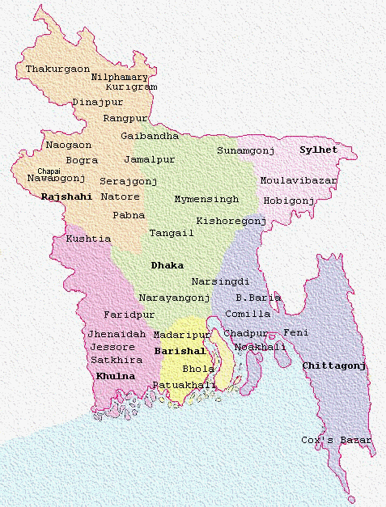

5.3 Prices:

Table:5 Schedule of charges relating to inland transaction:

SL.NO |  | ITEM | NATURE OF CHARGES |  |  | Existing rate of UTTARA BANK LIMITED |  |  | REVISED RATE OF UTTARA BANK LIMITED
01. |  | Current Account | a) Service Charges |  |  | a)Tk.200/+ VAT at half Yearly rest for individual.  Tk.300/+ VAT at half yearly rest for firms, Companies etc |  |  | -NIL-
 |  | Current Account | b) Incidental Charges |  |  | b) Tk.100/+VAT at half yearly rest If balance comes down the Minimum required limit of Tk.2,000/- |  |  | -NIL-
 |  | Current Account | c)Closing Charges |  |  | Tk.300/+VAT |  |  | Tk.300/+VAT
 |  | Current Account | d) Account Maintenance Charge |  |  | -NIL- |  |  | a) Tk.500/+ VAT at half yearly rest.
02. |  | SB Account | a) Service Charges |  |  | a) Tk.100/+VAT at half yearly rest. |  |  | -NIL-
 |  | SB Account | b) Incidental Charges |  |  | b) Tk.50/+VAT at half yearly rest If balance comes down the Minimum required limit of Tk.1,000/- |  |  | -NIL-
 |  | SB Account | c)Closing Charges |  |  | Tk.200/ + VAT |  |  | Tk.200/ + VAT
 |  | SB Account | d) Account Maintenance Charge |  |  | -NIL- |  |  | a) Tk.300/+ VAT at half yearly rest.
03 |  | STD | a) Account Maintenance Charge |  |  | -NIL- |  |  | a) Tk.300/+ VAT at half yearly rest.
 |  | STD | b)Closing Charges |  |  | -NIL- |  |  | Tk.300/+VAT
04. |  | Loan Account | Incidental Charges |  |  | Tk.300/+VAT at half yearly rest. |  |  | -NIL-
05. |  | Deposit Pension Scheme | Closing Charges |  |  | Tk.100/+VAT |  |  | Tk.100/+VAT. But No charge will be realized at the time of pre-matured encashment.
06 |  | COLLECTION  a) Commission on Collection of cheques  (local where there is a clearing house) |  |  |  | Free |  |  | Free
 |  | b) Commission where there is no clearing house |  |  |  | At actual for conveyance Minimum Tk.25/+ VAT per instance |  |  | At actual for conveyance Minimum Tk.25/+ VAT per instance
 |  | c) Commission  on Collection of outstation  cheques/bills (clean/ documentary) | a) Upto Tk.25,000/- |  |  | @0.15% Minimum Tk.25/+ VAT |  |  | @0.15% Minimum Tk.25/+ VAT
 |  |  | b) Above Tk.25,000/- but not exceeding Tk.1.00 lac |  |  | @0.15% Minimum Tk.100/+ VAT |  |  | @0.15% Minimum Tk.100/+ VAT
 |  |  | c)Above Tk.1.00 lac but not exceeding Tk.5.00 lac |  |  | @0.10% Minimum Tk.200/+ VAT |  |  | @0.10% Minimum Tk.200/+ VAT
 |  |  | d) Over Tk.5.00 lac |  |  | @0.10% Minimum Tk.750/+ VAT  Maximum Tk.1,500/+ VAT |  |  | @0.10%Minimum Tk.750/+ VAT  Maximum Tk.1,500/+ VAT
 |  | d) Postage  Telegram Charges | Postage |  |  | At actual Minimum Tk.20/+ VAT |  |  | At actual Minimum Tk.20/+ VAT
 |  | d) Postage  Telegram Charges | Telegram |  |  | N/A |  |  | N/A
 |  | d) Postage  Telegram Charges | Telex |  |  | N/A |  |  | N/A
 |  | d) Postage  Telegram Charges | Telephone |  |  | At actual Minimum Tk.40/- (Including VAT. Tk.35/-+5/-) |  |  | At actual Minimum Tk.40/- (Including VAT. Tk. 35/-+5/-)
07. |  | REMITTANCE(Inland) a) DD/TT/MT issuance  Telegraphic/Telex/Fax charge for TTs issued | Exchange |  |  | @0.10% Minimum Tk.25/+ VAT |  |  | @0.10% Minimum Tk.25/+ VAT
 |  |  | Telegram |  |  | N/A |  |  | N/A
 |  |  | Telex |  |  | N/A |  |  | N/A
 |  |  | Telephone |  |  | At actual Minimum Tk.40/- (Including VAT. Tk 35/-+5/-) |  |  | At actual Minimum Tk.40/- (Including VAT. Tk 35/-+5/-)
 |  | b)Payment order issue | Commission |  | a) Up to Tk.1,000/- | Tk.20/+ VAT |  |  | Tk.20/+ VAT
 |  | b)Payment order issue |  |  | b) Above Tk.1,000/- but not exceeding Tk.1.00 lac | Tk.30/+ VAT |  |  | Tk.30/+ VAT
 |  | b)Payment order issue |  |  | c) Above Tk.1.00 lac but not exceeding Tk.5.00 lac | Tk.50/+ VAT |  |  | Tk.50/+ VAT
 |  | b)Payment order issue |  |  | d) Above Tk.5.00 lac | Tk.100/+ VAT |  |  | Tk.100/+ VAT
 |  | c) SDR issue | Commission |  | Up to Tk.1,000/- | Tk.20/+ VAT |  |  | Tk.20/+ VAT
 |  | c) SDR issue |  |  | Above Tk.1,000/- but not exceeding Tk.1.00 lac | Tk.50/+ VAT |  |  | Tk.50/+ VAT
 |  | c) SDR issue |  |  | Above Tk.1.00 lac but not exceeding Tk.5.00 lac | Tk.100/+ VAT |  |  | Tk.100/+ VAT
 |  | c) SDR issue |  |  | Above Tk.5.00 lac | Tk.200/+ VAT |  |  | Tk.200/+ VAT
 |  | d) Cancellation of DD/PO | DD |  | a) upto Tk.1,000/ | Tk.25/+VAT |  |  | Tk.25/+VAT
 |  | d) Cancellation of DD/PO |  |  | b) Above Tk.1,000/- | Tk.50/+VAT |  |  | Tk.50/+VAT
 |  | d) Cancellation of DD/PO | PO |  | a) upto Tk.500/- | Tk.15/+VAT |  |  | Tk.15/+VAT
 |  | d) Cancellation of DD/PO |  |  | b) Above Tk.500/- | Tk.50/+VAT |  |  | Tk.50/+VAT
 |  | e) Issuance of duplicate instrument | Commission for DD/FDR/PO/SDR |  |  | Tk.200/ + VAT per single case |  |  | Tk.200/ + VAT per single case
08. |  | Purchase Of Cheques, Draft & Bills | Commission a) Up to Tk.25,000/- |  |  | @0.15% Minimum Tk.25/+ VAT |  |  | @0.15% Minimum Tk.25/+ VAT
 |  | Purchase Of Cheques, Draft & Bills | b) Above Tk.25,000/- but not exceeding Tk.1.00 lac |  |  | @0.15% Minimum Tk.100/+ VAT |  |  | @0.15% Minimum Tk.100/+ VAT
 |  | Purchase Of Cheques, Draft & Bills | c) Above Tk.1.00 lac but not exceeding Tk.5.00 lac |  |  | @0.10% Minimum Tk.200/+ VAT |  |  | @0.10% Minimum Tk.200/+ VAT
 |  | Purchase Of Cheques, Draft & Bills | d) Over Tk.5.00 lac |  |  | @0.10% Minimum Tk.750/+ VAT  Maximum Tk.1500/+ VAT |  |  | @0.10% Minimum Tk.750/+ VAT  Maximum Tk.1500/+ VAT
 |  | Postage | Postage |  |  | At actual Minimum Tk.20/+ VAT |  |  | At actual Minimum Tk.20/+ VAT
 |  | Postage | Telegram |  |  | N/A |  |  | N/A
 |  | Postage | TELEX |  |  | N/A |  |  | N/A
 |  | Postage | Telephone |  |  | At actual Minimum Tk.40/+ VAT |  |  | At actual Minimum Tk.40/+ VAT
 |  | Interest | Interest |  |  | Interest to be charged as per lending rate from the date of purchase to the date of realization |  |  | Interest to be charged as per lending rate from the date of purchase to the date of realization
09. |  | Standing Instruction | Commission |  |  | Tk.100/+VAT for Execution of each instruction |  |  | Tk.100/+VAT for Execution of each instruction
 | 10. | Godown Charge a)Borrowers Godown under Bank's Custody |  | i) Rent |  |  | On Borrower's A/c |  |  | On Borrower's A/c
 | 10. |  |  | ii) Insurance |  |  | On Borrower's A/c |  |  | On Borrower's A/c
 | 10. |  |  | iii) Salary & Allowances of Godown staff |  |  | On Borrower's A/c |  |  | On Borrower's A/c
 | 10. | b) Bank's Rented Godown |  | i) Rent |  |  | Actual rent for floor space occupied plus 75% to meet other maintenance cost to be realized from Borrowers A/C proportionately. |  |  | Actual rent for floor space occupied plus 75% to meet other maintenance cost to be realized from Borrowers A/C proportionately.
 | 10. |  |  | ii) Insurance |  |  | To be realized from Borrowers A/C proportionately |  |  | To be realized from Borrowers A/C proportionately
 | 10. |  |  | iii) Salary & Allowances of Godown staff |  |  | To be realized from Borrowers A/C proportionately |  |  | To be realized from Borrowers A/C proportionately
 | 11. | Issuance of Guarantee |  | Commission |  |  | @0.60% per Qtr. Minimum Tk.1000/+VAT but in case 100% cash margin (Non intt. bearing) is provided Tk.1000/+VAT is to be realised. Stamp charge at actual will be on Borrower's A/C |  |  | @0.60% per Qtr. Minimum Tk.1000/+VAT but in case 100% cash margin (Non intt. bearing) is provided Tk.1000/+VAT is to be realised. Stamp charge at actual will be on Borrower's A/C
 | 12 | Charges of Parcels |  | Commission |  |  | Tk.30/+VAT for each parcel for 1st 10 days and additional Tk.20/+VAT for every subsequent 10 days or part thereof. |  |  | Tk.30/+VAT for each parcel for 1st 10 days and additional Tk.20/+VAT for every subsequent 10 days or part thereof.
 | 13. | Locker’s and Safe Custody |  | Commission |  |  | Small size Tk. 750/+ VAT per annum |  |  | Small size Tk. 750/+ VAT per annum
 | 13. |  |  |  |  |  | Medium Size Tk.1,250/+ VAT per annum |  |  | Medium Size Tk.1,250/+ VAT per annum
 | 13. |  |  |  |  |  | Large Size Tk.2,000/+ VAT per annum |  |  | Large Size Tk.2,000/+ VAT per annum
 | 13. |  |  |  |  |  | Security Deposit for Key Tk.2000/-(Refundable) |  |  | Security Deposit for Key Tk.2000/-(Refundable)
 | 14. | a) Cheque Book issuance |  | Commission |  |  | a) Tk. 1/- Per leaf + VAT for all type of Accounts. |  |  | a) Tk. 1/- Per leaf + VAT for all type of Accounts.
 | 14. | b)MICR encoded cheque book |  | Commission |  |  | Tk 4.50+VAT per leaf |  |  | Tk 4.50+VAT per leaf
 | 15. | a)Stop Payment |  | Commission |  |  | a) Tk.50/+VAT |  |  | a) Tk.50/+VAT
 | 15. | b) Clearing Cheque Return & bounce |  | Commission |  |  | b) Tk. 100/+VAT |  |  | b) Tk. 100/+VAT
 | 16. | a) Solvency Certificate |  | Commission |  |  | a)Tk. 500/+VAT |  |  | a)Tk. 500/+VAT
 | 16. | b) Balance Certificate |  | Commission |  |  | b) Tk. 200/+VAT |  |  | b) (1st time Free for half yearly & annually) On Subsequent demand Tk.200/+VAT per instance.
 | 16. | c) Accounts Statement |  | Commission |  |  | c) (1st time Free for half yearly & annually) On Subsequent demand Tk.200/+VAT per instance. |  |  | c) (1st time Free for half yearly & annually) On Subsequent demand Tk.200/+VAT per instance.
 | 16. | d) Beneficiary Owner’s Certificate |  | Commission |  |  | Tk 100+VAT |  |  | Tk 100+VAT
 | 17. | Charges of Retail loans |  | a)Application form (non refundable)  - PL  - CL  - HRL |  |  | a)  Tk.100/-+ VAT Tk.100/-+ VAT Tk.200/-+ VAT | The existing loan processing fees regarding PL, CL, UHRL shall remain in force. |  | a)  Tk.100/-+ VAT Tk.100/-+ VAT Tk.200/-+ VAT | The existing loan processing fees regarding PL, CL, UHRL shall remain in force.
 | 17. |  |  | b) Loan  ( OD, CC ) Processing fee |  |  | All category of Loans (General)  Upto 5.00 Lac = Tk.1000/+ VAT  Upto 10.00 Lac = Tk.1500/+ VAT  Upto 15.00 Lac = Tk.2000/+ VAT  Upto 25.00 Lac = Tk.2500/+ VAT  Upto 50.00 Lac = Tk.3500/+ VAT  Upto 1.00 Crore =Tk 5,000+VAT  Upto 5.00 Crore =Tk 7,500+VAT  Above 5.00 Crore = Tk.10,000/+ VAT (Except loan against FDR, WDB etc) |  |  | All category of Loans (General)  Upto 5.00 Lac = Tk.1000/+ VAT  Upto 10.00 Lac = Tk.1500/+ VAT  Upto 15.00 Lac = Tk.2000/+ VAT  Upto 25.00 Lac = Tk.2500/+ VAT  Upto 50.00 Lac = Tk.3500/+ VAT  Upto 1.00 Crore =Tk 5,000+VAT  Upto 5.00 Crore =Tk 7,500+VAT  Above 5.00 Crore = Tk.10,000/+ VAT (Except loan against FDR, WDB etc)
 | 17. |  |  | c) Early settlement fees |  |  | -NIL- |  |  | Before adjustment of due date fees will be realized not more then 2% on the outstanding loan.
 | 18. | Miscellaneous  Charge |  | a)On Line Service |  |  | a) N/A |  |  | a) N/A
 | 18. |  |  | b) Call Deposit (Security Receipt Issue) |  |  | b)As per prevailing market rate |  |  | b)As per prevailing market rate
 | 18. |  |  | c) Ready Cash |  |  | c) N/A |  |  | c) N/A
 | 19. | Other Charge |  | a) Negotiation of Documents |  |  | a)At Actual (Mortgage/registration) etc |  |  | a)At Actual (Mortgage/registration) etc
 | 19. |  |  | b) Account Transfer |  |  | b) Tk 100/+VAT |  |  | b) Tk 100/+VAT
 | 19. |  |  | c) Fund Transfer (internal) |  |  | c) Tk 100/- + VAT per instance |  |  | -NIL-
 | 19. |  |  | d) Issue of NOC |  |  | d) Tk 100/+VAT |  |  | d) Tk 100/+VAT
Note: i) VAT will be realized as per Government rules.
II) All Charges except VAT under the schedule of charges will be exempted for the employees of our bank.

Table: 6 Schedule of charges relating to foreign exchange transaction.

Sl. # | Item | Period/Value | Revised Rate
1 | 1) L/c opening commission (all categories i.e. Cash/AID/Loan/Batter/Credit) including back to back L/c (both foreign and inland & under EDF). | Per quarter or part thereof | @0.40%
1 |  | Subsequent quarter | @0.40%
1 |  | Minimum | Tk.1000/-
1 | 2) L/C opening commission under deferred/ usance payment L/c | Per quarter or part thereof | @0.50%
1 | 2) L/C opening commission under deferred/ usance payment L/c | Subsequent quarter | @0.50%
1 | 2) L/C opening commission under deferred/ usance payment L/c | Minimum | Tk.1000/-
1 | 3) L/c opening commission for 100% cash margin | Per quarter or part thereof | @0.25%
1 | 3) L/c opening commission for 100% cash margin | Minimum | Tk.500/-
1 | 4) Acceptance commission under usance L/C including Back to Back L/C. | Per quarter or part thereof | @0.40%
1 |  | Minimum | Tk.1000/-
2 | Mailing charge of L/C | -- | At actual
3 | a) If L/Cs are transmitted by SWIFT | -- | Tk.3000/-
3 | b) If L/Cs are transmitted in short and inoperative by SWIFT | -- | Tk.1500/-
4 | a) Transmission charge of amendment by SWIFT (For value increase) | -- | Tk.3000/-
4 | b) Transmission charge of amendment by SWIFT (Other ) | -- | Tk.1500/-
5 | Transmission charge of Confirmation of Acceptance / Intimation of Discrepancies / Others correspondents by SWIFT | --- | Tk.1500/-
6 | Commission for Amendment of L/C (without change of value and time) | -- | Tk.1000/-
7 | Amendment for increase of value or extension of time. | - | At per with L/C opening charge for extended time and/or increased value as mentioned under Sl. No. 1, 2 & 3.2
8 | a) For adding confirmation (should be made through HO/ID) | For sight L/Cs on opener’s A/C | Foreign banks’ (confirming bank) charges at actual plus swift charge 1000/-.
8 | a) For adding confirmation (should be made through HO/ID) | For sight L/Cs on beneficiary’s A/C | Do.
8 | a) For adding confirmation (should be made through HO/ID) | For deferred /usance L/Cs up to 180 days on opener’s account | Do.
8 | a) For adding confirmation (should be made through HO/ID) | For deferred / usance LCs up to 180 days on beneficiary’s account | Do.
8 | b) Local add confirmation Charge | Sight/Deferred/Usance L/C. | @0.20%
9 | Commission on credit value of Add confirm L/C | Per quarter | 0.20%
10 | a) Foreign Correspondent Charges (For abroad) | - | At actual
10 | b) Foreign Correspondent Charges (For local) | - | Nil
11 | Charge for L/C cancelled or expired unutilized | - | Nil
12 | Handling charge of Import documents | - | Nil
13 | Commission on Import documents under L/C on collection basis. | - | @0.20% on Bill amount minimum USD30/- or equivalent realizable from Ben’s A/c
14 | Commission on Import documents without L/C on collection Basis. | - | @0.25% on Bill amount minimum USD30/- or equivalent realizable from Ben’s A/c
15 | Endorsement charge on non negotiable documents against deposit of full value of documents with shipping guarantee, if required | - | Nil
16 | Endorsement fee for processing Import document for custom assessment purpose subject to compliance of HO’s instruction upon receipt of 100% value of Doc. | - | Nil
17 | Collection of credit report on the supplier/buyer | - | Charges at actual of Foreign Rating Agency/bank plus Tk.1000/-
18 | Any other charges not mentioned above in connection with opening, advising and amendment of L/Cs | - | At actual.
19 | Cost of IMP/LCAF/LC application form | - | Tk.200/- plus actual cost of adhesive stamp
20 | Reimbursement Authority/Payment Instruction | - | i) For up to USD100000/- or equivalent USD25/-  ii) For USD100001/- and above or equivalent USD50/- or eqvt. or beneficiary’s A/c
21 | Discrepancy charge on Import document | - | USD60/- or eqvt. per set of doc./on ben’s A/c
22 | Transfer of LCAF to other bank/branch | - | Tk.500/- per case
23 | a) Document handling charge under EDF system | - | Tk.750/- per case
23 | b) Interest for EDF Loan | - | LIBOR + 1%
24 | Processing fee for obtaining permission of Bangladesh Bank to remit fund for advance payment against Import. | - | Tk.1000/- per case
25 | Registration of LCAF with Bangladesh Bank in case of Import without L/C | - | Tk.500/-
26 | EXPORT  1. a) Negotiation commission for clean Export bills in foreign currency.  1. b) Negotiation of discrepant documents subject to receipt of acceptance from L/C issuing bank by authenticated message | - | @0.15%
26 | 2. Commission on Export documents on collection in foreign currency | - | @0.15% Min. Tk.1000/-
26 | 3. Commission on Export documents on collection in local currency | - | @0.15% Min. Tk.1000/-
26 | 4. Commission on Export Document in case of advance payment | - | Tk.1500/- per DOC.
26 | 5. a) Advising commission of foreign Bank L/Cs to the local beneficiary (both UBL’s and other banks’ customer) | - | Tk.750/-
26 | 5. b) Advising of Inland L/c | - | Tk.750/-
26 | 5. c) Advising of amendment of foreign bank L/Cs/Inland L/Cs to the local beneficiary. | - | Foreign Bank’s amendment  i) For UBL’s customer Tk.750/-  ii) For other Bank’s customer Tk.750/-  iii) For Inland L/C Tk.750/- flat.
26 | 5. d) Transfer of Export L/C | - | i) Tk.750/- for own client & Tk.750/- for other banks’ client of Export L/C. ii) Tk.750/- for Inland L/C
 | 5 e) Transfer of amendments of L/Cs | - | i) Tk.500/- for own client , Tk.750/- for other banks’ client of Export L/C. & Tk.300/- for Inland L/C
 | 6. Collecting Bank’s charges abroad | - | At actual plus service charge Tk.750/-
 | 7. Mailing of Export documents | By Courier | i) By Courier- at actual minimum Tk.2500/- By post Tk.750/- (inland) Tk.100/-
 | 7. Mailing of Export documents | By Post
 | 8. Issuance of PRC (Proceeds Realization Certificate) | - | Tk.500/-
 | 9. a) Payment of cash subsidy (Jute) per case.  b) Duty draw back per case | - | Up to Tk.5.00 lac Tk.500/- per case. Above Tk.5.00 lac Tk.1000/- per case.
 | 10. Cash assistance per case | - | Tk.1000/- per case
 | 11. Issuance of EXP | - | Tk.100/- (per set)
 | 12. Interest for Export bill negotiation (FBP account) | after 21 days from the date of negotiation | 13%
 | 13. Any other charges not mentioned above | - | At actual.
27 | FOREIGN BANK GUARANTEE  1. Advising of Guarantees to the beneficiary in original without any engagement on our part. | - | Tk.1000/- (Flat)
27 | 2. Issuing of Guarantee against counter Guarantee of our foreign correspondents. | - | 0.50% per quarter or part thereof Min Taka eqvt. to USD 50/-
27 | 3. Issuing of guarantee with our full engagement on account of our own client. | - | 0.50% per quarter or part thereof Min Taka equivalent to USD50/-
28 | FOREIGN REMITTANCE  1(a) Purchase of foreign bank’s DD,PO, Banker’s cheque. | - | Commission @0.10% Min. Tk.500/- plus postage at actual.
28 | 1(b) Purchase of Cash / TC | - | Commission @0.10% minimum Tk.200/-. Mailing charge by post Tk.200/- per instance. Through Courier at actual per instance.
28 | 2) Handling charges for encashment of foreign DD/TT. | - | Up to Tk.1.00 lac Tk.200/- up to Tk.2.00 lac Tk.300/- above Tk.2.00 lac Tk.400/-
28 | 3 (a) Collection of clean item (FDD, PO, Banker’s cheque etc). | - | Commission @0.10% minimum Tk.200/-. Mailing charge by post Tk.200/- per instance. Through courier at actual per instance.
28 | 3 (b) Other charges including telex, fax,  e-mail/SWIFT etc. relating to remittance. | - | At actual to be deducted from collected proceeds.
28 | 4.a) Issuance of TC/endorsement in passport | - | Commission 1.00% on FC amount of TC for issuance and/or plus Tk.200/- for endorsement.
28 | 4. b) Issuance of cash (FC)/endorsement in passport. | - | Tk.200/-
28 | 5. a) Issuance of foreign currency draft. | - | Tk.600/- per instrument
28 | 5. b) For commercial settlement |  | 0.10% min. Tk.600/-
28 | 6. a) Issuance of TT in foreign currency | - | a)Tk.600/- per instrument
28 | 6. b) For commercial settlement |  | b)0.10% min. Tk.600/-
28 | 7. Cancellation of foreign currency DD/TT | - | Tk.500/- per DD/TT
29 | others:  1) Commission on document for  a) LIM | - | @0.50% on landed cost minimum Tk.1000/-
29 | b) LTR | - | i) Up to 1.00 crore:Tk.2500  (ii) above Tk.1.00 crore upto Tk.5.00 crore: Tk.5000/-  (iii) above Tk.5.00 crore Tk.10000/-
29 | 2) Debit Authority for non acceptance of remittance through Nostro A/c | - | USD25.00 or equivalent
29 | 3) Maintenance of Student File | - | i) For opening Tk.5000.00 per file  ii) For renewal Tk.3000/- per file.
29 | 4) Handling charge in case of re-Export of goods | - | Tk.2000/- per DOC.
29 | 5) Processing Fees for obtaining Bangladesh Bank’s permission for Buying House/Indenting Firm. | - | Tk.2000/- per case
29 | 6) Processing Fees for renewal of Bangladesh Bank’s permission for Buying House/Indenting Firm. | - | Tk.1500/- per case
29 | 7) Handling charge of renewal of IRC/ERC and Indentor’s IRC | - | Tk.500.00 per case
29 | 8) Delivery Order issue against LIM/Pledge goods. | - | Tk.200/- per delivery order
29 | 9) Money Exchange initial file processing fee | - | Tk.2000/-
29 | 10) Money Exchange License renewal fee | - | Tk.1000/-
29 | 11) Processing fee of document to release FC except Import DOC | - | Tk.2000/- per case
29 | 12) Forwarding of monthly statement of Money Exchange companies to Bangladesh Bank | - | Tk.500/- per case
29 | 13) Back to Back L/c certificate | - | Tk.500/-

5.4 Promotion:
Uttara Bank usually considers all sorts of promotional mix like:
1. Advertising:
Like other banks, Uttara bank also provides their promotional efforts in different media. Since the advertising is the most attractive media, it is used by all the banks. Several times we can see different types of add to persuade the prospective customers showing the attractiveness of the deposit scheme, consumer credit scheme and others.
Beside these, job advertisement is also circulated in the newspaper and internet job side.The following are the media that use by the uttara bank.
a) News Papers.
b) Internet.
c) Billboards.
d) Publication on the Supplementary.
2. Public Relation: Confirming the corporate social responsibility(CSR) Uttara bank Ltd. also took part in the several beautification project, cleanliness drive. Besides, they also act as sponsor in different events, sports, or the donation especially to the disaster victim people through prime ministers fund.
3. Personal selling:
Personal selling is the strongest media to promote its product with personal attachment in banking industry. Uttara bank Ltd. also has set of employees to promote their product in the market. They employ the manpower for collecting the deposit; persuade the client to take the credit from the bank. Also, where credit card is available they frequently inform about their card and influence them to take it by their personal quality as well as the organizational norms. In some of the
Cases where fund is inadequate (rural areas), the branch manager even meet different organization to be a corporate client of them promising to pay handsome benefits and services.
Segmentation, Targeting and Positioning:
Market segmentation: Uttara Bank chooses their target based on the income, occupation, and profession of clients across the country.
Market targeting: Uttara Bank has a target market
Product positioning: Uttara Bank is positioned on quality services
:

Chapter 6
Findings and Recommendations
6.1. Problems
The primary purpose of this study report is to get an idea about the “Marketing Practice of Uttara Bank Ltd”. After being an intern in this bank it is found some important points that can be considered as the gap between the theory and practices.
- Uttara bank has massive weakness in adopting modern technology as far as the e-banking implementation is concerned.
- The bank still has traditional product mix (though some are added) and it lacks some product like student saving or like that taking as a target market.
- The Bank has substantial branch network throughout the country but the question is productivity.
- Though Uttara bank has recovered itself in providing the quality service to the customer, still it inadequate compared to the some of the foreign as well as the indigenous bank while survive is a fact.
6.2 RECOMMENDATIONS
From the through investigation about marketing practices, its lack of using modern banking technology and some of the marketing strategy. To improve the business condition of Uttara Bank Ltd. and to gain the lost market share I suggest implementing the following suggestions:
Management of the Bank is to work for creation of conceptual framework covering core elements of developed “Model Marketing Plan – (MMP)” of UBL to face the competition a changes in the banking industry into the new millennium for sustained growth of business / profitability of the bank. To accomplish the tasks of formulation of “MMP” focus should be made on the following issues:

Business philosophy that identifies current and future opportunities, defines magnitude and quantum, determines target markets and cluster, and decides on products, services and programs to secure entry to markets for economic and financial gains were made. The aim of planned marketing efforts is to understand customers and to ensure that offered products and services adapt to targeted customers’ needs perfectly. The marketing plan to be designed to perform tasks of stimulating demands for Bank’s products and services to influence the level timing and composition of demand help customers’ consummate their business objectives.

Ideas of satisfying the customers’ needs by means of products and the entire cluster of action as associated with creation / delivering and finally consuming the products and services.
The bank should increase the budget on promotional activities.
They should highlights on physical evidence; such as tangible clues and atmosphere of the bank.
They should develop new features of their offerings.
They should employ the skilled manpower.
Process to be employed to interpret markets, customers’ needs and transformation: defining mission / objectives and goals, portfolio plans and new business plans. The plans were structured in 3 (three) operational levels: corporate level, business level and product level. The marketing mission was converted into specific objectives for each level targeted at: profitability, market-share, positioning, risk-diversification and innovation. The objectives to be made quantifiable, realistic and consistent towards useful implementation of the marketing action plan. The portfolio plan involved in reviewing of the current portfolio of businesses and deciding on new businesses and potential thrust sectors.
Identification of market opportunities through analysis of subjective issues, concepts, strategies and techniques of penetration to create market along with efforts to integrate actions based on collected data to fit into real banking solution having operational linkages with the marketing plan “ “Model Marketing Plan – (MMP)” of UBL.

Natural inducement of the target groups to UBL is that customers must perceive greater degree of satisfaction from the offered services. The qualitative improvement and development of cutting-edge products precipitate in higher degree of customers satisfaction and UBL to plan for improvement of services, adding flair to the products like introduction of ATM / On-line banking / Credit Card / Debit Card / introduction of relationship Manager and Customer-friendly deposit schemes.

Finally, Uttara bank must focus on attracting, and getting and retaining qualified personnel for filling up its positions as it is expanding. It is worth spending more on attracting qualified human resources rather than getting the wrong people in the wrong positions.

CONCLUSION
Banking sector has undergone various changes after the new economics policy based on privatization, globalization and liberalization adopted by Government of Bangladesh. Introduction of asset classification and prudential accounting norms, deregulation of interest rate and opening up of the financial sector made Bangladeshi Banking sector competitive. Encouragement to foreign banks and private sector banks increased competition for all operators in banking sector. Banks in Bangladesh prior to adoption of new economic policy was protected by Government and was having assured market due to almost state monopoly in banking sector. However, under the new environment, Bangladeshi banks needs to reinvent the marketing strategy for growth. In Bangladesh geographical development is not even throughout the country, there are full-fledged urban areas covering the metropolitan cities and other big cities. On the other hand there are underdeveloped rural areas too. For effective bank marketing different approach for different areas is required. In urban areas customer services is of paramount importances as the level of literacy and therefore awareness of the people is more. Also technology based marketing would have higher degree of success due to typical urban life style of the people. Universal banking providing all financial service under one roof will have more success in urban areas. In the rural areas for bank marketing personalized banking will go in long way. Also banks need to offer innovative tailor made deposits and advances products to suit individual customers. Delivery of advances of right amount of right amount and at right time is essential in rural marketing.

As an organization the Uttara Bank Limited has earned the reputation of top listed banks operating in Bangladesh. The organization is much more structured compared to any other listed bank operating in Bangladesh. It is relentless in pursuit of business innovation and improvement. It has a reputation as a leader in financing manufacturing sector.

With a bulk of qualified and experienced human resource, Uttara Bank Limited can exploit any opportunity in the banking sector. It is pioneer in introducing many new products and services in the banking sector of the country. Moreover, in the retail-banking sector, it is unmatched with any other listed banks because of its wide spread branch networking thought the country.

