Report
On
“Measuring Service Quality and Customer Satisfaction of Five Star Hotel in Bangladesh:
A Study on Pan Pacific Sonargaon Dhaka”

Submitted by
WWW.ASSIGNMENTPOINT.COM

Introduction

1.1 Prelude:
Located near the busy turn of the SAARC fountain in the heart of the city, the Pan Pacific Sonargaon, Dhaka, Bangladesh is one of the two oldest five star hotels of Bangladesh. It was established back in the year 1981. The hotel is government owned, but is operated by the international chain Pan Pacific Hotels and Resorts which ensures a true Pan Pacific flavor to all its guests.
Pan Pacific Sonargaon provides all the 5 star facilities, fabulous environment and world-class hospitality. The hotel tenders general facilities and services to its boarders like high speed broadband internet, television, refrigerator, and mineral water for every room. There are honor bars in all the rooms. The boarders of the suites, and executive floors (7th and 8th floor), the Pacific rooms, are offered extensive facilities and privileges, including butler service and a private lounge for the discerning hotel guests. They can also enjoy free breakfast, all-day tea and coffee, evening cocktails; and are entitled to free laundry and local calls. For health conscious house guests, there are the tennis court, gymnasium, swimming pool, and health club. Other than these, there are obvious round the clock room service and medical facilities. Picking up from airport, and business services like 24 hours fax require extra charge to be paid.
The hotel is currently undergoing a world-class renovation project. This will add 250 more rooms to the hotel and would also involve redecoration of the existing rooms. Over the course of this year, new room types will be introduced with the latest modern interior design, LCD and Plasma.
In the last 26 years of operation, Pan Pacific Sonargaon Hotel's image has been associated with attitude, experience, and commitment. These speak for its more 80 per cent occupancy all year round, whereas nearly 90-100 per cent occupancy in the peak seasons. The Pan Pacific Sonargaon Dhaka hotel is a lush hideaway in Dhaka’s exciting downtown, offering guests a

Calming respite from the city. Relax and rejuvenate with state-of-the-art facilities and an outdoor pool set amidst lush greenery. Take in the local culture where fascinating sights and sounds abound within close proximity to the Pan Pacific Sonargaon Hotel. Classic style meets contemporary luxury to deliver easy elegance at this prestigious 5 star Dhaka hotel situated prominently in the centre of Bangladesh’s Diplomatic Zone and commercial district. Steeped in rich history yet poised for success, the hotel is close to historic sites and exciting shopping. Experience absolute rejuvenation in every amenity available to you at Pan Pacific Sonargaon Dhaka.

Hotel Location:
Pan Pacific Sonargaon Hotel is eager to offer you enriching experiences during your visit. Rejuvenate your spirit at our 5 star hotel ideally located in the heart of Dhaka close to Motijheel Commercial Area, Diplomatic Zone, Gulshan, Baridhara, Parliament House and the Prime Minister’s Office. Take an easy two minute stroll to Bashundhara City, the largest shopping mall in the country.
Our hotel associates are ready to assist you in exploring historic Dhaka in the centre of Bangladesh. Discover old town Dhaka where visitors can find attractions including the Lalbagh Fort, the Star Mosque and the Ahsan Manzil Palace Museum. Personalise your stay in Sonargaon with a stroll along the banks of the river Buriganga. Create your memories at the 5 star Pan Pacific Sonargaon Dhaka hotel.

Pan Pacific Sonargaon Hotel’s Map:
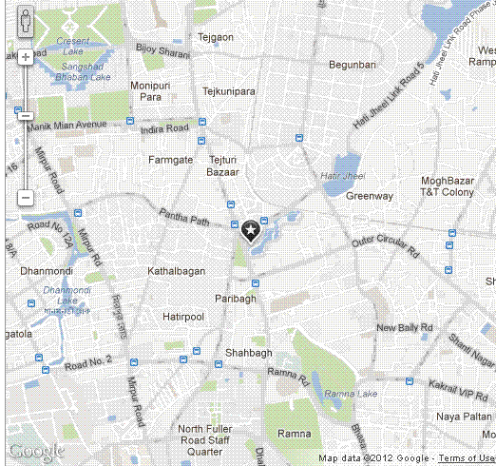

Airport Arrival:
Guests can find our hotel counter located at the Hazrat Shahjalal International Airport arrival lounge. Our Airport officers are available round the clock at the counter to welcome our guests and escort you to your transportation.
Airport Transfer Services:
- Airport Limo Service - Brand new Mitsubishi Outlander SUV limousine service is available at US$50 per vehicle each way.
- Shuttle Transport - Shuttle transport is available to and from airport at US$10 per person each way.
- Personal Limo Service – Chauffeur-driven Mitsubishi Outlander SUV is also available for exclusive personal use during your stay.

Driving Directions:
From Hazrat Shahjalal International Airport
- Drive south via Airport Road 10 km to Mohakhali Flyover.
- Drive straight through Tongi Diversion Road Traffic Signal and immediately afterwards turn right towards Karwan Bazar.
- The Pan Pacific Sonargaon Dhaka hotel is on the left.
Destination Information:
Area Information
The historic city of Dhaka, the capital, lies on the banks of the river Buriganga in the centre of Bangladesh. The old town of Dhaka, south of the city centre, is the site of most of the tourist attractions, including the Lalbagh Fort, the Star Mosque, and the Ahsan Manzil Palace Museum.

The city of Dhaka was predominantly a city of the Mughals, whose governors and viceroys built several palaces, mosques and katras. Dhaka's finest specimen of this time is the Aurangabad Fort, commonly known as Lalbagh Fort, uncompleted but worth a visit. Also in this area of Dhaka is the spectacular Ahsan Manzil Palace Museum, the Bara Katra, the Chota Katra and several mosques of note.
The old European quarter lies just north of Dhaka's old town, which houses the Presidential Palace and the National Museum. Dhaka's commercial and diplomatic regions are north-east of this zone. Dhaka Zoo and the Botanical Gardens are a short taxi ride into the suburbs.
Once famed for its muslin, Dhaka is now renowned for pink pearls and a rich tradition of handicrafts. Shoppers can find terrific prices for gold and silver products, and the Dhaka shopping areas of New Market and Elephant Road are often busy but worth the trip.
Currency
Bangladeshi Taka
Electricity
220 volt
Shopping & Business Hours
10:00 am – 8:00 pm
Taxes
15% Value Added Tax on all Goods and Services
Time Zone
+6 hours GMT
Tipping
Not mandatory, however 10% on top of the bill for exceptional service
Visa Requirements
Visa required prior to departure for most nationalities.

1.2 Objective of the study:

Every successful study should have precise and prickly objectives so; this report also has some special objective to make it effective.

The primary objective of this study is to fulfill the requirements of report on Major Marketing of BBA program. The secondary objective is to analyze the Customer Satisfaction and prospect of hotel industry in a five star hotel like Pan Pacific Sonargaon Hotel

In this regard objectives of the study may be stated as follows:

Analyzing the hotel overview
- To draw a vivid picture of the present state of Dhaka Pan Pacific Sonargaon Hotel by analyzing their synchronous condition in the current perspective
- To study the various services, foods and other unique facilities offered by the Pan Pacific Sonargaon Hotel to its customers
- To show the strengths, weaknesses, opportunities and threats of Pan Pacific Sonargaon Hotel to determine the current position of Pan Pacific Sonargaon Hotel in the competitive market

How to provide customer service in Bangladesh

How to retain the customer into the hotel

What is the opinion of the customer in this hotel

Finally gather all practical implification and real information about Bangladesh Travel, Tourism, and Hospitality with the Pan Pacific Sonargaon Hotel and prepare a future plan to create innovative real life modification for this hotel

1.3 Importance of the study:
The topic of the Report is “Measuring Service Quality of “Pan Pacific Sonargaon Hotel”. Data had recorded by using the Servuqual Model. Here I knew that which way to develop in questionnaire and how to collect data into the customers. I saw that the different customers have different opinion into the same hotel. I knew that which things are acceptable into the customers and I was which things are not acceptable into the customers. I learn that how to prepare into the Pei Chart, mean, median and mode. I also know that how to analyze the questionnaire and to take decision. I was identifying that which things are more important and necessary into the”Pan Pacific Sonargaon Hotel”.

1.4 Methodology of the study:

Data Source

Primary data has been collected from the hotel associates; bottom level, mid level, higher level. I was collecting data in twenty five persons into the hotel guest.

Data Collection Technique

Primary Data has been collected from field survey in “Pan Pacific Sonargaon Hotel” and it structured questionnaire method and interview. A copy of questionnaire would be attached with the appendix.

Secondary data has been collected through discussion with concern authorities and officials of respective management position.

Hotel guest’s information through structured questionnaire method which served by hotel authority.

Review and study relevant reports and documents and Internet and online study.

Data Processing Method

Data had recorded Servuqual Model would be used along qualitative analysis procedure to implement the study in line with the set objectives. I was also analysis the Pie Chart Mean, Median, Mode, Standard Deviation, Variance, Range and Sum.

1.5 Scope of the study:

This report covers the activities performed by the customer’s satisfaction of ”Pan Pacific Sonargaon Hotel”, such as dealing with customers, maintaining relationship with customers, making phone calls and answering the quarries, arranging functions of various types, arranging marketing & promotional activities etc. Besides this, the report will help in finding problems in the total service process and will provide some suggestions for possible solutions.

1.6 Limitation of the study:
Observing and analyzing the broad performance of the “Pan Pacific Sonargaon Hotel” in Bangladesh. Shortage of recent data as well as information of different activities of “Pan Pacific Sonargaon Hotel” was a great problem for me to depict the actual and up-to-date data collection. Moreover, all the employees of “Pan Pacific Sonargaon Hotel” were always busy with heavy workload. Therefore, they were not able to extend their co-operation properly. Although some of the employees are helpful but they didn’t have enough time to provide, as they are very busy with their assigned works. So, in some cases, observation was needed. The sample size was small. Due to maintain hotel confidentiality they avoid some of my questions.

1.7 Theoretical framework:

THE SERVQUAL MODEL

The two separate terms “satisfaction” and “quality” are difficult to define in general, and press writers tend to use those terms interchangeably. However, the more precise meanings and measurement of the two concepts were developed after a considerable debate. Although these two consensuses share something in common, the fundamental causes and outcomes differ from one another. While satisfaction is a wide and broad concept in general, service quality has specific attributes of the service itself. As shown below in Figure 1, service quality is a reflection of the customer’s perception of reliability, assurance, responsiveness, empathy and tangibles. Whereas customer satisfaction is more inclusive and perceived according to service quality, product quality, price, situational factors and personal factors.

Reliability
Responsiveness
Assurance
Empathy
Tangibles

Service Expectation

Perceived
service quality
Customer
Satisfaction

Service Performance

Figure: Service Quality and satisfaction
The SERVQUAL model is a widely accepted model of determining and expressing the customer satisfaction. It was first published in 1988 and has undergone improvements and revisions since then. As it is easy to understand and to identify the customer satisfaction level this model is selected to use in the report. There are five major tools those entirely represent the service quality. These are explained below:
Tangibles: Representing the Service Physically
Tangibles are defined as the appearance of physical facilities, equipment, personnel and communications materials. Customers, particularly new customers, use these physical representations or images to assess quality. Service companies can make good use of tangible factors to improve their image, provide continuity, and indicate quality to customers, or even combine them with another element to create a service quality strategy.
Reliability: Delivering on Promises
Reliability is defined as the ability to perform the promised service dependably and accurately. More specifically, it means that the company deliverers service provision, problem resolution, and pricing according to their promises. In this way, firms can keep their customers loyal to them.
Responsiveness: Being Willing to Help
Responsiveness is the willingness to help customers and to provide prompt service. The focus is weighted on how quickly and attentively companies are able to deal with customer requests, questions, complaints, and problems. Companies must have customer’s point of view to deliver service and handle requests in order to excel on this dimension.

Assurance: Inspiring Trust and Confidence
Assurance is the knowledge and courtesy of employees and their ability to convey trust and confidence. For high-risk service such as banking, insurance, medical, brokerage, and legal services, this aspect tends to be particularly significant. Companies need to gain trust and confidence in order to create trusting relationships with their customers.

Empathy: Treating Customers as Individuals
Empathy is the provision of caring individualized attention to customers. The core idea is to prove customers that they are cared and understood through personalized or customized service, as they are special and important for firms. Small firms are often able to reflect their personal knowledge of customer requirements and preferences and build relationships with their customers so that small firms tend to be more advantageous when competing with larger firms in this dimension. This attribute demands customization service process. Aspects like individual attention, understanding customer’s needs and interests were categorized in this section.
All of those elements are equally important in order to obtain one hundred percent of quality and have different influence on the final service quality. Customers use those five dimensions to organize information about service quality in their minds. Depending on a situation, sometimes all the dimensions are used, and at other times not. Although this model is found relevant for a variety of service business and therefore widely used, some researchers suggest that cross-cultural aspect is missing on those dimensions. Individuals from different backgrounds seek different experiences from the same set of service and also perceive actual experiences differently. This has to be taken into account when applying these dimensions.

Chapter-2
“Pan Pacific Sonargaon Hotel” At A glance

2.1 History

“Pan Pacific Sonargaon Hotel” and resorts:
Type | Hotel
Founded | 1981
Products | Temporary residence
Website | www.panpacific.com
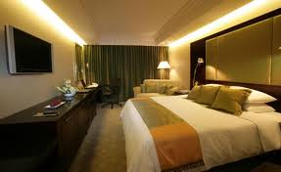
Pan Pacific Hotels and Resorts is a hotel-management company with 20 hotels (totaling over 7,300 rooms) in 11 countries in the Pacific Rim region. The company is a founding member of the Global Hotel Alliance, the world's largest alliance of independent hotel groups. The hotels are usually 30-storey buildings with balconies that make up the trademark name "pan pacific". They are so named because the way the balconies are laid out resembles one of the towers on the Pan Pacific Auditorium.

Pan Pacific was bought from Tokyo Corporation of Japan in 2007 by UOL Group Limited and headquartered in Singapore, it has offices in San Francisco, London, Singapore, Hong Kong and Tokyo. It was also recently recognized as amongst the top 25 hotel companies demonstrating social responsibility by the Coned Nast Traveler magazine.

Contents
- 1 Current Pan Pacific properties worldwide
  - 1.1 North America
  - 1.2 Asia Pacific
- 2 Former , Future and Joint Hotels
  - 2.1 Former Hotels
  - 2.2 Future Hotels
  - 2.3 Jointly managed with Tokyo Hotels Group
- 3 External links

Current Pan Pacific properties worldwide

North America
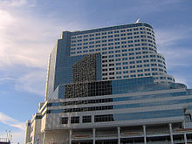

Pan Pacific Hotel, Vancouver
- Pan Pacific Seattle Hotel, Seattle, WA, USA
- Pan Pacific Vancouver Hotel, Vancouver, Canada
- Pan Pacific Whistler Mountainside Hotel, Whistler Mountainside, Canada
- Pan Pacific Whistler Village Centre Hotel, Whistler Village Centre, Canada

Asia Pacific
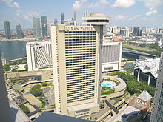
Pan Pacific Hotel Singapore from Centennial Tower
- Pan Pacific Singapore Hotel, Singapore
- Pan Pacific Orchard Hotel, Singapore (ex-Negara on Claymore/Meritus Negara)
- Pan Pacific Serviced Suites, Singapore
- Pan Pacific Serviced Suites Bangkok, Thailand
- Pan Pacific Yokohama Bay, Japan near Tokyo
- Pan Pacific Manila Hotel, Philippines
- Pan Pacific Kuala Lumpur International Airport Hotel, Malaysia
- Sari Pan Pacific Jakarta Hotel, Indonesia
- Pan Pacific Nirwana Bali Resort, Indonesia
- Pan Pacific Xiamen Hotel, China
- Pan Pacific Suzhou Hotel, China
- Pan Pacific Sonargaon Dhaka, Bangladesh
- Pan Pacific Perth, Australia - formerly Sheraton Perth

Former , Future and Joint Hotels

Former Hotels
- Pan Pacific Anaheim - now Disney's Paradise Pier Hotel, Anaheim, California
- Pan Pacific Bangkok - now Crowne Plaza Lumpini Park, Bangkok
- Pan Pacific San Francisco - now JW Marriott Union Square, San Francisco
- Pan Pacific San Diego - became dated, turned into Wyndham, recently refurbished into Westin.
- Mauna Lani Bay Hotel & Bungalows, Kohala Coast, Hawaii Island, Hawaii, USA

Future Hotels
- Pan Pacific Ningbo, China
- Pan Pacific Serviced Suites Ningbo
- Pan Pacific Taijin
- (Rumored , Pan Pacific Toronto and Pan Pacific Los Angeles), USA and Canada

Jointly managed with Tokyu Hotels Group
- Cerulean Tower Tokyu Hotel, Japan
- Haneda Excel Hotel Tokyu, Japan
- Kyoto Tokyu Hotel, Japan
- Nagoya Tokyu Hotel, Japan
- Narita Excel Hotel Tokyu, Japan
- Pan Pacific Yokohama, Japan

2.2 Price, service and amenities
Hotels (as well as other forms of accommodations) are generally segmented by the services and amenities offered. These two factors, along with location, also have a bearing on the price range.

- Budget hotels offer clean albeit simple rooms that provide the basics of places to sleep and shower. Usually budget hotels are designed for travelers looking to maximize their funds and minimize expenses. Prices can range from $25US per night to $65US per night.

- Business hotels offer a high standard by providing rooms equipped with what business travelers would consider necessities. Usually found in business-class hotel rooms are high speed Internet connections, alarm clocks, comfortable beds, irons and ironing boards, coffee makers, complimentary newspaper delivery and hairdryers. Rates can range from $80US per night to $250US per night. The facility of a business hotel would also offer an in-house restaurant, bar, exercise room and shuttle service to nearby airports. Limit concierge assistance is often included as well as room service, laundry and dry cleaning and wake-up calls.

- Luxury hotels are known for their lavish decor and extraordinary service. With superior amenities, accommodations at luxury hotels are designed to thoroughly pamper and impress guests. According to a Business Week Online article, those in the luxury market are getting harder to please stating that luxury goods and service providers can't afford to blunder with the level of service and customer experience they provide. For this reason, many luxury hotels go far beyond the norm by providing a lifestyle experience equal to or better than what guests have become accustomed to at home. Luxury hotels frequently offer full-service day spas, five-star restaurants staffed by world-class chefs, ballrooms, lavish pools, golf packages and guest services that are unsurpassed by any other class of hotel.

Rates vary greatly depending on location and proximity to popular events and attractions. There are other classifications of hotels; however, most will fall into one of these three or a combination of these three. With the lines between business and personal becoming more blurred, many entrepreneurs and business executives will attend conferences or embark on business trips with family in tow. Hotels are aware of this common occurrence and have become adept at providing facilities and service both business and recreational travelers enjoy.

2.3 Choosing a Hotel:

Because of the diversity of hotels a rating system, based on stars, was created. However, rating systems don't all carry the same definitions. For instance, the American Automobile Association (AAA) in the United States regularly reviews and rates facilities with a scale based on one star to five stars. The ratings reflect specific written standards set forth by AAA. Travelers who are familiar with this system will know what to expect when booking a reservation at a hotel rated on this scale. But in Europe or Latin America, ratings systems (if they exist) are widely scattered and unorganized. The same applied to most online travel booking sites that apply their own "star" system, which is not related to AAA.

If the facility is unfamiliar, rather than rely on a ratings system that could be unfounded, look to online review sites for help or ask friends or business associates for recommendations. I don't think there are enough pages or ink available at this time to write the known history of hotels, food and drinks. Don't even think about the many tales there could be written about hospitality since ancient times.The expectation to eat good food has been a pleasure since early men. To find a place to rest, a safe spot to sleep has been always on every travelers mind.The attempt to provide both, safe lodging and excellent food, day after day, in modern times can be found in the

full service hotel.What I attempt to do is to draw a picture in your, the reader's mind, coloring some of the stages when accommodation and food drastically changed over the ages.

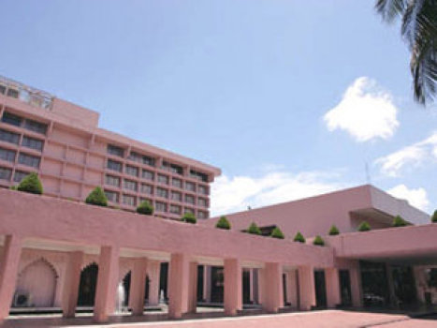

2.4 The core values of “Pan Pacific Sonargaon Hotel”

Warm
Traveling sometimes feels cold and impersonal but arriving at “Pan Pacific Sonargaon Hotel” makes it warm. The “Pan Pacific Sonargaon Hotel” members make one to feel welcome, because they know how to listen and they care.

Comfort
“Pan Pacific Sonargaon Hotel” gives the guests the opportunity to be themselves. Arriving at “Pan Pacific Sonargaon Hotel” makes one not only see but also feel the comfort all around the world. The “Pan Pacific Sonargaon Hotel” members greet and immediately make the guests feel at ease.

Connection
“Pan Pacific Sonargaon Hotel” helps guests connect to what matters most to them. The members connect with the guests as a person, so they fell welcome- like they belong here. “Pan Pacific Sonargaon Hotel” helps guests to stay in touch with what’s important to them so they can feel in control- not anxious or absent.
The business of “Pan Pacific Sonargaon Hotel” is no longer about selling rooms and their features but more about selling experiences, memories, lifestyle and a brand, with people and service culture.

Hospitality is all about love, care, warmth and empathy- the more the better. It’s not just about providing good food, drinks and a nice room. It includes understanding the needs of the guests. At “Pan Pacific Sonargaon Hotel” the guests feel special because they understand the guest’s needs wants, Expectations and emotions. Every guests of “Pan Pacific Sonargaon Hotel” feel a warm and welcoming connection and a sense of comfort and belonging.

Restaurants and Bars

Savour the diverse flavour of the world at our Dhaka restaurants.
Select from an abundance of tantalizing tastes at our Pan Pacific Sonargaon Dhaka restaurants. Experience varied cuisine created to tempt the palates of guests from around the world.

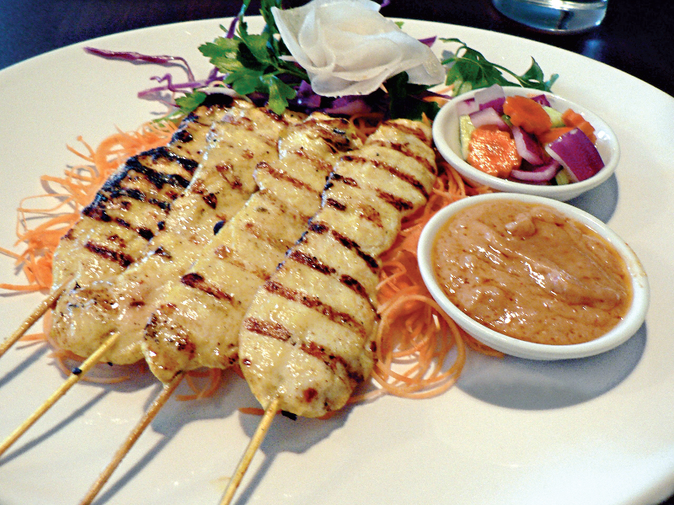

Jharna Grill
Our signature restaurant, offering imported meats and local freshly caught seafood, Jharna (in Bengali, translates to "fountain"), boasts a world-class menu and 5-star service set amongst the hotel's distinctive and elegant water features.
Location: Located on lobby level
Cuisine Type: Grill
Dress Code: Smart Casual
Operating Hours: Lunch : Saturday - Thursday 12:00 noon until 3:00 pm
Dinner : Daily 7:00 pm until 11:00 pm
Telephone: (880) 2811 1005

Ciao Bistro


Ciao Bistro offers traditional Italian cuisine. Using the freshest of imported and local ingredients, Ciao Bistro’s menu is ever changing; combining traditional favourites with modern cutting edge dishes. An extensive wine and beverage list is also available.
Location: Second floor, mezzanine level.
Cuisine Type: Italian
Dress Code: Smart Casual
Operating Hours: Dinner : Daily 6:00 pm until late
Telephone: (880) 2811 1005

Cafe Bazar
Located on the lobby level, Cafe Bazar offers ever changing contemporary international selections with an extensive buffet or a-la-carte menu for breakfast, lunch and dinner. Café Bazar

also offers a “Global Taste” buffet with a selection that changes daily, and is based on a particular region of the globe.
Location: Lobby Level
Cuisine Type: International
Dress Code: Smart Casual
Operating Hours: Breakfast, Lunch and Dinner : Daily 6:00 am until late
Telephone: (880) 2811 1005

Aromaz
Aromaz offers the best snacks and pastries in town, featuring freshly baked breads and oven fresh cakes with a wide range of variety.
Cuisine Type: Drinks and snacks
Dress Code: Smart Casual
Operating Hours: Daily 10:00 am until 9:00 pm
Telephone: (880) 2 811 1005

Lobby Lounge
Enjoy the finest coffee made by internationally trained baristas, tea and freshly baked treats in Dhaka's premier meeting place, accompanied with live flute and tabla music every evening, Lobby Lounge is a luxurious treat.
Cuisine Type: Drinks and snacks
Dress Code: Smart Casual
Operating Hours: Daily 7:00 am until late

Pool Cafe
Located on the pool side, this restaurant and bar serves healthy adaptations of South Indian favorites.
Location: Pool side
Cuisine Type: Indian
Dress Code: Smart Casual
Operating Hours: Daily 10:00 am until 10:00 pm
Telephone: (880) 2811 1005

Balcony Bar
Relax and enjoy a drink from our extensive list and catch all of the latest sports action on the big screen. Balcony Bar, located at Second Floor - mezzanine, has a wide range of imported beers and spirits, food and drink specials all week.
Enquire about our disco nights with complimentary entry for hotel guests.
Location: Located at Second Floor mezzanine
Cuisine Type: Drinks and snacks
Dress Code: Smart Casual
Operating Hours: Nightly 6:00 pm until 12:00 midnight
Telephone: (880) 2 811 1005

Dining Offers
Go on a culinary journey. Savor a wide choice of gastronomic delights at our selection of restaurants.
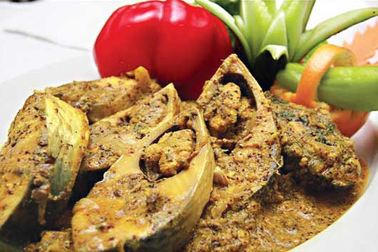

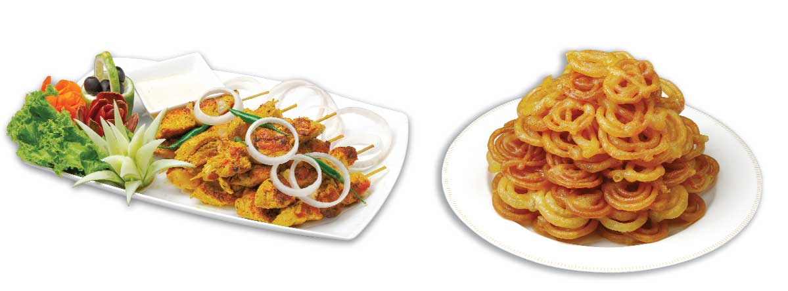

Hotel Offers
Take advantage of the following specials and experience the exclusive Pacific Touch at the luxury Pan Pacific Sonargaon Dhaka hotel.

Double Preferences by Pan Pacific Sonargaon Dhaka

Preferences gives you the power to customise your stay just the way you like it.
Now enjoy twice the flexibility with Double Preferences!
For a truly personalised experience, book Double Preferences by Pan Pacific Sonargaon Dhaka and enjoy guaranteed late check-out till 3pm with two preferences of your choice from the following:
- Daily breakfast for two
- Fruit Platter
- Guaranteed upgrade to next room category
- One way airport transfer by hotel car

Terms and conditions:
- Choice of Arrival Transfer must be specified with flight number and arrival time upon booking.
- Rates quoted are eligible for Frequent Flyer Programme mileage.
- Preferences cannot be exchanged for cash.
- Preferences selected upon booking will be applicable for the entire duration of stay.
- If preference choice is not selected at time of booking, a default choice (1st listed preference choice) will be selected.
- Rate changes may apply.
- Package is subject to availability and blackout dates may apply.
- Rates are subject to prevailing taxes.
- Please choose preference upon reservation and indicate in Comments.
Hotel Features.
Pan Pacific Sonargaon Dhaka has a health club, an outdoor pool, and a spa tub. Business amenities at this 4-star property include a business center, secretarial services, and audio-visual equipment. This Dhaka hotel offers a restaurant, a coffee shop/café, and a bar/lounge. The staff can arrange tour assistance, currency exchange, and computer rentals. Additional amenities include a fitness facility, a steam room, and a sauna. Guest parking is complimentary.

Guestrooms.
Accommodations at Pan Pacific Sonargaon Dhaka feature minibars and safes. Rooms have dial-up Internet access. Televisions are equipped with cable/satellite channels, DVD players, and pay movies. Additional amenities include irons/ironing boards and trouser presses.

The Business Center
An ideal meeting place for a small group. The Business center of the hotel provides a range of secretarial services including typing, printing, facsimile, photocopying, scanning, e-mail, web browsing and spiral binding etc.

Recreation Facilities
To expose the hotel guests to a host of recreation facilities, the hotel offers swimming, tennis, squash, and a modern gym where an invigorating workout can be a rewarding experience. The guests can walk into their own spa, revitalizing sauna, steam and Jacuzzi.

Guest Receiving Counter at Air-port
The “Pan Pacific Sonargaon Hotel” guest-receiving counter is situated at the arrival hall at the airport where the guest can ask for assistance to take them to “Pan Pacific Sonargaon Hotel”.

Other Facilities at “Pan Pacific Sonargaon Hotel”:
At the end of lobby shopping facilities is located. Where CD, Photoshop, handicrafts shop, jeweler and arts are available. At the third floor of the main building a new massage facility available for all the guests which is known as SPA. In the extension building a number of airline office, multinational office, UNO office, commercial banks, money exchange and “Pan Pacific Sonargaon Hotel” Laundry shop are located. Just beside the main entrance there is a desk for guide tour they can facilitate guided tour for the guest.
2.5 Guest programs:
“Pan Pacific Sonargaon Hotel” has built the industry’s leading frequent guest programs around big IDEA.
- Instant rewards & no blackout dates.
- Destinations wherever you go
- Everything you need for an enjoyable stay.
- Always consistent service and value.
Such programs are Starwood Privilege & Starwood Preferred Guest.

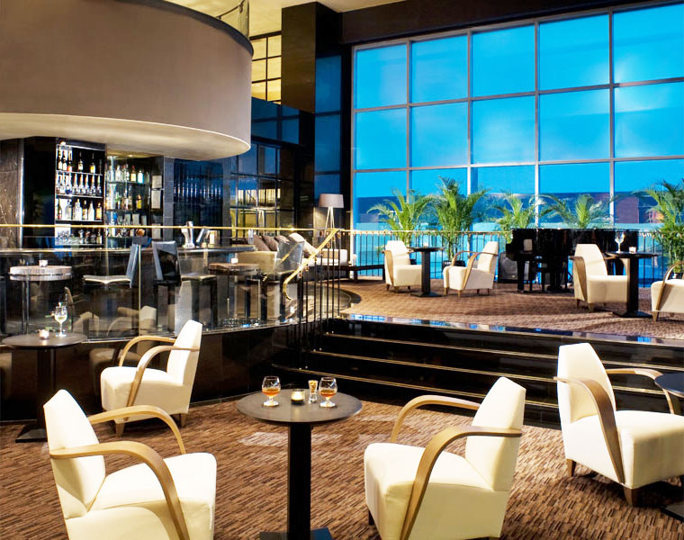

“Pan Pacific Sonargaon Hotel” Privilege
“Pan Pacific Sonargaon Hotel” privilege members enjoy a host of dining and accommodation benefits for even the most discerning lifestyle. This is a program that recognizes the guest’s appreciation of the finer things in life. As a “Pan Pacific Sonargaon Hotel” privilege member, one can explore a world of fascinating diversity and contrast and enjoy a tremendous array of rewards at the fingertips.

These include exceptional accommodation and dining privileges plus a virtually limitless variety of notable hotels in which to enjoy them. Some of the benefits and privileges a guest will receive are as follows:
- Complementary night stay at “Pan Pacific Sonargaon Hotel” Room discounts vouchers.
- Complimentary room upgrades
- 50% or 60% off Rack rates
- Late checkouts
- Group dining vouchers offering
- 10% off lowest retail \rates and the preferred rates in 80 participating proprieties in Asia Pacific and 13 fabulous properties in Australia, Fiji & Vanuatu.
- Unlimited dining discount in over 300 restaurants in Asia Pacific.
- Transferable guest memberships.

2.6 Brand champion in “Pan Pacific Sonargaon Hotel”:
Every service provider at “Pan Pacific Sonargaon Hotel” is a Brand champion of the world’s most popular brand “Pan Pacific Sonargaon Hotel”. They symbolize the brand by creating exceptional services to the guests and fellow associates. The business of “Pan Pacific Sonargaon Hotel” is about selling experiences, memories, lifestyle and a brand. Brand is the most important thing that can create emotion. People and Service culture are the most important ingredients in making a successful brand. People are the most valuable resources. Services are delivered by three methods. They are Place, Process and People. Everything communicates through them.

2.7 “Pan Pacific Sonargaon Hotel” signature service:

“Pan Pacific Sonargaon Hotel” is known by its services and the people who deliver the services are the ambassador of the brand. All associates deliver their best to satisfy the needs of the guests in a best possible way and their effort makes “Pan Pacific Sonargaon Hotel” the most accepted brand of the world by both the travelers and the business people. To provide best services the “Pan Pacific Sonargaon Hotel” Team tries to
- Understand people and where they come from
- People crave to be connected with the things that matter the most to them. “Pan Pacific Sonargaon Hotel” keeps them connected with those that matter.
- “Pan Pacific Sonargaon Hotel” tries to satisfy the needs and wants of the guests and cross their expectations.
- “Pan Pacific Sonargaon Hotel” is unique because of the experiences, relationships, memories and interactions it deliver to the guests.
- “Pan Pacific Sonargaon Hotel” has insights about the guests which allow it to develop some empathy to create emotional connection. Now a day’s business is about making connection. And “Pan Pacific Sonargaon Hotel” ‘s core value is to make connection.
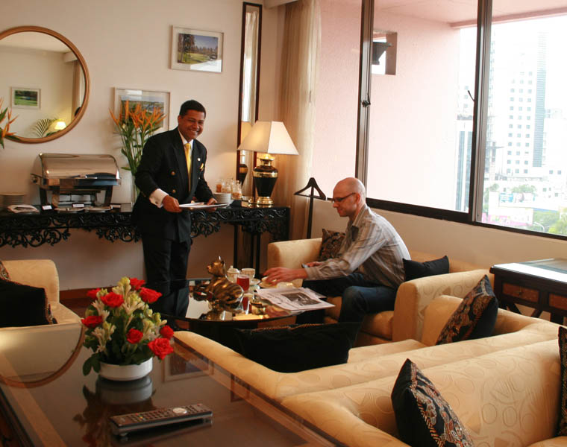

2.8 Organization chart of Sonargaon Hotel

General Manager
Ex-com Member

F & B Manager

Operation Manager-
Bolaka

Front Office Manager

Executive Secretary

Revenue Manager

Executive Chef

Ex-com Member

Financial Controller

Ex-com Member
Chief Engineer

Ex-com Member
Director- Human Resources
Ex-com Member
Director- Sales &
Marketing
Ex-com Member

Medical Consultant
HR Administrator
Director- CateringSales
Asst. Director
Sales& Marketing
Asst. Director
Marketing Communication
Credit Manager
Purchase Manager
Chief Accountant

Training Manager
HR Manager

2.9 Functional departments of “Pan Pacific Sonargaon Hotel”: “Pan Pacific Sonargaon Hotel”’s policy is to decentralize authority. The general manager is responsible for the successful operation his/her hotel. He is all in all of the Hotel. He has the authority to make decisions along with the Executive Committee (Ex-com) members. All other Ex-com members and the department heads reports directly to the General Manager. Whenever necessary, the general manager is assisted by the Departmental Heads. The functional departments of “Pan Pacific Sonargaon Hotel” are:
1. Sales & Marketing
2. Human Resource & Training
Room Division
Food & Beverage
A & G Controller
6. Engineering

All these departments work together with a common objective- to provide the best possible accommodation & services to the guests. These six departments are equally responsible for the successful operation of the hotel. The departments are interdependent. If any one of the departments does not work correctly, any function can face a disaster. All the sub-departments also work in lieu. The hard works of the peoples who works at “Pan Pacific Sonargaon Hotel” is the base of its popularity and success.

The Driving wheels of “Pan Pacific Sonargaon Hotel”
Sales and Marketing:
Sales & Marketing id the department that energizes and stimulates the Hotel operation rejuvenates it and keeps the Hotel going. The department does the marketing and promotion of the Hotel, sales the services, organizes functions and so on. The department incorporates:
- Sales & Marketing
- Public Relations
- Catering

The Sales & Marketing Department works in the following sectors:
- Press Relations
- Guest Relation
- Property Promotion
- Community and Customer Relation
- Internal Commutation
- Networking
- Promotion of MICE (Meeting, Incentives, Conferences & Exhibitions) facilities

Sales & Marketing:
The major task of sales and marketing segment is to make a position of their product in the customer’s mind. The sales team of Dhaka “Pan Pacific Sonargaon Hotel” is a competent one. They visit various local & multinational companies organizations both government & private, banks, manufacturing organizations etc. They knock wherever there is a possibility of business. They promote their special services and facilities and often offer special discounts for prospective clients. Thus they attract customers to book rooms for their guests at Sonargaon and arrange their various types of function at Sonargaon. The sales and marketing department also signs contract with various companies’ regarding providing accommodation facilities. Such an agreement was signed with the Saudi Arabian Airlines to offer accommodation to the crew members for the next two years. The sales and marketing efforts depend on demand. The efforts mainly is to consolidate and holding on the existing accounts as well as to target new accounts with emphasis on luring away clients from competitor hotels by offering them better and unique services, room rates and discounts.
The Sales team of Sonargaon Hotel tries hard to capture the new businesses and some selected major markets from the competitor hotels. As there is a huge competition in the market place and four Five Star Hotels are making every effort to capture the market, the sales team of Sonargaon Hotel is always ready to provide standing by service to the Hotel. Various activities of this department has establishes Dhaka Sonargaon as the friendliest Hotel in the city. They have taken the Hotel in such a position that it is known as the place of quality, personal service, caring for little things and a place with homely atmosphere. The sincere participation of the associates of the Sales & Marketing Department contributed significantly to enhance the positive image of the property and the Pan Pacific Sonargaonbrand in the competitive market.

To maintain guest relation the Sales & Marketing Department takes various steps such as:
- Maintaining good relationship with the guests is the key to repeat the guests.
- Welcome the VVIP guests and arrange banquets and welcome cakes when necessary.
- Send welcome letters and gifts to the potential guests.
- Arrange special reservation for the top customers.
- Send welcome gifts and cakes to repeat the guests.
- Send birthday cakes to the hotel guests during their stay along with birthday cards.
- Arrange farewell party for a long staying guest and crew members of airlines and other corporate guests.
- Invite corporate customers on special occasions.
- Inform in-house guests about the happenings and events at the hotel.
- Prepare welcome banners for large groups booked at the hotel.
- Handle guest reservation made through websites or direct phone calls efficiently.
- Reply guests letter and complaints speedily.

Public Relations
Public Relation section of the Sales& Marketing Department portrays the brand “Pan Pacific Sonargaon Hotel”. It provides extraordinary support to the sales team. The main objective of the public relation department is to

- Promote the image of the property accurately, positively and effectively through the channel of mass media both national and international.
- Uphold the activities of the Hotel to the potential customers competently to hold the new markets.
- Co-ordinate with the Sales & Marketing, Catering and Food & Beverage in matters relating to advertisements and promotional activities.
- Arrange, co-ordinate and manage various activities concerning the corporate social responsibilities.

- Maintaining effective relationship with the media, social groups etc.
- Support overall marketing and sales program.
- Preparing write-up for press release, publication etc.
- To carry the message indicating that Sonargaon is the most exciting and comfortable
- place to stay in Dhaka because of its service excellence and experience.

Press Relation:
Maintaining favorable press relation is one of the major tasks of today’s corporations. The public relation department of Dhaka “Pan Pacific Sonargaon Hotel” maintains relationship with the press in the following way:
- Maintain and strengthen the contact with local and trade press to ensure maximum coverage.
- Invite press during the inauguration of newly launched products, openings, cultural & food promotion, fashion shows and different types of exhibitions to get maximum exposure.
- In occasions of press anniversaries deliver congratulatory cakes and management wishes.
- Whenever possible to assist, participate or sponsor projects undertaken by press people. For generating publicity in the media these are very good source.
- Establishes contact with media guests staying in the Hotel.
- Encourages foreign travel writes staying with us to write on the property in travel magazines mentioning the name of “Pan Pacific Sonargaon Hotel” Hotel in their write-ups.
- Whenever it is possible to expose or present the logo or banner of “Pan Pacific Sonargaon Hotel”, takes the opportunity.
- Develop and writes press releases to local media both on “Pan Pacific Sonargaon Hotel” Sponsored projects or events and various moves taken by the Hotel.
- Develop features for the media regularly.
- Make a gorgeous press appearance while doing any socially responsible activities. Corporate social responsibilities now get the maximum coverage.

- The brochures of the Hotel with attractive pictures should be done.

- In order to continue the present trend of media appearance, a balanced and proportionate advertisement policy should be formulated.

Human Resources & Training Department:

This department recruits excellent people, trains them and them a part of “Pan Pacific Sonargaon Hotel” and the champion of the popular brand of the world “Pan Pacific Sonargaon Hotel”. This department manages the employees work schedule, keeps a record of the hours worked, arranges training sessions, and keeps the employees from big bosses to the lower level employees aware and updated about the new appearance of the brand. The tasks are subdivided as follows:

- HR Accounting
- Training Management
- HR Management & Staff facilities
- Medical
HR Accounting:
The time keeping department works with it.
Training management:
The primary task of this department is to train up the new as well as the existing employees about the brand “Pan Pacific Sonargaon Hotel”. its core values and about the standard of Starwood which should also be maintained in the “Pan Pacific Sonargaon Hotel”.
- The department hosts the orientation programs for the newly recruited personnel’s.
- Organize training sessions and gives certificates to the trainees.
- Give awards to the employees for excellent services.

HR Management & Staff Facilities:
- Organizes recruitment activities for different departments.
- Evaluates the performance of the associates and reward them.
- Organize associate meetings and takes care of the staff requirement and ensures that they get proper facilities.
- Various incentives are given and parties are arranged for the associates such as “Birthday parties” of the associates.

Medical:
The medical department takes care of the associate’s health and helps to maintain hygiene, provides medicine to the associates.
Room Division:
The room division includes the following subdivisions:
- Front Office
- Housekeeping
- Safety & Security Department

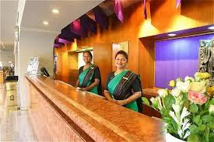

a) Front office:
Front office is liable for creating the first impression about the service quality of the hotel. Front office includes
Reception: Reception records the guest check in check out according to their reservation status. It also provides other help to the guests such as currency exchange.
Reservation: This department is the key to hotel business. Reservation Department does the necessary task for reservation of rooms, determine rates for regular & corporate customers in association with the Sales & Marketing Department and keep records of the previous reservations.

Concierge: The concierge desk of Dhaka “Pan Pacific Sonargaon Hotel”, provides details of hotel services as well as assists the guests with any request, prepares and arranges tour plan for the guests according to their direction. The concierge desk prepares the Bulletin Board for functions.
Health Club & Telephone Service: These are the two major sections of front office.
Airport Counter: This part of the front office receives the guests on arrival in the airport, and supports them until the guest reach the hotels pick up. They also take instant booking from arriving guests.
Transport: Providing 24 hours transport facility is another major task of the front office.
b) Housekeeping: This department keeps the hotel neat & clean, fresh and always new. This Section remains connected with each & every guests, always. The provide Laundry facility to the guests, make the room as the guests wish, and provide every service the guests may seek for during their stay in the hotel.
c) Safety& Security: Maintaining security & safety of the hotel is another major task of the room division. It ensures security for the room guests and as well the guest who come to attend functions. It also co-ordinates with the government body’s that ensures the security of the VVIP guests when they are invited for functions in the hotel. It is the purpose of the department to ensure security during any functions, fairs, conferences and any other occasions.

