Performance Evaluation
of
First Security Bank Limited

Submitted by

WWW.ASSIGNMENTPOINT.COM

Chapter—1: Introduction
1.1—Objective of the study
1.2—Methodology
1.3—Relation of the study
1.4—Scope and Limitation

Introduction:

Bank is a financial intermediary whose prime function is to move scarce resources in the form of credit from savers to those who borrow for consumption and investment. In a modern society, banks are very much important to the economy because of their ability to create money. Commercial banks are profit seeking enterprises. Balancing risk and return in their portfolio management with the goal of maximizing shareholder wealth. A bank is an organization that engages in the business of banking. Lending comprises a very large portion of a bank's total assets and forms the backbone of the bank. Interest on lending constitutes the highest proportion of income of a bank.

1.1-- Objective of the study:
The Main objective of the study is to access the overall banking procedure and financial performance evaluation through the analysis of some particular aspects. The main objectives are:
- To evaluate the principal activities of First Security Bank Limited
- To appraise the performance of FSBL
- To know in depth the operations of banking sector
- To identify services provided by FSBL
- Feature of general services provided by FSBL
- Contribution in the overall economy
- To know the major areas of loan and advance
- Contribution in import and export sector
- To conduct an comparative analysis with other banks
- Find out the financial performance of FSBL

1.2-- Methodology:
The methodology indicates the selection of sample banks, sources of data and the method of data analysis followed by indicating the limitation of the study. Data has been collected from both primary and secondary sources. Informal meeting with the senior officer was also helpful. This report is prepared by using both primary and secondary sources such as:
- Annual report of FSBL 2001--2003
- Bangladesh Bank publications
- SEC publication etc
- Personal observation
- Discussion with officers
- Internet
- Working with different departments
- Experts opinions and comments
- Published documents

1.3-- Relation of the study:

Knowledge and learning become perfect when it is associated with theory and practice. Theoretical knowledge gets its perfection with practical application. The study is very much related to the MBA program in Banking. The study helps to compare the knowledge gathered from the program and the real world banking sector operation. I have come to know the product and procedure of bank operation. The contribution of banks in the overall economy as financial intermediary. Huge of knowledge can be gathered from the study of banking sector operation.

1.4-- Scope and Limitation:

The study was conducted at the premises of the FSBL Dilkusha branch. The task of banking is not that much easy and it has a very wider aspect. So it is quite difficult to get a clear picture about the operations of banking business without being an expert banker. So the study is simply able to give an idea not the whole picture. I have conducted an analysis of the financial performance of FSBL.

As the report prepared with a short span of time, the report could not be made comprehensive and conclusive. Some usual constraints I did face during the course of my investigation. Due to the banks policy of maintain secrecy I did not get the opportunity to collect information regarding all departments.
Chapter—2: Overview of First Security Bank Limited (FSBL)
2.1—History and Background of FSBL
2.2—Feature of FSBL
2.3—Mission of FSBL
2.4—Objective and Goals of FSBL
2.5—General Information of FSBL

Overview of First Security Bank Limited (FSBL):

In the words of First Security Bank Limited,
Our Mission is to provide
Banking Services to our
Valued Clientele with
Utmost proficiency & sincerity
Reinforced by an efficient workforce
And the latest state of
The Art Technology.

2.1—History and Background of FSBL

First Security Bank Limited emerged as a new commercial bank to provide efficient banking services and to contribute socio-economic development of the country. The bank commenced its operation August 12, 1999, under the company Act 1994. The bank provides a broad range of financial services to its customers and corporate clients. The Broad of Directors consists of eminent personalities from the realm of commerce and industries in the country.

The company philosophy “A step ahead in time” has been precisely the essence of the legend of Asian success; the bank has been operating with talented and brilliant personnel, equipment with modern technology so as to make it most efficient to meet the challenges of 21st century.

During this short span of time the Bank successful in positioning itself as p progressive and dynamic financial institution in the country. The bank had been widely acclaimed by the business commodity from small businesspersons or entrepreneurs to large traders and industrial conglomerates included the top rated corporate borrowers for providing innovative financing solutions.
The sponsor and director of the bank are a successful group of prominent local and non-resident Bangladesh investor who has earned high credential and excellent reputation in their respective fields of business at home and abroad.

2.2—Feature of FSBL:

There are many reasons behind the better performance of First Security Bank Limited than any other newly established banks:
- The inner environment of all branches is well decorated
- First Security Bank Limited provides attractive interest rate in deposit scheme, which are the highest among other commercial banks
- The bank provide loan to the customers at lower interest rate with easy and flexible condition than the other do
- L/C commissions and other charges are relatively low than otherbanksThe bank has established correspondent relationship with many foreign banks.

2.3—Mission of FSBL:

First Security Bank Limited aims to become one of the leading banks in Bangladesh by quality of operations in their banking sector. The bank has some mission to achieve the organizational goals.
These are listed bellow:
- The bank believes in strong capitalization.
- It maintains high standard corporate and business ethics.
- First Security Bank Limited extends highest quality of services, which attracts the customers to choose them first.
- First Security Bank Limited provides products and services that encourage savings.
- First Security Bank Limiter’s main business mission is to obtain fine position in the banking sector of Bangladesh as well as internationally.
- It also emphasizes on a reasonable return from its investment to satisfy the shareholders.

2.4—Objective and Goals of FSBL:

The objectives and the goals of First Security Bank Limited are the following:
- Their main objective is to maximize profit, which in turn will maximize wealth.
- First Security Bank Limited is always ready to maintain the highest quality of services by banking technology prudence in management and by applying high standard of business ethics through its established commitment and heritage.
- First Security Bank Limited is committed to ensure its contribution to national economy by increasing its profitability through professional and disciplined growth strategy for its customer and by creating corporate culture in international banking area.

2.6—General Information of FSBL:

First Security Bank Limited was in Bangladesh on 29 August 1999 as a banking company under Companies Act 1994 to carry on banking business. It obtained permission from Bangladesh Bank on 22 September 1999 to commence its business. The main motto of this bank is to provide comparative better and improved modern banking services to its customers.

Nature of Business:
FSBL offers services for all banking needs of the customers, which includes deposit banking, loans and advances, export and import financing, inland international remittance facilities.

Chapter—3: Branch Banking
3.1—General Banking
3.2—Account Department
3.3—Loan and Advance Division
3.4—Foreign Exchange Division

Branch Banking:

Bank is nothing but an intermediary between lender (surplus unit) and borrowers (deficit unit). Savings and deposits are the main strength of the banks to provide loan. And the interest earned from the difference borrowing and lending is the major portion of banks income. Banks also earns from variety of operation. Branch banking includes four operational divisions in First Security Bank Limited. They are:
- General Banking
- Accounts Division
- Loan And Advance
- Foreign Exchange

General Banking:
General banking is the side where banks offer different alternatives to the clients to deposit and remit their money. Accounts division is also included in general banking. To encourage the clients, bank offers different options in front of their clients. Most of these options are very much similar between the banks, but the customer services and facilities may not be the same. First Security Bank Limited has variety of services provided to the retail as well as for corporate clients.

The services provided under general banking include the following:
- Account opening
- Account closing
- Cheque book issue
- Remittance
- Clearing
- Crossing
- Endorsements
- Dispatch

Account Department
Account opening:
Initially all the accounts are opened through deposit money by the customer and these accounts are called deposit account. Normally a person needs to open an account to take services from the bank. Without opening an account, one cannot enjoy variety of services from the bank. Thus, the banking usually begins through the opening of the account with the bank.
Bank accounts are mainly of three (3) types:
- Current Deposit Account
- Saving Bank Account
- Fixed or Time Deposit
There are also some other types of account facilities provided by the bank. These are:
  - Short Term Deposit (STD)
  - Monthly Saving Schemes (MSS)
  - Monthly Benefit Saving Scheme (MBSS)
  - Double Benefit Deposit Scheme (DBDS)

1. Current Deposit Account:
A current account is a running and active account, which may be operated upon any number of times during a working day. It is purely demand deposit account because the bank is bound to pay the amount to the accountholder on demand at any time within the banking hour. There is no restriction on the number and the amount of withdrawals from a current account. Generally the minimum amount to be deposited initially is tk. 1000/- for opening a current account.

2. Saving Bank Account:
A saving account is meant for the people of the lower and middle classes who wish to save a part of their incomes to meet their future need and intend to earn an income from their savings, it encourages savings of non-trading persons, institutions, society and clubs etc. The deposits are mostly small amounts. Frequently withdrawals are not allowed.
- Opening of Current and saving Account:
A current or a saving account could be opened through the following steps:
Step: 1
Application on the prescribed form: The person willing to open a current account with the bank has to apply in the prescribed form. The form must be filled up and signed accordingly by the applicant (s).
Step: 2
Documentation: The documents that must be provided by the party/parties willing to open a current account are mentioned according to different aspects:

i) Individual
- Two copies of passport size photograph
- Introducer’s signature in the A/C opening Card & photograph
- Nationality Certificate/passport’s photocopy (duly attested)
- Nominee’s Photograph
- Mother’s name
- Date of Birth & age
- TIN
ii) Proprietorship
- Two copies of passport size photograph
- Introducer’s signature in the A/C opening Card & photograph
- Nationality Certificate/passport’s photocopy (duly attested)
- Up-to-date copy of trade license
- Nominee’s Photograph
- Mother’s name
- Date of Birth & age
- Seal
- TIN
iii) Partnership
- Passport size photograph A/C Operator authorized by partners) Two copies (each)
- Introducer’s signature in the A/C opening Card & photograph
- Nationality Certificate/passport’s photocopy (duly attested)
- Up-to-date copy of trade license
- Seal
- TIN
- Partnership deed (from Notary public), partnership letter
iv) Limited company
- Passport size photograph A/C Operator (authorized by Board) Two copies (each)
- Introducer’s signature in the A/C opening Card & photograph
- Company resolution/Constitution
- Common seal of Company
- Memorandum & Articles of association (Certified by Joint Stock Company)
- List of Directors with sign
- Certificate of Incorporation
- Up-to-date copy of trade license
- Seal
- TIN
v) Societies, Clubs, etc
- Passport size photograph A/C Operator (authorized by Board) Two copies (each)
- Introducer’s signature in the A/C opening Card & photograph
- Nationality Certificate/passport’s photocopy (duly attested)
- Up-to-date copy of Office Bearers/ Governing Body/ Managing Committee
- Memorandum & Articles of association
- Seal
Incase of saving account opening the following documents are required:
- Two copies of passport size photograph
- Introducer’s signature in the A/C opening Card & photograph
- Nationality Certificate/passport’s photocopy (duly attested)
- Nominee’s Photograph
- Employer certificate
Step: 3
Introduction to the Applicant:
The applicant required to furnish in the application form the names of the referees from whom the banker may make requires regarding the character, integrity and respectability of the applicants. In most cases, the customer of the bank does the introduction or some other person known to the bank by signing on the application form with the account number.
Step: 4
Specimen signature:
Every customer is required to supply to his banker with one or more specimens of his/her signature. These signatures are taken on cards, which are preserved by the banker, and his signature of the account holder on the cheque is compared with Specimen signatures.
Final Step:
After the above formalities are over, the banker opens an account in the name of applicant. Then the bank provides the customer with:
- A pay in slip/deposit book: To facilitate the receipt of credit items paid in by a customer, the bank will provide the customer a pay in slip either loose or in a book forms. The customer has to fill up the pay in slip at the time of depositing the money with the bank. The casher with his/her initials and stamps will return the counter foil to the customer on the receipt of the money.
- Cheque Book: To facilitate withdrawals and payments to third parties by the customer, the bank will also provide a chequebook to the customer. But it is noted that to get a chequebook, the customer has to dully fill up the cheque requisition slip to the banker.
  - Closing of Current or Saving Account:
A customer’s account with a bank may be closed for the following circumstances:

1. Upon the request of a customer, an account can be closed.
- The customer may inform the bank in written of his/her intention to close the account. The customer has to apply to the branch in charge for closing the account. Then the in charge will remark on the account closing application for closing the account.
- By drawing a cheque of the whole amount and a nil balance confirmation to be taken from the account holder.
- Recover the unused cheque leaves and enter into the “Broken cheque book Register”
- Remove the account opening form, specimen signature card and all other papers relating to the closed account.
- Remarks of account closing at the ledger folio should be authenticated by the manager of supervising sfficials

2. The bank may itself ask the customer to close the account when the banker finds that the account is not been operated for a long lime.
- If the account is not operated upon for 6 months the banker will try to do the bilateral communication with the account holder, but if the banker does not then the account becomes “Dormant” account get any response from the account holder
- If this not the operated upon for 2 years then the account becomes “inoperative” account.
- If the current account lying in “inoperative” current account for many years then the account will be transferred to the “unclaimed deposit account.
- A new register for unclaimed deposit account will be maintained called “unclaimed deposit account.
- For withdrawal at any amount from the account, permission from head office or controlling office wins is required.

3. Fixed Deposit Receipt:
These are the deposits, which are made with the bank for fixed period specified in advance. It is purely a time deposit account. The bank doesn’t maintain cash reserves against deposits and therefore the bank offers higher rates of interest on such deposits. A FDR is issued to the depositor acknowledging receipt of the sum of money mentioned therein.

Procedure of Opening Fixed Deposit Account:
Before opening a Fixed Deposit Account a customer has to fill up an application form, which contains the following:
- Amount in figures
- Beneficiary’s name and address
- Period
- Rate of interest
- Date of issue
- Date o of maturity
- How the account will be operated (singly or jointly)
- Signature (s)
- F. D. R. no
- Special instruction (if any)

After fulfilling the above information and deposit the amount, FDR account is opened. A FDR receipt is issued and it is recorded in the FDR Register, which contains the following information:
- FDR account no.
- FDR no.
- Name of the FDR holder with address
- Maturity period
- Maturity date
- Interest rate

At present the rate of interest for Fixed Deposit Receipt (FDR) in the First Security Bank Limited are as follows:

For 1 month Interest rate for < 1core is 8.50%, for >1 core is 8.50%

For 3 month Interest rate for < 1core is 11.25%, for >1 core is 11.25%

For 6 month Interest rate for < 1core is 11.25%, for >1 core is 11.25%

For 1year Interest rate for < 1core is 11.25%, for >1 core is 11.25%

Other Types of Deposit Accounts:
There are also some other types of account facilities provided by the bank. These are:
i. Short Term Deposit (STD)
ii. Monthly Saving Schemes (MSS)
iii. Monthly Benefit Saving Scheme (MBSS)
iv. Double Benefit Deposit Scheme (DBDS)

i. Short Term Deposit (STD)
It is also a time deposit account. The formalities for opening is of this account are to those required for current account. The only difference is that, frequent withdrawal is discouraged and 7 days notice is required for withdrawal of any sum and interest is paid.
In Short Term Deposit Account, interest offered is less than of savings deposit, 6% interest is paid on this deposit.

ii. Monthly Saving Schemes (MSS)
Monthly Saving Scheme is that kind of scheme of FSBL, where deposit is monthly installments of various sizes for a fixed deposit and the benefit is lump sum returns after various terms of period.

The objectives of this scheme are:
- Building the habit of saving
- Attract small savers
- Saving for rainy days
- Ensure regular income flow

So this scheme is introduced to attract depositors and encourage saving (mainly the smaller earner people).

iii. Monthly Benefit Saving Scheme (MBSS)
Monthly Benefit Scheme is that kind of scheme, where a fixed amount of money has to be deposited every month for five years.

Monthly benefit amount on the deposited amount are as under:
Deposited Amount | Monthly Benefit Amount
Tk. 67,000/- | Tk. 500/-
Tk. 1,34,000/- | Tk. 1,000/-
Tk. 2,68,000/- | Tk. 2,000/-
Tk. 6,70,000/- | Tk. 5,000/-
Tk. 13,40,000/- | Tk. 10,000/-

The objectives of this scheme are:
- Help the retired persons for investing their retirement benefits
- Create investment opportunities for non resident Bangladeshi
- Explore investment opportunities for school, college, university etc.

iv. Double Benefit Deposit Scheme (DBDS)
In this scheme, a fixed amount of money, say tk. 50,000 or it’s multiply for 7 years has to be deposited. After 7 years deposited amount will be doubled.

Deposit amount to be doubled in 7 years, details are as under:

Period | Deposited Amount | Interest with deposit | Payable amount with interest at maturity
7 years | BDT. 10,000/- | Double | BDT. 20,000/-
7 years | BDT. 25,000/- | Double | BDT. 50,000/-
7 years | BDT. 50,000/- | Double | BDT. 1,00,000/-
7 years | BDT. 1,00,000/- | Double | BDT. 2,00,000/-
7 years | BDT. 2,00,000/- | Double | BDT. 4,00,000/-
7 years | BDT. 5,00,000/- | Double | BDT. 10,00,000/-
The objectives of this scheme are:
- Give maximum profit
- Help in meeting specific needs like education, marriage etc.
  - Remittance:
Sending money from one place to other places for the customer’s is another important service of banks and this service is an important part of countries payment system. For this service, people specially businesspersons transfer funds from one place to another very quickly. There are various types of remitting money, such as:

a. Pay Order (PO)
The pay order is used for making a remittance to the local creditor. Pay order gives the payee the fight to claim payment from the issuing bank, it can be en-cashed from issuing bank only. Unlike cheque, there is no possibility of dishonoring pay order because before issuing pay order bank takes out the money of the pay order in advance. Pay Order cannot be endorsed or crossed and so it is not negotiable instrument.
b. Demand Draft (DD):
Demand draft is an order of issuing bank on another branch of the same bank to pay specified sum of money to the payee on demand that is the named person or order of the demand. It is generally issued when customer wants to remit money in any place, which is out side of the clearing-house area of issuing branch. Payee can be purchaser himself or another mentioned in the DO. It is a negotiable instrument and it can be crossed or not.

c. Telegraphic or Telephonic Transfer (TT):
This method transfers money to one place to another place by telegraphic message. The sender branch will request another branch to pay required money to the required payee on demand. Generally, for such kind of transfer payee should have account with the paying bank. Otherwise it is very difficult for the paying bank to recognize the exact payee.
When sending money is urgent then the bank uses telephone for remittance. This service is only provided for valued customers, who is very reliable and with which banks have long-standing relationship.

d. Mail Transfer Advice (MTA):
Where the remitter desires the banker to remit the funds to the payee instead of purchasing a draft himself the banker does it through a mail transfer advice. The payee must have an account with the paying officer as the amount remitted in such a manner is meant for credit to the payee’s account and not for cash payment. It is the least used technique for transferring fund. Where there is no telex machine or telephone line then this method is used.

- Clearing:
Clearing house is an assembly of the locally operating scheduled banks for exchange of cheques, drafts, pay orders and other demand instruments drawn on each other and received from their respective customers for collection. The house meets at the appointed hour on all working days under the supervision of two central bank officers or its agent as the case may be, and works within the regulations framed therefore on the basis of prevailing banking practices. In Bangladesh, clearing house sites at Bangladesh bank where there is no office of the Bangladesh bank, Sonali bank acts as agent of Bangladesh bank.
There are mainly two types of clearing system in Bangladesh, such as:
- Internal clearing or inter branch clearing or inward clearing.
- External clearing or inter banks clearing or outward clearing.

The entire number banks representative daily conducts two meetings at a fixed time. In their first meeting they handover cheque, drafts etc. passed, which has drawn upon them. In case there are certain cheques, which could not be honored are returned to the presenting banks with the reason of non-payments in the second meeting at he clearing-house.

a. Operating Procedure:
Clearing operations are completed in three stages:
- Operation at branch level
- Operation at internal clearing house
- Operation at the clearing house in Bangladesh Bank
Bangladesh Bank clearing their house sites twice in a day. In its first meeting Bangladesh Bank clearing-house received instruments and distributes the same among the representatives comes with returned instruments and distributing among the representatives.

b. Software:
Software called NIKASH supplied by Bangladesh Bank is used in clearing of the cheques and other instruments. The in-charge of clearing section makes clearing slip for each cheque through computer using NIKASH and finally this cheques are send to the Bangladesh Bank Clearing-House sorting bank wise.
- Crossing:
Crossing cheque is written across the face of the cheque within two parallel lines. This practice becomes common even outside of clearing house, as an element of safety.
a. Purpose of crossing:
- To avoid possible loss that may occur by open cheques getting into the hands of wrong parties
- Crossing is a direction to the paying bank to pay the money generally to a bank or a particular bank; so that it can be easily traced out for whose use the money was received.

b. Forms of crossing:
General Crossing:
- Not negotiable
- And company and co
- Not transferable
Special Crossing:
- Payee A/C only
- Not negotiable

- Endorsements:
An endorsement is the mode of negotiating, a negotiable instrument.

- Dispatch:
Dispatch includes all correspondence, letter, statements, returns, and telegrams. This dispatch is also known as Mail. Dispatch is primarily divided into two types:
Inward: It means what are receives from the outside.
Outward: It means what sent to the outside.
It is also divided into (a) Ordinary. (b) Registered and (c) Local.

Loan and Advance Division
It’s very important department and a major side of the bank. This department mainly deals with loans that are provided to different parties. There are two major parts of this department:

a. Funded Part:
Over draft and loans comes under this section. By taking collateral from the borrower bank allows to take overdraft facility is a continuous process borrower has to pay interest for the withdrawn money. There are two types of loan:
- Time loan
- Term loan

Funded credits are as follows:
- Overdraft: When a current account holder is permitted by the bank to draw more than what stands to his credit, such advance is called an overdraft. The banker may take some collateral security or may grant such advance on the personal security of the borrower. FSBL gives this overdraft facility to its reputed clients.
- Consumer credit: Consumer credit is relatively new field of micro credit activities. People with limited income can avail this facility to buy household products such as Furniture, TV, Refrigerator, Car, etc.
- General loan: When a advance is made in a lump sum, repayable either in fixed monthly installment or in lump sum and no subsequent deduction allowed except by way of interest or incident charge etc. is called a general loan. The whole amount of loan id debited to the customers name on a loan account to be opened by the bank and is paid to the borrower either in cash or in his/her CD/SD account.
- Payment Against Documents (PAD): A PAD facility is provided by the bank to customer against the banks to documents/bill, like bill of leading, warehouse keeper certificate, delivery receipt, dock warrant. In other word, payment made by bank against lodgment of shipping documents of goods imported through L/C facility under this head.
- Packing credit: Packing credits is essentially a short-term advance granted to an exporter for assisting him to process, pack, and ship the goods.

Other funded credits are as:
- Staff loan
- Term loan
- Cash credit hypothecation
- Loan Against Trust Receipt (LTR)
- Small loan

b. Non-funded Part:
There is no cash amount involved in this kind of loan. L/C and Bank Guarantee fall in this kind of loan. In case of L/C foreign exchange department mainly deals with it.

Non-funded credits are as follows:
- L/C
- Bank guarantee

Foreign exchange:
Refers to the process or mechanism by which the currency of one country is converted into the currency of another country. Foreign exchange is the means and methods by which rights to wealth in a country’s currency are converted into rights to wealth in a country’s currency, in bank when we talk of foreign exchange, we refer to the general mechanism by which a bank converts currency of one country into that of another.

Foreign exchange is divided in three parts.
- Export
- Import
- Foreign Remittance

EXPORT:
The term exports means carrying out of anything from one country to another, as banker we define export as sending of visible things outside the country for sale. In a word export means goods are outwards and foreign currencies are inward. Export trade plays a vital role in the development process of an economy.

In order to export any goods or services to overseas the exporter must have attested photocopies of the following documents with the up to date ERC. The documents are as follows-
- Bill of exchange
- Commercial invoice
- Certificate of origin
- Packing list
- Insurance coverage
- Insurance coverage
- Beneficiary certificate

If the bank authority satisfies with all the information provided by the exporter, steps are taken to smooth out the process of export.

Procedure of Export:
The Exports Act, 1950 regulate the country’s export trade. There are a number of formalities, which an exporter has to fulfill before and after shipment of goods. These formalities or procedures of export mechanism are enumerated as follows:

Registration:
The exports from Bangladesh are subject to export trade control exercised by the ministry of commerce through chief controller of imports and exports. No exporter is allowed to export any commodity permissible for export from Bangladesh unless he or she is registered with CCI & E and holds valid export registration certificate (ERC). The ERC number is to be incorporated on EXP forms and other documents connected with exports.

Obtaining EXP:
After having the registration, the exporter applies to the bank with trade license and ERC for getting EXP. If the bank satisfied an EXP is issued to the exporter. Securing the order after having the registration, the exporter may proceed to secure the export order. Contracting the buyers directly through correspondence can do this.

Signing of the Contact: The following points are to be mentioned while making a contract-
- Description of the goods
- Quantity of the commodity
- Price of the commodity
- Shipment
- Insurance and marks
- Inspection

Procuring the Materials:
After making the deal and on having the L/C opened in this favor, the next step for the exports is to set about the task of procuring the contracted merchandise.

Shipment of Goods:

The following the documents normally involved at the stage of shipment
- EXP form
- Photocopy of registration certificate
- Photocopy of the contract
- Photocopy of the L/C
- Freight certificate from the bank
- Railway receipt, barges receipt or truck receipt
- Shipping instructions
- Insurance policy

After those, exporter submits all those documents along with a letter of indemnity to the bank for negotiation; an officer scrutinizes all the documents. If the document is a clean one, FSBL purchases the documents on the basis of banker-customer relationship. This known as foreign documentary Bill purchase (FDBP).

Procedure for FDBP:
After purchasing the documents, FSBL takes FDBP charges from customers A/c. a FDBF register is maintained for recording all the particulars.

Foreign Documentary bills for Collection: FDBP signifies that the exporter will receive payment only when the issuing bank gives payment. The exporter submits duplicate EXF form and commercial invoice, an FDBP register is maintained where first entry is given, when the documents are forwarded to the issuing bank for collection and the second one is after realization the proceeds.
Advising L/C:
When L/C export) is transmitted to the bank for advising the bank sends advising letter to the beneficiary depicting that L/C has been issued. The procedure of L/C advising is as follows---
- Verify the signatures
- Given entry in the L/C advising register.
- Issued voucher for L/C advising commission

Letter of Credit (L/C):
Letter of Credit (L/C) is an arrangement between an importer and the bank (issuing bank). The bank provides L/C in order to purchase goods from the exporter. The bank acts on the behalf of the clients to deal with exporter and the clients make the payments after receiving the goods accordingly.

Requirement of Opening a L/C:
- Current deposit account holder
- IRC (Import registration Certificate)
- Import policy
- L/C authorizing form duly registered
- L/C authorizing form duly registered
- L/C applications duly fill up and sign
- L/C applications duly fill up and sign
- Contract/indent
- Insurance coverage
- Income tax document
- Contingency liability voucher
- L/C registration

Back-to-Back Letter of Credit (BTB L/C):
A back-to-back letter of credit is a new credit. The banks main security is the original credit. Bank to back L/C is opened under a master L/C one or more L/C is opened against one master L/C.

Requirements of Opening a Back-to-Back L/C:
- Master L/C
- Valid import registration certificate and Export Registration certificate
- L/C Application and LCA form duly filled in signed
- Pro-forma invoice or indent
- Insurance cover note.
- IMP form duly signed.

Types of BTB L/C:
There three types of BTB L/C they are–
- Local BTB L/Cs
- Foreign BTD L/C
- EPZ

Opening Process of a L/C:
a) Approach by the applicant with submission of under mentioned documents:
- Approach letter
- L/C agreement
- L/C authorization form
- IMP form
- Pro forma invoice
- Insurance

b) Preparation of proposal by the branch. Parts of proposal are stated bellow:
- Name and address of the applicant
- Nature of constitution with name of owners
- Nature of business
- IRC # TIN #
- Commodity to be imported
- Beneficiary’s name and address
- Beneficiary’s credit report
- Country of origin Liability
- Security
- Other Conditions
- Recommendation 3 On receipt approval from the competent authority, branch issues L/C.

c) On the issuance of L/C, Branch may use the printed copy as prepared by the individual bank or developed by the concerned official. Related copies are stated bellow:
- Original copy
- Applicant copy
- Advising bank copy
- Issuing bank copy
- CCI and E copy (only for foreign L/C)

d) Parts of a L/C are discussed bellow:
- The L/C may be irrevocable document
- L/C opening date must be mentioned
- L/C number
- Beneficiary’s name with address
- Applicants name with address
- Advising bank
- Amount
- Date of shipment
- Sight
- Date and place of expiry
- Pro-forma invoice with date that had been sent by the Beneficiary
- Signature of authorized officials
- Other terms and conditions

Documentation:

At first prepare forwarding. Then arrange the following documents----
- Bill of exchange
- Commercial invoice
- Packing list
- Certificate and other documents

Retirement:
This means wait for payment. When the beneficiary sends the goods, they send related documents for payment to the bank. The bank starts the retirement procedure. At first checking these documents with the L/C, L/C time, date number, invoice, terms and conditions, beneficiary’s.

Foreign Payment:
The issuing bank prepares voucher, then entries in the IBTA register, ETDA, and then send to the ID. Id informed the bank, which maintains liaison between the issuing bank and advising bank. Then the bank pays to the beneficiary after checking the authentication code.

Payment:
Then they pay in local payment and foreign payment
Local Payment:
Local payment, the bank used P.O and Demand Draft.

Import:
Import is foreign goods and services purchased by firms, customers and government in Bangladesh. An importer must have import registration certificate (IRC) given by Chief Controller of Import & Export to import any thing from other country.

Import Procedure:
The importer enters in to a purchase contract with foreign suppliers. If suppliers have local agent, the importers obtain an indent and pro-forma invoice. If the suppliers have no local agents in Bangladesh, the importers holding valid import registration certificate (IRC).

Documents that needed for opening an import L/C are listed bellow:
- L/C application duly signed and sealed by the opener.
- At least 4 copies of pro-forma invoice/indent duly signed and sealed by the opener and beneficiary.
- Party application form duly signed and sealed by the opener.
- LCA/IMP forms duly signed and sealed by the opener.
- Beneficiary credit report
- Insurance cover note with money receipt.

Import Mechanism:
The exports and imports Act, 1950 regulate the country’s import trade. The chief controller of import and export provided the registration to the importer. Then the person secures a letter of credit Authorization from Bangladesh bank. And then a person becomes a qualified importer.

The import mechanisms are discussed bellow:
- To have an import L/C limit, an importer submits an application to the import department. An officer scrutinizes this application and accordingly prepares a proposal and forwards it to the head office. If the MD satisfies, he sanctions the limit and returns to the branch.
- After sanctioning the limit, an officer of FSBL makes a L/C application.
- After making the L/C application, must be scrutinized by the authority.
- The transmission of L/C is done through tested telex or fax or mai9l to advise the L/C to the beneficiary.
- After receiving all documents, the negotiating bank checks the documents against the credit. It the documents are found in order, the bank will pay accept or negotiate to FSBL.

The officials have to very much careful while making payment. This task constitutes the following--
- Usually payment is made within seven days after the documents have been received.
- A sale memo is prepared at B.C. rate to the customer. As TI and 00 rate is paid to the ID, the difference between these two rates is exchange trading. Finally, an inter Branch Exchange Trading credit advance is sent to ID.
- For arranging necessary fund for payment, a requisition is sent to the ID
- Telex is transmitted to the correspondent bank ensuring that payment is being made.

Remittance means to sent or transfer money worth from one place to another In this case, the bank acts as the media to transfer or remit the money. Against the service it charges some commissions from the client.

Drawing arrangements:
Drawing arrangements is made to facilitate remittance through concluding accounting relationship between a bank and corresponding, which may exist in the following three forms of accounts.

NOSTRO A/C:
A foreign currency account that a local bank maintains that account with another bank in abroad.

VOSTRO A/C:
An account, which a foreign bank maintains with a local bank, is called VOSTRO A/C.

LORO A/C:
An account, which a third party maintains with a foreign bank, is called LORO A/C.

Types of Remittance: There are two types of Remittance:
    - Foreign inward remittance:
The remittance in foreign currency, which is received from outside the country to our country, is known as foreign inward remittance. The remittance can be performed in two proceeds:
- Visible inward remittance: e.g. export proceeds.
- Invisible inward remittance: e.g.; family maintenance consultant fee. Cash is remitted through TT, DO, etc.

B. Foreign outward remittance: Funds remitted to overseas on behalf of the client:
FSBL FOREIGN TARNSACTIONS:
- Great Britain pound
- U.S Dollar
- EURO
- YEN

Chapter—4: Performance Evaluation of First Security Bank Limited from Different point of View
4.1—Trend of Assets Growth
4.2--Growth rate of Liquid Assets & Fixed Assets
4.3—Comparison of Operational Profit & Liquid
4.4—Deposit & Profit Comparison
4.5—Trend of Advance & Deposit
4.6—Total Assets
4.7—Asset Portfolio
4.8— Deposits and other Account
4.9—Loans and Advances
4.10— Foreign Exchange and Foreign Trade
4.11—Import
4.12—Export
4.13—Inward Remittance
4.14—Total Income
4.15—Net Interest Income
4.16—Operating Profit
4.17—Retained Earnings
4.18—Earnings per share
4.19—Capital funds
4.20—Reserve Funds
4.21—Investments
4.22—Branch Network and Expansion
4.23—Human Resources

From owners viewpoint

- Profitability of the Bank:
- Operating Profit margin
- Net Profit margin

- Growth of the Bank:
- Return on assets (RAO)
- Return on Equity (ROE)
- Provision for loan ratio

Asset utilization:
- Interest Income Ratio
- Non-interest Income Ratio
- Equity Multiplier

- Risk of the Bank:
- Interest expense ratio
- Non-interest expense ratio

Tax ratio

- From the view point of Depositors

1. Internal Liquidity
- Current ratio
- Quick Ratio

2. Operating Performance
- Capital to deposit ratio

Loan to deposit ratio
- Deposit to employee ratio
- CAMEL Rating

  - Capital adequacy
  - Asset quality
  - Earnings
  - Management efficiency
  - Liquidity
Composite Rating

FINANCIAL PERFORMANCE

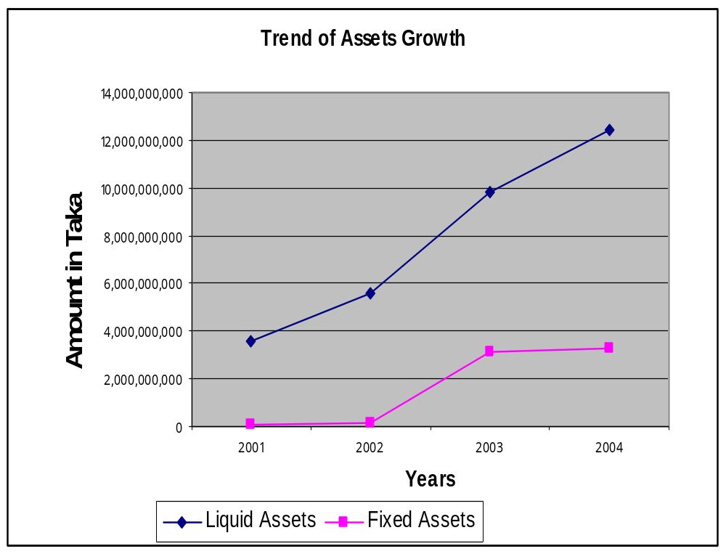
Chart 1

Chart 1 shows a significant improvement of the FSBL in treasury management. In successive years it has a remarkable improvement to increase its current assets while keeping investment in fixed. Even in year 2004 the fixed assets remain approximately close to previous year while there is double-digit growth in liquid asset this helped FSBL to gain from money market fluctuation in interest rate. Though in year 2003 fixed assets has increased more than 100%. But this is due to the set up cost and expansion in business. But following year it was able to maintain the fixed assets close to previous year.

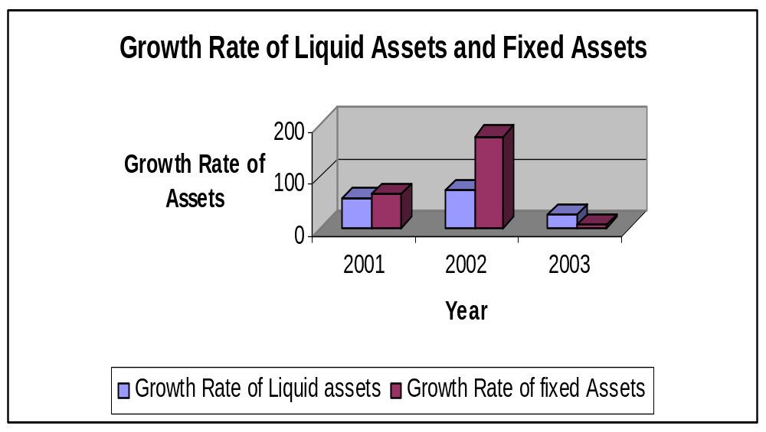
Chart 2

Chart 2 shows rate of growth of the liquid assets and fixed assets. In this chart we see that in year 2002 fixed assets increased more than 150% due to the expansion of business, major investment in this year was in primary cost of opening of new branches including proclamation of land and installment of computer and furniture. But in the following its investment in fixed assets increase more not over 4%. Though keeping fixed assets may help FSBL to get a good score in CAMEL rating but being a third generation newly established not more than 5 years it should invest more in land proclamation and expansion of business to be remain competitive. But an sustainable growth may be ensured keeping fixed cost same level while increasing liquid assets at the same time this can ensure profitability because of short term investment in money market to take the advantage in the fluctuation of interest rate.

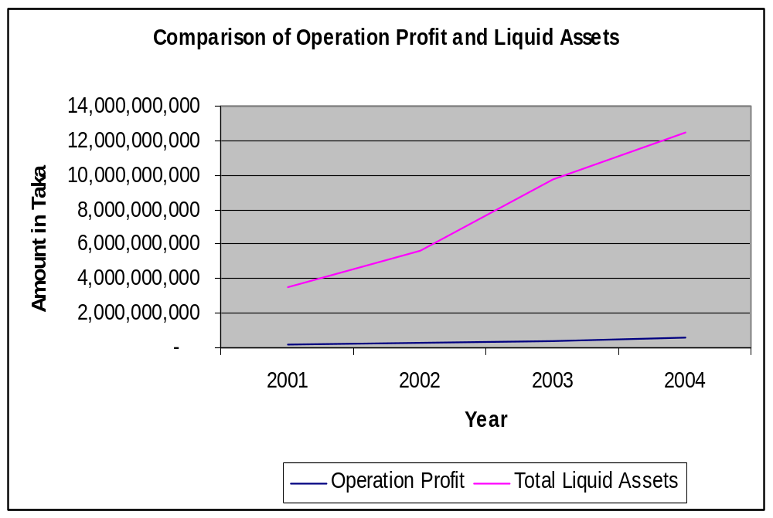

Chart 3 shows FSBL performance in Treasury Management. FSBL’s liquid assets ensured only liquidity. Where its volume of liquid assets increased sharply but it failed to ensure to profitability. It has invested more money in non interest bearing asset (cash and currencies) over the year profit has increased slightly but investment in liquid assets or non interest bearing assets increased straight upward. It is expected that over the year with more experience and strength and being acknowledge about the client transaction behavior it will shift more of it investment from non interest bearing assets to interest bearing assets like T-bills.
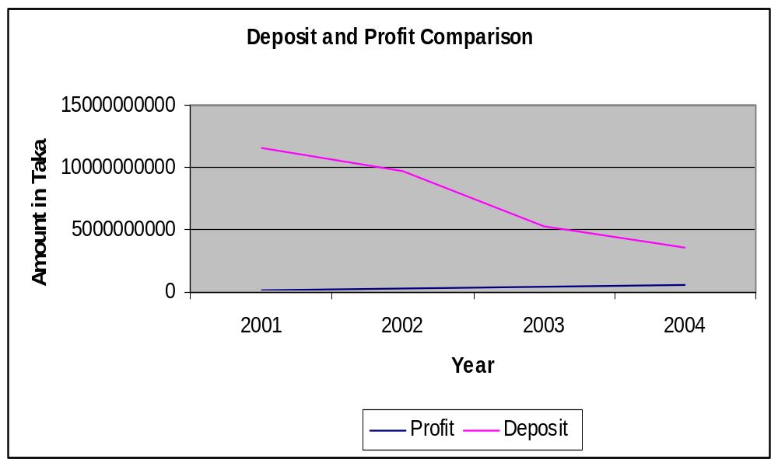

Chart 4 shows that in successive years deposit have fallen sharply. It is because in these successive years Government had taken loan from money market to meet its deficit budgets by increasing at the same time limit of investment in a single name had weaved so it fund flowed from depository financial sector to less risky Government Securities sectors. In this squeeze financial scenario it is very difficult to make any profit. But we see that in this period profit did not decrease even in year 2004 we that profit have increased slightly. Though in these periods core deposit has decreased sharply but FSBL was able to collect deposit from other financial institutions. That is a reason of FSBL to maintain high liquidity. Because it is more like that the deposit from other banks and financial institutions will be call back any time or have to repay on demand. Though this can help to keep cost of fund lower because it reduces dependent on high cost fixed deposit but at the same time it also hamper the growth rate. Over the year savings deposit even fixed deposit has decreased so it very much necessary for this moment to expand business, getting more strength by collecting money from offering saving deposit account or even fixed deposit account. Other wise growth will be stopped.
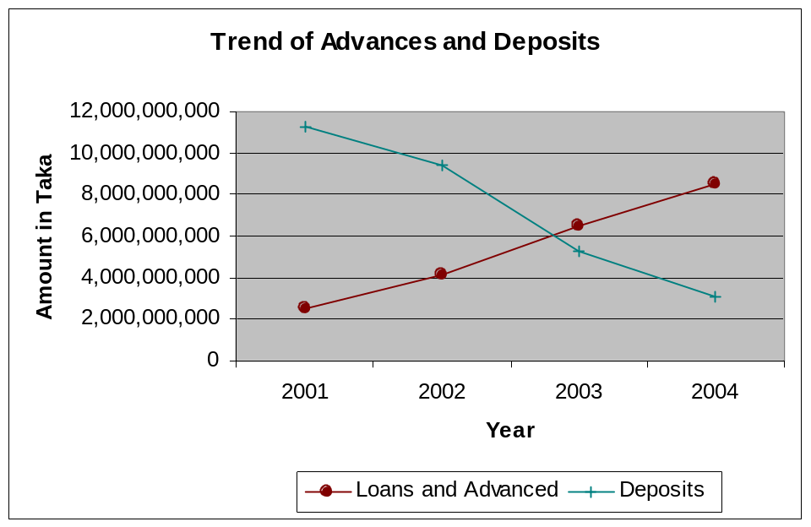

Chart 5 is showing the deposit and advance position of FSBL over the period. It depicts that though advance over the year has increase rapidly but deposit has decreased gradually. This is due to heavy dependency on borrowing from the other financial institutions. But heavy dependency on the deposit of other financial institute may not be seen a good sing. FSBL should improve it core deposit that is from small severs by offering various types of saving product other wise in case of deposit crunch a deposit run may create a heavy problem in future especially in case of contraction monitory policy.
Total Assets: Trend of total asset is shown in the table from year 2001-2004.

Year | 2001 | 2002 | 2003 | 2004
Total Assets | Tk. 4459.52 million | Tk.7227.44 million | Tk. 13369.48 million | Tk.16169.27 million

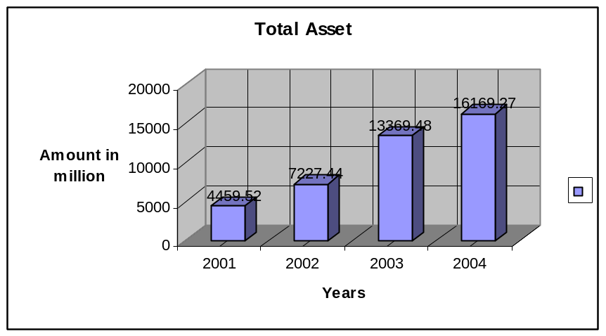
Figure: Trend of total assets.

Asset Portfolio:
The bank total assets outstanding as of December 31, 2004 amounted to Tk. 16169.27 million as compared to 2003 amounted to Tk. 13369.49. Loans & advances contributed 52.57% cash 2.48% balances with others bank 14.47%, money at call and short notice 2.15%, investments 7.87% and the total other assets 20.46% as against 48.44%, 3.00%, 14.83%, 4.52%, 5.63% and 23.58% respectively in 2003.

Components | Amount in million | % Of Total
Loans and Advances | 8500.27 | 52.57
Cash | 402.33 | 2.48
Balance with other Banks | 2338.98 | 14.47
Money at Call and short Notice | 347.50 | 2.15
Investments | 1271.72 | 7.87
Total Other Assets | 3308.47 | 20.46
Total | 16169.27 | 100.00

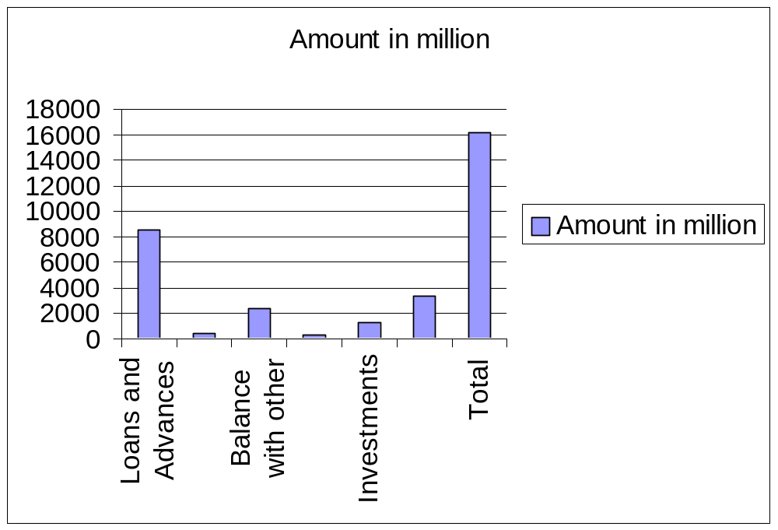

Figure of Assets Portfolio

Deposits and other Accounts:

Deposits are the major sources of a Banks fund. They serve surplus units y offering a wide variety of deposit accounts. During the preliminary stages of operation the volume of deposit was comparatively low. But it started increasing as its operations gets going.

The total deposit of the Bank increased sharply from Tk. 5230.30 million at the end of 2002 to Tk. 9443.57 million at the end of 2003 and at the end of the year 2004 it increased to 11231.67 million. Deposits of the bank stood at tk. 11231.67 million at the end of December 2004 as compare to tk 9773.56 million at the end of December 2003. Deposits of the bank include Savings bank deposits, Term deposits, Current and other account deposits and bills payable.
Year | 2001 | 2002 | 2003 | 2004
Deposit (million tk) | 3080.18 | 5230.30 | 9773.56 | 11231.67

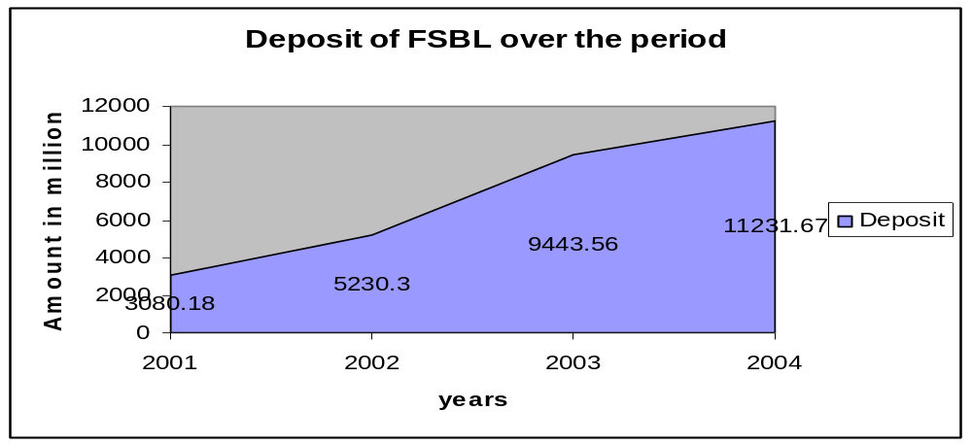
Break-up of Deposits:
(Tk. in Million)
Type | 2001 | 2002 | 2003 | 2004
Savings Bank Deposits | 92.37 | 180.45 | 218.78 | 311.43
Term Deposits | 2176.67 | 3688.00 | 6939.10 | 7806.26
Current & Other account deposit | 602.71 | 1006.21 | 2066.68 | 2767.50
Bills Payable | 97.15 | 152.97 | 208.07 | 340.32
Bearer certificates of deposit | 111.28 | 203.58 | 10.93 | 6.15
Total | 2968.9 | 5027.63 | 9432.63 | 11225.5

Loans and Advances:

First Security Bank Limited has been extending credit facilities to productive and priority sectors under the guidelines of Bangladesh Bank. Outstanding advances of the bank moved up from tk. 6476.84 million on the 31st December 2003 to tk. 8500.27 million on the 31st December 2004. That means the loans and advances of First Security Bank Limited has increased over time. In extending credit facilities, the bank attached due importance to sectoral needs and requirements of both public and private sectors.

Year | 2001 | 2002 | 2003 | 2004
Loans &Advances (million tk) | 2539.80 | 4102.61 | 6476.84 | 8500.27
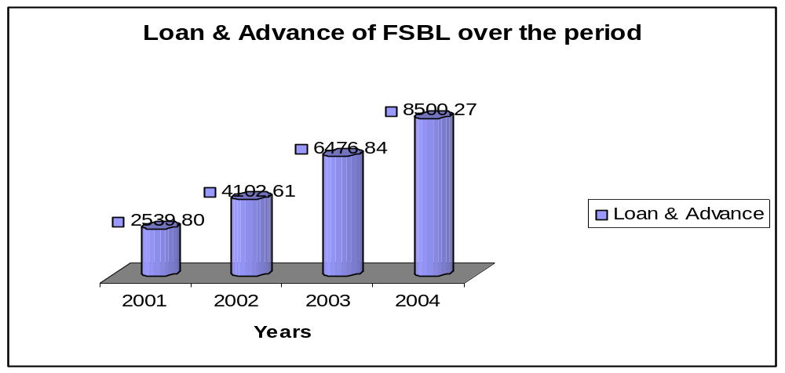

Foreign Exchange

The bank has earned excellent business reputation in handling & funding international trade, particularly in boosting-up of export & import of the country. The foreign exchange and foreign trade business during the year 2004 stood at tk. 11079.12.
The comparative position of foreign exchange & trade business during the year 2001-2004 as follows –
Year | 2001 | 2002 | 2003 | 2004
Foreign Exchange (Tk. in Million) | 1797.69 | 5799.54 | 8535.50 | 11079.12

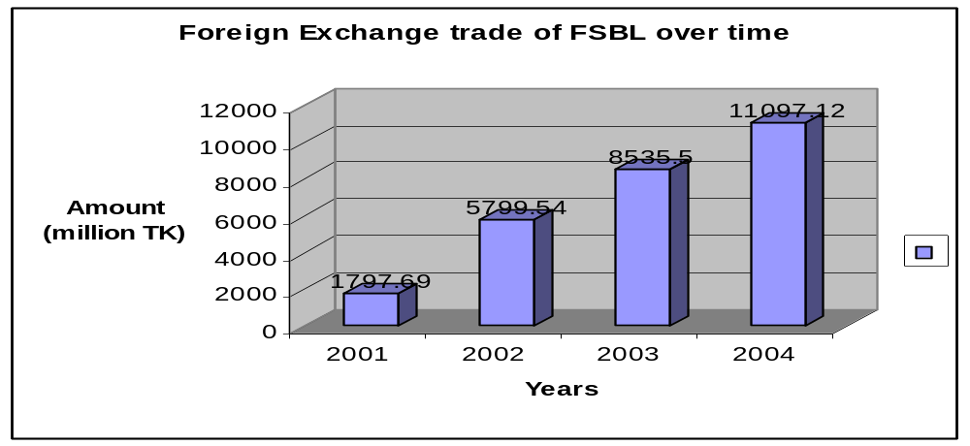

Import: The bank foreign exchange business relating to import into Bangladesh expanded markedly by 31.32% to Tk. 7413.90 million at the end of December 2004 from Tk. 5645.60 million a year ago. A year wise graphical presentation of the same is provided below.
Year | 2001 | 2002 | 2003 | 2004
Import | Tk. 222.60million | Tk. 3750.60 million | Tk. 5645.60 million | Tk. 7413.90 million
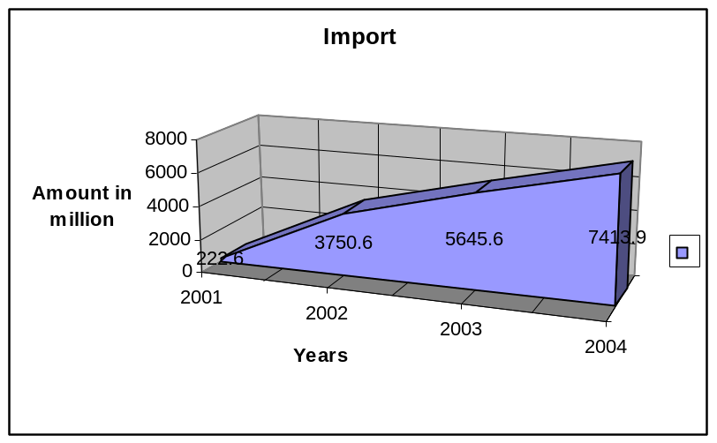
Figure: Trend of Import.

Export: Export business handled by the bank during 2004 stood at tk. 3650.60 million, showing a growth of 30.05% from Tk. 2807.00 million during 2003. A year wise graphical presentation of the same is provided below.
Year | 2001 | 2002 | 2003 | 2004
Export | Tk. 1514.20 million | Tk. 1988.40 million | Tk. 2807.00 million | Tk. 3650.60 million
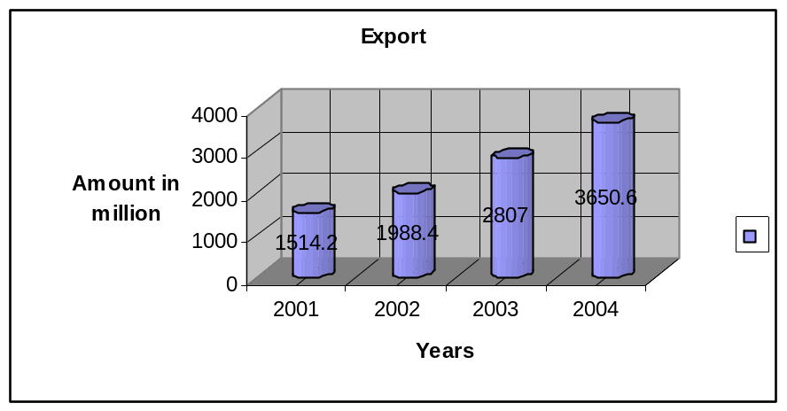
Figure: Trend of Export
Branch Network and Expansion:
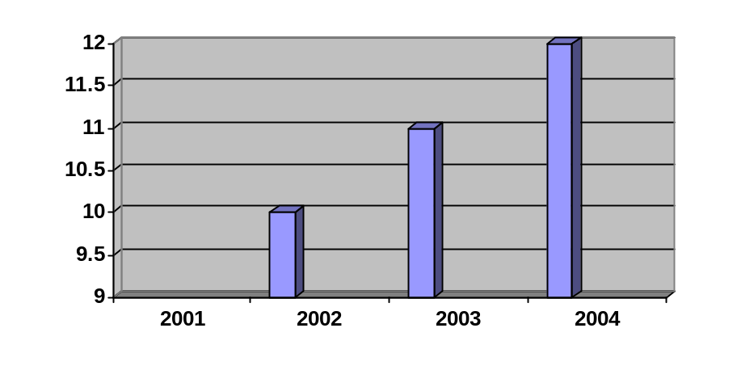During the year 2002 the total number of branches of First Security Bank Limited stood at 10, in 2003 it was 11 and in year 2004 it stood at 12 branches. The Bank has proposed a long-term program to Bangladesh Bank to open more branches in phases in important locations in Bangladesh.

Year | Branch
2001
2002 | 10
2003 | 11
2004 | 12

Figure: Trend of branch expansion
Human Resources:
Total number of employees stood at 467 as on 31st December 2004. The bank continued to encourage its employees to receive training and participate in various seminars and workshop to enrich their professional skills.
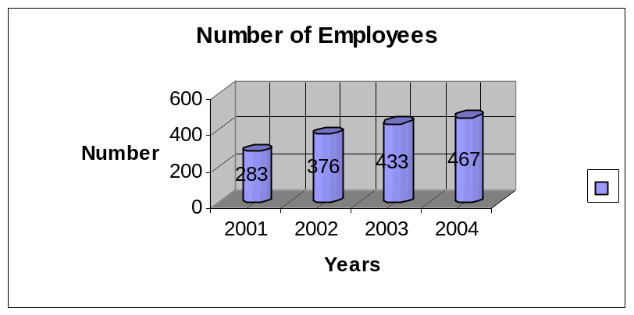
Year | No. of Employees
2001 | 283
2002 | 376
2003 | 433
2004 | 467
Figure: Number of Employees
Inward Remittance:
During 2004 the bank handled inward remittance from Bangladeshi workers abroad to the tune of Tk. 32.62 million against 82.90 million of 2003. A year wise graphical presentation of the same is provided below.
Year | 2001 | 2002 | 2003 | 2004
Remittance | Tk. 60.89 million | Tk. 60.54 million | Tk. 82.90 million | Tk. 42.62 million

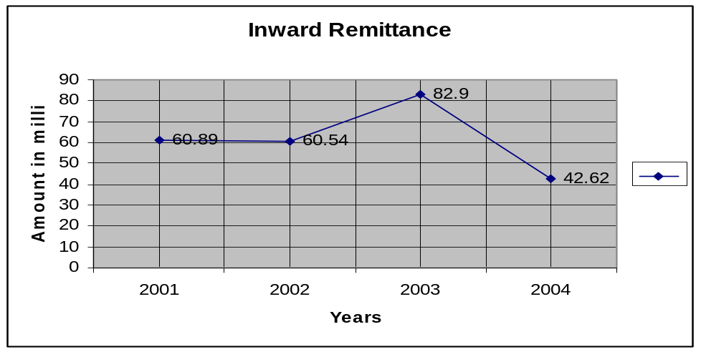
Figure: Trend of Inward remittance

Results of Operation:

Total Income: During the year total operating income of the bank stood at Tk. 327.64 million compare to previous year total income of Tk. 385.38 million. A year wise graphical presentation of the same is provided on next page:
Year | 2001 | 2002 | 2003 | 2004
Total Income | Tk. 173.27 million | Tk. 264.00 million | Tk. 385.38 million | Tk. 327.64 million

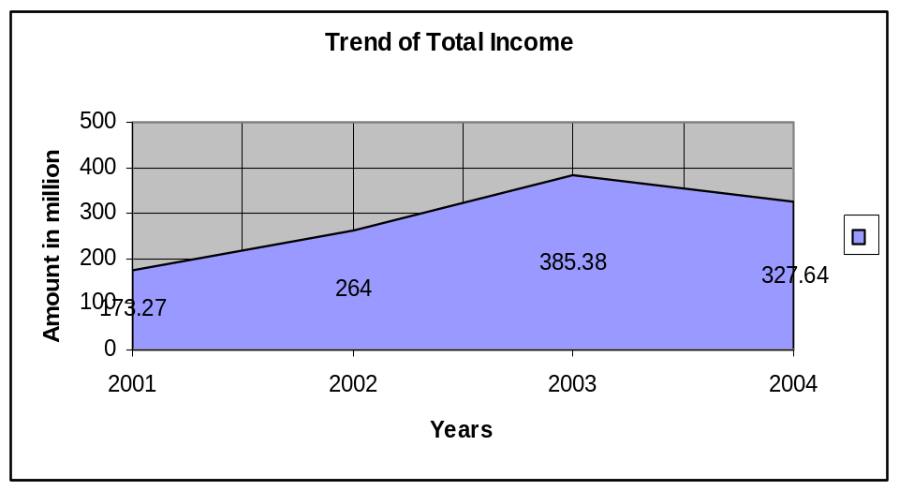
Figure: Trend of total income

Net Interest Income:

The interest income of the year 2001 was 109.35 million; in year 2002 amounted to Tk. 141.79 million. In year 2003 it was Tk. 204.44 million. In year 2004 the interest income stood for Tk. 327.64 million showing a gradual increase.
Year | 2001 | 2002 | 2003 | 2004
Net Interest Income | Tk. 109.35 million | Tk. 141.79 million | Tk. 204.44 million | Tk. 327.64 million
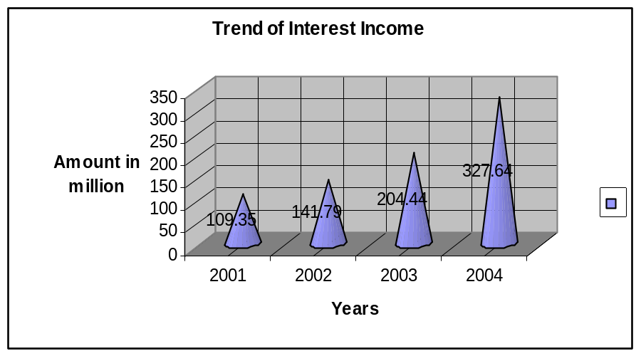
Figure: Trend of Interest Income

Operating Income:
The profit of the year 2002 before provision amounted to Tk. 127.08 million as against Tk. 70.59 million of preceding year showing and increased by 80.03%. But in year 2003 before provision amount is 221.16 million. In year 2004 operating profit stood for Tk. 383.74 million.

Year | 2001 | 2002 | 2003 | 2004
Operating income | Tk. 70.59 million | Tk. 127.08 million | Tk. 221.16 million | Tk. 383.74 million

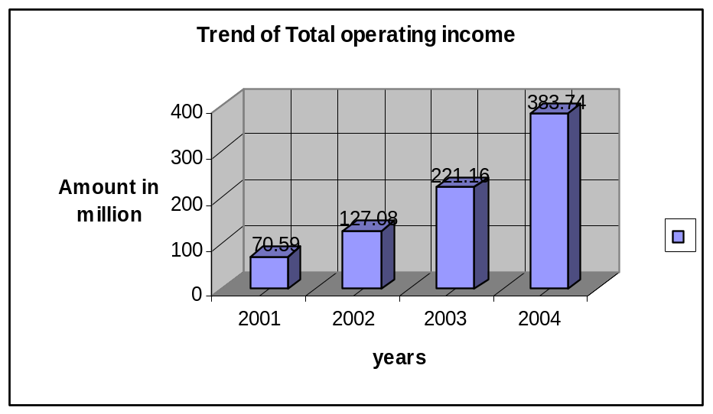
Figure: Trend of Total operating income

Retained Earnings:
Retained earnings were placed at Tk. 106.14 million for the year 2004 as against Tk. 44.18 million in the previous year 2003. A year wise graphical presentation of the same is provided on next page:
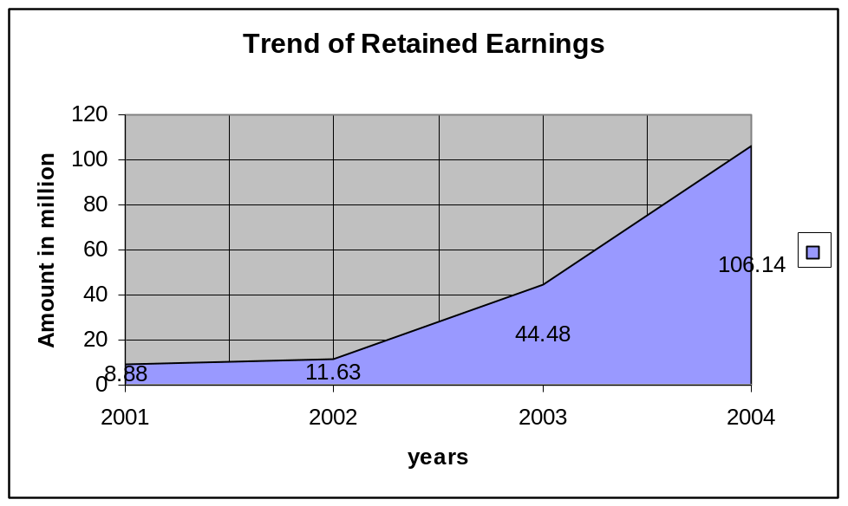
Year | 2001 | 2002 | 2003 | 2004
Retained Earnings | Tk. 8.88 million | Tk. 11.63 million | Tk. 44.48 million | Tk. 106.14 million
Figure: Trend of Retained Earnings.

Earnings Per share:
Earnings per share in year 2001 was Tk. 17.26 million but decreased in 2002 to Tk. 9.21 million, after that it started to increase and in year 2003 it stood Tk. 17.45 million
In year 2004 it was Tk. 31.71 million.

Year | 2001 | 2002 | 2003 | 2004
EPS | Tk. 17.26 million | Tk. 9.21 million | Tk. 17.45 million | Tk. 31.71 million

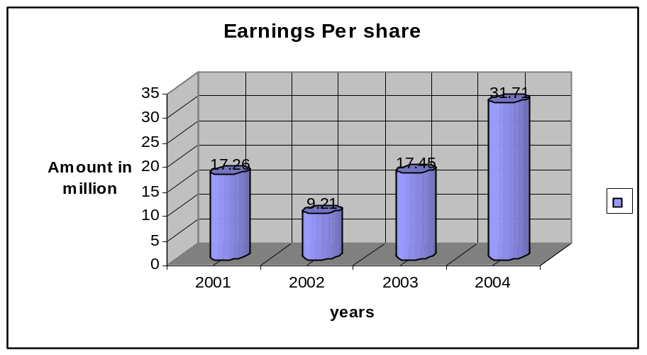
Figure: Trend of Earning Per Share

Capital funds:

Authorized capital of the bank is tk. 1,000.00 million and paid up capital was tk. 200.00 million in the year 2004. Over the period 2001-2002 the paid –up capital was fixed at tk. 200.00 million and 320 over the period 2003-2004.
Year | 2001 | 2002 | 2003 | 2004
Paid up capital | Tk.200million | Tk.200million | Tk.320million | Tk.320million
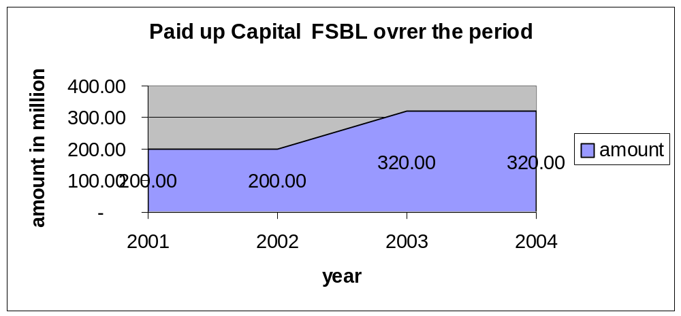Figure: Trend of Paid-up Capital

Reserve Funds: Reserve fund of the bank was tk. 6476.86 million at 2003 and it stood at tk. 8500.00 million as on 31st December 2004 that means it increase at a increasing rate. The reserve fund of First Security Bank Limited for the period 2001-2004 was as follows- (Tk. In million)
Year | 2001 | 2002 | 2003 | 2004
Reserve Funds | 2539.80 | 4102.61 | 6476.86 | 8500
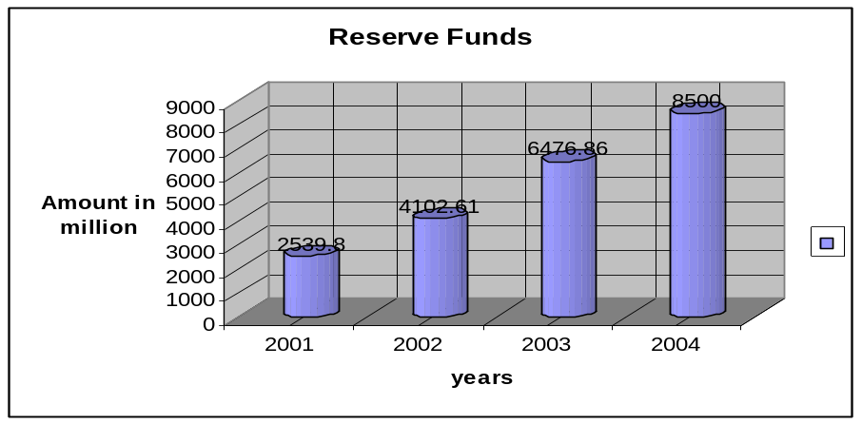
Figure: Trend of Reserve Funds

Investments: First Security Bank Limiter’s investment portfolio mainly comprised investment in government securities, Treasury bills, Bonds etc. (Tk. In million)
Year | 2001 | 2002 | 2003 | 2004
Investment | 340.39 | 540.36 | 751.73 | 1271.72
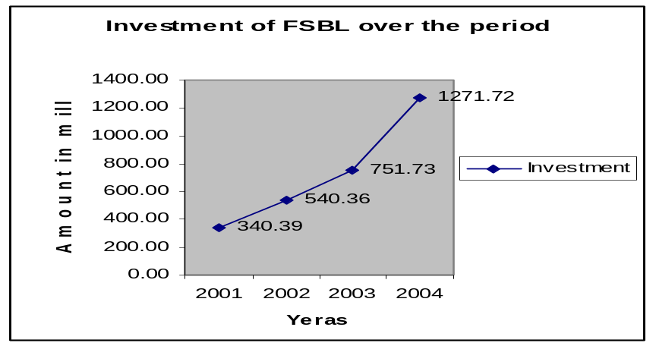

Performance Evaluation of First Security Bank Limited from Different Point of View:
From owners viewpoint:

As an owner of a bank we will analyze three area of a bank:

- Profitability of the Bank
- Growth of the Bank
- Risk of the Bank

- Profitability of the Bank:
Operating Profit margin:
This ratio indicates operating income of the bank in relation to total revenue after taking into account operating cost.
Operating Profit margin = Operating profit / Total Revenue.
(Tk. in Million)
Ratio/Year | 2001 | 2002 | 2003 | 2004
Operating Profit | 70.59 | 127.08 | 221.16 | 383.73
Total revenue | 321.40 | 496.62 | 818.29 | 1253.87
Operating Profit Margin | 21.96% | 25.59% | 27.03% | 30.60%

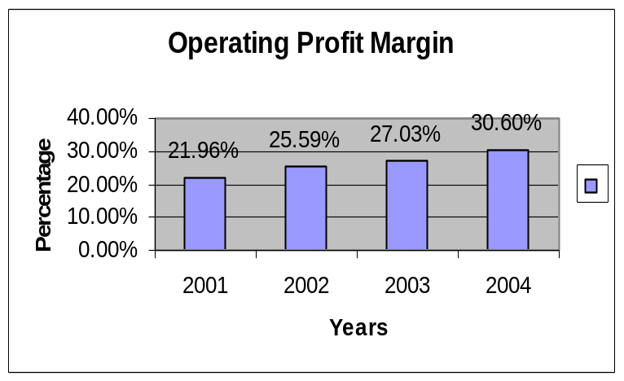

Interpretation: In case of First Security Bank Limited we observed that operating profit margin ratio increased gradually over the period this indicates that the bank is operationally efficient.

Net Profit margin: This ratio indicates net income of the bank in relation to total revenue after taking into account operating cost, financial expenses and corporate taxes. Net Profit margin = Net income / Total Revenue. (Tk. in Million)
Ratio/Year | 2001 | 2002 | 2003 | 2004
Net Income | 50.75 | 38.37 | 116.50 | 197.66
Total revenue | 321.40 | 496.62 | 818.29 | 1253.87
Net Profit Margin | 15.80% | 7.73% | 14.24% | 15.76%

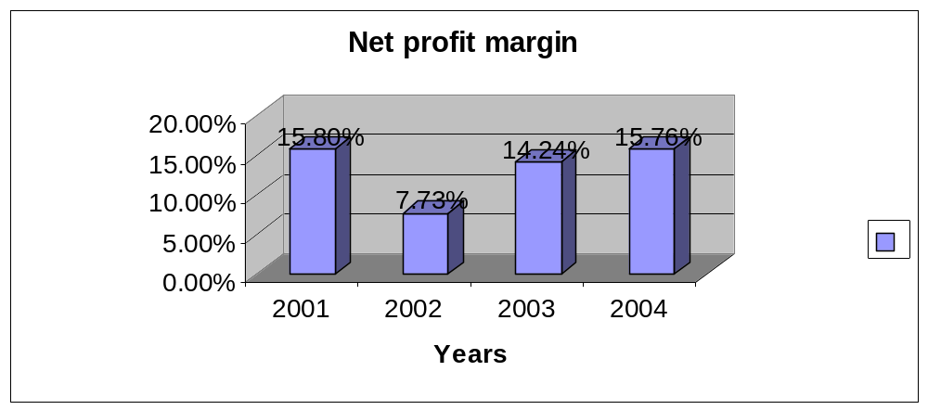Interpretation: In case of First Security Bank Limited, we observed that net profit margin ratio increased over time except year 2002. This ratio has increased due to the decrease of administrative, general expense and income tax relative to revenue.

2. Growth of the Bank:
Return on assets (ROA): Return on assets measure the success of a firm in using assets to generate earning independent of the financing if those assets. This measure therefore separates financing activity from operating and investing activities. RAO is particularly useful in assessing the performance of business segment of firm when as is typical, financing for those segments comes form a central corporate pool of resources. ROA = Net income / Total assets
(Tk. in Million)
Ratio/Year | 2001 | 2002 | 2003 | 2004
Net Income | 50.75 | 38.37 | 116.50 | 197.66
Total Assets | 4459.52.2 | 7227.45 | 13369.50 | 16169.27
Return on Assets | 1.14% | 0.53% | 0.87 % | 1.22%

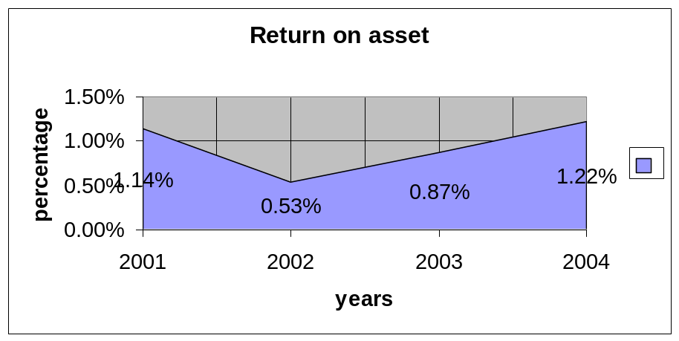
Interpretation: The ratio of return on asset of First Security Bank Limited is relatively low; it is lower than 1% over the years 2002 and 2003. It had increased little in 2004 .It indicates that total asset of the bank increased but net profit did not increase with the assets. This shows the management inefficiency in using the bank asset to generate profit.

Return on Equity (ROE): This ratio indicates the degree to which the form is able to convert operating income into an after income that eventually can be claimed by the shareholder. This is a useful ratio for analyzing the ability of the firm’s management to realize an adequate return on the capital invested by the owners of the firm.
ROE = Net income / Total equity (Tk. in Million)
Ratio/Year | 2001 | 2002 | 2003 | 2004
Net Income | 50.75 | 38.37 | 116.50 | 197.66
Total Equity | 211.24 | 253.66 | 429.51 | 531.00
Return on equity | 24.02% | 15.12% | 27.12% | 37.22%

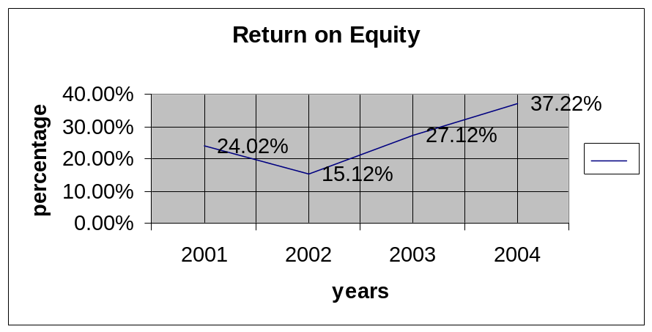
Interpretation: From the above data we find that return on equity of FSBL increased in 2004 because the bank has increased its net income as well as the equity.

Provision for loan ratio:
Provision for loan loss / Total operating income (Tk. in Million)
Ratio/Year | 2001 | 2002 | 2003 | 2004
Provision for loan loss | 2.47 | 77.20 | 104.66 | 186.07
Total operating income | 173.27 | 263.99 | 385.38 | 591.67
Provision for loan ratio | 1.58% | 29.24% | 27.16% | 31.45%

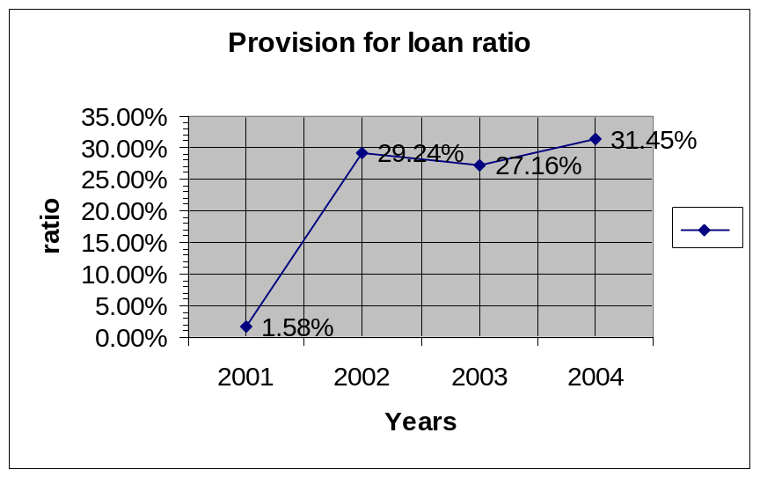

Interpretation: Provision for loan losses ratio of FSBL decreased in 2002, which shows the management efficiency to disburse and recovery of loan.

Asset utilization: Asset utilization ratio = Total operating income / Total asset
(Tk. in Million)
Year | 2001 | 2002 | 2003 | 2004
Total operating income | 173.27 | 263.99 | 385.38 | 591.67
Total asset | 4459.52 | 7227.45 | 13369.50 | 16169.27
Asset utilization ratio | 3.89% | 3.65% | 2.88% | 3.66%

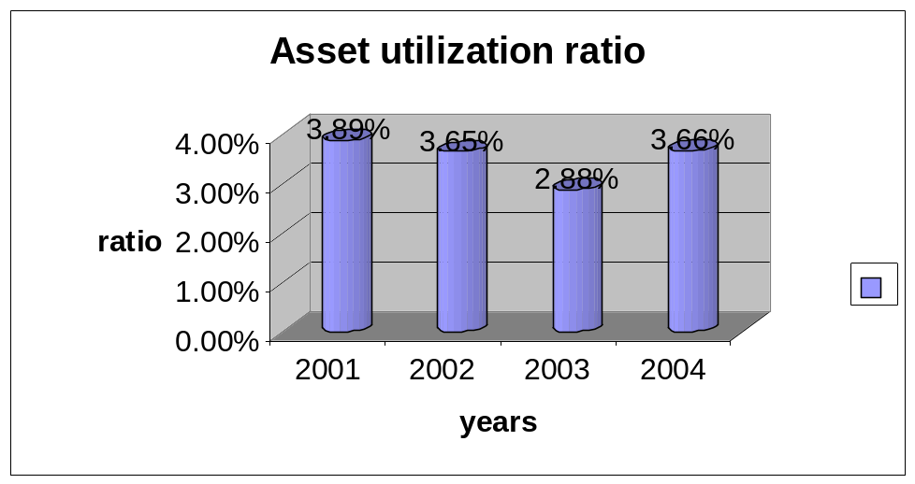

Interpretation: The data of asset utilization shows that the ratio of FSBL gradually decreased from 2001 to 2003. But in later period it increased in 2004. This indicates that the bank is most inefficient to mobilize profit from total assets.

Interest Income Ratio:
Interest Income Ratio = Interest Income / Total assets (Tk. in Million)
Ratio/Year | 2001 | 2002 | 2003 | 2004
Interest Income | 321.40 | 496.62 | 818.29 | 1253.87
Total assets | 4459.52 | 7227.45 | 13369.50 | 16169.27
Interest Income Ratio | 7.21% | 6.87% | 6.12% | 7.75%

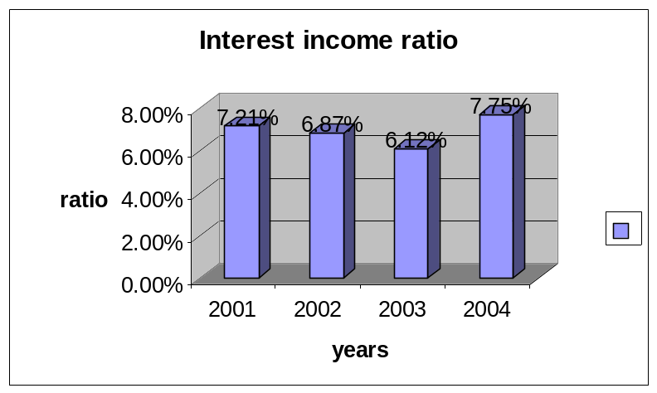
Interpretation: From the above data we see that interest income ratio decreased overtime but little increased in 2004. It indicates that the bank is trying to keep the interest income more stables and they were not successful in this area.

Non-interest Income Ratio: = Non-interest Income / Total assets

(Tk. in Million)
Ratio/Year | 2001 | 2002 | 2003 | 2004
Non-interest Income | 63.91 | 263.99 | 180.94 | 264.04
Total assets | 4459.52 | 7227.45 | 13369.50 | 16169.27
Non-interest Income Ratio | 1.43% | 3.65% | 1.35% | 1.63%
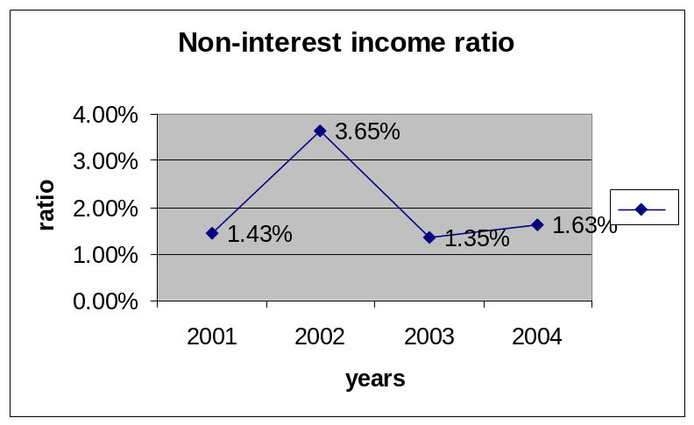

Interpretation: Above table shows the non-interest income of FSBL increased in 2002 because of more activities other than deposit.
Equity Multiplier: Equity multiplier measures the value of assets funded with each taka of equity capital. The higher the ratio, the more leverage or debt the bank is using to fund its assets. Thus the ratio is a measure of the degree of leverage the bank is using. Equity multiplier = Total assets / Total equity capital
(Tk. in Million)
Ratio/Year | 2001 | 2002 | 2003 | 2004
Total assets | 4459.52 | 7227.45 | 13369.50 | 16169.27
Total equity capital | 211.24 | 253.66 | 429.51 | 530.99
Equity multiplier | 41.28% | 39.39% | 40.28% | 41.02%

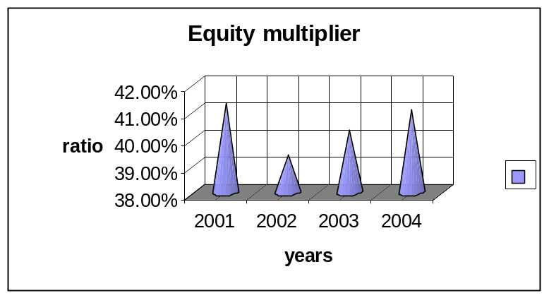
Interpretation: Equity multiplier of FSBL was too high, which indicates that the bank was highly depended on leverage.

3. Risk of the Bank:
Interest expense ratio: Interest expense ratio is different method to evaluate the bank’s expense management.

Interest Exp. Ratio = Interest expenses / Total operating income

(Tk. in Million)
Ratio/Year | 2001 | 2002 | 2003 | 2004
Interest expenses | 212.05 | 354.82 | 613.85 | 926.24
Total operating Income | 173.26 | 263.99 | 385.38 | 591.67
Interest Exp. Ratio | 1.22 | 1.34 | 1.59 | 1.57

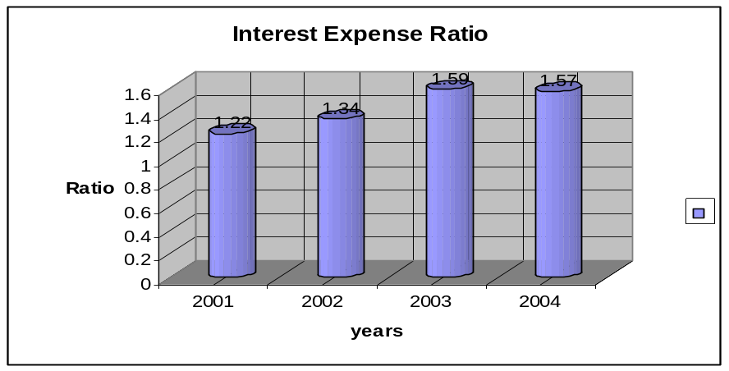

Interpretation: From the above data we see that interest expenses ratio was more over stable up to 2002 but increased more in 2003. It indicates that the bank was trying to keep the interest expenses more stables up to 2002but in later period they were unable to maintain the track.

Non-interest expense ratio:

Non interest expense /Total operating income (Tk. in Million)
Ratio/Year | 2001 | 2002 | 2003 | 2004
Non interest expense | 102.677 | 136.91 | 164.22 | 207.93
Total operating income | 173.26 | 263.99 | 385.38 | 591.67
Non interest expense ratio | 59.26% | 51.86% | 42.61% | 35.14
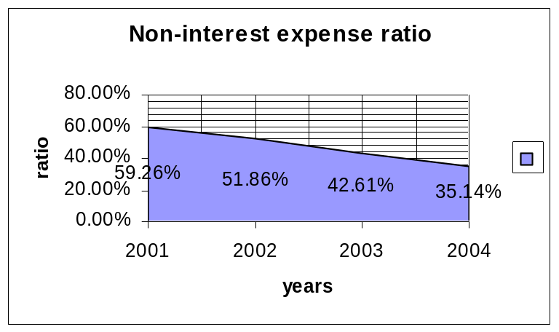
Interpretation: Above table shows the non-interest expenses of FSBL was decreasing over time but it was too high in 2001 because of more activities other than deposit, which had to pay high cost.

Tax ratio:
Tax ratio= Income Taxes / Total operating income
(Tk. in Million)
Ratio/Year | 2001 | 2002 | 2003 | 2004
Income Taxes | 16.24 | 19.95 | 60.65 | 96.18
Total operating income | 173.26 | 263.99 | 385.38 | 591.67
Tax ratio | 9.37% | 7.66% | 15.74% | 26.26%

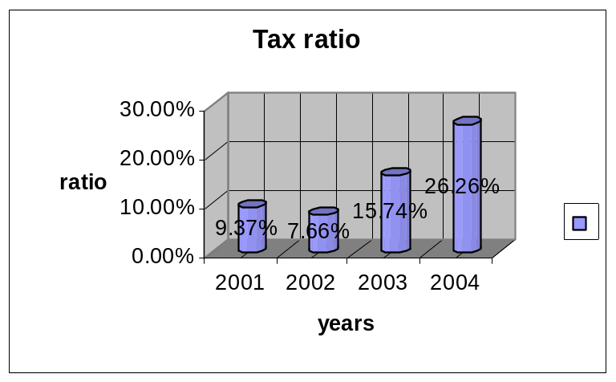

Interpretation: From 2001 to 2002, the tax ratio decreased, because the total operating income of FSBL was increased.
From the view point of Depositors:
- Internal Liquidity
- Operating Performance

Internal Liquidity: Current Ratio = Current assets / Current liabilities
(Tk. in Million)

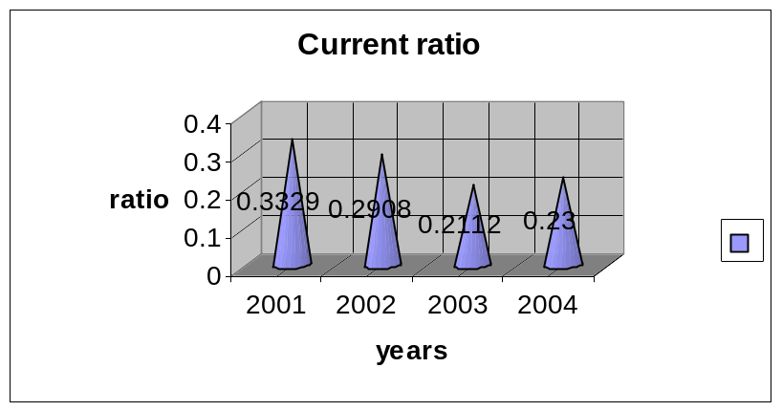
Ratio/Year | 2001 | 2002 | 2003 | 2004
Current assets | 3724.49 | 5898.75 | 10217.77 | 12860.81
Current liabilities | 4248.29 | 6973.79 | 12939.97 | 15638.27
Current Ratio | 0.3329 | 0.2908 | 0.2112 | 0.2300

2. Operating Performance: Capital to deposit ratio = Total Capital / Total deposit
(Tk. in Million)
Ratio/Year | 2001 | 2002 | 2003 | 2004
Total Capital | 211.24 | 253.66 | 429.51 | 530.60
Total deposit | 3080.19 | 5230.30 | 9443.57 | 11231.68
Capital to deposit ratio | 6.86% | 4.85% | 4.56% | 4.72%
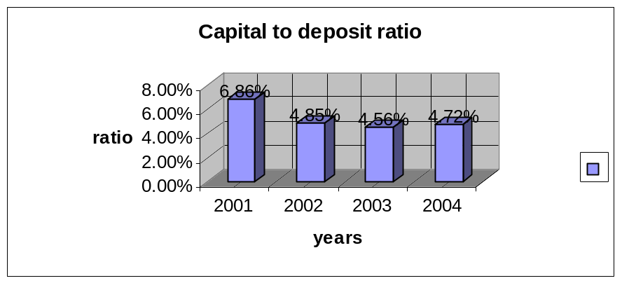
Loan to deposit ratio: Loan to deposit ratio = Total Loan / Total deposit
(Tk. in Million)
Ratio/Year | 2001 | 2002 | 2003 | 2004
Total Loan | 2539.80 | 4102.61 | 6476.84 | 8500.27
Total deposit | 3080.19 | 5230.30 | 9443.57 | 11231.68
Loan to deposit ratio | 82.45% | 78.44% | 68.58% | 75.68%

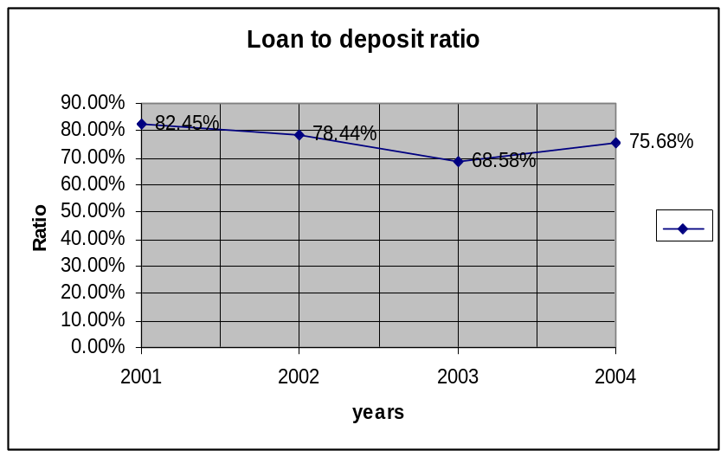

Deposit to employee ratio=Total Deposit / Total number of employee
(Tk. in Million)
Ratio/Year | 2001 | 2002 | 2003 | 2004
Total Deposit | 3080.19 | 5230.30 | 9443.57 | 11231.68
Total number of employee | 283 | 376 | 433 | 467
Deposit to employee ratio | 1.088 | 13.91 | 21.81 | 24.05

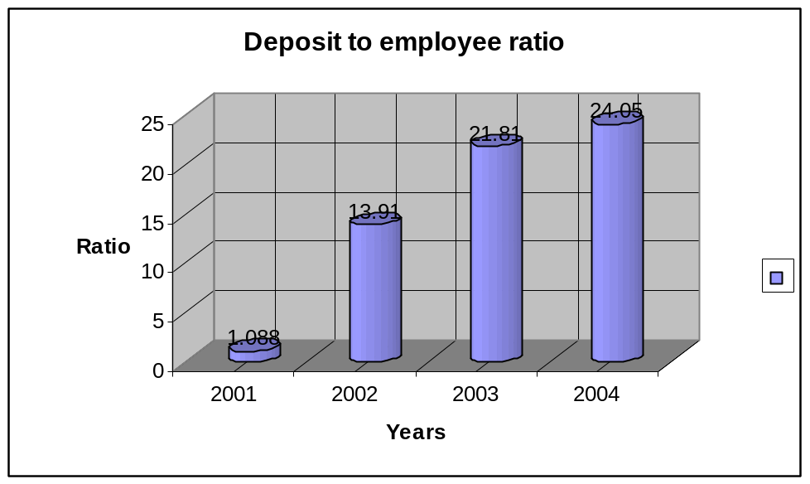

CAMEL Rating: CAMEL rating is a suitable way of analyzing bank’s financial performance. It is a technique, which is widely used by the central bank as well as financial analysts to identify bank’s financial position. Five alphabets of CAMEL means:

C = Capital adequacy

A = Asset quality
M = Management efficiency
E = Earnings
L = Liquidity

These cover all major aspects of financial indicators. To appropriately identify bank’s financial position, rating is used which is calculated by following way-
Rating | Condition | Composite Range
1 | Strong | 1.0-1.49
2 | Satisfactory | 1.50-2.49
3 | Fair | 2.50-3.49
4 | Marginal | 3.50-4.49
5 | Unsatisfactory | 4.50-5.00

Elements of CAMEL rating are calculated step by step in the following:

1. Capital adequacy: Capital adequacy of First Security Bank Limited was 7.57% in year 2004.
Rating | Condition | Range
1 | Strong | 9.00% – above
2 | Satisfactory | 8.00% - 8.99%
3 | Fair | 7.00% - 7.99%
4 | Marginal | 5.00% - 6.99%
5 | Unsatisfactory | 4.99% - below

Interpretation:
Since the capital adequacy ratio of the First Security Bank Limited in 2004 was 7.57%. Therefore, the capital adequacy of First Security Bank Limited was fair. That means rating was 3.

2. Asset quality: To identify of assets quality of First Security Bank Limited, classification of loans and advance and provision for loans and advances is required to know –

Particulars | 2004 | % of total loan
a) Unclassified | 7079.49 | 83.29%
b) Classified: | 1420.78 | 16.72%
i) Substandard | 359.96 | 4.23%
ii) Doubtful | 51.41 | 0.60%
iii) Bad & loss | 1009.41 | 11.88%
Total loans and Advances | 8500.27 | 100%

Classified loan ratio = Classified loan / total loan
= 1420.78 million / 8500.27 million
= 16.72%
Rating | Condition | Range
1 | Strong | Up to 5.00%
2 | Satisfactory | 5.01% – 10.00%
3 | Fair | 10.01% - 15.00%
4 | Marginal | 15.01% - 20.00%
5 | Unsatisfactory | Above 20.00%

Interpretation:
Classified loan ratio of the First Security Bank Limited at 2004 was 16.72%. So, the asset quality of First Security Bank Limited is marginal. That means rating was 4.

3. Earnings: ROA = Net income / Total asset (Tk. in Million)
Ratio/Year | 2004
Net Income | 197.66
Total Assets | 16169.27
Return on Assets | 1.23%

Rating | Condition | Composite Range
1 | Strong | 1.0%- above
2 | Satisfactory | 0.85% - 0.99%
3 | Fair | 0.70%- 0.84%
4 | Marginal | 0.55%-0. 69%
5 | Unsatisfactory | 0.54% and below

Interpretation: Return on assets of the First Security Bank Limited at 2004 was 1.23%. So, the Earnings of First Security Bank Limited were strong. That means rating was 1.

4. Liquidity: Liquidity ratio = total liquid assets / total times demanded liabilities
= 7488.03 million / 60923.1 million = 35.38%
Rating | Condition | Range
1 | Strong | 30.00% - above
2 | Satisfactory | 20.00% - 29.99%
3 | Fair | 19.00% - 19.99%
4 | Marginal | 15.00% - 18.99%
5 | Unsatisfactory | Below 15.00%

Interpretation: Liquidity ratio of the First Security Bank Limited at 2004 was 35.38%. So, the liquidity of First Security Bank Limited was strong. That means rating was 1.

5. Management efficiency:
The management rating is an average of the four ratings given to capital, assets quality, earnings and liquidity.
Rating (C+A+E+L)/4 = (3 + 4 +1 +1) / 4= 2.25
Rating | Condition | Range
1 | Strong | 1.0-1.49
2 | Satisfactory | 1.50-2.49
3 | Fair | 2.50-3.49
4 | Marginal | 3.50-4.49
5 | Unsatisfactory | 4.50-5.00
Interpretation: The range of rating of Management efficiency of First Security Bank Limited was 2.25, which was Satisfactory. That means rating was 2.

CAMEL Rating:
Capital adequacy | Unsatisfactory | 5
Asset quality | Marginal | 4
Management efficiency | Fair | 3
Earnings | Strong | 1
Liquidity | Strong | 1

Composite Rating: Composite rating is the average of the all ratings.
Thus, Composite rating = (3+4+2+1+1) / 5 = 2.20

Rating | Condition | Composite Range
1 | Strong | 1.00 - 1.49
2 | Satisfactory | 1.50 - 2.49
3 | Fair | 2.50 - 3.49
4 | Marginal | 3.50 - 4.49
5 | Unsatisfactory | 4.50 - 5.00

Conclusion of CAMEL rating: Since the composite range of CAMEL rating of First Security Bank Limited in 2004 was 2.20. So, it shows that the financial position of First Security Bank Limited was Satisfactory.

